

Boeing Autonomous
SolidWorks Parts, Assemblies, and Drawing Files
By: Elise C., Selina C., Jacob K., Marek L., Desirae M., Natasa P., Lily Q.

Brakes Subsystem
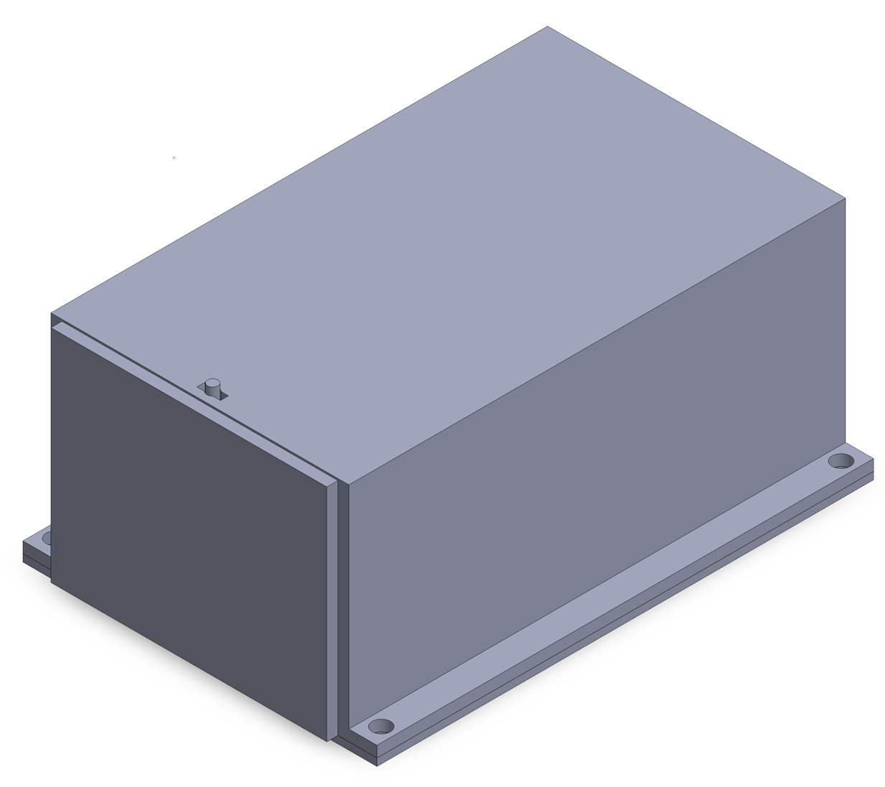
Figure 1: Prototype 2 Assembly

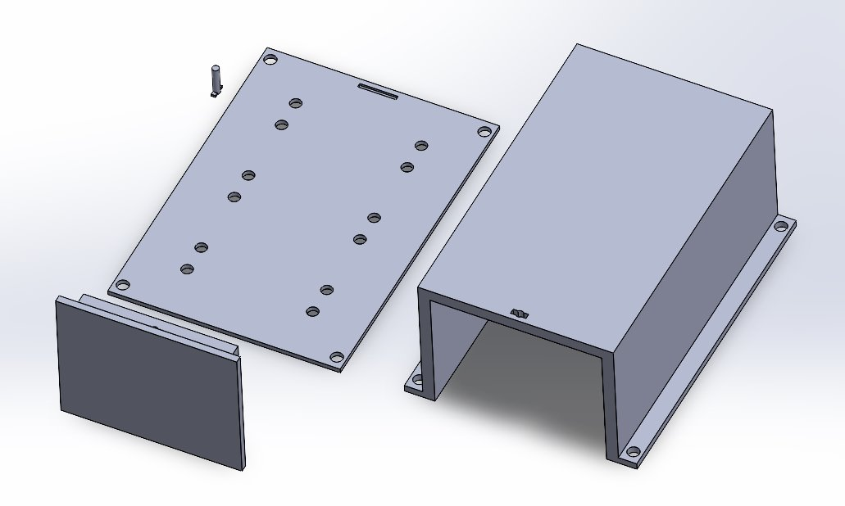
Figure 2: Prototype 2 Assembly Exploded
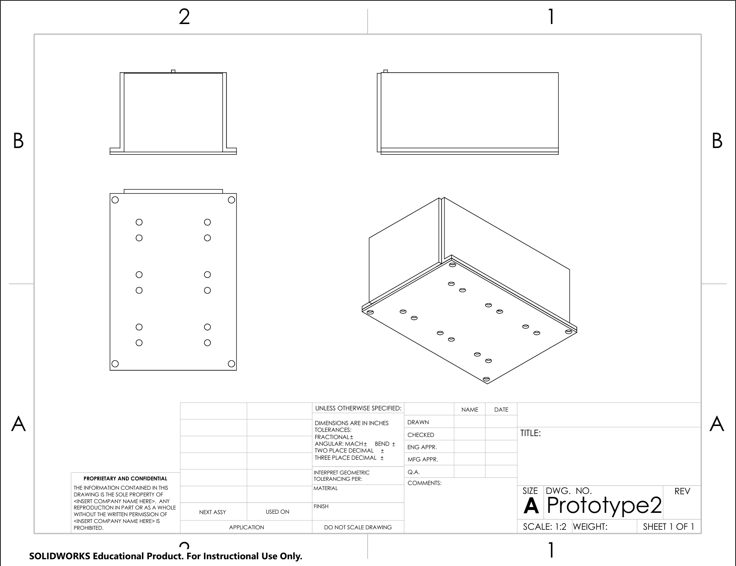
Figure 3: Prototype 2 Assembly Drawing

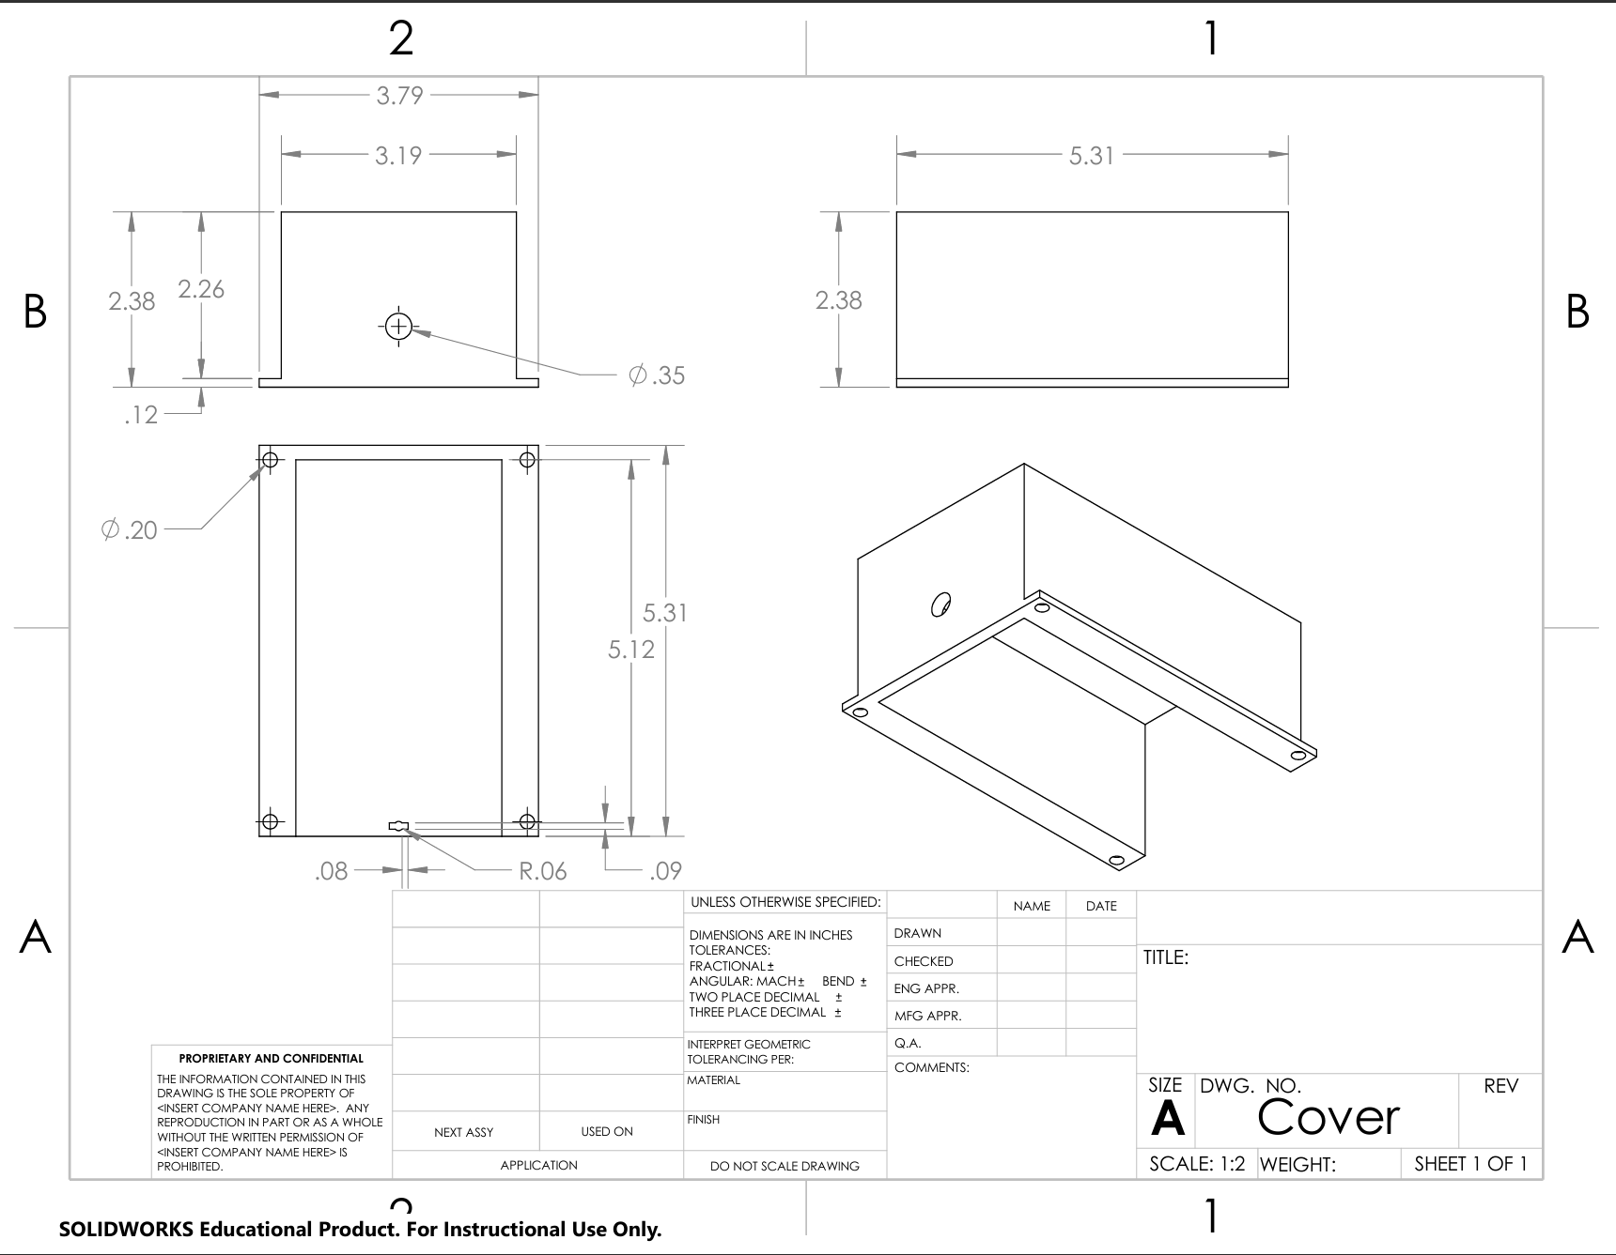
Figure 4: Prototype 2 Cover Drawing
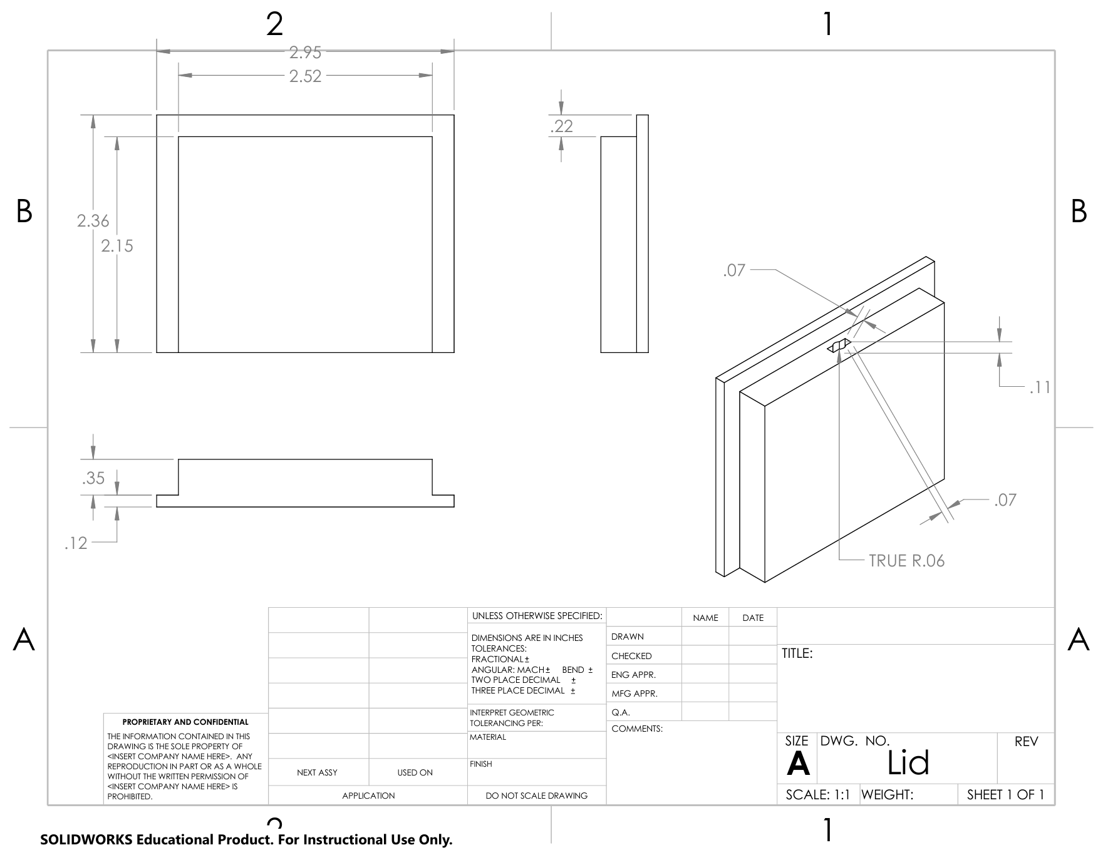
Figure 5: Prototype 2 Lid Drawing
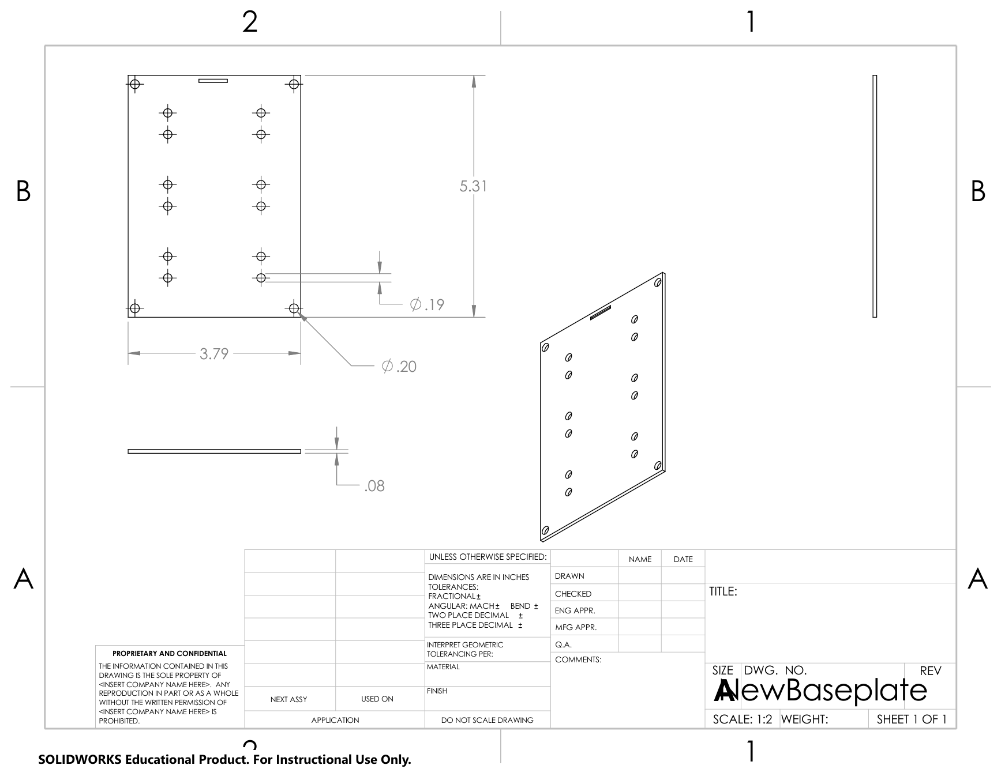
Figure 6: Prototype 2 New Base Plate Drawing
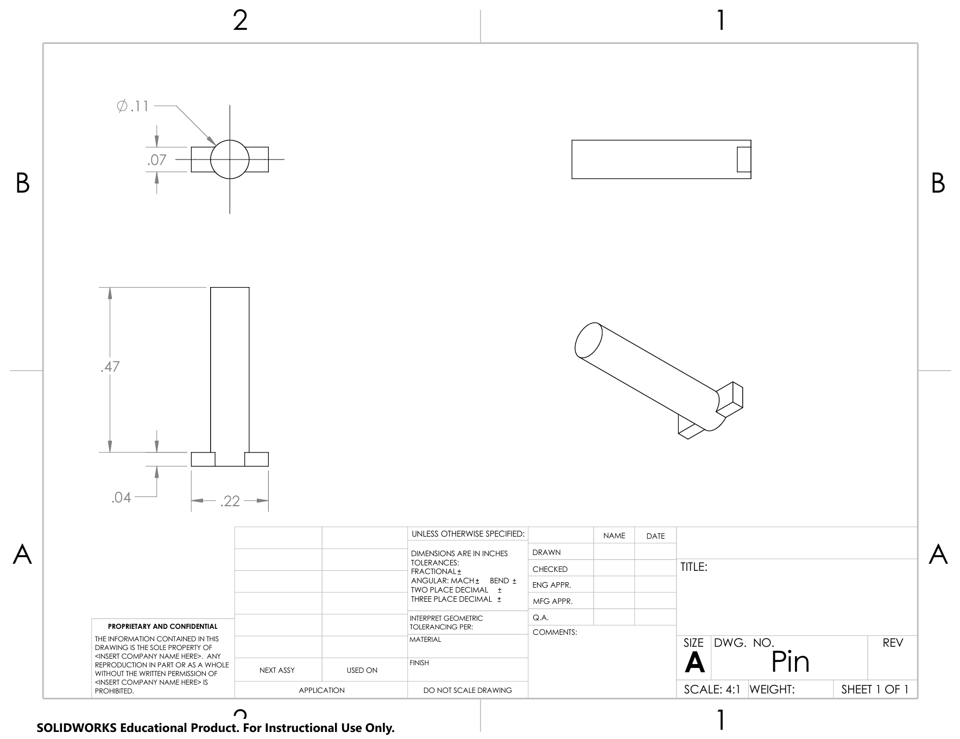
Figure 7: Prototype 2 Pin Drawing
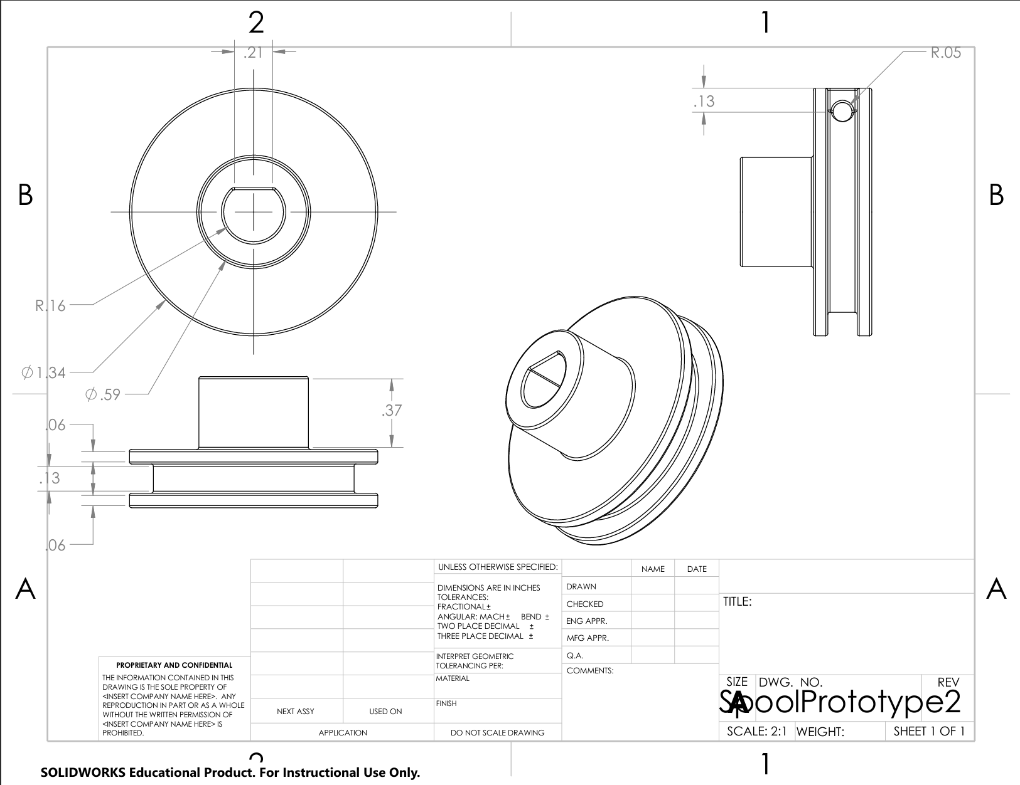
Figure 8: Prototype 2 Spool Drawing
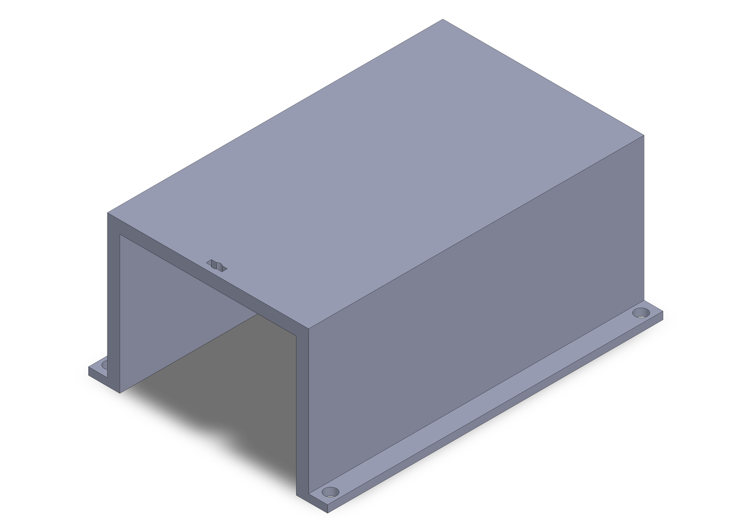
Figure 9: Prototype 2 Cover

Figure 10: Prototype 2 Lid

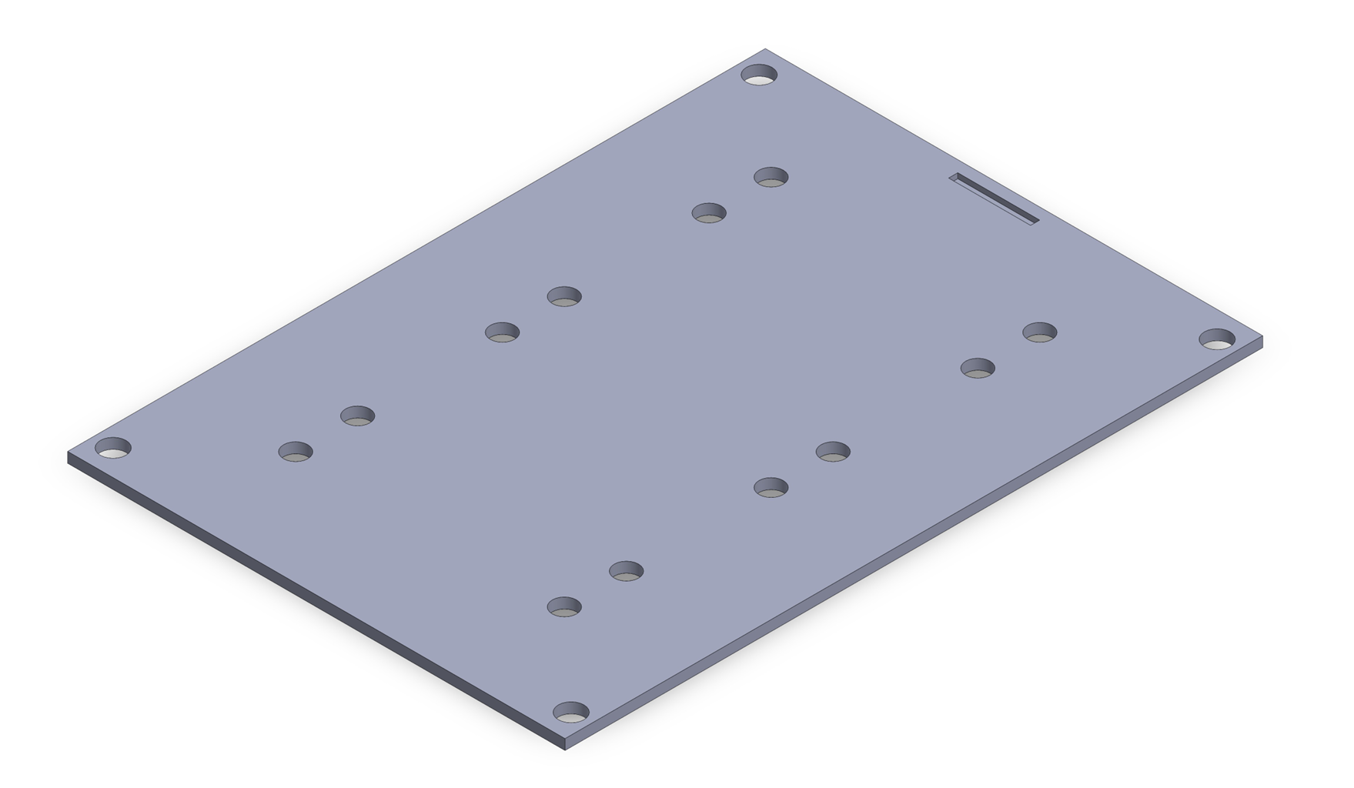
Figure 11: Prototype #2 Base Plate

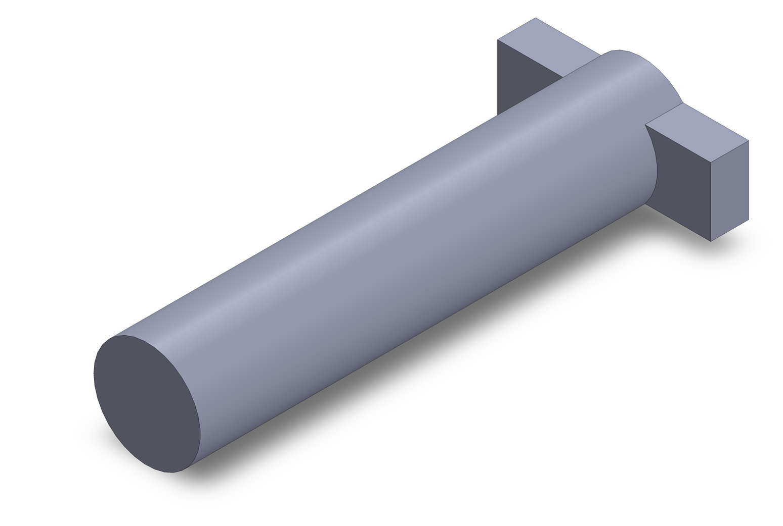
Figure 12: Prototype #2 Pin

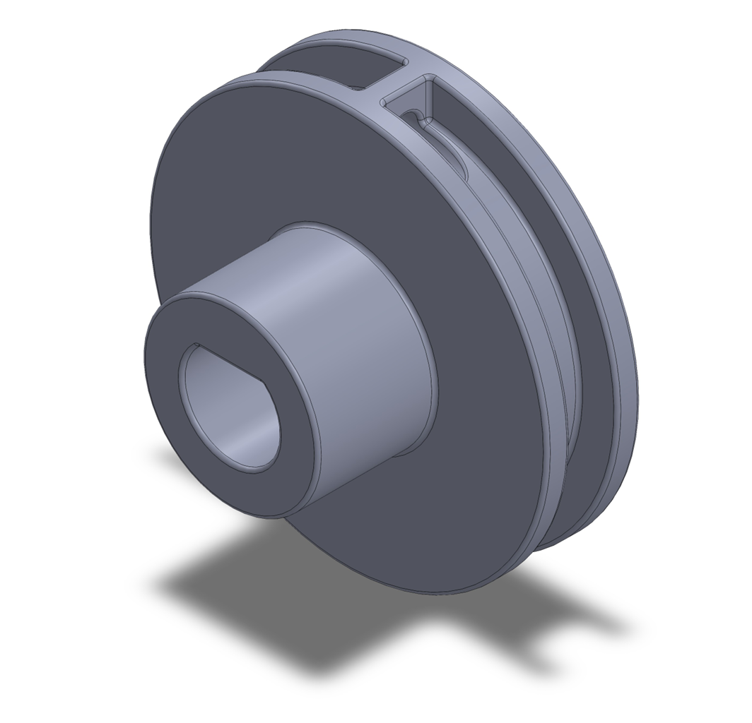

Figure 13: Prototype #2 Spool
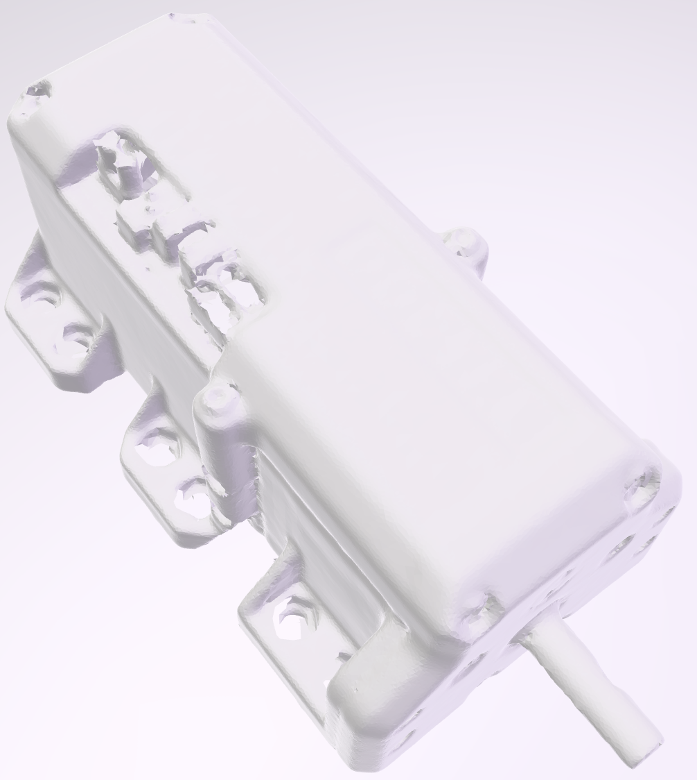
Figure 14: Docyke 350kg Motor
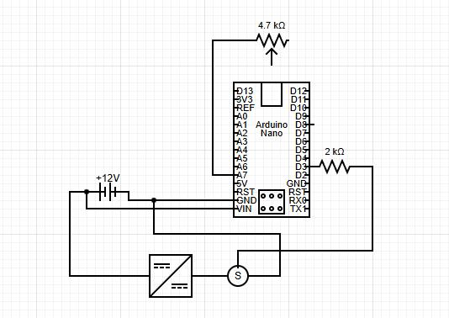
Figure 15: Brakes Electrical Diagram
Steering Subsystem
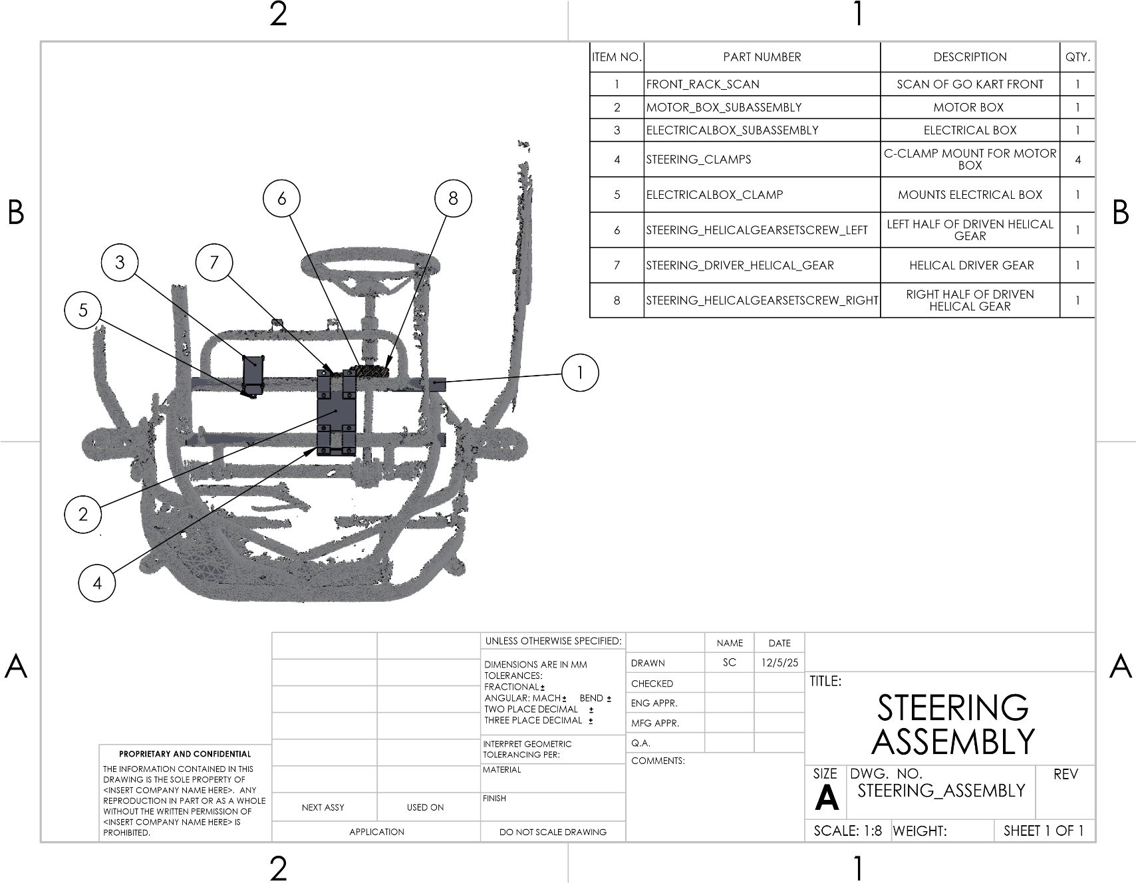
Figure 16: STEERING ASSEMBLY
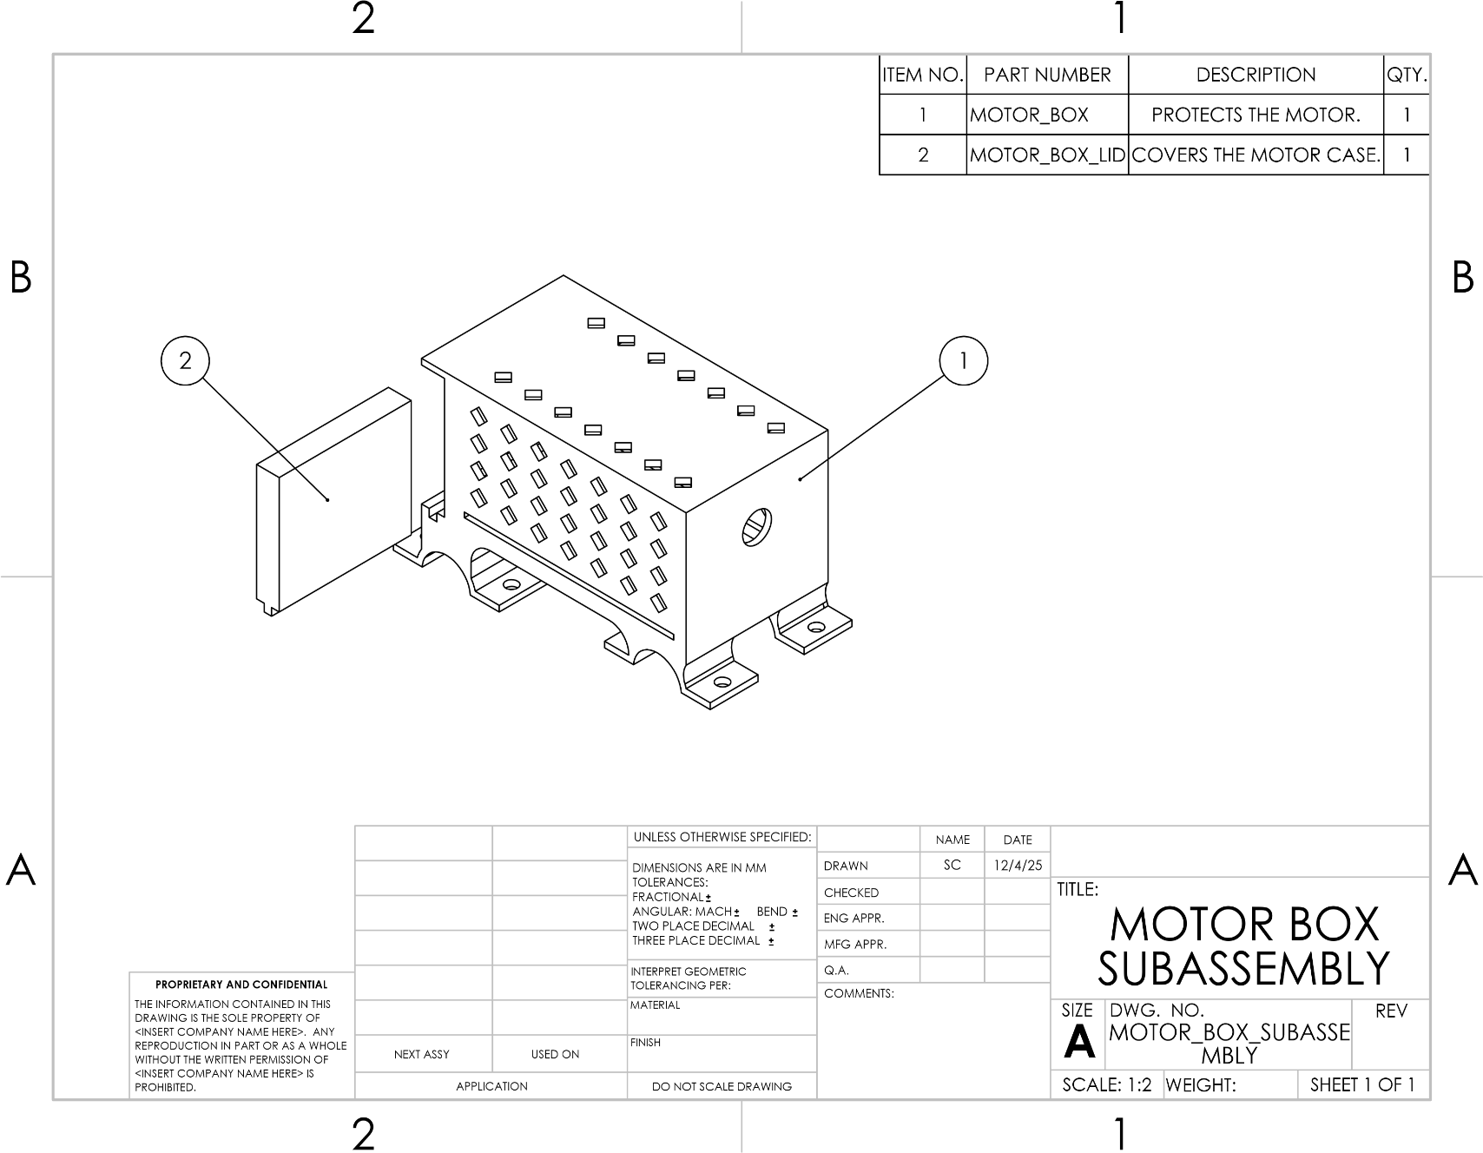
Figure 17: MOTOR BOX SUBASSEMBLY
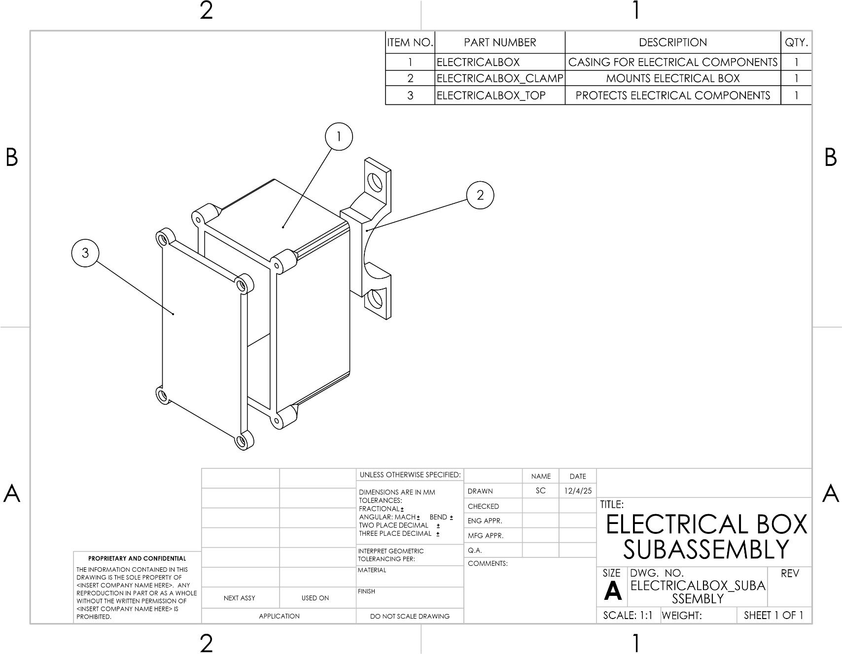
Figure 18: ELECTRICAL BOX SUBASSEMBLY
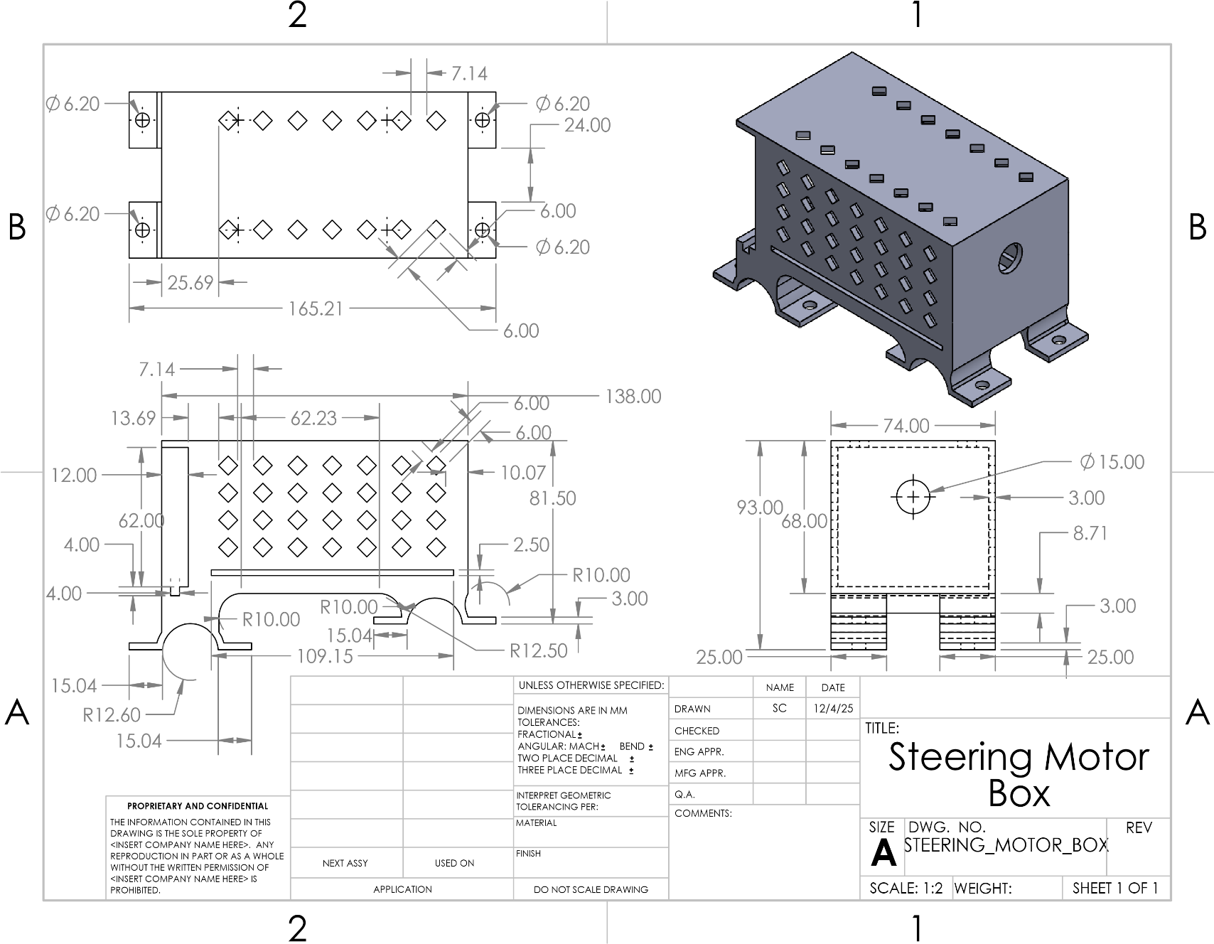
Figure 19: STEERING MOTOR BOX
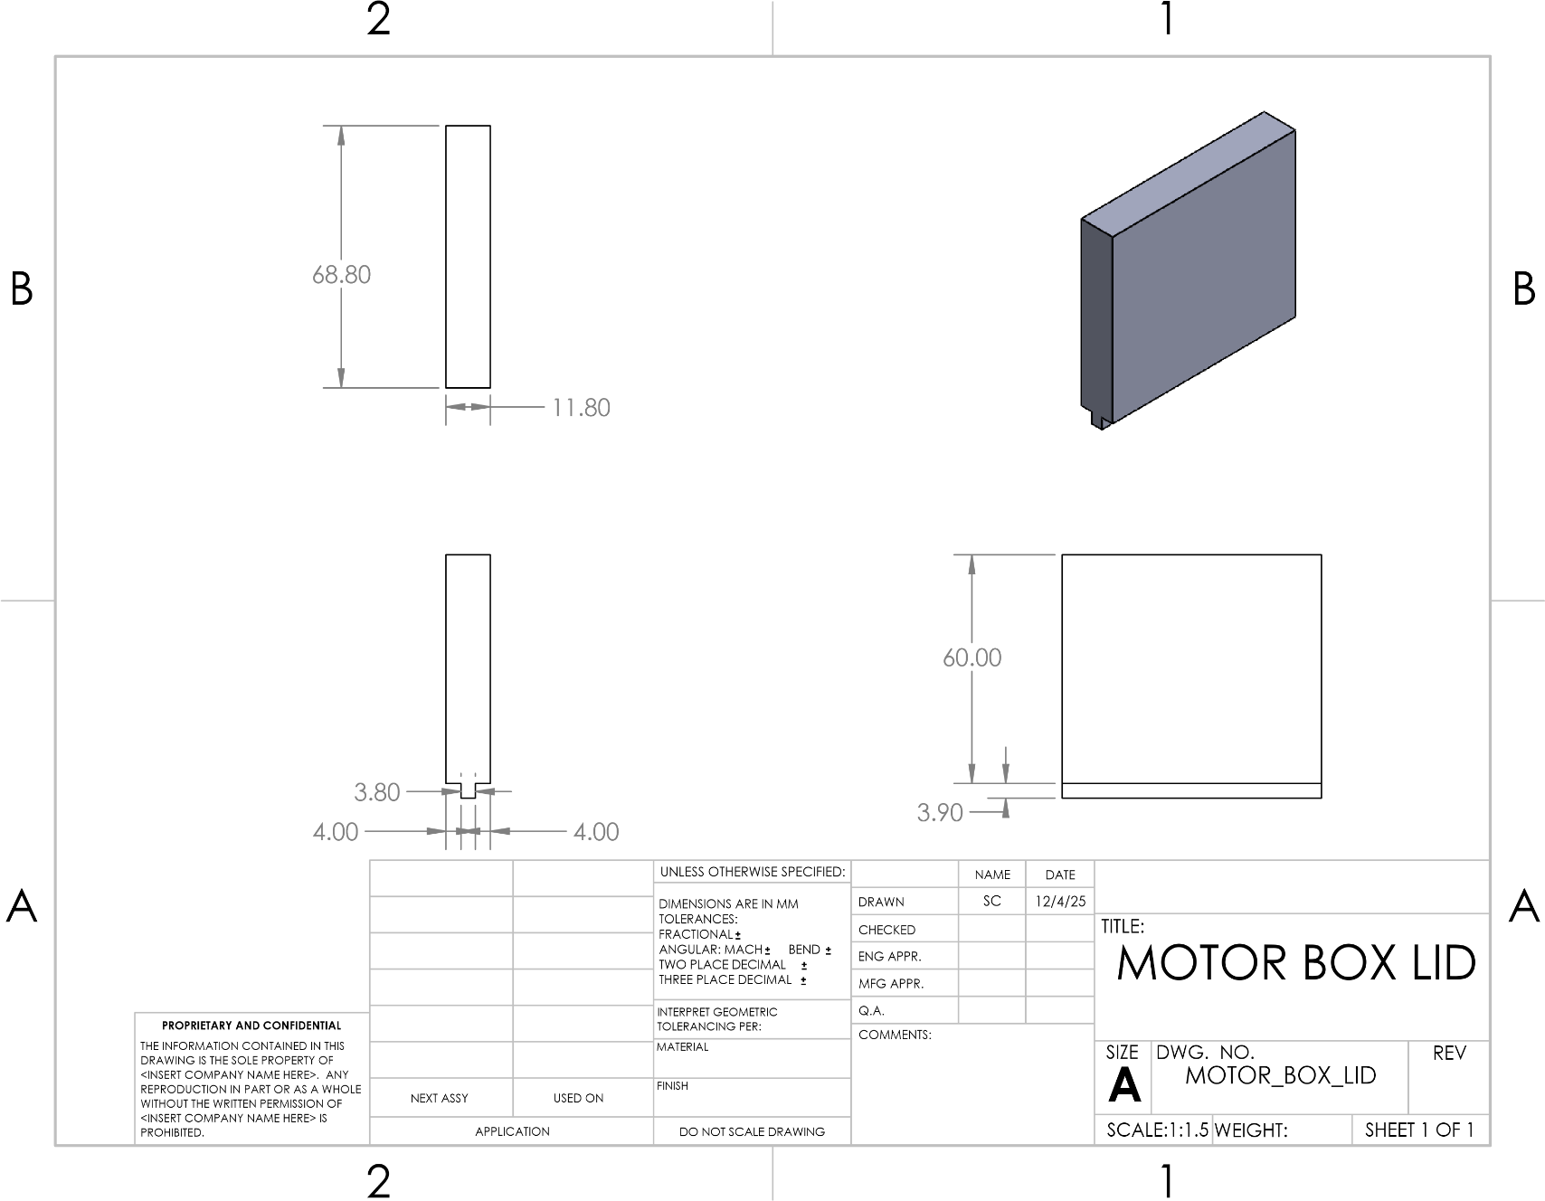
Figure 20: MOTOR BOX LID
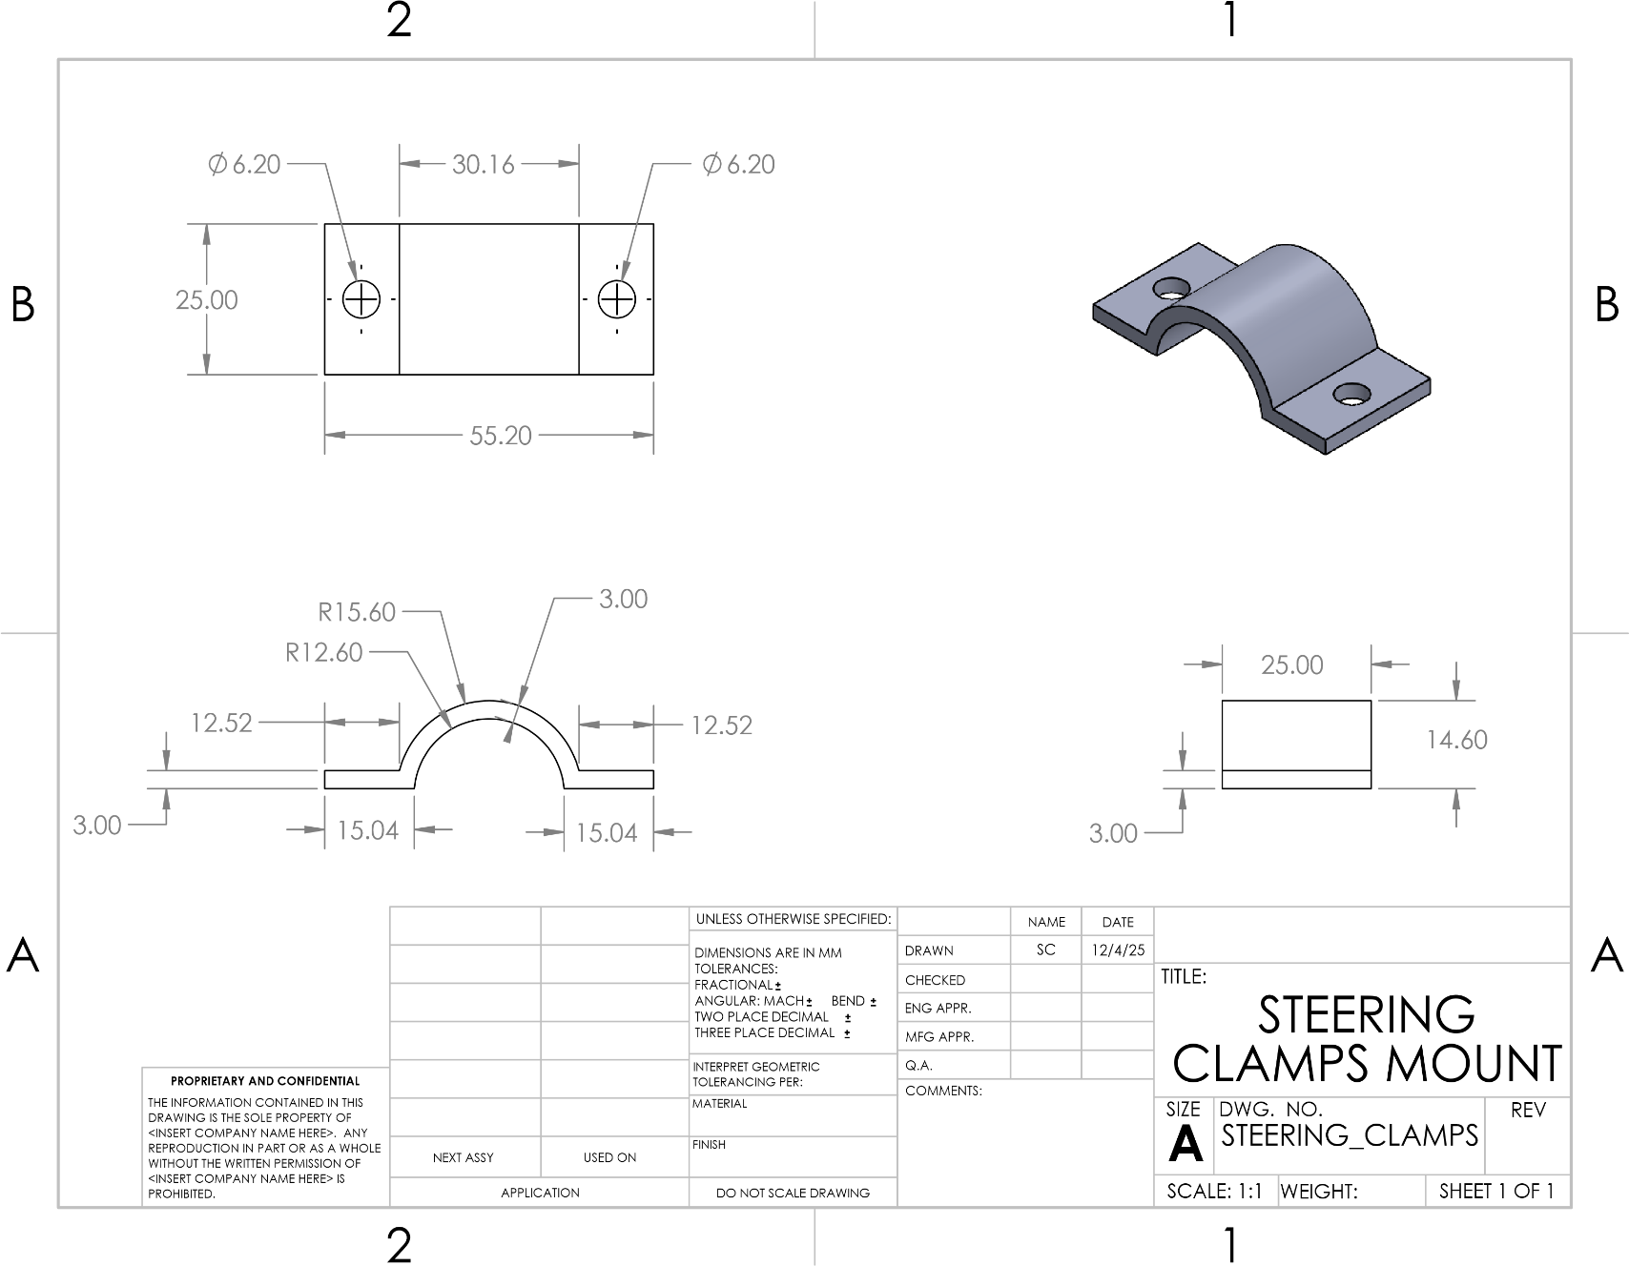
Figure 21: STEERING CLAMPS MOUNT
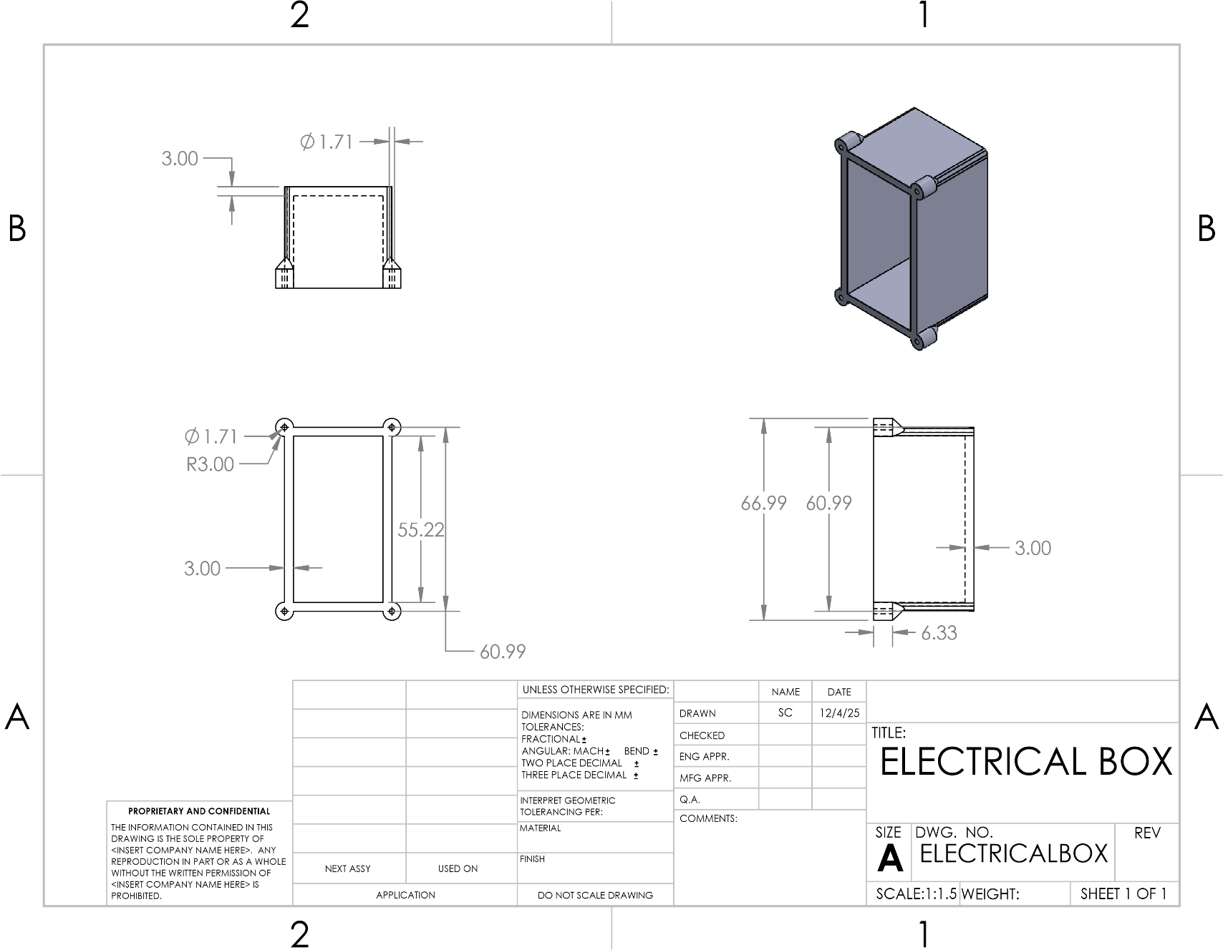
Figure 22: ELECTRICAL BOX
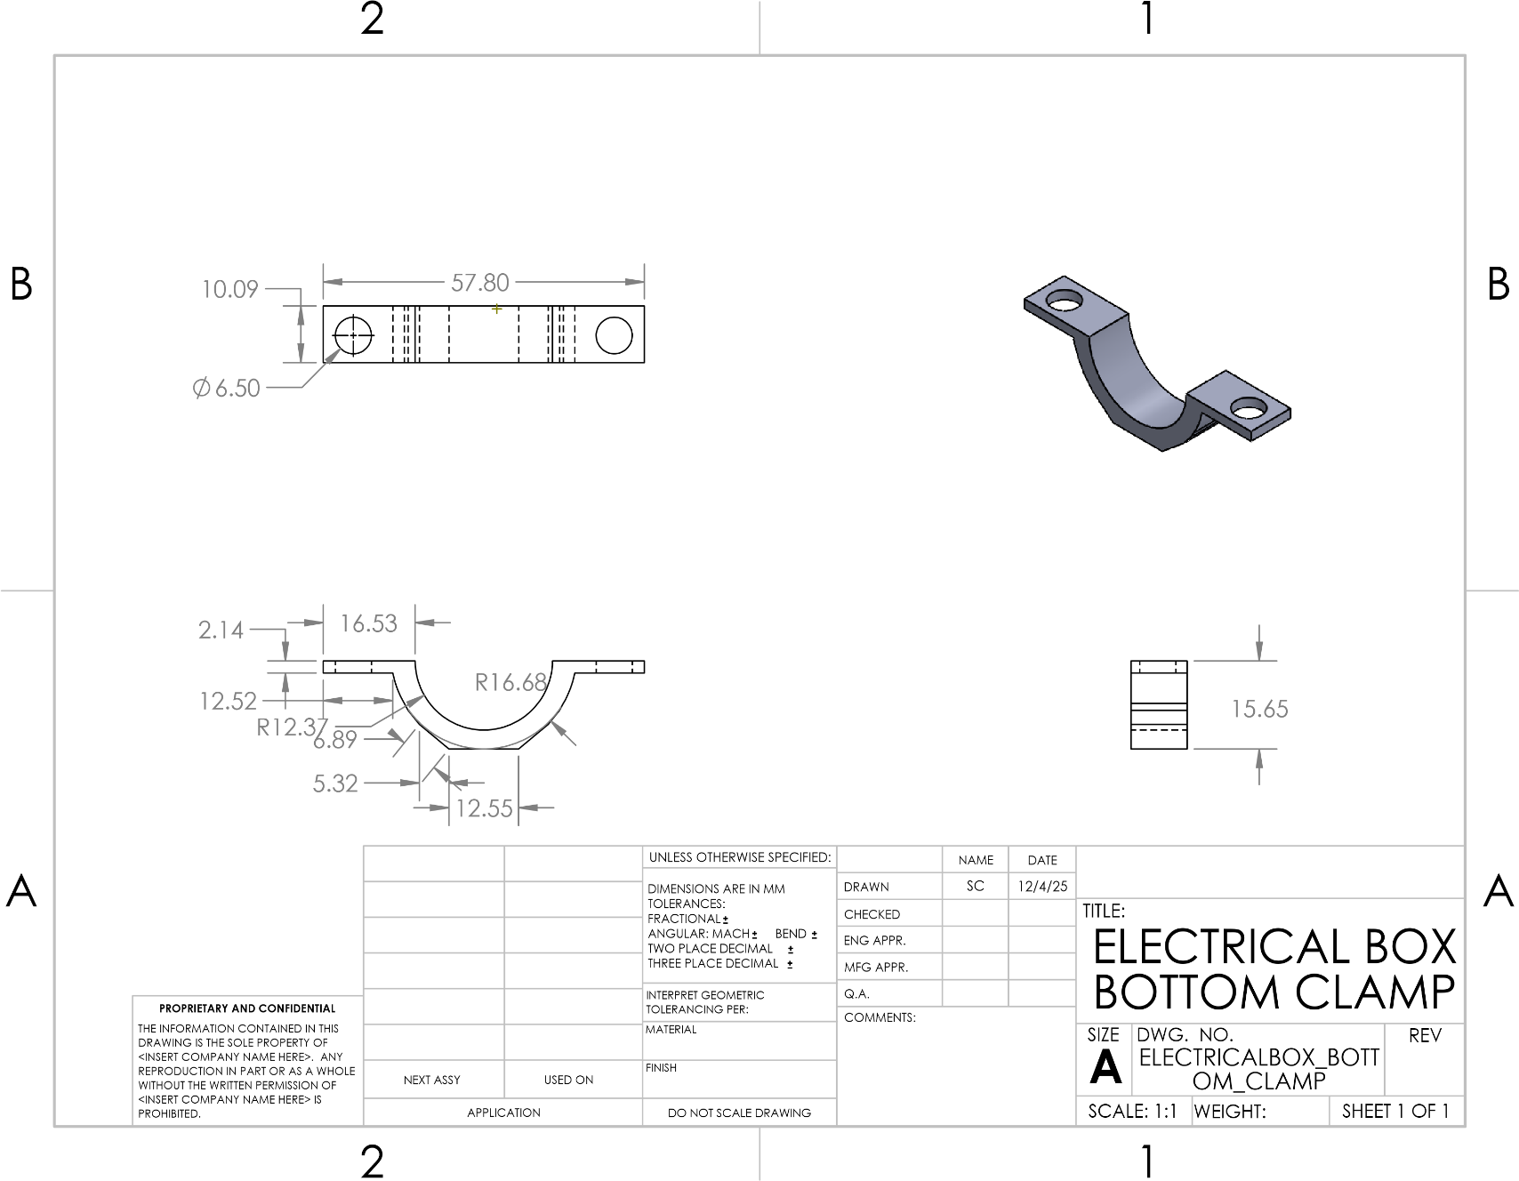
Figure 23: ELECTRICAL BOX BOTTOM CLAMP
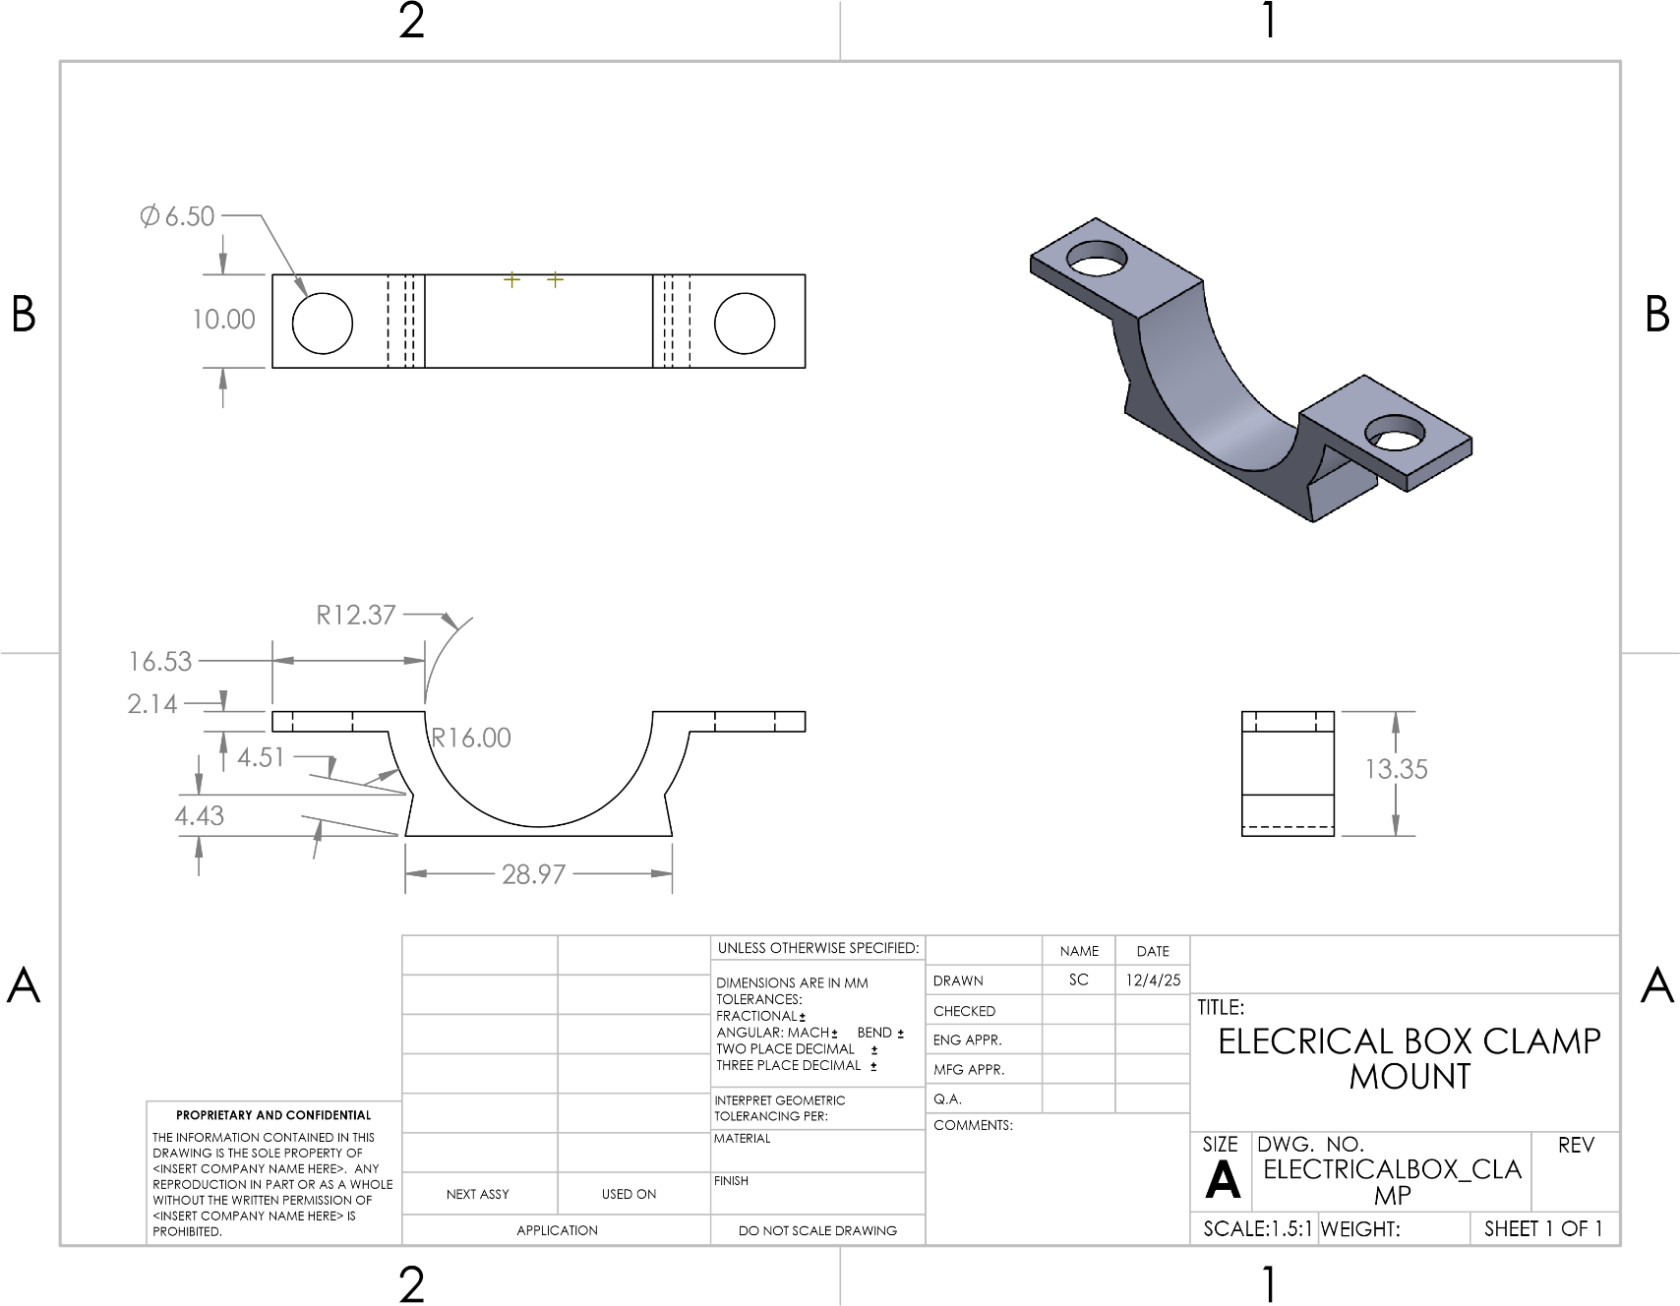
Figure 24: ELECTRICAL BOX CLAMP MOUNT
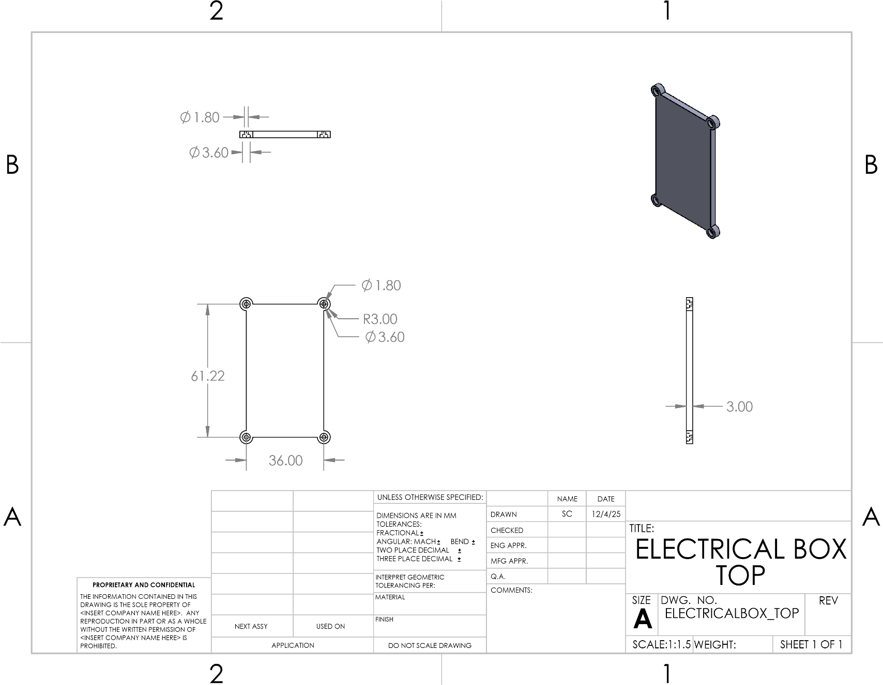
Figure 25: ELECTRICAL BOX TOP
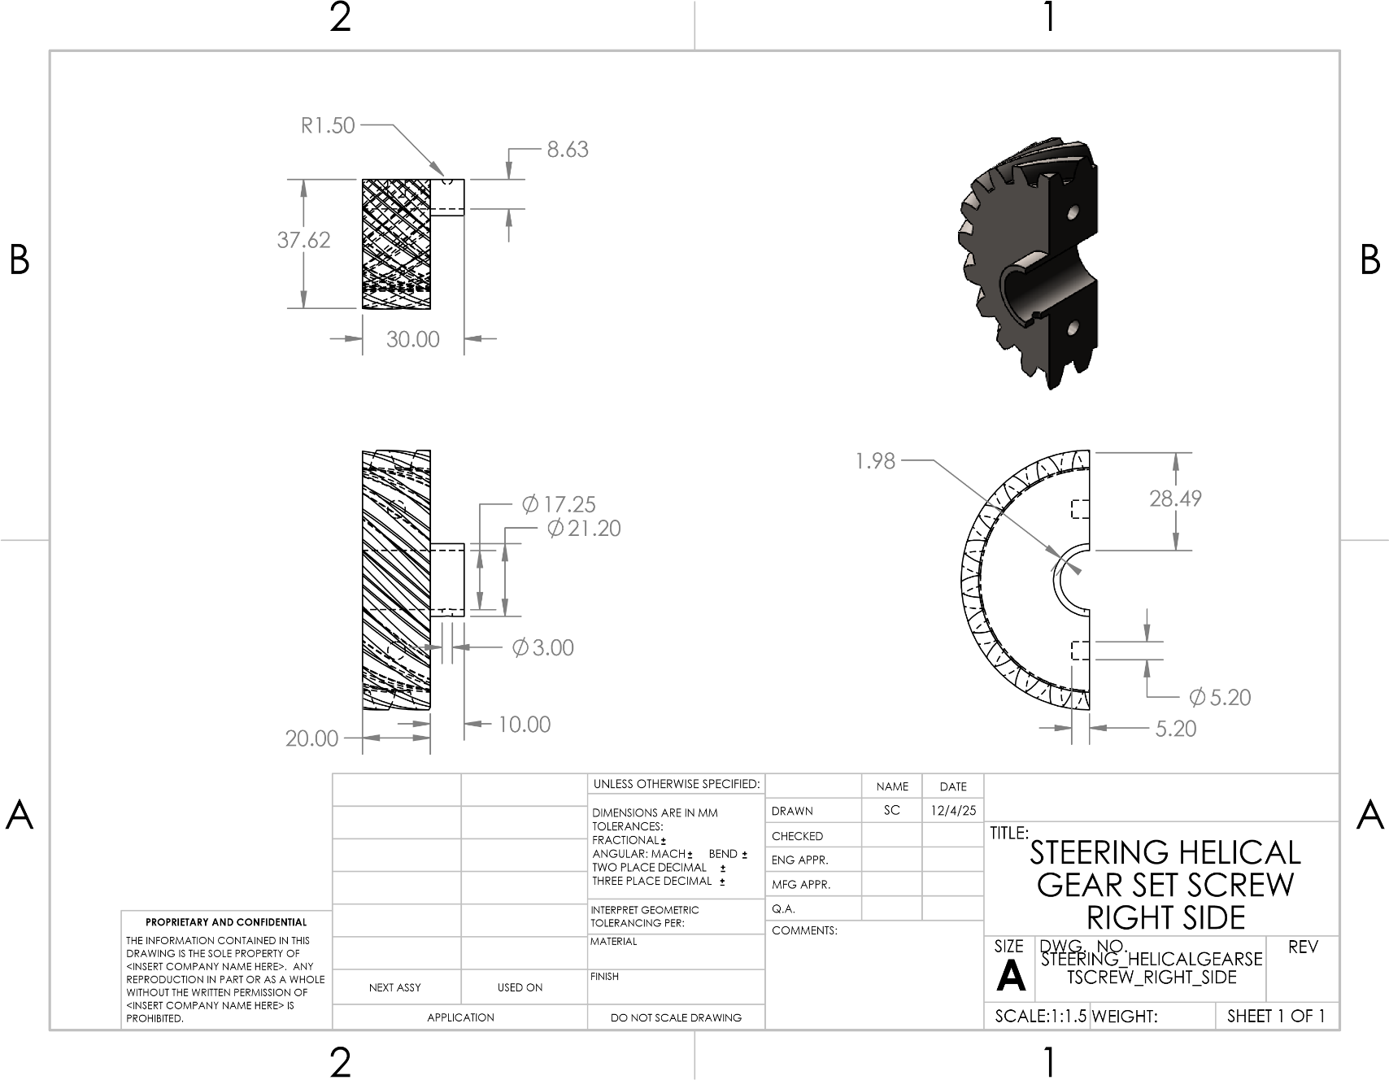
Figure 26: STEERING HELICAL GEAR SET SCREW RIGHT SIDE
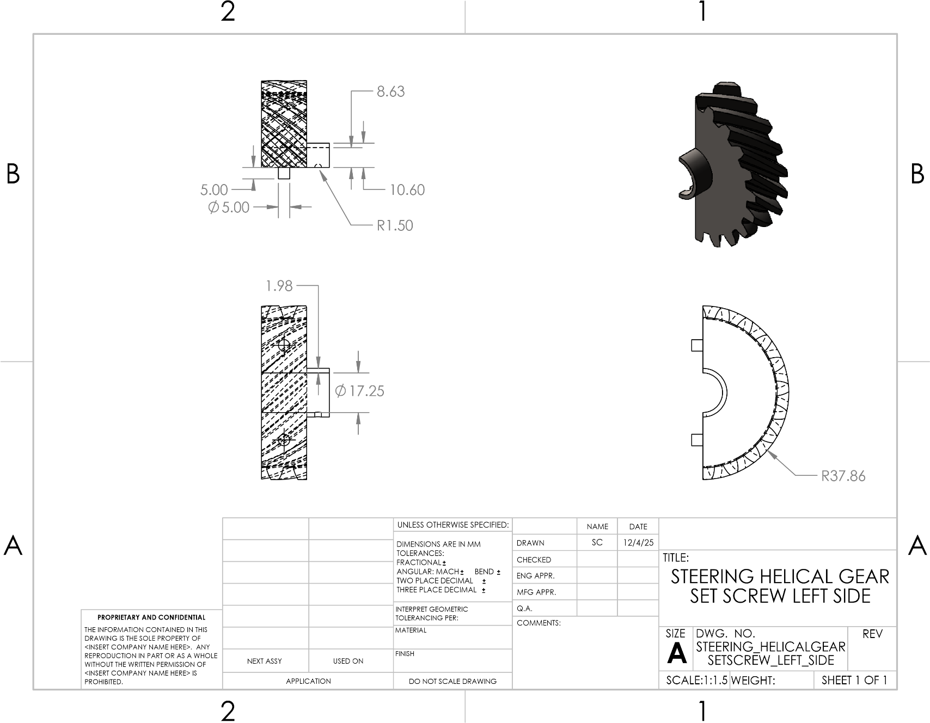
Figure 27: STEERING HELICAL GEAR SET SCREW LEFT SIDE
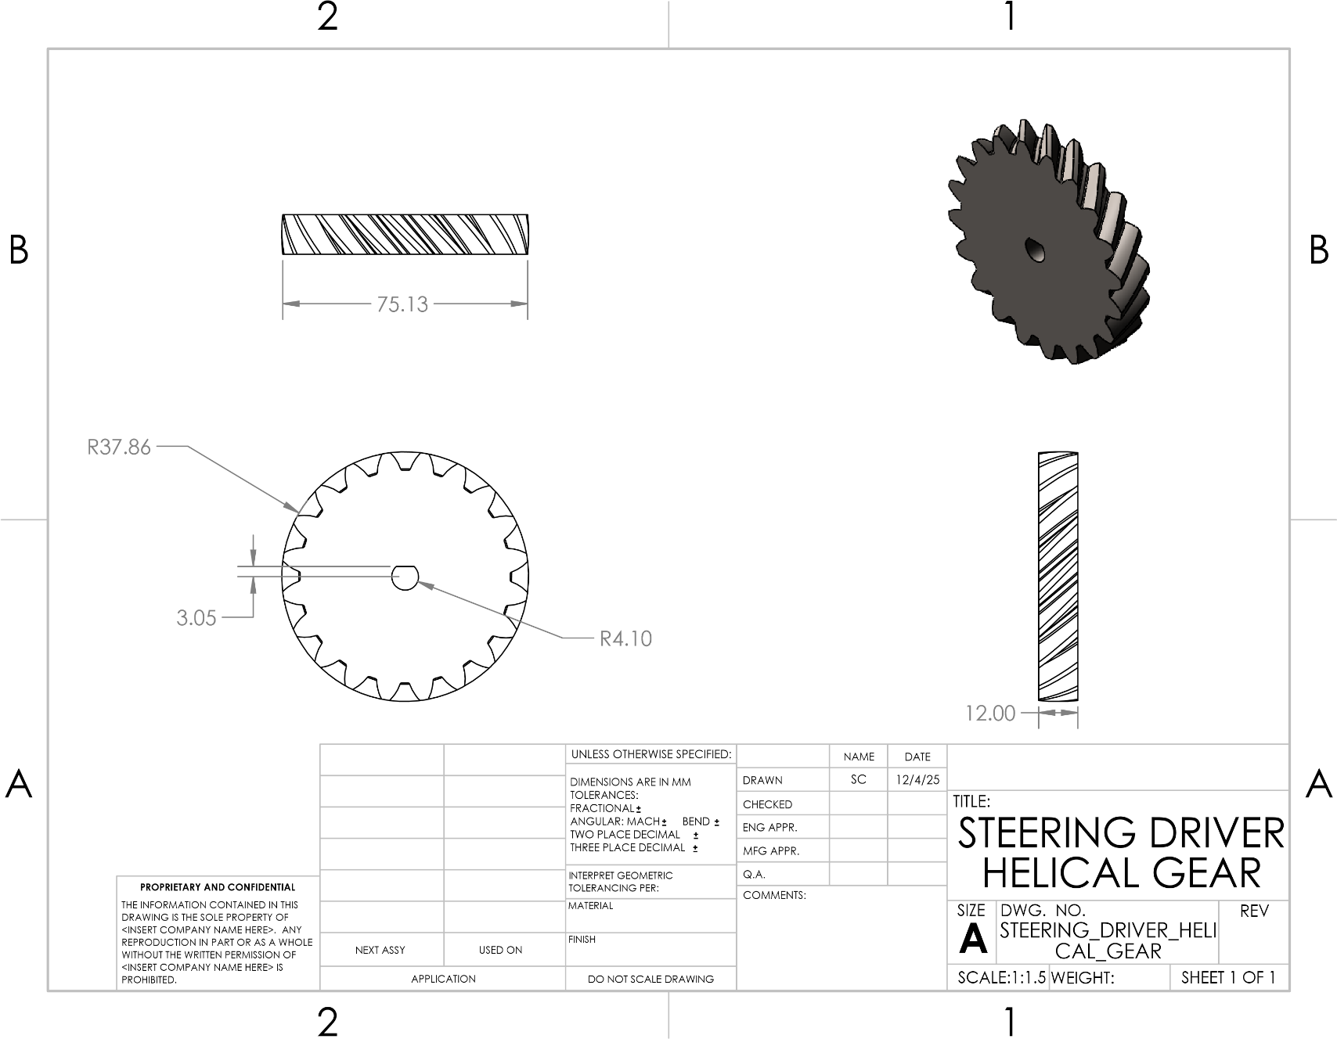
Figure 28: STEERING DRIVER HELICAL GEAR
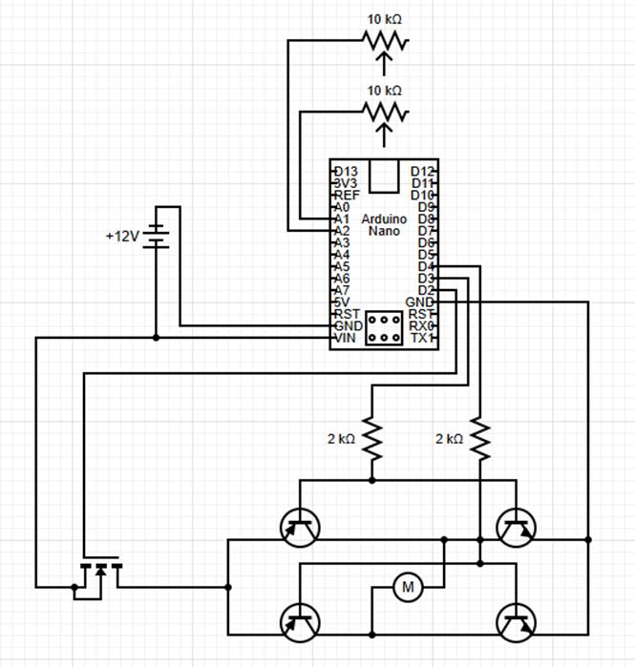
Figure 29: Wiring Schematic for Steering
Throttle Subsystem
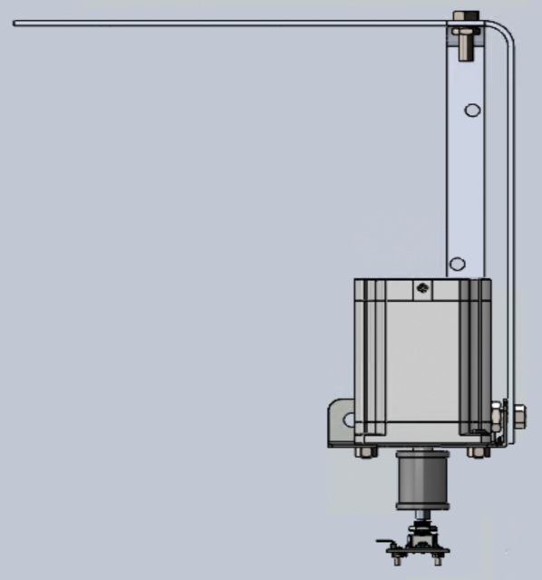
31
30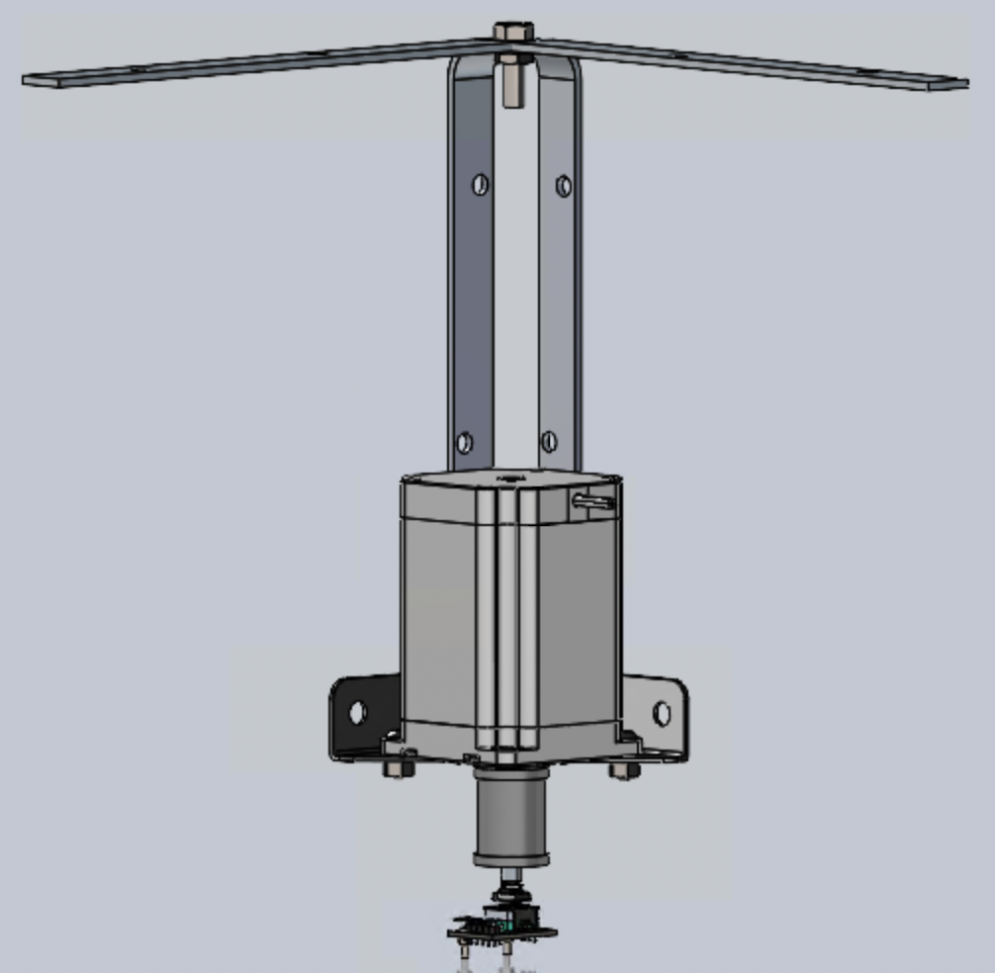 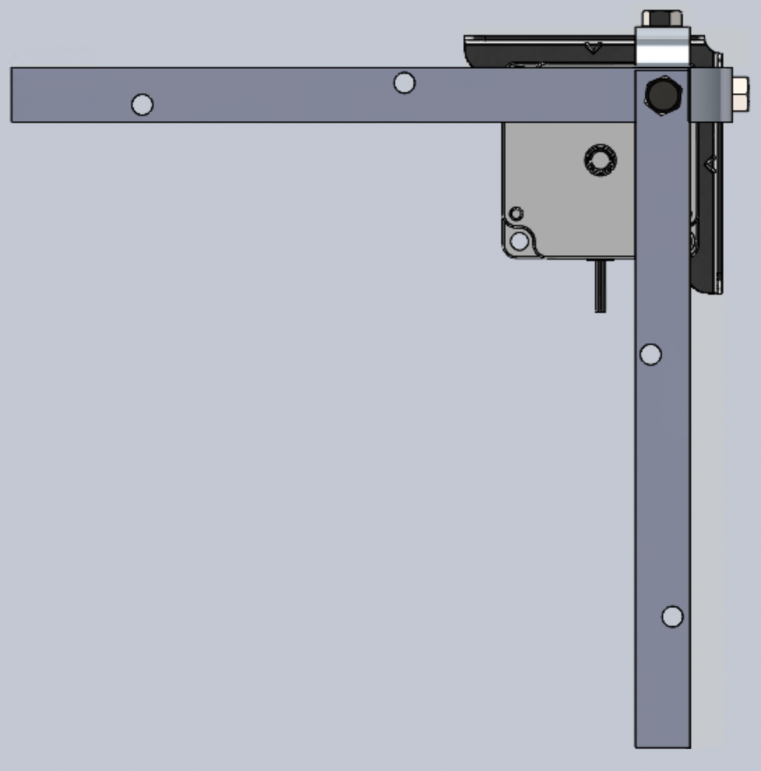32
Figures 30-32: Full Assembly of Lever Mechanism
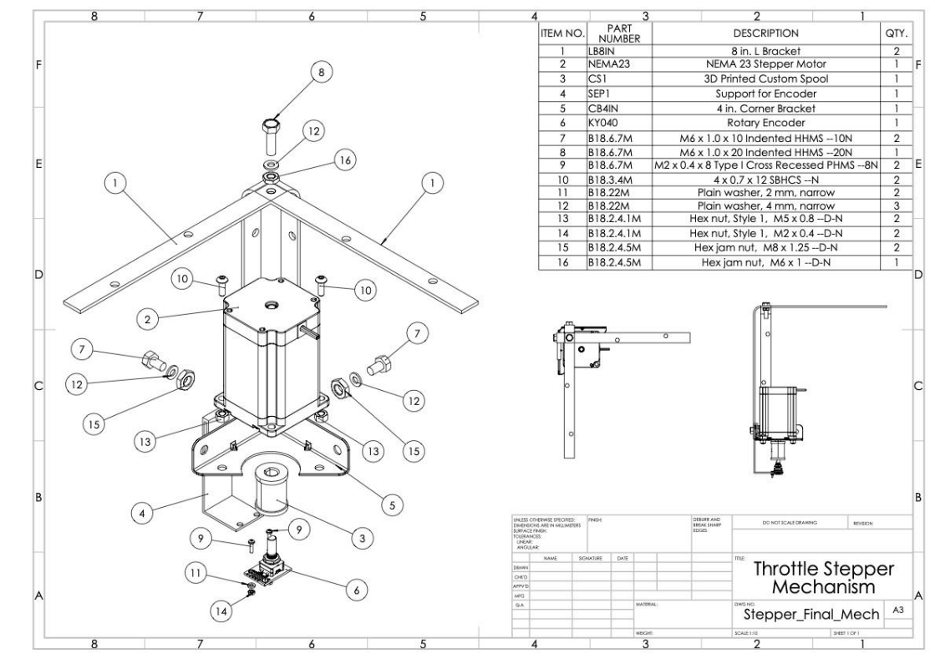
Figure 33: Throttle Stepper Full Mechanism
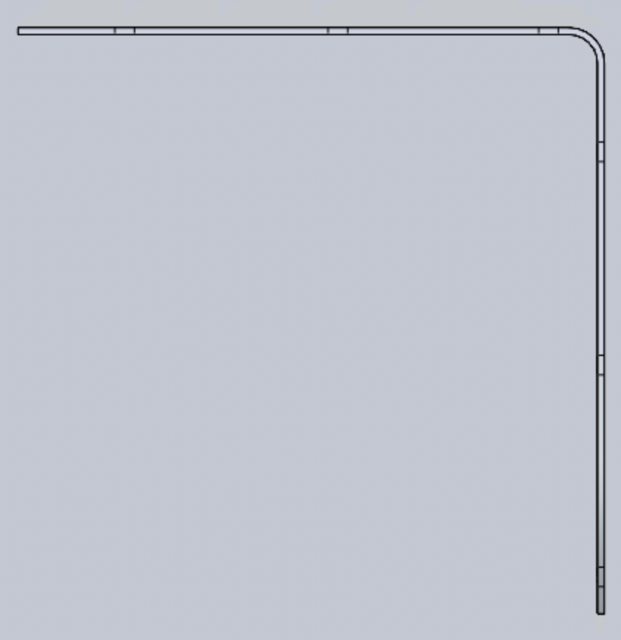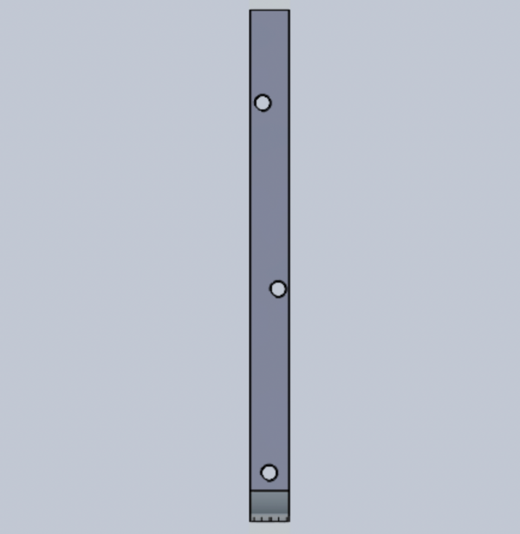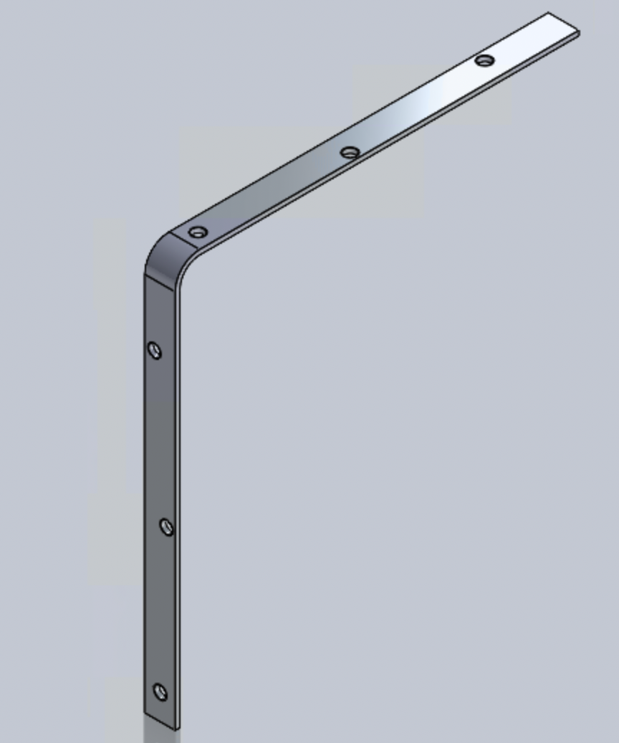
34
35
36
Figures 34-36: 8 in. L-Bracket

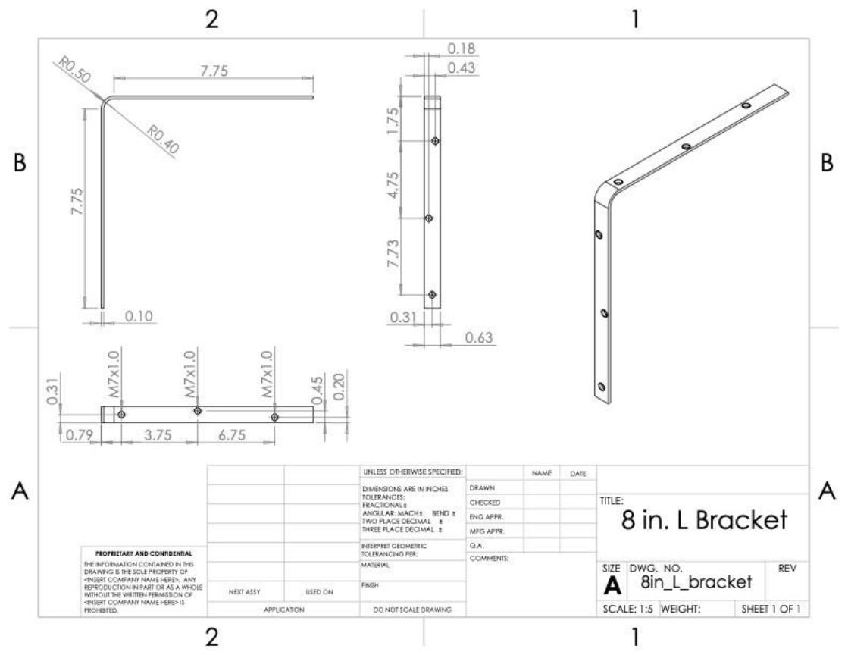
Figure 37: 8 in. L-Bracket [1]
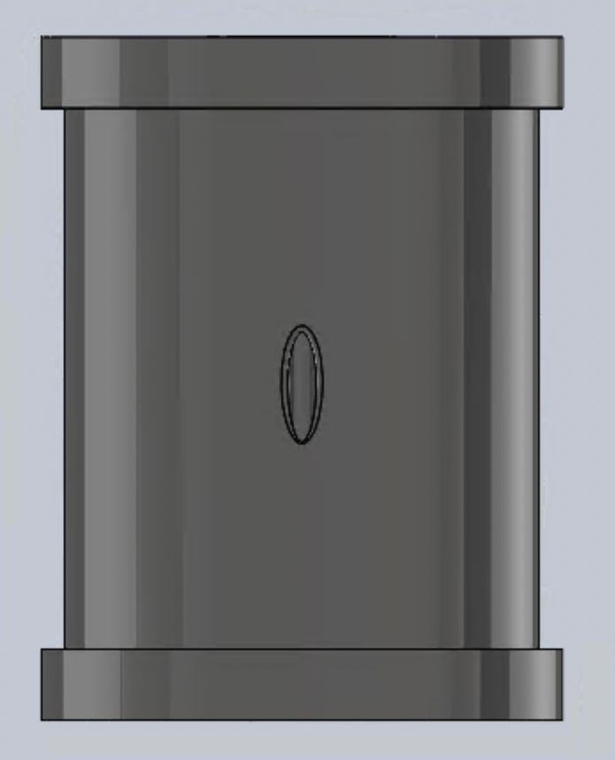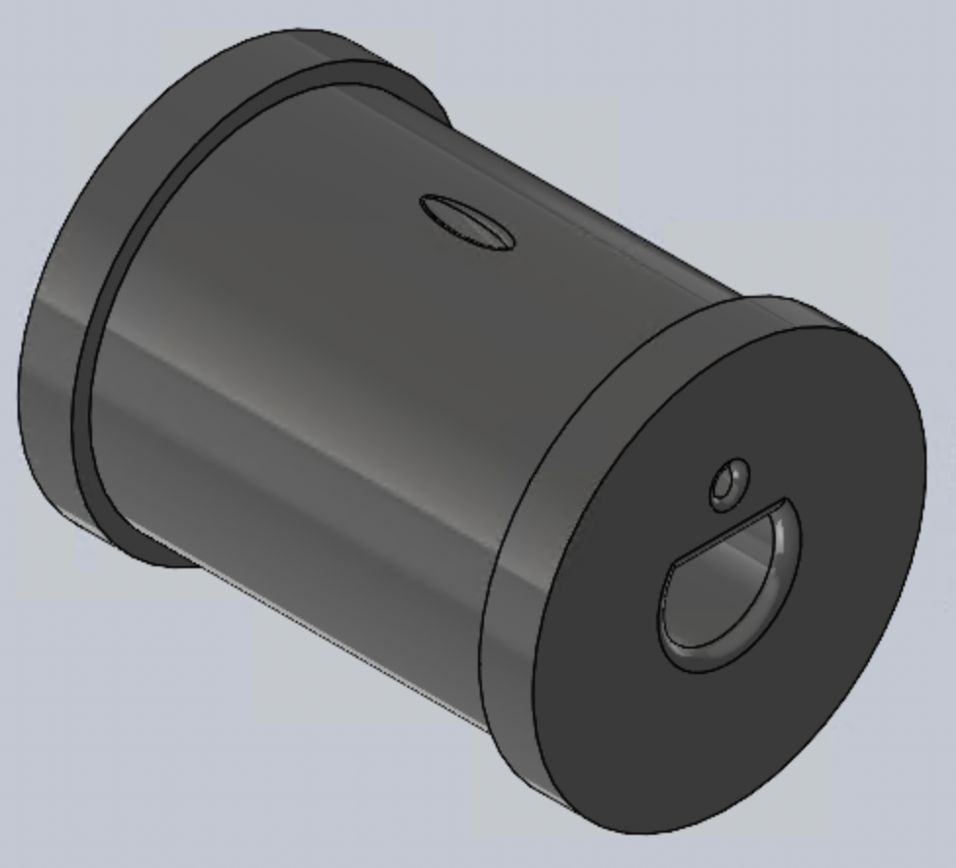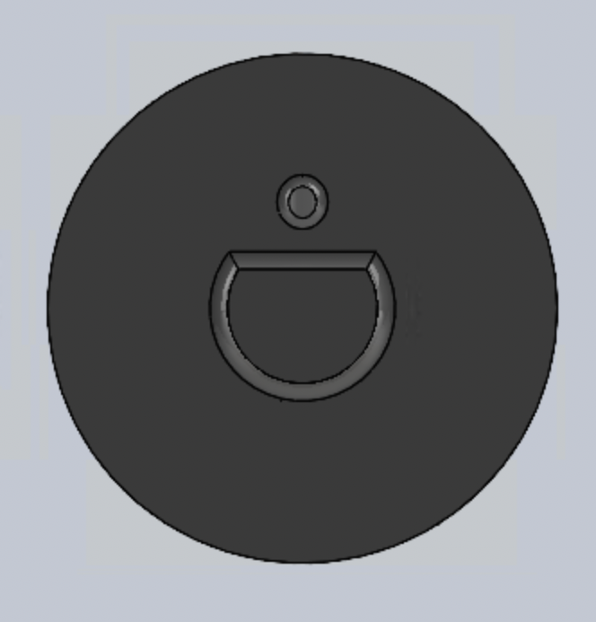
38
39
40
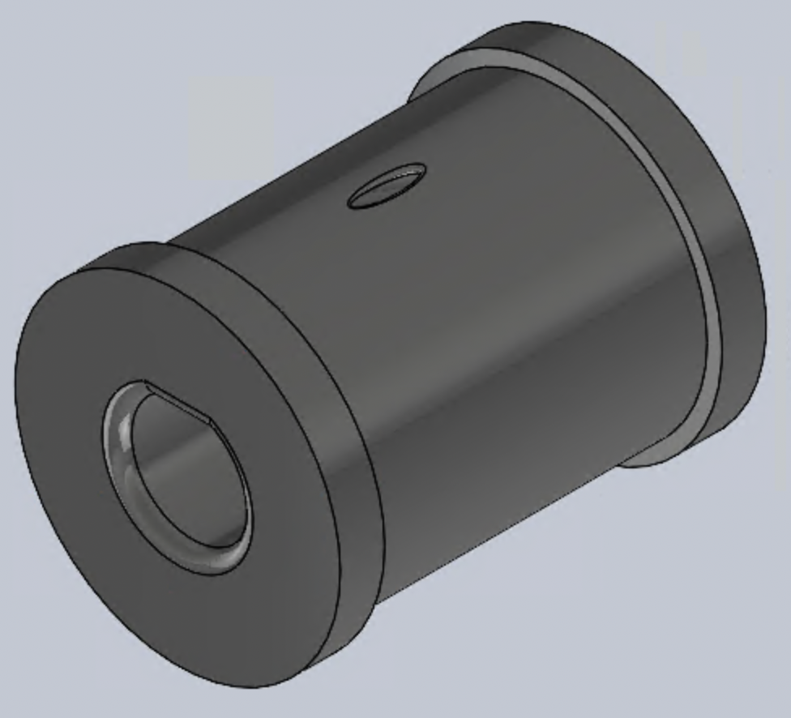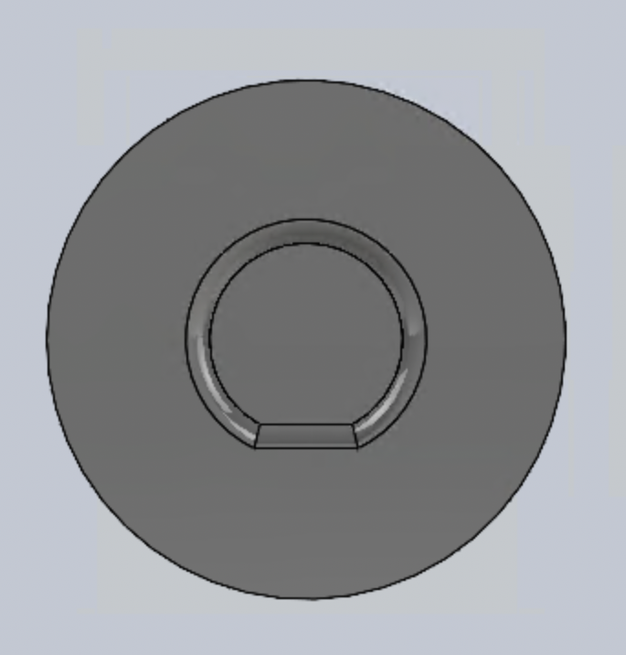
42
41
Figures 38-42: Spool for Stepper Motor
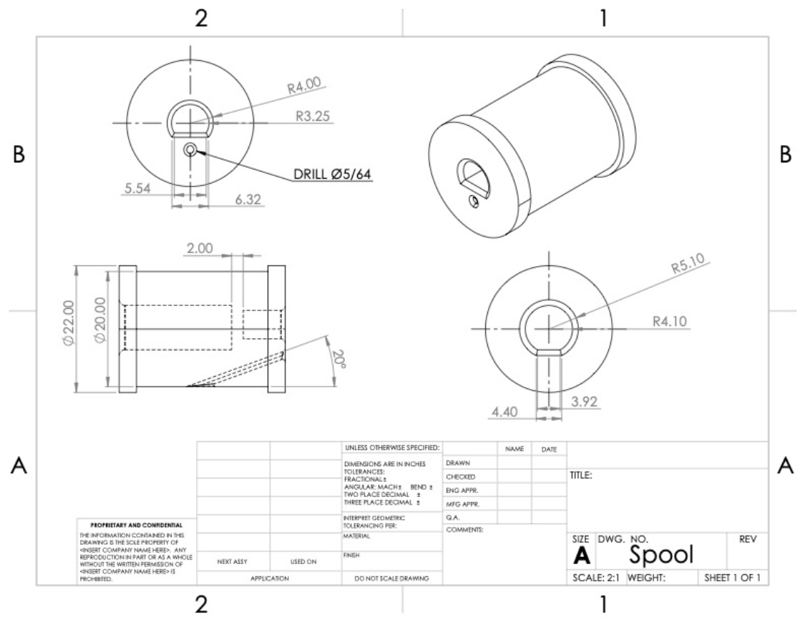
Figure 43: 3D Printed Spool for Stepper Motor
44 45 46 47
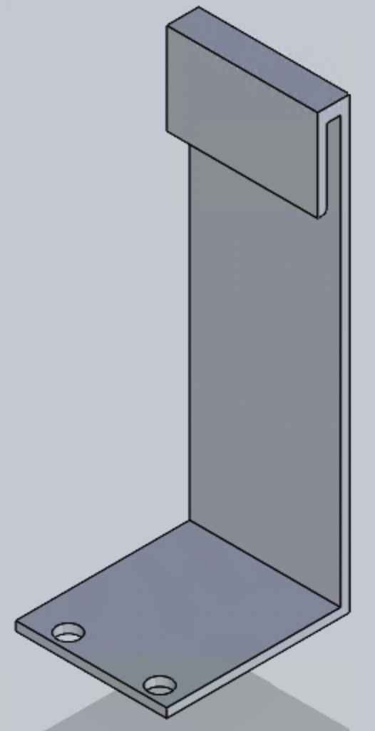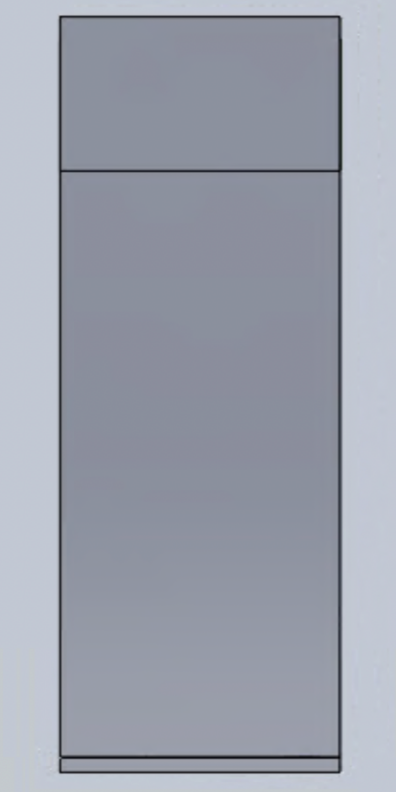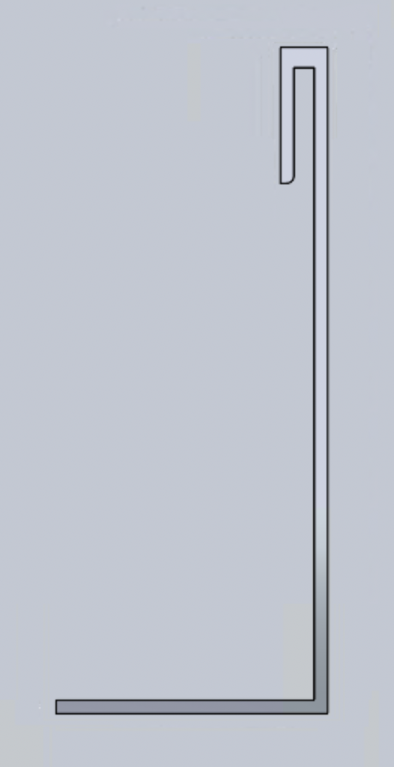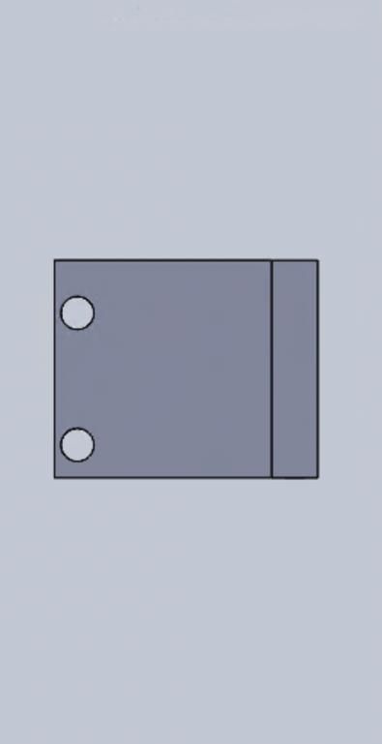
Figures 44-47: Encoder Support Design

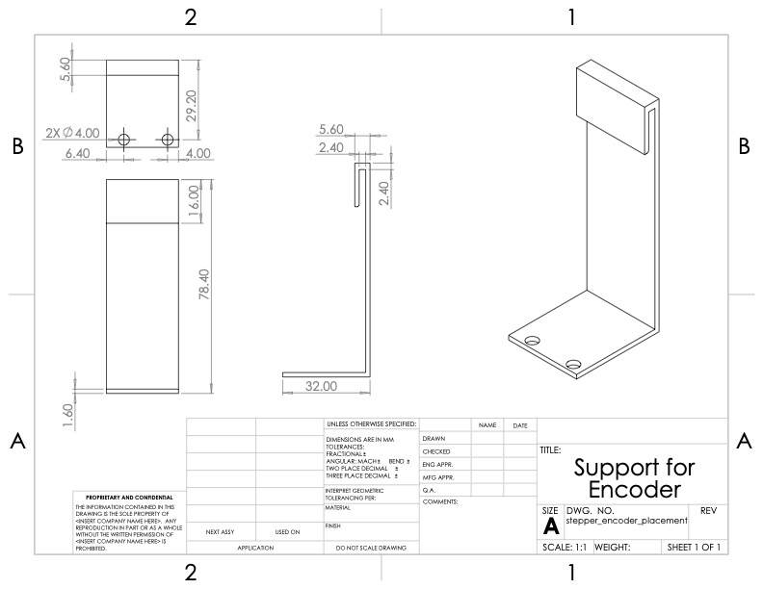
Figure 48: Support Design for Encoder (Aluminum)
49 50
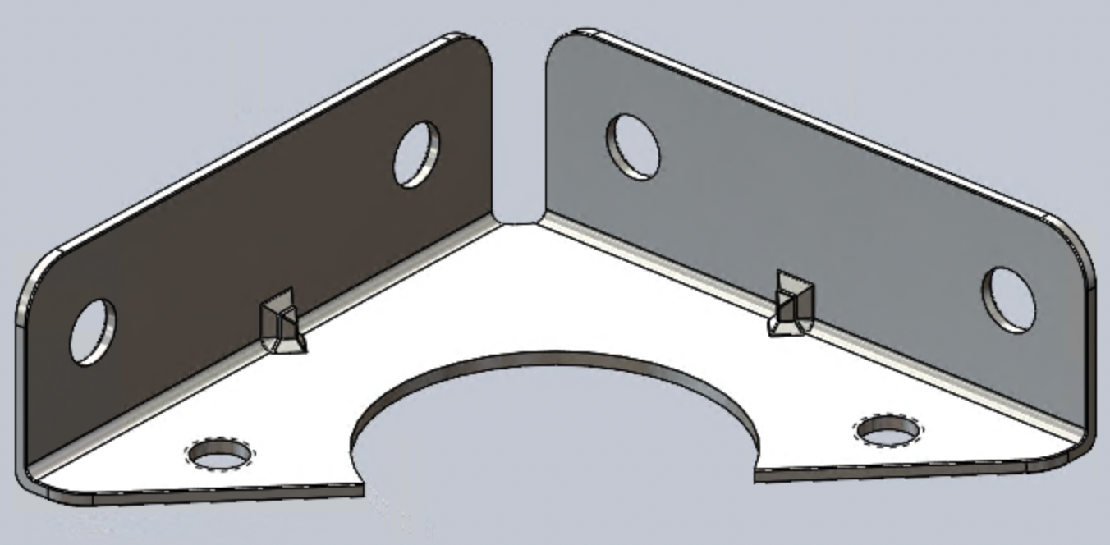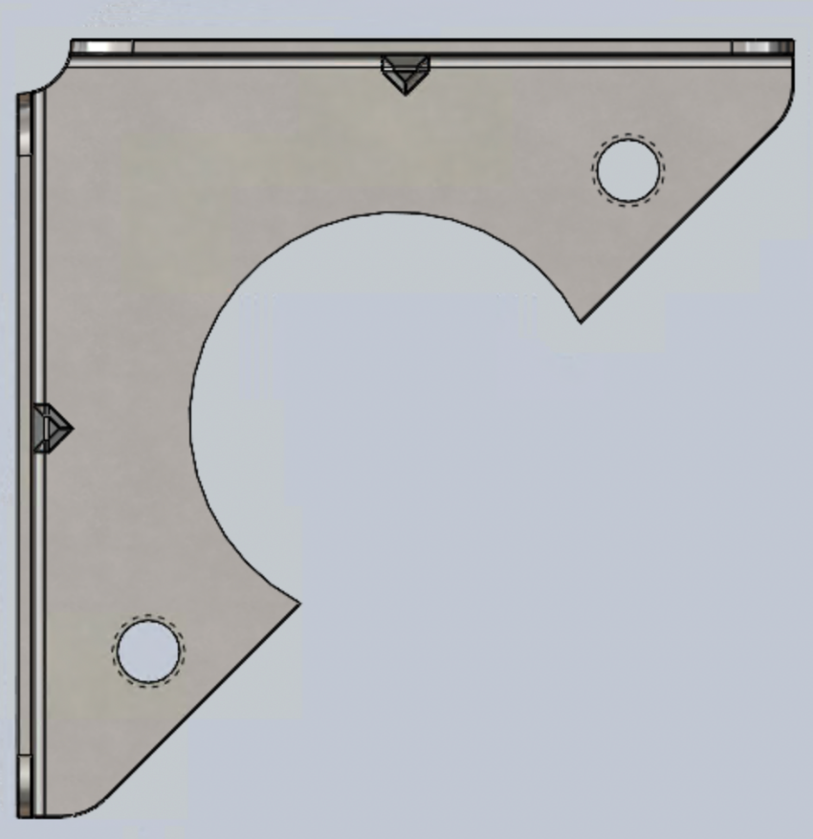
51 52
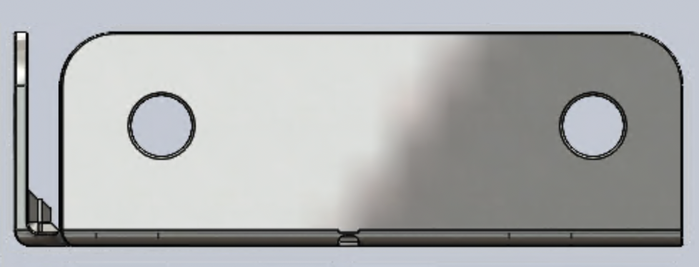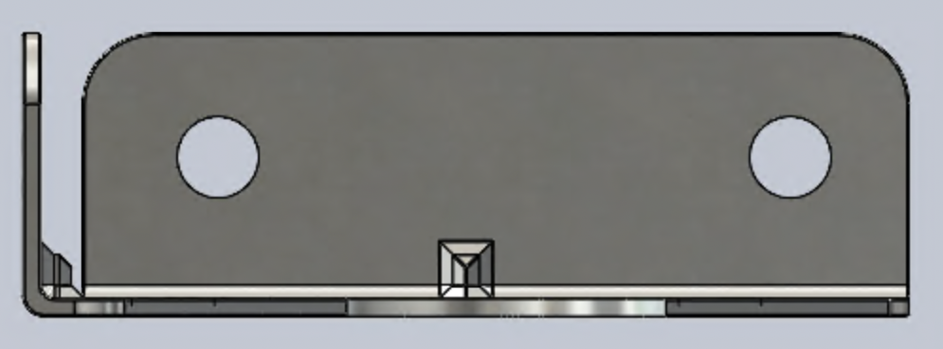
Figures 49-52: Corner Bracket
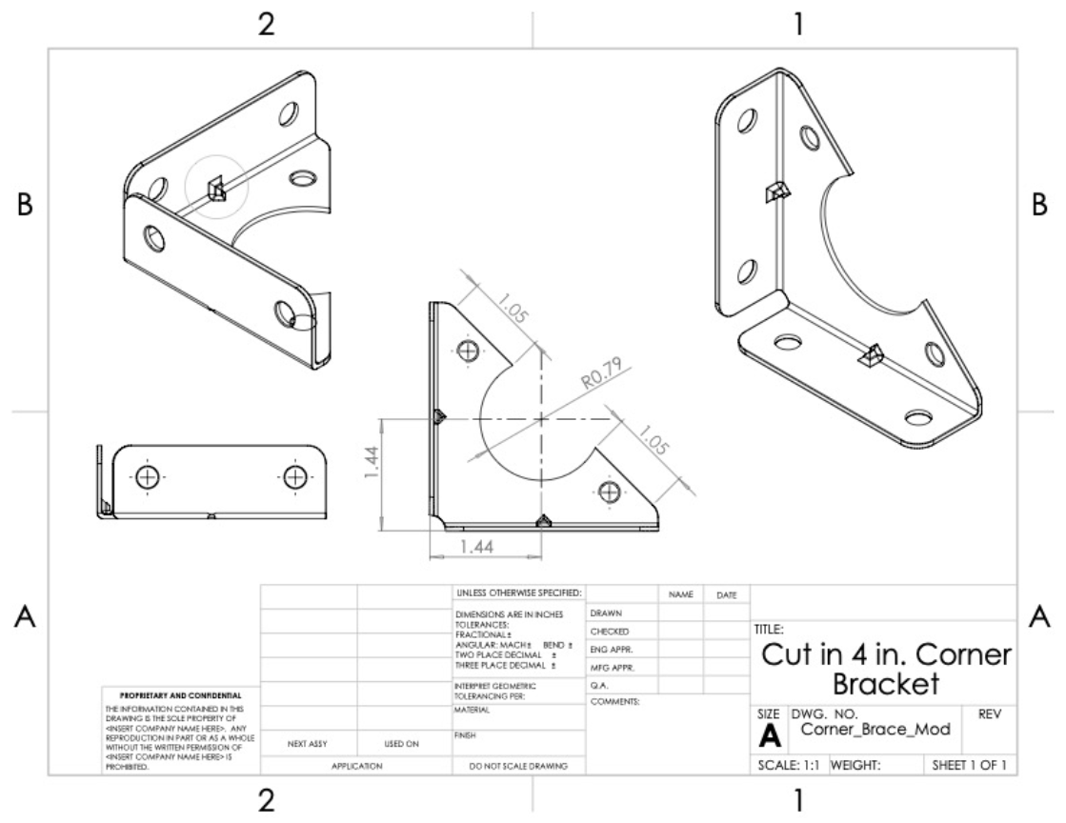
Figure 53: Modified 4in. Corner Bracket (Cut-In) [2]
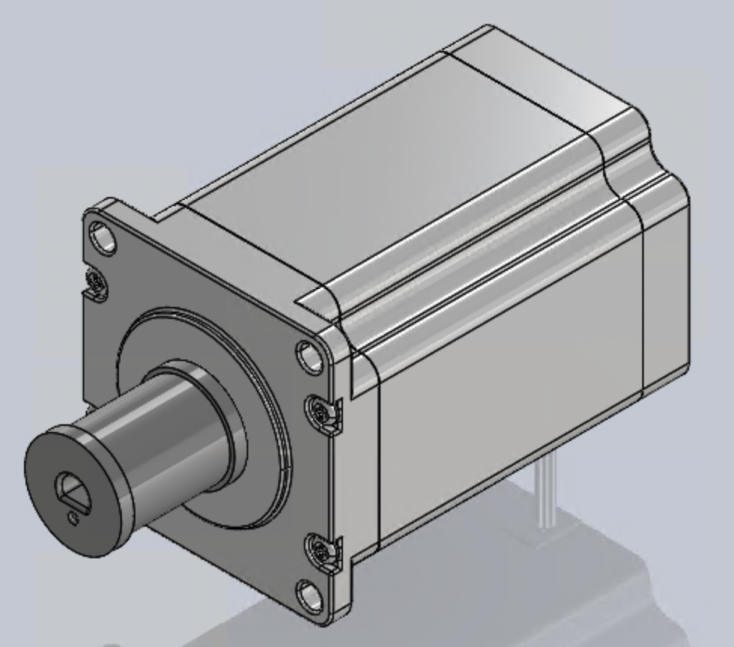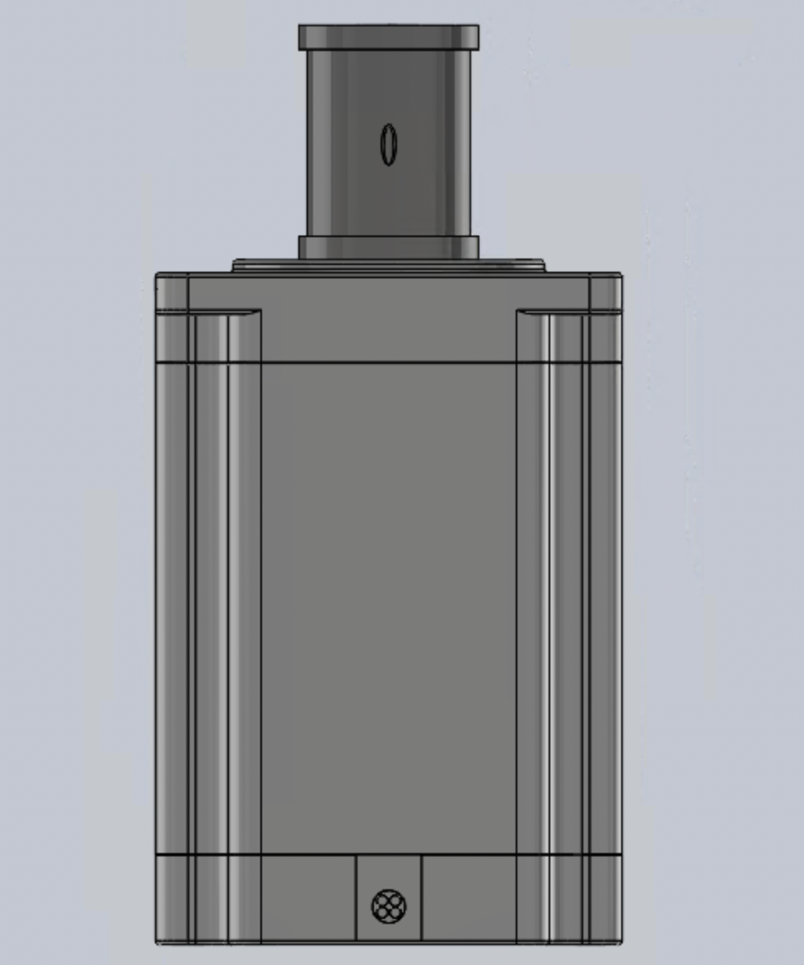
55
54
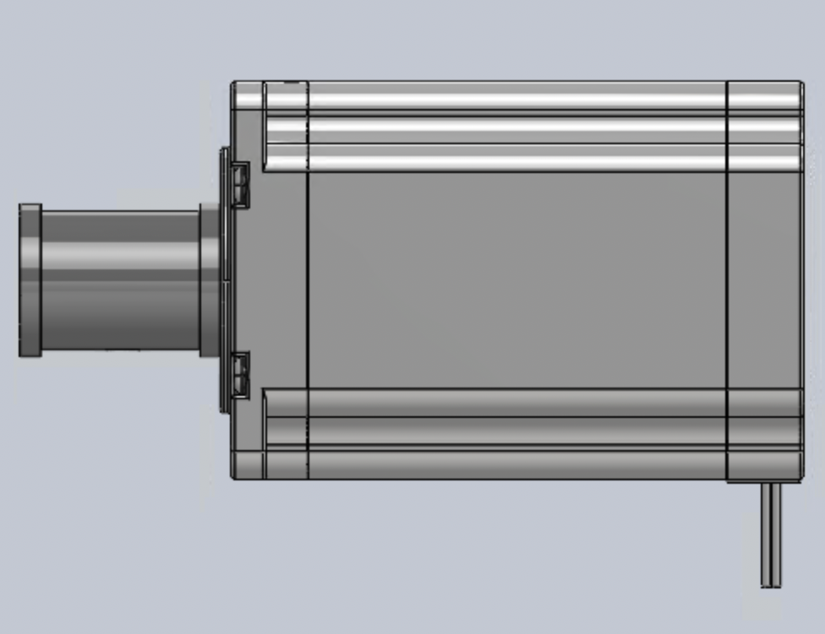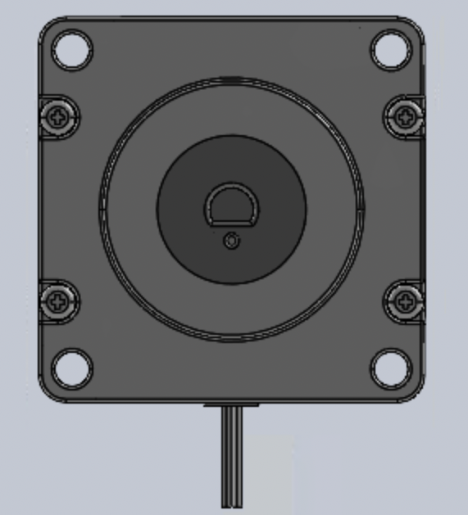
57
56
Figures 54-57: Stepper Motor and Spool Assembly
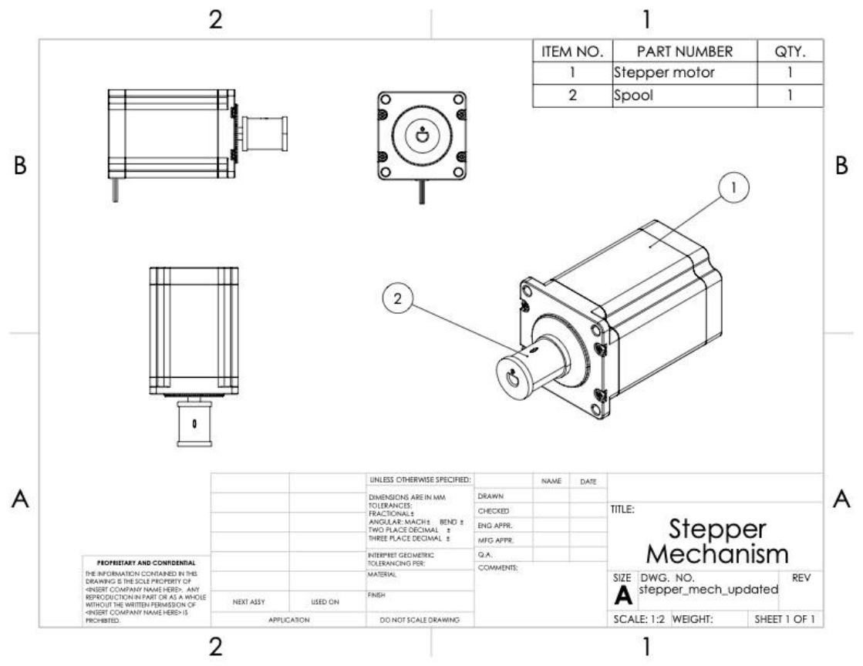
Figure 58: Stepper Motor and Spool Assembly [3]
59 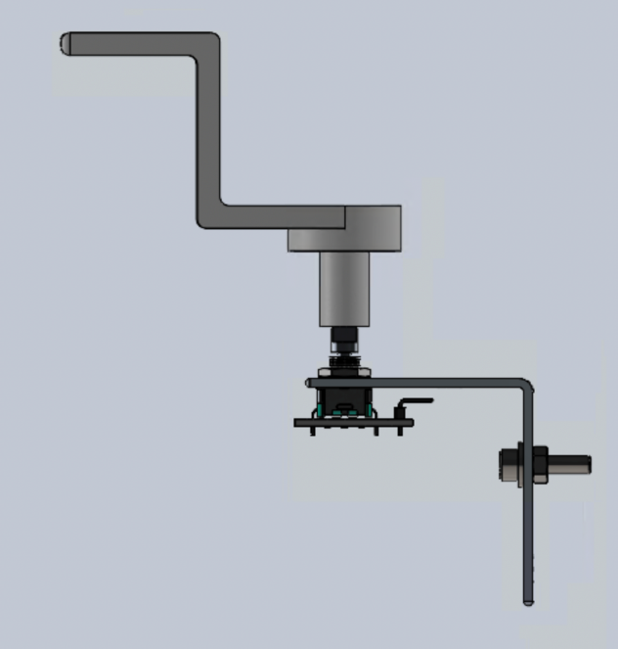 60 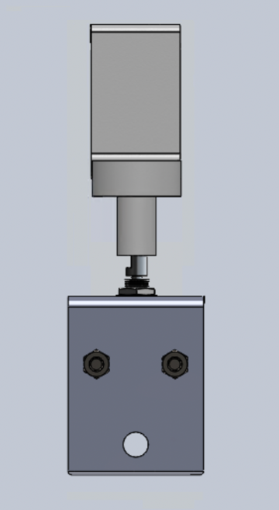 61 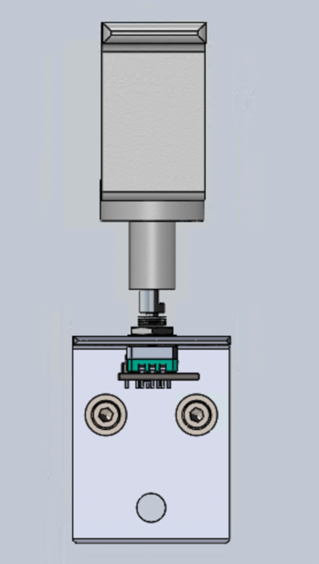
62 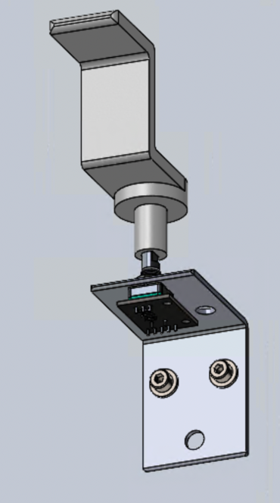 63 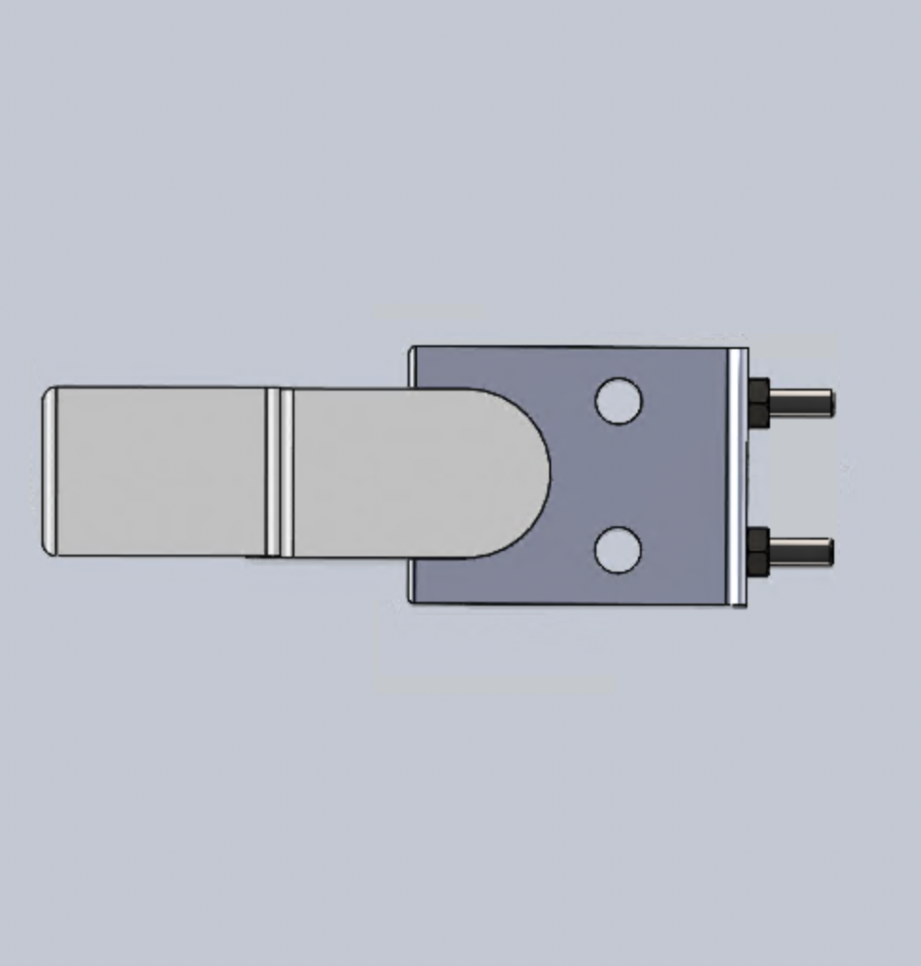 64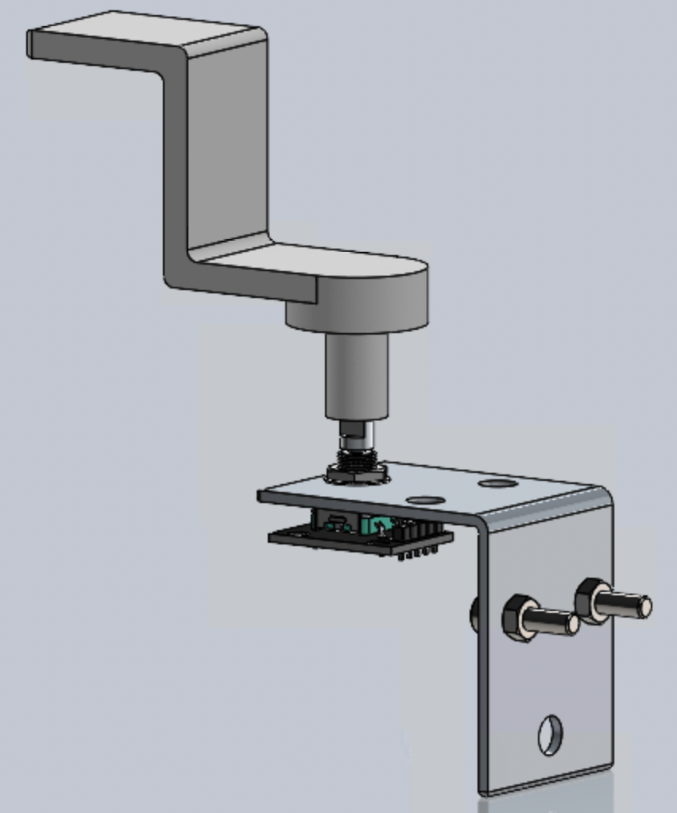
Figures 59-64: Full Assembly of Pedal Mechanism
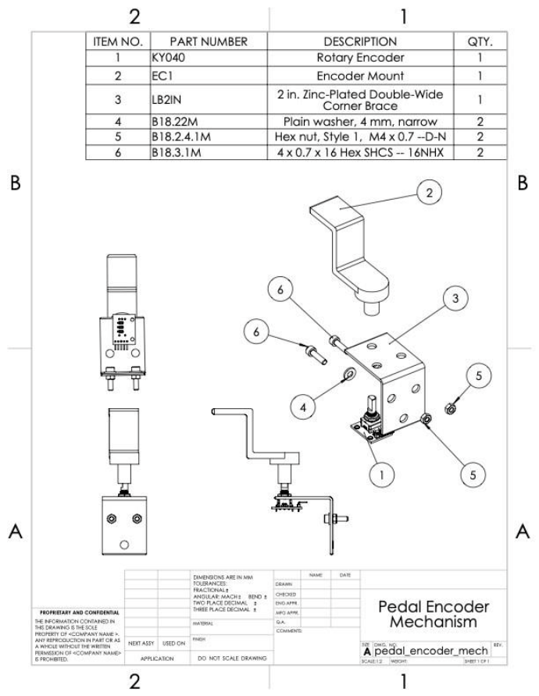
Figure 65: Pedal Encoder Full Mechanism
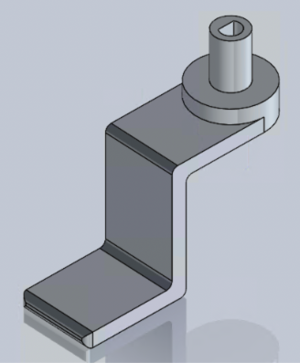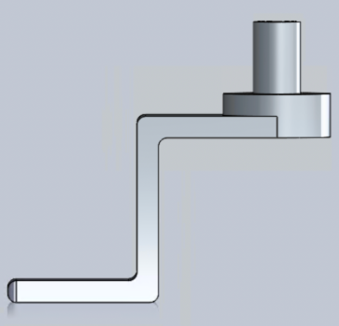
66
67
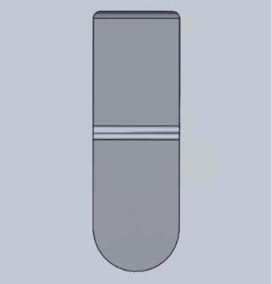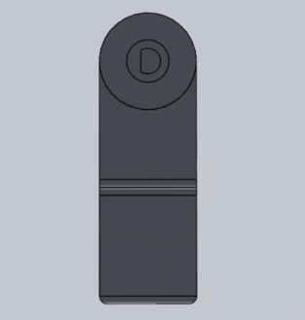
69
68
Figures 66-69: Mount for Pedal Encoder
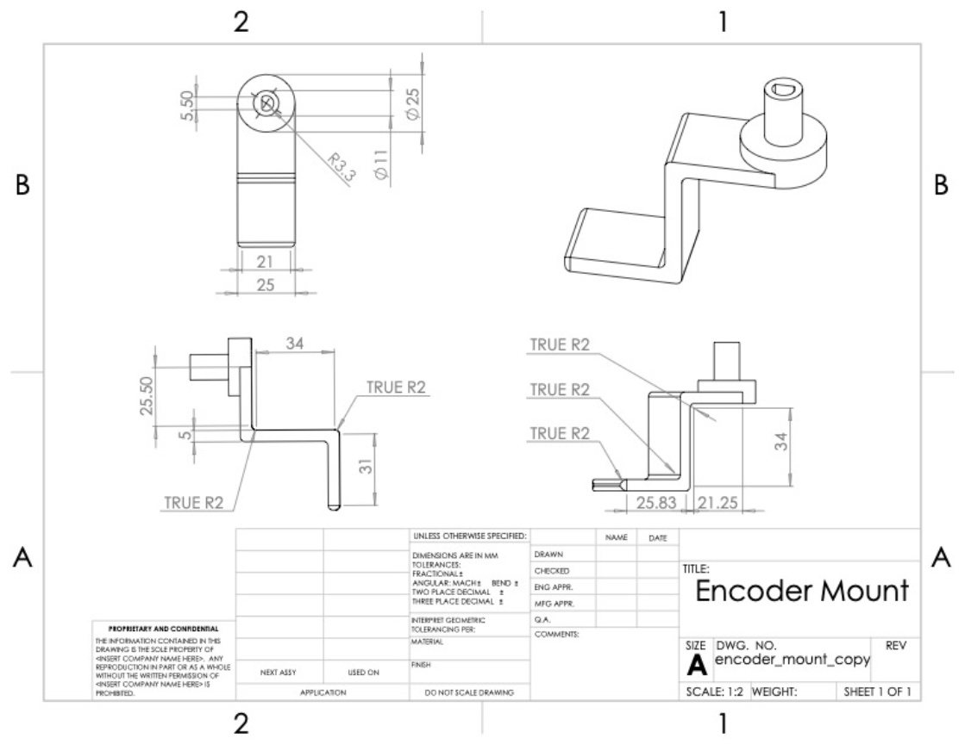
Figure 70: 3D Printed Mount for Encoder
71 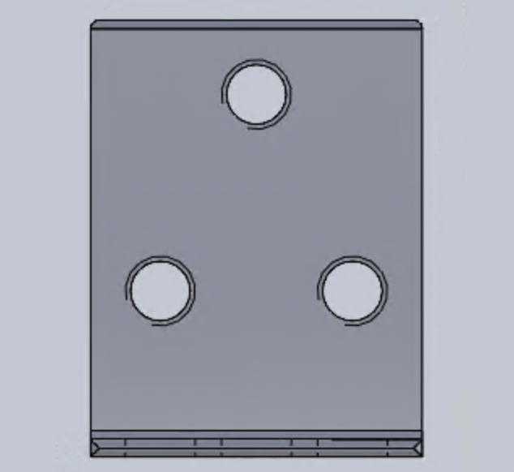 72 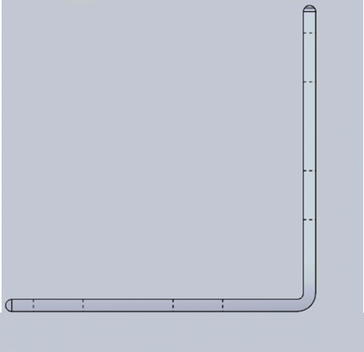
73 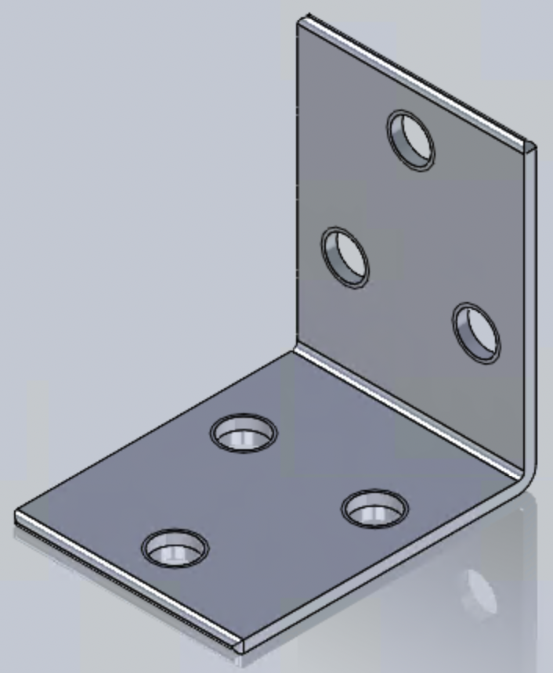
Figures 71-73: L Bracket
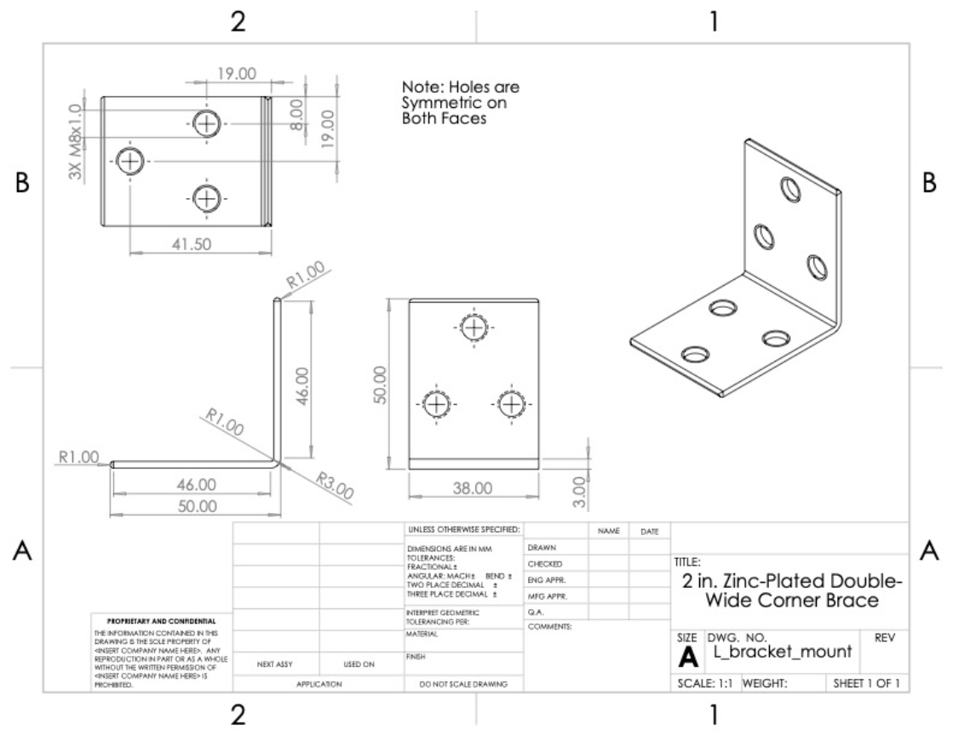
Figure 74: 2 in. Zinc-Plated Double-Wide Corner Brace [4]
75 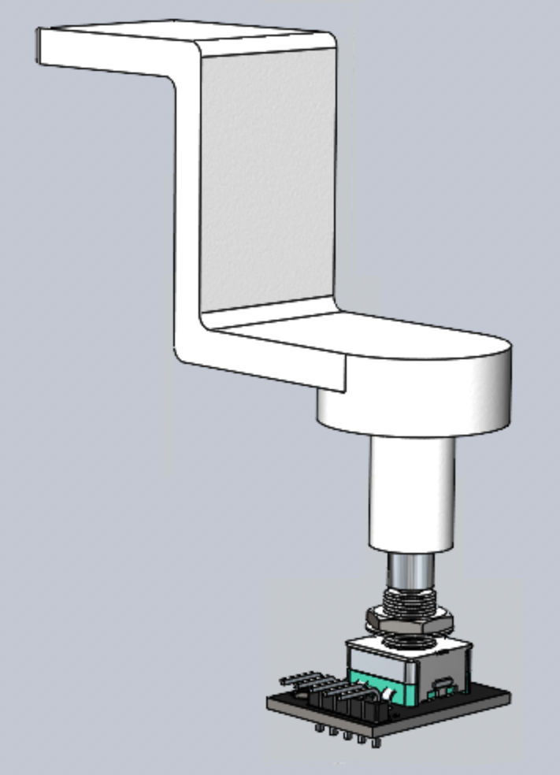 76 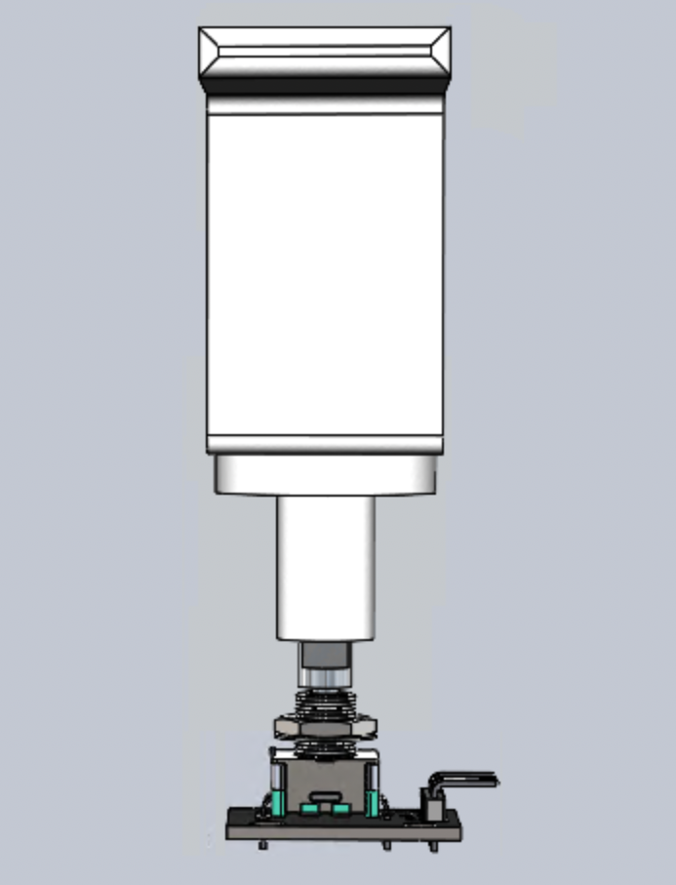
77 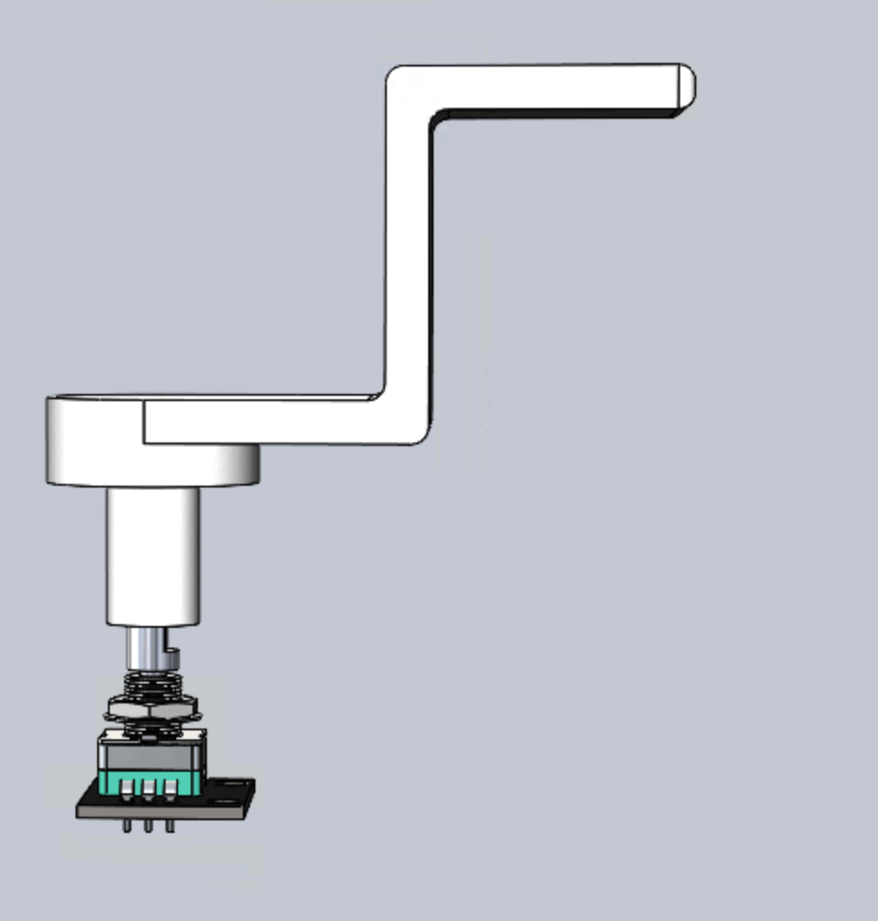 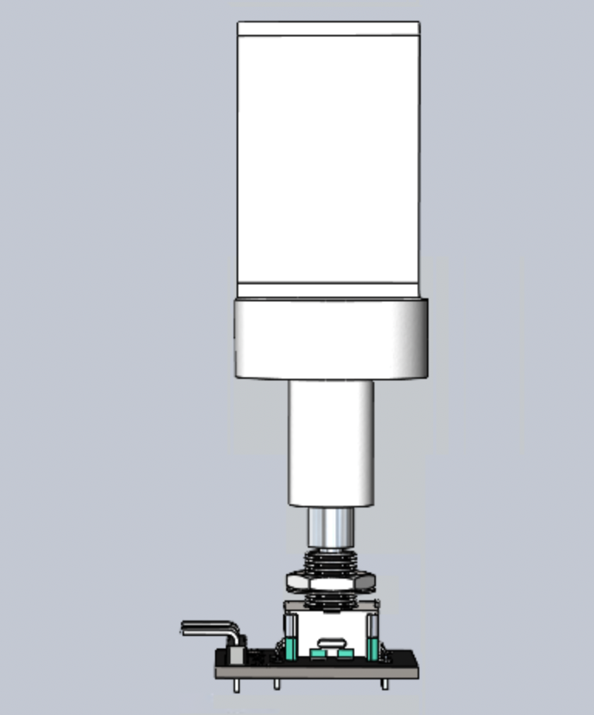
78
Figures 75-78: Encoder and Pedal Mount
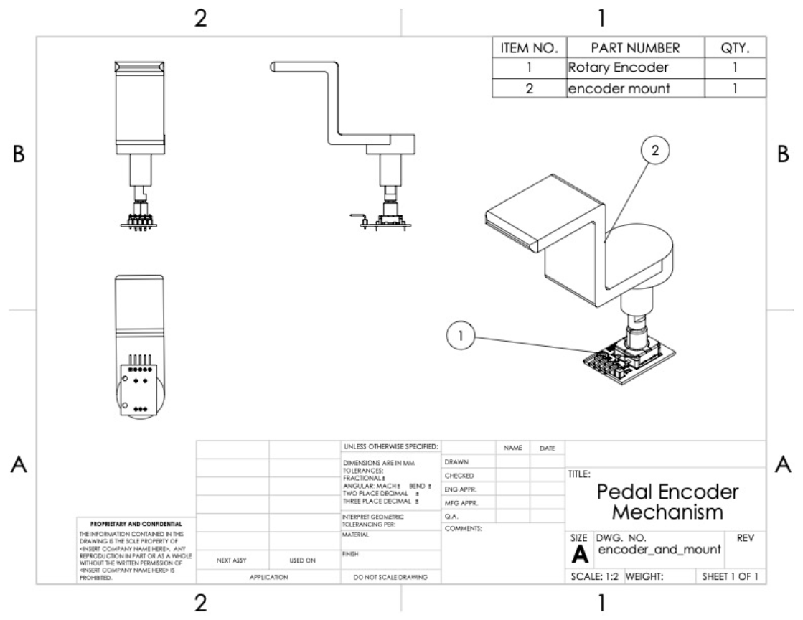
Figure 79: Pedal Encoder and Mount Assembly [5]
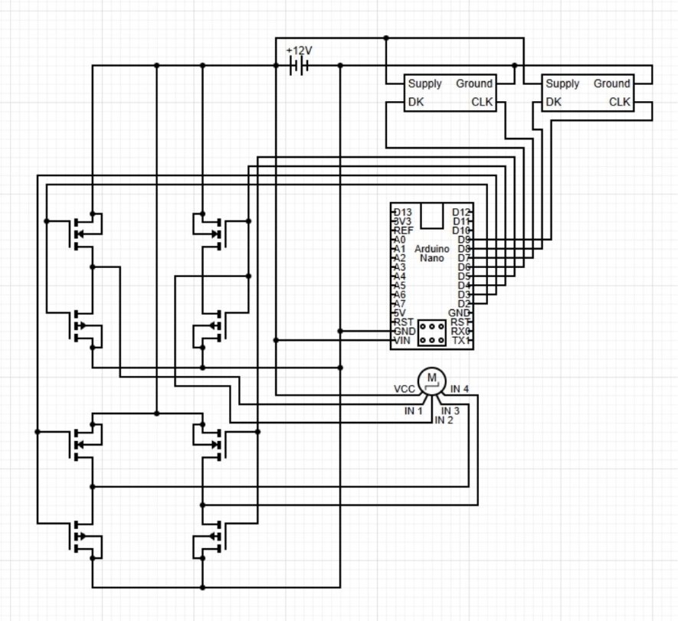
Figure 80: Electrical Assembly for Throttle Mechanism

References
[1] “(4-Pack) 8 in. Black Corner Brace,” Homedepot.com, 2025. https://www.homedepot.com/p/Everbilt-4-Pack-8-in-Black-Corner-Brace-12704/315016279?source=shoppingads&locale=en-US&fp=ggl&srsltid=AfmBOopRt_Tx5pozCQ4VpkGx4otEtnWvg_OkKf_hQLxkZ-PSEE2rJX2eaks

‌[2] “(2-Pack) 4 in. Zinc-Plated-Heavy Duty Corner Brace,” Homedepot.com, 2025. https://www.homedepot.com/p/Everbilt-2-Pack-4-in-Zinc-Plated-Heavy-Duty-Corner-Brace-24376/327600345

[3] “Nema 23 Stepper Motor 2.4Nm(339.87oz.in) 4A 57x57x82mm 8mm Shaft 4 Wires - 23HS32-4004S | StepperOnline,” Omc-stepperonline.com, 2023. https://www.omc-stepperonline.com/nema-23-stepper-motor-2-4nm-339-79oz-in-4a-57x57x82mm-8mm-shaft-4-wires-23hs32-4004s

[4] “(2-Pack) 2 in. Zinc-Plated Double-Wide Corner Brace,” Homedepot.com, 2025. https://www.homedepot.com/p/Everbilt-2-Pack-2-in-Zinc-Plated-Double-Wide-Corner-Brace-24482/327600343

[5] “360 Degree Rotation Encoder Module,” PiShop.us, 2025. https://www.pishop.us/product/360-degree-rotation-encoder-module/?srsltid=AfmBOorw4x0uUsYIZcAN4De6heMC-ZMMnNWBVMnapdcc_DyHJwFZ0KSt4NA

