Particle Image Velocimetry

Conceptual Design Report Template

Chris Rapoport – Project Manager and Test Engineer
Rory Kian Pack – Financial Manager and Manufacturing Engineer
Santiago Gamez – Website Developer and CAD engineer
Jett Scruggs – Logistics Manager

Spring 2025-Fall 2025



Project Sponsor: Dr. Timothy Becker, Wyatt Clark
Faculty Advisor: Dr. Zhongwang Dou
Instructor: Professor Carson Pete

DISCLAIMER
This report was prepared by students as part of a university course requirement. While considerable effort has been put into the project, it is not the work of licensed engineers and has not undergone the extensive verification that is common in the profession. The information, data, conclusions, and content of this report should not be relied on or utilized without thorough, independent testing and verification. University faculty members may have been associated with this project as advisors, sponsors, or course instructors, but as such they are not responsible for the accuracy of results or conclusions.

EXECUTIVE SUMMARY
Particle Image Velocimetry (PIV) is a method of evaluating fluid flows that involves using a laser to illuminate fluorescent microparticles and then capturing images of the particles in the flow with a high-speed camera. The images are then imported into a PIV software which tracks the displacement of the particles between frames and then calculates the velocity of each particle. This allows the visualization of the flow, as well as the calculation of properties such as stresses, strains, and forces. The sponsor of this project, Dr. Tim Becker, is the Principal Investigator of the NAU Bioengineering Devices Laboratory, a lab dedicated to studying and improving stroke treatments. Dr. Becker is interested in performing PIV studies to investigate the properties of neurovascular blood flow, as well as how endovascular treatments affect this blood flow, and will ultimately use the information gained from these studies to drive the design process of novel medical devices.
During the first client meeting the team and the client worked together to develop the requirements that serve as the standard to be met for a successful outcome. The requirements that the customer specified concerned the system’s setup time, the framerate and resolution of the camera, the power of the laser, the resolution and number of channels of the function generator, the width of the laser sheet, and the safety of the setup. The team then produced engineering requirements that are easily calculable or measurable, with each correlating to one or more customer requirement. The two requirements were used to create a quality function deployment diagram, and the client was asked to weigh each of the requirements. The client also informed the team that they required that the three principal components of the system, the camera, laser, and function generator, be purchased and delivered by the end of the spring semester.
The team’s first action after meeting with the client was to conduct research into PIV, researching the PIV systems that are currently available commercially as well as the components used in PIV systems that are used in published studies, conducting a literature review to investigate what kind of components are used in PIV for biomedical applications as well as how phantoms for PIV are produced. Then mathematical and experimental models were applied and developed to calculate a number of parameters of the laser sheet, such as its thickness and power; and other things relevant to PIV, such as the cost of producing phantoms and the particle density of an image.
The team’s research then informed the concept generation process, where the team first broke down the PIV system into four main subsystems, the three principal components of the system and the configuration of the system. The team researched their respective components and developed concepts for the system’s configuration and then evaluated the resulting products and ideas using the engineering and customer requirements defined earlier. The results of this evaluation were presented to and discussed with the clients, and a decision was made on each of the components of the system, keeping us on track with the requirement to have each component by the end of the semester.

TABLE OF CONTENTS
DISCLAIMER 1
EXECUTIVE SUMMARY 2
TABLE OF CONTENTS 3
1 BACKGROUND 1
1.1 Project Description 1
1.2 Deliverables 1
1.3 Success Metrics 1
2 REQUIREMENTS 2
2.1 Customer Requirements (CRs) 2
2.2 Engineering Requirements (ERs) 2
2.3 House of Quality (HoQ) 1
3 Research Within Your Design Space 1
3.1 Benchmarking 1
3.2 Literature Review 3
3.2.1 Santiago Gamez 3
3.2.2 Rory Kian Pack 6
3.2.3 Chris Rapoport 9
3.2.4 Jett Scruggs 11
3.3 Mathematical Modeling 13
3.3.1 Camera Exposure – Jett Scruggs 13
3.3.2 Light Sheet Generator – Santiago Gamez 14
3.3.3 Laser Power – Rory Kian Pack 15
3.3.4 Laser Experiment – Chris Rapoport 17
3.3.5 Phantom Financial Analysis – Rory Kian Pack 17
3.3.6 Reynold’s Number for Neurovascular Blood Flow – Jett Scruggs 20
3.3.7 Particle Density – Chris Rapoport 20
3.3.8 Optimization of Camera and Lens Setup – Jett Scruggs 21
4 Design Concepts 23
4.1 Functional Decomposition 23
4.2 Concept Generation 1
4.1.1 Camera – Jett Scruggs 1
4.1.2 Laser – Rory Kian Pack 1
4.1.3 Function Generator – Chris Rapoport 2
4.1.4 Configuration – Santiago Gamez 2
4.2 Selection Criteria 4
4.2.1 Camera – Jett Scruggs 4
4.2.2 Laser – Rory Kian Pack 5
4.2.3 Function Generator – Chris Rapoport 5
4.2.4 Configuration – Santiago Gamez 5
4.3 Concept Selection 6
4.3.1 Camera – Jett Scruggs 6
4.3.2 Laser – Rory Kian Pack 6
4.3.3 Function Generator – Chris Rapoport 6
4.3.4 Configuration – Santiago Gamez 7
5 Schedule and Budget 8
5.1 Schedule 8
Figure X: Tentative schedule for the fall semester. 9
5.2 Budget 10
5.3 Bill of Materials 12
6 Design Validation and Initial Prototyping 13
6.1 Failure Mode and Effects Analysis 13
6.2 Initial Prototyping 15
7 CONCLUSIONS 24
8 REFERENCES 25
9 APPENDICES 29
a. Appendix A: Particle Density Calculator for PIV 29
b. Appendix B: Laser Pulse Energy MATLAB Program 31
c. Appendix C: Phantom Manufacturing Spreadsheet 31

BACKGROUND
In this chapter we will discuss the basics of our project, including defining Particle Image Velocimetry, the research that our sponsors conduct and why they commissioned our team to build a Particle Image Velocimetry setup, the deliverables our team is tasked with providing and how success will be measured for this project.

Project Description
The primary sponsor for this project is Dr. Timothy Becker, an Associate Professor at Northern Arizona University and the Principal Investigator of the NAU Bioengineering Devices Lab (BDL), which studies stroke treatments. Stroke affects 800,000 people annually in the United States and is a leading cause of death and disability [1]. There are two types of strokes: ischemic and hemorrhagic. Ischemic stroke occurs when a blood clot blocks blood flow from reaching distal parts of the brain [2]. Hemorrhagic stroke occurs when a section of a brain vessel is weakened, also known as an aneurysm, and ruptures, causing a brain bleed [3]. Recently catheter-based treatments such as aneurysm coiling and manual aspiration thrombectomy have made large strides in improving stroke outcomes [4,5]. An understanding of the flow effects, or hemodynamics, of the brain and how treatments affect hemodynamics is needed to further improve treatment options. Particle Image Velocimetry helps visualize flow using a high-speed camera, laser, and microscopic fluorescent particles [6]. The laser illuminates the particles in the flow and the camera captures images. By tracking the particles change in positions between images, the flow properties such as positions, velocities, forces, stresses, and strains are calculated using a PIV software, in the case of this project, PIVLabs.

Deliverables
The majority of deliverables our team is responsible for are course deliverables for ME 476C, while the only client deliverable that was requested of us is to have the principal components of the PIV system (the camera, laser, and function generator) purchased and ready before the end of the spring semester, which we are currently on track to do. The major course deliverables that the team is responsible for are as follows: 3 presentations (2 already completed), 2 reports (this being the first), 2 prototype demonstrations, a website for our project (the first stage of which is complete), and a CAD model and bill of materials for our final design.

Success Metrics
The ultimate goal of this project is to produce a PIV system that the BDL will use in many studies and that will help to improve stroke treatment. There are many past capstone projects in the BDL that do not ever end up being used, our goal is to provide a system that will see years of use. As this will not be measurable at the time our project is complete, we will rely on the customer requirements, found in section 2.1, and the engineering requirements, found in 2.2. If we can meet or exceed each of these requirements, the project will be considered a success.

REQUIREMENTS
In this chapter we will introduce the customer requirements that were given to us by our client, as well as the engineering requirements that the team came up with ourselves. We will also present our House of Quality, or Quality Function Deployment diagram (QFD), which shows the correlation between the customer requirements and engineering requirements, as well as the weight that our client placed on each of the customer requirements.

Customer Requirements (CRs)
From the meetings with the clients, the team was able to establish a set of requirements that were required for determining the best design of the PIV setup. First was the ease of setup. The PIV setup needed to be easy to set up and move if needed, not requiring intensive labor or a large amount of people to do. The camera requirements were lumped together but spaced out in the QFD below. The framerate was needed to be around the 1000 FPS mark, tied with a resolution of about 1.3-2.1 MP. At this rate, a runtime of ten seconds was ideal. For the laser it needed to be within a power range of 50-150mW in order to properly fluoresce the particles. In order to do this, the laser sheet thickness was needed to be around the 100-200µm in width. On top of this, the use of a multi-function generator was required. It needed to be sufficient enough to handle the other equipment being used with it, while also being a common enough interface to not require complete retraining to understand how to properly use it. Finally, everything has to be safe to use. This isn’t quite up to par with OSHA standards, but being conscious of the refraction of high-powered lasers and their effects is paramount to reduce the risk of vision loss or other damage.

Engineering Requirements (ERs)
Based on the customer requirements, the team was able to translate or quantify them into measurable items. For the ease of setup, the team determined that setup time would be a simple yet effective way of monitoring this factor. For this, it was decided that it should be possible to set this up within an hour or less than 60min. For the camera, the resolution, framerate, and run time were translated over into the technical requirements, as the target ranges/values were provided, being 1.3-2MP (1280*1040-1920*1280 pixels), 1000 frames per second, and around 10 seconds of runtime, respectively. The laser power was decided to be similarly translated, along with the sheet thickness of the laser being projected onto the PIV setup’s patient model. For the multifunction generator, it needed to be on a reliable frequency, decided to be about 10⁻⁹ seconds. Finally, for the laser safety requirements, the team came up with a risk assessment score to quantify the overall safety of the setup, with the higher the value meaning the safer it is to use.

House of Quality (HoQ)
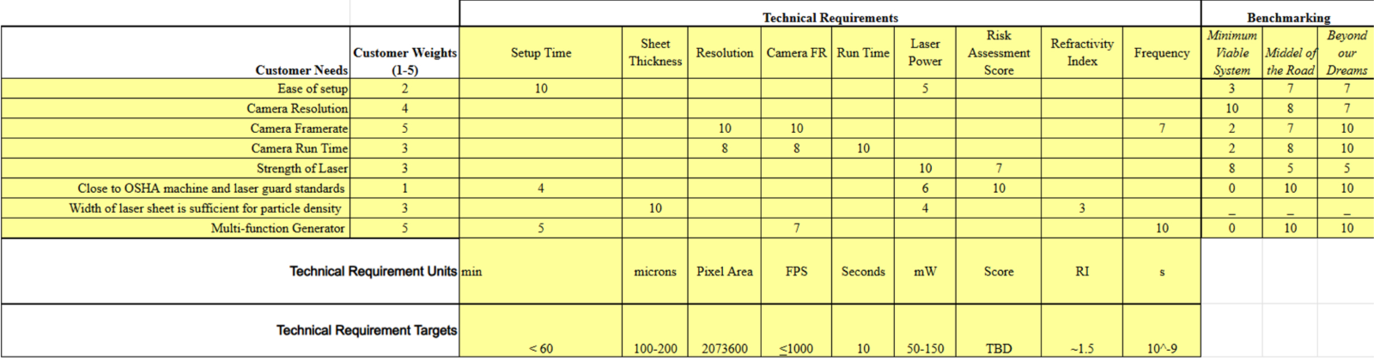
Figure 1 - Quality Function Deployment Diagram

Research Within Your Design Space
In this chapter we will discuss the research and modeling conducted in order to gain a better understanding of the current state of Particle Image Velocimetry, as well as to learn how to apply PIV to our client’s needs. To do this, we researched existing PIV setups, performed a literature review looking into different aspects of PIV, and utilized mathematical formulas to drive the design process.

Benchmarking
Benchmarking existing systems in the PIV space can be somewhat challenging due to both the highly custom nature of many PIV systems and the relatively secrecy they are developed in. Due to these challenges, the team developed benchmarks based on known specifications from other labs and development teams across the world.

Minimum Viable PIV System - Least capable system possible that can still technically be called a Particle Imaging Velocimeter. This system is representative of the one created by Kojo Chaway Acquah et al. [25]. It is possible at an incredibly low total cost (including mounting hardware and tracer particles) of 520.50 USD. The system our team creates should be much more capable than this system due to having a budget two orders of magnitude higher, but this example shows us where we can save money without sacrificing ultimate capability. The breakdown of this system and its major components are shown below in table 1.

Table 1 – Breakdown of least capable benchmark system and components.

Subsystem: | Component: | Price: | Specifications:
Camera | GoPro Hero 8 Black | $256.49 | 1080p @ 240Hz, Max ISO 6400
Laser | Visible green laser module, 300mW with TLL | $79.99 | 532 nm, 300mW
Function Generator | Arduino Nano v3 (DIY Synchronizer) | $25.40 | 120Hz laser control, no camera control

Middle-of-the-Road PIV System – This system uses purpose-built components that are common in many research laboratories that are not entirely focused on the development of Particle Imaging systems. This system will likely produce results that are of a similar accuracy to the system we will create but with drawbacks in terms of set-up times and flexibility. The main inspiration for this system is based on recommendations from scientists and engineers in the PIV space. The total price for this system less mounting components is $7,373.00. The breakdown of this system and its major components are shown below in table 2.

Table 2 – Breakdown of middle-of-the-road benchmark system and components.

Subsystem: | Component: | Price: | Specifications:
Camera [7] | Chronos 1.4 High Speed Camera 32GB | $4,500.00 | 1080p @ 1000Hz, Max ISO 740, 16 seconds recording time
Laser [8] | Thorlabs Nanosecond Pulsed Laser System | $1,713.00 | 523nm, 1500mW, 50kHz Max Frequency
Function Generator [9] | Tektronix AFG1022 | $1,160.00 | 2 Channel, 125MS/s, 25MHz Sine Waveform

Top-of-the-Line PIV System - This system requires a much higher budget than ours but provides a cutting-edge example to aim for with our system. This system is based on talks had with our technical advisor and other experts in the field online. This system would be capable of providing in-depth velocity data on very high-speed flows in a wide range of flow geometries. The total cost of this system without supporting or mounting equipment is $46,605.00. The breakdown of this system and its major components are shown below in table 3.

Table 3 – Breakdown of top-end benchmark system and components.

Subsystem: | Component: | Price: | Specifications:
Camera [10] | DITECT 1.3MP, 2000fps High-Speed Camera | $15,750.00 | 1.3MP @ 2000Hz, 16 GB RAM, 14 seconds recording time
Laser [11] | Litron LD25-527  PIV | $27,980.00 | 523nm, 25mJ pulse energy, 200Hz to 20kHz Frequency
Function Generator [12] | Berkeley Nucleonics Pulse Generator – Model 575 | $2,875.00 | 8 Independent Channel Outputs, Pulse Width: 10 ns - 1000 s,  Pulse Delay: 0 ns - 1000 s,  Pulse and Delay Resolution: 250 ps

Literature Review

3.2.1 Santiago Gamez
F. Zigunov, “How Bright are my PIV Particles?,” Zigunov Aero, Jun. 30, 2023. https://zigunov.com/2023/06/30/how-bright-are-my-piv-particles/ (accessed Mar. 09, 2025). (Website)
This is an article made by an assistant professor at Syracuse University, Dr. Fernando Zigunov. The article is called, “How Bright are my PIV Particles?”, and evaluates Zigunov’s method to theoretically calculate if your PIV system will work. It uses all the laser and optics components of your system including the Camera ISO, wavelength information, pixel sizing, and other light parameters. This will be beneficial in our prototype phase because we will be able to test and evaluate different PIV systems with different components faster. Instead of having to test multiple different systems and hoping for the best, we can have a better understanding before we get into the hands-on testing phase.
“Considerations When Using Cylinder Lenses,” Edmundoptics.com, 2023. https://www.edmundoptics.com/knowledge-center/applicationnotes/lasers/considerations-when-using-cylinder-lenses/srsltid=AfmBOoqqON2maCTx6XYNjrSre8Ck-e4nh7X_ULfvTMfIijDaxhKc-Ai2 (accessed Mar. 09, 2025). (Website)
In this article Edmund Optics goes over how a cylindrical lens can be used to create a sheet of light. It states that cylindrical lenses are different from spherical lenses because they will not affect light in the perpendicular dimension. This means that they have optical power in only one direction. The drawback from the cylindrical lens is that the manufacturing aspect of your lens can not have any mistakes. If there is a misalignment in the polishing process, then the cylindrical lens will be prone to aberration, and it could affect its performance elsewhere. This will be important as the team decides on what kind of method would be best to split the laser into a laser sheet.
U. Stopper et al., “PIV, 2D-LIF and 1D-Raman measurements of flow field, composition and temperature in premixed gas turbine flames,” vol. 34, no. 3, pp. 396–403, Apr. 2010, doi: https://doi.org/10.1016/j.expthermflusci.2009.10.012. (Journal)

This is a journal called, Experimental Thermal and Fluid Science, that evaluates different diagnostic measuring techniques and how they were applied to view the air flames of an industrial swirl burner. Although the PIV is not made for the same application, it is still a useful example of a successful PIV. A useful note from this article is that the “resolution of the measured velocity depends on the seeding particle density, the degree of window contamination, and the turbulence of the flow (Aigner, 2010).” It is possible we may need to take these factors into account when determining how well we can picture particles and how many. The PIV setup in the journal also consisted of a laser lens system with two mirrors, two cylindrical lenses, and one spherical lens. This could be helpful when thinking of different possible prototypes.

S. R. Tenney, M. Moshirfar, and Y. Ronquillo, “Concave And Convex Lenses,” PubMed, Oct. 31, 2022. https://www.ncbi.nlm.nih.gov/books/NBK587441/ (Book)
This book section goes over useful formulae for calculating the focal length of a concave and convex lens, the magnification, and the optical power. As well as notes on aberration which is possible when working with lenses. The PIV laser system will require a precise combination of convex and concave lenses in order to display an accurate laser sheet over the patient. Moving forward in this project we will have to decide on the correct lens distance between each lens in order to create the desired focal point. This book’s contents will help the team quantify the parameters on what is possible with the lenses.
View, “My milli-micro-PIV setup,” The Fluid Dynamics Lab, Feb. 15, 2021. https://ronshnapp.wordpress.com/2021/02/15/my-milli-micro-piv-setup/ (accessed Mar. 09, 2025). (Website)
This is a website that talks about a milli-micro-PIV setup. The website starts by talking about PIV setup and all the basic components that it requires. After giving some background information, the author then goes in depth about the lenses they used and how they configured their setup. The laser beam first hits a mirror and then turns 90 degrees as it enters the first spherical lens. From there it enters another spherical lens that collimates the beam. From there it enters the third lens, concave cylindrical, to expand the beam in the horizontal direction. To finish the setup the beam goes through a convex cylindrical lens that focuses the beam in the desired sheet thickness. This formation is something to consider when thinking of multiple ways to set up the optics system.
“Light sheet optics for PIV - HackMD,” HackMD, 2023. https://hackmd.io/@cdcl-rpr/light-sheet-optics (accessed Mar. 09,2025). (Website)

This online resource is a study on creating a laser system that creates a laser sheet that is 200 mm in height and 1.6 mm thick. Although the author is not verified, he references his use of a book called, Particle Image Velocimetry, made in 2018. This article shows his laser PIV setup and describes what lens types he used and at what distances each of their focal points were. This will be useful as we review different lens types and decide what lenses will be the most efficient. This information can be used to theoretically calculate the focal points and laser sheet thickness using different lenses.
“Gaussian Beam Propagation,” Edmundoptics.com, 2017. https://www.edmundoptics.com/knowledge-center/applicationnotes/lasers/gaussianbeam-propagation/srsltid=AfmBOorJAMCl13Iu7FQpSGa_Uktg12pTzUPRDqvCvcvbUiEqHlaRmdB (accessed Mar. 09, 2025). (Website)
In this article Edmund optics explains how gaussian beam propagation is evaluated to understand the formation of the laser beam and its travel. This will be helpful towards creating our laser system for the PIV and understanding the radiance of the laser itself. This article gives useful formulas for different applications of gaussian beams including “focusing a gaussian beam to a spot”. This formula is useful for the laser system by calculating how the laser beam will converge tightly into one point before it diverges into a laser sheet. From there we will have to decide how we would want to make the lasers converge using different lenses.
G. J. Johnson, “Springer Handbook of Lasers and Optics200884Edited by Frank Träger. Springer Handbook of Lasers and Optics. Heidelberg and New York, NY: Springer 2007. xxvi+1332 pp., ISBN: 978 0 387 95579 7 £192.50 $199 Includes a CD‐ROM containing all eight chapters; also available as an e‐book (ISBN 978 0 387 30420 5),” Reference Reviews, vol. 22, no. 2, pp. 42–42, Feb. 2008, doi: https://doi.org/10.1108/09504120810855093. (Book)
This is the Springer handbook of lasers and optics that develops fundamental information for a plethora of different applications. In chapter 9 it goes over gaussian beam theory and the fundamental equations for calculating traits of the beam. This will be useful, but is information gained from other sources as well. A new component from this book compared to other research is chapter 21.6 on protective measures. It states some key components to consider when deciding on protective eyewear including wavelength of operation, laser output wavelength, and any other relevant national regulations. It has some other information when dealing with higher powered lasers, but that is not applicable for this project.
Laser Beam expanders | edmund optics, https://www.edmundoptics.com/knowledge-center/application-notes/lasers/beam-expanders/ (accessed Apr. 18, 2025).
This article reviews the concept of what is known as a Galilean telescope which is a beam expander theory. This beam expansion theory utilizes a convex and concave lens like previous sources had utilized in their lens configurations. This is a good reference for repeating the same success in this PIV lens configuration. It goes over useful formulae for this beam theory and will be useful as prototyping begins. It gives calculations regarding magnification power, distance between lenses, and focal length of lenses. This article also goes over other factors such as divergence, reflectivity, and transmissivity.
How to Design your own Beam Expander Using Stock Optics | edmund optics,
https://www.edmundoptics.com/knowledge-center/application-notes/optics/how-to-design-your-own-beam-expander-using-stock-optics/?utm_medium=chat&utm_campaign=link-shared-in-chat&utm_source=livechat.com&utm_content=www.edmundoptics.com (accessed Apr. 18, 2025).

This article goes over specifications of a laser such as the beam divergence and the diameter of the beam. These concepts will be key to understand when making this lens configuration. Understanding the beam diameter is key in having valid calculations for the beam thickness. After speaking about the beam diameter, the article talked more about other laser components such as output power and what differentiates different class lasers from each other. The article finishes with a short segment on available laser accessories including their own beam expanders. A laser beam expander could be an interesting prospect for the lens configuration if within the budget moving forward.

Can a beam expander be used in reverse? | edmund optics, https://www.edmundoptics.com/knowledge-center/application-notes/optics/can-a-beam-expander-be-used-in-reverse/?utm_medium=chat&utm_campaign=link-shared-in-chat&utm_source=livechat.com&utm_content=www.edmundoptics.com#:~:text=Reversing%20the%20orientation%20of%20a%20laser%20beam%20expander,new%20magnifying%20power%20of%201%2F5%20instead%20of%205 (accessed Apr. 18, 2025).

This website was useful in understanding if flipping the lenses in a Galilean expansion set of lenses would work and make the beam compress. It stated that although possible, placing the two lenses in reverse would most likely not lead to the desired result. It gave a formula that would be able to calculate the lasers divergence if you swapped the lens, but this formula is only useful if you already have the beam diameter measurements at two different distances. This article was useful in double checking results and having a greater understanding of the beam expansion process. This article helped influence current results for the lens train moving forward.

Rory Kian Pack
W. H. Ho, I. J. Tshimanga, M. N. Ngoepe, M. C. Jermy, and P. H. Geoghegan, “Evaluation of a Desktop 3D Printed Rigid Refractive-Indexed-Matched Flow Phantom for PIV Measurements on Cerebral Aneurysms,” Cardiovasc Eng Tech, vol. 11, no. 1, pp. 14–23, Feb. 2020, doi: 10.1007/s13239-019-00444-z. (Journal Article)

This source covers the direct manufacturing of transparent flow phantoms using an SLA resin 3D printer, for use with a 2D PIV system. This method is faster and cheaper than the traditional casting method, but there are a few considerations to make before picking a method of manufacture. First is that the refractive index of the resin used in this study is higher than the silicone used in casting methods. This can introduce difficulties surrounding the selection of a blood equivalent fluid, although this can be worked around with the correct mixture. Another potential issue is the slightly higher surface roughness of the resin phantom compared to a cast silicone counterpart. Despite these challenges, this method of manufacturing is still attractive due to its lower cost per unit, faster turnaround time, lower complexity, and less rigorous equipment requirements. This study had 2 separate examples prepared: one was an idealized aneurysm geometry, while the other was a complex patient-specific arterial geometry.
D. P. G. Nilsson et al., “Patient-specific brain arteries molded as a flexible phantom model using 3D printed water-soluble resin,” Sci Rep, vol. 12, no. 1, p. 10172, Jun. 2022, doi: 10.1038/s41598-022-14279-7. (Journal Article)

This source reviews a phantom manufacturing process that is roughly halfway between the traditional silicone casting process and the novel SLA process presented in Ho et al. This process uses a water-soluble resin in an SLA type 3D printer to create a negative of the phantom geometry, which is then used in a silicone mold. This method still requires the careful silicone handling and desiccator of the traditional casting method, but with a quicker turnaround time due to the negative requiring almost no post-processing. As for advantages over the full SLA process, this method can produce phantoms with a lower RI, better clarity, and smoother surfaces. This study was focused on the production of large, complicated, patient-specific arterial models. This will be useful for helping the teams working on further research once our design is complete but is unlikely to directly inform our PIV design.
J. Tu, G. H. Yeoh, C. Liu, and Y. Tao, Computational fluid dynamics: a practical approach, Fourth edition. Oxford Cambridge, MA: Butterworth-Heinemann, 2024. doi: 10.1016/C2021-0-01771-5. (Textbook)

This textbook covers the practical aspects of implementing Computational Fluid Dynamics (CFD) simulations into design and research. It will be very useful in understanding what governing equations and assumptions to use when modeling flow in the phantom geometry we will use to test out the PIV prototypes and final system. An especially useful method in this case will likely be to simulate the tracer particles in the fluid system as actual particles in a two-phase flow, which will help us pick what particle characteristics are most well suited to our system.
M. Tomaszewski, K. Sybilski, P. Baranowski, and J. Małachowski, “Experimental and numerical flow analysis through arteries with stent using particle image velocimetry and computational fluid dynamics method,” Biocybernetics and Biomedical Engineering, vol. 40, no. 2, pp. 740–751, Apr. 2020, doi: 10.1016/j.bbe.2020.02.010 (Journal Article)

This paper goes in-depth on an experiment conducted by the authors involving the effectiveness of various stents in arterial applications. While their results won’t directly inform the design of our system or experiments, the process documented will help guide our progress. Special attention will be paid to what design decisions the authors made that impacted the ease of use of their PIV system.
F. Kojo Chaway Acquah, J. Paul Konadu Takyi, and H. R. Beem, “Design and characterization of a low-cost particle image velocimetry system,” HardwareX, vol. 19, p. e00563, Sep. 2024, doi: 10.1016/j.ohx.2024.e00563. (Journal Article)

This paper discusses the development of a PIV system with a budget even lower than ours. The authors managed to create a working PIV for slightly over 500 USD. This paper serves as a great benchmark for what even the prototypes of our system should be capable of. It also gives examples of places to save cost (like lenses) that will allow us to spend more on actual capability. Finally, this source’s explanation of the simple experiments used to verify the results of the authors’ PIV system will help our team design our own experiments to validate our system prototypes.
D. J. Biswas and D. J. Biswas, Insights into laser science. in A beginner’s guide to lasers and their applications / Dhruba J. Biswas, no. Part 1. Cham: Springer, 2023. (Textbook)
This textbook covers the basic theory and application of lasers in a variety of fields. This resource will be useful in helping us choose the specifics of the laser diode that we will use in our final design. This is important because no members of the team have any background or formal education in the design or use of lasers. Aspects of our design like diode selection, optics selection, and safety guarding will be informed by the content in this source.
“Laser Diode Tutorial,” Thorlabs - Photonics Products & Solutions. https://www.thorlabs.com/newgrouppage9.cfm?objectgroup_id=1832 (accessed Mar. 09, 2025). (Webpage)
This webpage from Thorlabs- the manufacturer of the laser driver and diode package our team will be using- goes over the basic concepts of diode lasers and their applications in research and industry. This page will be very useful as we develop the specifics of our laser subsystem and will guide us in any future purchasing decisions our team needs to make.
A. G. Rahma and T. Abdelhamid, “Hemodynamic and fluid flow analysis of a cerebral aneurysm: a CFD simulation,” SN Appl. Sci., vol. 5, no. 2, p. 62, Feb. 2023, doi: 10.1007/s42452-023-05276-0 (accessed Apr. 4, 2025). (Journal Article)
This paper was very instructive in showing the decisions to be made in the creation of the virtual prototype in ANSYS Fluent. Additionally, the results from this paper will help inform the verification process of the results not only generated by the team’s CFD modeling, but also from preliminary PIV tests. Understanding the underlying physical models which describe flow in aneurysms helps the team to better understand what changes in measuring and simulation system properties are necessary to improve the accuracy of our simulations and testing setups.
“Boundary Conditions of Bloodflow in Artery | Ansys Courses,” ANSYS Innovation Courses | Free, online, physics and engineering courses, May 13, 2020. https://innovationspace.ansys.com/courses/courses/fluent-3d-bifurcating-artery/lessons/physics-setup-lesson-5/topic/boundary-conditions/ (accessed Apr. 5, 2025). (Website)
This ANSYS learning course module helped the team implement proper boundary conditions in the latest version of the virtual prototype. Understanding the intricacies in the model introduced by true pulsatile flow will help evaluate if the distribution of tracer particles throughout the blood analogue fluid is sufficiently broad. If this is not the case, the team will need to create an additional apparatus that ensures tracer particles are present throughout the flow phantom without disrupting the behavior of the flow model.

J. Y. Moon, D. C. Suh, Y. S. Lee, Y. W. Kim, and J. S. Lee, “Considerations of Blood Properties, Outlet Boundary Conditions and Energy Loss Approaches in Computational Fluid Dynamics Modeling,” Neurointervention, no. 1, p. 1, 2014, doi: 10.5469/neuroint.2014.9.1.1 (accessed Apr. 7, 2025). (Journal Article)
This source covers many of the pitfalls made by scientists and engineers when modeling arterial blood flow in commercial CFD solver programs. Specifically, the explanation for the development of a pulsatile pressure outlet boundary was very helpful in determining how the team’s final CFD prototype should function. This paper will continue to be an important resource in achieving accurate and physically verifiable flow behavior in our In Silico models as the project progresses.

Chris Rapoport
C. A. Luisi et al., “Investigation of Cerebral Hemodynamics During Endovascular Aspiration: Development of an Experimental and Numerical Setup,” Cardiovasc. Eng. Technol., vol. 14, no. 3, pp. 393–403, Jun. 2023, doi: 10.1007/s13239-023-00660-8.

This paper discusses a study which used PIV to investigate the flow characteristics in the circle of Willis. They then validated the results of this analysis using computational fluid dynamics (CFD). This is a great source as this is exactly the kind of study that our PIV system will be used for. This article gives great insight into the production of neurovascular phantoms, as well as the PIV setup itself, including which data acquisition settings were used during the study. It also gives us insight as to how to validate our own PIV system using CFD.

C. N. Ionita, Y. Hoi, H. Meng, and S. Rudin, “Particle image velocimetry (PIV) evaluation of flow modification in aneurysm phantoms using asymmetric stents,” presented at the Medical Imaging 2004, A. A. Amini and A. Manduca, Eds., San Diego, CA, Apr. 2004, p. 295. doi: 10.1117/12.534274.
This is a paper discussing a PIV study of flow modification during treatment of aneurysms using flow diverters. This is another study that closely resembles the kind of research that the BDL needs the PIV system for. Like the previous paper this study discusses the production of phantoms, as well as the equipment and settings used for the data collection. This paper will be useful for determining which equipment to buy and how to set it up for an in-vitro experiment, as well as how to construct phantoms.

M. Raffel, C. E. Willert, S. T. Wereley, and J. Kompenhans, Particle Image Velocimetry: A Practical Guide. Berlin, Heidelberg: Springer Berlin Heidelberg, 2007. doi: 10.1007/978-3-540-72308-0.
This is a comprehensive guide to particle image velocimetry. This book goes into depth on important topics such as equipment, particle density, and recording and validation techniques. It also discusses the math used on the analytical side of PIV. This book will be useful in helping to determine which equipment to buy, how to setup the equipment for data acquisition, and post-processing and analyzing the data collected in the experiment. This source will be used as a guiding document for our project.

N. Buchmann, “Development of Particle Image Velocimetry for In-Vitro Studies of Arterial Haemodynamics,” University of Canterbury. Mechanical Engineering, 2010. doi: 10.26021/1526.
This is a doctoral dissertation that describes PIV studies of arterial hemodynamics. Although this paper is concerned with cardiovascular instead of neurovascular flow it is still very useful for our purposes as it gives a very thorough description of phantom construction, particle density, refractive index matching, as well as pre- and post-processing of the images captured.
C. Zhang, S. Vasilevskis, and B. Kozlowski, “Particle Image Velocimetry: User Guide,” Department of Civil Engineering, Aalborg University, Aalborg, Report, 2018.
This is another comprehensive guide to PIV. While this source is a comprehensive guide, it goes into greater depth on the equipment side of things than the above PIV guide. This book gives an in-depth description of each component of the PIV system, as well as how to install the components. This also includes an entire chapter on how to calibrate the system, which will be crucial to getting our system operational.

S. Scharnowski and C. J. Kähler, “Particle image velocimetry - Classical operating rules from today’s perspective,” Opt. Lasers Eng., vol. 135, p. 106185, Dec. 2020, doi: 10.1016/j.optlaseng.2020.106185.
This is an article that mostly discusses how to capture, process and interpret data collected from PIV studies. It especially focuses on particle density and methods to reduce noise, or unnecessary data, from the analysis. It also discusses how to know the limits of what a particular PIV system is capable of. This article will be very important when we have our system constructed and have moved on to the validation stage of the project.
S. Kefayati, J. S. Milner, D. W. Holdsworth, and T. L. Poepping, “In Vitro Shear Stress Measurements Using Particle Image Velocimetry in a Family of Carotid Artery Models: Effect of Stenosis Severity, Plaque Eccentricity, and Ulceration,” PLoS ONE, vol. 9, no. 7, p. e98209, Jul. 2014, doi: 10.1371/journal.pone.0098209.
This article discusses a study that studied the wall shear stress in carotid artery models using PIV. This source was chosen because the client specifically mentioned being interested in getting shear stress measurements from the PIV system. This article will serve as a guide on how to use PIV to calculate shear stress. In addition to the information about shear stress, the paper also discusses the construction of the carotid artery phantoms used in the study, which will be of interest to us when we are constructing our own phantoms.
ANSI Z136.1-2014, Safe Use of Lasers, American National Standards Institute (ANSI).
This is the ANSI standard for laser safety. It contains a number of tables containing equations to determine the safety measures necessary for different laser wavelengths, powers, and applications. This document was used when determining which types of safety goggles are required for our laser and will our guiding document when determining the necessary safety measures for the PIV system.
“PIVlab - open source particle image velocimetry,” PIVlab. Accessed: Apr. 18, 2025. [Online]. Available: https://www.pivlab.de/
PIVLab is an open source software for analyzing images from PIV studies. It is the software our client requested that we use for processing the PIV images. In addition to tutorials and information about how to use the software to control PIV equipment and process the images the PIVLab website also contains information about choosing equipment for PIV and explanations of concepts such as frame straddling. This website was used while selecting a laser and function generator and will continue to be used as a guide for choosing settings for conducting PIV studies and for processing and interpreting the data collected.
J. Sheng, H. Meng, and R. O. Fox, “Validation of CFD simulations of a stirred tank using particle image velocimetry data,” Can. J. Chem. Eng., vol. 76, no. 3, pp. 611–625, Jun. 1998, doi: 10.1002/cjce.5450760333.
This article describes a study comparing CFD simulations to a PIV study performed on a stirred tank. A PIV study of a stirred tank is discussed as one of our tests in section 3.3.4 to test how well our laser fluoresces the particles. This article was the inspiration for that test, and will serve as a guide as we adapt the methods used in the article to our needs.

Jett Scruggs
F. Zigunov, “Particle brightness estimator,” Zigunov Aero, https://3dfernando.github.io/PIV_ISOSpeed.html (accessed Mar. 9, 2025):
- Zigunov introduces a method for estimating particle brightness in Particle Image Velocimetry (PIV) applications. This resource provides a tool to estimate particle brightness in real-time, which is crucial for ensuring that the particles are optimally visible for velocity measurement. The technique enhances PIV accuracy by adjusting for variations in lighting conditions, particle characteristics, and camera sensitivity, enabling more reliable results in complex flow measurements.
F. Zigunov, “How bright are my piv particles?,” Zigunov Aero, https://zigunov.com/2023/06/30/how-bright-are-my-piv-particles/ (accessed Mar. 9, 2025):
- This article by Zigunov delves deeper into the factors influencing the brightness of particles in PIV, discussing the role of laser intensity, particle type, and optical properties of the system. It provides insights into the challenges of maintaining consistent particle brightness across various experimental setups and offers solutions for ensuring optimal particle visibility and image quality. This is particularly useful for practitioners aiming to enhance the accuracy and reliability of PIV measurements in diverse experimental environments.
W. Merzkirch, Flow Visualization, Second. London, United Kingdom: Academic Press INC, 1987:
- Merzkirch’s comprehensive textbook on flow visualization provides an in-depth exploration of the principles and techniques behind visualizing fluid flows. The second edition addresses both traditional and modern methods of flow visualization, with a focus on Particle Image Velocimetry (PIV). It serves as a foundational resource for understanding how various imaging techniques, including PIV, can be applied to analyze flow dynamics and improve measurements in experimental fluid mechanics.
G. Cavazzini, Ed., The Particle Image Velocimetry: Characteristics, Limits and Possible Applications. Rijeka, Croatia: InTech, 2019:
- This edited volume offers a collection of contributions from various experts on the theory, applications, and limitations of Particle Image Velocimetry (PIV). It covers a range of topics, from the basic principles of PIV to advanced applications in different engineering fields, including aerospace, civil engineering, and bioengineering. The book also discusses the challenges faced in PIV measurements, such as dealing with tracer particles, optical configurations, and flow conditions, making it a valuable reference for both researchers and practitioners.
M. Y. Yousif, D. W. Holdsworth, and T. L. Poepping, “Deriving a blood-mimicking fluid for particle image velocimetry in Sylgard-184 vascular models,” 2009 Annual International Conference of the IEEE Engineering in Medicine and Biology Society, pp. 1412–1415, Sep. 2009. doi:10.1109/iembs.2009.5334175:
- This paper discusses the development of a blood-mimicking fluid for use in PIV experiments involving vascular models made from Sylgard-184. The authors focus on creating a fluid that accurately simulates blood flow characteristics, including viscosity and density, to ensure the accuracy of PIV measurements in medical and biological applications. This work is significant for improving the use of PIV in biomedical studies, especially for understanding fluid dynamics in artificial blood vessels and similar systems.
B. J. Petrovsky, “Particle image velocimetry applications of fluorescent dye-doped particles,” Particle Image Velocimetry Applications of Fluorescent Dye-doped Particles, https://ntrs.nasa.gov/api/citations/20160007394/downloads/20160007394.pdf (accessed Mar. 10, 2025):
- Petrovsky’s work focuses on the application of fluorescent dye-doped particles in Particle Image Velocimetry, enhancing the detection sensitivity and precision of PIV measurements. The integration of fluorescent particles allows for better signal differentiation in complex flow environments, particularly in low-light or turbulent conditions. This application improves the quality of velocity measurements in various fields, including aerodynamics, environmental studies, and medical diagnostics.
P. Luzzatto-Fegiz, Simultaneous PIV and LIF measurements in stratified flows using pulsed lasers, Jul. 2022:
- Luzzatto-Fegiz presents a methodology for combining Particle Image Velocimetry (PIV) and Laser-Induced Fluorescence (LIF) measurements in stratified flow environments. Using pulsed lasers, this technique allows for simultaneous measurement of velocity fields and tracer concentration profiles in complex fluid flows. The integration of these two techniques enhances the ability to study and characterize turbulent and stratified flows, with applications in environmental engineering and fluid dynamics research.
R. D. Keane and R. J. Adrian, “Optimization of particle image velocimeters: II. multiple pulsed systems,” Measurement Science and Technology, vol. 2, no. 10, pp. 963–974, Oct. 1991. doi:10.1088/0957-0233/2/10/013
- In their 1991 article, Keane and Adrian explore the key parameters that influence the accuracy and effectiveness of double-pulsed PIV systems. They focus on optimizing the timing between laser pulses, camera exposure settings, particle image displacement, and seeding density to enhance correlation reliability and reduce motion blur. These findings are critical when designing a PIV system, as they provide quantitative methods to ensure that particles are tracked effectively between frames without losing resolution or introducing error due to excessive movement. By applying their recommendations, it is possible to fine-tune the interaction between the camera, laser, and flow field to maximize measurement precision.
R. J. Adrian, “Twenty years of particle image velocimetry,” Experiments in Fluids, vol. 39, no. 2, pp. 159–169, Jul. 2005. doi:10.1007/s00348-005-0991-7
- This paper by R. J. offers a broad review of the evolution of PIV technologies and their applications. The article highlights advancements in hardware integration, image processing algorithms, and the development of stereo and time-resolved PIV techniques. It provides valuable context for modern system design by discussing how transitions in sensor technology and computing power have expanded what PIV systems can measure. For anyone building a system from the ground up, these insights support decisions around modality selection, scalability, and forward-compatibility. This paper is particularly useful for aligning system design with the current (2005) best practices and anticipating future upgrades.
L. Martínez-Suástegui, “Overview on stereoscopic particle image velocimetry,” Advanced Methods for Practical Applications in Fluid Mechanics, Mar. 2012. doi:10.5772/34728
- This article by L. Martínez-Suástegui provides a detailed guide for designing and implementing a stereoscopic PIV system, emphasizing both foundational principles and advanced calibration and processing techniques. It outlines the limitations of 2D PIV in capturing out-of-plane flow components and advocates for a dual-camera stereoscopic setup to resolve full 3D velocity vectors. Key elements such as camera synchronization, laser illumination, and seeding strategies are discussed as part of a fully integrated system. In the data processing section, it highlights the use of adaptive correlation and validation methods to refine vector fields and reduce noise, and it explains how processed data can be exported to platforms like MATLAB and Tecplot 360 for 3D visualization. Altogether, the chapter serves as a practical and technical blueprint for building a flexible, accurate, and upgrade-ready stereoscopic PIV system.

Mathematical Modeling

3.3.1 Camera Exposure – Jett Scruggs
The H18 represents the exposure at which the intensity of the PIV particle image reaches 18% of its pixel saturation. It is determined using the following equation:
$$H_{18}=\frac{10Lux*s}{S} (1)$$
where SSS is the camera's sensitivity in lux-seconds. This equation allows for the calculation of the appropriate exposure needed to avoid pixel saturation while ensuring enough light to accurately capture the particles' motion. This exposure value is essential for precise PIV imaging, enabling proper calibration of lighting and camera settings.
The calculation of H18 is crucial in optimizing the PIV process. By knowing the camera’s sensitivity SSS and the required light intensity, one can ensure that the exposure is adjusted to capture clear and accurate particle images without overexposing the sensor. This helps in achieving reliable particle motion data for analysis.
Plugging in the ISO values of different cameras, such as the Chronos 1.4 Monochrome and Color cameras, the following results were obtained:
$$H_{18,BW}=\frac{10lux*s}{740}=.01351$$
$$H_{18,Color}=\frac{10lux*s}{320}=.03125$$
From these results, it shows that the monochrome camera requires half the light exposure to reach the 18% grey level when compared to the color camera. Because ISO generally correlates to a higher camera efficiency, and overexposure tends to occur more easily due to sensitivity to light, having some metric of comparison can help to show how well-suited certain cameras are for the purpose of this project. For example, while the monochrome camera is better suited for PIV, cameras with much higher ISO options should also be considered, regardless of having color imagery or not.

3.3.2 Light Sheet Generator – Santiago Gamez
To create the desired laser sheet thickness, it is going to require a specific combination of convex and concave lenses with specific distancing. The lens system was created below based on the lens system made by Shashikant Verma and utilized the same equations [18]. The initial bi-convex lenses will make the diameter of the laser beam smaller as it approaches the concave lens. After this process the laser will go through the first concave lens which will expand the beam in the horizontal direction, and then the final concave lens which will expand the beam in the vertical direction. For the calculations below, the final laser sheet thickness will depend on the focal length of the last concave lens, the beam waist before reaching the lens, and the wavelength of the laser beam. Assumptions for the initial convex lenses focal lengths were made to get a theoretical laser diameter of 0.4 mm, which is pictured below in green. The length from the last lens to the point of illumination was assumed to be 180 mm which calculated an angle of divergence, $θ$, of 6.667 milliradians. This angle of divergence was used to calculate a beam waist, $w_{o}$, of 25.4011 micrometers. The second to last step in this process is to substitute the known values into the, $w_{f}$, equation to calculate half of the beam thickness. The focal length, $f$, is equal to 7.5 since that is the focal length of the last lens. Since this formula is only for half of the beam thickness, once multiplying it by two, the final sheet thickness, $T_{sh}$, is solved. The calculations performed and a picture representing the theoretical lens system is depicted below:

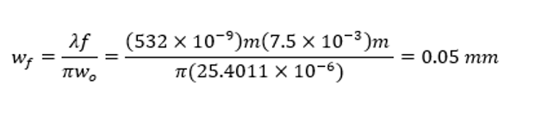(2,[18]) 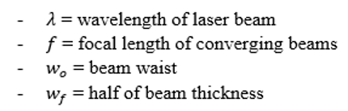
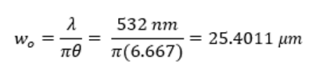(3,[18]) 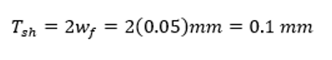 (4,[18])
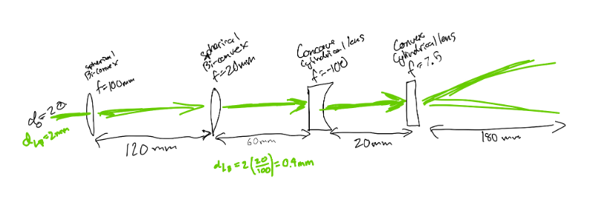

Figure 2: Laser light sheet generator

3.3.3 Laser Power – Rory Kian Pack
In most modern PIV setups, a technique known as “frame-straddling” is used to maximize the amount of light energy dumped into the tracer particles in the flow being studied. Frame straddling involved pulsing the laser on either side of the camera exposure period, as shown in figure 3 below.
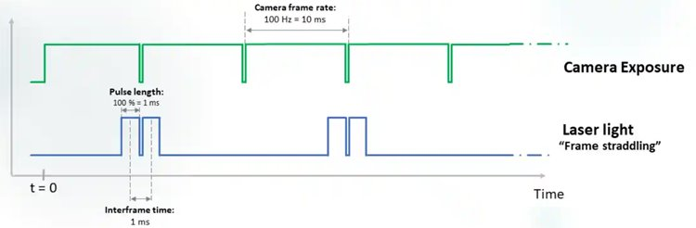
Fig. 3. Diagram showing how frame straddling involves pulsing light around camera exposures, and the relative timescale involved [40].
In order to determine if the laser being evaluated for concept selection would be energetic enough for the flows that are to be studied with the proposed PIV system, the laser pulse energy had to be calculated.
Since pulse energy for continuous wave lasers (which are the majority of the lasers under consideration) is tied to repetition frequency, that had to be evaluated simultaneously. Repetition frequency is a function of the camera refresh rate in a frame-straddled application, with laser repetition frequency generally needing to be an order of magnitude faster than the camera frame rate. This is defined in equation 5 below.
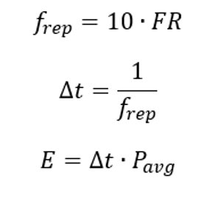 (5)

The next step is to define pulse width, the amount of time the laser is emitting for. This is defined as the reciprocal of repetition frequency in equation 6 below.
(6)

The final step to evaluating laser pulse energy is to obtain the product of average laser emission power and pulse width, as defined in equation 7 below.

(7)

These equations were utilized alongside the continuous power outputs of 5 lasers in consideration for concept selection (see table 8) to generate graphs in MATLAB showing pulse energy across a range of possible camera framerates. For the full program used to generate these graphs, see appendix B.

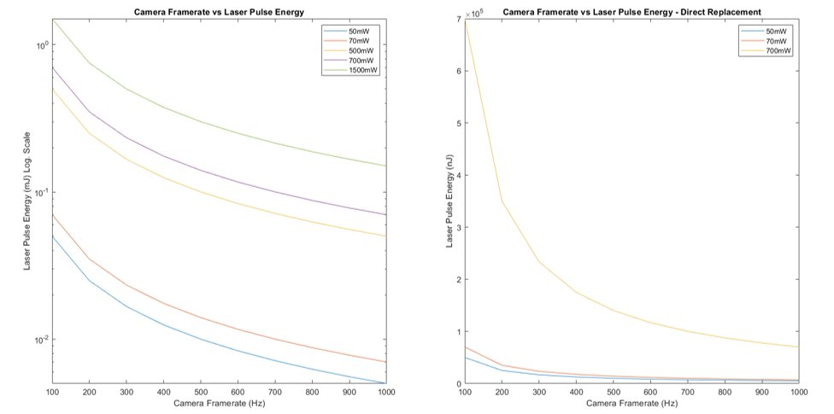
Fig. 4. Graphs of laser pulse energy vs camera framerate. Left shows all 5 potential lasers on a logarithmic scale for clearer comparison. Right shows 3 direct diode replacement choices on an absolute scale.
This analysis directly informed the concept selection choices documented in section 4.3.

3.3.4 Laser Experiment – Chris Rapoport
To determine whether the laser we were given by the BDL is powerful enough for use with the BDL comprehensive flow model we must ensure that it can fluoresce the particles when they are moving at the velocities that the flow model produces, around 0.26 m/s on the high end. After consulting with our technical advisor Dr. Dou, we devised an experiment to test whether our laser can illuminate particles at the required speed. The experiment is as follows:
      - Fill a 2-liter beaker with water and place on stir plate. Add stir bar and PIV particles.
      - Position the laser facing the beaker. Position the camera looking down on the beaker from above.
      - Begin stirring the water in the beaker, starting at a low RPM.
      - Pulse the laser and capture images with the camera, with the laser pulsing just before and after each image is captured. Observe particle fluorescence.
      - Increase the RPM of the stir plate.
      - Repeat steps 4 and 5 until particles are no longer fluorescing.
After data acquisition for the experiment is complete, the images captured will be loaded into PIVLab for analysis, where the program will calculate the velocities of the particles. A figure detailing the setup of the experiment is shown in Figure 5.
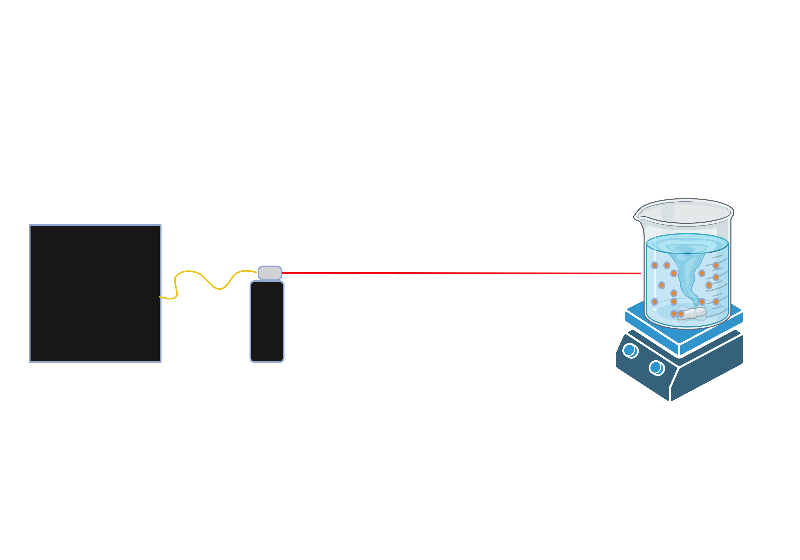
Fig. 5. Laser fluorescence experiment.

3.3.5 Phantom Financial Analysis – Rory Kian Pack
An additional area of concern for the capstone team is the creation of a wide variety of flow “phantoms” to test different flow geometries with the PIV system. Flow phantoms are models of flow geometries, made of transparent material for use with imaging systems. Our sponsor showed significant interest in optimizing the manufacturing process for flow phantoms for use in future research involving the team’s PIV system.
There exists two primary methods for the manufacture of flow phantoms in modern PIV study. The first kind, as detailed in a study by W. H. Ho et al., is a rigid flow phantom manufactured directly in a Stereolithography (SLA) process using clear resin [21]. The second kind, explained in the study from Nilsson et al., uses a flexible silicone mixture in a lost-mold casting process [22].
In order to determine which of the two methods outlined above would be the most optimal for our application, we conducted a simple quantity-cost analysis using gathered price information and information from the studies mentioned above [21,22]. The cost analysis is broken down in terms of fixed and variable costs and is detailed below in equation 8.
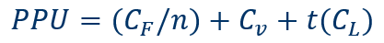 (8)
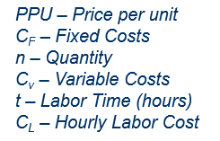

The equation 8 above was combined with the three tables below to create a model showing the costs of rigid SLA phantom manufacturing and flexible silicone manufacturing, with rigid further divided into in-house and outsourced manufacturing.

Table 4 - Fixed and variable costs associated with traditional, lost-mold silicone casting phantom production process.
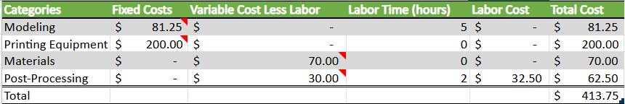

Table 5 - Fixed and variable costs associated with outsourced SLA additive phantom production process.
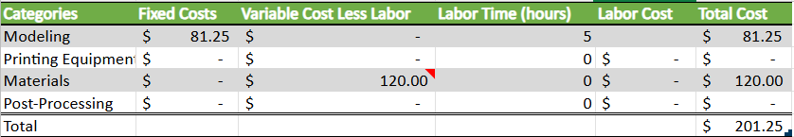

Table 6 - Fixed and variable costs associated with in-house SLA additive phantom production process.
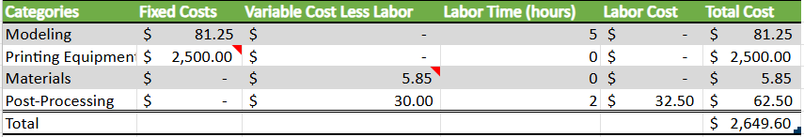
These sourced costs (see Appendix C for full spreadsheet) were used to calculate the Price Per Unit across a range of quantities from 1 to 200 units. The results of these calculations are shown in figure 6 below.
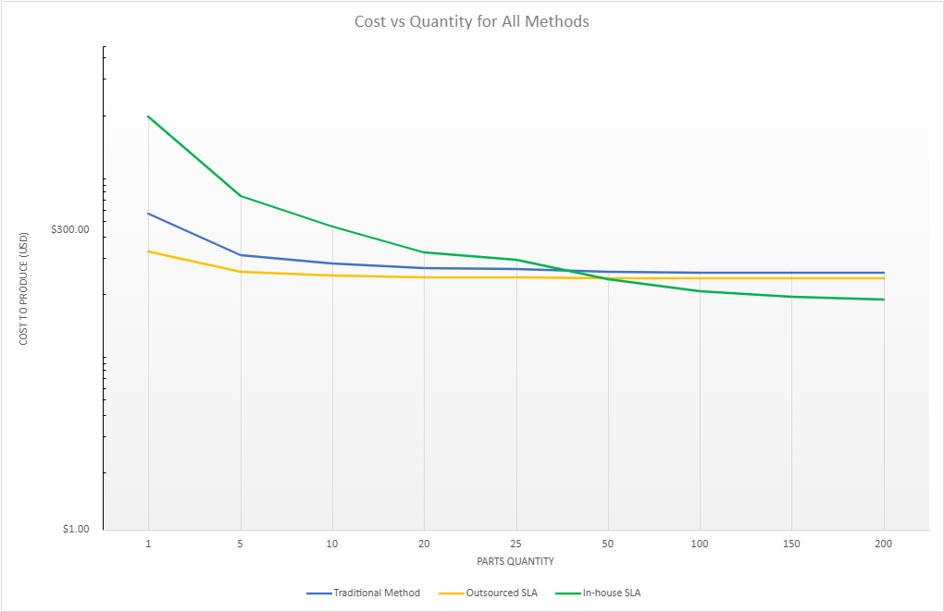
Fig. 6. Chart showing price of each method vs quantity of models produced, with logarithmic scale to better showcase critical points.0000000000000
The conclusion from this analysis is that for future testing, it will likely be best for the BDL to acquire a resin SLA printer to make flow phantoms, but for the purposes of validating the PIV design, outsourcing the manufacturing is likely a better use of limited funds. The traditional silicone casting method remains an option for specialist applications, but the relatively high cost per unit even at high quantities as well as the skill required to produce good models makes it a likely poor decision for this project.

3.3.6 Reynold’s Number for Neurovascular Blood Flow – Jett Scruggs
The Reynolds number is a dimensionless quantity that plays an essential role in fluid dynamics, specifically in Particle Image Velocimetry (PIV). It is a measure of the relative importance of inertial forces to viscous forces in a fluid flow. The formula for Reynolds number, especially in relation to arterial blood flow, is:
$$Re=\frac{(ρuD)}{μ} (9)$$
where ρ is the density of the blood (1060 kg/m³), u is the average velocity of blood travelling through the artery (0.55 m/s), D is the average diameter of the artery (1.83E-3 m), and μ is the dynamic viscosity of the blood (2.78E-3 Pa*S). All of these were standardized to 37 degrees Celsius, and in the Basilar artery. The results are shown below:
$$Re=\frac{(1060*0.55*1.83E-3)}{2.78E-3}=\sim 383.77$$
While the exact bounds are unknown for blood flow, this number suggests a normal (laminar) blood flow through the Basilar artery. A low Reynolds number indicates that viscous forces dominate, leading to smooth, laminar flow, while a high Reynolds number suggests turbulent flow where inertial forces cause chaotic fluid motion.
The Reynolds number for arterial blood flow is important for understanding the nature of blood movement within the circulatory system. It helps to determine whether the flow is laminar or turbulent. In healthy arteries, the Reynolds number typically suggests laminar flow, where blood moves smoothly in layers, which is efficient and non-disruptive to the vascular walls. However, if the Reynolds number becomes too high, it indicates turbulent flow, which can increase shear stress on blood vessels, potentially leading to conditions like atherosclerosis or arterial damage. Calculating this number is essential for understanding and managing cardiovascular health in relation to blood flow.

3.3.7 Particle Density – Chris Rapoport
While conducting a PIV study, it is important to have the correct particle density in your images. Particle density is how much of the area of interest is taken up by the PIV particles. If particle density is too low, there will not be enough data to accurately visualize the flow, while if particle density is too high the software will not be able to distinguish between the particles [6]. The particle density is given by the equation
$$PD= \frac{n_{particles}* A_{particle}}{A_{phantom}} (10)$$
where $n_{particles}$ is the number of particles, $A_{particle}$ is the average area of a particle in, and $A_{phantom}$ is the area of the phantom, both in cm². The purpose of this analysis is to determine how many particles are needed for a particular study, so we will solve the equation for $n_{particles}$
$$n_{particles}= PD\frac{A_{phantom}}{A_{particle}} (11)$$
since the flows we are measuring are moving, we must take that into account when measuring the number of particles to use, and the equation becomes
$$n_{particles}= PD\frac{A_{phantom}}{A_{particle}}* \frac{Q}{V_{phantom}}*t (12)$$
where $Q$ is the volumetric flow rate in mL/min, $V_{phantom}$ is the volume of the phantom in mL, and $t$ is time. Finally, since these particles are less than 100 microns in diameter they cannot be counted, so the number of particles is converted to the mass of particles needed
$$m_{particles}= \frac{n_{particles}}{p_{particles}} (13)$$
where $p_{particles}$ is the density of the particle, in g/cm³. To ensure that it is easy for BDL researchers to calculate the number of particles needed for a study, I made a MATLAB program that calculates the mass of particles needed when the particle and phantom dimensions, volumetric flow rate, and study time are input. The MATLAB program can be found in Appendix A.

3.3.8 Optimization of Camera and Lens Setup – Jett Scruggs
Having a functional setup for PIV is essential, but having one that is refined and optimized for all of the equipment included is important. Without this optimization, it would be harder to tune the equipment to work better with each other. What these equations serve to do is to provide confirmation that all of the specifications work well with each other, and in the case that they don’t, what could be a theoretical fix or solution for these problems. There are a few assumptions that were made about this optimization, which can be refined later as actual measurements are taken for the equipment as it is ordered. For example, these assumptions include the magnification of the camera lens (15), the length of the sensor (11.3mm), the wavelength of the laser (520nm), the numerical aperture (2), the refractive index of the medium (2.8), and the average flow velocity of the Basilar artery (0.55m/s).
The first equation is for further use in the later equations, and is listed below:
$$Pixel size=p=\frac{L_{Sen}}{L_{Res}} (\#)$$

This equation determines the size of the pixels, given the length of the camera’s sensor and the resolution length. This value is then used in the following equation:
$$FOV=\frac{L_{Res}p}{M}=\frac{1920(\frac{11.3}{1920})}{15}=.753mm (\#)$$

The field of view is important, as it essentially approximates the overall viewing window at a given resolution and magnification, using the calculated pixel size. Based on these values, this PIV setup would be able to view a space as small as .753mm at maximum resolution and at a magnification of 15.

$$Pixel Resolution=\frac{FOV}{L_{Res}}=\frac{.753}{1920}=3.92E-4mm/pixel (\#)$$

In a related fashion the pixel resolution essentially breaks the field of view down into the individual sizes of each pixel, inside of this field of view. While the overall pixel size would be calculated as p for no magnification and at the maximum length of the sensor, the pixel resolution takes the magnification into account, also referencing the overall viewing window.

$${Resolution Limit=δ}_{r}=\frac{1.22λ}{NA}=\frac{1.22(520)}{.2}=3.17E-3mm (\#)$$

The resolution limit essentially calculates the likelihood of optical blur. Becau1se this value is much larger than the pixel resolution, this essentially means that the sensor has more resolution than necessary, but the optics blur the image before the camera captures it. In order to fix it, the team would need better optics (higher NA, shorter wavelength, or better lens quality).

$$DOF=\frac{2np(1+M)}{M^{2}}=\frac{2(2.8)(\frac{11.3}{1920})(1+15)}{{15}^{2}}=2.34E-3mm (\#)$$

DOF in this case doesn’t represent degrees of freedom, but depth of field. What this means is the range of distance in imagery that appears acceptably sharp and in focus, which is vital for ensuring clear visuals for PIV. Essentially, particles outside of this value will begin to blur, and given the very small number, it is possible to decrease the magnification, reduce the resolution, or alter the n-value of the medium in order to increase the distance to an acceptable depth.
$${Motion Blur=B}_{m,200}=UT_{e}=\left(.55\right)\left(\frac{1}{200}\right)=2.75E-3mm (\#)$$

The motion blur value is smaller than the pixel size, which means that the motion blur at the given frame rate (200FPS) is within acceptable measures of motion blur. In order to lessen the risk of motion blur, the same equation was used for a frame rate of 600, which resulted in a much smaller number.

$${Motion Blur=B}_{m,600}=UT_{e}=\left(.55\right)\left(\frac{1}{600}\right)=9.167E-4 mm (\#)$$

While not entirely necessary, knowing that the frame rate could be increased to reduce motion blur is useful to the overall performance of the PIV system. The results of this optimization helped to better show how the specifications of the settings have real-world effects of the PIV setup. Notably, the results of the equations for the depth of field and the resolution limit showed some of the shortcomings of the setup at current theoretical settings, but with the components of the equations representing tangible values, it is possible to correct things. At the very least, these equations provide reasonable estimates of what the real-world values would actually be, which helps to streamline the process of tuning and calibrating each component with respect to each other.

Design Concepts

Functional Decomposition
The first component of the functional decomposition for the PIV system is the black box model. This model focuses on the flow into and out of the camera subsystem, as that is where the most important data in the system is generated. This is pictured below in Figure 7.

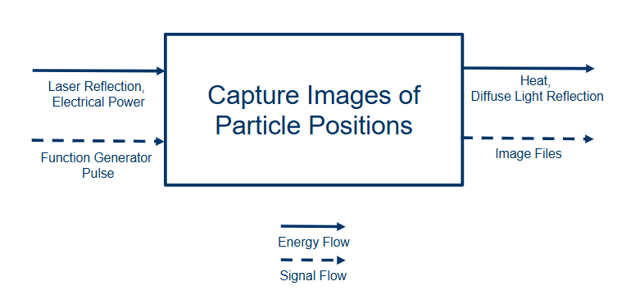
Fig. 7. Black box model component of system functional decomposition.

The next part of the functional decomposition for the PIV system is a subsystem breakdown. This allowed the team to understand how the various subsystems worked together, and where concept selection processes would need to take into account the design ramifications on other subsystems. The subsystem functional decomposition is pictured below in Figure 8.

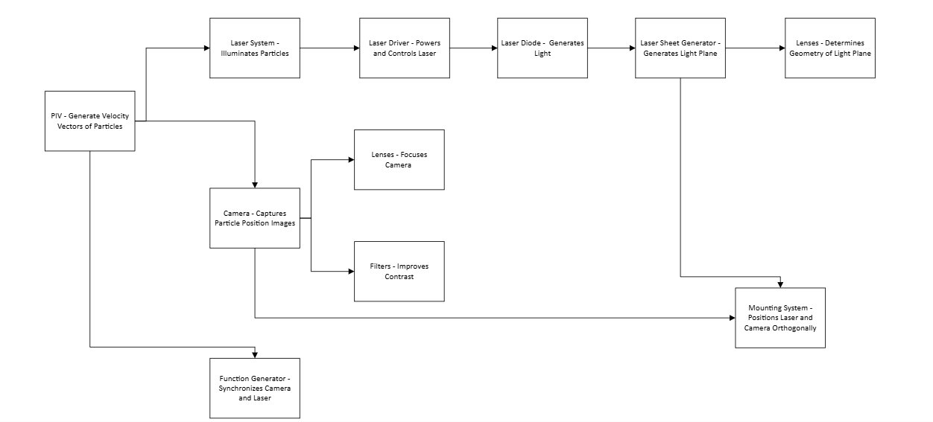

Fig. 8. Subsystem functional decomposition flow map.

This flow map can be seen as a visualization of the relationship established between engineering requirements inside the Quality Function Deployment Diagram presented in section 2.3. The most important conclusion is that each subsystem is largely independent, so maximizing the quality and utility inside each subsystem is the most important goal for the concept selection process.

Concept Generation

Camera – Jett Scruggs
In terms of concept generation, the camera selection was primarily shaped by the need to meet specific performance requirements, including resolution, framerate, and memory capacity to maintain high-quality imaging for about 10 seconds. The resolution had to be sufficient to clearly capture 30µm diameter tracer particles, while the framerate needed to be high to accurately track their movement. Additionally, the camera’s memory had to be able to sustain this performance over the duration of the capture to avoid missing important data.
Generally, the majority of the concept generation came down to the above criteria. For higher-tier options, we would be forking over upwards of $15,000 for a camera, albeit with +2MP resolution at a couple thousand frames per second, and a memory to record more than ten seconds at a time. On the lower end, a cheaper camera would record at 1000 frames per second at a fraction of that resolution for ten seconds, or even at 200 frames per second at 1.3MP and an even shorter amount of time. Because of this, the team opted for a mid-tier option, looking at about 1.3MP at 1000 FPS, for 10 seconds.

Laser – Rory Kian Pack
Concept generation for the laser subsystem was largely constrained due to the fact that an existing laser driver/diode was gifted to the PIV team from the NAU Bioengineering Devices Lab. This presented an option, that while not optimal, was incredibly cost efficient compared to all others.
Nonetheless, extensive research was still conducted to see what other options existed for superior laser systems at a reasonable cost. These options fell into 2 main categories, with one being diode packages for the existing laser driver, and whole new laser packages. All laser diode packages had to fit A, D, or G Pin code connectors for 5.6mm Diameter TO Can laser diode connectors. Ideal options would include fiber pigtails pre-installed.
New laser systems were selected based on ease of integration with the system overall, with special attention given to purpose-built PIV laser systems. Pulsed laser systems were also favored in this category as they might be easier to consistently modulate than a continuous wave diode laser system. All considered options, with their relevant specifications are shown below in table 7.

Table 7 – Laser Specification Matrix
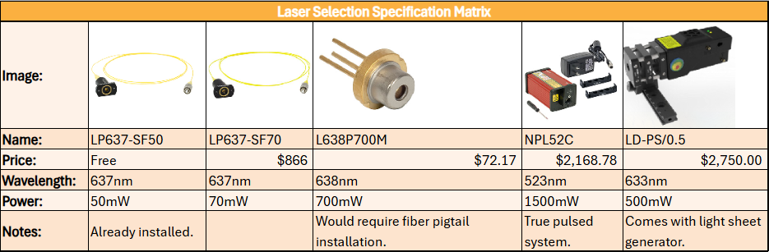

Function Generator – Chris Rapoport
Concept generation for the function generator was focused on identifying a number of options that fit the requirements that the client provided us, while presenting products at a range of prices in order to potentially save money for more critical components, if needed. For the function generator, the only requirement that our client gave us was that it’s resolution must be in the nanosecond range. While resolution was the only hard requirement the client gave us for the function generator, different options were evaluated by a number of metrics, which will be discussed further in section 4.3.3.

Configuration – Santiago Gamez
Four configuration designs were created modeling different possible configurations for the three main components of the PIV system as a whole. These three components include the laser system, the camera, and the cart. Each of these designs is pictured below with a brief description of the design and its pros and cons.
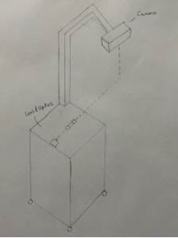
Fig. 9: Hanging Camera Design
This design includes a cart with the laser and optics resting on top, with the camera connected to the cart via an arm extension. This design allows for the camera to be perpendicular to the laser from above. Where the dashed lines meet is the point of intersection of the laser and camera aiming at the testing model. The pro of this design is its setup time. Since everything is connected to the cart, the setup process will be very fast allowing the user to roll the cart to the point of operation. The cons of this design include its versatility, cost, and weight. With the camera above, it is only possible to have one to two positions of the cart around the point of operation which is not very versatile. Because the cart will have an arm extension connected to the camera, the cost to manufacture this cart will be greater and will in turn weigh more than other designs.
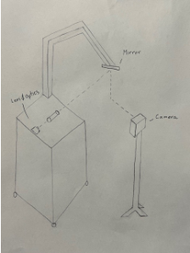
Fig. 10: Hanging Mirror Design
This design includes an adjustable cart with the laser and optics resting on top and an arm extension that has a mirror on it directing the laser at the intersection point from above (shown with dashed lines). The camera is on a separate mount directed at where that laser is pointing down from the mirror. The pro of this design is its versatility. Due to the laser hitting the mirror from above, it allows for three different points of operation around the testing area. It is possible to position the mirror so that the laser hits the mirror above the testing area, but it is also possible to lower this adjustable cart and hit the laser directly at the testing area from the side. Without the laser directed at the mirror, this design would operate like the Cart and Camera design which has two points of operations around the testing area. With the mirror this design has another point of operation from above which is what makes it the most versatile and has three points of operation. The cons of this design include its setup time, cost, and weight. In redirecting a laser with a mirror, it will require time to line up the mirror with the laser so that it hits the testing area perfectly from above. This will make the setup process for this design more time-consuming and possibly strenuous. The cost of the adjustable cart (adjustable in height) with a mirror and arm extension will make it the most expensive and heaviest design.
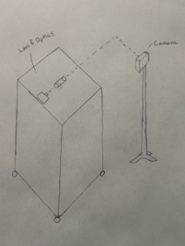
Fig. 11: Cart and Camera
This design includes a cart with the laser and optics resting on the top with the camera on its own mount on the side. This is the simplest design with it having a standard cart with no arm extensions. The cart will be rolled to the point of operation with the camera being carried separately. The pros of this design include the setup time, cost, and weight. The setup process should be quite fast as it will only require the user to roll the cart to the point of operation and move the camera mount perpendicular to that point. The cost and weight of this design are the least possible by utilizing a standard cart and a separate standard camera mount on the side. The con of this design is its versatility. Since there is no way for the camera or laser to be properly directed at the testing area from above, it only has two points of operation around the table. Because the cart will have an arm extension connected to the camera, the cost to manufacture this cart will be greater and will in turn weigh more than other designs.

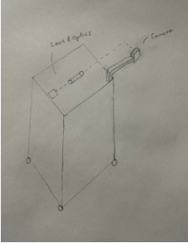
Fig. 12: Rolling Camera
This design includes a cart with the laser and optics resting on top, but instead with an arm extension horizontal to the side of the cart. The pro of this design is its setup time. Because the camera is connected to the cart with the correct distancing, the user will be able to roll the cart to the point of operation and all components of the PIV system will be aligned correctly. The cons of this design are the versatility, cost, and weight. Since the camera is connected directly to the cart from the side, only two points of operation are possible around the table which makes it not very versatile. Because the cart will have an arm extension connected to the camera, the cost to manufacture this cart will be greater and will in turn weigh more than other designs.

Selection Criteria

Camera – Jett Scruggs
The selection criteria for the camera were notably driven by the requirements for its performance at a given framerate at a certain resolution, and how much memory was needed to achieve this quality for about 10 seconds. For the resolution, the images required for this project must be fairly detailed in order to show the tracer particles fluorescing within the system, which are about 30µm in diameter. In addition, the number of images produced per second must be high, as this allows for better tracking of the behavior and movement of particles through the system. On top of this, the memory stored in the camera must be high enough to support this resolution and framerate for a sustained time, because if a window is too short, then the users might miss the opportunity to record crucial information. With a budget of between $5000-8000, the potential options for a camera were limited, but not entirely unobtainable.
From the research conducted, the team found several camera options that fit the budget. These options are shown in the Concept Selection section, but they consisted of both new and used cameras within the price range. It was important that we left enough of a budget for additional costs, however. For example, some cameras require separate lenses in order to function, the cost of which ranges from a couple hundred to over a thousand dollars.

Laser – Rory Kian Pack
The two most important specifications for this subsystem are wavelength and pulse energy at a given pulse width. The relationship between repetition frequency and pulse energy was already discussed at length in the engineering analysis section of this report. Wavelength is particularly important because different wavelengths of laser require different fluorescent tracer particles and different camera light filters.
Wavelength for each laser system is measured in nm, and pulse energy is indirectly measured by laser optical output power in mW.
Since the ultimate application of this system is not yet fully determined, in-depth conversations were had with both the client and the project’s technical advisors to determine what level of laser would be necessary for the flow regimes likely to be encountered.
Ultimately, 3 diode options for the CLD1010LP laser driver were chosen for final concept selection, while 2 additional complete laser systems were also considered.

Function Generator – Chris Rapoport
As mentioned above, the only hard customer requirement for the function generator was that it must have a resolution in the nanosecond range at a minimum. Other specifications that were considered while evaluating different products were jitter, the number of channels, the trigger rate, and how user-friendly the generator is. Resolution, the most important of the specifications, is a measure of the smallest time step between pulses the generator is capable of. The jitter is a measure of how accurate the timing of the generator is. The number of channels determines the number of external devices, in our case lasers and cameras, that the generator can control. The user-friendliness of the generators was determined subjectively based on whether the function generator had knobs and buttons, or if it requires the user to program the settings on a computer. Aside from the user-friendliness, all these specifications were provided by the manufacturer of the generator.

Configuration – Santiago Gamez
The four main criteria for the configuration of the PIV is the setup time, versatility, cost, and weight. These criteria were made to make certain the team meets the customer’s need “ease of use” and other limitations of the project including money. The goal for the setup time is to be able to operate the PIV system in under 60 minutes. Setting up other components of the PIV like the multifunction generator will take time, which means moving the main components of the configuration will need to take as little time as possible to assist the process. The versatility criteria emphasizes different points of operation for the PIV, which will allow the users to potentially use the PIV system for multiple applications. It is also possible that different points of operation around the testing area will allow for better information gathered. This is something to consider when making versatility a priority. Due to other components of the PIV such as the laser, camera, and generator being expensive; making the cart as simple as possible will allow the team to save money and allocate it to other parts of the PIV. The cost criteria for the configuration makes certain that the team does not spend much money on the cart and camera mounting system. The weight criteria is to ensure the client will be able to move the components of the PIV easily. If the product weighs too much, then this could also lead to a more difficult setup process.

Concept Selection

Camera – Jett Scruggs
Table 8: Decision Matrix for Potential Camera Options
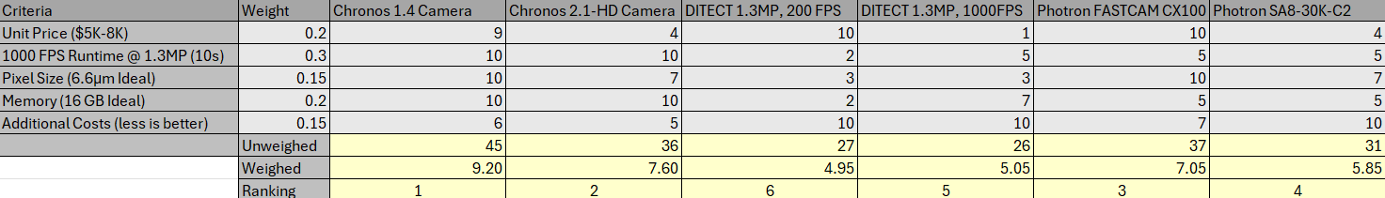
The above table holds much of the data used for determining how the cameras compare to each other, especially when considering factors like performance at certain resolutions and framerates, and for how long. Additional relevant information such as the price, pixel size, and additional costs are all included (if the information was available). From this, and the weights given, it was found that both Chronos cameras and the CX100 were the best available options to use. Pending further analysis and research between these options, one will be selected for future use during the project.

Laser – Rory Kian Pack
The specification table included in section 4.1.2 summarizes the information communicated to the client and technical advisor in meetings regarding the generation of the final concept. The final decision was made to use the LP637-SF50 diode alongside the CLD1010LP driver for initial testing, with the Thorlabs NPL52C Nanosecond Pulse laser slated to be integrated into the final system. While the CLD1010LP is a cost-effective option for optics and function generator testing, its low power, continuous wave nature, and red output were deemed insufficient for the system. The NPL52C is a true pulse laser, allowing for microsecond precision with nanosecond pulse length. This system also produces green light, which significantly increases the options for compatible fluorescent particles.

Function Generator – Chris Rapoport
Table 9: Function generator specifications table
 | Stanford Research DG645 | Quantum Composer 9520 | BNC 750 | BNC 725 | BNC 575 | BNC 525
Resolution | 5 ps | 250 ps | 100 ps | 10 ns | 250 ps | 4 ns
Jitter | <100 ps | <50 ps | <50 ps | < 200 ps | <120 ps | <250 ps
Channels | 4 | 4,8 | 4,8 | 8 | 4,8 | 6
Trigger Rates | 1 MHz | 20 MHz | 50 MHz | 100 MHz | 10 MHz | 20 MHz
Price | $4,495 | $4,300-$6,200 | $3,450-$5750 | $6,690 | $4,800-$6,700 | $2875
Comments |  |  | No interface |  | LabView Certified | No Interface  LabView Certified
Above is the table used to communicate the results of the function generator concept generation to the client. After consulting with the client the decision was made to move forward with purchasing the Quantom Composeer 9520, primarily due to the cost as well as the fact that this model has an interface with nobs and buttons

Configuration – Santiago Gamez
Table 10: Pugh Chart: Configuration

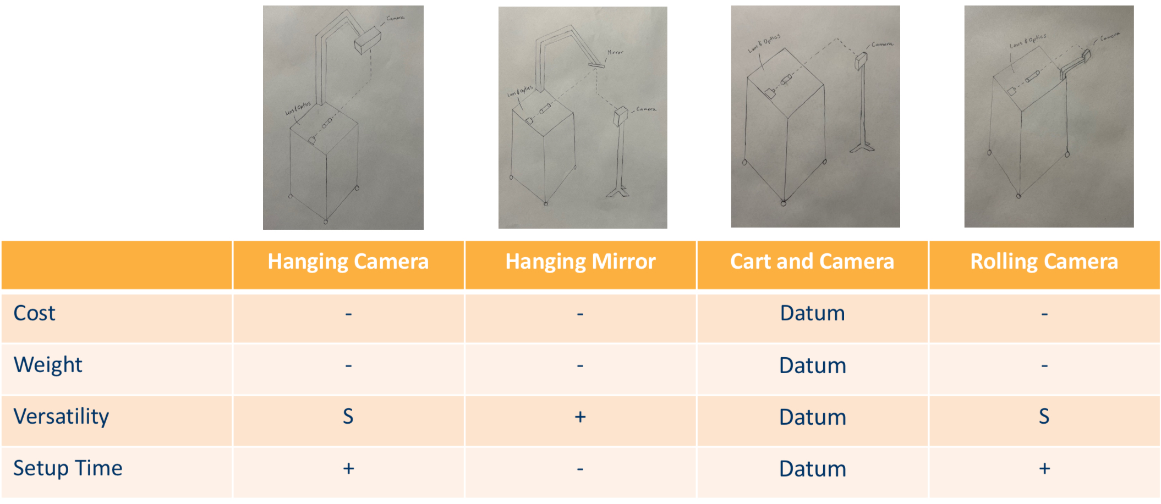
The Pugh chart shown above lists each design and compares it to the datum design, “Cart and Camera”, based on each criterion. The “Cart and Camera” design is the datum because it is the simplest design that meets all necessary criteria. If the design is ranked lower in that criterion a minus symbol is shown, if ranked higher a plus symbol is shown, and if ranked the same an “S” is shown. Based on the results shown above it would be best to pick our datum design, “Cart and Camera”, because no other designs have a greater number of pluses than minuses. An early CAD model of this design is shown in two pictures below along with a brief description.
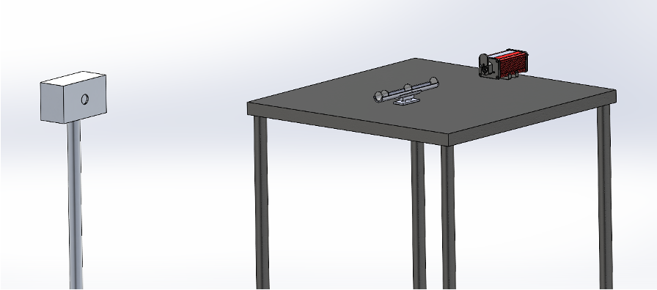

Fig. 13: Cart and Camera Conceptual Design

The components of this design include a table (cart), the laser and lens system resting on the table, and the camera orthogonal to the laser on a separate mount. The lens configuration on the table is modeled after the theoretical lens system discussed in section 3.3.2.

Schedule and Budget

Schedule
Shown below in Figure 14 is our schedule from March 14 through to the end of the semester. We are currently behind on ordering our principal components as our client opted to perform initial testing with a camera currently on-hand at the BDL, so the camera will likely be purchased over the summer. Tasks to be completed before the end of the semester include initial testing, the second prototype build and website checks, the final CAD and BoM, and our individual analysis homework. Shown in Figure 15 is our projected schedule for the fall semester, including all class deliverables, design builds, and website checks as well as the process for registering and presenting at the Engineering Fest and handing off the final design to our client.

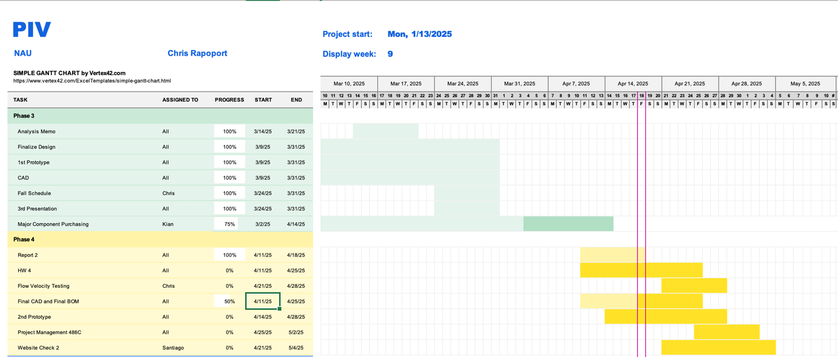
Figure 14: Schedule for the remainder of the spring semester.

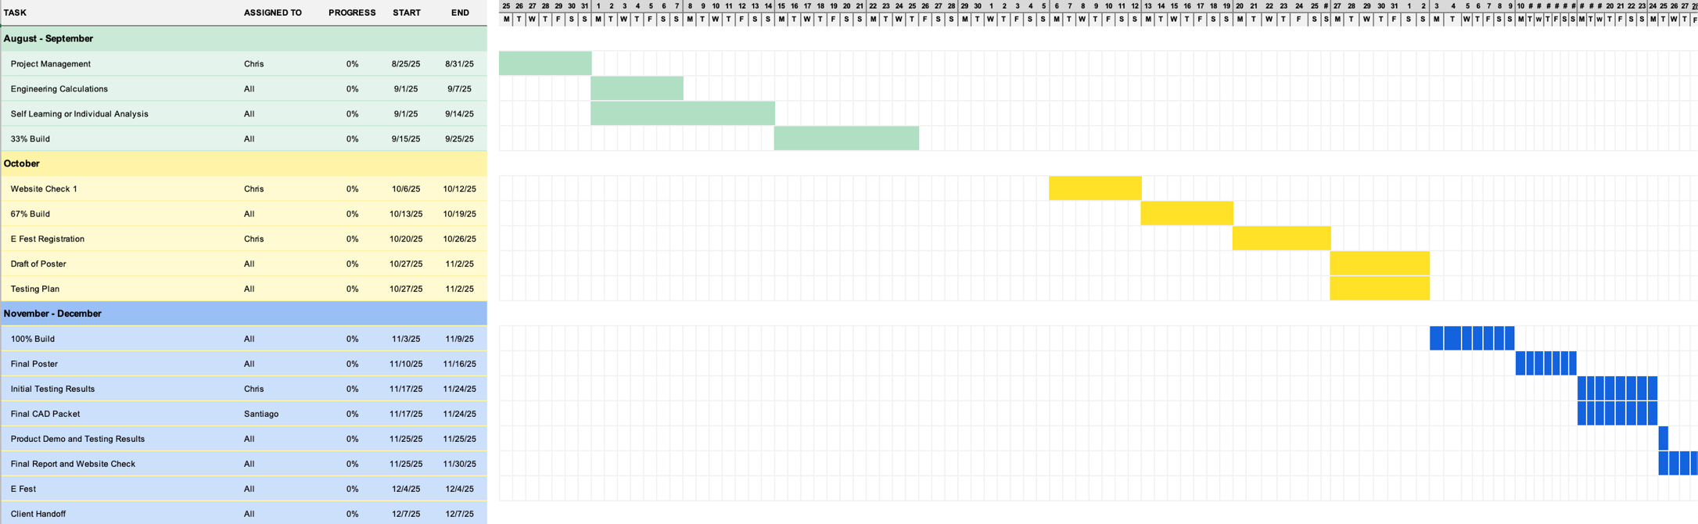

Figure 15: Tentative schedule for the fall semester.

Budget
The vast majority of the critical equipment purchases for the PIV system have already been completed, with the camera remaining the last major component to be purchased. The current budget allocation and existing expenses are detailed in figure 16 and table 11 below:

Fig. 16. Graphical breakdown of budget and expenditure, with actual being paid costs, committed being allocated but unpaid, and available being assigned to systems but unallocated.

Table 11 – Breakdown of Budget and Expenditure
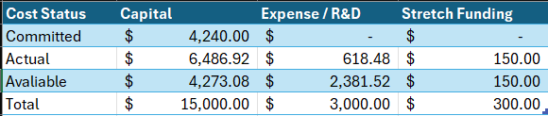

Below, table 12 shows the exact breakdown of all actual line items across all 3 funding categories.

Table 12 – Breakdown of Actual Budget Line Items
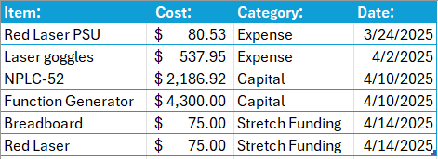

The line items under stretch funding are valued at the maximum allowable amount for their contribution to the capstone fundraising requirement- just a fraction of their actual purchase or trade value. Once the team has completed testing using the CLD1010LP red laser, it will likely be sold on the secondary market to help fund any extraneous expenses encountered on the back half of the project life cycle.

As far as fundraising goes, since the team did not receive the HURA grant this semester, each member has agreed to personally contribute an equal portion of the remaining $150.00 fundraising requirement not covered by donated equipment. Further options in terms of material, labor, and community contributions are also being taken into considerations as additional areas of improvement for equipment are found in the project.

Since testing will require only lab time, electricity, and team member labor it is neglected in our overall cost and budget analysis. The cost of consumables such as fluorescent particles are included in the available portion of the R&D budget- these particles are priced in the range of $200-400 for the amount needed in testing.

For a more specific breakdown of individual part prices, see the Bill of Materials in section 5.3.

5.3 Bill of Materials
Table 13 - Bill of Materials
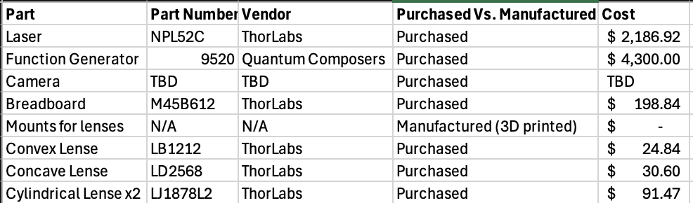

6 Design Validation and Initial Prototyping

6.1 Failure Mode and Effects Analysis
The team’s FMEA was conducted with the help of a spreadsheet that aligns failure modes with severity, risk, detection strategies, and mitigation actions. Due to the simple nature of mechanical components in the system, and the fact that the vast majority of them are not going to be manufactured in-house, most potential failures are electronic or thermal in nature. Table X on the next page details FMEA concerns collected by the team.
The primary concerns that will be mitigated through testing and design revisions are those related to thermal management and laser safety. The thermal management concerns are going to be evaluated in two ways: through CFD analysis of enclosure cooling, and through experimental testing of the design at max duty cycle for a long period of time. This testing will significantly exceed the use case for our client, allowing us to find the actual limits of the system from a thermal longevity standpoint. The safety concerns are going to be managed using industry standard laser safety mitigation methods, alongside traditional machine guarding, and Lock-out Tag-out Test-out procedural methodologies.
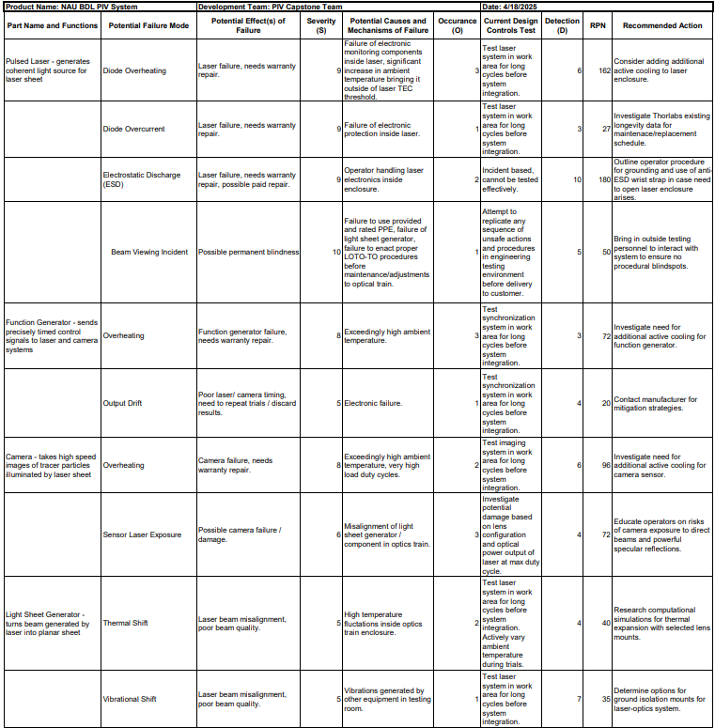
Table 14 – FMEA Investigation Results

6.2 Initial Prototyping
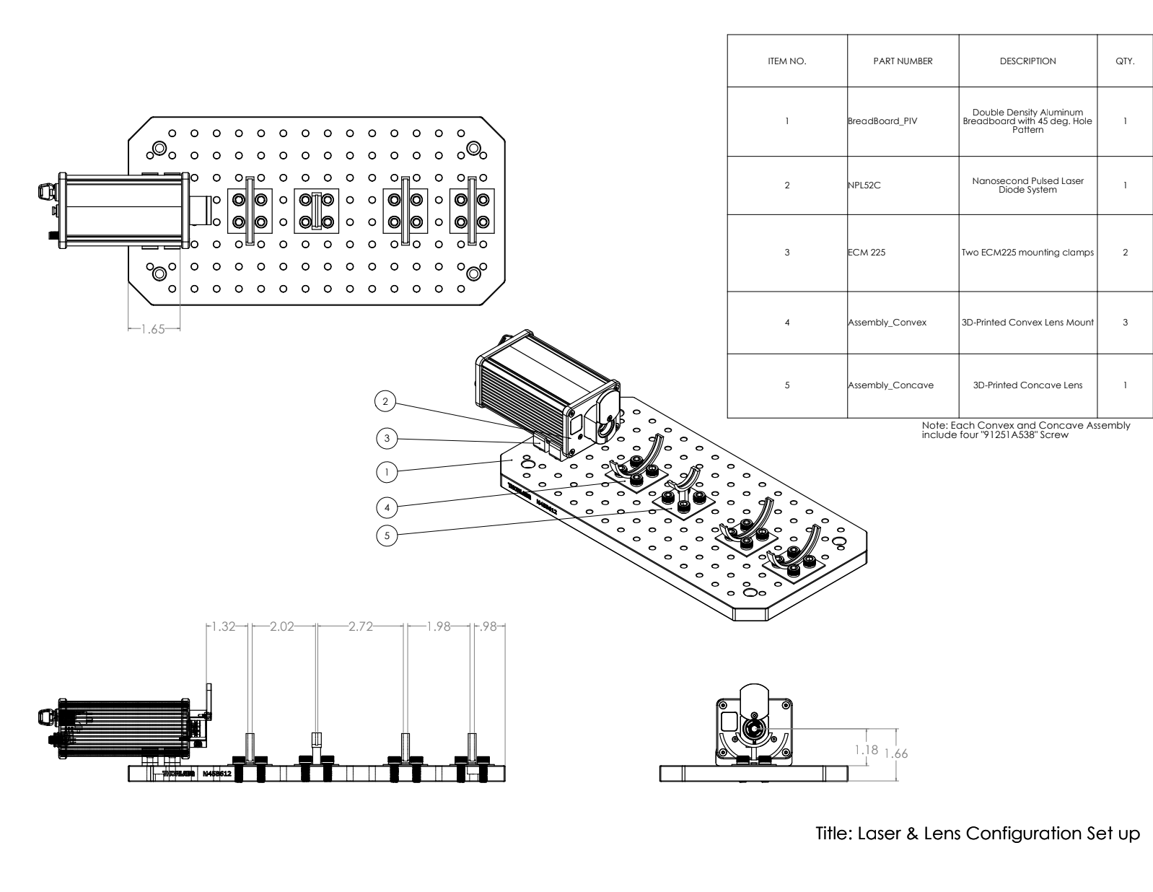
Fig. 15. Lens Configuration Assembly Prototype 1 (system)
Figure _ above is the assembly drawing of the team’s first prototype for the lens configuration of the PIV system. This prototype included the laser, convex and concave lens mounts, and a breadboard.
The function is as follows, first the laser turns and passes through the convex lens to contract the beam, then the laser passes through the concave lens to expand the beam to the desired thickness. After this the laser will pass through two cylindrical lenses to diverge the beam first in the x-direction, and then again in the y-direction. For this prototype the second set of mounts was the same, but in future iterations there will be cylindrical lens mounts in place with them. The hypothesis is that the behavior of the laser beam mostly relies on the first two lenses. It will be useful to complete early tests using the first two lenses alone and then continue in research on how the cylindrical lenses will affect the laser beam after.
The goal of this prototype was to create a possible lens configuration for base level testing. If we can 3D print mounts and get them lined up on a breadboard, then we can do early testing with a less powerful laser. We learned that the breadboard could hold all the lens configuration components, as well as the laser. Based on the info learned from the design process the team will be able to complete early testing with 3D printed mounts and cheap lenses. This will allow us to understand more on how the laser will travel through our theoretical lens train.
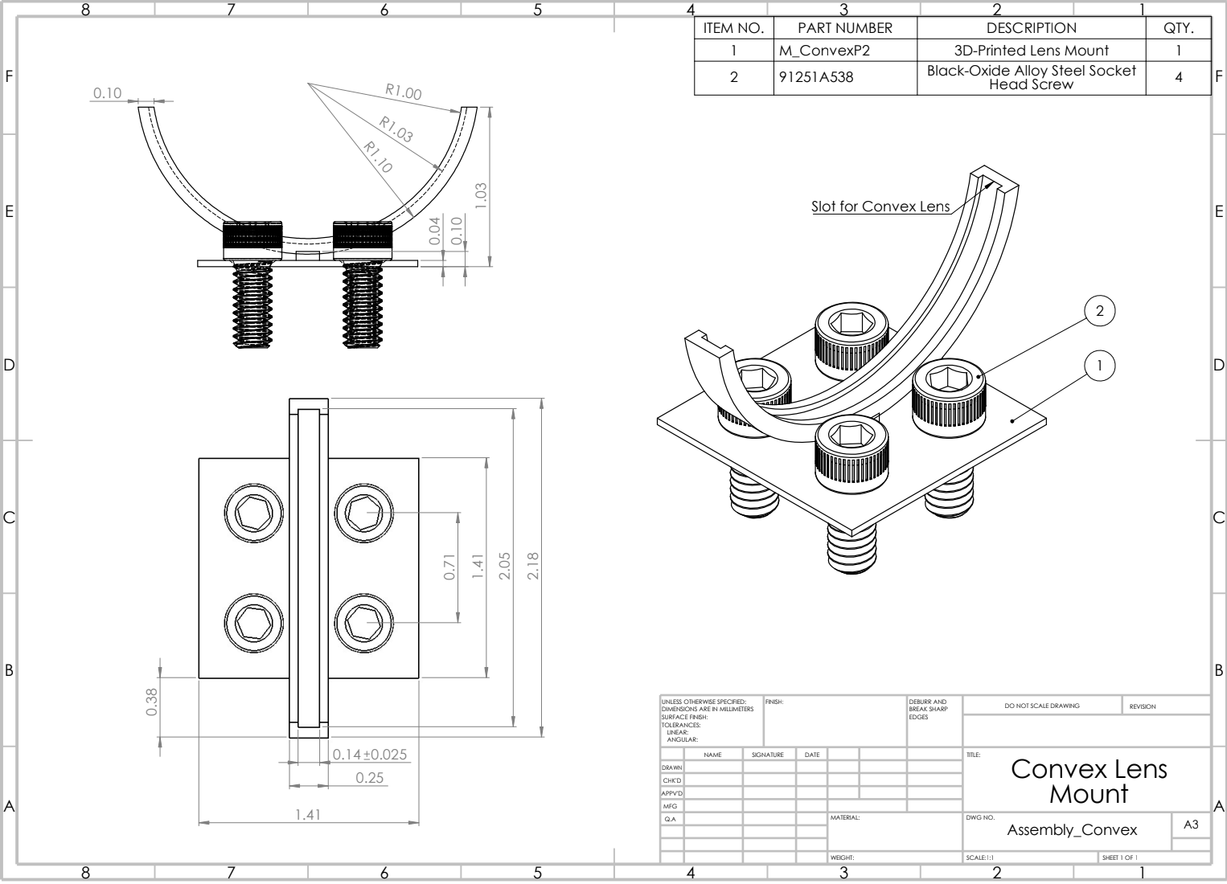
Fig. 16. Convex Lens Mount (sub-system)
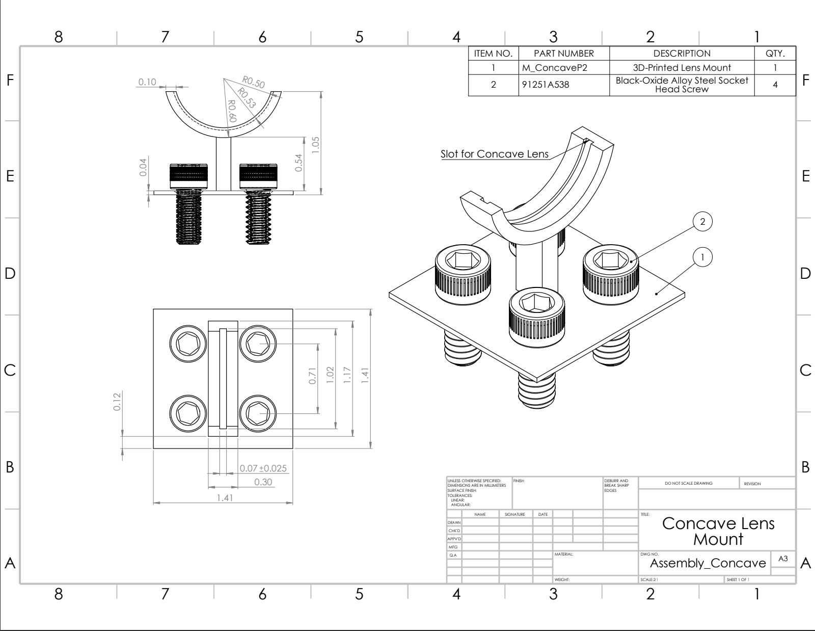
Fig. 17. Concave Lens Mount (sub-system)

Figures 16 and 17 above are the drawings of the convex and concave lens mounts designed for the lens assembly. This prototype gives the team useful information such as if the center of the lens is lined up with the center of the laser diode, and at what height will this be accomplished. To make this prototype successful the correct dimensions had to be considered with respect to the laser and the breadboard. With this we learned that the correct height for the distance between the laser diode and the breadboard was 1.18 [in]. This informs the parameters for the lens mounts moving forward and allows the team to have a successful design. It is worth noting, the only difference between the two lens mounts is the radius that the mount complies with. Moving forward it is possible that the team will change the radius of the lens and or the lengths between them, but now the team has set parameters for adjusting to what the situation deems necessary.

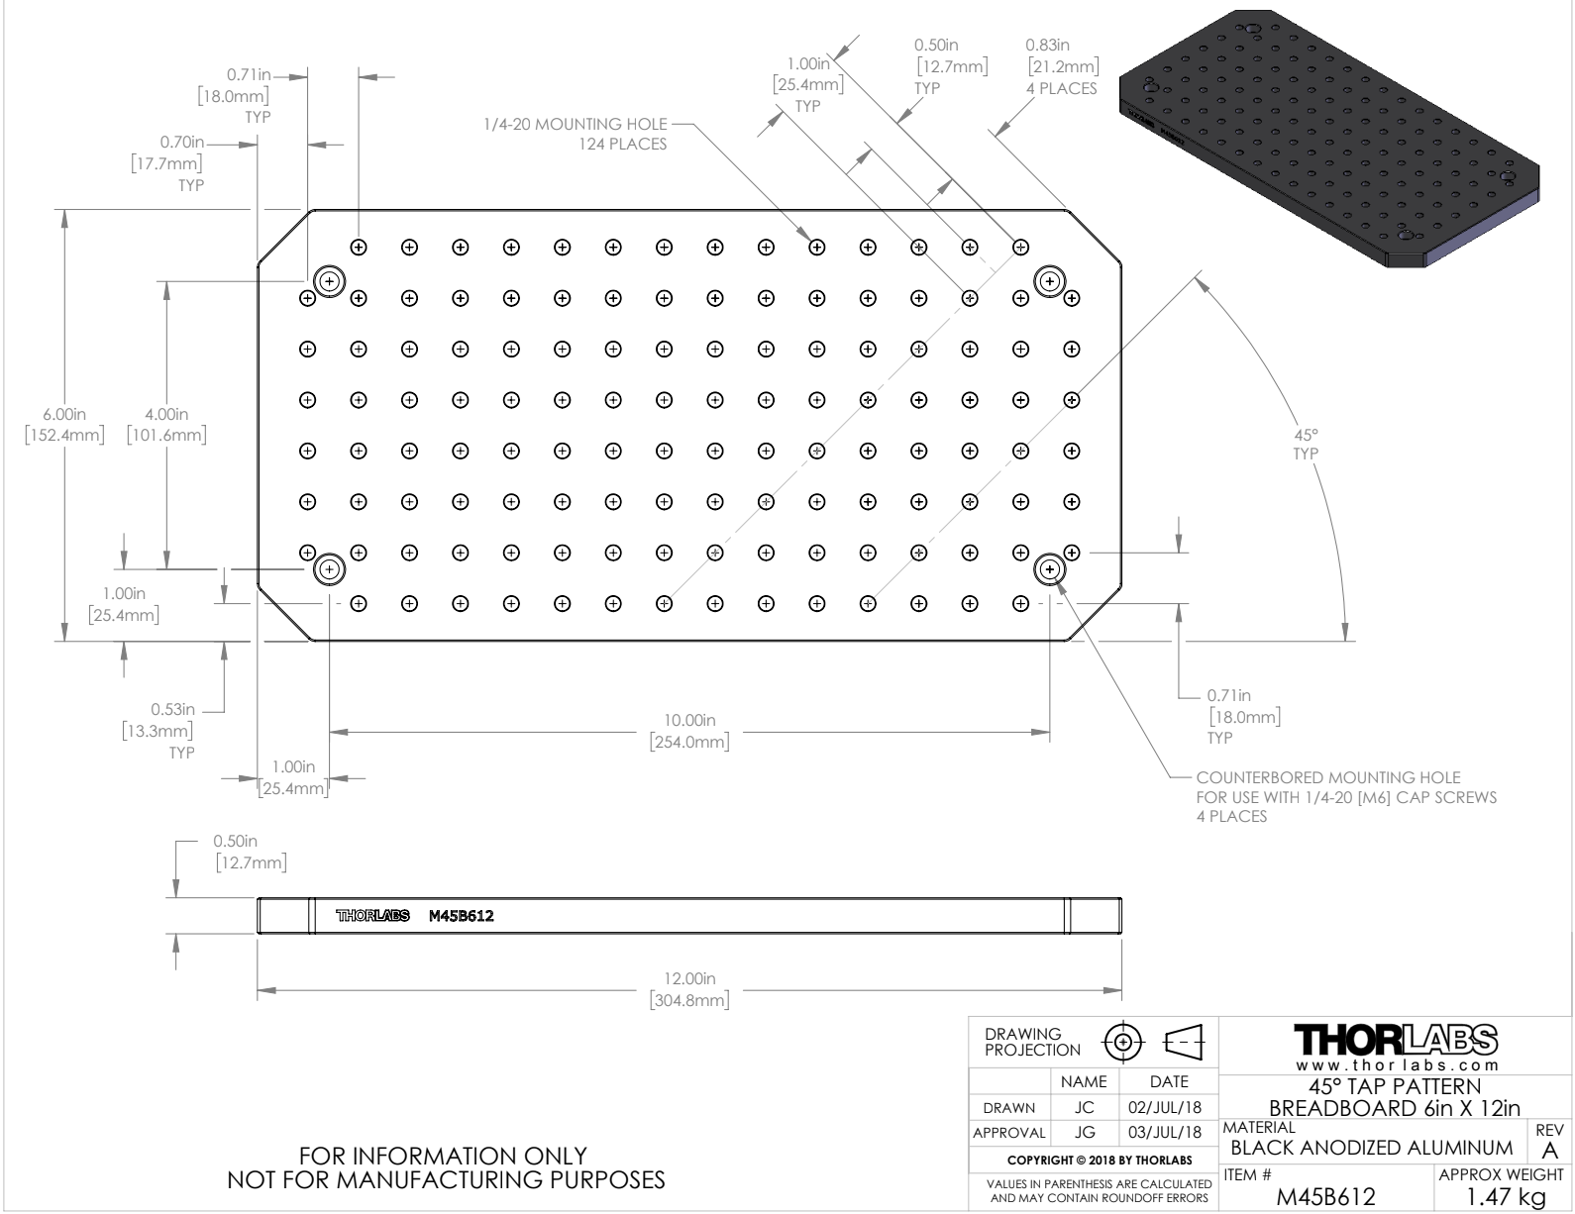
Fig. 18. Breadboard (sub-system)
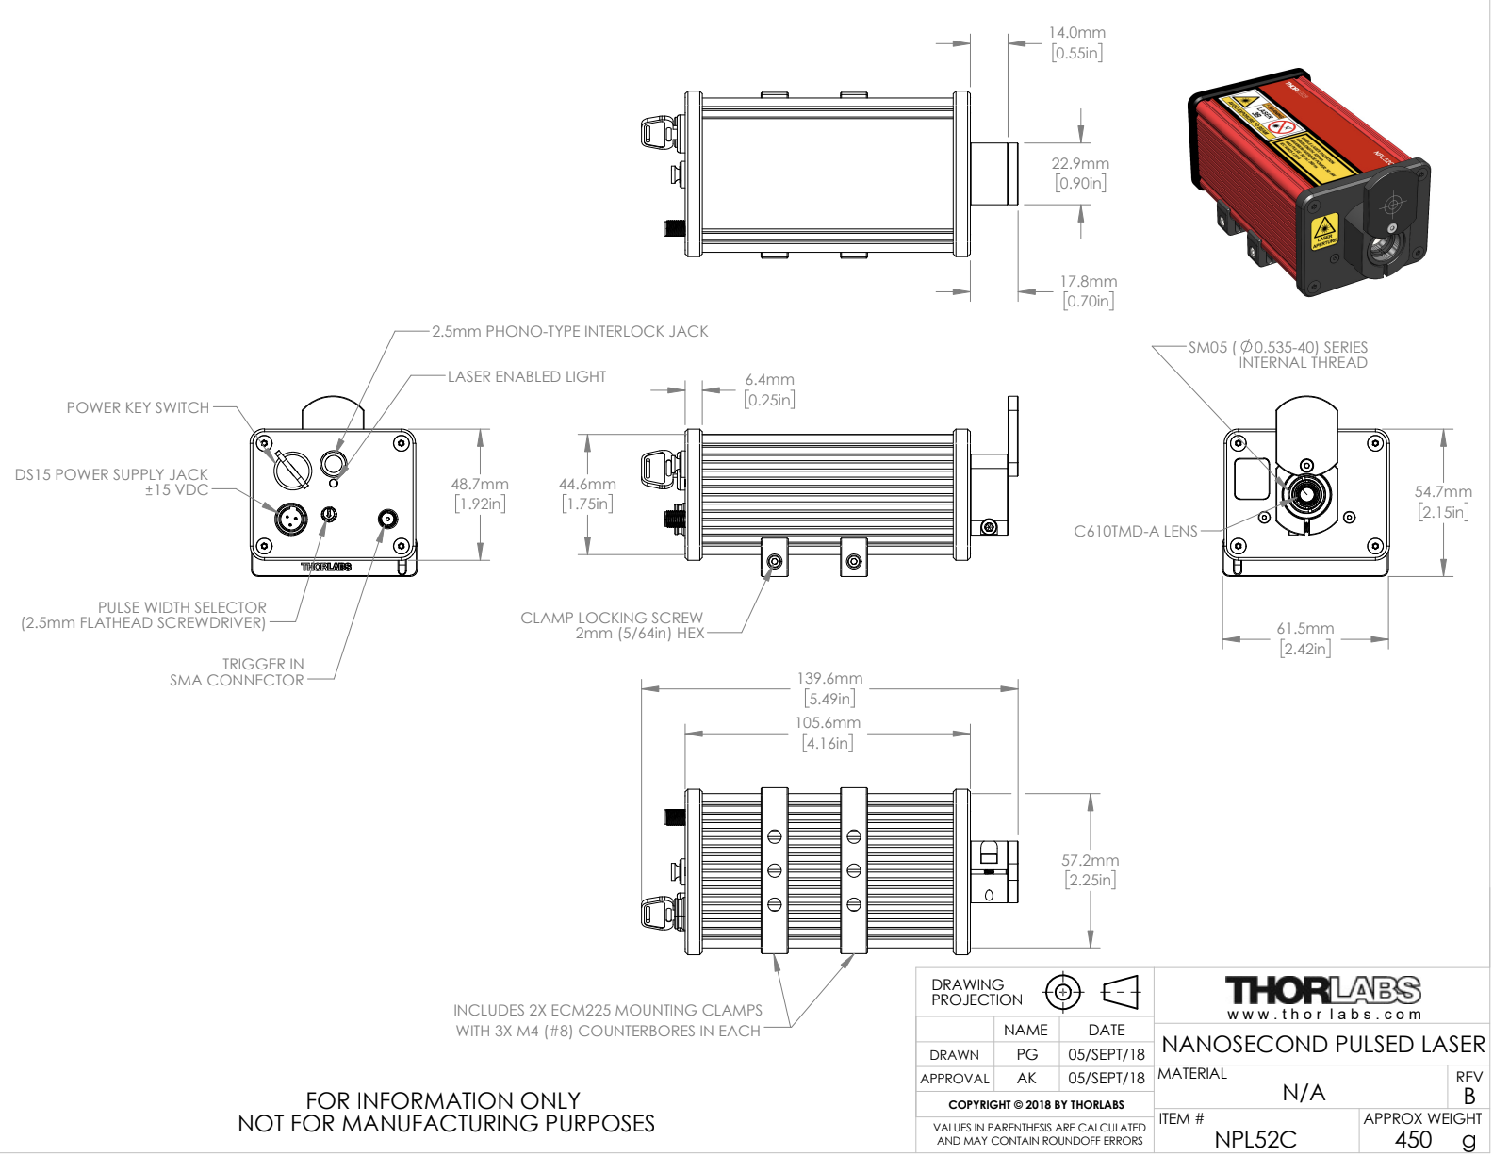
Fig. 19. Laser (sub-system)
Figures 18 and 19 are drawings of the breadboard and laser that informed our design’s parameters moving forward. The breadboard was donated free of charge and was utilized for the base of the lens configuration system. Besides its cost, it can hold a maximum weight of 38 pounds and should be an optimal length as well. This breadboard is used to hold all the lens mounts in line and in place; and was utilized to parametrize the measurements for the lens mounts. From this point the laser chosen through concept generation, was placed onto the breadboard to analyze how it would rest on the board. This gave useful information in respect to how much leftover distance is on the breadboard for the lens mounts. These two components, the laser and breadboard, allowed for valid approximations of the lens mounts created and informed the teams’ prototypes moving forward.

Other Engineering Calculations

6.3.1 Laser Sheet Generator – Santiago
After analyzing what would hypothetically work using the equations from Shashikant Verma, it was necessary to break down what information Verma utilized and try to make progress with our configuration [18]. This led to utilizing the principles of the Galilean expansion theory to find the focal lengths of the first concave and convex lens necessary for the lens configuration. To start, the laser has two angles of divergence on the major and minor axis. For the green laser utilized the major and minor axis are 3.7 and 0.6 micrometers. Using each axis will result in a different initial beam waist value, $w_{o}$. To stay in respect of Galilean expansion, the major axis of 3.7 was used for these calculations. This initial beam waist value, $w_{o}=44.73 micrometers$, is then multiplied by the square root of two to get the of variation of the beam, $w\left(z\right)=63.26 micrometers$. This variation of the beam is the wavefront of the beam at a working distance $z$ [19]. From this point the Galilean expansion techniques were utilized. According to edmund optics the magnification power, $MP$, is the ouput beam diameter, $D_{o}$, divided by the input beam diameter, $D_{i}$ [41]. To compliment this according to a different edmund optics article, $MP$ is equal to the focal length of the positive lens, $f_{+}$, divided by the focal length of the negative lens, $f_{-}$ [42]. The next step in the process is to find focal lengths with values that equal the ratio of, $MP=D_{o}/D_{i}$. This process led to a theoretical solution for the focal lengths of the concave and convex lenses viable to achieve a laser beam diameter of 0.1 millimeters. After solving for the value of the focal lengths using what was available online and what matched the diameter ratio, the length, $L=15 mm$, necessary between the two lenses was found using the sum of the focal lengths [42]. For this altered lens configuration using the Galilean expansion theory, the concave lens is the first lens of the system before the convex lens. It is worth noting that this is opposite of what is displayed in the first prototype. It was thought that the Galilean expansion theory could be utilized in the reverse direction, but this was proved incorrect after further research [43]. The calculations performed and a picture representing the first two lenses in the configuration, concave and convex, are displayed below:
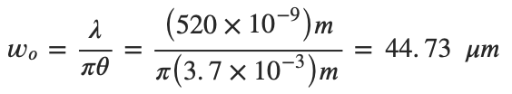 (14, [18])
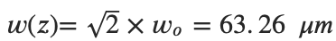 (15, [19])
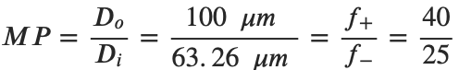 (16, [42])
(17, [42])
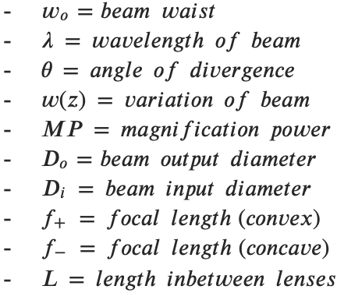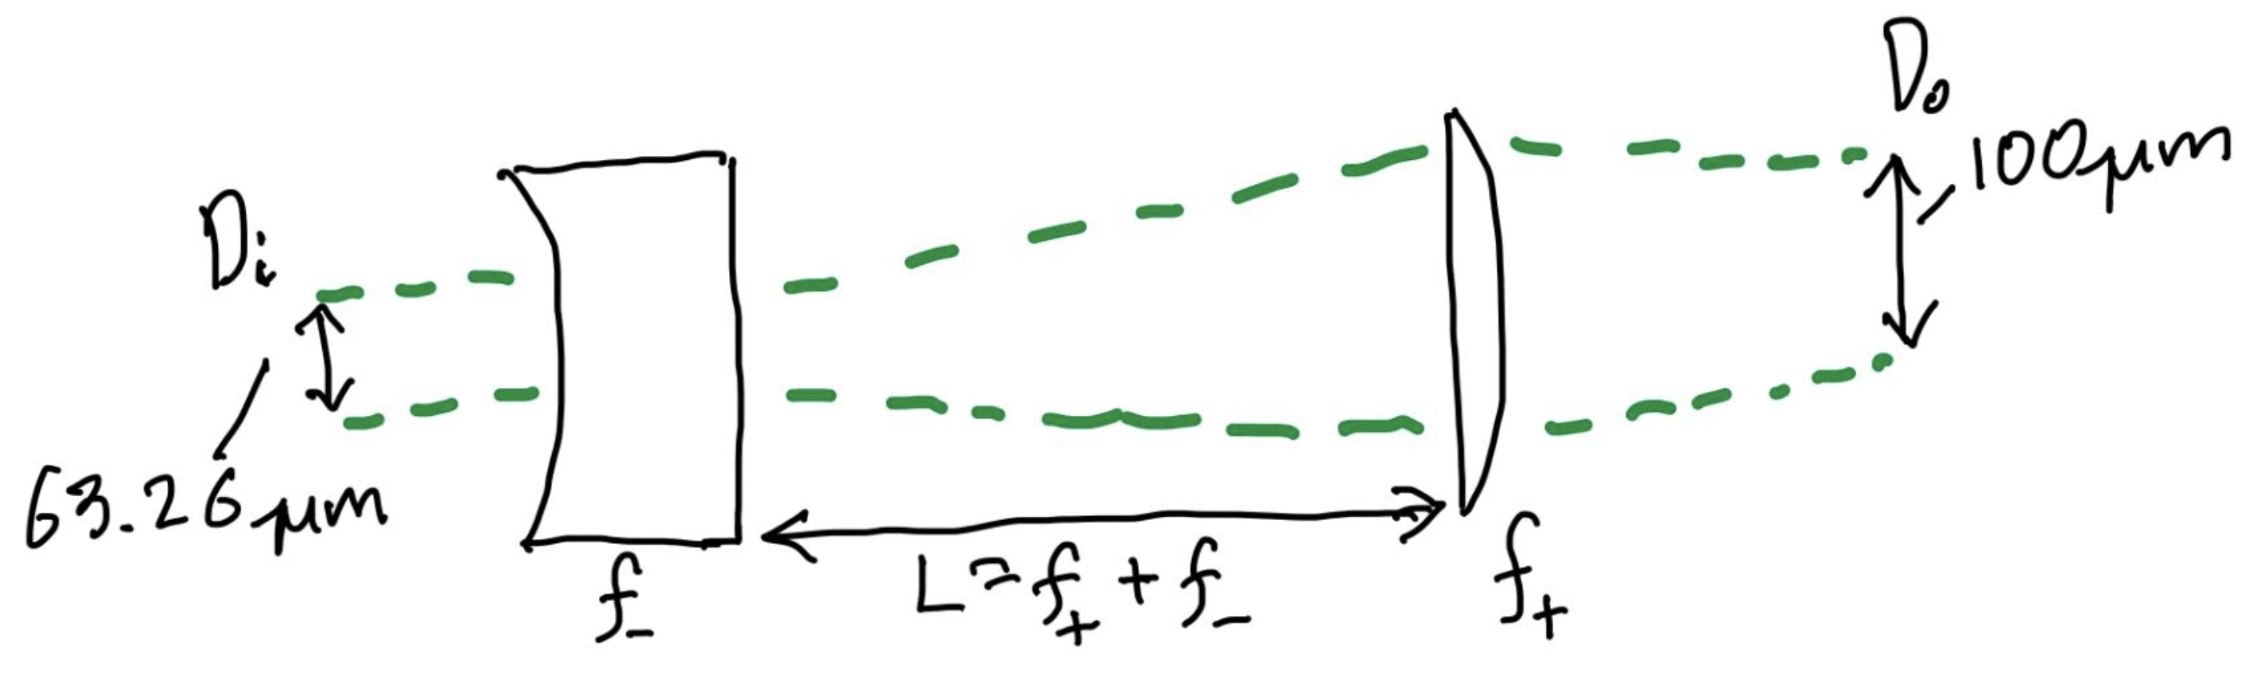
Fig. 20 Concave and Convex lens setup

6.3.2 Optical Density Requirements – Chris
When working with high-powered lasers it is imperative to use laser safety goggles with the optical density appropriate to the wavelength and power of the laser, as well as the application the laser will be used in, to avoid causing permanent damage or injury to the eyes. Using the tables in ANSI Z136.1, equations were selected to calculate the optical density required. The first step is to calculate the maximum permissible exposure (MPE) of the laser. Because we are using a pulsed laser I first calculated the MPE of a single pulse of the laser.
$${MPE}_{Single Pulse}= 1.8* {10}^{-3}* t^{.75}= 1.8* {10}^{-3}* {\left(129* {10}^{-9}\right)}^{.75}= 1.23* {10}^{-8}\frac{J}{{cm}^{2}}$$
where t is the time in seconds. Next the MPE of a single pulse was used to compute the overall MPE of the laser.
$$MPE= \frac{{MPE}_{Single Pulse}}{N^{.25}}= \frac{1.23* {10}^{-8}}{{4000}^{.25}}=1.54* {10}^{-9} \frac{J}{{cm}^{2}}$$
where N is the number of pulses to be performed. Next I calculated the incident energy density $H_{o}$.
$$H_{o}= \frac{E_{Pulse}}{A}= \frac{196* {10}^{-9}}{π\frac{{0.05}^{2}}{4}}=9.5* {10}^{-5}\frac{J}{{cm}^{2}}$$
where $E_{Pulse}$ is the pulse energy of the laser and A is the cross-sectional area of the beam. Finally, the required optical density was calculated.
$$OD= \log_{10}\frac{H_{o}}{MPE}= \log_{10}\frac{9.5* {10}^{-5}}{1.54* {10}^{-9}}=4.79$$

6.3.3 CFD Flow Analysis - Rory Kian Pack
A key part of final testing before handing the system over to the client will be the verification of results gathered from the PIV system. One way to do this is to compare results to existing PIV analyses done in the literature, but those tests are relatively few and far between. A far more popular option for analyzing blood flow, in aneurysms specifically, is Computational Fluid Dynamics (CFD).

The CFD analyses conducted by our team were all completed in ANSYS Fluent, a commercial CFD software that uses a finite volume method to discretize and solve many equations related to fluid flow. In order to begin generating solutions that are sufficiently accurate for PIV verification, a simple aneurysm flow model was developed. This model uses an idealized aneurysm geometry, which consists of a tube with a spherical projection on the side. An example of this geometry is presented below in figure X.

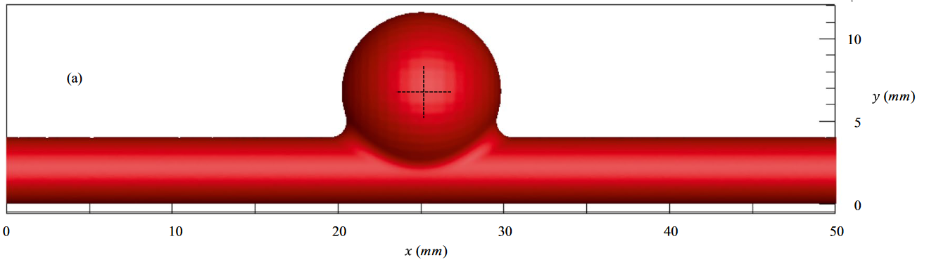
Fig. X. Simplified aneurysm geometry for comparison with PIV results [50].

This geometry was meshed using Fluent’s built-in watertight meshing workflow, producing a high-quality mesh of the fluid region within the aneurysm geometry. Next, boundary conditions were assigned based on the guidelines set by recent, advanced studies in hemodynamic CFD. The inlet was a specified mean-velocity inlet, with the velocity set at 0.23 m/s based on empirical data of blood flow in cerebral arteries [53]. The outlet boundary condition was set as specified pressure. The pressure setting was based on averaged healthy systolic and diastolic pressures – 100mmHg from 120/80 mmHg. The use of this pressure is due to the fact that the BDL blood flow simulator uses these settings.

For this first simulation, pulsatile flow was not modeled. Instead, the velocity and pressure were averaged. However, the simulation was still transient in nature in order to better model the movement of tracer particles throughout the system, as a form of discrete flow analysis. The time settings for this simulation were 8 seconds runtime (similar to max recording time on selected cameras) with a 0.5 second time step. The pressure-based solver in Fluent was used for this simulation, as blood flow is largely incompressible. In this case, water was used as the working fluid because specifications for the BDL’s blood analogue (HPMC) are not available at this time.

There are two main results generated from this simulation. The first is a 2D vector field showing the velocity distribution inside the aneurysm. This result is similar to what will be produced by the PIV system, and is pictured below in figure A.
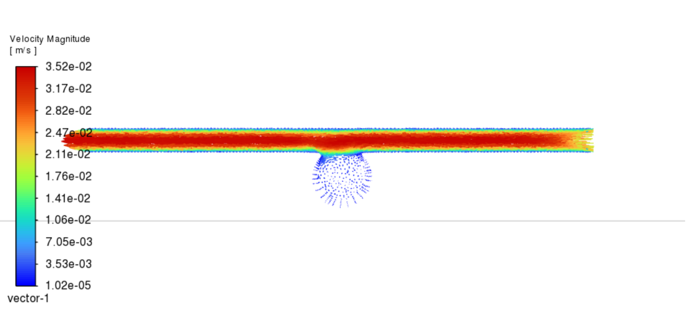
Fig. A. Vector distribution field showing fully developed pipe flow along with a large area of recirculation inside the aneurysm “bubble”.

The next result is more informative to the actual design- a simulation of tracer particles, in the plane of the light sheet, released at the inlet and modeled as massless particles moving through the flow. This is show below in figure B.

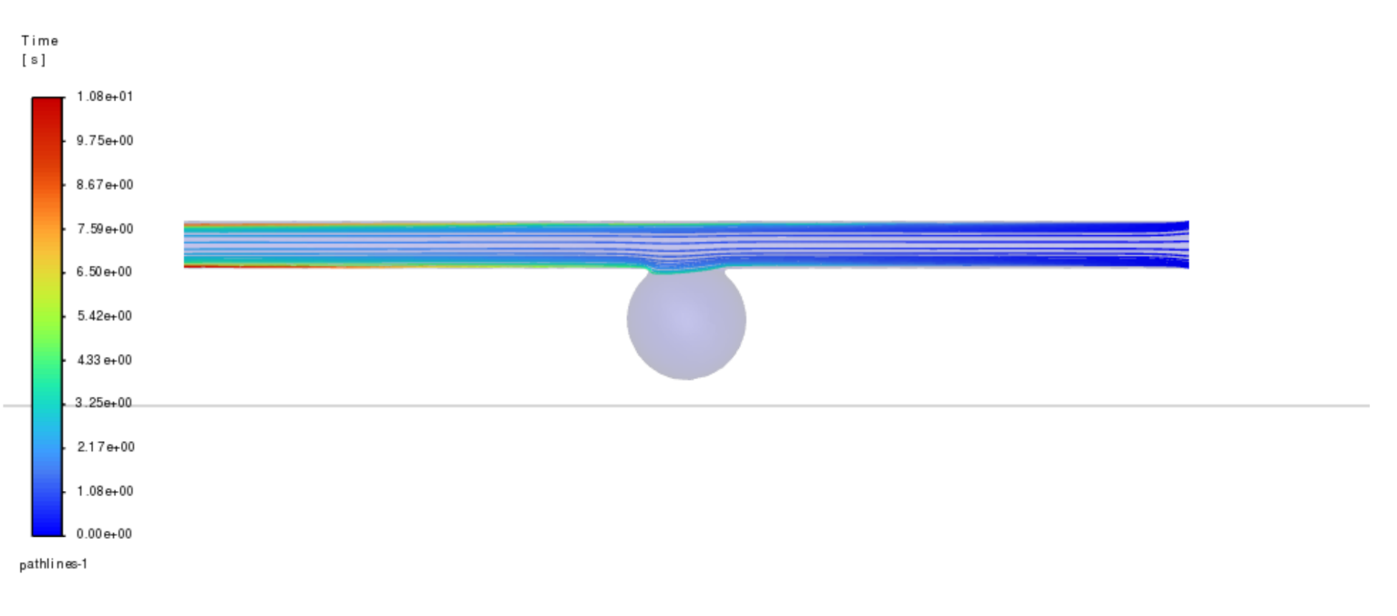
Fig. B. Pathline vector showing massless tracer particles moving through flow.

This result has worrying implications. The tracer particles are not entering the zone of recirculation seen in the vector plot in figure A. This means that we would not be able to observe the flow phenomena there with the PIV system. There are several possible explanations for this: the non-viscous nature of the water simulation could be unrepresentative of blood (or HPMC); the non-pulsatile nature of the flow is failing to create the necessary turbulent perturbations for tracer distribution; or the flow is simply too fast and too laminar for massless particles to be effectively distributed. Further simulations are required to identify this root cause and determine if it necessitates a change in the system design.

6.3.4 Jett Scruggs

6.4 Future Testing
The first test we will conduct will be a simple PIV study of flow going through a tube. This will allow us to practice selecting the correct settings to synchronize the laser and camera, with the ideal timing being a laser pulse just before and after each image is captured by the camera, a technique known as frame straddling. This will also allow us to ensure the software is successfully tracking the positions of each particle. Once this test is completed, we will move to PIV studies of more complex geometries such as a bifurcated vessel model and an aneurysm model. We will then compare the results of these studies to peer-reviewed literature studying hemodynamics in these geometries, as well as our own CFD analysis to ensure that our models are accurately representing physiological blood flow. Once this is complete we will then fully incorporate the PIV system with the BDL comprehensive flow system.
In addition to testing to ensure that the system is outputting accurate results we will also conduct tests to determine the ease of use and safety of our system. Testing the ease of use will involve timing BDL members as they set up the system for a study, with the goal being the customer requirement of setting up the system in less than an hour. Testing the safety of the device will be done by deliberately attempting to misuse the laser and observing whether our safety measures prevent this misuse.

CONCLUSIONS
This memo reviewed and documented the on-going process of the creation of a Particle Imaging Velocimetry system for the Northern Arizona University Bioengineering Devices Laboratory. This system will be integral in the testing of biomedical devices used to help treat cerebrovascular strokes. The project was broken down into background, requirements, research, and concept generation. This covered everything from the establishment of requirements from the client to the analysis required for the selection of components for each individual subsystem.

Ultimately, it was determined that this PIV system has to be capable of high-resolution, time-resolved solutions on a variety of flow regimes and geometries. In addition, the system must be safe and relatively easy to use by lab personnel.

In order to meet all requirements specified by our client and quantified in the QFD diagram, the team will use the information researched to build a properly functioning PIV system. The specification tables, decision matrix, and Pugh chart discussed in the concept selection portion of this memo will be utilized to ensure all major subsystems work as intended to make the PIV system operational. Based on concept selection section 4.3 of the memo the following subsystems will be used.

The camera used for the system will be either Chronos camera or the CX100. The laser for this project will be the ThorLabs NPL52C nanosecond pulsed laser. The multifunction generator used for the PIV will be the Quantum Composer 9520. The configuration of the PIV setup will model the “Cart and Camera” design depicted in figure 11. A rough CAD design of this concept is shown in figure 13 and 14. It is worth noting that the multifunction generator although not shown in the figures, will be included inside the cart.

Moving forward the team will be assembling the system and performing the tests discussed in 6.4, including simple PIV studies, safety tests, and a timed setup. Over the summer break the team will shift to designing and testing the silicon phantoms that will be the models used with the PIV system as well as working with members of the BDL to ensure that the PIV setup meets their needs.

REFERENCES
[1] “How many people are affected by/at risk for stroke? | NICHD - Eunice Kennedy Shriver National Institute of Child Health and Human Development.” Accessed: Feb. 26, 2025. [Online]. Available: https://www.nichd.nih.gov/health/topics/stroke/conditioninfo/risk
[2] C. Hui, P. Tadi, M. Z. Khan Suheb, and L. Patti, “Ischemic Stroke,” in StatPearls, Treasure Island (FL): StatPearls Publishing, 2025. Accessed: Feb. 26, 2025. [Online]. Available: http://www.ncbi.nlm.nih.gov/books/NBK499997/
[3] A. K. A. Unnithan, J. M. Das, and P. Mehta, “Hemorrhagic Stroke,” in StatPearls, Treasure Island (FL): StatPearls Publishing, 2025. Accessed: Feb. 26, 2025. [Online]. Available: http://www.ncbi.nlm.nih.gov/books/NBK559173/
[4] K. C. J. Compagne et al., “Improvements in Endovascular Treatment for Acute Ischemic Stroke: A Longitudinal Study in the MR CLEAN Registry,” Stroke, vol. 53, no. 6, pp. 1863–1872, Jun. 2022, doi: 10.1161/STROKEAHA.121.034919.
[5] M. Koyanagi et al., “Long-term outcomes of coil embolization of unruptured intracranial aneurysms,” J. Neurosurg., vol. 129, no. 6, pp. 1492–1498, Dec. 2018, doi:10.3171/2017.6.JNS17174.
[6] S. Scharnowski and C. J. Kähler, “Particle image velocimetry - Classical operating rules from today’s perspective,” Opt. Lasers Eng., vol. 135, p. 106185, Dec. 2020, doi: 10.1016/j.optlaseng.2020.106185.
[7] Menka, “Chronos 1.4 High Speed Camera | Kron Technologies,” Kron Technologies, Dec. 28, 2022. https://www.krontech.ca/product/chronos-1-4-high-speed-camera/?v=7516fd43adaa (accessed Mar. 09, 2025). (Webpage)
[8] “Nanosecond Pulsed Laser Systems,” Thorlabs - Photonics Products & Solutions. https://www.thorlabs.com/newgrouppage9.cfm?objectgroup_id=10823#ad-image-0 (accessed Mar. 09, 2025). (Webpage)
[9] “AFG1022 Arbitrary Function Generator - Tektronix,” Mouser Electronics, 2025. https://www.mouser.com/new/tektronix/tektronix-afg1022/ (accessed Mar. 09, 2025). (Webpage)
[10] “DITECT 1.3MP, 2000fps High-Speed Camera,” Light186. https://light186.com/product/ditect-1-3mp-2000fps-high-speed-camera/ (accessed Mar. 09, 2025). (Webpage)
[11] “Lasers For PIV - Litron,” Litron. https://www.litronlasers.com/product-range/lasers-for-piv/ (accessed Mar. 09, 2025). (Webpage)
[12] “Multi-Channel Digital Delay and Pulse Generator | Berkeley Nucleonics,” Pulse & Delay Generators, RF/Microwave Signal Generators. https://www.berkeleynucleonics.com/Model-575 (accessed Mar. 09, 2025). (Webpage)
[13]F. Zigunov, “How Bright are my PIV Particles?,” Zigunov Aero, Jun. 30, 2023. https://zigunov.com/2023/06/30/how-bright-are-my-piv-particles/ (accessed Mar. 09, 2025).
[14]“Considerations When Using Cylinder Lenses,” Edmundoptics.com, 2023. https://www.edmundoptics.com/knowledge-center/application-notes/lasers/considerations-when-using-cylinder-lenses/?srsltid=AfmBOoqqON2maCTx6XYNjrSre8Ck-e4nh7X_ULfvTMfIijDaxhKc-Ai2 (accessed Mar. 09, 2025).
[15]U. Stopper et al., “PIV, 2D-LIF and 1D-Raman measurements of flow field, composition and temperature in premixed gas turbine flames,” vol. 34, no. 3, pp. 396–403, Apr. 2010, doi: https://doi.org/10.1016/j.expthermflusci.2009.10.012.
[16]S. R. Tenney, M. Moshirfar, and Y. Ronquillo, “Concave And Convex Lenses,” PubMed, Oct. 31, 2022. https://www.ncbi.nlm.nih.gov/books/NBK587441/
[17]View, “My milli-micro-PIV setup,” The Fluid Dynamics Lab, Feb. 15, 2021. https://ronshnapp.wordpress.com/2021/02/15/my-milli-micro-piv-setup/ (accessed Mar. 09, 2025).
[18]“Light sheet optics for PIV - HackMD,” HackMD, 2023. https://hackmd.io/@cdcl-rpr/light-sheet-optics
[19]“Gaussian Beam Propagation,” Edmundoptics.com, 2017. https://www.edmundoptics.com/knowledge-center/application-notes/lasers/gaussian-beam-propagation/?srsltid=AfmBOorJAMC-l13Iu7FQpSGa_Uktg12pTzUPRDqvCvcvbUiEqHlaRmdB (accessed Mar. 09, 2025).
[20]G. J. Johnson, “Springer Handbook of Lasers and Optics200884Edited by Frank Träger. Springer Handbook of Lasers and Optics. Heidelberg and New York, NY: Springer 2007. xxvi+1332 pp., ISBN: 978 0 387 95579 7 £192.50 $199 Includes a CD‐ROM containing all eight chapters; also available as an e‐book (ISBN 978 0 387 30420 5),” Reference Reviews, vol. 22, no. 2, pp. 42–42, Feb. 2008, doi: https://doi.org/10.1108/09504120810855093.
[21] W. H. Ho, I. J. Tshimanga, M. N. Ngoepe, M. C. Jermy, and P. H. Geoghegan, “Evaluation of a Desktop 3D Printed Rigid Refractive-Indexed-Matched Flow Phantom for PIV Measurements on Cerebral Aneurysms,” Cardiovasc Eng Tech, vol. 11, no. 1, pp. 14–23, Feb. 2020, doi: 10.1007/s13239-019-00444-z. (Journal Article)
[22] D. P. G. Nilsson et al., “Patient-specific brain arteries molded as a flexible phantom model using 3D printed water-soluble resin,” Sci Rep, vol. 12, no. 1, p. 10172, Jun. 2022, doi: 10.1038/s41598-022-14279-7. (Journal Article)
[23] J. Tu, G. H. Yeoh, C. Liu, and Y. Tao, Computational fluid dynamics: a practical approach, Fourth edition. Oxford Cambridge, MA: Butterworth-Heinemann, 2024. doi: 10.1016/C2021-0-01771-5. (Textbook)
[24] M. Tomaszewski, K. Sybilski, P. Baranowski, and J. Małachowski, “Experimental and numerical flow analysis through arteries with stent using particle image velocimetry and computational fluid dynamics method,” Biocybernetics and Biomedical Engineering, vol. 40, no. 2, pp. 740–751, Apr. 2020, doi: 10.1016/j.bbe.2020.02.010 (Journal Article)
[25] F. Kojo Chaway Acquah, J. Paul Konadu Takyi, and H. R. Beem, “Design and characterization of a low-cost particle image velocimetry system,” HardwareX, vol. 19, p. e00563, Sep. 2024, doi: 10.1016/j.ohx.2024.e00563. (Journal Article)
[26] D. J. Biswas and D. J. Biswas, Insights into laser science. in A beginner’s guide to lasers and their applications / Dhruba J. Biswas, no. Part 1. Cham: Springer, 2023. (Textbook)
[27] C. A. Luisi et al., “Investigation of Cerebral Hemodynamics During Endovascular Aspiration: Development of an Experimental and Numerical Setup,” Cardiovasc. Eng. Technol., vol. 14, no. 3, pp. 393–403, Jun. 2023, doi: 10.1007/s13239-023-00660-8.
[28] C. N. Ionita, Y. Hoi, H. Meng, and S. Rudin, “Particle image velocimetry (PIV) evaluation of flow modification in aneurysm phantoms using asymmetric stents,” presented at the Medical Imaging 2004, A. A. Amini and A. Manduca, Eds., San Diego, CA, Apr. 2004, p. 295. doi: 10.1117/12.534274.
[29] M. Raffel, C. E. Willert, S. T. Wereley, and J. Kompenhans, Particle Image Velocimetry: A Practical Guide. Berlin, Heidelberg: Springer Berlin Heidelberg, 2007. doi: 10.1007/978-3-540-72308-0.
[30] N. Buchmann, “Development of Particle Image Velocimetry for In-Vitro Studies of Arterial Haemodynamics,” University of Canterbury. Mechanical Engineering, 2010. doi: 10.26021/1526.
[31] C. Zhang, S. Vasilevskis, and B. Kozlowski, “Particle Image Velocimetry: User Guide,” Department of Civil Engineering, Aalborg University, Aalborg, Report, 2018.

[32] S. Kefayati, J. S. Milner, D. W. Holdsworth, and T. L. Poepping, “In Vitro Shear Stress Measurements Using Particle Image Velocimetry in a Family of Carotid Artery Models: Effect of Stenosis Severity, Plaque Eccentricity, and Ulceration,” PLoS ONE, vol. 9, no. 7, p. e98209, Jul. 2014, doi: 10.1371/journal.pone.0098209.
[33] F. Zigunov, “Particle brightness estimator,” Zigunov Aero, https://3dfernando.github.io/PIV_ISOSpeed.html (accessed Mar. 9, 2025):
[34] F. Zigunov, “How bright are my piv particles?,” Zigunov Aero, https://zigunov.com/2023/06/30/how-bright-are-my-piv-particles/ (accessed Mar. 9, 2025):
[35] W. Merzkirch, Flow Visualization, Second. London, United Kingdom: Academic Press INC, 1987:
[36 ]G. Cavazzini, Ed., The Particle Image Velocimetry: Characteristics, Limits and Possible Applications. Rijeka, Croatia: InTech, 2019:
[37] M. Y. Yousif, D. W. Holdsworth, and T. L. Poepping, “Deriving a blood-mimicking fluid for particle image velocimetry in Sylgard-184 vascular models,” 2009 Annual International Conference of the IEEE Engineering in Medicine and Biology Society, pp. 1412–1415, Sep. 2009. doi:10.1109/iembs.2009.5334175:
[38] B. J. Petrovsky, “Particle image velocimetry applications of fluorescent dye-doped particles,” Particle Image Velocimetry Applications of Fluorescent Dye-doped Particles, https://ntrs.nasa.gov/api/citations/20160007394/downloads/20160007394.pdf (accessed Mar. 10, 2025):
[39] P. Luzzatto-Fegiz, Simultaneous PIV and LIF measurements in stratified flows using pulsed lasers, Jul. 2022
[40] “Low-cost particle image velocimetry (PIV) system / Optolution,” Home / Optolution. https://optolution.com/en/home/low-cost-particle-image-velocimetry-piv-system/ (accessed Mar. 09, 2025).
[41] Laser Beam expanders | edmund optics, https://www.edmundoptics.com/knowledge-center/application-notes/lasers/beam-expanders/ (accessed Apr. 18, 2025).
[42] How to Design your own Beam Expander Using Stock Optics | edmund optics, https://www.edmundoptics.com/knowledge-center/application-notes/optics/how-to-design-your-own-beam-expander-using-stock-optics/?utm_medium=chat&utm_campaign=link-shared-in-chat&utm_source=livechat.com&utm_content=www.edmundoptics.com (accessed Apr. 18, 2025).
[43] Can a beam expander be used in reverse? | edmund optics, https://www.edmundoptics.com/knowledge-center/application-notes/optics/can-a-beam-expander-be-used-in-reverse/?utm_medium=chat&utm_campaign=link-shared-in-chat&utm_source=livechat.com&utm_content=www.edmundoptics.com#:~:text=Reversing%20the%20orientation%20of%20a%20laser%20beam%20expander,new%20magnifying%20power%20of%201%2F5%20instead%20of%205 (accessed Apr. 18, 2025).
[44] ANSI Z136.1-2014, Safe Use of Lasers, American National Standards Institute (ANSI).
[45] “PIVlab - open source particle image velocimetry,” PIVlab. Accessed: Apr. 18, 2025. [Online]. Available: https://www.pivlab.de/
[46] J. Sheng, H. Meng, and R. O. Fox, “Validation of CFD simulations of a stirred tank using particle image velocimetry data,” Can. J. Chem. Eng., vol. 76, no. 3, pp. 611–625, Jun. 1998, doi: 10.1002/cjce.5450760333.
[47] R. D. Keane and R. J. Adrian, “Optimization of particle image velocimeters: II. multiple pulsed systems,” Measurement Science and Technology, vol. 2, no. 10, pp. 963–974, Oct. 1991. doi:10.1088/0957-0233/2/10/013
[48] R. J. Adrian, “Twenty years of particle image velocimetry,” Experiments in Fluids, vol. 39, no. 2, pp. 159–169, Jul. 2005. doi:10.1007/s00348-005-0991-7
[49] L. Martínez-Suástegui, “Overview on stereoscopic particle image velocimetry,” Advanced Methods for Practical Applications in Fluid Mechanics, Mar. 2012. doi:10.5772/34728
[50] G. Rahma and T. Abdelhamid, “Hemodynamic and fluid flow analysis of a cerebral aneurysm: a CFD simulation,” SN Appl. Sci., vol. 5, no. 2, p. 62, Feb. 2023, doi: 10.1007/s42452-023-05276-0 (accessed Apr. 4, 2025).
[51] “Boundary Conditions of Bloodflow in Artery | Ansys Courses,” ANSYS Innovation Courses | Free, online, physics and engineering courses, May 13, 2020. https://innovationspace.ansys.com/courses/courses/fluent-3d-bifurcating-artery/lessons/physics-setup-lesson-5/topic/boundary-conditions/ (accessed Apr. 5, 2025).
[52] J. Y. Moon, D. C. Suh, Y. S. Lee, Y. W. Kim, and J. S. Lee, “Considerations of Blood Properties, Outlet Boundary Conditions and Energy Loss Approaches in Computational Fluid Dynamics Modeling,” Neurointervention, no. 1, p. 1, 2014, doi: 10.5469/neuroint.2014.9.1.1 (accessed Apr. 7, 2025).
[53] Allen D Elster, “Expected Velocities,” Questions and Answers in MRI. [Online]. Available: https://mriquestions.com/expected-velocities.html

APPENDICES

Appendix A: Particle Density Calculator for PIV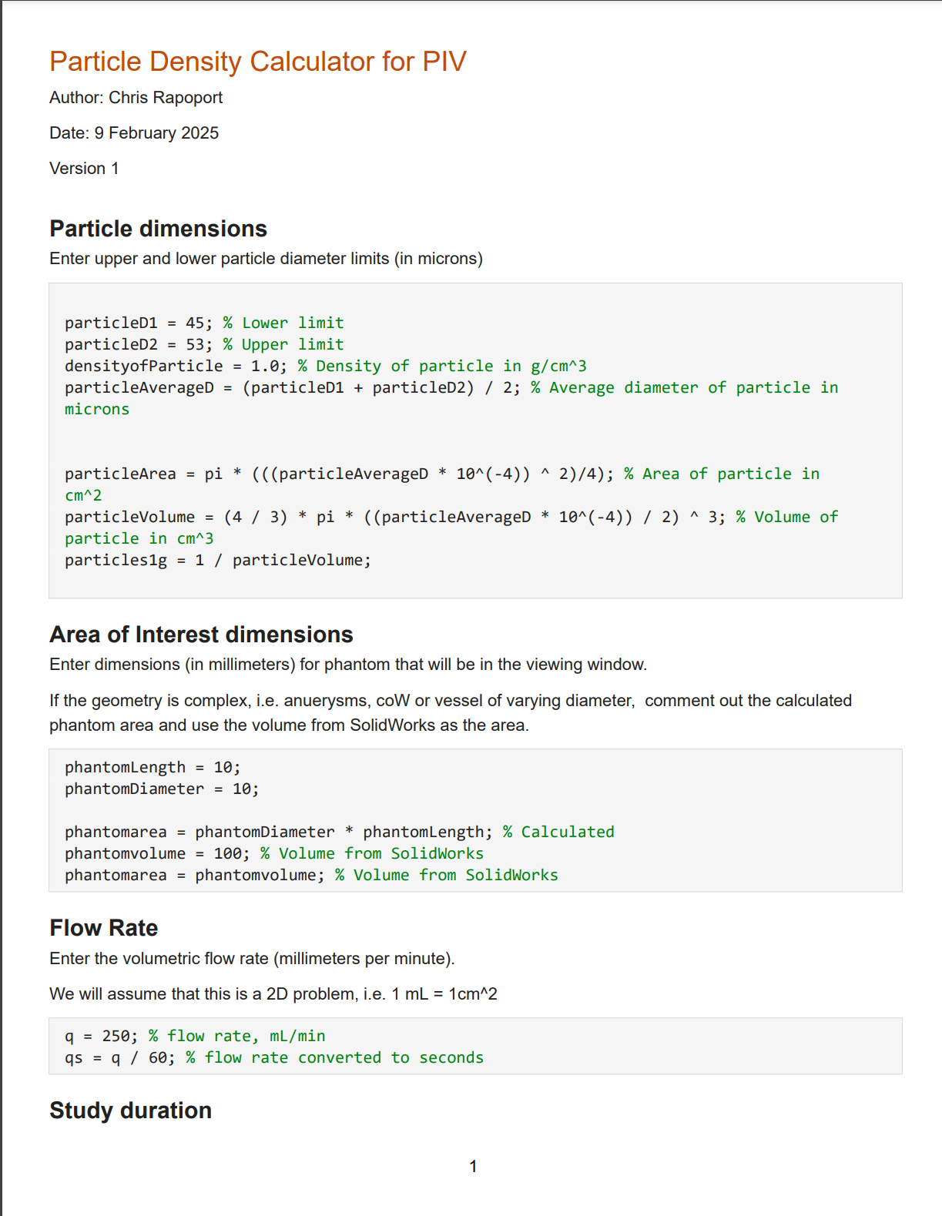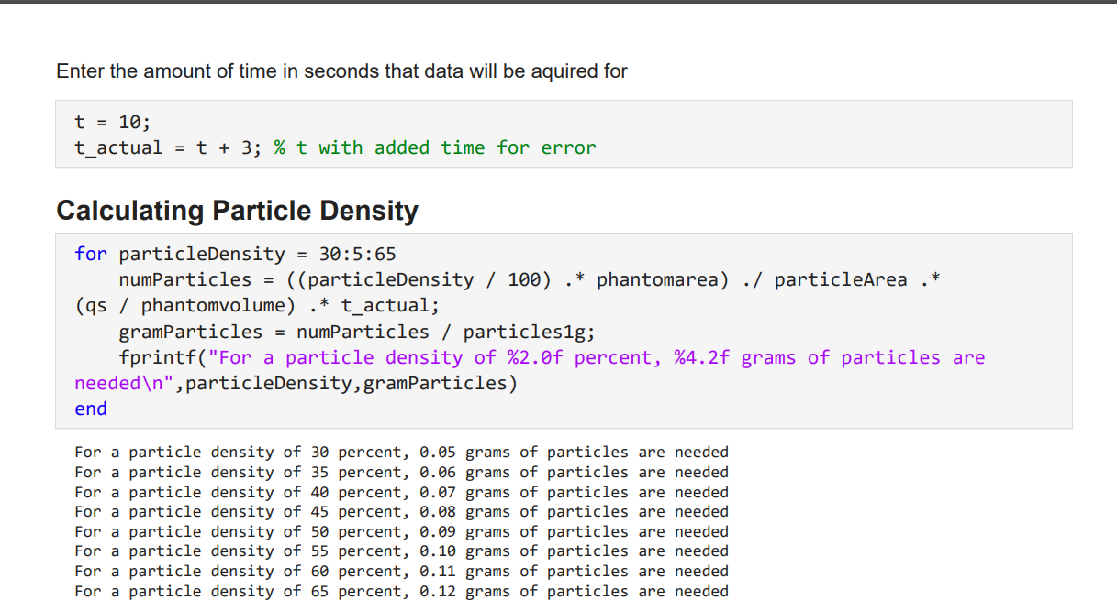

Appendix B: Laser Pulse Energy MATLAB Program
Below is the full code used to generate the figures in the laser pulse energy analysis:
“format shortEng

Avg_P = [50 70 500 700 1500] ;
F_r = 100:100:1000;
F_t = 1./F_r
dt = (0.1.*F_t)';
PE = Avg_P.*dt

figure
tiledlayout(1,2)

nexttile
plot(F_r,PE)
title("Camera Framerate vs Laser Pulse Energy")
xlabel("Camera Framerate (Hz)")
ylabel("Laser Pulse Energy (mJ) Log. Scale")
legend('50mW','70mW','500mW','700mW','1500mW')
yscale log

nexttile
plot(F_r,10^6.*(PE(:,[1 2 4])))
title("Camera Framerate vs Laser Pulse Energy - Direct Replacement")
xlabel("Camera Framerate (Hz)")
ylabel("Laser Pulse Energy (nJ)")
legend('50mW','70mW','700mW')”

Appendix C: Phantom Manufacturing Spreadsheet

See access link to view: Phantom Manufacturing Cost Analysis.xlsx

