Initial Design Report 1

FSAE Suspension
Competition Team Number 072
Lumberjack Racing

Parker Johnson: Suspension Design Lead
Chris Laney: Brakes Engineer
Garrett Pearson: A-Arm Engineer
Mathew Cusson: Steering Engineer
Joseph Ciao: Pushrod Assembly Engineer

Fall 2024-Spring 2025

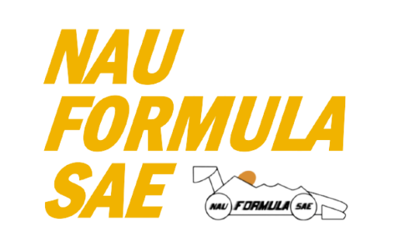

Project Sponsor: Northern Arizona University
Faculty Advisor: Constantin Ciocanel
Instructor: David Willy

TABLE OF CONTENTS
Contents
TABLE OF CONTENTS 3
DISCLAIMER 4
EXECUTIVE SUMMARY 2
1.1 Project Description(Chris) 2
1.2 Deliverables(Chris) 2
1.3 Success Metrics(Joseph) 3
2 REQUIREMENTS 4
2.1 Customer Requirements (CRs) 4
2.2 Engineering Requirements (ERs) 4
2.3 House of Quality (HoQ)(Joseph) 5
3 Research Within Your Design Space 6
3.1 Benchmarking 6
3.2 Literature Review 7
3.2.1 Suspension Geometry & Steering Knuckle Literature review (Parker Johnson) 7
3.2.2 Brakes Literature Review - Chris Laney 7
3.2.3 A-Arm Literature Review (Garrett Pearson) 8
3.2.4 Steering Literature Review (Mathew Cusson) 9
3.2.5 Pushrod Literature Review (Joseph Ciao) 9
3.3 Mathematical Modeling 10
3.3.1 Parker Johnson 10
3.3.2 Brakes - Chris Laney 12
3.3.3 A-Arm Garrett Pearson 16
4 Design Concepts 21
4.1 Functional Decomposition 21
4.2 Concept Generation 21
4.2.1 Steering Knuckles (Parker Johnson) 21
4.2.2 Brakes Assembly (Chris Laney) 22
4.2.3 Steering Assembly – Matthew Cusson 23
4.3 Selection Criteria 24
4.3.1 Steering Knuckles (Parker Johnson) 24
4.3.2 Brakes Assembly – Chris Laney 24
4.3.3 Steering Assembly – Matthew Cusson 24
4.4 Concept Selection 25
4.4.1 Steering Knuckles (Parker Johnson) 25
4.4.2 Brakes Assembly (Chris Laney) 26
4.4.3 Steering Assembly (Matthew Cusson) 27
5 CONCLUSIONS 28
6 REFERENCES 29

DISCLAIMER
This report was prepared by students as part of a university course requirement. While considerable effort has been put into the project, it is not the work of licensed engineers and has not undergone the extensive verification that is common in the profession. The information, data, conclusions, and content of this report should not be relied on or utilized without thorough, independent testing and verification. University faculty members may have been associated with this project as advisors, sponsors, or course instructors, but as such they are not responsible for the accuracy of results or conclusions.

EXECUTIVE SUMMARY
This report presents the initial design and development of the suspension system for Lumberjack Racing’s 2025 Formula SAE vehicle. Our objective is to design a formula style car that will not only pass tech for the competition but also perform reliably in all dynamic and static events. Building on the lessons learned from last year’s team, which placed 97th overall due to various mechanical and performance issues, we have prioritized early completion, increased testing, and improved system reliability. Through the efforts listed in this document we hope to improve in all areas of the competition in May.
Last year's vehicle faced challenges related to limited suspension adjustability, poor steering feel, and inadequate mounting points, all of which contributed to subpar performance in events. To address these, we have focused on optimizing the pushrod assembly, steering response, and damper selection to achieve better handling and control. Each member of the team has done extensive research into top team design choices to inspire our own. Every design choice has gone through decision matrices to ensure the best overall choice is made. Key challenges addressed in the report include minimizing suspension failure risks, reducing weight while maintaining strength, and improving vehicle handling.
The design process began with an in-depth assessment of customer requirements (CRs) and engineering requirements (ERs), derived from our advisor’s feedback and the Formula SAE Rulebook. Using the rules as a basis the team set certain target goals such as vehicle adjustability, suspension durability, and compliance with safety standards and converted those into a HoQ to properly weigh each requirement. The team has used modeling on various tools including MATLAB, Soildworks, Vsusp, and ANSYS to test and improve the design concepts each team member has come up with. This was used to evaluate key parameters like camber gain, toe, and King Pin Inclination (KPI). This allowed us to optimize the suspension design for improved cornering and stability under various load conditions.
In conclusion, this report details the extensive research, modeling, and decision-making processes that have shaped our suspension design. We have made significant steps in improving the overall performance, reliability, and adjustability of the vehicle. By addressing the shortcomings of last year’s design and incorporating lessons learned from top teams, we are confident that our suspension system will contribute to a more successful competition outcome in the 2025 Formula SAE event.

Project Description(Chris)
Formula Student is an international competition that has been taking place since 1980. Universities from around the country come together to compete their open-wheeled racing formula vehicles against one another. At this point, more than 125 universities compete yearly and the event has expanded to several other countries. The basis of the competition is to design, test, analyze, and build a competitive race car compared to the best of other universities.

Deliverables(Chris)
The main deliverable of this project is the final designed and tested car. Throughout the semesters, there is also several reports, presentations, and other individual assignments due for the capstone class. Competition specific deliverables include the finished car, a report, and presentation. The remainder of the deliverables are client/course related and consist of assignments designed to teach the student useful skills related to the engineering design/manufacturing process.

Success Metrics(Joseph)
For this project to be deemed successful the team has a few targets in mind. Last year’s car was able to pass tech but had many troubles during competition. This meant the car was unable to compete in most of the events and only placed 97th overall. Also, the car did not do much of anything when it came to aerodynamics, which is very important when it comes to the judges and their scores. The overall goal is to pass tech, be able to compete in all events, and score higher overall. Another success metric is to have the car built much earlier and do more extensive testing. This will help eliminate the reliability issues last year’s team ran into. Some key changes will include improving the adjustability of the suspension, improving steering feel and ease, and improved mounting for suspension.

REQUIREMENTS (Parker Johnson)
This section of the report contains an assessment of the Customer Requirements given to us by our faculty advisor, Constantin Ciocanel. These requirements are vague however they give our team a good basis for fully developing a list of customer requirements that stem from the main ones given to us. From these we can produce Engineering requirements which are quantifying versions of the CR’s and give our team a strong foundation for the goals of the project and hold us to the highest standard possible in the given time for this project. The Engineering Requirements cannot be produced completely from the CR’s, since there is a limited amount that can be quantified. However, it is necessary to rely on the FSAE Rulebook to give us quantifiable requirements we need to follow to pass technical inspection and be successful at competition.

Customer Requirements (Parker Johnson)
During the formation process of the team and initial research over the summer, a quick meeting with our faculty advisor ensued giving us a good idea of the customer requirements. This was a brief discussion and was vague, but our team was able to interpret the customer requirement into separate, non-quantifiable requirements. Our customer requirement was to successfully build a car, pass inspection, and compete in all events at competition. Since this requirement is not specific enough for the purpose of a HoQ, we had to further break this down into different requirements developed by our team to ensure our success in these areas. The main CR’s we developed that directly apply to our advisor’s CR’s are as follows: High adjustability, ease of machinability, strong components, reliable, durable, and improved ergonomics. The rest of the CR’s developed by the team are non-essential for the success in the advisor’s requirements, however we want to go above and beyond and improve the car overall in a way that potentially give our team an even higher placement in competition. See our HoQ in section 2.3 for full list of CR’s.

Engineering Requirements (Parker Johnson)
These Engineering Requirements were developed by any possible quantification of the Customer Requirements and included requirements from the FSAE 2025 Rulebook for technical inspection, since our team cannot compete if we do not meet these requirements. Most of these requirements are defined by the SAE organization to ensure a safe competition area for the driver as well as volunteers for the Formula Student class race car. There are some general requirements for dimensions of the car, such as a minimum wheelbase of 60”, and the shorter track width must not be less than 75% of larger track width of the vehicle. This should not be a problem with our car since we are predicting the same track width in the front as in the rear to be 48” wide. Another important Engineering requirement worth noting is the max Center of Gravity location, which is defined as 16”. This is to simulate a maximum lateral acceleration and prove that the vehicle will not roll over, so long as it is below this height. The vehicle also needs to be at a maximum of 2.75” from the ground at the lowest side impact structure, to ensure a lower CoG location. The car also needs to have at least 2” of vertical wheel travel, to demonstrate a serious attempt at a suspension system made for the vehicle. One of the main safety factors for this vehicle are the brakes, and we are required to have 2 independent circuits to prevent total brake failure, as well as a brake pedal that can withstand a force of 2000 N minimum.

House of Quality (HoQ)(Joseph)
Table 1: QFD
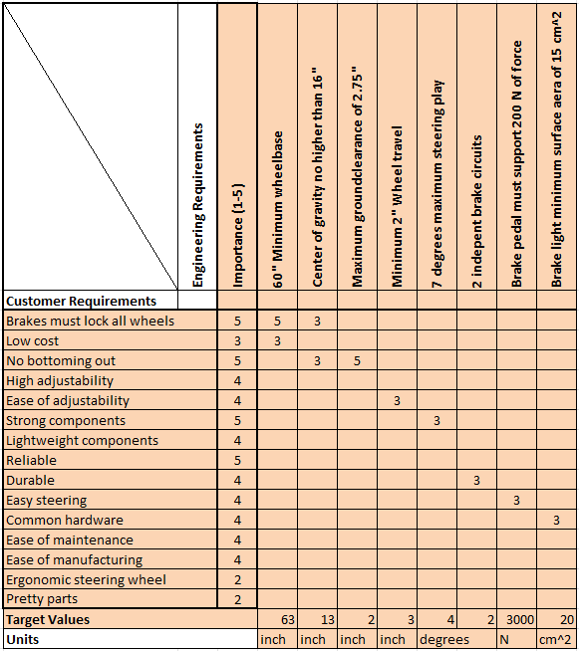

Research Within Your Design Space

Benchmarking

A-Arm/General Measurements (Garrett Pearson)
Last year's winning car out of Ohio State University used a double a-arm system which is by far the most common and most proven system FSAE teams use. This system allows for good stability at high speeds and good adjustability without a complete redesign. While most control arms found in FSAE are made of steel like Ohio State’s, some teams have run control arms made of carbon fiber. This allows for significantly reduced weight of the arms while not having to sacrifice the strength of the system but comes at a greater material cost [16]. The length of the A-arms is also an important consideration in the design process. The 2nd place team from last year's competition, University of Illinois, ran their car with a track width of 49in [17] and the third-place team, California-Berkeley, ran with a track width of 47in [18]. A generally shorter track width like the previously mentioned teams have, makes the steering response faster and the car able to turn tighter, which is important for the type of events we will be competing in. While control arms are not the only thing that contributes to track length, these measurements will give us a good idea of how long to make our a-arms so that our total track length falls around the other top teams.

Brakes (Chris Laney)
Many winning teams over the years use very similar braking set-ups, but with slight variances depending on setup. It was found that at least five of the top ten teams in the last few years used Wilwood GP200 calipers, however that number may be much higher due to the secrecy in this sort of technical information. Most teams that used different calipers front to rear used the larger of the two in the front, with a smaller corresponding master cylinder bore size. A few other popular caliper choices were the Brembo P34 and ISR 22-048, however these are much more uncommon in this country and a more expensive choice. The most common master cylinder among competitive teams was the Tilton 78 series, which is offered with a large variety of bore sizes. It’s swiveling design is popular because it can be very space efficient depending on the mounting orientation and is easily adjustable. Most teams used rotors between 200-250 mm in diameter, most of which were floating. Last year’s car used a simple Wilwood GS-1 master cylinder and a Wilwood PS-1 caliper. Both of which were heavy and bulky and not seriously considered to be used again on this year’s car.

Pushrod/Dampers (Joseph Ciao)
Top Formula SAE teams consistently rely on a few high-performance damper choices to optimize their suspension systems. The most popular options include the Öhlins TTX25 MkII, the Penske 8760 Series, and the Koni 2812 Series dampers. These dampers stand out for their precision engineering, offering unmatched adjustability in compression and rebound settings, allowing teams to fine-tune their car’s handling for maximum performance on the track. Their build quality ensures durability under racing conditions, while their ease of serviceability makes them a practical choice for teams needing quick adjustments during competition. Teams like TU Munich, University of Stuttgart, and TU Graz have been known to use these dampers to gain a competitive edge in recent years.

Steering (Matthew Cusson)
The standard FSAE vehicle setup relies on a NARRCO steering rack with hollow tie rods to connect to the wheels due to the fact that steering racks are hard to manufacture in a precise and quick manner, especially more so for new teams that have lower budgets. Along with this most teams are utilizing a carbon fiber steering wheel that has electronics wired to it for information systems and as such is a wider design with a build construction that is fitting of a formula one car where it has a more rectangular shape and has holes for the thumbs to go into for higher amounts of driver comfort. The steering wheels tend to be built by the teams since each vehicle has different drivers and the steering wheel has to accommodate this.

Literature Review

Suspension Geometry & Steering Knuckle Literature review (Parker Johnson)
To start designing a suspension system we had to get a basic understanding on the dynamics of the vehicle in multiple cases, and this is perfectly laid out for us in the book Race Car Vehicle Dynamics [1]. To further expand on the suspension system and design, a great resource to use was Suspension Geometry and Computation [2], and this source was particularly helpful in understanding the suspension geometry and its effects on vehicle handling and response to different dynamic situations. These laid the foundation for us to start creating a suspension geometry that would perform in a way desirable for our goals of a FSAE race car.
During this process we wanted to compare our possible design with another successful FSAE team, University of Missouri, who described their suspension and frame design in detail [3]. During the design process, our team had a rough time getting information on ideal camber gain levels depending on the tire deflection and this source from optimum kinematics had great insight into this design consideration [4]. Another great source which has been huge help was the FSAE forum on reddit, which has many FSAE veterans including some judges who volunteer at competition, giving students great advice on car design as well as other considerations [5].
To start designing the front suspension geometry, it is important to have a good simulation system such as Vsusp [6] in which the user can model different geometries to identify important parameters such as camber gain, track width, and King Pin Inclination angle, or KPI for short. After these values were defined, we could start looking into the design of a steering knuckle for an FSAE car, which the analysis and insight into the process for a specific team was shown in an article [7]. Another great source for our team to use for identifying good components and design strategies was a website called “Design judges” [8] which includes many articles written by real design judges.

Brakes Literature Review - Chris Laney
In designing a braking system, there are many parameters to consider. The vehicle as a whole operates as a system, as do the suspension system and braking system individually from each other, however related dynamically. To get a good idea of how the entire vehicle dynamics relate to how the brakes operate, an excellent place to start is in Race Car Vehicle Dynamics [12]. Chapters 10 and 11 relate the braking system to overall vehicle dynamics, and chapters 2, 14, and 18 look at the forces of the tires, brakes, and environmental effects. We got some more application specific info from Hoosier themselves[8], who published a spec sheet for several of their formula specific tires along with some sizing info. A few braking reports have been published over the years specifically pertaining to FSAE applications from various universities all of which have differing setups[9][13].

Calculating the forces related to maximum deceleration and other brake system design ratios is another significant part of the design process, some of which can be done with equations and information found in Race Car Vehicle Dynamics[12], however relating desirable system ratios to variable distances is application specific in every aspect of the system. Using equations and concepts found in [11], [15], and [16], enough mathematical modeling could be achieved to describe enough of the system that is considered variable at this point. Also, using tools like Matlab, SolidWorks, and Desmos is helpful in visualizing geometry simply or in full detail.

Various viable pedal box designs are out there and well published, not all specific to FSAE however all helpful conceptually in designing a pedal box that fits our needs best. Firstly, we look at an in-depth analysis of a flange-mounted pedal box in [14] and find that it can easily be optimized for our application however has some strength and sizing related concerns. We find another design in [15] with the swivel master cylinder which is immediately attractive due to its sizing and adjustability. Many design concepts and variables are presented in these sources and we are able to refine our design nicely from the information presented here.

A-Arm Literature Review (Garrett Pearson)
‌ An important aspect of research for our vehicle is to see what other groups have done well in the past. Looking at some of the top team's websites from last year's competition gives us insight into the engineering behind their successful vehicles. The University of Illinois and the University of California-Berkley, who placed second and third respectively, both give rough dimensions used for their vehicles [17][18]. This information can be very helpful in comparing our own designs to the proven designs of successful teams.
Making sure that the suspension can survive all aspects of the competition is critical when creating our car. Any breaks in the suspension could be incredibly dangerous to the driver and others so durability is extremely important. A research paper from the Huaiyin Institute of Technology showed strength analysis of the suspension system as it traveled through its motion [20]. Another paper showed how to achieve proper stress distribution along the control arms to maximize strength and stability of the suspension [22].
A lightweight suspension is also preferable for racing purposes. One research paper showed how to make control arms light without losing overall strength in the system [22]. The researchers recommend using steel instead of aluminum despite the lower weight of the aluminum arms. A paper from MIT discusses the use of carbon fiber control arms on FSAE cars [16]. The paper goes over the assembly of an arm to be used in an FSAE car and how the arm compares in strength and weight to an aluminum arm. The paper concludes that with proper construction the carbon fiber performs better in both categories.

Steering Literature Review (Mathew Cusson)
The fundamental makeup of a steering system is understanding how it works in a three-dimensional space. The vital systems that impact steering are Ackerman, Toe, Bump steer, and Slip angles. Ackerman is defined as the steering angles of the inner and outer wheels relative to each other when moving around a corner. This is vital to the operation of a vehicle as it allows for tighter turns to be taken on the same wheelbase, to an extent [30] [33]. Toe is the distance between the front center point of the wheels compared to the rear center point of the wheels and this directly manages the balance between turn in speed and responsiveness and vehicle control during a corner [35]. This relation generally sees toe in on the rear or no toe and a choice between toe in or out on the front depending on driver skill and preference. These adjustments are made with smaller increments to avoid excessive tire wear or unpredictable grip scenarios.

Bump steer is a dynamic factor that is made from calculating caster, kingpin inclination, dynamic toe, along with other factors[30]. Over time this value has been a point of study in multiple instances due to the evolving technology and vehicle dynamic systems, with stability issues being a direct result of bump steer that was greatly mismanaged in early vehicle design[32]. To summarize the effect it is the change in vehicle toe as the suspension rises and falls, referred to as “bump” and “droop” respectively. This effect is paramount to keep minimized as it causes greater steering effort and must be carefully managed to keep steering effort down [36].
The slip angle is directly related to the vehicle steering as it is the angle between where the wheel is pointed and where the tire patch is oriented [30] [34]. This is a value that is known based on the tire compound and has a direct effect on the toe and ackerman needed to get around corners efficiently. These components need to be managed by the steering wheel and the driver and require a specially made steering wheel that is able to keep effort at a desirable level while racing [31] [32].
‌

Pushrod Literature Review (Joseph Ciao)
[11] . This book provides a comprehensive foundation in automotive chassis design, covering key principles related to vehicle dynamics, suspension, and structural considerations. It serves as an essential reference for fundamental design aspects in the Formula SAE project. [12] Milliken’s work offers specialized knowledge on vehicle dynamics, with a focus on damper performance and tuning. This is critical for optimizing the damping characteristics in the Formula SAE car. [13] This paper presents the design process of a Formula Student team, providing an overview of the decisions and analysis involved in the development of a suspension system for a race car. [14] This study explores optimization techniques for suspension arms in Formula Student vehicles, focusing on improving performance through careful geometry and structural analysis. [15] This paper delves into the design and optimization of suspension systems in Formula SAE, addressing key performance metrics such as stiffness and weight reduction while maintaining structural integrity. [16] This online resource provides guidance on simulating and modeling automotive suspension systems in MATLAB and Simulink, offering tools for dynamic analysis and system optimization. This video series offers practical tutorials on the suspension design process, from basic theory to detailed design considerations, making it a useful visual resource for engineers working on suspension systems. [18] Summit Racing offers a selection of coilover springs designed for Formula SAE, allowing teams to choose optimal spring rates to improve vehicle handling and performance.

Mathematical Modeling
[Summarize your equations, engineering tools, and examples that apply to your design space. Separate sections by sub-system and by student.
(Example: 3.3.1 Motor sub-assembly – John Doe and Jane Fonda) Cite each equation/tool/example per IEEE citation style.]

Parker Johnson
During the Suspension Geometry research and modeling we needed to figure out the effects of Caster and KPI on the camber gain at different steering positions. Both parameters are the axis that the tire rotates about during steering, from the front view (KPI) and side view (Caster). These parameters need to be non-zero and are defined by the angle of the line passing through the upper and lower ball joint. Having an angle for these parameters in the right direction will provide a higher amount of steering stability, increased control for driver and allows the steering wheel to return to the straight position while driving in a straight line. However, these angles need to be minimized to some extent since it does make the steering harder to operate as these angles increase. A simulation made in SolidWorks is shown below in Figure #() and accurately shows the amount of camber gain at a few steering positions.
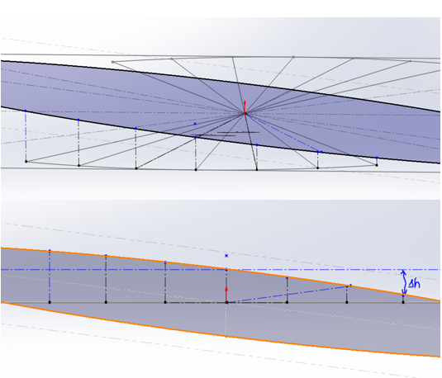
Figure 1: Camber Change Simulation
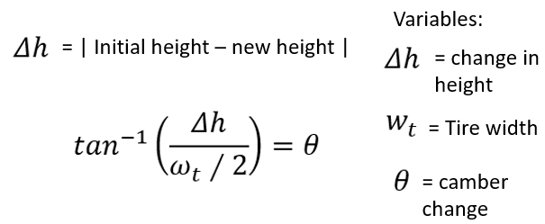
Figure 2: Camber equation
This was modeled using a 7 deg caster angle as well as a 7 deg KPI angle, which we expect to give us a good amount of camber change without being too high. Looking at this model in the side view, the image produces an ellipse which is an accurate representation of the amount of camber change depending on the steering angle. As you can see the change is not linear, however we do get a desired change in each direction to help supplement camber change during roll conditions.
The next set of calculations involves Free Body Diagrams as well as Force and Moment equations to start giving the team actual numbers to determine factors of safety for the parts they are designing. An example of this includes the Roll analysis and the forces that go into each suspension link as well as the pushrod system. This is shown in figure #() below.
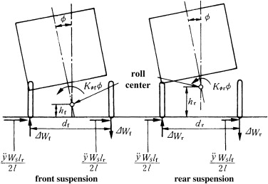
Figure 3: Roll Analysis
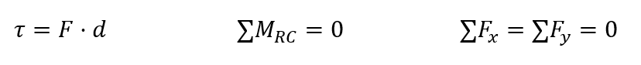
Figure 4: Force Analysis

Brakes - Chris Laney
The primary modeling tools used to design the braking system are SolidWorks and Matlab. Matlab is an extremely useful tool in this context for the sake of iterative calculations as the design process progresses. SolidWorks is also extremely useful due to it’s ability to simulate forces, similar to Ansys, as well as it’s many useful modeling tools. Without these two tools, this aspect of the project would be very challenging.
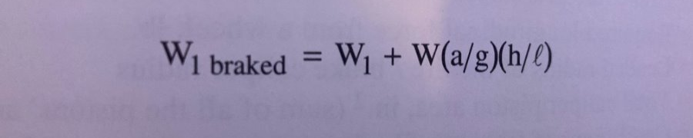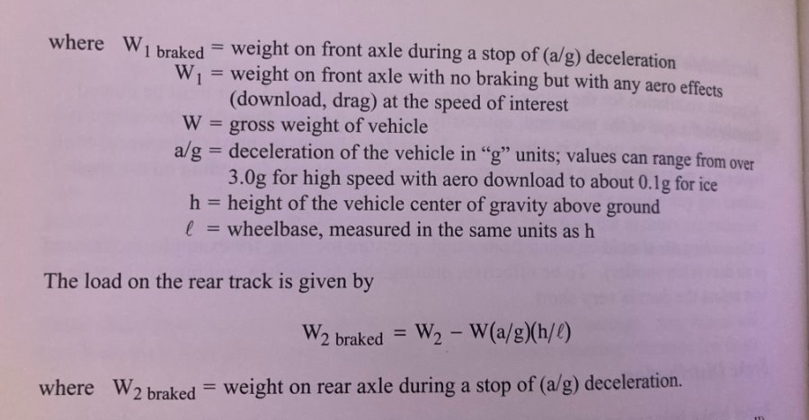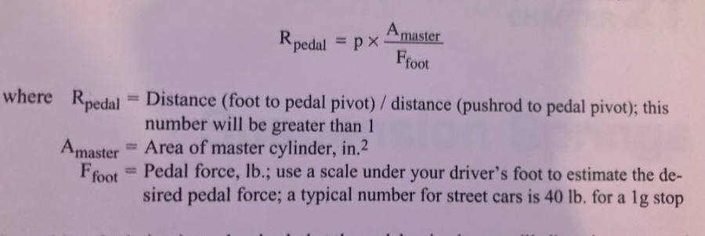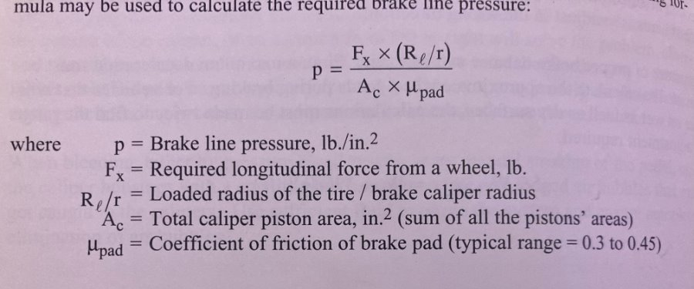
Figure 5: Braking Calculations from Race Car Vehicle Dynamics[4]
Race Car Vehicle Dynamics gives us a lot of applicable equations for our car’s braking performance. Above are the equations presented for dynamic wheel weights and internal brake line pressure, both of which directly affect the car’s maximum braking performance. Inputting these into Matlab, we get these results. More useful equations can be found in citations 2,5, and 7.
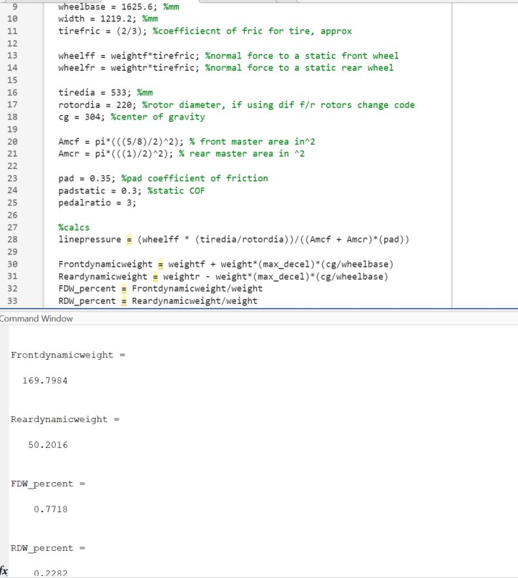
Figure 6: Matlab Code
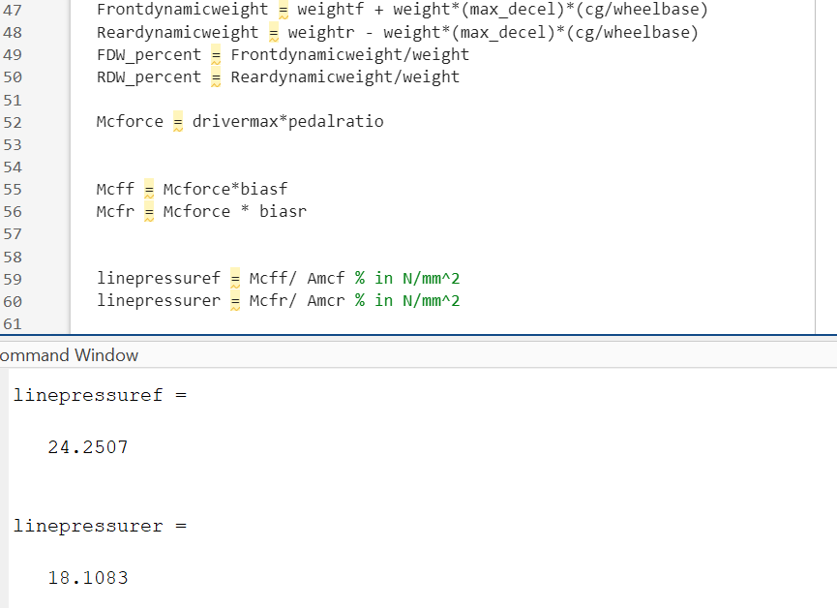
Figure 7: Matlab code and sample results
First picture showing dynamic weight balance in percentages and KG, second calculation showing brake line pressure at theoretical maximum driver load of 2000N in N/mm^2. 18 translates to about 2600 psi and 24 translates to 3770 psi, much more than the [1500] required to lock up the tires. This iteration was done with a pedal ratio of 4 and master cylinder bores of 5/8 and 1” for front and rear respectively.
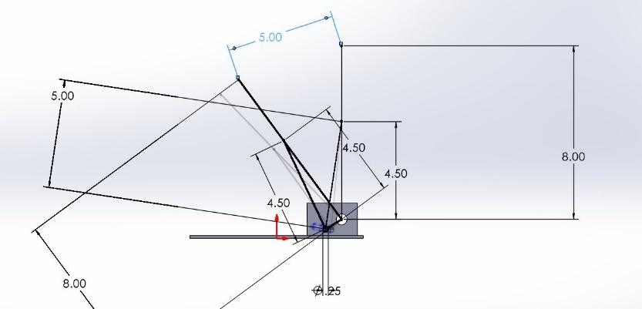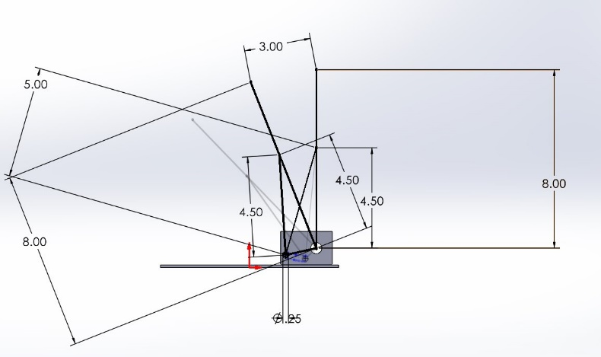
Figure 8: SolidWorks Pedal Ratio Iterations
This SolidWorks sketch represents the pedal in it’s fully decompressed and fully compressed positions. The pedal ratio is represented at the top by the 5 and 3 respectively for top and bottom photos. Using different iterations of pedal ratio, I was able to sketch the curve needed for adjusting the pedal ratio whilst having a constant mounting location at the top of the pedal.

A-Arm Garrett Pearson
A crucial aspect of A-arm design is the length of the arm. The length of an A-arm is defined as the length from the wheel hub to the mounting point on the body. This length effects, camber, suspension travel, and overall handling, all key components in the performance of a race car.
To find how arm length effects camber I used the “VSup” suspension geometry program. I input our suspension measurements to map out the exact layout our car will have. Using the graphing function, I was able to show the relationship between Arm length and Camber Angle.
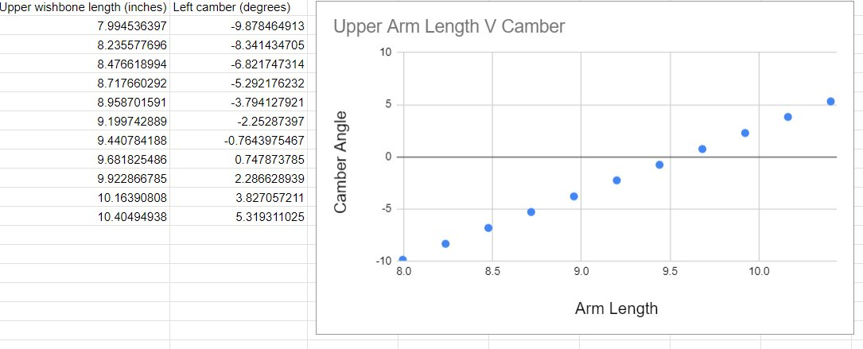Figure 9: Arm length vs camber
To achieve a desired camber angle of -1 degree, the graph shows that our arm length should be around 9.5 in. Now that we have found our ideal arm length, we must find out how that length affects the instant center of the vehicle.
The instant center is the point at which the car rotates around and is key to understanding how the car will corner. A high instant center means the car will tend to have a slower steering response time, while a lower instant center gives us faster steering response time more ideal for track racing.
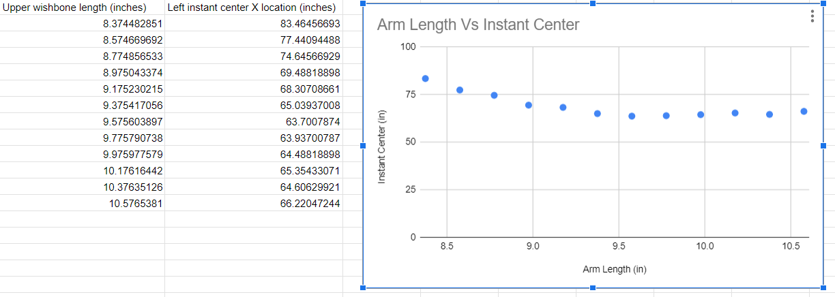 Figure 10: Arm length vs instant center
Using the same ”VSusp” program we can graph how our arm length affects the instant center. Our chosen arm length of 9.5 in gives us an instant center of about 64 in. This is a relatively low instant center, which is ideal. As the arm becomes very long or very short the instant center grows very large, which is not ideal for our car.
3.3.4 Mathew Cusson
The first variable that had to be accounted for in the steering wheel design are the materials used. This is accomplished by using ideal measurements for our steering column material and tie rod material. The governing equation needed is the following, where stress is equal to the force over the given area.

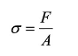
Figure 11: Stress equation
Along with this calculation we know that the following equation for shear stress is shown, where T is the torque, C is the radius from the center of the object rotating to the point where the force is acting. J is the polar moment of inertia and is relevant to the material being used. In this instance the steering column is a solid rod.

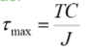
Figure 12: Shear stress equation
The goal for the equations was to find the needed radius of the steering column and the factor of safety for the tie rods. The minimum value wanted is five for maximized safety and durability of the part. For the steering column the yield strength of 40000 PSI is used from 6061 aluminum assuming a torque of 100 Ft*Lbs which is the max amount that should be expected under worst case scenario use. We adjust this equation to isolate the diameter of the function which leads to the following equation:

(pi* d^3)/16 = 1200in/lb / 8000 lb/in2

Solving this we see a minimum diameter of .914 in or a minimum radius of .457 in which is acceptable since the minimum diameter of the steering column that was being considered for the design is .6 in.
For the tie rod there is going to be 1024 steel used with a yield stress of 50800 PSI and after applying a factor of safety of five the max stress is 10160 PSI. using the above equation for stress the formula is arranged for force in Lb and the equation is as follows:

F = 10160lb/in2 / (* (.0049 in 2))

Where .0049 in is the difference in the outer radius from the inner radius. Solving for this means a max force of 156.41 Lb. This value is a reasonably high value for the kind of force that can be seen in the tube of the tie rod.

The next calculated part of the vehicle dynamics is the bump steer calculation which is derived as a three-dimensional effect that is derived from a model of the vehicle where the measurement in the steering angle is taken at bump and droop to determine the angle. This value is kept to a minimum to ensure predictable driving feel for the driver and overall stability of the vehicle.

The vehicle suspension is shown below where the circle represents the wheel radius at any given point throughout a turn at the location height of the tie rod.
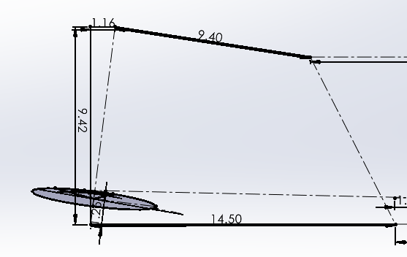
Figure 13: Suspension arm

The current expected values for this steering rack setup is .48 in at bump and .16 in at droop which are both values within reason and when comparing this steering rack size to a longer model the new bump and droop values are .2 in at bump and .11 at droop. This is a consideration to use a new steering rack but may infringe on the space limits that the vehicle has.

3.3.5 Pushrod assembly- Joseph Ciao
For the pushrod assembly design, one critical aspect is calculating the buckling load to ensure the pushrod can withstand the forces acting upon it. This is done using the Euler buckling equation:

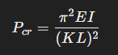
Figure 14: Euler buckling equation

where P_{cr} is the critical buckling load, Eis the modulus of elasticity, I is the moment of inertia of the pushrod cross-section, K is the column effective length factor, and L is the length of the pushrod. This equation guides the selection of appropriate length and thickness for the pushrod to prevent buckling under compression. Once the suspension geometry is finalized, we can determine the exact length of the pushrod and verify its structural integrity. Finite element analysis (FEA) will be performed using ANSYS to simulate and stress-test the pushrod and rocker arm. This analysis will ensure the components meet the required strength and stiffness under operational loads, allowing us to fine-tune the dimensions.
Our goal for this year is to streamline the design process by simplifying the geometry of the rocker armwhile maintaining structural robustness.

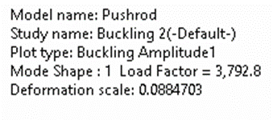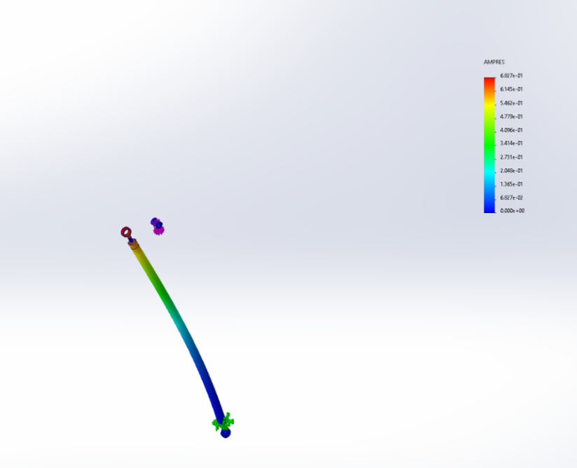
Figure 15: Pushrod analysis

The rocker arm design will target a close-to-1:1 ratio in terms of motion transmission, with the suspension system aiming for a 1.5:1 motion ratio to balance performance and control. Simplifying the design reduces manufacturing time and cost without compromising the system’s effectiveness.

Design Concepts

Functional Decomposition
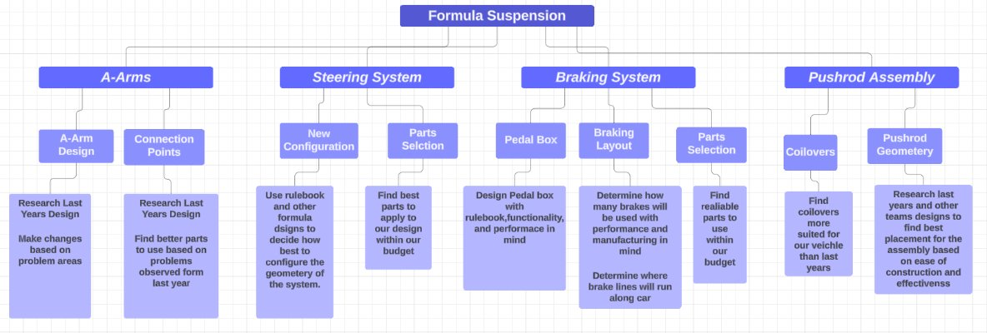
Figure 16: Suspension Functional Decomposition

Our Decomposition chart breaks down the individual systems that come together to make our vehicle suspension. Each sub-section has several main issues that need to be resolved for our vehicle to perform well. Underneath each issue are the key things to investigate that will help create an effective solution.

Concept Generation

Steering Knuckles (Parker Johnson)
There were a few designs to be considered during the generation process, the most notable being the simple knuckle design (Design 1) and the more complex steel design (Design 3). There is another more complicated aluminum design (Design 2) that is also evaluated below.
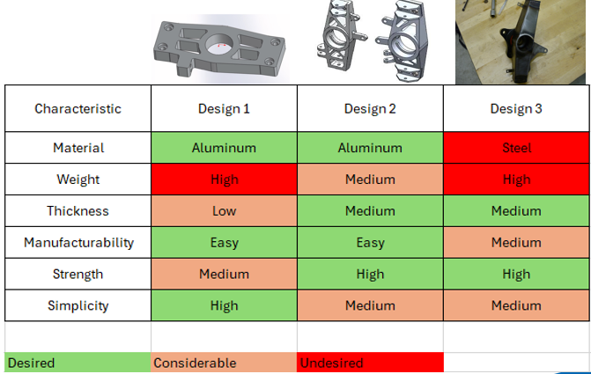
Figure 17: Knuckle Concept Generation

This process gave us valuable insight and a way to quantify desired qualities of each design. As we can see from the table above, design 2 stood out the most as far as manufacturability, material and strength being the most important qualities in this decision process. Further analysis is done later in the concept selection section.

Brakes Assembly (Chris Laney)
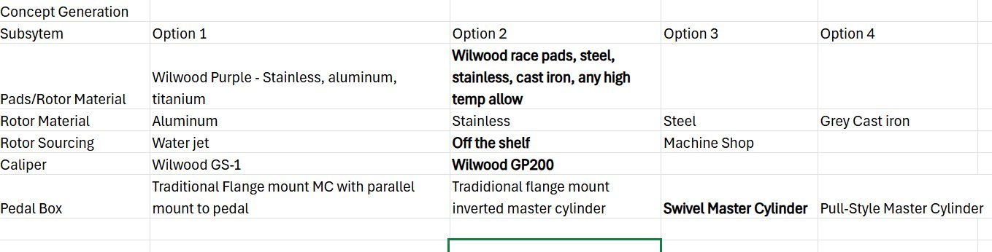Figure 18: Concept Generation Summary
This is an overview of the relevant subsystems/off the shelf items related to the braking system. The bolded ones are the ones chosen or strongly leaning towards. The most significant subsystems in the braking assembly is the pad/rotor/caliper combination and the pedal box design, so those will be described further.
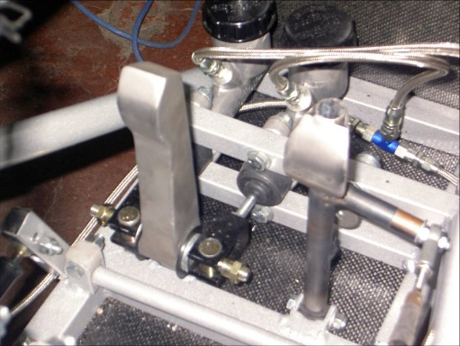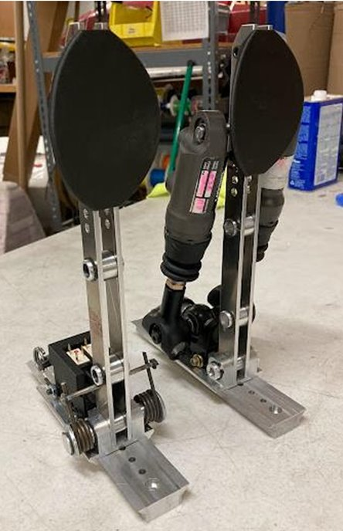
Figure 19: Example Pedal Box designs

These two images represent the two rough pedal box designs, the left picture being the traditional flange-mount master cylinder and the right picture utilizing swivel mounted master cylinders. Some pros of the flange-mount style is that it’s simple, easy to reinforce, easy to manufacture/build, and linear in terms of pedal travel and pedal ratio. Some cons involve it being heavy and bulky. Some pros of the swivel master cylinder design include lack of weight, adjustability, and small volume. Some cons of the swivel master cylinder design include it’s relative difficulty in manufacturing, as welding is required, and the cost of the master cylinders themselves.
With respect to the rotor/pad/caliper assembly, the standout combination from the benchmarking done was the Wilwood GP200 caliper with varying rotor compounds and one of two pads depending on the rotor material. This caliper seems like the go-to for many teams and it’s reliability and simplicity trump most of the shelf calipers of this size and weight. Many off the shelf rotors are available in varying sizes, compounds, and designs at a reasonably affordable price.

Steering Assembly – Matthew Cusson
The steering assembly of the vehicle is made of four primary components that are the steering wheel, steering column, steering rack, and tie rods. Of these concept variations the most significant change is the material used or how the material is mounted. The table below shows the subsystems of this steering design and multiple options that the design could take.
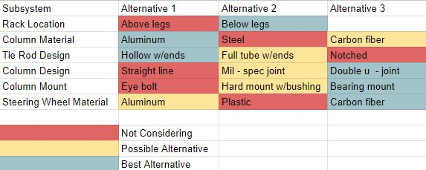
Table 2: Suspension subcomponents

A qualitative assessment is needed to fully evaluate what the best options are since these material variations can all be interchanged with each other with little issue and the overall differences are relatively minor. The categories in red are not considered for the following reasons: above legs are not practical within the rule set, a steel steering column is too heavy, notched tie rods are an unsafe design long term, a straight line steering wheel is impossible due to vehicle design, eye bolts have too much play for regulation, and a plastic steering wheel is too weak for a shifter system.

Selection Criteria

Steering Knuckles (Parker Johnson)
The selection criteria defined for the steering knuckles were largely based of manufacturability, since our team will be very limited on the ability to create complex features on our parts. We are mainly limited to outsourcing any work we have, besides anything that can be done on the vertical mill of lathe. The next most important selection criteria is the material itself, since aluminum is easily machinable and can be made as one piece. The final and most important criteria is the strength of the component, which is mainly affected by the design. There are many forces acting on this member that cause tension, compression and bending moments about different points, and this component is crucial to holding the wheels together on the car.

Brakes Assembly – Chris Laney
Between the two pedal box designs, a decision matrix was not required as the decision was relatively simple. The standout qualities of the design that took part in the decision making process was weight, adjustability, and size. For the caliper/pad/rotor designs, a decision matrix is required to make an informed decision. The largest variable at play here is the rotor material, qualities of which we care about are price, weight, thermal conductivity, coefficient of friction, machinability, and overall strength.

Steering Assembly – Matthew Cusson
Of the remaining options from the table, they are weighed against each other by way of weight, cost, and ability to obtain the materials within a short time frame. These metrics all exist to satisfy the requirements for FSAE 2024 vehicle requirements for steering assemblies that specify the following: There is at most 7 degrees of play in the steering wheel. The steering rack must be mechanically connected to the wheels. The steering rack must be mechanically attached to the chassis. All steering joints must be visible. The steering column must be connected with a quick disconnect steering wheel. The steering wheel needs an oval or near oval perimeter. The steering wheel must stay below the front hoop of the vehicle.

Concept Selection

Steering Knuckles (Parker Johnson)
The figure below shows the decision matrix created for the steering knuckles. It is apparent that the manufacturability, strength, and simplicity are of the highest importance, since they are the most important factors that will decide our success for the timeline our team has current and intends to follow. These are shown in the figure #(20) below.
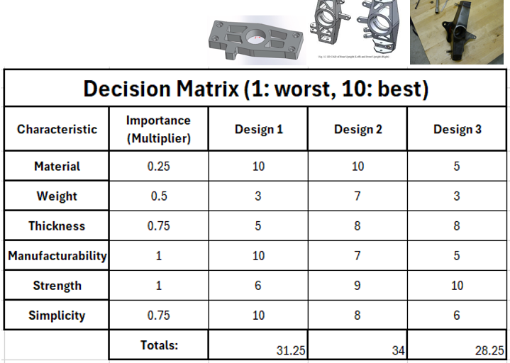
Table 3: Steering Knuckle Decision Matrix

Based off this analysis, we can see that Design 2 is rated the highest for multiple reasons. Most of these points have already been discussed previously in the report but is also worth mentioning that design 2 will look good, perform well under different stresses, and be able to support a wide range of wheel hub styles. Design 3 is rated the lowest since it is steel, which will increase the weight, and is also made of many pieces that will be required to be welded together. This design does not fit well with our timeline and therefore will be avoided. Design 1 is simple and may be easy to make, however it does not look that appealing and will not perform well under bending stresses. After each consideration we found that Design 2 is best. Preliminary design iterations have already been done and are shown below in figure #(21).
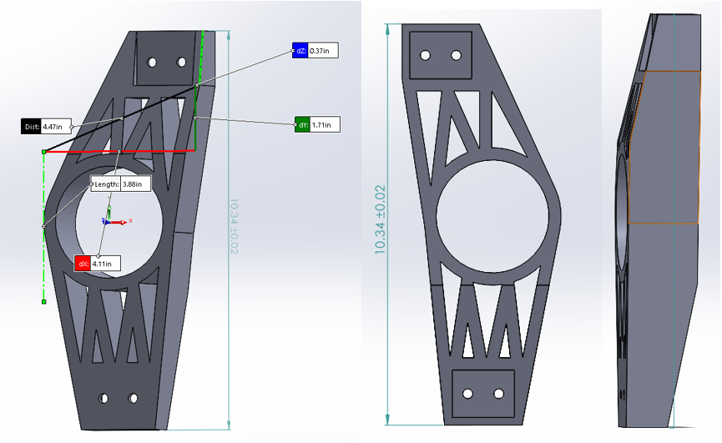
Figure 20: Steering Knuckle Rough CAD

Brakes Assembly (Chris Laney)
The decision for the pedal box design was straightforward. Due to the potential simplicity of the rest of the system, this subsystem was worthwhile to put more time into, so it was decided early on to proceed with a swivel master cylinder design due to its lightweight design, compact packaging, and adjustability potential.
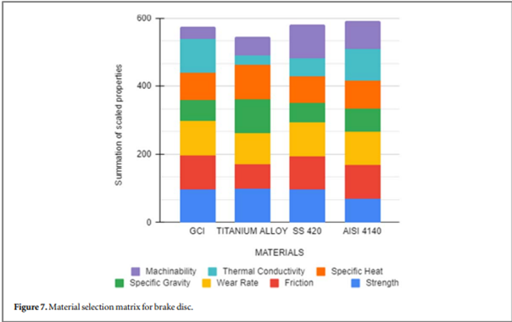
Figure 21: Decision Matrix for rotor selection
A very similar decision to ours was made by the MIT team [back in 2018, and as their decision matrix had matching parameters to ours minus the cost aspect. The price of GCI and AISI 4140 is significantly less than that of aluminum alloys, titanium alloys, or common compounds of stainless steel in the desired sizes. Since rotors are a wear item and will undergo more design changes later it is a significant concern to be able to get/make more rotors in a short period. Due to the availability of rear motorcycle rotors from Go AZ Motorcycles in Flagstaff, it was decided that an off-the shelf rotor of some steel of stainless steel would be used.

Steering Assembly (Matthew Cusson)
After evaluating the team budget and the expected forces that the parts will see the best alternatives have been selected for the vehicle. This design entails a system mounted below the legs with an aluminum steering column due to weight and price. After this are hollow tie rods with rod ends that are purchased because of the weight savings and simplicity to implement compared to a full rod. A double u joint will be used to connect the two halves of the steering rack because it is a constant velocity type joint that makes sure that the steering has no unexpected variation in rotation speed when turning the wheel. This system will be mounted to the chassis using a pillow bearing mount due to the play that is minimized by not having a rotating eye bolt. The final consideration used is that the steering wheel is going to be made from carbon fiber because the natural stiffness along with being lightweight allows it to be an ideal candidate for installing a shifting system into.

CONCLUSIONS
The Formula Student project represents a significant educational opportunity for our team, challenging us to design and build a competitive race car while adhering to rigorous standards. Our primary objective is a fully functional vehicle that passes technical inspection and competes successfully in all events. Learning from last year's experiences, we aim to enhance our car's reliability, adjustability, and overall performance, targeting an improvement in our competition ranking.
To achieve these goals, we have carefully transformed customer requirements into actionable engineering deliverables, drawing from both our faculty advisor's guidance and the FSAE Rulebook. These requirements set a strong foundation for our design and manufacturing processes, ensuring that safety, performance, and FSAE compliance are achieved.
As we progress, our focus will remain on thorough testing and early completion of the car, addressing the challenges faced in previous competitions. By using efficient methods like Functional Decompositions, Decision Matrixes, Pugh Charts, and collaboration within our team, we look to not only meeting but exceed the expectations of last year's team, ultimately aiming for a successful experience at the FSAE competition.

REFERENCES

[1] D. L. Milliken and W. F. Milliken, Race Car Vehicle Dynamics: Problems, Answers, and Experiments. Warrendale, PA: SAE International, 2003.
[2] J. C. Dixon, Suspension Geometry and Computation. Chichester, U.K: Wiley, 2009.
[3] E. F. Gaffney and A. R. Salinas, Introduction to Formula SAE® Suspension and Frame Design. Warrendale, Pa: Society of Automotive Engineers, 1997.
[4] G. Valdo and C. Rouelle, “FSAE front axle optimization using OptimumKinematics optimization module,” OptimumG, https://optimumg.com/fsae-front-axle-optimization-using-optimumkinematics-optimization-module/ (accessed Sep. 16, 2024).
[5] R/FSAE on reddit: Scrub radius and mechanical trail help, https://www.reddit.com/r/FSAE/comments/1dbmr01/scrub_radius_and_mechanical_trail_help/ (accessed Sep. 16, 2024).
[6] “Vehicle suspension: Front view online suspension simulator,” Vehicle Suspension: Front View Online Suspension Simulator, https://vsusp.com
[7] S. Ranganathan, S. gopal, S. eswaran, and S. muthusamy, “Design and analysis of steering knuckle for FSAE vehicle,” SAE International Journal of Advances and Current Practices in Mobility, https://www.sae.org/publications/technical-papers/content/2020-28-0506/ (accessed Sep. 16, 2024).
[8] S. Yaeger et al., “Designjudges.com,” DesignJudges.com, https://www.designjudges.com/ (accessed Oct. 20, 2024).
[8] “Circuit Tire Specifications.” Hoosier Racing Tires, www.hoosiertire.com/news/article/64377/Circuit_Series_Tire_Specs. Accessed 16 Sept. 2024.

[9] Gupta3, Eshaan, et al. “Design and analysis of brake system for FSAE race car” Engineering Research Express, IOP Publishing, 25 Apr. 2022, iopscience.iop.org/article/10.1088/2631-8695/ac6ecd.

[10] Markel, Andrew. “Brake Math: Calculating the Force Needed to Stop a Car.” Brake & Front End, 5 Nov. 2020, www.brakeandfrontend.com/brake-math-calculating-the-force-needed-to-stop-a-car/.

[11] Milliken, William F., 1911-2012. Race Car Vehicle Dynamics. Warrendale, PA :Society of Automotive Engineers, 1995.
Chapters 2, 10, 11, 12, 18, 20

[12] Mora, Luis Alberto. Design of a FSAE Braking System, Massachusetts Institute of Technology, 1 Jan. 2018, dspace.mit.edu/handle/1721.1/119947.

[13] Schiller, Brad W. “2007 Formula SAE Pedal Box.” 2007 Formula SAE Pedal Box, Massachusetts Institute of Technology, 1 Jan. 2007, dspace.mit.edu/handle/1721.1/40481?show=full.

[14] Shivkumar Mirajgave, et al. “Design and Cost Effective Manufacturing of Swivelling Brake Master Cylinder for a Formula Student Vehicle.” Materials Today: Proceedings, Elsevier, 2 Jan. 2023, www.sciencedirect.com/science/article/pii/S2214785322074740.

[15] Tom McCready and James Walker, Jr. of SCR motorsports. “Brake Bias and Performance.” Brakes, www.brakes-shop.com/brakepedia/general/brake-bias-and-performance. Accessed 16 Sept. 2024.
[16] J. Reimpell, J. Betzler, and H. Stoll, The Automotive Chassis, Hodder Education, 2000.
[17] W. F. Milliken, Race Car Vehicle Dynamics and Workbook, Soc. of Automotive Eng., 1998.
[18] Y. S. Saurabh et al., “Design of Suspension System for Formula Student Race Car,” Procedia - Engineering, vol. 144, pp. 1138–1149, 2016, doi: https://doi.org/10.1016/j.proeng.2016.05.081
[19] K. B. Evseev and A. B. Kartashov, “Search for optimal design parameters of suspension arms for -Formula Student race car,” Izvestiya MGTU MAMI, vol. 9, no. 3–1, pp. 32–37, Feb. 2015, doi: https://doi.org/10.17816/2074-0530-67179.
[20]A. A. Vadhe, “Design and Optimization of Formula SAE Suspension System,” International Journal of Current Engineering and Technology, vol. 8, no. 3, May 2018, doi: https://doi.org/10.14741/ijcet/v.8.3.17.
[21] “Automotive Suspension - MATLAB & Simulink,” www.mathworks.com.
[22]“Suspension Design Series,” YouTube, http://www.youtube.com/playlist?list=PLfNrVTkV8cM_kaP29HJqIXWjDcHNv-cqs (accessed Sep. 16, 2024).
Summitracing.com, 2024. https://www.summitracing.com/search/part-type/coilover-springs/product-line/hyperco-formula-sae-coilover-springs (accessed Sep. 19, 2024).
[23]A. Cobi, “Design of a Carbon Fiber Suspension System for FSAE Applications,” 2012. Available: https://dspace.mit.edu/bitstream/handle/1721.1/74433/813136157-MIT.pdf

[24]“Our Cars – Illini Motorsports.” https://motorsports.illinois.edu/our-cars-2/
[25]“B24 – Berkeley Formula Racing,” Berkeley.edu, 2024. https://fsae.studentorg.berkeley.edu/b24/ (accessed Oct. 20, 2024).
[26]Shafi Md Istiak, Md Rokunuzzaman, and M. A. Islam, “Design of suspension system for formula student race car,” International Conference on Mechanical, Industrial and Materials Engineering 2019, Dec. 2019, Accessed: Oct. 20, 2024. [Online]. Available: https://www.researchgate.net/publication/363196220_Design_of_suspension_system_for_formula_student_race_car
[27]L. Sun, Z. Deng, and Q. Zhang, “Design and Strength Analysis of FSAE Suspension,” The Open Mechanical Engineering Journal, vol. 8, no. 1, pp. 414–418, Dec. 2014, doi: https://doi.org/10.2174/1874155x01408010414.
[28]H. Zhao, Y. Chen, and X. Liu, “Lightweight Design of the Vehicle Suspension Control Arm,” Proceedings of 5th International Conference on Vehicle, Mechanical and Electrical Engineering, 2019, doi: https://doi.org/10.5220/0008849300210025.‌
[29]P. Andrea, C. Santamaría, A. Sierra, O. Andrés González Estrada, and O. Andrés González, “Stress analysis of a suspension control arm.” Available: https://hal.science/hal-01916247/document
[30] J. C. Dixon, Suspension Geometry and Computation. Chichester, U.K: Wiley, 2009.

[31] J. Rodriguez et al., “Automotive Steering System Preferences evaluated using a driving simulator - International Journal of Automotive Technology,” SpringerLink, https://link.springer.com/article/10.1007/s12239-016-0006-0?error=cookies_not_supported&code=651a5789-c052-4355-9167-d85115dbe9d2 (accessed Sep. 15, 2024).

[32] H. Chase, A study of modern automotive-vehicle steering-systems on JSTOR, https://www.jstor.org/stable/44723675 (accessed Sep. 16, 2024).

[33] J. Vogel, “Tech explained: Ackermann Steering Geometry,” Racecar Engineering, https://www.racecar-engineering.com/articles/tech-explained-ackermann-steering-geometry/ (accessed Sep. 16, 2024).

[34] Racelogic, “Slip angle explained,” https://www.racelogic.co.uk/_downloads/vbox/Application_Notes/Slip%20Angle%20Explained.pdf (accessed Sep. 16, 2024).

[35] D. G. Bhosale, Shubham Lilakant Rahate, K. Rege, and Sakthivel Palanivelu, “To Study the Influence of Variation in Camber and Toe on Handling of Passenger Vehicle during Cornering,” SAE technical paper series, Jan. 2019, doi: https://doi.org/10.4271/2019-26-0073

[36] U. Kulkarni, H. Gowda, and Hima Kiran Venna, “Effect of Tie Rod Length Variation on Bump Steer,” Feb. 2016, doi: https://doi.org/10.4271/2016-28-0201

