Northern Arizona University Formula SAE Powertrain

Initial Design Report

Damian Boniella
Matt Gingold
Tobin Lanford
Joey LeBlanc
Lucille Longhurst

Fall 2024 - Spring 2025


Project Sponsor: Northern Arizona University
Faculty Advisor: David Willy

DISCLAIMER
This report was prepared by students as part of a university course requirement. While considerable effort has been put into the project, it is not the work of licensed engineers and has not undergone the extensive verification that is common in the profession. The information, data, conclusions, and content of this report should not be relied on or utilized without thorough, independent testing and verification. University faculty members may have been associated with this project as advisors, sponsors, or course instructors, but as such they are not responsible for the accuracy of results or conclusions.

EXECUTIVE SUMMARY
Formula Society Automotive of Engineers (FSAE) is a collegiate competition that challenges students to conceive, design, fabricate a small formula-style race car. Vehicles compete in a series of static events, including Design, Cost and Manufacturing, and Business Presentation, as well as dynamic events, including Acceleration, Skid Pad, Autocross, Endurance, and Fuel Efficiency. SAE International is the governing body and sets forth all regulations and engineering requirements for the design and competitive rule set. NAU FSAE collectively followed all the rulesets and regulations.
Powertrain is a sub-team within Northern Arizona University’s (NAU) FSAE team comprised of five mechanical engineering students and four electrical engineering students. Powertrain is the system within the vehicle that is responsible for generating and delivering power to the wheels and enabling motion. Ultimately, the powertrain team is focused on designing a cost-effective, high performance powertrain system that optimizes reliability.
The design centers around the 2018 Honda CBR600RR engine, using innovative components including a short intake system, electric paddle shifters, and more. The system is built to balance the need of customer requirements and the technical engineering requirements, ensuring both performance and compliance with FSAE competition rules. The short intake was selected for its cost-effectiveness and ease of manufacturing. It gathers air from within the engine compartment and simplifies tuning, staying within the tire envelope while using a 20mm restrictor to meet regulations. This design reduces overall cost and complexity, making it a customer-friendly solution without sacrificing performance. The exhaust headers, designed as long tube steel, focus on minimizing deflection between the engine and rear axle to improve vehicle stability. It meets the requirement of the noise limits (103dB at idle and 110dB at speed) and avoid running near the fuel system. They are carefully designed for easy installation, streamlining the manufacturing and welding processes.
The differential mounts are load bearing and incorporate horizontally adjustable brackets to allow for precise chain tensioning while limiting adjustments to one direction. The choice of aluminum 6061 for the mounts provides cost efficiency and ease of machinability. The drivetrain includes electric paddle shifters, which improve shifting response time and reduce driver fatigue. A 3.8 gear ratio, using an 11-tooth front sprocket and a 42-tooth rear sprocket, was selected for optimal balance between acceleration and speed. The system uses a 520-type chain with approximately 62 links. To enhance handling, an adjustable limited-slip differential (LSD) was chosen, allowing for tunable performance based on track conditions.
As of October 10, the team successfully ran the engine for the first time. Current efforts focus on engine maintenance, finalizing the design of the exhaust headers and differential mounts, as well as fabricating the sprocket mount. Fundraising efforts are ongoing to support the remaining project needs. The team will finalize the exhaust system, complete machining tasks, and conduct full testing of the drivetrain to validate performance and reliability. The NAU FSAE Powertrain team is making steady progress towards delivering a high-performance, cost-effective vehicle, with the remaining focus on finalizing critical components, securing funding, and validating the drivetrain through comprehensive testing to ensure competitive success.

TABLE OF CONTENTS
Contents
DISCLAIMER Error! No bookmark name given.
EXECUTIVE SUMMARY Error! No bookmark name given.
TABLE OF CONTENTS Error! No bookmark name given.
1 BACKGROUND Error! No bookmark name given.
1.1 Project Description Error! No bookmark name given.
1.2 Deliverables Error! No bookmark name given.
1.3 Success Metrics Error! No bookmark name given.
2 REQUIREMENTS Error! No bookmark name given.
2.1 Customer Requirements (CRs) Error! No bookmark name given.
2.2 Engineering Requirements (ERs) Error! No bookmark name given.
2.3 House of Quality (HoQ) Error! No bookmark name given.
3 RESEARCH WITHIN DESIGN SPACE Error! No bookmark name given.
3.1 Benchmarking Error! No bookmark name given.
3.2 Literature Review Error! No bookmark name given.
3.2.1 Intake - Damian Boniella Error! No bookmark name given.
3.2.2 Exhaust Manifold - Matt Gingold Error! No bookmark name given.
3.2.3 Differential Mount - Tobin Lanford Error! No bookmark name given.
3.2.4 Engine - Joey LeBlanc Error! No bookmark name given.
3.2.5 Sprockets/Gear Ratio - Lucille Longhurst Error! No bookmark name given.
3.3 Mathematical Modeling Error! No bookmark name given.
3.3.1 Intake Design Calculations - Damian Boniella Error! No bookmark name given.
3.3.2 Exhaust Design Calculations - Matt Gingold Error! No bookmark name given.
3.3.3 Differential Mount Calculations - Tobin Lanford Error! No bookmark name given.
3.3.4 Engine Design Calculations - Joey LeBlanc Error! No bookmark name given.
3.3.5 Sprockets/Gear Ratio - Lucille Longhurst Error! No bookmark name given.
4 Design Concepts Error! No bookmark name given.
4.1 Functional Decomposition Error! No bookmark name given.
4.2 Concept Generation Error! No bookmark name given.
4.2.1 Intake Designs - Damian Boniella Error! No bookmark name given.
4.2.2 Exhaust Designs – Matt Gingold Error! No bookmark name given.
4.2.3 Differential Mount – Tobin Lanford Error! No bookmark name given.
4.2.4 Engine Selection - Joey LeBlanc Error! No bookmark name given.
4.2.5 Shifter, Sprockets, Chain Selection - Lucille Longhurst Error! No bookmark name given.
4.3 Selection Criteria Error! No bookmark name given.
4.3.1 Intake Selection Criteria – Damian Boniella Error! No bookmark name given.
4.3.2 Exhaust Selection Criteria – Matt Gingold Error! No bookmark name given.
4.3.3 Differential Mount Selection Criteria – Tobin Lanford Error! No bookmark name given.
4.3.4 Engine Selection Criteria – Joey Leblanc Error! No bookmark name given.
4.3.5 Shifter, Sprockets, and Chain Selection – Lucille Longhurst Error! No bookmark name given.
4.4 Concept Selection Error! No bookmark name given.
4.4.1 Intake Design - Damian Boniella Error! No bookmark name given.
4.4.2 Exhaust Design - Matt Gingold Error! No bookmark name given.
4.4.3 Differential Mounting - Tobin Lanford Error! No bookmark name given.
4.4.4 Engine Selection - Joey LeBlanc Error! No bookmark name given.
4.4.5 Shifter, Gear, and Chain Selection - Lucille Longhurst Error! No bookmark name given.
5 CONCLUSIONS Error! No bookmark name given.
6 REFERENCES Error! No bookmark name given.
7 APPENDICES Error! No bookmark name given.
7.1 Appendix A: MATLAB CODE Error! No bookmark name given.
7.2 Appendix B: Final Drive Ratio Error! No bookmark name given.
7.3 Appendix B: Sprocket Analysis Error! No bookmark name given.

BACKGROUND
This Chapter will provide a description of the project, deliverables for the project, and the success metrics. These topics will not only include FSAE guidelines but also our own guidelines for the project. As a team we will strive to produce a better car than the previous year’s team and set high standards for ourselves.

Project Description
The goal of the project is to design and build a small-scale formula style racecar over the course of the 2024-2025 academic school year. With the goal of competing in the Formula SAE competition in Brooklyn, Michigan where we will compete against a hundred different schools in a variety of events that test the overall performance of the car. Fundraising is a key component to the development and fabrication of our vehicle, allowing us to effectively budget the project based on both current funds and anticipated future contributions. The table below provides a brief summary of the project’s current financial balance.
Table 1: Current NAU FSAE Sponsor List
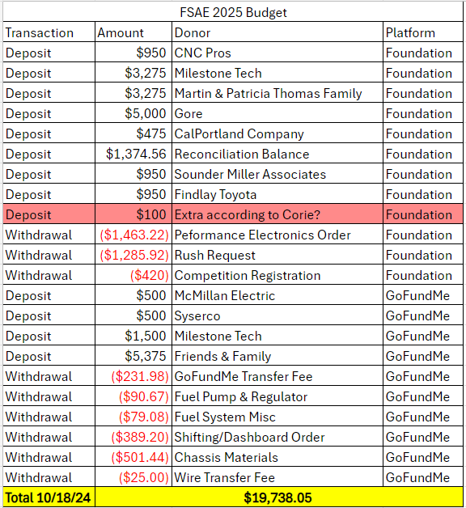
To date, we have achieved significant progress towards our goal of $40,000. Additionally, NAU may contribute funds to assistance with travel expenses. Collectively, the team has raised over the minimum 10%, a requirement of the NAU ME476C course, based on the initial funds provided to us. Our fundraising initiatives have included creating a donation website (GoFundMe), reaching out to businesses for sponsorship opportunities, and offering five tiers of sponsorship agreements based on the level of contribution both with varying levels of advertisement exposure.
This project is vital in our academic and professional growth as it allows students to gain hands on experience before entering the workforce. The FSAE project provides engineering students with practical experience in design and manufacturing within the automotive field, offering invaluable experience for those looking at a career in the automotive industry. Additionally, it introduces students to a variety of new challenges and learning opportunities which may be beneficial to those still exploring potential career paths. FSAE is truly a test of the team’s application of engineering principles, manage budgets, collaborate effectively, and project management skills, requiring a high level of commitment from all team members.

Deliverables
Deliverables are utilized to create structure, help the team in staying on track of their assignments. The major deliverables for NAU Formula SAE project can be categorized into three categories: course-related, competition specific, and client-specific.
Formula SAE is part of ME476C course. The in-class deliverables are critical components that help us track our progress and ensure we are meeting our project milestones. Major in-class assignments involve, timecards, peer evaluations, reports, and presentation, all of which are geared towards documenting progress, sharing updates, and receiving updates. Both Report 1(due October20) and Report 2 (due Nov 27) are comprehensive documents that encapsulate design decisions, engineering analysis, and project timelines. Moreover, peer evaluations help ensure that team members are contributing effectively, similarly with timecards, it allows individuals to track hours spent on project tasks which ensures accountability and time management.
Furthermore, staff meetings occur regularly once a week. This is a chance for Powertrain to discuss, clarify, and update one another and the professor about progress within the project. Two other major milestones include prototype demonstrations which were to have our engine running and 3D print all machined parts by November 13, 2024, and the final CAD and bill of materials (BOM) by December 03, 2024. Throughout the semester, each in class deliverable is designed to push the team toward in creating a functional, competitive vehicle while honing our professional and technical skills.
Within the FSAE competition, major deliverables are designed to demonstrate the team’s overall engineering capabilities, project management, and overall vehicle performance which closely aligns with both ME 476C and competition standards. The key deliverable is the final race car itself, which must meet strict technical specifications set by the competitions. Alongside the vehicle, teams are required to submit a comprehensive series of technical reports and presentations that outline the design decisions, engineering processes and cost analysis of the project. The deliverables include a design report, cost report, and a business presentation. The design report explains the rationale behind the car’s deign choices, providing a detailed analysis on components, materials, and simulation results. The cost report details the financial aspect of the project breaking down material costs and labor which is imperative in showing the team’s understanding of real-world manufacturing. The business presentation explains the marketability and cost efficiency of the design in a hypothetical production scenario.
During the competition, teams must also deliver live presentations on their car’s design, budget and performance which are judged by industry professionals. First the vehicle goes under rigorous technical inspection to ensure it complies with all competition rules regarding safety and performance. After technical inspection, the vehicle’s performance is evaluated in dynamic events such as acceleration, skid pad, financial, and business deliverable ensure that students gain a comprehensive experience in managing a complex engineering from designing to execution. While developing skills that are directly applicable in the automotive and engineering industries. Finally, since our team is sponsored by numerous companies, it is imperative that we follow through with all marketing materials that we promised in exchange for sponsorship including branding on our website, vehicle, and social media promotions.
In conclusion the NAU FSAE project requires a wide range of deliverables that not only ensure progress but fosters engineering, project management and communication skills. From course-related milestones such as reports, timecards and peer evaluations to competition specific requirement such as the final race car, technical presentation, static and dynamic events, and cost analysis, each deliverable is structured to guide the team through each phase of the project. The deliverables hold the team accountable and help align our efforts in producing a high performing, competitive vehicle. Additionally, the fulfillment of client specific obligations highlights the importance of professionalism and marketing in real world scenarios. All the deliverables ensure that by the end of the project, the team is prepared with the skills and experience necessary to succeed in both competition and our future engineering careers.

Success Metrics
For the 2025 NAU Formula SAE project to be considered a success several criteria must be met. The team must first produce a running and driving car that can reliably complete laps around a track and compete in a variety of scenarios such as a drag strip, autocross course, and brake tests. Then the build will be taken to Michigan to be judged in an annual design event where it will compete against race cars from over 100 other colleges around the country. To be considered a success by the team the car must pass inspection within the first two days of the competition and compete in every event offered at the competition. The events the car will be subject to are the design presentation, cost report, manufacturing report, acceleration, skid pad, autocross, and endurance. The previous iteration of the NAU Formula SAE car did not pass inspection until late in the competition and only competed in the final event which was the endurance. This was because of several design requirements that were overlooked. For powertrain this failed to include a feasible differential mount/chain adjustment mechanism, tuning for the fuel injection system, a custom exhaust to meet noise requirements, and a quick and reliable shifting system for competitive lap times. At competition this resulted in a car that struggled to pass the technical inspection and was not able to be competitive in the single event it did compete in. NAU FSAE 2025 aims to improve on last year's mistakes and run a successful and reliable car at the competition this year.

REQUIREMENTS
This chapter will cover the customer and engineering requirements, in depth, for our project. These requirements will also be represented visually through a House of Quality (HoQ) to determine the importance of each requirement.

Customer Requirements (CRs)
- Functional Drivetrain
  - The team wants our drivetrain to be reliable and operate smoothly for our drivers.
- Clean Wiring
  - The team wants professional and clean wiring throughout the vehicle for aesthetic and ease of problem-solving purposes.
- Engine runs after brake test
  - For technical inspection, the vehicle must lock up all four wheels and have the engine running at the end of the test to complete the test.
- Ease of service
  - The drivetrain must be easy to repair in case of a part failure.
- Interchangeability of parts
  - Parts used within the drivetrain system must be easy to change and still work as intended.
- Design meets all competition rules
  - All aspects of the drivetrain system must be rule compliant.
- Safety
  - The vehicle must be safe for all drivers and spectators around it.
- Cost
  - The vehicle cost must be reasonable for the team to work with.
- Ease of shifting
  - The drivetrain system must be easy to shift and shift smoothly.
- Useable powerband
  - The drivetrain must perform optimally through the powerband with our given restrictions.
- Sound
  - The exhaust system must meet competition requirements and not harm drivers' or spectators' hearing.
- Chain tension adjustability
  - The powertrain system must have adjustable chain tensioning to account for chain slack and stretching.
- Body roll
  - Vehicle body roll must be kept to a minimum to increase performance by distributing engine weight.
- Acceleration rating
  - The team will need a high acceleration rating to score well in the drag race event.
- Horsepower rating
  - The team will need a high horsepower rating for better performance in the events’ high-speed sections.
- Torque rating
  - The team will need a high torque rating for better performance when coming out of conners in the events.
- Track weight
  - Must keep vehicle as little as possible to increase performance.

Engineering Requirements (ERs)
- Functionality
  - All systems within the drivetrain system must work repeatedly without a failure. This will be measured with a yes/no outcome with each drivetrain system having the desired goal of yes.
- Under 710cc
  - The engine used must be under 710cc to meet competition rules. The team has set a target engine size of 600cc.
- Power to weight ratio
  - The team needs to maximize the power to weight ratio to maximize vehicle’s performance. The team will shoot for a power to weight ratio of 0.25 hp/lb.
- Manufacturability
  - Manufactured parts within the drivetrain system must be quick and easy to manufacture. The team has set a goal for all manufactured parts to be manufactured within two weeks.
- Dynamometer tuned
  - To maximize the performance of the vehicle, the vehicle must be dynamometer tuned. This will be a yes/no outcome with the desired outcome being yes, measurable dynamometer goals are explained below.
- Cost
  - The cost of the drivetrain system must be reasonable for the team to work with. The team has a cost goal of $14,207 for the drivetrain system.
- Ease of diagnostics
  - The drivetrain system must be easy to diagnosis problems when they occur. The team has a goal of being able to diagnose drivetrain problems within 15 minutes.
- Center of gravity
  - The vehicle needs a low center of gravity to pass the tilt test which tests the amount of g’s your vehicle can handle. The team has set a center of gravity height to be 10 in. off the ground.
- Ergonomics
  - The team needs the vehicle to have an ergonomic design to provide comfort to the drivers to maximize performance. This will be a yes/no outcome with the desired outcome being yes for all drivers.
- Engine vitals
  - Engine vitals must always be readable for drivers to check the health of the engine. This goal will have a yes/no outcome with the desired outcome being yes, measurable engine vitals goals are explained below.
- Useable torque
  - Torque must not break the wheels loose but provide adequate torque for fast acceleration. The team will have a target torque value of 150 ft-lb after being dynamometer tuned.
- Operating temperature
  - The engine must run at operating temperature for the best performance. The team will have a desired temperature of 212 degrees Freiheit.
- Sub team passes inspection
  - Drivetrain must pass technical inspection. This will be measured with a yes/no outcome with the desired outcome being yes.
- Durability
  - The drivetrain system must be strong enough to survive the entire competition. The team has set the goal of surviving all 4 days of competition.
- Serviceability
  - The drivetrain system must be easily serviceable to fix any failures during competition. The team has set an average repair time goal of 30 minutes.
- Fast shifting
  - Fast shifting will maximize the team’s timed performance during competition. The team has set a goal of an average shift time of 50 milliseconds.
- Lightweight
  - The team needs the vehicle to be lightweight to maximize performance. The team has set a vehicle goal weight of 440 lbs. without a driver.

House of Quality (HoQ)
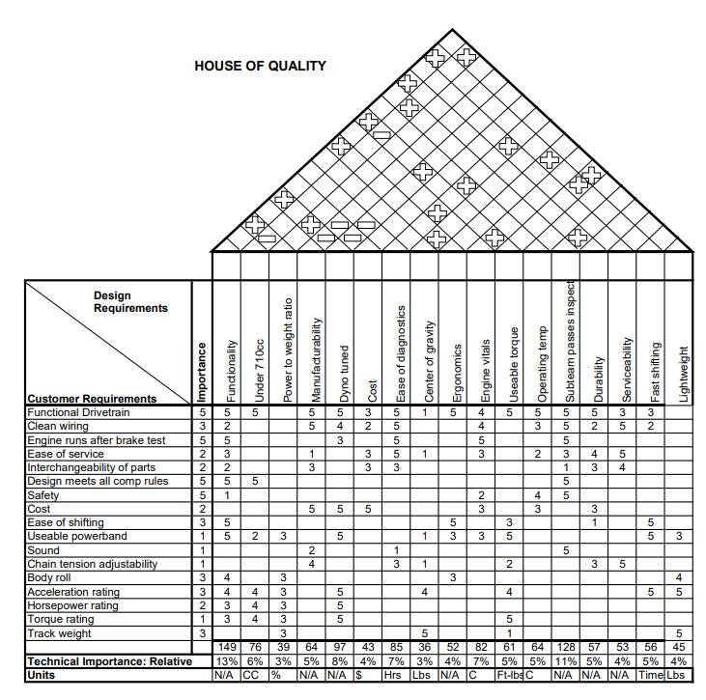
Figure 1: HoQ

From the HoQ, the team needs to prioritize the engineering requirements of functionality and sub team passes inspection because these requirements have the highest correlations to our customers' requirements, with the correlation scores being 13% and 11% respectively. However, the team will not want to prioritize power to weight ratio and center of gravity due to their low correlation scores of 3%.

RESEARCH WITHIN DESIGN SPACE

Benchmarking
NAU FSAE 25 benchmarked Ohio State University from last year’s 2024 competition because they received first place overall in the competition. They utilized an electro-pneumatic shifting system, a Motec ECU, and produced 87HP from their engine. Here are their results:
Ohio State University FSAE Michigan 2024: [40]
- Overall result: 1st
- Acceleration: 4.271 s
- Skidpad: 5.346 s
- Autocross: 46.911 s
- Endurance: 1395.891 s (23.26 minutes)
- Efficiency: 0.535
NAU FSAE 25 benchmarked University of North Carolina Charlotte car from last year’s 2024 competition because they received second place overall in the competition. They used a paddle shifting system, four-cylinder engine, and a Motec ECU. Here are their results:
University of North Carolina Charlotte FSAE 2024 [39]
- Overall result: 2nd
- Acceleration: 4.811 s
- Skidpad: 5.243 s
- Autocross: 50.329 s
- Endurance: 1408.963 s (23.48 minutes)
- Efficiency: 0.691
NAU FSAE 25 benchmarked last year's car heavily to see where improvements could be made. The utilized a 2004 Honda CBR600F4i engine, a hand clutch and shifter, and did not tune their car with an ECU despite having bought a Dynojet Power Commander 6 specifically for their engine. Last year’s team was barely able to compete in the competition and the current team hopes to improve on their results. To do so this year’s team must treat them as state-of-the-art because they had the same resources available that the team does now. Here are their results:
Northern Arizona University FSAE Michigan 2024 [41]
- 96th Overall
- Acceleration: DNA
- Skidpad: DNA
- Autocross: DNA
- Endurance: 2092.469 s (~ 35 minutes)
- Efficiency: DNA
Further benchmarking of the powertrain hardware, especially the differential mounts, was based on information in the MIT FSAE Reports. [1]

Literature Review

Intake - Damian Boniella
[2] Internal Combustion Engine Fundamentals
This textbook describes the information needed to design an engine by providing equations and real-life examples. Within this textbook interest has been placed on sections: 6.1, 7.5, and 14.3. These sections include information on intake air flow phenomena and provide the characteristics for modeling air flow within an intake. This source’s information will be used to provide insight on intake design and for setting up test models.
[3] Engineering Fundamentals of the Internal Combustion Engine
This is another textbook that describes information needed to design an engine. Within this textbook interest has been placed on sections 2.9, 5.1, 6.6, and 6.7. These sections provide the equations needed to design an intake and provide some intake flow modeling solutions. This source’s information will be used to help lead intake design and verify the design’s functionality.
[4] Machinery’s Handbook
This handbook provides information on standards used within engineering. Interest has been placed in pages 1004-1327 because they provide information about machining standards. Some of the information included is machine speeds, feed rates, and cutting fluids. This information will be used when machining parts for the vehicle.
[5] Nozzle Geometry Variations on the discharge coefficient
This source is a research paper on how geometries can affect discharge coefficients. The paper goes into depth with multiple geometries being tested and results of the discharge coefficient being shown. This paper is important because with a restrictor in the intake system, the intake will act as a nozzle; and to provide maximum power to the engine, the intake system will need a high discharge coefficient to provide maximum air.
[6] EXPERIMENTAL AND ANALYTICAL SONIC NOZZLE DISCHARGE COEFFICIENTS FOR REYNOLDS NUMBERS UP TO 8x10^6
This is a NASA research paper on nozzle discharge coefficients for varying Reynolds numbers. The research also provides results on how nozzle geometry can affect velocities and pressures within nozzles. This information will be useful for generating high velocities and pressures within the intake system to provide more air to the engine.
[7] PERFORMANCE OF CONICAL JET NOZZLES IN TERMS OF FLOW AND VELOCITY COEFFICIENTS
This is a NASA research paper on nozzle mass flow and velocity coefficients. The research shows how nozzle geometry affects velocity and pressure within the nozzle using differing mass flow rates. This information will be useful for generating high pressures and velocities within the intake system to provide more air to the engine.

[8] Calculating Critical Air scoop speed with a forward-facing Air Inlet
This is an online article on calculating scoop size and showing the effects that scoops have on performance. The article goes into detail on the effectiveness of scoops for high performance vehicles and provides some equations for scoop performance. This information will be useful for determining if a scoop is a good performance option for our vehicle.
[9] Proper hood scoop sizing
This is an online forum discussing scoop sizing for high performance vehicles. The forum discusses issues people have had with scoop sizing, how to accurately calculate scoop sizing, and how to determine scoop sizing problems. This information will be used to determine if a scoop is a good option for our vehicle.

Exhaust Manifold - Matt Gingold
[2] J.B. Heywood, Internal Combustion Engine Fundamentals, 2nd edition. New York: McGraw-Hill, 2018.
I used chapter 5: “Ideal Models of Engine Cycles”, and Chapter 6: “Gas Exchange Processes.” These helped to look at how to deal with hot gases in the exhaust system and how to optimize them.
[10] Mike Mavrigian, Performance Exhaust Systems, How to Design, Fabricate, and Install. North Branch MN: CarTech Inc, 2014. https://www.google.com/books/edition/Performance_Exhaust_Systems/FkP7AwAAQBAJ?hl=en&gbpv=1&dq=motorcycle+exhaust+system+design&printsec=frontcover
This helped to decide how to fabricate an exhaust by considering things like equal length headers and how to make them work properly without causing too much “noise” within the pipes.
[4] Erik Oberg, Franklin D. Jones, Holbrook L. Horton, and Henry H. Ryffel, Machinery’s Handbook, 29th Edition. New York: Industrial Press, 2012.
Here it compared different materials to use for the exhaust piping
[11] Hiroshi Kuribara, et al, Prediction of Fatigue Strength of Motorcycle Exhaust System Considering Vibrating and Thermal Stresses. SAE International Journal of Engines, 2016. https://www.jstor.org/stable/26284825?seq=1
This source investigates exhaust failures due to vibrations and thermal stresses
[12] A M Siregar, et al, Engineering of motorcycle exhaust gases to reduce air pollution. IOP Conference Series: Materials
Science and Engineering, 2020. https://iopscience.iop.org/article/10.1088/1757-899X/821/1/012048/meta
Siregar talks about interesting ways to reduce emissions from a motorcycle exhaust system
[13] Taguchi, T., Aoki, M., Katsukawa, Y., KOGA, M. et al., "Development of a Noise Prediction Technique for Designing a High-Performance Muffler of Motorcycle," SAE Technical Paper 2010-32-0023, 2010, https://doi.org/10.4271/2010-32-0023
Taguchi talks about custom mufflers, and how to optimize them for the engine at hand.
[14] MXA, Ten Things You Need to Know About Mufflers. Motocross Action Mag, 2019. https://motocrossactionmag.com/10-things-you-need-to-know-about-mufflers/
This talks about all the traits you should look for in a muffler and points out some nifty things.
[15] Martin Pechout, et al, Regulated and unregulated emissions and exhaust flow measurement of four in-use high performance motorcycles. Science Direct: Atmospheric Enviroment: X, 2022. https://www.sciencedirect.com/science/article/pii/S2590162122000247
This compares different bikes with differing displacements to see emissions and flow rates.
[16] Zach Jobe, et al, DIY Exhaust! - Is it worth it? Donut Media: Money Pit, 2021. https://www.youtube.com/watch?v=io9k0gNj7c4
Here is a video showing the process of making a custom exhaust (this example is on a car), and it even includes using a welder and showing how to use it.

Differential Mount - Tobin Lanford
[17] “Section 17-5 Roller Chain,” Shigley’s Mechanical Engineering Design 11th Edition
This section in Shigley’s Mechanical Engineering Design provides equations for calculating the forces transferred through the chain driven by the engine and transmission to the rear sprocket and subsequently the differential mounting hardware. Standards for chain drives and chain sizes are also given in this section.
[4] “Inch Threaded Fasteners,” Machinery’s Handbook: A Reference Book for the Mechanical Engineer, Designer, Manufacturing Engineer, Draftsman, Toolmaker, and Machinist
The Machinery’s Handbook has a collection of many standards that are useful in automotive design. For the differential mounts, it is necessary to consider U.S measurement bolt standards and design the adjustable components of the differential mounts around these standard sizes to ensure easy manufacturability.
[18] “Materials and technologies for Lightweighting of structural parts for Automotive Applications: A Review”
A report on the methods and materials relevant to reducing weight in commercial and passenger vehicles for the purpose of reducing the carbon footprint in relation to transportation and the cost of producing vehicles. The scenarios that were analyzed show significant success by 2030 based on these two parameters, and successful applications of these materials and techniques are highlighted. The sections on aluminum, additive manufacturing, and alternative joining techniques are particularly relevant to our vehicle design.
[1] “Design of Differential Mounts and Rear Inboard Braking for an FSAE Vehicle,” in Advances in Manufacturing Engineering
Discusses the design and optimization process of the differential mounting hardware and an inboard braking system for an FSAE vehicle. The design in this paper is also based around a Drexler limited slip differential so the design constraints are similar to our own. However, our team will be using traditional outboard braking, unlike the design in this paper.
[19] “Design of an Aluminum Differential Housing and Driveline Components for High Performance Applications”
This report is from the 2004 MIT FSAE team and depicts the design process for an aluminum replacement housing of a Torsen T-1 differential. This redesign aimed to reduce weight from the stock cast-iron housing. Additionally, the report discusses the design of bearing mounts for the differential, which will be particularly useful for our design. MIT’s 2004 team also used finite-element analysis to ensure the hardware will withstand the forces present.
[20] “Lightweight Torsen Style Limited Slip Differential and Rear Driveline Package for Formula SAE”
Another report from MIT, this time from their 2006 FSAE team. Similar to the previous report they chose to design a custom aluminum differential housing. However, this report details the design and manufacturing process for the entire powertrain from a Honda CBR600 F4i to the rear wheels.
[21] “Design of a Chain Driven Limited Slip Differential and Rear Driveline Package for Formula SAE Applications”
Finally, this is another report from MIT’s 2005 FSAE team on the design of the entire powertrain.

Engine - Joey LeBlanc
[22] Engine Management: Advanced Tuning
- Discusses different sensor functions and tuning procedures for when NAU FSAE tunes the build
[2] Internal Combustion Engine Fundamentals
- Chapter 2: Engine Design Operation Parameters
- Chapter 3: Thermochemistry of Fuel- Air Mixtures
- Used for engine horsepower and torque calculations
[23] “Sustainable use of single-cylinder engine over multi- ...,”
- Used to decide on an inline four cylinder engine as opposed to a single cylinder engine
[24] FSAE Engine Selection: Four or One Cylinder.”
- Used to research how other teams decided on a single cylinder or inline four cylinder engine
[25] “Design of a custom FSAE engine,”
- Gives insight on things that need to be considered when designing or selecting an engine
[26] FSwiki, “List of Engines,”
- Provides an extensive list of engines other teams have used in FSAE competitions and was used to cross reference engine choices
[27] “Thread: Engine selection: New advances V. tried and true,”
- Information from current students on selecting an engine
[28] “R/FSAE on reddit: Internal Combustion Engine for our first car,”
- Considerations for a first-year team when selecting an engine
[29] “R/FSAE on reddit: Engine choices,”
- A alumni & student perspective on the different engine choices

Sprockets/Gear Ratio - Lucille Longhurst
[17] R. G. Budynas and J. K. Nisbett, Shigley's Mechanical Engineering Design, 11th ed. New York: McGraw-Hill, 2020.
From Chapter 12, General Gears, Shigley’s Mechanical Engineering Design, basic foundational concepts of gear designs were found.
[30] U.S. Tsubaki, Inc., The Complete Guide to Chain, Wheeling, IL, USA: U.S. Tsubaki, Inc., 1997.
Utilizing 4.1.4, Power transmission chain, it went fully into depth of how chain lengths are calculated. Moreover, it provided background of how the chain interacts with the gears/sprockets. Several examples were listed and showed effectively how to choose the correct chain with a gear/sprocket.
[4] E. Oberg, C. J. McCauley, and H. H. Ryffel, *Machinery's Handbook*, 29th ed. New York: Industrial Press, 2012.
The machinery’s handbook offers a set standard of gears, splines and cams which will be imperative for the integration of sprockets and the design of the sprocket mount. This is an integral part to the car’s transmission.
[31] M. Irfan, "Modelling and optimization of gear shifting mechanism," Licentiate thesis, Dept. of Applied Mechanics, Chalmers Univ. of Technology, Gothenburg, Sweden, 2017.
- Focuses on developing and optimizing a gear-shifting mechanism through modeling techniques to improve performance, reliability, and efficiency in automotive applications.
[32] C. Tyagi, S. Verma, A. Pandey, D. Prasad, and V. Nath, "Study and Design of Electro-Pneumatic Shifting System," in Proc. 3rd Int. Conf. Microelectronics, Computing and Communication Systems, 2019, pp. 481-488.
The study by Tyagi et al. presents the design and analysis of an electro-pneumatic gear shifting system for automotive applications. The system is developed to improve the precision, speed, and efficiency of gear shifting, which is critical in high-performance vehicles. Their analysis highlights the system's ability to reduce shift times and enhance control, making it a suitable solution for racing and other demanding driving conditions..
[33] P. Arora, M. R. Agrawal, P. P. Singh, N. Gobinath, and M. Feroskhan, "Design and Analysis of a Formula SAE Vehicle Chain Sprocket under Static and Fatigue Loading Conditions," SAE Int. J. Mater. Manf., vol. 14, no. 3, pp. 275-282, 2021, doi: 10.4271/05-14-03-0018.
Arora et al. evaluates the structural integrity and performance of a chain sprocket used in FSAE vehicles, focusing on its behavior under static and fatigue loading conditions. The study ensures that the sprocket can withstand the stresses encountered during operation. It ensured it provided reliability and durability over time.
[34] R. J. Chalmela, Electro-pneumatic shifting and servo control of a clutch for a FSAE racecar, M.S. thesis, Dept. Mech. and Aerosp. Eng., Univ. Texas at Arlington, Arlington, TX, USA, 2017.
Report from University Texas in Arlington of how their FSAE completed an electro-pneumatic shifting and servo control of a clutch. The project focused on improving gear shift precision and reducing shift times to enhance overall vehicle performance. The system integrated electro-pneumatics and servo controls to automate the clutch operation, providing a competitive advantage in racing scenarios.
[35] L. Redstone, L. Weston, and J. Deglint, FSAE electronic shifter: Final project report, Univ. Victoria, Victoria, BC, Canada, Dec. 2012. [Online]. Available: http://electronicshifter.wordpress.com/.
Redstone, Weston, and Deglint shared their final year project report detailing the development and completion of an electronic shifter for their FSAE car. The project focused on enhancing gear-shifting efficiency and precision through electronic control, with the goal to improve overall vehicle performance during competition. The report discusses the design process, challenges, and the implementation of the system.
[36] A. J. Kennett, Design of a pneumatically assisted shifting system for Formula SAE® racing applications, M.S. thesis, Dept. Mech. Eng., Massachusetts Institute of Technology, MA, USA (2008)
The article discusses the design and implementation of a pneumatically assisted shifting system for FSAE cars. The system was developed to improve the speed and precision of gear changes, thereby enhancing vehicle performance during races. It highlights the benefits of pneumatic assistance, such as reduced shift times and improved driver control, making it an optimal solution for competitive automotive applications.

Mathematical Modeling

Intake Design Calculations - Damian Boniella
The results below were used to validate and determine design choices within the intake system. These calculations are rough calculations due to most values being estimates of the actual values that cannot be determined at this time.
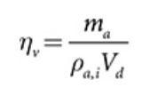
Volumetric Efficiency Equation: [2] Internal Combustion Engine Fundamentals

Engine CFM Equation: [37] Piston Slap: CFM Calculations the Easy Way and Hard Way

Using the above equations with some given information based on the CBR600RR, a calculation for the needed cubic feet per minute of air required to run the engine at redline can be calculated. CBR600rr: Displacement: 36.55 in^3, Redline: 13,500 RPM, η_{V}: 88%. The resultant maximum CFM required to run the engine was CFM_{MAX} = 125.64 ft^3/min, which is reasonable for an engine this size. To calculate information on the air moving through a restrictor the below equations will be needed.

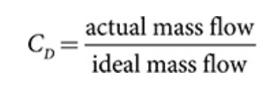
Discharge Coefficient: [2] Internal Combustion Engine Fundamentals

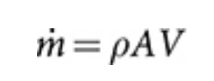
Mass Flow Rate: [2] Internal Combustion Engine Fundamentals

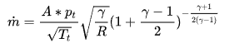
Choked Mass Flow Rate Theoretical Equation: [38] Restrictor
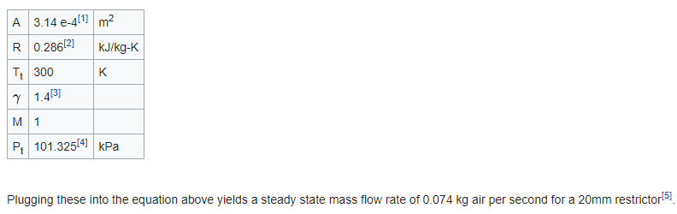
Choked Mass Flow Rate Theoretical Equation Example: [38] Restrictor

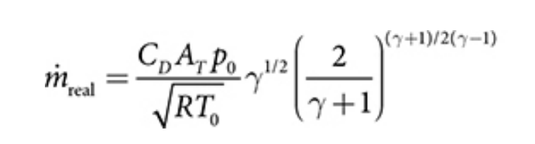
Choked Mass Flow Rate Actual Equation: [2] Internal Combustion Engine Fundamentals

Using some standard sea level and theoretical values for parameters: Density: 1.225 kg/m^3, CD: 90%, A: 20mm Restrictor, R: 286.9 J/kg*K, T: 288.15 K, P: 101325 Pa. The calculated results are as followed: Mass Flow Rate Theoretical = 0.3032 kg/s = 535 cfm, Mass Flow Rate Actual = 0.2729 kg/s = 481 cfm, Max Theoretical Velocity = 197 m/s = 646 ft/s.

Exhaust Design Calculations - Matt Gingold

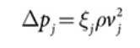
This is Bernoulli’s equation assuming there is a quasi-steady flow. ξj is the flow resistance coefficient, and vj is the local velocity. This can relate to the piston speed, which is:

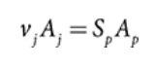
Here, Aj is the minimum flow area, and Ap is the piston area.

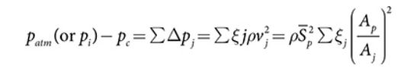
From those, you can use this equation to calculate the velocity of the air and know the friction of the air in the pipe. These are the calculations once everything is plugged in.
$$\sum{E_{j}ρv_{j}^{2}}=ρS_{p}^{2}\sum{E_{d}}{\frac{A_{p}}{A_{j}}}^{2}$$
$$v_{j}^{2}=S_{p}^{2}{\frac{A_{p}}{A_{j}}}^{2}$$
$$v_{j}=\sqrt{\frac{1000π}{(30)(4.25)}{\frac{π{67}^{2}}{π{22.5}^{2}}}^{2}}$$
$$v_{j}=193.74 [\frac{mm}{s}]$$

Differential Mount Calculations - Tobin Lanford
Calculations pertain to the potential durability of the differential mounts. Forces will be exerted on the differential mounts from the engine and through the axles. These forces must be carefully considered in the design and will be used to ensure the final design has an adequate factor of safety against deformation and failure using FEA software. The results below indicate the maximum theoretical maximum force that will be exerted on the rear sprocket from the drive chain and into the differential mounts.
T_{E} is the manufacturer stated maximum stock engine torque. Actual maximum engine torque will be lower due to the intake airflow restrictor required by the SAE regulations.
$$T_{E}=49 [lbf*ft]$$
The following equation represents the torque transfer through the CBR600RR transmission and our final drive ratio. The CBR600RR transmission drives an 11-tooth sprocket where N is the number of teeth in the vehicle’s rear sprocket.
$$N=42 [teeth]$$
$T_{S}= T_{E}×\frac{76}{36}×\frac{33}{12}×\frac{N}{11}=[lbf*ft]$[22]
P is the pitch of the rear sprocket.
D_{S} is the rear sprocket diameter.
F_{S} is the maximum possible force on the rear sprocket.
$$P=0.625 \left[in\right]$$
$D_{s}= \frac{P}{sin⁡(180/N)}×\frac{1 [ft]}{12 [in]}=[ft]$[19]
$F_{S}= \frac{T_{S}}{{(D}_{S}/2)}=[lbf]$[22]

Engine Design Calculations - Joey LeBlanc
When selecting an engine, the first thing NAU FSAE considered was the power and torque output of each engine. According to competition guidelines set by SAE international all teams must have a restrictor nozzle of 20mm diameter which limits power and torque in all engines. NAU FSAE wanted to calculate the actual power and torque with the restrictor of the chosen CBR600RR engine and they are shown below.
All equations are from chapters 2&3 of Heywood's [10]:
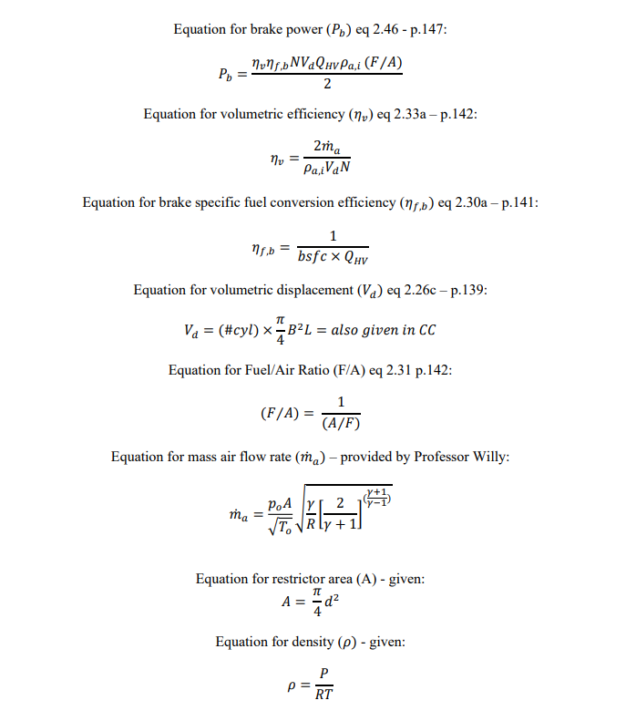
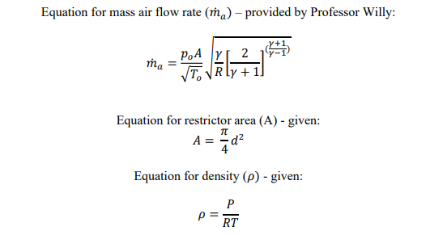
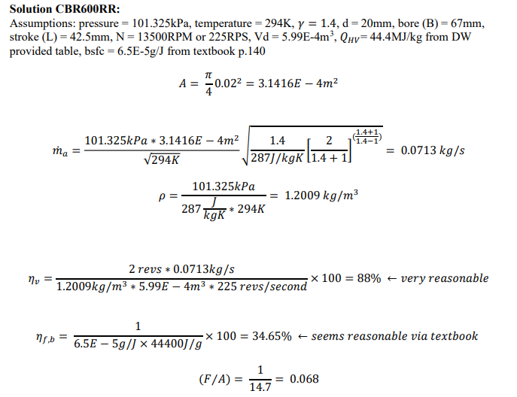
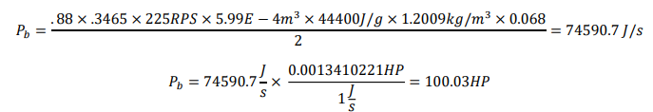
This calculation shows a brake horsepower calculation for the teams selected Honda CBR600RR engine at ideal atmospheric conditions.
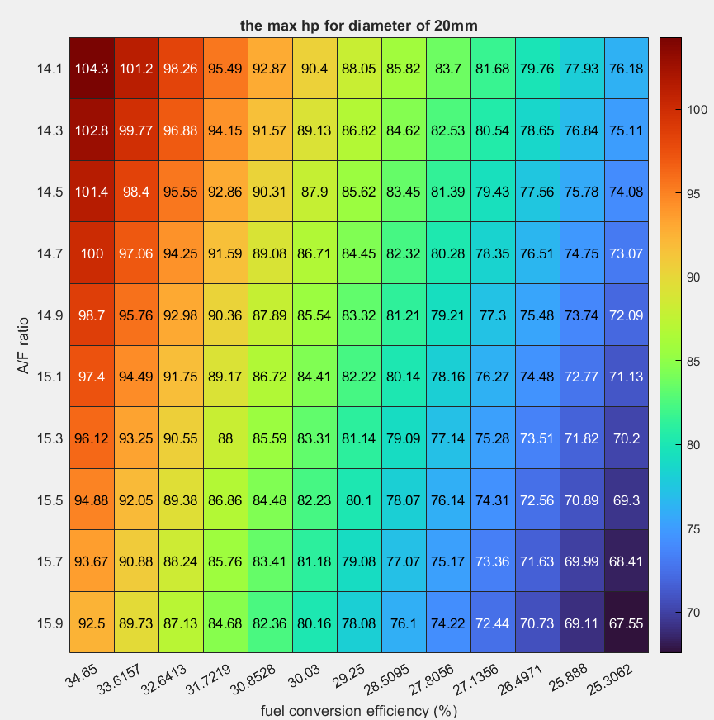
Figure 2: Actual HP CBR600RR

This MATLAB chart shows the theoretical max brake horsepower at different fuel conversion efficiencies and air/fuel mixtures. The ideal A/F ratio is 14.7 and the ideal fuel conversion efficiency is about 34%. At ideal operating conditions the maximum power that can be achieved with a 20mm diameter restrictor is 100 horsepower.

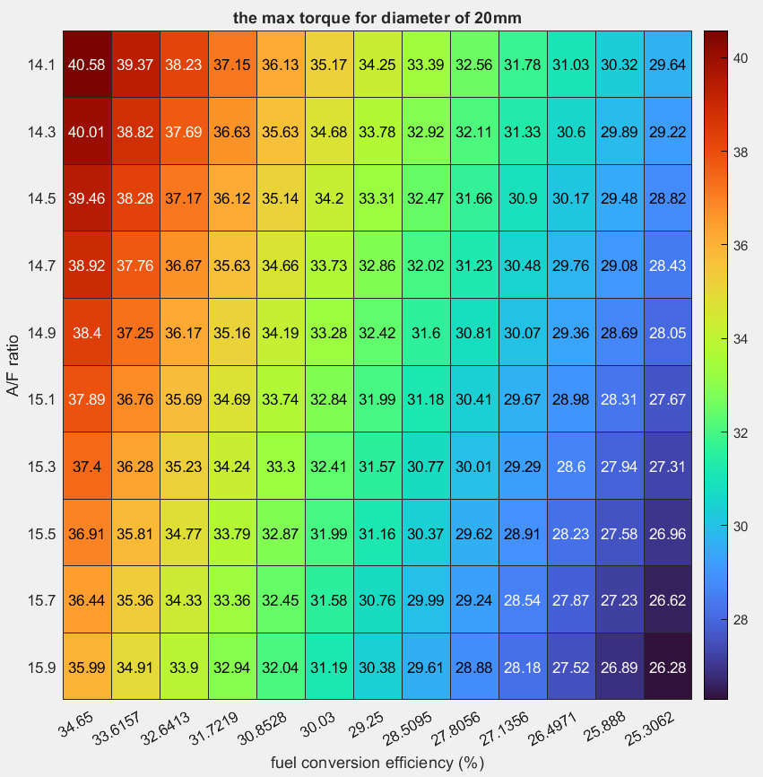
Figure 3: Actual Torque CBR600RR
This MATLAB chart shows the theoretical max brake torque at different fuel conversion efficiencies and air/fuel mixtures. The ideal A/F ratio is 14.7 and the ideal fuel conversion efficiency is about 34%. Reading this chart shows that the maximum torque at ideal operating conditions is 38.92 [lb-ft] of torque and varies based on the fuel conversion efficiency and the air-fuel ratio.

Sprockets/Gear Ratio - Lucille Longhurst
In choosing the gear ratio and sprockets, the team chose to prioritize maximizing acceleration over top speed, given the nature of the competition, where quick acceleration plays a critical role in dynamic events such as Autocross and Endurance. The vehicle’s drivetrain configuration was built around a 3.8 gear ratio, achieved by selecting an 11-tooth front sprocket and a 42-tooth rear sprocket paired with a 520 chain. This choice aimed to strike an optimal balance between acceleration, mechanical reliability, and ease of integration within the drivetrain system. To begin the selection of the gear ratio, the torque and power output from the Honda CBR600RR engine (figure 4) were analyzed. The torque curve, based on provided data, modeled from 2,500 RPM to 15,000 RPM, showing peak torque of 47.5 ft-lb at 10,000 RPM and peak power of 118 hp at 13,500 RPM

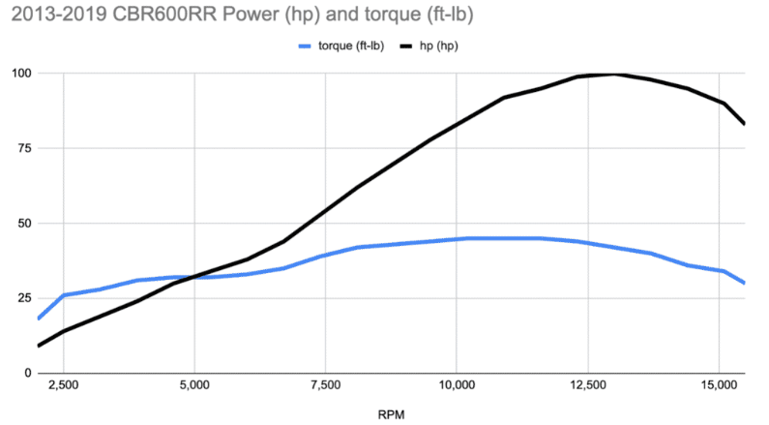
Figure (4): Engine Specifications

Table (2): Derived Points from Figure (4)
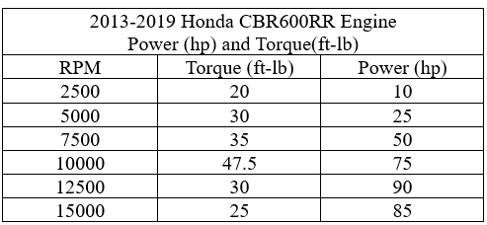

Table (3): Transmission Gear Ratios from Manual
Gear Ratio (1-N-2-3-4-5-6)
1 | 2.750 | 33/12
2 | 2.000 | 32/16
3 | 1.666 | 30/18
4 | 1.444 | 26/18
5 | 1.304 | 30/23
6 | 1.208 | 29/24
Primary Reduction | 2.111 | 76/36

Based on the engine specifications data points table (2), the transmission gear ratios from the manual (table (3)), and the tire circumference 64.4 inches, MATLAB code was used for the calculations to simulate the effect of gear ratio on the vehicle’s wheel RPM, and top speed. The following gear ratios were compared: 3.0, 3.2, 3.4, 3.6, 3.8, 4.0. The following equations were utilized:
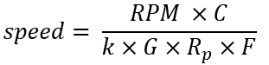
Speed (mph)
$RPM$=Engine (rpm)
$G$= Gear Ratio
$R_{p}$= Engine RPM
$C$= Tire Circumference
$k$ = $1 mph=\frac{5280 ft}{60 min}=88\frac{ft}{min}$
$F$= Final Drive Ratio
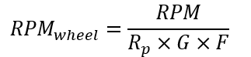
${RPM}_{wheel}$ =Wheel RPM
$RPM$=Engine (rpm)
$G$= Gear Ratio
$R_{p}$= Engine RPM
$F$= Final Drive Ratio

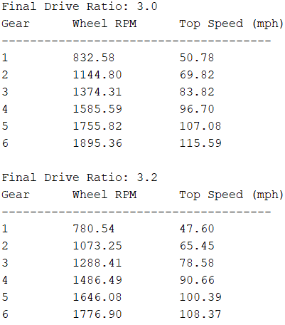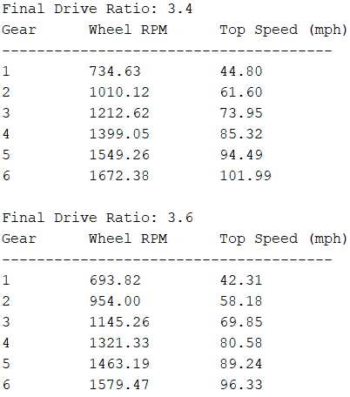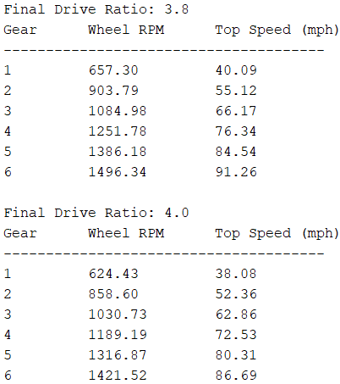
Figure (5): Gear Ratio Comparison

After comparing the results, the 3.8 gear ratio proved to be the optimal choice, as it provided the best balance between acceleration and top speed.

The next step involved comparing various front tooth sprocket combinations, specifically 11-42, 12-46, 13-50, and 14-53. Using MATLAB, a simulation was conducted to analyze the maximum speed in each gear and the average acceleration for each sprocket combination. Several key assumptions were made: the estimated mass of the vehicle, including the driver, was 716.5 [lb], and the coefficient of friction was set at 1.2. The following equations were utilized:
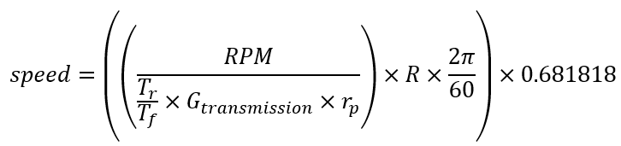
Speed (mph)
$RPM$=Engine (rpm)
$G_{transmission}$= Gear Ratio (1 to 6)
$r_{p}=$Primary Reduction
$T_{r}$=Rear Sprocket Teeth
$T_{f}$= Front Sprocket Teeth
$R$=Tire Radius (ft)

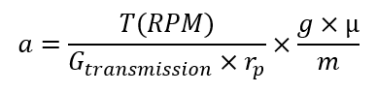
$a$ = acceleration $\frac{ft}{s^{2}}$
$T$=Torque (ft-lb)
$G_{transmission}$= Gear Ratio (1 to 6)
$r_{p}=$Primary Reduction
$RPM$=Engine (rpm)
$g$= 32.174 $\frac{ft}{s^{2}}$
$µ$= coefficient of friction
m= mass (lb)

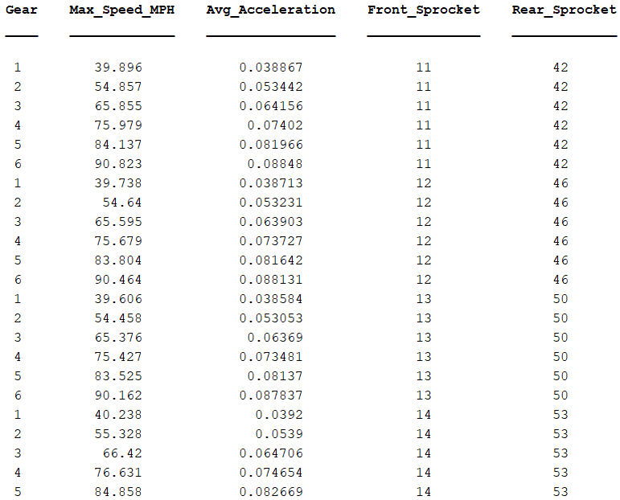
Figure 6: Sprocket Output Comparison
After closely analyzing all possible sprocket configurations, the team ultimately chose the 11-tooth front sprocket and 42-tooth rear sprocket. While all combinations provide similar drive ratios, they differ slightly in terms of chain dynamics and mechanical stress. The 11-tooth front sprocket, paired with the 42-tooth rear sprocket, offers a more aggressive acceleration profile due to the smaller front sprocket. Additionally, it still achieves competitive top speeds in higher gears, making it a suitable choice that ensures the vehicle meets performance demands.

The final step in the design process involved selecting an appropriate chain and determining the number of links required. The team selected a 520-chain, a standard choice due to its widespread availability, cost effectiveness, and lightweight nature. The chain is commonly used in motorbikes and meets the performance demands of the project. Using the equations below the number of chain links were calculated and the center-to-center distance between the sprockets was converted to pitches.

$$C_{pitches}=\frac{C}{P}$$
$C= \text{Center-to-Center distance,}10.25 in$
$P=\text{Pitch (in.), }0.625$
$C_{pitches}=\text{Converted Value, 16.4}$

$$N_{links}=2C_{pitches}+\frac{N_{front }+N_{rear}}{2}\frac{\frac{N_{rear}-N_{front }}{2π}}{C_{pitches}}$$

$C_{pitches}=\text{Converted Value, 16.4}$
$N_{front}$= Teeth in Front Sprocket
$N_{rear}$= Teeth Rear Sprocket
$N_{links}=60.78$ links $\sim 62$ links

With the pitch value calculated, the chain length was calculated yielding a value of 60.78 links. However, it is critical that the number of links is not rounded down because this would lead to excessive tension. Moreover, an odd number of links cannot be used due to the chain’s alternating link design. Therefore, the number of links was rounded up to 62 to ensure proper fit and function.

In selecting the gear ratio and sprockets, the team prioritized maximizing acceleration over top speed, choosing a 3.8 gear ratio with an 11-tooth front and 42-tooth rear sprocket. MATLAB simulations confirmed this setup provided an optimal balance between acceleration and top speed. For the chain selection, the team opted for a 520 chain, known for its lightweight, cost-effectiveness, and availability. The chain length was calculated to be 60.78 links, but to avoid tension issues and maintain proper link alternation, it was rounded up to 62 links.

Design Concepts

Functional Decomposition
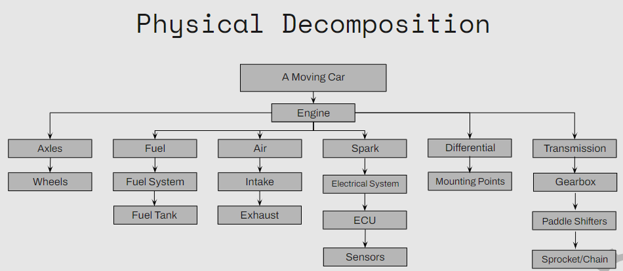
Figure 7: Physical Decomposition
The drivetrain’s physical decomposition was divided into two key areas: what the engine needs to run and what the engine requires for vehicle movement. For the engine to run it requires fuel, air, and spark. For fuel, the vehicle will need a fuel system which will also involve a fuel tank. For air, the vehicle will need an intake to get air into the engine and an exhaust to get the spent gases out of the engine. Lastly, spark will involve the electrical system, ECU, and sensors to time the combustion of the engine. To make the vehicle move a transmission will be used with a gearbox and paddle shifters to transmit power to a chain and sprocket. From the chain and sprocket, the power will enter the differential, which will be mounted to provide power to both axles. Lasty, the wheels transfer power to the ground to make the vehicle move. With this general information, the team was able to determine personal tasks that each member would be responsible for completing to ensure successful completion and integration, leading to a functioning vehicle.

Concept Generation

Intake Designs - Damian Boniella
The table below shows all the materials required to build all the intake design concepts.
Table 4: Materials used to make the Intake
Items: | 1 | 2 | 3 | 4 | 5
3D Filament | PA6-CF | PET-CF | PC | PETG-CF | ASA-CF
Throttle Body | 28mm | 30mm | 32mm | 34mm
Air Filter | 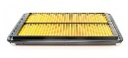 | 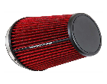
Temperature Sensor | 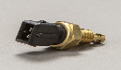 | 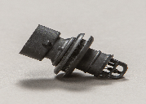 | 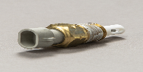
MAP Sensor | 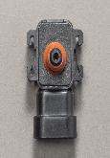 | 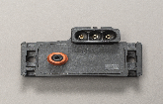

The formula and long intakes were both designed to be placed above the driver's head within the main hoop of the vehicle. The formula intake would take advantage of ram air effects by acting as a scoop providing large amounts of clean air to the engine, whereas the long intake would not take advantage of ram air effect but take advantage of the clean air. The side intake would also take advantage of clean air but be routed to the left-hand, or right-hand, side of the driver, sticking close to the body work of the vehicle. The short air intake would reside in the engine compartment of the vehicle taking in dirty air for the engine but having the benefits of being the most cost effective and least time-consuming design.

Table 5: Intake Concept Generation
Concept: | Formula Intake  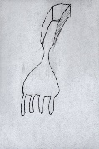 | Side Intake  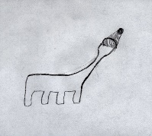 | Short Intake  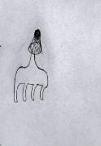 | Long Intake  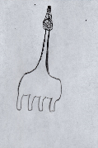
Materials  Used: | PET-CF, Throttle Body: 34mm, Square Air Filter, Temp. Sensor 1, MAP Sensor 1 | PA6-CF, Throttle Body: 32mm, Conical Air Filter, Temp. Sensor 1, MAP Sensor 1 | PC, Throttle Body: 32mm, Conical Air Filter, Temp. Sensor 1, MAP Sensor 1 | PA6-CF, Throttle Body: 32mm, Conical Air Filter, Temp. Sensor 1, MAP Sensor 1
Advantages: | Ram Air Effect, Style Points | Clean Air, Style Points | Small Material Usage, Needs Little Structural Support, Low Cost | Clean Air, Widely Used by Other Teams
Disadvantages: | Large Material Usage, Needs Structural Support, High Cost | Large Material Usage, Needs Structural Support, High Cost | Hot and Disturbed Air | Large Material Usage, Needs Structural Support, High Cost

Exhaust Designs – Matt Gingold
Table 6 shares four types of exhaust headers for a vehicle: long tube headers (steel and titanium), short tube headers (steel), and stock headers (steel). Each header type offers different advantages and disadvantages, prioritizing power delivery, size, and practicality for the use in FSAE. Long tube headers, both steel and titanium, provide more top-end power and lower the engine but are bulky. However, titanium has the benefit of better heat dissipation, though it's more expensive. In contrast, short tube headers offer more low-end power and are compact but are harder to manufacture. Meanwhile stock headers are readily available but require the engine to be positioned higher and are less optimized for performance.
Table 6: Exhaust Concepts
Concept: | Long Tube Headers (Steel) | Long Tube Headers (Titanium) | Short Tube Headers (Steel) | Stock Headers (Steel)
Image: | 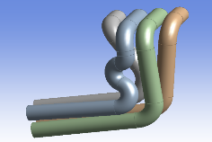 | 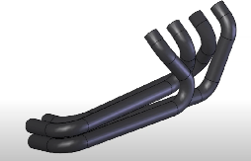https://www.youtube.com/watch?v=mWcKGWQfAos | 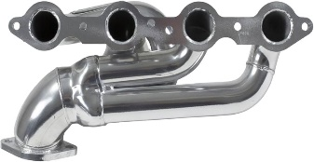https://www.amazon.com/BBK-40200-Performance-Exhaust-Headers/dp/B003HII37E | 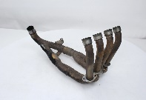https://cheapthrillsmoto.com/products/exhaust-header-honda-cbr600rr-03-04-oem-cbr-600-rr
Pros: | More top-end power  Lowers engine.  Cheap to create | More top-end power  Lowers engine.  High Exhaust volume  Better Heat dissipation | More low-end power  Lowers engine.  Smaller in size  Cheap to make | Stock configuration  Have one currently.
Cons: | Large/bulky  Less low-end power | Large/Bulky  Less low-end power  Low exhaust velocity  Much more expensive | Less high-end power  More difficult to make (might upset our welders) | Engine must be higher (~6 inches)  Not as optimized for our use

Differential Mount – Tobin Lanford
The table below depicts the possible design concepts for the differential mounting that were considered, including different mounting locations, the chain tensioning system, materials, and the choices of the limited slip differential itself. The highlighted row indicates the final design concept.
Table 7: Differential Mount Concepts
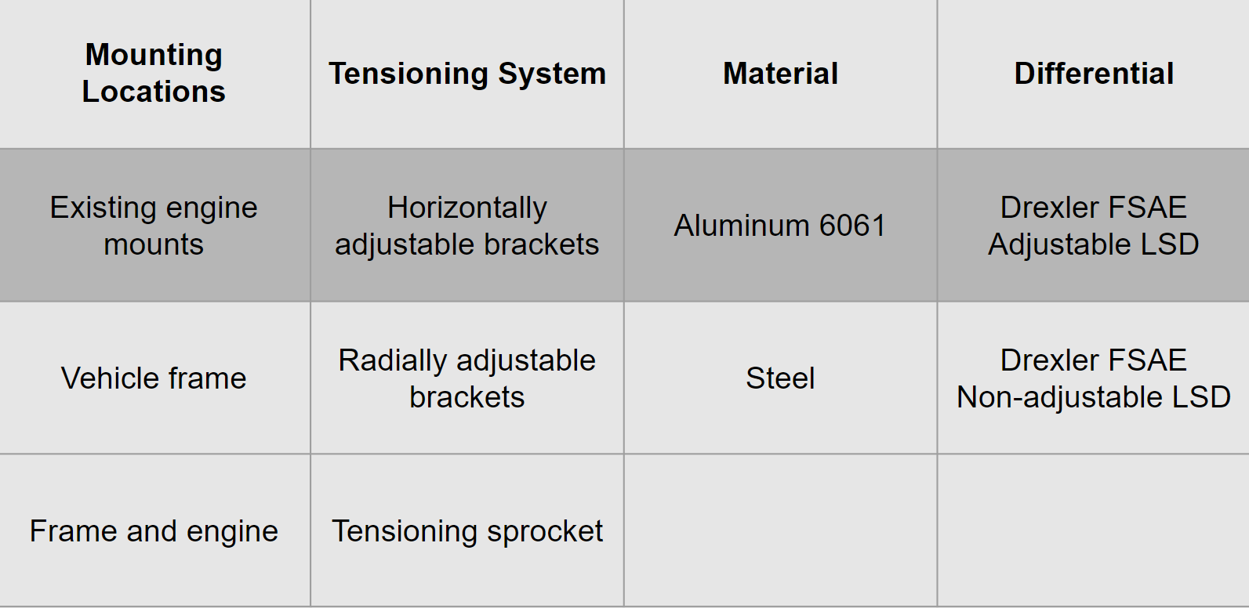

Engine Selection - Joey LeBlanc
Table 8: Engine Concepts
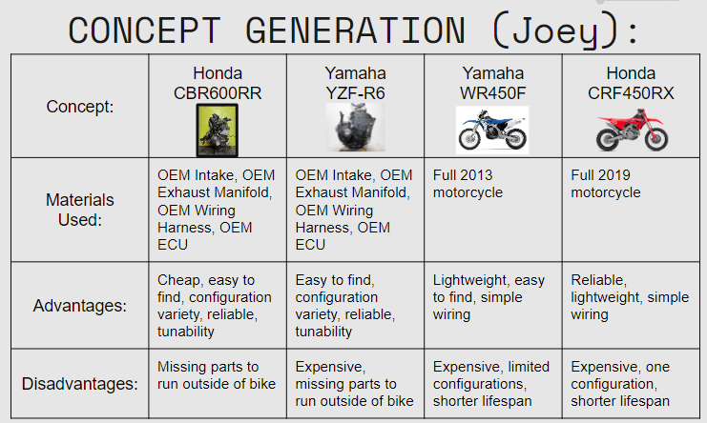
This chart compares the different engines considered for selection for the 2025 NAU FSAE car. The different configurations are also represented by the Honda CBR600RR (Longblock), Yamaha YZF-R6 (Short Block), Honda CRF450RX (Full Bike), and Yamaha Wr450F (Full Bike). The different engines all come with their benefits and drawbacks which makes a decision matrix necessary to choose between the four choices. Benefits of the short and long block include a reduced price while drawbacks are that they do not come running or with as many parts. Benefits of the full bike configuration are that they typically come running, however they are much more expensive than a short or long block.

Shifter, Sprockets, Chain Selection - Lucille Longhurst
For the design process, a Morphological Matrix was utilized to compare different options for the shifting system. Each sub-system was analyzed with various configurations based on shifting mechanisms, gear ratios, sprocket sizes, and chain types.
Table 9: Shifting System Morphological Matrix
Morphological Matrix
 | Option 1 | Option 2 | Option 3 | Option 4
Shifting Mechanism | Cable Lever Pull System | Electric Paddle Shifters | Pneumatic Paddle Shifters
Gear Ratio | 3.4 | 3.6 | 3.8 | 4.0
Sprocket Size (Front) | 11 | 12 | 13 | 14
Chain Type | 420 | 428 | 520 | 529

In evaluating possible shifting systems, the following options were considered: the cable lever pull system, electric paddle shifters, and pneumatic paddle shifters. Option one, cable lever pull system, is a simple and low-cost solution. It was the method used by the 2024 NAU FSAE team and offers ease of installation, maintenance, and reliability. However, the primary drawback is its relatively slow shifting speed, which can be a disadvantage in competitive environments where quick gear changes are crucial.

Options two and three both involve paddle shifters, which are known for providing fast and precise shifts. When properly implemented, paddle shifters can offer near-instantaneous shifts with minimal delay, significantly reducing shift times. This advantage is especially beneficial in events like Autocross and Endurance, where frequent and rapid gear changes are required.

The cons of both electric and pneumatic paddle shifters are quite similar. Both systems introduce higher complexity. Electric paddle shifters require intricate wiring, control units, and actuators, which can increase the potential for system failures. On the other hand, pneumatic paddle shifters rely on a compressed air system, including air tanks, compressors, and air lines, which adds considerable weight and complexity. The pneumatic system also requires regular maintenance and air pressure monitoring to ensure consistent performance. Additionally, both systems involve higher costs compared to the cable lever system. However, if executed correctly, the significant performance improvements such as faster and more precise shifting can outweigh these drawbacks.

When selecting an optimal gear ratio, the key question is whether to prioritize top speed or acceleration. In racing, acceleration is often more critical, as drivers need to quickly reach high speeds, especially in tight corners. Lower gear ratios, ranging from 3.0 to 3.4, can provide higher top speeds; however, higher gear ratios result in increased acceleration values, albeit at the cost of top speed.

Once the gear ratio is determined, the next step is to choose the front sprocket. In FSAE competitions, front sprocket options typically range from 11 to 14 teeth. An 11-tooth sprocket maximizes acceleration due to its compact size but can lead to increased wear on the chain and sprocket because of the high rotational speed. On the other hand, 12- and 13-tooth sprockets offer a balance between acceleration and top speed, sacrificing a bit of acceleration for better durability. A 14-tooth sprocket is optimal for achieving higher top speeds and reducing wear and tear on the chain, but this choice significantly compromises acceleration.

To connect the front and rear sprockets, it is essential to select a suitable chain. Various chain types were considered, including the 420, 428, 520, and 529, each with its own advantages and disadvantages. The 420 chain is very lightweight and affordable, but its low strength and durability make it unsuitable for high-performance applications. Similarly, the 428 chain is slightly stronger than the 420 chain; however, it still lacks the durability required for high-stress situations, making it less ideal than the 520 or 529 chains. The 520 chain is strong and durable, making it a popular choice in motorsport and an ideal option for high-performance applications. While it is heavier than both the 420 and 428 chains, its strength justifies the weight increase. The 529 chain offers the highest strength among all the options but is also the heaviest and most expensive. Its robust design may be considered overkill for a Formula SAE application, where the balance between weight and performance is crucial.

The design process highlighted the importance of evaluating various shifting systems, gear ratios, and chain types to optimize performance for a Formula SAE vehicle. Each component's strengths and weaknesses were carefully analyzed to ensure that the chosen configurations would meet the demands of competitive racing. This comprehensive approach emphasizes the critical balance between performance, reliability, and complexity in engineering design.

Selection Criteria

Intake Selection Criteria – Damian Boniella
Engineering requirements that are important to the intake system are functionality, dynamometer tuned, manufacturability, cost, durability, serviceability, and lightweight. The intake system needs to be functional with providing the maximum amount of air to the engine. This air will need to account for with dynamometer tuning to increase engine performance. Manufacturability is key in the intake system due to the system being 3D printed. However, with the system being 3D printed the cost, durability, and weight of the design will need to be considered. If durability is increased, to prevent failure of the system, the weight and cost will also increase with a likelihood of decreasing manufacturability. Lastly, the design will be serviceable to prevent entire system failures and allow restrictor rules to be tested. Considering all engineering requirements, the team has put functionality, dynamometer tuned, and manufacturability as the most important requirements within the intake system.

Exhaust Selection Criteria – Matt Gingold
One purpose of making a custom exhaust is to get more power out of it than the stock exhaust system provides. This is not the main reason for us though because our goal is to lower the entire motor 4 – 5 inches minimum. To achieve this, the exhaust cannot be run underneath the engine, so we must make out own. There are numerous things to consider when designing a custom exhaust. The biggest one is what type of power is being made. A 2-stroke engine obviously makes noticeably different power than a 4-stroke engine, so they cannot use the same exhaust design. This also applies for engines that have bigger displacement versus ones that have smaller ones. The two main designs that were in the concept generation were long tube headers and short tube headers. This is because we do not have much space for anything complicated, and the goal is to not anger the welders that we have so we can get more stuff done in a timely manner. These 2 ideas had simpler styles that would be easier to weld and would fit in the space we need them to. The main difference between long tube headers and short tube headers is that long tubes make more power in higher revving vehicles while short tubes make more power down low. With our engine revving past 15,000 rpm, it made more sense to go with long tube headers. While they are slightly more complicated than short tube headers, the higher power could help us to perform better, and possibly win more points when we attempt our design presentation.

Differential Mount Selection Criteria – Tobin Lanford
The important engineering requirements regarding the differential mounting hardware are functionality, manufacturability, cost, durability, and weight. With durability and functionality being the two most important. The mounting brackets must allow the differential to operate smoothly and as intended by the manufacturer. These brackets will also need to be withstand forces that exceed the maximum possible forces that will be transferred through the drive chain and the rear axles, resulting in an adequate and comfortable factor of safety. This will be iteratively ensured throughout the design process using finite element analysis in SolidWorks and ANSYS. Manufacturability will be maximized by choosing the simplest design that will accomplish these fundamental goals for the differential mounts. While cost and weight should be considered and minimized in the differential mount design, these are at a lower priority than the previously discussed requirements.

Engine Selection Criteria – Joey Leblanc
When selecting an engine for the NAU Formula SAE 2024-2025 build, several key factors must be considered: price, engine configurations, wiring complexity, reliability, tunability, weight, power, torque, availability, and size. Based on benchmarking and research conducted by the 2024-2025 NAU Powertrain team, the engines under consideration for the upcoming season include the Honda CBR600RR, Yamaha YZF-R6, Yamaha WR450F, Honda CRF450RX. Essential criteria such as fuel injection, electric start, and a displacement of less than 710cc were prioritized in the research due to competition rules and design constraints.
Price
The cost of the engine and its components is a crucial factor in designing and manufacturing the MK2 NAU Formula racecar. In the previous generation, the expense of the engine and its parts was second only to the cost of the wheels and tires, as the engine was purchased in a complete motorcycle configuration. This year, the team anticipates that the engine will again rank as one of the most expensive components of the racecar, potentially surpassing even the wheels and tires as they may be reused from the 23’-24’ season. To determine average costs, the team analyzed five to ten listings for each engine model from various classified sites, including eBay, Facebook Marketplace, and Craigslist. While similar engine configurations fell within a comparable price range, costs varied significantly across different configurations. Given our budget constraints as a second-year FSAE team, cost is being considered the most critical factor in the engine selection process.

Configurations
Three feasible engine configurations have been identified for this year’s FSAE racecar project:

1. Complete Motorcycle Purchase:
This option involves buying a whole motorcycle to disassemble and use its engine and parts. The primary advantages of this configuration are the immediate availability of a running engine upon purchase and the potential to sell off surplus parts. However, there are significant drawbacks. The main concerns include uncertainty regarding engine health, as assessing this through leak down and compression tests can be challenging without disassembling the bike—a process that might not be permitted by the seller. Additionally, the higher cost and the lack of a guaranteed resale value for the parts make this option risky. The inability to return the motorcycle once purchased further complicates the situation, as engine compression reliability is crucial for meeting the year’s powertrain goals and overall project timeline. Repairing an engine with low compression is well within the abilities of this year’s powertrain team, however, the process is costly, time consuming, and most likely something that should be avoided all together.

2. Short Block Engine:
The short block configuration involves acquiring an engine block with an integrated transmission, internal components like the crankshaft, pistons, rods, a complete cylinder head, and essential casings such as valve and side covers. This configuration offers several benefits, including verified engine health due to pre-sale compression and leak down tests conducted by sellers. It is also the most cost-effective of the three options and often allows for returns and shipping from reputable sellers. Nonetheless, drawbacks include the need to purchase a large quantity of additional parts separately and the potential for long shipping times, especially if incorrect or incomplete parts are ordered. There is also a risk of assembly errors with the engine’s air intake, fuel system, and wiring if parts are mistakenly ordered or improperly assembled.

3. Long Block Engine:
The long block configuration comprises everything needed to run the engine on a stand, except for a battery and fuel pump. This includes a complete short block, OEM intake and fuel system, OEM wiring harness and ECU, necessary sensors, various coolant lines, and typically an exhaust manifold. The main advantages of this option are the confirmed engine health at purchase and the overall cost-effectiveness. Additionally, if the battery and fuel pump are acquired promptly, the engine can be operational immediately. This approach allows the team to focus on designing other powertrain components rather than taking the time to disassemble a motorcycle and reassembling the long block outside of the bike. However, the long block configuration may have more limited availability compared to short blocks, and it requires the separate purchase of a radiator (not required to run on a stand), fuel pump, and battery.

Wiring Complexity
When benchmarking the MK1 NAU FSAE racecar, one significant issue that stands out is the complex and substandard engine wiring. The stock wiring harness from the Honda CBR600F4i was adapted to fit the MK1 build, resulting in a tangled and inefficient wiring setup. This disorganization blocks access to critical drivetrain components such as the lower fuel system and the battery. During competition, these wiring issues had a substantial impact on the MK1’s performance. Specifically, the fuel filter was found to be restricting fuel flow to the engine, while the battery terminal arced against the metal casing, both of which contributed to poor engine performance.

To accurately evaluate different engine options, it is essential to consider the wiring complexity associated with single-cylinder versus four-cylinder engines, as well as on-road versus off-road components. Single-cylinder engines typically have simpler wiring due to fewer components, such as only one spark plug. However, their wiring complexity has increased with the addition of systems like throttle position sensors, fuel injection, crankshaft and camshaft position sensors, and emission control systems. Additionally, some single-cylinder motorcycles considered for this project are dual-sport models. Although they lack some on-road features like blinkers and mirrors, they include wiring for components such as headlights, speedometers, and taillights, which adds to the overall wiring complexity and shorten the gap between them and the four-cylinder engines. As a result, motocross single-cylinder engines are slightly more desirable in terms of wiring simplicity. However, these engines are often equipped with kick-start mechanisms rather than electric starts, and newer models with electric start tend to be more expensive with less established aftermarket tuning support which has removed them from the selection.

For the MK2 NAU Formula SAE build, the team plans to purchase a custom wiring harness along with an aftermarket standalone ECU, dashboard kit, and wideband oxygen sensor as part of an electronic fuel injection system. This approach will streamline the wiring and allow for the creation of a base tune in-house before sending the car to a tuner for dynamometer testing. This is particularly crucial given the mandatory 20mm restrictor that must be fitted to all cars. Both single-cylinder and four-cylinder engines will require tuning to accommodate the reduced intake diameters.
These considerations are considered top priority and are compiled with less important considerations in a decision matrix in the next section.

Shifter, Sprockets, and Chain Selection – Lucille Longhurst
The concept selection process for our shifting mechanism was guided by a set of rigorous selection criteria rooted in both engineering and customer requirements. For the shifting mechanism, we established a response time requirement of 10-15 milliseconds to ensure rapid gear changes. While we did not conduct our own calculations for this requirement, we referenced various academic papers and online sources that indicated this range as an optimal benchmark in similar systems. Reliability was also critical, necessitating high durability under repeated use. Additionally, integration with the vehicle's existing electronics and control systems was critical, all components needed to be compatible with the vehicle’s electronics and control systems.

Regarding the gear ratio, we sought an optimal ratio that would effectively prioritize acceleration while maintaining top speed. This requirement was quantified through calculations based on engine power curves, expected torque, and vehicle dynamics, using MATLAB simulations to identify the best performance outcomes. For the front sprocket size, we focused on material strength, ensuring that the sprocket could withstand high torque loads without failure. In terms of the chain type, we required that the chain had enough adequate tensile strength for load bear moreover it had high resistance to stretching and fatigue.

Customer requirements also played a significant role in the selection criteria. The shifting mechanism had to be user-friendly, allowing for quick gear changes. Moreover, responsiveness was another essential factor, demanding immediate gear shifts for optimal performance during acceleration and deceleration, measured through timed testing during practice runs. Comfort was also a priority, requiring the mechanism to be ergonomic for prolonged use without causing driver fatigue. Accuracy was listed as well since the system needed to provide precise and immediate feedback to the driver. Lastly, the user interface had to be intuitive and responsive.

The concept selection process for our shifting mechanism has had a comprehensive approach, both balancing engineering and customer requirement. By utilizing existing online references and industry benchmarks, we established an optimal response time. Moreover, requirements such as reliability, and integration compatibility continue to guide our design choices. Our focus on optimizing gear ratios, material strength, and chain durability ensures that we will meet performance targets while maintaining safety and reliability. The incorporation of user-friendly features, responsiveness, comfort, accuracy, and an intuitive user interface ensures we deliver a high-quality driving experience.

Concept Selection

Intake Design - Damian Boniella
The four new intake designs, and last year’s design, were placed into a decision matrix and ranked 1-5, with 5 being the best possible score. The criteria that the designs were ranked on were 3D filament usage and print time, ease of tuning, overall cost, air quality including amount of air and how clean that air is, and ease of implementation. Last year’s intake, however, cannot be used for our project due to changing customer requirements and will serve as a benchmark within this decision matrix.

Table 10: Intake Decision Matrix
 | Formula Intake | Side Intake | Short Intake | Long Intake | Last Years
Material Usage and Print Time | 1 | 2 | 4 | 3 | 5
Ease of Tuning | 2 | 3 | 5 | 4 | 1
Overall Cost | 1 | 2 | 4 | 3 | 5
Air Quality | 5 | 4 | 2 | 3 | 1
Ease of Implementation | 1 | 2 | 4 | 3 | 5
Total: | 10 | 13 | 19 | 16 | 17

Short Intake: Is the smallest of all the intakes resulting in reduced overall costs and ease of implementation. This intake will be gathering air for within the engine compartment.
Customer: Most cost-effective design, easiest to implement, easy to tune, short print time
Engineering: Stays within the tire envelope, 20mm restrictor, delivers air to engine

Long Intake: Is a larger intake design that takes advantage of clean air above the engine compartment. The intake will need to be supported due to cantilever weight, with this design being more expensive than Short Intake.
Customer: Gathers clean air, next easiest intake to implement, easy to tune
Engineering: Stays within the tire envelope, 20mm restrictor, delivers air to engine

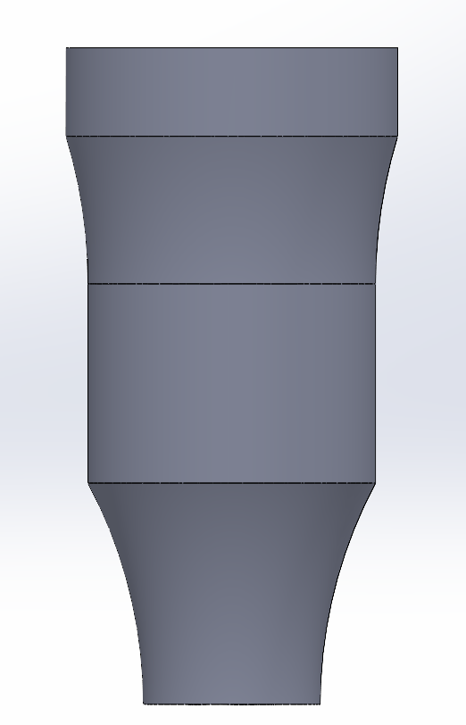
Figure 8: Current Intake CAD Model

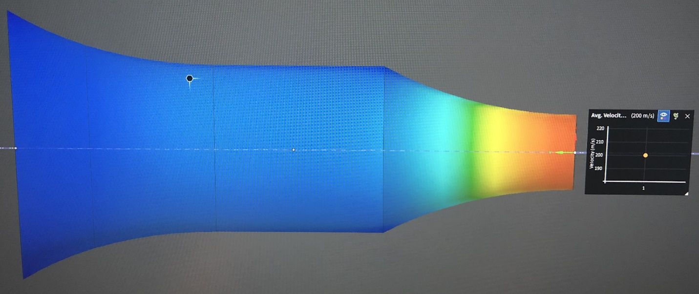
Figure 9: CFD Simulation on Current Intake Design

Exhaust Design - Matt Gingold
Table 11: Exhaust Decision Matrix
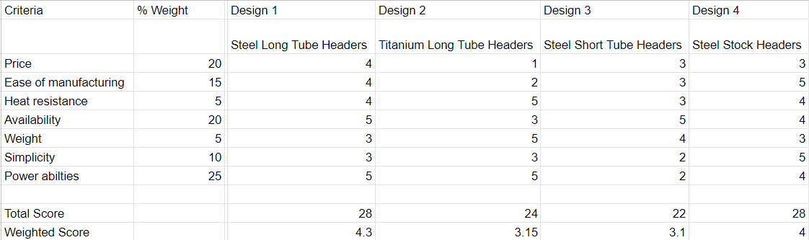
Using this chart, it can be inferred that the best option for our exhaust will be the long tube headers that are made of steel.

Differential Mounting - Tobin Lanford
Utilizing the existing engine mounts for mounting has two main advantages. The specific mounts that will be used are the rear swing arm mount and the lower rear engine mount. Primarily, these mounts were already designed to support the load of the engine and the associated components of the motorcycle’s power train which will simplify the design of our differential mounts and allow us to save weight that would be necessary for creating additional mounting locations on the frame. Additionally, mounting the differential directly to the engine will help minimize deflection between the rear axle and the engine itself. Thus, increasing our ability to keep the drive chain properly tensioned.
The decision to horizontally limit the adjustability of the differential mounts. Radial adjustments would mean the rear axle is able to be adjusted in an arc round the swing arm mount, so the horizontal and vertical position are intrinsically linked. This could lead to fitment issues between the rear axle and frame of the vehicle. Therefore, horizontally adjustable differential mounts will allow for easy on-the-fly chain tensioning while avoiding interferences.
Aluminum 6061 was chosen as the material for the differential mounts due to its light weight, relatively low cost and easier machinability. This alloy is often used in automotive structural components.
Finally, an adjustable Drexler limited slip differential was chosen over a non-adjustable variant, despite an increase in cost, for the ability to further tune the handling of our vehicle once testing begins.
Below is the current CAD assembly of the Drexler limited slip differential mounted to engine.
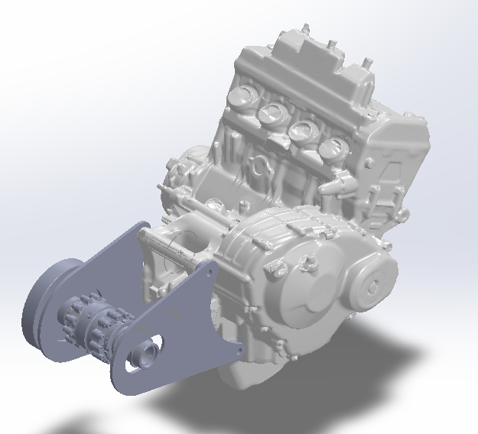
Figure 10: Drexler LSD Mounted to CBR600RR

Engine Selection - Joey LeBlanc
Table 12: Engine Decision Matrix
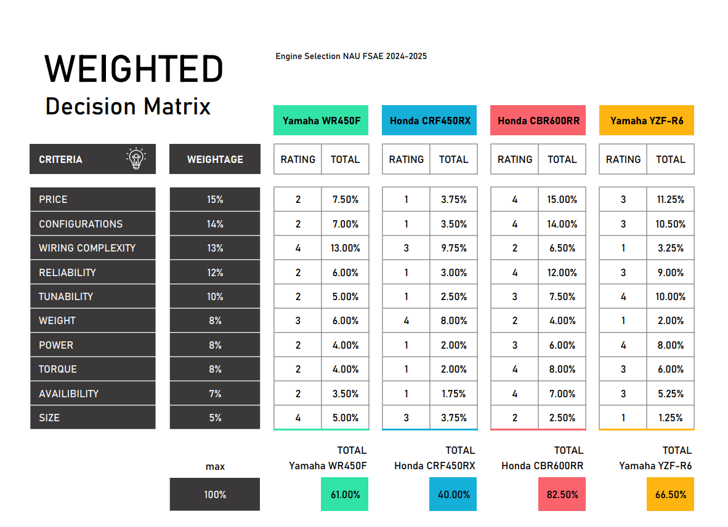
This decision matrix was the team’s final step in deciding which engine would be purchased for the MK2 formula car. The team decided to put price and configurations as the top priorities as these are the biggest challenges when finding an engine to purchase.
Reliability and tunability are also large factors in the engine selection process because of how the first iteration of the NAU FSAE Team performance went at competition.
Power, weight, and torque are rated as less important because the team is a second-year iteration and building a reliable and cheap car is more important than being competitive for the team’s current goals.
Availability and size of the engine are both considered to be the lowest ranking of the constraints because all engines selected here are commonly available and the chassis was designed with a 4-cylinder sport bike engine in mind.
The CBR600RR won by a large margin and then became the team’s engine of choice.

Shifter, Gear, and Chain Selection - Lucille Longhurst
The design process highlighted the importance of evaluating various shifting systems, gear ratios, and chain types to optimize performance for a Formula SAE vehicle. Each component's strengths and weaknesses were carefully analyzed to ensure that the chosen configurations would meet the demands of competitive racing. This comprehensive approach emphasizes the critical balance between performance, reliability, and complexity in engineering design.

In the pursuit of designing an efficient shifting mechanism for the FSAE vehicle, a decision matrix was employed to help facilitate the selection process. It allowed the team to score each option against the identified criteria. The following shifting systems were compared: Electric Paddle Shifters, Pneumatic Paddle Shifters and a Cable Lever Pull system. To effectively compare the options: weight reduction, functionality, cost, ease of manufacturing, durability, user interface, performance, ergonomics, and fast shifting capabilities were considered.
Table 13: Shifting System Decision Matrix
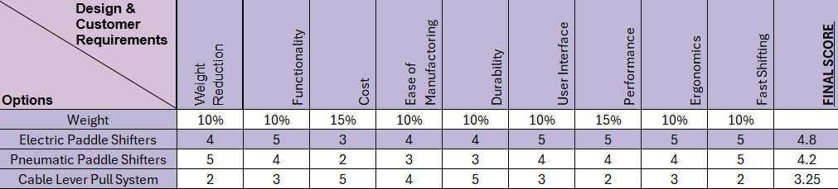
The Electric Paddle Shifters emerged as the most favorable option, achieving a final score of 4.8. The scoring reflects their superior performance across most criteria, particularly in terms of functionality, user interface, and performance, which are essential for achieving competitive acceleration and responsive shifting. In contrast, while Pneumatic Paddle Shifters offered benefits in weight reduction and fast shifting, their higher costs and complexities in manufacturing made them less optimal. The Cable Lever Pull System, despite its ease of manufacturing and lower cost, scored the lowest due to limitations in performance and user experience.
To validate the design choices and simulate the expected performance outcomes regarding the gear ratio and sprocket choices, we conducted extensive simulations using MATLAB which allowed us to model various operating conditions and assess the impact of different gear ratios, and sprocket sizes on overall performance. The simulation results indicated that the final selected configuration would effectively met the desired acceleration benchmarks and enhances the vehicle’s drivability which includes gear ratio of 3.8, sprocket sizes of 11-tooth front and 42-tooth rear. Moreover, the 520 chain was selected for its balance of weight, strength and flexibility making it ideal for the high-performance demands for our FSAE vehicle. The design allowed for effect power transmission while minimizing weight which is crucial in achieving competitive acceleration and overall efficiency. Additionally, the 520 chain is widely used in motorsports making it compatible with various sprocket for our shifting system.

Overall, the structured approach to concept selection, combined with simulation analysis, positions our team to deliver a high-performance shifting mechanism that not only enhances vehicle dynamics but also adheres to the principles of innovation and efficiency integral to Formula SAE.

CONCLUSIONS
Formula SAE is collegiate level design competition that requires teams to design, manufacture, and assemble a formula style racecar using a mix of custom and purchased components. This vehicle will be entered to compete against over one hundred other similar vehicles designed by teams around the country at the end of the academic year in May 2025. In order to compete teams must first pass a technical inspection to ensure that their vehicles abide by the rules and regulations laid out by SAE International. Competition includes a variety of events ranging from a static leak test to an endurance style race. Fundraising is a major factor in this project due to the large costs associated with vehicle components. The total budget for this project was estimated at $40,000. At this point in the semester over 75% of these funds have been allocated or spent and we are confident in our ability to fundraise the outstanding amount by the end of the project. The final designs for the vehicle’s power train include a Honda CBR600RR, a custom short intake, a custom steel tubing exhaust, a Drexler FSAE limited slip differential mounted to the engine, and an electronic paddle shifting system. Powertrain progress is overall on track, with some aspects being ahead of schedule. Most significantly the CBR600RR successfully runs on a stand, which is about four weeks ahead of the deadline for Prototype 1. Currently, we are prioritizing the finalization of the sprocket mount, differential mounts, and exhaust system as these components will ultimately decide where the engine will need to be located in the frame, which will then need to be coordinated with the other FSAE sub-teams.

REFERENCES
[1] S. Das, P. Gogoi, M. Agrawal, and Rounak, “Design of Differential Mounts and Rear Inboard Braking for an FSAE Vehicle,” in Advances in Manufacturing Engineering, Singapore: Springer, 2022, pp. 437–455
[2] J. B. Heywood, Internal Combustion Engine Fundamentals. New York: McGraw-Hill Education, 2019.
[3] W. W. Pulkrabek, Engineering Fundamentals of the Internal Combustion Engine. United States of America: Prentice Hall, 2004.
[4] E. Oberg and C. J. McCauley, Machinery’s Handbook: A Reference Book for the Mechanical Engineer, Designer, Manufacturing Engineer, Draftsman, Toolmaker, and Machinist. New York: Industrial Press, 2012.
[5] T. Setoguchi, S. Matsuo, H. D. Kim, and M. Alam, “Nozzle Geometry Variations on the discharge coefficient,” ScienceDirect, https://www.sciencedirect.com/science/article/pii/S2212540X16000031 (accessed Aug. 25, 2024).
[6] A. J. Szaniszlo, “EXPERIMENTAL AND ANALYTICAL SONIC NOZZLE DISCHARGE COEFFICIENTS FOR REYNOLDS NUMBERS UP TO 8x10^6,” NASA, https://ntrs.nasa.gov/api/citations/19750006921/downloads/19750006921.pdf (accessed Aug. 25, 2024).
[7] “PERFORMANCE OF CONICAL JET NOZZLES IN TERMS OF FLOW AND VELOCITY COEFFICIENTS,” NASA, https://ntrs.nasa.gov/api/citations/19930091998/downloads/19930091998.pdf (accessed Aug. 25, 2024).
[8] J. Szabo, “Calculating Critical Air scoop speed with a forward facing Air Inlet,” EngineLabs, https://www.enginelabs.com/engine-tech/calculating-critical-air-scoop-speed-with-a-forward-facing-air-inlet/ (accessed Aug. 7, 2024).
[9] “Proper hood scoop sizing,” Yellow Bullet Forums, https://www.yellowbullet.com/threads/proper-hood-scoop-sizing.2022842/ (accessed Aug. 7, 2024).
[10] Mike Mavrigian, Performance Exhaust Systems, How to Design, Fabricate, and Install. North Branch MN: CarTech Inc, 2014. https://www.google.com/books/edition/Performance_Exhaust_Systems/FkP7AwAAQBAJ?hl=en&gbpv=1&dq=motorcycle+exhaust+system+design&printsec=frontcover
[11] Hiroshi Kuribara, et al, Prediction of Fatigue Strength of Motorcycle Exhaust System Considering Vibrating and Thermal Stresses. SAE International Journal of Engines, 2016. https://www.jstor.org/stable/26284825?seq=1
[12] A M Siregar, et al, Engineering of motorcycle exhaust gases to reduce air pollution. IOP Conference Series: Materials, Science and Engineering, 2020. https://iopscience.iop.org/article/10.1088/1757-899X/821/1/012048/meta
[13] Taguchi, T., Aoki, M., Katsukawa, Y., KOGA, M. et al., "Development of a Noise Prediction Technique for Designing a High-Performance Muffler of Motorcycle," SAE Technical Paper 2010-32-0023, 2010, https://doi.org/10.4271/2010-32-0023
[14] MXA, Ten Things You Need to Know About Mufflers. Motocross Action Mag, 2019. https://motocrossactionmag.com/10-things-you-need-to-know-about-mufflers/
[15] Martin Pechout, et al, Regulated and unregulated emissions and exhaust flow measurement of four in-use high performance motorcycles. Science Direct: Atmospheric Enviroment: X, 2022. https://www.sciencedirect.com/science/article/pii/S2590162122000247
[16] Zach Jobe, et al, DIY Exhaust! - Is it worth it? Donut Media: Money Pit, 2021. https://www.youtube.com/watch?v=io9k0gNj7c4
[17] R. G. Budynas and J. K. Nisbett, “Chapter 17: Flexible Mechanical Elements,” in Shigley’s Mechanical Engineering Design 11th Edition, McGraw Hill, 2020, pp. 882–934
[18] S. Cecchel, “Materials and technologies for Lightweighting of structural parts for Automotive Applications: A Review,” SAE International Journal of Materials and Manufacturing, vol. 14, no. 1, Sep. 2020. doi:10.4271/05-14-01-0007
[19] R. A. James, Design of an Aluminum Differential Housing and Driveline Components for High Performance Applications, https://dspace.mit.edu/bitstream/handle/1721.1/32762/57570210-MIT.pdf?sequence=2&isAllowed=y (accessed Sep. 14, 2024).
[20] Scelfo Tony, Lightweight Torsen Style Limited Slip Differential and Rear Driveline Package for Formula SAE, https://dspace.mit.edu/bitstream/handle/1721.1/36702/77550024-MIT.pdf?sequence=2&isAllowed=y (accessed Sep. 14, 2024).
[21] K. Durand, Design of a Chain Driven Limited Slip Differential and Rear Driveline Package for Formula SAE Applications, https://dspace.mit.edu/bitstream/handle/1721.1/32862/62587598-MIT.pdf?sequence=2&isAllowed=y (accessed Sep. 2024).
[22] G. Banish, Engine Management: Advanced Tuning. North Branch, MN: CarTech, 2007.
[23] B. Devak and P. Deepan, “Sustainable use of single-cylinder engine over multi- ...,” International Research Journal of Engineering and Technology, https://www.irjet.net/archives/V4/i7/IRJET-V4I7301.pdf (accessed Sep. 16, 2024).
[24] K. Lutenbacher, B. Mayeaux, and J. Waller, “FSAE Engine Selection: Four or One Cylinder.” Available: https://korilutenbacher.weebly.com/uploads/5/4/9/9/5499743/klutenbacher_bmayeaux_jwaller_me4633_fsae_report.pdf

[25] T. Ayres, K. Hayward, and F. Guzzomi, “Design of a custom FSAE engine,” ResearchGate, https://www.researchgate.net/profile/Kevin_Hayward/publication/320081033_Design_of_a_Custom_FSAE_Engine/links/5a4c1d0fa6fdcc3e99cf6b23/Design-of-a-Custom-FSAE-Engine.pdf (accessed Sep. 16, 2024).

[26] FSwiki, “List of Engines,” List of engines, https://fswiki.us/List_of_Engines (accessed Sep. 16, 2024).
[27] C. Catto, “Thread: Engine selection: New advances V. tried and true,” Engine selection: new advances V. tried and true , https://www.fsae.com/forums/showthread.php?3760-Engine-selection-new-advances-V.-tried-and-true%2Fpage5 (accessed Sep. 16, 2024).
[28] “R/FSAE on reddit: Internal Combustion Engine for our first car,” FSAE Reddit, https://www.reddit.com/r/FSAE/comments/nc7ke3/internal_combustion_engine_for_our_first_car/ (accessed Sep. 16, 2024).
[29] “R/FSAE on reddit: Engine choices,” FSAE Reddit, https://www.reddit.com/r/FSAE/comments/8ljj9r/engine_choices/ (accessed Sep. 16, 2024).
[30] U.S. Tsubaki, Inc., The Complete Guide to Chain, Wheeling, IL, USA: U.S. Tsubaki, Inc., 1997.
[31] M. Irfan, "Modelling and optimization of gear shifting mechanism," Licentiate thesis, Dept. of Applied Mechanics, Chalmers Univ. of Technology, Gothenburg, Sweden, 2017.
[32] C. Tyagi, S. Verma, A. Pandey, D. Prasad, and V. Nath, "Study and Design of Electro-Pneumatic Shifting System," in Proc. 3rd Int. Conf. Microelectronics, Computing and Communication Systems, 2019, pp. 481-488.
[33] P. Arora, M. R. Agrawal, P. P. Singh, N. Gobinath, and M. Feroskhan, "Design and Analysis of a Formula SAE Vehicle Chain Sprocket under Static and Fatigue Loading Conditions," SAE Int. J. Mater. Manf., vol. 14, no. 3, pp. 275-282, 2021, doi: 10.4271/05-14-03-0018.
[34] R. J. Chalmela, Electro-pneumatic shifting and servo control of a clutch for a FSAE racecar, M.S. thesis, Dept. Mech. and Aerosp. Eng., Univ. Texas at Arlington, Arlington, TX, USA, 2017.
[35] L. Redstone, L. Weston, and J. Deglint, FSAE electronic shifter: Final project report, Univ. Victoria, Victoria, BC, Canada, Dec. 2012. [Online]. Available: http://electronicshifter.wordpress.com/.
[36] A. J. Kennett, Design of a pneumatically assisted shifting system for Formula SAE® racing applications, M.S. thesis, Dept. Mech. Eng., Massachusetts Institute of Technology, MA, USA (2008)
[37] S. Mehta, “Piston Slap: CFM Calculations the Easy Way and Hard Way,” Hagerty Media, https://www.hagerty.com/media/advice/piston-slap/piston-slap-cfm-calculations-the-easy-way-and-hard-way/ (accessed Sep. 14, 2024).
[38] “Restrictor,” Fswiki, https://fswiki.us/Restrictor (accessed Oct. 5, 2024).
[39] “49ers racing IC,” 49ers Racing IC, https://www.49ersracing.com/ (accessed Oct. 20, 2024).
[40] “Formula SAE at Ohio State,” Formula Buckeyes, https://www.formulabuckeyes.org/ (accessed Oct. 20, 2024).
[41] “Formula SAE,” NAU Formula SAE | Student Racing Team | SAE, https://www.ceias.nau.edu/capstone/projects/ME/2024/F23toSp24_Formula24/ (accessed Oct. 20, 2024).

APPENDICES

Appendix A: Power Calculations MATLAB
%%%%%%%%%%%%%%%%%%%%%%%%%%%%%%%%%%%%%%%%%%%%%%%%%%%%
% Programmer: SAFSONXSHNOBEL – modified from Professor Willy's code
% Program: IC_Engine_Fundamentals_Calc
% Class: Fall 24 Capstone
% Comments:
% 1. Brake Power - usable power delivered by engine to load
% 2. See written calcs for eq refs
% 3. Equations & theory taken from internal-combustion-engine-fundamentals-Heywood
% Assumptions:
% 1. Obey's conservation of mass, energy (1st law), and 2nd law (entropy)
% 2. Air density = 1.1999kg/m^3
% 3. QHV -From worldnuclear.org
% 4. 20mm restrictor diameter
% 5. typical discharge coefficient, mdotair from Professor Willy's code
% 6. Assumes chocked flow at restrictor, no less/no more
% 7. assumed engine specs
%%%%%%%%%%%%%%%%%%%%%%%%%%%%%%%%%%%%%%%%%%%%%%%%%%%
%% clear stuff
clc;
close all;
clear;
%% parameters
%air properties
po=1.1; % atm (11.33/14.7 for flagstaff) - total pressure in atm
poPa=101325; % N/m^2 or Pa - total pressure in pascals
To=294; % K
R=287; % J/kgK
gamma=1.4; % sp heat ratio (sometimes k)
Mair=28.97; % kg/kmol molecular weight
rho = 1.1999; %kg/m^3
rhoair = rho*1000; %g/m^3
% fuel properties
QHVa=44.4; % MJ/kg - 87 octane fuel energy/kg (https://world-nuclear.org/information-library/facts-and-figures/heat-values-of-various-fuels)
QHVb=QHVa*1000000; % J/kg
QHV = QHVb/1000; % J/g
Mfuel=110; % kg/kmol molecular weightof 87 octane (https://www.cdc.gov/niosh/npg/npgd0299.html)
% restrictor properties
NozzleDia=.02; % 20mm restritor diameter
NozzleArea=0.25*pi*NozzleDia^2; % restrictor cross-sectional area ("throat area")
cd=0.95; % restrictor dischange coefficient (0.95 for optimal nozzle, 0.6 for plate)
% engine properties
% eta=0.55:0.01:0.65; % engine efficiency average
cylno = input("Please Enter Number of Cylinders: "); % number of cylinders
if cylno == 4
W = 123; %lbs approx
elseif cylno == 1
W = 64.6; %lbs approx
end
B = input("Please Enter Bore (meters): "); %m
L = input ("Please Enter Stroke (meters): "); %m
n=input ("Please Enter Redline (RPM): "); % rpm stock redline
N=n/60; % rev/s
AFmass=14.1:0.2:16; % mass-basis air-fuel ratio (14.7 = stoichiometrically perfect)
AF=AFmass*(Mfuel/Mair); % convert to air-fuel on molar basis
r=8:0.5:14; % engine compression ratio (8-14)
bsfci = 65:2:89; % ug/J (specific fuel consumption)
bsfc = bsfci/1000000; % g/J
vd = cylno*(pi/4)*B.^2*L; % displaced volume (m^3)
%% theoretical max eff calcs
% brake specific fuel conversion efficiency
for k=1:length(bsfc)
nfb(k) =1./(bsfc(k)*QHV); % decimal percentage
end
%% chocked flow mass flow of air calcs
c1=gamma/R;
c2=2/(gamma+1);
c3=(gamma+1)/(gamma-1);
mdotAir=cd*poPa*NozzleArea/(sqrt(To))*sqrt(c1*c2^c3); % kg/s
nv = (2*mdotAir)/(rho*vd*N); %volumetric efficiency
if nv > 1
nv=.9; %estimation because nv formula not valid
end
%% engine hp calcs
for i=1:length(AFmass)
for j=1:length(bsfc)
mdotFuel(i)=mdotAir./AFmass(i);
FA(i) = mdotFuel(i)/mdotAir; % kg/s
Pb(i)= (nv*nfb(j)*N*vd*QHV*rhoair*FA(i))/2; % power available in J/s
Torque(i) = (nv*nfb(j)*vd*QHV*rhoair*FA(i))/(pi*4); % torque in Nm
Tact(i,j) = Torque(i)*0.7375621493; % torque in ftlbs
Php(i,j)=Pb(i)*0.0013410221; % power available in hp
end
end
PtW = Php/W;
%% plot stuff
figure(1)
plot(bsfc,nfb)
title('fuel conversion efficiency for brake specfic power')
ylabel('fuel conversion efficiency (%)')
xlabel('brake specific fuel consumption (g/J)')
figure(2)
heatmap(nfb*100,AFmass,Php)
title(['the max hp for diameter of ',num2str(NozzleDia*1000),'mm'])
xlabel('fuel conversion efficiency (%)')
ylabel('A/F ratio')
colorbar
colormap turbo
figure(3)
heatmap(nfb*100,AFmass,Tact)
title(['the max torque for diameter of ',num2str(NozzleDia*1000),'mm'])
xlabel('fuel conversion efficiency (%)')
ylabel('A/F ratio')
colorbar
colormap turbo

fprintf('The volumetric efficiency calculated is %f. If over 100%%, please use a different mass air flow equation.\n', nv);

Appendix B: Final Drive Ratio
% Constants
tire_diameter = 20.5 / 12; % Tire diameter in feet
tire_circumference = pi * tire_diameter; % Tire circumference in ft
primary_reduction = 2.111; % Primary reduction ratio
mph_conversion = 88; % Conversion factor: 1 mile/hour = 88 ft/min

% Transmission ratios (1st, 2nd, 3rd, 4th, 5th, 6th gear ratios)
gear_ratios = [2.750, 2.000, 1.666, 1.444, 1.304, 1.208];

% Final drive ratios to compare
final_drive_ratios = [3.0, 3.2, 3.4, 3.6, 3.8, 4.0];

% Engine maximum RPM
max_rpm = 14500; % Engine RPM value for top speed

% Function to calculate vehicle speed (mph) at max RPM
calculate_speed = @(rpm, gear_ratio, final_drive_ratio) ...
(rpm * tire_circumference) / (mph_conversion * gear_ratio * primary_reduction * final_drive_ratio);

% Function to calculate wheel RPM
calculate_wheel_rpm = @(rpm, gear_ratio, final_drive_ratio) ...
rpm / (primary_reduction * gear_ratio * final_drive_ratio);

% Loop over each final drive ratio
for k = 1:length(final_drive_ratios)
final_drive = final_drive_ratios(k);

% Output Header
fprintf('Final Drive Ratio: %.1f\n', final_drive);
fprintf('%-10s%-15s%-15s\n', 'Gear', 'Wheel RPM', 'Top Speed (mph)');
fprintf('--------------------------------------\n');

% Loop over each gear
for j = 1:length(gear_ratios)
gear_ratio = gear_ratios(j);

% Calculate wheel RPM and top speed at max engine RPM
wheel_rpm = calculate_wheel_rpm(max_rpm, gear_ratio, final_drive);
speed = calculate_speed(max_rpm, gear_ratio, final_drive);

% Output the data for each gear
fprintf('%-10d%-15.2f%-15.2f\n', j, wheel_rpm, speed);
end
fprintf('\n'); % Line break between different final drive ratios
end

Appendix B: Sprocket Analysis
% Constants
g = 32.174; % Acceleration due to gravity (ft/s^2)
mu = 1.2; % Coefficient of friction for dry racing surface %can change
mass_lb = 325 * 2.20462; % Total mass (lb) *can change

% Transmission and primary reduction ratios
gear_ratios = [2.75, 2.0, 1.666, 1.444, 1.304, 1.208]; % Gear 1 to 6
primary_reduction = 2.111; % Primary reduction ratio

% Conversion factors
rpm_to_rad_per_sec = 2 * pi / 60; % RPM to rad/s

% Engine Data (graphhhh)
max_RPM = 14500;
RPM = linspace(2500, max_RPM, 100); % Generate 100 points between 2500 and 14500 RPM

% Torque and Power Curves (from provided graph data points)
RPM_points = [2500, 5000, 7500, 10000, 12500, 15000];
Torque_ftlb = interp1(RPM_points, [25, 30, 35, 35, 30, 25], RPM, 'linear'); % Torque in ft-lb

% Front sprocket options and corresponding rear sprockets
front_sprockets = [11 12 13 14 ]; % Your design uses 11 tooth front
rear_sprockets = [42 46 50 54]; % Rear sprocket

% Tire radius (convert diameter in inches to feet)
tire_diameter_in = 20.5;
tire_radius_ft = (tire_diameter_in / 12) / 2; % Convert to feet

% Conversion factor for speed (ft/s to mph)
C = 0.681818; % Conversion factor (1 ft/s = 0.681818 mph)

% Table to hold the results
results_table = []; % Initialize the results table as empty

% Function to calculate acceleration (in imperial units)
calculate_acceleration = @(torque, gear_ratio) (torque ./ (gear_ratio * primary_reduction)) ./ mass_lb * g * mu;

% Loop over front sprockets
for i = 1:length(front_sprockets)
front_sprocket = front_sprockets(i);
rear_sprocket = rear_sprockets(i);

% Calculate overall gear ratios based on the primary reduction and sprockets
total_ratios = gear_ratios .* (rear_sprocket / front_sprocket) * primary_reduction;

% Calculate speed and acceleration in each gear at each RPM
% &conversionsss
for gear = 1:6
% Speed (ft/s) = (RPM / total_ratio) * (tire_radius * rpm_to_rad_per_sec)
speeds = (RPM ./ total_ratios(gear)) * (tire_radius_ft * rpm_to_rad_per_sec); % Speed in ft/s
speeds_mph = speeds * C; % Convert speed to mph

accelerations = zeros(1, length(RPM)); % Preallocate for acceleration values %%placeholders if u will
for j = 1:length(RPM)
torque_at_RPM = Torque_ftlb(j); % Get torque in ft-lb at the current RPM
accelerations(j) = calculate_acceleration(torque_at_RPM, total_ratios(gear)); % Calculate acceleration for gear
end

% Store only the maximum speed and av accgeleration
max_speed = max(speeds_mph); % Max speed for this gear
avg_acceleration = mean(accelerations); % Avg acceleration for this gear

% Append to the results table!
new_row = table(gear, max_speed, avg_acceleration, front_sprocket, rear_sprocket, ...
'VariableNames', {'Gear', 'Max_Speed_MPH', 'Avg_Acceleration', 'Front_Sprocket', 'Rear_Sprocket'});
results_table = [results_table; new_row]; % Append the new row to the results
end
end

% Displayyyy the RESULTS
disp('Maximum Speed and Average Acceleration in Each Gear for Front and Rear Sprocket Sizes (Imperial Units):');
disp(results_table);

