Northern Arizona University Formula SAE Powertrain

Final Design Report

Damian Boniella
Matt Gingold
Tobin Lanford
Joey LeBlanc
Lucille Longhurst


Fall 2024-Spring 2025

Project Sponsor: Northern Arizona University
Faculty Advisor: David Willy

DISCLAIMER
This report was prepared by students as part of a university course requirement. While considerable effort has been put into the project, it is not the work of licensed engineers and has not undergone the extensive verification that is common in the profession. The information, data, conclusions, and content of this report should not be relied on or utilized without thorough, independent testing and verification. University faculty members may have been associated with this project as advisors, sponsors, or course instructors, but as such they are not responsible for the accuracy of results or conclusions.

EXECUTIVE SUMMARY
Formula Society Automotive of Engineers (FSAE) is a collegiate competition that challenges students to conceive, design, and fabricate a small formula-style race car. Vehicles compete in a series of static events, including Design, Cost and Manufacturing, and Business Presentation, as well as dynamic events, including Acceleration, Skid Pad, Autocross, Endurance, and Fuel Efficiency. SAE International is the governing body and sets forth all regulations and engineering requirements for the design and competitive rule set. NAU FSAE collectively followed all the rulesets and regulations.
Powertrain is a sub-team within Northern Arizona University’s (NAU) FSAE team comprised of five mechanical engineering students and four electrical engineering students. Powertrain is the system within the vehicle that is responsible for generating and delivering power to the wheels and enabling motion. Ultimately, the powertrain team is focused on designing a cost-effective, high performance powertrain system that optimizes reliability.
The design centers around the 2018 Honda CBR600RR engine, using innovative components including a short intake system, electric paddle shifters, and more. The system is built to balance the need of customer requirements and the technical engineering requirements, ensuring both performance and compliance with FSAE competition rules.
This semester, our team has focused on prototyping and 3D printing key machined parts, including the throttle body, differential mount, and sprocket mount. Through the prototyping process, both the differential mount and sprocket mount have been adjusted to meet design requirements. In addition, FEA analysis using ANSYS has been conducted on the intake, exhaust, differential mounts, and sprocket mount to validate their structural integrity. To date, the differential mount, exhaust tips, and sprocket mount are in the manufacturing phase.
Moving forward, further work is required on the intake system. Specifically, the lower intake runners need to be designed and sized to properly fit the intake boots. Additionally, the main plenum requires further research to optimize its design. We also need to explore manufacturing methods for both the intake and exhaust systems to ensure efficient and cost-effective production. Ideally, we aim to implement a three-piece intake system, similar to those used by other schools, to allow for easier assembly and minimize leaks. Further design considerations include determining the optimal locations for sensors on the intake and finalizing the material selection to ensure durability, weight efficiency, and performance under racing conditions.
In conclusion, the NAU FSAE Powertrain team has made significant progress this semester in the design and development of the vehicle’s powertrain system. Through careful prototyping, 3D printing, and FEA analysis, key components such as the throttle body, differential mount, and sprocket mount have been refined to meet both performance and structural integrity requirements. The use of the 2018 Honda CBR600RR engine, along with innovative systems like a short intake and electric paddle shifters, ensures a balance between high performance and FSAE competition compliance. As the team moves forward, further development of the intake system and finalization of the body design will be crucial to achieving a fully optimized and competitive vehicle for the upcoming events. The team remains committed to achieving a reliable, high-performance powertrain system that meets all technical specifications and race-day challenges.

TABLE OF CONTENTS
Contents
DISCLAIMER 1
EXECUTIVE SUMMARY 2
TABLE OF CONTENTS 3
1 BACKGROUND 1
1.1 Project Description 1
1.2 Deliverables 2
1.3 Success Metrics 3
2 REQUIREMENTS 4
2.1 Customer Requirements (CRs) 4
2.2 Engineering Requirements (ERs) 5
2.3 House of Quality (HoQ) 7
3 Research Within Your Design Space 8
3.1 Benchmarking 8
3.2 Literature Review 9
3.2.1 Intake – Damian Boniella 9
3.2.2 Exhaust Manifold – Matt Gingold 10
3.2.3 Differential Mount – Tobin Lanford 12
3.2.4 Engine – Joey LeBlanc 13
3.2.5 Sprocket/Gear Ratio/ Intake Runners– Lucille Longhurst 14
3.3 Mathematical Modeling 16
3.3.1 Intake Design Calculations – Damian Boniella 16
3.3.2 Exhaust Design Calculations – Matt Gingold 17
3.3.3 Differential Mount Calculations – Tobin Lanford 18
3.3.4 Engine Calculations – Joey LeBlanc 21
3.3.5 Sprockets/Gear Ratio – Lucille Longhurst 23
4 Design Concepts 29
4.1 Functional Decomposition 29
4.2 Concept Generation 30
4.2.1 Intake Design – Damian Boniella 30
4.2.2 Exhaust Design – Matt Gingold 32
4.2.3 Differential Mount – Tobin Lanford 32
4.2.4 Engine Options – Joey LeBlanc 33
4.2.5 Shifter, Sprockets, Chain Options – Lucille Longhurst 34
4.3 Selection Criteria 35
4.3.1 Intake Selection Criteria – Damian Boniella 35
4.3.2 Exhaust Selection Criteria – Matt Gingold 35
4.3.3 Differential Mount Selection Criteria – Tobin Lanford 36
4.3.4 Engine Selection Criteria – Joey LeBlanc 36
4.3.5 Shifter, Sprocket, and Chain Selection – Lucille Longhurst 37
4.4 Concept Selection 39
4.4.1 Intake Design – Damian Boniella 39
4.4.2 Exhaust Design – Matt Gingold 42
4.4.3 Differential Mounting – Tobin Lanford 42
4.4.4 Engine Selection – Joey LeBlanc 44
4.4.5 Shifter, Gear, and Chain Selection, Sprocket Mount – Lucille Longhurst 45
5 Schedule and Budget 48
5.1 Schedule 48
5.2 Budget 50
5.3 Bill of Materials (BoM) 51
6 Design Validation and Initial Prototyping 53
6.1 Failure Modes and Effects Analysis (FMEA) 53
6.1.1 Intake – Damian Boniella 53
6.1.2 Exhaust – Matt Gingold 53
6.1.3 Differential Mount – Tobin Lanford 54
6.1.4 Engine – Joey LeBlanc 55
6.1.5 Sprocket Mount – Lucille Longhurst 56
6.1.6 Overview 56
6.2 Initial Prototyping 57
6.2.1 Intake – Damian Boniella 57
6.2.2 Exhaust – Matt Gingold 60
6.2.3 Differential Mount – Tobin Lanford 62
6.2.4 Engine – Joey LeBlanc 64
6.2.5 Sprocket Mount – Lucille Longhurst 64
6.3 Other Engineering Calculations 66
6.3.1 Intake – Damian Boniella 66
6.3.2 Exhaust – Matt Gingold 67
6.3.3 Differential Mount – Tobin Lanford 69
6.3.4 Sprocket Mount – Lucille Longhurst 72
6.4 Future Testing Potential 73
7 Final Hardware 73
7.1 Final Physical Design 73
7.1.1 Full Assembly 73
7.1.2 Intake System 74
7.1.3 Exhaust System 75
7.1.4 Differential Assembly 75
7.1.5 Fuel System 76
8 Final Testing 76
8.1 Top Level Testing Summary Table 76
8.2 Detailed Testing Plan 78
8.2.1 Test 1 78
8.2.2 Test 2 78
8.2.3 Test 3 79
8.2.4 Test 4 79
8.2.5 Test 5 80
8.2.6 Test 6 80
8.2.7 Test 7 80
8.2.8 Test 8 81
8.2.9 Test 9 81
8.2.10 Test 10 82
9 Future Work 82
10 CONCLUSION 82
REFERENCES 83

BACKGROUND
This section will provide a description of the project, deliverables for the project, and the success metrics. These topics will not only include FSAE guidelines but also our own guidelines for the project. As a team we will strive to produce a better vehicle than the previous year’s team and set high standards for ourselves.

Project Description
The goal of the project is to design and build a small-scale formula style racecar over the course of the 2024-2025 academic school year. With the goal of competing in the Formula SAE competition in Brooklyn, Michigan where we will compete against a hundred different schools in a variety of events that test the overall performance of the car. Fundraising is a key component to the development and fabrication of our vehicle, allowing us to effectively budget the project based on both current funds and anticipated future contributions. The table below provides a summary of the project’s current financial balance.
Table 1: Current NAU FSAE Sponsor& Budget List
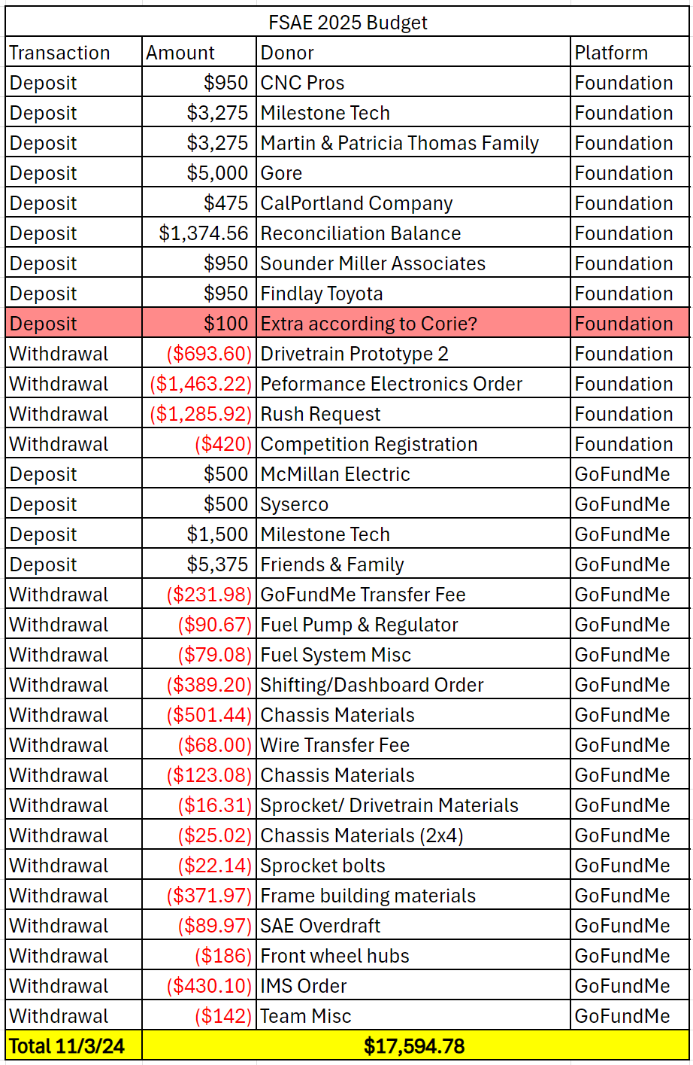
To date, we have achieved significant progress towards our goal of $40,000. Additionally, NAU may contribute funds to assistance with travel expenses. Collectively, the team has raised over the minimum 10%, a requirement of the NAU ME476C course, based on the initial funds provided to us. Our fundraising initiatives have included creating a donation website (GoFundMe), reaching out to businesses for sponsorship opportunities, and offering five tiers of sponsorship agreements based on the level of contribution both with varying levels of advertisement exposure.
This project is vital in our academic and professional growth as it allows students to gain hands-on experience before entering the workforce. The FSAE project provides engineering students with practical experience in design and manufacturing within the automotive field, offering invaluable experience for those looking for a career in the automotive industry. Additionally, it introduces students to a variety of new challenges and learning opportunities which may be beneficial to those still exploring potential career paths. FSAE is truly a test of the team’s application of engineering principles, managing budgets, collaborating effectively, and project management skills, requiring a high level of commitment from all team members.

Deliverables
Deliverables are utilized to create structure, and to help the team stay on track of their assignments. The major deliverables for NAU Formula SAE project can be categorized into three categories: course-related, competition specific, and client-specific.
Formula SAE is part of the ME476C course. The in-class deliverables are critical components that help us track our progress and ensure we are meeting our project milestones. Major in-class assignments involve timecards, peer evaluations, reports, and presentation, all of which are geared towards documenting progress, sharing updates, and receiving updates. Both Report 1(due October20) and Report 2 (due Nov 27) are comprehensive documents that encapsulate design decisions, engineering analysis, and project timelines. Moreover, peer evaluations help ensure that team members are contributing effectively, similarly with timecards, it allows individuals to track hours spent on project tasks which ensures accountability and time management.
Furthermore, staff meetings occur regularly once a week. This is a chance for Powertrain to discuss, clarify, and update one another and the professor about progress within the project. Two other major milestones include prototype demonstrations which were to have our engine running and 3D print all machined parts by November 13, 2024, and the final CAD and bill of materials (BOM) by December 03, 2024. Throughout the semester, each in class deliverable is designed to push the team toward creating a functional, competitive vehicle while honing our professional and technical skills.
Within the FSAE competition, major deliverables are designed to demonstrate the team’s overall engineering capabilities, project management, and overall vehicle performance which closely aligns with both ME 476C and competition standards. The key deliverable is the final race car itself, which must meet strict technical specifications set by the competitions. Alongside the vehicle, teams are required to submit a comprehensive series of technical reports and presentations that outline the design decisions, engineering processes and cost analysis of the project. The deliverables include a design report, cost report, and a business presentation. The design report explains the rationale behind the car’s deign choices, providing a detailed analysis of components, materials, and simulation results. The cost report details the financial aspect of the project breaking down material costs and labor which is imperative in showing the team’s understanding of real-world manufacturing. The business presentation explains the marketability and cost efficiency of the design in a hypothetical production scenario.
During the competition, teams must also deliver live presentations on their car’s design, budget and performance, which are judged by industry professionals. First the vehicle goes under rigorous technical inspection to ensure it complies with all competition rules regarding safety and performance. After technical inspection, the vehicle’s performance is evaluated in dynamic events such as acceleration, skid pad, financial, and business deliverable ensure that students gain comprehensive experience in managing a complex engineering from designing to execution. While developing skills that are directly applicable in the automotive and engineering industries. Finally, since our team is sponsored by numerous companies, it is imperative that we follow through with all marketing materials that we promised in exchange for sponsorship including branding on our website, vehicle, and social media promotions.
In conclusion, the NAU FSAE project requires a wide range of deliverables that not only ensure progress but fosters engineering, project management and communication skills. From course-related milestones such as reports, timecards and peer evaluations to competition specific requirements such as the final race car, technical presentation, static and dynamic events, and cost analysis, each deliverable is structured to guide the team through each phase of the project. The deliverables hold the team accountable and help align our efforts in producing a high performing, competitive vehicle. Additionally, the fulfillment of client specific obligations highlights the importance of professionalism and marketing in real world scenarios. All the deliverables ensure that by the end of the project, the team is prepared with the skills and experience necessary to succeed in both competition and our future engineering careers.

Success Metrics
For the 2025 NAU Formula SAE project to be considered a success several criteria must be met. The team must ultimately produce a running and driving car that can reliably complete laps around a track and compete in a variety of scenarios such as a drag strip, autocross course, and brake tests. As a team, we will take the final build to Michigan to be judged in an annual design event where it will compete against race cars from over 100 other colleges across the country. To be considered a success by the team the car must pass inspection within the first two days of the competition and compete in every event offered at the competition. The events the car will be subject to are the design presentation, cost report, manufacturing report, acceleration, skid pad, autocross, and endurance. In 2024, the NAU FSAE team did not pass inspection until towards the end of the competition and only competed in the final event, endurance. These failures were due to several design decisions being overlooked. Specifically, within powertrain, the team failed to include a feasible differential mount/chain, tuning for the injection system, the exhaust did not meet noise requirements, and the shifting system was unreliable. The overlooked design failures resulted in the team struggling to pass the technical inspection and was not a competitive vehicle. The NAU FSAE 2025 team aims to build upon last year’s failures and run a successful and more reliable car compared to last year at the 2025 FSAE competition.

REQUIREMENTS
This chapter will cover the customer and engineering requirements, in depth, for our project. These requirements will also be represented visually through a House of Quality (HoQ) to determine the importance of each requirement.

Customer Requirements (CRs)
- Functional Drivetrain
  - The team wants our drivetrain to be reliable and operate smoothly for our drivers.
- Clean Wiring
  - The team wants professional and clean wiring throughout the vehicle for aesthetic and ease of problem-solving purposes.
- Engine runs after brake test
  - For technical inspection, the vehicle must lock up all four wheels and have the engine running at the end of the test to complete the test.
- Ease of service
  - The drivetrain must be easy to repair in case of a part failure.
- Interchangeability of parts
  - Parts used within the drivetrain system must be easy to change and still work as intended.
- Design meets all competition rules
  - All aspects of the drivetrain system must be rule compliant.
- Safety
  - The vehicle must be safe for all drivers and spectators around it.
- Cost
  - The vehicle cost must be reasonable for the team to work with.
- Ease of shifting
  - The drivetrain system must be easy to shift and shift smoothly.
- Useable powerband
  - The drivetrain must perform optimally through the powerband with our given restrictions.
- Sound
  - The exhaust system must meet competition requirements and not harm drivers' or spectators' hearing.
- Chain tension adjustability
  - The powertrain system must have adjustable chain tensioning to account for chain slack and stretching.
- Body roll
  - Vehicle body roll must be kept to a minimum to increase performance by distributing engine weight.
- Acceleration rating
  - The team will need a high acceleration rating to score well in the drag race event.
- Horsepower rating
  - The team will need a high horsepower rating for better performance in the events’ high-speed sections.
- Torque rating
  - The team will need a high torque rating for better performance when coming out of conners in the events.
- Track weight
  - Must keep vehicle as little as possible to increase performance.

Engineering Requirements (ERs)
- Functionality
  - All systems within the drivetrain system must work repeatedly without a failure. This will be measured with a yes/no outcome with each drivetrain system having the desired goal of yes.
- Under 710cc
  - The engine used must be under 710cc to meet competition rules. The team has set a target engine size of 600cc.
- Power to weight ratio
  - The team needs to maximize the power to weight ratio to maximize vehicle’s performance. The team will shoot for a power to weight ratio of 0.25 hp/lb.
- Manufacturability
  - Manufactured parts within the drivetrain system must be quick and easy to manufacture. The team has set a goal for all manufactured parts to be manufactured within two weeks.
- Dynamometer tuned
  - To maximize the performance of the vehicle, the vehicle must be dynamometer tuned. This will be a yes/no outcome with the desired outcome being yes, measurable dynamometer goals are explained below.
- Cost
  - The cost of the drivetrain system must be reasonable for the team to work with. The team has a cost goal of $14,207 for the drivetrain system.
- Ease of diagnostics
  - The drivetrain system must be easy to diagnosis problems when they occur. The team has a goal of being able to diagnose drivetrain problems within 15 minutes.
- Center of gravity
  - The vehicle needs a low center of gravity to pass the tilt test which tests the amount of g’s your vehicle can handle. The team has set a center of gravity height to be 10 in. off the ground.
- Ergonomics
  - The team needs the vehicle to have an ergonomic design to provide comfort to the drivers to maximize performance. This will be a yes/no outcome with the desired outcome being yes for all drivers.
- Engine vitals
  - Engine vitals must always be readable for drivers to check the health of the engine. This goal will have a yes/no outcome with the desired outcome being yes, measurable engine vitals goals are explained below.
- Useable torque
  - Torque must not break the wheels loose but provide adequate torque for fast acceleration. The team will have a target torque value of 150 ft-lb after being dynamometer tuned.
- Operating temperature
  - The engine must run at operating temperature for the best performance. The team will have a desired temperature of 212 degrees Freiheit.
- Sub team passes inspection
  - Drivetrain must pass technical inspection. This will be measured with a yes/no outcome with the desired outcome being yes.
- Durability
  - The drivetrain system must be strong enough to survive the entire competition. The team has set the goal of surviving all 4 days of competition.
- Serviceability
  - The drivetrain system must be easily serviceable to fix any failures during competition. The team has set an average repair time goal of 30 minutes.
- Fast shifting
  - Fast shifting will maximize the team’s timed performance during competition. The team has set a goal of an average shift time of 50 milliseconds.
- Lightweight
  - The team needs the vehicle to be lightweight to maximize performance. The team has set a vehicle goal weight of 440 lbs. without a driver.

House of Quality (HoQ)
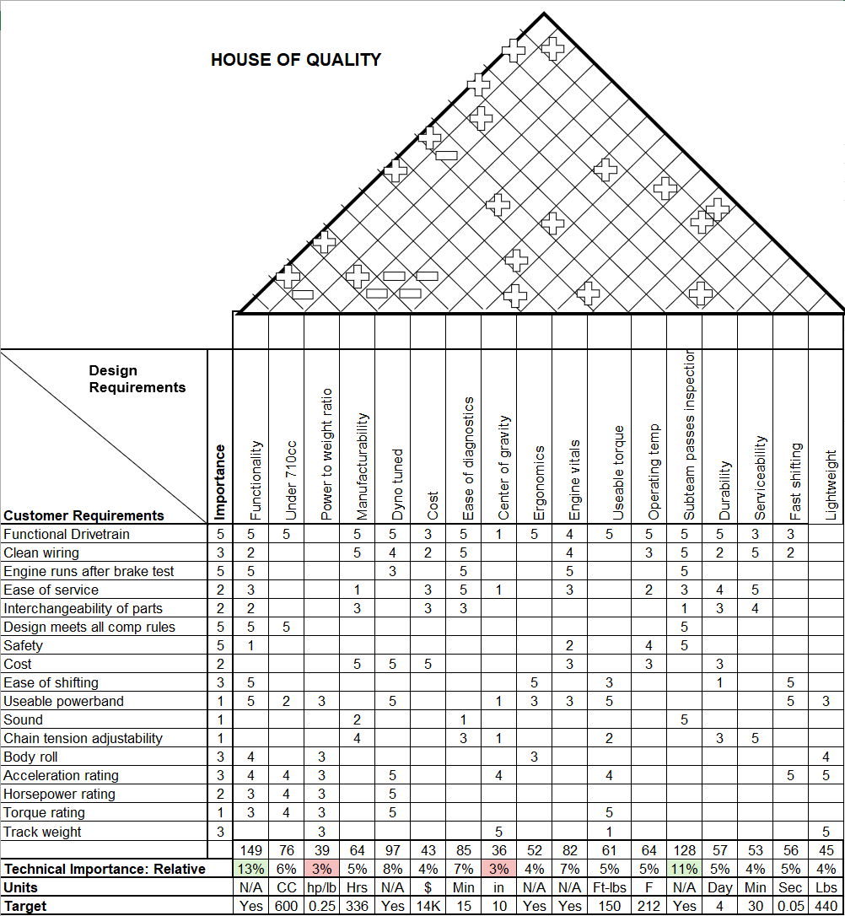Figure 1: HoQ

From the HoQ, the team needs to prioritize the engineering requirements of functionality and sub team passes inspection because these requirements have the highest correlations to our customers' requirements, with the correlation scores being 13% and 11% respectively. However, the team will not want to prioritize power to weight ratio and center of gravity due to their low correlation scores of 3%.

Research Within Your Design Space

Benchmarking
NAU FSAE 25 benchmarked Ohio State University from last year’s 2024 competition because they received first place overall in the competition. They utilized an electro-pneumatic shifting system, a Motec ECU, and produced 87HP from their engine. Here are their results:
Ohio State University FSAE Michigan 2024: [1]
- Overall result: 1st
- Acceleration: 4.271 s
- Skidpad: 5.346 s
- Autocross: 46.911 s
- Endurance: 1395.891 s (23.26 minutes)
- Efficiency: 0.535
NAU FSAE 25 benchmarked University of North Carolina Charlotte car from last year’s 2024 competition because they received second place overall in the competition. They used a paddle shifting system, four-cylinder engine, and a Motec ECU. Here are their results:
University of North Carolina Charlotte FSAE 2024 [2]
- Overall result: 2nd
- Acceleration: 4.811 s
- Skidpad: 5.243 s
- Autocross: 50.329 s
- Endurance: 1408.963 s (23.48 minutes)
- Efficiency: 0.691
NAU FSAE 25 benchmarked last year's car heavily to see where improvements could be made. They utilized a 2004 Honda CBR600F4i engine, a hand clutch and shifter, and did not tune their car with an ECU despite having bought a Dynojet Power Commander 6 specifically for their engine. Last year’s team was barely able to compete in the competition and the current team hopes to improve on their results. To do so this year’s team must treat them as state-of-the-art because they had the same resources available that the team does now. Here are their results:
Northern Arizona University FSAE Michigan 2024 [3]
- 96th Overall
- Acceleration: DNA
- Skidpad: DNA
- Autocross: DNA
- Endurance: 2092.469 s (~ 35 minutes)
- Efficiency: DNA
Further benchmarking of the powertrain hardware, especially the differential mounts, was based on information in the MIT FSAE Reports. [4]

Literature Review

Intake – Damian Boniella
[5] Internal Combustion Engine Fundamentals
This textbook describes the information needed to design an engine by providing equations and real-life examples. Within this textbook interest has been placed on sections: 6.1, 7.5, and 14.3. These sections include information on intake air flow phenomena and provide the characteristics for modeling air flow within an intake. This source’s information will be used to provide insight on intake design and for setting up test models.
[6] Engineering Fundamentals of the Internal Combustion Engine
This is another textbook that describes information needed to design an engine. Within this textbook interest has been placed on sections 2.9, 5.1, 6.6, and 6.7. These sections provide the equations needed to design an intake and provide some intake flow modeling solutions. This source’s information will be used to help lead intake design and verify the design’s functionality.
[7] Machinery’s Handbook
This handbook provides information on standards used within engineering. Interest has been placed in pages 1004-1327 because they provide information about machining standards. Some of the information included is machine speeds, feed rates, and cutting fluids. This information will be used when machining parts for the vehicle.
[8] Nozzle Geometry Variations on the discharge coefficient
This source is a research paper on how geometries can affect discharge coefficients. The paper goes into depth with multiple geometries being tested and results of the discharge coefficient being shown. This paper is important because with a restrictor in the intake system, the intake will act as a nozzle; and to provide maximum power to the engine, the intake system will need a high discharge coefficient to provide maximum air.
[9] EXPERIMENTAL AND ANALYTICAL SONIC NOZZLE DISCHARGE COEFFICIENTS FOR REYNOLDS NUMBERS UP TO 8x10^6
This is a NASA research paper on nozzle discharge coefficients for varying Reynolds numbers. The research also provides results on how nozzle geometry can affect velocities and pressures within nozzles. This information will be useful for generating high velocities and pressures within the intake system to provide more air to the engine.
[10] PERFORMANCE OF CONICAL JET NOZZLES IN TERMS OF FLOW AND VELOCITY COEFFICIENTS
This is a NASA research paper on nozzle mass flow and velocity coefficients. The research shows how nozzle geometry affects velocity and pressure within the nozzle using differing mass flow rates. This information will be useful for generating high pressures and velocities within the intake system to provide more air to the engine.
[11] Calculating Critical Air scoop speed with a forward-facing Air Inlet
This is an online article on calculating scoop size and showing the effects that scoops have on performance. The article goes into detail on the effectiveness of scoops for high performance vehicles and provides some equations for scoop performance. This information will be useful for determining if a scoop is a good performance option for our vehicle.
[12] Proper hood scoop sizing
This is an online forum discussing scoop sizing for high performance vehicles. The forum discusses issues people have had with scoop sizing, how to accurately calculate scoop sizing, and how to determine scoop sizing problems. This information will be used to determine if a scoop is a good option for our vehicle.
[13] The Effects of Intake Plenum Volume on the Performance of a Small Normally Aspirated Restricted Engine
This online paper research is done by another FSAE team on plenum volume and its effects on engine performance. The paper uses a previous generation engine to ours, however, the engine characteristics are still the same resulting in usable data. The paper will be used to determine a plenum volume that is effective for the team’s desired performance.
[14] Design and Analysis of an Operative Inlet
This online paper research is done by another FSAE team on intake runner characteristics and its effects on air pressure, velocity, and mass flow rate within the intake runners. The paper changes runner characteristics like inner diameter, length, and bend angle. The paper will be used to verify design choices that have been made for the intake runners.
[15] Measurement Procedure for Determination of Silencer Effectiveness…
This is a standard for the procedure of measuring the effectiveness of intake or exhaust silencer. The standard covers the instrumentation, environment, and testing procedures needed to conduct accurate testing for intake or exhaust silencer. This standard will be used when testing our vehicle for noise compliance.

Exhaust Manifold – Matt Gingold
[5] J.B. Heywood, Internal Combustion Engine Fundamentals, 2nd edition. New York: McGraw-Hill, 2018.
I used chapter 5: “Ideal Models of Engine Cycles”, and Chapter 6: “Gas Exchange Processes.” These helped to look at how to deal with hot gases in the exhaust system and how to optimize them.
[16] Mike Mavrigian, Performance Exhaust Systems, How to Design, Fabricate, and Install. North Branch MN: CarTech Inc, 2014. https://www.google.com/books/edition/Performance_Exhaust_Systems/FkP7AwAAQBAJ?hl=en&gbpv=1&dq=motorcycle+exhaust+system+design&printsec=frontcover
This helped to decide how to fabricate an exhaust by considering things like equal length headers and how to make them work properly without causing too much “noise” within the pipes.
[7] Erik Oberg, Franklin D. Jones, Holbrook L. Horton, and Henry H. Ryffel, Machinery’s Handbook, 29th Edition. New York: Industrial Press, 2012.
This compared different materials to use for the exhaust piping. This was good information because it is a fine balance between getting a material that works and one that is not too expensive. This helped to rule out titanium for our exhaust piping because it was too expensive and offered little reward comparatively.
[17] Hiroshi Kuribara, et al, Prediction of Fatigue Strength of Motorcycle Exhaust System Considering Vibrating and Thermal Stresses. SAE International Journal of Engines, 2016. https://www.jstor.org/stable/26284825?seq=1
This source investigates exhaust failures due to vibrations and thermal stresses. This is extremely important because if the exhaust fails during a race, we will most likely get disqualified and not even have a chance to win.
[18] A M Siregar, et al, Engineering of motorcycle exhaust gases to reduce air pollution. IOP Conference Series: Materials Science and Engineering, 2020. https://iopscience.iop.org/article/10.1088/1757-899X/821/1/012048/meta
Siregar talks about interesting ways to reduce emissions from a motorcycle exhaust system. This is less important than most things because we are not worried about emissions for tech, but it was still nice to know and mentioned some things that might also be able to get the noise level of the engine down as well.
[19] Taguchi, T., Aoki, M., Katsukawa, Y., KOGA, M. et al., "Development of a Noise Prediction Technique for Designing a High-Performance Muffler of Motorcycle," SAE Technical Paper 2010-32-0023, 2010, https://doi.org/10.4271/2010-32-0023
Taguchi talks about custom mufflers, and how to optimize them for the engine at hand. This was helpful to look at because it helps to know the best muffler this bike would be for optimal performance.
[20] MXA, Ten Things You Need to Know About Mufflers. Motocross Action Mag, 2019. https://motocrossactionmag.com/10-things-you-need-to-know-about-mufflers/
This talks about all the traits you should look for in a muffler and points out some things that would be good to have. It also mentioned some things that were not as important which was very good to know as to not waste time and money looking for things we did not need.
[21] Martin Pechout, et al, Regulated and unregulated emissions and exhaust flow measurement of four in-use high performance motorcycles. Science Direct: Atmospheric Enviroment: X, 2022. https://www.sciencedirect.com/science/article/pii/S2590162122000247
This compares different bikes with differing displacements to see emissions and flow rates. It was very helpful to see how different bikes could manage their exhaust gases and where our engine fell on that spectrum.
[22] Zach Jobe, et al, DIY Exhaust! - Is it worth it? Donut Media: Money Pit, 2021. https://www.youtube.com/watch?v=io9k0gNj7c4
This is a video on how to make a custom exhaust for a car, yet the premises are very similar to that of a motorcycle. It even has some basic knowledge on welding within the video to help viewers get an idea of how it works and how one could get started.
[23] Chern Jiek, How To Import SOLIDWORKS Part/ Assembly Files Into Ansys. Senpai Corner,
Sep 12, 2022. https://www.senpaicorner.com/post/how-to-import-solidworks-part-assembly-files-into-
Ansys
This was very specific to me making my part shift from Solidworks to Ansys, yet gave me some good basic knowledge on how to do so with a little extra.
[24] Erudite Plus, CFD Exhaust Manifold | Best Exhaust Manifold Simulation Tutorial | ANSYS
Fluent. YouTube, Mar 1, 2022. https://www.youtube.com/watch?v=AJyiqctB8rE
This video also helped me model my exhaust in Ansys and test by showing me different ways to test the part and different styles that showed different results.

Differential Mount – Tobin Lanford
[25] “Section 17-5 Roller Chain,” Shigley’s Mechanical Engineering Design 11th Edition
This section in Shigley’s Mechanical Engineering Design provides equations for calculating the forces transferred through the chain driven by the engine and transmission to the rear sprocket and subsequently the differential mounting hardware. Standards for chain drives and chain sizes are also given in this section.
[7] “Inch Threaded Fasteners,” Machinery’s Handbook: A Reference Book for the Mechanical Engineer, Designer, Manufacturing Engineer, Draftsman, Toolmaker, and Machinist
The Machinery’s Handbook has a collection of many standards that are useful in automotive design. For the differential mounts, it is necessary to consider U.S measurement bolt standards and design the adjustable components of the differential mounts around these standard sizes to ensure easy manufacturability.
[26] “Materials and technologies for Lightweighting of structural parts for Automotive Applications: A Review”
A report on the methods and materials relevant to reducing weight in commercial and passenger vehicles for the purpose of reducing the carbon footprint in relation to transportation and the cost of producing vehicles. The scenarios that were analyzed show significant success by 2030 based on these two parameters, and successful applications of these materials and techniques are highlighted. The sections on aluminum, additive manufacturing, and alternative joining techniques are particularly relevant to our vehicle design.
[1] “Design of Differential Mounts and Rear Inboard Braking for an FSAE Vehicle,” in Advances in Manufacturing Engineering
Discusses the design and optimization process of the differential mounting hardware and an inboard braking system for an FSAE vehicle. The design in this paper is also based around a Drexler limited slip differential so the design constraints are similar to our own. However, our team will be using traditional outboard braking, unlike the design in this paper.
[27] “Design of an Aluminum Differential Housing and Driveline Components for High Performance Applications”
This report is from the 2004 MIT FSAE team and depicts the design process for an aluminum replacement housing of a Torsen T-1 differential. This redesign aimed to reduce weight from the stock cast-iron housing. Additionally, the report discusses the design of bearing mounts for the differential, which will be particularly useful for our design. MIT’s 2004 team also used finite-element analysis to ensure the hardware will withstand the forces present.
[28] “Lightweight Torsen Style Limited Slip Differential and Rear Driveline Package for Formula SAE”
Another report from MIT, this time from their 2006 FSAE team. Similar to the previous report they chose to design a custom aluminum differential housing. However, this report details the design and manufacturing process for the entire powertrain from a Honda CBR600 F4i to the rear wheels.
[29] “Design of a Chain Driven Limited Slip Differential and Rear Driveline Package for Formula SAE Applications”
This is another report from MIT’s 2005 FSAE team on the design of the entire powertrain.
[30] “Aluminum 6061-T6”
Material Properties for selected aluminum plates for the differential mounts. The listed properties were used to validate the properties of the “Aluminum Allow” selected in ANSYS for FEA of the differential mounts.
[31] “Rolling Bearings”
SKF bearing selection guide and catalog. The equations provided in this document were used to select and validate the reliability and life of the bearings that will hold the Drexler differential.
[32] “520 roller chain 10FT BOX: Non-standard series roller chain”
Chain dimensions, specifically pitch, for selected 520 non-standard chain size.
[33] “2018 Honda CBR600RR”
Provides specifications for a stock Honda CBR600RR. Stated maximum engine torque value was used for calculating the torque transferred to the differential.

Engine – Joey LeBlanc
[34] Engine Management: Advanced Tuning
- Discusses different sensor functions and tuning procedures for when NAU FSAE tunes the build
[5] Internal Combustion Engine Fundamentals
- Chapter 2: Engine Design Operation Parameters
- Chapter 3: Thermochemistry of Fuel- Air Mixtures
- Used for engine horsepower and torque calculations
[35] “Sustainable use of single-cylinder engine over multi- ...,”
- Used to decide on an inline four-cylinder engine as opposed to a single cylinder engine
[36] FSAE Engine Selection: Four or One Cylinder.”
- Used to research how other teams decided on a single cylinder or inline four-cylinder engine
[37] “Design of a custom FSAE engine,”
- Gives insight on things that need to be considered when designing or selecting an engine
[38] FSwiki, “List of Engines,”
- Provides an extensive list of engines other teams have used in FSAE competitions and was used to cross reference engine choices
[39] “Thread: Engine selection: New advances V. tried and true,”
- Information from current students on selecting an engine
[40] “R/FSAE on reddit: Internal Combustion Engine for our first car,”
- Considerations for a first-year team when selecting an engine
[41] “R/FSAE on reddit: Engine choices,”
- A alumni & student perspective on the different engine choices
[42] P. H. Smith and J. C. Morrison, The Scientific Design of Exhaust & Intake Systems Philip H. Smith; John C. Morrison. Cambridge, Mass: Bentley, 2009.
- Design theory of intake and exhaust manifolds

Sprocket/Gear Ratio/ Intake Runners– Lucille Longhurst
[25] Shigley's Mechanical Engineering Design
The textbook provides principles for mechanical design, particularly in the areas of stress analysis, and fatigue considerations. For the sprocket mount and chain analysis, it aided in calculating stresses and deflections under dynamic loads and evaluating failure modes such as fatigue and yielding. The design guidelines and equations provided in the book are essential for ensuring the mount and chain system meet safety and performance standards.
[7] Machinery's Handbook
The Machinery’s Handbook engineering design and analysis, including detailed specifications for chains, sprockets, and materials. It is useful for determining standard dimensions and tolerances for sprocket components and chain drives. The tabulated data and calculation methods assist in optimizing the sprocket mount’s performance under various operational conditions.
[43] Design of Machine Elements
[44] Design and Analysis of a Formula SAE Vehicle Chain Sprocket under Static and Fatigue Loading Conditions
The paper describes the structural integrity and performance of a chain sprocket used in FSAE vehicles, focusing on its behavior under static and fatigue loading conditions. The study explains how the sprocket can withstand the stresses encountered during operation. It ensured it provided reliability and durability over time.
[45] Electro-pneumatic shifting and servo control of a clutch for a FSAE racecar
Report from University Texas in Arlington of how their FSAE completed an electro-pneumatic shifting and servo control of a clutch. The project focused on improving gear shift precision and reducing shift times to enhance overall vehicle performance. The system integrated electro-pneumatics and servo controls to automate the clutch operation, providing a competitive advantage in racing scenarios.
[46] FSAE electronic shifter: Final project report
L. Redstone, L. Weston, and J. Deglint, FSAE electronic shifter: Final project report, Univ. Victoria, Victoria, BC, Canada, Dec. 2012. [Online]. Available: http://electronicshifter.wordpress.com/.
Redstone, Weston, and Deglint shared their final year project report detailing the development and completion of an electronic shifter for their FSAE car. The project focused on enhancing gear-shifting efficiency and precision through electronic control, with the goal to improve overall vehicle performance during competition. The report discusses the design process, challenges, and the implementation of the system.
[47] Analysis of a Variable Runner Intake System for a Formula SAE Race Car
The dissertation focuses on the design and computational fluid dynamics (CFD) analysis of a variable runner intake system for a Formula SAE (FSAE) race car. The study discusses how such an intake system can improve engine performance by optimizing airflow at different engine speeds. Through CFD simulations, the research assesses the impact of the intake system on overall vehicle performance, aiming to enhance power delivery and efficiency.
[48] Design and fabrication of air intake for FSAE race
The paper discusses designing the intake runners for an FSAE race car, aiming to optimize airflow for maximum engine performance. Moreover, the intake runners are carefully made to ensure a smooth and efficient path for air, enhancing throttle response and power output. Explaining how the design takes into account factors such as length, shape, and material to meet the performance demands of a high-performance race car in the competitive FSAE environment.
[49] Design and fabrication of intake system for FSAE vehicle
Regarding the runners, the paper focuses on designing optimized intake runners that improve airflow efficiency. The design aims to enhance engine performance by reducing pressure losses and ensuring smooth air intake, critical for maintaining power output and engine responsiveness.
[50] The Complete Guide to Chain
Utilizing 4.1.4, Power transmission chain, it went fully into depth of how chain lengths are calculated. Moreover, it provided background of how the chain interacts with the gears/sprockets. Several examples were listed and showed effectively how to choose the correct chain with a gear/sprocket.
[51] Optimization of a Formula SAE Vehicle Intake Manifold
The report discusses the optimization of intake manifold designs to enhance airflow and engine performance for Formula SAE vehicles. It explains the role of runner geometry in achieving uniform airflow distribution and improving volumetric efficiency. It focuses on computational and experimental approaches and provides insights into refining runner lengths and diameters to meet the unique performance requirements of Formula SAE competition.

Mathematical Modeling

Intake Design Calculations – Damian Boniella
The results below were used to validate and determine design choices within the intake system. These calculations are rough calculations due to most values being estimates of the actual values that cannot be determined at this time.
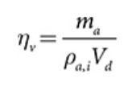
Volumetric Efficiency Equation: [5] Internal Combustion Engine Fundamentals

Engine CFM Equation: [52] Piston Slap: CFM Calculations the Easy Way and Hard Way

Using the above equations with some given information based on the CBR600RR, a calculation for the needed cubic feet per minute of air required to run the engine at redline can be calculated. CBR600rr: Displacement: 36.55 in^3, Redline: 13,500 RPM, η_{V}: 88%. The resultant maximum CFM required to run the engine was CFM_{MAX} = 125.64 ft^3/min, which is reasonable for an engine this size. To calculate information on the air moving through a restrictor the below equations will be needed.

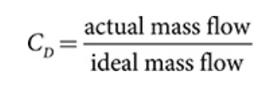
Discharge Coefficient: [5] Internal Combustion Engine Fundamentals

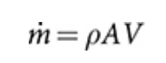
Mass Flow Rate: [5] Internal Combustion Engine Fundamentals

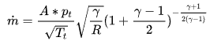
Choked Mass Flow Rate Theoretical Equation: [6] Restrictor
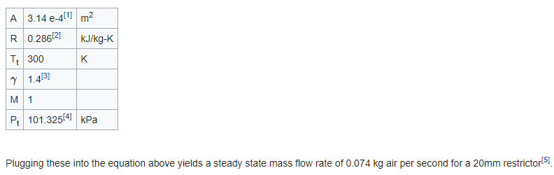
Choked Mass Flow Rate Theoretical Equation Example: [53] Restrictor

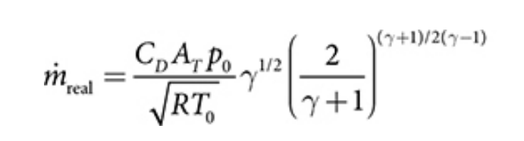
Choked Mass Flow Rate Actual Equation: [2] Internal Combustion Engine Fundamentals

Using some standard sea level and theoretical values for parameters: Density: 1.225 kg/m^3, CD: 90%, A: 20mm Restrictor, R: 286.9 J/kg*K, T: 288.15 K, P: 101325 Pa. The calculated results are as followed: Mass Flow Rate Theoretical = 0.3032 kg/s = 535 cfm, Mass Flow Rate Actual = 0.2729 kg/s = 481 cfm, Max Theoretical Velocity = 197 m/s = 646 ft/s.

Exhaust Design Calculations – Matt Gingold

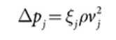
This is Bernoulli’s equation assuming there is a quasi-steady flow. ξj is the flow resistance coefficient, and vj is the local velocity. This can relate to the piston speed, which is:

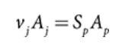
Here, Aj is the minimum flow area, and Ap is the piston area.

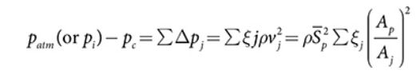
From those, you can use this equation to calculate the velocity of the air and know the friction of the air in the pipe. These are the calculations once everything is plugged in.
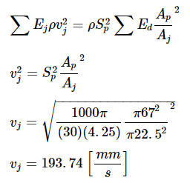

Differential Mount Calculations – Tobin Lanford
Calculations pertain to the potential durability of the differential mounts. Forces will be exerted on the differential mounts from the engine and through the axles. These forces must be carefully considered in the design and will be used to ensure the final design has an adequate factor of safety against deformation and failure using FEA software. The results below indicate the maximum theoretical maximum force that will be exerted on the rear sprocket from the drive chain and into the differential mounts.
T_{E} is the manufacturer stated maximum stock engine torque. Actual maximum engine torque will be lower due to the intake airflow restrictor required by the SAE regulations.
$$T_{E}=49 [lbf*ft]$$
The following equation represents the torque transfer through the CBR600RR transmission and our final drive ratio. The CBR600RR transmission drives an 11-tooth sprocket where N is the number of teeth in the vehicle’s rear sprocket.
$$N=42 [teeth]$$
$T_{S}= T_{E}×\frac{76}{36}×\frac{33}{12}×\frac{N}{11}=1086 [lbf*ft]$[22]
P is the pitch of the rear sprocket.
D_{S} is the rear sprocket diameter.
F_{S} is the maximum force on the rear sprocket.
$$P=0.625 \left[in\right]$$
$D_{s}= \frac{P}{sin⁡(180/N)}×\frac{1 [ft]}{12 [in]}=0.697 [ft]$[19]
$F_{S}= \frac{T_{S}}{{(D}_{S}/2)}=3117 [lbf]$[22]
$$F_{S}=13863 [N]$$
The maximum sprocket force, due to the tension in the drive chain, will be used to calculate the reaction forces on each differential mount. This process is detailed below.
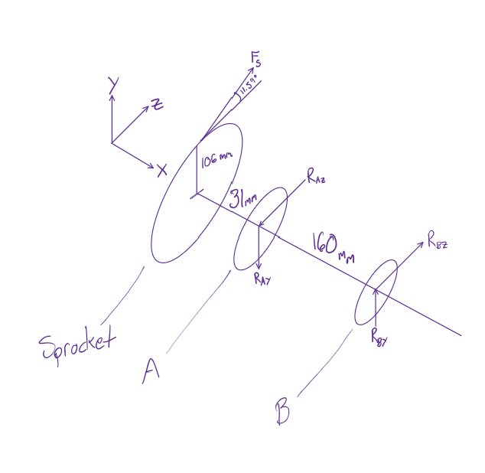
Figure 21: Differential and Rear Sprocket FBD

Force Components on Rear Sprocket
$$F_{Sz}=F_{S}\cos\left(11.59\right)=13577 \left[N\right]$$
$$F_{Sy}=F_{S}\cos\left(11.59\right)=2785 \left[N\right]$$
X-Z Plane
$$\sum{M_{A}}=0=-F_{Sz}\left(0.031\right)+R_{Bz}(0.160)$$
$$R_{Bz}=F_{Sz}\frac{0.031}{0.160}=2631 [N]$$
$$\sum{F_{z}}=0=F_{Sz}-R_{Az}-R_{Bz}$$
$$R_{Az}=16208 [N]$$

X-Y Plane
$$\sum{M_{A}}=0=-F_{Sy}\left(0.031\right)+R_{By}(0.160)$$
$$R_{By}=F_{Sy}\frac{0.031}{0.160}=539.6 [N]$$
$$\sum{F_{y}}=0=F_{Sy}-R_{Ay}-R_{By}$$
$$R_{Ay}=3325 [N]$$
Total Reaction at Bearing A
$$R_{A}=16546 [N]$$
The calculated reaction forces are necessary for conducting finite element analysis on the differential mount. Reaction forces at bearing B were found using the same method as above and equal about 1/6th of the forces at bearing A. Therefore, the FEA presented later in the report will focus on the sprocket side differential mount.

Engine Calculations – Joey LeBlanc
When selecting an engine, the first thing NAU FSAE considered was the power and torque output of each engine. According to competition guidelines set by SAE international all teams must have a restrictor nozzle of 20mm diameter which limits power and torque in all engines. NAU FSAE wanted to calculate the actual power and torque with the restrictor of the chosen CBR600RR engine and they are shown below.
All equations are from chapters 2&3 of Heywood's [5]:
This calculation shows a brake horsepower calculation for the teams selected Honda CBR600RR engine at ideal atmospheric conditions.

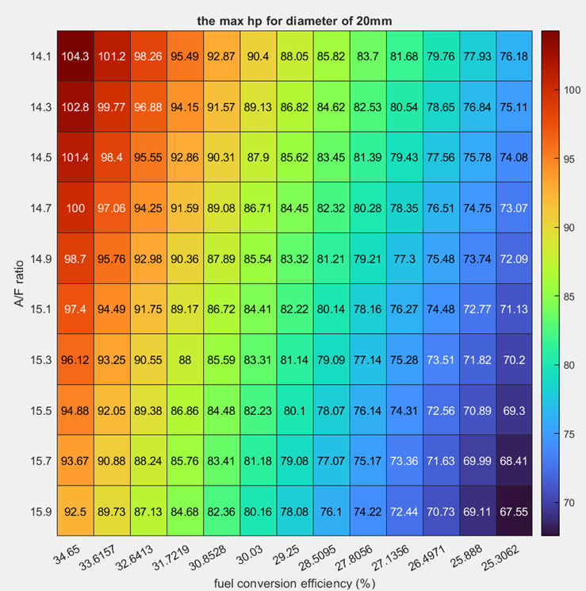
Figure 3: Actual HP CBR600RR

This MATLAB chart shows the theoretical max brake horsepower at different fuel conversion efficiencies and air/fuel mixtures. The ideal A/F ratio is 14.7 and the ideal fuel conversion efficiency is about 34%. At ideal operating conditions the maximum power that can be achieved with a 20mm diameter restrictor is 100 horsepower.

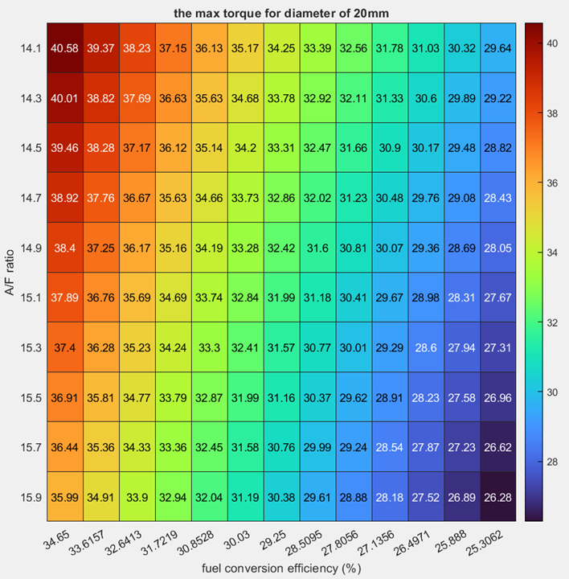
Figure 4: Actual Torque CBR600RR

This MATLAB chart shows the theoretical max brake torque at different fuel conversion efficiencies and air/fuel mixtures. The ideal A/F ratio is 14.7 and the ideal fuel conversion efficiency is about 34%. Reading this chart shows that the maximum torque at ideal operating conditions is 38.92 [lb-ft] of torque and varies based on the fuel conversion efficiency and the air-fuel ratio.

Sprockets/Gear Ratio – Lucille Longhurst
In choosing the gear ratio and sprockets, the team chose to prioritize maximizing acceleration over top speed, given the nature of the competition, where quick acceleration plays a critical role in dynamic events such as Autocross and Endurance. The vehicle’s drivetrain configuration was built around a 3.8 gear ratio, achieved by selecting an 11-tooth front sprocket and a 42-tooth rear sprocket paired with a 520 chain. This choice aimed to strike an optimal balance between acceleration, mechanical reliability, and ease of integration within the drivetrain system. To begin the selection of the gear ratio, the torque and power output from the Honda CBR600RR engine (figure 5) were analyzed. The torque curve, based on provided data, modeled from 2,500 RPM to 15,000 RPM, showing peak torque of 47.5 ft-lb at 10,000 RPM and peak power of 118 hp at 13,500 RPM

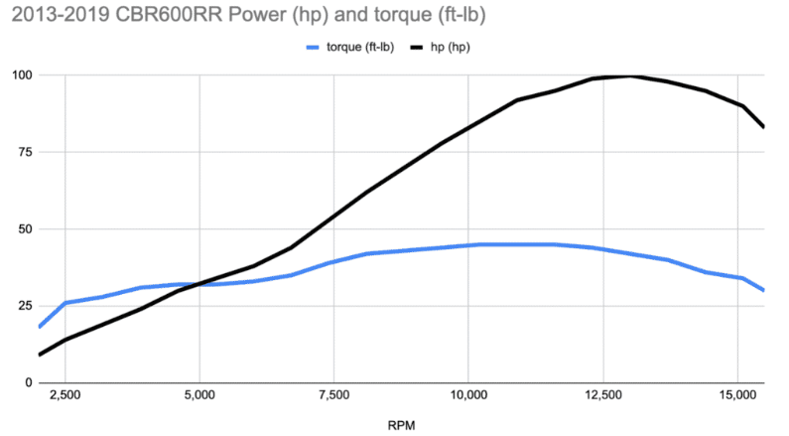
Figure 5: Engine Specifications

Table 2: Derived Points from Figure 5
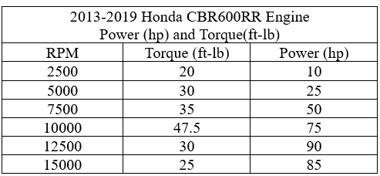

Table 3: Transmission Gear Ratios from Manual
Gear Ratio (1-N-2-3-4-5-6)
1 | 2.750 | 33/12
2 | 2.000 | 32/16
3 | 1.666 | 30/18
4 | 1.444 | 26/18
5 | 1.304 | 30/23
6 | 1.208 | 29/24
Primary Reduction | 2.111 | 76/36

Based on the engine specifications data points table (2), the transmission gear ratios from the manual (table (3)), and the tire circumference 64.4 inches, MATLAB code was used for the calculations to simulate the effect of gear ratio on the vehicle’s wheel RPM, and top speed. The following gear ratios were compared: 3.0, 3.2, 3.4, 3.6, 3.8, 4.0. The following equations were utilized:
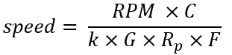
Speed (mph)
$RPM$=Engine (rpm)
$G$= Gear Ratio
$R_{p}$= Engine RPM
$C$= Tire Circumference
$k$ = $1 mph=\frac{5280 ft}{60 min}=88\frac{ft}{min}$
$F$= Final Drive Ratio
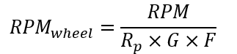
${RPM}_{wheel}$ =Wheel RPM
$RPM$=Engine (rpm)
$G$= Gear Ratio
$R_{p}$= Engine RPM
$F$= Final Drive Ratio

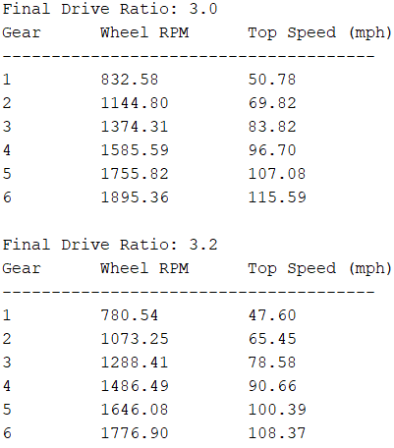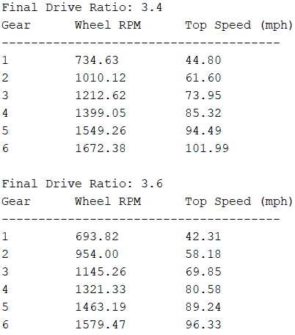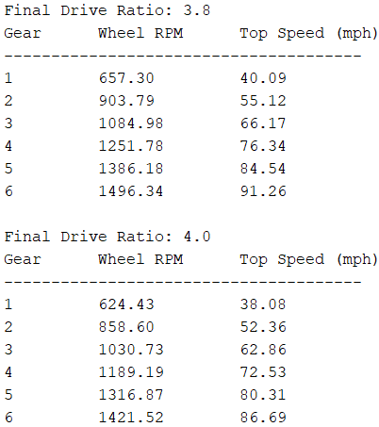
Figure 6: Gear Ratio Comparison

After comparing the results, the 3.8 gear ratio proved to be the optimal choice, as it provided the best balance between acceleration and top speed.

The next step involved comparing various front tooth sprocket combinations, specifically 11-42, 12-46, 13-50, and 14-53. Using MATLAB, a simulation was conducted to analyze the maximum speed in each gear and the average acceleration for each sprocket combination. Several key assumptions were made: the estimated mass of the vehicle, including the driver, was 716.5 [lb], and the coefficient of friction was set at 1.2. The following equations were utilized:
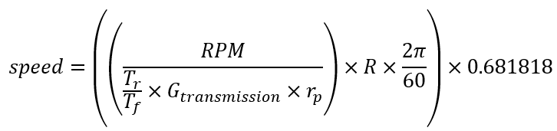
Speed (mph)
$RPM$=Engine (rpm)
$G_{transmission}$= Gear Ratio (1 to 6)
$r_{p}=$Primary Reduction
$T_{r}$=Rear Sprocket Teeth
$T_{f}$= Front Sprocket Teeth
$R$=Tire Radius (ft)

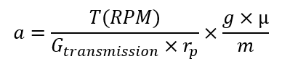
$a$ = acceleration $\frac{ft}{s^{2}}$
$T$=Torque (ft-lb)
$G_{transmission}$= Gear Ratio (1 to 6)
$r_{p}=$Primary Reduction
$RPM$=Engine (rpm)
$g$= 32.174 $\frac{ft}{s^{2}}$
$µ$= coefficient of friction
m= mass (lb)

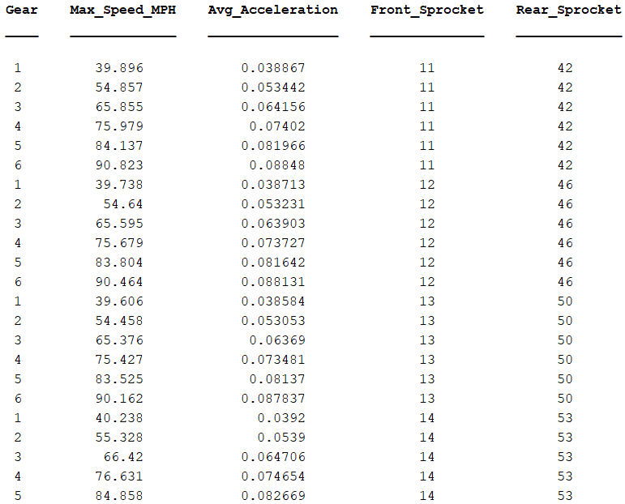
Figure 7: Sprocket Output Comparison

After closely analyzing all possible sprocket configurations, the team ultimately chose the 11-tooth front sprocket and 42-tooth rear sprocket. While all combinations provide similar drive ratios, they differ slightly in terms of chain dynamics and mechanical stress. The 11-tooth front sprocket, paired with the 42-tooth rear sprocket, offers a more aggressive acceleration profile due to the smaller front sprocket. Additionally, it still achieves competitive top speeds in higher gears, making it a suitable choice that ensures the vehicle meets performance demands.

The final step in the design process involved selecting an appropriate chain and determining the number of links required. The team selected a 520-chain, a standard choice due to its widespread availability, cost effectiveness, and lightweight nature. The chain is commonly used in motorbikes and meets the performance demands of the project. Using the equations below the number of chain links were calculated and the center-to-center distance between the sprockets was converted to pitches.

$$C_{pitches}=\frac{C}{P}$$
$C= \text{Center-to-Center distance,}10.25 in$
$P=\text{Pitch (in.), }0.625$
$C_{pitches}=\text{Converted Value, 16.4}$

$$N_{links}=2C_{pitches}+\frac{N_{front }+N_{rear}}{2}\frac{\frac{N_{rear}-N_{front }}{2π}}{C_{pitches}}$$

$C_{pitches}=\text{Converted Value, 16.4}$
$N_{front}$= Teeth in Front Sprocket
$N_{rear}$= Teeth Rear Sprocket
$N_{links}=60.78$ links $\sim 62$ links

With the pitch value calculated, the chain length was calculated yielding a value of 60.78 links. However, it is critical that the number of links is not rounded down because this would lead to excessive tension. Moreover, an odd number of links cannot be used due to the chain’s alternating link design. Therefore, the number of links was rounded up to 62 to ensure proper fit and function.

Rear Sprocket Torque:
Calculating rear sprocket torque for each $i-\text{th}$ RPM and $j-\text{th}$ gear
$$T_{\text{rear, ij}}=T_{\text{Nm,i}}×\text{Effective Ratio × }S$$
$T_{\text{rear, ij}}:$ Rear sprocket torque for i-th RPM and j-th gear
$T_{\text{Nm,i}}:$Engine torque at i-th RPM
Effective Ratio
$S:$ Scaling Ratio

Torque per Bolt:
$$T_{\text{bolt,ij}}=\frac{T_{\text{rear,ij}}}{6}$$
$T_{\text{bolt,ij}}:$Torque per bolt for i-th RPM and j-th gear
$T_{\text{rear,ij}}:$ Rear sprocket torque for the i-th RPM and j-th gear
6: Number of bolts on mount

Shear Force per Bolt:
$$F_{\text{shear, ij}}=\frac{T_{\text{bolt,ij}}}{r_{\text{BCD}}}$$

$F_{\text{shear, ij}}:$Shear force per bolt for i-th RPM and j-th gear
$T_{\text{bolt,ij}}:$Torque per bolt
$r_{\text{BCD}}:$Bolt circle radius (m)

The outputs are provided below. These terms were calculated using the equations detailed above. In the code, some values are NaN due to unrealistic scenarios, such as the vehicle operating at 14,500 RPM in first gear, which would not occur in practice. Additionally, a scaling factor was applied because the derived values from the graph may be overestimated or imprecise, potentially leading to misleading stress calculations. Since the engine is being used in a non-conventional application (not on a bike), the mechanical efficiency of the vehicle is not fully known. The maximum values were used to determine where the highest stress would act on the mount.

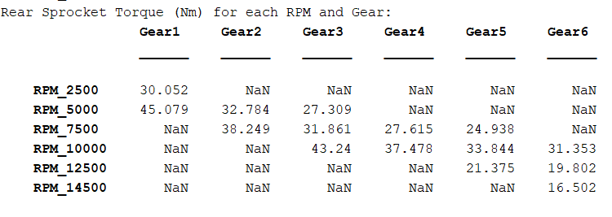
Figure 8: Rear Sprocket Torque and Varying RPMs and Gears
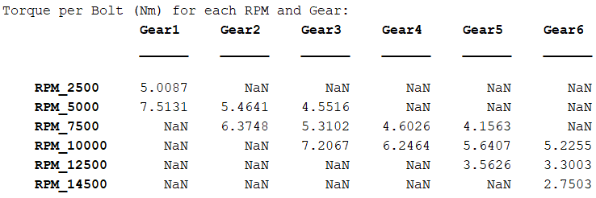

Figure 9: Torque per Bolt at Varying RPMs and Gears

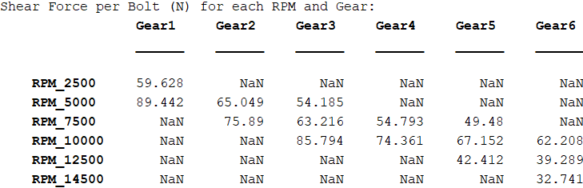
Figure 10: Shear Force per Bolt at Varying RPMs and Gears

The drivetrain analysis and simulations optimized the Formula SAE vehicle's performance, focusing on gear ratios, sprocket configurations, and chain selection. A 3.8 gear ratio was selected for its balance between acceleration and top speed, while the 11-tooth front and 42-tooth rear sprocket combination provided aggressive acceleration and sufficient top speed. A 520 chain with 62 links was chosen for its lightweight, cost-effective properties and proper tensioning. Rear sprocket torque, torque per bolt, and shear forces were calculated across varying RPMs and gears to identify critical stress points on the mount. The analysis accounted for practical constraints, such as unrealistic high-RPM scenarios and non-conventional application inefficiencies, ensuring accurate results. The final drivetrain design meets the performance demands of the competition while maintaining reliability under peak stress conditions.

Design Concepts

Functional Decomposition
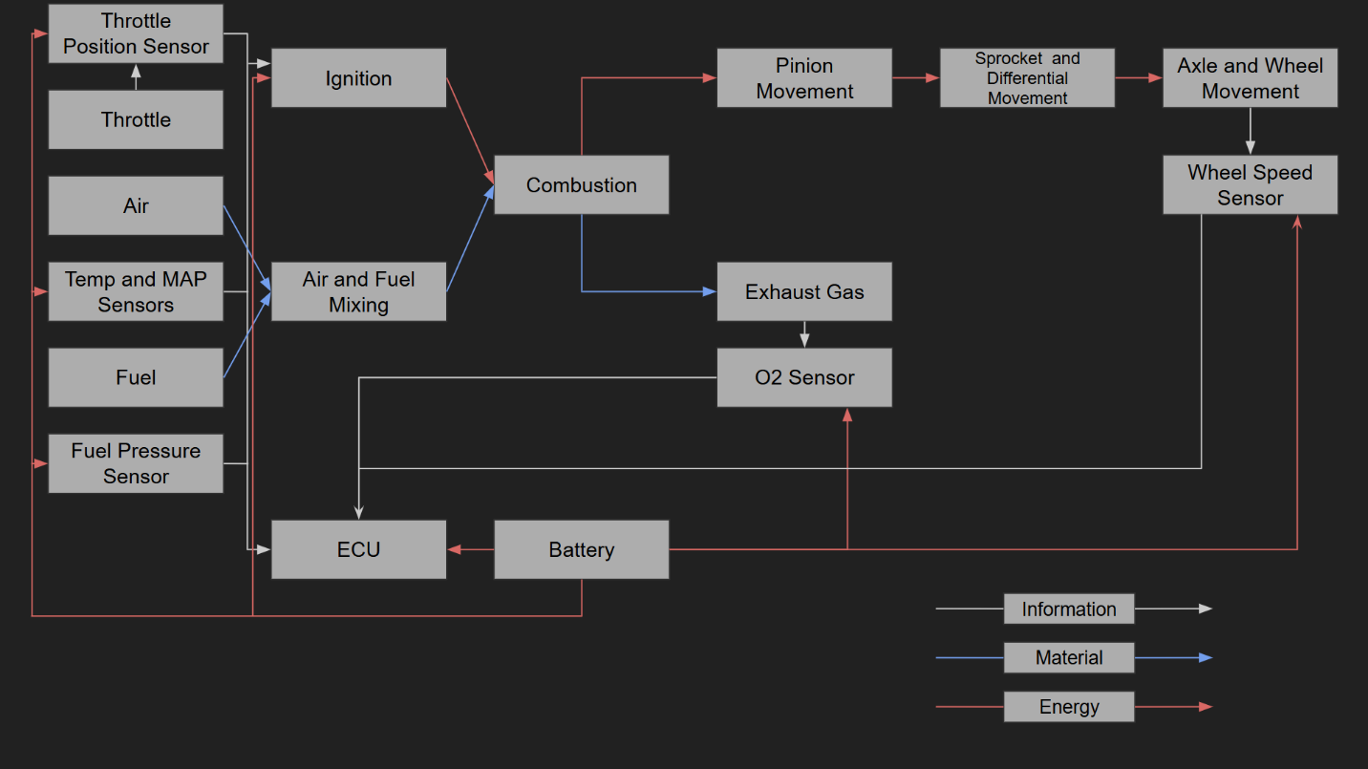Figure 11: Functional Decomposition

Depicted in the functional decomposition are the most important parts within the powertrain system. The mechanical energy produced by the combustion of the air-fuel mixture powers the pinion, sprocket, differential, and axles to move the wheels. The throttle, exhaust gases, and sensors all relay information to the ECU to determine when the ignition needs to act to provide adequate mechanical power. This functional decomposition was used to break down the powertrain system into key components like intake, exhaust, differential and sprocket mounts, timing, and wiring. The mechanical engineers were tasked with creating intake and exhaust systems and the differential and sprocket mounts, whereas the electrical engineers were tasked with timing and wiring of the engine.

Concept Generation

Intake Design – Damian Boniella
The table below shows all the materials required to build all the intake design concepts.

Table 4: Materials used to make the Intake
Items: | 1 | 2 | 3 | 4 | 5
3D Filament | PA6-CF | PET-CF | PC | PETG-CF | ASA-CF
Throttle Body | 28mm | 30mm | 32mm | 34mm
Air Filter | 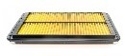 | 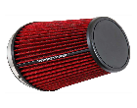
Temperature Sensor | 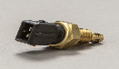 | 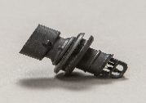 | 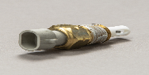
MAP Sensor | 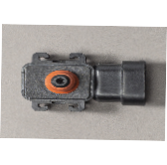 | 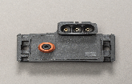

The formula and long intakes were both designed to be placed above the driver's head within the main hoop of the vehicle. The formula intake would take advantage of ram air effects by acting as a scoop providing large amounts of clean air to the engine, whereas the long intake would not take advantage of ram air effects but take advantage of the clean air. The side intake would also take advantage of clean air but be routed to the left-hand, or right-hand, side of the driver, sticking close to the body work of the vehicle. The short air intake would reside in the engine compartment of the vehicle taking in dirty air for the engine but having the benefits of being the most cost-effective and least time-consuming design.

Table 5: Intake Concept Generation
Concept: | Formula Intake  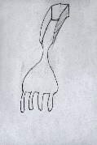 | Side Intake  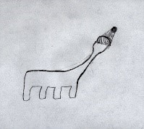 | Short Intake  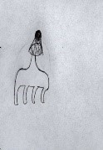 | Long Intake  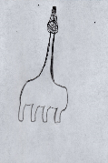
Materials  Used: | PET-CF, Throttle Body: 34mm, Square Air Filter, Temp. Sensor 1, MAP Sensor 1 | PA6-CF, Throttle Body: 32mm, Conical Air Filter, Temp. Sensor 1, MAP Sensor 1 | PC, Throttle Body: 32mm, Conical Air Filter, Temp. Sensor 1, MAP Sensor 1 | PA6-CF, Throttle Body: 32mm, Conical Air Filter, Temp. Sensor 1, MAP Sensor 1
Advantages: | Ram Air Effect, Style Points | Clean Air, Style Points | Small Material Usage, Needs Little Structural Support, Low Cost | Clean Air, Widely Used by Other Teams
Disadvantages: | Large Material Usage, Needs Structural Support, High Cost | Large Material Usage, Needs Structural Support, High Cost | Hot and Disturbed Air | Large Material Usage, Needs Structural Support, High Cost

Exhaust Design – Matt Gingold
Table 6 shares four types of exhaust headers for a vehicle: long tube headers (steel and titanium), short tube headers (steel), and stock headers (steel). Each header type offers different advantages and disadvantages, prioritizing power delivery, size, and practicality for the use in FSAE. Long tube headers, both steel and titanium, provide more top-end power and lower the engine but are bulky. However, titanium has the benefit of better heat dissipation, though it's more expensive. In contrast, short tube headers offer more low-end power and are compact but are harder to manufacture. Meanwhile stock headers are readily available but require the engine to be positioned higher and are less optimized for performance.

Table 6: Exhaust Concepts
Concept: | Long Tube Headers (Steel) | Long Tube Headers (Titanium) | Short Tube Headers (Steel) | Stock Headers (Steel)
Image: | 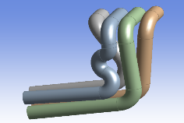 | 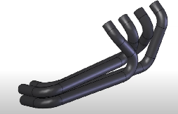https://www.youtube.com/watch?v=mWcKGWQfAos | 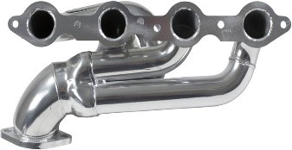https://www.amazon.com/BBK-40200-Performance-Exhaust-Headers/dp/B003HII37E | 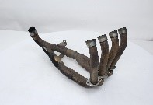https://cheapthrillsmoto.com/products/exhaust-header-honda-cbr600rr-03-04-oem-cbr-600-rr
Pros: | More top-end power  Lowers engine.  Cheap to create | More top-end power  Lowers engine.  High Exhaust volume  Better Heat dissipation | More low-end power  Lowers engine.  Smaller in size  Cheap to make | Stock configuration  Have one currently.
Cons: | Large/bulky  Less low-end power | Large/Bulky  Less low-end power  Low exhaust velocity  Much more expensive | Less high-end power  More difficult to make (might upset our welders) | Engine must be higher (~6 inches)  Not as optimized for our use

Differential Mount – Tobin Lanford
The table below depicts the possible design concepts for the differential mounting that were considered, including different mounting locations, the chain tensioning system, materials, and the choices of the limited slip differential itself. The highlighted row indicates the final design concept.

Table 7: Differential Mount Concepts
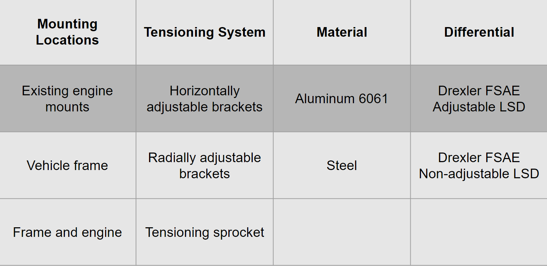

Engine Options – Joey LeBlanc
Table 8: Engine Concepts
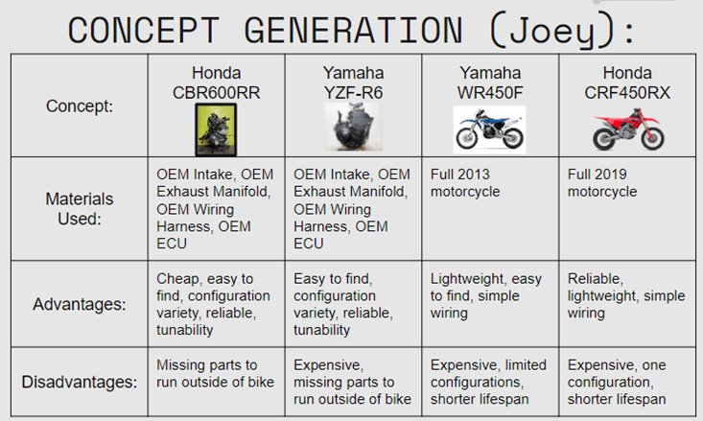

Shifter, Sprockets, Chain Options – Lucille Longhurst
For the design process, a Morphological Matrix was utilized to compare different options for the shifting system. Each sub-system was analyzed with various configurations based on shifting mechanisms, gear ratios, sprocket sizes, and chain types.
Table 9: Shifting System Morphological Matrix
Morphological Matrix
 | Option 1 | Option 2 | Option 3 | Option 4
Shifting Mechanism | Cable Lever Pull System | Electric Paddle Shifters | Pneumatic Paddle Shifters
Gear Ratio | 3.4 | 3.6 | 3.8 | 4.0
Sprocket Size (Front) | 11 | 12 | 13 | 14
Chain Type | 420 | 428 | 520 | 529

In evaluating possible shifting systems, the following options were considered: the cable lever pull system, electric paddle shifters, and pneumatic paddle shifters. Option one, cable lever pull system, is a simple and low-cost solution. It was the method used by the 2024 NAU FSAE team and offers ease of installation, maintenance, and reliability. However, the primary drawback is its relatively slow shifting speed, which can be a disadvantage in competitive environments where quick gear changes are crucial.

Options two and three both involve paddle shifters, which are known for providing fast and precise shifts. When properly implemented, paddle shifters can offer near-instantaneous shifts with minimal delay, significantly reducing shift times. This advantage is especially beneficial in events like Autocross and Endurance, where frequent and rapid gear changes are required.

The cons of both electric and pneumatic paddle shifters are quite similar. Both systems introduce higher complexity. Electric paddle shifters require intricate wiring, control units, and actuators, which can increase the potential for system failures. On the other hand, pneumatic paddle shifters rely on a compressed air system, including air tanks, compressors, and air lines, which adds considerable weight and complexity. The pneumatic system also requires regular maintenance and air pressure monitoring to ensure consistent performance. Additionally, both systems involve higher costs compared to the cable lever system. However, if executed correctly, the significant performance improvements such as faster and more precise shifting can outweigh these drawbacks.

When selecting an optimal gear ratio, the key question is whether to prioritize top speed or acceleration. In racing, acceleration is often more critical, as drivers need to quickly reach high speeds, especially in tight corners. Lower gear ratios, ranging from 3.0 to 3.4, can provide higher top speeds; however, higher gear ratios result in increased acceleration values, albeit at the cost of top speed.

Once the gear ratio is determined, the next step is to choose the front sprocket. In FSAE competitions, front sprocket options typically range from 11 to 14 teeth. An 11-tooth sprocket maximizes acceleration due to its compact size but can lead to increased wear on the chain and sprocket because of the high rotational speed. On the other hand, 12- and 13-tooth sprockets offer a balance between acceleration and top speed, sacrificing a bit of acceleration for better durability. A 14-tooth sprocket is optimal for achieving higher top speeds and reducing wear and tear on the chain, but this choice significantly compromises acceleration.

To connect the front and rear sprockets, it is essential to select a suitable chain. Various chain types were considered, including the 420, 428, 520, and 529, each with their own advantages and disadvantages. The 420 chain is very lightweight and affordable, but its low strength and durability make it unsuitable for high-performance applications. Similarly, the 428 chain is slightly stronger than the 420 chain; however, it still lacks the durability required for high-stress situations, making it less ideal than the 520 or 529 chains. The 520 chain is strong and durable, making it a popular choice in motorsport and an ideal option for high-performance applications. While it is heavier than both the 420 and 428 chains, its strength justifies the weight increase. The 529 chain offers the highest strength among all the options but is also the heaviest and most expensive. Its robust design may be considered overkill for a Formula SAE application, where the balance between weight and performance is crucial.

The design process highlighted the importance of evaluating various shifting systems, gear ratios, and chain types to optimize performance for a Formula SAE vehicle. Each component's strengths and weaknesses were carefully analyzed to ensure that the chosen configurations would meet the demands of competitive racing. This comprehensive approach emphasizes the critical balance between performance, reliability, and complexity in engineering design.

Selection Criteria

Intake Selection Criteria – Damian Boniella
Engineering requirements that are important to the intake system are functionality, dynamometer tuned, manufacturability, cost, durability, serviceability, and lightweight. The intake system needs to be functional with providing the maximum amount of air to the engine. This air will need to account for with dynamometer tuning to increase engine performance. Manufacturability is key in the intake system due to the system being 3D printed. However, with the system being 3D printed the cost, durability, and weight of the design will need to be considered. If durability is increased, to prevent failure of the system, the weight and cost will also increase with a likelihood of decreasing manufacturability. Lastly, the design will be serviceable to prevent entire system failures and allow restrictor rules to be tested. Considering all engineering requirements, the team has put functionality, dynamometer tuned, and manufacturability as the most important requirements within the intake system.

Exhaust Selection Criteria – Matt Gingold
One purpose of making a custom exhaust is to get more power out of it than the stock exhaust system provides. This is not the main reason for us though because our goal is to lower the entire motor 4 – 5 inches minimum. To achieve this, the exhaust cannot be run underneath the engine, so we must make out own. There are numerous things to consider when designing a custom exhaust. The biggest one is what type of power is being made. A 2-stroke engine obviously makes noticeably different power than a 4-stroke engine, so they cannot use the same exhaust design. This also applies for engines that have bigger displacement versus ones that have smaller ones. The two main designs that were in the concept generation were long tube headers and short tube headers. This is because we do not have much space for anything complicated, and the goal is to not anger the welders that we have so we can get more stuff done in a timely manner. These 2 ideas had simpler styles that would be easier to weld and would fit in the space we need them to. The main difference between long tube headers and short tube headers is that long tubes make more power in higher revving vehicles while short tubes make more power down low. With our engine revving past 15,000 rpm, it made more sense to go with long tube headers. While they are slightly more complicated than short tube headers, the higher power could help us to perform better and possibly win more points when we attempt our design presentation.

Differential Mount Selection Criteria – Tobin Lanford
The important engineering requirements regarding the differential mounting hardware are functionality, manufacturability, cost, durability, and weight. With durability and functionality being the two most important. The mounting brackets must allow the differential to operate smoothly and as intended by the manufacturer. These brackets will also need to withstand forces that exceed the maximum possible forces that will be transferred through the drive chain and the rear axles, resulting in an adequate and comfortable factor of safety. This will be iteratively ensured throughout the design process using finite element analysis in SolidWorks and ANSYS. Manufacturability will be maximized by choosing the simplest design that will accomplish these fundamental goals for the differential mounts. While cost and weight should be considered and minimized in the differential mount design, these are at a lower priority than the previously discussed requirements.

Engine Selection Criteria – Joey LeBlanc
When selecting an engine for the NAU Formula SAE 2024-2025 build, several key factors must be considered: price, engine configurations, wiring complexity, reliability, tunability, weight, power, torque, availability, and size. Based on benchmarking and research conducted by the 2024-2025 NAU Powertrain team, the engines under consideration for the upcoming season include the Honda CBR600RR, Yamaha YZF-R6, Yamaha WR450F, Honda CRF450RX. Essential criteria such as fuel injection, electric start, and a displacement of less than 710cc were prioritized in the research due to competition rules and design constraints.
Price
The cost of the engine and its components is a crucial factor in designing and manufacturing the MK2 NAU Formula racecar. In the previous generation, the expense of the engine and its parts was second only to the cost of the wheels and tires, as the engine was purchased in a complete motorcycle configuration. This year, the team anticipates that the engine will again rank as one of the most expensive components of the racecar, potentially surpassing even the wheels and tires as they may be reused from the 23’-24’ season. To determine average costs, the team analyzed five to ten listings for each engine model from various classified sites, including eBay, Facebook Marketplace, and Craigslist. While similar engine configurations fell within a comparable price range, costs varied significantly across different configurations. Given our budget constraints as a second-year FSAE team, cost is being considered the most critical factor in the engine selection process.

Configurations
Three feasible engine configurations have been identified for this year’s FSAE racecar project:

1. Complete Motorcycle Purchase:
This option involves buying a whole motorcycle to disassemble and use its engine and parts. The primary advantages of this configuration are the immediate availability of a running engine upon purchase and the potential to sell off surplus parts. However, there are significant drawbacks. The main concerns include uncertainty regarding engine health, as assessing this through leak down and compression tests can be challenging without disassembling the bike—a process that might not be permitted by the seller. Additionally, the higher cost and the lack of a guaranteed resale value for the parts make this option risky. The inability to return the motorcycle once purchased further complicates the situation, as engine compression reliability is crucial for meeting the year’s powertrain goals and overall project timeline. Repairing an engine with low compression is well within the abilities of this year’s powertrain team, however, the process is costly, time consuming, and most likely something that should be avoided all together.

2. Short Block Engine:
The short block configuration involves acquiring an engine block with an integrated transmission, internal components like the crankshaft, pistons, rods, a complete cylinder head, and essential casings such as valve and side covers. This configuration offers several benefits, including verified engine health due to pre-sale compression and leak down tests conducted by sellers. It is also the most cost-effective of the three options and often allows for returns and shipping from reputable sellers. Nonetheless, drawbacks include the need to purchase a large quantity of additional parts separately and the potential for long shipping times, especially if incorrect or incomplete parts are ordered. There is also a risk of assembly errors with the engine’s air intake, fuel system, and wiring if parts are mistakenly ordered or improperly assembled.

3. Long Block Engine:
The long block configuration comprises everything needed to run the engine on a stand, except for a battery and fuel pump. This includes a complete short block, OEM intake and fuel system, OEM wiring harness and ECU, necessary sensors, various coolant lines, and typically an exhaust manifold. The main advantages of this option are the confirmed engine health at purchase and the overall cost-effectiveness. Additionally, if the battery and fuel pump are acquired promptly, the engine can be operational immediately. This approach allows the team to focus on designing other powertrain components rather than taking the time to disassemble a motorcycle and reassembling the long block outside of the bike. However, the long block configuration may have more limited availability compared to short blocks, and it requires the separate purchase of a radiator (not required to run on a stand), fuel pump, and battery.

Shifter, Sprocket, and Chain Selection – Lucille Longhurst
For the design process, a Morphological Matrix was utilized to compare different options for the shifting system. Each sub-system was analyzed with various configurations based on shifting mechanisms, gear ratios, sprocket sizes, and chain types.

Table 10: Shifting System Morphological Matrix
Morphological Matrix
 | Option 1 | Option 2 | Option 3 | Option 4
Shifting Mechanism | Cable Lever Pull System | Electric Paddle Shifters | Pneumatic Paddle Shifters
Gear Ratio | 3.4 | 3.6 | 3.8 | 4.0
Sprocket Size (Front) | 11 | 12 | 13 | 14
Chain Type | 420 | 428 | 520 | 529

In evaluating possible shifting systems, the following options were considered: the cable lever pull system, electric paddle shifters, and pneumatic paddle shifters. Option one, cable lever pull system, is a simple and low-cost solution. It was the method used by the 2024 NAU FSAE team and offers ease of installation, maintenance, and reliability. However, the primary drawback is its relatively slow shifting speed, which can be a disadvantage in competitive environments where quick gear changes are crucial.

Options two and three both involve paddle shifters, which are known for providing fast and precise shifts. When properly implemented, paddle shifters can offer near-instantaneous shifts with minimal delay, significantly reducing shift times. This advantage is especially beneficial in events like Autocross and Endurance, where frequent and rapid gear changes are required.

The cons of both electric and pneumatic paddle shifters are quite similar. Both systems introduce higher complexity. Electric paddle shifters require intricate wiring, control units, and actuators, which can increase the potential for system failures. On the other hand, pneumatic paddle shifters rely on a compressed air system, including air tanks, compressors, and air lines, which adds considerable weight and complexity. The pneumatic system also requires regular maintenance and air pressure monitoring to ensure consistent performance. Additionally, both systems involve higher costs compared to the cable lever system. However, if executed correctly, the significant performance improvements such as faster and more precise shifting can outweigh these drawbacks.

When selecting an optimal gear ratio, the key question is whether to prioritize top speed or acceleration. In racing, acceleration is often more critical, as drivers need to quickly reach high speeds, especially in tight corners. Lower gear ratios, ranging from 3.0 to 3.4, can provide higher top speeds; however, higher gear ratios result in increased acceleration values, albeit at the cost of top speed.

Once the gear ratio is determined, the next step is to choose the front sprocket. In FSAE competitions, front sprocket options typically range from 11 to 14 teeth. An 11-tooth sprocket maximizes acceleration due to its compact size but can lead to increased wear on the chain and sprocket because of the high rotational speed. On the other hand, 12- and 13-tooth sprockets offer a balance between acceleration and top speed, sacrificing a bit of acceleration for better durability. A 14-tooth sprocket is optimal for achieving higher top speeds and reducing wear and tear on the chain, but this choice significantly compromises acceleration.

To connect the front and rear sprockets, it is essential to select a suitable chain. Various chain types were considered, including the 420, 428, 520, and 529, each with their own advantages and disadvantages. The 420 chain is very lightweight and affordable, but its low strength and durability make it unsuitable for high-performance applications. Similarly, the 428 chain is slightly stronger than the 420 chain; however, it still lacks the durability required for high-stress situations, making it less ideal than the 520 or 529 chains. The 520 chain is strong and durable, making it a popular choice in motorsport and an ideal option for high-performance applications. While it is heavier than both the 420 and 428 chains, its strength justifies the weight increase. The 529 chain offers the highest strength among all the options but is also the heaviest and most expensive. Its robust design may be considered overkill for a Formula SAE application, where the balance between weight and performance is crucial.

The design process highlighted the importance of evaluating various shifting systems, gear ratios, and chain types to optimize performance for a Formula SAE vehicle. Each component's strengths and weaknesses were carefully analyzed to ensure that the chosen configurations would meet the demands of competitive racing. This comprehensive approach emphasizes the critical balance between performance, reliability, and complexity in engineering design.

Concept Selection

Intake Design – Damian Boniella
The four new intake designs, and last year’s design, were placed into a decision matrix and ranked 1-5, with 5 being the best possible score. The criteria that the designs were ranked on were 3D filament usage and print time, ease of tuning, overall cost, air quality including amount of air and how clean that air is, and ease of implementation. Last year’s intake, however, cannot be used for our project due to changing customer requirements and will serve as a benchmark within this decision matrix.

Table 11: Intake Decision Matrix
 | Formula Intake | Side Intake | Short Intake | Long Intake | Last Years
Material Usage and Print Time | 1 | 2 | 4 | 3 | 5
Ease of Tuning | 2 | 3 | 5 | 4 | 1
Overall Cost | 1 | 2 | 4 | 3 | 5
Air Quality | 5 | 4 | 2 | 3 | 1
Ease of Implementation | 1 | 2 | 4 | 3 | 5
Total: | 10 | 13 | 19 | 16 | 17

Short Intake: Is the smallest of all the intakes resulting in reduced overall costs and ease of implementation. This intake will be gathering air for within the engine compartment.
Customer: Most cost-effective design, easiest to implement, easy to tune, short print time
Engineering: Stays within the tire envelope, 20mm restrictor, delivers air to engine

Long Intake: Is a larger intake design that takes advantage of clean air above the engine compartment. The intake will need to be supported due to cantilever weight, with this design being more expensive than Short Intake.
Customer: Gathers clean air, next easiest intake to implement, easy to tune
Engineering: Stays within the tire envelope, 20mm restrictor, delivers air to engine

Using the above information, and the decision matrix, the team will be using a short intake design for the intake system. This was due to the design scoring highly in all categories, but air quality.

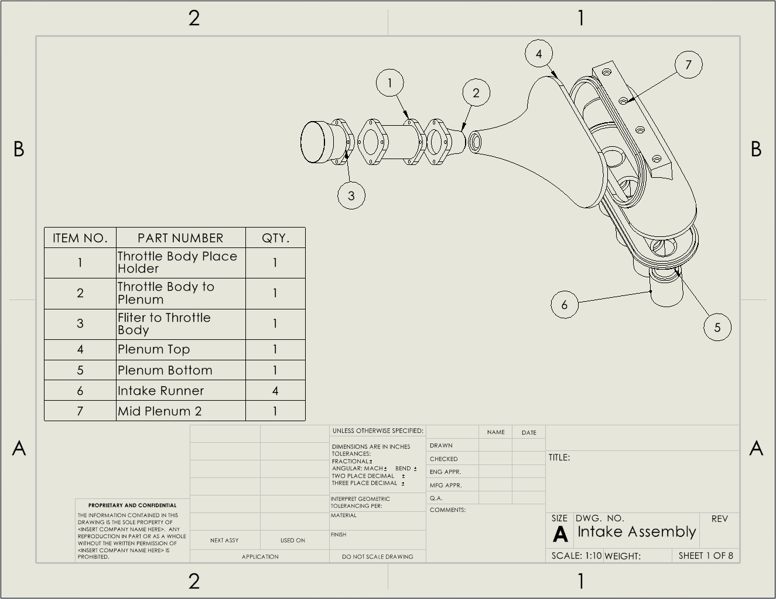Figure 12: CAD Drawing of the Current Intake System

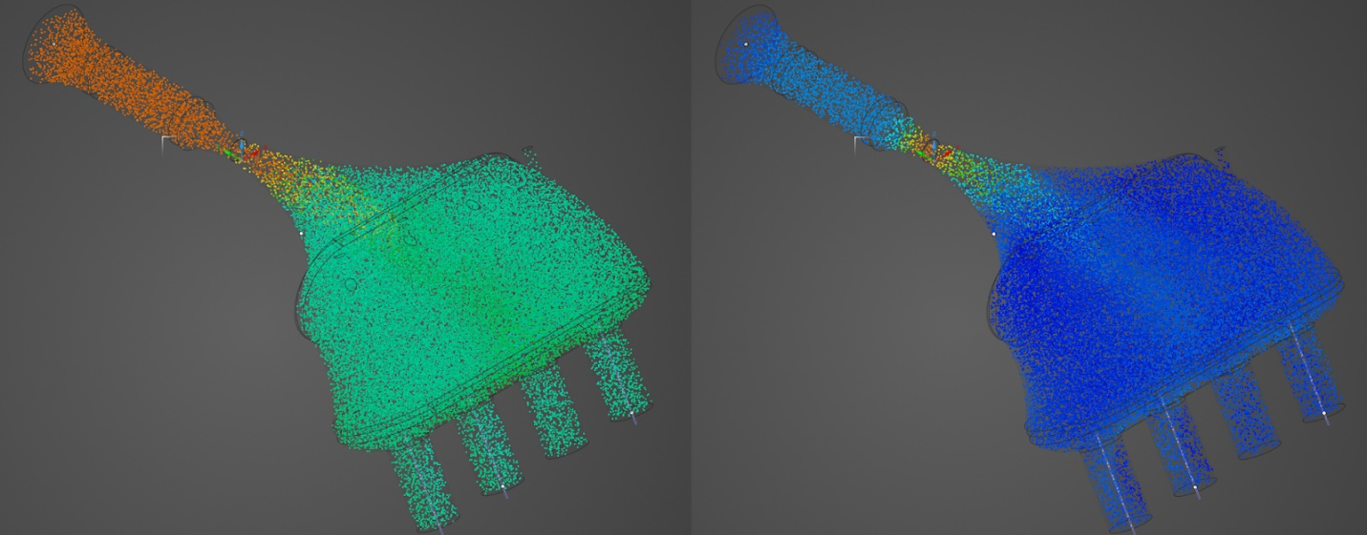Figure 13: ANSYS Simulation of Current Intake System (Left: Pressure | Right: Velocity)

Exhaust Design – Matt Gingold
Table 12: Exhaust Decision Matrix
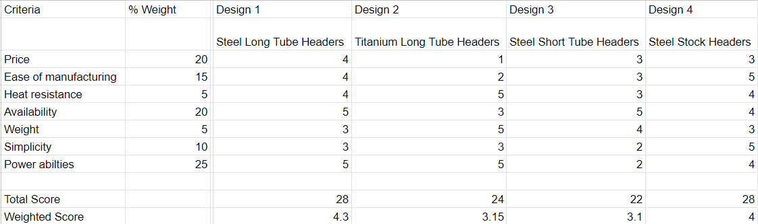
Using this chart, it can be inferred that the best option for our exhaust will be the long tube headers that are made of stainless steel. 304 stainless steel will be selected because it will meet the heat tolerance and strength requirements while being slightly easier to machine as compared to 340 for example. The long tubes, while being more expensive, will provide better power output, especially at higher RPMs, which is crucial to our engine.

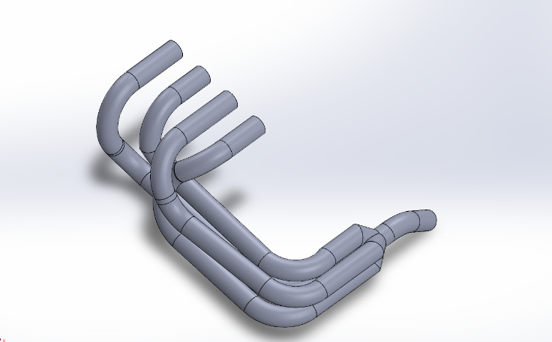
Figure 14: Final Exhaust Design

This is the final layout of the exhaust, and what will be made to go on this year’s car. It will clear all of the tubes for the frame and will provide enough space to put a heat shield between it and the gas tank.

Differential Mounting – Tobin Lanford
Utilizing the existing engine mounts for mounting has two main advantages. The specific mounts that will be used are the rear swing arm mount and the lower rear engine mount. Primarily, these mounts were already designed to support the load of the engine and the associated components of the motorcycle’s power train which will simplify the design of our differential mounts and allow us to save weight that would be necessary for creating additional mounting locations on the frame. Additionally, mounting the differential directly to the engine will help minimize deflection between the rear axle and the engine itself. Thus, increasing our ability to keep the drive chain properly tensioned.
The decision to horizontally limit the adjustability of the differential mounts. Radial adjustments would mean the rear axle is able to be adjusted in an arc round the swing arm mount, so the horizontal and vertical position are intrinsically linked. This could lead to fitment issues between the rear axle and frame of the vehicle. Therefore, horizontally adjustable differential mounts will allow for easy on-the-fly chain tensioning while avoiding interferences.
Aluminum 6061 was chosen as the material for the differential mounts due to its light weight, relatively low cost and easier machinability. This alloy is often used in automotive structural components.
Finally, an adjustable Drexler limited slip differential was chosen over a non-adjustable variant, despite an increase in cost, for the ability to further tune the handling of our vehicle once testing begins.
The horizontal position of the differential is determined by the four jack bolts that pinch the bearing housing. A step feature in the bearing housings keeps them secure between the plates of each differential mount. This feature is visible in Figure 15.

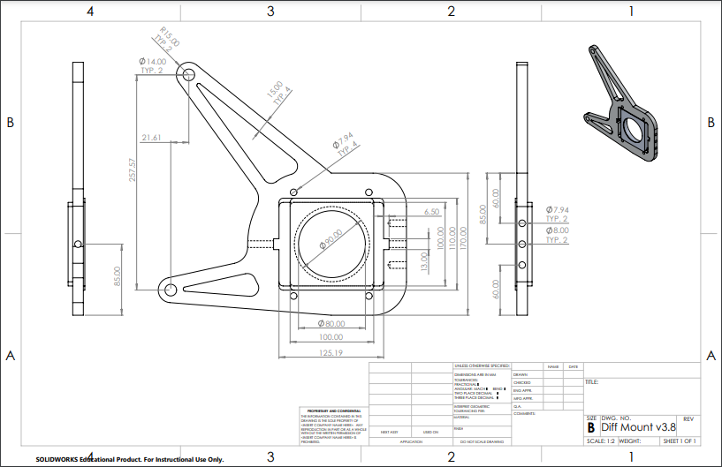
Figure 215: Diff Mount Plate and Bearing Housing

Below is a CAD assembly of the Drexler limited slip differential mounted with a version of the differential plates without the lightweighting cut-outs seen above.

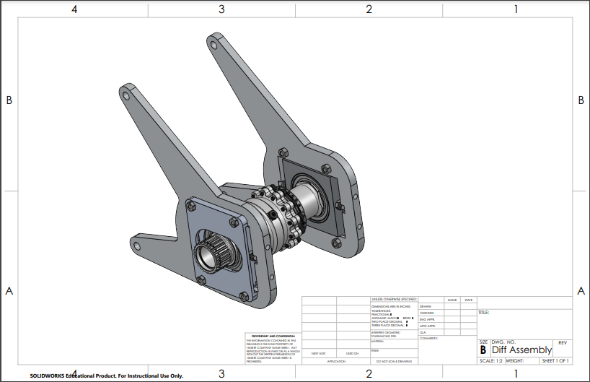
Figure 16: Drexler LSD Package

Engine Selection – Joey LeBlanc
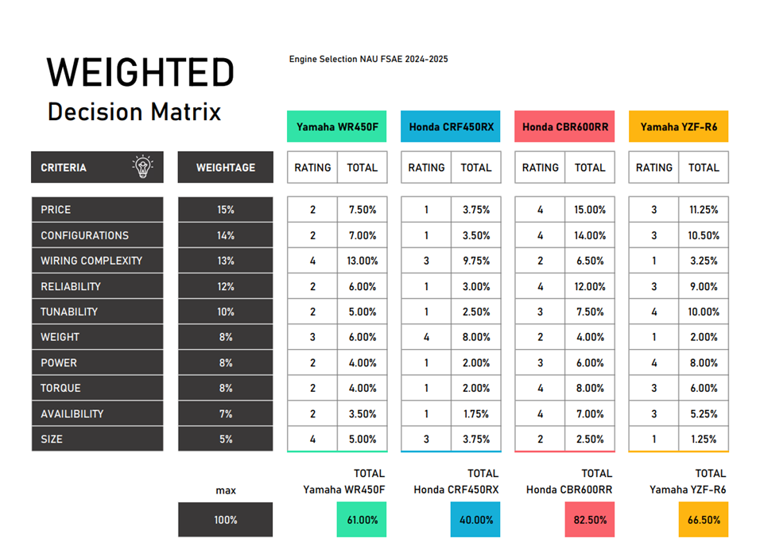
Figure 17: Decision Matrix for Engine Selection

This decision matrix was the team’s final step in deciding which engine would be purchased for the MK2 formula car. The team decided to put price and configurations as the top priorities as these are the biggest challenges when finding an engine to purchase.
Reliability and tunability are also large factors in the engine selection process because of how the first iteration of the NAU FSAE Team performance went at competition.
Power, weight, and torque are rated as less important because the team is a second-year iteration and building a reliable and cheap car is more important than being competitive for the team’s current goals.
Availability and size of the engine are both considered to be the lowest ranking of the constraints because all engines selected here are commonly available and the chassis was designed with a 4-cylinder sport bike engine in mind.
The CBR600RR won by a large margin and then became the team’s engine of choice.

Shifter, Gear, and Chain Selection, Sprocket Mount – Lucille Longhurst
The design process highlighted the importance of evaluating various shifting systems, gear ratios, and chain types to optimize performance for a Formula SAE vehicle. Each component's strengths and weaknesses were carefully analyzed to ensure that the chosen configurations would meet the demands of competitive racing. This comprehensive approach emphasizes the critical balance between performance, reliability, and complexity in engineering design.

In the pursuit of designing an efficient shifting mechanism for the FSAE vehicle, a decision matrix was employed to help facilitate the selection process. It allowed the team to score each option against the identified criteria. The following shifting systems were compared: Electric Paddle Shifters, Pneumatic Paddle Shifters and a Cable Lever Pull system. To effectively compare the options: weight reduction, functionality, cost, ease of manufacturing, durability, user interface, performance, ergonomics, and fast shifting capabilities were considered.

Table 13: Shifting System Decision Matrix
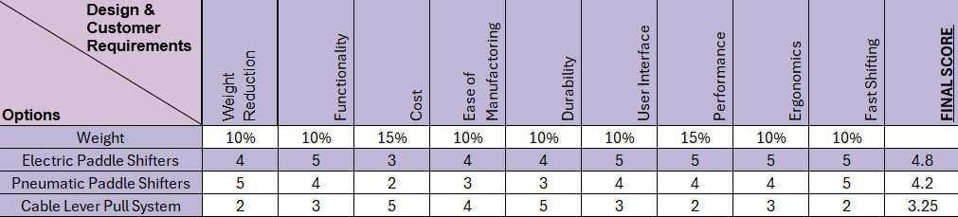
The Electric Paddle Shifters emerged as the most favorable option, achieving a final score of 4.8. The scoring reflects their superior performance across most criteria, particularly in terms of functionality, user interface, and performance, which are essential for achieving competitive acceleration and responsive shifting. In contrast, while Pneumatic Paddle Shifters offered benefits in weight reduction and fast shifting, their higher costs and complexities in manufacturing made them less optimal. The Cable Lever Pull System, despite its ease of manufacturing and lower cost, scored the lowest due to limitations in performance and user experience.
To validate the design choices and simulate the expected performance outcomes regarding the gear ratio and sprocket choices, we conducted extensive simulations using MATLAB which allowed us to model various operating conditions and assess the impact of different gear ratios, and sprocket sizes on overall performance. The simulation results indicated that the final selected configuration would effectively meet the desired acceleration benchmarks and enhances the vehicle’s drivability which includes gear ratio of 3.8, sprocket sizes of 11-tooth front and 42-tooth rear. Moreover, the 520 chain was selected for its balance of weight, strength and flexibility making it ideal for the high-performance demands for our FSAE vehicle. The design allowed for effect power transmission while minimizing weight which is crucial in achieving competitive acceleration and overall efficiency. Additionally, the 520 chain is widely used in motorsports making it compatible with various sprockets for our shifting system.

After completing the mathematical calculations and procuring the necessary supplies, the next step was to build the sprocket mount. The sprocket mount connects the rear sprocket to the differential, transmitting torque from the chain to the differential. It is designed to withstand dynamic forces while maintaining alignment to ensure reliable power delivery. Manufactured from 7075 aluminum alloy, the stock material was pre-equipped with a spline to mate with the differential, providing a robust and lightweight foundation. The sprocket mount design needed to balance structural integrity, weight minimization, and functionality within the assembly. A small flange was incorporated to enhance structural strength, and the mount’s thickness had to accommodate a C-clip to securely hold the assembly in place. Additionally, it needed to provide proper alignment between the front and rear sprockets, support the rear sprocket under dynamic loads, and fit the specified bolt pattern while ensuring adequate clearance around the edges. The initial stock material measured 19 cm in diameter and 5 cm in width—significantly oversized for the application. To meet the design requirements, the stock was machined down to achieve the necessary dimensions. The final design maintained sufficient thickness to securely support the rear sprocket while minimizing weight to optimize performance without compromising strength. Based on these criteria and calculations, the final design was completed. The CAD model of the sprocket mount is shown below.

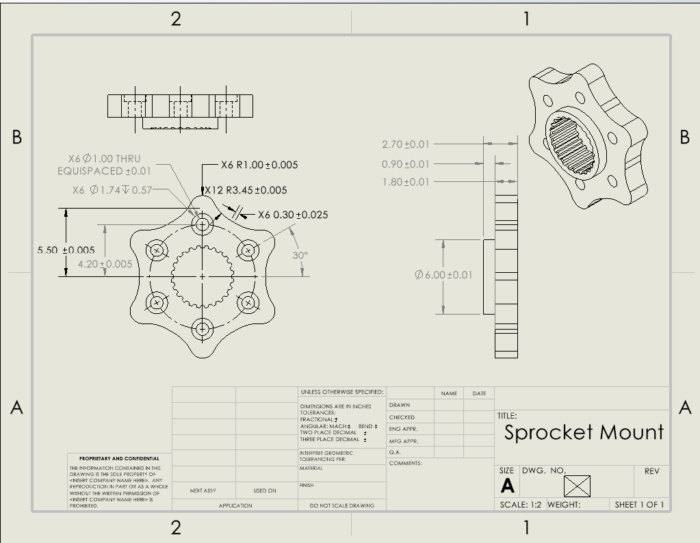
Figure 18: Sprocket Mount

Through careful evaluation of shifting systems, gear ratios, sprocket configurations, and chain selection, the team arrived at a well-balanced solution that meets the vehicle's acceleration and drivability requirements. The selection of Electric Paddle Shifters, along with the gear ratio of 3.8, 11-tooth front sprocket, and 42-tooth rear sprocket, ensured efficient power transmission, fast shifting, and competitive performance. The sprocket mount, designed using 7075 aluminum alloy and incorporating features for structural integrity and weight minimization, further enhanced the drivetrain’s efficiency. Ultimately, the design successfully combined cutting-edge engineering principles with practical considerations, resulting in a robust and high-performance drivetrain system for the Formula SAE vehicle.

Schedule and Budget

Schedule
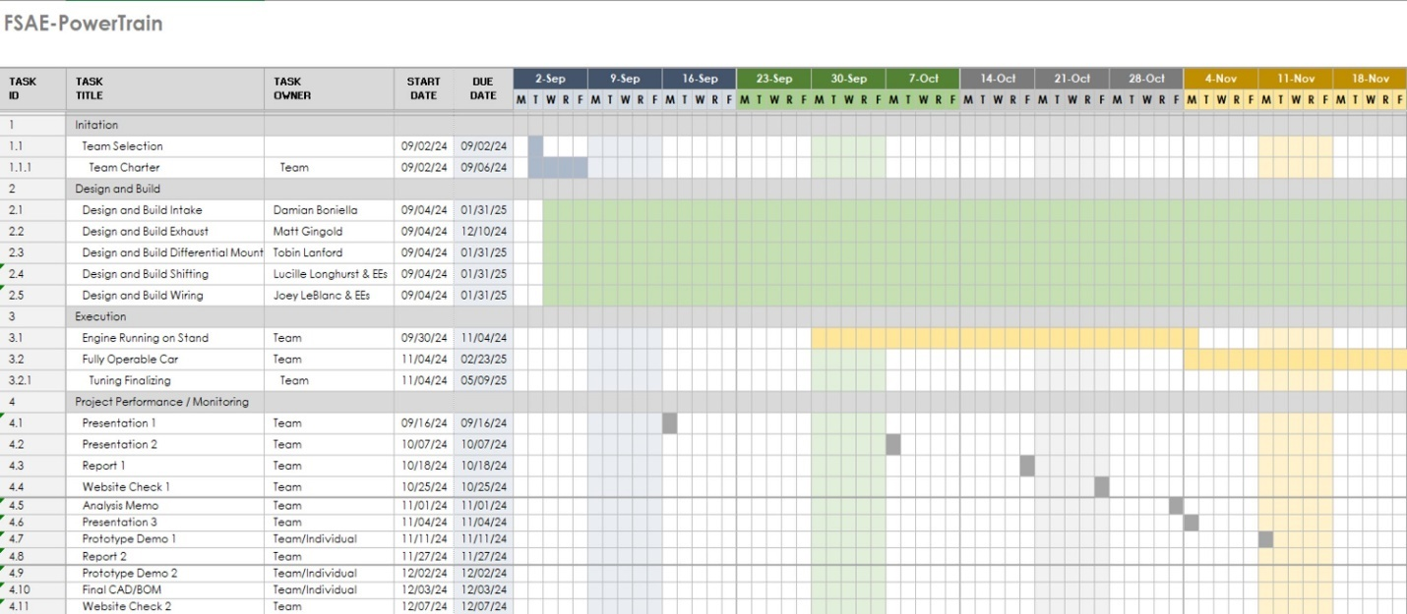
Figure 19: First Semester Schedule
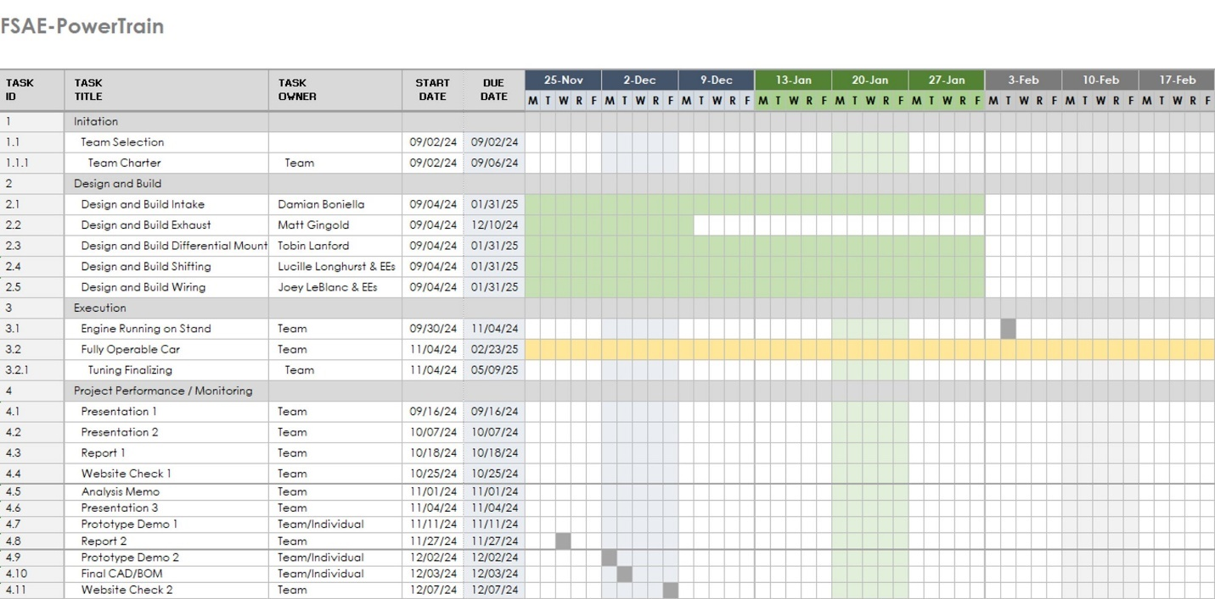
Figure 20: First Semester Schedule (Continued)
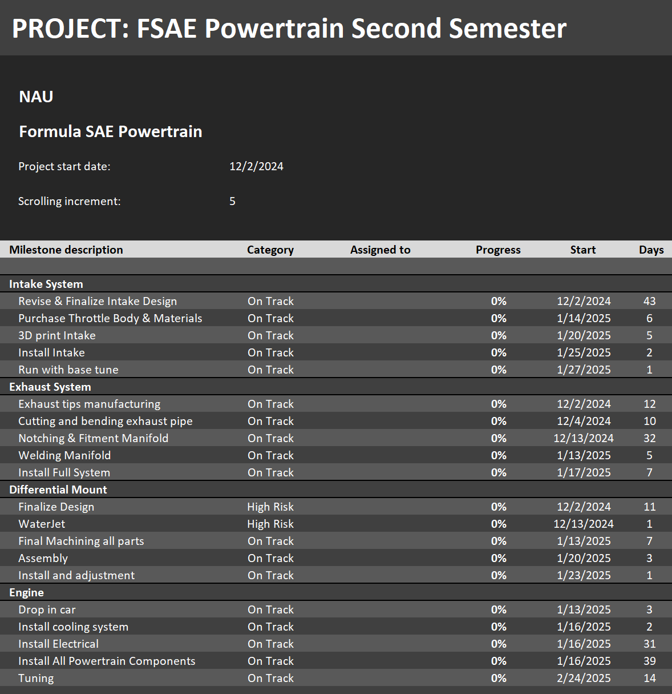
Figure 21: Second Semester Gantt Chart

Budget
Table 124: FSAE Budget Table

Bill of Materials (BoM)

Shown in Table 15 is the most current estimate of Powertrains' total budget, this budget is at this point still an estimate. The budget has increased from its previous estimate because the team has decided to purchase axles rather than attempt to design them. The budget potentially can be decreased by tuning the engine in house or getting time donated on a dynamometer at a shop. The exhaust system may also be cheaper than anticipated as we will be welding it in house and several parts will be produced from raw stock.
Table 35: FSAE Powertrain BOM
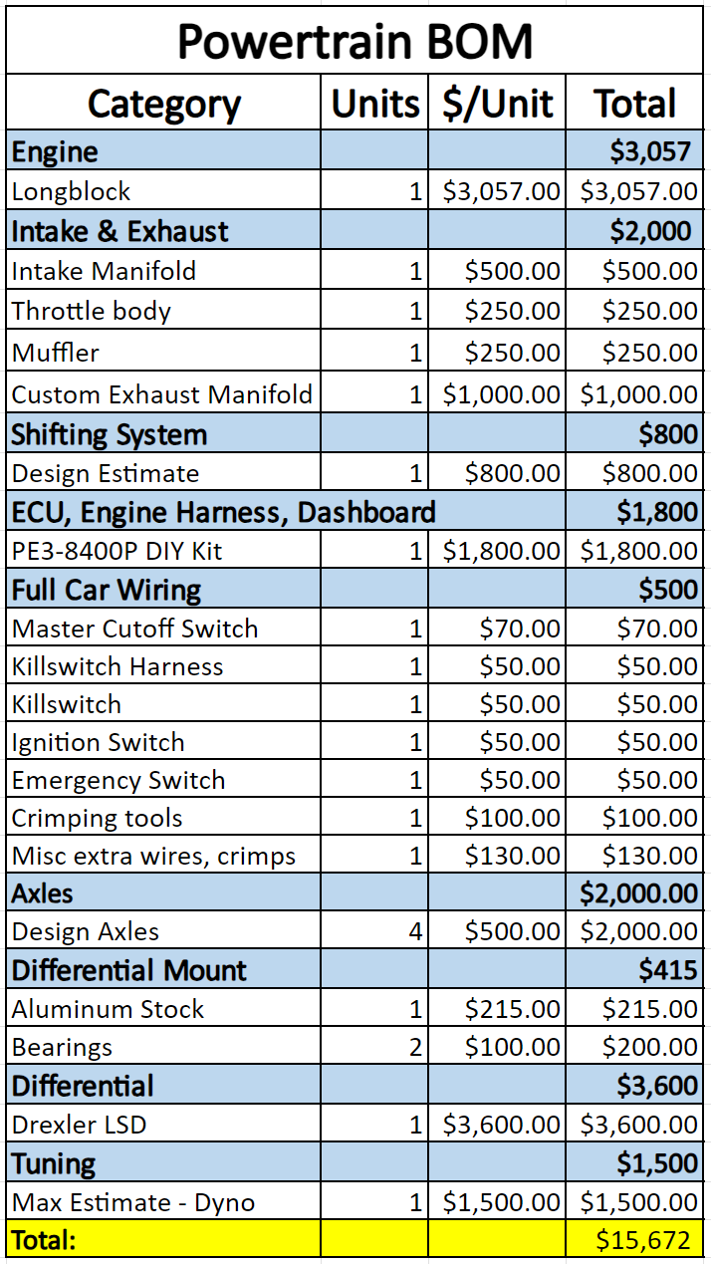
This is Powertrains’ current spending to date. Most of the parts have been purchased which sets the team up to start implementing their designs into the frame once it is built. Purchasing will continue once the current design iterations have been built.
Table 46: All FSAE Powertrain Purchases
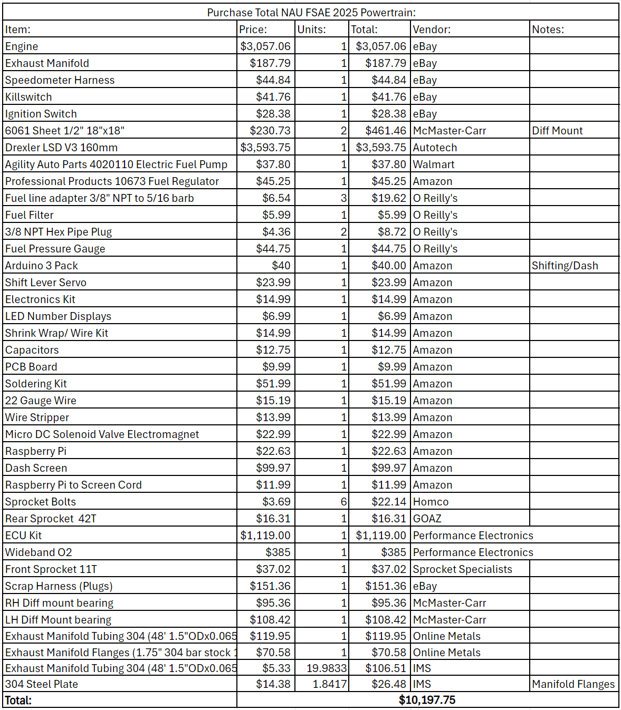

Design Validation and Initial Prototyping

Failure Modes and Effects Analysis (FMEA)

Intake – Damian Boniella
Table 57: Failure Scenarios and Prevention for the Intake
Possible Failures | Effects | Prevention
Intake melting due to engine temperatures | Air coming in from places it was not supposed to, and melted plastic entering the combustion chambers | Use high grade plastic for printing that will be able to handle the extreme temperatures
Intake cracking when under extreme load | Air coming in from places it was not supposed to, and broken plastic entering combustion chambers | Make use of frame for extra supports to prevent relying on a cantilever support system

Exhaust – Matt Gingold
Table 68: Failure Scenarios and Prevention for the Exhaust
Possible Failures | Effects | Prevention
Too high of temperatures going through the exhaust | Warping or splitting of pipe | Use stainless steel for its high heat capabilities
Design does not fit within provided space | Cannot fit exhaust and must redesign it/modify pipe | Use CAD in order to space everything out and give extra space just in case things do not line up perfectly during the building stage
High heat from exhaust interfering with gas tank | Explosion from a gas tank catching on fire | Give ample space and shielding between the exhaust tubes and gas tank

Differential Mount – Tobin Lanford
Table 79: Failure Scenarios and Prevention for the Differential Mount
Possible Failures | Effects | Prevention
Stripping of jack nuts and/or bolts | Loss of chain tension adjustability | Selected high strength steel bolts
Excessive deformation in mounting brackets | Misalignment and possible damage to Drexler LSD | FEA to determine deformation and factor of safety against expected loading scenarios
Overheating bearings | Premature wear on bearings and increased friction | Selected bearings with improved heat dissipation and high rpm ratings

Engine – Joey LeBlanc
Table 80: Failure Scenarios and Prevention for the Engine
Possible Failures | Effects | Prevention
Engine Overheats | Loss of power and destruction within the motor | Make sure cooling system can provide plenty of cooling power for the motor at extreme situations
Radiator gets damaged | Loss of coolant resulting in engine temps rising to critical levels | Protect the radiator using a metal cage and plastic side skirts
Poorly tuned motor | Poor performance and possibly pre-detonation resulting in engine damage | Use a professional tuner within the Phoenix area to make sure the tune is optimized

Sprocket Mount – Lucille Longhurst
Table29: Failure Scenarios and Prevention for the Sprocket Mount
Possible Failures | Effects | Prevention
Bolts shearing | Loss of connection between engine and driveshaft | Using high grade bolts that can manage the loads
Sprocket mount breaking/deforming | Improper balance which can cause vibrations or loss of connection between engine and driveshaft | Using 7075 T6 Aluminum which is plenty capable of handling the stresses that can be caused upon it
Improper balance in part after machining | Can cause vibrations that can rattle bolts loose or cause the part to fail quickly due to fatigue | Minimize imbalances in the design and keep them within acceptable levels for our operating speeds

Overview
It is extremely important to make an FMEA chart when building something such as a racing car. There are so many moving parts that must be accounted for, otherwise the car could fail, or worse, someone could get hurt or die. These smaller charts do a great job at quickly listing the possible failures of some parts relating to the drivetrain, yet they will be further explored during prototyping and will be further discussed in that section. If any of these parts fail during a race, then the car will be taken out of the race with no chance of winning. This is why everything must be slightly overbuilt to make sure that nothing will cause us to have to leave Michigan with a broken car. Preparing these lists helps to make sure that all of the parts will survive some scenarios, yet it is even more important to have some prototyping done in order to work out more unforeseen issues.

Initial Prototyping

Intake – Damian Boniella
Upper Intake Plenum Designs:
Question: What top plenum design/shape allows for the most equal airflow to the intake runners?

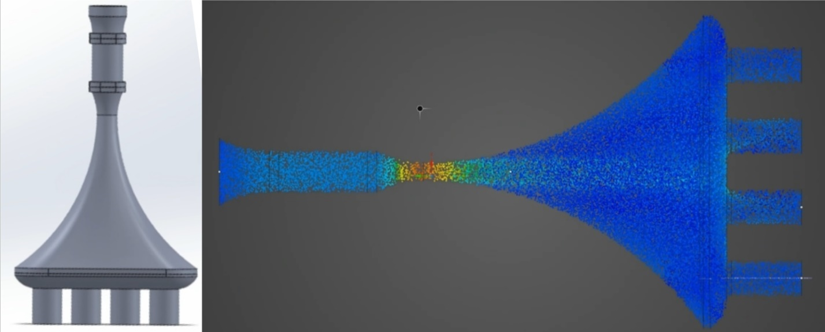Figure 22: Top Plenum Design 1 (Left: CAD Model | Right: Velocity Simulation)

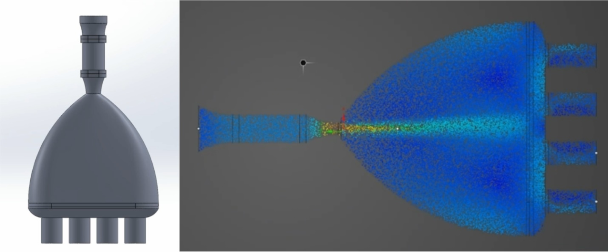Figure 23: Top Plenum Design 2 (Left: CAD Model | Right: Velocity Simulation)

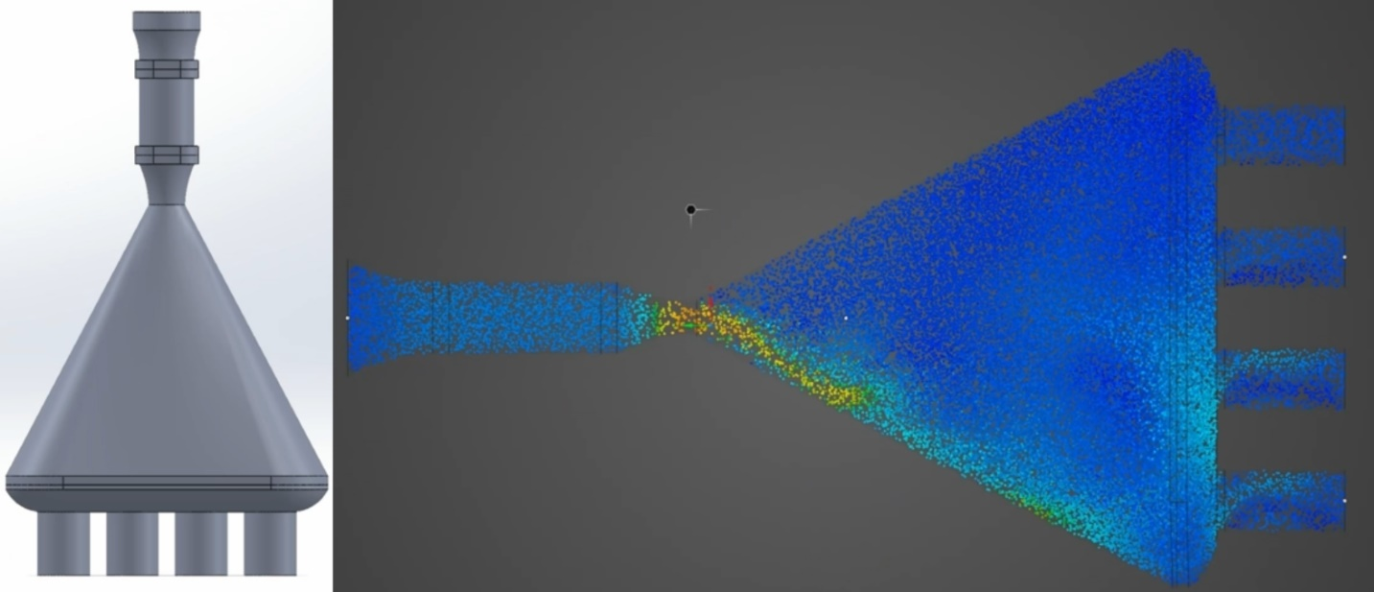Figure 24: Top Plenum Design 3 (Left: CAD Model | Right: Velocity Simulation)

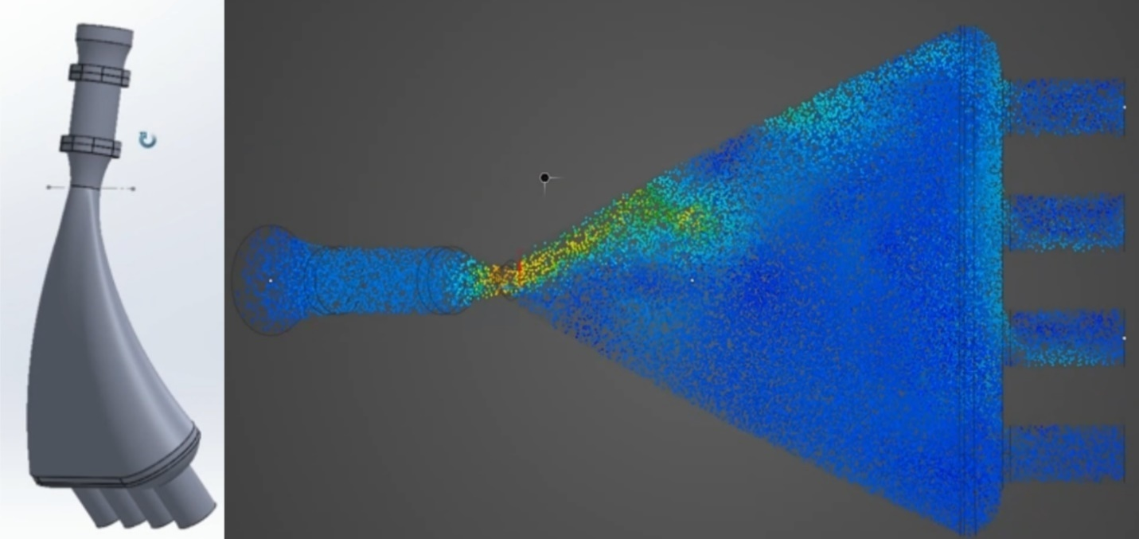Figure 25: Top Plenum Design 4 (Left: CAD Model | Right: Velocity Simulation)

Answer: Design 1 had the most equal airflow to the intake runners; however, it still experienced some turbulence. Design 2 experienced lots of turbulence within the top plenum itself and in the intake runners. Design 3 and Design 4 acted similarly though Design 4 had a curved top plenum design, so it can be assumed that curved and straight designs will work similarly, but the curved design allows for more fuel rail placement options.
Future Plans: With this information, the plan moving forward is to use Design 1, changing height and curve characteristics to improve equal airflow to the intake runners and improve fuel rail placement options.
3D Printed Upper Intake Components:
Question: How do the current upper intake components fit with the existing air filter, and are redesigns/hardware modifications needed to fit upper intake components together?

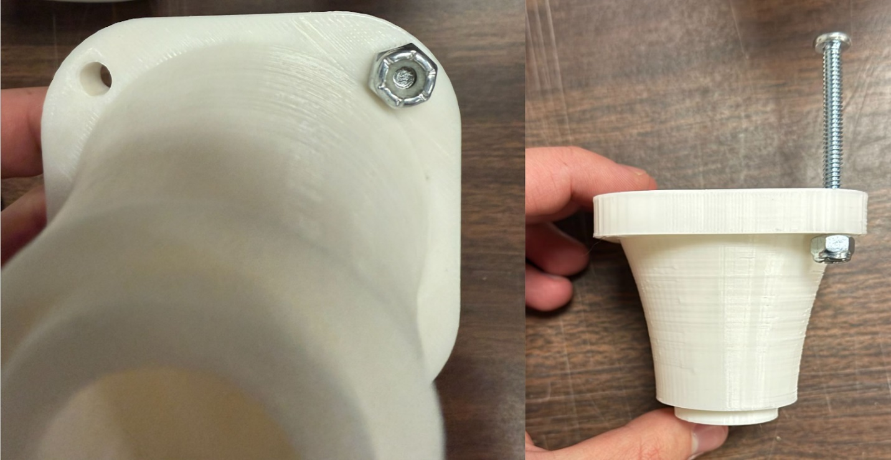Figure 26: Throttle Body to Filter Funnel with Hardware

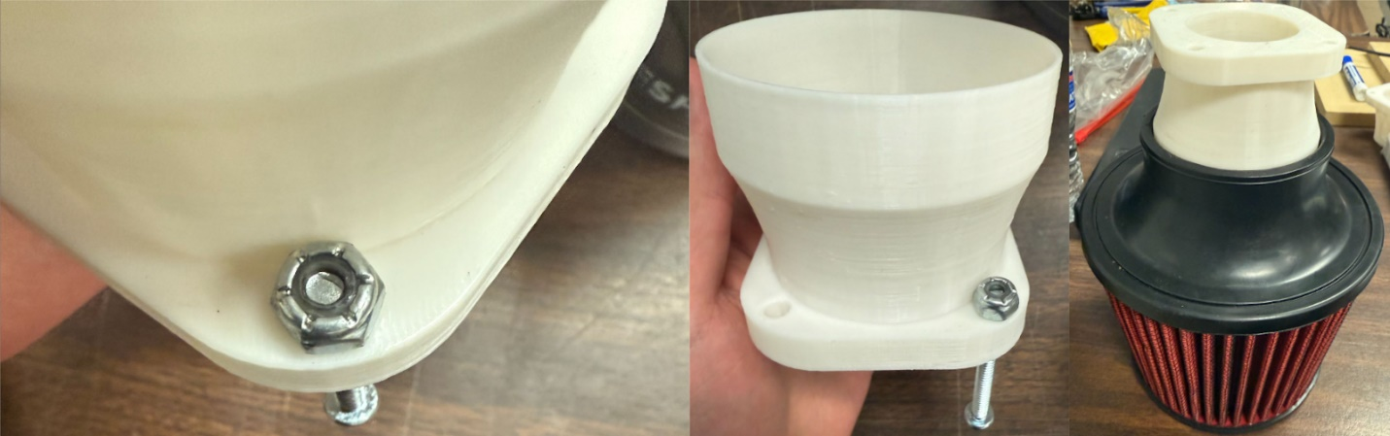Figure 27: Filter to Throttle Body Funnel with Hardware and Air Filter

Answer: The hardware was able to fit with both parts, however, the hardware is not omnidirectional, so an order must be followed to place the hardware correctly. The filter funnel slips and can fall into the filter due to the outer diameter being too small.
Future Plans: With this information, the plan moving forward is to increase the outer diameter of the filter funnel by about 0.5mm-1mm to decrease the slippage of the filter, this will also be paired hose clamp. The hardware will be appropriate for the application; however, the bolts will need to be cut to not run into the parts themselves, possibly fixing the non-omnidirectional problem.

Question: Will the intake melt or deform when experiencing high engine temperatures?
Answer: High melting point 3D filaments can be used to prevent the intake for melting due to high engine temperatures. Ducting can also be used to create air flows over the engine compartment to reduce temperatures in and around the intake system.

Question: How will the intake be supported to not cause it to break when experiencing higher G forces like cornering or hitting bumps?
Answer: The intake will be supported by using bracing points within the intake system that will connect it to the frame of the vehicle. However, the intake system will not be completely fixed to the frame or engine. All bracing points will use a flexible rubber/foam part that will allow the engine and frame to flex independently without adding extra stress to the intake system.

Exhaust – Matt Gingold
Question: How will you prevent the exhaust from overheating during normal and extreme operation?

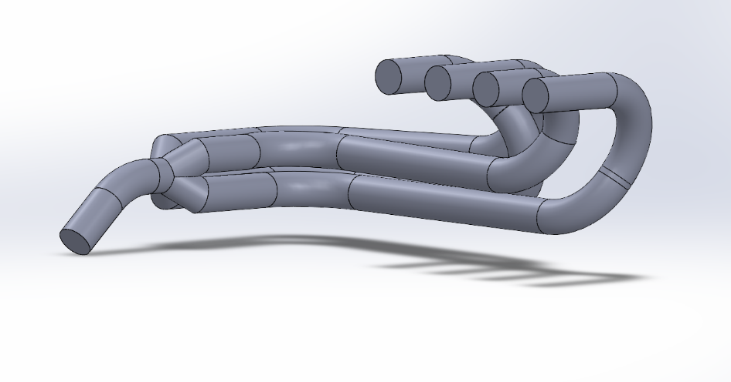
Figure 28: CAD Model of the Exhaust

Answer: The material will be stainless steel, which according to research and testing, will be able to withstand the extremely high temperature gases that are exiting the engine. It was also cheaper than titanium by a large margin, which saved a ton of cost.

Question: How is this design going to fit in the tight space that it is restricted to?

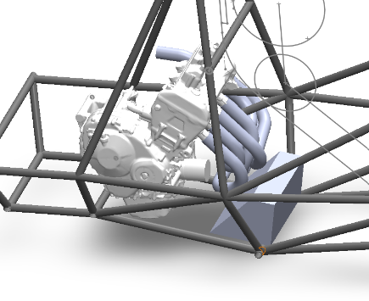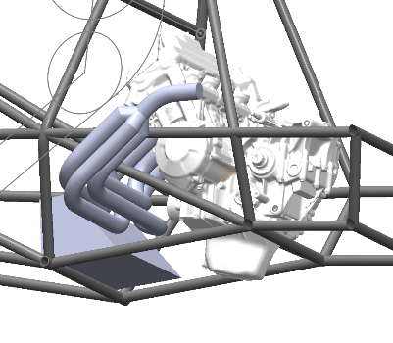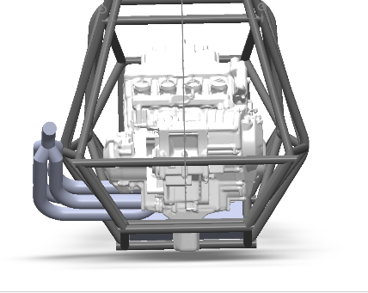
Figure 29: Engine and Exhaust in the Frame

Answer: Here is the CAD file that was made in order to make sure that the design fits within our requirements. Everything is also pushed to its limits to make sure there was plenty of extra space if needed. The engine is pushed as far forward as possible, and the oil filter on it is oversized to make sure it is removeable. The gas tank is also as close as possible to the engine to give space for a heat shield, yet it is very extreme due to the fact that the heat shield will be much further back in the car.

Question: How are you going to prevent the extremely hot exhaust from possibly igniting gas within the fuel tank?

Answer: This will be done using space and a heat shield. The exhaust will get wrapped in heat tape to help mitigate the heat it puts off. It will also have much more space than in the CAD file because after talking to the guy designing the heat shield, there will be much more space than I gave myself. We will also most likely install a smaller heat shield between the exhaust and gas tank in order to make sure that it stays cool during operation. All of this tied with the fact that the gas tank will be completely sealed should prevent any fires from starting between the 2.

Differential Mount – Tobin Lanford
The initial differential mount prototype was manufactured in the NAU Idea Lab and designed by Tobin Lanford and Joseph Leblanc. This prototype can be seen below with the sprocket side bearing placed in the bearing housing.

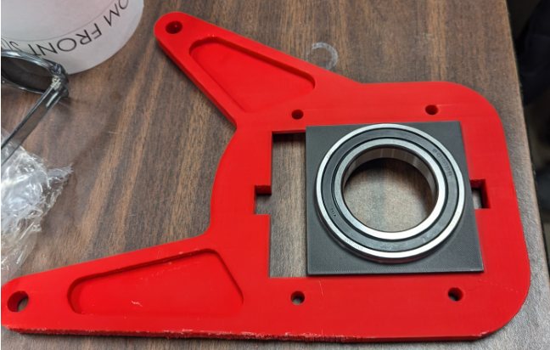
Figure 303: Differential Mount with Bearing and Bearing Housing

The differential mount prototype was produced primarily to determine if the mounting bolt holes are properly sized and located to mount to our CBR600RR engine.

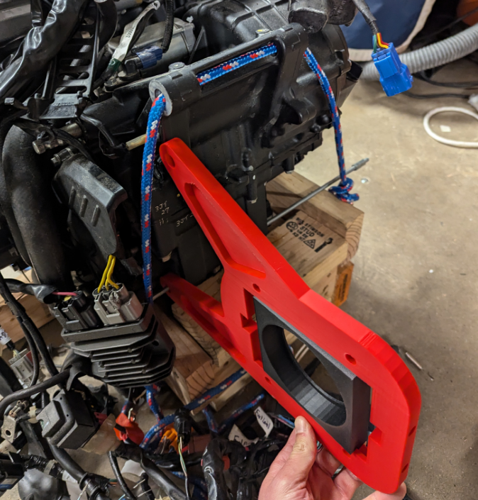
Figure 31: Testing Fitment between Differential Mount and Engine

Unfortunately, as seen above, the bolt holes were initially placed incorrectly, and these bolt holes have since been relocated in the recent design iterations. A second prototype is being produced, this time from a cheaper material, to test the fitment of these new bolt hole locations.
Secondarily, the prototype was used to test the fitment of the components on the sprocket side of the differential assembly, which can be seen in the next image. Fitment of these components is satisfactory based on the tolerances achievable with 3D printed parts. However, we know the tolerances on these parts will need to be specified before the machining can begin.
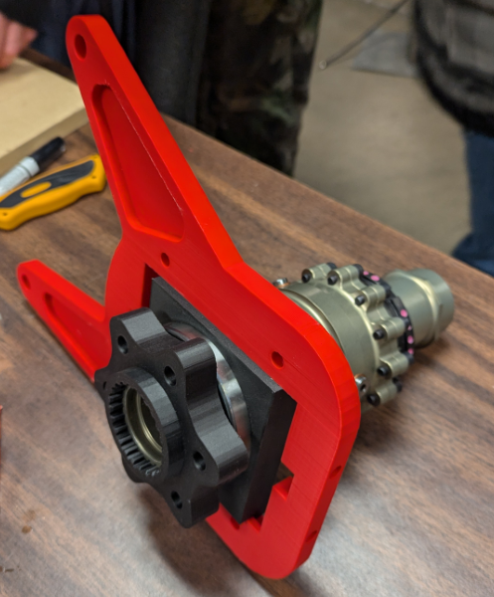
Figure 32: Partial Differential Prototype Assembly

There are several critical components of this assembly, some of which are not included in this initial prototype assembly. The differential mounting plate itself will need to be strong enough to withstand the extreme loading scenarios that will occur during vehicle operation. FEA using ANSYS will be performed to ensure the plate has been adequately designed. The jack bolts that will secure the bearing housing in the mounting plate also must be able to withstand significant compressive forces from the bearing housing. High Strength steel bolts have been tentatively selected for these components but further analysis of the strength of the bolt’s thread will provide more security in this design. The bearings are also critical components to allow the differential to rotate freely when power is applied through the drive chain. These bearings have been selected using an extremely high design life so that they will continue operating properly throughout extensive testing and competition. Additionally, the maximum rated bearing RPM is significantly higher than the speeds the bearings will see in use.

Engine – Joey LeBlanc
Question: How would you prevent the engine from overheating during testing or racing?
Answer: To prevent the engine from overheating or having a failure during testing or racing the team plans to have the ecu monitor engine temperature and output wirelessly to a phone to display real time data. If the engine exceeds the maximum operating temperature determined by the team it will be shut off until it cools.
Question: How are you planning on protecting the radiator from damage from stuff like rocks when the car is driving around?
Answer: The radiator will have a plastic or carbon fiber side skirt which will prevent debris from hitting it. In addition to this it will have metal mounts which will act as a cage to prevent hazardous material from damaging it while driving.
Question: How are you planning on getting the motor tuned so we can make optimal power while not sacrificing the engine in the process?
Answer: The team plans to seek the advice of Professional Tuners in the greater phoenix area as well as experts at Performance Electronics, so engine failure does not result from tuning the build. There are also safeguard programs that will be built into the ECU and its programming which will shut the engine off under highly undesirable conditions and will blow the ECU instead of the engine in case of a massive failure.

Sprocket Mount – Lucille Longhurst
The goal of the prototype was to create a sprocket mount that would seamlessly integrate with the rear sprocket and fit onto the differential without interfering with the engine. The prototype, designed by Lucille Longhurst and 3D printed at the NAU IDEA Lab, was intended to achieve this goal. However, we overlooked the inclusion of a bearing in the design, which led to the need to purchase socket head bolts to address the issue. Despite the bolt sizing error, the overall fit of the mount was successful, and all parts aligned correctly. Based on this feedback, the CAD design has been updated and adjusted accordingly.

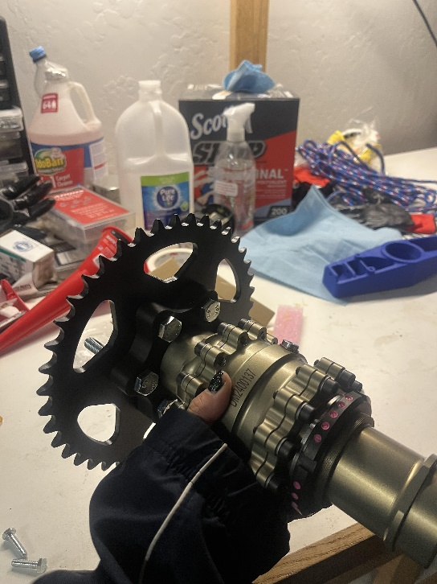
Figure 33: Sprocket Mount Prototype

Question: How are you preventing the bolts that connect the mount to the sprocket from shearing under heavy loads?
Answer: The bolts are made of steel which has a high tensile and shear strength to resist dynamic and heavy loads during operation. The bolts are preloaded as well to reduce dynamic loading. It ensures that shear sources are transferred as friction between the mount and sprocket rather than directly through the bolts.
Question: How did you prevent the sprocket mount from deforming, which could lead to imbalances, loss of chain tension, or complete failure?
Answer: The mount is made from 7075 T6 Aluminum which has a high yield strength and resists deformation under operational loads. Additionally, FEA simulations were performed during the design phase to identify and mitigate weak points in the mount’s geometry.
Question: How are you planning on keeping the parts perfectly balanced, so they do not rattle themselves apart? Does it need to be perfectly balanced to accomplish that?
Answer: The mount is designed with tight tolerances to minimize imbalances. Small slight imbalances can be tolerated within acceptable limits for the operating speed and vibration of the vehicle. Also bolts and washers are of uniform weight and evenly torqued to prevent asymmetric forces during rotation.

Other Engineering Calculations

Intake – Damian Boniella
Using research done by Hamilton et al [DB14], the team desires a plenum volume that is roughly two times the engine displacement. From the research, this will result in a power increase of 1.3 horsepower and a torque increase of 2-3 Newton meters in the low RPM range (1300-7000 rpm).
Engine Displacement = (π/4) x Bore^2 x Stroke x Number of Cylinders
Bore relates to the diameter of the piston, whereas stroke refers to the distance that the piston travels. The number of cylinders is based on the engine, which in our case is four, resulting in an engine displacement of 599 CC.
Volume = Area x Height
The volume equation applies to the intake system, but interest is placed on the volume that air can occupy within the plenum. Using the engine displacement from the above equation and the research by Hamilton et al, the team desires a plenum volume of 1.2 liters.

Using ANSYS to model the air flow in the intake with parameters: Inlet Pressure: 101325 pa, Fluid Used: Air, Outlet Mass Flow Rate: 0.07139 Kg/s. The current CAD model and simulation results can be seen in the figures below.

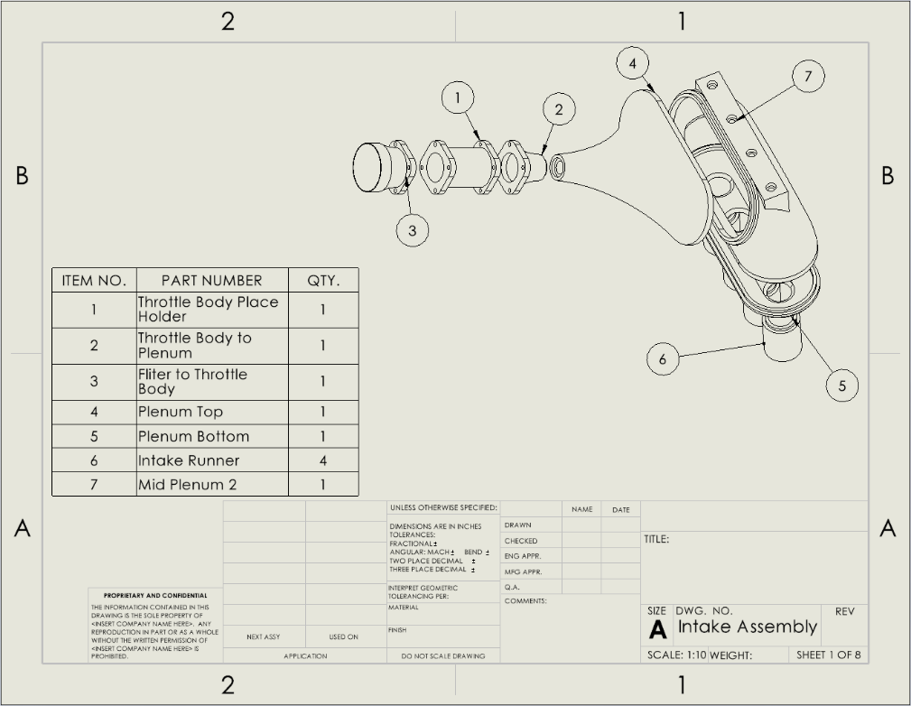
Figure 34: CAD Drawing of the Current Intake System

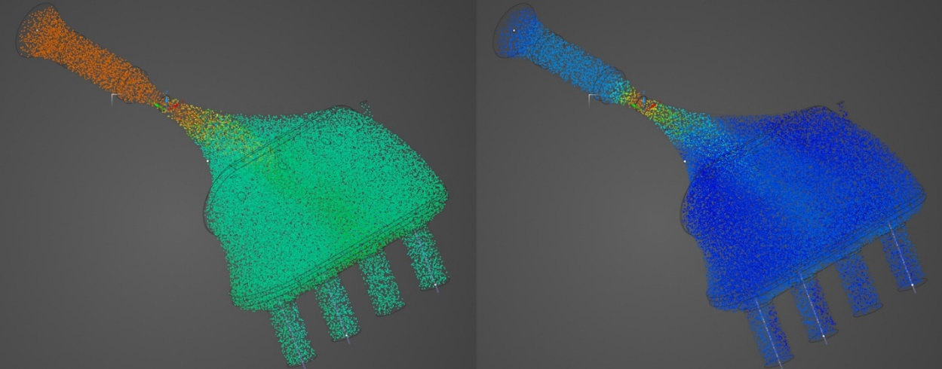
Figure 35: ANSYS Simulation of Current Intake System (Left: Pressure | Right: Velocity)

From the simulation on the current design, turbulence within the intake runners is small with all runners seeing equal velocities within them. However, there is some stagnant air toward the front of the runners, which can be decreased with more design modifications. The overall pressure within the mid plenum for the current design was 9.47e4 pa, which is a pressure drop of 6.3e3 pa from the ambient pressure at the inlet.

Exhaust – Matt Gingold
After doing all the original calculations, I designed the exhaust that would be able to be manufactured while also having smooth airflow to decrease turbulence. With that, I made sure the material could withstand the temperature of the exhaust which stainless steel does. I then calculated the length of each runner of the exhaust to make sure they were roughly equal.
Runner 1: ~ 860mm
Runner 2: ~ 830mm
Runner 3: ~ 790mm
Runner 4: ~ 860mm
Once these were all close to each other and everything was good, we ordered the materials we needed, and we are currently in the process of creating those parts.

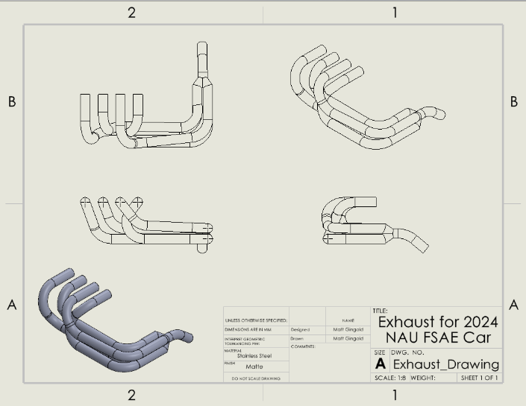
Figure 36: Drawing of Exhaust Manifold

This is the final design for the exhaust and allows us to determine what needs to be done in order to actually make this part. The other part we are making is the exhaust tips that mount up to the exhaust ports. Those can be seen in this drawing:

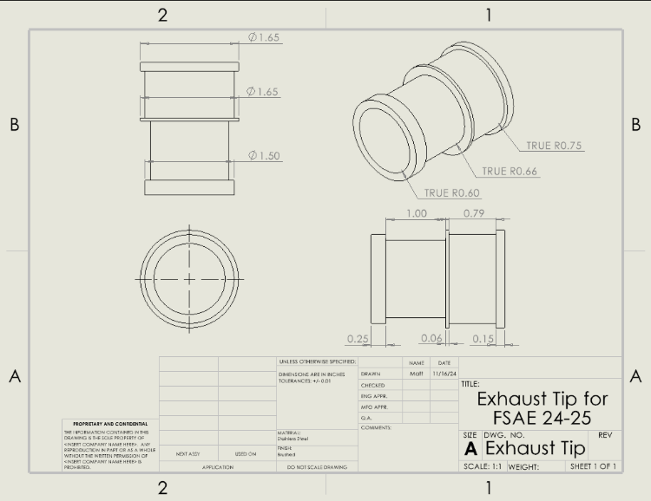
Figure 37: Exhaust Tip Drawing

While we only have the pipe in the machine shop and we have not begun bending them, these are currently being built. There are 4 of them, one for each cylinder, that are all being machined down from some bar stock. This is turning out to be quite a lengthy process, yet they should all hopefully be done by the end of the fall 2024 semester. While I was waiting for the pipe to come in, I also had the ability to learn more about Ansys testing, and what it could do. Here is a simulation I was able to make within the software:

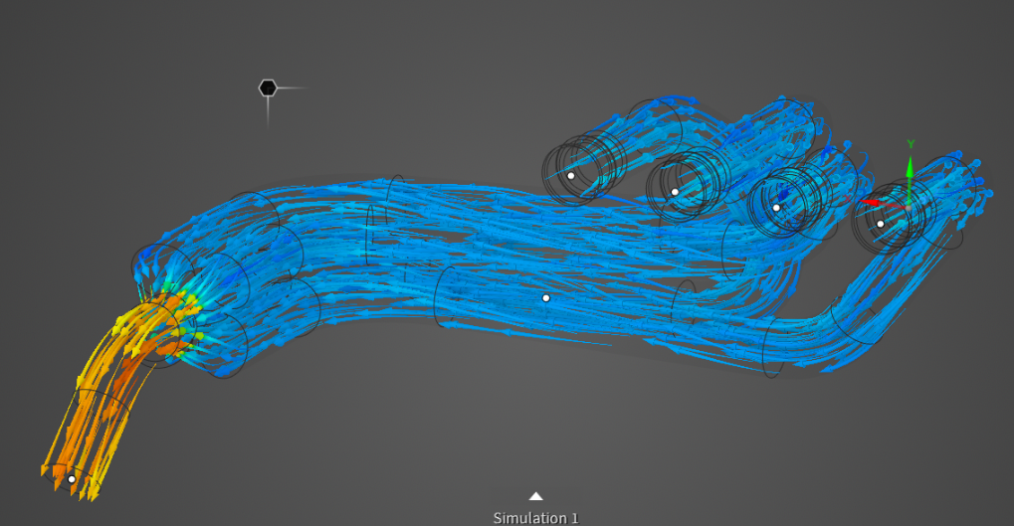
Figure 38: Exhaust Gas flow Simulation

This allowed me to make sure that all of my joints were allowing smooth and laminar air flow through the pipes to help make power. It did show me that my link between all of the pipes was rather short and caused some turbulence. This can now be remedied by increasing the length of that section and smoothing out those pipes some more to make sure that it does not act as a choke point.

Differential Mount – Tobin Lanford
Finite element analysis of the sprocket side differential mount was conducted using ANSYS Mechanical to determine if the mount design and material selection will withstand the maximum expected loads transferred from the engine through the drive chain. The following images depict the mesh generated by ANSYS, the static loading setup, and the results of the study. The moment applied to the bearing housing represents the maximum possible torque of a stock CBR600RR mated to our custom final drive ratio.

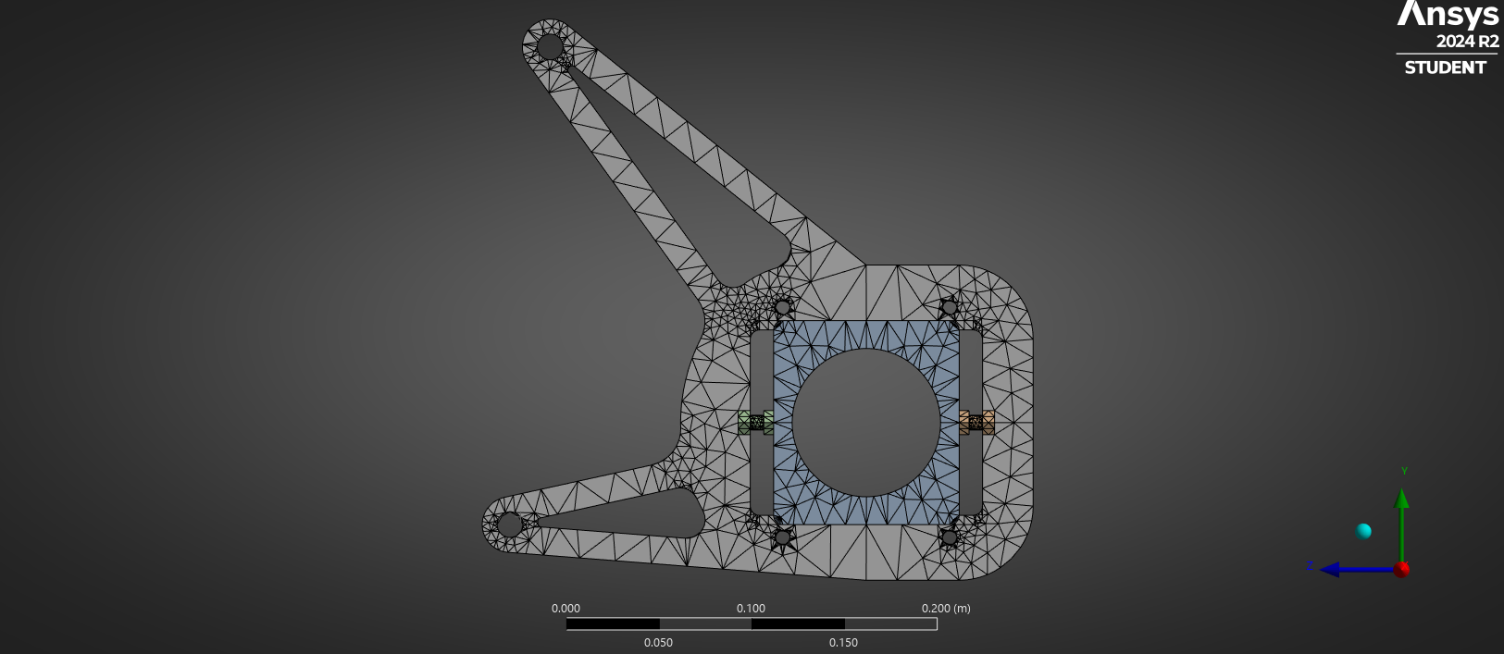
Figure 394: Differential mount mesh

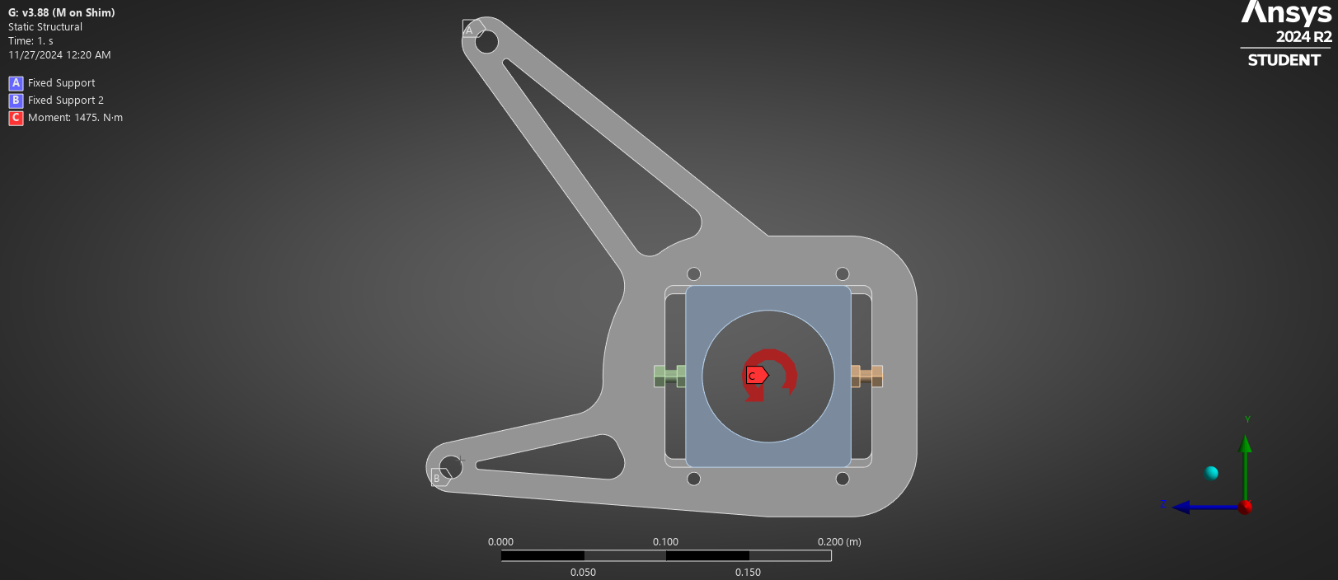
Figure 40: Static Load and Fixed Supports Applied to the Differential Mount
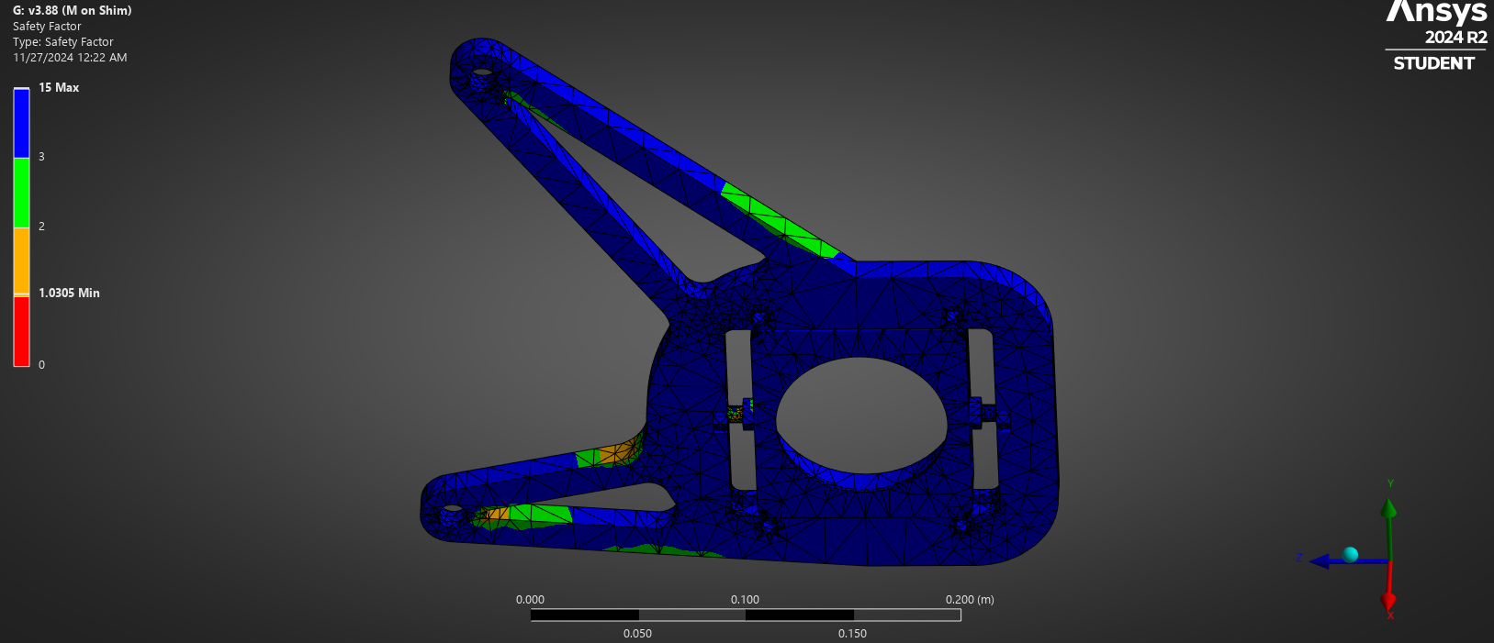
Figure 41: Fatigue Stress FOS Results

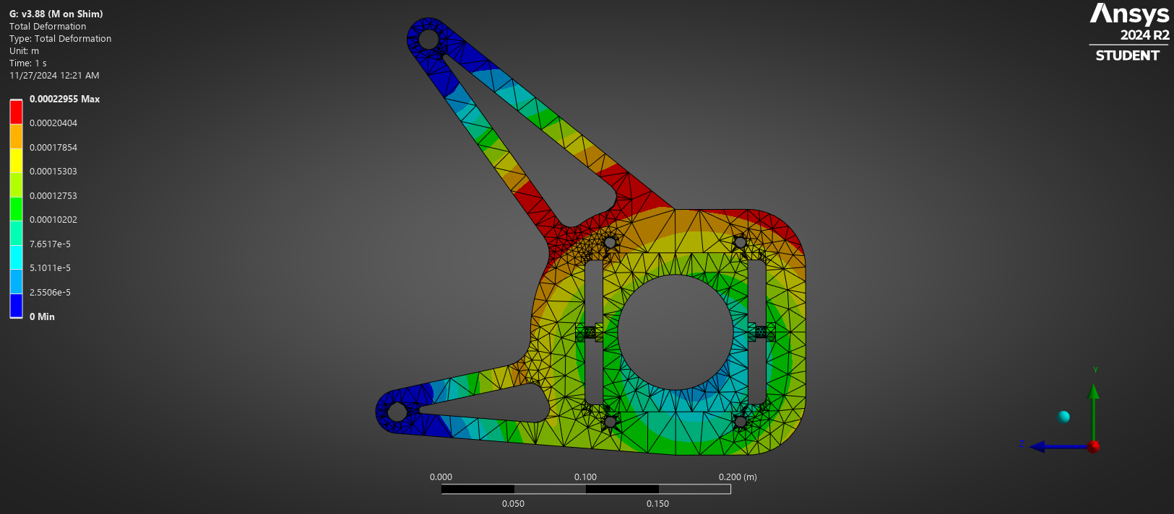
Figure 42: Deformation Results

The minimum factor of safety seen in fatigue stress results is just over 1.0. However, this minimum occurs on the jack bolt in compression and is not currently modeled with the proper material properties. In the future this model will be revised to better understand how the jack bolts will behave under loading. The actual minimum FOS on the differential mount itself is greater than 1.5, therefore this plate design is adequate. Additionally, the deformation that occurs in the mounting plate is negligible and will not hinder the operation of the differential.

An additional static structural analysis was conducted that includes all structural components of the differential assembly in order to better understand its durability. Due to the more complex geometry of this model, some mesh refinement was required to achieve high quality results. As expected, the factor of safety for the whole structural assembly was greater than that of an individual mounting plate, as seen in the figure below.
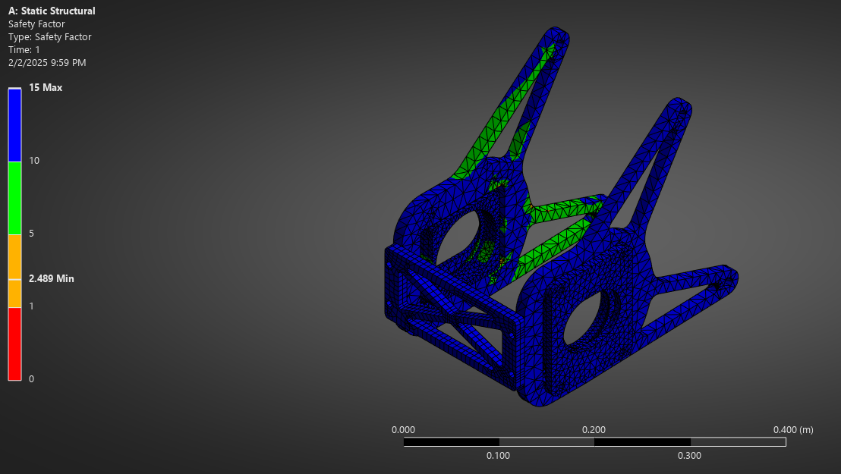
Figure 43: Full Differential Assembly FOS

Sprocket Mount – Lucille Longhurst
A finite element analysis was conducted on the sprocket mount utilizing static structural analysis. The area of concern was the bolt holes. Within the FEA, targets and contact surfaces were identified on the bolt holes and pretension loads were added of 20 kN. The transmitted torque of 5000 Nm was added to the center of mount. Finally, the chain tension force was uploaded and was added radially as a remote force on six different points around the mount. A dynamic analysis was done by adding a variation of forces over time shown in Table 22.

Table 22: Dynamic Forces over Time
Time (seconds) | Forces (Newtons)
0 | 0
1 | 333
2 | 500
4 | 416
6 | 500
8 | 250
10 | 0

Ultimately, the factor of safety exceeded the acceptable value of 2. Through the simulation, the mount had a life of 1.5 million cycles and did not deform or shear under the dynamic forces.

Future Testing Potential
Some future testing procedures mainly involve us driving the car once it is road ready. This will theoretically be done at the south commuter parking lot on campus, yet it is still in the works because NAU is attempting to decide how they want us to go about doing it safely. Once we are on the road, we can test the bigger systems like the cooling system, suspension, shifting, and transmission/differential. We can test the intake and the exhaust on the motor while it sits on the stand, yet we must get that running again. We had it running yet took some things from it temporarily to test other things. We also must temporarily hook up a cooling system to get the motor running on the stand. This will be done with some miscellaneous tubing and a radiator from a 1985 Toyota MR2. This will not be the final system, which is why it is not particularly test worthy but should be able to allow the motor to get up to operating temperature without failing or breaking. With the engine up to temp, one can test the exhaust and make sure it does not deform or shift due to excessive heat buildup. This can also be said for the intake because it will be sitting over a motor that gets extremely hot and will radiate heat upwards. While driving we can test the differential mount and sprocket mount to make sure that they do not fail under heavy load. They are designed so that someone can mash on the gas and brake at the same time and still survive, but it will still be tested to make sure that the calculations were done right, and they have a good factor of safety during real world applications.

Final Hardware

Final Physical Design
The final physical design of the powertrain system closely resembles the final CAD model seen below, as the result of many iterative improvements of our designs before and during the build process. Most changes made during the building process were necessary to correct fitment issues. Significant changes included a chain guide wheel to prevent the drive chain from rubbing against a rear engine mount member and alterations to the exhaust tube routing were made to avoid collisions with the frame.

Full Assembly
The full powertrain assembly includes the major subsystems; engine and transmission, differential, exhaust, intake, shifting system, and clutch and throttle controls. The throttle and clutch are controlled via cables routed from the pedal box to the engine and the shifting system is controlled by paddle shifters located on the steering wheel which will actuate a servo motor mounted to the transmission. The Honda CBR600R has a custom wiring harness that was designed and fabricated by the electrical engineering sub-team. All other major assemblies will be discussed below with their associated figures.

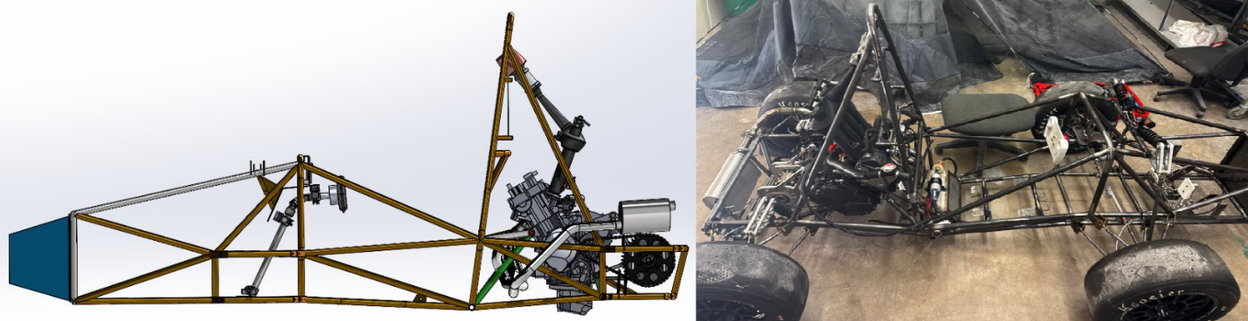
Figure 44: Full Powertrain Assembly in Frame (Left: CAD | Right: Final Product)

Intake System
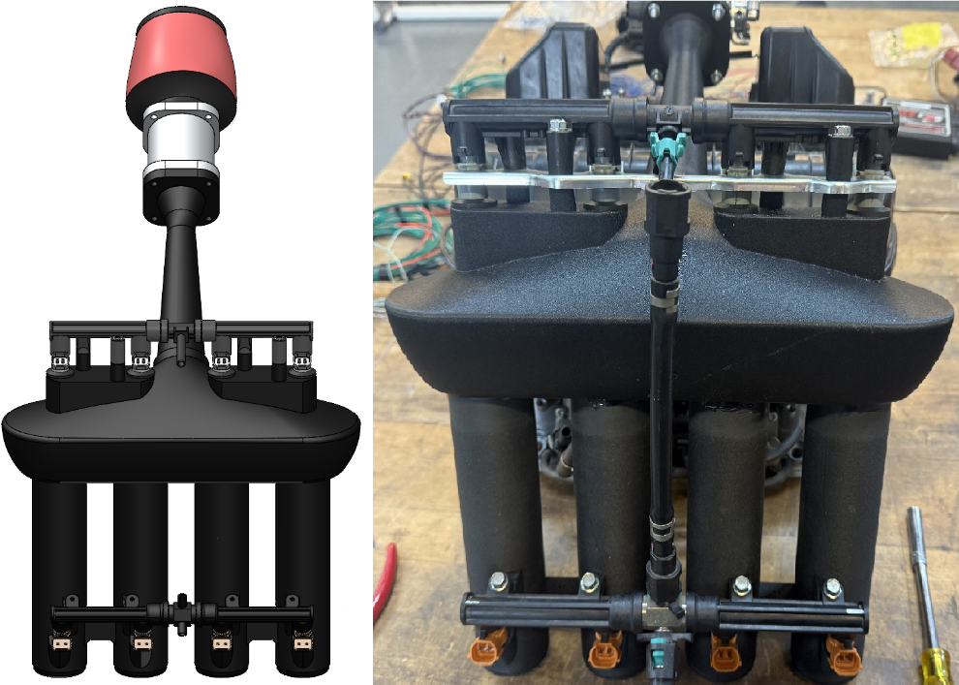
Figure 45: Intake System (Left: CAD | Right: Final Product)

The final intake system was printed out of PATH-CF to withstand the wide range of engine temperatures and to have a high strength. The intake runners, mid plenum, and nozzle were sanded to fit together then epoxied together. The nuts for both fuel rails and both sensors were then epoxied. Finally, all components were bolted together to make the final product. The fuel line between the two fuel rails was also lengthened due to the distance between the fuel rails increasing.

Exhaust System
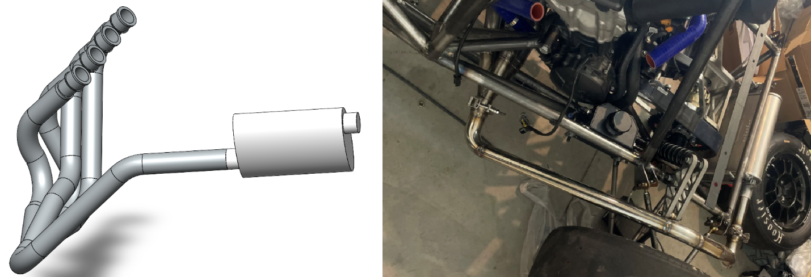
Figure 46: Exhaust System (Left: CAD | Right: Final Product)

The final exhaust system was made from the originally planned stainless steel, yet it had some slight modifications. The end of the exhaust was changed in order to improve the mounting hardware on the car and increase our likelihood of passing the technical inspection. The muffler is a car muffler as with the original plan, only the routing of the tubing changed slightly. The headers also changed slightly. From the previous designs it had longer runners, yet that proved to be difficult to mount in the engine bay. To avoid that issue, they were made to be shorter so only 1 pipe had to exit the frame rather than 4. This also gave us the ability to have more low-end power which is critical in a race because it is made up of turns and not just straight lines. The tube bends were made by a local shop, and welding was handled in house by our team.

Differential Assembly
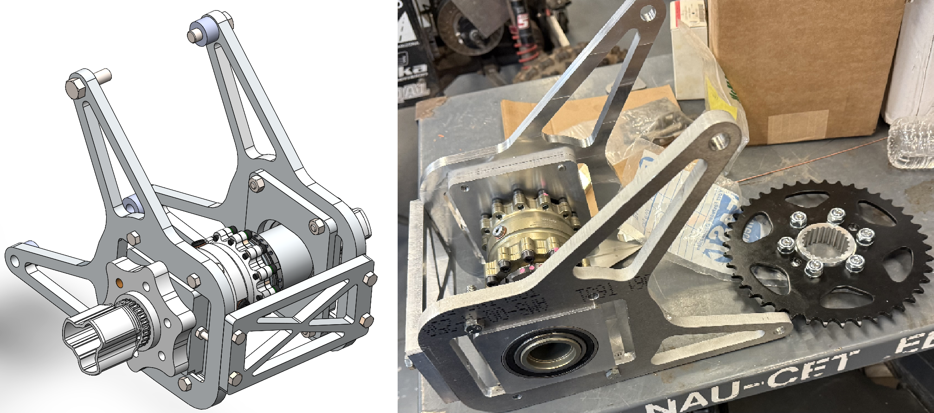
Figure 47: Differential Assembly (Left: CAD | Right: Final Product)

The exterior geometry of each differential mounting component was water jet cut, with additional finer machining steps done either in house or outsourced to local shops to complete each mounting bracket. Since the water jet process leaves a rough finish, sanding and polishing was necessary to remove sharp edges and improve aesthetics. The sprocket mount was CNC machined to fit with final fitment being done with a file. All fasteners will be secured with either nylon lock nuts or threaded with safety wire.

Fuel System
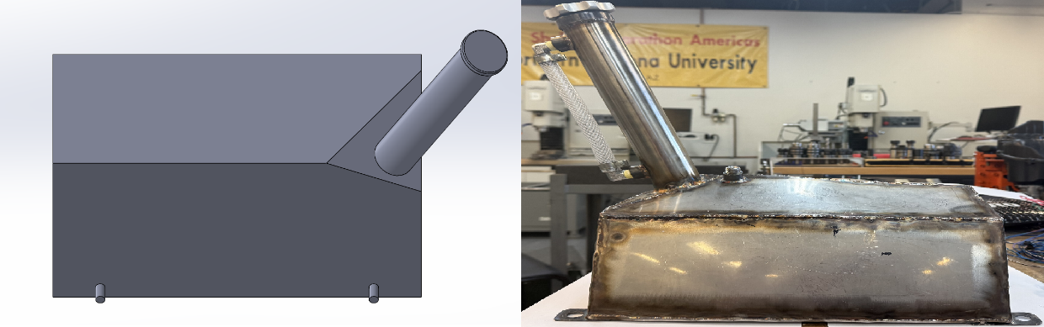
Figure 48: Fuel System (Left: CAD | Right: Final Product)

The fuel tank was first cut from a large piece of sheet metal then welded to match the unique geometry of the model. The overall size of the tank did not change during assembly, yet some small parts did. The ports from the tank to the fuel pump changed from being on either side to being on one side of the tank. This allows more fuel to be closer to the line that pulls it so we can avoid fuel starvation at low fuel levels. A pressure relief valve was also added to avoid creating a vacuum inside the tank as more fuel was removed, and it had a one-way valve so that no liquid fuel would be able to drain out in the case of a rollover. The plate and fill-tube were slightly modified in order to help prevent as much air from getting trapped at the top of the fuel tank, and the proper sight tube was added to comply with the competition rules. Brackets were also welded to the side of the gas tank in order to mount it to the frame rather than strapping it in place.

Final Testing

Top Level Testing Summary Table
The following testing plan is structured around the engineering and customer requirements that were outlined at the beginning of the NAU FSAE project. These requirements were based largely on the rules and regulations set by the Society of Automotive Engineers. Additionally, the team aims to determine how much the 2025 NAU FSAE car has improved over the 2024 car. The table on the next page lists each test and its corresponding requirements and the necessary resources.

Table 23: Test Summary Table
Experiment/Test | Relevant Requirements | Testing Equipment Needed | Other Resources
EXP1 – Visual Test | CR2 – Clean Wiring  CR6 – Design meets Comp. Rules  CR12 – Chain Tension Adjustability  ER2 – Under 710cc  ER13 – Sub Team passes Inspection | Tape measure  Numerous People  Complete car to look at  Flashlights | A good weather day  A well-lit area
EXP2 – Comfort test | CR4 – Ease of Service  ER9 – Ergonomics  ER10 – Engine Vitals | All possible racers  Full set of gear  Tape measure | A good weather day  A well-lit area
EXP3 – Startup | CR7 – Safety  CR11 – Sound  ER7 – Ease of Diagnostics  ER10 – Engine Vitals  ER12 – Operating Temperature | Fluids  Testing area  Complete engine setup  Fire-extinguisher  Decibel Reader | Open area/ventilated  Numerous people
EXP4 – Mild Revving | CR10 – Useable Powerband  CR11 – Sound  ER1 – Functionality  ER7 – Ease of Diagnostics  ER12 – Operating Temperature | Fluids  Testing area  Complete engine setup  Fire-extinguisher  Decibel reader | Open area/ventilated  Numerous people
EXP5 – Moving Under own Power | CR1 – Functional Drivetrain  CR7 – Safety  CR9 – Ease of Shifting  CR10 – Useable Powerband  CR11 – Sound  ER1 – Functionality  ER7 – Ease of Diagnostics  ER10 – Engine Vitals  ER11 – Useable Torque  ER12 – Operating Temperature | Fluids  Testing area  Complete car setup  Fire-extinguisher  Decibel reader  Safety gear | Open area/ventilated  Numerous people/racers
EXP6 – Tuning Test | CR1 – Functional Drivetrain  CR10 – Useable Powerband  CR14 – Acceleration Rating  CR15 – Horsepower Rating  CR16 – Torque Rating  CR17 – Track Weight  ER1 – Functionality  ER3 – Power to Weight Ratio  ER5 – Dynamometer Tuned  ER10 – Engine Vitals  ER11 – Useable Torque  ER12 – Operating Temperature  ER17 - Lightweight | Dynamometer *  Complete car  Fire-extinguisher  Safety gear  Scale | Numerous people
EXP7 – Tilt Test | CR6 – Design meets Comp. Rules  CR7 – Safety  ER8 – Center of Gravity  ER13 – Sub Team passes Inspection | Numerous people  Fluids  Mostly complete car  Ability to lift car  Angle reader | Well-ventilated area  Ability to clean up messes
EXP8 – Fatigue Test | CR1 – Functional Drivetrain  CR3 – Engine Runs after Brake Test  CR7 – Safety  CR9 – Ease of Shifting  CR10 – Useable Powerband  CR13 – Body Roll  ER1 – Functionality  ER11 Useable Torque  ER12 – Operating Temperature  ER14 – Durability  ER16 – Fast Shifting  ER17 – Lightweight | Fluids  Large testing area  Complete car setup  Fire-extinguisher  Safety gear  Numerous people | Open area  Numerous racers
EXP9 – Race Demo | CR1 – Functional Drivetrain  CR4 – Ease of Service  CR5 – Interchangeability of Parts  CR7 – Safety  CR9 – Ease of Shifting  CR10 – Useable Powerband  CR13 – Body Roll  ER1 – Functionality  ER7 – Ease of Diagnostics  ER9 – Ergonomics  ER10 – Engine Vitals  ER11 – Useable Torque  ER12 – Operating Temperature  ER14 – Durability  ER15 – Serviceability  ER16 – Fast Shifting | Large testing area  Cones  Fluids  Complete car  Fire-extinguisher  Safety gear  Numerous people/racers | Open area  Safety Personnel *
EXP10 – Cash Balance | CR8 – Cost  ER4 – Manufacturability  ER6 – Cost | Computer  Project Funds Information  People dealing with Cash inflow | Quiet workspace

Detailed Testing Plan

Test 1
This experiment will consist of looking over the car once it is completed. There are numerous requirements that will be examined here, the first of which is CR2. This one is for a clean wiring harness which will allow the team to pass through the technical inspection faster and allow for a lower diagnostic time. This is because with simple and clean wiring, everything can be traced and repaired in a much smaller time frame. After the wiring has been inspected, the focus will move to CR6 that takes into consideration the competition rules. This will proceed by having numerous people go through every major system on the car and compare them all to the rulebook for tech. This should be a simple step as everything has been designed with the rulebook in mind, yet it is never bad to double check. The next thing to visualize is CR12. This is the first thing that requires a tool because it is measuring the chain tension adjustability. A simple tape measure will work for this test, but the goal is to have the ability to keep the chain at a certain “slack” to maximize the efficiency of the power delivery system. ER2 is extremely simple in this case. It states that the motor cannot have a displacement that is larger than 710cc, so if we put in an engine that has a lower displacement, this portion of the testing will pass quickly. Finally, this test references ER13, which is a very similar testing process to CR12. The goal is to pass the technical inspection quickly and without any major modifications.

Test 2
This is the comfort test. It will consist of any person looking to drive the car to sit in it and determine if it is practical or not. The first requirement is CR4 which is ease of service. This is because every person on our team is different, so having a way to modify the seating arrangement is crucial to allowing more people to drive the car. The competition also requires 3 different racers, so being able to put our best racers in the car and quickly make them more comfortable will theoretically decrease the total lap time. Next, ER9 is considered which corresponds to ergonomics. This is like CR4 yet follows a more natural outlook. CR4 focuses more on the adjustability of components using things like a tape measure to get numerical results. ER9 looks more into the seating position of the rider and how well they fit into the car. This is also where we will begin testing the escape plan for our riders. To pass technical inspection, every listed racer must be able to go from fully strapped in the car to outside of the car within 5 seconds. Better ergonomics will allow the rider to more smoothly exit the vehicle in such a timely manner. After that, ER10 is investigated. This is the part for engine vitals, which must always be visible to every racer when they are driving. If the display is clearly visible with the helmet on and there are no technical problems in the dashboard, this will also be a simple test.

Test 3
This test will consist of the engine running. It does not particularly matter whether the engine is properly mounted within the chassis or not, but if it has all its major systems completely intact, it will be able to perform this test. Obviously CR7, which is safety, must be involved because the safety of every team member is extremely important. Having any possible failure within the engine can mean that people can be injured, so some distance, a fire-extinguisher, and simple PPE is in order. This can consist of closed toe shoes, no lose clothing, and no flammable items near the motor. After the safety of everyone is guaranteed, the motor will be started. Numerous things will be tested like CR11. This is the one for sound and will be tested using a decibel reader to make sure it is within the range of the rulebook which is 103dB at idle. After that we will look at ER7 which is ease of diagnostics. Anytime something is planned to run after being put together, there will almost certainly be some type of issue. The goal here is to be able to have our team locate and solve that issue within a certain time frame to practice for what could occur at the races. It will also allow us to be able to continue the testing and have more time to test since the problem was solved quicker. Once the motor is consistently running at idle, we can get it up to operating temperature and consider ER10 (engine vitals) and ER12 (operating temperature). These will allow us to feel more confident that the motor will not overheat on race day because the engine will continue to moderate the temperature to not allow it to cause damage to itself. This is why the entire system must be hooked up because if there is a leak in the cooling system or a fault with the cooling fan, the engine will not be able to regulate its temperature. If this is to happen, then the test will have to be stopped, and more diagnostics will be in order.

Test 4
This test will come after the completion of test 3. This is because to be able to confidently rev up the motor, everything that is needed to pass test 3 are prerequisites for this test. CR7 will still be considered here because safety is always extremely important, so having a fire-extinguisher on hand will be crucial. CR10 (useable powerband) will now be important because if the powerband is extremely poor, the motor will not be able to rev up consistently or even at all. CR11 will also be considered as there are different rules on how loud the engine can be at anything other than idle, so a decibel reader will be used throughout the testing to make sure the sound is never over 110dB because that is the max value the rulebook allows for. ER1 (functionality) will also be considered here because if the engine cannot rev up decently (this whole test is still pre-tune), then the motor will need more work to be tunable later in testing. ER7 is still important here because the team still needs to address problems and fix them in a reasonable amount of time. The time chosen for us was 15 minutes, but there are going to be differences in that value depending on the problem. That is more of a general goal to be aimed for when dealing with complicated systems such as engines. Finally, ER12 will still be considered here because the engine must remain cool even with the engine revving. Due to the fact that the engine is not moving in these tests, some fans might be required to help keep up moderate airflow, yet the radiator fan should be able to manage the engine temperatures if it is working properly.

Test 5
This test will follow test 4, but it requires a full car to be assembled because the engine must be able to move the car without any external help. This will also satisfy the requirement for CR1 which is functional drivetrain. CR7 will be even more important to maintain here to not allow the car to run over anyone, and a fire-extinguisher will prevent us from burning down the entire car if a small fire starts. With the car rolling through this test, it will allow us to see if CR9 (ease of shifting) applies. This will be determined by numerous drivers who preferably have experience driving manual cars. This will give some guidance into where there can be some improvement to prevent the driver from getting tired out due to poor design choices. CR10 will apply here as well as CR11. The useable powerband will be important to make sure that the engine can actually move the entire car. It does not have to do this well for this test but must move it slightly to be ready for the tuning test. Measuring the sound with the decibel reader will also be important because it will be the theoretical first time that the exhaust is at its final resting point, so measuring from that just like they will do in the technical inspection will be an important test to perform. ER1 (functionality) will also be taken into consideration, yet is like CR1, so they can be evaluated at the same time. Just as with the previous few tests, ER7 will also be noted because if any problems went wrong, we would like to fix them within a reasonable amount of time. ER10 and ER12 are there to make sure that the engine can survive within the confines of the chassis and everything else that mounts next to it (like the gas tank or the differential). Knowing the statis of the engine and getting it up to operating temperature while rolling around slowly will allow us to verify that. ER11 is similar to CR10 because without torque, there is no power. We will not be attempting to spin the tires in this test because this test does not require a large area, so knowing the torque and seeing how it handles our platform will be further discussed in different tests.

Test 6
This is the tuning test. To accomplish this, we must get scheduled with a tuning shop down in Phoenix, Arizona. This is because we need a dynamometer so we can make adjustments to the tune on our engine. That will allow us to make maximum power without the fear of blowing up the engine. A bunch of the same requirements will be further analyzed from test 5, these being CR1, CR10, ER1, ER10, ER11, and ER12. Beyond those, there are some new tests that will be analyzed such as CR14 (acceleration rating), CR15 (horsepower rating), CR16 (torque rating), CR17 (track weight), ER3 (power to weight ratio), ER5 (dynamometer tuned), and ER17 (lightweight). These will all be determined at the tuning shop once the professionals have finished tuning the car and put it on a scale to determine the final weight of the car. This will allow us to determine the power to weight ratio, and if the final weight ended up within our design criteria.

Test 7
Here is the tilt test. This is a part of the technical inspection where they tilt the car almost onto its side to test if any fluids come out, and if the car can manage to stay on the machine while it is at such a drastic angle. CR6 and ER13 are obviously in consideration here because it is a part of the inspection that is directly being tested. CR7 is also important because we do not want the car to fall on anyone or any fluids to leak out and cause any irritation or harm. The car will have to be lifted from one side to complete this test, so either a jack can perform the task, or a few willing participants to get to the angle of the machine. Just in case there are some fluids that leak out, we will need things like rags or towels to clean up the mess before it stains any concrete. The only other thing being tested here is ER8, which is for the center of gravity of the car. If the car cannot fail the tilt test, we can theoretically tilt the car to the balance point. That coupled with an angle reader device will allow us to calculate where the center of gravity actually lies within the car.

Test 8
This test is the fatigue test. Once that car has been properly tuned, it is time to really push the car to its limits. To do so, we will have to use a large portion of the south commuter parking lot. We have been in discussions with some of the upper management who are in charge of managing the parking lots, and we will provide them with a date for us to use the lot once we have the car ready to go. We will then set up some drills where the car will take some hard turns and accelerate fast both up to speed and down to a complete stop. We will also test the brakes by making sure all of the tires lock up, which is shown in CR3 (engine runs after brake test). From previous tests, requirements CR1, CR9, CR10, ER1, ER11, ER12, and ER17 will be further analyzed. Safety (CR7) is always extremely important, so every rider will be equipped with a full set of gear to make sure that if they end up crashing the car, they will come out unscathed or minimally injured, and a fire extinguisher will be on stand-by incase a fire breaks out. Other new things that are analyzed during this test are things like CR13 which is body roll. This is for when there is hard cornering and the car’s body is wanting to “roll over.” Theoretically, the suspension system should not allow for much body roll, but these tests will show if that is true or not. ER14 (Durability) will also be considered here because the car will need to withstand constant abuse over the span of 4 days, so it needs to stay strong and not have any major failures within this hardcore testing plan. Small issues are easy to resolve, yet a major component failure could be a huge setback, but it is important to find out every problem now before it is too late. Finally, ER16 (fast shifting) is determined here. This is because there will be fast acceleration through numerous gears, so we want to be able to tell how fast the car can shift, and if there are any ways we can make it faster.

Test 9
This is the final major test, and it is deemed as the race demo. It can be followed shortly after the fatigue test as long as the car manages to survive without needing any major repair. It consists of a large area where we can put a bunch of cones down to make a small racetrack to test lap times and corning ability. Safety will be properly considered just as it was in the fatigue test, and requirements CR1, CR7, CR9, CR10, CR13, ER1, ER9, ER10, ER11, ER12, ER14, and ER16 will be expanded upon throughout the test. CR4 (ease of service) and ER7 (ease of diagnostics) will also be heavily considered because a pit stop will be conducted for every driver switch, refueling, or problem occurring. This means the team will have numerous tests to quickly go over major components during the pit stop if there is nothing wrong to make sure it does not have problems. If a problem develops, then the team gets tested further to see how quickly they can respond and solve the problem within a reasonable time. CR5 (interchangeability of parts) is also tested because if a part manages to break, then the team will be given a certain amount of time to complete the repair and see if the replacement part will go in nicely and continue to survive. If no parts break on this test or even the fatigue test, then this can be tested by simply making the team replace a good part with another part to time them. This will allow us to determine if we are ready to deal with extremely poor circumstances that could occur out on the track. Finally, ER15 (serviceability) will be tested. This is done extremely similarly to CR5 yet will be done on a broader range of things rather than simply looking at changing parts.

Test 10
This is the final test, and it is the cash balance test. This will take everyone who has a say/opinion about the finances of the project and put them into a room. They will discuss the remaining budget of the build, if the original estimates were correct/close, and what could be improved. Both CR8 (cost) and ER6 (cost) will be heavily discussed here as it is the main topic of the meeting. ER4 will also be discussed because there is little time remaining until the races in Michigan. This means that if any new parts need to be made due to a shift in the budget, there needs to be a way to get them in a timely manner so tests can still be performed.

Future Work
If designing and manufacturing times were increased, more time would be spent optimizing the intake and exhaust systems for further increased performance of the car. Designing time would also be spent decreasing weight out of the drivetrain system, as well as increasing the strength of components within the drivetrain system. Additionally, a different team structure would highly benefit the team. The current structure the team has are three sub team leaders. In addition to that, there should be a separate logistics manager, more than one welder, and a manufacturing lead. By delegating and giving more tasks to separate team members it will make the team more efficient and have a more manageable work balance.
Overall, with extra time the team would like to reach out to more sponsors for material donations. The time would also be spent finding more ways to reduce costs with the drivetrain system. Engine upgrades are also another key area that the team would like to explore. Some possible upgrades for the powertrain could be cams, dry sump oil pan, E85 conversion kit, and new clutch actuation system.

CONCLUSION
Formula SAE is a collegiate level design competition that requires teams to design, manufacture, and assemble a formula style racecar using a mix of custom and purchased components. This vehicle will be entered to compete against over one hundred other similar vehicles designed by teams around the country at the end of the academic year in May 2025. In order to compete teams must first pass a technical inspection to ensure that their vehicles abide by the rules and regulations laid out by SAE International. Competition includes a variety of events ranging from a static leak test to an endurance style race. Fundraising is a major factor in this project due to the large costs associated with vehicle components. The total budget for this project was estimated at $40,000. At this point in the semester over 95% of these funds have been allocated or spent. The final designs for the vehicle’s powertrain include a Honda CBR600RR, a custom short intake, a custom steel tubing exhaust, a Drexler FSAE limited slip differential mounted to the engine, and an electronic paddle shifting system. Powertrain progress is overall on track, with some aspects being ahead of schedule. The CBR600RR has been successfully run on a stand, and the team is hard at work finalizing all aspects of the manufactured components. The car will be running under its own power in a week's time with the car being ready to pass technical inspection in a few weeks. Final tuning of the car will also happen within a few weeks, so maximum performance can be achieved. The team hopes to do well at the competition with all desired design aspects being met.

REFERENCES
[1] “Formula SAE at Ohio State,” Formula Buckeyes, https://www.formulabuckeyes.org/ (accessed Oct. 20, 2024).
[2] “49ers racing IC,” 49ers Racing IC, https://www.49ersracing.com/ (accessed Oct. 20, 2024).
[3] “Formula SAE,” NAU Formula SAE | Student Racing Team | SAE, https://www.ceias.nau.edu/capstone/projects/ME/2024/F23toSp24_Formula24/ (accessed Oct. 20, 2024).
[4] S. Das, P. Gogoi, M. Agrawal, and Rounak, “Design of Differential Mounts and Rear Inboard Braking for an FSAE Vehicle,” in Advances in Manufacturing Engineering, Singapore: Springer, 2022, pp. 437–455
[5] J. B. Heywood, Internal Combustion Engine Fundamentals. New York: McGraw-Hill Education, 2019.
[6] W. W. Pulkrabek, Engineering Fundamentals of the Internal Combustion Engine. United States of America: Prentice Hall, 2004.
[7] E. Oberg, F. D. Jones, H. L. Horton, H. H. Ryffel, and R. G. Budynas, Machinery's Handbook, 30th ed. New York, NY, USA: Industrial Press, 2016.
[8] T. Setoguchi, S. Matsuo, H. D. Kim, and M. Alam, “Nozzle Geometry Variations on the discharge coefficient,” ScienceDirect, https://www.sciencedirect.com/science/article/pii/S2212540X16000031 (accessed Aug. 25, 2024).
[9] A. J. Szaniszlo, “EXPERIMENTAL AND ANALYTICAL SONIC NOZZLE DISCHARGE COEFFICIENTS FOR REYNOLDS NUMBERS UP TO 8x10^6,” NASA, https://ntrs.nasa.gov/api/citations/19750006921/downloads/19750006921.pdf (accessed Aug. 25, 2024).
[10] “PERFORMANCE OF CONICAL JET NOZZLES IN TERMS OF FLOW AND VELOCITY COEFFICIENTS,” NASA, https://ntrs.nasa.gov/api/citations/19930091998/downloads/19930091998.pdf (accessed Aug. 25, 2024).
[11] J. Szabo, “Calculating Critical Air scoop speed with a forward facing Air Inlet,” EngineLabs, https://www.enginelabs.com/engine-tech/calculating-critical-air-scoop-speed-with-a-forward-facing-air-inlet/ (accessed Aug. 7, 2024).
[12] “Proper hood scoop sizing,” Yellow Bullet Forums, https://www.yellowbullet.com/threads/proper-hood-scoop-sizing.2022842/ (accessed Aug. 7, 2024).
[13] L. J. Hamilton and J. E. Lee, “The Effects of Intake Plenum Volume on the Performance of a Small Normally Aspirated Restricted Engine,” SAE International journal of engines, vol. 1, no. 1, pp. 1312–1318, 2009, doi: 10.4271/2008-01-3007. (accessed Nov. 20, 2024).
[14] S. Aziz et al., “Design and Analysis of an Operative Inlet,” IOP Conference Series: Materials Science and Engineering, https://iopscience.iop.org/article/10.1088/1757-899X/429/1/012075/pdf (accessed Nov. 22, 2024).
[15] “Measurement Procedure for Determination of Silencer Effectiveness in Reducing Engine Intake or Exhaust Sound Level(STABILIZED May 2014) ,” SAE INTERNATIONAL, https://www.sae.org/standards/content/j1207_201405/ (accessed Oct. 28, 2024).
[16] Mike Mavrigian, Performance Exhaust Systems, How to Design, Fabricate, and Install. North Branch MN: CarTech Inc, 2014. https://www.google.com/books/edition/Performance_Exhaust_Systems/FkP7AwAAQBAJ?hl=en&gbpv=1&dq=motorcycle+exhaust+system+design&printsec=frontcover
[17] Hiroshi Kuribara, et al, Prediction of Fatigue Strength of Motorcycle Exhaust System Considering Vibrating and Thermal Stresses. SAE International Journal of Engines, 2016. https://www.jstor.org/stable/26284825?seq=1
[18] A M Siregar, et al, Engineering of motorcycle exhaust gases to reduce air pollution. IOP Conference Series: Materials Science and Engineering, 2020. https://iopscience.iop.org/article/10.1088/1757-899X/821/1/012048/meta
[19] Taguchi, T., Aoki, M., Katsukawa, Y., KOGA, M. et al., "Development of a Noise Prediction Technique for Designing a High-Performance Muffler of Motorcycle," SAE Technical Paper 2010-32-0023, 2010, https://doi.org/10.4271/2010-32-0023
[20] MXA, Ten Things You Need to Know About Mufflers. Motocross Action Mag, 2019. https://motocrossactionmag.com/10-things-you-need-to-know-about-mufflers/
[21] Martin Pechout, et al, Regulated and unregulated emissions and exhaust flow measurement of four in-use high performance motorcycles. Science Direct: Atmospheric Enviroment: X, 2022. https://www.sciencedirect.com/science/article/pii/S2590162122000247
[22] Zach Jobe, et al, DIY Exhaust! - Is it worth it? Donut Media: Money Pit, 2021. https://www.youtube.com/watch?v=io9k0gNj7c4
[23] Chern Jiek, How To Import SOLIDWORKS Part/ Assembly Files Into Ansys. Senpai Corner,
Sep 12, 2022. https://www.senpaicorner.com/post/how-to-import-solidworks-part-assembly-files-into-Ansys
[24] Erudite Plus, CFD Exhaust Manifold | Best Exhaust Manifold Simulation Tutorial | ANSYS
Fluent. YouTube, Mar 1, 2022. https://www.youtube.com/watch?v=AJyiqctB8rE
[25] R. G. Budynas and J. K. Nisbett, “Chapter 17: Flexible Mechanical Elements,” in Shigley’s Mechanical Engineering Design 11th Edition, McGraw Hill, 2020, pp. 882–934
[26] S. Cecchel, “Materials and technologies for Lightweighting of structural parts for Automotive Applications: A Review,” SAE International Journal of Materials and Manufacturing, vol. 14, no. 1, Sep. 2020. doi:10.4271/05-14-01-0007
[27] R. A. James, Design of an Aluminum Differential Housing and Driveline Components for High Performance Applications, https://dspace.mit.edu/bitstream/handle/1721.1/32762/57570210-MIT.pdf?sequence=2&isAllowed=y (accessed Sep. 14, 2024).
[28] Scelfo Tony, Lightweight Torsen Style Limited Slip Differential and Rear Driveline Package for Formula SAE, https://dspace.mit.edu/bitstream/handle/1721.1/36702/77550024-MIT.pdf?sequence=2&isAllowed=y (accessed Sep. 14, 2024).
[29] K. Durand, Design of a Chain Driven Limited Slip Differential and Rear Driveline Package for Formula SAE Applications, https://dspace.mit.edu/bitstream/handle/1721.1/32862/62587598-MIT.pdf?sequence=2&isAllowed=y (accessed Sep. 2024).
[30] A. Correia, “2018 Honda CBR600RR,” Motorcycle specifications, https://www.motorcyclespecs.co.za/model/Honda/honda_cbr600rr_18.htm (accessed Nov. 27, 2024).
[31] “Aluminum 6061-T6,” ASM material data sheet, https://asm.matweb.com/search/specificmaterial.asp?bassnum=ma6061t6 (accessed Nov. 27, 2024).
[32] “Rolling Bearings,” SKF, https://cdn.skfmediahub.skf.com/api/public/0901d196802809de/pdf_preview_medium/0901d196802809de_pdf_preview_medium.pdf (accessed Nov. 28, 2024).
[33] “520 roller chain 10FT BOX: Non-standard series roller chain,” www.usarollerchain.com, https://www.usarollerchain.com/520-Roller-Chain-p/520-chain-10ft.htm (accessed Nov. 27, 2024).
[34] G. Banish, Engine Management: Advanced Tuning. North Branch, MN: CarTech, 2007.
[35] B. Devak and P. Deepan, “Sustainable use of single-cylinder engine over multi- ...,” International Research Journal of Engineering and Technology, https://www.irjet.net/archives/V4/i7/IRJET-V4I7301.pdf (accessed Sep. 16, 2024).
[36] K. Lutenbacher, B. Mayeaux, and J. Waller, “FSAE Engine Selection: Four or One Cylinder.” Available: https://korilutenbacher.weebly.com/uploads/5/4/9/9/5499743/klutenbacher_bmayeaux_jwaller_me4633_fsae_report.pdf
[37] T. Ayres, K. Hayward, and F. Guzzomi, “Design of a custom FSAE engine,” ResearchGate, https://www.researchgate.net/profile/Kevin_Hayward/publication/320081033_Design_of_a_Custom_FSAE_Engine/links/5a4c1d0fa6fdcc3e99cf6b23/Design-of-a-Custom-FSAE-Engine.pdf (accessed Sep. 16, 2024)
[38] FSwiki, “List of Engines,” List of engines, https://fswiki.us/List_of_Engines (accessed Sep. 16, 2024).
[39] C. Catto, “Thread: Engine selection: New advances V. tried and true,” Engine selection: new advances V. tried and true , https://www.fsae.com/forums/showthread.php?3760-Engine-selection-new-advances-V.-tried-and-true%2Fpage5 (accessed Sep. 16, 2024).
[40] “R/FSAE on reddit: Internal Combustion Engine for our first car,” FSAE Reddit, https://www.reddit.com/r/FSAE/comments/nc7ke3/internal_combustion_engine_for_our_first_car/ (accessed Sep. 16, 2024).
[41] “R/FSAE on reddit: Engine choices,” FSAE Reddit, https://www.reddit.com/r/FSAE/comments/8ljj9r/engine_choices/ (accessed Sep. 16, 2024).
[42] P. H. Smith and J. C. Morrison, The Scientific Design of Exhaust & Intake Systems Philip H. Smith; John C. Morrison. Cambridge, Mass: Bentley, 2009.
[43] V. B. Bhandari, Design of Machine Elements, 4th ed. New Delhi, India: McGraw-Hill Education, 2017.
[44] P. Arora, M. R. Agrawal, P. P. Singh, N. Gobinath, and M. Feroskhan, "Design and Analysis of a Formula SAE Vehicle Chain Sprocket under Static and Fatigue Loading Conditions," SAE Int. J. Mater. Manf., vol. 14, no. 3, pp. 275-282, 2021, doi: 10.4271/05-14-03-0018.
[45] R. J. Chalmela, Electro-pneumatic shifting and servo control of a clutch for a FSAE racecar, M.S. thesis, Dept. Mech. and Aerosp. Eng., Univ. Texas at Arlington, Arlington, TX, USA, 2017.
[46] L. Redstone, L. Weston, and J. Deglint, FSAE electronic shifter: Final project report, Univ. Victoria, Victoria, BC, Canada, Dec. 2012. [Online]. Available: http://electronicshifter.wordpress.com/.
[47] M. A. Kandil, Design and CFD Analysis of a Variable Runner Intake System for a Formula SAE Race Car, Dissertation, [Online]. Available: https://www.researchgate.net/publication/368356845_Design_and_CFD_Analysis_of_a_Variable_Runner_Intake_System_for_a_FSAE_Car. [Accessed: 27-Nov-2024].
[48] S. S. Sawant, P. N. Gurav, P. S. Nivalkar, P. M. Sawant, and S. N. Waghmare, "Design and fabrication of air intake for FSAE race," Dept. of Mechanical Engineering, Ambav (Devrukh), Ratnagiri, Maharashtra, India, [Online]. Available: https://ijsart.com/Content/PDFDocuments/IJSARTV4I120719636530833605777062.pdf. [Accessed: 27-Nov-2024].
[49] M. Shashantgouda, S. Ghorpade, S. Londhe, A. Shivakumar, and C. Thakur, "Design and fabrication of intake system for FSAE vehicle," Dept. of Automobile Engineering, Saraswati College of Engineering, Kharghar, Navi-Mumbai, Maharashtra, India, [Online]. Available: https://www.irjmets.com/uploadedfiles/paper//issue_4_april_2023/35849/final/fin_irjmets1681388748.pdf [Accessed: 27-Nov-2024].
[50] U.S. Tsubaki, Inc., The Complete Guide to Chain, Wheeling, IL, USA: U.S. Tsubaki, Inc., 1997.
[51] S. M. Nyhus, "Optimization of a Formula SAE Vehicle Intake Manifold," Bachelor of Science Technical Report, Department of Mechanical and Aerospace Engineering, School of Engineering and Applied Science, Univ. of Virginia, Charlottesville, VA, USA, Spring 2023
[52] S. Mehta, “Piston Slap: CFM Calculations the Easy Way and Hard Way,” Hagerty Media, https://www.hagerty.com/media/advice/piston-slap/piston-slap-cfm-calculations-the-easy-way-and-hard-way/ (accessed Sep. 14, 2024).
[53] “Restrictor,” Fswiki, https://fswiki.us/Restrictor (accessed Oct. 5, 2024).

