NG Two-Stage Supersonic Rocket

Initial Design Report

Austin Paothatat: Project Manager/Test Engineer
Avery Charley: Manufacturing Engineer/Financial Manager
Koi Quiver: CAD/Test Engineer
Lindsey Dineyazhe: Financial Manager/CAD Engineer

Spring 2024-Fall 2024


Project Sponsor: Northrop Grumman Space Systems, Launch Vehicles
Faculty Advisor: Carson Pete
Sponsor Mentors: Caleb Feda, Daniel Petschow, Paul Hoeffecker, Victoria Ewert
Instructor: Carson Pete

DISCLAIMER
This report was prepared by students as part of a university course requirement. While considerable effort has been put into the project, it is not the work of licensed engineers and has not undergone the extensive verification that is common in the profession. The information, data, conclusions, and content of this report should not be relied on or utilized without thorough, independent testing and verification. University faculty members may have been associated with this project as advisors, sponsors, or course instructors, but as such they are not responsible for the accuracy of results or conclusions.

EXECUTIVE SUMMARY
Our senior capstone design project requires us to design, fabricate, test, and launch a two-stage high-powered rocket to an altitude of 50k ft AGL max and reach and maximize speed at Mach 2 and above. The main goal of this project is to utilize our engineering knowledge to conceptualize and build a product that meets our client's needs. Our main stakeholder is Northrop Grumman Space Systems, Launch Vehicles Division. They are experts in space launch and military launch vehicles. NG mentors will help us with our design process and technical aspects of our design project.
The vehicle is required to carry a payload of up to 10 pounds inside of a 6-inch internal diameter bay, this is a main requirement of the client, but the full requirements are listed later in the report. With our baseline requirements from the course and the clients, we have set to come up with a full concept vehicle. Throughout the report is our process from benchmark comparisons, mathematical modeling, concept generation, and then concept selection. The process helps us expand our design and compare it to similar launch vehicles that have many different capabilities.
The current progress of the design is at the final concept stage. The final concept is currently meeting our hard requirements of the structural side. We have a two-stage launch vehicle with an internal diameter of 6”. While the launch vehicle is not at a stage of refined hard dimensions beside the diameter. The vehicle is refined into component layout, recovery system functionality, avionics bay flight computers, separation system mechanism, and nose cone geometry.
Progression with this concept can now move into analysis of each component and sub-system. Analysis will include in-depth hand calculations on the design. These will define hard dimensions of materials like the carbon body tube, separation system, fin design, and any internal structures. The analysis will further material selection and optimizing structures to maximize performance of the launch vehicle.
Analysis will be used to create two prototype systems of the main launch vehicle. Prototyping will be based on reducing risk on the full-scale launch vehicle. The prototypes will be physical functional models of the concept selection process design choices. Testing will provide valuable data to the design, and we will gain confidence within our design or improve where deemed necessary by calculations. To further our analysis, we will utilize commercial programs. In addition to CAD, we will be using simulation systems like FEA, CFD, and Flight simulation software to visualize our calculations into the 3d model world. The tools help us complete complex calculations and solutions to the design progress.
The project is completed through the concept selection process. Moving forward with the project, the plans are outlined above, and we seek to complete in-depth analysis and our prototyping and testing. As we progress through the first part of the course, we are converging into our preliminary design review to end the semester. The PDR will conclude the first steps of designing the launch vehicle and will be presented to the class and the mentor team at Northrop Grumman.

TABLE OF CONTENTS
Contents
DISCLAIMER 1
EXECUTIVE SUMMARY 2
TABLE OF CONTENTS 3
1 BACKGROUND 1
1.1 Project Description 1
1.2 Deliverables 1
1.3 Success Metrics 1
2 REQUIREMENTS 2
2.1 Customer Requirements (CRs) 2
2.2 Engineering Requirements (ERs) 2
2.3 House of Quality (HoQ) 2
3 Research Within Your Design Space 3
3.1 Benchmarking 3
3.2 Literature Review 3
3.3 Mathematical Modeling 3
4 Design Concepts 4
4.1 Functional Decomposition 4
4.2 Concept Generation 4
4.3 Selection Criteria 4
4.4 Concept Selection 4
5 Schedule and Budget 5
5.1 Schedule 5
5.2 Budget 5
5.3 Bill of Materials (BoM) 5
6 Design Validation and Initial Prototyping 6
6.1 Failure Modes and Effects Analysis (FMEA) 6
6.2 Initial Prototyping 6
6.3 Other Engineering Calculations 6
6.4 Future Testing Potential 6
7 CONCLUSIONS 7
8 REFERENCES 8
9 APPENDICES 9
9.1 Appendix A: Descriptive Title 9
9.2 Appendix B: Descriptive Title 9

BACKGROUND
The Northrop Grumman Supersonic Rocket Team is embarking on a groundbreaking capstone project to develop a two-stage supersonic rocket made from advanced composite materials. Partnering with our client Northrop Grumman, the team aims to meet rigorous technical specifications while pushing the boundaries of NAU’s rocketry experience. Our main goal is to not only meet but surpass our customers’ expectations while keeping the budget under $7,000. This project serves as a critical steppingstone towards future endeavors, providing a launch vehicle for future capstone payloads and serving as a test bed for future space shot rockets. Key objectives include maximizing payload volume, ensuring recoverability, and addressing possible environmental conditions. Throughout the project, progress will be tracked through presentations, reports, and analysis memos. Success metrics include meeting client requirements, ensuring proper operation and components, and optimizing performance through rigorous testing and simulation.

Project Description
The key objective of this mission is to design a cost-effective test platform that will be required to achieve a height that will exceed 40,000 feet and meet and maintain a supersonic speed of Mach 2 while under an acceleration surpassing 12g. Additionally, it must carry a scientific payload that meets the exact specifications outlined by industry partner, Northrop Grumman (NG).

The launch vehicle must be made of composite materials selected during the analysis portion of the preliminary design review. These materials will be tested under the ASME standards of composite testing. The team will also utilize Matlab and other programming simulation programs to assist in predicting flight trajectories, structural analysis, and aerodynamic flows of the vehicle to ensure that the vehicle has the best shot of achieving all requirement set by our course, client, and sponsors of the project. The final launch vehicle will be fabricated and tested by the team to take the launch vehicle to flight at the Arizona Eagle Eye Tripoli launch site in Wickenburg, AZ. The flight will take place in the fall of 2024.
The full list of requirements set by the course and the clients is stated in section 2.

Deliverables
During the project, the team will use a series of deliverables to stay up to date on progress. These deliverables include presentations, a Preliminary Design Report (PDR), and an Analysis Memo that summarizes the technical requirements. Consistently tracking progress throughout the project will help the team ensure that they are meeting their goals and delivering a high-quality product.
- Presentation 1 – Tailored towards research for the project and minor engineering calculations for the prototype envisioned.
- Presentation 2 – The team created several designs and critiqued them to narrow down to the final design.
- Report 1 – Breaks down of the past two presentations and their challenges. In addition, it provides a fluent synopsis of the progress the team made.
- Analysis Memo – An individual task requiring selection and mathematical justification of a key engineering characteristic, design component, or decision crucial to the project's viability.
- Preliminary Design Review
- Presentation 3 – A final presentation that should detail the prototype's functionality and include pros and cons, detailed drawings, and financial analysis.

Success Metrics
The success of our project hinges on meeting the comprehensive requirements outlined by our client for a two-stage supersonic rocket. A detailed list of these requirements can be found in Section 2.1. Additionally, the flawless operation of each component during flight is paramount to achieving our objectives.
Beginning with the nose cone selection, we have opted for the Von Karman design, for its exceptional stability and minimal drag at supersonic speeds. However, the challenge of temperature flux poses a potential threat to the integrity of the epoxy layers, jeopardizing its aerodynamic properties. To address this concern, our team will analyze temperature fluctuations during flight to ensure the nose cone’s structural integrity remains intact.
Moving on to the body of the rocket, we anticipate significant pressure drag during supersonic flight, potentially leading to undesirable bending or buckling. Thus, our strategy entails conducting rigorous strength tests on various carbon fiber layer orientations. Adhering to ASME methodologies, we will determine the optimal number of layers and orientations to achieve maximum strength. Success will be gauged by minimal body deformations and a Factor of Safety exceeding 3.
A critical challenge lies in the development of an effective separation system for the rocket. Given the Rocket Club’s previous focus on single-stage rockets, we lacked guidance on suitable separation mechanisms. The success criteria entail an as expected separation at the designated time and the system’s ability to maintain structural integrity during flight.
Lastly, the performance of our motors is pivotal to the rocket’s overall success. Without proper ignition and propulsion timing the maximum performance can suffer. Thus, extensive simulations utilizing RockSim will be conducted to optimize motor performance and ensure the attainment of Mach 2 speeds. Given budget constraints, real-world testing of motor configurations will be limited to final flight plans. However, onboard GPS tracking will provide real-time velocity feedback, enabling us to validate our success margin.
Below is a table that defines what our definition of success is dependent on. This can be a quick guide to gauge our success out in the field when final launch time arrives.

Mission Success Criteria
Table 1: Mission success criteria
Success Levels | Goals
Complete Mission Success | - Payload system performs as expected by NG and NAU team  - Payload safely delivered and data captured  - Launch vehicle performance met with altitude goal  - Launch vehicle recovered and in reusable condition  - Recovery system performs as expected and designed  - No anomalies during full flight and payload mission until completed flight and recovery
Partial Mission Success | - Flight success  - Velocity and altitude requirements met  - Payload flown but no data recorded  - All components are recovered and reusable
Partial Mission Failure | - Failure of payload or launch vehicle performance  - Successful flight with failure of payload data recording or delivery  - Velocity or altitude requirement missed  - Vehicle or payload systems damaged during flight or landing
Complete Mission Failure | - Failure of both launch vehicle and payload systems  - Failure of recovery system deployment and beyond reasonable repair state  - Failure of vehicle before, during, or after flight

REQUIREMENTS
The requirements section of the report contains the requirements set forth in the project proposal by the customer, and the engineering requirements derived by the team from customer requirements. Each customer and engineering requirement has a definition of how it pertains to the project and what is being designed through the requirement. The first set of requirements, there were still questions that the team needed answered, along with knowing needing to know which requirements the client wanted the team to focus on. There have been edits and changes to the customer and engineering requirements throughout the project and reviews and meetings with the client. The team started understanding what the client wants/needs as the project continues. Some of the engineering requirements just have a successful or unsuccessful goal due to that aspect of the design needing to work. The requirements listed below are the current set of customer and engineering requirements developed by the team and the client, with the updated QFD at this current stage.

Customer Requirements (CRs)
The customer requirements set by the customer were stated initially in the proposal. After multiple meetings with the client, the customer expanded on some of the definitions of the requirements made in the initial proposal and added a few additional requirements. The requirements added were due to the class and the client wants to see specific analysis. All the customer requirements are stated in the list below:
- Develop a two-stage launch vehicle.
  - The vehicle needs to be a two-stage rocket. Two stages mean the rocket needs an initial booster that will eject off the vehicle after being used to maximize the flight time and velocity. The second stage will continue the flight after the first stage ejects off the vehicle.
- Use of a specific stage separation device.
  - The client wants the team to use a specific separation method discussed. The specific information on the separation system is proprietary Northrop Grumman information and cannot be shared in the report.
- The vehicle will be constructed of composite materials.
  - The client would like the vehicle to be constructed out of a composite material for strength and lightweight capability. The client would also like composite material to be used to be reused.
- Vehicle will reach an altitude of at least 40,000 ft AGL (Above Ground Level).
  - The client would like the vehicle to reach the height of 40,000ft. This is a hard number that is not subject to change. The launch site we chose to launch the vehicle at has an altitude ceiling of 50,000ft.
- Scaled prototype rocket required as a proof of concept.
  - The client and the capstone project instructor/advisor would like one of our prototypes to be a scaled down proof of concept vehicle. Used to prove that our current design would work to reach the speed required, the altitude is reached, and the separation system the team choses would work.
- Final launch vehicle will be required to carry a maximum 10 Lb payload that will fit within a 6” diameter bay
  - One of the major requirements set by the clients is the vehicle should have a payload bay that should have a 6” diameter. The vehicle should have the ability to carry at least a 10 lbs payload. As stated by the client, this requirement is important as the vehicle is for research uses.
- Vehicle required to reach and maintain over Mach 2 and maximize time spent at that speed or greater.
  - This is a major requirement set by the client. The client would not just like the vehicle to reach Mach 2, but also maximize the time spent at Mach 2 or greater. Mach 2 is equivalent to about 1500 mph. The rocket being at this speed will result in the application of compressible flows and non-linear representations.
- Acceleration of the vehicle needs to meet a minimum of 12g’s.
  - The force acting on the vehicle at launch should result in at least 12g acceleration.
- Vehicle trajectory will be simulated in Matlab and in Rocksim.
  - The trajectory of the vehicle should be modeled in both Rocksim and Matlab. Rocksim is a modeling application for rockets, you can set the parameter you need to predict certain measurements on the vehicle. The team is also required to program a code to predict the trajectory of the vehicle.
- Composite structural components will be simulated and tested to ASME standards.
  - The client would also like the team to test the composite material the team is planning to use for the body of the vehicle. This is testing the materials' strength properties at different layers and determine which lay up pattern is best performing.
- The current payload will carry instrumentation to measure vibrations during flight tests and the ability for the team to predict them.
  - The client set this requirement initially in the proposal, but after discussion with the team both the client and the team decided that if needed this requirement could be subject to change.
- Vehicle required to use commercial rocket motors.
  - The team must use solid fuel commercial rocket motors to easily replace and reuse the vehicle.
- Recovery of entire launch vehicle for reuse.
  - The client would like the team to design the entire vehicle to be reused after each launch. Other than the motors, the entire vehicle needs to be reuseable.

Engineering Requirements (ERs)
Engineering Requirements are derived from the customer requirements stated above. There are not as many engineering requirements as customer requirements due to some of the requirements being combined. In the customer requirements stated above, the customer set goals for the vehicle and the team to reach. As the team met with the client, the engineering requirements were changed from what the team initially set to what the current requirements are.
- Maximize Velocity – Mach 2 or 1500 mph
  - The velocity is the speed of the vehicle as it flies. This requirement is one of the major engineering requirements. The goal is to reach and maximize the time at Mach 2 /1500mph. The goal time duration at Mach 2 the team is aiming for is at least 30 seconds.
  - The requirement is a two-sided constraint as this can be engineered by the body size, but the other requirements will affect the velocity of the vehicle. Every part of the rocket will affect the velocity of the vehicle as the more weight we add the or take off it will affect the velocity.
- Separation Event – Successful or unsuccessful separation
  - This requirement as it pertains to the project is just a yes or no if it works. The project is not specifically designing a separation system, but rather the vehicle needs to have two stages. The team just needs to know if the separation works with the device that will be chosen.
  - This requirement is a one-sided constraint as the only constraint that would affect the separation event is the separation device and method. Nothing else affects the separation event.
- Altitude – 40,000 ft AGL (Above Ground Level)
  - Altitude is one of our major engineering requirements, as the altitude can be measured and engineered by the team. The client also stated they want the vehicle to reach this height. The capstone instructor initially set the altitude goal as 50,000ft as it is the highest altitude the main launch site the team has chosen has as a ceiling.
  - This requirement is a two-sided constraint, like the velocity requirement every aspect of weight and speed will affect the altitude the vehicle is able to reach. For example, if you change one thing like weight this will affect the altitude, same with fins of the vehicle.
- Payload Weight – 10lbs
  - As this is a research vehicle, the client is adamant that the vehicle has the capability to sustain supersonic flight with a 10 lbs payload. The team does not know exactly what the payload is, but the vehicle needs to be able to safely return to the ground. The measurement of the payload will be how many pounds max the vehicle can carry to while maintaining supersonic flight.
  - This requirement is a one-sided constraint since it cannot change due to the client. This goal is set and will only affect other requirements, rather than being able to engineer this requirement.
- Lightweight – 45 lbs
  - The vehicle needs to be lightweight because we are trying to sustain supersonic speeds and carry a payload. The client would also like the ability to easily set up the vehicle and if it is lightweight, then that would ease the setup of the vehicle. The vehicle will be measured in lbs, and the weight that the team is shooting for is a body weight of about 30 lbs and a total weight of 50 lbs. The extra weight will come from all the additional parachutes, motors, and payload.
  - This requirement is a two-sided constraint due to the team being able to design and engineer the body for minimizing weight. When engineering other parts of the vehicle that will affect the weight of the vehicle. This requirement has an effect and can be affected.
- Cost of production - $7,000
  - This is the requirement is relatively important, as the client would like this to be an affordable and reusable vehicle so it would be possible to manufacture more without extreme expenses. This requirement is directly related to the project budget. The project has a budget of roughly $7,000, if the team does not exceed that price, then this engineering requirement will be fulfilled.
  - This requirement is a one-sided constraint as we cannot really design for a low cost of production. We can only design our rocket and with the lowest price possible by low material, not super expensive parts, but the cost of production does not really affect this specific project.
- Reusable – more than 1 use
  - The requirement will be measured by the number of uses the vehicle will have before needing major maintenance or needing to be replaced. For our purposes, the team cannot launch the final product more than 1 or 2 times. Therefore, if the vehicle has minimal damage after our launches, the team will predict the number of uses the vehicle has, before needing major maintenance or being replaced.

- Payload Volume – 282.7 in^3
  - This requirement was the least regarded as important as the client did not have any specific volume requirement and the payload weight is more important than the payload volume. The team has assumed that most 10 lbs payloads would approximately be less than 10 in tall. The volume measurement will be measured in cubic inches. If the team can reach the goal of 282.7 in^3 this engineering requirement would be considered successful.
  - This is a two-sided constraint due to the team being able to engineer this, and this would for example affect the lightweight constraint. This both has an effect and can be affected by other requirements. This could be seen as a one-sided constraint, but it is really a two-sided constraint.

House of Quality (HoQ)
Below is the QFD, also known as the HoQ. The team updated the HoQ/QFD from the initial HoQ/QFD due to the client and team discussing the ranking and changing of the initial customer and engineering requirements. The first version of the QFD had the customer and engineering requirements derived from the proposal and from the first few discussions with the client and what the client was talking about most. After the first draft of the QFD, the team reviewed the QFD with the client and the client decided that the weights and some of the customer and engineering requirements needed to be changed. The CR and ER from sections 2.1 and 2.2 were edited in the QFD to show what needs to be focused on in the overall project. The current QFD is shown below:
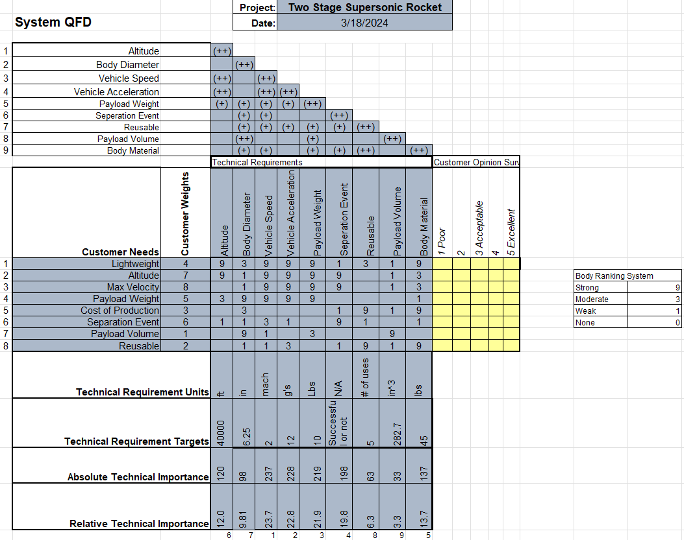
Figure 1: Quality Function deployment/ House of Quality

Research Within Your Design Space

Benchmarking
For our benchmarking we have three low to high end launch vehicles as our benchmarking of our vehicle. We want to compare our vehicle somewhere in between these three options.
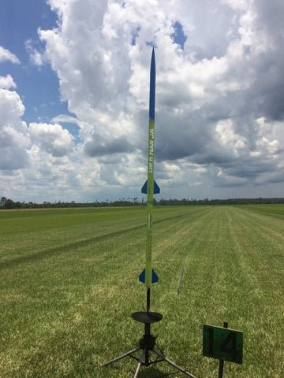
Figure 2: Wildman Jr Two-stage Rocket
The first benchmark is the Wildman Jr two stage rocket kit. This is a hobby kit that does not carry a payload but still has the functionality and performance of a two-stage rocket. This compares lower than where our launch vehicle is ranked between this.
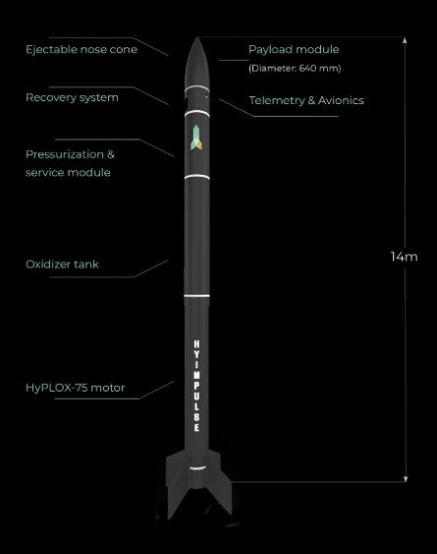
Figure 3: Hyimpulse Sounding Rocket
The second benchmark is the Hyimpulse sounding rocket. This is a medium sized sub-orbital vehicle. This is used for reaching beyond the Karmen line and into zero gravity weightlessness. This is a much bigger vehicle than ours and is used for the same purpose. The vehicle is a single stage rocket but still functions as a high altitude launch vehicle for running experiments. Our vehicle will be placed below this as our requirements are not designing a space launch rocket.
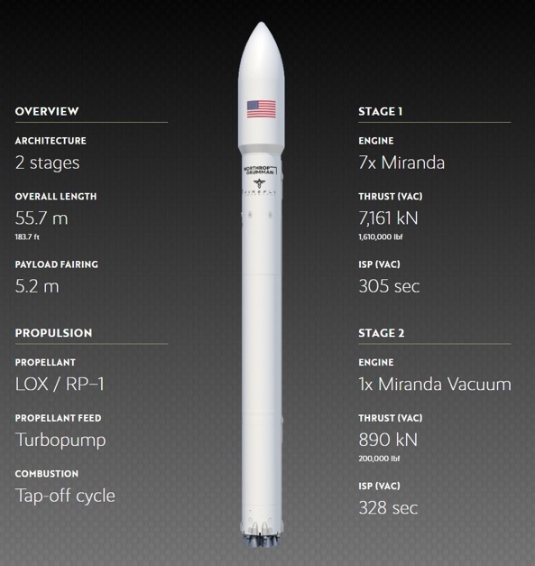
Figure 4: Northrop Grumman/ Firefly Medium Launch Vehicle
The final benchmark is the Northrop Grumman MLV. This is an orbital class launch vehicle. This vehicle is capable of delivering a payload into orbit around earth. We wanted to add this comparison to create the benchmark of where we are at. The comparison to an orbital launch vehicle ground the design aspects of our vehicle and where the complexity of all the benchmarks compare to each other.

Literature Review

Lindsey Dineyazhe
[1] "A - C F D - Applied Computational Fluid Dynamic Analysis of Thermal and Fluid Flow Over Space Shuttle Or Rocket Nose Cone"
A-CFD is a research project-based book that analyzes the thermal and fluid flow over the nose cone of hypersonic space shuttles. The book investigates the effect of shock waves on pressure, temperature, and other parameters. The optimization process is conducted to identify the best-suited shape of nose cones for best-suited hypersonic flight. This reference supports this project by conducting an analysis on thermal and fluid flow over a rocket nose cone to assess what kind of nose cone would be better able to withstand high temperatures that are generated from aerodynamic heating.
[2] "Rocket Flight Engineering"
This book discusses all components of rocketry, including many studies done to determine flight characteristics of rockets in differing conditions. Several sections of the book focus on rockets in supersonic flight. This reference benefits this project as it also goes into depth of nose cone design best for supersonic flight.
[3] “A review on computational drag analysis of rocket nose cone”
This article analyzes various shapes and characteristics of a rocket nose cone to minimize aerodynamic drag and heat generation during ascent. Different software programs, including Catia and Solid work, are used to design and analyze the nosecone's shape. Flow simulations are conducted to identify the most efficient nose profile with the least amount of drag at different Mach numbers.
[4] “NATIONAL ADVISORY COMMITTEE FOR AERONAUTICS INVESTIGATION OF THE DRAG OF VARIOUS AXIALLY SYMMETRIC NOSE SHAPES OF FINENESS RATIO 3 FOR MACH NUMBERS FROM 1.24 TO 7.4”
This report does an in-depth study of determining the nose cone drag for Mach numbers ranging from 1.24 to 7.4 with a fineness ratio of 3. Pressure-distribution measurements are also observed for the nose cone models. This report benefits the project as the rocket is expected to reach Mach 2 or higher and the best nose cone for this should be assessed.
[5] “Optimization Design of Rocket Nosecone for Achieving Desired Apogee by Empirical Research and Simulation-Based Comparison”
This paper focuses on using research and simulations to determine what aerodynamic rocket nose cone design allows for higher apogee results. An analysis of the effects of the nose cone material, size, and shape are done using OpenRocket software and Solidworks. This research benefits this project's design of the nose cone to allow the rocket to reach the desired altitude by minimizing drag.
[6] “Richard Nakka’s Experimental Rocketry Site”
This website consists of tons of information and resources for amateur experimental rocketry. It covers many terms and aspects of the design of almost every part of a rocket. This website is helpful for this project, especially for members with little to no rocketry experience, in the design process as most components will be made from scratch.
[7] “Nose Cone Tip Thermal Analysis - MIT Rocket Team - MIT Wiki Service”
This website performs a thermal analysis of a rocket nose cone tip. As the nose cone is the part of the rocket subjected to the most heat, it has potential for burning and damage when in flight. This analysis is important for the design of the nose cone in this project to avoid these damages.

3.2.2 Avery Charley
[8] “Fundamentals of Aerodynamics”
The book presented a basic analysis of the drag equation for an object in flight. However, our rocket will face supersonic conditions where analytical analysis is limited. Therefore, we have no choice but to rely on theories supported by experimental data gathered in supersonic conditions. The Drag Equation we used helped us to determine the amount of force needed to detach the first stage of the rocket through drag separation.

[9] “Hybrid Rocket Propulsion Design Handbook”
This chapter provides essential equations that are fundamental for rocket design and can be applied to various chemical propulsion systems. These equations cover important parameters such as thrust, characteristic velocity, specific and total impulse, and are accompanied by a summary table that clarifies their relationships. The chapter also explains the rocket equation and discusses aspects of staging.

[10] “Fundamentals of Rocket Propulsion”
I found this book to be very informative regarding the analytical aspect of multistage rockets. It provided an overview of the purpose of multistage, followed by the “Rocket Equation” which emphasizes the significance of achieving higher velocity during flight. However, the references mentioned in the book are specifically intended for large space rockets, whereas our application is much smaller and lighter. Despite this, the mathematical calculations and breakdown of the Rocket Equation provided in the book are still useful for our purposes.

[11] “Numerical Investigation on the Interaction between Rocket Jet and Supersonic Inflow”
This paper studies the interaction between a rocket jet and supersonic inflow through numerical simulation using the Navier-Stokes equations with a k-ω SST turbulence model. The results show that the nozzle inlet mass flow rate significantly affects the interaction, with low rates causing flow separation and shock train. In contrast, higher rates result in continuous gas expansion and more complex shocks downstream.

[12] “Effect of Silane Coupling Treatments on Mechanical Properties of Epoxy Based High-Strength Carbon Fiber Regular (2 x 2) Braided Fabric Composites.”
The study focused on enhancing the adhesion of carbon fiber-reinforced composites by modifying epoxy resin with 3-aminopropyltriethoxysilane (APTES) and 3-aminopropylmethyldimethoxysilane (APMDMS). Various concentrations of silane treatment were applied to the epoxy resin. Results indicated that APTES/APMDMS-treated epoxy/carbon braided composites at 0.5 wt% exhibited improvements in tensile and flexural strength, as well as tensile and flexural modulus. Impact testing revealed enhancements of 6.87% and 4.31% for 0.5 wt% APTES and APMDMS composites, respectively, compared to untreated ones.

[13] “Fins for Rocket Stability”
I've been looking for information on separation systems, but then I decided to broaden my search to rocket fin design. I found a website that was easy to navigate and provided a lot of helpful information. It explained the ideal lengths and number of fins to use, as well as the importance of having a low center of gravity for the rocket.

[14] “Exploring the different types of rocket staging – a comprehensive GUIDE,”
I chose this article as an overview of the staging process. It involves separating a rocket into stages, each with its own engine and fuel supply. Single-stage rockets are suitable for small payloads. Two-stage rockets are the most common and lift the rocket with better efficiency. Multistage rockets offer improved efficiency, payload capacity, and speeds, making them ideal for deep-space missions. Each type shapes space exploration as technology evolves.

[15] “Low Shock Payload Separation System”
This report was created for a previous capstone project, and it provides a detailed overview of the magnetic separation system that was designed for a significantly larger fuselage. Since the client had worked with the former team, I was able to outline the concept of the separation system based on the previously tested product. However, the main challenge is to streamline the parameters to align with our current project.

3.2.3 Austin Paothatat
[16] “Rocket Propulsion.”
Basic rocket design textbook goes into the fundamentals of rocket science and how they work. We will utilize this to cover our basis on the theory of rocket propulsion and motion. The main topics that we would use are staging and the rocket equation.

[17] “The flight of uncontrolled rockets.”
The book covers the uncontrolled flight events of rockets. It describes the aerodynamics affects, rotational motion, and what calculations are needed to predict the trajectory which will further help us in creating our Matlab simulation code.

[18] “Aerodynamics and flow characterization of multistage rockets,”
Aerodynamics of our two-stage flight is going to be important to maximize the boost stage to get us to our requirements. The 2nd stage fin flow will affect our booster stage fins aerodynamics and will need to account and model to see the effects this will have depending on our fin design and locations.

[19] “Multidisciplinary optimization of single-stage sounding rockets using solid propulsion”
The second stage will require optimization to reach our flight requirements of the second stage. Although this paper is directed toward a space shot rocket, we can use this to optimize our design within the same Mach speed regime and design for even higher altitudes for future flights.

[20] “Multistage 2-DOF Rocket Trajectory Simulation Program for Freshmen Level Engineering Students,”
The paper covers a Matlab code that students use to predict flight trajectories within a certain accuracy. We will be required to create our own version of this to predict the trajectory of our rocket. This will be a great reference into the coding and what analysis is used to create methods like Eulers and Runge-Kutta. We will use this code to also plot our flight in a google map and find the possible landing locations of the vehicle.

[21] “Glenn Research Center,”
Glenn Reasearch Center is a website that covers design aspects of rockets and other related physics problems. This will be a good resource to use as baseline calculations are made. Overall source for fundamental rocketry and physics.

[22] “Preliminary design and test of high altitude two-stage rockets in New Zealand,”
This document describes the development of a high-altitude rocket design by students at the University of Canterbury. The document covers the entire vehicle design from propulsion, staging, and recovery of their system and the floatation device used to recover in a body of water. This is a similar project in terms of physical vehicle design but ours is at a much lower altitude.

3.2.4 Koi Quiver
[23] “Viscous hypersonic flow: theory of reacting and hypersonic boundary layers.”
This book relates to the project overall by providing information of effects of the air at turbulent flows. The book supplies specific information specifically for calculating the coefficient of skin friction, boundary layer, etc. as the air is turbulent. The book also provides all the same information for the flow of air being laminar. The rocket will really have a main effect of skin friction drag and a little pressure difference drag with the design we have chosen.

[24] “Rocket Propulsion Elements"
This book provides information on the basics of rocketry and rocket propulsion. This provides a good sense of base knowledge pertaining to the project and how to go about calculating forces on the rocket. If the team needs to do any calculations on nozzles, this book has information on how to calculate it for certain nozzles.

[25] “A REVIEW ON NOSE CONE DESIGNS FOR DIFFERENT FLIGHT REGIMES”
This paper provides knowledge on how different nose cones designs react to supersonic flight. The main calculation the paper provides is the total nose cone drag. Which is an aspect of drag that needs to be calculated for our vehicle. The paper provides information on the nose cone design we decided to use for the overall design. This paper helps greatly with what is happening with understanding how supersonic air flows around our nose cone.

[26] “CONCEPTUAL DESIGN AND ANALYSIS OF TWO STAGE SOUNDING ROCKET,”
This paper provides information on two staging rockets and how air flows around different designs of the body. The paper graphs the effects of temperature vs the altitude, along with drag coefficient and drag force vs the Mach number. This provides a representation of what our rocket’s drag forces and coefficient if the bodies are similar. The paper also provides the basic formulas the authors used to help guide the team's thinking.

[27] “Engineering Toolbox”
This site is a resource used to sometimes find values of certain variables or research information on certain methods. Used for research and reminders of general engineering knowledge. I have used this to find the value of the drag coefficient for a certain situation. Can also use it to find different drag coefficients.

[28] "Multi-objective optimization of a fin shape for a passive supersonic rocket stage"
This document provides information and a baseline of how to calculate the drag of rocket fins at supersonic flight. It provides the research of the IEEE organization. The document provides multiple coefficients of drag for geometries that have already been determined but are like the fin geometry the team has chosen.

[29] “Skin-Friction and Forced Convection from Rough and Smooth Plates”
This paper provides information on how to potentially calculate the skin friction of a surface, in this case the body of our rocket is going to be constructed completely out of carbon fiber and most likely surfaced with epoxy. If we cannot find a general skin friction coefficient for the surface, then we would have to calculate our own. This paper would help and provide information on how to do that. If we need to change the material, then we could recalculate the skin friction of the surface.
[30] “What is the best Fin shape for a model rocket”
This is a newsletter article from the company Apogee components. The contents of the article are talking about the best designs for rockets. They have elliptical, rectangular, trapezoidal, etc. Designs and provide some general drag force calculations for each design and at a certain angle of attack.
[31] “Laminar Composites”
This is a textbook that has to do with working with composites in aerospace applications. The specific airflow applications in this textbook are all laminar flow cases. The book does not have to do with turbulent flow, which is the type of airflow the vehicle will be in, but the layup of the carbon fiber is the information that most pertains to the project.
[32] “Mechanics of Composite Stuctures”
This is a textbook that has to do with how composites in certain structure forms will react to forces. This will help make most of the vehicle's parts. The book will also help when the team decides to do testing on layers of carbon fiber to see how much stress can be put on the vehicle.

Mathematical Modeling

Nose Cone – Lindsey Dineyazhe
An important aspect of the nose cone is its ability to withstand extremely high stagnation point temperatures of a high altitude, supersonic flight. To ensure that the nose cone does not take any damage from the heat, an analysis of the stagnation temperature on it must be done. The stagnation temperature should not exceed the melting point of the material of the nose cone. The following Equation (1) will be used to calculate the stagnation temperature in K, Kelvin:
$T_{stag}=T_{s}\left(1+\frac{λ-1}{2}⋅Ma^{2}\right)$ [1]
where TS is the static temperature at a given altitude in K, is the specific heat ratio for air valued as a constant of 1.4, and Ma is the Mach number to be reached. For this analysis the minimum desired altitude of 40,000 ft and Mach number 2 will be used. The static temperature at this altitude would approximately be 215 K. Inserting these values into Equation (1) gives us a stagnation point temperature of 387 K. This means the melting point of the material of the nose cone, at a minimum, would need to be well below this temperature.
Another crucial aspect of the nose cone is the fineness ratio. The fineness ratio is the ratio of the length of the nose cone body to its maximum diameter as seen in Equation (2). An increase in this ratio would help to reduce the wave drag coefficient affecting the nose cone, but it can also increase the skin friction drag as a result of more exposed surface area. Generally, a high fineness ratio is desired for supersonic speeds, approximately 5:1. Anything above this would hardly reduce wave drag and only increase friction drag.
$Fineness ratio=\frac{L}{D}=L:D$ [2]
In Equation (2), L is the length of the nose cone in inches and D is the maximum diameter at the base of the nose cone also in inches. Using the currently set diameter of the rocket body, 6.25 inches, as the base diameter of the nose cone, the equation above is adjusted to find an acceptable nose cone length to achieve a fineness ratio of 5:1. The nose cone would need to be 31.25 inches in length for the desired fineness ratio.

Rocksim Simulations – Austin Paothatat
Below is an updated simulation model for our final concept selection design. With this we have narrowed down the rocket motor selection to only a few choices that are commercially available. Utilizing Rocksim we have optimized the current design to reach or arrive close to our customer requirements. Overcoming the drag of the launch vehicle we made the choice to move into level 3 rocket motors. Both motors will be within the N Class impulse of rocket motors. Below in Table 2, these are the preliminary motor choices we have within the simulation and in Figure 5, these are the parameters we are currently meeting with the design.
With the diameter of the rocket, we are finding that the commercially available motors are not reaching our altitude goal and we are just below our velocity requirement. More work will be required to optimize the design further to meet the requirements. With the motors that are available to us, we are limited in reaching our altitude goal without pushing budget boundaries with a custom motor.

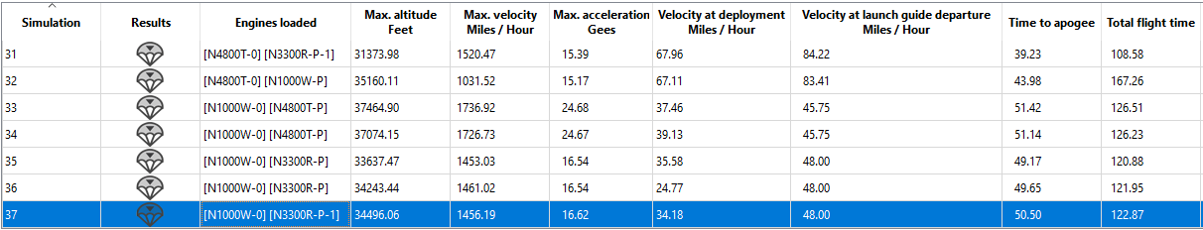Figure 5: Rocksim Table of Flight Data for single stage

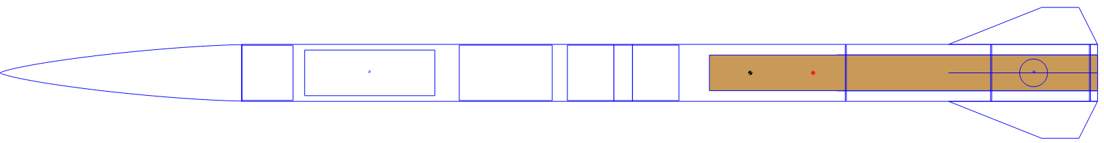Figure 6: Rocksim Sustainer Concept vehicle

Figure 7: Rocksim Full Concept vehicle

Rocket Motor Selections
Preliminary Motor Choice Specifications
Motor | Total Impulse (N-s) | Total Mass (Grams) | Burn Time (Seconds) | Propellant Mass (Grams)
N1000W  (Booster) | 14,126 | 12,771 | 13.1 | 8,293
N3300R  (Sustainer) | 14,041 | 12,054 | 4.4 | 7,512
Table 2: Preliminary Motor Choices

3.3.4 Separation System- Avery Charley
Multistage is a process that is essential in achieving higher velocities without requiring an excessively large motor. However, to achieve this objective, it's important to establish an efficient connection between the stages and ensure impeccable timing during the disconnection process. This synchronization is crucial to optimize propulsion efficiency and maintain trajectory integrity. As a result, the primary focus shifts towards engineering the necessary structural robustness to withstand the intense forces acting upon the vehicle during both the unity and separation phases.
As the rocket accelerates and transitions into supersonic speeds, traditional analytical methods encounter limitations in accurately predicting the diverse levels of drag it will encounter. To address this challenge and estimate the drag forces necessary for stage separation, we turn to the Drag Equation tailored for incompressible speeds.
$F_{d}=\frac{1}{2}ρV^{2}C_{d}A_{cyl}$ [3]
In addition, the Parasitic Drag Equation and weight of the stages will help in finding the total drag force.
$F_{f}=\frac{1}{2}ρV^{2}C_{f}A_{SA}$ [4]
$W=m∙g$ [5]
The team expected to achieve a velocity under Mach 1 (which is equivalent to 630.67 ft/s) at an altitude of around 9,500—10,000 feet. The next step was understanding the value for our Coefficient of Drag ($C_{d}$), which was different from various sources that rockets usually have a Coefficient of Drag (Cd) ranging from 0.75 to 0.89, so I chose the value of 0.85 for my analysis. Obtaining accurate values for parasitic drag on carbon fiber proved to be challenging due to conflicting information from various sources and different versions of the material. However, after thorough research, I managed to find a reliable source that provided the value of 0.3 [30]. Using the dimensions and weight obtained from Austin's RockSim simulations, I calculated the total drag force on the Upper Stage to be 1679.61 lb and the Booster Stage to be 870.77 lb. These values account for the parasitic drag induced by both stages. While these are large forces to overcome for the separation system, I will be assuming the rockets thrust will carry the separation system without straining it during flight until separation.
Booster Stage Aerodynamics Calculations:
$$F_{f}=\frac{1}{2}ρV^{2}C_{f}A_{SA}$$
$$F_{fb}=\frac{1}{2}\left(17.8×{10}^{-4}\frac{slugs}{ft^{3}}\right){\left(630.67\frac{ft}{s}\right)}^{2}\left(0.3\right)\left(8.077 ft^{2}\right)=857.760 lbf$$
$$W_{b}=m∙g=0.402 slugs∙32.2\frac{ft}{s^{2}}=13.01 lbf$$
$$F_{total}=F_{fb}+W_{b}=857.760 lbf+13.01 lbf=870.77 lbf$$
Upper Stage (2nd Stage) Aerodynamic Calculations:
$$F_{f}=\frac{1}{2}ρV^{2}C_{f}A_{SA}$$
$$F_{fU}=\frac{1}{2}\left(17.8×{10}^{-4}\frac{slugs}{ft^{3}}\right){\left(630.67\frac{ft}{s}\right)}^{2}\left(0.85\right)\left(0.20 ft^{2}\right)=60.179 lbf$$
$$W_{b}=m∙g=1.507 slugs∙32.2\frac{ft}{s^{2}}=48.53 lbf$$
$$F_{dU}=\frac{1}{2}\left(17.8×{10}^{-4}\frac{slugs}{ft^{3}}\right){\left(630.67\frac{ft}{s}\right)}^{2}\left(0.3\right)\left(14.942 ft^{2}\right)=1586.808 lbf$$
$$F_{total}=F_{fb}+W_{b}+F_{dU}=60.179 lbf+48.53 lbf+1586.808=1679.61 lbf$$
It's worth noting that the Upper Stage of a rocket experiences a significantly greater drag force than the lower stage, primarily due to the size difference between the two. This means that when calculating the total drag on the rocket, it's safe to assume that the Upper Stage will bear the brunt of the Induced Drag, while the Booster Stage will experience more of the Parasitic Drag. Taking these factors into account is crucial for accurate calculations and successful rocket design.
Unfortunately, due to recent events, the separation system is now a protected design under Northrop Grumman Space Systems, Launch Vehicles Division. No technical data, visuals, or prototypes will be displayed or discussed in this report.
3.3.5 Fin drag – Koi Quiver
At supersonic flights the drag from the fin would have a larger affect than the vehicle fins being at subsonic flight. For the first part of analysis, I calculated the rocket fin drag. I calculated for a single fin and then multiplied that force by the number of fins to get the total drag force from the fins. There were some assumptions made to get certain numbers to get an accurate calculation.
The assumptions made were Coefficient of a flat plate at turbulent flow, density of air at 20,000ft elevation, and a little bit of error due to air compressibility at Mach 2. The variables are:
- $v$ = 686 $\frac{m}{s}$
- $C_{d}$ = 0.005
- $A$ = 0.01677 $m^{2}$
- $P$ = 0.0880349 $\frac{kg}{m^{3}}$
The formula used to calculate the drag for is:
$D=\frac{1}{2}ρv^{2}C_{d}A$ [6]
The calculated drag of one fin of the vehicle is 1.74 N or 0.390 lbf. To account for the total drag force was calculated to be 13.9 N or 3.12 lbf.

Design Concepts

Functional Decomposition
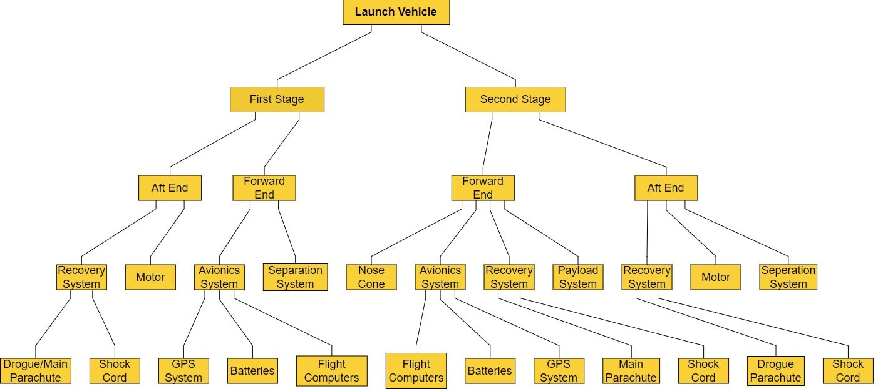
Figure 8: Functional decomposition chart

Above in Figure 8 is our functional decomposition chart that visually displays our flow of components into subsystems and into the final launch vehicle configuration. We will utilize this in our design process as we come to create drawings for all subsystems and components.
We can use the chart to organize our drawings from a top-level assembly of the launch vehicle and flow from the single components to create subassembly drawings including systems like avionics, recovery, and separation systems. We will build on this chart to include drawing names, part numbers and where they will flow into. Keeping the CAD and drawings organized will allow us to easily find them and see what we have completed so far.
The chart will also be utilized to create our testing, and mechanical assembly procedures. This will allow us to compare where the flow will need to stem from and how our assembly will be step by step of components, subsystems, and final launch vehicle. Procedures and testing will benefit us when we are preparing to assemble and launch the vehicle.

Concept Generation
All photos of concepts are in Appendix A
4.2.1 Avionics
The avionics system will house all flight computers that record our data and control recovery energetics. These are planned to be the raven blue Feather Weight altimeters. These systems will be redundant on both the booster stage and 2nd stage. The concepts below cover the type of recovery system the avionics will be used with.
Concept 1: Single deployment both stages no drogue/Streamer [A1]
Single Deployment- Both stages will house one main parachute that will be deployed at a predetermined low altitude (around 500ft AGL). The vehicle will have one separation event deploying the drogue/streamer at apogee and there will be a system to deploy the main parachute from the deployment bag.
Concept 2: Dual deployment both stages [A2]
Dual deployment- The vehicle will have two events; The first event will be the drogue parachute deployment. This event will happen at or near the apogee of the stages. The vehicle will fall under the drogue parachute until the next event that will deploy the main parachute at a predetermined altitude.
Concept 3: Single deployment 2nd stage and Dual deployment booster stage [A3]
Single/dual deployment- This style will utilize the A1 and A2 recovery systems. The single will be on the 2nd stage and the dual on the booster stage.
Concept 4: Dual deployment 2nd stage and Single deployment booster stage [A4]
Single/dual deployment- This style will utilize the A1 and A2 recovery systems. The dual will be on the 2nd stage and the single on the booster stage. Single on the booster makes a much less complex system and allows for lighter weight boost stage to maximize performance.
Concept 5: Single deployment both stages drogue/Streamer [A5]
Single deployment- This style will utilize the A1 and A2 recovery systems. The single deployment will be in both stages. This is the same concept as A1 but will use a drogue or streamer during the descent until the main parachute is deployed.

4.2.2 Separation Systems
Concept 1: Flanged Drag Separation [B1]
I came up with an idea while studying the various ways to separate a two-stage rocket. The concept is based on a technique called "Drag Separation," where the pressure drag from the vehicle pulls off the empty first stage. The drawing illustrates a wider flange with a slightly larger diameter at the top of the rocket. This should help the separation forces remove the first stage more effectively. The con of this design is the possibility the separation will not happen due to a snug fit between the two bodies.
Concept 2: Cupped Separation with Boat Tail [B2]
This variation of the concept involves drag separation technique, but with a different approach. Unlike the traditional method where the upper body cups the lower body, this approach has the lower body cupping the upper body with little to no resistance when separating. To ensure the upper body doesn't fall off easily, the lower half will require a secure mechanism. Adding a boat tail to the end of the rocket has been mentioned by multiple sources as an advantage of this design. This addition increases the overall speed during flight and provides additional performance values. However, the disadvantage of this design is the lack of structural support between the upper and lower body.
Concept 3: Universal Separation [B3]
This concept is the standard for drag separation in all model rockets large and small. The inner tube has a small decrease in diameter to fit the upper body securely. The pros of this design are the universal acceptance of this method, and the con is the lack of performance improvements.
Concept 4: Twist Lock Separation [B4]
The idea behind this concept comes from a twist-off jar. The indentations on the inner design will securely lock the two bodies together while the 3 springs on the inside are strained to the unlock position. The pro of this design is the locking connection between the two bodies. However, the con of the design is the same as the pro, the twist motion could send the rocket flying in the opposite direction. IN addition, the springs could not have enough force to separate the two bodies.
Concept 5: N/A

4.2.3 Body Design
The concept generation of the body design parameters were two-stages, payload bay, basic aerodynamic understanding, and a few extra parameters. All these rocket bodies would be constructed with carbon fiber, so the construction method would be laying layers of material.
Concept 1: Different Diameter Two-Stage Body [C1]
This concept was designed with the idea that the two stages have different diameters. The first stage, the bottom stage, having a larger diameter than the second stage, the upper stage. The reason the first stage was larger was for drag when it is time for the first stage to separate from the second stage, which was also to house the motor and have space for extra devices in the future for the first stage. This concept was also inspired by the large rockets built by NASA in the past. The first stage being larger was also to house a larger motor if needed.
Concept 2: Uniform Diameter Two-Stage Body [C2]
This concept was designed to have a uniform diameter all the way down the rocket for simplicity of construction, ease of aerodynamic capability, and strength of the body. There is uniform force at every point on the walls of the vehicle and no complexity of stress calculations. This is the simplest design for both the first and second stage of the vehicle. Least amount of drag over the body of the rocket.
Concept 3: Payload Bay Mid-Body Bulge Two-Stage Body [C3]
This concept was designed with the intention to minimize nose cone drag, less material need in construction, and still achieve the wanted payload bay inner diameter. The downside of this concept is the construction of the bulge would be difficult as the bulge has a nonlinear diameter change due to trying to decrease the drag around the payload bay. The bulge would create more drag as the air would have to go around creating a higher presser change. The rest of the body diameter would also be minimal, wide enough to fit the motors.
Concept 4: Front Payload Bay Bulge Two-Stage Body [C4]
This concept was designed like concept C3 but to achieve the payload bay diameter with the least amount of drag, the payload bay would be moved to right behind the nose cone. This is so there is only one diameter change over the body, still creating drag but not as much as concept C3. This would also complicate the construction of the overall body as the diameter change is nonlinear. The rest of the body would be minimal diameter to try and eliminate some of the drag around the body.
Concept 5: Atom Bomb style Two-Stage Body [C5]
This concept was designed with the idea of 1940’s era bombs. The second stage, the upper stage, of the vehicle was designed to reduce drag around the payload bay's bulge. The first stage of the vehicle had a minimum diameter to fit the rocket motor and attempt to reduce drag. The concept will still result in more drag than concept C2.

4.2.4 Fin Design
Concept 1: Trapezoidal Rocket Fin [D1]
This concept was designed to maximize area but attempt to reduce drag the further out from the body the fin gets. The trapezoidal design is a common fin used by many similar designs. The straight lines of the fin are there to minimize the development heat on the rocket fin.
Concept 2: Arrow Fin Style Rocket Fin [D2]
This concept was designed to allow for better air flow around the fin. The area of the fin would result in the vehicle being less stable as it travels through the air.
Concept 3: Body bonded Rocket Fin [D3]
The concept was designed to have a method to bond a rocket fin to the outside of the body if a minimal diameter rocket body is used. This would require a type of adhesive and the base of the fin to have the same curvature as the rocket body.
Concept 4: Boat Fin Style Rocket Fin [D4]
The concept was designed to ease the airflow around the rocket fin and increase the area more than concept D2. Like a boat fin.
Concept 5: Classic Style Rocket Fin [D5]
This concept was designed to have a large area and not create as much heat as the rounded rocket fins at supersonic flight. This rocket fin was modeled after the rocket fins of the 50’s and 60’s.

4.2.5 Nose Cone
Concept 1: Tangent Ogive [E1]
The Tangent Ogive concept is the formation of a part of a circle where the base lies on the radius of the circle and is tangent to the rocket’s body. This profile shape is also can be easily constructed as the circle’s segment can just be drawn using a compass. The radius of the circle that forms this profile is related to the wanted length and base radius of the nose cone.
Concept 2: ½ Power [E2]
The ½ Power concept is part of a power series of parabolic nose cone shapes, characterized by a blunt tip. The ½ is the ‘n’ factor that controls the bluntness of the nose. The base of this shape is also not tangent to the rocket’s body, which can affect its aerodynamic, but can be modified to smooth the discontinuity.
Concept 3: Conical [E3]
The conical concept is a common and simple nose cone shape. The sides of the cone are straight lines coming to a point, making it the easiest cone to manufacturer. Its ease of manufacturing allows for accurate measurements and a faster build. However, the hard transition from the base of this type of nose cone to the rocket's body can increase drag.
Concept 4: Ellipsoid [E4]
The Ellipsoid concept consists of a half of an ellipsoid profile shape rotated about its major axis. Its blunt tip and tangent base are ideal for subsonic flight; however, it may not be ideal for supersonic flight.
Concept 5: Von Karman [E5]
The Von Karman concept is a nose cone shape mathematically derived to achieve minimum drag, rather than use of geometric shapes. It originates from the Haack series shapes where the shape of the cone is determined by C in the following equation:
$y=\frac{R\sqrt{θ-\frac{\sin\left(2θ\right)}{2}+C\sin^{3}{}θ}}{\sqrt{π}}$ [7]
$θ=\cos^{-1}\left(1-\frac{2x}{L}\right)$
For the Von Karman C=0, R is the nose cone base radius, and L is the length of the nose cone. Although the base for this shape is also not tangent to the body, the discontinuity is minimal, and has almost no effect on the drag.

4.2.6 Internal Rocket Layout
The rocket's interior will consist of a main parachute, a drogue parachute, avionics/electronics, two motors, and the payload. While there will be parachutes, avionics, and a motor for each stage in the rocket, the payload bay should be within the second stage only, so as to remain within the rocket after separation. The layout of these components in each stage is considered.
Concept 1: Payload Bay in the Nose Cone [F1]
This concept places the payload bay within the nose cone and where the avionics bay in each stage is placed between the parachute bays.
Concept 2: Payload Bay with Drogue Bay [F2]
This concept places the payload bay with the drogue bay in the second stage.
Concept 3: Payload Bay After Nose Cone [F3]
This concept places the payload bay right after the nose cone.
Concept 4: Payload Bay with Avionics Bay [F4]
This concept places the payload bay with the avionics bay after the nose cone rather than in between the parachute bays.
Concept 5: Payload Bay Between Parachute Bays [F5]
This concept places the payload bay between the parachute bays while the avionics bay is placed with the drogue bay.

Selection Criteria
The selection criteria for the concept selection were:
- Vehicle Speed
- Vehicle Acceleration
- Payload Weight
- Separation Event
- Body Material
- Altitude
- Body Diameter
- Reusable
- Payload volume

The selection criteria when the team did the selection process were rated as seen above. Any concept that leads to the best vehicle speed was the overall best determiner if the concept was best for the design. All the selection criteria were taken from QFD since the importance of the selection criteria and the reasoning we were looking for certain design decisions were already sorted. All the selection criteria have the ability to have calculations and mathematical reasoning behind why the concept was chosen.

Concept Selection
4.4.1 Morphological Matrix and Designs
The concepts for each of the subsystems are placed in a morphological matrix seen in Figure 9. From this matrix six differing full body designs are made using various concepts. Each design is pitted against each other in the following chart and matrix to narrow down to the best final design.

Subsystem | 1 | 2 | 3 | 4 | 5
Avionics | A1  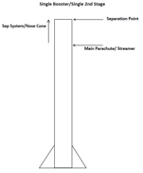 | A2  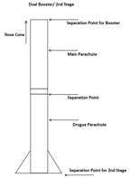 | A3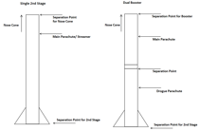 | A4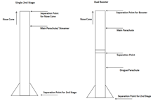 | A5  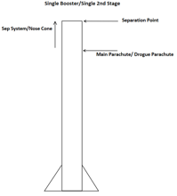
Separation System | B1  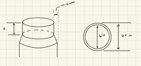 | B2  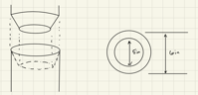 | B3  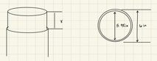 | B4  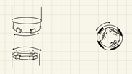 | B5
Body Design | C1  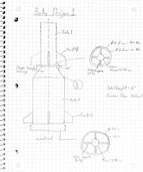 | C2  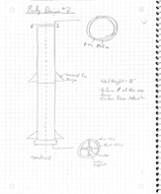 | C3  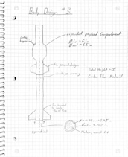 | C4  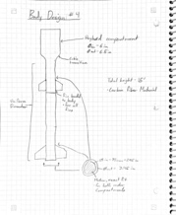 | C5  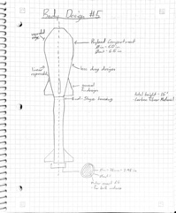
Fin Design | D1  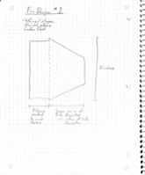 | D2  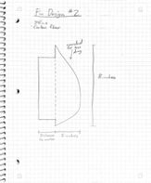 | D3  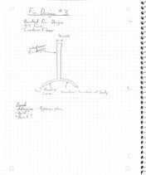 | D4  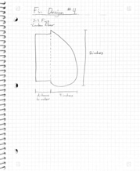 | D5  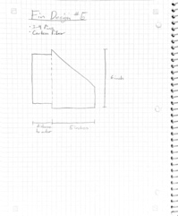
Nose cone | E1  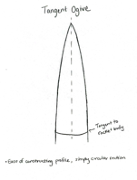 | E2  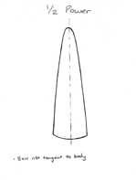 | E3  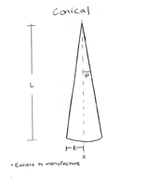 | E4  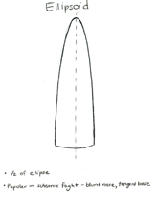 | E5  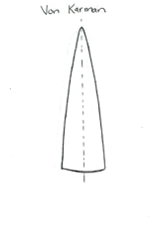
Rocket Layout | F1  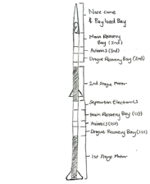 | F2  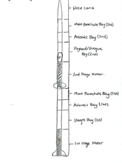 | F3  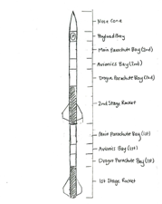 | F4  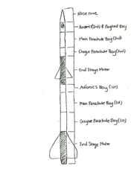 | F5  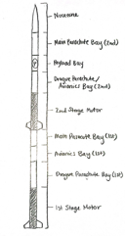
Figure 9: Morphological Matrix

Design 1
Components: A3, B1, C1, D4, E2, F4
Description: Single deployment 2nd stage and Dual deployment booster stage, Flanged Drag Separation, Different Diameter Two-Stage Body, Boat Fin Style Rocket Fin, ½ Power Nose Cone, Payload Bay with Avionics Bay
Design 2
Components: A1, C2, D1, E5, F5
Description: Single deployment both stages no drogue/Streamer, Uniform Diameter Two-Stage Body, Trapezoidal Rocket Fin, Von Karman Nose Cone, Payload Bay Between Parachute Bays
Design 3
Components: A5, B4, C5, D3, E4, F1
Description: Single deployment both stages drogue/Streamer, Twist Lock Separation, Atom Bomb Two-Stage Body, Body bonded Rocket Fin, Ellipsoid Nose Cone, Payload Bay in the Nose Cone
Design 4
Components: A4, B3, C4, D2, E1, F3
Description: Dual deployment 2nd stage and Single deployment booster stage, Universal Separation, Front Payload Bay Bulge Two-Stage Body, Arrow Fin Style Rocket Fin, Tangent Ogive Nose Cone, Payload Bay After Nose Cone
Design 5
Components: A1, C1, D5, E5, F5
Description: Single deployment both stages no drogue/Streamer, Different Diameter Two-Stage Body, Classic Style Rocket Fin, Von Karman Nose Cone, Payload Bay Between Parachute Bays
Design 6 (Datum)
Components: A2, B2, C3, D5, E3, F2
Description: Dual deployment both stages, Cupped Separation with Boat Tail, Payload Bay Mid-Body Bulge Two-Stage Body, Classic Style Rocket Fin, Conical Nose Cone, Payload Bay with Drogue Bay. This design was designated as the datum, meaning its abilities to meet the listed concept criteria were neither exceptionally nor poorly executed.

4.4.2 Pugh Chart
After creating the six designs, they were evaluated in a Pugh Chart. Based on the design criteria, the other five concepts were assessed in relation to the datum. The Pugh Chart is shown in Figure 10 below.

Concept  Criteria | Design 1 | Design 2  X | Design 3 | Design 4  X | Design 5  X | Design 6
Max Velocity | - (wide body, more drag) | + (aerodynamic) | - (high drag force) | S | S | datum
Separation Event | S | + | S | + | + | datum
Payload Capacity | -(unstable) | +(stable) | S | S | - | datum
Altitude | - | +(max velocity | - | S | S | datum
Lightweight | -(wide body) | +(less material) | - | S | - | datum
Cost of Production | -(more material) | +(less material) | - | S | - | datum
Reusable | S | S | S | S | S | datum
Payload Volume | - | - | + | S | - | datum
∑+ | 0 | 6 | 1 | 1 | 1 | N/A
∑- | 6 | 1 | 4 | 0 | 4 | N/A
∑s | 2 | 2 | 3 | 7 | 3 | N/A
Figure 10: Pugh Chart
All five designs were scored relative to the datum where + is meets the criteria more than the datum, - is meets the criteria less than the datum, and S is the same or equivalent as the datum. All the symbols were then tallied and the three designs that consisted of the least -’s were Designs 2,4 and 5.

4.4.3 Decision Matrix

The three concepts chosen from above are then quantitatively compared against the design criteria. This comparison was conducted using a Decision Matrix seen in Figure 11 below. Scaled-up versions of the three designs evaluated can be seen in Appendix B.

Criterion | Weight | Design 2  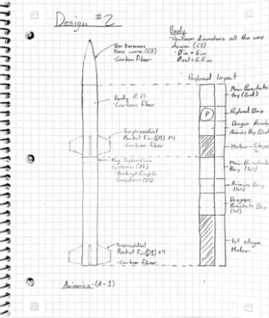 |  | Design 4  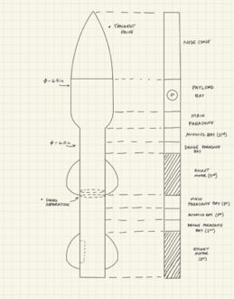 |  | Design 5  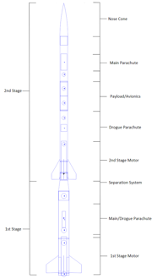
Criterion | Weight | Un-weighted score | Weighted score | Un-weighted score | Weighted score | Un-weighted score | Weighted score
Max Velocity | 30% | 100 | 30 | 90 | 27 | 95 | 28.5
Separation Event | 0%
Altitude | 25% | 100 | 25 | 90 | 22.5 | 95 | 23.75
Payload Weight
Lightweight | 15% | 85 | 12.75 | 70 | 10.5 | 80 | 12
Cost of Production | 15% | 95 | 14.25 | 75 | 11.25 | 90 | 13.5
Reusable | 10% | 95 | 9.5 | 95 | 9.5 | 95 | 9.5
Payload Volume | 5%
Total | 100% | Sum: | 91.5 | Sum: | 80.75 | Sum: | 87.25
Figure 11: Decision Matrix
Each criterion was weighted based on importance to the customer and engineering requirements. The designs were scored unweighted and weighted then summed up. The design that scored the highest in most criteria and overall was Design 2.

4.4.4 Final Design

Design 2 from above became the team’s current final design. A rough depiction of this design was created in SolidWorks and shown in Figure 12 below. The benefits of this design include a balanced weight distribution, a simple aerodynamic body, simplified avionics and recovery systems, ease of manufacturability, and best performance.

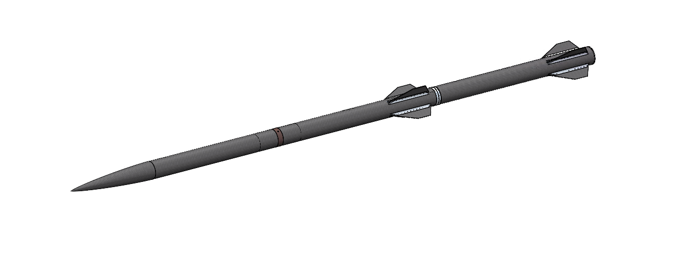
Figure 12: Final CAD Design

Schedule and Budget

Schedule
Below is the schedule breakdown for the first semester of the NG Supersonic Rocket project. As you can see there are only 3 stages shown, due to the filling out of the Gnatt chart the first stage was accidentally deleted or turned into stage 2. Stage 1 was just the start of the whole project; most of the semester schedule and deliverables are in stages 2 and 3. As shown by the Gantt chart below most of the team assignments this semester was the Client Meetings, Staff/Team meetings, reports, and presentations. Reports and presentations were broken down into more manageable pieces for the team to complete individually.
The objectives each team member completed were tailored to the skills the student has and what role the student plays on the team. Avery took lead of all the objectives that pertained to the separation system, website, and parts of the team financing. Avery is also the lead materials engineer on the team, his analysis of FEA is why he is the main materials engineer for the vehicle. Lindsey took the lead on the Nose cone, budget, and fundraising efforts. Lindsey is also doing the heat analysis for certain parts of the vehicle. Austin is the Project Manager of the team and also the lead vehicle simulation engineer. Austin has been working with RockSim to simulate the fight of the rocket. All his tasks have been based off of his role as shown below. Koi is the lead taking the lead as CAD engineer, body, and aero engineer for the project. Most of his tasks were based around his role and his analysis will be a general CFD model of the rocket.
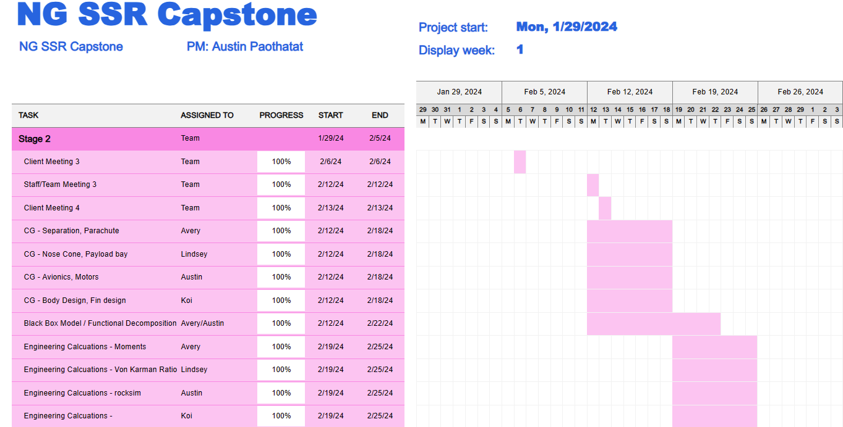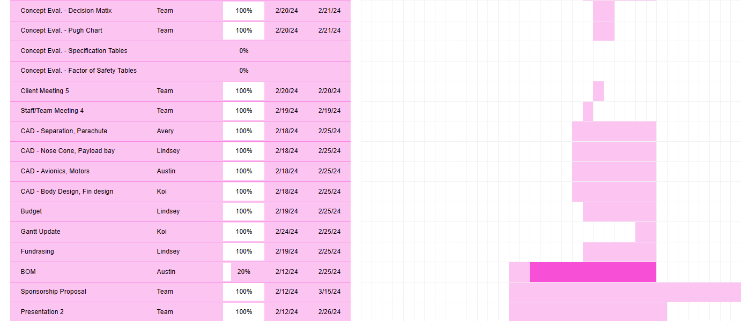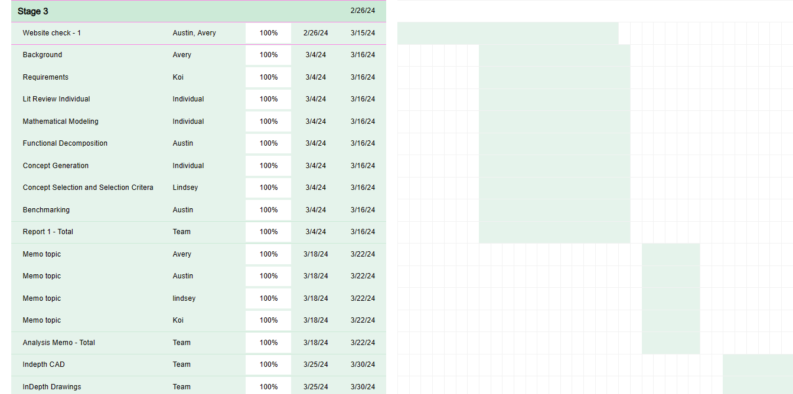
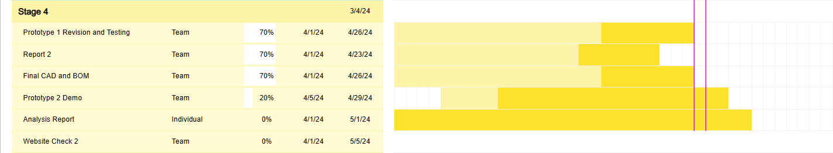Figure 13: Spring 2024 Schedule

The current draft of the fall 2024 capstone semester is below. This schedule is based off the tenative schedule the current capstone instructor has shared. As shown below, most of the tasks and assignments are team assignments, until the team gets closer to this semester the more the Gantt chart will populate. All of the team assignments and deliverables are in the current draft of the second semester all the way to the end of the fall 2024 semester.

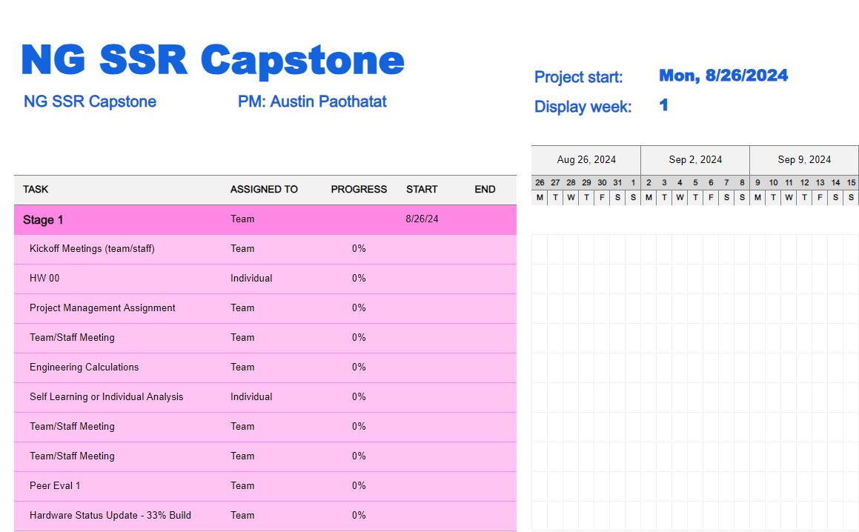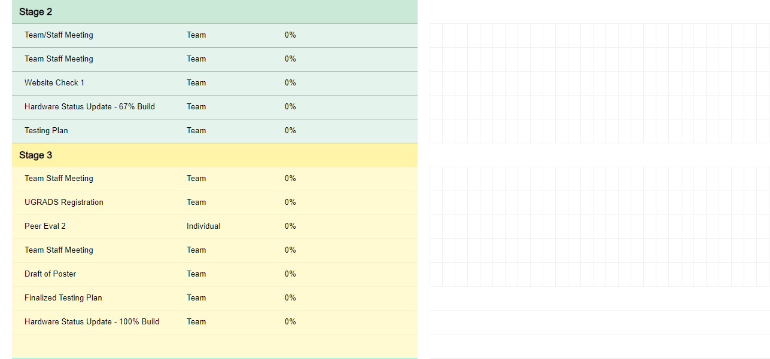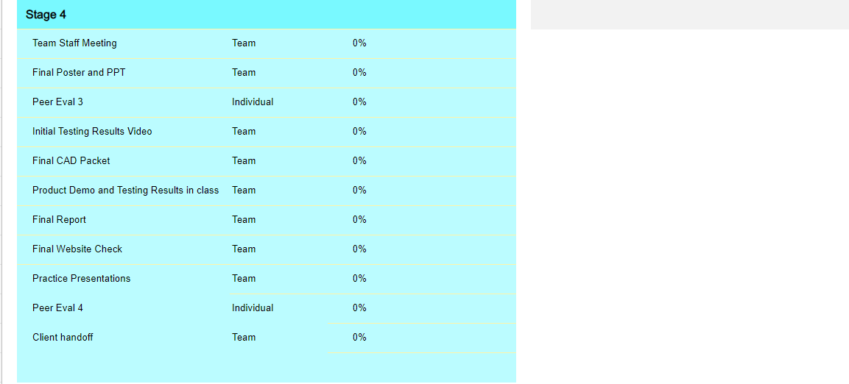
Figure 14: Fall 2024 Schedule Draft

Budget
The budget for this project is dependent on the funding obtained from our client, Northrop Grumman, and the team fundraising. Fundraising was accomplished through a GoFundMe webpage and direct family/friend donations. Further fundraising is expected to take place over the summer break. Prototyping purchases made, in addition to the current anticipated final build expenses, are outlined in section 5.3 Bill of Materials (BoM). There are no anticipated travel expenses included in the budget at the moment, as further discussion will be forthcoming regarding personal travel expenses related to the project. A rundown of the total budget to date is depicted in Table 3 below.

Table 3: Project Budget and Funding
Description | Funding | Expenses
NRG Funding | $7,000 | -
Fundraising | $838.81 | -
Prototyping | - | $80.31
Final Design Build | - | ~$6,967.39
Travel | - | N/A
Total | $7,838.81 | ~$7,047.70

Bill of Materials (BoM)
The Bill of Materials below uses a simplified design. The team will manufacture most of the body, and the motors will be purchased due to their complexity. The BOM below is for the major components of the design. That way there is no cluttering with all the extra small parts.

Table 4: Project Bill of Materials
Two-Stage Supersonic Rocket
Part(s) | Material | Purchase/Manufactured | Vender | Part Number | Cost
Nose Cone | Carbon Fiber | Manufactured | Sponsored
Upper Body | Carbon Fiber | Manufactured | Sponsored
Lower Body | Carbon Fiber | Manufactured | Sponsored
Upper Motor | N/A | Purchased | Aerotech | N1000W | $1258
Lower Motor | N/A | Purchased | Aerotech | N3300R | $1154
Avionics Bulkheads | Aluminum | Manufactured | Metals Depot | R36 | $30
Recovery | TBD | TBD | TBD | TBD | TBD
Fins x 4 | Carbon Fiber | Manufactured | Sponsored
Separation System | Aluminum | Manufactured | Metalsdepot | R36 | $425
Flight Computers x4 | N/A | Purchased | Featherweight | Blue_Raven | $175 ea

The team has opted to use the Separation System as the prototype for testing since it is expected to be the most challenging aspect of the project. Regrettably, we are bound by a nondisclosure agreement with our client, Northrop Grumman, and therefore cannot divulge any specific details regarding the items.

Table 5: Prototype Bill of Materials (BOM)
Part(s) | Material | Purchase/Manufactured | Vender | Part Number | Cost
Item 1 | 3D Printed | Manufactured | N/A | N/A | $2
Item 2 | 3D Printed | Manufactured | N/A | N/A | $2
Item 3 | Stainless Steel | Purchased | McMaster-Carr | N/A | $9.12
Item 4 | Stainless Steel | Purchased | APW Company | N/A | $67.19
 |  |  |  | Total: | $80.31

According to the full CAD assembly of the vehicle. The current full vehicle BOM the team has is below. All parts are included with an estimated full price of the final build based off the preliminary design of the vehicle. Some of the parts below are protected by an NDA through the Northrop Grumman company:
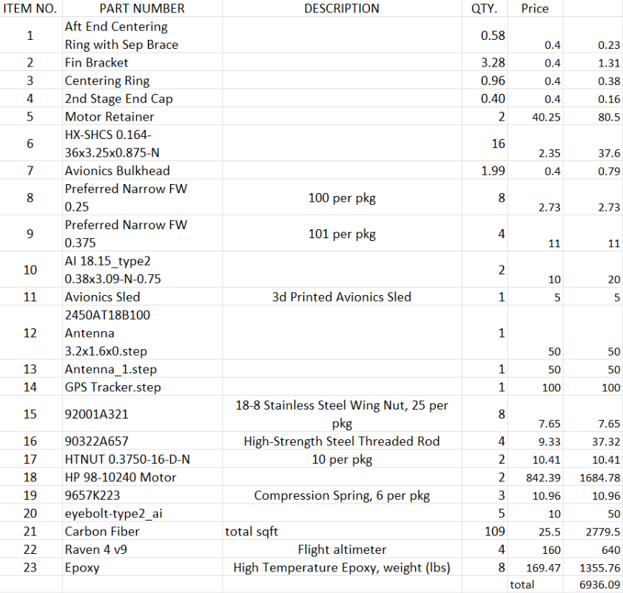
Figure 15: Project Bill of Materials

Design Validation and Initial Prototyping

Failure Modes and Effects Analysis (FMEA)
[Discuss your team’s FMEA, including critical potential failures and how your design mitigated these potential failures. Discuss the risk trade-off analysis that your team has performed. ]

Table 6: FMEA
Item # | Item | Failure | Root Cause | Likelihood  1 = least  5 = most | Severity  1 = least  5 = most | Precaution | Performance  1 = least  5 = most | Schedule  1 = least  5 = most | Cost  1 = least  5 = most
1.1 | Separation System (Staging) | Fails to Separate, buckling, thermal, | Electrical Failure, Mechanical failure | 3 | 5 | Ground Testing before launch to certify system | 1 | 3 | 3
1.2 | Separation System (Structural) | Failure in flight of sep. system, impact, thermal | System detaches mid-flight/ aero forces exceed limits | 2 | 4 | Ensure system is secured before flight. | 1 | 3 | 3
1.4 | Body (Structural) | Body bending, cracks, deformities | Forces during flight/temperature | 2 | 5 | Visual/NDT inspections | 2 | 2 | 3
1.5 | Fins (Structural) | Bending, cracks, deformities | Material deformation, adhesive epoxy failure | 2 | 5 | Visual/ NDT inspections | 2 | 2 | 3
1.6 | Avionics | Flight computers do not set off energetics | Battery failure, electrical short, match failure | 2 | 5 | Ground testing with energetics | 4 | 2 | 3

Initial Prototyping
6.2.1 Question
As part of our prototype development, the team decided to focus on exploring the Separation System. This was chosen because our team had no experience with the system, and there were limited resources available from previous capstone projects. However, it's important to note that the specifics of the Separation System are protected by a non-disclosure agreement with our client, so we are unable to provide detailed information. Thus, our main objective for the prototype is to ensure that the Separation System performs reliably during flight, as expected.
6.2.2 Results
At the time of submission, the items ordered have not yet been delivered, so the team has no results to discuss. The structural functionality of the system performs as expected. Once further prototype testing has been performed, we will manufacture a full-scale model and perform more testing like structural and functionality testing with electronics.

Other Engineering Calculations
RASAero Simulation
Currently in progress for the analysis of the rocket. RASAero is another simulation program similar to Rocksim that will aid in development of our rocket at Mach speeds and the ability to compare programs to see if they are the same.
Here are the preliminary results we are getting from RASAero which are looking positive but will need more simulation runs. The model will need to be updated for all the new changes we have made within the design.
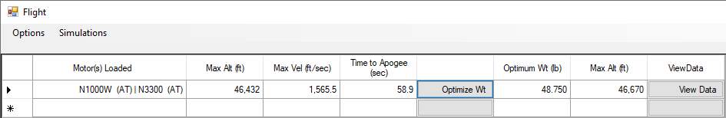Figure 16: RASAero Flight Results

Figure 17: RASAero Model

Future Testing Potential
- Structural Component Testing: Composite material strength testing, Separation system, Fin assembly.
    - These components will be simulated and tested to ASME D638 and other applicable standards.
    - Meets our structural testing requirement.

- Functionality Test of Systems: Avionics deployment, Separation system deployment, Payload ground testing
    - All systems will be tested individually for this series of tests.
    - Proves the function of systems apart of the staging system and payload.

- Systems Test: Full dress rehearsal of the launch vehicle (Not including energetics)
    - Proves launch vehicle is ready for flight and functions as expected.

- Subscale Testing: Built and tested subscale launch vehicle
    - Further proves components and will be used for scale-up data collection and improvements. This will be launched to collect data.

- Full scale launch: Final launch vehicle will be constructed and run through the testing procedures and complete a full flight.

CONCLUSIONS
To review, the objective of this capstone project is to design, build, test, and launch a two-staged supersonic rocket. The goal of this rocket is to reach speeds of Mach 2 or higher at about 50,000 ft. Our team is working towards building this rocket with advanced composite materials. Our foremost goal is to not only meet but surpass our clients’, Northrop Gruman, expectations while keeping the budget under $7,000. The current final rocket design will have a uniform diameter body throughout both stages and be comprised of a single deployment in both stages (with no drogue/streamer). The separation system is protected property and cannot be discussed in detail. The rocket will have four trapezoidal fins and a Von Karman shaped nose cone. The payload bay will also be between the parachute bays in the rocket's second stage. The next step of the project is to conduct prototype testing when the parts arrive. Once that is complete, some team members will assist with research, testing, and risk analysis over the summer to ensure the project stays on track. During Fall 2024, the team hopes to complete the body first since manufacturing will take the longest, followed by the separation system, leading to a full launch in October.

REFERENCES
Literature Review References:
[1] A Kanni Raj, "A - C F D - Applied Computational Fluid Dynamic Analysis of Thermal and Fluid Flow Over Space Shuttle Or Rocket Nose Cone". Createspace Independent Publishing Platform, 2016.
[2] Eugen Sänger, "Rocket Flight Engineering". 1965.
[3] B. Mathew, O. Bandyo, A. Tomar, A. Kumar, A. Ahuja, and K. Patil, “A review on computational drag analysis of rocket nose cone.” Available: https://ceur-ws.org/Vol-2875/PAPER_11.pdf
[4] Airesearc, E. Perkins, L. Jorgensen, and S. Sommer, “NATIONAL ADVISORY COMMITTEE FOR AERONAUTICS INVESTIGATION OF THE DRAG OF VARIOUS AXIALLY SYMMETRIC NOSE SHAPES OF FINENESS RATIO 3 FOR MACH NUMBERS FROM 1.24 TO 7.4.” Available: https://ntrs.nasa.gov/api/citations/19930091022/downloads/19930091022.pdf
[5] M. Ajuwon et al., “Optimization Design of Rocket Nosecone for Achieving Desired Apogee by Empirical Research and Simulation-Based Comparison.” Available: http://ieworldconference.org/content/SISE2020/Papers/Ajuwon.pdf
[6] “Richard Nakka’s Experimental Rocketry Site,” www.nakka-rocketry.net. https://www.nakka-rocketry.net/RD_nosecone.html.
[7] “Nose Cone Tip Thermal Analysis - MIT Rocket Team - MIT Wiki Service,” wikis.mit.edu. https://wikis.mit.edu/confluence/display/RocketTeam/Nose+Cone+Tip+Thermal+Analysis
[8] J. D. Anderson, Fundamentals of Aerodynamics, 6th ed. New York, NY: McGraw-Hill Education, 2017.
[9] Chandler Karp, A., & Jens, E. T. (2024). Hybrid Rocket Propulsion Design Handbook (First edition.). Academic Press. Chapter 2 p 19
[10] D. P. MISHRA, Fundamentals of Rocket Propulsion. Boca Raton, FL: CRC PRESS, 2020.
[11] L. Zhu, J. Song, B. Hu, and Z. Xu, “Numerical Investigation on the Interaction between Rocket Jet and Supersonic Inflow,” Journal of Physics: Conference Series, vol. 2460, no. 1, p. 012066, Apr. 2023. doi:10.1088/1742-6596/2460/1/012066
[12] O. Eryilmaz and E. Sancak, “Effect of Silane Coupling Treatments on Mechanical Properties of Epoxy Based High-Strength Carbon Fiber Regular (2 x 2) Braided Fabric Composites,” Polymer Composites, vol. 42, no. 12, pp. 6233–6954, Dec. 2021. doi: https://doi.org/10.1002/pc.26311
[13] R. Nakka, “Fins for Rocket Stability,” Richard Nakka’s Experimental Rocketry Site, http://www.nakka-rocketry.net/fins.html (accessed Feb. 5, 2024).
[14] “Exploring the different types of rocket staging – a comprehensive GUIDE,” Space Mesmerise, https://spacemesmerise.com/en-us/blogs/space-technology/exploring-the-different-types-of-rocket-staging-a-comprehensive-guide (accessed Feb. 8, 2024).
[15] Rocket Propulsion. Laxmi Publications Pvt Ltd, 2016.

[16] F. R. (Feliks R. Gantmakher, L. M. Levin, and E. T. J. Davies, The flight of Uncontrolled Rockets. Oxford, England: Pergamon Press, 1964.

[17] G. Srinivas and M. V. S. Prakash, “Aerodynamics and Flow Characterisation of Multistage Rockets,” IOP conference series. Materials Science and Engineering, vol. 197, no. 1, pp. 12077-, 2017, doi: 10.1088/1757-899X/197/1/012077.

[18] A. Okninski, “Multidisciplinary Optimization of Single-stage Sounding Rockets using Solid Propulsion,” Aerospace science and technology, vol. 71, pp. 412–419, 2017, doi: 10.1016/j.ast.2017.09.039.

[19] Z. Doucet, “Multistage 2-DOF Rocket Trajectory Simulation Program for Freshmen Level Engineering Students,” ProQuest Dissertations Publishing, 2019.

[20] “Glenn Research Center,” NASA, https://www1.grc.nasa.gov/ (accessed Feb. 4, 2024).

[21] J. Davies et al., “Preliminary Design and Test of High Altitude Two-stage Rockets in New Zealand,” Aerospace science and technology, vol. 128, pp. 107741-, 2022, doi: 10.1016/j.ast.2022.107741.

[22] W. H. Dorrance, Viscous hypersonic flow : theory of reacting and hypersonic boundary layers. Mineola, New York: Dover Publications, Inc, 2017.

[23] Sutton, Rocket Propulsion Elements. John Wiley & Sons, 2001.

[24] A. Iyer and A. Pant, “A REVIEW ON NOSE CONE DESIGNS FOR DIFFERENT FLIGHT REGIMES,” International Research Journal of Engineering and Technology (IRJET), vol. 07, no. 08, pp. 3546–3554, Aug. 2020, Available: https://www.irjet.net/archives/V7/i8/IRJET-V7I8605.pdf

[25] A. Mishra, K. Gandhi, K. Sharma, N. Sumanth, and Y. Krishna. Teja, “CONCEPTUAL DESIGN AND ANALYSIS OF TWO STAGE SOUNDING ROCKET,” International Journal of Universal Science and Engineering, vol. 07, pp. 53–73, Aug. 2021.

[26] Engineering Toolbox, “Drag Coefficient,” Engineering Toolbox, 2004. https://www.engineeringtoolbox.com/drag-coefficient-d_627.html

[27] P. Żurawka, N. Sahbon, D. Pytlak, M. Sochacki, A. Puchalski and S. Murpani, "Multi-objective optimization of a fin shape for a passive supersonic rocket stage," 2023 IEEE Aerospace Conference, Big Sky, MT, USA, 2023, pp. 1-12, doi: 10.1109/AERO55745.2023.10115859.

[28] A. Jaffer, “Skin-Friction and Forced Convection from Rough and Smooth Plates.” Available: https://people.csail.mit.edu/jaffer/convect/rough.pdf

[29] D. McAdams, C. Choate, J. Buskirk, B. Larzalere, and N. Murphy, Low Shock Payload Separation System, Flagstaff, AZ, rep., 2017
[30] T. Van Milligan, “What is the best fin shape for a model rocket?,” 2017. Available: https://apogeerockets.com/education/downloads/Newsletter442.pdf

[31] G. H. Staab, Laminar composites. Amsterdam: Butterworth-Heinemann, 2015.

[32] L. P. Kollár and G. S. Springer, Mechanics of Composite Structures. Cambridge University Press, 2003.

Other References:
“Stagnation Temperature - Real Gas Effects,” Nasa.gov, 2021. https://www.grc.nasa.gov/www/BGH/stagtmp.html#:~:text=The%20static%20temperature%20is%20the (accessed Mar. 19, 2024).
‌
“JR STG UPG-WM,” wildmanrocketry.com, https://wildmanrocketry.com/products/jr-stg-upg-wm?_pos=6&_sid=9da97005a&_ss=r (accessed Mar 15, 2024).

T. Schnell, “Sounding Rocket,” Home, https://www.hyimpulse.de/en/products/4-project-2-sounding-rocket (accessed Mar 15, 2024).

“Antares Rocket,” Northrop Grumman, https://www.northropgrumman.com/space/antares-rocket (accessed Mar 15, 2024).

APPENDICES

Appendix A: Concept Generation Pictures
9.1.1 Avionics
[A1]
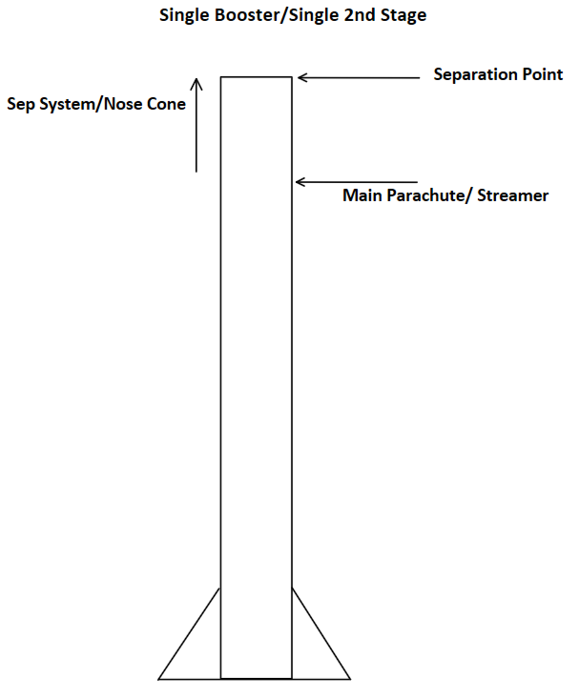
[A2]
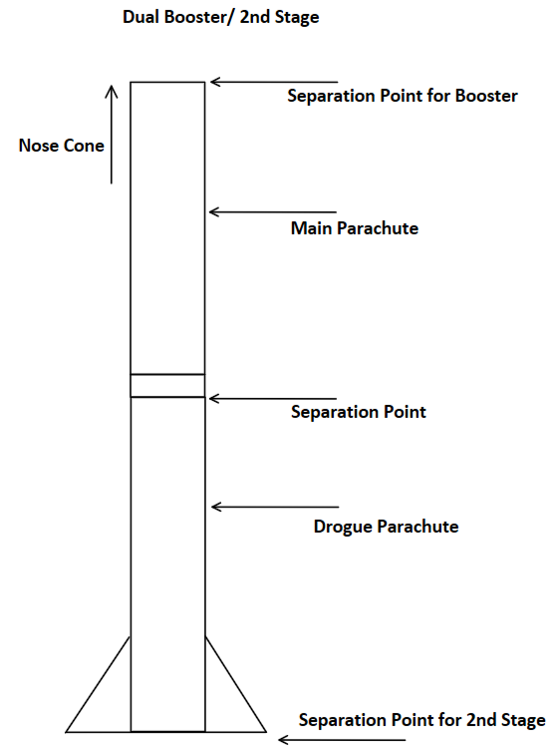
[A3]
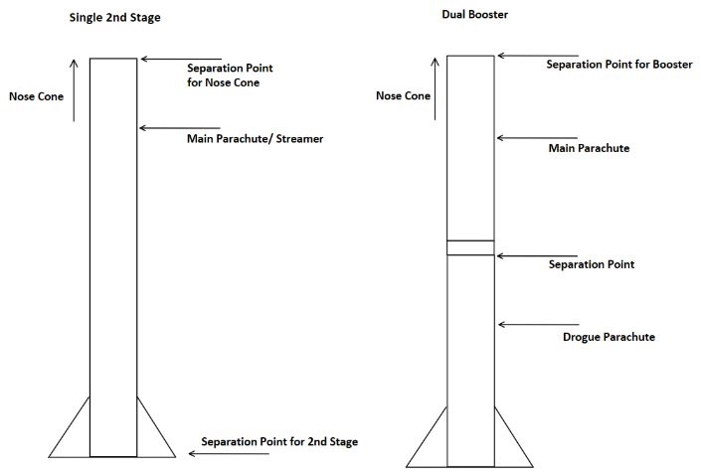
[A4]
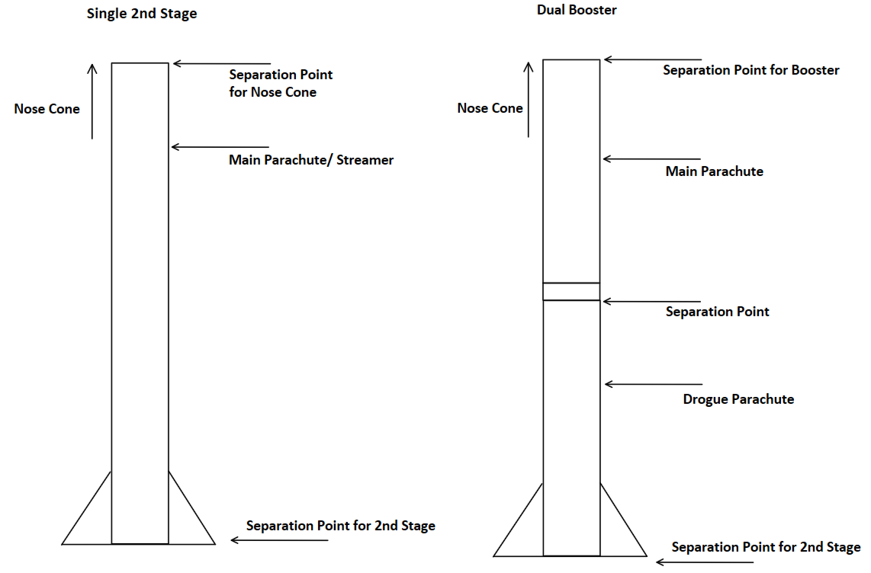
[A5]
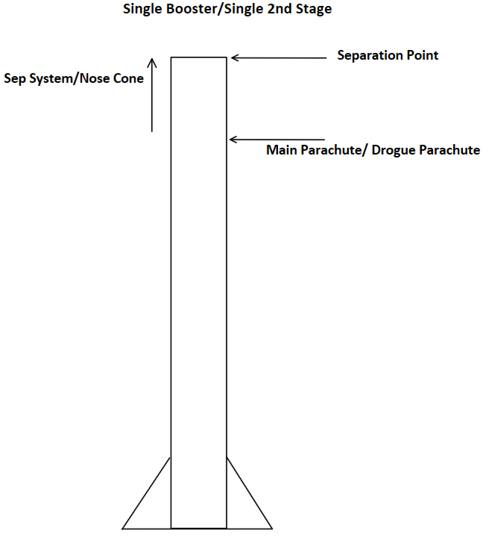
9.1.2 Separation System
[B1]
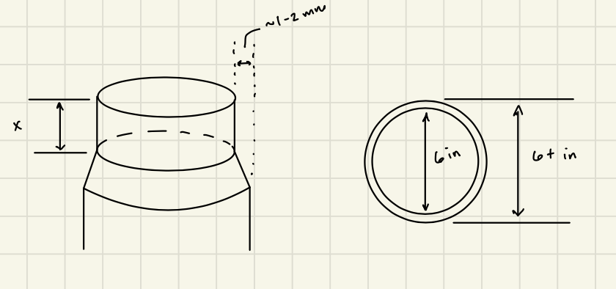
[B2]
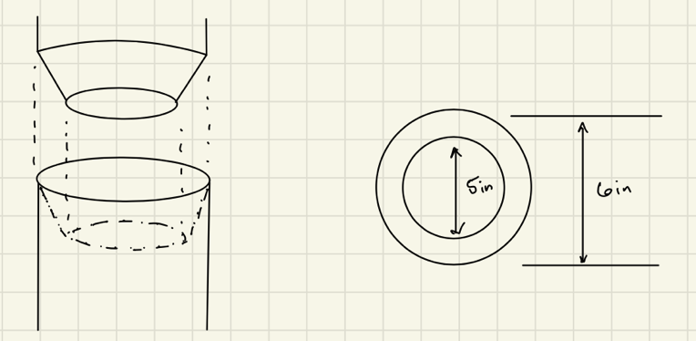
[B3]
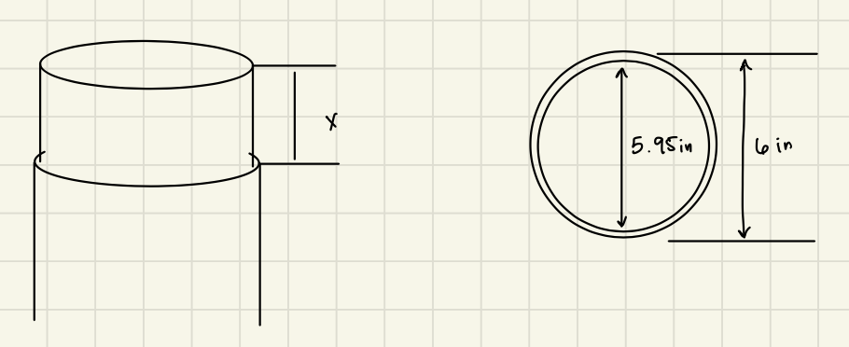
[B4]
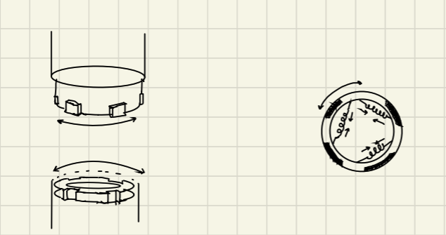
[B5]
N/A

9.1.3 Body Design
[C1]
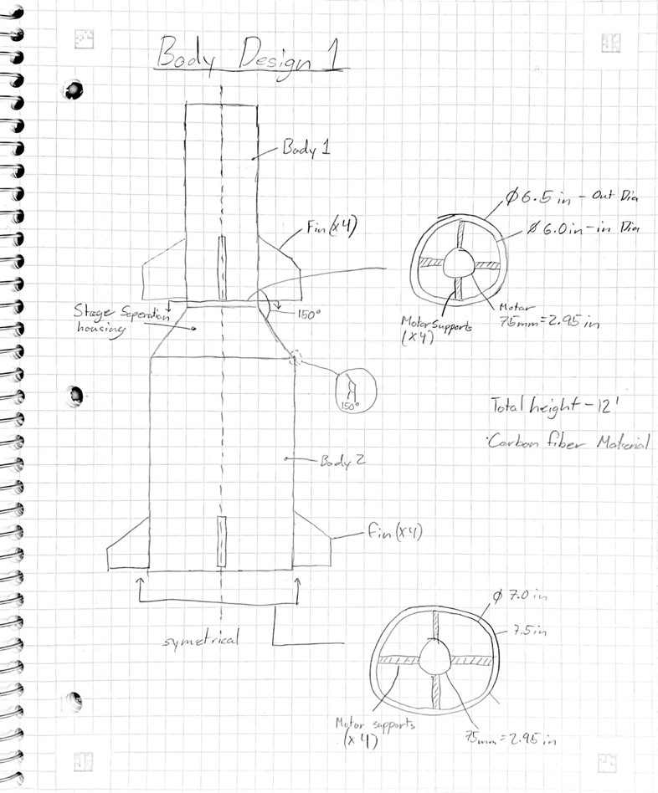
[C2]
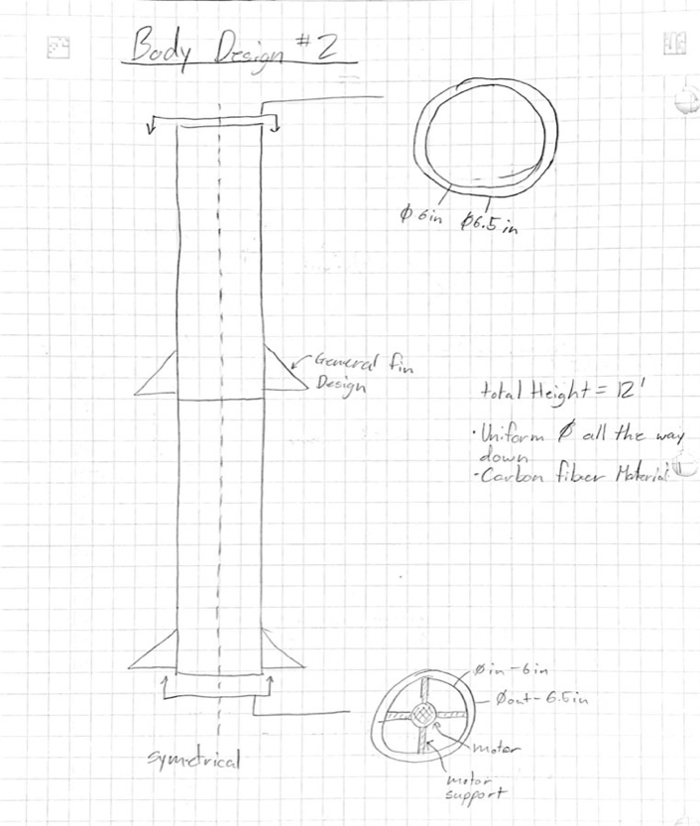
[C3]
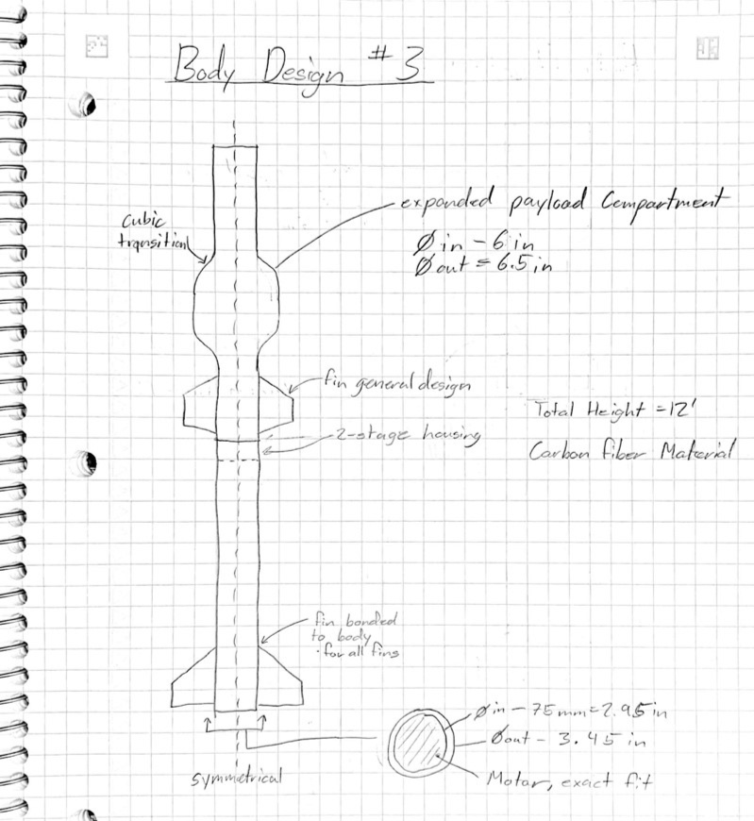
[C4]
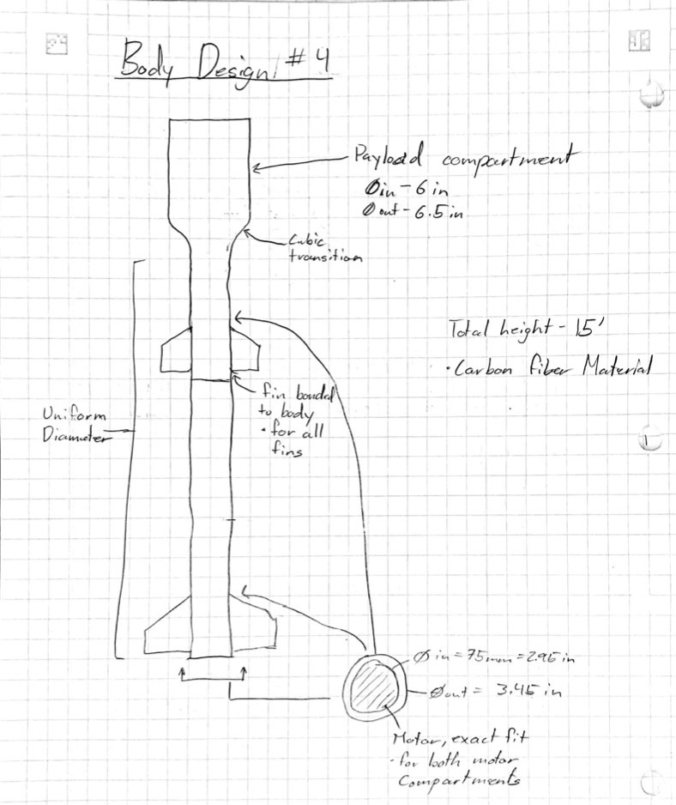
[C5]
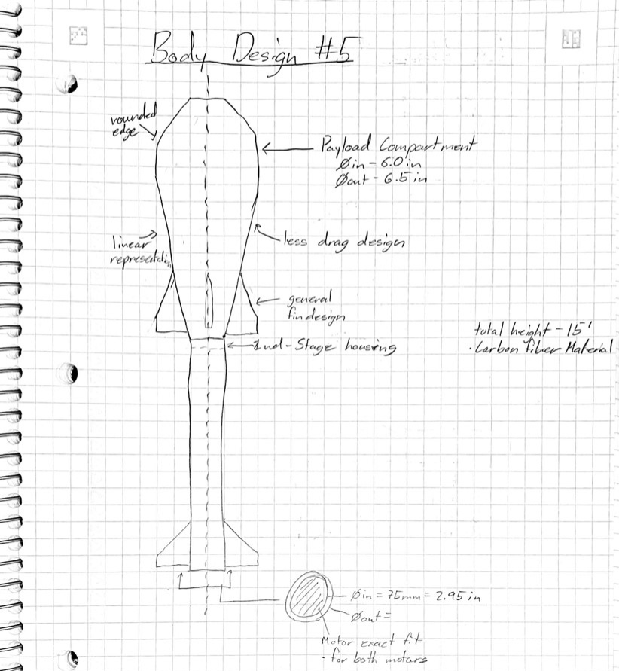
9.1.4 Fin Design
[D1]
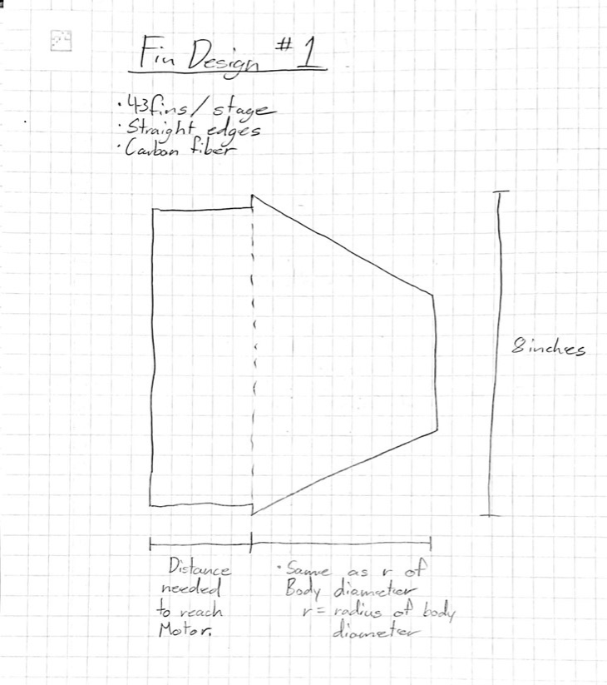
[D2]
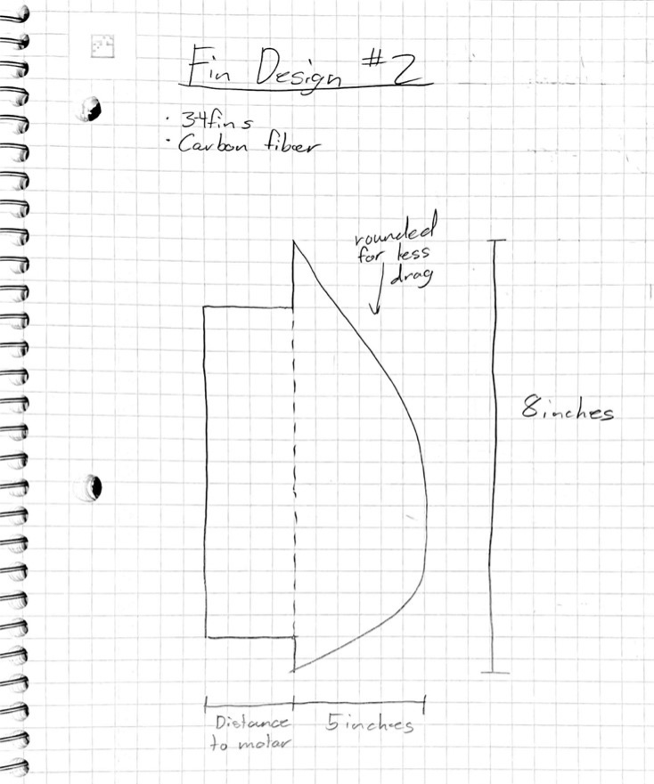
[D3]
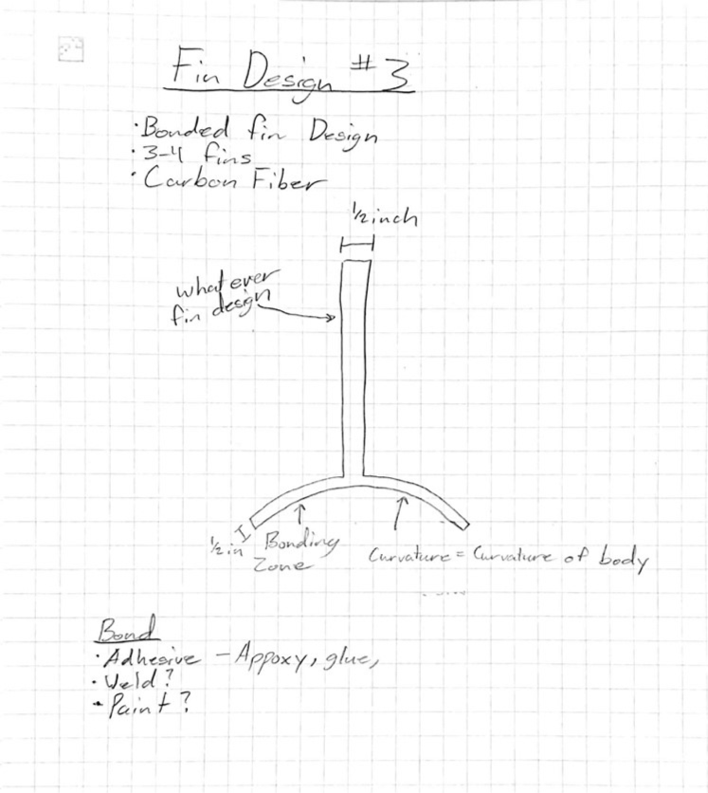

[D4]
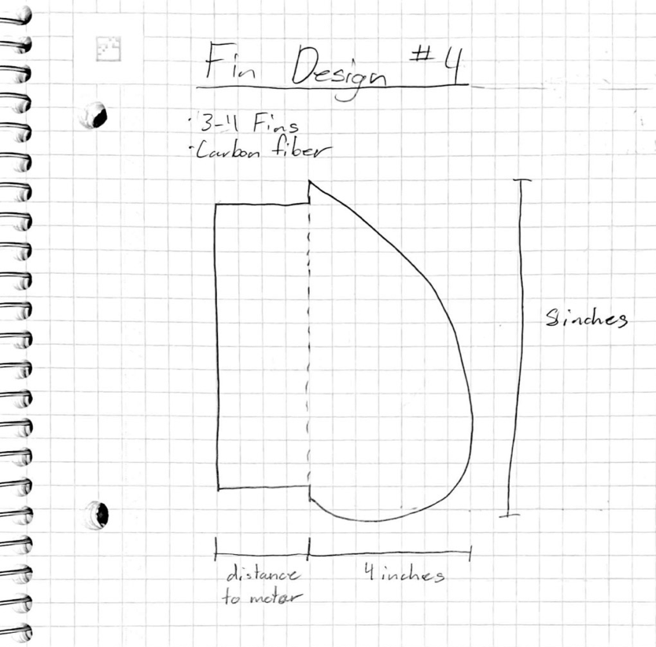
[D5]
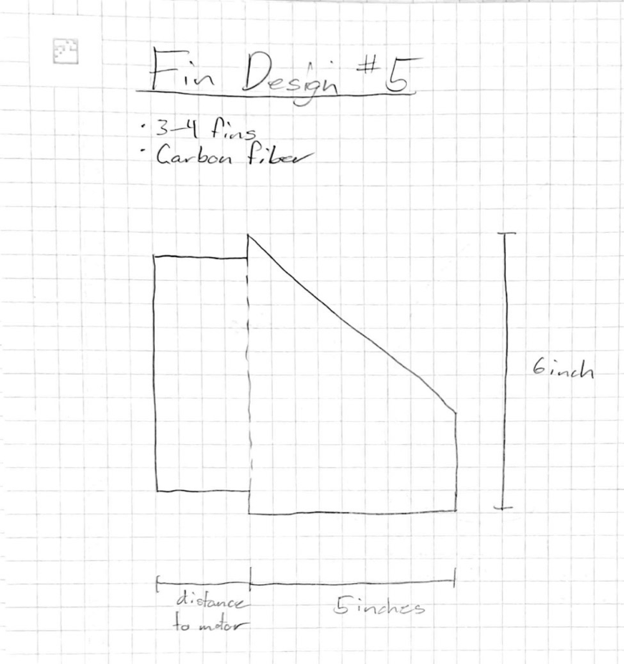

9.1.5 Nose Cone
[E1]
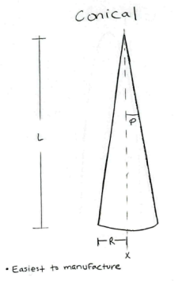
[E2]
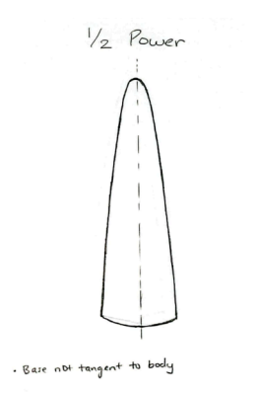
[E3]
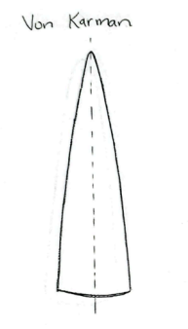
[E4]
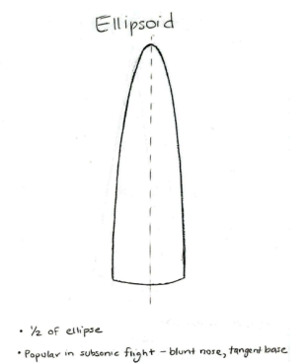
[E5]
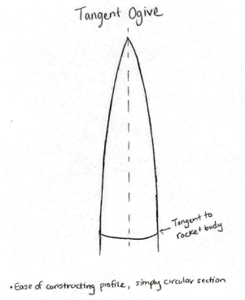

9.1.6 Internal Rocket Layout
[F1]
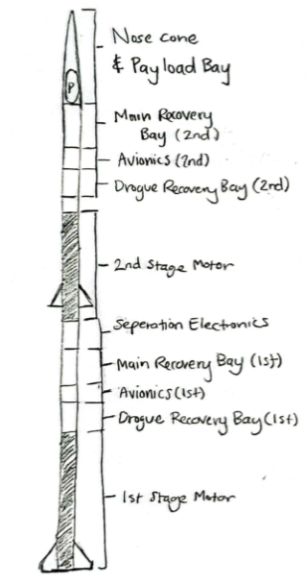
[F2]
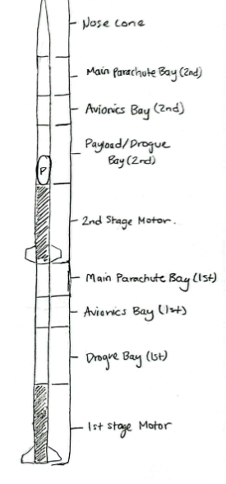
[F3]
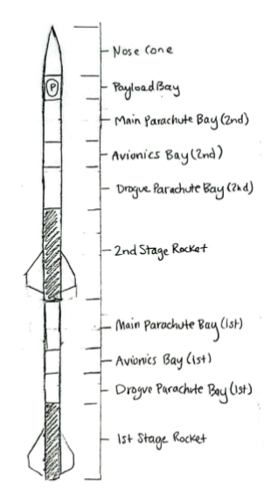
[F4]
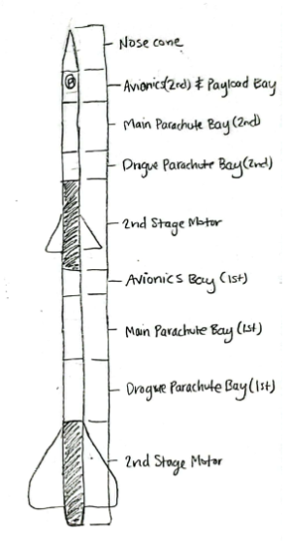
[F5]
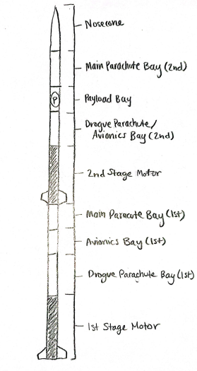

Appendix B: Decision Matrix Designs
Design 2
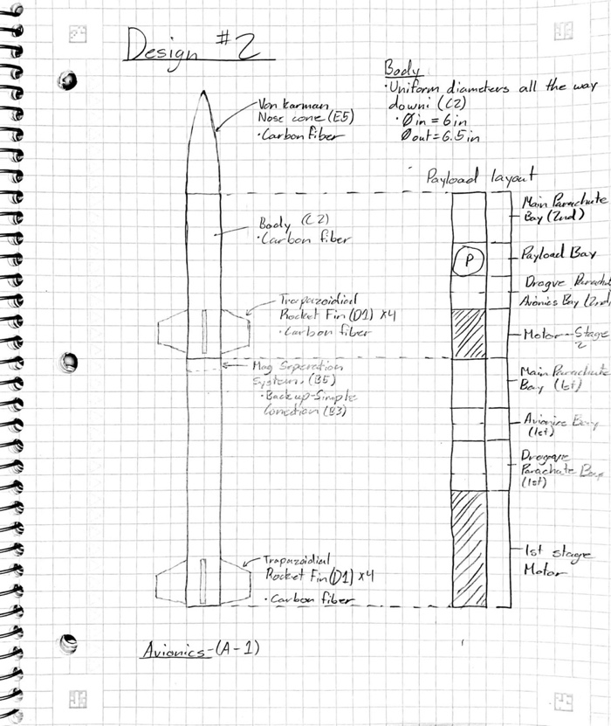

Design 4
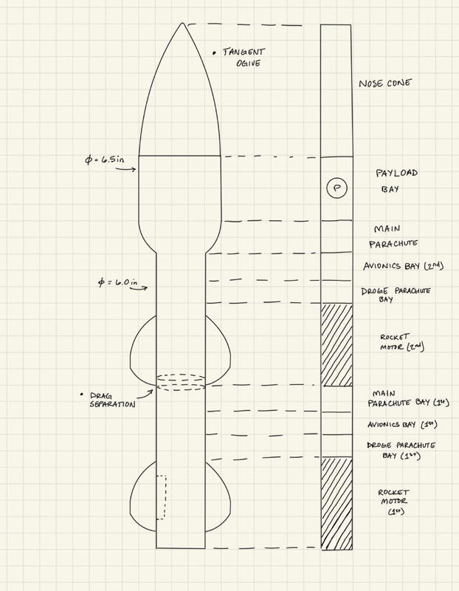

Design 5
