NG Two-Stage Supersonic Rocket

Engineering Calculations Summary - 486C

Austin Paothatat: Project Manager / Test Engineer
Avery Charley: Manufacturing Engineer / Financial Manager
Koi Quiver: CAD / Test Engineer
Lindsey Dineyazhe: Financial Manager / CAD Engineer

Spring 2024-Fall 2024


Project Sponsor: Northrop Grumman Space Systems, Launch Vehicles
Faculty Advisor: Carson Pete
Sponsor Mentors: Caleb Feda, Thomas Ortz, Paul Hoeffecker, Victoria Ewert
Instructor: David Willy

Top Level Design Summary- Austin Paothatat
The goal of this project is to provide a launch vehicle capable of carrying a 10lb payload for scientific research purposes. The vehicle is required to reach a speed of at least Mach 2 and an altitude of 45k ft AGL. This will provide a sufficient flight profile for the client's needs listed in Section 1.2. The design provided below gives a summary of the full system and subsystems and how they function together.
*The separation system is not included in this report to avoid any NDA infractions.

Figure 1: Full Launch Vehicle CAD
The second stage and its subassemblies are listed in Figure 2 below. This is the final stage of the launch vehicle and will carry the payload to the required performance requirements. The second stage is a single deployment recovery system. The entire vehicle will be recoverable for reuse.
Figure 2: Second Stage Subassemblies

Figure 3 depicts the internal fin and motor retainer structure that will transfer the forces from the motors into the rocket body. This subassembly is currently being updated with hardware and a three-fin model to see if there is any performance gain from one less fin.
Figure 3: Motor retainer and Fin Bracketry Subassembly
Figure 4 displays the second stage avionics bay that will carry the flight computers that will control the recovery deployment charges and the second stage ignition. One update to this design is the aft bulkhead will be modified to attach to the forward closure of the rocket motor.
Figure 4: Second Stage Avionics Subassembly
Figure 5 is the full launch vehicle with a view of the locations of each subassembly. Not shown is the payload bay directly in front of the second stage avionics bay. We have not received any definition of the payload so we cannot add definition into the design until we receive it from the client to avoid lost time.
Figure 5: Full Launch Vehicle Assemblies

1.1 House of Quality (HoQ)
Below in Figure 6 is the QFD, also known as the House of Quality (HoQ). The team updated the QFD from the initial QFD after discussing and modifying the ranking and customer/ engineering requirements with the clients. The first version of the QFD had the customer and engineering requirements derived from the proposal and from the first few discussions with the client and what the client was talking about most. After the first draft of the QFD, the team reviewed the QFD with the client and the client decided that the weights and some of the customer and engineering requirements needed to be changed. The CR and ER were edited in the QFD to show what needs to be focused on in the overall project. The current QFD is shown below.
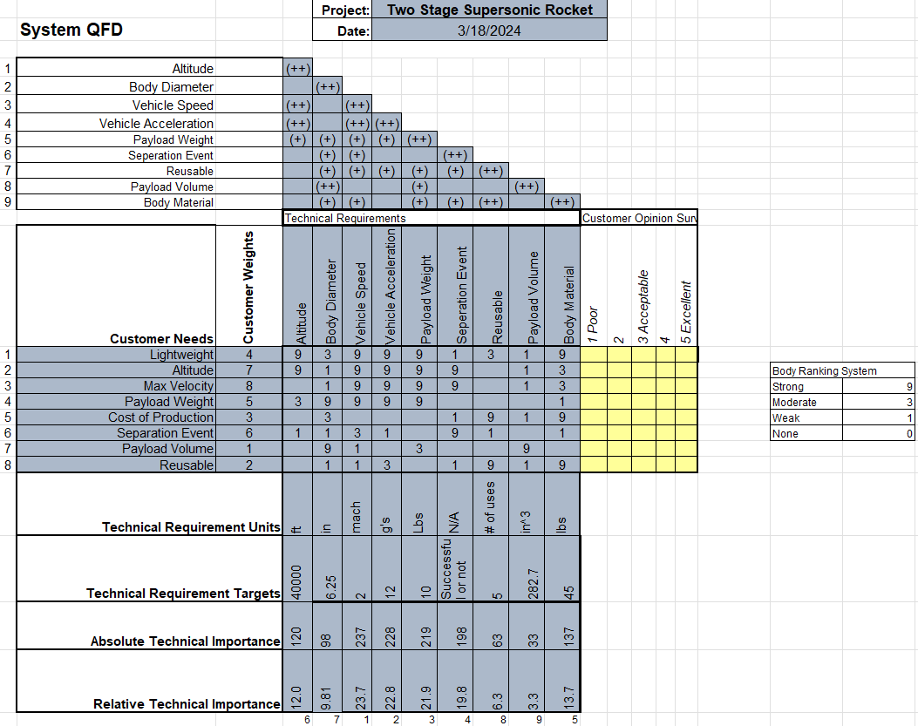
Figure 6: Quality Function deployment/ House of Quality

1.2 Customer Requirements (CRs)
The customer requirements set by the customer were stated initially in the proposal. After multiple meetings with the client, the customer expanded on some of the definitions of the requirements made in the initial proposal and added a few additional requirements. The requirements added were due to the class and the client wants to see specific analysis. All the customer requirements are stated in the list below:
- Develop a two-stage launch vehicle.
  - The vehicle needs to be a two-stage rocket. Two stages mean the rocket needs an initial booster that will eject off the vehicle after being used to maximize the flight time and velocity. The second stage will continue the flight after the first stage ejects off the vehicle.
- Use of a specific stage separation device.
  - The client wants the team to use a specific separation method discussed. The specific information on the separation system is proprietary Northrop Grumman information and cannot be shared in the report.
- The vehicle will be constructed of composite materials.
  - The client would like the vehicle to be constructed out of a composite material for strength and lightweight capability. The client would also like composite material to be used to be reused.
- Vehicle will reach an altitude of at least 45,000 ft AGL (Above Ground Level).
  - The client would like the vehicle to reach the height of 45,000 ft. This is a hard number that is not subject to change. The launch site we chose to launch the vehicle at has an altitude ceiling of 50,000 ft.
- Scaled prototype rocket required as a proof of concept.
  - The client and the capstone project instructor/advisor would like one of our prototypes to be a scaled down proof of concept vehicle. Used to prove that our current design would work to reach the speed required, the altitude is reached, and the separation system the team choses would work.
- Final launch vehicle will be required to carry a maximum 10 lb payload that will fit within a 6” diameter bay.
  - One of the major requirements set by the clients is the vehicle should have a payload bay that should have a 6” diameter. The vehicle should have the ability to carry at least a 10 lbs payload. As stated by the client, this requirement is important as the vehicle is for research uses.
- Vehicle required to reach and maintain over Mach 2 and maximize time spent at that speed or greater.
  - This is a major requirement set by the client. The client would not just like the vehicle to reach Mach 2, but also maximize the time spent at Mach 2 or greater. Mach 2 is equivalent to about 1500 mph. The rocket being at this speed will result in the application of compressible flows and non-linear representations.
- Acceleration of the vehicle needs to meet a minimum of 12g.
  - The force acting on the vehicle at launch should result in at least 12g acceleration.
- Vehicle trajectory will be simulated in Matlab and in RockSim.
  - The trajectory of the vehicle should be modeled in both RockSim and Matlab. RockSim is a modeling application for rockets, you can set the parameter you need to predict certain measurements on the vehicle. The team is also required to program a code to predict the trajectory of the vehicle.
- Composite structural components will be simulated and tested to ASME standards.
  - The client would also like the team to test the composite material the team is planning to use for the body of the vehicle. This is testing the materials' strength properties at different layers and determining which layup pattern is best performing.
- The current payload will carry instrumentation to measure vibrations during flight tests and the ability for the team to predict them.
  - The client set this requirement initially in the proposal, but after discussion with the team both the client and the team decided that if needed this requirement could be subject to change.
- Vehicle required to use commercial rocket motors.
  - The team must use solid fuel commercial rocket motors to easily replace and reuse the vehicle.
- Recovery of entire launch vehicle for reuse.
  - The client would like the team to design the entire vehicle to be reused after each launch. Other than the motors, the entire vehicle needs to be reuseable.

1.3 Engineering Requirements (ERs)
Engineering Requirements are derived from the customer requirements stated above. There are not as many engineering requirements as customer requirements due to some of the requirements being combined. In the customer requirements stated above, the customer set goals for the vehicle and the team to reach. As the team met with the client, the engineering requirements were changed from what the team initially set to what the current requirements are.
- Maximize Velocity – Mach 2 or 1500 mph
  - The velocity is the speed of the vehicle as it flies. This requirement is one of the major engineering requirements. The goal is to reach and maximize the time at Mach 2 /1500mph. The goal time duration at Mach 2 the team is aiming for is at least 30 seconds.
  - The requirement is a two-sided constraint as this can be engineered by the body size, but the other requirements will affect the velocity of the vehicle. Every part of the rocket will affect the velocity of the vehicle as the more weight we add the or take off it will affect the velocity.
- Separation Event – Successful or unsuccessful separation
  - This requirement as it pertains to the project is just a yes or no if it works. The project is not specifically designing a separation system, but rather the vehicle needs to have two stages. The team just needs to know if the separation works with the device that will be chosen.
  - This requirement is a one-sided constraint as the only constraint that would affect the separation event is the separation device and method. Nothing else affects the separation event.
- Altitude – 45,000 ft AGL (Above Ground Level)
  - Altitude is one of our major engineering requirements, as the altitude can be measured and engineered by the team. The client also stated they want the vehicle to reach this height. The capstone instructor initially set the altitude goal as 50,000ft as it is the highest altitude the main launch site the team has chosen has as a ceiling.
  - This requirement is a two-sided constraint, like the velocity requirement every aspect of weight and speed will affect the altitude the vehicle is able to reach. For example, if you change one thing like weight this will affect the altitude, same with fins of the vehicle.
- Payload Weight – 10lbs
  - As this is a research vehicle, the client is adamant that the vehicle has the capability to sustain supersonic flight with a 10 lbs payload. The team does not know exactly what the payload is, but the vehicle needs to be able to safely return to the ground. The measurement of the payload will be how many pounds max the vehicle can carry to while maintaining supersonic flight.
  - This requirement is a one-sided constraint since it cannot change due to the client. This goal is set and will only affect other requirements, rather than being able to engineer this requirement.
- Lightweight – 45 lbs
  - The vehicle needs to be lightweight because we are trying to sustain supersonic speeds and carry a payload. The client would also like the ability to easily set up the vehicle and if it is lightweight, then that would ease the setup of the vehicle. The vehicle will be measured in lbs, and the weight that the team is shooting for is a body weight of about 30 lbs and a total weight of 50 lbs. The extra weight will come from all the additional parachutes, motors, and payload.
  - This requirement is a two-sided constraint due to the team being able to design and engineer the body for minimizing weight. When engineering other parts of the vehicle that will affect the weight of the vehicle. This requirement has an effect and can be affected.
- Cost of production - $7,000
  - This is the requirement is relatively important, as the client would like this to be an affordable and reusable vehicle so it would be possible to manufacture more without extreme expenses. This requirement is directly related to the project budget. The project has a budget of roughly $7,000, if the team does not exceed that price, then this engineering requirement will be fulfilled.
  - This requirement is a one-sided constraint as we cannot really design for a low cost of production. We can only design our rocket and with the lowest price possible by low material, not super expensive parts, but the cost of production does not really affect this specific project.
- Reusable – more than 1 use
  - The requirement will be measured by the number of uses the vehicle will have before needing major maintenance or needing to be replaced. For our purposes, the team cannot launch the final product more than 1 or 2 times. Therefore, if the vehicle has minimal damage after our launches, the team will predict the number of uses the vehicle has, before needing major maintenance or being replaced.
- Payload Volume – 282.7 in^3
  - This requirement was the least regarded as important as the client did not have any specific volume requirement, the payload weight is more important than the payload volume. The team has assumed that most 10 lbs payloads would approximately be less than 10 in tall. The volume measurement will be measured in cubic inches. If the team can reach the goal of 282.7 in^3 this engineering requirement would be considered successful.
  - This is a two-sided constraint due to the team being able to engineer this, and this would for example affect the lightweight constraint. This both has an effect and can be affected by other requirements. This could be seen as a one-sided constraint, but it is really a two-sided constraint.

Summary of Standards, Codes, Standards, and Regulations
The standards, codes, and regulations that the project must abide by are all related to safety of the rocket and population near the launch site. The vehicle must meet both launch site and Northrop Grumman (NG) standards, codes, and regulations. Launch site regulation is for the duration during launch and flight of the vehicle. Northrop Grumman’s standards, codes, and regulations pertain to design decision and manufacturing of the vehicle and all its parts.
The launch site chosen is the Tripoli Rocketry Association INC. In Phoenix, Az area. The Tripoli Rocketry Association Safety Code meets or exceeds NFPA 1122 and 1127 for members launching rockets with commercial motors [1]. Tripoli Rocketry Association Safety Code combines and revises the High-Power Safety Code, Research Safety Code, rules for Model Rockets and Radio-Controlled Booster Gliders [1]. By signing the launch site waiver, the group will not have to obtain any additional certifications or fight privileges. Signing the launch site waiver is also an agreement to have already designed the launch vehicle to abide by Tripoli Rocketry Association Safety Code. If the vehicle does not comply with Tripoli Rocketry Association Safety Code, the project team will not be allowed to at Tripoli Launch sight the day of. The full safety code document can be found on the Tripoli Rocketry Association website under the safety tab [1].
For Northrop Grumman to use the vehicle after the project, the launch vehicle must abide by Northrop Grumman manufacturing, safety standards, codes, and regulations. The client Northrop Grumman has not sent out a specific list of manufacturing, safety standards, codes, and regulations to the project team to abide by. The team has been designing based of general National Assocation of Rocketry and GD&T [2]. Northrop Grumman has mentioned that some design decisions might not fall into their specific codes and standards. The project team has made those changes, but no official document of standards, codes, and regulations has been given to the project team. Will ask Northrop Grumman if they would be able to provide written standards, codes, and regulations in future meetings to assure design can be flown by Northorp Grumman.

Summary of Equations and Solutions
Finite Element Analysis: Avery Charley
Computational Fluid Dynamics: Koi Quiver
Supersonic Heating of body: Lindsey Dineyazhe
RAS Areo and Rocksim flight simulation: Austin Paothatat
Assemblies that are at most risk of load are the fins, fin brackets, separation system, and nose cone. The largest load applied to the vehicle will be at ignition of the motors. There for FoS will be calculated at max load and max Q. The team will use equations already built into the FEA, Heating Analysis, and CFD programs that will be used for analysis.
The project team had not compiled enough data to develop a defined FoS table. FEA, CFD, Mass Properties, Heating Analysis, and Final Simulations need to be done in order to develop a fully defined FoS table. The team has been over designing most of the parts and assemblies already. There are 3-5 parts that are specifically in question of how high their FoS is, these are the parts that the upcoming analysis will develop data for. That data will then be used to calculate the FoS of all parts and major assemblies.
Each analysis will provide more definitive data for the flight velocity above Mach 1. Due to the vehicle reaching the supersonic velocity region, CFD and Heating Analysis will use the characteristics of air at the supersonic speeds of the rocket to get more accurate data.

3.1 Mathematical Modeling

3.1.1 Nose Cone – Lindsey Dineyazhe
An important aspect of the nose cone is its ability to withstand extremely high stagnation point temperatures of a high altitude, supersonic flight. To ensure that the nose cone does not take any damage from the heat, an analysis of the stagnation temperature on it must be done. The stagnation temperature should not exceed the nose cone's material melting point. The following Equation (1) will be used to calculate the stagnation temperature in K, Kelvin:
$T_{stag}=T_{s}\left(1+\frac{λ-1}{2}⋅Ma^{2}\right)$ [1]
where $$T_{s}$$ is the static temperature at a given altitude in K, $$λ$$ is the specific heat ratio for air valued as a constant of 1.4, and Ma is the Mach number to be reached. For this analysis, a worst-case scenario will be examined to determine precautions needed avoid failure if these scenarios are encountered. Therefore, values above the minimum required altitude and Mach number will be used in the stagnation temperature calculation. The static temperature at an altitude of 55,000 ft (about 16.76 km) would approximately be 218 K. Additionally, the maximum Mach number for supersonic speed to be use is 5. Inserting these values into Equation (1) gives us a stagnation point temperature of 1308 K. To accommodate this potential scenario, the team decided to incorporate a metal tip to the nose cone that will be able to withstand the stagnation temperature for a majority of the nose cone. A steel material will be used for the nose cone tip as the melting point for steel is approximately 1623 K, well above the calculated stagnation temperature.
Another crucial aspect of the nose cone is the fineness ratio. The fineness ratio is the ratio of the length of the nose cone body to its maximum diameter as seen in Equation (2). An increase in this ratio would help reduce the wave drag coefficient affecting the nose cone but can also increase the skin friction drag due to more exposed surface area. Generally, a high fineness ratio is desired for supersonic speeds, at approximately 5:1. Anything above this would hardly reduce wave drag and only increase friction drag.
$Fineness ratio=\frac{L}{D}=L:D$ [2]
In Equation (2), L is the length of the nose cone in inches and D is the maximum diameter at the base of the nose cone also in inches. Using the currently set diameter of the rocket body, 6.25 inches, would also be the base diameter of the nose cone, the equation above is adjusted to find an acceptable nose cone length to achieve a fineness ratio of 5:1. The nose cone would need to be 31.25 inches in length for the desired fineness ratio.

3.1.2 Rocksim and RASAero Simulations – Austin Paothatat
Simulations provide vital information for our flight performance and recovery system. Utilizing two software programs called Rocksim and RASAero, these two programs will assist us in the simulations of our flight profile. These will be used as the basis for our vehicle performance and to pull data from and compare our calculations and Matlab code. Current models of the launch vehicle can be found below.
Modeling
RockSim
Below is the modeling in RockSim. This is the current design and with estimated mass based on design. The results showed that we will reach the speed and acceleration performance requirement. The main concern is the altitude and RockSim is saying we are only reaching about 35k ft AGL, which is 10k ft below our customer requirement.
Figure 7: RockSim Meta Data

Figure 8: RockSim Model

Figure 9: RockSim Flight Data

RASAero
RASAero is a program designed to be used with supersonic rocket flight and will better suit our needs as a program and flight profile verification. This is new software to the team and the results will need to be verified before trusting the program RASAero gave us similar speeds but says we will reach our altitude goal of 45k ft AGL. RASAero can import Rocksim files and compare mass, CG, CP locations, along with vehicle performance values. The results are below but look promising to reach our performance goals. The two pieces of software will need to be compared more and verified by hand calculations to complete further analysis to get our flight conditions correct. Simulations will be updated until and on launch day.
Figure 10: RASAero Flight Data

Figure 11: RASAero Model

The simulations shown below are still the current model of the launch vehicle. The simulations will be updated once the mass properties of the launch vehicle are completed. Furthering the simulations we will develop a more detailed list of launch conditions and vehicle performance parameters and the forces that will be acting on the vehicle.

Rocket Motor Selections
In Table 1 are the specifications in our critical design motor choice for this point in the design. Below are shown the basic specifications of the motor like total impulse, total mass, burn time, and propellant mass. With these motors simulated we receive the performance values in figure ##.
Table 1: Critical Design Motor Choice Specifications
Motor | Total Impulse (N-s) | Total Mass (Grams) | Burn Time (Seconds) | Propellant Mass (Grams)
N1000W  (Booster) | 14,126 | 12,771 | 13.1 | 8,293
N3300R  (Sustainer) | 14,041 | 12,054 | 4.4 | 7,512

3.1.3 Separation System- Avery Charley
Multistage is essential in achieving higher velocities without requiring a large motor. However, to achieve this objective, it's important to establish an efficient connection between the stages and ensure impeccable timing during the disconnection process. This synchronization is crucial to optimize propulsion efficiency and maintain trajectory integrity. As a result, the primary focus shifts towards engineering the necessary structural robustness to withstand the intense forces acting upon the vehicle during both the unity and separation phases.
As the rocket accelerates and transitions into supersonic speeds, traditional analytical methods encounter limitations in accurately predicting the diverse levels of drag it will encounter. To address this challenge and estimate the drag forces necessary for stage separation, we turn to the Drag Equation tailored for incompressible speeds.
$D_{i}=\frac{1}{2}ρV^{2}C_{d}A_{cyl}$ [3]
In addition, the Parasitic Drag Equation and weight of the stages will help in finding the total drag force.
$D_{f}=\frac{1}{2}ρV^{2}C_{f}A_{SA}$ [4]
$W=m∙g$ [5]
The team expected to achieve a velocity under Mach 1 (which is equivalent to 630.67 ft/s) at an altitude of around 9,500—10,000 feet. For my analysis, I will set the altitude at 10,000 feet (~3000 meters). The next step was understanding the value for our Coefficient of Drag (Cd), which was different from various sources that rockets usually have a Coefficient of Drag (Cd) ranging from 0.75 to 0.89. Since the supersonic rocket is technically a rocket, I chose the “model rocket” Coefficient of Drag at 0.75. Obtaining accurate values for parasitic drag on carbon fiber proved to be challenging due to conflicting information from various sources and different versions of the material. However, after thorough research, I managed to find a reliable source that provided the value of 0.3. Using the dimensions and weight obtained from Austin's RockSim simulations, I calculated the total drag force on the Upper Stage to be 7389.58 N (1661.24 lbf) and the Booster Stage to be 4136.01N (929.81 lbf). These values account for the parasitic drag induced by both stages. While these are large forces to overcome for the separation system, I will be assuming the rockets thrust will carry the separation system without straining it during flight until separation.
- Booster Stage Aerodynamics Calculations (10,000 feet/ ~3000 m):
$$D_{f}=\frac{1}{2}ρV^{2}C_{f}A_{SA}$$
$$D_{fB}=\frac{1}{2}\left(0.9093\frac{kg}{m^{3}}\right){\left(192.227\frac{m}{s}\right)}^{2}\left(0.3\right)\left(0.752m^{2}\right)=3790.05 N$$
$$W_{B}=m∙g=10.35kg∙9.81\frac{m}{s^{2}}=101.53 N$$
$$F_{total}=D_{fB}+W_{B}=3790.05 N+101.53 N=3891.58 N→ 874.86 lbf$$
- Upper Stage (2nd Stage) Aerodynamic Calculations (10,000 feet/ ~3000 m):
$$D_{f}=\frac{1}{2}ρV^{2}C_{f}A_{SA}$$
$$D_{iU}=\frac{1}{2}\left(0.9093\frac{kg}{m^{3}}\right){\left(192.227\frac{m}{s}\right)}^{2}\left(0.75\right)\left(\frac{π}{4}{\left(0.157m\right)}^{2}\right)=244.43 N$$
$$W_{b}=m∙g=14.23 kg∙9.81\frac{m}{s^{2}}=139.60 N$$
$$D_{fU}=\frac{1}{2}\left(0.9093\frac{kg}{m^{3}}\right){\left(192.227\frac{m}{s}\right)}^{2}\left(0.3\right)\left(1.39m^{2}\right)=7,005.55 N$$
$$F_{total}=D_{iU}+W_{b}+D_{fU}=244.43 N+139.60 N+7,005.55 N=7389.58 N→1661.24 lbf$$
It's worth noting that the Upper Stage of a rocket experiences a significantly greater drag force than the lower stage, primarily due to the size difference between the two. This means that when calculating the total drag on the rocket, it's safe to assume that the Upper Stage will bear the brunt of the Induced Drag, while the Booster Stage will experience more of the Parasitic Drag. Considering these factors is crucial for accurate calculations and successful rocket design.
A Finite Element Analysis (FEA) was conducted in SolidWorks on the previous version of the Separation System. However, significant changes have been made to the new version, which will be modeled using ANSYS. As a result, a new FEA will be completed in the coming weeks.

3.1.4 Fin drag – Koi Quiver
At supersonic flights the drag from the fin would have a larger affect than the vehicle fins being at subsonic flight. For the first part of analysis, I calculated the rocket fin drag. I calculated for a single fin and then multiplied that force by the number of fins to get the total drag force from the fins. There were some assumptions made to get certain numbers to get an accurate calculation.
The assumptions made were Coefficient of a flat plate at turbulent flow, density of air at 20,000ft elevation, and a little bit of error due to air compressibility at Mach 2. The variables are:
- $v$ = 686 $\frac{m}{s}$
- $C_{d}$ = 0.005
- $A$ = 0.01677 $m^{2}$
- $P$ = 0.0880349 $\frac{kg}{m^{3}}$
The formula used to calculate the drag for is:
$D=\frac{1}{2}ρv^{2}C_{d}A$ [6]
The calculated drag of one fin of the vehicle is 1.74 N or 0.390 lbf. To account for the total drag force was calculated to be 13.9 N or 3.12 lbf.

3.2 Design Validation and Initial Prototyping

3.2.1 Failure Modes and Effects Analysis (FMEA)
Table 2: FMEA
Item # | Item | Failure | Root Cause | Likelihood  1 = least  5 = most | Severity  1 = least  5 = most | Precaution | Performance  1 = least  5 = most | Schedule  1 = least  5 = most | Cost  1 = least  5 = most
1.1 | Separation System (Staging) | Fails to Separate, buckling, thermal, | Electrical Failure, Mechanical failure | 3 | 5 | Ground Testing before launch to certify system | 1 | 3 | 3
1.2 | Separation System (Structural) | Failure in flight of sep. system, impact, thermal | System detaches mid-flight/ aero forces exceed limits | 2 | 4 | Ensure system is secured before flight. | 1 | 3 | 3
1.4 | Body (Structural) | Body bending, cracks, deformities | Forces during flight/temperature | 2 | 5 | Visual/NDT inspections | 2 | 2 | 3
1.5 | Fins (Structural) | Bending, cracks, deformities | Material deformation, adhesive epoxy failure | 2 | 5 | Visual/ NDT inspections | 2 | 2 | 3
1.6 | Avionics | Flight computers do not set off energetics | Battery failure, electrical short, match failure | 2 | 5 | Ground testing with energetics | 4 | 2 | 3

3.2.2 Initial Prototyping

3.2.2.a Question
As part of our prototype development, the team decided to focus on exploring the Separation System. This was chosen because our team had no experience with the system, and there were limited resources available from previous capstone projects. However, it's important to note that the specifics of the Separation System are protected by a non-disclosure agreement with our client, so we are unable to provide detailed information. Thus, our main objective for the prototype is to ensure that the Separation System performs reliably during flight, as expected.

3.2.2.b Results
At the time of submission, the items ordered have not yet been delivered, so the team has no results to discuss. The structural functionality of the system performs as expected. Once further prototype testing has been performed, we will manufacture a full-scale model and perform more testing like structural and functionality testing with electronics.

3.2.3 Future Testing Potential
- Structural Component Testing: Composite material strength testing, Separation system, Fin assembly.
    - These components will be simulated and tested to ASME D638 and other applicable standards.
    - Meets our structural testing requirement.
- Separation System Testing: Tests of separation systems
    - Functionality of separation
    - Strength test
    - Bending strength
    - Electronics system test
- Functionality Test of Systems: Avionics deployment, Separation system deployment, Payload ground testing
    - All systems will be tested individually for this series of tests.
    - Proves the function of systems including the staging system and payload.
- Systems Test: Full dress rehearsal of the launch vehicle (Not including energetics)
    - Proves launch vehicle is ready for flight and functions as expected.
- Full scale launch: Final launch vehicle will be constructed and run through the testing procedures and complete a full flight.

Flow Charts and Other Diagrams

4.1 Functional Decomposition
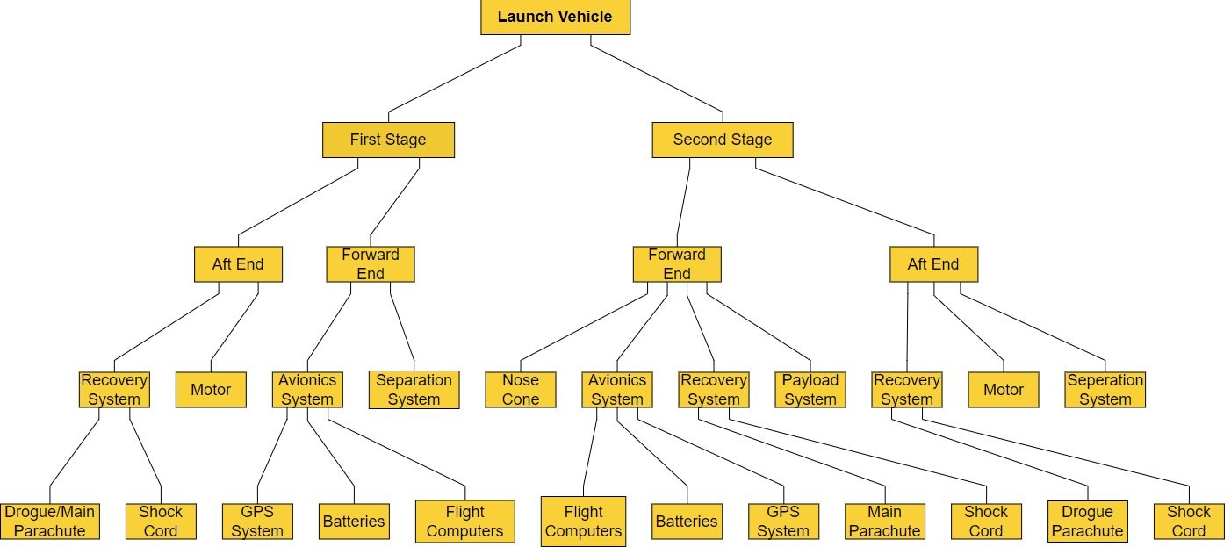
Figure 12: Functional Decomposition Chart

Above in Figure 12 is our functional decomposition chart that visually displays our flow of components into subsystems and into the final launch vehicle configuration. We will utilize this in our design process as we come to create drawings for all subsystems and components.
We can use the chart to organize our drawings from a top-level assembly of the launch vehicle and flow from the single components to create subassembly drawings including systems like avionics, recovery, and separation systems. We will build on this chart to include drawing names, part numbers and where they will flow into. Keeping the CAD and drawings organized will allow us to easily find them and see what we have completed so far.
The chart will also be utilized to create our testing, and mechanical assembly procedures. This will allow us to compare where the flow will need to stem from and how our assembly will be step by step of components, subsystems, and final launch vehicle. Procedures and testing will benefit us when we are preparing to assemble and launch the vehicle.

4.2 Wiring Diagrams
Once we receive flight computers and payload systems, we will integrate them into the vehicle and provide wiring diagrams. The definition of the electronics is unclear apart from the flight computer which we need to order due to the computers we were planning to use being damaged from a previous flight. The electrical diagrams will include payload wiring and power supply that is independent of the flight computers. There will be four flight computers for redundancy. Each will be independent from each other and have their own power supplies to avoid dependence on each other.

Moving Forward
Although several analyses and calculations have been done to finalize our initial rocket design, additional analyses will need to be made as we continue to progress into our final design and construction. To further analyze the vehicle design's performance, simulations must be conducted including a Finite Element Analysis (FEA) and Computational Fluid Dynamics (CFD). Utilizing these will allow us to predict the behavior of our rocket when subjected to various conditions. These results will aid us in building a more efficient and successful product for the client. Other calculations that will also need to be made include mass properties and additional stress/strain on the hardware as they are added to the subsystem assemblies in the design.

Citations:
[1] “High-Power Safety Information - Tripoli Rocketry Association,” www.tripoli.org. https://www.tripoli.org/content.aspx?page_id=22&club_id=795696&module_id=520420

[2] “High Power Rocket Safety Code - National Association of Rocketry,” www.nar.org, Mar. 26, 2014. https://www.nar.org/safety-information/high-power-rocket-safety-code/

