Hamster Mouse
ME486C: Project Management

Jared Hemauer
Rylee Horney
Joseph Lopez
Keenan Keams

Spring 2024 – Fall 2024

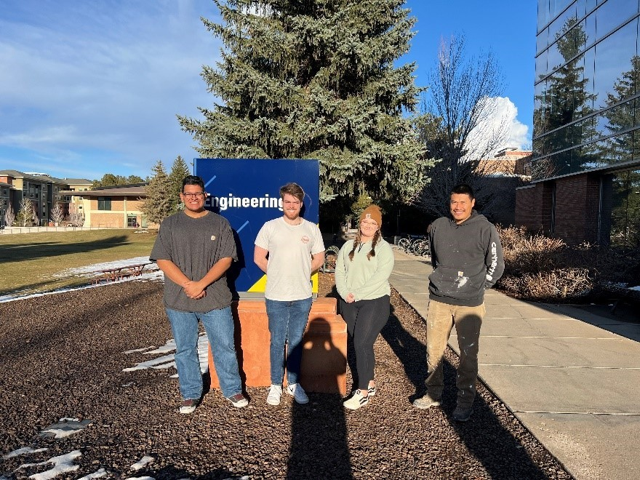

Project Sponsor: Reza Sharif-Razavian
Sponsors Mentor: Terae Jones
Instructor: David Willy

Reflection
Project Management- Success
In the list below are all the methods and procedures that the team used to meet deadlines and keep the project organized.
- The team meets weekly to discuss design and plans for upcoming team assignments.
- Every other week the team met with the client to allow for goals to be set to meet their expectations promptly.
- Created a group chat that was used to openly communicate with each other when questions arose.
- Distribution of work when it came to presentations and prototypes was even.
- Having tons of conversations with other professors and people in the industry to help guide analysis and decisions on our robot’s design.
Project Management- Areas for Improvement
Included in the list below are procedures and methods that need to be improved to help make the upcoming semester more successful for the project and team.
- Deadlines must be made further before the deadline so that the team is not rushing to complete tasks.
  - Our team has improved our Gantt chart creating deadlines about two or three days in advance. Allowing for the team to be prepared for finalizing presentations and reports.
- Communication among certain team members could be worked on and improved. The lack of communication regarding individual tasks left the other team members confused about the progress of the project.
  - Topic will be discussed in the first team meeting of the semester to set standards and understand the reasons for the deficit overall. This will hopefully create a better understanding of how our team will function and allow each member to be reminded of the importance of good communication.
- Verifying calculations two to three times before purchasing parts or presenting them to the class.
  - Creating a requirement that each member will review the other team member's calculations and if questions arise discuss them with project sponsors or other professors.

Remaining Design Efforts
This next section lists tasks that must be completed before the team starts building and implementing testing plans.
- Finalize designing the mechanism for opening and closing the robot so that parts can be added and worked on.
- Add wiring and other small objects/adjustments to the CAD model in SOLIDWORKS
- Complete CAD model

Gantt Chart Update
Below is an updated Gantt Chart with the current due dates of our 33% build and expands further to completion of the project. The list below is what the team is focused on for the completion of the 33% build.
- Finalize parts to be purchased and complete final design.
- Complete self-learning assignment
- Begin putting components together to function for the demo.
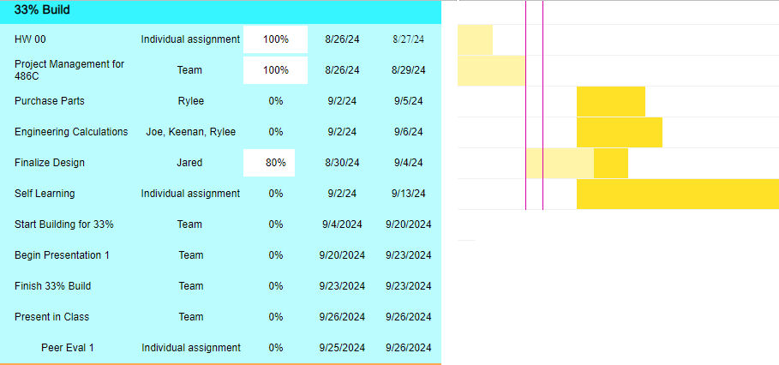
Figure 1. Gantt chart for Hamster team

Top Level Finances

Income sources:
The main source of the team’s income has been from the client Dr. Reza, but the team has gotten some funding from GoFundMe. The funding from the client was $1000 however he did mention that he would be willing to provide the team with an extra $100 if needed. The team received $250 from GoFundMe donations, making the team's total budget $1350.
Expenses to Date:
The team's current expenses are as follows. The remaining amount, seen in the summary, is what the team will leave the client at the end of the project. This amount is based on the current BOM for the final design and the previous prototypes. The final product amount may increase due the motors changing from the spring, still needing to perform an analysis to determine gage of wire, and unexpected issues. The unexpected cost may rise in manufacturing or testing of the machine due to the parts breaking or being received damaged.
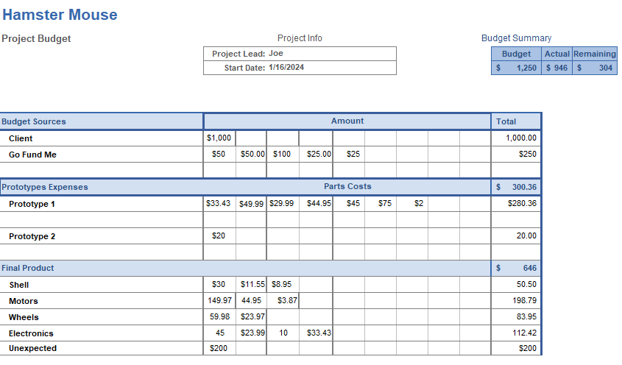
Figure 2. Hamster expenses overview

Purchasing Plan
Shown in Figure 3 is the team's most up-to-date and detailed bill of materials. This BOM shows the breakdown of each part of the team’s design. Displaying the amount for each part needed, if it’s being purchased or manufactured, the vendor, cost, and the lead time. This BOM will let the team properly plan the purchase/manufacturing of our parts to be successful for the rest of the capstone project.
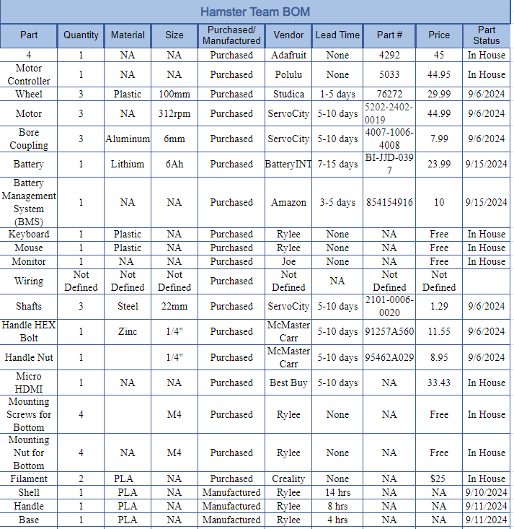
Figure 3. Hamster’s detailed BOM

Figure 4 shows each of the parts that will be purchased from the Hamster team’s BOM in Figure 3. Based on the lead times shown in the figure, the team needs to determine which parts will need to be ordered first and which parts may be put on hold for the second hardware check in the class. (1) The other action item the team needs to take is finding what gage wire will be used in the robot and what vendor the team will purchase from. (2) Lastly, the team needs to determine where we will purchase the new motors from based on the calculations to get them as soon as possible. (3)
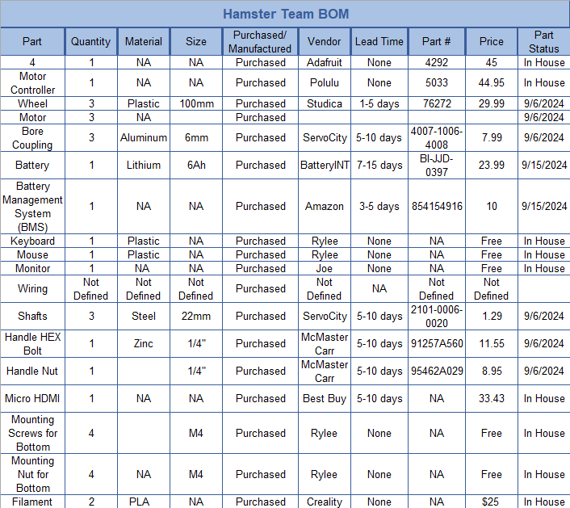
Figure 4. Parts that need to be purchased from the BOM

Manufacturing Plan
The team’s manufacturing plan does not entail many parts to be made. Most parts can be seen in Figure 5 below. The BOM shows that most parts will be purchased directly. The only part that will be manufactured is the robot's shell. Below is the breakdown of who, what, when, and where the shell will be manufactured.
Shell, Base, and Handle – All three of these parts will be manufactured by Rylee using her reality Ender 3D printer and will be made of PLA. The goal is to have all parts made as soon as the design is final at the beginning of the semester. The shell has an estimated print time of 14 hours, the base is estimated to take 4 hours, and the handle is expected to take 8 hours.
Figure 5. Parts that need to be manufactured from Hamster BOM

