Hamster Mouse

ME486C: Engineering Calculations Summary

Jared Hemauer

Rylee Horney

Joseph Lopez

Keenan Keams

Spring 2024 – Fall 2024



Project Sponsor: Reza Sharif-Razavian

Sponsors Mentor: Terae Jones

Instructor: David Willy

1.0 Top Level Design Summary
The Hamster project is focused on helping stroke patients that are currently going through physical therapy. The robot will be used as a device that will give patients the ability to practice exercises recommended by their doctor to help them regain mobility in the parts of their upper body that may have been affected by their health condition. The team’s solution to this problem is to create a robot that is small enough to fit on a table, produce a force large enough to move a patient’s arm to help them regain function, and will last at least 30 minutes for the patient’s exercise. In figure 1 is the most up to date top-level CAD model of the robot.
  - Current CAD Model
The team’s current CAD design is shown below. Based on recent client meetings the model has changed drastically since last semester. The team has focused on decreasing overall height of the robot to relieve the possible stress that patients could feel while using the device. The model is still using the same components in regards to wheel type, motor controller, battery, and microcontroller (Raspberry Pi). The sub-components to the assembly are the chassis, motors, wheels, microcontroller, battery, and motor controllers. The motors are located on the bottom of the model to allow for a higher clearance as well as more room for the small components to be above them. The motor controller is a “hat” on the raspberry pi allowing for the microcontroller to recognize and take inputs in from the motors. The team is still working towards finishing the CAD model with load cells, air circulation for cooling, and modifying the placement of the wheels based on clients request.
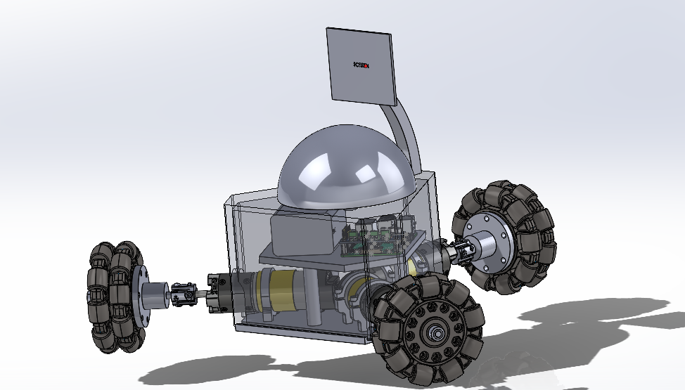
Figure 1. Current CAD Model for Hamster

1.2 Customer Requirements (CRs)
Provided is a list of the customer requirements from the initial proposal and feedback from meetings.

- Size – the client wants the device to be small enough that it is portable and can move over the surface of a desk.

- Speed – the device will need to be able to reach a speed of up to 1 m/s in any direction. This is to allow for the device to keep up with a patient’s hand speed.

- Force – must be able to produce a force of up to 10 N to the patient’s hand in any direction or 5 Nm of torque about the vertical axis.

- Internal Friction – when motors are not being used the device must be able to be moved with less than 5N of force.

- Backlash- when motors are off the device must not move more than 0.1mm.

- Run Time – device must run for at least 30 minutes on a single charge.

- Interface: device must be able to receive commands from a computer and send its position back to the computer in (x, y) coordinates.

- Screen – there must be a touch screen that is at least four inches on the device.

- Cost – total production of the device must be <$500.

- Microcontroller – client prefers Raspberry Pi to be used due to faster processing speeds.

- Ease of Use – should not require more than a number for the force being applied and a direction.

- Comfortable – the device should be comfortable in a patient’s hand.

1.3 Engineering Requirements (ERs)
Below is the list of engineering requirements chosen based on the customer requirements previously listed. The cross reference of the two requirements can be seen in figure 2.

- Motor Output (kW) – the motor must be able to produce enough rotations per minute to meet speed requirement of 1 m/s.

- Battery Life (kW hr ) – needs to last with three motors and the other electrical components for at least 30 minutes.

- Battery Amperage (A) - need to be able to produce enough current for all components in the robot at least 6 Ah (i.e. three motors, raspberry pi, sensors, motor controller, and screen)

- Size (ft) – less than 1ftx1ftx1ft

- CPU Speed (s) – the microcontroller needs to be able to send commands quickly so there is minimal delay in the movement of the robot. (16 MHz)

- Weight (lb.)- the device should not weigh more than 8 lbs. to allow for patient to be able to move it easily.

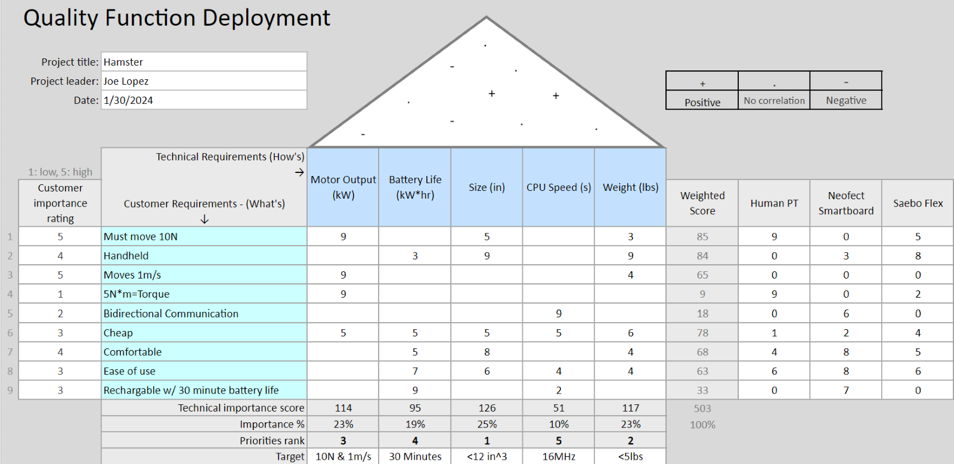Figure 2. Hamster team QFD

2.0 Summary of Standards, Codes, and Regulations
This robot is required to be able to help assist and resist stroke patients in mobility movement. The Hamster robot is going to be a medical rehabilitation robot for mild to moderate stroke patients. The standard for a rehabilitation robot is “IEC 80601-2-78:2019 applies to the general requirements for basic safety and essential performance of medical robots that physically interact with a PATIENT with an IMPAIRMENT to support or perform REHABILITATION, ASSESSMENT, COMPENSATION, or ALLEVIATION related to the PATIENT’S MOVEMENT FUNCTIONS, as intended by the MANUFACTURER.”[1]. Another standard is ANSI/RIA R15.06 which states when building and operating robotic systems we are taking safety measures to protect ourselves and coworkers when integrating systems, operations, and maintenance of the robot. Another popular standard for Medical Rehabilitation Robots is “IEC 80601-2-78 which adds mechanical hazards defined by robots to the mechanical hazards in IEC 60601-1." Currently, OSHA has no specific standards for the robotics industry.

3.0 Summary of Equations and Solutions
3.1 Omnidirectional Wheel velocity control in matrix form- Joe Lopez
As provided by Northwestern University, from their video series on modern robotics, a matrix that shows how the velocity of each wheel is calculated. The variables used in this equation are as follows, u is equal to the velocity of each wheel (m/s), r is equal to the radius of the wheel (m), d is the distance from the center of the robot to the wheel itself (m), $ω$ is equal to the angular velocity that is desired (m/s), v is equal to the desired linear velocity in the x or y direction (m/s). It should be noted that the subscripts are referring to the wheels position, wheel 1 being the north wheel, wheel 2 being the southeast wheel, and wheel 3 being the southwest wheel. By utilizing python, it is possible to control the robot’s position by asking the user for inputs for the linear and angular velocity while having the values for the other variables embedded into the code itself. The code has other functions to output the velocity in each wheel in RPMs instead of m/s.
 | $$\left[\begin{matrix}u_{1} \\ u_{2} \\ u_{3}\end{matrix}\right]=\frac{1}{r}\left[\begin{matrix}-d & 1 & 0 \\ -d & -\frac{1}{2} & -sin⁡(\frac{π}{3}) \\ -d & -\frac{1}{2} & sin⁡(\frac{π}{3})\end{matrix}\right]\left[\begin{matrix}ω \\ v_{x} \\ v_{y}\end{matrix}\right]$$ | (1)
3.2 Motor Torque Requirements- Joe Lopez
The client asks of us to have a 5 Nm torque when the robot is twisting and in order for that to be accomplished each of the motors must be able to output a certain amount of torque. In order for this to be determined the following calculations are needed. First 5 Nm is divided by the distance from the center of the robot that gives a value in N. Then that value is divided by 3 because that is the number of motors on the robot, this gives us the value of the force per motor. After that set that value equal to the Nm needed over the radius of each wheel. The resulting value is the required amount of torque per motor.
$$Newtons= \frac{Torque needed Nm}{Distance from center m}$$
$$Force per motor N= \frac{Newtons of force}{Number of motors}$$
$$Force per motor N= \frac{Required Torque Nm}{Radius of wheel m}$$

3.3 Instruction Execution Time – Rylee Horney
In order to understand if the team will be able to execute a movement in a reasonable amount of time regarding “physical therapy” exercises, the team needed to calculate the instruction execution time. T_{exec} reflects the time necessary for instructions to be executed. It is defined in equation 3, where f_{cpu} is the microcontroller frequency in Hertz. This computation gives critical information about whether or not the movement of the robot would be feasible for the team. Furthermore, when it comes to power consumption, equation 4 calculates the power consumed by the microcontroller, with I being the device's current need. With these measures being calculated the team can make proper design choices to enhance our system’s operations and reduce the amount of power usage in the robot.
 | $$T_{exec }=\frac{1}{f_{cpu}}$$ | (3)
 | P= f_{cpu}×I | (4)
3.4 Shear Deformation of PLA Filament – Rylee Horney
Several essential characteristics must be considered while doing engineering calculations for PLA filament shear deformation. For a given shear force (V) of 10N, cross-sectional area (A) of 2.03 mm², length (L) of 127 mm, Young's modulus (E) of 4.107 GPa, and Poisson's ratio (v) of 0.332, the shear deformation (θ) may be calculated using the equation θ = (V * L) / (G * A), where G is the shear modulus of elasticity. Using equation 3 yields a value of around 1.54 GPa. Substituting the provided values into the shear deformation equation, equation 6, provides a result of around 4.06 nm. These calculations give useful insight into the mechanical behavior of the PLA filament under shear stresses, which can help with the design and optimization of structures or components made from this material. A better graphic representation of the work is provided here.
 | $$G=\frac{E}{2(1+v)}$$ | (5)
 | $$θ=\frac{V∙L}{G∙A}$$ | (6)

3.5 FEA Calculations – Jared Hemauer
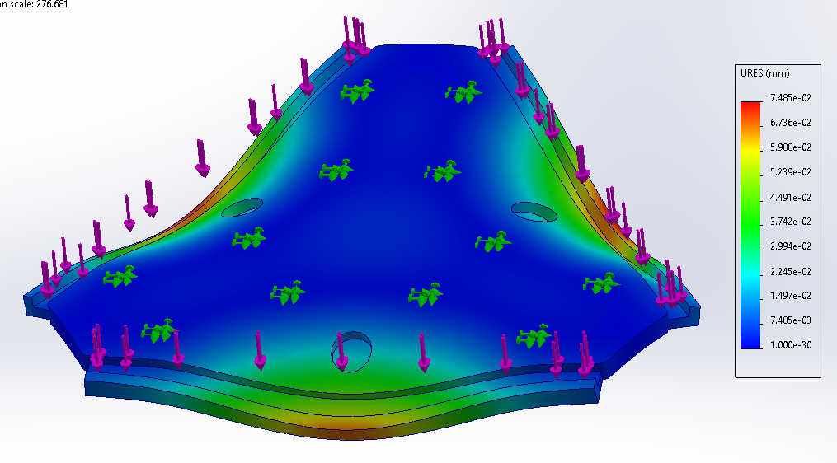
Figure 3: Deflection Analysis
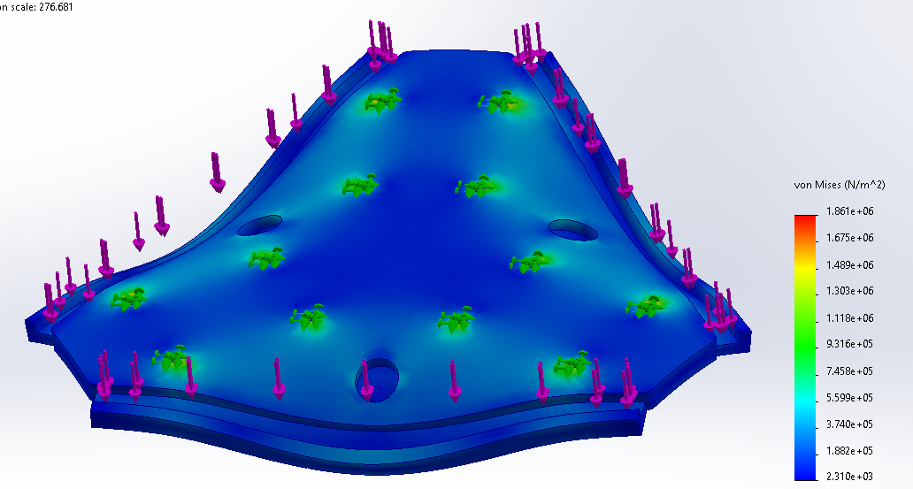
Figure 4: Stress Analysis
Using the SOLIDWORKS’ built-in simulation tool, simulationXPRESS, we were able to calculate the stress and deformation that would be applied to the base plate. The base plate was chosen because it would be taking the majority of the applied forces. The simulation was conducted using a 20lbf load applied perpendicular to the base and the fixture points were where the motor mounts will be placed, the resulting factor of safety was 24. The deflection was calculated to be .075mm (.003 in) and the stress applied was 1.8e6 Pa (261 psi). From this information we are comfortable using a .25 in PLA plate to support our design.

3.6 Power of the DC Motor- Keenan Keams
When trying to understand the power output of a robot, we first have to understand the power output of the motor and how much power the motors are drawing from the battery. I used a simple but very effective electrical equation Ohm’s Law. In equation 7 the P is power in Watts which is equal to the product of voltage (E) and current (I). Our current motors require 12 V and 9.2amp stall current needing 110.4 Watts to run. With the power required to run the motors we then can look for a 12V battery to support the robots power needs.
P=IxE (7)

4.0 Flow Charts and Other Diagrams
Figure 3 begins by illustrating our main goal of having the robot move a patient’s arm. The second row details the subfunctions, outlining their processing and interrelationships. This functional decomposition model is crucial for our project as it helps the team grasp the energy flow within the robot. Additionally, it breaks down each function into smaller, more manageable tasks, which will assist us in the building and coding phases of the robot.

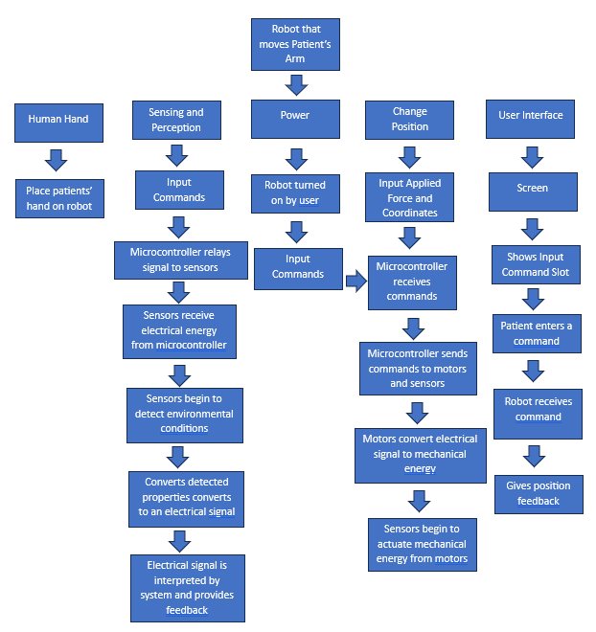
Figure 3: Hamster Project Function Decomposition

5.0 Moving Forward
One of the main things the team has to work on is changing the way the robot is controlled. As of right now the robot is controlled via lines of code which ask the user for a desired linear velocity, a desired angular velocity, and the direction the user wishes the robot wants to go. The client has requested that we shift the focus of the code to ask the user for a desired force linearly and rotationally. The way the client suggested this is the transpose the matrix from the velocity equation. Along with some more edits to the code the client suggested the team is currently looking into how the math works out for this force control. On the topic of force control the team is currently looking into using a closed loop controller to make sure that the proper amount of force is being applied by the motors. A PID controller and the team is planning on meeting with the Capstone TA soon to discuss the process and get help from him. The last thing that the team has to work on in relation to calculations and analyses is creating an accurate circuit diagram with all of the updated products, in addition to a circuit diagram being created the CAD file will be updated as new design changes and new products get added to the team’s robot.

Reference
[1] “IEC 80601-2-78:2019.” ISO, 11 July 2019, www.iso.org/standard/68474.html#:~:text=IEC%2080601%2D2%2D78%3A2019%20applies%20to%20the%20general,FUNCTIONS%2C%20as%20intended%20by%20the.

