SAE Baja 2022-2023

ME 486C Project Management Report

Front Suspension | Zachary Biehl
Front Suspension | Jared Bonds
Front Suspension | Dylan Wisniewski
Drivetrain | Erik DiMaria
Drivetrain | Claire Pescatore
Drivetrain | Logan Gerard Wilson
Rear Suspension | Samuel Larios
Rear Suspension | Robert Gerlinger
Rear Suspension | Tanner Bunch



Project Sponsor: Gore, Jacobs Engineering, Nestle Purina Pet Care, Novakinetics AeroSystems, and Horizontal Boring LLC., Findlay Toyota, Slime,

Faculty Advisor: David Willy
Instructor: David Willy

Table of Contents
1 Reflection: 2
1.1 Project Management - Successes: 3
1.2 Project Management - Room for Improvements and Action Items: 3
1.3 Remaining Design Efforts: 3
2 Gantt Chart: 4
2.1.1 Figure 1: ME486C Deliverable Schedule 4
2.1.2 Figure 2: ME486C Purchasing Plan 5
2.1.3 Figure 3: ME486C Manufacturing Plan 6
3 Purchasing Plan: 6
3.1 Front Suspension Purchasing Excel Sheet: 6
3.1.1 Figure 4: Front Suspension Purchasing Key 6
3.1.2 Figure 5: Front Suspension Purchasing Sheet 7
3.2 Rear Suspension Purchasing Excel Sheet: 7
3.2.1 Figure 6: Rear Suspension Purchasing Sheet 7
3.3 Drivetrain Purchasing Excel Sheet: 7
3.3.1 Figure 7: Drive Train Purchasing Sheet 8
4 Manufacturing Plan 8
4.1.1 Figure 8: Manufacturing Key 9
4.1.2 Figure 9: Manufacturing Plan 10
5 Competition/Capstone Deliverable Overlap 10
5.1.1 Figure 10: Baja SAE Deadlines 10

Reflection:

Project Management - Successes:
Below is a bulleted list of successful things our team completed last semester with respect to project management and team communication. These marks can show our overall progress. It is important for us to identify these and move on with missing elements to our design.
  - Attended weekly group meeting in the NAU Machine Shop
  - Attended weekly SAE club meetings
  - Attended weekly client meetings with David Willy
  - Attended weekly capstone meetings in Engineering conference room
  - Acquired several successful sponsorships/donations
  - 6/9 Team members are Machine Shop Advanced training certified in at least one discipline
  - 3/9 Team members attended SAE Baja competition in Tucson
  - Team bonding via extracurricular activities

Project Management - Room for Improvements and Action Items:
As we are entering the second semester of working on this project, our team has identified room for improvement to finish off the project build. Ideas to focus on include project management improvements, team communication and possible setbacks along the way. Action items are listed below each improvement bullet.
  - Improve communication between sub teams
    - Meet on a weekly basis to discuss next steps for each upcoming deadline.
      - Covering our bases with documentation
      - Leaving extra time for potential delivery delays
  - Work on assignments much earlier than expected due date.
    - Meet deadlines for capstone class and competition accordingly.
      - Making sure our team is fit for competition and passes the capstone requirements.
  - Account for a long queue at the machine shop and send in parts to be made in advance.
    - Drivetrain team needs to solidify design to send SolidWorks parts to the machine shop.
      - Quicker manufacturing and assembly
      - Similarly with rear and front suspension sending some parts to be sent to the mill and lathe.
      - Finish manufacturing sooner to work on assembly quicker.

Remaining Design Efforts:
Below are the remaining design items that our team needs to finalize and create some computer models to then manufacture.
  - Design engine mounts using existing frame members.
  - Locate gear box output location to determine axle length and 4WD drivetrain mounting points.
  - Design brake system
  - Design steering system
  - Mount cosmetic features which may include small design implications.

Gantt Chart:
In this section the Baja team will present their three Gantt Charts that will serve as the completion schedules for Class Deliverables, Purchasing, and Manufacturing. Each chart will depict the next few weeks of progress leading up to the 33% build progress update in February.

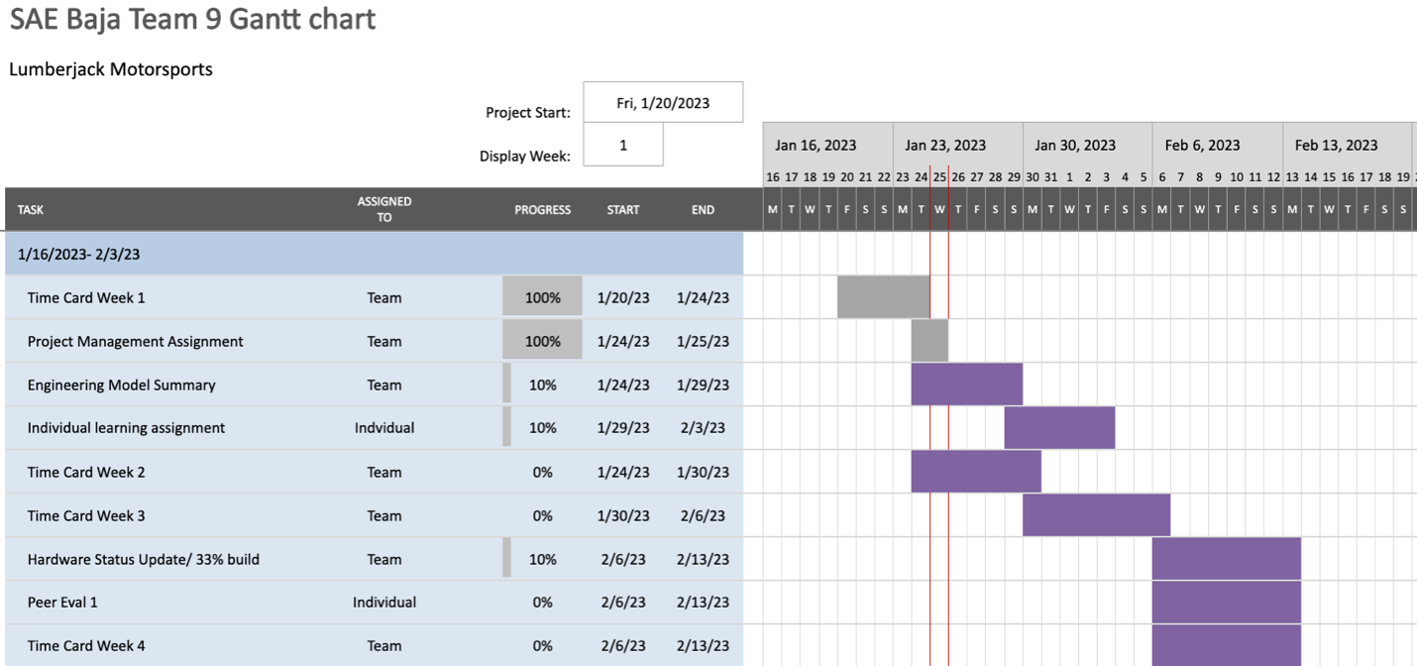

Figure 1: ME486C Deliverable Schedule
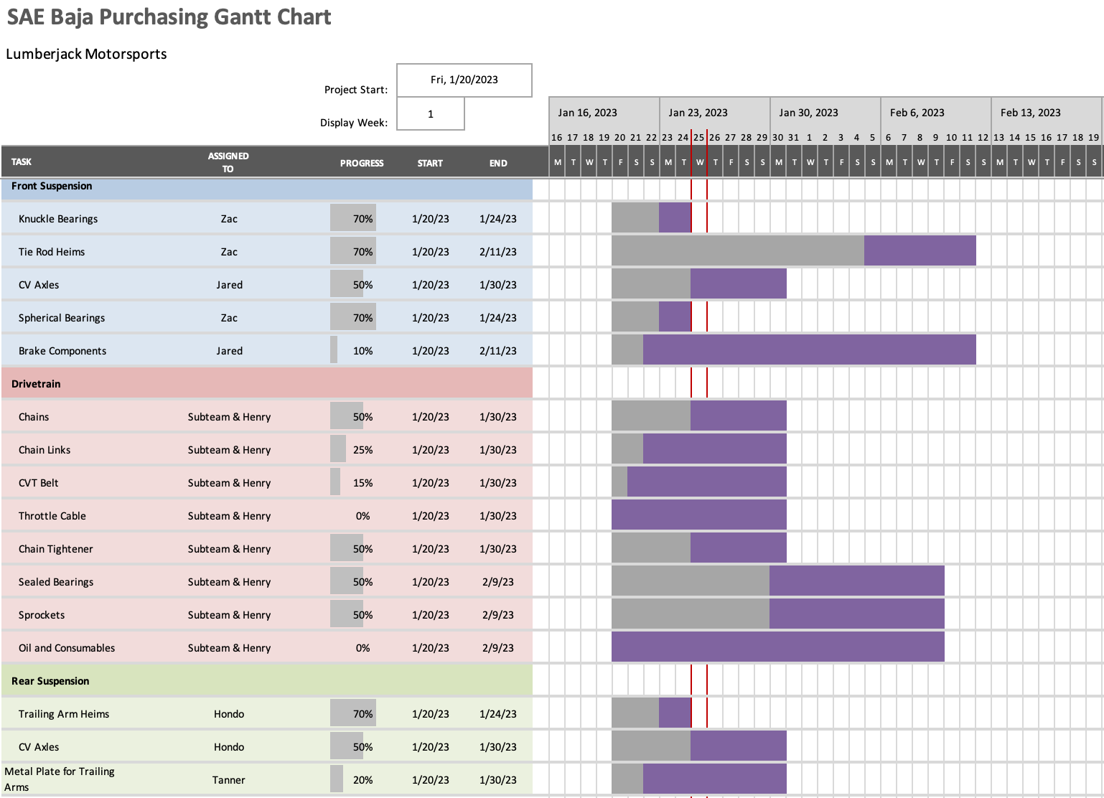

Figure 2: ME486C Purchasing Plan
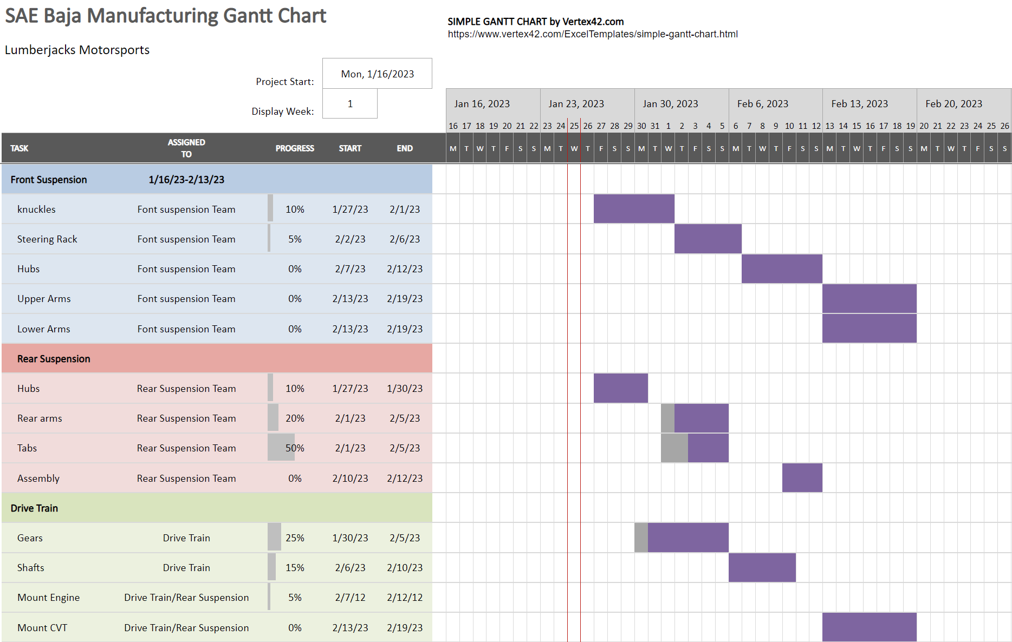

Figure 3: ME486C Manufacturing Plan

Purchasing Plan:
For organizing all line items, the SAE Baja team decided to create a Microsoft Excel document. Within this document there are three separate pages including Front Suspension, Rear Suspension, and Drivetrain. Each page lists all parts that each sub team will need to complete the fabrication of the Baja vehicle. Columns for these pages include Item Number, Item Name, Quantity, Price (each), Price (total), Link to the Website, Part Number, Primary Vendor, Secondary Vendor (if applicable), and lastly the Manufacturer that makes the part. Part statuses are displayed using a color system, for which a key can describe the meanings for each. Each key can be seen with its corresponding page.

Front Suspension Purchasing Excel Sheet:
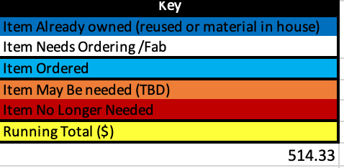

Figure 4: Front Suspension Purchasing Key
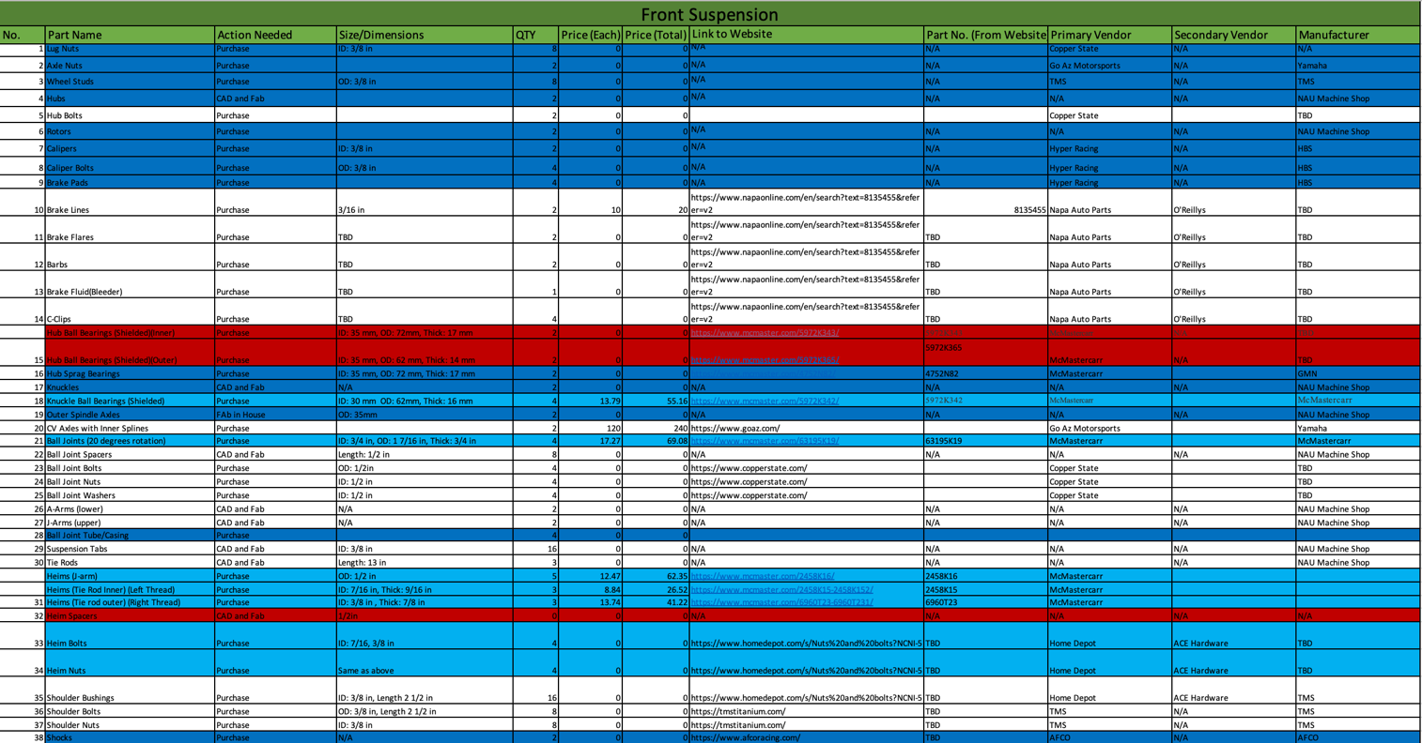
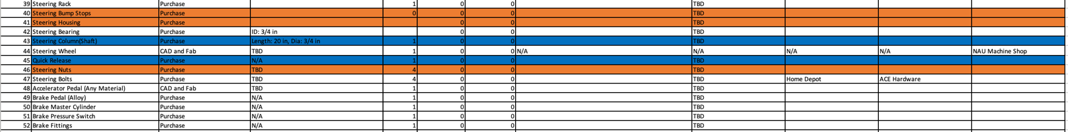

Figure 5: Front Suspension Purchasing Sheet

Rear Suspension Purchasing Excel Sheet:
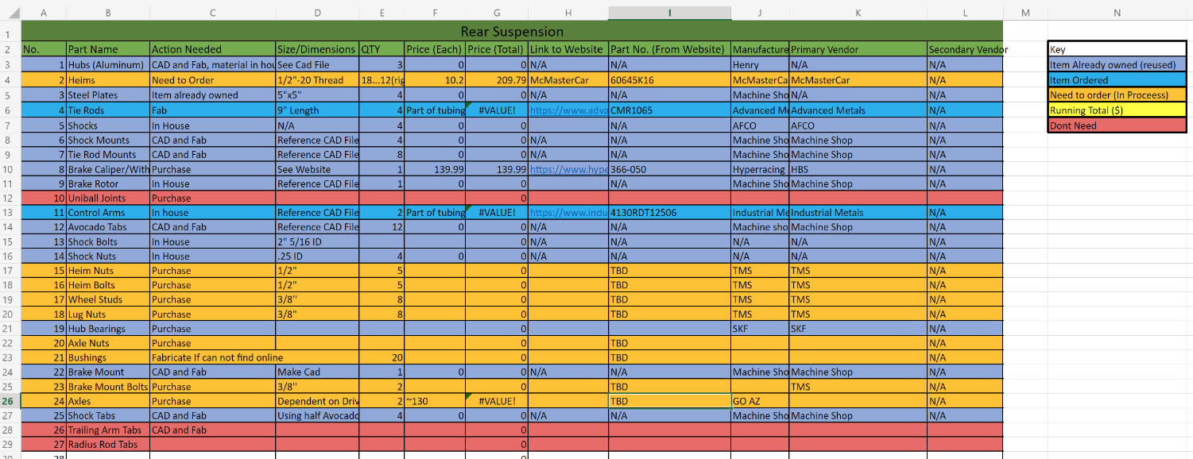

Figure 6: Rear Suspension Purchasing Sheet

Drivetrain Purchasing Excel Sheet:
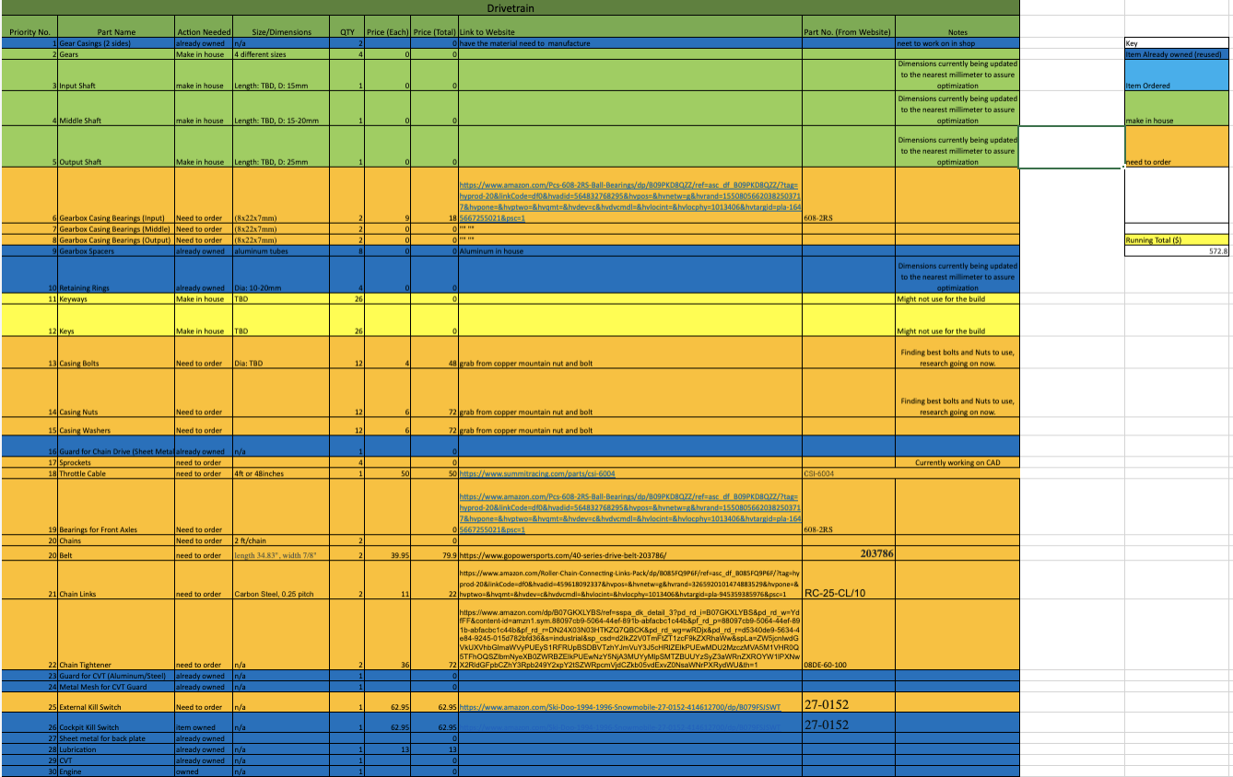

Figure 7: Drive Train Purchasing Sheet

Manufacturing Plan

To make sure that all parts are manufactured correctly and in a timely fashion, all teams have ranked each part in the level of importance per machine that is used to create the part. This ensures all parts are done and that each team knows which part is next for each machine. Once the machined parts are made and assembled, the team can then set up their 33%, 66%, and 100% completion plan to ensure there is plenty of time for testing their designs.
To meet these times, the following table has been created to meet all the requirements. Each part is color coded to their sub-team, along with the member of each sub-team that is responsible for each part. An estimation of how long each part will take to make is included to give an idea of how much time will be needed to complete each sub-assembly. The importance of each part is listed in terms of how accessible each part is ready to be made, along with how important the part is to the car. The material being used for the parts is also listed to give an idea of how much of each material is needed for the whole project. Lastly, each part has been listed with a machine that will be used to machine the part. If the part is being outsourced, the part is listed in the outsource section, with the outsource location being listed.
KEY
Front
Drive Train
Full Team
Rear

Figure 8: Manufacturing Key

Importance | Part | Who | Duration (hr) | Raw Material | Location
 |  | CNC
1 | Knuckles | Jared | 30 | 6061 T6 | Machine shop
2 | Front Hubs | Jared | 20 | 6061 T6 | Machine shop
3 | Rear Hubs | Robert | 20 | 6061 T6 | Machine shop
4 | GB Casing | Logan | 16 | 6061 T6 | Machine shop
5 | Steering Rack | Zachary | 8 | 4130 | Machine shop
6 | Gears (4x) | Logan | 12 | 4130 | Machine shop
 |  | Plasma Cutter
1 | Half avocado tabs | Dylan | 8 | 4130 | Machine shop
2 | Housing plates | Samuel | 1 | 4130 | Machine shop
 |  | Mill
1 | Steering Rack End Link | Zachary | 4 | 6061 T6 | Machine shop
2 | Steering Rack Mounting Plate | Jared | 8 | 6061 T6 | Machine shop
 |  | Fab
1 | Engine Mount | Eric |  | 4130 | Machine shop
2 | Control arms | Tanner | 10 | 4130 | Machine shop
3 | Lower Control Arms | Jared | 8 | 4130 | Machine shop
4 | Upper Control Arms | Jared | 8 | 4130 | Machine shop
5 | Sprocket Holders | Claire | 15 | 4130 | Machine shop
6 | Footbox Front Hoop | Jared | 4 | 4130 | Machine shop
7 | Chain Guard | Claire | 3 | 4130 | Machine shop
8 | CVT Casing | Eric | 5 | 4130 | Machine shop
 |  | Lathe
1 | Tie Rods | Tanner | 6 | 4130 | Machine shop
2 | Shafts | Logan | 12 | 4130 | Machine shop
3 | Tie Rods | Zachary | 5 | 4130 | Machine shop
4 | Spacers | Logan | 8 | 6061 T6 | Machine shop
5 | Spline inserts | Robert | 7 | 4130 | Machine shop
6 | Spline inserts | Dylan | 4 | 4130 | Machine shop
 |  | Outsource
1 | Rear axles | Samuel | NA | NA | GoAZ
2 | Bearings | Claire | NA | NA | Amazon
3 | Steering Wheel | Dylan | 16 | Carbon/ Fiber Glass | Novakinetics
4 | Footbox Floor | Zachary | 6 | Zinc-plated Steel | Machine shop
5 | Body Panels | Team | 24 | Carbon/ Fiber Glass | Novakinetics

Figure 9: Manufacturing Plan

Competition/Capstone Deliverable Overlap
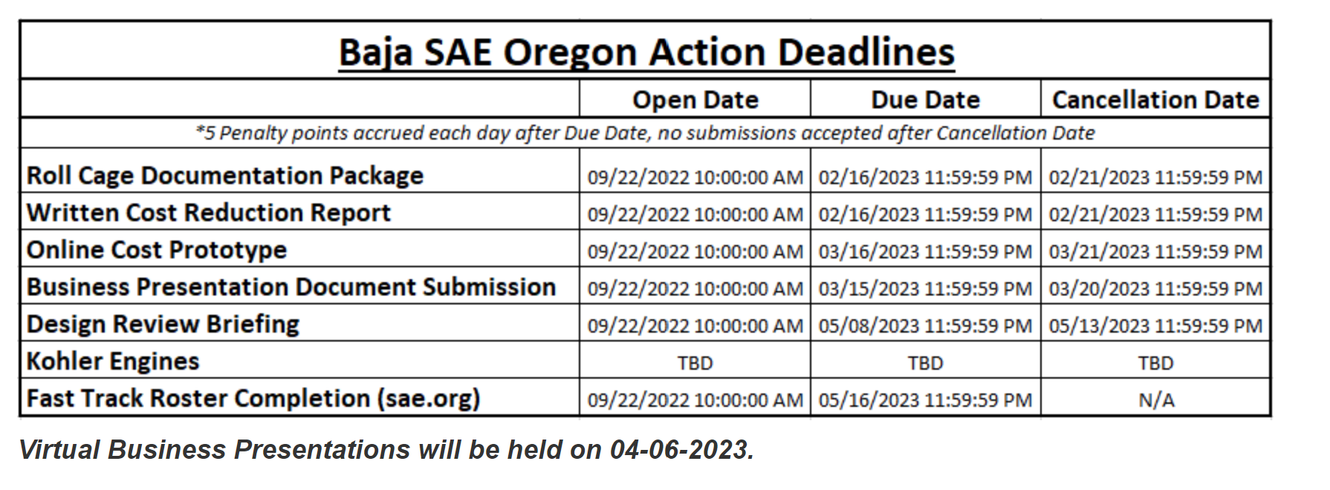

Figure 10: Baja SAE Deadlines
To get the most out of ME486C it is important to line up the deliverables due for the competition and the assignments for the class to eliminate meaningless assignments. During the discussion as a team and going through the SAE Baja deliverables and the requirements for each deliverable the assignments that could be merged with the competition deliverables would be the Final CAD packet and operational/assembly plan. The competition deliverable that overlaps with these assignments is the design review briefing. Within the design review briefing SAE is requiring all views of the completed assembly within CAD. Along with that all of the subsystem goals and targets must be explained with pictures from CAD. The mesh of systems and how they interact must also be shown and explained. The CAD pictures of the drawings and assemblies will fulfill the final CAD package assignment requirements and the explanations on how the subsystems come together and mesh with one another will fulfill the operational/assembly plan requirements. It would be ideal to change the final CAD package assignment and operation/assembly plan to be submitted as the design review briefing as the deliverable involves all aspects of those assignments.

