To copy VP Online diagram as image to MS Office, please select menu Edit > Copy as Image to MS Office

SAE Aero 2023 Competition

Preliminary Proposal

Alec Zodrow
Alexander Vierhout
Devin Rossi duBois
Gabriela Liquidano
Iain Pettit
Jacob Cabanyog

2022-2023



Project Sponsor: W.L. Gore and Associates
Faculty Advisor: Dr. Willy
Instructor: Armin Eilaghi

DISCLAIMER
This report was prepared by students as part of a university course requirement. While considerable effort has been put into the project, it is not the work of licensed engineers and has not undergone the extensive verification that is common in the profession. The information, data, conclusions, and content of this report should not be relied on or utilized without thorough, independent testing and verification. University faculty members may have been associated with this project as advisors, sponsors, or course instructors, but as such they are not responsible for the accuracy of results or conclusions.

TABLE OF CONTENTS
[Use your word processor to delete the following Table of Contents and insert a new TOC. Include front matter (except for the cover page), body of the report, and all appendices. The Table should include four levels of headings, e.g., down to 2.2.1.3, as illustrated below. Front matter should be in Roman numerals.]

Contents
DISCLAIMER 1
TABLE OF CONTENTS 2
1. BACKGROUND 1
1.1 Introduction 1
1.2 Project Description 1
2. REQUIREMENTS 2
2.1 Customer Requirements (CRs) 2
2.2 Engineering Requirements (ERs) 2
2.3 House of Quality (HoQ) 4
3. DESIGN SPACE RESEARCH 5
3.1 Literature Review 5
3.1.1 Devin duBois 5
3.1.2 Alec Zodrow 6
3.1.3 Gabriela Liquidano 9
3.1.4 Iain Pettit 10
3.1.5 Jacob Cabanyog 12
3.1.6 Alexander Vierhout 14
3.2 Benchmarking 16
3.2.1 System Level Benchmarking 16
3.2.1.1 Existing Design #1: Georgia Tech 16
3.2.1.2 Existing Design #2: Texas A&M 17
3.2.1.3 Existing Design #3: Northern Arizona University 17
3.2.2 Subsystem Level Benchmarking 18
3.2.2.1 Subsystem #1: Wing Planform 18
3.2.2.1.1 Existing Design #1: Rectangular Planform 18
3.2.2.1.2 Existing Design #2: Triangle Planform 18
3.2.2.1.3 Existing Design #3: Tapered Planform 18
3.2.2.2 Subsystem #2: Propellor Design 19
3.2.2.2.1 Existing Design #1: Two-Blade Propellor 19
3.2.2.2.2 Existing Design #2: Two-Blade Propellor with Shroud 19
3.2.2.2.3 Existing Design #3: Three-Blade Propellor 19
3.2.2.3 Subsystem #3: Tail Design 19
3.2.2.3.1 Existing Design #1: Two Tail 19
3.2.2.3.2 Existing Design #2: Dual Tipped 19
3.2.2.3.3 Existing Design #3: Conventional 20
3.3 Functional Decomposition 20
3.3.1 Black Box Model 20
3.3.2 Functional Model/Work-Process Diagram/Hierarchical Task Analysis 21
4. CONCEPT GENERATION 22
4.1 Full System Concepts 22
4.1.1 Full System Design #1: Delta-Wing 22
4.1.2 Full System Design #2: 2-Tail 23
4.1.3 Full System Design #3: Hammerhead 23
4.1.4 Full System Design #4: Hatchback 24
4.2 Subsystem Concepts 25
4.2.1 Subsystem #1: Wings 25
4.2.1.1 Design #1: Rectangular Planform 25
4.2.1.2 Design #2: Triangular Planform 25
4.2.1.3 Design #3: Tapered Planform 26
4.2.2 Subsystem #2: Propeller 26
4.2.2.1 Design #1: 2 Blades 26
4.2.2.2 Design #2: 2 Blades with Shroud 26
4.2.2.3 Design #3: 3 Blades 27
4.2.3 Subsystem #3: Tail 27
4.2.3.1 Design #1: 2-Tail 27
4.2.3.2 Design #2: Dual tipped 28
4.2.3.3 Design #3: Conventional 28
4.2.4 Subsystem #4: Fuselage 28
4.2.4.1 Design #1: Slots 28
4.2.4.2 Design #2: Hatchback 29
4.2.4.3 Design #3: Rear door 29
4.2.5 Subsystem #5: Material 29
4.2.5.1 Design #1: Carbon Fiber 29
4.2.5.2 Design #2: Balsa Wood 29
4.2.5.3 Design #3: Aluminum 30
4.2.6 Subsystem #6: Landing Gear 30
4.2.6.1 Design #1: Tricycle 30
4.2.6.2 Design #2: Reverse Tricycle 30
4.2.6.3 Design #3: Skis 31
5. DESIGNS SELECTED – First Semester 32
5.1 Technical Selection Criteria 32
5.2 Rationale for Design Selection 32
5.3 REFERENCES 34

1. BACKGROUND

Introduction
The task at hand is to design a remote-controlled aircraft that can compete in the 2022 SAE Aero Micro Design Competition. The 2022 NAU Micro team will develop a final design oriented around both competition requirements, as well appealing to our stakeholder goals. A deeper understanding of the engineering design process will be obtained by the team of six, allowing us to apply our aeronautical engineering knowledge to a physical final deliverable. Tasked with designing a plane from the ground up, the team will learn about professional documentation of a project as well as developing presentation skills. The latter half of the project will further the team’s ability to manufacture a final design and bring it to competition in March of 2023.

Project Description
The original project description provided by the sponsor is, “The SAE Aero Design competition is a real‐world design challenge designed to compress a typical aircraft development program into one calendar year, taking participants through the system engineering process of breaking down requirements. It exposes participants to the nuances of conceptual design, manufacturing, system integration/test, and sell‐off through demonstration”.

2. REQUIREMENTS
Before the process of designing and manufacturing started, the team compiled final goals to reach before attending competition. These goals were determined based off what is required by the SAE competition as well as what is expected of the team from our client Professor David Willy. The team then used these customer requirements to come up with a set of quantifiable engineering requirements that will address each of the customer’s needs in their own unique way. An analysis of the two sets of requirements was done using a house of quality.

Customer Requirements (CRs)
The overall project objective is to create an aircraft that can safely compete in the SAE Aero competition and finish the course successfully. Shown below are the customer requirements in no specific order. Being competition ready has the biggest weight to it being at 19%. The reason for this weight is because not only does the sponsor want us to have a plane that will be able to compete in the competition, but also being competition ready implies that we have something that we can get to fly and ready to compete. Lightweight is second highest in the customer weights being at 17%. This is because we want the plane to have an easy weight ratio allowing the plane to lift off the 4x8 ft takeoff platform. Stable flight is third being 13%. Stable flight ensures that everything in the plane’s dimensions is designed properly and there are possibilities for safe landings. Short takeoffs are at 12% because of the small platform that we are given to takeoff on. In the competition, if the plane fails to take off before the takeoff platform ends, the plane will fall off and go straight into the ground. The durability has a weight of 10%, this is still a decently high percentage. This is because having a durable plane would mean less repairs and less problems. Another weight of 10% is for being cost effective. Having the design be cheaper allows us to create more prototypes and more money for solving problems that can be found during flight testing or other testing. The ability to land has a weight percentage of 7% and that is because the ability to land can’t come without being able to fly or take off. Repairability has a weight of 5%, this is because we know that there will be damage to the plane and want to have it repaired easily. High maneuverability is at 4% due to not really caring much about the maneuverability because we are focused on getting a plane up and down safely. The payload capacity is at 3%, this is because although the competition wants us to carry more weight for more points, the sponsors main objective is to get the plane to take off and land to place in the competition. Lastly the high speed has a customer weight of 2% and that is because again of the wants and needs of the sponsor although the competition wants us to compete in who can finish the track the fastest.

Engineering Requirements (ERs)
The first engineering requirement is to reduce the total cost of the design. To do this, the team will choose materials that have high strength and durability, that are on the cheaper side. This engineering requirement will go along with the customer requirements of being durable and having a low cost. Examples of this would be Balsa wood, and some types of foams to have a durable design, with cheap material. The target cost of one rendition of the plane is $600-$900. With a budget of $3000 dollars provided by our sponsor, the team needs to limit the percentage of the budget used on materials to allow for adequate prototyping as well as travel costs.
The second engineering requirement is to reduce the total weight. To reduce the total weight of the aircraft, the team will choose the materials being used to design, and in the landing gear, there will be a lot of weight that can be altered. This is an important requirement due to the knowledge of knowing the weight is a big factor to lift ratios. An example of reducing weight would be using skid plates for the tail wheel landing gear, instead of a wheel configuration. The target weight for the final design is to be within 3-4 pounds. This number was decided upon by the team because the plane in limited to 450 W of power per competition rules. Most commercial motors that intake that power is fitted to planes no larger than 4 pounds.
The next engineering requirement is to increase the max stress that the plane can endure during flight. Increasing the max stress will allow the wings and body of the plane to withstand the stress applied from the air when flying. This can be done by improving the strength-to-weight ratio through material selection or building more supporting members of the plane. This will increase the reliability and durability of the plane itself. Our initial goal for stress resistance capabilities is to have all parts being able to withstand 200 ± 30 psi for the entirety of the flight, including the landing. This target strength was determined from a preliminary analysis of the total stress the plane might be under at any given time. The plane also needs to be able to endure rough transportation to competition because the team might need to ship the plane to Fort Worth, Texas.
High thrust to weight ratio is our next engineering requirement. This will help us address the issue that most SAE Aero teams run into. With only 8 feet of runway to take off from, the team will need an exceptional initial acceleration to generate enough lift. Our target thrust-to-weight ratio is 1:1.6, but the team will be happy with a ratio as high as 1:3. This should guarantee a consistent take-off at competition. This will also allow the team to score more competition points in the cargo run. Having the ability to increase throttle will allow the team to carry more weight and not worry about takeoff capabilities.
The fifth engineering requirement is to have a high lift-to-drag ratio. With a target lift-to-drag ratio of 4:5, the team will be able to increase speed and maneuverability when in flight. Higher ratios of 1:1 will give the team more room to breathe when it comes to stresses on the plane. Reductions in drag will come from designing a slim body that not only reduces skin drag but pressure drag as well. Further analysis of this can be done by putting protypes of this into a wind tunnel and measuring pressure differences. Effective airfoil design will produce more lift without increasing the platform area of the wings.
The sixth engineering requirement is to increase the total part count. The reason the team chose this as an important engineering requirement is to increase repairability of the plane. With a target of 5 major parts of the plane, the team plans to possess the ability of interchange portions of the plane at any given time in case of emergency. This is to address the issue of a broken part or even a part that is not performing to the team’s standards. This will also allow us to potentially have different wing designs for when we are carrying different amounts of cargo.
The final engineering requirement is to maximize power consumption. With a competition required power limiter of 450 W, the team wants to aim to consume between 400 and 450 watts of power. This will allow us to produce the most amount of thrust, which will in turn produce more lift. This will also reduce or takeoff distance and increase maneuverability, as a higher speed will allow more manipulation of the working fluid.

House of Quality (HoQ)
A house of quality was constructed to compare our eleven customer needs to our seven engineering requirements. In the house of quality, the customer needs were weighted from most important to least important, with being competition ready as the highest priority. The engineering requirements were then assigned a score of one, three, or nine, which represents how well they address the customer needs. A summation of the ratings for each requirement was made to give the team insight into which engineering goal will satisfy our customers' needs the best. In addition to the internal analysis of our own goals, three benchmarking projects from past SAE teams were explored to see how well those designs would have addressed our personal goals. These teams were given a score of 1-5 on their tackling of each customer's need. This process is displayed in Figure 1.
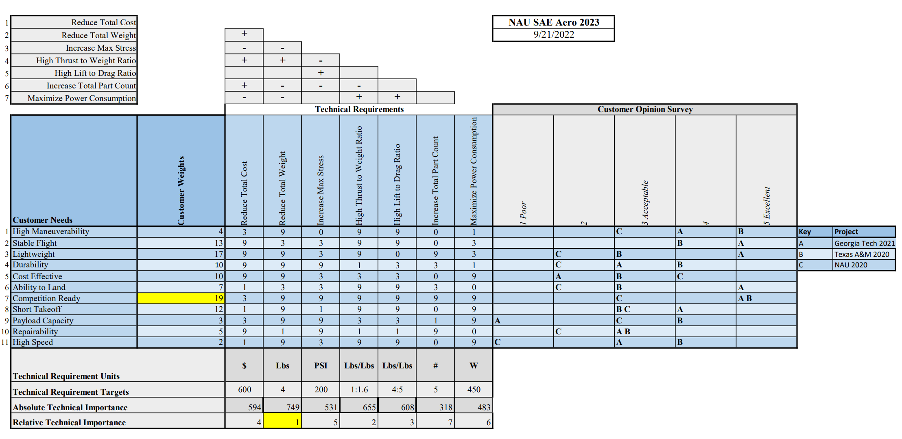
Figure 1: House of Quality
The use of the House of Quality was a key initial step into the design phase of the project. The HoQ indicated that the most important engineering requirement to address is the reduction of the total plane weight. With a target weight of four pounds, the team will focus efforts on all portions of the plane to achieving this weight. The team will look at the build process of Georgia Tech’s 2021 RC plane to know how to efficiently reduce weight without losing performance.

3. DESIGN SPACE RESEARCH
This chapter describes the approaches used in the initial research of the project. A literature review gives different sources that were used to study aeronautical concepts and how they can apply to the project. Different systems and subsystems are then identified and benchmarked to see how the plane has been previously designed. The project was then broken down using functional decomposition and a Black Box Model and Functional Decomposition model were created.

Literature Review

Devin duBois
As the Test Engineer, Devin was given the task research information on the landing gear. The reason for this is because to prevent multiple failed attempts, you need to construct a stable and safe landing gear that will make it easier to land. Devin will be testing the components and making sure before flight testing, everything works properly. The five relevant sources that are used to help understand and how to build a correct and stable landing gear are shown below and will be explained why they are useful in this project.

Source #1: Chapter 8.6.7 Aircraft Performance and Design-Book
In Source 1, the main topic is choosing a landing gear between tricycle, tail dragger, or bicycle landing gears. It also gives equations needed to solve for the exact distances between the wheel placements, and the how high the propellor needs to be off the ground. The propellor tip should be at least 9 inches of clearance above the ground, meaning the radius of the tip of the propellor should be 9 inches above the ground or more. The tail dragger landing gear gives that propellor clearance and a better lift due to the plane being tilted back causing a higher angle of attack in the sitting position. After finding the position of cg and placements of the landing gear, the wheel sizes now factor in. The wheel sizes will be dependent on the weight of the aircraft and the size factor. This source contains a lot more information that is to help benefit constructing a landing gear for this project.

Source #2: The Design of Aircraft Landing Gear-Book
Source 2 goes into full detail of how to design the landing gear. The first five chapters talk about an introduction to designing the landing gear and the main parts of a landing gear. The main parts are the tires, wheels, brakes, and brake control. After figuring out everything to do with those, the book moves into the layout of the landing gears and how the stability and maneuverability are affected by the design of the landing gear. After getting a general arrangement of the landing gear, the book goes into detail with shock absorbers and how to retract the landing gear when in flight. Although our project will not consist of this, it is still mentioned to be a good credible source for gathering information about creating reliable landing gear. Lastly, the book goes into equations and functions required to figure out the exact measurements needed for the landing gear to work correctly.

Source #3: Chapter 13 The Anatomy of the Landing Gear-Book
Source 3 is the anatomy of landing gears, which goes into details of what is happening in the landing gear. The reliable source talks about the importance of tires, wheels, and brakes, their dimensions. To go further into detail, the source talks about calculating the turning radius, tire footprints, tire types, inflation pressures, tire geometry and sizes. There are also various landing gears that are shown and explained why and how they are used. The last thing the source does is give the geometric layouts for a tricycle, taildragger, and a monowheel landing gear, step by step, and their reaction loads and how their equations work.

Source #4: An Investigation of an active landing gear system to reduce aircraft vibrations caused by landing impact-Article
Source 4 includes mathematical models of a controlled landing gear system and the stability analysis of the landing gear. On the wheel, there are two loads being applied, the upper mass being the weight of the plane, and the lower mass being the weight of the piston applied to the wheel. The source shows how to solve the dynamic equilibriums, the spring force that is produced by pressure, the damping force, the ground reaction force, the friction force, and the active control force. There are equations that are fully explained and how to apply them to other landing gear configurations. The stability analysis includes the matrix equations which are going through all the equations that were made from the previous section and solving for everything in 2-dimensional. The source provides the solutions to the static equilibrium, the dynamic equations, and the stability condition. The last thing the source talks about is the numerical simulation, that is running through multiple analyses with different types of runways or landing strips. Talking about their stability, and their performance.

Source #5: Landing-Impact Characteristics of Load-Alleviating Struts on a Model of a Winged Space Vehicle-Report
Source 5 talks about a different type of landing gear that might be suitable for the project. The source talks about a landing gear that includes skid plates as part of the landing gear. The source includes information about the dimensions the aircraft has with different types of skid plates for the back end of the landing gear. It includes the pros and cons of having skid plates, the pros are that the weight is extremely less and will allow all the ratios to be less hard to reach. With that being a pro, the con is that there will be a lot more friction on the landing gear due to no wheels. The report includes measurements to help show how the skid plates can ensure a safer landing for the cargo on board but can be damaged severely overtime if not constantly remanufactured. There are drawings and measurements given for different styles of skid plate landing gears that can be used to test the project design.

The following sources will be used to help design and manufacture the landing gear that will be used for the aircraft. Sources 1, 2, and 3 will all be used for their calculations and understanding how to choose the correct dimensions for the wheels, tires, brakes. Source 4 will be used to go in full depth of calculating the forces applied to the landing gear so we can evaluate where the problem could be before running into the problems. Source 5 will be used during the design stage to test and see if having a skid plate could be more beneficial than using a normal style landing gear. Each source will be used in consideration when assembling the project's landing gear.

Alec Zodrow
As the Manufacturing Engineer of the team, Alec’s technical focus for the project involves the material and form of the plane, and how the team will be able to machine and assemble it. Alec also has background knowledge of control surface design, which adds to the scope of his technical focus. The sources to provide information and reference for these topics are summarized and cited below.

Source #1: Control Surface Design: Keeping them Balanced
There are two main ways to balance control surfaces. These are the horn balance and the external air foil balance. The horn balance is a section of the surface that extends towards the hinge line. The horn balance will reduce floating and keep the plane more stable. It is also easier to build and can house mass balancing weights. However, they will produce structural load and are susceptible to damage. External airfoil is a small surface mounted to a main control surface. These are very easy to modify but are susceptible to the drag they increase.

The control surfaces will need to be balanced to ensure the plane can fly properly. Knowing the different methods will allow the team to choose the one that best fits their needs.

Source #1: How to Manufacture Carbon Fiber Parts
Carbon fiber has the highest strength and stiffness-for-weight ratio in industry but is one of the most expensive materials. Its fibers can be aligned in different orientations to align with force vectors that will be acting on it. There are three main ways to manufacture it: Wet Lay-up, Prepreg Lamination, and resin transfer molding. Wet lay-up involves pouring resin into a mold followed by placing in the carbon fiber and flattening with a roller by hand. It requires the most skill but is the cheapest method. In Prepreg Lamination the resin is injected into the fiber which is then layered together and cured with heat and pressure. This method is most precise and repeatable. Resin transfer molding is where dry fibers are inserted into a mold and resin is then injected into the mold. This is often used for high volume manufacturing.
Carbon fiber is one of the best material options if the team can get a hold of some. Nova kinetics is a composite company in Flagstaff that may assist the team in the manufacturing of some carbon fiber parts. Having background knowledge of what methods and their advantages will allow the team to be able to work with Nova Kinetics and create lightweight parts for the plane.

Source #2: Chapter 8.6.5 Horizontal and Vertical Tail Size
The horizontal and vertical tail volume ratios are defined by equations including other size variables of the plane. In general, these values end up being 0.7 for horizontal tails and 0.04 for vertical tails. There are three main forms for tails: conventional, T-tail, and cruciform. Conventional are the most common and have horizontal stabilizers at the base of the vertical. This form is light weight but must be placed far enough back from the propeller to keep the horizontal stabilizers out of the prop wash. The T-tail structure is heavier, but the vertical tail has a smaller induced drag and higher lift slope. It also avoids prop washing entirely. The cruciform is a tradeoff between the pros and cons of the other two tails. Once a tail is chosen, the moment arm can be determined for both the horizontal and vertical portions to see how they will affect flight. The tails are almost never cambered on planes and use a straight cross section of an airfoil. A common choice is the NACA 0012 airfoil.

Having the volume coefficients for the tails will allow the group to properly size theirs. This also will determine what size the control surfaces should be, and what material and manufacturing methods should be used for the tail. The advantages and disadvantages of the different tails will give the group the knowledge to properly select which one to use. Each one of these has been looked at for concept generation, so the group can use this information to select one. The text also derives how to find the aerodynamic centers and the moment arms for the tails, which is critical for seeing how they will affect flight performance. This information is also needed to determine control surface size and placement to see what moment they will have about the center of gravity when used.

Source #3: Flight Controls
This source is pulled from the Pilot’s Handbook of Aeronautical Knowledge and covers flight control systems for aircraft. Flight controls can be broken into primary and secondary. Primary Flight Controls control the yaw, pitch, and roll of a plane. These are the axes planes can move around when flying. These are controlled using flaps on the wings and tail of the plane. The ailerons control roll, the elevators control pitch, and the rudder controls yaw. When using the ailerons to roll during a flight, an effect known as adverse yaw occurs which throws the plane out of the turn radius. This is counteracted by turning the rudder with the plane. Secondary Flight Controls use systems like flaps, spoilers, and leading-edge devices to adjust lift and drag characteristics during flight. Flaps are placed on the back of wings to increase lift. Spoilers are on top of wings and when raised up increase drag allowing for the plane to stop. Leading-edge devices are placed onto the front of wings and can be cuffs, slots, or flaps. These devices are used to increase the coefficient of lift and the camber of the wing.

This source will help the team design and set up their control surfaces. Knowing the many types and their advantages and disadvantages will allow for the proper selection and installation of them on the aircraft. The flaps are devices that the team will use to increase the lift on the plane. Having to take off in a short amount of time will require a high coefficient of lift, and the flaps can help provide these. The text also provides schematics on the mechanical systems that control the control surfaces. This provides reference for how the team can design theirs and compare to see if those methods are practical for the required surfaces.

Source #4: 3D Printing Best Practices
A deposition is the smallest size that a 3D printer can print in. This smallest size is called a voxel, which is like a 3D pixel. 3D printers use scaffolding structures when printing to support parts of the structure when being formed. To avoid the use of scaffolding one should not go past the threshold angle of the printer. This is usually 45 degrees. Printed parts are strong in tension but weak in shear. This is due to the stress going with or against the grain of the print. This also applies with bending stress. Printers usually have a linear accuracy of 0.2% to 2%. To account for thermal distortion during printing. Pads and rafts should be added to the bottom of parts.

3D printing will most likely be used for varying small components in the plane as well as for other tasks like prototyping and testing. Knowing the best practices of 3D printing will allow the team to properly do this and not have parts break under stress or come out in undesired tolerances or shapes.

Source #5: Control Surface Design: Keeping them Balanced
There are two main ways to balance control surfaces. These are the horn balance and the external air foil balance. The horn balance is a section of the surface that extends towards the hinge line. The horn balance will reduce floating and keep the plane more stable. It is also easier to build and can house mass balancing weights. However, they will produce structural load and are susceptible to damage. External airfoil is a small surface mounted to a main control surface. These are very easy to modify but are susceptible to the drag they increase.

The control surfaces will need to be balanced to ensure the plane can fly properly. Knowing the different methods will allow the team to choose the one that best fits their needs.

Gabriela Liquidano
As the Financial Manager, Gabriela was tasked with coming up with different ideas for the team to raise money for travel costs for competition or any other expenses related to the project. A few different ideas that she was able to come up with were to host a fundraiser with Chipotle as they give back thirty-three percent of their earnings to the cause. The team was able to submit an application for a fundraiser with Chipotle but are currently awaiting approval status. Another idea was to start a GoFundMe and have the team share the link to family and friends for additional help to aid in travel costs. The team is also planning on teaming up with the company Novakinetics to aid in material supplies. They agreed that if the team builds a relationship with them, they in exchange will donate the team composites for material usage. Not only was Gabriela tasked with the finances of the team but was also tasked with analyzing one of the four forces of flight, thrust. Through multiple sources and research, Gabriela was able to calculate a rough estimate on the force of thrust for the team’s aircraft. Below each source will be explained and how they individually helped gain insight on thrust.

Source #1 General Thrust Equation (nasa.gov):
Source 1 depicts that thrust is a mechanical force. Such force is generated through the reaction of accelerating a mass of gas. To accelerate the gas, one needs a propulsion system. Through this knowledge, NASA derives the simple equation of force which is equal to mass times acceleration to calculate specific thrust of an aircraft. There are generally four inputs and four outputs in a propulsion device. These include mass flow rate, velocity, area, and density. In Aerodynamics, the mass flow rate is equal to mass divided by time or density times velocity times area. The general thrust equation is given by F = (m dot* V)e - (m dot*V)0 + (pe-p0) * Ae. Through this equation one can see that there are two possible ways to produce high thrust. One way would be by making the engine flow rate as high as possible. This is the design theory behind propeller aircraft engines. Another way to produce high thrust would be to make the exit velocity much greater than the input velocity. This idea stems from turbojets and rockets. [6]

Source #2 Section 8.4.3 and Section 5.5.1, Aircraft Performance and Design:
Source 2 was given to the team by their client Willy to help guide them through the project. The book “Aircraft Performance and Design” covers both static and accelerated performance topics while also focusing on the philosophy and methodology of design. Gabriela focused on sections 8.4.3 and 5.5.1. Section 8.4.3 depicts the thrust-to-weight ratio while section 5.5.1 talks about propeller-driven aircraft which is what the team plans to use for their final design. Through section 5.5.1, Gabriela learned thar thrust is highest at zero velocity which is also called the static thrust and decreases as $V_{∞}$ increases. It is common knowledge that the propeller attaches to a motor which in return delivers power. The power available from a propeller can be given by the equation, $P_{A}=n_{pr }P$ where $n_{pr }$is the propeller efficiency and P being the shaft power. Thrust is therefore $T_{A }= \frac{n_{pr}P}{V_{∞}}$. Section 8.4.3 on the other hand evaluates the thrust-to-weight ratio. Thrust divided by weight determines the takeoff distance, rate of climb, and maximum velocity. This is essential as the team has a short platform on which the aircraft must take off from in competition. Ground roll is estimated by $s_{g}= \frac{1.21\left(\frac{W}{S}\right)}{gp_{∞}{\left(CL\right)}_{max}\left(\frac{T}{W}\right)}$. In this section, Gabriela found that the power-to-weight ratio is more relevant for propeller-driven airplanes than thrust-to-weight ratio. [11]

Source #3 RC Plane Weight: The Ultimate Guide - Goodies RC:
Source 3 demonstrates just how important the weight of an aircraft affects its flight and thrust. The weight determines the thrust required to keep the plane airborne. The more a plane weighs, the more thrust it requires. Too heavy and the plane will not fly, but too light and the RC plane can be problematic. Therefore, it is important for the team to calculate a reasonable power-to-weight ratio. Depending on the motor the team purchases will also determine the weight of the plane. Motors have a limited thrust output, which means the plane cannot weigh more than the thrust output by the propeller. Through this site, Gabriela learned that an RC plane requires a minimum of 50 W of power for every pound of weight to at least get off the ground. The typical ratio for an RC plane is 0.5:1 which means that the thrust value must be half the weight of the aircraft. This number is subject to change depending on other interchangeable variables such as power, weight, and propeller area. [7]

Source #4 Propeller Thrust (nasa.gov):
Source 4 describes what a propeller propulsion system is as well as explaining the simple momentum theory. Through this source, Gabriela found that the angle of attack of the airfoils at the tip should be lower than the hub because it is moving at a higher velocity than the hub. In return, analyzing the airflow through the propeller becomes very difficult. On the bright side, the team can use aerodynamics to solve such a problem. Through the airfoil theory, the team knows that the pressure over the tip of a lifting wing is lower than the pressure below the wing. Since the team will be using a spinning propeller, the pressure will be lower than the free stream in front of the propeller and higher than free stream behind the propeller. Looking at the math aspect of thrust one can see that thrust depends on the mass flow rate through the propeller and the velocity change through the propulsion system. The airspeed through the propeller can be calculated through the average of the free stream and exit velocities. [8]

Source #5 Thrust | How Things Fly (si.edu):
Source 5 was simply used to gain insight and introductory knowledge on the four forces that determine flight in an aircraft. These forces include thrust, drag, lift and weight. To understand how things fly, one must begin by learning the four forces of flight. When an airplane flies, the wings must generate enough lift to overcome the weight of the plane. The engine must then produce enough thrust to overcome the drag. This allows the plane to move forwards. All the forces are interconnected and a change in one affects all the others. Make the wings too long and both drag and lift increase meaning thrust must be increased as well to move the plane forward. An airplane is controlled along three axes, the longitudinal axis (front to back), the lateral axis (wingtip to wingtip), and the vertical axis (top to bottom). This in return provides stability and control. [9]

The sources mentioned above will aid the team by helping them understand the four different forces of flight and thus analyze each one to build a flying aircraft. Sources 1,2,3, and 4 provide a deep analysis on thrust derivations and power-to-weight ratios. These derivations and equations will be used to calculate how much thrust is needed to be produced by the propeller to overcome drag. This information will help the team move the airplane forward through the air. Each source will be used to guide the team when making vital decisions such as wingspan, size, and power output.

Iain Pettit
As the project manager, Iain is responsible for team organization and planning of the intermediate goals throughout the project. The project manager will also assist on topics such as CAD design, manufacturing, and plane electronics. Iain also dove into the research of material selection and performed a rough preliminary stress analysis. This included the research of different combinations of material to ensure a sturdy and safe final design. One goal of the team is to also make the plane cost effective, so material selection is closely tied in with raw material cost and manufacturing cost. A review of literature sources discussing the different material options was performed.

Source #1: What are RC Planes Made Of?
The construction of RC planes is a common project for hobbyists interested in aeronautics, and a lot of testing of material selection has been done in prior projects. The RC plane community has narrowed the materials commonly used into two types. There are the more forgiving and affordable materials that are used by small budget projects and there are the more reliable high-end materials. The affordable materials include balsa wood and plywood to be used for structural strength, combined with materials such as plastic shrink wraps to create surfaced to generate lift. Balsa wood has a high strength-to-weight ratio in comparison to most woods. This is common for low-speed planes that do not need to endure high flight stress. High-end materials include fiberglass, and when a high strength to weight ratio is needed, carbon-fiber is most used. Carbon-fiber is “five times stronger and twice stiffer than steel” and has a density only a fraction that of steel. Fiber glass provides a similar strength to weight ratio for much cheaper but is much harder to manufacture.

Source #2: Aircraft Performance and Design - Chpt. 7.3.2: Weight of the Plane- First Estimate
An accurate weight estimate is crucial for a successful final flight of the plane. As outlined in the book, “Aircraft Performance and Design”, one of the most important analyses to perform when building a plane is the first estimation of the final weight of the plane. This is such a pivotable point in the design process because the weight of the plane will affect what amount of thrust will be required, thus getting a rough idea will allow the team to move forward with selection of a propeller and motor configuration. Material selection will play a huge part in this first weight estimate. Materials with a high strength-to-weight-ratio will help give the team some tolerance as the design of the plane changes over time. Once a final design of the plane has been generated, the second and more accurate weight estimated will have to be done.

Source #3: NASA Structural Stress Analysis
Aeronautical flight at any scale requires an in-depth analysis of the flight stress on a body to ensure the prevention of material failure. Common sources of material failure are takeoff and landing stresses, pressure and flow induced stresses, and stresses caused by the handling and transporting of the plane. A system damper is often designed into landing gear to reduce total stress on the plane's main components when landing. All components of the plane must also be designed to withstand the force of thrust, force the air as it flies, and the force of any foreign debris in the case of an emergency. The team also must also account for the transportation of the plane from Flagstaff, Arizona to Fort Worth, Texas. The materials of the plane must also be designed to withstand a more than the expected load on the plane, for this must be a safe to fly object.

Source #4: Aerodynamic Considerations in the Design of Truss-Braced-Wing Aircraft
With most of the plane volume found within the wings, weight reduction can be focused on the airfoils. Solid airfoils will produce the heaviest wing configuration possible but will not necessarily provide the strongest. Common in additive manufacturing, fill patterns are applied as an alternative to 100% filled parts to reduce weight will maintaining the structural integrity. Common patterns are often programmed into 3D printing splicer programs, for they have been heavily analyzed for a wide range of use. These patterns often mimic known geometric patterns that provide the ability to reduce weight. The analysis done by this source looks at geometry designed specifically for airplane airfoils. Common shapes such as hexagons and triangles are placed within the airfoil cross-section to provide weight reduction of manufacturing will allow it. Simpler geometry in the form of trusses can be used if the manufacturing process limits the designed geometry.

Source #5: Aircraft Horizontal and Vertical Tail Design
The tail of most RC is a common origin point for material failure during flight. With tension, bending, and torsion stresses acting on the thinnest portion of the plane, material strength design is as crucial as any other design criteria. Often, the strongest material will be saved for fragile parts to reduce cost and weight. With the potential to use carbon fiber for certain parts, a heavy analysis of the tail design will have to be performed to ensure a durable final build.

Jacob Cabanyog
As the CAD engineer of the team, Jacob’s focus is designing and evaluating parts of the plane through computational methods including Solidworks finite element analysis and computational fluid dynamics. One critical component to the teams’ design is the wings. The wing design dictates many performance parameters of the teams’ aircraft. Some of these parameters include speed, maneuverability, and minimum distance required for take-off. Factors that influence these parameters are lift to drag ratio, aspect ratio, control surfaces, wing planform, airfoil shape, etc. Therefore, the five sources summarized below discuss wind design and optimization. These sources are intended to be referenced during prototyping and final design stages of the project.

Source #1: Development of Micro Air Vehicle Based on Aerodynamic Modeling Analysis in Tunnel Tests
The first reference is a conference paper that evaluates and compares the aerodynamic performance of fixed square and triangle wing planforms. The authors’ goal is to select a superior wing planform for a micro air vehicle [15]. The evaluation of aerodynamic performance for the two designs was conducted via wind tunnel and water tunnel tests. Through these tests, the coefficient of lift and drag were determined for various angles of attack. The lift to drag ratio was plotted logarithmically for both planforms to compare across different angles of attack. For all angles of attack ranging from 0 to 15 degrees, the triangle planform had a greater lift to drag ratio [15]. Therefore, the wind tunnel test concluded that the triangle planform produced better aerodynamic performance. The water tunnel tests were used to compare induced turbulence from each platform for various angles of attack. As the angle of attack increased, the induced turbulence increased for both designs. However, the square planform produced more turbulence than the triangle planform across all angles of attack. These results further solidified that the triangle planform was a better design choice. One important aspect to note is that this analysis was done specifically for micro class airplanes. It is important to clarify the general size of the aircraft because the aerodynamics are different when compared to commercial class airplanes.
This reference applies to the project because the team is currently in the stage of prototyping and wing planform is difficult to design. There are many different types of wing planforms that each have strengths and weaknesses. The team will likely evaluate the prototype wing design through similar methods used by the authors such as wind tunnel and water tunnel experiments. Moreover, the team plans to utilize computational fluid dynamics via Solidworks or a similar CAD program. Therefore, this source is a valuable reference towards selecting a wing planform.

Source #2: Structural wing sizing and planform shape optimization using multidisciplinary CAD-CAE integration process
The second reference is a conference paper that discusses methods of wing planform design and optimization through computer-based models. The methodology of this approach describes a bi-level design optimization process for approximating wing structural weight through an automated CAD-CAE integration framework [16]. For the lower-level task, the authors used various computer aided tools to create four modules that generate and optimize a fixed wing platform. The geometry module utilizes SIEMENS NX to generate a CAD model that serves as a structure to be modified. The aerodynamic module utilizes inviscid potential flow code VORLAX. This code models three-dimensional lifting surfaces based on vortex lattice method. The results of this module give the load distribution and the aerodynamic coefficients. The structural modeling module utilizes the commercial finite element modeling software MSC.PATRAN. This sets up a finite element model for structural analysis. Then, the structural sizing model solves the finite element analysis and sizes the wing accordingly. The upper-level task is to determine the optimal planform shape which minimizes the structural weight while maintaining an adequate lift-to-drag ratio. This process is executed through multi-objective genetic algorithm on a radial basis function surrogate model. The results of this process proved that the bi-level design approach is reliable and efficient.
This reference applies to the project because the team will utilize computer aided tools including Solidworks to conduct structural analysis of protype and final designs. The method discussed in this paper may serve as a useful reference for the team as the computational process takes place.

Source #3: The NRL micro tactical expendable (MITE) air vehicle
The third reference is a journal article that discusses an overview of the NRL Micro Tactical Expendable (MITE) air vehicle design process. The aerodynamic design considerations included wing aspect ratio at low Reynolds numbers and design refinement via computational fluid dynamics. In large planes, aspect ratio is often maximized to reduce induced drag. Structural considerations limit the wing aspect ratio. For micro airplanes, airfoil aerodynamics limit the aspect ratio before structural integrity becomes a concern. As profile drag increases in small planes, loss of stability becomes more likely. The authors derive an empirical equation at NRL to determine an optimal tradeoff between profile drag and induced drag in micro air vehicles [17]. The authors also use computational fluid dynamics for two objectives. The first objective is to determine optimal configurations for aerodynamic performance. The second objective is to determine aerodynamic coefficients. These coefficients serve as an input for NRL’s flight simulator.
This reference applies to the project because the methods of analysis discussed are like the teams’ plans for analysis. Because the size of MITE is like the size constraints for the project, the team can utilize the empirical equation to determine an optimal aspect ratio for the wing design based on the Reynolds number for the teams’ plane. The methods of computational fluid dynamics analysis discussed in this article may also serve as a valuable reference. The team plans to use Solidworks and other flow simulators.

Source #4: Micro air vehicle: configuration, analysis, fabrication, and test
The fourth reference is a journal article that discusses the development of two electrically powered micro air vehicles. Authors discuss the pros and cons of four different wing planforms based on tip stalling and ease of fabrication [18]. The rectangular platform has safe stall characteristics, and its geometry makes it easy to manufacture. A negative feature of this design is the large amounts of downwash that appear at the tip. The elliptical planform produces maximum lift coefficients because the load distribution matches the elliptic area. One con is that perfect stall characteristics are rarely achieved because the wing is usually slightly yawed prior to the stall. The tapered planform tip stalling likely occurs when the load distribution is not proportional to the area. The authors decided to design a triangle planform because it appropriately combines a rectangular and tapered planform, and it is easy to build.
This journal article relates to the project because the prototyping process considers the difficulty of fabrication. The initial wing designs the team attempted to fabricate are the rectangular platform. This process is more difficult than expected. The team can use this paper as a reference for evaluating wing planforms and fabricating them.

Source #5: Identification of Geometrical Parameters Dependency on Aerodynamic and Stability Characteristics of Flying Wing Micro Air Vehicle
The fifth reference is a conference paper that discusses airfoil selection, wing planform design, and stability optimization for micro air vehicles. Micro air vehicles perform better when the selected airfoil has less thickness to chord ratio (t/c) of about 6%, high lift, low drag, and zero pitching moment at the center of gravity [19]. The authors compared several airfoils through a series of analysis to select an airfoil that has high lift and low drag. The wing planform is a triangle shape but the aspect ratio, sweep angle, and dihedral angle all ranged in value. A total of 72 configurations were made and tested for aerodynamic performance and stability. The main instabilities in the design Dutch Roll and Spiral Divergence. Dutch Roll occurs when aircraft roll and yaw at the same time but out of phase. Spiral divergence occurs when aircraft directional stability was found larger than the lateral stability [19]. To combat these issues, the authors utilized a dihedral angle of 5 degrees and addition of wingtips with a cant angle of 75 degrees. The wingtips provided directional and lateral dynamic stability for all 72 configurations.
This journal article applies to the project because the stability issues presented in this source are likely to be experienced during the prototyping tests. The team can use this source as a reference for fixing instability issues, and optimizing geometric parameters such as aspect ratio, sweep angle, and dihedral angle. Optimizing these geometric parameters ensures efficient aerodynamic performance.
The sources discussed will all be used as references during the prototype testing and optimization process. According to Dong, the triangle planform is superior based on wind tunnel and water tunnel tests [15]. Benaouali provides methods of computational design and optimization via computer aided tools [16], while Dong concluded the design from experimental results [15]. Dong, Kellogg, Huaiyu, and Shams all utilize delta wing planforms [15],[17],[18],[19]. The team can use the prototypes presented in these sources as a reference and inspiration for the SAE aero project. The team can also perform similar methods of design and optimization discussed in these sources.

Alexander Vierhout
For this project, Alexander was chosen to be the logistics manager. As the logistics manager, Alexander's focus is to keep in contact with anyone the team may need. However, Alexander also has a few niches focuses for the plane itself. The two other subjects that Alexander is focusing on are electronics and the fuselage for the plane. For the purpose of this report, Alexander completed a literary analysis of various research articles detailing information regarding airplane fuselages. These resources, the information they provide, and how they will be used in the project is detailed below.

Source #1: Chapter 8.6.3: Fuselage Configuration
The first source used was given to the team by their client, David Willy. This section of this chapter details fuselage configuration. Put in this section, a theoretical plane is discussed and within this playing fuselage contains a pilot, five passengers, baggage, and fuel []. The text proceeds to do numerous calculations regarding how big their fuel tank is, its location, how big the seats are, how big the engine is, and how big the baggage compartment is []. The most notable part of this section that will be utilized by the team is a section depicting fuselage design for subsonic airplanes. The chapter states, “For subsonic airplanes, the taper angle should be no larger than about 15 degrees” []. For the capstone project the team will be creating a subsonic airplane and will be utilizing this immediately. It is also stated that this taper angle is used to avoid flow separation across the back end of the fuselage [].

Source #2: The modified design of aero plane fuselage to overcome drag resistance acting due to flow of air
This article details a unique design that can be utilized for airplanes in order to decrease the drag on a plane while greatly reducing power consumption utilized by the plane. This article notes that typical fuselage bodies are not airfoil shaped and therefore increase the amount of area for striking of fluid on the airplane body [20]. The external design of the airplane can be altered to work around this phenomenon. The idea designed within this article illustrates a pipe with decreasing diameter and length attached to the external surface of the fuselage [20]. With numerous of these pipes added to the external surface, the drag force on the plane is reduced, and due to the decreasing diameter of the pipe, air traveling through the pipe creates a force that would help accelerate the airplane [20]. From Alexander's previous knowledge from other fluid dynamic courses, this idea may not be feasible, but it will be investigated. Due to a large issue when designing the teams playing being the lift to drag ratio, this design could greatly decrease the drag on the team's plane.

Source #3: Chapter 12 - The Anatomy of the Fuselage
This chapter of this book focuses on the design of a fuselage that would be used to carry passengers. Although the team will not be carrying passengers, this article elaborates on how passengers create difficulties with wing positioning and payload combinations. This information is not going to be utilized by the team; However, this chapter gives three common fuselage shapes and the pros and cons presented with each of them [21]. The three commonly used fuselage shapes are as follows: frustum, tubular, and tadpole [21]. The chapter then elaborates upon how these three designs or altered depending on wing positioning and passenger combinations [21]. Although the information presented discussing how the initial geometries will be altered will most likely not be needed, this information will be investigated. The most vital information that will be utilized by the team from this article are the pros and cons of each general fuselage geometry. The three geometries will be analyzed and, depending on the team's exact needs, a fuselage geometry will be selected. This chapter also details information regarding an estimated volume and surface area of each of these three geometries that can be utilized for back-of-the-envelope calculations.

Source #4: Fuselage aerodynamic prediction methods
The fourth source in Alexander's literature review elaborates upon how important it is to analyze the aerodynamics of an airplane fuselage. The article states that the aerodynamics of a fuselage can “impact wing and horizontal tail design” as well as “aircraft stability characteristics” [22]. This article derives various equations that can be utilized to estimate fuselage aerodynamic drag, pitching, and yawing moment coefficients [22]. It is important to note that the article does utilize a few different stated fuselages, and the information is derived through experimental methods. The fuselages utilized within the article are meant to seat numerous people, however, the information can be utilized by the team for general geometry and more in-depth calculations. Depending on the fuselage selected by the team, this article depicts numerous charts that assist in the evaluation of the fuselage’s aerodynamic characteristics. These charts can be utilized by the team when further investigating fuselage designs.

Source #5: Twin-fuselage configuration for improving fuel efficiency of passenger aircraft
The final article analyzed in Alexander's literature review discusses the potentiality in twin fuselage configurations. Twin fuselage configurations or when one major fuselage is split into two and are conjoined by the wings and tail. The article elaborates upon how aircraft design is shifting towards ultra-high aspect ratio wing configurations to increase aircraft performance [23]. The article proposes that twin fuselage configurations is a promising concept for this challenge [23]. The article states, “The results show a significant advantage of TF [twin fuselage] configuration over the conventional cantilever configuration, which presents reductions of 29.33% and 33.60% in the fuel consumption and maximum takeoff weight, respectively.” [23]. This information will be utilized by the team in order to increase their aircraft carrying capacity and fuel range. If the team were able to decrease the airplanes fuel consumption, the team could ultimately use smaller batteries for their aircraft, allowing for the plane to be much lighter. Additionally, a twin fuselage configuration could decrease the airplane's takeoff weight allowing for the plane to take off in a shorter distance. This would be much needed by the team since competition rules indicate a very short runway.

Benchmarking
The team performed benchmarking by studying Georgia Tech’s 2022 micro class airplane. This institution placed first in all classes for the SAE Aero 2022 competition. The team also attended the other SAE Aero capstone group’s presentation. The other capstone group is one semester ahead, so their prototype is in the final stages of design. In fact, this group provided a physical prototype with working electronic components for the team to observe.

System Level Benchmarking
The team based their system level benchmarking on three different previous SAE Aero designs. The first design that the team selected to benchmark against was Georgia Tech’s 2022 SAE Aero Micro design. This design was selected because this team came in first place overall in the competition. The second system level design that the team chose to benchmark against was Texas A&M’s 2022 SAE Aero Micro design. This design was selected by the team because this design came in fourth overall for the 2022 micro class competition. Finally, the team selected NAU’s 2020 SAE Aero design to benchmark against. This design was selected in order to compare our design to a previous design that almost went to competition.

Existing Design #1: Georgia Tech
Georgia Tech’s 2022 SAE Aero design was selected because they placed first overall for the 2022 micro competition. This design is noted as having a centered delta wing with a four-foot wingspan. for the 2022 micro competition, teams had to carry as many pizza boxes and steel plates as possible after taking off from a small table and flying three hundred feet as fast as possible. Although this is not what the 2023 competition will entail, we still have the same sizing limits and take-off requirements. With that in mind, we will be able to benchmark our design to understand what we can do to facilitate a quick takeoff. The Georgia Tech design can be seen below in Figure 2.
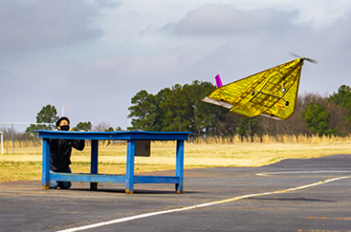
Figure 2: Georgia Tech's 2022 SAE Aero Micro class competition design

Existing Design #2: Texas A&M
Texas A&M’s 2022 SAE Aero Micro design was selected by the team because this design came in fourth overall for the 2022 micro class competition. This design contained a boxy fuselage with a biplane style wing design. This design also competed in the same competition as the previous design mentioned. This design was selected because it came in fourth overall and allows the team to benchmark against a design that came in first place, and a design that did not take one of the top three positions. Similarly, to the previous existing design, this design has all the same size requirements to the 2023 competition standards. The Texas A&M design can be seen below in Figure 3.
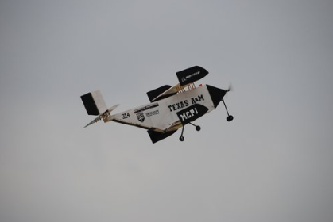
Figure 3: Texas A&M's 2022 SAE Aero Micro class competition design

Existing Design #3: Northern Arizona University
NAU’s 2020 SAE Aero design to benchmark against was selected in order to compare our design to a previous design that almost went to competition. The NAU 2020 SAE Aero design Contains an airfoil shaped fuselage, one pair of low set airfoils, and a motor sat far out in front of the nose. This team's design was selected in order to benchmark against a previous NAU design. This team had a larger payload that was required to be carried, as well as a larger power limit. The team selected to benchmark against this design because it was a design that almost went to competition. Therefore, the team can utilize the previous design as a baseline. The NAU 2020 SAE Aero design can be seen below in Figure 4.
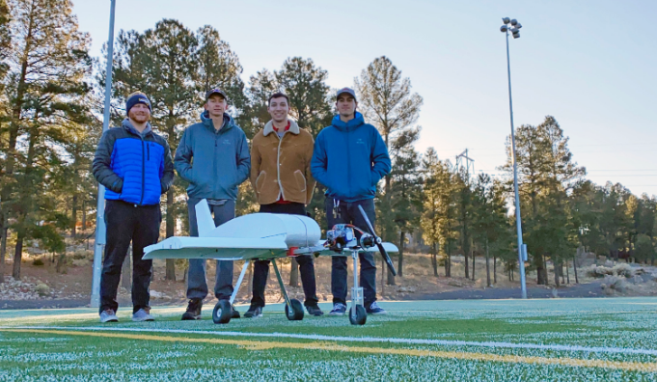
Figure 4: Northern Arizona University's 2020 SAE Aero Design Competition airplane design

Subsystem Level Benchmarking

Subsystem #1: Wing Planform
This subsystem is important to the overall project because wing design contributes to multiple features of the plane including speed, maneuverability, and stability. The challenges the team faces while navigating the project are minimizing required take off distance, maintaining stable flight, performing 180 degree turns, and landing. Geometric characteristics of the wing design determine aerodynamic performance and the plane’s ability to execute task challenges.

Existing Design #1: Rectangular Planform
The rectangular planform has safe stall characteristics. Stalls occur when smooth airflow over the wings is disrupted. This disturbance results in a loss of lift. The cross section of the wing stays constant across the wingspan from the fuselage to the wingtip. The constant cross section makes the rectangular platform easy to fabricate. For initial prototype considerations, the team attempted to make a foam glider utilizing a rectangular planform. This wing design offers plane stability in exchange for aerodynamic efficiency. This design would ensure stable flight and employs less weight, but difficulties arise when take-off distance is limited.

Existing Design #2: Triangle Planform
The triangle planform appropriately combines the rectangular and tapered planforms. When compared to rectangular planforms, the triangle planform produces greater lift to drag ratios across all angles of attack ranging from 0 to 15 degrees. Water tunnel tests indicate that triangle planforms produce less turbulence compared to rectangular planforms. The fabrication process is relatively easy as well. This wing design would contribute towards satisfying the take-off distance constraint, but weight would increase and stability may encounter issues.

Existing Design #3: Tapered Planform
[Describe this subsystem-level existing design and explain how it relates to your requirements.]
The tapered planform is simply a more aerodynamically efficient design when compared to the rectangular planform. The narrowing of the wingtips produces less drag when compared to rectangular planforms. This design offers plane stability and lightweight characteristics, but take-off distance may be problematic.

Subsystem #2: Propellor Design
The propeller design refers to different configurations of propulsion motors propellers. Different configurations generate different amounts of thrust, but some can counteract total thrust depending on the scale of the plane.

Existing Design #1: Two-Blade Propellor
A two-blade propeller design is the traditional configuration of propellers used on most RC planes. The blades are mirrors of each other and are positioned 180 degrees apart from each other. Existing plane designs with these propellers generate a given amount of lift depending on the size of the blade and produce minimal drag in comparison to a higher number of blade configuration.

Existing Design #2: Two-Blade Propellor with Shroud
A two-blade propeller with a shroud is referring to our first existing design of a propeller with two blades with an additional component. A shroud is a circular frame around the blade intended to direct the flow of the working fluid through the system. This helps prevent turbulent flow from arising around the blades, which will in turn make our thrust generation more efficient. The downside to this is that the shroud will add more weight to the plane and produce more drag on the front of the plane.

Existing Design #3: Three-Blade Propellor
A three-blade propeller is one with three identical blades that are oriented to be 120 degrees apart from each other. A three-blade propeller generates more thrust in comparison to a two-blade propeller but will require more weight as well as will increase the drag force on the plane. A three-blade propeller is often used in larger planes but has been used on small aircraft for the SAE competition in past years.

Subsystem #3: Tail Design
The tail of an airplane generates additional lift and provides stabilization. This subsystem contains a vertical stabilizer to prevent the nose from pitch rotation. The horizonal components generate lift similarly to the wings.

Existing Design #1: Two Tail
Existing designs of this tail configuration are designed to be more rigid and reduce weight in comparison to a single tail design. A single tail design will be less resistant to torsional stresses, for there is only one point of connection to the body. This design also allows the tail elevators to be placed offset from the propeller

Existing Design #2: Dual Tipped
A dual tipped tail design features a single connection to the body of the plane, with a horizontal wing in the rear. At either end of the horizontal section is two elevators to provide stability to the plane. These elevators are offset from the propeller to avoid “prop-wash”. This configuration is less stable than the two tail design but provides more lift and is less weight.

Existing Design #3: Conventional
The conventional tail design is in reference to the design most commonly used in commercial airliners. The tail design is great for supporting cargo because it has a large planform area that produces a lot of lift in the rear. It is also not tapered as much as some other tail designs, so the connection of the tail is more sturdy.

Functional Decomposition
For this section the team created a black box model and a functional decomposition model to depict the input and outputs of each sub-system of an aircraft. These sub-systems include landing gear, fuselage, propeller, tail, and wing design. Each sub-system guides the aircraft in flight and correlates to the four forces related to flight. Such forces include drag, lift, weight, and thrust. The size of the aircraft and gravity affect the weight and drag. The wings affect lift, and the propeller determines thrust. Each input and output of the model aircraft that the team will be designing is crucial for the team's success. In order to fully understand how an airplane works and flies, the team first designed a black box model to determine the different inputs and outputs running through the aircrafts system. Afterwards, the team designed a functional model to break down each sub-system to depict how each part affects flight and the different forces associated with it.

Black Box Model
A black box is a system which can be viewed in terms of its inputs and outputs. For the teams design the inputs will be the same as the outputs. First, energy will be inputted through the battery's electricity which will be turned on through human energy with the push of a button. The output then results in kinetic, potential, heat, and sound energy through the planes' movement through the air. The second input will then be material as hand air cargo. This will result in the same output as the material does not change throughout the flight of the planes. Lastly, the third input will be the signal which includes the on/off switch and its radio servos and motor. The output will then be the visual signal. Therefore, through each input and output the team understands the general inputs and outputs that can be further analyzed through a functional model.
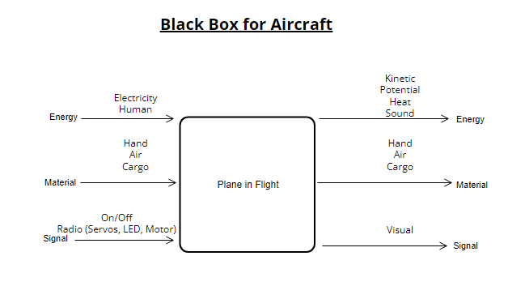
Figure 5: Black Box Model

Functional Model/Work-Process Diagram/Hierarchical Task Analysis
A functional model is a structured representation of the functions within the modeled system or subject area. The model below depicts each sub-system of the team’s final design. Beginning with electricity, it then is imported and stored into an on/off switch. This energy is then released once the plane is turned on or off and results in a visual signal. Human energy is also prevalent as one is needed to turn the plane on or off. This is also stored into the cargo and turned into kinetic energy. Thirdly comes hand with is used to actuate electricity and then converted to electrical energy to rotational energy. This is then converted to thrust, and the plane is then exported into the air. Hand is also stored and exported and released as cargo. Once the plane is in the air the plane converts to mechanical energy to drag and lift to as well aid the plane through the air. The last system described in the functional model is the cargo. First the cargo is imported and then stored which is then exported and turned into potential energy.
The functional model aids the team in its project by allowing them to fully understand all sub-systems' inputs and outputs. It also helps the team understand the designs’ functions and processes through take-off and landing. Such a model assists the team with discovery of information needs, helps identify opportunities, and establish a basis for determining product and service costs.
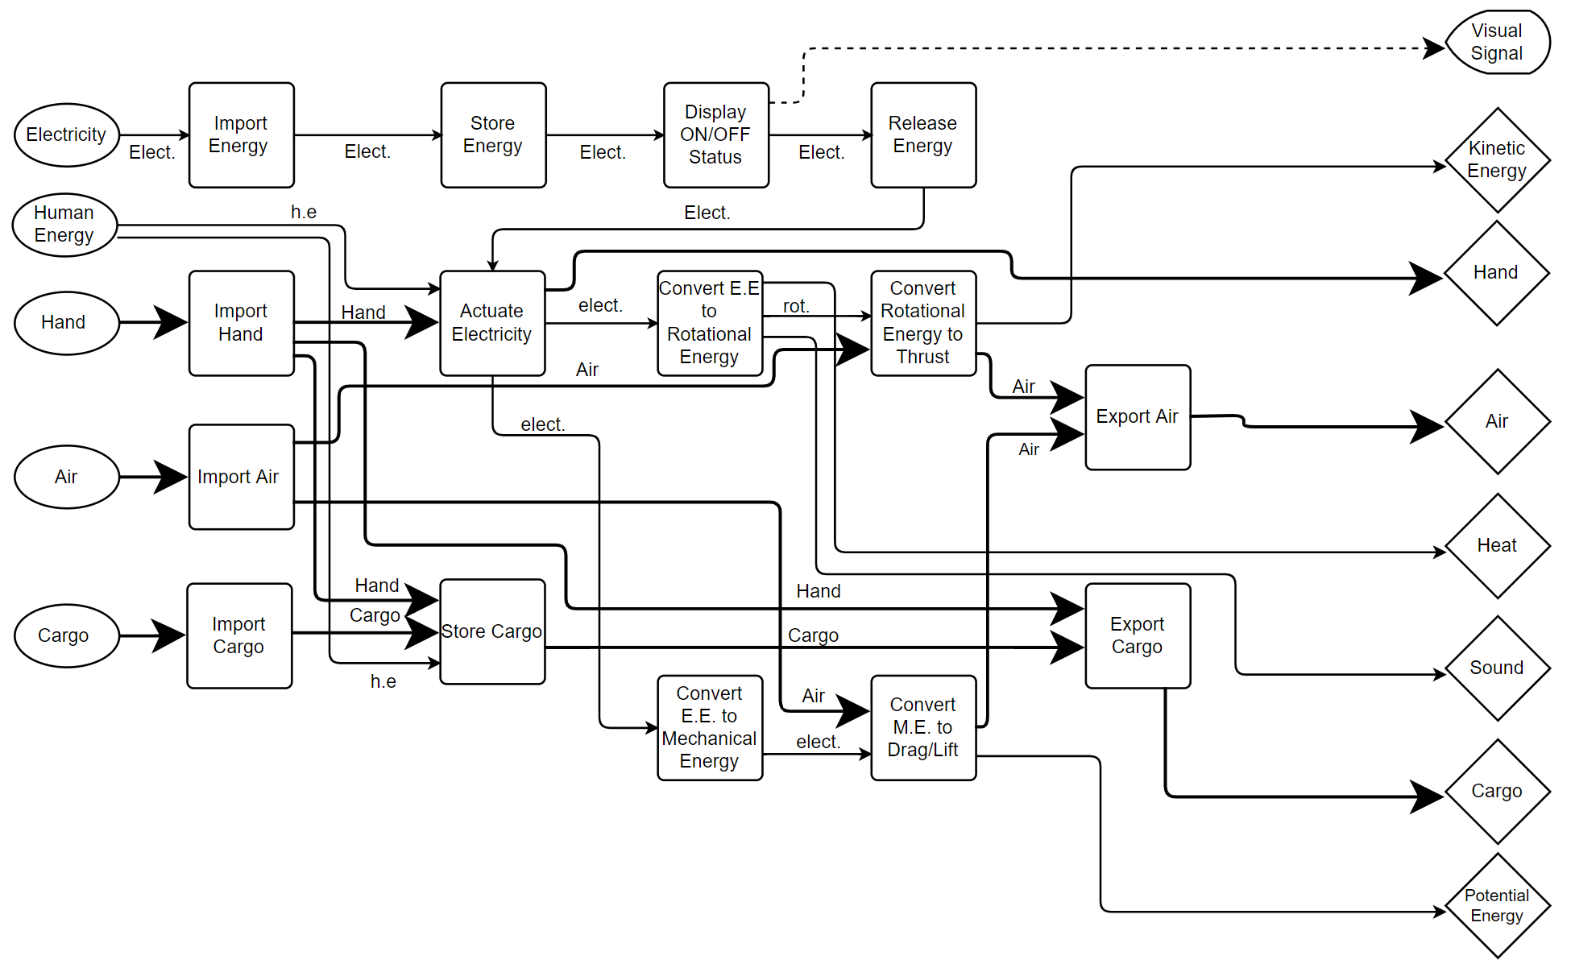
Figure 6: Functional Decomposition Model

4. CONCEPT GENERATION
The team divided the plane into 6 sub-systems. These sub-systems include landing gear, propeller design, fuselage, tail design, material, and wing design. Each member was tasked with creating their own unique designs for each sub-system. Collectively the team generated 36 total concept generations. From there they formulated 6 different designs to be evaluated through a Pugh chart and Decision matrix.

Full System Concepts

Full System Design #1: Delta-Wing
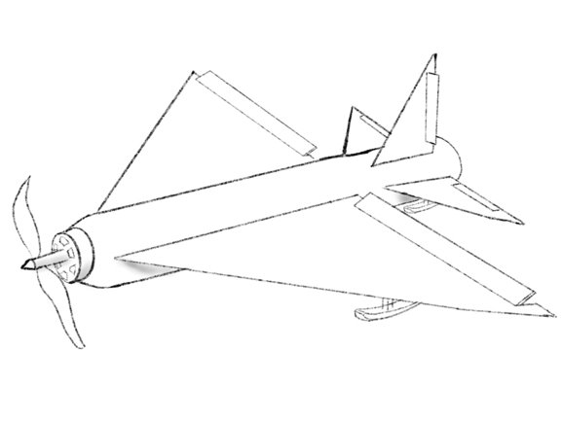
Figure 7: Delta-wing Design
This design features a delta wing placed on a cylindrical fuselage with a conventional tail configuration. The body will use skis with a low coefficient of friction as a landing surface. It will be powered by a 2-blade propeller with no shroud. This design will produce a high amount of lift but will have a large weight and volume. The skis will also make taking off harder but provide for safer and easier landings. The conventional tail design is lightweight but in danger of being hit with prop wash. The 2-blade propeller will produce a good weight to thrust ratio for itself but may need more thrust if this design is heavier. The high lift will allow for lots of cargo to be carried.

Force of Lift: 9.327 N

Full System Design #2: 2-Tail
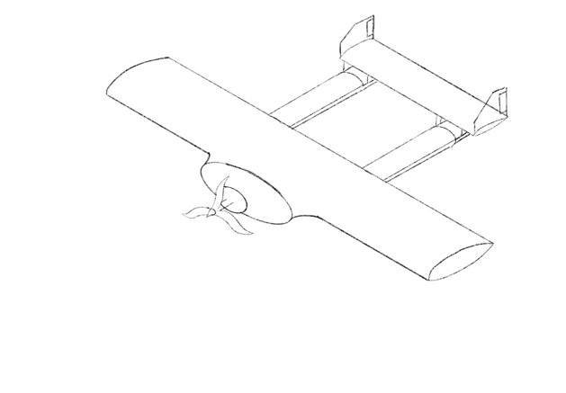
Figure 8: 2-Tail Design
This design features a long straight wing design with a 2-tail empennage. It uses a reverse tricycle landing gear configuration and a 3 bladed propeller. The wings design allows for air to flow as fast as possible over the airfoil generating high lift. The 2-tail will help keep the horizontal stabilizer out of the prop wash and increase stability. It will also create good structural integrity by not having bending moments on one connecting piece. The design is lightweight as it allows for the fuselage to be as small as it can be. The 3 bladed design will add unnecessary weight as the design will not be heavy enough to warrant all 3.
Force of Lift: 6.218 N

Full System Design #3: Hammerhead
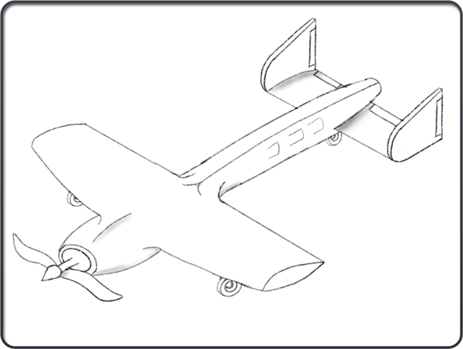
Figure 9: Hammerhead Design

The “Hammerhead” Design is named after its resemblance to the general configuration of a hammerhead shark. This design features a traditional tapered fuselage design, but it varies in how the cargo is loaded. The cargo is inserted into slots shaped to fit the cargo as a press fit to allow for easy removal. This design is also a single-propeller design, like our other designs, but has a slightly different tail design. The split tail design is shaped to prevent the turbulent air coming off the propeller from hitting our elevated stabilizers. The landing gear is featured as a “reverse tricycle” design to allow for most of the force from landing to be taken onto two wheels instead of one.
Force of Lift: 6.218 N

Full System Design #4: Hatchback
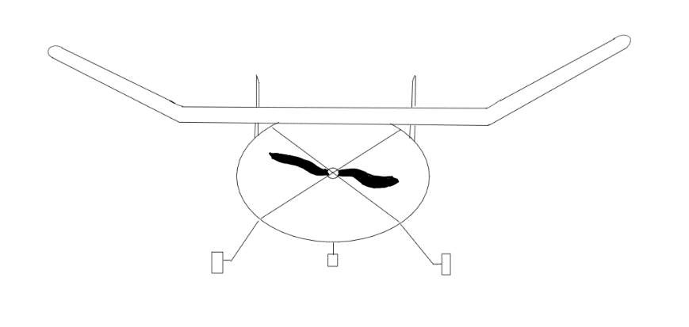
Figure 10: Hatchback Design Front View
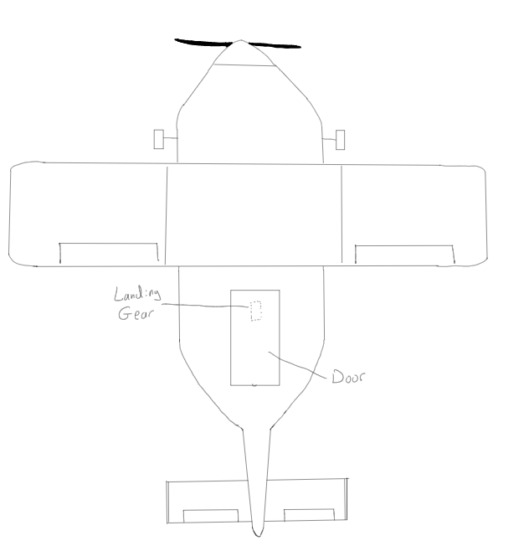
Figure 11: Hatchback Design Top View

This design features an angled-up wing design with a dual tipped tail. The fuselage has a hatchback style cargo bay with an entrance at the top. It uses a reverse tricycle landing gear. This design will have a low lift to weight and thrust to weight ratio. The body will be able to hold lots of cargo but will be wide and heavy. The tail and angled wing designs will create a stable and controllable flight path.
Force of Lift: 4.263 N

Subsystem Concepts

Subsystem #1: Wings

Design #1: Rectangular Planform
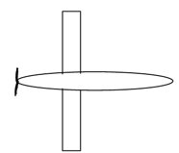
Figure 12: Rectangular Planform
Pros:
- High lift
- Easy to manufacture
Cons:
- Low structural integrity

Design #2: Triangular Planform
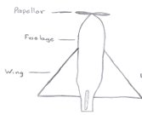
Figure 13: Triangular Planform
Pros:
- Large Planform Area
Cons:
- Higher expected weight

Design #3: Tapered Planform
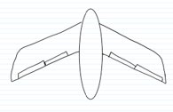
Figure 14: Tapered Planform
Pros:
- Low drag
- Stable
Cons:
- Low lift

Subsystem #2: Propeller

Design #1: 2 Blades
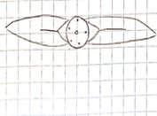
Figure 15: Two-Blade Propeller
Pros:
- Good thrust to weight ratio
Cons:
- low thrust

Design #2: 2 Blades with Shroud
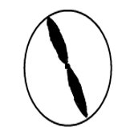
Figure 16: Two-Blade Propeller with Shroud
Pros:
- Efficient
- High thrust
Cons:
- More weight

Design #3: 3 Blades
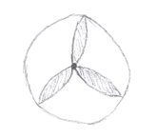
Figure 17: Three-Blade Design
Pros:
- High thrust
Cons:
- High weight

Subsystem #3: Tail

Design #1: 2-Tail
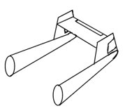
Figure 18: Two-Tail Configuration
Pros:
- Avoids prop wash
- Stable
- Structurally sound
Cons:
- Difficult to machine

Design #2: Dual tipped
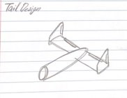
Figure 19: Dual tipped Configuration
Pros:
- Stable flight
Cons:
- Heavy

Design #3: Conventional
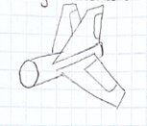
Figure 20: Conventional Configuration
Pros:
- Lightweight
Cons:
- In prop wash

Subsystem #4: Fuselage

Design #1: Slots
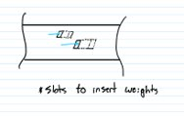
Figure 21: Slotted Fuselage
Pros:
- Easy access
- Simple
Cons:
- Difficult to machine

Design #2: Hatchback
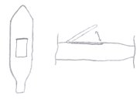
Figure 22: Hatchback Fuselage

Pros:
- Easy access
Cons:
- Higher drag

Design #3: Rear door
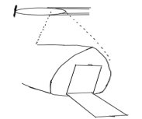
Figure 23: Rear Door Fuselage
Pros:
- Low drag
Cons:
- Hard to access

Subsystem #5: Material

Design #1: Carbon Fiber
Pros:
- Lightweight
- Strong
Cons:
- Expensive

Design #2: Balsa Wood
Pros:
- Lightweight
- Cheap
Cons:
- weak

Design #3: Aluminum
Pros:
- Strong
Cons:
- Expensive
- Heavy

Subsystem #6: Landing Gear

Design #1: Tricycle
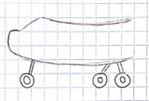
Figure 24: Tricycle Landing Gear
Pros:
- Less drag
Cons:
- Harder to land

Design #2: Reverse Tricycle
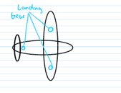
Figure 25: Reverse Tricycle Landing Gear
Pros:
- Easier to land
- Structurally Supportive
Cons:
- More drag

Design #3: Skis
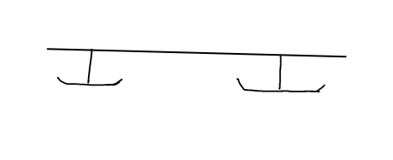
Figure 26: Skid Plate Landing gear
Pros:
- Easy to land
Cons:
- Hard to take off

5. DESIGNS SELECTED – First Semester
For chapter 5, the team included a Pugh chart and their decision matrix to demonstrate how they chose their final design and what criteria they followed to determine such. The Pugh chart reveals a list of all the critical qualities needed for the final design. The team then used this criterion to compare five different designs to a basic datum of an aircraft. Following these steps, the team chose the best three and compared the final three designs in a Decision Matrix. The final designs were then scored through a weighted process and the best design was then chosen. This allowed the team to analyze important considerations aligned with the team’s goals.

Technical Selection Criteria
The team used key customer and engineering requirements to compare every design to determine which would be the best option. The team deemed fit to use high maneuverability, stable flight, lightweight, durability, cost effective, ability to land, competition ready, short take-off, payload capacity, repairability, and high speed as the critical criterion. In the Pugh chart five different designs were compared to a datum using said qualities to determine the best three. After that the team weighed each criterion depending on their importance given competition guidelines and customer requirements, the best three designs from the Pugh chart were scored in the decision matrix to determine the final design.
High maneuverability is important because the plane must be able to make 180 degree turns in the competition path. The plane must be stable in flight to maneuver easily. The aircraft must also be lightweight yet durable. The reason behind lightweight is because the competition is only allowing a power limiter of 450W and from research the team found that an aircraft must have 50 W of power for every pound of weight. Through this knowledge the team concluded that they must have a max weight of 9 pounds. The plane must be durable because in case of any failed attempts at flight, the plane must be easily repaired to reduce cost. The aircraft must also be competition ready as it is a major requirement for class. The aircraft must also have a short takeoff as the competition only provides a small platform for the aircraft to take flight.

Rationale for Design Selection
Each team member participated in creating different concept generations and then came together to vote on the best designs. Each member was tasked to design one of each of the sub-systems being fuselage, material, propeller, tail, wing design, and landing gear. The team ended with 36 different concept generations and from there they designed 6 different designs to evaluate through a Pugh chart. Each design was scored either as better, worse, or same as the datum they selected which consisted of a basic model airplane. From there the team calculated the end scores by adding and subtracting total positives and total negatives. Through this process, the calculations resulted in concept one, four, and six to be the final best three designs. From there the team created a decision matrix and weighed the given criterion depending on their importance given competition guidelines and customer requirements.
After completing the decision matrix, the team weighed each criterion. High maneuverability weighed 4 percent. Stable flight weighed 13 percent. Lightweight and durability weighed 15 and 10 percent, respectively. Cost effective weighed 10 percent as well. Ability to land weighs 7 percent. Competition ready, short takeoff, and payload capacity weighed 7, 19,12 and 3 percent, respectively. Lastly, repairability weighed 5 percent and high speed weighed 2 percent. Collectively the total weight should be equal to 100 percent. The score was then weighed from 1-5, 5 being the best. After completing the math, the team scored concepts 1, 4 and 6 depending on the weighted scores. After this step, the team concluded that concept 6 was the best design for the competition. Concept 6 received a score of 4.25 while concept 4 scored a 3.71 and concept 1 a 3.52.
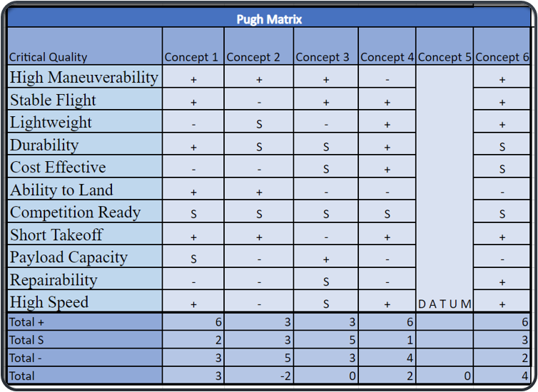
Figure 27: Pugh Chart
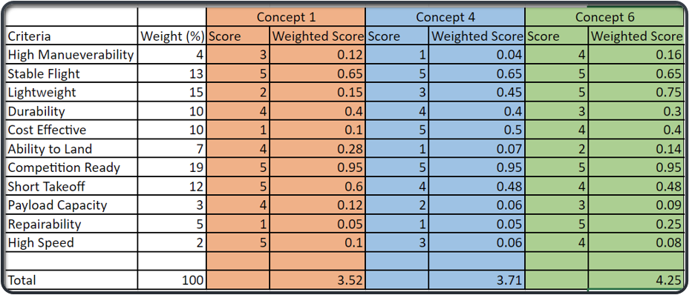
Figure 28: Decision Matrix

REFERENCES
[1] “3D printing best practices - Cincinnati incorporated.” [Online]. Available: https://wwwassets.e-ci.com/PDF/Products/3D-Printing-Best-Practices-Guide.pdf. [Accessed: 24-Oct-2022].
[2] J. J. D., “Chapter 8.6.5 Horizontal and Vertical Tail Size,” in Aircraft Performance and Design, Boston, MA: McGraw-Hill Higher education, 2012.
[3] E. Staff, “Control Surface Design: Keeping them balanced,” AVweb, 25-Jan-2018. [Online]. Available: https://www.avweb.com/flight-safety/control-surface-design-keeping-them-balanced/. [Accessed: 23-Oct-2022].
[4] “Handbooks & Manuals,” Handbooks & Manuals | Federal Aviation Administration. [Online]. Available: https://www.faa.gov/regulations_policies/handbooks_manuals. [Accessed: 23-Oct-2022].
[5] “How to manufacture carbon fiber parts,” Formlabs. [Online]. Available: https://formlabs.com/blog/composite-materials-carbon-fiber-layup/. [Accessed: 22-Oct-2022].
[6] “General thrust equation,” NASA. [Online]. Available: https://www.grc.nasa.gov/WWW/k-12/airplane/thrsteq.html. [Accessed: 23-Oct-2022].
[7] P. Good, “RC Plane weight: The ultimate guide,” Goodies RC, 10-Jan-2022. [Online]. Available: https://www.goodiesrc.com/rc-plane-weight/. [Accessed: 23-Oct-2022].
[8] “Propeller thrust,” NASA. [Online]. Available: https://wright.grc.nasa.gov/airplane/propth.html. [Accessed: 23-Oct-2022].
[9] “Welcome to how things fly,” How Things Fly. [Online]. Available: https://howthingsfly.si.edu/media/thrust. [Accessed: 23-Oct-2022].
[10] aerotoolbox, “Horizontal and vertical tail design,” AeroToolbox, 28-Sep-2022. [Online]. Available: https://aerotoolbox.com/design-aircraft-tail/. [Accessed: 23-Oct-2022].
[11] J. J. D., Aircraft Performance and Design. Boston, Mass: McGraw-Hill Higher education, 2012.
[12] “Aerodynamic considerations in the design of truss-braced-wing aircraft.” [Online]. Available: https://www.researchgate.net/publication/283010588_Aerodynamic_Considerations_in_the_Design_of_Truss-Braced-Wing_Aircraft. [Accessed: 24-Oct-2022].
[13] “Llis,” NASA. [Online]. Available: https://llis.nasa.gov/lesson/819. [Accessed: 23-Oct-2022].
[14] R. Jamieson, “The Radio Control Model Hub,” radio control models. [Online]. Available: https://rcmodelhub.com/what-are-rc-planes-made-of/. [Accessed: 23-Oct-2022].
[15] Dong Sun, Huaiyu Wu, Rong Zhu and Ling Che Hung, "Development of Micro Air Vehicle Based on Aerodynamic Modeling Analysis in Tunnel Tests," Proceedings of the 2005 IEEE International Conference on Robotics and Automation, 2005, pp. 2235-2240, doi: 10.1109/ROBOT.2005.1570445.
[16] Benaouali and S. Kachel, "Structural wing sizing and planform shape optimization using multidisciplinary CAD-CAE integration process," 2017 8th International Conference on Mechanical and Aerospace Engineering (ICMAE), 2017, pp. 478-483, doi: 10.1109/ICMAE.2017.8038692.
[17] Kellogg, C. Bovais, and R. Foch R, et al. "The NRL micro tactical expendable (MITE) air vehicle," Aeronautical Journal, August 2002, vol. 106, pp. 431-441
[18] Huaiyu Wu, Dong Sun and Zhaoying Zhou, "Micro air vehicle: configuration, analysis, fabrication, and test," in IEEE/ASME Transactions on Mechatronics, vol. 9, no. 1, pp. 108-117, March 2004, doi: 10.1109/TMECH.2004.823885.
[19] T. A. Shams, S. I. A. Shah, H. Abbas, S. Khushbash, M. A. Ahmad and K. Mehmood, "Identification of Geometrical Parameters Dependency on Aerodynamic and Stability Characteristics of Flying Wing Micro Air Vehicle," 2021 International Bhurban Conference on Applied Sciences and Technologies (IBCAST), 2021, pp. 152-158, doi: 10.1109/IBCAST51254.2021.9393015.
[20] S. V. Chavan and S. S. Pawar, “The modified design of aeroplane fuselage to overcome drag resistance acting due to flow of air,” Materials Today: Proceedings, 12-Jun-2018. [Online]. Available: https://doi.org/10.1016/j.matpr.2018.02.331. [Accessed: 23-Oct-2022].
[21] S. Gudmundsson, “The anatomy of the fuselage,” General Aviation Aircraft Design (Second Edition), 14-Jan-2022. [Online]. Available: https://doi.org/10.1016/B978-0-12-818465-3.00012-4. [Accessed: 23-Oct-2022].
[22] F. Nicolosi, P. D. Vecchia, D. Ciliberti, and V. Cusati, “Fuselage aerodynamic prediction methods,” Aerospace Science and Technology, 16-Jun-2016. [Online]. Available: https://doi.org/10.1016/j.ast.2016.06.012. [Accessed: 23-Oct-2022].
[23] Y. Ma and A. Elham, “Twin-fuselage configuration for improving fuel efficiency of passenger aircraft,” Aerospace Science and Technology, 08-Aug-2021. [Online]. Available: https://doi.org/10.1016/j.ast.2021.107000. [Accessed: 23-Oct-2022].
[24] kgulledge3, “Design build fly team dominates at the SAE Aero Design East Competition,” Aerospace Engineering | Georgia Institute of Technology | Atlanta, GA, 23-Jul-2021. [Online]. Available: https://ae.gatech.edu/news/2021/06/design-build-fly-team-dominates-sae-aero-design-east-competition. [Accessed: 20-Sep-2022].
[25] SAE International, 2022 Collegiate Design Series SAE Aero Design Rules, 2022.0 ed. 2022.
[26] A. D. J. John, Aircraft Performance and Design, Boston, Mass: McGraw-Hill Higher education, 2012
[27] United States Department of Transportation, "Federal Aviation Administration," United States Government, 23 August 1958. [Online]. Available: https://www.faa.gov/. [Accessed 17 September 2022].
[28] “Visual Paradigm,” Online cross-functional Flowchart Tool. [Online]. Available: https://online.visual-paradigm.com/diagrams/features/flowchart-tool/cross-functional-flowchart-maker/. [Accessed: 12-Oct-2022].
[29] “Delta Wing,” Delta Wing - an overview | ScienceDirect Topics. [Online]. Available: https://www.sciencedirect.com/topics/engineering/delta-wing. [Accessed: 12-Oct-2022].
[30] I. I Fly America, “The wing's The thing,” Wing Design. [Online]. Available: https://iflyamerica.org/safety_wing_design.asp. [Accessed: 12-Oct-2022].
[31] J. Bennett, “Why airplane wings angle backwards,” Popular Mechanics, 14-Nov-2017. [Online]. Available: https://www.popularmechanics.com/flight/a19875/why-airplane-wings-angle-backwards-explainer/. [Accessed: 12-Oct-2022].
[32] “Tail designs,” whatwhenhow RSS. [Online]. Available: http://what-when-how.com/flight/tail-designs/#:~:text=The%20many%20types%20of%20airplane,and%20multiple%2Dplane%20tail%20designs. [Accessed: 12-Oct-2022].
[33] P. J. Pritchard, J. C. Leylegian, R. Bhaskaran, J. W. Mitchell, and R. W. Fox, Fox and McDonald's introduction to Fluid Mechanics, 9th edition. Wiley, 2015.
[34] B. Dunbar, “The four forces of Flight,” NASA. [Online]. Available: https://www.nasa.gov/audience/foreducators/k-4/features/F_Four_Forces_of_Flight.html. [Accessed: 12-Oct-2022]. Amazon.com: Flysky FS-I6 6CH 2.4GHz AFHDS RC transmitter w/FS-IA6B ...” [Online]. Available: https://www.amazon.com/Flysky-Transmitter-Multirotor-Helicopter-Quadcopter/dp/B07CXL9LCT. [Accessed: 12-Oct-2022].
[35] “Amazon.com: Gowoops SX1278 Lora Radio Wireless 433mhz UART serial ...” [Online]. Available: https://www.amazon.com/Gowoops-Wireless-Transmitter-Compatible-Microcomputer/dp/B07G7ZRLQB. [Accessed: 12-Oct-2022].
[36] “Arduino Uno Rev3 [a000066] + free shipping - amazon.com.” [Online]. Available: https://www.amazon.com/Arduino-A000066-ARDUINO-UNO-R3/dp/B008GRTSV6. [Accessed: 12-Oct-2022].
[37] “Arming plug cable with T-Plug Connectors,” Arming Plug Cable with T-Plug Deans Connectors. [Online]. Available: https://innov8tivedesigns.com/arming-plug-cable-with-t-plug-connectors.html. [Accessed: 12-Oct-2022].
[38] “Avian 4260-480kv outrunner brushless motor,” Spektrum Avian 4260-480Kv Outrunner Brushless Motor | Horizon Hobby. [Online]. Available: https://www.horizonhobby.com/product/avian-4260-480kv-outrunner-brushless-motor/SPMXAM4715.html. [Accessed: 12-Oct-2022].
[39] “Ceias ︳Northern Arizona University,” The College of Engineering, Informatics, and Applied Sciences. [Online]. Available: https://nau.edu/ceias/. [Accessed: 12-Oct-2022].
[40] “HS-5245MG Servo,” ServoCity. [Online]. Available: https://www.servocity.com/hs-5245mg-servo/?sku=35245S00%E2%80%8B. [Accessed: 12-Oct-2022].
[41] “SAE 2021 limiters,” NeuMotors store. [Online]. Available: https://neumotors.cartloom.com/storefront/product/sae-2021-limiters. [Accessed: 12-Oct-2022].
[42] “Treaded wheels, 3’ (2),” Dubro Products Treaded Wheels, 3" (2) | Horizon Hobby. [Online]. Available: https://www.horizonhobby.com/product/treaded-wheels-3-2/DUB300T.html. [Accessed: 12-Oct-2022].
[43] H. Wang, J. T. Xing, W. G. Price, and W. Li, “An investigation of an active landing gear system to reduce aircraft vibrations caused by landing impacts and runway excitations,” Login - CAS – central authentication service, 21-Oct-2008. [Online]. Available: https://www-sciencedirect-com.libproxy.nau.edu/science/article/pii/S0022460X08002563. [Accessed: 24-Oct-2022].

[44] R. K. Schmidt, The design of Aircraft Landing Gear. SAE International, 2021.

[45] S. Gudmundsson, “13,” in General Aviation Aircraft Design: Applied Methods and procedures, Kidlington, Oxford: Butterworth-Heinemann, 2022.

[46] U. J. Blanchard, “Landing-Impact Characteristics of Load-Alleviating Struts on A Model of A Winged Space Vehicle,” 20-Oct-2022.

- APPENDICES
  - Appendix A: Requirements
Figure 1: House of Quality

  - Appendix B: Design Space Research
Figure 2: Georgia Tech's 2022 SAE Aero Micro class competition design
Figure 3: Texas A&M's 2022 SAE Aero Micro class competition design

Figure 4: Northern Arizona University's 2020 SAE Aero Design Competition airplane design
Figure 5: Black Box Model
Figure 6: Functional Decomposition Model

  - Appendix C: Concept Generation
Figure 7: Delta-wing Design
Figure 8: 2-Tail Design

Figure 9: Hammerhead Design

Figure 10: Hatchback Design Front View

Figure 11: Hatchback Design Top View

Figure 12: Rectangular Planform

Figure 13: Triangular Planform
Figure 14: Tapered Planform

Figure 15: Two-Blade Propeller

Figure 16: Two-Blade Propeller with Shroud

Figure 17: Three-Blade Design
Figure 18: Two-Tail Configuration

Figure 19: Dual tipped Configuration

Figure 20: Conventional Configuration

Figure 21: Slotted Fuselage
Figure 22: Hatchback Fuselage

Figure 23: Rear Door Fuselage

Figure 24: Tricycle Landing Gear

Figure 25: Reverse Tricycle Landing Gear
Figure 26: Skid Plate Landing gear

  - Appendix D: Design Selected

Figure 27: Pugh Chart
Figure 28: Decision Matrix

