



Landing Gear Analysis
Team P8 – SAE Aero Team

Alexander Vierhout
Devin Rossi duBois
February 5, 2023
ME486C – Section 2

Intro
To be successful in the SAE Aero competition, the team will need to have a landing gear that can successfully support the total weight of the plane while being static, and during landing. This analysis is to include a re-detailed landing gear, the previous landing gear from last semester was designed for an RC plane that had a wingspan of four feet, and a max impact force for that design was around 16 lbs. This new designed landing gear is designed to support an RC plane with a wingspan of 36 inches and a max impact force of around 11 lbs. The dimensions of each part in the landing gear were chosen carefully to guarantee great stability and support to the teams designed plane. The results we received from last semester will not work for this semesters design because the competition has changed their rules making the team readjust everything this semester. The dimensions made before were all chosen for a plane that had a much bigger size and weight.
Difference in Assumptions
From our previous semester landing gear analysis, our plane was allowed a max wingspan of four feet. Over the course of the capstone project, SAE has changed some of the rules for designing our plane. The biggest contributor to the design change is the alteration in the max wingspan. SAE has changed the max wingspan from 48 inches to 36 inches for the Micro Class competition. This alteration forces the team to decrease the overall size of the plane, affecting the overall weight and tail length. With a reduction in the planes weight, the team can expect a lower impact force on the landing gear. Additionally, a shorter tail length forces the team to alter the location of the tail landing gear. For the purpose of this design, the team will assume a max weight of four pounds. The team does not expect the planes actual weight to come near four pounds, so this will create a factor of safety as well as give the team working room.
Additional assumptions that will be used for this analysis will be the planes speed and landing time. For the later use of the impulse on the landing gear, the team will assume a landing speed of 30 mph or 13.4 m/s. This assumption was made based off of the team’s first prototype and how quickly it flew. Although this pane did not have any cargo weight which would slow the plane down, this assumption will also assist with creating a large factor of safety for the plane. Finally, the landing time for the plane will be assumed as 0.5 seconds. This assumption was made after watching numerous aircraft landings and inspecting the momentum change. Also, it was considered if the landing that was inspected was a poor or professional landing. Most of the non-professional landings had a longer momentum change time, so the team assumed a longer time for our own landing time.
Schematics
The previous landing gear configuration was built for a larger plane and had larger dimensions. Below in the Appendix, shows a comparison of the two landing gears with their drawings. They will be labeled under each figure to show which part is apart of the old or new landing gear. The old landing gear was used very little for the new landing gear, the old one was the very first iteration of the landing gear and had problems with it that are now fixed. The last years wheels could not be found but were sized to fit the diameters of the pegs on the old landing gear frames. The main wheel sizing was 1.73 in. inner diameter with a diameter of 9 in. and a width of 4.075 in. The tail wheel sizing was 1.00 in. inner diameter with an outer diameter of 5.85 in. and a width of 3.03 in.

Equations
The maximum force applied to the plane during landing can be calculated through Equation 1, the impulse formula. This force is calculated by dividing the change in momentum by the time interval in which the force is applied. For our scenario, the change in momentum will comprise of the plane going from full speed vertically, to stopped. The speed and time interval that will be utilized for this calculation will be taken from the assumptions made earlier.
$Δp=F* Δt$ [1]
Where, $Δp$ = 24.32, the change in momentum
F = the force that will be applied during landing
$Δt$ = 0.5, the time it takes for the planes momentum to be counteracted
From this calculation, we were able to find that the force applied during landing would be 10.9 lbf. For safety reasons, this force will later be rounded to 11 lbf.
The landing gear has supports in three places, two wheels in the front, and one wheel in the back. Figure 1 below is a FBD of the landing gear setup compared to the COG and shows the exact placement of the supports. With this FBD, the team can calculate $F_{M}$ (force in main wheels) and $F_{t}$ (force in tail wheel).
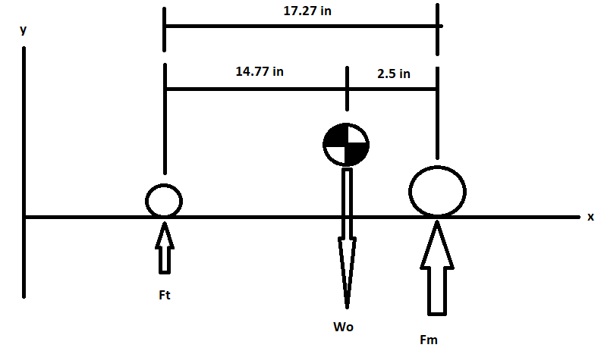
Figure 1: Free Body Diagram of Weight Displacement
To find the values, $F_{M}$ and $F_{t}$, the total weight, $W_{o}$ is needed, and is assumed to be 11 pounds. We chose this value of 11 lbs to withstand the maximum force that will apply while landing. This is to ensure that the wheels can support the impact of the landing as well as the weight of the plane.
After summing the forces in the y-direction in the FBD above in Figure 1, you get the values 9.408 lbs for $F_{M}$ and 1.592 lbs for $F_{t}$. The value $F_{M}$ needs to be divided by two because there are two main wheels, so the value of $F_{M}$ is 4.704 lbs for each wheel.
To find the exact sizing of the wheels needed to support the total weight of the plane can be calculated by Equations 2 and 3. Equation 2 represents how to find the diameter of the wheels, while Equation 3 is to find the width of the wheels.
$A({F)}^{b}=D$ [2]
Where, A = 1.51, set value for general aviation planes from Raymer (Ref. 2)
F = force applied to the wheel
b = 0.349, set value for general aviation planes from Raymer (Ref. 2)
D = Diameter of wheel
$C({F)}^{d}=W$ [3]
Where, C = 0.715, set value for general aviation planes from Raymer (Ref. 2)
F = Force applied to the wheel
d = 0.312, set value for general aviation planes from Raymer (Ref. 2)
W = Width of wheel
The two front main wheels need to be 2.59in. in diameter, and 1.59in. in width, and the tail wheel needs to be 1.78in. in diameter, and 0.83in. in width to successfully hold up the total weight of the plane. This finalizes the analysis on the wheels of the landing gear.
The frame of the landing gear was built to support the weight being distributed from the plane into the wheels and to only allow the plane to roll forward and backwards. The frame of the landing gear is going to be made of an aluminum alloy, this is chosen because aluminum is light and can be strong enough to support our low weight RC plane. While constructing the main landing gear frame, The World Models (Ref. 3), was viewed to compare materials and dimensions to see if our design is reasonable. The tail landing gear frame is designed to easily transfer the weight applied onto the frame, and into the wheel.
FEA
Just as another check to see if the landing gear is safe to use in the real world, the team put the two landing gears under stress analysis to see if there will be any points of failure.
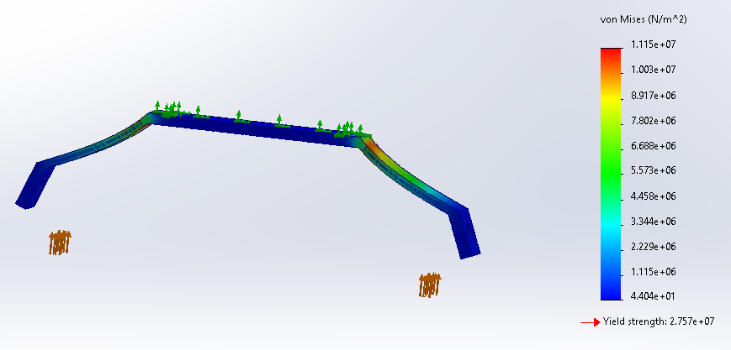
Figure 2: Stress Analysis on Front Landing Gear
To verify that the support is strong enough to support the weight applied, the team placed the structure under a stress analysis in SOLIDWORKS. Shown in Figure 2 is the stress analysis with the FOS (factor of safety) being 2.479. The applied forces are represented by the orange arrows and represent the total $F_{m}$. Each wheel holds 4.704 lbs so the total force applied here is 9.408 lbs. The green arrows indicate that that section will be static and won’t move when the forces are applied. This section of the landing gear will be attached to the bottom of the fuselage. The stress in the top joints is of the landing gear are red indicating that is where there can be a problem if one is to occur.
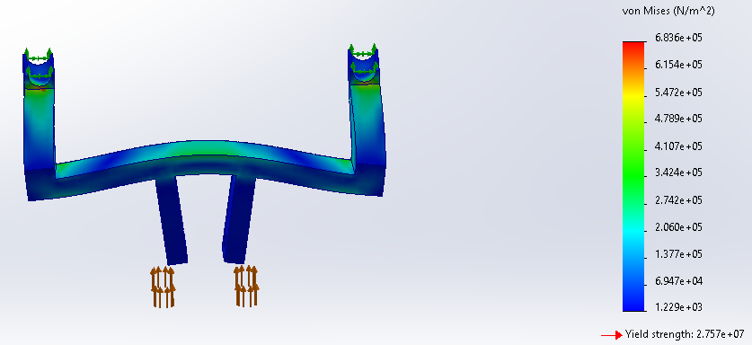
Figure 3: Stress Analysis on Tail Landing Gear
Figure 3 shows the stress analysis on the tail landing gear with its applied force of $F_{t}$. This is a total force of 1.592 lbs and is applied through the structure from the tail wheel and into the skeleton of the plane. The orange arrows are equal to each other and sum up to the total of 1.592 lbs. The green arrows are where the landing gear will be attached to the planes exoskeleton bars right in front of the tail. The von Mises meter on the right shows the levels of stress that specific spot takes when under the load and is color oriented. This structure has no yellow readings indicating a safe structure.
Models
The new main landing gear frame dimensions are shown below in Figure 4, this is a CAD drawing that shows the dimensions of it. This is going to be attached to the bottom of the fuselage once completely built. The two wheels will be connected to the frame by two pegs with two nuts attached to both sides of each peg once put through the frame and the wheel. The main wheel dimensions can be seen in Figure 5.
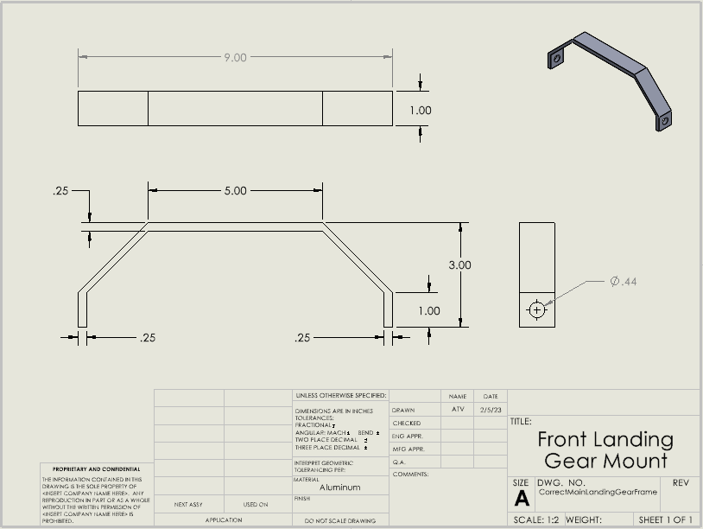
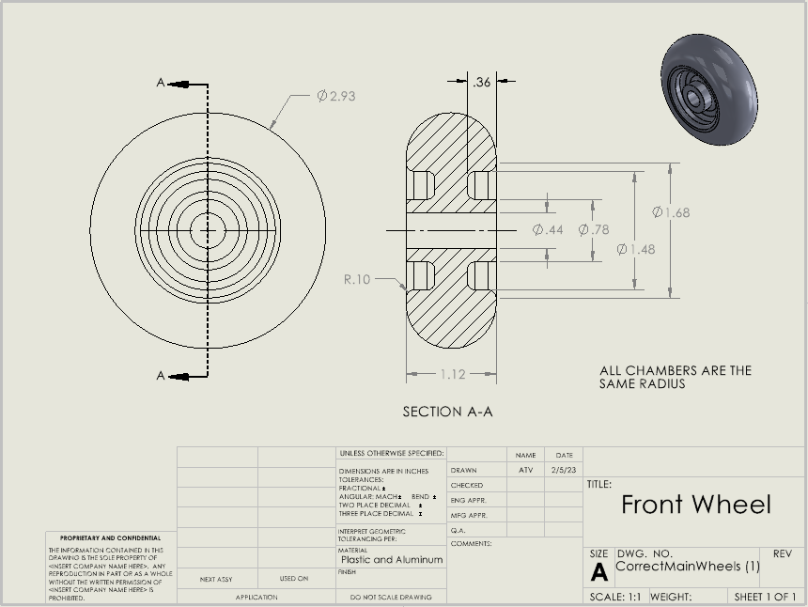
Figure 4: Main Landing Gear Drawing Figure 5: Front Wheels Drawing
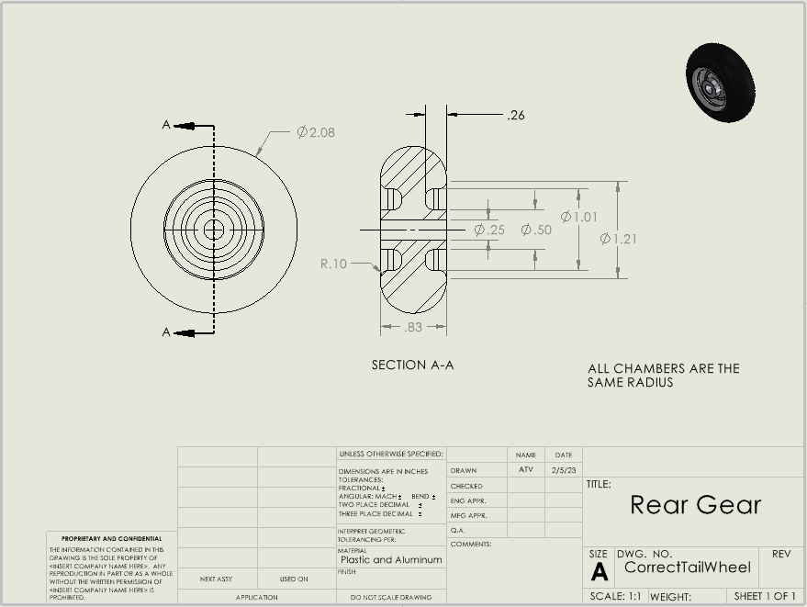
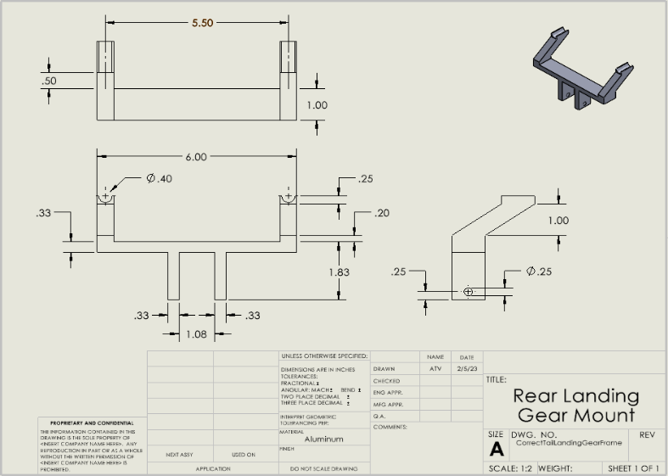
The new tail landing gear frames dimensions can be seen in Figure 6, which is a CAD drawing that shows exact sizes. The tail wheel drawing can be seen in Figure 7, which is connected to the tail frame by two nuts and a peg that goes in between the wheel and through the tail landing gear.
Figure 6: Tail Landing Gear Drawing Figure 7: Tail wheel Drawing

Results
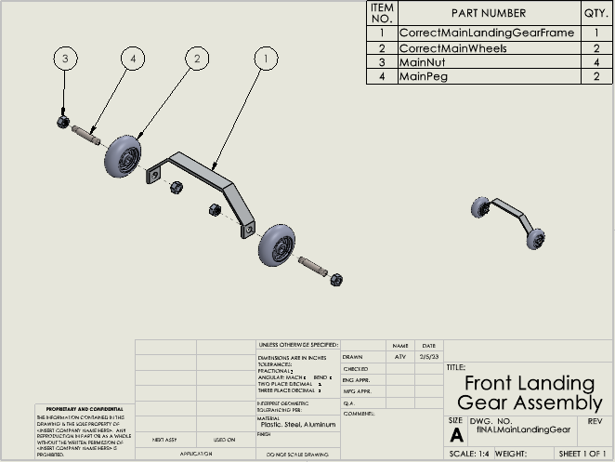
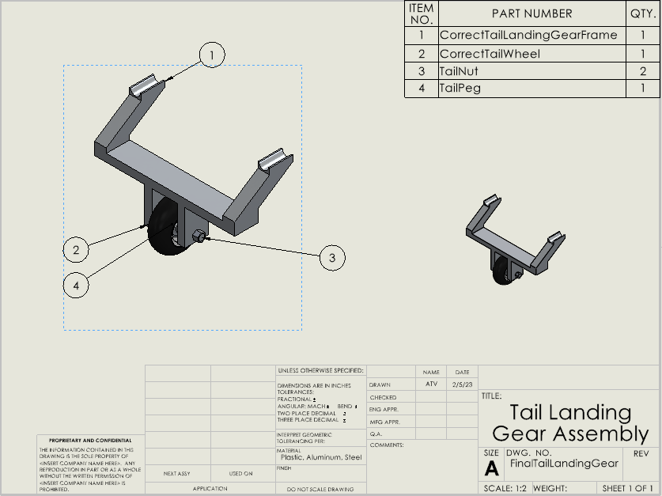
Shown in Figure 8 is the completely assembled Front Landing Gear, as well as the completely assembled Tail Landing Gear shown in Figure 9.
Figure 8: Front Landing Gear Assembly Figure 9: Tail Landing Gear Assembly
The results of this new landing gear is that it will be able to support our plane very well. After completing all of these analysis, the team did a weight analysis and found that the weight of the landing gear needs to be dropped. The team will go back and reiterate the new landing gear setups and try to thin out places where they can drop the weight but still try to keep the FOS above a reasonable number so the safety of the plane is guaranteed.

References

- J. J. D., Aircraft Performance and Design. Boston, Mass: McGraw-Hill Higher education, 2012.
- Daniel P. Raymer, Aircraft Design: A Conceptual Approach, 2nd ed., AIAA Education Series, American Institute of Aeronautics and Astronautics, Washington, 1992.
- “RC planes, robots, boats, cars, radios, servos, parts and FPV - the world models,” RC Planes, Robots, Boats, Cars, Radios, Servos, Parts and FPV - The World Models. [Online]. Available: https://theworldmodels.com/. [Accessed: 03-Feb-2023].

Appendix

Figure 1: Free Body Diagram of Weight Displacement
Figure 2: Stress Analysis on Front Landing Gear

Figure 3: Stress Analysis on Tail Landing Gear

Figure 5: Front Wheels Drawing
Figure 6: Tail Landing Gear Drawing
Figure 7: Tail wheel Drawing
Figure 8: Front Landing Gear Assembly
Figure 9: Tail Landing Gear Assembly
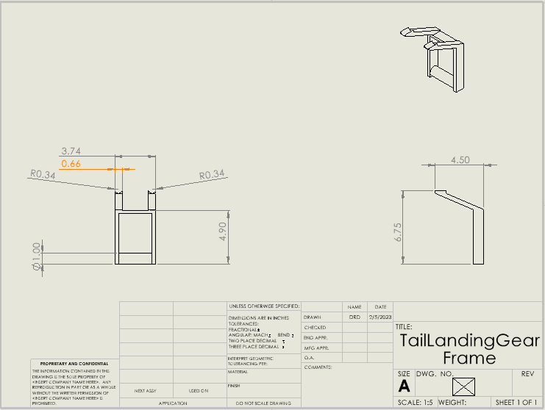
Figure 10: Old Tail Landing Gear Frame
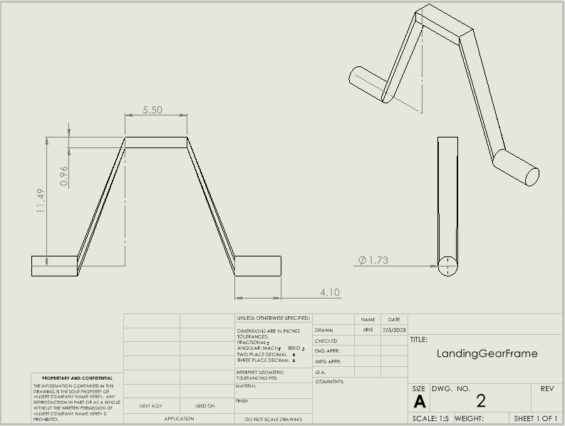
Figure 11: Old Main Landing Gear Frame

