Team 8 SAE Aero
ME 486C Section 002

Stability Analysis

Alec Zodrow
Jacob Cabanyog

Date: 2/5/2023



Introduction:
The goal of this project is to design and manufacture an electric airplane to compete in the SAE Aero Micro Class competition. The SAE competition is hosted annually in Fort Worth, Texas, and is focused and airplane design. This competition challenges students from across the globe to design an aircraft capable of carrying a regulation sized box in the most efficient manner. Teams are judged based on the weight and speed of the plane, so it must be carefully designed in order to maximize those factors.

This analysis will focus on the static stability of the team’s current design, as static stability is needed to be able to properly fly and control an aircraft. The use of the computational flow dynamics (CFD) software XFLR5 will ensure that the plane is statically stable during its max cruise speed, while also producing positive lift. The positioning and sizing of the tail relative to the main wing is critical for stability during flight. The horizontal tail controls the pitch axis of the plane, and the moment arm it generates depends on how big its planform area is and how far it is from the center of gravity. This can be quantified by the Tail Volume coefficient. This analysis will result in tail dimensions and placement and the ideal center of gravity placement.

Methods:
This analysis utilizes CFD software that is based on the Navier Stokes Equations. These are a set of partial differential equations that describe the flow of a fluid. The software meshes a 3-D model of the plane and computes the state of the fluid flow at each section using numerical methods. To do this it must first linearize the Navier Stokes Equations and then solve them using LU Decomposition. The use of numerical methods means that the software can only output approximations and never exact answers. This is acceptable as the approximations are very accurate and are only off on a very small scale. The Navier Stokes Equations can be found in the Appendix [2].

Assumptions:
One major assumption made during the CFD analysis was inviscid flow. This assumption was made because only pitch moments and lift/weight forces are being considered. The shear forces generated from viscous flow are negligible to pitching moments because the direction of the force causes drag and yaw moments.

Variables:
- Area_{elev}: Area of the elevator
- Area_{wing}: Area of the wing
- CG: Center of gravity
- C_{m}: Pitch moment coefficient
- LA_{elev}: Moment arm of the elevator
- MAC_{wing}: Mean aerodynamic chord
- NP: Neutral Point
- TV: Tail volume coefficient

To conduct a flow simulation, specific airfoils had to first be imported to model the wing and tail configuration. Each airfoil needed to be analyzed over a range of Reynolds Numbers to generate plots for each one, so the software knows how they react to flow. The main wing uses a S1223 foil, and the elevator uses a NACA 2412 foil. The plane can then be modelled using XFLR5. The body of the plane was not included in this model because the software makes a note to not include it. The resulting model can be seen in (Figure 1)

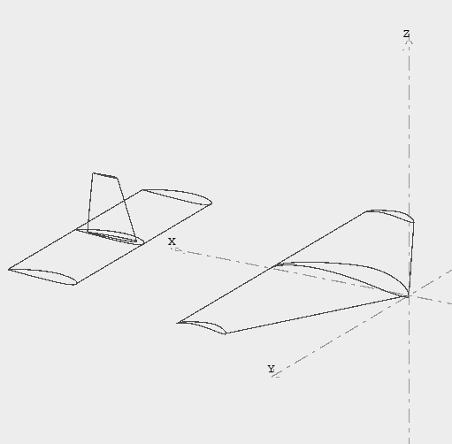
Figure 1: Plane Model

The loading scenario analyzed is at the max cruise speed, which has been assumed to be 12.2 m/s. To get initial approximations of the dimensions, the tail volume was utilized which is a measure of the elevator’s capacity to balance the wing’s self-pitching moment. The tail volume allowed us to find an appropriate lever arm. To begin an initial tail volume coefficient was assumed to be 0.7. This was pulled from Aircraft Performance and Design by John D. Anderson [3]. A MATLAB code was utilized to turn this coefficient into dimensions for the elevator and the placement of it. This was done using (Equation 1) [1].

$TV=\frac{{LA}_{elev}*{Area}_{elev}}{{MAC}_{Wing}*{Area}_{Wing}}$ [1]

The MATLAB code can be found in the appendix. The dimensions came out to 7 inches in chord length and 15 inches in width, with a 20-inch distance between the quarter chord points of the wing and tail. The neutral point of an aircraft is the point along its axis where the pitching moment coefficient is not dependent on angle of attack. This sets the rear limit for the center of gravity [1]. This can be found through XFLR5, by iterating different center of gravity locations until the resulting moment coefficient vs. angle of attack graph has a slope of 0. Once this is determined, more iterations need to be conducted until the center of gravity is placed in a manner that the moment coefficient vs. angle of attack graph has a negative slope. By having a negative slope, it shows the plane is in stable static equilibrium, meaning that the pitching moment is balanced, and the plane can fly steadily [1]. The size and positioning of the tail is also iterated to allow for the center of gravity to be in an easily designable position.

Results and Discussion:
This section details the results generated from the analysis, and the analysis and discussion of them.

Results:
The CFD analysis allowed us to iterate the wing and tail configuration to achieve an angle of attack that produces zero pitch moment and generates lift. This was accomplished by running several simulations and analyzing the plots generated. For each iteration, we first analyzed the pitch moment coefficient vs the angle of attack. Figure 2 shows that when the pitch moment is equal to zero (balanced flight) the angle of attack is approximately 0.5 degrees. Figure 4 suggests that the plane generates lift at this angle of attack and therefore flies. Figure 3 further validates this claim by displaying a positive coefficient of lift at the zero-pitch moment position. The center of gravity and neutral point are position 0.15 meters and 0.24 meters away from the nose respectively. The mean aerodynamic chord length is 0.26 meters. The tail chord length is 0.178 meters. The tail width is 0.3 meters. The moment arm is 0.64 meters. The tail volume coefficient is 1.292. These dimensions were used to achieve the graphs depicted in figures 2-4 and are listed in table 1.
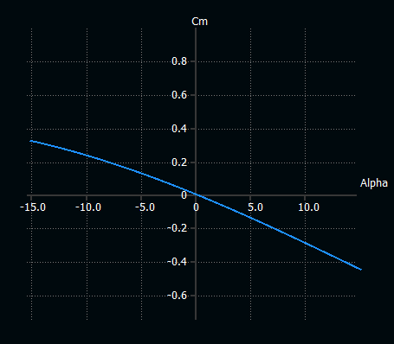
Figure 2: Angle of Attack vs Pitch Moment Coefficient

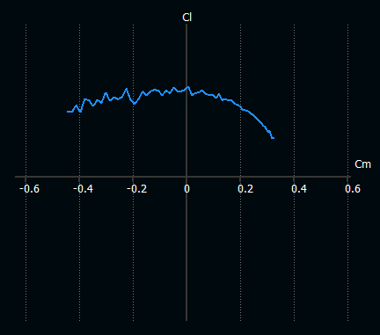
Figure 3: Pitch Moment Coefficient vs Coefficient of Lift

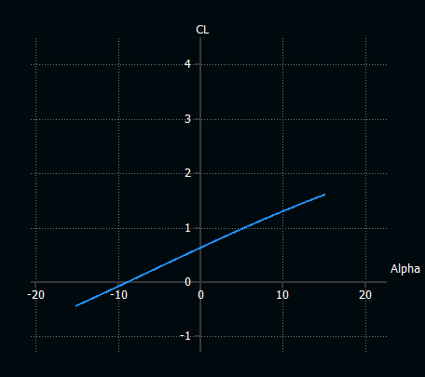
Figure 4: Angle of Attack vs Coefficient of Lift

Table 1: Plane Specifications
Center of Gravity  (m) | Neutral Point  (m) | Mean Aerodynamic Chord (m) | Tail Chord Length  (m) | Tail Width  (m) | Tail Moment Arm  (m) | Tail Volume Coefficient
0.150 | 0.240 | 0.260 | 0.178 | 0.300 | 0.640 | 1.292

Discussion:
A common margin to measure the moment arms of the plane is through static margin. This is a ratio between the distance between the neutral point and center of gravity and the mean aerodynamic chord of the main wing. This is shown in (Equation 2) below [1].

$Static Margin=\frac{X_{NP}-X_{CG}}{MAC}$ [2]

The static margin came out to 34.6%. This is relatively compared to numbers used in Aircraft Performance and Design by John D. Anderson [3]. The book referenced that it normally is about 10%. Attempts to have the results match this only led to a less stable airplane. The group does not yet have much knowledge on how static margin affects aircraft flight, so further investigation is needed to see if this is acceptable, but by the other stability margins discussed in this report the plane is expected to fly properly. The location of the neutral point and center of gravity can be seen on the plane Solidworks model in (Figure 5).
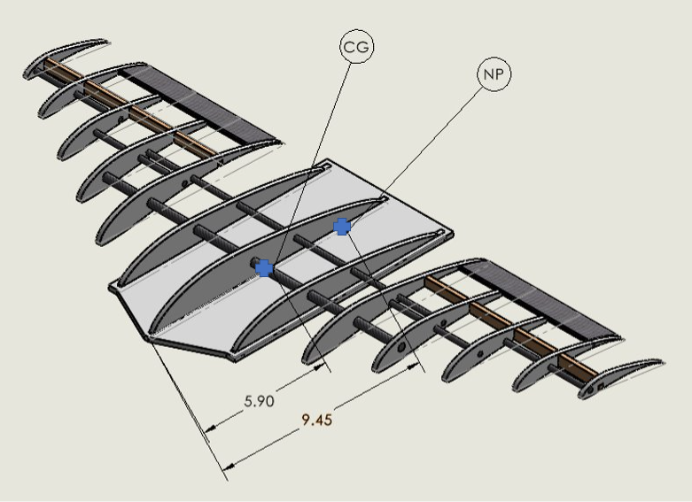
Figure 5: Center of Gravity and Neutral Point Diagram

The center of gravity was able to be placed in a prime location that allows for the team to place the heavier items (battery, cargo, etc.) in a manner so that it will align with this determined position.

Conclusion:
The analysis was able to determine the sizing and placement of the tail as well as the ideal location for the center of gravity. The elevator was found to need a chord length of 7 inches and a width of 11.8 inches. It also has a moment arm of 25 inches. The center of gravity must be designed to be 5.9 inches away from the nose of the plane. For future work the dynamic stability should be assessed to see how many vibrational modes it has, and if they are stable or not.

References:
[1] A. Depperois, “About Stability Analysis using XFLR5.” Nov-2010.
[2] “Computational Fluid Dynamics,” Computational Fluid Dynamics - an overview | ScienceDirect Topics. [Online]. Available: https://www.sciencedirect.com/topics/materials-science/computational-fluid-dynamics#:~:text=Computational%20fluid%20dynamics%20(CFD)%20is,and%20energy)%20governing%20fluid%20motion. [Accessed: 05-Feb-2023].
[3] J. D. Anderson, Aircraft Performance and Design. Boston, MA: McGraw-Hill Higher education, 2012.

Appendix:

Appendix 1: Equations

$$TV = \frac{\left(LA_{elev}⋅Area_{elev}\right)}{MAC_{Wing}⋅Area_{Wing}}$$

Equation 1: Tail Volume

$$Static Margin=\frac{X_{NP}-X_{CG}}{MAC}$$

Equation 2: Static Margin

$$ρ\left(\frac{du}{dt}\right) = -∇p + μ∇^{2}u +ρg$$
$$∇⋅u=0$$
Equations 3-4: Navier Stokes Equation

Appendix 2: MATLAB Code

Tail Volume Calculation
clc
clear all

Tail Volume Coefficients and Wing Dimensions
V_HT = 0.7; %Horizontal tail coefficient
V_VT = 0.04; %Veritcal tail coefficient

S = 313.5; %in^2 Planform area of wing
c = 9.5; %in Mean chord length
b = 33; %inches Wingspan

Calculation
HT = V_HT*c*S %in^3
VT = V_VT*b*S %in^3

L_HT = 20; %in
L_VT = 20; %in

S_HT = HT/L_HT %in^2
S_VT = VT/L_VT %in^2

Derived Dimension
c_HT = 7; %in
W_HT = 15; %in
AH = c_HT*W_HT

h_VT = 5.6; %in
c_VTb = 5; %in
c_VTT = 2.5; %in

AV = c_VTT*h_VT+0.5*c_VTT*h_VT

Appendix 3: Figures and Tables
Figure 1: Plane Model

Figure 2: Angle of Attack vs Pitch Moment Coefficient

Figure 3: Pitch Moment Coefficient vs Coefficient of Lift

Figure 4: Angle of Attack vs Coefficient of Lift

Figure 5: Center of Gravity and Neutral Point Diagram

Table 1: Plane Specifications
Center of Gravity  (m) | Neutral Point  (m) | Mean Aerodynamic Chord (m) | Tail Chord Length  (m) | Tail Width  (m) | Tail Moment Arm  (m) | Tail Volume Coefficient
0.150 | 0.240 | 0.260 | 0.178 | 0.300 | 0.640 | 1.292

