Abstract
In this report, the team will summarize all codes/standards, calculations, diagrams, charts, and proof that their solution will be successful in competition.
Jacob Cabanyog
Devin DuBois
Gabriela Liquidano
Iain Pettit
Alex Vierhout
Alec Zodrow

Engineering Model Summary
ME 486C_P8_SAE Aero Team
Contents
Top Level Summary 2
CAD Model 2
Engineering/Customer Requirements 3
Engineering Requirements: 4
Standards, Codes, and Regulations 5
Equations and Solutions 7
Moving Forward 12
References 13
Appendix 14
Reynolds Number, Velocity Analysis, and Load Case Scenarios 20
Plane Properties 20
Air and Gravity 20
Velocity Calculations 20
Ratios 20
Distance to Takeoff 21
Reynolds Numbers 21
Coefficient of Lift and Drag for the Tail and Wing 21
Lift Force Calculations 21
Drag Force Calculations 21
Total Lift and Drag 22

Top Level Summary
The task at hand is to design a remote-controlled aircraft that can compete in the 2023 SAE Aero Micro Design Competition. The 2023 NAU Micro team will both design and manufacture an electric aircraft from the ground up aimed to succeed in both the speed and payload capacity portion of the final competition. A deeper understanding of the engineering design process will be obtained by the team of six, allowing us to apply our aeronautical engineering knowledge to a physical final deliverable. Currently, the team is working on our second iteration of plane design, following an unsuccessful first flight. Stability and weight reduction is the team’s current focus for this iteration.
CAD Model
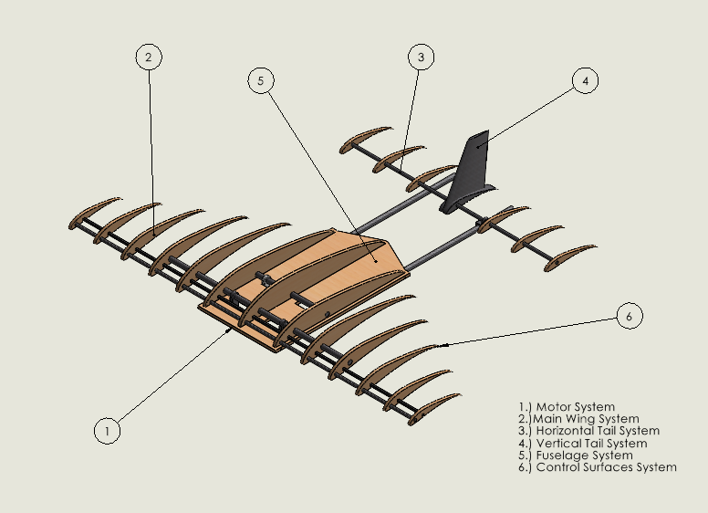
Figure 1: Top Level CAD Model
The first subsystem, the Motor System is responsible for thrust generation for the plane. Our motor, an Avian 4250-800Kv Outrunner, is an electric brushless motor often used for RC aircrafts. Combined with a 12” ABS propeller and power by the onboard LiPo battery, will pull the aircraft through the air, creating a pressure difference of the wings. The Main Wing System is responsible for generating most of the lift for the plane, due to this pressure difference generated by moving through the working fluid. The pressure difference will allow the plane to take off and glide in the air, by counteracting the gravitational weight pulling down on the plane during flight. The Main Wing System will also house a portion of the Control Surfaces System: the ailerons. The ailerons are responsible for roll movements of the plane, by creating increases and decreases in pressure differences of the main wings. The Horizontal Tail System is another subsystem responsible for generating lift and housing other components. The tail wing provides stability in the cross-sectional plane of the aircraft to prevent the aircraft from rolling forward on itself during flight. The tail wing also contains a long, horizontal control surface called the elevator. The elevator is responsible for the pitch movement of plane. This is done by increasing and decreasing the lift generated by the tail wing to increase or decrease the plane’s elevation. The fuselage is a subsystem designed solely to house internal components of plane such as the battery, electronic speed controller, and cargo. The fuselage is yet to be designed, but will rectangular in shape and mounted under the main wings. Shifts in the position of the fuselage and will be determined as the final center of gravity is determined by the team. The final subsystem of the aircraft is the landing assembly. The landing assembly is responsible for two functions. The wheels in the landing assembly are responsible for reducing friction between the plane and the ground during takeoff and landing. The landing gear also provides the plane with an additional increase in angle of attack during takeoff by angling the plane at a larger angle then when it is in flight.

Engineering/Customer Requirements

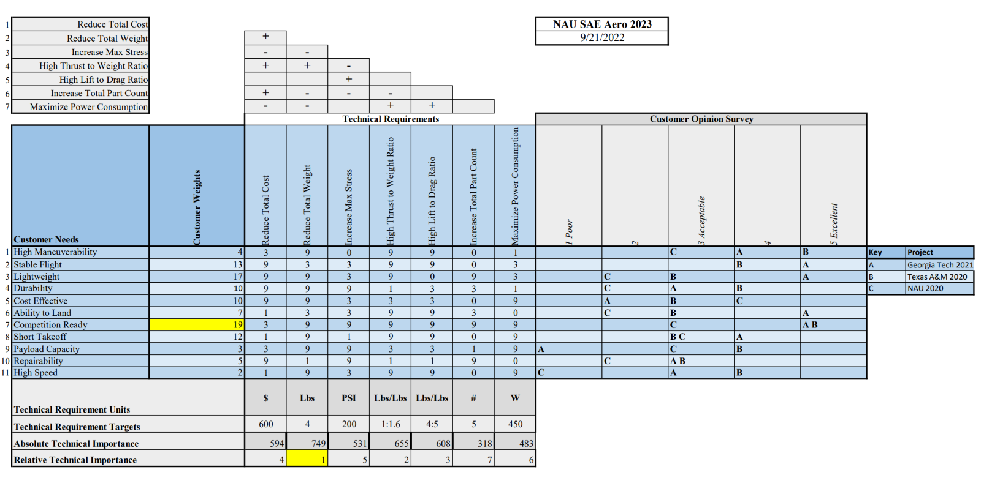Figure 2: House of Quality
The overall project objective is to create an aircraft that can safely compete in the SAE Aero competition and finish the course successfully. Shown above is the QFD, which includes the customer requirements in no specific order. A competition ready design holds the highest weight at 19%. The reason for this weight is because not only does the client desire a plane that will be able to compete in the competition, but also being competition ready implies that the team successfully designed a plane that is ready to compete. Lightweight is the second highest customer weight at 17%. This is because the team wants the plane to have an easy weight ratio allowing the plane to lift off the 4x8 ft takeoff platform. Stable flight is third at 13%. Stable flight ensures that everything in the plane’s dimensions is designed properly and there are possibilities for safe landings. Short takeoffs are at 12% because the platform that the plane must be able to take off from is relatively small. In the competition, if the plane fails to take off before the takeoff platform ends, the plane will fall off and go straight towards the ground. The durability of the plane has a weight of 10%. This is because having a durable plane would mean less repairs and less potential damage from system failures. A cost-effective design holds a weight of 10%. A cheaper design allows for the creation of more prototypes and saves money for solving potential problems during flight testing or other testing. The ability to land has a weight percentage of 7%. The reason for this is because the ability to land is the last task that must be performed for a complete trial run in the competition. Repairability has a weight of 5%, this is because we know that there will be damage to the plane and want to have it repaired easily. High maneuverability is at 4% due to lack of concern for maneuverability because the team is focused on getting a plane to fly safely. The payload capacity is at 3%. Although the competition encourages teams to carry more weight for more points, the sponsors main objective is to get the plane to take off and land to place in the competition. Lastly the high speed has a customer weight of 2%. High speed is encouraged by the competition judges; however, it is not as important as ensuring a functional design.

Engineering Requirements:
The first engineering requirement is to reduce the total cost of the design. To do this, the team chose materials that have high strength and durability and are low cost. This engineering requirement will go along with the customer requirements of being durable and having a low cost. Examples of this would be Balsa wood, and some types of foams to have a durable design, with cheap material. The target cost of one rendition of the plane is $600-$900. With a budget of $3000 dollars provided by our sponsor, the team needs to limit the percentage of the budget used on materials to allow for adequate prototyping as well as travel costs.
The second engineering requirement is to reduce the total weight. To reduce the total weight of the aircraft, the team chose lightweight materials to prototype the frame. The main material used is foam, but considerations of utilizing carbon fiber may be executed in later stages of the project. This is an important requirement due to the knowledge of knowing the weight is a big factor to lift ratios. Another example of reducing weight would be using skid plates for the tail wheel landing gear, instead of a wheel configuration. The target weight for the final design is 3-4 pounds. This number was decided upon by the team because the plane in limited to 450 W of power per competition rules. Most commercial motors that intake that power is fitted to planes no larger than 4 pounds.
The next engineering requirement is to increase the max stress that the plane can endure during flight. Increasing the max stress will allow the wings and body of the plane to withstand the stress applied from the aerodynamic forces when flying. This can be done by improving the strength-to-weight ratio through material selection or building more supporting members of the plane. This increases the reliability and durability of the plane itself. The initial goal for stress resistance capabilities is to have all parts being able to withstand 200 ± 30 psi for the entirety of the flight, including the landing. This target strength was determined from a preliminary analysis of the total stress the plane might be under at any given time. The plane also needs to be able to endure rough transportation to competition because the team might need to ship the plane to Fort Worth, Texas.
High thrust to weight ratio is the next engineering requirement. This helps the team address the issue that most SAE Aero teams run into. With only 8 feet of runway to take off from, the plane needs exceptional acceleration capabilities to generate enough lift. The target thrust-to-weight ratio is 1:1.6, but the team is satisfied with a ratio as high as 1:3. This guarantees a consistent take-off at competition. This also allows the team to score more competition points in the cargo run. Having the ability to increase throttle allows the team to carry more weight and not worry about takeoff capabilities.
The fifth engineering requirement is to have a high lift-to-drag ratio. With a target lift-to-drag ratio of 4:5, the team will be able to increase speed and maneuverability when in flight. Higher ratios of 1:1 gives the team more room to breathe when it comes to stresses on the plane. Reductions in drag come from designing a slim body that not only reduces skin drag but pressure drag as well. Further analysis of this can be done by putting protypes of this into a wind tunnel and measuring pressure differences during the testing procedures. Effective airfoil design will produce more lift without increasing the planform area of the wings.
The sixth engineering requirement is to increase the total part count. The reason the team chose this as an important engineering requirement is to increase repairability of the plane. With a target of 5 major parts of the plane, the team plans to possess the ability of interchange portions of the plane at any given time in case of emergency. This is to address the issue of a broken part or even a part that is not performing to the team’s standards. This will also allow us to potentially have different wing designs for when we are carrying different amounts of cargo.
The final engineering requirement is to maximize power consumption. With a competition required power limiter of 450 W, the team wants to aim to consume between 400 and 450 watts of power. This will allow us to produce the most amount of thrust, which will in turn produce more lift. This will also reduce the takeoff distance and increase maneuverability, as a higher speed will allow a more variable manipulation of the working fluid.

Standards, Codes, and Regulations
Two sources are used that designate standards and regulations for the aircraft design: the Institute of Electronics and Electrical Engineers (IEE) and the Society of Automotive Engineers (SAE). IEEE was used a guideline for the electrical components within the plane. It also serves a source for physical explanations behind electrical concepts. SAE sets the regulations that the plane must comply with for the competition. This includes several very specific part requirements and design limitations. All standards are tabulated below in (Table 1).

Table 1: Standards of Practice as Applied to this Project
Standard Number or Code | Title of Standard | How it applies to Project
SAE Aero 2.1 | Aircraft Identification | School name, address, email address must be on the plane and be at least 2 in of height
SAE Aero 2.2 | Prohibited Aircraft Configuration | The design must be a fixed wing aircraft
SAE Aero 2.3 | Empty CG Requirements | The plane must fly without any cargo and the center of gravity must be clearly marked on both sides of the plane
SAE Aero 2.7 | Spinner and Safety Nut Requirement | To secure the propeller a spinner or rounded nut must be used. Nylon-insert lock nuts are prohibited
SAE Aero 2.11 | Static Payload Plate Attachment | Static payload plates must be secured with metal hardware that penetrates all plates
SAE Aero 2.16 | Stored Energy Restrictions | Must be powered by motor onboard the aircraft. No other forms of energy are allowed such as rubber bands or C02 cartridges.
SAE Aero 2.19 | Power Limiter | Specified Power limiter must be used to limit the propulsion power
SAE Aero 2.20 | Red Arming Plug | Aircraft must have a red arming plug that can disarm the propulsion system. It must be placed in the back half of the aircraft.
SAE Aero 9.1 | Aircraft Dimension Requirements | Micro Class aircraft are limited to a maximum planform wingspan of 36inches
SAE Aero 9.2A | Propulsion Requirements | Aircraft must be powered by electric propulsion only
SAE Aero 9.2C | Aircraft Propulsion System Battery | A LiPo battery with no more than 4 cells must be used.
SAE Aero 9.2E | Power Limiter | Power limiter must be 450W
IEEE 128-1976 | Guide For Aircraft Electric Systems | Provides recommendations and technical reasoning for how the team can design the electrical systems.
FAA Aeronautics and Space – Chapter 1 – Part 107 | Small Unmanned Aircraft Systems | Any aircraft that weighs above 0.55 lbs must be registered under the FAA before flight. The pilot must also be registered.

Equations and Solutions
To analyze the performance of the plane, three load cases were utilized: takeoff, landing, and max cruise speed. These represent the most critical loading the plane will be subjected to during operation. Takeoff requires the plane generated a high amount of lift and thrust quickly to takeoff in the span of 8ft. Max cruising speed is the point where drag and wing stress will peak. Landing is the case where the force will be highest on the body. For each case, lift and drag forces of flight and Reynolds Number was determined to assess if the plane will function properly at all the load cases. In addition, a stress scenario was also analyzed for max cruise speed and takeoff distance was determined.

To determine lift and drag, (Equations 1-2) are used below. The coefficients of lift and drag were pulled from airfoiltools.com. All calculations were performed using the MATLAB script found in the appendix below.
$L=C_{L}*ρ*A*\frac{v^{2}}{2}$ [1]
$D=C_{D}*ρ*A*\frac{v^{2}}{2}$ [2]
It is important to note that these drag values result from form drag only, and is not a complete picture of the drag polar. To determine the actual values for lift and drag, computational fluid dynamics is needed. This will be discussed later in the Moving Forward section. Reynolds numbers for all three cases was calculated using (Equation 3) below.
$Re=V*L/v$ [3]
The values calculated by (Equations 1-3) are tabulated in (Table 3)
Table 3: Lift, Drag, and Reynolds Numbers
 | Lift (lbf) | Drag (lbf) | Re
Takeoff | 3.06 | 0.02 | 1.7e4
Max Cruise Speed | 7.82 | 0.02 | 1.9e5
Landing | 0.18 | 8.6e-4 | 2.8e4

For takeoff, the competition constrains the runway to 8 feet. To ensure that the plane can takeoff in this short of distance, the ground roll distance was determined using (Equation 4).
$S_{g}=\frac{1.21*(\frac{W}{S})}{g*ρ*C_{L}*(\frac{T}{W})}$ [5]

This calculation can be found in the MATLAB script in the Appendix. This values was determined to be 0.31 feet. This number seems unreasonably small which brings doubts to its validity, but if its true it would be considered a great design success. During max cruise speed, the loading on the wings will be at its max. Treating the wing as a cantilevered beam, the loading scenario can be described by the free body diagram in (Figure 3).
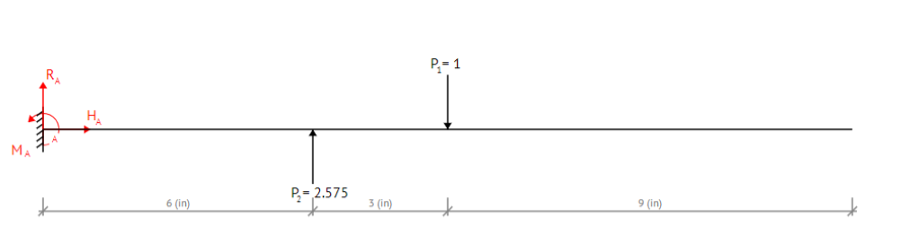
Figure 3: Free body diagram for wing
A maximum moment of 14.8 lbs-in was found to be acting on the wing. Using (Equation 6), minimum diameter of the support rod can be determined.

$d={[\frac{16n}{π}\left(\frac{1}{S_{ut}}\left[4{\left(K_{f}M\right)}^{2}\right]\right)]}^{1/3}$ [6]
The value was determined to be 0.88 in if only 1 bar is supporting the weight of the wing. In (Table 4) the worst load case scenarios are tabulated alongside the minimum factors of safeties.
Table 4: Minimum Factors of Safety
Sub-system | Part | Load Case Scenario | Material | Minimum FoS
Motor System |  |  |  | 1.1
 | Motor |  | n/a | 1.2
 | Propeller | Impact force from crash landing | n/a | 3.2
 | ESC |  | n/a | 1.1
 | Battery |  | n/a
Main Wing System |  |  |  | 1.0
 | Support Rods | Bending force of 3.835lbf from wing loading at wingspan center | Carbon fiber | 1.5
 | Airfoils | Impact force of 4lbf | Balsa Wood | 1.0
Horizontal Tail System |  |  |  | 1.5
 | Support Rod | Bending force of 0.97lbf | Carbon Fiber | 1.5
 | Airfoils | Impact force of 4lbf | Balsa Wood | 1.0
Vertical Tail System |  |  |  | 1.0
 | Vertical Stabilizer | Impact force of 4lbf | PLA | 1.0
Fuselage System |  |  |  | 1.0
 | Base Plate | Impact force of 4lbf | Balsa Wood | 1.0
 | Side Walls | Impact force of 4lbf | Balsa Wood | 1.0
 | Bracket | Shearing force of 6lbf | PLA | 1.0
Control Surface System |  |  |  | 1.0
 | Elevator | Impact force of 4lbf | PLA | 1.0
 | Rudder | Impact force of 4lbf | PLA | 1.0
 | Ailerons | Impact force of 4lbf | PLA | 1.0
 | Control Rods | Moment of 2.2 lbf | Steel | 1.3
Landing Gear system |  |  |  | 2.0
 | Tire | 4lbf applied force during landing | Rubber/Plastic | 2
 | Support Bar | 4lbf applied force during landing | Steel | 2
*If FOS is red then the factor of safety is only planned and has not been determined through analysis yet
Flow Chart and Other Diagrams
The team has used functional diagrams such as black box models and functional decomposition models to guide in the engineering design process. These diagrams provide a step by step explanation of how the different aircraft components interact their surroundings to control the four characteristics of flight: lift, drag, weight, and thrust.
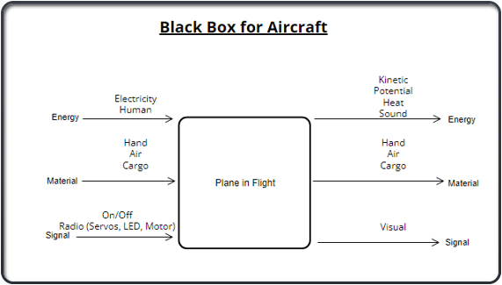
Figure 4: Black Box Model
The Black Box Model provides a rudimentary outline of the inputs and outputs of the aircraft by showing the conversion energy, material, and signals.
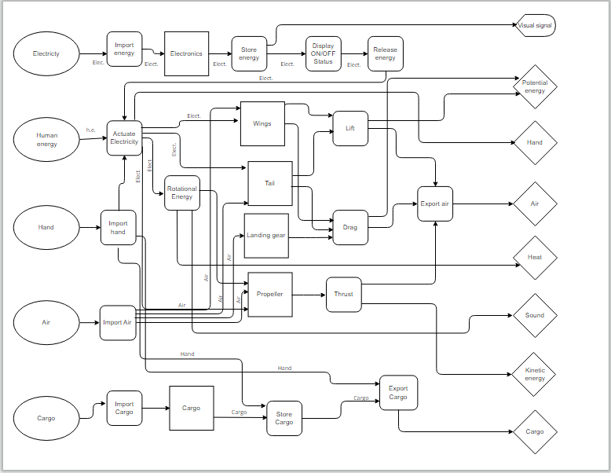
Figure 5: Functional Decomposition Model
The functional decomposition model shown above in Figure 5 demonstrates the exact use of each input, and what subsystems are using those inputs. This model also shows the method in which this inputs are used throughout the aircraft.
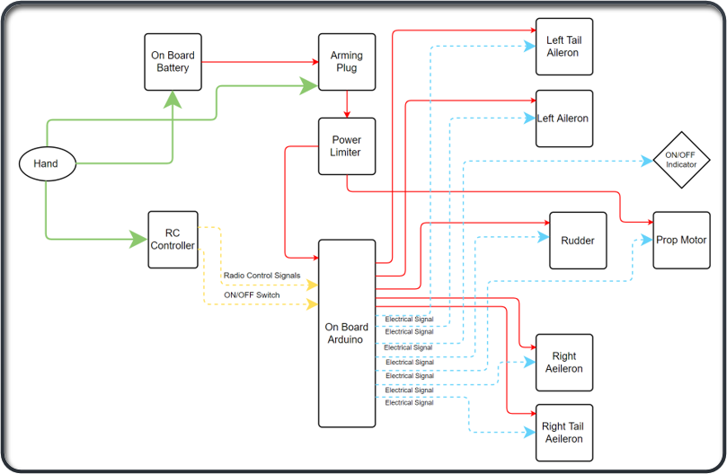
* “On Board Arduino” is now the “On Board Receiver”.
Figure 6: Wiring Diagram
The wiring diagram displayed in Figure 6 shows the wiring configuration of all onboard electronics and how signals are communicated between the transmitter and the receiver.

Moving Forward
In ME 476C the team was able to calculate the four forces of flight, lift, drag, thrust, and weight. These forces were found using drag and lift coefficients found through various equations. The team found that the forces of flight were adequate given the three load cases. While this is promising for preliminary design, the true values still need to be determined using computational fluid dynamics, specifically XFLR5. This software can model fluid flow over the plane and give full accurate values for lift and drag. This will in turn allow for the team to make more precise design decisions. XFLR5 will also be used to assess the stability of the plane. It can ensure that the different surfaces that apply moments about the center of gravity are balances, and that the plane is in a state of both static and dynamic equilibrium. In terms of finishing the design, the fuselage is still a work in progress. The configuration of the 12in x 12in x 2in box, the weighted plates, and the electronics is still being discussed and modelled. The control surfaces also need to be added into the CAD model, though the circuit configuration of the servo motors is known. The specific sizing of the control surfaces still needs to be determined to ensure that they apply adequate moments to give the desired maneuverability. A full stress analysis also needs to be done using a Finite Element Analysis through SolidWorks. Static and Dynamic testing is in progress. More propellers need to be tested, as well as testing incorporating a shroud. Once these analyses are performed and the model is completed the team can move on to constructing another prototype. For the 33%+ build, the team wants to have a fully operating aircraft for testing. A variety of test have already been constructed in reports from 476C. These include mock competition trials, speed tests, weight tests, and more. Based off those results the plane will be considered for design changes. By the 67% build deadline the team wants to have another improved prototype constructed. It will be run through testing again to determine if another model is necessary. By this time the team should have already contacted the Flagstaff Flyers and utilized their facilities for testing, but their assistance in flying the plane as well as teaching the team to fly is critical to the team’s success. While time is the biggest challenge of this competition, the teams plan moving forward will ensure that the proper analysis and testing are completed, bolstering the teams chance to place well at the SAE Aero Design Competition.

References
[1] “Avian 4260-480kv outrunner brushless motor,” Spektrum Avian 4260-480Kv Outrunner Brushless Motor | Horizon Hobby. [Online]. Available: https://www.horizonhobby.com/product/avian-4260-480kv-outrunner-brushless-motor/SPMXAM4715.html.
[2] Benaouali and S. Kachel, "Structural wing sizing and planform shape optimization using multidisciplinary CAD-CAE integration process," 2017 8th International Conference on Mechanical and Aerospace Engineering (ICMAE), 2017, pp. 478-483, doi: 10.1109/ICMAE.2017.8038692.
[3] J. J. D., Aircraft Performance and Design. Boston, Mass: McGraw-Hill Higher education, 2012.
[4] I Fly America, “The wing's The thing,” Wing Design. [Online]. Available: https://iflyamerica.org/safety_wing_design.asp. [Accessed: 12-Oct-2022].
[5] SAE International, 2022 Collegiate Design Series SAE Aero Design Rules, 2022.0 ed. 2022.
[6] S. Gudmundsson, “The anatomy of the fuselage,” General Aviation Aircraft Design (Second Edition), 14-Jan-2022. [Online]. Available: https://doi.org/10.1016/B978-0-12-818465-3.00012-4.

Appendix
Figure 1: Top Level CAD Model

Figure 2: House of Quality
Table 1: Standards of Practice as Applied to this Project
Standard Number or Code | Title of Standard | How it applies to Project
SAE Aero 2.1 | Aircraft Identification | School name, address, email address must be on the plane and be at least 2 in of height
SAE Aero 2.2 | Prohibited Aircraft Configuration | The design must be a fixed wing aircraft
SAE Aero 2.3 | Empty CG Requirements | The plane must fly without any cargo and the center of gravity must be clearly marked on both sides of the plane
SAE Aero 2.7 | Spinner and Safety Nut Requirement | To secure the propeller a spinner or rounded nut must be used. Nylon-insert lock nuts are prohibited
SAE Aero 2.11 | Static Payload Plate Attachment | Static payload plates must be secured with metal hardware that penetrates all plates
SAE Aero 2.16 | Stored Energy Restrictions | Must be powered by motor onboard the aircraft. No other forms of energy are allowed such as rubber bands or C02 cartridges.
SAE Aero 2.19 | Power Limiter | Specified Power limiter must be used to limit the propulsion power
SAE Aero 2.20 | Red Arming Plug | Aircraft must have a red arming plug that can disarm the propulsion system. It must be placed in the back half of the aircraft.
SAE Aero 9.1 | Aircraft Dimension Requirements | Micro Class aircraft are limited to a maximum planform wingspan of 36inches
SAE Aero 9.2A | Propulsion Requirements | Aircraft must be powered by electric propulsion only
SAE Aero 9.2C | Aircraft Propulsion System Battery | A LiPo battery with no more than 4 cells must be used.
SAE Aero 9.2E | Power Limiter | Power limiter must be 450W
IEEE 128-1976 | Guide For Aircraft Electric Systems | Provides recommendations and technical reasoning for how the team can design the electrical systems.
FAA Aeronautics and Space – Chapter 1 – Part 107 | Small Unmanned Aircraft Systems | Any aircraft that weighs above 0.55 lbs must be registered under the FAA before flight. The pilot must also be registered.

Table 3: Lift, Drag, and Reynolds Numbers
 | Lift (lbf) | Drag (lbf) | Re
Takeoff | 3.06 | 0.02 | 1.7e4
Max Cruise Speed | 7.82 | 0.02 | 1.9e5
Landing | 0.18 | 8.6e-4 | 2.8e4

Figure 3: Free body diagram for wing

Table 4: Minimum Factors of Safety
Sub-system | Part | Load Case Scenario | Material | Minimum FoS
Motor System |  |  |  | 1.1
 | Motor |  | n/a | 1.2
 | Propeller | Impact force from crash landing | n/a | 3.2
 | ESC |  | n/a | 1.1
 | Battery |  | n/a
Main Wing System |  |  |  | 1.0
 | Support Rods | Bending force of 3.835lbf from wing loading at wingspan center | Carbon fiber | 1.5
 | Airfoils | Impact force of 4lbf | Balsa Wood | 1.0
Horizontal Tail System |  |  |  | 1.5
 | Support Rod | Bending force of 0.97lbf | Carbon Fiber | 1.5
 | Airfoils | Impact force of 4lbf | Balsa Wood | 1.0
Vertical Tail System |  |  |  | 1.0
 | Vertical Stabilizer | Impact force of 4lbf | PLA | 1.0
Fuselage System |  |  |  | 1.0
 | Base Plate | Impact force of 4lbf | Balsa Wood | 1.0
 | Side Walls | Impact force of 4lbf | Balsa Wood | 1.0
 | Bracket | Shearing force of 6lbf | PLA | 1.0
Control Surface System |  |  |  | 1.0
 | Elevator | Impact force of 4lbf | PLA | 1.0
 | Rudder | Impact force of 4lbf | PLA | 1.0
 | Ailerons | Impact force of 4lbf | PLA | 1.0
 | Control Rods | Moment of 2.2 lbf | Steel | 1.3
Landing Gear system |  |  |  | 2.0
 | Tire | 4lbf applied force during landing | Rubber/Plastic | 2
 | Support Bar | 4lbf applied force during landing | Steel | 2

Figure 4: Black Box Model

Figure 5: Functional Decomposition Model

Figure 6: Wiring Diagram

Equation 1
$$L=C_{L}*ρ*A*\frac{v^{2}}{2}$$
Equation 2
$$D=C_{D}*ρ*A*\frac{v^{2}}{2}$$
Equation 3
$$Re=V*L/v$$
Equation 4

Equation 5
$$S_{g}=\frac{1.21*(\frac{W}{S})}{g*ρ*C_{L}*(\frac{T}{W})}$$
Equation 6
$$d={[\frac{16n}{π}\left(\frac{1}{S_{ut}}\left[4{\left(K_{f}M\right)}^{2}\right]\right)]}^{1/3}$$

Reynolds Number, Velocity Analysis, and Load Case Scenarios
clc
clear all

Plane Properties
W = 3; %lbs
S = 1.65; %ft^2
T = 4; %lbs
CL = 2.25;
c = .792; %ft
W_Area = 2.18; %ft^2
T_Area = 0.689; %ft^2
W_Area_F = 0.33; %ft^2
T_Area_F = .105; %ft^2

Air and Gravity
rho = 0.00233; %slugs/ft^3
g = 32.2; %ft/s^2
u = .3786e-6; %lbf*s/ft^2
v = 1.64e-4; %ft^2/s

Velocity Calculations
V_stall = sqrt(2*W/(rho*S*CL*32.2))
V_Lo = 1.1*V_stall
V_inf = 0.7*V_Lo %average velocity over takeoff
V_max = 40; %ft/s
V_Landing = 1.23*V_stall
V_Takeoff = 25.45; %ft/s

Ratios
T_W = T/W
W_S = W/S

Distance to Takeoff
D = 1.21*W_S/(32.2*g*rho*CL*T_W)

Reynolds Numbers
Re_Takeoff = V_inf*c/(v)

Re_Cruising = V_max*c/(v)

Re_Landing = V_Landing*c/(v)

Coefficient of Lift and Drag for the Tail and Wing
Tail = struct('Takeoff',[],'Landing',[],'Cruise',[])
Tail.Takeoff = struct('CL',[0.5676],'CD',[0.02326],'L',[],'D',[])
Tail.Landing = struct('CL',[1.0522],'CD',[0.03883],'L',[],'D',[])
Tail.Cruise = struct('CL',[0.7912],'CD',[0.01712],'L',[],'D',[])
Wing = struct('Takeoff',[],'Landing',[],'Cruise',[])
Wing.Takeoff = struct('CL',[1.6794],'CD',[0.04],'L',[],'D',[])
Wing.Landing = struct('CL',[1.804],'CD',[0.056],'L',[],'D',[])
Wing.Cruise = struct('CL',[1.6753],'CD',[0.02867],'L',[],'D',[])

Lift Force Calculations
Tail.Takeoff.L = Tail.Takeoff.CL*rho*V_Takeoff^2/2*T_Area;
Tail.Landing.L = Tail.Landing.CL*rho*V_Landing^2/2*T_Area;
Tail.Cruise.L = Tail.Cruise.CL*rho*V_max^2/2*T_Area;

Wing.Takeoff.L = Wing.Takeoff.CL*rho*V_Takeoff^2/2*W_Area;
Wing.Landing.L = Wing.Landing.CL*rho*V_Landing^2/2*W_Area;
Wing.Cruise.L = Wing.Cruise.CL*rho*V_max^2/2*W_Area;

Drag Force Calculations
Tail.Takeoff.D = Tail.Takeoff.CD*rho*V_Takeoff^2/2*T_Area_F;
Tail.Landing.D = Tail.Landing.CD*rho*V_Landing^2/2*T_Area_F;
Tail.Cruise.D = Tail.Cruise.CD*rho*V_max^2/2*T_Area_F;

Wing.Takeoff.D = Wing.Takeoff.CD*rho*V_Takeoff^2/2*W_Area_F;
Wing.Landing.D = Wing.Landing.CD*rho*V_Landing^2/2*W_Area_F;
Wing.Cruise.D = Wing.Cruise.CD*rho*V_max^2/2*W_Area_F;

Total Lift and Drag
Takeoff_Total_L = Wing.Takeoff.L+Tail.Takeoff.L
Takeoff_Total_D = Wing.Takeoff.D+Wing.Takeoff.D

Cruise_Total_L = Wing.Cruise.L+Tail.Cruise.L
Cruise_Total_D = Wing.Cruise.D+Tail.Cruise.D

Landing_Total_L = Wing.Landing.L+Tail.Landing.L
Landing_Total_D = Wing.Landing.D+Tail.Landing.D

