
Team Hi-Jacks
ME-486C
Colby Murphy
Dante Faria
Tommy Schreiber
Damien Brothers
Jay Khunt

Finalized Testing Plan
Design Requirements Summary
The customer requirements for this project are to create a lightweight drone frame that minimizes weight while maximizing the thrust to weight ratio, strength, and flight time. Additionally, the drone needs to be simple to manufacture, inexpensive, optimized component's locations, with minimal hardware. “Extra credit” is given if the drone is flyable by the end of the project, something the team decided to make mandatory. Each requirement is tabulated below.

Table 1: Customer requirements
Requirement Number | Customer Requirement
CR1 | Lightweight
CR2 | High thrust to weight ratio
CR3 | High frame strength
CR4 | Long flight time
CR5 | Ease of manufacturing
CR6 | Inexpensive
CR7 | Optimized component locations
CR8 | Minimal hardware
CR9 | Flyable

To meet the customer requirements, the team created a list of engineering requirements that relates to what the customer has in mind for the drone. Primarily, the frame needs to be under three pounds, have a thrust to weight ratio greater than 1.81, and be able to withstand impacts and typical forces of flight. Then the client wants the frame to be simple to produce, have a total project cost less than $5000, have each component placed so that necessary parts have a good field of view, an overall central center of gravity, made with few parts, and be able to takeoff, maneuver, and land. These requirements are tabulated below.

Table 2: Engineering requirement
Requirement Number | Engineering Requirement
ER1 | Weigh less than 3 pounds
ER2 | Thrust to weight ratio greater than 1.81
ER3 | Able to withstand impacts and forces of flight
ER4 | Flight time around 10 minutes
ER5 | Simple to produce
ER6 | Total project less than $5000
ER7 | Central COG and good FOV
ER8 | Few parts
ER9 | Ability to takeoff, maneuver, and land

Top Level Testing Summary
Each test and its related requirements are shown in table 3. To summarize, the takeoff and maneuver testing will be a testament to how well the drone can get off the ground and stay in the air using the components we were supplied with. The drop test simulation and landing tests will be dependent on the strength and reliability of the drone frame, especially the legs. Thrust-to-weight ratio, weight, and flight characteristics will all be needed to meet the customer requirements but can be tested with a scale and common knowledge of flight.
Table 3: Tests and their relevant requirements
Test | Relevant Design Requirements
Takeoff | CR1, CR2, CR9, ER2, ER9
Maneuvering | CR1, CR2, CR3, CR9, ER1, ER9
Flight stability | CR3, CR7, ER3, ER7
Flight characteristics | CR2, CR4, ER2, ER4
Landing | CR1, CR2, CR9, ER2, ER9
Drop Test Simulation | CR3, CR5, CR6, CR8, ER3, ER8
Thrust to weight ratio | CR2, ER2
Weight | CR1, ER1
Detailed Testing Plans
Takeoff Testing
Take-off testing will consist of a fully completed drone frame with all electrical components attached. The question that was answered with this testing was how much throttle needs to be applied to the controller for the drone to become airborne. The same experiment is completed but instead, using QGroundControl as the throttle. To output accurate results, this testing is to be indoors, away from all wind/air conditioning, a fully charged battery, and a drone with proper CG (center of gravity). The variable that is calculated in this test will be the percentage of throttle given to the power management board, 0-100%. There are three trials for each controller method for a total of 6 tests. The throttle will be slowly increased by 5% on the controller until the propellors lift all legs of the drone off the ground. The results from this test were easy to find using QGroundControl and its analytics. For the handheld controller, the average throttle value ranged from 35-40% throttle before all legs would come off the ground. As for the online software, throttle only needed to be 30-35% engaged to see the drone leave the ground. This data shows that there is a small discrepancy between which controller method is being used but due to the handheld Flysky controller being wireless, there must be a small disconnect as far as power going through the power module directly vs. indirectly. Since the clients made it optional to make the drone fly, the extent of this testing was just to compare the two controller methods.
Flight Stability Testing
Flight stability is paramount to the success of the project. QGroundControl, the software used to control and modify the drone, has several options that would be able to assist in stabilizing the drone during flight and landing/takeoff. The software has several preset “modes” that assist with different things. As part of testing the drone, it will be necessary to analyze the behavior of the drone while it is in several of these modes. Variables analyzed will include stability, maneuverability, and safety. These characteristics will be assessed by manually flying the drone and comparing each run to the next. The most optimized flight mode will then be selected for the drone to remain in. As these metrics are mostly subjective to the controller, no special equipment is required for testing. Other changes could affect stability, such as longer arms or different legs, and these variables could be assessed as well. This would be done by swapping parts of various dimensions to quantify the differences each of the individual parts and their dimensions could cause to the overall flight stability of the drone.
Maneuverability Testing
Maneuverability of the drone is a key part of flying the drone safely and ensuring the drone stays safe while in the air. This testing is not as important as some of the other tests due to the fact that the client does not require the drone to fly but because the drone is flying already, ensuring the drone will fly safely is important. The requirements that this testing hits relate to customer requirements 1, 2, 3, and 9 as well as engineering requirements 1 and 9. Like flight stability testing, the maneuverability testing will be done using QGroundControl as well as adjusting the controller so that the controls for the pitch, yaw, and roll are not as sensitive. There will also need to be some collaboration with the center of gravity testing as this will affect how maneuverable the drone is entire. To accurately adjust for the maneuverability, the controller settings will be adjusted one at a time to figure out which setting works best for the drone that is already built. Most of this testing will be minor adjustments to ensure a smoother flight for the drone.
Flight Characteristics Testing
Using software called eCalc, the team will be able to determine the required flight characteristics, thrust to weight and flight time. Once all the drone components are put into eCalc, it will automatically give an accurate estimate. The team hopes to achieve a power to weight ratio greater than 2.1 and a flight time of around 10 minutes. When going through the software it was found that it can calculate many more important parameters than what is needed such as total possible load capacity, max speed, temperature of components, and total possible flight distance. Since these are not needed, the data won't be used for the client, but it will be useful to note when flying the drone and any future work that will be done on the drone.
Landing Testing
The landing depends on various other tests such as Takeoff, Maneuverability and Flight stability. The drone needs to be able to land just as safely and efficiently as it took off. The test will be mostly conducted outdoors with different terrain considering the use of drone but will also be tested for stability in QGroundControl software. The question answered for this test will be is it safe to land on any terrain? And is it stable enough to lower down the drone and land? And is the landing going to be impactful or not? Now for the testing part, it needs to be mostly outdoors to test different terrain. But considering the weather of Flagstaff (snow and rain) and terrain available near campus, we could only find either concrete floors or grass beds. However, the drone is designed to be used in dry weather. Considering that we conducted a few tests on our prototype 2 on a concrete floor. There were approximately 5-6 tests done at different heights starting from as minimal as just taking off the ground up to 20 feet. First few tests up until approximately 10 feet up in the air, the drone was quite stable (60%-70%) and landed on its legs with little bounce and an impact on the ground but not to an extent that it can destroy the drone. But as soon as the drone reached more than 10 feet in the air up until 20 feet the stability gradually decreased and at 20 feet maneuvering the drone destabilized 100% and had a hard crash on the concrete which destroyed 2 legs, 1 arm, 2 propellors and 2 Trusses. With the results it is safe to say that it will be safe to land on softer floors such as grass or sand and if not, it will be safe to land on harder floors with higher stability. Stability is quite difficult to answer as of now considering it is manual flight and we do not have 100% information of manual flight nor are any of us certified with controls of manual flight.
Drop Testing Simulation
In order to meet the customer requirements 3, 5, 6, and 8 as well as the engineering requirements 3 and 8, a drop test simulation was conducted in order to test the design of the drone frame as well as the material that was used to build the drone frame. This simulation was conducted using the drop test feature within Solidworks and placed the drone frame without any of the manual flight components attached above a solid flat ground 10 feet in the air. The way that the drop test simulation works within Solidworks, the portion of the drone that would be most affected would be the legs of the drone and would give the user a great sense of what kind of stresses the legs will be put under in normal testing scenarios as the legs will be undergoing these forces very frequently upon landing the drone as there will be times of hard landings.
Thrust to Weight Ratio Testing
Again using eCalc, the team will be analytically determining the thrust to weight ratio. By inputting each component of the drone into the software, the team will be given an accurate value. This included the battery capacity, type of motors, speed controller and propellors being used as well as the total weight. The minimum, given by the client, is 1.81. Since the current drone is referencing a drone currently built by the client, using the same components, the thrust to weight ratio will be much higher than 1.81 if the team manages to keep the weight within spec. The team hopes to achieve a value greater than 2.1 which is a 15% improvement.
Weight Testing
Weight testing is our most important test due to the client’s number one requirements being that the drone is under 3lbs. As the project progressed over the last eight months, the team has changed the design of the drone frame over five different occasions. This was mostly due to component organization as well as optimal flight characteristics. Each of these prototypes never surpassed 2.2lbs meaning that the final version will be only slightly heavier. The test will simply consist of putting an empty drone frame on a scale. Once all components are mounted it is expected to weight around seven pounds.
Specification Sheet Preparation
Table 4: Customer requirement summary
Customer Requirement | CR met? (✓ or X) | Client Acceptable? (✓ or X)
CR1 | ✓ | ✓
CR2 | ✓ | ✓
CR3 | ✓ | ✓
CR4 | ✓ | ✓
CR5 | ✓ | ✓
CR6 | ✓ | ✓
CR7 | ✓ | ✓
CR8 | ✓ | ✓
CR9 | ✓ | ✓

Table 5: Engineering requirement summary
Engineering  Requirement | Target | Tolerance | Measured/  calculated value | er met?  (✓ or X) | client  acceptable?  (✓ or X)
er1 - weight | < 3lbs | +0.0lbs | 2.2lbs | ✓ | ✓
er2 – thrust:weight | >1.81 | -0 | 2.3 | ✓ | ✓
er3 – force | 2000 psi | - 500 psi | 6000psi | ✓ | ✓
er4 – flight | >10 minutes | - 0 seconds | 8.5 minutes | X | X
er5 – production | 7 days | +/- 3 days | 4 days | ✓ | ✓
er6 – cost | < $5,000 | +$0 | $2400 | ✓ | ✓
er7 – cg & fov | < ½” | +/- 1/8” | ~1/2” | ✓ | ✓
er8 – # of parts | < 30 parts | +/- 3 parts | 27 parts | ✓ | ✓
er9 – flight safety | 90% | +/- 5% | 87% | ✓ | ✓

QFD
The QFD shown below demonstrates how the customer and engineering requirements are related. The CRs are what the customer wants from the project and the ERs are the values assigned to each CR. This is so the team has a numeric value to hit so that it is clear when each requirement is met or not.

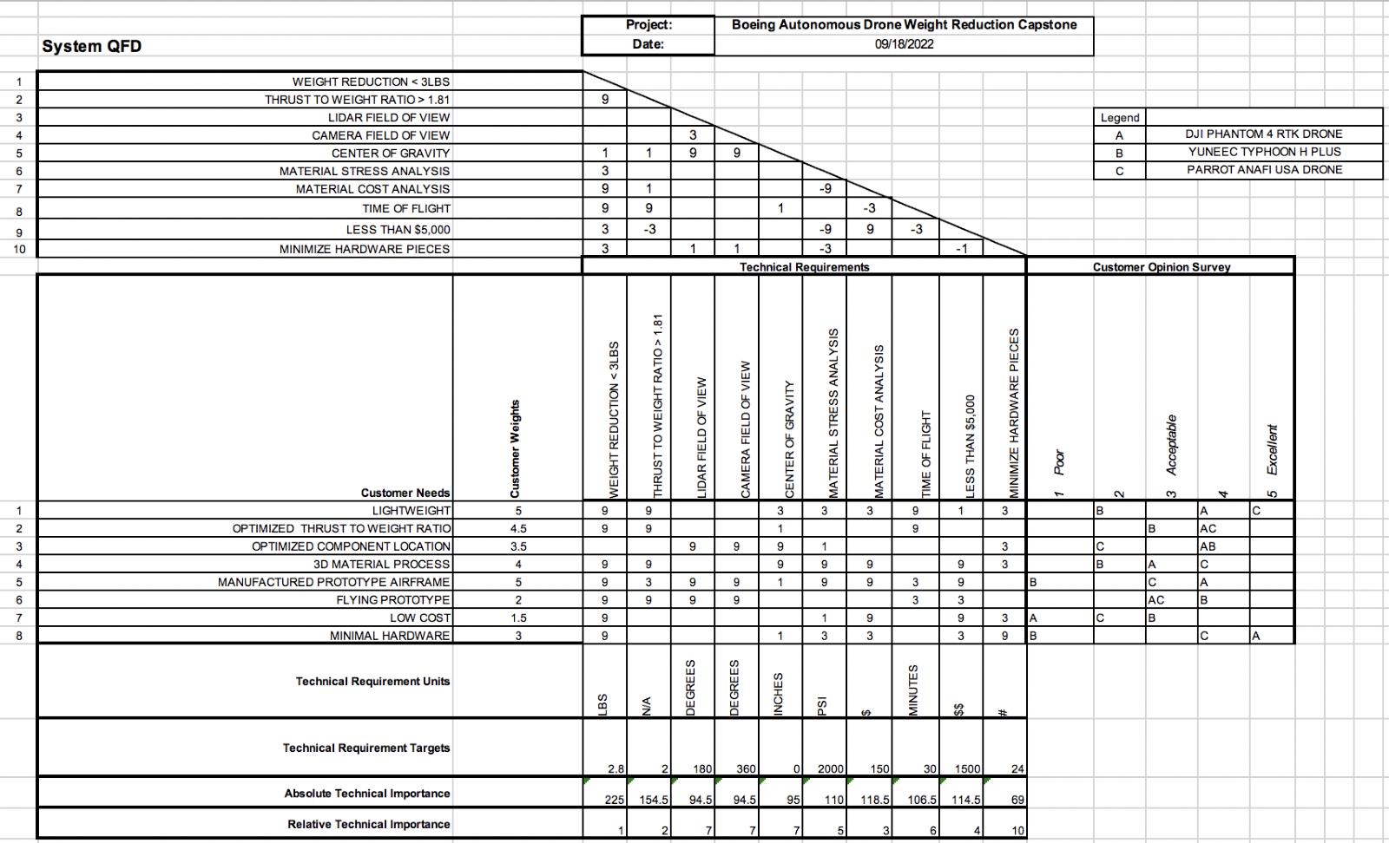
Figure 1: QFD

