P16: Helium-Filled Bubble Soap Generator

Final Report

Aaron Walcott
Simei Portillo Ramos
Musaab Nasralla

Fall 2022 – Spring 2023

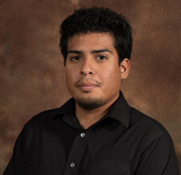



Project Sponsor: Dr. Zhongwang Dou
Faculty Advisor: Dr. Zhongwang Dou
Instructor: David Willy

DISCLAIMER
This report was prepared by students as part of a university course requirement. While considerable effort has been put into the project, it is not the work of licensed engineers and has not undergone the extensive verification that is common in the profession. The information, data, conclusions, and content of this report should not be relied on or utilized without thorough, independent testing and verification. University faculty members may have been associated with this project as advisors, sponsors, or course instructors, but as such they are not responsible for the accuracy of results or conclusions.

EXECUTIVE SUMMARY
The development of a microscale bubble generator is a challenging task, but the team has shown significant progress despite encountering some setbacks along the way. The current success of the project heavily relies on the nozzle's efficiency, making the nozzle testing phase crucial to ensure that the generator can produce the desired outcome.
The initial design of the nozzle was a three-layer coaxial nozzle, which the team printed using resin. However, the smallest layer, which had a diameter of 0.3 millimeters, posed a significant challenge in the production process. Most machines, including the 3D printer, could not print this layer efficiently due to its size and complexity. This setback led the team to explore other options, and they were fortunate to receive a brass two-layer nozzle that they integrated into their design.
To address the issues with the smallest layer, the team added a new layer that can be screwed onto the nozzle, with the smallest layer measuring 0.5 millimeters. This modification has greatly improved the nozzle's efficiency, and the team is confident that it will meet the client's requirements. They also opted to machine the adapter out of aluminum to enhance the nozzle's durability and lifespan, considering the high pressures and temperatures involved in the bubble generation process.
In addition to the nozzle, the team is also working with a high-speed camera that can capture videos at 68,000 frames per second. This camera's capabilities are essential to the project, as it will enable the team to capture the bubbles' motions, which are vital for Dr. Dou's research in aerodynamics or hemodynamics. With the new camera's specifications, the team will be able to conduct extensive analysis of the nozzle and ensure that it meets the client's requirements.
Overall, the team has made significant progress in developing a microscale bubble generator for Dr. Dou, and with their current trajectory, they are poised to deliver a successful outcome.

ACKNOWLEDGEMENTS
The main acknowledgement goes towards the client Dr. Zhongwang Dou, he let the team use his lab for numerous hours to perform testing on the team’s device. Additionally, this acknowledgement reaches towards his graduate assistants as they also played a big role in the testing of the team’s device.
The second acknowledgement goes to Dr. David Willy for continuing to keep the team motivated on the project and keeping the team on time to ensure they meet the deadlines.
A third acknowledgement goes to Claude at Quality Tool, he made the manufacturing possible by providing tools to the NAU machine shop so that their device could be made in house rather than outsourced.

TABLE OF CONTENTS
Contents
DISCLAIMER i
EXECUTIVE SUMMARY ii
ACKNOWLEDGEMENTS iii
TABLE OF CONTENTS iv
1 BACKGROUND 1
1.1 Introduction 1
1.2 Project Description 1
2 REQUIREMENTS 2
2.1 Customer Requirements (CRs) 2
2.2 Engineering Requirements (ERs) 2
2.3 Functional Decomposition 2
2.3.1 Black Box Model 2
2.3.2 Functional Model/Work-Process Diagram/Hierarchical Task Analysis 3
2.4 House of Quality (HoQ) 3
2.5 Standards, Codes, and Regulations 4
3 DESIGN SPACE RESEARCH 5
3.1 Literature Review 5
3.1.1 Student 1 (Aaron Walcott) 5
3.1.2 Student 2 (Simei Portillo) 6
3.2 Benchmarking 7
3.2.1 System Level Benchmarking 7
3.2.1.1 Existing Design #1: Cylindrical storage design 7
3.2.1.2 Existing Design #2: Boxed design with small feet 7
3.2.1.3 Existing Design #3: Descriptive Title 8
3.2.2 Subsystem Level Benchmarking 8
3.2.2.1 Subsystem #1: Nozzle Structure 8
3.2.2.1.1 Existing Design #1: 3D Printed Coaxial Nozzle 8
3.2.2.1.2 Existing Design #2: Interlocking Coaxial Nozzle 9
3.2.2.1.3 Existing Design #3: 3-Layer Coaxial Nozzle 9
3.2.2.2 Subsystem #2: Casing Structure 10
3.2.2.2.1 Existing Design #1: Cylindrical Casing 10
3.2.2.2.2 Existing Design #2: Box Casing with Feet 10
3.2.2.2.3 Existing Design #3: Box Casing with Wheels 10
3.2.2.3 Subsystem #3: Type of Bubble Flow 10
3.2.2.3.1 Existing Design #1: Monodisperse Bubbling 10
3.2.2.3.2 Existing Design #2: Monodisperse Jetting 10
3.2.2.3.3 Existing Design #3: Polydisperse Jetting 11

4 CONCEPT GENERATION 12
4.1 Full System Concepts 12
4.1.1 Full System Design #1: Boxed Casing 12
4.1.2 Full System Design #2: Bubble Bazooka 12
4.1.3 Full System Design #3: Retractable Hose Dispenser 12
4.2 Subsystem Concepts 12
4.2.1 Subsystem #1: Nozzle Structure 12
4.2.1.1 Design #1: Arrow Type Structure 13
4.2.1.2 Design #2: Arrow Type Nozzle Structure 13
4.2.1.3 Design #3: Coaxial Nozzle 13
4.2.2 Subsystem #2: Casing structure 14
4.2.2.1 Design #1: Box Casing 14
4.2.2.2 Design #2: Bubble Bazooka 14
4.2.2.3 Design #3: Retractable Hose Dispenser 14
4.2.3 Subsystem #3: Type of Bubble flow 15
4.2.3.1 Design #1: Monodispersed Bubbling 15
4.2.3.2 Design #2: Polydisperse Jetting 15
4.2.3.3 Design #3: Atomizer 15
5 DESIGN SELECTED – First Semester 16
5.1 Design Description 16
5.2 Implementation Plan 16
6 Project Management – Second Semester 18
6.1 Gantt Chart 18
6.2 Purchasing Plan 18
6.3 Manufacturing Plan 19
6.4 Bonus/Substitution Sections 19
6.4.1 Flow Rate Ranges and Bubble Characteristics 19
6.4.2 MATLAB 19
6.5 Major Changes Applied during Second Semester and Justifications 19
7 Final Hardware 20
7.1 Final Hardware Images and Descriptions 20
7.2 Design Changes in Second Semester 20
7.2.1 Design Iteration 1: Change in Third-Layer Adapter Discussion 20
7.3 Challenges Bested 21
8 Testing 22
8.1 Testing Plan 22
8.1.1 Ex1-Bubble Output Rate Test 22
8.1.2 Ex2-Bubble Concentration Test 22
8.1.3 Ex3-Device Run Time Test 22
8.1.4 Ex4-Bubble Diameter Test 22
8.2 Testing Results 23

9 RISK ANALYSIS AND MITIGATION 24
9.1 Potential Failures Identified First Semester 24
9.1.1 Potential Critical Failure 1: Thermal Fatigue 24
9.1.2 Potential Critical Failure 2: Stress Rupture 24
9.1.3 Potential Critical Failure 3: Corrosion Wear 24
9.1.4 Potential Critical Failure 4: Combined Creep and Fatigue 24
9.1.5 Potential Critical Failure 5: Combined Creep and Fatigue 24
9.1.6 Potential Critical Failure 6: Combined Creep and Fatigue 24
9.1.7 Potential Critical Failure 7: Corrosion Wear & Combined Creep and Fatigue 25
9.1.8 Potential Critical Failure 8: Corrosion Wear 25
9.1.9 Potential Critical Failure 9: Combined Creep and Fatigue 25
9.1.10 Potential Critical Failure 10: Corrosion Wear & Combined Creep and Fatigue 25
9.2 Potential Failures Identified This Semester 25
9.3 Risk Mitigation 25
10 LOOKING FORWARD 26
10.1 Future Testing Procedures 26
10.2 Future Iterations 26
11 CONCLUSIONS 27
11.1 Reflection 27
11.2 Resource Wishlist 27
11.3 Project Applicability 27
12 REFERENCES 28
13 APPENDICES 29
13.1 Appendix A: MATLAB Code for Bubble Analysis 29
13.2 Appendix A2: Results from Code 31
13.3 Appendix A3: Picture of bubble tracking 32
13.4 Appendix B.1: 3rd Layer Adaptor Drawing 33
13.5 Appendix B.2: Brass Nozzle 34
13.6 Appendix B.3: Exploded View of Brass Nozzle 35
13.7 Appendix C.1: Shortened FMEA 36
13.8 Appendix C.2: Full FMEA 37

BACKGROUND

Introduction
The Project the team is tasked on working is to make a microscale bubble generator. The client, Dr. Zhongwang Dou, is an Assistant Professor in the Engineering Department at Northern Arizona University and would like to have this device in his lab. The microscale bubble generator is a device that could be used like wind tunnel to be used to analyze the aerodynamics of objects. The bubbles are a form of seeding particle for visualization to see how the object is affected by a fluid.

Project Description
The goal of this project as said above is to make a microscale bubble generator. The client has requested that the machine can generate bubbles ranging from 15-150 microns in diameter. The client would also like this machine to have an output of one hundred million bubbles a second with a general density of twenty thousand per cubic centimeter with “easy to adjust settings.” This is so that one can analyze objects with precision. Finally, the client has requested that the machine has a residence time of thirty or more minutes.

REQUIREMENTS

Customer Requirements (CRs)
The team has been given a set of multiple requirements by the client Dr. Zhongwang Dou that the bubble generator should have. The most important requirements are the bubble output rate, the concentration of the bubble, and the size of the bubble. These are the major requirements which will make our machine different and better than the currently available machines. The requirements with ratings are given below.
- CR1: Bubble output rate, this was rated at 12/12
  - This was rated a 12 since it was one of the main goals of the project
- CR2: Bubble Concentration, this was rated at 12/12
  - This was rated a 12 since it was one of the main goals of the project
- CR3: Device residence, this was rated at 10/12
  - This was rated a 10 since it was slightly less important than the others since the client felt as though the 30-minute run time was not as important
- CR4: Device material, this was rated at 10/12
  - This was also rated a 10 since the device needs to be able to withstand higher pressures being pushed through the nozzle.
- CR5: Bubble size, this was rated at 12/12
  - This was rated a 12 since it was one of the main goals of the project
- CR6: User friendly, this was rated at 4/12
  - The client mentioned this as a goal however felt as though it was not the most important since his lab would mostly be the people using the device
- CR7: Durability, this was rated at 12/12
  - The device needs to be able to withstand a constant stream of fluids and pressure going through the nozzle so the team felt as though durability was very important since the product needs to be a quality one that would last a long period of time.
- CR8: Reliability, this was rated at 12/12

Engineering Requirements (ERs)
The engineering requirements were based on the customer requirements that the team received. So, the team took the customer requirements and had to come up with a feasible way to conceptualize them. They were then able to make the list below.
- ER1: Bubble output rate 100,000,000 bubbles/second
- ER2: Bubble concentration of 20,000 bubbles/cm³
- ER3: Device residence of 30 minutes
- ER4: Device material of aluminum and brass
- ER5: Bubble size of 15-150 microns

Functional Decomposition

Black Box Model
This section will be used to talk about the black box model of the team’s project. Pictured below in Figure 1 is the black box model which is a simplified version of the functional model but is still a good representation of how the team visualizes their project. They chose three different modes of imports that allow them to make the bubbles with three different outputs. This is important for the team since they can easily come back to this and see exactly what needs to be done in order to complete their project.
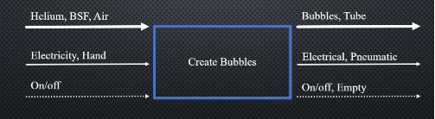
Figure 1: Black Box Model

Functional Model/Work-Process Diagram/Hierarchical Task Analysis
Using the black box model in chapter 2.3.1, a Functional Decomposition model was developed. The functional decomposition model uses the same notation as a black box model but creates a breakdown of each step throughout the device’s process. Each step was conceived from the customer requirements and the preliminary soup bubble design.
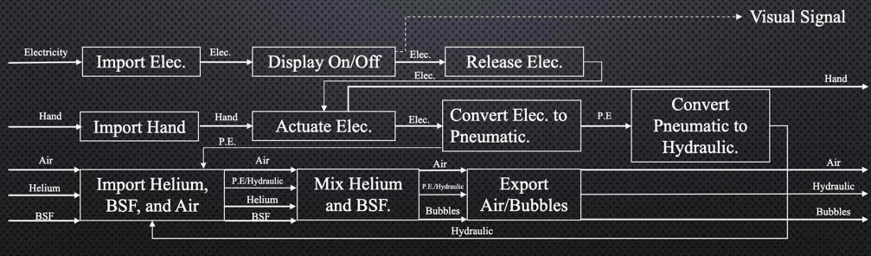
Figure 2: Detailed Decomposition Model

House of Quality (HoQ)
For connecting the engineering requirements and customer requirement this house of quality is made. The importance score is given to every requirement, and we will use scores to understand how much the requirement is fulfilled. The importance of each requirement will be correlated. After completing the House of Quality, it was determined that the nozzle structure has the most importance in this project as it affects the bubble structure, output, size, and volumetric concentration. We also found out that we needed to design a 3-layer coaxial atomizer.
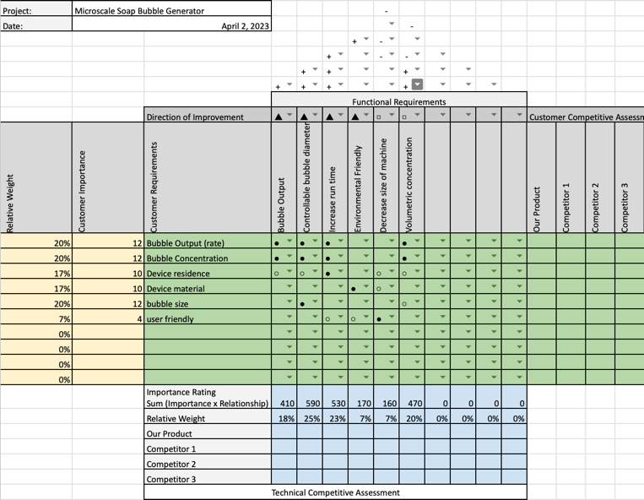
Figure 3: House of Quality

Standards, Codes, and Regulations
In this section of the report the team will be writing about the standards and codes they believe they will need for their project. The first code being from the ASME standards, and it details how the team needs to tolerate their CAD drawings as well as their dimensioning. The second code is also from the ASME standards which details metric bolts. The team thinks this is relevant since they will need to know about how to put their final device next semester. The third code is relevant to their project since it details pump energy, and they are pumping multiple fluids to produce their bubble. The fourth code is detailing valves which the team is going to be using so they can regulate the amount of fluid being pumped through their nozzle. Finally, the last code is detailing temperature measurement, this is relevant since the team will need to monitor the device temperature to make sure it stays at a normal operating temperature otherwise their fluids could change and make the device nonfunctional. Below in the table are the codes.
Table 1: Standards of Practice as Applied to this Project
Standard Number or Code | Title of Standard | How it applies to Project
ASME  Y14.5 | Dimensioning and Tolerancing | Applying GD&T to the CAD models of the adapter and nozzle
ASME  B18.3.6M | Metric Series Socket Screws | Information about socket head screws for the main device
ISO/ASME  14414 - 2019 | Pump system energy assessment | Assess the energy needed for the team’s pumps
ASME  N278.1 - 1975(R1992) | Self-Operated and Power-Operated Safety-Related Valves Functional Specification Standard | Information about valves that the team will need to look at pressure running through their device
ASME  PTC 19.3 - 1974-(R2004) | Temperature measurement | Going to need to examine the overall device temperature

DESIGN SPACE RESEARCH
In this section of the report, the team will be talking about the few previous designs that the client has given to the team so that they can benchmark what they need to do in order to take these designs and figure out how to change them and generate concepts to fit what the client wants.

Literature Review
This section will be used to discuss what literature sources two students used for their technical parts of the project, including descriptions of each source and the main points of the source.

Student 1 (Aaron Walcott)
Aaron was tasked with the nozzle structure design as his technical part of the project he referred to these resources that the client provided.
[1]
- Title: Development and application of helium-filled soap bubbles. For large-scale PIV experiments in aerodynamics
- Author: Caridi, Giuseppe Carlo Alp
- Recommended by: Dr. Zhongwang Dou
- Main Points:
- Why soap bubbles work as a tracer
- How the machines are designed
- How to upscale the machines
[2]
- Title: Soap bubbles for volumetric velocity measurements in air flows
- Author: Diogo Barros, Yanchong Duan, Daniel Troolin, Ellen K. Longmire, Wing Lai.
- Recommended by: Dr. Zhongwang Dou
- Main Points
- Hardware descriptions
- Characteristics of bubbles
- Bubble response time
[3]
- Title: Development of micro soap bubble generator for PIV tracer using home stereolithography 3D printer
- Authors: Shu Shibata, Takumi Yamazaki, and Hisashi Matsuda
- Recommended by: Dr. Zhongwang Dou
- Main Points
- 3D printing of a coaxial nozzle
- Resin printing
- Quick testing of 3d printed nozzles
[4]
- Title: On the use of helium-filled soap bubbles for large-scale tomographic PIV in wind tunnel experiments
- Authors: Fulvio Scarano, Sina Ghaemi, Giuseppe Carlo Alp Caridi, Johannes Bosbach, Uwe Dierksheide, Andrea Sciacchitano
- Recommended by: Dr. Zhongwang Dou
- Main Points
- Flow rates
- Bubble sizing
- Velocimetry

[5]
- Title: Continuous Coaxial Nozzle Design for LMD based on Numerical Simulation
- Authors: J.I.Arrizubieta, I Tabernero, J. Exequiel Ruiz, A.Lamikiz, S.Martinez, E.Ukar
- Recommended by: N/A
- Main Points
- Coaxial nozzle design
- Simulation
- Computational Fluid Dynamics

Student 2 (Simei Portillo)
Simei was tasked in researching the air pump and water pump design which will be operated with the pressure of 200 psi to 1000 psi.
[6]
- Title: FLUID CHARACTERISTICS AND PRESSURE DROP IN A HIGH PRESSURE FOAM SYSTEM
- Author: Gabriel M. Neunzert
- Recommended: Dr. Zhongwang Dou
- Main points:
- To make the investigation of rheological properties of high pressure foam system
- Measuring the pressure drop of high pressure foam system.
- Investigation of high pressure instrumentation system
[7]
- Title: Bubble Clouds: 3D Display Composed of Soap Bubble Cluster
- Author: Yuki Kubo
- Recommended: Dr. Zhongwang Dou
- Main points:
- Examining the bubble cloud made up of bubble clusters
- Checking the density of bubble cluster with varying pressure
- Investigation of the reaction in the electrification of bubbles at high pressure
[8]
- Title: Bubble Clouds: Applications: Volumetric Flow Measurements
- Author: F. Scarano and D. Violato
- Recommended: Dr. Zhongwang Dou
- Main points:
- Observation of HFSBs with the use of bubble generator
- Understanding the high bubble generating capacity and its dependence on pressure
- Role of helium and soap in the bubble generation
[9]
- Title: Mounting and Application of Bubble Display System: bubble cosmos
- Author: Masahiro Nakamura
- Recommended: Dr. Zhongwang Dou
- Main points:
- Understanding the soap bubble displaying method by projecting real image to the soap bubbles under high pressure
- Understanding the bubble burst judgment
- Investigating soap bubble generator with smoke and clear fog fluid.

[10]
- Title: Large-scale volumetric flow measurement in a pure thermal plume by dense tracking of helium-filled soap bubbles
- Author: Florian Huhn
- Recommended: Dr. Zhongwang Dou
- Main points:
- Use of large tracer particles 300 micrometer helium filled soap bubbles in high pressure.
- Tracking of HFSBs up to 275000
- Statistical analysis of soap bubble generator

Benchmarking
This section of the report will be used to discuss the other existing designs of the microbubble generator and how the team used them to come up with concepts and how they used these designs to benchmark what needs to be done to meet the customer requirements.

System Level Benchmarking
This section of the report will be used to discuss other relevant microscale bubble generators that have similar requirements to the one that the team’s client is requesting.

Existing Design #1: Cylindrical storage design
This design is one that the client did not talk about too much, however this design has an external tank that would be easy to replace for relatively cheap which was one of the client requests. This design is also pushing all the fluids through a bigger hose which fits the client request of having the fluids mix internally.
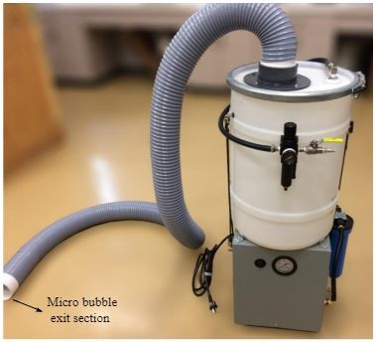
Figure 4: Cylindrical Design

Existing Design #2: Boxed design with small feet
This design uses the boxed design that the client is requesting. It has a screen to navigate the settings which is one design feature that the client has listed. It also has three distinct labeled plug ins for the different fluids which satisfies the easy-to-use settings as well as using separate tanks for them which allows for easily replaceable fluids.
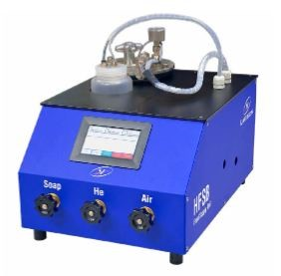
Figure 5: Existing Design Number Two

Existing Design #3: Descriptive Title
This design has most of the specifications that the client has requested. It has a relatively small design which means it is easily able to move around easily in small spaces such as the client’s lab. It also has “easy to change settings” which is a plus since it only has a few knobs and dials. As well as it has an easy access side door which means the nozzles can be changed out, which is a big requirement that the client wants as the nozzle diameter needs to be easily adjustable.
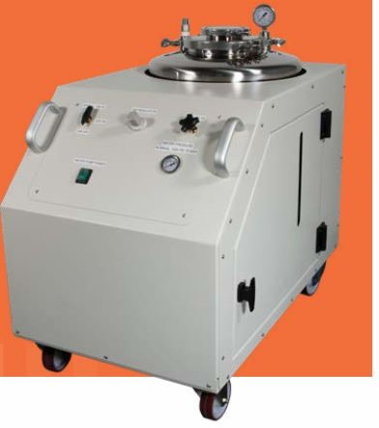
Figure 6: Existing Design Number Three

Subsystem Level Benchmarking
This section of the report will be used to talk about the subsystem level of existing designs for the microscale bubble generator.

Subsystem #1: Nozzle Structure
This section will be used to talk about the existing nozzle structures that have been used or theorized that have relevant specifications that are like those that the client has requested.

Existing Design #1: 3D Printed Coaxial Nozzle
This Nozzle is a 3D printed coaxial nozzle that uses the inner hole for helium, the second opening for air/bubble fluid solution (BFS), and the last bigger opening for air/BFS. This is relevant since the client mentioned that this type of nozzle would most likely be the one the team would use. However, the client also mentioned that the team’s nozzle would have to be even smaller since this design does not meet the bubble diameter requirement.
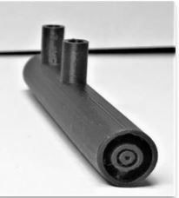
Figure 7: 3D Printed Coaxial Nozzle

Existing Design #2: Interlocking Coaxial Nozzle
This nozzle design is one that has a smaller chamber for the air to circulate through rather than feeding all the way through the nozzle. The nozzle has a way for the bubble fluid solution to get mixed with air and helium to create the bubble which is why the team considered this design. However, the client said this nozzle does not have an adjustable nozzle so the team would have to be careful if this was a nozzle they wanted to consider.
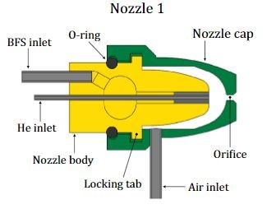
Figure 8: Interlocking Nozzle with Air Chamber

Existing Design #3: 3-Layer Coaxial Nozzle
This nozzle was recommended by the client in that it is coaxial, meaning the air, BFS, and helium all travel in a tube rather than sitting in a chamber. The inner opening again, being used for helium, the outer two openings would be used for air and BFS. The air and BFS would mix, and the helium would push through the mixture to create the bubble. This design meets requirements since it is the right size, however, it is not adjustable, so the team had to take that into account when going into the concept generation.
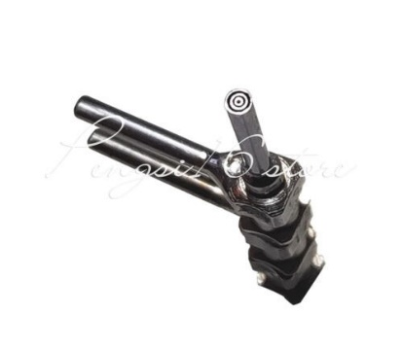
Figure 9: 3-Layer Coaxial Nozzle

Subsystem #2: Casing Structure
This section will be used to talk about the existing casing structures of microscale bubble generators.

Existing Design #1: Cylindrical Casing
As seen in Figure 4, this design uses a cylindrical barrel as the main storage of all the fluids that will be used. This meets the requirements since it is relatively small and easy to move around or fit into a smaller space. However, the client is requesting a machine that has the bubbles directly pumped out through the nozzle to the object that is being analyzed so this machine is not quite what the team is looking for.

Existing Design #2: Box Casing with Feet
This design (Figure 5) uses the boxed design that the client is requesting. It has a screen to navigate the settings which is one design feature that the client has listed. It also has three distinct labeled plug ins for the different fluids which satisfies the easy-to-use settings as well as using separate tanks for them which allows for easily replaceable fluids.

Existing Design #3: Box Casing with Wheels
This machine (Figure 6) is similar to the requirements that the client requested. The machine is small so it would fit in smaller spaces or be easier to be moved around. It also meets the requirement of bubbles being directly pumped through the nozzle to the object being analyzed. Additionally, this machine has everything incorporated into it.

Subsystem #3: Type of Bubble Flow
This subsection is about the type of bubble flow that can be made from the nozzle that other teams have created. The type of bubble flow is important because it determines how spaced out the bubbles are coming out of the nozzle as well as how they are grouped.

Existing Design #1: Monodisperse Bubbling
This is a type of bubble dispersion that has the bubbles coming out slower with slightly more spacing between each bubble. The bubbles tend to stay in a straight line. This relates to the team’s requirements since it would allow for bubbles at a high density.
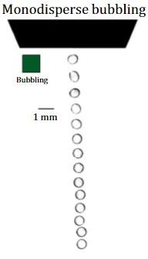
Figure 10: Flow Visualization of Monodisperse Bubbling

Existing Design #2: Monodisperse Jetting
Monodisperse jetting is similar to monodisperse bubbling, however the bubbles tend to separate towards the end of the stream. This would be relevant to the team’s project since it would allow for the bubbles to disperse around an object that is being analyzed.
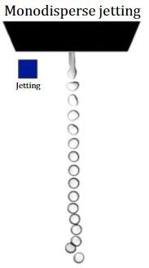
Figure 11: Flow Visualization of Monodisperse Jetting

Existing Design #3: Polydisperse Jetting
Polydisperse jetting is again like monodisperse jetting, but the bubbles are more spaced out and not a uniform line. This would be relevant for the project since it would allow for a wider view of the bubbles going around the object that is being analyzed.
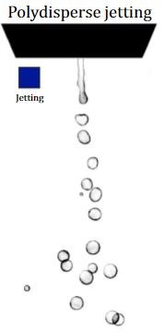
Figure 12: Flow Visualization of Polydisperse Jetting

CONCEPT GENERATION
This section of the report will be used to discuss the concepts that the team produced to present to the client after benchmarking and brainstorming. It will detail the subsystems as well as the full system. For the subsystems we will go over the nozzle structure, casing structure (what the device will look like on the outside), and the bubble flow output form the nozzles. While the Full System Design and the Subsystem of casing structure look alike, the Subsystem will mainly focus on the material used and the Full System Design will focus on the shape of the design.

Full System Concepts
As previously mentioned above, the Full System Concepts will focus on the shape of the design that we produced after discussing the benchmarking and brainstorming ideas that could possibly help us accomplish the customer and engineering requirements.

Full System Design #1: Boxed Casing
This first design (Figure 16), while remarkably like already existing devices, will be built with the hopes of being lightweight, this will allow for ease of mobility and enough interior space for all electrical circuits and storage space. The design, since it will have to have all tanks connected from the outside, will allow to connect multiple tanks and compressors as needed, for example, if we wanted to make an experiment that will take hours to run test, we could connect multiple helium tanks at once to not have to stop the test while we connect a new helium tank.

Full System Design #2: Bubble Bazooka
Figure 17 shows a sketch for this design which was inspired based on a Bazooka Bead Blaster. This design will allow for the device to have legs to support it and keep it in place without rolling in any direction, it will have a set of handles that will allow for a person to easily carry the device around. The compactness of de design will allow to have the compressor, helium tank, and BSF connected from the outside which will benefit the team in designing a device that it is lightweight with the possibility of having a small storage place for additional material that will fit in it.

Full System Design #3: Retractable Hose Dispenser
The design on Figure 18 includes the bubble soap formula on the casing design, this allows to include a pump to pressurize the soap formula with compressed air allowing for a higher production of helium-filled bubbles exiting the nozzles. The idea of having a retractable and extendable hose and attaching the nozzles at the end of it, will allow the nozzles to disperse the bubbles with an atomizer flow, which is what the client is looking for. Some questions that we encountered while discussing this design were “will the casing have enough space to store the hose?”, “How long will the hose be able to extend?”, and “Will we have to hold the extended hose, or will it be attached in a hole of a wall that will have access inside the wind tunnel?”

Subsystem Concepts
The main subsystems for which we developed concepts are nozzle structure, casing structure, and type of bubble flow. These concepts were the main parts for the full system design, we used a decision matrix for which we took into consideration ER’s, CR’s and benchmarking to determine and evaluate which parts would be the main focus for design. Below we discuss the three subsystems that were evaluated. Each subsystem has three designs in which we discuss the design and list the pros and cons for each.

Subsystem #1: Nozzle Structure
The first subsystem and the one to be determined to be the most important, as it requires the most time and effort spent on, is the nozzle structure. The nozzle structure, as preferred by the client, must be able to create helium-filled bubbles ranging from 15-150 microns. The nozzles are expected to have an innermost diameter of 0.2-0.25 mm where the Helium will be traveling through and a middle diameter of approximately 0.3-0.4 mm in which the bubble soap formula will trap the helium inside to create the bubbles.

Design #1: Arrow Type Structure
This was the first design of an arrow shaped nozzle that the team came up with. Inside there would be a compartment for air and a compartment for the bubble fluid solution while the helium gets pushed through. The team thought this was an innovative idea because it was like a coaxial nozzle and would be easier to print than a coaxial nozzle. However, the client wanted a coaxial nozzle specifically, so the team revised it in further CAD models.
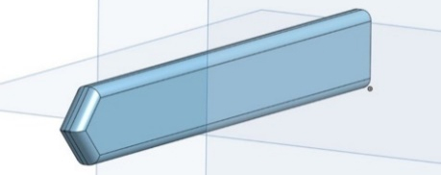
Figure 13: First Design of an Arrow Nozzle

Design #2: Arrow Type Nozzle Structure
This nozzle was designed to have one airway for air and another for the bubble fluid solution. The smaller hole in the middle of the nozzle would be used for the helium. This nozzle was designed to be interlocking with another piece going around it to make a compartment for the air and BFS solution however when it was presented to the client, he said that this design wouldn’t work since it is not coaxial.
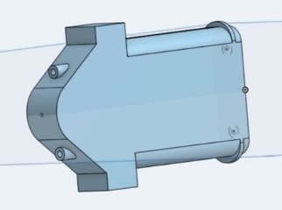
Figure 14: Revision One of the Arrow Nozzle

Design #3: Coaxial Nozzle
The coaxial nozzle is the client’s preferred design for the nozzle. This design allows the nozzle to automatically create the bubbles and fill them up with helium. Compared to the two earlier designs, it might be harder to 3D print because of the accuracy needed but it will be more effective in creating the bubbles. This nozzle allows for an atomizer bubble flow which will be discussed in more detail in section 4.2.3.3.
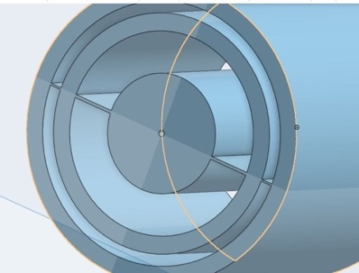
Figure 15: Coaxial Atomizer Nozzle

Subsystem #2: Casing structure

Design #1: Box Casing
Some difficulties this design might present when developing it are that this design will be out of budget because of the material we plan to use is either steel or aluminum. Another problem that might arise from this material is that since it is metal, we will not have many opportunities of correcting mistakes when it comes to assembling and shaping the metal to look like the design. The advantages of the material of this design are that if we either choose aluminum or steel, then the structural integrity will be sturdier, easier to shape with one of our member’s welding skills and will be able to last longer if properly maintained.
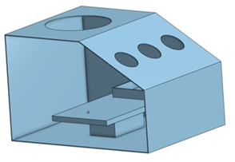
Figure 16: Boxed Design

Design #2: Bubble Bazooka
The bubble bazooka is planned to be made of a recycled tank whose material is steel or plastic, both with the hope of being found in undamaged shape. The advantages of having steel would be that it would be sturdier than plastic but if the tank is recycled, then it would come with corrosion. If the tank found were to be made of plastic, then the advantage would be that it could be more preserved than that of steel, but the disadvantage of having plastic is that we would not really be eco-friendly when welding plastic into the desire shape, which is one of the customer requirements for this project.
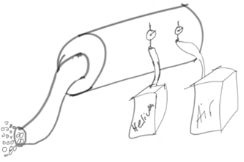
Figure 17: Bubble Bazooka Design

Design #3: Retractable Hose Dispenser
Figure 18 shows the design for a retractable hose dispenser, the box casing will be like in material to design #1. The material for the retractable hose will be made of a recycled plastic or water hose that anyone in our team might be able to obtain. An advantage of using this material would be that it can easily be rolled up and stored inside the casing. A disadvantage of using this material would be that if we wanted to use a hose, then it would be hard to find one long enough in good condition to recycle.
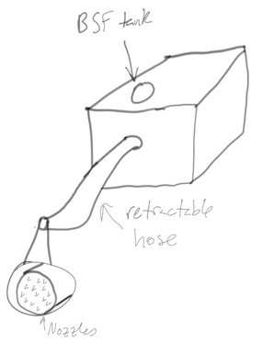
Figure 18: Retractable Hose Dispenser

Subsystem #3: Type of Bubble flow

Design #1: Monodispersed Bubbling
The monodispersed bubbling is not a concept the team produced but rather a flow we all thought would be common as we read articles provided by the client, our knowledge, and our own research. This type of bubbling flow would be affected by the air pressure coming out of the nozzle which could cause bubbles to come out closer to each other or further apart.
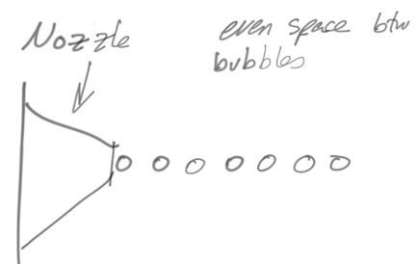
Figure 19: Monodispersed Bubbling Nozzle

Design #2: Polydisperse Jetting
The polydisperse jetting is an already existing concept and like design #1 of this section. The main difference between the monodispersed bubbling and polydisperse jetting is that the jetting will produce more bubbles at a higher rate and density than the monodispersed bubbling. Some disadvantages that will present with this method are that the bubbles will have a higher range in diameter which could cause the bubbles to exceed the desired diameter for the bubbles.

Design #3: Atomizer
The atomizer is the preferred bubble flow from the client. This bubble flow allows for the bubbles to be dispersed through an area instead of only having a direct flow like the earlier designs discussed above. A problem we might encounter when designing this method of flow will be the accuracy of the interior design that will allow to have this flow. If we base our device on the prototype sketch of section 4.2.2.3: Retractable Hose Dispenser, then we could accomplish one of the customer requirements which consist of having a 3-layer coaxial atomizer nozzle and would exit directly into the area in which this device would be used to make aerodynamic studies inside a wind turbine.
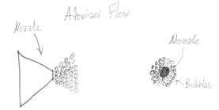
Figure 20: Atomizer Nozzle Sketch

DESIGN SELECTED – First Semester

Design Description
The team’s current prototype is a resin 3D printed nozzle that is coaxial with three different layers. The outermost layer being for the air, the second layer for the bubble fluid solution and the smallest inner layer being or the helium. These three layers all converge in an end cap that mixes the fluids together and the helium pushes through and creates the bubble from the mixture. The team is currently working on a newer prototype as they received a brass version of the nozzle. The team was tasked with making the third layer to it since it is just a two-layer nozzle. This new nozzle is made of brass and the third layer will be made of aluminum so that the nozzle overall should be able to last a long time. The team’s first design and current design can be shown in Figures 21 and 23-25. Another major idea that has changed from the team’s initial prototype and the final design they are working to now is the overall size. They learned that to get the nozzle diameter they wanted it would be complicated to print since it was so small. The client saw this and ordered a coaxial nozzle online. This was going to change a few things for the team since now they have a whole new nozzle to work with towards the end of the semester.
The team had also started looking at which formulas they would need to use for future analysis since to this point the team has not had to do calculations for the prototype. The team found equations of interest through the sources that the client gave to the team. Below is equation 1 which is the equation of motion for a particle. This equation will help the team determine what needs to be done to figure out how to get a good particle spacing so that it can be analyzed. Additionally, equation 2 will be used to help decide the velocity of the output of the particles.
$m\frac{du_{p}}{dt}=\frac{πd^{3}}{6}ρ_{p}g-\frac{πd^{3}}{6}ρ_{f}g-3πμd\left(u_{p}-u_{f}\right)$---------- [1]
$u_{t}=u_{p}-u_{f}=\frac{\left(∆tρ_{p}-ρ_{f}\right)d^{2}g}{18μ}$-------- [2]
Continuing, the team has made a nozzle design using onshape and was working on the updated version of the nozzle since they received the new nozzle the client would like to be using. Refer to Appendix B.1-B.3 and Figures 24 and 25 to see the nozzle drawings and current CAD models. Pictured below is the first design nozzle the team had prototyped.
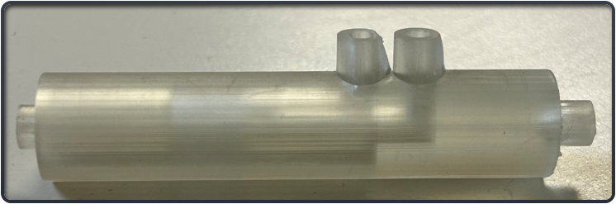
Figure 21: 3D Resin Printed Nozzle

Implementation Plan
The current nozzle detailed in section 5.1 of this report will be the final design so the team can start working on the rest of the device. The team plans on getting the third layer manufactured in house at the NAU machine shop. One of the team members is planning on getting certified so that he can hopefully use the machines to make the design in order for the team to save some money. The team member has background knowledge in CNC machining as well as a general knowledge of how to use the other machines such as a mill and lathe however he is going to try and make his parts easy to CNC since he has a lot of experience in that. The team currently has a relatively small bill of materials as seen in Table 2, and there are a few things they are going to buy or already bought as well as the client has provided some of the bill of materials such as the high-speed camera and air compressor which saves the team twenty thousand dollars or more.
The team member will additionally be refreshing himself on how to CAM a part which is taking a CAD assembly or part and importing it to another program to convert it to gcode which is what CNC machines read to produce a part. Finally, he will be making sure that he can create readable part drawings that may need to be manufactured by his peers in the machine shop for time efficiency however he plans to try and do most of it himself.
For the second semester, the team would be able to move on to the rest of the device. The nozzle is the most important part so with that design finalized the team will be able to continue. For the first month of the second semester, the team will be expected to design the outer casing of the device. They will then move on to the electronics after they have finished that since they will have a representation of the amount of space, they will be able to work in.
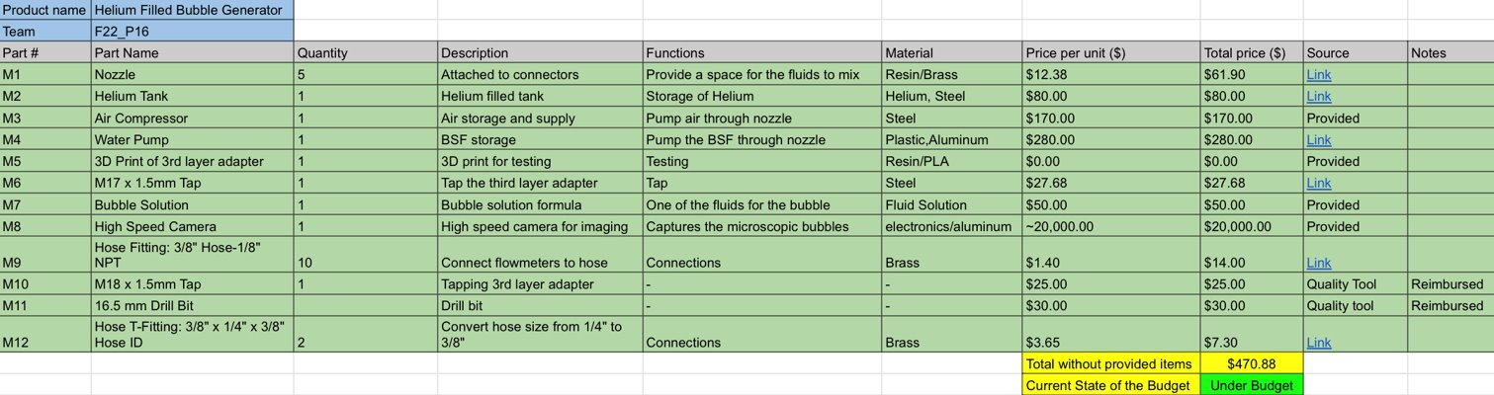
Table 2: Bill of Materials

Project Management – Second Semester

Gantt Chart
Table 3 provides a summary list of tasks which needed to be done during this semester. Throughout the semester, the team had to provide status updates to Dr. Willy, 1/3rd build, 2/3^{rds} build, and 100% build. These status updates mainly consisted in showing progress with the manufacturing plan, purchasing plan, and assembly. In the Gantt chart, the team also included some additional tasks such as the design of the 3rd layer adaptor, machine shop work order, testing set up, nozzle testing, and class assignments such as this report. The team also decided to include the deadlines for the symposium as they are important for the project’s demonstration on completion. Throughout the semester, the team has been using the same format for the Gantt chart and has only been including additional assignments and tasks that had to be done as new assignments and tasks came up.
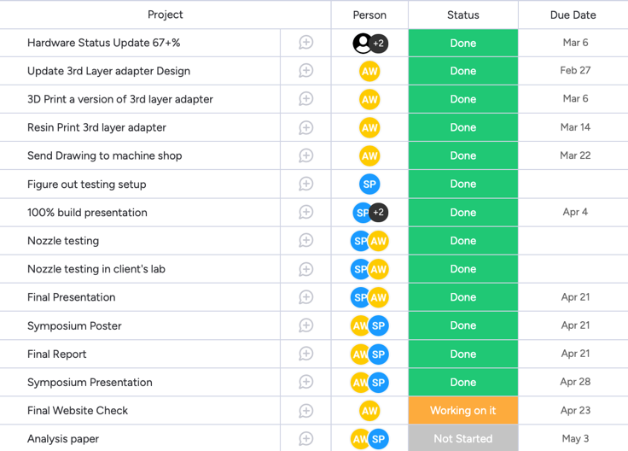
Table 3: Gantt Chart

Purchasing Plan
For the purchasing plan, the team listed all the materials shown in the BOM with how much each idem costed per unit, how many units were purchased, the total price, where was it purchased, and whether the item had been purchased or not. M1 is the 2-layer coaxial nozzle that was provided by the client, M2 is the Helium tank that will be used by the client during actual experiments done in his lab, M3 is the air compressor which is used to connect at one end of the 3-layer coaxial nozzle, M4 is the “water pump” or automatic syringe that is used to store and transfer the bubble soap formula into the nozzle, M5 is the aluminum bar provided by the client to manufacture the 3rd layer adaptor that screws into the 2-layer coaxial nozzle. M6, M10, and M11 are special drill bits and Taps used to make the threads and holes on the 3rd layer adaptor. M9 and M12 are hose fittings used to connect the hoses with the air compressor, water pump, and nozzle. M7 and M8 are the bubble soap formula and the high-speed camera respectively, these two items were provided by the client. M7 is a fluid solution that the client and his lab assistants have been working on in order to replace the commercial bubble soap formula since replicating the bubble formula will greatly decrease expenses.
This current purchasing plan differs from the one the team created at the beginning of the semester in such a way that it shows materials that the team and the client were not expecting to purchase. For example, items M6, M10, and M11, the team thought that the machine shop would provide those type of taps and the drill bit, but because they are special sizes the team had to find a way in which to purchase them and deliver quickly in order to not fall behind any more than what we were already.
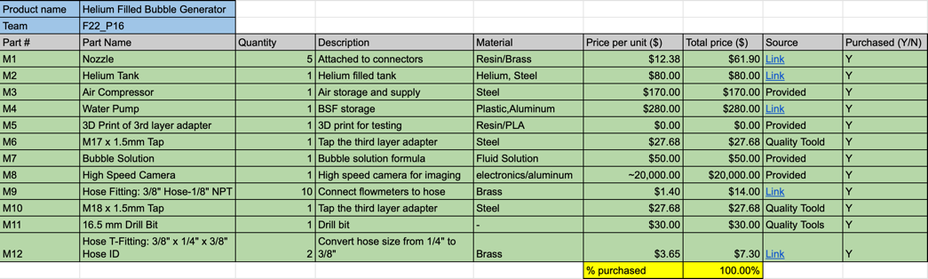
Table 4: Purchasing Plan

Manufacturing Plan
Table 5 demonstrates a list of parts that needed to be manufactured this semester. This list mainly consists of the manufacturing of the 3rd layer adaptor using an aluminum bar and the 3D printed prototype of the nozzle for initial prototype designs. The 3rd layer adaptor design made of aluminum was sent to the machine shop in order for them to accurately manufacture the design. At the beginning of the semester, the team thought that the manufacturing plan should include the assembly and parts of the assembly, but thanks to the guidance of Dr. Willy, we realized that we only needed to include a list of materials that needed to be manufactured by. The team and not parts that were brought “off the shelf”.
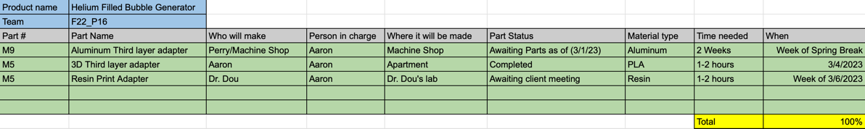
Table 5: Manufacturing Plan

Bonus/Substitution Sections

Flow Rate Ranges and Bubble Characteristics
Throughout this semester the team was tasked with analyzing how much input flow the nozzle would need to have a steady production of bubbles. For this analysis, the team research how to create neutrally buoyant bubbles using the bubble soap formula, helium, and air. According to Faleiros et al. [11] the team would need to find an equivalence balance between the density of helium and the bubble soap formula with that of air.

MATLAB
For some of the analysis the team used MATLAB by importing the video and analyzing the frames of the video and tracking the particles over a time interval. This was used to help find the bubble output rate and the diameter of the bubbles. Both of these are engineering requirements, and this was how the team decided to analyze them. The code and pictures of results can be seen in Appendix A1 and A2

Major Changes Applied during Second Semester and Justifications
As mentioned in section 5.1, the team originally thought of making a nozzle design made of 3D printed resin (Figure 21), but due to some complications with the 3rd layer, as it had to include an exit hole of 0.3 millimeters, the client proposed on buying a 2-layer coaxial nozzle and then design a 3rd layer adaptor that would screw into the nozzle. The 3rd layer adaptor was made of aluminum, as seen in Figure 25, this adaptor included an exit hole of 0.5 millimeters and not 0.3 millimeters as the team did not have enough funds to EDM wire a hole that small. To create the 0.5-millimeter hole, the machine shop tap-drilled the hole using a 0.5-millimeter drill bit bought from Harbor Freight. Everybody had doubts that this method would work as the drill bit was of low quality, and thanks to the ability of some members of the machine shop, they successfully drilled the hole.

Final Hardware

Final Hardware Images and Descriptions
Figure 22 is a diagram of the testing setup that the team used to validate their design.
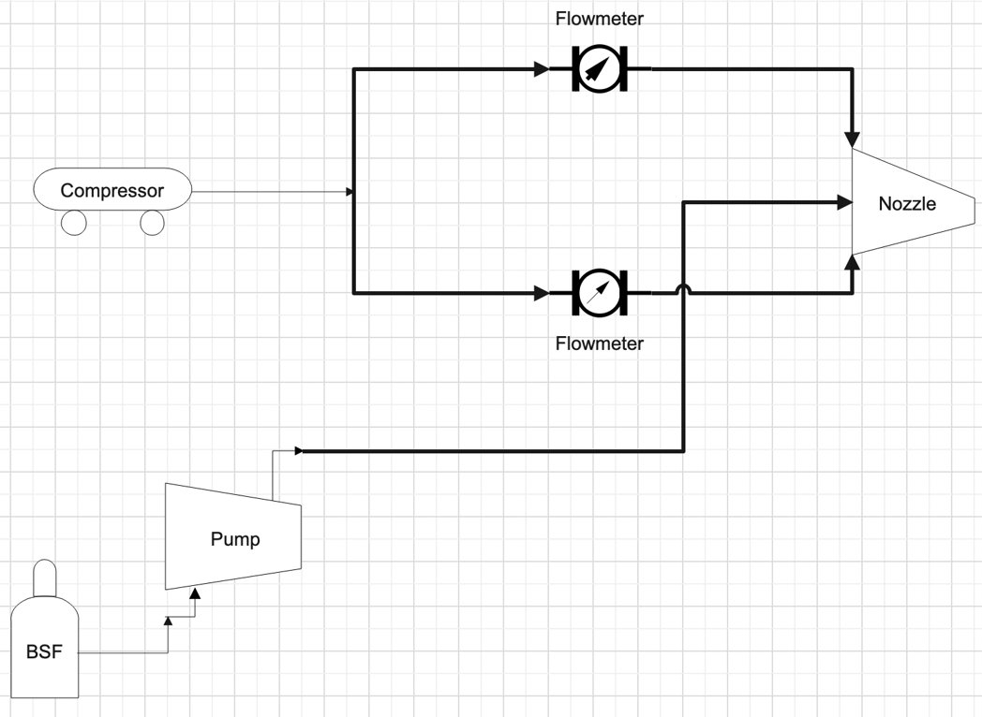
Figure 22: Schematic Diagram
Figure 23 is a representation of the full design in SolidWorks.
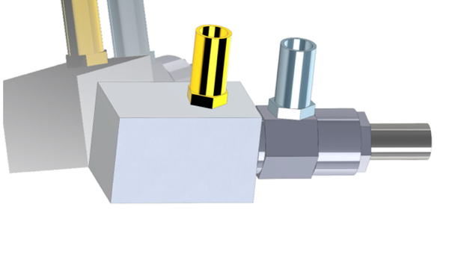
Figure 23: Full CAD design

Design Changes in Second Semester
The main change that was made after the first semester of the project was the shift from resin printing to a brass and aluminum nozzle. This was done since the resin print was not able to have the small outlet line cleared of material.

Design Iteration 1: Change in Third-Layer Adapter Discussion
The original design overall was a whole nozzle however, the client was not able to print the design so with the team moving towards an initial nozzle that was made of brass and that was purchased then the team designed a third-layer adapter so that there would be the desired number of inputs. Below in figure 24 and 25 the new design and full nozzle can be seen.
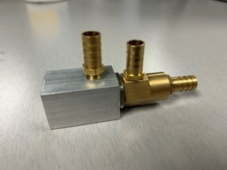
Figure 24: Full Nozzle
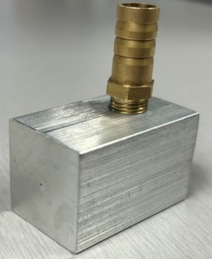
Figure 25: Team’s solution to the third layer

Challenges Bested
The main challenge that the team faced in ensuring that they would be 100% built was the manufacturing side of the process. This was the main challenge since this design needed to have a 0.5-millimeter hole cut through aluminum. This was done thanks to Claude from Quality Tool in Flagstaff since he had the tools that were needed. Other than the micro hole there were not many challenges in the manufacturing. However, there was another problem that was faced in the design aspect and that was the initial design sent to the machine shop was slightly too big for the client, so a team member remade it quickly and sent it back to the shop.
Another challenge that arose during this project was that helium is fairly expensive to buy just for testing. To get around this the client just suggested that the team use air for both of the nozzle inputs alongside the bubble solution. This provided the team with a way to test their device at a much cheaper rate since they would not have to be using the helium.

Testing

Testing Plan
The experimental details of the testing plan are described below, each experiment was determined by associating the current Customer and Engineering Requirements. Table 6 shows some of the results obtained from testing and Table 7 shows whether the team met the customer requirements design at the beginning out first semester.

Ex1-Bubble Output Rate Test
During this test, the goal is to be able to measure the number of bubbles that had been generated by the 3-layer coaxial nozzle, we need to be able to generate 10,000,000 bubbles/s. To be able to perform this test and any other test, the team will need to first have finished the 3rd layer of the nozzle, which is currently at the Machine Shop. Another equipment needed to perform this test is the Phantom v7.3 camera which has been provided by the client and the wind tunnel. Below is a list of steps needed to perform the test:
- Connect compressor, Pump, and Helium tank to nozzle.
- Open Valves to start generating bubbles.
- Set Phantom camera to record the generated bubbles.
- Use MATLAB code to
The main variables that need to be calculated from these results are the bubble diameters and bubble concentrations.

Ex2-Bubble Concentration Test
During this test, the goal is to be able to measure the number of bubbles that had been generated by the 3-layer coaxial nozzle, we need to be able to generate 20,000 bubbles/cm³. To perform this test, we will need the 3-layer coaxial nozzle, Phantom camera, and wind tunnel. Below is a list of steps needed to perform the test:
- Connect compressor, Pump, and Helium tank to nozzle.
- Open Valves to start generating bubbles.
- Set Phantom camera to record the generated bubbles.
- Use MATLAB code depth perception included.
The main variables that need to be calculated from these results are the bubble diameters and bubble concentrations as well as the type of bubble stream the team is achieving.

Ex3-Device Run Time Test
During this test, the goal is to be able to generate bubbles non-stop for at least 30 minutes. To perform this test, we will need the 3-layer coaxial nozzle, stopwatch, and wind tunnel. Below is a list of steps needed to perform the test:
- Connect compressor, Pump, and Helium tank to nozzle.
- Open Valves to start generating bubbles.
- Start stopwatch as soon as bubbles are being generated.
The main variables that need to be calculated from these results are the length of time the machine can run as well as the durability of the machine.

Ex4-Bubble Diameter Test
During this test, the goal is to be able to measure the diameter of the bubbles that had been generated by the 3-layer coaxial nozzle. The team needs to be able to generate bubbles with diameters that range between 15-150 microns. To perform this test, we will need the 3-layer coaxial nozzle, Phantom camera, and wind tunnel. Below is a list of steps needed to perform the test:
- Connect compressor, Pump, and Helium tank to nozzle.
- Open Valves to start generating bubbles.
- Set Phantom camera to record the generated bubbles.
- Use MATLAB code depth perception included.
The main variables that need to be calculated from these results are the bubble diameters and bubble concentrations and the type of bubble stream.

Testing Results
After testing was done specification sheets were collected from the results. The specification sheets below show whether the ERs/CRs of the project were met or not. Table # also shows the targets and measured values for each ER. The ER for bubble output was not met, however the bubble output for the ER and CR were client acceptable. This was the only Engineering requirement that the measured value did not meet the target value within the tolerance.
Engineering Req (ER) | Target | Tolerance | Measure/Calc  Value | ER Met?  (Y/N) | Client Acceptable? (Y/N)
ER1-Bubble Output | 3^6 | + 3^3 | 3.6*10^5 | Y | Y
ER2-Bubble Density | 20000 /cm^3 | + 100 / cm^3 | 5000 | N | Y
ER3-Residence  Time | 30 minutes | + 2-3 minutes | 35 minutes | Y | Y
ER4-Material | ⁻ | ⁻ | ⁻ | - | -
ER5-Bubble Size | 15-150  Microns | + 20 microns | 50-300 microns | Y | Y
Table 6: Specification Sheet Engineering Requirements
Customer Requirement | Description | Cr Met? (Y/N) | Client Acceptable? (Y/N)
CR1 | Bubble output | N | Y
CR2 | Bubble Concentration | N | Y
CR3 | Device residence | Y | Y
CR4 | Device material | Y | Y
CR5 | Bubble size | Y | Y
CR6 | User friendly | Y | Y
CR7 | Durability | Y | Y
CR8 | Reliability | Y | Y
Table 7: Specification Sheet Customer Requirements

RISK ANALYSIS AND MITIGATION
This section discusses the potential failures and ways the team came up with to mitigate those potential failures. Last semester, the team was tasked to complete the FMAE excel template. For the FMAE, the team had to come up with a minimum of four critical subsystems to then figure out ten potential failures later for each subsystem. The excel sheet also provides a summary of the FMEA (Appendix C.1) in which it has been shortened to ten of the highest RPN values for the team’s project.

Potential Failures Identified First Semester

Potential Critical Failure 1: Thermal Fatigue
The first potential failure is thermal fatigue from the connection of all electrical components, this can be caused by overloading the supply power into the air compressor and water pump. Thermal fatigue may cause a fire or power outage on the power supply or devices. This problem can be fixed by making sure that the total amount of electricity coming out of the power supply is not consumed completely from the air compressor and the water pump.

Potential Critical Failure 2: Stress Rupture
The second potential failure is stress rupture from the nozzle, this can be caused by having a high output pressure coming out of the air compressor, water pump, and helium tank. Stress rupture can cause a destruction of the nozzle which affects the bubble output rate and the size of the bubbles. To avoid stress rupture on the nozzle the team plan on using valves that control the pressure going into the nozzles.

Potential Critical Failure 3: Corrosion Wear
The third potential failure is corrosion wear on the aluminum sheets that we plan on using for the device. Corrosion wear can happen with any leaks from the BSF, if this were to happen then the aluminum sheet will start to wear down until eventually it will need to be replaced. To avoid this potential failure, the team will need to secure all connections where the BSF will be passing through.

Potential Critical Failure 4: Combined Creep and Fatigue
The fourth potential failure is combined creep and fatigue on the helium tank. This potential failure can happen by overstressing the helium tank and not providing proper care to the tank (this will be noticeable over time). Combined creep and fatigue can cause the helium tank to explode or leak through cracks that have appeared over time. To avoid this potential failure, the team and the lab team will need to take proper precautions when handling the helium tank and providing proper maintenance overtime.

Potential Critical Failure 5: Combined Creep and Fatigue
The fifth potential failure is combined creep and fatigue on the air compressor. This potential failure can only happen if the pressure regulator on the compressor is broken or the storage for the compressed air is dropped. Combined creep and fatigue can cause the air compressor to explode or leak through cracks that have appeared over time. To avoid this potential failure, the team and the lab team will need to take proper precautions when handling the air compressor and providing proper maintenance overtime.

Potential Critical Failure 6: Combined Creep and Fatigue
The sixth potential failure is combined creep and fatigue on the regulators or valves, like potential failures four and five. This potential failure can occur when the valves are overstressed by the pressure of air, helium, and BSF. If a failure were to happen in the valves, the air, helium, and BSF would leak out making a disaster inside the device which could potentially lead to more failures. To avoid this potential failure, the team and the lab team will have to obtain valves that can withstand the maximum pressure obtained from the compressor, helium tank, and water pump that will pressurize the BSF.

Potential Critical Failure 7: Corrosion Wear & Combined Creep and Fatigue
The seventh potential failure is corrosion wear & combined creep and fatigue for the water pump. It was determined that for the water pump it could have combined creep and fatigue since it will be pressurizing the BSF and in case there is a problem and the water pump breaks and spills all over the device, then it could cause corrosion wear if it’s not properly cleaned. To avoid this potential problem, the team are expecting for the water pump to be made of a durable material, and in case it was to break, then the team plans on building a little removable tray that can be cleaned in case of spills and leaks.

Potential Critical Failure 8: Corrosion Wear
The eighth potential failure is corrosion wear for the exit hose. This potential failure can occur if the exit hose is not properly clean after using the device, this could cause the exit hose to deteriorate over time. To avoid this potential failure, the team has decided to find a hose that will have little to no corrosion over time (like a garden hose) and will be asking the lab team to properly clean the hose occasionally.

Potential Critical Failure 9: Combined Creep and Fatigue
The ninth potential failure is combined creep and fatigue for the hoses that will connect from the air compressor, helium tank, and BSF to the nozzles. This potential failure can occur if the hoses are not made of a material that can withstand such high pressures, if this failure were to occur then the device will not be able to create the helium-filled bubbles and could cause a spill all around and inside the device. To avoid this failure, the team will find a hose that withstands high pressures as well as properly securing the hoses to wherever they connect.

Potential Critical Failure 10: Corrosion Wear & Combined Creep and Fatigue
The tenth and last potential failure is corrosion wear & combined creep and fatigue for the connectors of the hoses. This potential failure can occur if the connectors are not strong enough to withstand the pressure forces to keep the hoses attached in place, if this failure were to occur, we would not be able to create bubbles as well as having a mess of spilled and leaked material. To avoid this failure the team has decided to find strong connectors such as those found in cars or add a series of “steps” into all 3D printed components.

Potential Failures Identified This Semester
A new failure that was found during the second semester of this project was the bubble solution. The team needed to figure out what solution could be used that wasn’t a commercial solution. The commercial solution was expensive and with the new solution it would be much cheaper. However, with the new solution the failure would be in the proper mixture.

Risk Mitigation
After discussing all the potential critical failures above, the team has determined that mitigating one failure will not negatively affect mitigating another critical failure, on the contrary, it will benefit other components as they will not be affected at all. In other words, we have determined that there is no trade-off between mitigating one failure with all other components.

LOOKING FORWARD

Future Testing Procedures
One of the tests that is currently still being worked on is the MATLAB analysis of the bubbles that were captured with the highspeed camera. This is still being worked on since the client wants to have a matrix of different solutions at different flow rates to compare all of the results between them to determine which to use in the future.

Future Iterations
A future iteration for this project that could be pushed to another capstone team would be the refinement of the MATLAB code that was produced for this project. This code involves particle imaging through MATLAB, and the team was able to get a good idea of the results however it could have been more refined to get more detailed results. The reason that this could be pushed forward is that the team did not have a long time to figure out the particle analysis in MATLAB however one team member was able to get the code working in a few days. But this part of the project could be seen almost as its own capstone project since the client was requesting this type of analysis be done with numerous different bubble solutions and all at different flow rates.

CONCLUSIONS
After measuring the testing results it was determined that the product design was capable of completely satisfying all design requirements to a point that the client accepted. This means that the goal of the project was accomplished. The product can do an acceptable bubble output rate. Also, the product made the bubble size from 50-300 microns, this shows that their goal for bubble diameter was completed in an acceptable range. The team also reached their goal that was stated at the beginning of Fall 2022 which was to successfully complete the project.

Reflection
The team applied numerous different design principles throughout the project like the black box model and the house of quality. These were not the most common throughout the project though. The team practiced a lot of design iterations to produce a quality product for a client. Along with the iterations they had to make sure that all of their parts in the CAD were made properly along with the drawings having proper tolerances and more.

Resource Wishlist
If the team were to do this project over again one main thing that would be requested would be a bigger budget since the team had to pay out of pocket for items that were needed, given they were reimbursed but that process took time. Additionally, a few more people added to the team would have been nice since the client requested a big workload for just a few people. This would also allow some team members to get a break to work on other classwork since most of their time was taken towards just trying to complete deliverables for the class. As well it seemed off that a group of three students was required to do the same quality of work and same amount of work as those with a group of nine or thirteen. This was a struggle for the team since they were always staying up late just to provide decent quality work.

Project Applicability
This project has improved the team’s skills in design and flow analysis which helps prepare them for the future if they are looking to go into an aerodynamic or biomedical field. But this is not the only application since there were many other challenges that were faced that would prepare the team for the real-world workplace. An example of this would be to take a list of requirements from a client and put them into an engineering requirement or a value that would be attainable. This prepares the team for the workforce in the future since they will most likely be working for a client and that client will request ideas and the team would need to come up with a way to bring those ideas to life.

REFERENCES
[1] Caridi, G. C. A. (2018). Development and Application of Helium-Filled Soap Bubbles: For Large-Scale PIV Experiments in Aerodynamics. https://doi.org/10.4233/uuid:effc65f6-34df-4eac-8ad9-3fdb22a294dc
[2] Barros, D.C., Duan, Y., Troolin, D.R. et al. Air-Filled Soap Bubbles for Volumetric Velocity Measurements. Exp Fluids 62, 36 (2021). https://doi.org/10.1007/s00348-021-03134-6
[3] S. Shibata, T. Yamazaki, and H. Matsuda, “Development of Micro Soap Bubble Generator for piv tracer using home stereolithography 3D printer,” 14th International Symposium on Particle Image Velocimetry, vol. 1, no. 1, 2021.
[4] F. Scarano, S. Ghaemi, G. C. Caridi, J. Bosbach, U. Dierksheide, and A. Sciacchitano, “On the use of helium-filled soap bubbles for large-scale tomographic PIV in wind tunnel experiments,” Experiments in Fluids, vol. 56, no. 2, 2015.
[5] J. I. Arrizubieta, I. Tabernero, J. E. Ruiz, A. Lamikiz, S. Martinez, and E. Ukar, “Continuous coaxial nozzle design for LMD based on numerical simulation,” Physics Procedia, vol. 56, pp. 429–438, 2014.
[6] G. M. Neunzert, "FLUID CHARACTERISTICS AND PRESSURE DROP IN A HIGH PRESSURE FOAM SYSTEM," ProQuest , vol. 1, no. 2, p. 71, 2018.
[7] Y. Kubo, "Bubble Clouds: 3D Display Composed of Soap Bubble Cluster," ACM, vol. 01, no. 2, p. 10, 2015.
[8] M. Raffel, "Applications: Volumetric Flow Measurements," Springer, vol. 2, no. 1, p. 632, 2018.
[9] M. Nakamura, G. Inaba, J. Tamaoki, K. Shiratori, and J. Hoshino, “Mounting and application of bubble display system: bubble cosmos,” Jun. 2006.
[10] Huhn, F., Schanz, D., Gesemann, S. et al. Large-scale volumetric flow measurement in a pure thermal plume by dense tracking of helium-filled soap bubbles. Exp Fluids 58, 116 (2017). https://doi.org/10.1007/s00348-017-2390-2
[11] David Engler Faleiros, Marthijn Tuinstra, Andrea Sciacchitano, and Fulvio Scarano. Generation and control of helium-filled soap bubbles for piv.ExperimentsinFluids, 60(3):40, 2019.

APPENDICES

Appendix A: MATLAB Code for Bubble Analysis
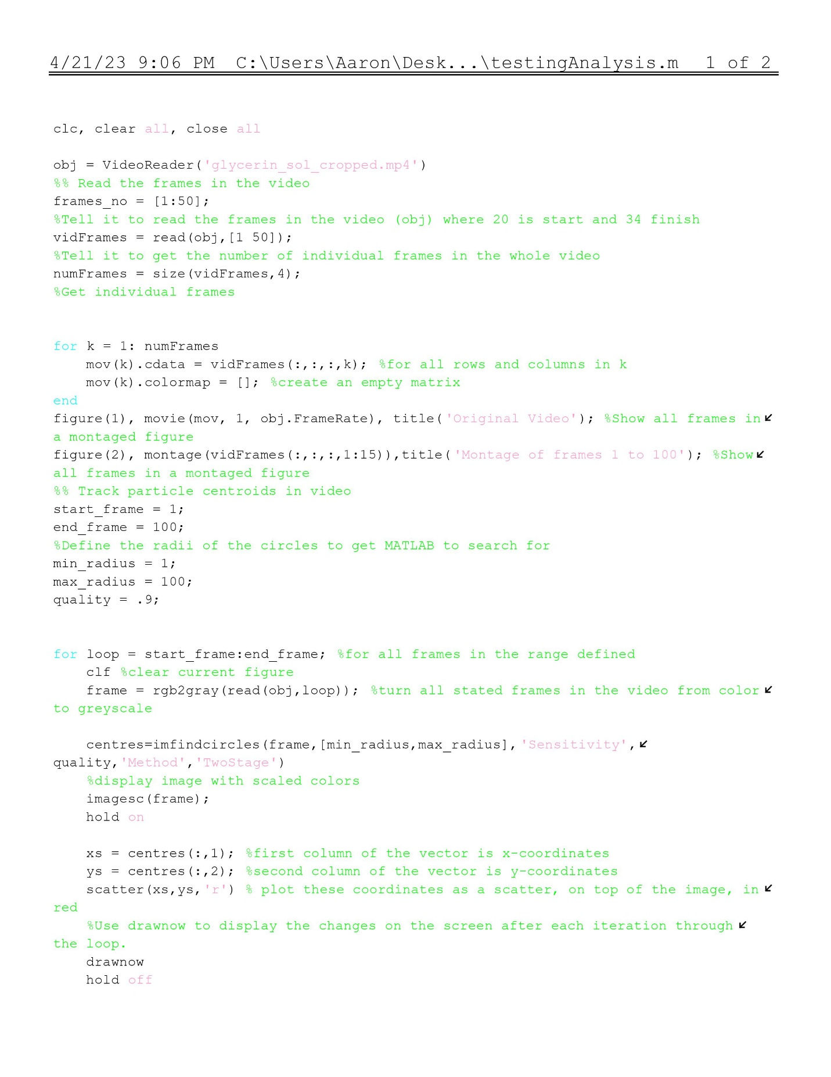
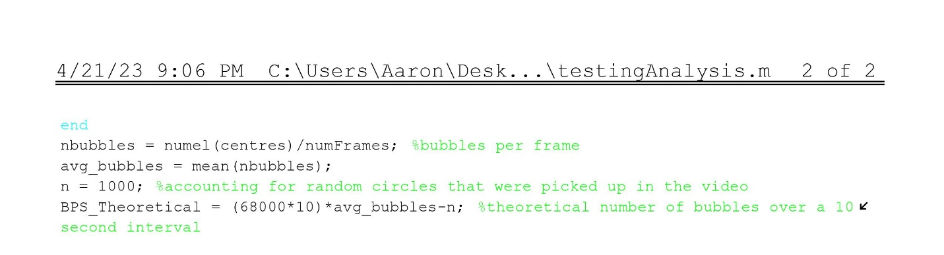

Appendix A2: Results from Code
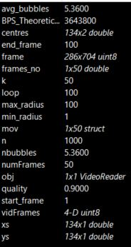

Appendix A3: Picture of bubble tracking
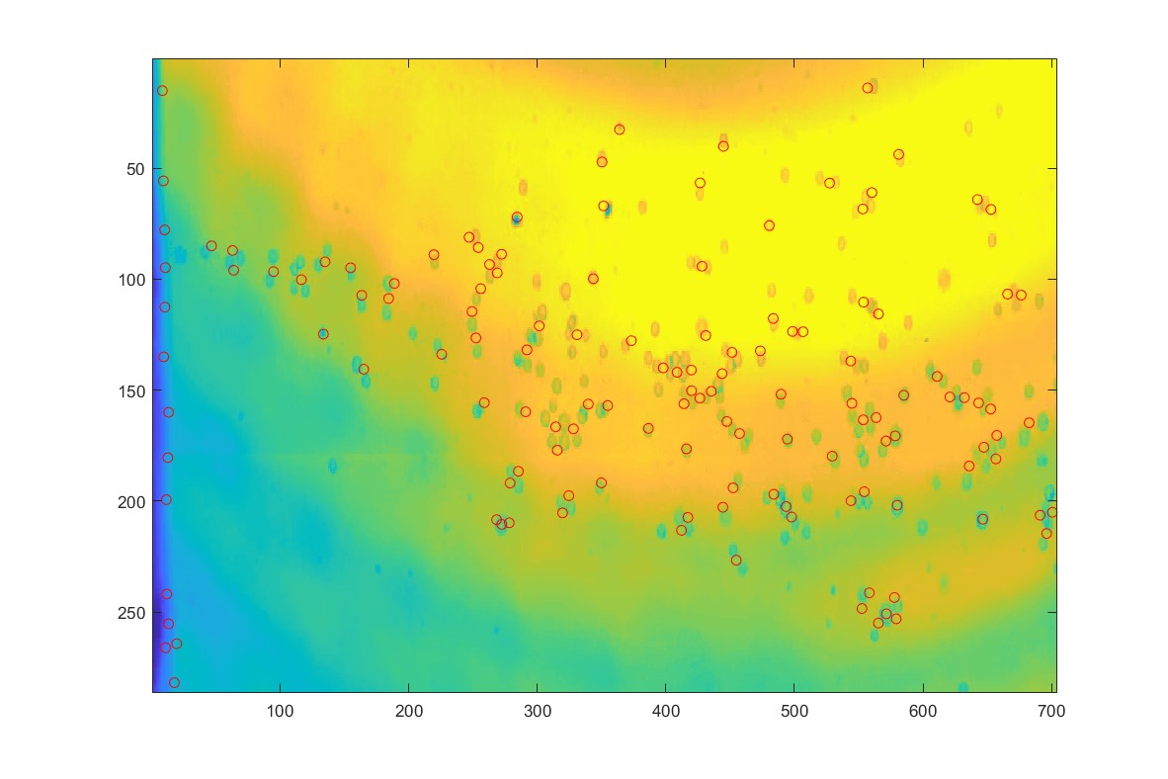

Appendix B.1: 3rd Layer Adaptor Drawing
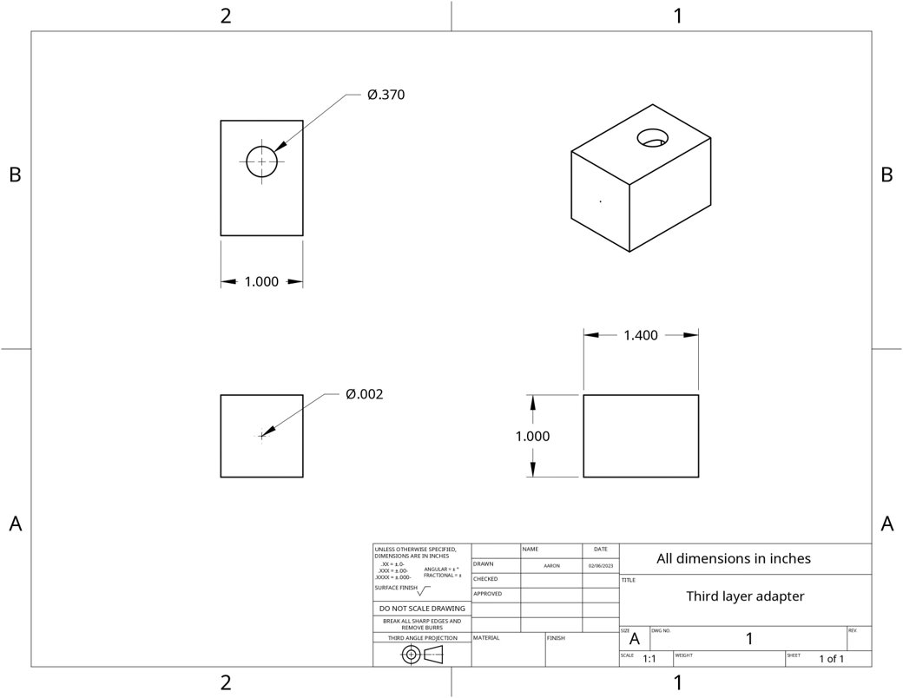

Appendix B.2: Brass Nozzle
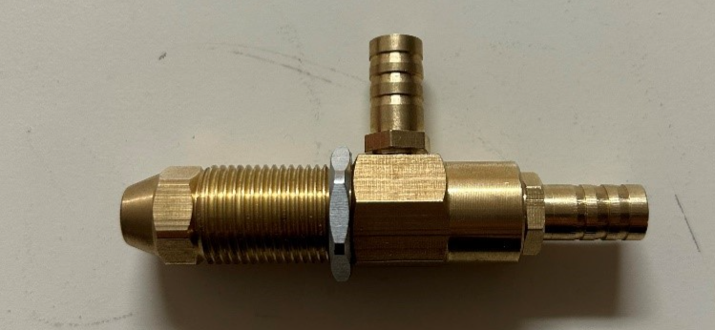

Appendix B.3: Exploded View of Brass Nozzle
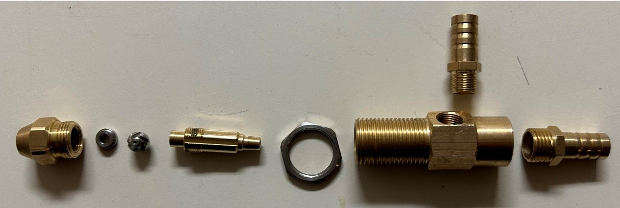

Appendix C.1: Shortened FMEA
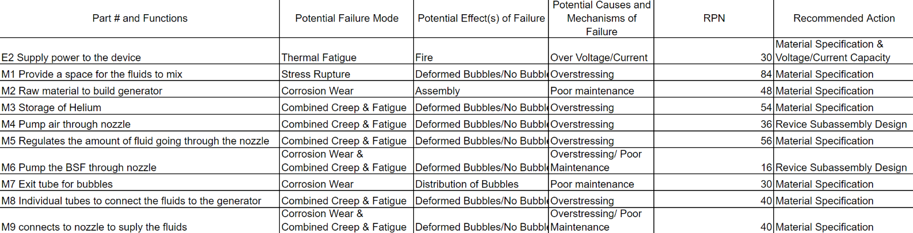

Appendix C.2: Full FMEA
