To: David Willy

From: CWC 3D Gen
+
Date: 09/17/2021

Re: Hardware Review 1

The purpose of this memo is to explain what the CWC 3D Gen team has completed for hardware one review. This includes photos of the current physical model, purchasing requests, manufacturing processes, and whether the team is on track for the next hardware review in week 10.

Concept

Figures 1, 2 and 3 showcase multiple angles of the generator design configured for hardware review one. The product shown shows the 3D printed parts created for the final design concept.

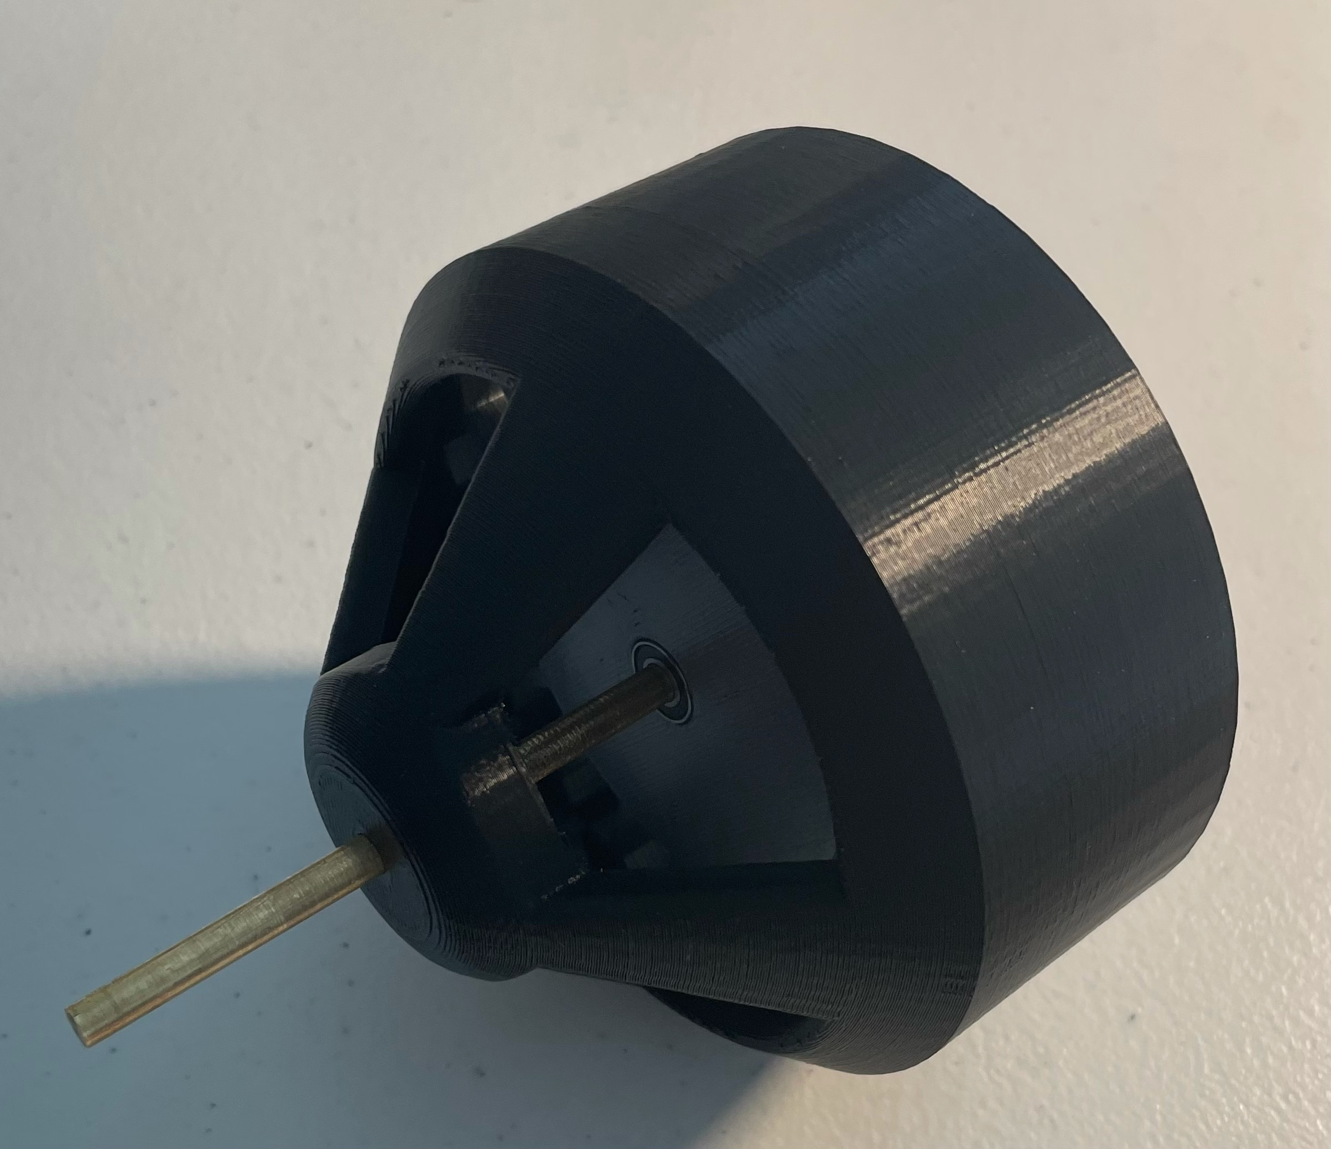
Figure 1: Final Motor Design

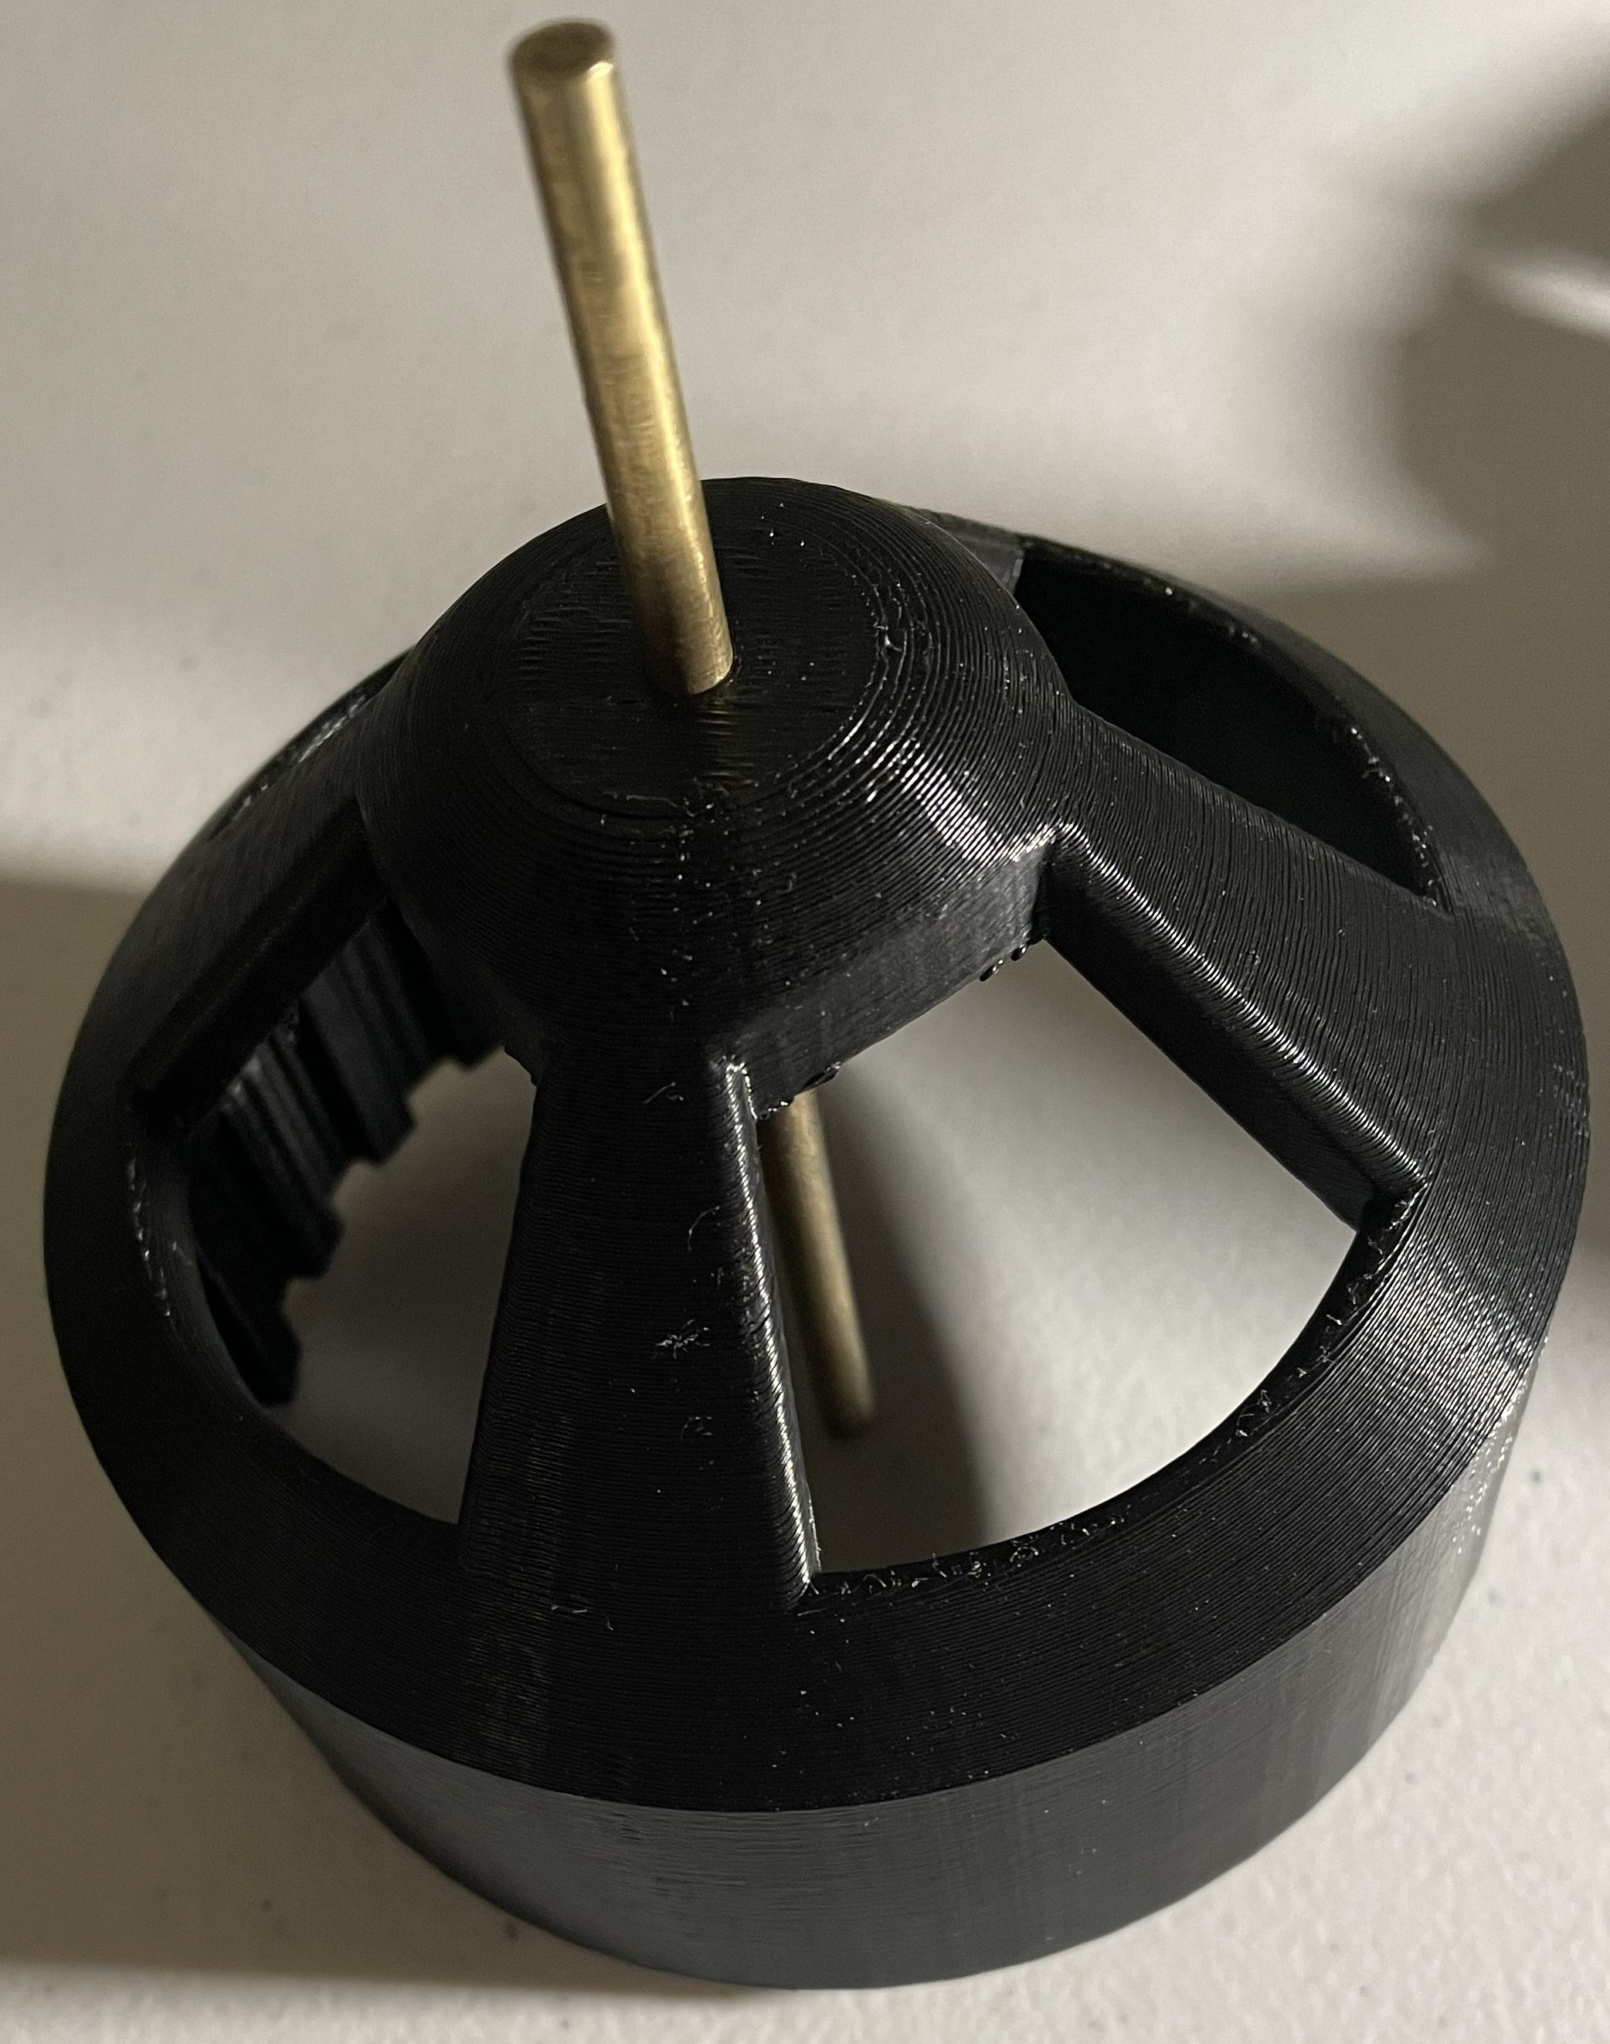
Figure 2: 3D Printed Rotor with Brass Rod
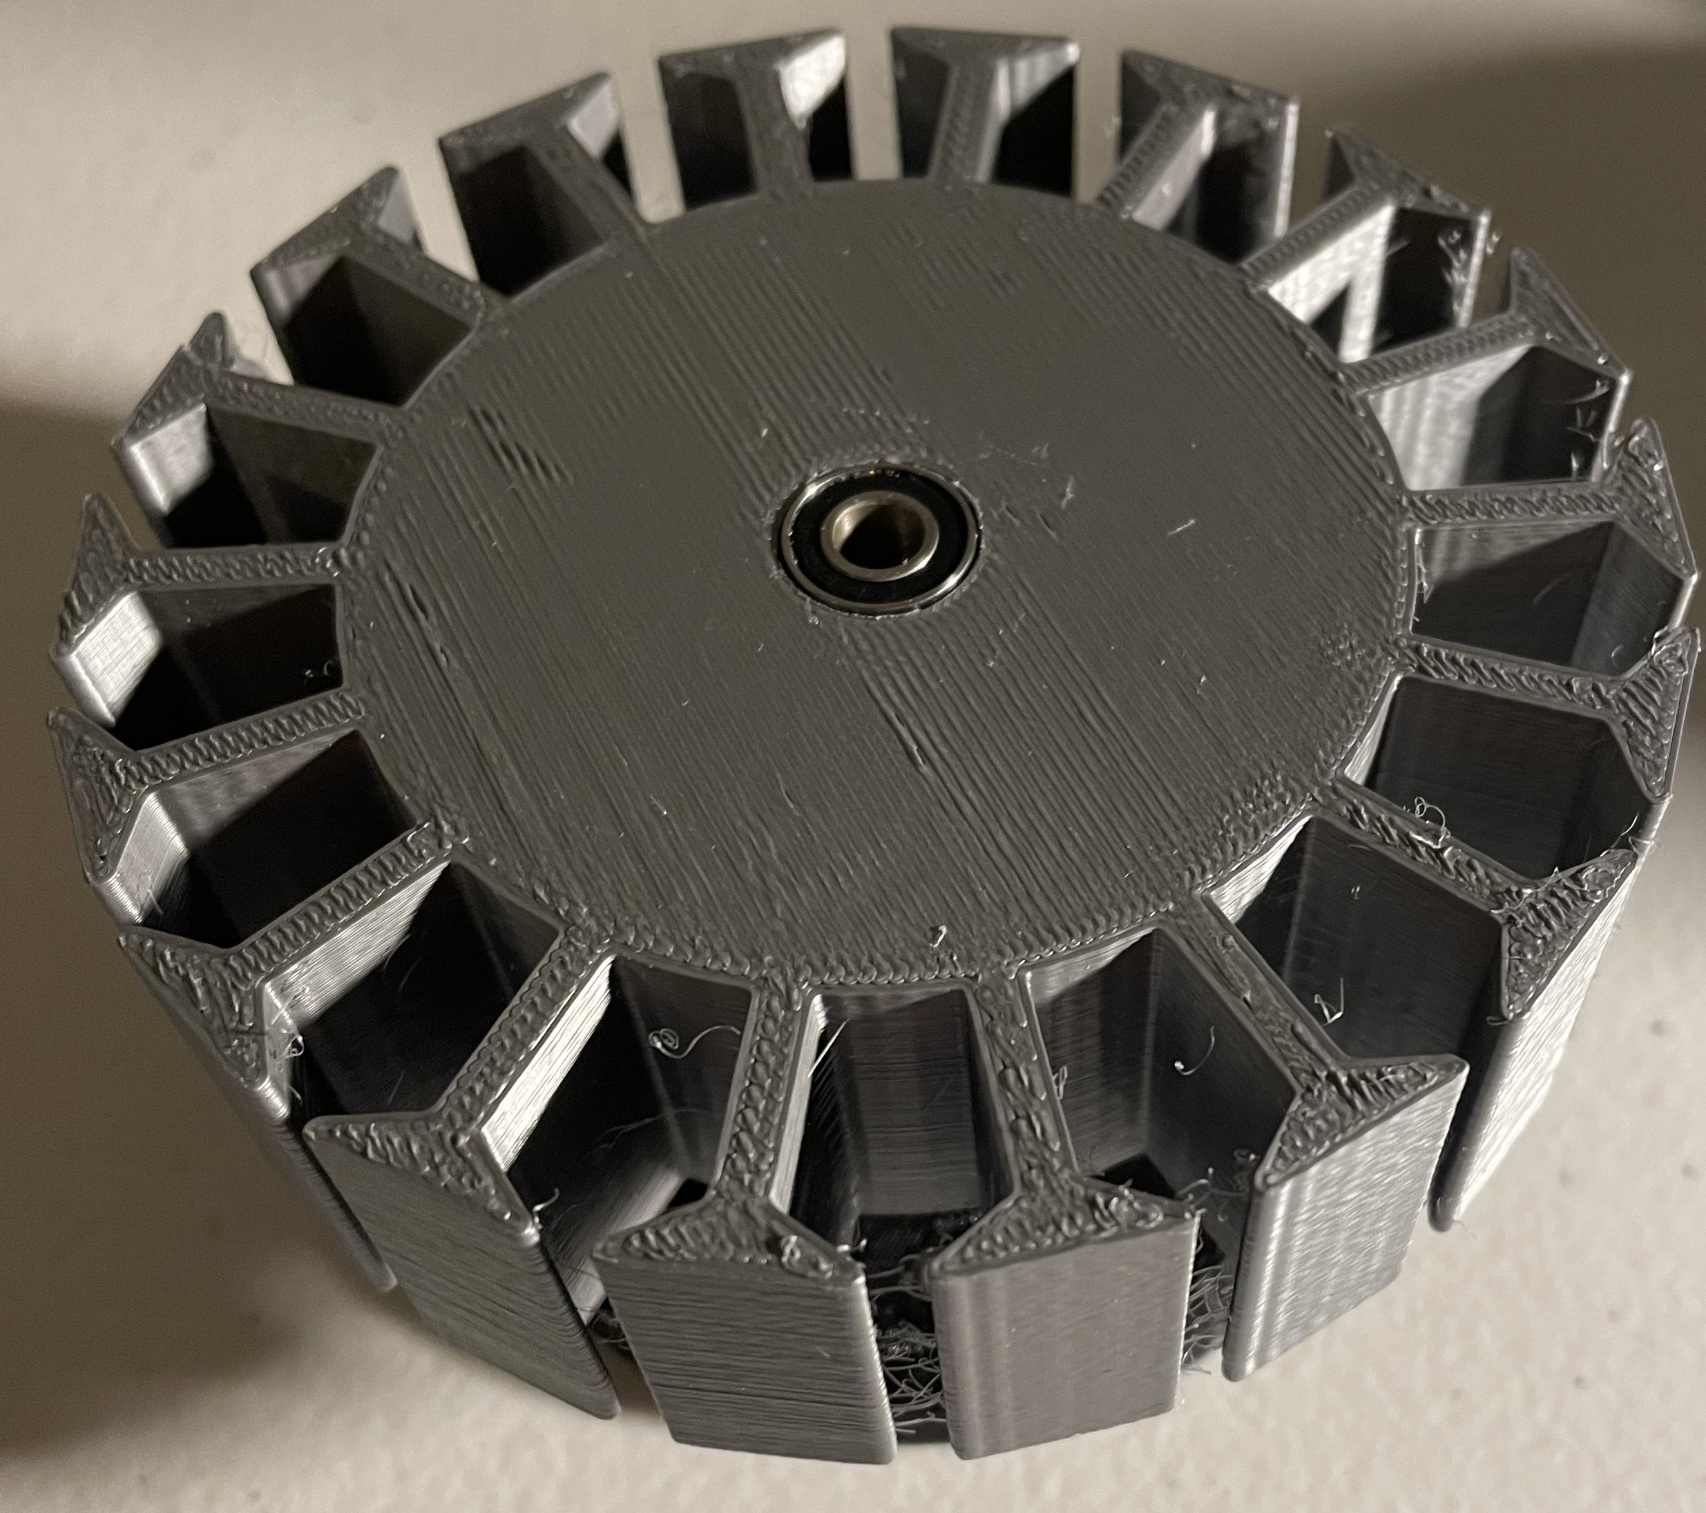
Figure 3: Inner Stator 3D Printed Part with Bearing
For the manufacturing portion of this hardware review PLA was the plastic used for the parts shown in the above figures. Since the team would like to test this motor for performance, PLA is a cheaper material and easier material to print with. The rotor was printed at 100% infill to achieve the greatest strength. The stator was printed with 50% infill to save time and material as this is also not a high stressed part. The team utilized the same shaft from the previous semester as well as the bearings to be able to complete a fit check. Once the newest design improvements have been made and the performance is measured, the team will produce a final design and print that motor using polycarbonate/abs and an iron-filled PLA for the stator. These material changes should be implemented by hardware review two. The figure below shows the current 3D printed model that the team used to present the current generator design.

Progress

The final design structure of the generator was broken up into three separate parts. There is the stator, rotor and backplate parts. The backplate allows the generator to be easily mounted into a micro wind turbine system using bolts. The backplate is shown below in figures 4 and 5. It has four slots to allow for easy alignment adjustments of the generator. The backplate attaches to the stator using a pressure fitment method. The backplate design houses the female end of the fitment, of which the stator can align with, and the parts glued together. FEA structural strain analysis was run on the backplate to simulate potential torque from the generator on the stationary part. Even under 2 N-m of induced torqued, the part geometry and PLA material were proven to be successful with a given 8mm thickness of the mounting hole structure. The overall backplate is 70 mm to leave room for mounting bolts to go all the way through the stator part potentially.

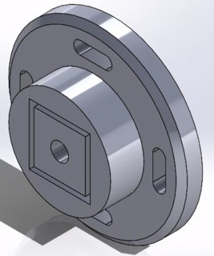
Figure 4: Backplate Isometric CAD View
Figure 5 below shows the rear of the backplate design where a bearing is inserted into the center hole shelf.
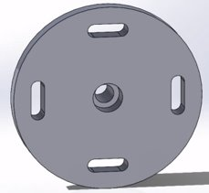
Figure 5: Backplate Rear View CAD
Figures 6 and 7 showcase the final rotor design modeled in SolidWorks. Four large columns allow for heat dissipation from the current through the copper around the stator to prevent loss in electromotive force (EMF) between the wires and magnets and general heat damage to the polylactic acid (PLA) printed components. Based on our Motor-CAD analysis, the 3D printed rotor has 24 poles for each of our 1”x1/4”x1/8”, N52 magnets to an 18-tooth stator for the 3-phase delta wiring. The tip of the rotor cone has a 5mm through hole to fit a 5mm brass rod that is fixed permanently to the stator and is driven axially through the rotor and backplate via 10mm ball bearings with an inner diameter of 5mm for the rod. The inner diameter of the rotor is 92.5mm and is designed to have a close fit to the stator with its outside diameter at 90.68mm leaving a 1.8mm gap between the rotor ID and stator OD.

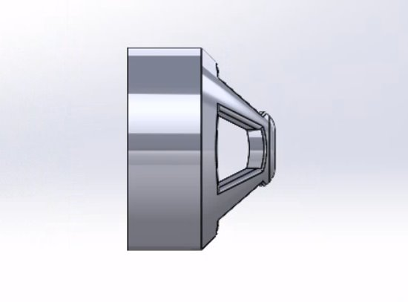
Figure 6: CAD Rotor Right View

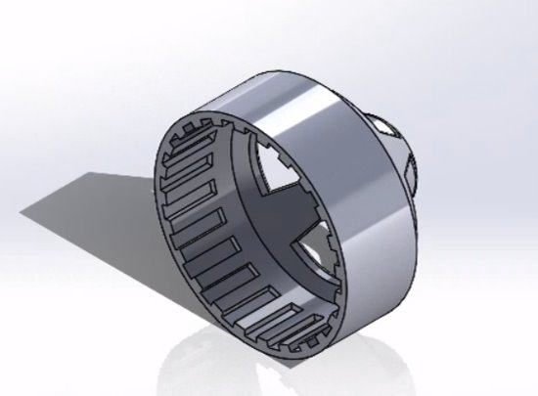
Figure 7: CAD Rotor Isometric View
Decisions and Purchases

The latest submitted purchase request includes Neodymium magnets, with a N52 rating, and a spool of copper wire AWG 18. The new magnets were chosen with a bigger size and the highest magnetic force possible to improve performance. The copper wire was increased in gauge size from previous prototype to improve conductivity of electricity. The waiting time for these items to be delivered has set us a little behind regarding testing. Since the body is already built, the team can get back on track quickly as soon as the items arrive. We hope to have a final generator with updated materials by the second hardware review.

Moving forward our team is going to submit a work order to create a shaft that is the proper size of the inner bearing diameter at 5mm. Furthermore, we also would like to purchase more printing materials for the final prototype to be shown in hardware review two. There may also be the purchase of larger bearings to compensate for thrust exerted by the potential micro wind turbine on the generator input shaft. We will also consider wrapping the coils in insulation paper to help protect the windings of the stator.
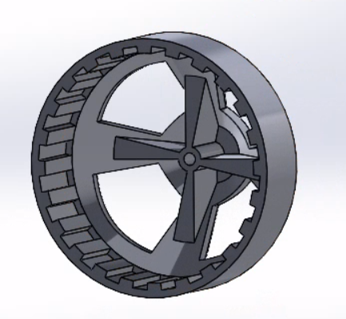
Figure 8: Updated CAD Rotor
Our team has noticed several design changes that can be made quickly to the rotor to avoid failure during assembly and testing. The rotor can be redesigned slightly to help reduce contact between the rotor and stator whilst also decreasing the torque on the end of the brass rod where the stator will be fixed. The inclusion of ribs along the interior of the rotor columns strengthens the support of the brass rod that is fit into the stator and reduces the moment arm between the end of the rod and the rotor itself; as shown in figure 8 above. Without moment support, the rotor runs the risk of waning downward and rubbing against the stator and the copper wires. The additional material and ribs will also ensure the rod is rotating straight axially through the rotor and not with a slight bend.

