SAE Baja

Preliminary Proposal

Omer Alamoudi
Chujian Wang
Salem AL Marri
Musaed Fraidoun
Rashid Algelmod

2019-2020



Project Sponsor: It is an analytical project which means we do not have a sponsor.
Faculty Advisor: Dr. David Willy
Instructor: Dr. David Willy

DISCLAIMER
This report was prepared by students as part of a university course requirement. While considerable effort has been put into the project, it is not the work of licensed engineers and has not undergone the extensive verification that is common in the profession. The information, data, conclusions, and content of this report should not be relied on or utilized without thorough, independent testing and verification. University faculty members may have been associated with this project as advisors, sponsors, or course instructors, but as such they are not responsible for the accuracy of results or conclusions.

TABLE OF CONTENTS
[Use your word processor to delete the following Table of Contents and insert a new TOC. Include front matter (except for the cover page), body of the report, and all appendices. The Table should include four levels of headings, e.g., down to 2.2.1.3, as illustrated below. Front matter should be in Roman numerials.]

Contents
DISCLAIMER 1
TABLE OF CONTENTS 2
1 BACKGROUND 1
1.1 Introduction 1
1.2 Project Description 1
1.3 Original System 1
1.3.1 Original System Structure 1
1.3.2 Original System Operation 1
1.3.3 Original System Performance 1
1.3.4 Original System Deficiencies 1
2 REQUIREMENTS 2
2.1 Customer Requirements (CRs) 2
2.2 Engineering Requirements (ERs) 2
2.3 House of Quality (HoQ) 3
3 DESIGN SPACE RESEARCH 4
3.1 Literature Review 4
3.1.1 Student 1 (John Doe) 4
3.1.2 Student 2 (Jane Doe) 4
3.2 Benchmarking 4
3.2.1 System Level Benchmarking 4
3.2.1.1 Existing Design #1: Descriptive Title 4
3.2.1.2 Existing Design #2: Descriptive Title 5
3.2.1.3 Existing Design #3: Descriptive Title 5
3.2.2 Subsystem Level Benchmarking 5
3.2.2.1 Subsystem #1: Descriptive Title 5
3.2.2.1.1 Existing Design #1: Descriptive Title 5
3.2.2.1.2 Existing Design #2: Descriptive Title 5
3.2.2.1.3 Existing Design #3: Descriptive Title 5
3.2.2.2 Subsystem #2: Descriptive Title 5
3.2.2.2.1 Existing Design #1: Descriptive Title 5
3.2.2.2.2 Existing Design #2: Descriptive Title 5
3.2.2.2.3 Existing Design #3: Descriptive Title 5
3.2.2.3 Subsystem #3: Descriptive Title 5
3.2.2.3.1 Existing Design #1: Descriptive Title 6
3.2.2.3.2 Existing Design #2: Descriptive Title 6
3.2.2.3.3 Existing Design #3: Descriptive Title 6
3.3 Functional Decomposition 6
3.3.1 Black Box Model 6
3.3.2 Functional Model/Work-Process Diagram/Hierarchical Task Analysis 6
4 CONCEPT GENERATION 7
4.1 Full System Concepts 7
4.1.1 Full System Design #1: Descriptive Title 7
4.1.2 Full System Design #2: Descriptive Title 7
4.1.3 Full System Design #3: Descriptive Title 7
4.2 Subsystem Concepts 7
4.2.1 Subsystem #1: Descriptive Title 7
4.2.1.1 Design #1: Descriptive Title 7
4.2.1.2 Design #2: Descriptive Title 7
4.2.1.3 Design #3: Descriptive Title 7
4.2.2 Subsystem #2: Descriptive Title 7
4.2.2.1 Design #1: Descriptive Title 8
4.2.2.2 Design #2: Descriptive Title 8
4.2.2.3 Design #3: Descriptive Title 8
4.2.3 Subsystem #3: Descriptive Title 8
4.2.3.1 Design #1: Descriptive Title 8
4.2.3.2 Design #2: Descriptive Title 8
4.2.3.3 Design #3: Descriptive Title 8
5 DESIGNS SELECTED – First Semester 9
5.1 Technical Selection Criteria 9
5.2 Rationale for Design Selection 9
6 REFERENCES 10
7 APPENDICES 11
7.1 Appendix A: Descriptive Title 11
7.2 Appendix B: Descriptive Title 11

BACKGROUND

Introduction
SAE Baja is a competition for university students to build a small off-road car that is able to resist all terrains. The project importance is that our team is encouraged to be a part of SAE Baja 2021 to work on three subsystems which are brake, front suspension, and dashboard systems. The objective of our project is to stop the car in less distance and shorter time compared to SAE 2020 vehicles. No less important, the benefits for stakeholders are the vehicle will be safer and more durable if we reach our objectives. The rules state that the braking mechanism must be capable of simultaneously locking all four wheels [1]. More significantly, however, the device must be able to be used by the driver reliably, repeatedly during the endurance case.

Project Description
At the beginning of the fall term, we received an email about SAE Baja states that, It will be assumed that you will design these subsystems as iterations on the 2021 vehicle, but completely new ideas are welcome [2]. By following the original project description provided by the sponsor we had five options to redesign and improve but we decided to choose three of them which are: brake, front suspension, and dashboard system. This project includes an SAE-BAJA off-roading vehicle design that can be abide by SAE BAJA completion rules in order to compete. Such designs must be able to perform and operate well in all situations: acceleration tests, braking tests, hill climbing, and endurance. To achieve such objectives, the design is very important to be optimal and accurate, front suspension systems and also braking systems of such vehicles are parts of such design which should be designed in a good and accurate manner. In this project, such two systems will be investigated, analyzed, and developed.

Original System

Mechanical engineering students have designed and improved SAE Baja in the past three years and they did a good job but as any project that has pros and cons. The SAE Baja team worked on CVT, a Spicer gearbox, and CVT axles in 2017, but there were some issues with their design, such as; they bought the CV but it was not an excellent performance because it was not adjusted, Also, the there was an issue with CV because of its length it doesn’t fit the rear geometry. On the other hand, the SAE Baja team of last year worked on gearbox, drivetrain, and gears which are not related to our systems that we work on.

Original System Operation
Drum brake is the first and disk brake is the second, both are designed to dissipate kinetic energy by conversion to thermal energy while they use similar concepts, they work somewhat differently. Drum brakes are commonly used around the globe on medium to heavy duty trucks, although most passenger vehicles use disk brakes. For applications comparable to that of an SAE Baja vehicle, the reason that disk brakes are more sought after is that they are much less susceptible during braking to temperature spikes. See Figure 7.2 (Appendix) for a description of disk brakes. Disk brakes are able to resist with little fade at high temperatures that reach approximately 673 K to 700 K, if the heat is more than this range they will be damaged [3].

Original System Performance
[Use this section to describe the performance of the system at the time your project began. Obtain or collect data and compute and present statistics on weight, volume, speed, accuracy, power requirements, efficiency and other system performance parameters. Include sample calculations as appropriate but place extensive calculations in an Appendix. Clearly document and justify your approach to collecting and summarizing performance data. This section should clearly present a baseline against which the performance of your re-engineered system may be compared.]

Original System Deficiencies
[In this section, explain, with reference to its performance and other characteristics, why the original system did not meet current Customer (and, optionally, Engineering) Requirements.

REQUIREMENTS
This chapter introduces the customer requirements, engineering requirements and HoQ of our project. The requirements gave us the direction and standards of project design. When comparing different designs, these requirements can help us to score and choose the best design plan.

Customer Requirements (CRs)
Aim of the project is to design and build a reliable single seat sporting vehicle which is suitable for all terrain. The project is divided into three subsystems i.e. Front-End Suspension, Brakes and Dashboard. These subsystems are allotted to individual members of the team. Following are the requirements extracted from the SAE Baja Project Rule book.

Engineering Requirements (ERs)
Depending on the customer requirements (CR), the engineering requirement is generated based on the CR. The main ideas here in the ERs that focus the durability and stability of the car, and absolutely weight. Based on Baja competition rules, the measurement of weight should be 250 Ib, and the track width of the vehicle should be <64 In. The brake system must follow the competition rules for SAE Baja that states to lock all four wheels at the same time. The heat that is released from the rotors in Baja vehicles is approximated in a range that is not above 700 K, so the best brake system is the disk because it has the ability to absorb the heat better than other brake systems. For dashboard, The error of the test instrument used to measure the vehicle speed shall not be greater than ±1.0%. The minimum speed division value should not be greater than 10km/h. The minimum graduation value of the tachometer should not be greater than 500r/min.The nominal voltage of the meter is: 12V, and the working voltage range is 10.8V-16V. The working current range of the meter is 0.05A to 0.4A. If using more than 12V, the voltage regulator on Arduino may overheat and damage the board.

Engineering Requirements | Targets | Rationale
Heat | Less receptive to heat | The brake system in SAE Baja should be designed and equipped as the disk brake because it is less receptive to heat during the stopping vehicle time.
Spring | Unbreakable | The Spring means that it contributes to reduce the effect of shock force when the vehicle shocks a stone or rigid body
Track width | <64 in | referees to the distance between the two wheels in the front suspension. when the track width is smaller
Dashboard shows data | Error <±1.0%. | Accuracy of the value displayed on the dashboard
Component protection cover | Be uniform | The protective layer should be uniform, without obvious defects such as bubbles, spots, rust and shedding.
Circuit Power Limit | 10.8V-16V;0.05A-0.4A | Voltage range:10.8V-16V. Current range:0.05A to 0.4A.
Decrease the Weight | <250 Ibs | Depends on the Baja rules, is able to carry the driver weight that should not exceed 250 Ibs
Battery | 12 V | Depends on power limit and component operating voltage

House of Quality (HoQ)
[Summarize project requirements in a House of Quality using the template provided on the course website. If the HoQ is small enough you may include it here as landscape or portrait. If it is too large, add the HoQ as an Appendix. Include a detailed introduction to the section and a discussion of how the HoQ has helped the team in the design process. Be specific and detailed (i.e. do not write any statements that could be applied to multiple projects besides your own). Ensure that every Engineering Requirement has a legitimate target value and tolerance to the target.]
For the Preliminary Proposal include only CRs, Weightings, ERs, Target Values (with tolerances), and approvals. Testing Procedures will be added to the next report.

DESIGN SPACE RESEARCH
[Put introduction to Ch. 3 here detailing what the chapter contains before leading into Section 3.1.]

Literature Review
[Use this section to describe what sources were used for benchmarking and design research. This could have been done by examining similar systems, literature review, or web searches. Each student should have at least five relevant sources (academic and professional journals, books, websites, catalogs, interviews with sponsor, advisor, design tools etc.), given in the following subsections. For each source, include a summary and discuss how it specifically applies to your project design space.

Student 1 (Omer Alamoudi)
Omer is responsible for the brake system and understands each concept for the brake system that is related to SAE Baja. Such as parts that are related to the system which are; pedals, rotors, piston cylinders, and calipers. There are many types of calipers which are: Caliper with Increased Piston Area, Caliper with Mechanical Engagement, Dual/Triple Caliper System, and Caliper with Multiple Pistons, each one of these has its features. Also, we decided to make some holes in the rotor to get less heat while we take care of its thickness. Extreme rotor temperature induces hot spots, geometry changes of the material and stress patterns along the rotor surface [4].
There are two acceptable systems for the brake system which are: drum and disk systems but the disk has more efficiency [7]. Because of its durability and easier to be fixed than other systems. Also, one of the rules for SAE Baja is the brake should lock off all the wheels at the same time which means the brake system should be in an excellent placement to prevent bad scenarios and protect the driver [1].
The second type of brake system is drum brakes, it works for SAE Baja but it is not preferred in the competition because they are not easy to be fixed and they are not able to resist high temperature standing on their specifications[6]. The disk brake gets lower heat compared to the drum because of the low sensitivity to temperature, disk brakes can operate with minimal fade at high temperatures [8].

Student 2 (Chujian Wang)
Source[53] is a report written by the University of Rochester SAE Baja Team. In order to improve the display, monitoring and display capabilities to record car speed and engine speed, equipment design, manufacturing and testing provide this capability. A display program is written to accurately display the sampled data on the computer. Remote computer. The program can also record sample data (engine speed, wheel speed, fuel status)
Source[49] is a tutorial on how to deploy an infrared speed sensor on Arduino, written by ADMINISTRATOR in ELECTRONICS HUB. It introduces the working principle and connection method of the infrared speed sensor, as well as the Arduino running code. It helped me understand the infrared speed sensor very well.
Source[50] is a tutorial on how to build a capacitive liquid sensor. A capacitive liquid sponsor relies on the fact the capacitance or charge between 2 metal plates will change (in this case increase) depending on what material is between them. This allows us to create a level sensor that is safe for use with any liquid. [50] It provides a method of autonomously detecting liquid level. But our fuel tank is made of metal, this method is not applicable
Source[51] is an article about liquid level sensors. It introduces how the Hall effect is applied to liquid level sensors. And gives a very vivid Hall level sensor application diagram. It analyzes the mathematical principles of the Hall effect, as well as magnetic field analysis.It uses diagrams to analyze several examples of Hall-effect sensors and analyzes several ways to deploy Hall-effect sensors.
Source[52] is a report about Design of an SAE Baja Racing Off-Road Vehicle Powertrain, written by Eric T. Payne in Spring 2015. It helped me understand the mathematical theory of engine speed and deepened my understanding of the project. The structure of the report and the method of analysis helped me learn how to write a report.

Student 3 (Salem AL Marri)
source [33] is an article written by the Society of Automotive Engineers regarding the 2012 SAEBaja Competition. More specifically it looks at the different suspension systems that were used during the competition. I can use this document for inspiration in how to develop
unique and interesting suspension systems for this project. Such ideas include a piggy-
back oil reserve and coil over shocks. The information included in this document also provides great detail regarding multilink suspensions

source [34] is a presentation by the Powder River Racing SAE Baja Front Suspension Team at the University of Wyoming. They were required to build the front suspension for their mini-Baja vehicle. Within this presentation, the team discusses ideas that they used for their mini-Baja vehicle regarding the front suspension and steering that they used. In the development of their project, they discuss their use of the A-Arm suspension of their design. They also provide some important information regarding the manufacturing process.

source [35] is an article that discusses off-road suspensions. Topics covered in this article include the use of a solid axle, radius arm setup, Parallel and Triangulated Four-Link, Ford Twin Traction Beam, the King of Hammers Suspension, and the Fully Independent Suspension. All of this information is helpful in providing inspiration for our suspension designs. By reading about the different forms of suspension we will be able to get ideas for building our Baja vehicle. In understanding how different suspensions have been used effectively in other types of off-road vehicles as possible forms of suspensions that can be used for our Baja vehicle.

source [36] is an excellent, in-depth review of vehicle performance in off-road conditions with a focus on key elements of the running gear systems of vehicles. Included in this book, there are topics regarding suspension systems, wheels, and tires. There are also spreadsheets that give insight into steering, handling, and overall performance of wheeled systems. I can use this textbook for guidance because it provides component design and characteristics for suspension systems. I will also be able to use the information regarding steering that is provided in the book in order to get inspiration and ideas for designing our suspension and steering systems.

source [37] is the book covers front and rear solid axle systems, twin-traction beam systems, an independent suspension systems, as well as coil springs, leaf springs, and shocks. More in-depth information is provided regarding the companies of Jeep, Toyota, Ford, GM, and Dodge and their use of 4 x 4 suspension. I can use the information in this book for inspiration in how to build the suspension system for our Baja vehicle. There is a good amount of information regarding suspension and steering systems in this book that will help guide us. It is a trusted source that provides accurate engineering and technical information.

Student 4(Musaed Fraidoun)
This reference [38] discusses the failure of the rear suspension in the 2009 model. And how the issue is resolved by integrating a rear steer point that helped with camper gain in turns which increased its handling.

This reference [39] is about the establishment of Baja SAE in 2015, Colorado, boulder. The team worked towards certain goals which Included high safety factors, high endurance, and high durability. This meant sacrificing some aspects such as weight amongst other specialty challenges. However, this served their intent in fabricating a rugged, marketable, off road vehicle.

This reference [40] uses a model of a baja SAE vehicle. And subjects it into a multi body dynamic analysis of the interconnected suspension system. And the results show that there is a performance advantage of the interconnected suspension system over the conventional anti-roll bar configuration. Which is mostly shown in low frequencies which is more suitable for an off road vehicle.

In this reference [41], multi body dynamics models have been created in order to allow the team to improve their vehicle designs. They addressed issues that needed more effort in older models. After their tests, the study showed insightful understanding of the parameters and forces involved in suspension systems and their variations in different events influencing vehicle stability.

In this reference [42] we can figure out the SAE Baja rules and regulations which we can take into consideration as we can look at the most compatible ways to work it out without violating SAE rules.

Student 5 ( Rashid Algelmod)
This source [43] is talking about Baja Racing described as an off-road motocross race aimed at limit testing of one’s driving skills and endurance. In the race, the global collegiate teams make their Baja racecar aimed at competing in three-set competitions. The competitions are judged based on several criteria derived from multiple presentations regarded designs, audits costs for suspension hardcore, and four-hour duration race. The outshining team that competes in the three challenges receives a reward referred to as the Mike Schmidt Memorial Iron Team Award. This is consequently comparable to the world champion identity. Michigan Baja Racing team featured 2 electrical engineering students who, despite taking the first Mike Schmidt Memorial Iron Team Award, broke the record for their resultant cumulative score since 2001, since the start of the awarding [43]. They scored 900 points upon participating in all three set competitions and took the first Baja SAE California, Baja SAE Rochester, and the second on the Baja SAE Tennessee Tech count.

This source [44] is talking about the vehicle road suspension is planned and focused on maintaining the contact between the roadways and the wheel and, secondly, separating vehicles from irregularities. The vehicle's chassis and the wheel-carrying stub axle types of linkages provide a unique suspension system. The double-wishbone suspension system in recent passenger's car forms the main groupings. This kind of connection allows movement in the vertical direction to upright move about the surface in contact with the tier [44]. Wheel control is aided by the adhesion created by the link of wishbone arrangement. With the computer application system, the wishbone system allows fresh potentials providing dynamic control (suspension) to favor the situations.

This source [45] is talking about MacPherson Strut Suspension is used in most modern front-wheel cars due to its efficiency, lightness, and compactness. In this system, the wheel bearing assembly's studs retain the wheel rim and the brake rotor while the outer steering knuckle bottles the front wheel bearing assembly. The front driveshaft is tied to the midpoint of the wheel-bearing bulb. Running from the steering knuckle to the gear, the tie-rod end links the steering connection [45]. Some of the key organs include the lower control arm that regulates side to side movement of the anterior wheel, while the stabilizer bar minimizes body roll due to the front wheel's unstable striding. Shock absorber struts offer essential suspension restraining while Coil springs control suspension travel.

This source [46] is talking about The experimental approach modifies the suspension system to enhance safety in ride and handling. The process is tedious, costly, and slightly inaccurate; thus, a simulated vehicle suspension system is required. The shift from negative to positive for the multilink suspension system is to recompense for the front-wheel drive's understeer. The modeling and simulation of a half-car body of a real suspension system grounded on the PROTON WRM 44 P0-34 took place [46]. The model is established by defining the hardpoint's position before stipulating the joint type and component features. The virtual test generates Kinetic and Compliance data sets which compares the real and the virtual results. The multi-link suspension system has similar characteristics to the McPherson suspension system.

This source [47] is talking about MacPherson suspension maintains the vehicle's flatness on the road, takes little space, and is generally lighter. Additionally, MacPherson suspensions are cheap and allow the speeding of the vehicle due to their lightweight. Contrary, the suspension has a long vertical assembly and is generally present in lowered cars. Due to their vertical nature, they limit vehicle control as they reduce ground-wheel contact. The Double Wishbone suspension allows stable car control [47]. They allow steady steering and wheel alignment while in motion and have a boosted negative chamber. Besides the pros in Double Wishbone Suspension, their main disadvantage is their cost.

Benchmarking
For Baja SAE engineering, a number of competitions have been held. The group has gone over the most recent successful designs. Through the analysis of previous work, a conclusion is reached. To survey the required areas, the team takes on various perspectives. The published design reports, group dissuasion, and interviewing interested parties are all examples of this. The team has concentrated on component design that reflects more defensible results based on the user's needs. The decision was made in the end to select the most important components. In the following sections, we'll go over the most recent Baja SAE designs.

System Level Benchmarking
Over the last few years, various ventures have successfully designed productive prototypes for the Baja SAE competition. New methods and specific performance have appeared each year. Innovations have led to increasing customer loyalty. To that end, this template has used the most highly regarded active designs in the last few years. The proposals applied and the details of the design are examined in order to suggest a continuous development of the design strategy. This project originated from when the previous projects had arrived. The suggested advancement is carefully calculated according to which the concept is designed to share the additional organizational effectiveness that the Baja SAE population requires. This section provides a survey of three existing system-level designs and outlines the benefits of configurations of components. The section also illustrates the chance of the concept concerned, which may be partly used in the planned project.

Existing Design #1: Auburn university
Dr Peter D Jones Auburn University's War Eagle Motorsports is animated to both race and host Baja SAE Alabama this year. Expanding on a fruitful history, the group has made a vehicle that is lightweight, solid, fast, and arranged to contend. The current year's vehicle highlights: movable engine for tensioning, engine on deck for a lower focal point of gravity, in-house machined and last drive gearbox, and custom suspension segments. The group comprises a different arrangement of researchers since it is responsive to all understudies and majors. Both the group and vehicle couldn't exist without the liberal assistance of our supporters. The 2009 Auburn University Baja Team couldn't want anything more than to thank the ensuing patrons: Birmingham Gear, Martin Sprocket and Tools, Mid-South Nuclear, Materials Technology Inc, Yamaha, Simulations Plus Inc, Harris, Carter Brothers, RSC, Briggs and Stratton of Auburn, the National Center for Asphalt Testing, Alabama Bolt and give, Lotus Engineering, and a lot of something else
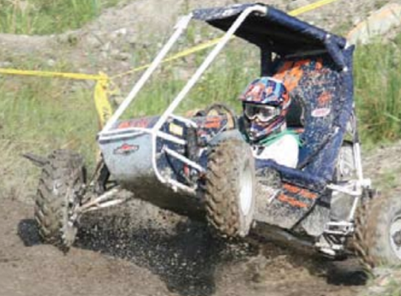
Figure 1 Auburn university [9]

Existing Design #2: Rochester Institute of Technology
The plan got the second spot of the California Baja SAE 2019 rivalry. The Rochester Institute of Technology dashing group had effectively acquired an incredible score in the moving and suspension assessment. This achievement has urged the group to investigate more insights regarding the front-end suspensions framework which conceded the capable outcomes for the Rochester hustling group. As demonstrated by figure 2 , the front-end suspensions framework, which won the opposition, is a twofold wishbone component. The framework holds cylindrical style control arms, and a curl over safeguard that is appended to the lower arm. The upper side of the safeguard is fixed over the nose of the Baja vehicle. This edge decreases the feeling of anxiety on the lower control arm and makes a greatest suspension dislodging. One more, the length of upper control arms is more limited than the lower control arms.
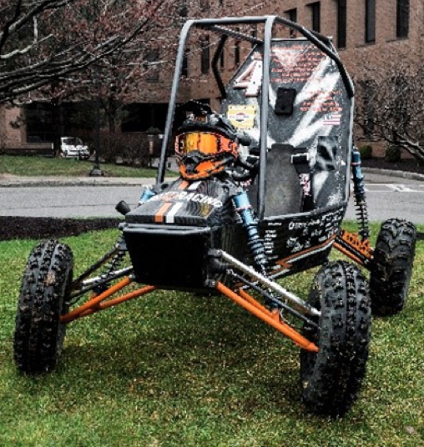
Figure 2 the front-end suspensions design The Rochester’s Baja SAE vehicle [22]

Existing Design #3: California Polytechnic State UNIV
John G Fabijanic Located only minutes from the alluring California coast, Cal Poly San Luis Obispo is discovered somewhere between la and San Francisco. The college's accentuation on "learn by doing" is reflected by the different active exercises that the researchers are presented to. This year, Cal Poly SLO is anticipating running two vehicles inside the Baja Oregon rivalry. Vehicle number 33 uses a CVT transmission, which has been utilized for quite a long time by the college, while vehicle number 69 will utilize a specially created manual gearbox. The group trusts that the manual gearbox will help the vehicle's speeding up out of corners. The two vehicles will utilize rack and pinion guiding, with a custom rack from Stiletto items. All joints on the two vehicles are TIG welded for added strength and solidness. Vehicle number 33 uses double wishbone suspension inside the front, and Elka loop over stuns. While the front suspension on the 69 vehicle will be generally comparative, it'll utilize a particular 5-interface established inside the back, and Fox air-stuns on each of the four corners as opposed to the Elkas
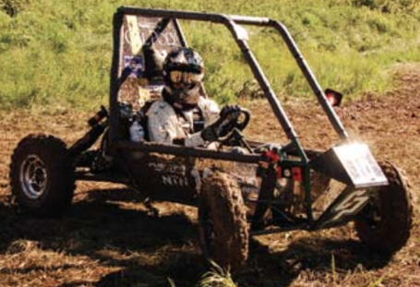
Figure 3 California Polytechnic State UNIV [10 ]

Subsystem Level Benchmarking
Following three sections present the relevant subsystem to the design components selected in this project.

Subsystem #1: Shock Absorbers
The shock absorber is an essential component of the front-end suspension system. In this subsystem, three shock absorbers are given and detailed. Including, the remote reservoir shocks, the mono-tube, and the twin tube design.

Existing Design #1: Air Shock
Air suspension frameworks appear to be considerably more secretive at the same time, for reasons unknown, they are certifiably not a ton extraordinary. Most present day suspensions are composed of a loop spring that slips over a stun or is situated close to it. At its center, an air suspension truly gets rid of those curl jumps on adaptable, pressure-filled sacks of air that are regularly made of similar kind of elastic as your tires. At the dash of a catch, the sacks can be swelled or emptied, immediately changing ride tallness and how the suspension performs.
At the center of any air suspension framework is its packs, or air springs. Here, elastic cries that component metal plates at each end slip over the stuns, like a curl spring. Like curl springs, air springs are reformist in nature, which means expanded pressure brings about a stiffer spring. The capacity to modify an air spring's rate at any second methods the potential for better execution or ride quality just got a ton simpler.
Odds are, fitting an air spring pack to your vehicle just got much simpler, as well. The entire cycle has progressed significantly throughout the most recent ten years, as indicated by Air Lift Performance's Corey Rosse
There's significantly more to an appropriate air suspension framework than four sacks worth of hot air, however. Any unit worth your thought consists of a wide range of different parts. It begins with an installed air blower that is controlled by the vehicle's electrical framework and can expand each sack on request. The blower takes care of the springs separately utilizing adaptable, polyurethane lines or, at times, specially bowed, tempered steel tubing (you'll see the top show vehicles shaking hard lines). More often than not, a different air tank is incorporated that helps promptly increment and keep up pneumatic force inside the framework and take into account smoother advances between enormous pressing factor changes. The two segments are commonly mounted in the storage compartment, at times in a custom fenced area, yet they can likewise be covered up under the body or joined to the unibody or edge.
The blower works like some other pneumatic machine, drawing outside air into its inside tank, where it's compressed and conveyed its opposite end. Someone must disclose to it when to siphon and how much air to permit past itself, however, which implies a type of driver-impelled regulator must be coordinated into the framework. Here, manual or electronic regulators are accessible that can be mounted close to the driver or got to from a cell phone application at times for simple, on-request ride-tallness change
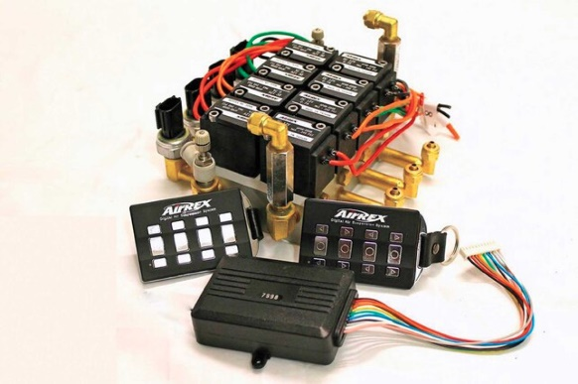

Figure 4 Air Shock controllers [12]

Existing Design #2: Mono-Tube Shocks
This shock involves a floating piston within a cylindrical piston. The piston and the oil seal break the cylinders into two areas. The usual damping agent, which is usually oil, is present in the lower half of the cylinder. This area is the usual operational journey for damping the piston. Use high-duck gas to fill the upper half of the cylinder. The typical form of gas used is nitrogen. This mechanism offers an additional damping feature. When the piston begins to shift as a result of stock, the fluid and the compressed gas can act on each other to withstand the shock, so that the stock force on the other side can be minimized. The mono-tube shocks shown in figure 6 are generally preferred rather than the twin pipes. Since mono-tubes can split gas from fluid without mixing. Meanwhile, both working fluids mix twin tubes (hydraulic oil and pressurized gas). The flat pistons and the oil density are very fine and precise components however, monotones are expensive. This makes maintenance sensitive and not easy [13].
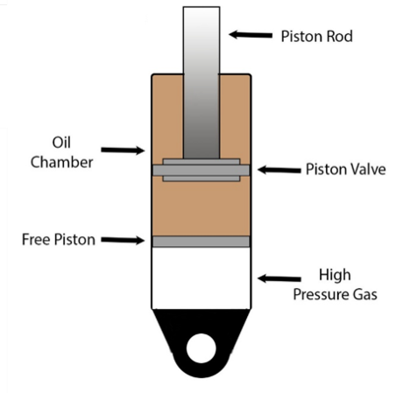
Figure 5 Mono-Tube Shock [14]

Existing Design #3: Twin-Tube Shocks
In principle, two-fluid chambers are used for the twin-tube shocks, one inside, and the other outside. A valve that enables the hydraulic oil to flow from the inner chamber to the outer chamber is used. Due to the interaction of the hydraulic oil and existing air, this configuration can cause a foaming state. The passing valve, on the other hand, may affect the twin-tube response sensitivity. The damping quality is therefore not guaranteed on the rough road. The twin-tube shock schematic is illustrated in Figure 7 .
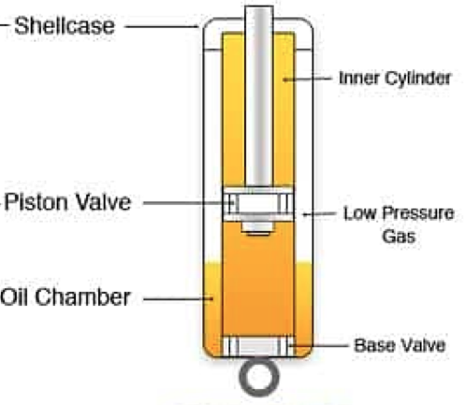
Figure 6 Twin-Tube Shock [15]

Subsystem #2: Geometry
The geometry systems are the connected wheelbase to the mainframe of the vehicle. This system induces all connections used to connect the corporal frame to the wheelbase that contains the front (or back) axles.

Existing Design #1: Double Wishbone
In off-road vehicles, the double-wishbone configuration is the most common type for front-end suspension. As indicated in figure 8, the wishbone system connects the nose of the step with the frame by two arms. The arms may be A or U-formed [16]. The upper and lower arm usually defines the two parts of the arms. The popular system design is for the lower arm of the shock absorber. The upper brace can also be connected. The connection to the Lower arm, however, can increase the irregular road damping control. For the front-end suspension system, the wishbone system is normally applied. Where rear-end suspension components are uncommon to install. The main benefits of this system are the ability to provide effective damping and reactive control of the vehicle.
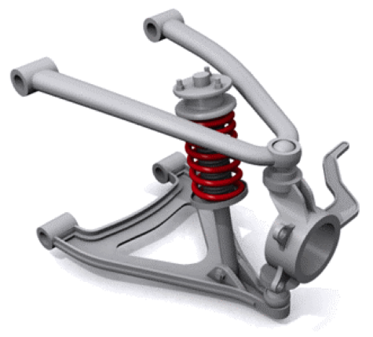
Figure 7 Double wishbone suspension [17]

Existing Design #2: MacPherson strut
For independent suspension, this is a popular choice. It works by combining the shock absorber and coil spring into a single unit. The upper control arm and the wishbone system's shock absorber can be replaced with this configuration. MacPherson struts are typically assembled almost vertically, or in a near-vertical position, as shown in Figure 9 . Because the suspension system is influenced by the force on the vertical axes, this type of mounting would aid the suspension system in absorbing as much of the impact as possible. As a result, the vehicle is very useful in a rough driving environment. The low initial cost of the MacPherson strut suspension system is another benefit. Aside from the fact that it's simple to keep up with, [18].
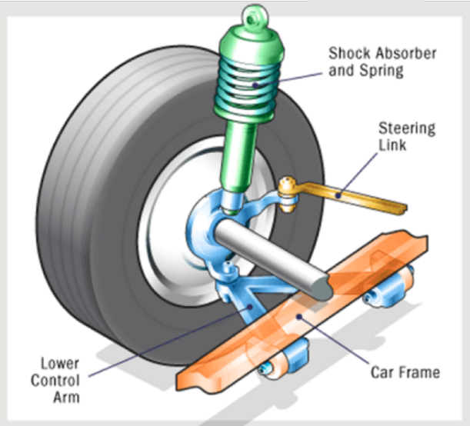
Figure 8 MacPherson strut system [19]

Existing Design #3: Unequal Length Double A-arms
The most common design for a Baja front-end suspension system is equal and unequal double A-arms. The lower A-arm is the primary location for this mechanism. Furthermore, the system allows the shock to pass through the upper A-middle. arm's In most cases, the unequal length setup is preferred because it allows for maximum tire patch through body roll. The equal-length arms, on the other hand, gain positive camber during wheel rotation, resulting in difficult cornering. Figure 10 shows a Baja vehicle design with unequal double A-arms. The cross-sections of the members of the unequal A-arms setup can be designed in a variety of ways. Tubular, boxed, and billet machined arms are some of the options. The tubular A-arms design, however, is the widest.
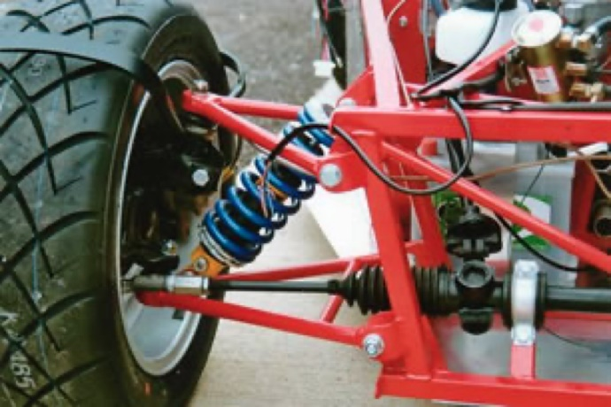
Figure 9 Unequal Length Double A-arm Suspension [20]

Subsystem #3: Dashboard
Dashboard is the component that displays the data of the vehicle, including speed, fuel level and rpm. During the driving, the driver needs to not only observe the surrounding environment but also concerned about the state of the vehicle. The data is from the sensors placed in specific locations. Through some circuits and wires, the data of the vehicle will be shown on the dashboard screen. References for the number of items provided, the number of items provided by the vehicle, and the number of items provided.

Existing Design #1: Infrared speed sensor
Coming to the sensor, the Infrared LED and the NPN Photo Transistor are placed directly facing each other. When there is no object in the slot, the light from the Infrared LED always falls on the Photo Transistor. The wheel has 20 holes in it, so whenever the wheel makes one rotation, the infrared light from the IR LED is obstructed for 20 times from falling on the photo transistor.[49]This is a method of detecting RPM, the speed of the vehicle can be calculated by detecting RPM.

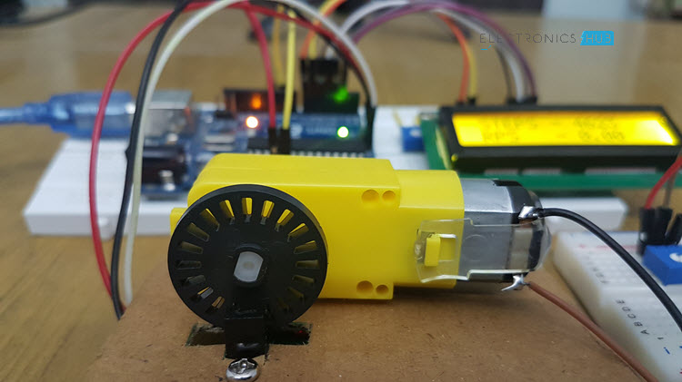
Figure10: LM393 Speed Sensor Module [49]

Existing Design #2: Capacitive Liquid Sensor
A capacitive liquid sponsor relies on the fact the capacitance or charge between 2 metal plates will change (in this case increase) depending on what material is between them. This allows us to create a level sensor that is safe for use with any liquid.[50] This type of solution sensor can be used for fuel level detection in our project. But the shortcomings of this design are obvious. The metal casing of the fuel tank has a significant effect on his measurement. The exposed wires are also susceptible to environmental influences.

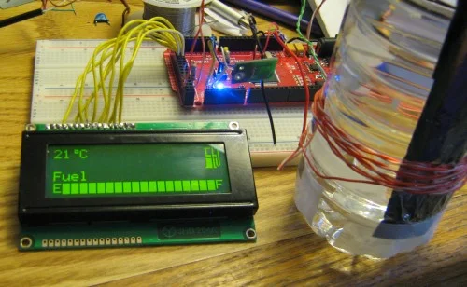
Figure11: LM393 Speed Sensor Module [50]

Existing Design #3: Hall Sensors for Fuel Level Sensing
A fuel level sensor (FLS) is used in all automobiles to indicate fuel level. Various methods are used to measure fuel level such as resistive film, discrete resistors, capacitive, and ultrasonic. Resistive-based sensors are most commonly used for this application. These sensors are mechanically connected to a float which moves up or down depending on the fuel level. [51] As the float moves, the resistance of the sensor changes. The sensor is part of the current balance circuit of the fuel gauge display circuit, which is usually composed of a coil used to drive the display needle. As the resistance of the fuel sensor changes, the position of the needle changes proportionally to the current flowing in the coil.
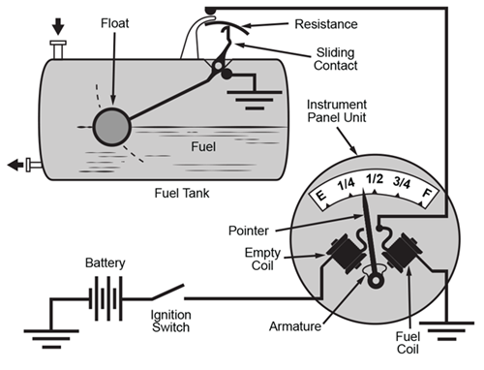
Figure12: Hall Sensors for Fuel Level Sensing[51]

Functional Decomposition

Black Box Model

[Provide an introduction to this section before presenting the Black Box Model with appropriate inputs and outputs in the form of materials, energies, and signals. Include a discussion of how this model helps the team to visualize or clarify your project.] Front-end suspension system
To absorb and control rough road reaction shocks, the front-end suspension system is used. The system is also used to provide elastomeric support for the Baja vehicle's weight, as well as effective maneuvering. The impact force is strongly influenced by the road profile. The vehicle mass is converted to kinetic energy by the road profile, which acts as a shock force. The front suspension system is then in charge of releasing the kinetic energy generated and allowing the human to direct the vehicle. The inputs to the suspension system may be joined by a noise signal, such as a vibration displacement. because of the noise signals' minimal effect Usually, the outputs of relative signals are ignored. A variation of heat energy and temperature gradient is also expected due to the energy transformation. The black box model of the front-end suspension system is shown below in figure 1.
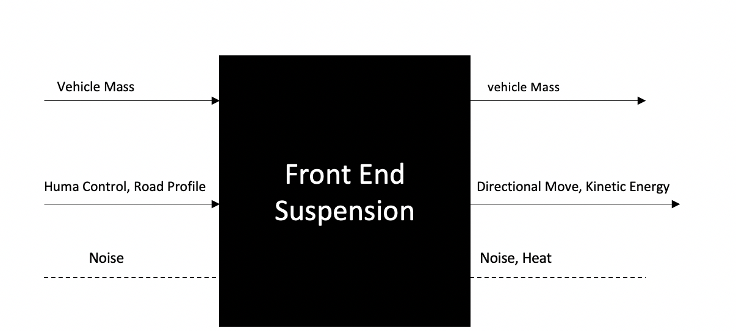
Figure 13 Black box model of the front-end suspension system

Black Box Model Brake system :
The black box model of the brake system is created once the car is moving, so the inputs are the steel, human energy, Kinetic energy, and the brakes are on or off while outputs are steel, friction force, acceleration, and brakes are on or off.
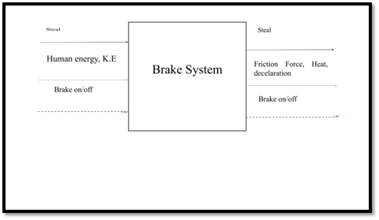
Figure 14 Black box model Brake system
Black Box Model of Dashboard :
As a detection and display device, the task of the dashboard is to detect data and display it on the screen. Its material input is mainly sensors and screens. The material output has hardly changed. The energy input is mainly electric and kinetic energy. The kinetic energy is converted into speed data through the wheels, and displayed as light energy on the screen through sensors and circuits. The input signal is the analog signal received by the sensor, and the output signal is the visible light signal

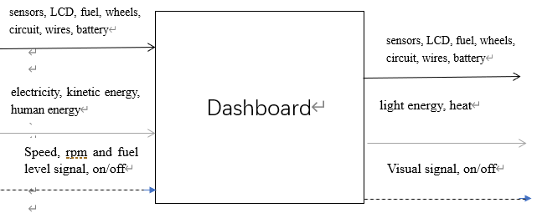
Figure 15 Black box model of Dashboard

Functional Model/Work-Process Diagram/Hierarchical Task Analysis
[Provide an introduction to this section before presenting the team’s selected model with appropriate form based on the process diagram/model/analysis. Include a discussion of how this model helps the team to visualize or clarify your project.]

Front-end suspension system
The analysis of the fort-end suspension process is required for system design. The black box model was divided into stepwise workflow processes by the team. The expected functional output and the normal input for each step are defined. The model is then used to create exciting front-end suspension component configurations. As a result, the team was able to determine the most efficient design that meets the requirements of the Baja SAE vehicle. The impact (shock) force of the terrain profile is the starting point for the process. The Baja vehicle will receive a new dynamic signal as a result of the shock it has received. The vehicle weight and direction change are also stored in the front-end system. As a result, the vehicle mass admits the initial shock force, which then reflects a sudden dynamic behavior to the vehicle systems. The energy of the off-road shock impact is represented in the system as a kind of potential energy at this point. The front-end system's shock absorber is now responding to the sudden dynamic signal by converting vehicle potential energy into kinetic energy within the absorber mechanism. The kinetic energy is then dissipated and released by the front-end suspension system. The dynamic movement is then stabilized once more, and the Baja vehicle is damped and returned to its original position. To change the vehicle's direction, a human control may be added, which necessitates the application of torque to the steering wheel. The human control's potential energy is transformed into kinetic energy. The steering converts this energy into a mechanical component that causes the vehicle to change direction. The process of energy transformation is expected to include heat. However, because it is so minor, it is often overlooked. The front-end suspension system is decomposed functionally in Figure 1.

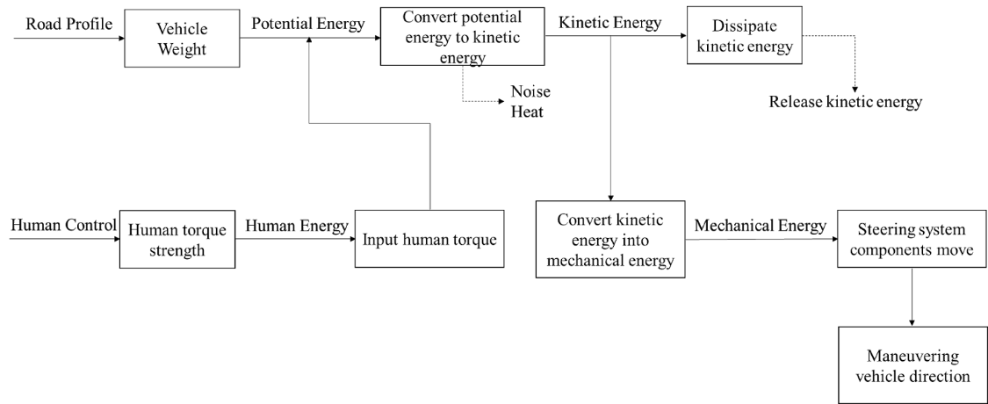
Figure 16 functional decomposition of the front-end suspension system

Functional Model for the brake system:
We have three inputs that are converted by energy in sequences of processes that lead the vehicle to stop as the friction force.
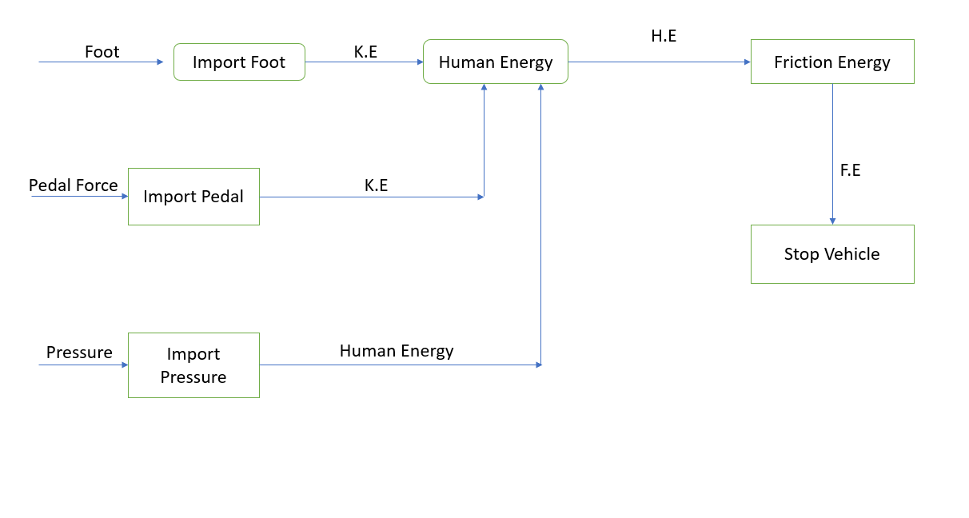
Figure 17 functional decomposition of the Brake system
Functional Model for the dashboard:
This figure shows the flow of the entire instrument panel system. The main process is that the analog signal of the vehicle is transformed into a digital signal through sensors and circuits, and displayed as a light signal on the screen.

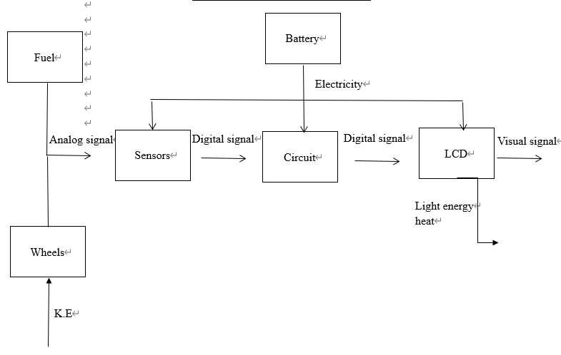
Figure 18 Functional Decomposition of the dashboard

CONCEPT GENERATION

The front-end suspension, the braking systems, and dashboard have been designed and validated on the Baja vehicle performance. The team has reviewed the exciting design of the above-mentioned systems and focused on the advantages/disadvantages of each system. The team has developed different concepts. This section presents the system and the subsystem design.

Full System Concepts

Full System Design #1: Unequal A-Arm Mono-Tube with Torsion spring
This design is light in the suspension geometry and has an effective camber [26,27]. For the geometry, takes an unequal double wishbone A-arm, the spring representing torsion bar spring, also, in this design, it includes the mono-tube. Despite this, the revised suspension geometry of the car is bound to neutralize the weight on the front-end suspension by spreading it equally across all wheels. The light suspension geometry is also important towards off-road activities where the center of gravity is shifted multiple times. Light suspension geometry and the effective camber prevent the vehicle from tipping over.

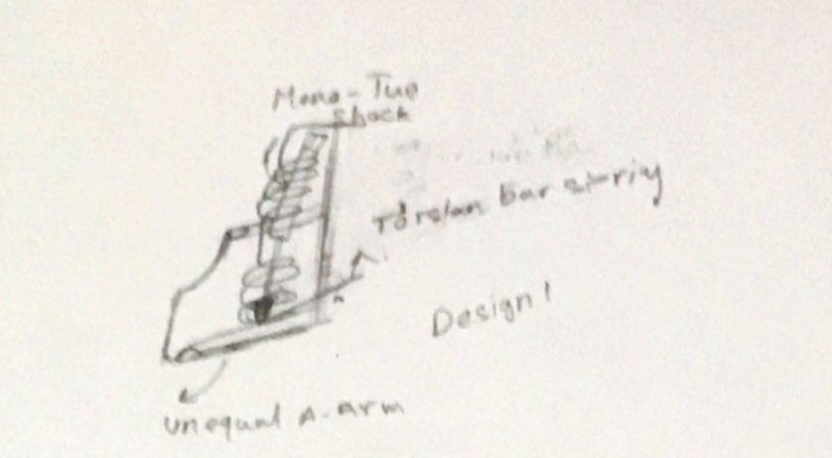
Figure[19]: Unequal A-Arm Mono-Tube with Torsion spring

Full System Design #2: Double Wishbone and Mono-tube with Coil Spring.
This design is the best overall. It provides the best camber control, with a highly reliable shock-absorbing mechanism [4,5]. These two features make this design the most reliable in off-road terrains where great camber control and a reliable shock absorbing system are essential. This system is generally compact since the A-arms geometry offers good compactness with high linking features. It is also lightweight and effective in ensuring stability, strength, and resistance to strenuous forces. The design is provided with a coil spring that absorbs shock and integrates well with the double wishbone equal-length A-arms. A high initial cost is realized with this design as it uses expensive but efficient components in the manufacture and assembly phases. Nevertheless, the design provides the desired suspension performance, and long-run shock-absorbing capability.

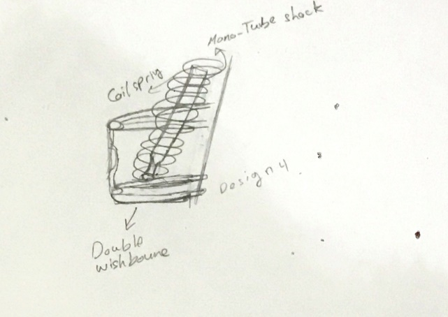
Figure[20]:Double Wishbone and Mono-tube with Coil Spring

Full System Design #3: MacPherson Strut and Twin-Tube with Torsion spring
In this design, the most defining feature that separates it from the rest is the use of a torsion bar as the main weight-bearing feature. The torsion bar is used for the front-end suspension. This feature gives the design more durability and elasticity. The design is also compact with desired component weight, which potentially makes it easy to navigate For the geometry of this design that is considered adjustable with this design is MacPerson Strut. However, the maintenance of this design is not attainable by the users. In addition, the safety of this design with the twin-tube shocks is not among the best, and thus precaution should be used when driving it.

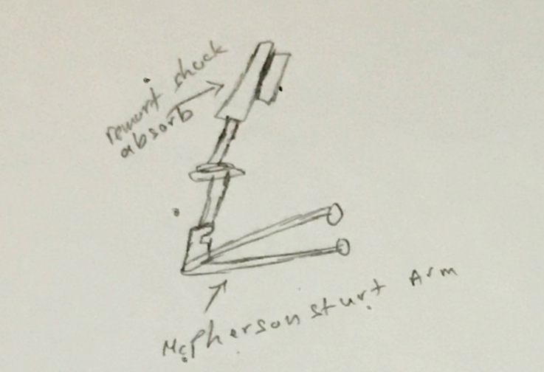

Figure[21]:MacPherson Strut and Twin-Tube with Torsion spring

Subsystem Concepts

Subsystem #1: Geometry

Design #1: Double wishbone
The wishbone design has become one of the most popular for Baja vehicle assembly. Also, this kind of design is known for its strength and the effectiveness. It is known that a double wishbone has perfect features that it is light on the weight and can bear the bumps. Following are the porns and cros:
The advantages:
- light weight
- Independent suspension system
- Keeps high degree wheel-tires alignment
The disadvantages:
- expensive
- Difficult repair
- complex manufacturing and measurements.

Design #2: MacPherson Strut

In design 2, it has a different kind of geometry that is identified as Macpherson strut. The MacPherson Strut design combines the shock absorber and the spring in the same unit [30]. It is used in many vehicles, but as analyzed, most Baja vehicles do not like to design such as this type of design. Gaining the camber with hard cornering can be attained through improving on the steering of the vehicle. Improving the efficiency at off-road driving can be done using better shocks that can limit the destabilization of the vehicle in tough terrain. Lastly, an alternative for camber can help solve the challenge without necessarily interfering with the performance of other sections of the vehicle.
The advantages:
lighter weight due to reduced unsprung weight
offering comfort in ride and performance
Essay to assemble and maintenance
fit the small wheels in an off-terrain setting makes it minimalist but functional.

The disadvantages:
more space required to install, tall design
Less- efficient off-road
difficulty to gain camber with hard cornering.
lost efficiency in performance of wheel

Design #3: Unequal A-arm Double Wishbone
The design is a feasible damping capacity on the rough terrain. The constituent dual control arms of this setup are not equal. These differences in the sizes of the two control arms are responsible for the advantages of the setting. The complexity in installing the dimension can be solved through adapting simple manual solutions in the place of technical manufacturing processes that are difficult to obtain repair parts for. Additionally, shock performance can be maintained through applying high car frames. Lastly, the suspension and the spring needs to be changed as they are too rigid

The advantage:
- easy to perform road cornering control.
- gaining negative camber during hard cornering.
- Light suspension geometry makes the design suitable for off-roading
- The vehicle cannot easily tip over.

The disadvantage:
- complexity in installing dimension determination.
- shock/spring is almost 90 degrees which affects the shock performance.
- Rigidity in the suspension of the vehicle.

Subsystem #2: Shock absorber

Design #1: Mono-tube shock
This design is popular for the Baja system. This demonstrates the reliability of this system for off-road riding. A maximum possible vertical mounting angle of this design may as well offer a more effective damping performance.
The advantage:
damping stability
possessing the potential to be improved in performance.
aeration does not occur since air and oil are separated
The disadvantage:
high initial cost
any outer damage that can affect the internal function

Design #2: Twin- Tube Shock
This design preserves the oil and pressurized gas in a way that is different from the mono-tube mechanism. In this setup, the oil is kept inside the cylinder and sounded with the pressurized gas [31]. Its performance can be improved through regular maintenance that reduces the chances of aeration in the system and thus halts performance.
The advantage:
- the low production cost.
- more durability.
- efficient stability.
The disadvantages:
- possibility to create aeration
- limitation of the oil capacity
- less opportunity to be customized

Design #3: Air Shock
Air shocks are used as replacements or alternatives for hydraulic shocks.Air shocks should be used alternatively with other types of shocks. This will combine the benefits of all versions while reducing the weaknesses of each form. The application of hydraulic shocks in places where a lot of force is expected to be acting on will be crucial towards overcoming the limitations of the air shocks. The advantages of shock are relatively cheaper to;

The advantage:
- acquire
- operate
- replace
The disadvantages:
- less reliable and inefficient
- have less capacity than hydraulics

Subsystem #3: Spring
[Please keep subsystems consistent with the functional decomposition and subsystem benchmarking.]

Design #1: Torsion spring
The torsion spring works uniquely by storing the energy by twisting not through compression. This type of spring may provide a less-desirable response to keep the wheels in touch with the ground [32]. The design requires more lateral space since it does not fit axial assembly. It has mainly two advantages, good for side mounting, and can store the energy by the twist. The disadvantages of the design are the less effectiveness for off-road, and the limitation to handle the bumps well.

The advantage:
- durable due to the presence of the torsion bar.
- easy to navigate due to its low weight
- has high responsiveness to steering control

The disadvantage:
- highly inefficient in shock absorption
- maintenance costs of the design are too high.
- design is relatively unsafe to drive in.

Design #2: Coil Spring
[Describe in detail a design solution you have considered. Include a list of Pros and Cons.]
This design is the widest for Baja vehicles. The coil spring can store more energy when exposed to compress force. The design is customizable and compact. Coil springs should be used alternatively with other types of springs. This will combine the benefits of all versions while reducing the weaknesses of each form.
- The advantage:
- ability to better customize the vehicle to make it unique and suit the performance.
- improves the off-road capability of the vehicle.

The disadvantages:

- high initial costs
- high acquisition costs also translate to high maintenance costs
- limitation to be used for heavy vehicles

Design #3: Air Spring
The air spring design can provide further stability and can bear more vehicle weights than traditional springs. It is usually made of rubber-and-fabric. The design is a container shaped like bellows. The spring action results from the compression and expansion of the air.

The advantage:
- stability and control for a larger payload
The disadvantage:
- high initial cost and the complex maintainability
- not preferred for rough terrain.

DESIGNS SELECTED – First Semester

The design selected involved processes that indicated the criteria for selection. It also captured the priority that the engineering team used to choose appropriate designs. The fundamental design selections ensured that the team followed all protocols to meet the design requirements. The technical team used each component of the design by applying the same criteria after ascertaining their efficiency. They confirmed that every detail was observed to acquire the desired outcome. In general, the technical team chose the best components reflecting the real result of the process.

Technical Selection Criteria
[Identify the technical criteria you will use for comparing the designs in Chapter 4 and explain why they are significant in your design selection. These should be key customer and engineering requirements, and must be quantifiable in nature. Describe how these criteria are used in the Pugh Chart versus Decision Matrix, i.e. why were they chosen for each particular selection method.]
The engineering team considered the engineering and customer requirement to meet the expected objectives by determining the best design. They ensured quality by reviewing all the criteria for the design. This process included the Baja SAE updated standards, which is a collegiate design series. The technical team conducted numerous evaluations to determine which plan was the best. This process examined the original cost of the system and its durability. Moreover, the evaluation process determined the system's effectiveness and reliability to ensure the project functioned as envisaged. The team applied this approach to enable it to decide the right design to adopt. The team realized that the Baja SAE competition requires a design that performs efficiently and effectively considering the evaluation results.
Baja SAE has three regional competitions, which guide engineering design projects and possible challenges. In this criterion, the engineering team selects a system following two steps. The first one involves Pugh chart analysis, a decision matrix that allows listing of solutions on one excels. Using this procedure, the engineering team examined design performance using aspects such as capability, durability, and safety over rough terrain. The second step entails decision matrix selection, which allows evaluation and prioritizes a list of options needed to implement the selected design. After designs have been chosen through the Pugh chart, they are then evaluated through a decision matrix.

Rationale for Design Selection
5.2.1 Front Suspension Design Selection:
The technical team selected different elements of the design. First, they chose the double-wishbone geometry to apply in the front-end suspension system. This design has an Upper and Lower arm, Damper, Spring, and wheel hub. The double-wishbone geometry allowed the selection of mono-tube shock consisting of coil springs. Notably, this selection emerged after a detailed evaluation process meant to determine the effectiveness of the system. The team applied the Pugh chart as depicted in table 1 in the appendix A section to ascertain the selected design's efficiency. This process led to selecting three designs, which were evaluated through the decision matrix, as shown in table 2 in the appendix section A. The technical team considered the engineering and the customer requirement before forming a conclusion about the best design to adopt. The team factored all the criteria to choose the right strategy for the process
5.2.1 Brake system Design Selection:

There are two systems which can use, disk and drum brake system, both aim to stop the vehicle but each one of this type is designed for specific vehicles. Drum brakes systems are designed to build for heavy vehicles while the disk brakes for the normal vehicles. Also, the disk brake gets lower heat compared to the drum because of the low sensitivity to temperature, disk brakes can operate with minimal fade at high temperatures [8]. No less important, the disk is easier than drum in to be fixed which means it is appropriate for the SAE Baja competition.
5.2.1 Dashboard Design Selection:
The purpose of the dashboard is to detect accurate vehicle data and display it on the screen.The basic concept of the dashboard consists of three parts. Sensors, circuits and screens. Circuit I chose to use Arduino as the circuit board。 For the screen I use LCD, which is a commonly used display on Arduino. The infrared sensor can count the number of rotations of the wheel by counting the number of times the infrared has passed through the hole on the wheel. The hall effect speed sensor is characterized by its stability after installation, low cost and high accuracy. The main disadvantage is that it is difficult to install and easy to be affected by environmental factors. The advantage of an infrared speed sensor is that it is not easily affected by environmental factors, the circuit is simple, and it is easy to install. The disadvantage is that the accuracy is not high and it is easily affected by light and dust. But these can be avoided with a protective cover. After an evaluation, the data showed that the infrared speed sensor is more suitable for our team’s project.

REFERENCES
[Include here all references cited, following the reference style described in the syllabus. There should only be one Reference list in this report, so all individual section or subsection reference lists must be compiled here with the main report references. If you wish to include a bibliography, which lists not only references cited but other relevant literature, include it as an Appendix.]
[1] Sourav Pattnaik (2020). Design and Analysis of Braking System for Baja All-Terrain vehicle. International Research Journal of Engineering and Technology (IRJET) .Volume: 07 Issue: 02.
[2] Dr.David Willy (2021) SAE BAJA Spring 2021 ME476C [
[3] Limpert, R. (2011). Brake design and safety (3rd ed.). Warrendale, Pa.: Society of Automotive
Engineers.
[[4]R. Limpert, Brake design and safety, 3rd ed., Warrendale, Penn.: SAE International, 2011.
[5]"Hydraulic Disc Brakes | Order Custom Hydraulic Disk Brakes from Knott Brake - Knott Brake Company", Knottbrake.com, 2021. [Online]. Available: https://knottbrake.com/categories/disc-brakes/hydraulic-disc-brakes/. [Accessed: 05- Mar- 2021].
[6]"Drum brakes", Your Mechanic, 2019. [Online]. Available: https://www.yourmechanic.com/article/how-drum-brakes-work. [Accessed: 05- Mar- 2021].
[7]"Disc vs. Drum Brakes: Pros and Cons", NAPA Know How Blog, 2020. [Online]. Available: https://knowhow.napaonline.com/disc-vs-drum-brakes-pros-and-cons/. [Accessed: 05- Mar- 2021].
[8] J. M. K. M. a. R. H. D. Stimson, "2015-2016 SAE Baja Major Qualifying Project Final Report," wpi.edu, vol. 1, no. 1, pp. 1-70, 2016.
[9] Students.sae.org, 2021. [Online]. Available: http://students.sae.org/competitions/bajasae/wisconsin/eventguide2.pdf. [Accessed: 05- Mar- 2021].
[10] Students.sae.org, 2021. [Online]. Available: http://students.sae.org/competitions/bajasae/wisconsin/eventguide2.pdf. [Accessed: 05- Mar- 2021].
[11] 2021. [Online]. Available: http://www.f2autolife.com/. [Accessed: 04- Mar- 2021].
[12] "BODEN AUTOHAUS", BODEN AUTOHAUS, 2021. [Online]. Available: http://www.bodenautohaus.com. [Accessed: 04- Mar- 2021].
[13] "Shock absorbers explained", Outback Travel Australia, 2021. [Online]. Available: https://outbacktravelaustralia.com.au/4wd-mods-tech-torque/shock-absorbers-explained/. [Accessed: 05- Mar- 2021].
[14] W. shock?, "What is a monotube shock?", Help.summitracing.com, 2021. [Online]. Available: https://help.summitracing.com/app/answers/detail/a_id/5251/~/what-is-a-monotube-shock%3F. [Accessed: 05- Mar- 2021].
[15] "Monotube vs. twin tube shocks - Which should you trust with your vehicle?", Strutmasters, 2021. [Online]. Available: https://www.strutmasters.com/monotube-vs-twin-tube-shocks/. [Accessed: 05- Mar- 2021].
[16] "What Actually Is Double Wishbone Suspension?", Car Throttle, 2021. [Online]. Available: https://www.carthrottle.com/post/what-actually-is-double-wishbone-suspension/. [Accessed: 05- Mar- 2021].
[17] [1]2021. [Online]. Available: http://www.carbibles.com/suspension_bible.html. [Accessed: 05- Mar- 2021].
[18] "What Actually Is Double Wishbone Suspension?", Car Throttle, 2021. [Online]. Available: https://www.carthrottle.com/post/what-actually-is-double-wishbone-suspension/. [Accessed: 05- Mar- 2021].
[19] "How Car Suspensions Work | Repair, Car fix, Car mechanic", Pinterest, 2021. [Online]. Available: https://www.pinterest.com/pin/468092954999018913/. [Accessed: 05- Mar- 2021].
[20] Automotivearticles.com, 2021. [Online]. Available: http://www.automotivearticles.com/uploads/a-arm_img.jpg. [Accessed: 05- Mar- 2021].
[21] "Log in to Facebook | Facebook", Facebook, 2021. [Online]. Available: https://www.facebook.com/michiganbajaracing. [Accessed: 05- Mar- 2021].
[22] "The Key to Winning Off-Road Racing: Understand the Loads on Your Car", Ansys.com, 2021. [Online]. Available: https://www.ansys.com/blog/key-to_winning-off-road-racing-know-the-loads-on-your-car-baja-sae. [Accessed: 05- Mar- 2021].
[23] "Baja SAE", Bajasae.net, 2021. [Online]. Available: https://www.bajasae.net/res/CompetitionResults.aspx?competitionid=09bafb4a-baf7-4c4d-a974-2aa0ac22ba9d. [Accessed: 05- Mar- 2021].
[24] "Beaver Racing Goes to Washington | SAE Beaver Racing | Oregon State University", Beaverracing.org, 2021. [Online]. Available: http://beaverracing.org/feature-story/beaver-racing-goes-washington. [Accessed: 05- Mar- 2021].
[25] J. Ullrich, "Why Upgrade to Remote Reservoir Shocks | Off Road Blog", Offroadpowerproducts.com, 2021. [Online]. Available: https://offroadpowerproducts.com/blog/why-upgrade-to-remote-reservoir-shocks/. [Accessed: 05- Mar- 2021].

[26] J.-S. Young, H.-Y. Hsu, and C.-Y. Chuang, “Camber Angle Inspection for Vehicle Wheel Alignments,” Sensors, vol. 17, no. 2, p. 285, Feb. 2017, doi: 10.3390/s17020285. [Online]. Available: https://www.ncbi.nlm.nih.gov/pmc/articles/PMC5336001/. [Accessed: 20-Feb-2021]

[27]M. B. Baharom, K. Hussain, and A. J. Day, “Design of full electric power steering with enhanced performance over that of hydraulic power-assisted steering,” Proceedings of the Institution of Mechanical Engineers, Part D: Journal of Automobile Engineering, vol. 227, no. 3, pp. 390–399, Jan. 2013, doi: 10.1177/0954407012468413. [Online]. Available: https://journals.sagepub.com/doi/abs/10.1177/0954407012468413. [Accessed: 20-Feb-2021]

[28] W. Shivaraj. Singh and N. Srilatha, “Design and Analysis of Shock Absorber: A Review,” Materials Today: Proceedings, vol. 5, no. 2, pp. 4832–4837, 2018, doi: 10.1016/j.matpr.2017.12.058. [Online]. Available: https://www.sciencedirect.com/science/article/pii/S221478531733033X. [Accessed: 20-Feb-2021]
[29] L. Cao, Y. Lin, F. Lu, R. Chen, Z. Zhang, and Y. Li, “Experimental Study on the Shock Absorption Performance of Combined Aluminium Honeycombs under Impact Loading,” Shock and Vibration, vol. 2015, pp. 1–8, 2015, doi: 10.1155/2015/689546. [Online]. Available: https://www.hindawi.com/journals/sv/2015/689546/. [Accessed: 21-Feb-2021]
[30]S. D. Shinde, S. Maheshwari, and S. Kumar, “Literature review on analysis of various Components of McPherson suspension,” Materials Today: Proceedings, vol. 5, no. 9, pp. 19102–19108, 2018, doi: 10.1016/j.matpr.2018.06.263. [Online]. Available: https://www.sciencedirect.com/science/article/pii/S2214785318313865. [Accessed: 18-Feb-2021]
[31]“Study on cavitation phenomenon of twin-tube hydraulic shock absorber based on CFD,” Engineering Applications of Computational Fluid Mechanics, 2019. [Online]. Available: https://www.tandfonline.com/doi/full/10.1080/19942060.2019.1666035. [Accessed: 19-Feb-2021]
[32]J. Sheng and J. P. Desai, “Design, modeling and characterization of a novel meso-scale SMA-actuated torsion actuator,” Smart Materials and Structures, vol. 24, no. 10, p. 105005, Aug. 2015, doi: 10.1088/0964-1726/24/10/105005. [Online]. Available: https://www.ncbi.nlm.nih.gov/pmc/articles/PMC6980391/. [Accessed: 05-Mar-2021]
[33] S. of Automotive Engineers, “Suspension - CCNY SAE,” Google Sites, 01-Nov-2014.
[Online]. Available: https://sites.google.com/site/ccnysae/past-competitions/2012-
baja/component-redesigns/suspension. [Accessed: 30-Jan-2021].
[34] L. Wright, K. Hopkins, M. Clark, and D. Tomczak, “SAE Baja - Front Suspension,”Mountain Scholar, 01-Jan-2020. [Online]. Available: https://mountainscholar.org/bitstream/handle/20.500.11919/2469/Front_Suspension_and_steering.pptx?sequence=1&isAllowed=y. [Accessed: 30-Jan-2021].
[35] M. Ingalsbee, “Off Road Suspension 101: An In-Depth Look,” Off Road Xtreme,
19-Dec-2017. [Online]. Available: https://www.offroadxtreme.com/engine-tech
/brakes-suspension/off-road-suspension-101-an-inside-look/. [Accessed: 30-Jan-2021].

[36] B. Maclaurin, High speed off-road vehicles: suspensions, tracks, wheels and dynamics,
1st ed. Hoboken, NJ: Wiley, 2018.

[37] T. McGee, 4 x 4 Suspension Handbook. North Branch, MN: CarTech, Inc, 2008.

[38] Eng.auburn.edu, 2021. [Online]. Available: http://www.eng.auburn.edu/~dbeale/MECH4240-50/reports/VirtualPrototyping_MECH4250FinalReport_2010Sp.pdf. [Accessed: 06- Mar- 2021].

[39] Colorado.edu, 2021. [Online]. Available: https://www.colorado.edu/saebaja/sites/default/files/attached-files/team_65_design_report.pdf. [Accessed: 06- Mar- 2021].

[40] B. Minaker and Z. Yao, "Design and Analysis of an Interconnected Suspension for a Small Off-Road Vehicle", Archive of Mechanical Engineering, vol. 64, no. 1, pp. 5-21, 2017. Available: 10.1515/meceng-2017-0001 [Accessed 6 March 2021].

[41] S. Bansode, "Modeling Of Multibody Dynamics In Formula SAE Vehicle Suspension Systems", Hdl.handle.net, 2021. [Online]. Available: http://hdl.handle.net/1805/22737. [Accessed: 06- Mar- 2021].

[42] "Baja SAE", Bajasae.net, 2021. [Online]. Available: https://www.bajasae.net/cdsweb/gen/DocumentResources.aspx. [Accessed: 06- Mar- 2021].

[43] Michigan Engineering. 2021. Baja Racing breaks records while leaving the competition in the dust | Michigan Engineering. [online] Available at: <https://news.engin.umich.edu/2019/09/baja-racing-breaks-records/> [Accessed 28 January 2021].
[44] Suresh, Ganzi. (2013). Design Optimization of a Wishbone Suspension of a Passenger Car.
[45] Skedsoft.com. 2021. Macpherson Strut Front Suspension System Design. [online] Available at: <https://www.skedsoft.com/books/automobile-engineering/macpherson-strut-front-suspension-system-design> [Accessed 29 January 2021].
[46] Ikhsan, Nurzaki & Ramli, Rahizar & Alias, A.. (2015). Analysis of the Kinematics and Compliance of a Passive Suspension System using Adams Car. Journal of Mechanical Engineering and Sciences. 8. 1293-1301. 10.15282/jmes.8.2015.4.0126.
[47] Stevens, M., 2021. MacPherson Strut vs Double Wishbone Suspension (Pros and Cons). [online] CarTreatments.com. Available at: <https://cartreatments.com/pros-and-cons-of-macpherson-vs-double-wishbone-suspension/> [Accessed 28 January 2021].

[48] Rhyan Brogmus, David Woods and Sam Hunker, Drivetrain Preliminary Report, NAU capstone, 2017
[49] ADMINISTRATOR, How to Interface LM393 Speed Sensor with Arduino?, ELECTRONICS HUB, SEPTEMBER 7, 2018
[50]VadimS, Building a Capacitive Liquid Sensor, instructables circuits, 2014
[51] Shashank Wekhande and Ranjit Farakate, Hall Sensors for Fuel Level Sensing, ALLEGRO, 2017
[52] Gary Pepka, position and level sensor using Hall effect sensing technology, Allegro MicroSystems, 2016
[53]Wes Clawson and Eddie Samuels, Dashboard and Wireless Transfer Module, the University of
Rochester SAE Baja Team, No release date.
[54] Payne, Eric T., "Design of an SAE Baja Racing Off-Road Vehicle Powertrain" (2015). Honors Research Projects. 30.

APPENDICES

Appendix A: Descriptive Title
Table 1: Pugh Chart of Front suspension
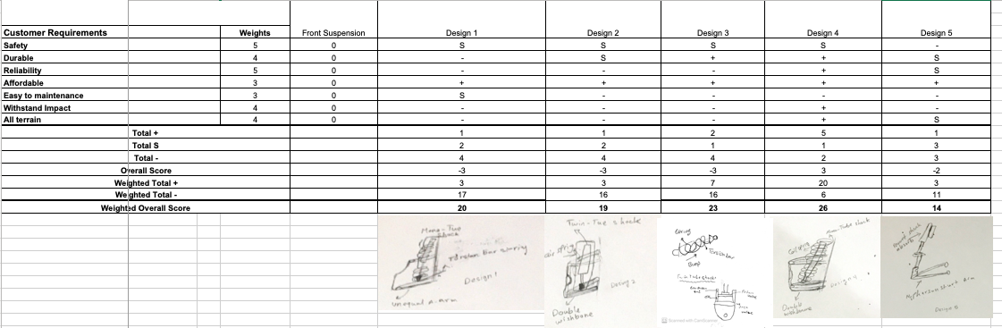
Table 2: Decision Matrix of Front suspension
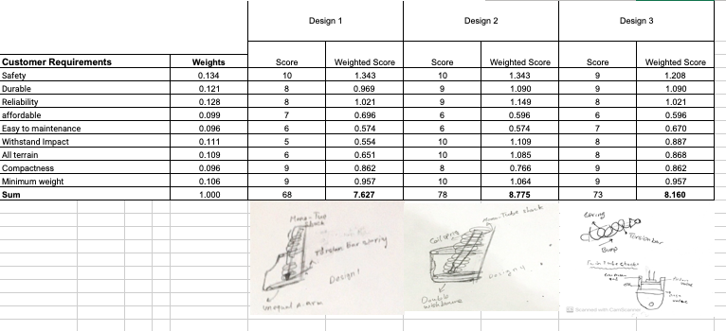
Table 3: Decision Matrix of Brake system
