SAE Baja

Final Proposal

Omer Alamoudi
Chujian Wang
Salem Al Marri
Musaed Fraidoun
Rashid Algelmod

2020-2021



Instructor: Dr. David Willy

DISCLAIMER
This report was prepared by students as part of a university course requirement. While considerable effort has been put into the project, it is not the work of licensed engineers and has not undergone the extensive verification that is common in the profession. The information, data, conclusions, and content of this report should not be relied on or utilized without thorough, independent testing and verification. University faculty members may have been associated with this project as advisors, sponsors, or course instructors, but as such they are not responsible for the accuracy of results or conclusions.

EXECUTIVE SUMMARY

The brake of SAE Baja vehicle is to find out the heat generated and dissipated on the disc brake of the wheel which equals to almost 85.15 °C as the maximum temperature in Celsius, the time needed to stop the vehicle was found by using of calculation, and completion of the brake system will be explained in detail in the rest pages. No less important, the team used Solid works to discover the heat that comes from the friction force between the pads and the rotor, time needed to stop the vehicle by using Newton’s laws, and updated caliper design of the brake.

For the dashboard, the team designed a system based on the Arduino board, which uses the IR sensor to detect the speed of the vehicle. The purpose of the design is to have a clear and brief outlook and it has accuracy speed display and short display delay on the LCD. Moreover, a stepper motor is added into the system to analog the speed table, which can make it more convenient for the driver to see the speed of the vehicle and make the appearance of the dashboard more concise and briefer. In general, the design of the dashboard meets the requirements of a concise appearance, displaying vehicle speed data, accurate readings, and low display delay.

For the suspension and steering, the team designed a durable and reliable systems that can endurance the weight of vehicle and the driver weight as well. The team select the doble wishbone A arm for the front suspension with mounting the shock absorber on the upper arm and selecting the Monotube shock absorber. Moreover, the team select the rack and pinion design through the concept generation of both systems. The suspension system and steering system can successful during the competition based on the output and the result that team get from the Finite Element Analysis (FEA), and Motion analysis. These two simulations can test the system if it will work and successful. Therefore, the team used them to prove the engineering requirement and to meet the customer requirement. The result of FOS from the FEA were greater than 1 which means the systems are work and not failed. Finally, team were able to prove most of the engineering requirement and customer requirements.

ACKNOWLEDGEMENTS
Baja vehicle analytical team wish to acknowledge and give their warmest gratitude to David Willy agreeing to the client’s project and providing tremendous support from the onset to completion. Without Dr. David Willy supports, this project would not be successful.

Moreover, team would like to give special appreciates to the clients for their unwavering support during this project. Dr. Willy guided the entire team through this journey until we achieved our goals. We could not have done it without helping of Dr. Willy who is always answering and supporting the team’s concern to guide the team to the right way.

Team are incredibly grateful to the Department of Mechanical Engineering and all staff members working there. team special thank go to Dr. Willy, who helped team to perform, build and analyze the project in analytically. our benefited from the concerted effort, professionalism, worthy experience, and enormous assistance of Dr. Willy.

TABLE OF CONTENTS
Contents
DISCLAIMER 2
EXECUTIVE SUMMARY 3
ACKNOWLEDGEMENTS 4
TABLE OF CONTENTS 5
1 BACKGROUND 2
1.1 Introduction 2
1.2 Project Description 2
2 REQUIREMENTS 3
2.1 Customer Requirements (CRs) 3
2.2 Engineering Requirements (ERs) 4
2.3 Functional Decomposition 4
2.3.1 Black Box Model 5
2.3.2 Functional Model/Work-Process Diagram/Hierarchical Task Analysis 5
1.1.1.1 Front End Suspension 6
1.1.1.2 Brake System 6
1.1.1.3 Dashboard System 7
2.4 House of Quality (HoQ) 7
2.5 Standards, Codes, and Regulations 7
3 DESIGN SPACE RESEARCH 9
3.1 Literature Review 9
3.1.1 Disc vs. Drum Brakes: Pros and Cons [2] 9
3.1.2 Dashboard and Wireless Transfer Module [40] 9
3.1.3 Baja SAE in 2015, Colorado, boulder [14] 9
3.1.4 Society of Automotive Engineers [12] 9
3.1.5 Powder River Racing SAE Baja Front Suspension Team at the University of Wyoming [13] 9
3.1.6 MacPherson Strut vs Double Wishbone Suspension [15] 10
3.2 Benchmarking 10
3.2.1 Subsystem Level Benchmarking 10
3.2.1.1 Subsystem #1: Shock absorbed 10
3.2.1.1.1 Existing Design #1: Monotube shock absorber 10
3.2.1.1.2 Existing Design #2: Twin Tube shock absorber 11
3.2.1.2 Subsystem #2: Geometry 11
3.2.1.2.1 Existing Design #1: Double wishbone 11
3.2.1.2.2 Existing Design #2: MachPherspn 12
3.2.1.2.3 Existing Design #3: Unequal Length Double A-arms 12
3.2.1.3 Subsystem #3: Steering System 13
3.2.1.3.1 Existing Design #1: Rack and Pinion Steering System 13
3.2.1.3.2 Existing Design #2: Recirculating Ball Screw steering mechanism 14
3.2.1.4 Subsystem 4: Dashboard 15
3.2.1.4.1 Existing Design #1: Infrared speed sensor 15
3.2.1.4.2 Existing Design #2: Capacitive Liquid Sensor 15
3.2.1.4.3 Existing Design #3: Hall Sensors for Fuel Level Sensing 16
3.2.1.5 Subsystem 5: Brake System The brake system is responsible to slowdown the vehicle and it should be designed in an excellence to prevent disasters that will affect the driver life. Also, there are existing critical parts for the brake, and they will be explained below, 17
3.2.1.5.1 Existing Design #1: Complete System 17
3.2.1.5.2 Existing System: Brake Pads 17
4 CONCEPT GENERATION 18
4.1 Subsystem Concepts 18
4.1.1 Subsystem #1: Geometry 18
4.1.1.1 Design #1: Double wishbone 18
4.1.1.2 Design #2: MacPherson Strut 18
4.1.1.3 Design #3: Unequal A-arm Double Wishbone 19
4.1.2 Subsystem #2: Shock absorber 19
4.1.2.1 Design #1: Mono-tube shock 19
4.1.2.2 Design #2: Twin- Tube Shock 19
4.1.3 Subsystem 3: Steering System 20
4.1.3.1 Design #1: Worm Gear Steering Mechanism 20
4.1.3.2 Design #2: Rack and Pinion Steering Mechanism 20
4.1.4 Subsystem 3: Brake System: 21
4.1.5 Subsystem 3: Dashboard System: 21
4.1.5.1 Design #1: LM393 speed sensor 21
4.1.5.2 Design #2: IR sensor 21
5 DESIGN SELECTED – First Semester 23
5.1 Design Description 23
5.1.1 Brake System 23
5.1.2 Front Suspension 26
5.1.3 Dashboard System: 28
6 IMPLEMENTATION – Second Semester 30
6.1 Design Changes in Second Semester 30
6.1.1 Design Iteration 1: Change in Brake Disk discussion 30
6.1.2 Design Iteration 2: Change in Front suspension 30
6.1.3 Design Iteration 3: Change in dashboard 30
7 RISK ANALYSIS AND MITIGATION 31
7.1 Potential Failures Identified First Semester 31
7.1.1 Potential Critical Failure 1: Leather Pads 31
7.1.2 Potential Critical Failure 3: Wishbone 31
7.1.3 Potential Critical Failure 4: Rotor 31
7.1.4 Potential Critical Failure 5: Connections 31
7.1.5 Potential Critical Failure 5: Spring 32
7.1.6 Potential Critical Failure 5: Spring 32
7.2 Potential Failures Identified This Semester 32
7.2.1 Potential Critical Failure 1: Disc Brake 32
7.2.2 Potential Critical Failure 5: Tie Rod 32
7.2.3 Potential Critical Failure 6: The RPM measurement 33
7.3 Risk Mitigation 33
7.3.1 Suspension System 33
7.3.2 Suspension System 33
7.3.3 Steering System 33
7.3.4 Dashboard 33
8 ER Proofs 34
8.1 ER Proof #1 – [Track Width 62 inc] - Tolerance [ +2] 34
8.2 ER Proof #1 – [Able to carry driver weight 130 lb] – Tolerance [ +5] 34
8.3 ER Proof #1 – [Weight of vehicle 375 lb] – Tolerance [ +5] 35
8.4 ER Proof #1 – [[Spring Compression 4.5 in] – Tolerance [ + 0.5] 35
8.5 ER Proof #1 – [Steering Degree 30 degree] – Tolerance [ +5] 35
8.6 ER Proof #1 – [Steering effort 8 lb] – Tolerance [ +0.5] 36
8.7 ER Proof #1 – [Braking Distance 7 Meter] – Tolerance [ + 0.5] 36
8.8 ER Proof #1 – [ Braking Time <5 sec] – Tolerance [0] 37
8.9 ER Proof #1 – [Braking Temperature <100 ] – Tolerance [ 0] 38
8.10 ER Proof #1 – [scope of speed detection] – Tolerance [+ 5] 39
8.11 ER Proof #1 – [Speed detection accuracy] – Tolerance [ 5%] 39
8.12 ER Proof #1 – [Display delay < 1s] – Tolerance [+ 0.5s] 40
9 LOOKING FORWARD 41
9.1 Future Work 41
10 CONCLUSIONS 42
10.1 Reflection 42
10.2 Postmortem Analysis of Capstone 43
10.2.1 Contributors to Project Success 43
10.2.2 Opportunities/areas for improvement 43
11 REFERENCES 45
12 APPENDICES 49
12.1 Appendix A: House of Quality (HOQ) 49
12.2 Appendix B: Failure Modeling FMEA 50
12.2.1 potential Critical Failure 6: Controller Board 50
12.2.2 Potential Critical Failure 7: Wishbone Central Rod 50
12.2.3 Potential Critical Failure 8: Caliper 50
12.2.4 Potential Critical Failure 9: Spindle 50
12.2.5 Potential Critical Failure 10: Brake Rod 50
12.3 Appendix C: FEA Testing and Final Product 51

BACKGROUND

Introduction
The rationale of this design is to assess the design of a small off-road car capable of treading complex terrains comparatively. In order to effectively design and create a prototype, the three vital subsystems must be properly evaluated, namely the brake, front suspension, steering, and dashboard systems. The main goal of the design is for the prototype to have a shorter stopping time and distance relative to the commercially known SAE 2021 vehicle designs. The rules state that the braking mechanism must be capable of simultaneously locking all four wheels [1]. The main takeaway of this endeavor is for the stakeholders to believe that such a design is safer and sturdier. This can only be attained if the braking mechanism is able to do the locking process in a simultaneous manner for the four wheels available.

Project Description
There are four main points for improving and designing new systems in this design: brake, steering, front suspension, and dashboard systems. The SAE-BAJA off-roading vehicle designs and regulations will be incorporated for possible market benchmark propulsion and commercialization in this design. The tests involved acceleration tests, hill climbing, and endurance tests. The achievement of these targets necessitates the accurate design of the vehicle's suspension and braking system to be comparable to the commercially existing ones. For this project, the design is generated from the SAE Baja and the customer requirements in the competition rules to compete. The design should overcome all difficult and complex conditions such as acceleration tests, braking tests, hill climbing, and endurance. To succeed and realize the design's target, it should be an accurate front suspension and braking system in the perfect, accurate manner of design. Finally, the implementation of this design will be analyzed, and the testing will follow by meeting all the client's requirements.

REQUIREMENTS
For any design project, requirements are the main focus, and on the premise of given requirements, the project designs. There are different requirements, and one is customer requirements which obtain from the project description, engineering requirements obtains from the customer requirements. This chapter introduces the customer requirements, engineering requirements, and HOQ of our project. The client gave us the direction and standards of project design. When comparing different designs, these requirements can help us choose the finest design plan.

Customer Requirements (CRs)
The project aims to style and build a reliable single-seat sporting vehicle that's suitable for all-terrain. The project is split into three subsystems: front suspension, brakes, steering, and dashboard. These subsystems were assigned to the members of the team. Following are the requirements that were pulled out from the SAE Baja Project instructions.
Table 1: Customer Requirement
Customer Requirements | Details
Short stopping distance | The system needs to efficiently stop the vehicle in short duration of time
Comfortable for the driver | The suspension needs to work smoothly and efficiently to provide complete comfort of the driver
Sleek dashboard | Display the dashboard with all the data in simplified manner
Accurate dashboard degree | The difference between the measured speed value and the actual value should be small.
Safety | The systems should be safe to use
Durable and reliable | Suspension and brake should work for long duration and Systems should be reliable and must not fail during the operation.
Dimensional stability | The vehicle should be stable to maintain the wheel
Track width | The distance between the front wheels to make the stability of the car
Ease to maintain | The vehicle maintenance should be simple and easy to fix
Heat | The friction of the peds and rotor should be safe
Light weight | Suspension, brakes, and dashboard everything should be light weight

Engineering Requirements (ERs)
Depending on the customer requirements (CR), the engineering requirement is generated by the CR. the most ideas here within the ERs that specialize in the sturdiness and stability of the car, and absolutely weight. Supported Baja competition rules, the measurement of weight should be less than 225 Ib and the target is to be 130 Ib, and therefore the track width of the vehicle should be less than 64 In. The weight of vehicle should not limit 375 Ib with the tolerance. Also, the steering effort will not excused the 8 Ib , and the steering should rotate within 30 degree. The brakes must follow the competition rules for SAE Baja that states to lock all four wheels at the same time. The warmth that's released from the rotors in Baja vehicles is approximated in an exceedingly range that's not above 500 K, that the best brakes are that the disk because it's the power to soak up the warmth better than other brake systems
Table 2: Engineering requirements
Sr. | Engineering requirements | Unit | Target value | Tolerance
1 | Track Width | inch | 62 | +2
2 | Able to carry driver weight | lb | < 130 | +5
3 | Weight of vehicle | lb | 370 | +5
4 | Spring Compression | in | 4.5 | +0.5
5 | Steering Degree | - | 30 | +5
6 | Steering Effort | Ib | 8 | + 0.5
7 | Braking Distance | Meters | 7 | + 0.5
8 | Braking Time | Sec | <5 | -
9 | Braking Temperature | °C | < 100 | -
10 | scope of speed detection | Km/h | 80 | +5
11 | Speed accuracy | Km/h | <5 | + 5%
12 | Display delay | s | <1 | + 0.5

Functional Decomposition
Functional decomposition is the division of particular projects into subsystems. Thus, the functional decomposition defines how the system works from the start till the tip and what steps will perform within the system to require the input to the output. The hierarchical task analysis or functional model defines the system with its subsystems while the recorder model defines the inputs and outputs of the system, and it doesn't define what's happening inside the system, whereas the functional model defines the entire internal working of the system. In this section, the black-box model and functional model will be introduced.

Black Box Model
The Black Box model tells the inputs and outputs of the system, and these inputs and outputs consist of a mass, energy, and signal. The project contains three aspects, front suspension, brake system, and dashboard system, so the black-box model of each subsystem is shown below.
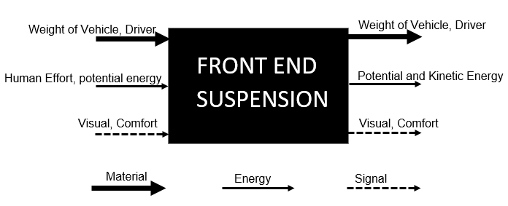
Figure 1: Black Box Model for Front End Suspension
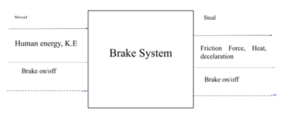
Figure 2: Black Box Model for Brake System
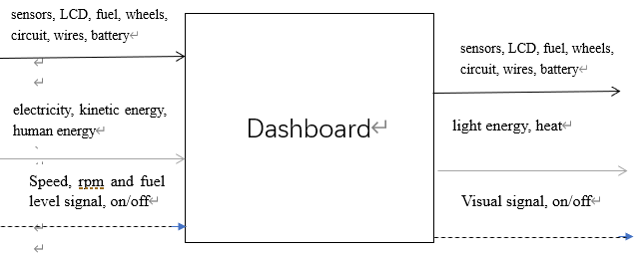
Figure 3: Black Box Model for Dashboard

Functional Model/Work-Process Diagram/Hierarchical Task Analysis
Functional model describes the inputs, outputs and the complete process to reach the input to the output through different steps that perform within the system defined in the functional model.

Front End Suspension
The suspension system consists of three sub-functions. In the first sub-function, potential energy generated in the form of jerks is transferred to the coil. The weight of the driver and the vehicle is the main reason behind the production of potential energy. In the second sub-function, the potential energy exerted on the spring through compression is converted to periodic motion as the spring reacts to the force applied to it. In the last sub-function, the spring, which is the shock absorber, takes up the kinetic energy, paving the way for the system to regain its original state. Consequently, the vehicle becomes comfortable and safe to drive once the kinetic energy is absorbed. The steering system also comprises four sub-functions. Firstly, the driver applies force on the steering wheel, producing torque. Secondly, the steering column facilitates the movement of the generated torque to the gear assembly, which operates through a rotational motion. The rack and pinion arrangement enables the transfer of the rotational motion to the rack, stimulating the rack gear to initiate a horizontal motion.
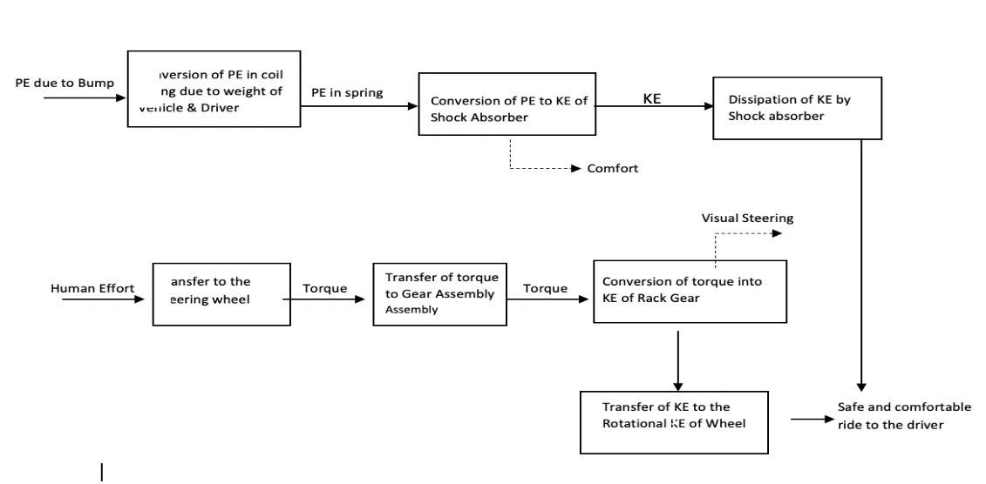

Figure 4: Functional Decomposition of Front End

Brake System
There are three inputs that are converted by energy into a series of processes that lead the vehicle to stop as the friction force.
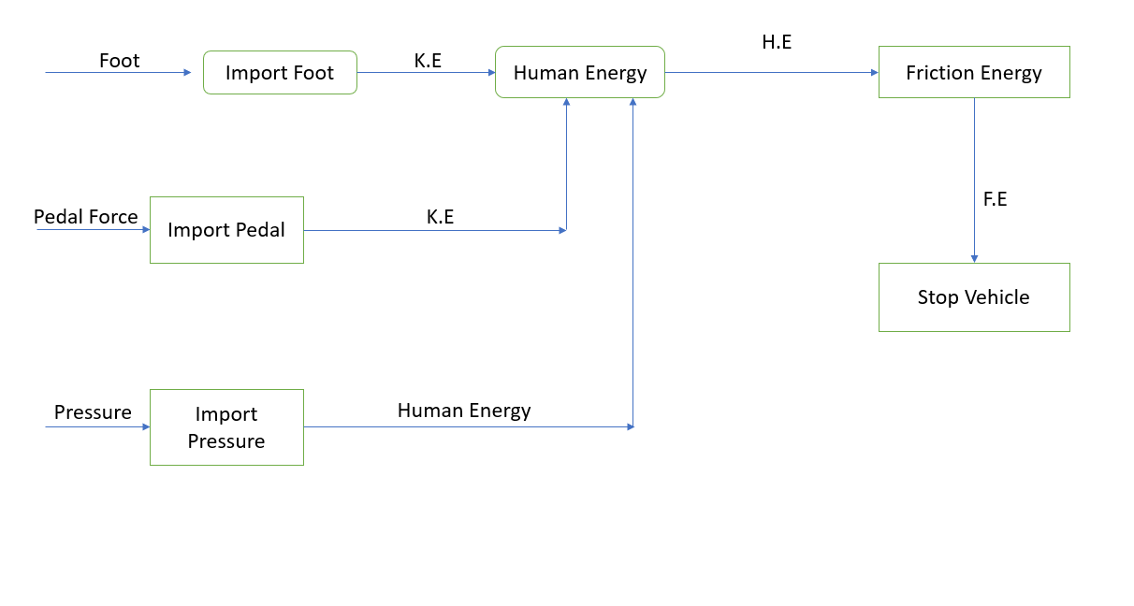
Figure 5: Functional Decomposition of Brake System

Dashboard System
The figure is indicating the whole instrument panel system. The main cycle is to convert the transmission of the analog signal system of the vehicle into a digital signal through sensors and circuits, and display it on the screen as a light signal.

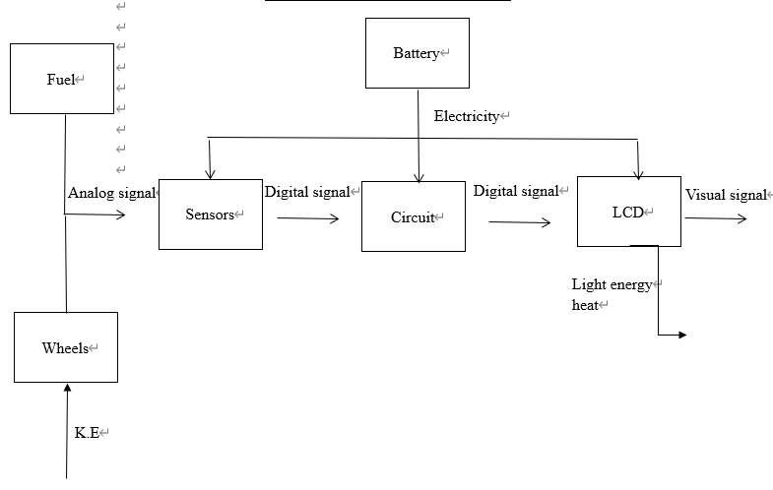
Figure 6: Functional Decomposition of Dashboard

House of Quality (HoQ)
House of Quality provides the link between the customer requirements and engineering requirements. As engineering requirements have devised from customer requirements, so it is important to define the relationship with the customer requirements and through this relationship determine the priority list of engineering requirements as which engineering requirement is most important and which engineering requirement is least important. It will benefit in finalizing the product and in testing phases where engineering requirements are measured through different tests, as the engineering requirement fulfilled by the design is fine or needs an improvement or the deficiency of that engineering requirement is fine for the project. The HoQ will be provided and shown in the Appendix A.

Standards, Codes, and Regulations

Table 3: Standards of Practice as Applied to this Project
Standard Number or Code | Title of Standard | How it applies to Project
ASTM | American Society of Testing and Materials | Apply this code for testing the materials and verifying the material is up to the ASTM standards.
IEEE | Institute of Electrical and Electronics Engineers | Research done for the design project must follow the IEEE standards and all the citations must be done according to the IEEE standards.
ASME | American Society of Mechanical Engineers | This code applies for mechanical designing of the project and it helps in standardizing the design material.
AGMA | American Gear Manufacturing Associations | This code applies for the manufacturing of the product in case the project will manufacture

DESIGN SPACE RESEARCH
This section focuses on the researches to learn more about the SAE Baja vehicles rules and basic functional of the Baja vehicles. Also, through these searches been done to look widely in the literature review to feed our knowledges about the subsystems that we are responsible for. This chapter will discuss about the literature review and benchmarking.

Literature Review

Disc vs. Drum Brakes: Pros and Cons [2]
This resource explains the difference between two types of the disc brakes and the drum brakes differences, all the features of both brakes, the team preferred the disc brakes because it has more efficiency, and it can be maintained. Also, the disc brake gets less heat comparing to the drum.

Dashboard and Wireless Transfer Module [40]
This purpose of this resource is to design a device that has the ability to display, monitor and record the cars velocity. The highlight of their design is the wireless system, which can transmit vehicle data remotely. They believe that real-time speed is not so important for racers, the important thing is to detect and record racing data The Dashboard and Wireless Transfer Module was thoroughly tested and examined in order to provide the simplest, reliable, accurate, and most compact method for operation.

Baja SAE in 2015, Colorado, boulder [14]
The main purpose of this reference is to focus on the factor of safety (FOS), the durability, and durability of the car. No less important, this reference explains about the highly endurance of the weight of the car and the driver as well. Since the competition required to have endurance, stability, and durability to prevent the failures.

Society of Automotive Engineers [12]
The resource discusses about the differences between suspension that can be utilized for the Baja vehicles and it gives the team inspiration of how to improve the suspension system. Also, this source talks about types of shock absorber oil reserve and coil over shock. Multilink suspension was explained in detail in this article.

Powder River Racing SAE Baja Front Suspension Team at the University of Wyoming [13]
This is power point resource that are having an explanation about the differences between the thoughts of sizes of Baja vehicle. Moreover, the PowerPoint illustrate the design of A arms in the vehicle and the type of front suspensions and steering were as well presented the clear ideas of them.

MacPherson Strut vs Double Wishbone Suspension [15]
This reference mainly concentrates the two types of the front suspensions that used widely in the vehicles. Also, it compares MacPherson strut and double wishbone suspension such as: the light weight, easily assemble, the stability of the balance wheel, and the cost.

Benchmarking
For Baja SAE engineering, several competitions have been held. The group has gone over the most recent successful designs. Through the analysis of previous work, a conclusion is reached. To survey the required areas, the team takes on various perspectives. The published design reports, group dissuasion, and interviewing interested parties are all examples of this. The team has concentrated on the component design that reflects more defensible results based on the user's needs. The decision was made in the end to select the most critical components. We'll go over the most recent Baja SAE designs in the following sections.

Subsystem Level Benchmarking
Following three sections present the relevant subsystem to the design components selected in this project

Subsystem #1: Shock absorbed
The shock absorber is an essential component of the front-end suspension system. In this subsystem, three shock absorbers are given and detailed. Including, the mono-tube shock absorber, and the twin tube shock absorber design.

Existing Design #1: Monotube shock absorber
This shock involves a floating piston within a cylindrical piston. The piston and the oil seal break the cylinders into two areas. The usual damping agent, which is usually oil, is present in the lower half of the cylinder. This area is the usual operational journey for damping the piston. Use high-duck gas to fill the upper half of the cylinder. The typical form of gas used is nitrogen. This mechanism offers an additional damping feature. When the piston begins to shift as a result of stock, the fluid and the compressed gas can act on each other to withstand the shock, so that the stock force on the other side can be minimized. The mono-tube shocks shown in figure 7 are generally preferred rather than the twin pipes. Since mono-tubes can split gas from fluid without mixing. Meanwhile, both working fluids mix twin tubes (hydraulic oil and pressurized gas). The flat pistons and the oil density are very fine and precise components however, monotones are expensive. This makes maintenance sensitive and not easy [27].
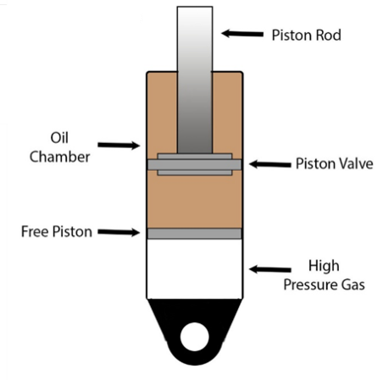
Figure 7: Mono-Tube Shock [28]

Existing Design #2: Twin Tube shock absorber
Unlike a mono-tube shock that has one cylinder, the twin-tube shock has two cylinders; the inner and outer that are modified to maximize efficiency in absorbing shocks when the vehicle is moving. The outer cylinder holds the hydraulic fluid and acts as a reservoir while the inner cylinder provides the surface where the piston and shaft move to dissipate the energy due to impact. The piston valves control most of the damping since this is the section with the active component. In some designs, low pressure nitrogen gas is added to the shock absorber to replace oxygen, which reduces aeration and reduced performance, [29].
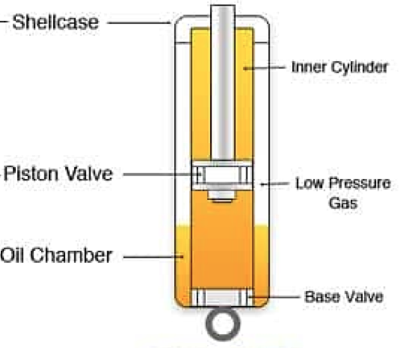
Figure 8: Twin-Tube Shock [30]

Subsystem #2: Geometry
The geometry systems are the connected wheelbase to the mainframe of the vehicle. This system induces all connections used to connect the corporal frame to the wheelbase that contains the front (or back) axles.

Existing Design #1: Double wishbone
Double wishbone suspension systems improve driving comfort regardless of the bumpiness of the road. It is considered an independent suspension system where each wheel is separated from the system. It has the advantage of improving comfort because the bumps on the road affect the contacted wheel, which prevents the transfer of loads to the frame of the car and other tires [31]. The suspension works by allowing each wheel to react to bumps independently from the others. This ability is achieved by the two control arms wishbone-shaped arms located between the chassis and the knuckle located on the wheel.

Existing Design #2: MachPherspn
For independent suspension, this is a popular choice. It works by combining the shock absorber and coil spring into a single unit. The upper control arm and the wishbone system's shock absorber can be replaced with this configuration. MacPherson struts are typically assembled almost vertically, or in a near-vertical position, as shown in Figure 9. Because the suspension system is influenced by the force on the vertical axes, this type of mounting would aid the suspension system in absorbing as much of the impact as possible. As a result, the vehicle is very useful in a rough driving environment. The low initial cost of the MacPherson strut suspension system is another benefit. Aside from the fact that it's simple to keep up with, [32].

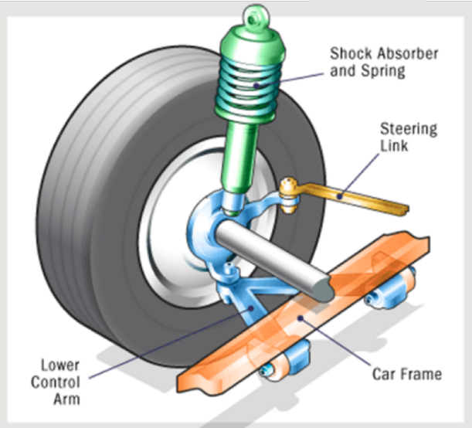
Figure 9: MacPherson strut system [33]

Existing Design #3: Unequal Length Double A-arms
Unequal length A-arm suspension comprises an upper A-arm that is shorter than the lower link. The lower link can be an A-arm or L-arm depending on the applications. During operation, the camber of the vehicle changes as it rolls due to the four-bar linkage mechanism of the unequal arm length. The roll ensures that the contact patch remains square or perpendicular to the ground, thus increasing the stability of the vehicle when the driver is engaging tight corners [34]. Most importantly, the roll caused by the unequal length of the arms reduces the wear of the outer edge of the tire, thus reducing maintenance costs.

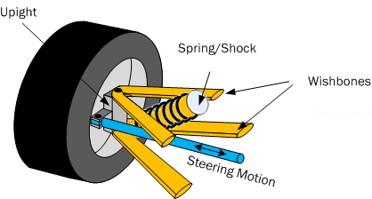
Figure 10: Unequal Length A-arm Suspension [34]

Subsystem #3: Steering System
The benchmarking for the steering mechanism in this section explaining the considerations and the physics of it. The operating principals of similar products was assessed during the research, which informed the types included in the report. Some of the designs of the steering mechanisms that the team found are shown and explained in Figures 7 – 9.

Existing Design #1: Rack and Pinion Steering System
Rack and Pinion steering mechanisms are used in most vehicles due to their simplicity in design and inexpensive manufacturing. The schematic shown in Figure 12 represents a typical rack and pinion steering mechanism.
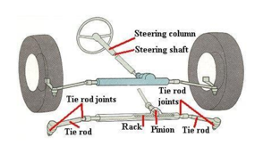
Figure 11: Schematic Diagram of the Rack and Pinion Steering Mechanism [35]
The system comprises the steering wheel, column, rack and pinion gear assembly, and the tie rods [35]. Due to the nature of the steering wheel, the input forces are circular, but the relative movements of the wheels should be linear. Therefore, the rack and pinion gear system convert the rotational motion of the steering into linear motion in the direction of the driver. The rotation causes the rack to move to the left so that the wheel inclines in towards the right and the vehicle turns in the same direction [36]. These systems are easy to fabricate due to the simple design, which implies that it can be used to develop the SAE Baja Vehicle. It also fits in the financial plan because its cost is less than the customer’s requirement.

Existing Design #2: Recirculating Ball Screw steering mechanism
A recirculating ball screw steering mechanism transfers forces using a system of mechanical components from the steering to the wheels. Figure 8 shows the recirculating ball steering mechanism, which consists of a worm gear, ball nut, sector gear, and the pit arm. The mechanisms work in that when the driver rotates the steering wheel, the forces rotate the worm gear, which then transfers the rotational motion into the linear motion of the ball nut. The output motion is then transferred to the sector gear that forces the pitman arm to move, which is connected to the tires and the vehicle then turns [37].

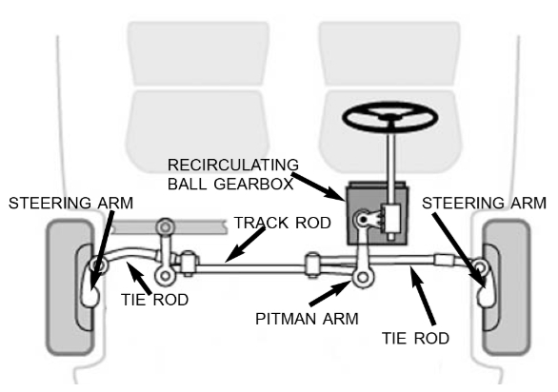
Figure 12: Schematic diagram of the Recirculating [38]
These systems require more turning force compared to the rack and pinion configuration due to the number of parts involved. The friction between the numerous parts reduces the force that is transferred to the succeeding components, hence high and faster wear and tear. Moreover, this configuration needs a higher turning radius for effective performance due to the presence of the sector gear. It also has more weight than the former due to the number of parts [39].

Subsystem 4: Dashboard
Dashboard is the component that displays the data of the vehicle, including speed, fuel level and rpm. During the driving, the driver needs to not only observe the surrounding environment but also concerned about the state of the vehicle. The data is from the sensors placed in specific locations. Through some circuits and wires, the data of the vehicle will be shown on the dashboard screen. References for the number of items provided, the number of items provided by the vehicle, and the number of items provided.

Existing Design #1: Infrared speed sensor
Coming to the sensor, the Infrared LED and the NPN Photo Transistor are placed directly facing each other. When there is no object in the slot, the light from the Infrared LED always falls on the Photo Transistor. The wheel has 20 holes in it, so whenever the wheel makes one rotation, the infrared light from the IR LED is obstructed for 20 times from falling on the photo transistor.[21] This is a method of detecting RPM, the speed of the vehicle can be calculated by detecting RPM.

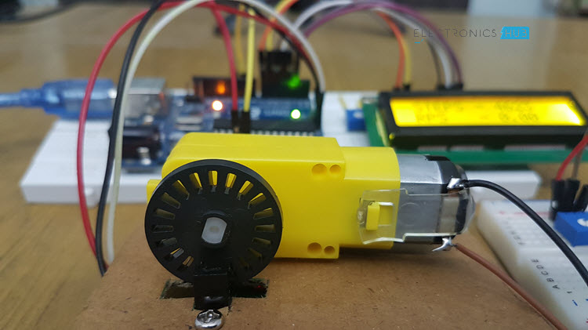
Figure13: LM393 Speed Sensor Module [21]

Existing Design #2: Capacitive Liquid Sensor
A capacitive liquid sponsor relies on the fact the capacitance or charge between 2 metal plates will change (in this case increase) depending on what material is between them. This allows us to create a level sensor that is safe for use with any liquid.[22] This type of solution sensor can be used for fuel level detection in our project. But the shortcomings of this design are obvious. The metal casing of the fuel tank has a significant effect on his measurement. The exposed wires are also susceptible to environmental influences.

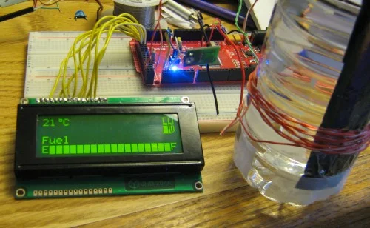
Figure14: LM393 Speed Sensor Module [22]

Existing Design #3: Hall Sensors for Fuel Level Sensing
A fuel level sensor (FLS) is used in all automobiles to indicate fuel level. Various methods are used to measure fuel level such as resistive film, discrete resistors, capacitive, and ultrasonic. Resistive-based sensors are most commonly used for this application. These sensors are mechanically connected to a float which moves up or down depending on the fuel level. [23] As the float moves, the resistance of the sensor changes. The sensor is part of the current balance circuit of the fuel gauge display circuit, which is usually composed of a coil used to drive the display needle. As the resistance of the fuel sensor changes, the position of the needle changes proportionally to the current flowing in the coil.
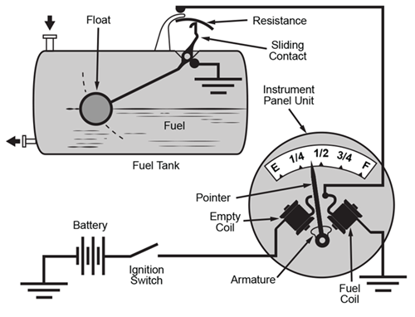
Figure 15: Hall Sensors for Fuel Level Sensing [23]

Subsystem 5: Brake System
The brake system is responsible to slowdown the vehicle and it should be designed in an excellence to prevent disasters that will affect the driver life. Also, there are existing critical parts for the brake, and they will be explained below,

Existing Design #1: Complete System
The brake system contains five basic components: Pedal, master cylinders, calipers, rotors, and bias bar. Starting with the pedal is the first step of slowing down the SAE Baja vehicle, and it depends on the force that comes from the driver's foot. Also, the pedal should be strong enough to withstand the forces on it. Secondly, the bias bar is responsible for compressing the fluid to decrease the cylinder bore. Thirdly calipers, in each wheel, there is a caliper that is conducted with two pads, and the main function of it is to pressure into the clamping force, and there are two types of calipers which are: floating calipers and fixed calipers, each of them has their own features. After that, rotors are usually made by cast iron in SAE Baja vehicles. It has two energies: the kinetic energy provided by the caliper and the heat energy provided by the friction force. Finally, a bias bar is used to connect the brake pedal to the master cylinder. [24]

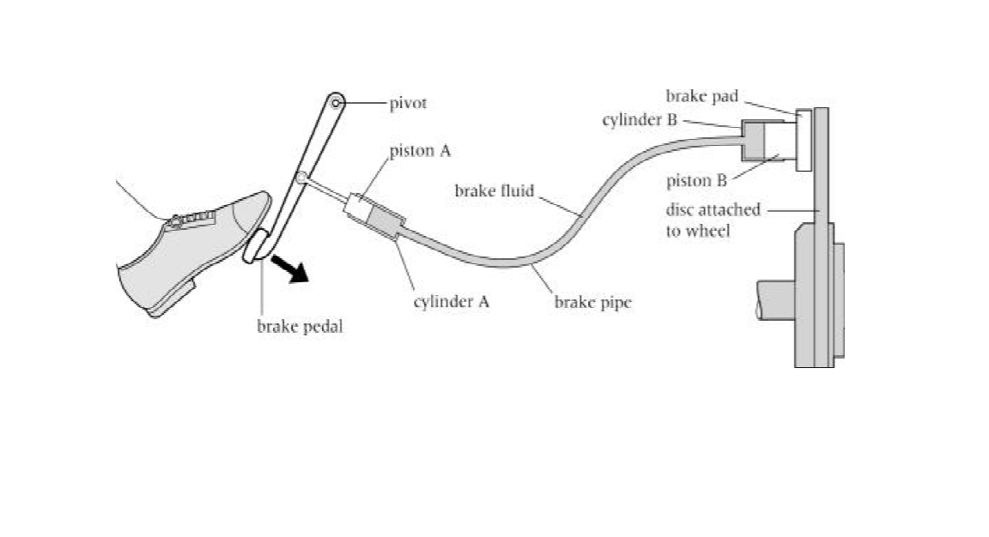
Figure 16: Brake System [25]

Existing System: Brake Pads
In each wheel there two brake pads, the brake pads are attached to the brake caliper to provide the friction force required to stop the vehicle, the brake pads should be in a good metal to withstand the friction to prevent the worst-case scenario that will affect a disaster during the competition.
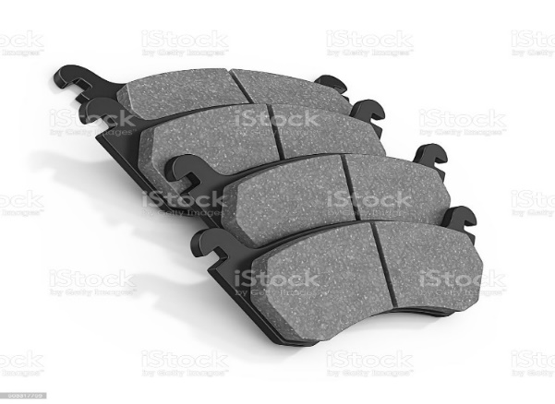
Figure 17: Brake pads [26]

CONCEPT GENERATION
The front-end suspension, the braking systems, and dashboard have been designed and validated on the Baja vehicle performance. The team has reviewed the exciting design of the above-mentioned systems and focused on the advantages/disadvantages of each system. The team has developed different concepts. This section presents the subsystem design.

Subsystem Concepts

Subsystem #1: Geometry

Design #1: Double wishbone
The suitability of suspension systems is determined by evaluating options and comparing their cost and benefit. In the case of a double wishbone suspension, the environment that the vehicle operates is the primary determinant Following are the porns and cros:
The advantages:
- Offers smooth off-road experience
- highly optimizable for different applications.
- Minimal vibrations during operations.
The disadvantages:
- expensive
- Difficult to design and manufacture
- complex manufacturing and measurements.

Design #2: MacPherson Strut
MacPherson strut suspensions are mostly found near the front end of the vehicle. The position and functionality determine its uses. An engineer can make these decisions after considering the pros and cons
The advantages:
- Highly compact
- Takes less space
- lighter weight due to reduced unsprang weight
- Essay to assemble and maintenance
The disadvantages:
- Less durable
- Difficult to replace
- Uncomfortable rides.

Design #3: Unequal A-arm Double Wishbone
Applications that require high wheel contact need suspension such as the unequal A-arm double wishbone system. While this system gives increased tire contact, they are complex to manufacture, which makes them expensive. A comparison of the pros and cons following here:

The advantage:
- Better camber control.
- Reliable for off-road conditions.
- Better vehicle handling.
The disadvantage:
- Costly to manufacture.
- It has many components.
- Difficult and expensive to repair and maintain.

Subsystem #2: Shock absorber

Design #1: Mono-tube shock
This design is popular for the Baja system. This demonstrates the reliability of this system for off-road riding. A maximum possible vertical mounting angle of this design may as well offer a more effective damping performance.
The advantage:
- Very durable.
- Zero restrictions on installations.
- Difficult for fluid to penetrate the fluid.
The disadvantage:
- Rigid
- Difficult to achieve sufficient stroke.

Design #2: Twin- Tube Shock
Twin- Tube is widely used for the shock absorber and there are many vehicle of Baja prefer to used this kind and the Pros and Cons are provided here.
The advantage:
- Maintains gas pressure for longer.
- Has superior manufacturing methods.
- Requires less effort to operate.
The disadvantages:
- Cannot be installed at an angle.
- Costly maintenance
- Low damping efficiency.

Subsystem 3: Steering System

Design #1: Worm Gear Steering Mechanism
The worm gear steering mechanism shown in Figure 8 has the worm gear is attached at end of the shaft of the steering column. When the driver rotates the steering wheel, the worm gear rotates, and its motion is converted to linear motion to turn the wheel in the direction that the driver intends.
The advantage:
- Compact
- High load capacity.
- Durable
- Precise linear motion.
The disadvantages:
- Low performance.
- High frictional losses.

Design #2: Rack and Pinion Steering Mechanism
This steering system includes the rack and pinion assembly that are directly connected. Due to the direct coupling of these components, motion is transferred to the pinion gear through the shaft and steering column causing the pinion to rotate. The rotational motion is then translated into linear motion on the rack, which causes the vehicle to turn with the help of the tie rods

The advantage:
- Simple in construction
- Economical
- Easy manufacturing
The disadvantages:

- Tiresome to use.
- Inefficient.

Subsystem 3: Brake System:
Which is the component that receives the heat energy because of the friction force, and it is a common brake in SAE Baja vehicles because of its advantages. Also, its material is cast iron, and the team decided to choose the disk brake once we compare the types of brakes.

Advantages of the brake disk:
- Brake disk uses less effort to stop the SAE Baja vehicle.
- Safer than other brakes.
- It has two brake pads.
- Produce less heat.
- Easy to fix.
Disadvantages of the brake disk:
- More expensive than other brakes.
- It is hard to operate the brake disk.
- It has many parts to be connected.

Subsystem 3: Dashboard System:

Design #1: LM393 speed sensor
LM393 speed sensor can be divided into two parts: the sensor part and the control part. The sensor part of LM393 speed sensor module includes infrared LED and NPN phototransistor. The signal from the phototransistor is provided to the LM393 and depending on whether there is an object between the infrared LED and the phototransistor, the output of the LM393 IC will be high or low. The module can be used in association with a microcontroller for motor speed detection, pulse count, position limit, etc. [41]
The advantage:
- Easy to measure the speed of small motors
- Economical
- Easy manufacturing
The disadvantages:
- Not conducive to practical application
- Large measurement error

Design #2: IR sensor
The infrared sensor includes an infrared LED and an infrared photodiode. Together they are called optocouplers. The infrared sensor has a built-in infrared transmitter and infrared receiver. An infrared transmitter is a light emitting diode (LED) that emits infrared radiation. When the infrared transmitter emits radiation, it will reach the object, and some of the radiation will be reflected back to the infrared receiver. According to the receiving intensity of the infrared receiver, the output of the sensor is defined. [42] It can calculate the pulse frequency or the speed data of the vehicle
The advantage:
- Suitable for practical applications
- Cheap
The disadvantages:
- Susceptible to environmental influences
- Limited by measuring distance

DESIGN SELECTED – First Semester
In this section, the selected design will be introduced, and all the details about that design will be provided in the following sections. In addition, the next part will introduce the design layout in the form of a CAD model. A detailed design description is provided, and an implementation plan is also proposed. In the implementation plan, the plan will describe the resources that will be used to implement the project, including a complete bill of materials. The implementation will be implemented in the next semester, so the implementation plan will be used in the next semester.

Design Description
There are four separate components to design in this project: the steering system, the front suspension system, the dashboard system, and the brake system. The chosen design includes a wishbone-based suspension and a disc brake system with caliper and disc, as well as an Adriano-based dashboard design. The design chosen in the preliminary report is the same as the design chosen at the time of choice. There were two choices for braking systems: drum brake and disc brake. The disc brake system was chosen because drum brakes are intended for heavy cars, while disc brakes are designed for normal vehicles. Disk brakes often generate less heat than drum brakes, and because of their low-temperature sensitivity, they can run with reduced fade at high temperatures. Not only that, but the disc is simpler to patch than the drum, making it ideal for the SAE Baja competition. Similarly, the suspension system, a double-wishbone suspension system that involves upper and lower arms, damper, and spring, has remained the same and will remain the same in the coming semester.

Brake System
This system has different components which includes
- Caliper
- Spindle
- Rotor
- Hinges
- Leather Pads

Caliper:
The caliper in this configuration is a holder to hold leather pads and it is fixed over the rotor, the caliper can press to tighten from inside and can loosen to release the rotor. Basic purpose of the caliper is to hold the disc and provide friction against the rotor to stop it. The design of the caliper is in figure 7.

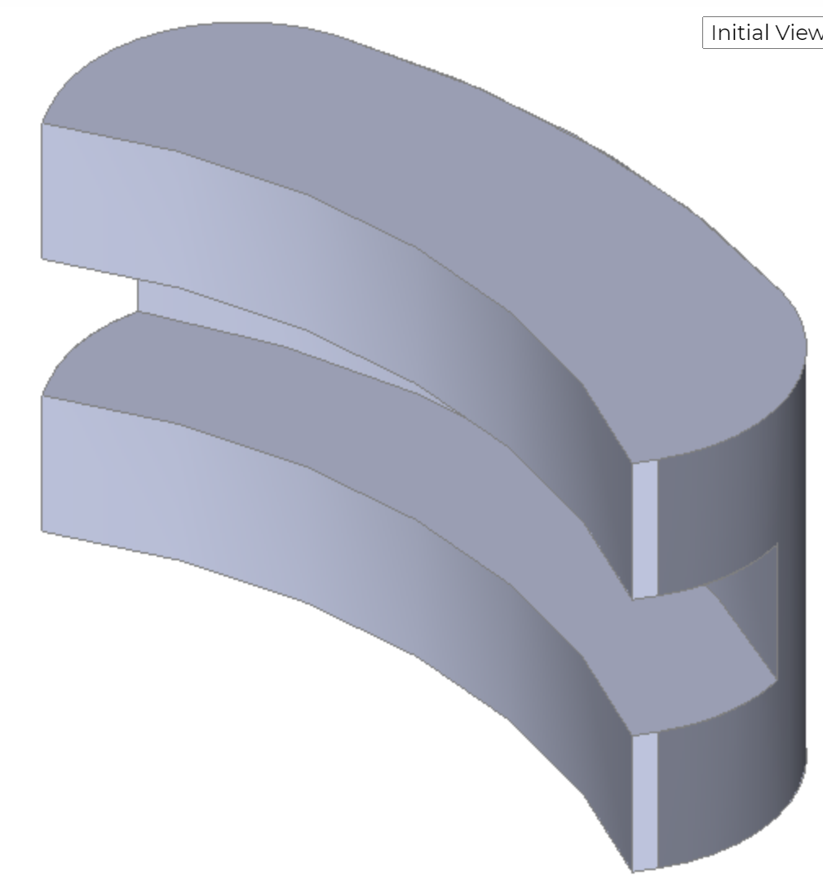
Figure 18: Caliper
The caliper design is clear in the above figure as it looks like a clip and the working caliper is just like a clip which can open its mouth or can close its mouth. Inside the mouth of the brake caliper, a leather pad will be installed to provide the required friction to stop the vehicle. When the brake pedal is pressed by the driver, the pedal will pass the force to the caliper and that force will compress the caliper and tighten its mouth and it will stop the vehicle. This is one of the most important parts in the braking system and without the desire working of the caliper, the brake system will not be able to perform effectively. Now coming to the next part in the brake system that is the spindle.

Spindle:
Spindle is a joint holder that is present after the disc, and it holds the disc and it holds the wheels as well. The design of the spindle has shown below in figure 8.
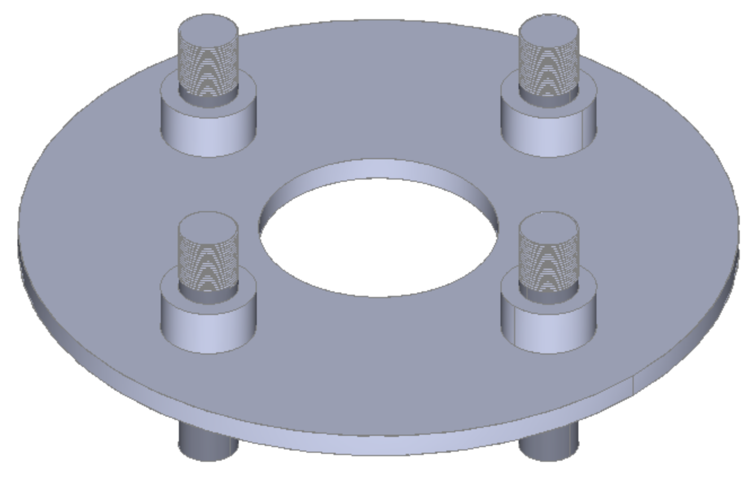
Figure 19: Spindle
This spindle will put on the same rod, on which the disc will put, and the wheel as well will put over the same excel rod, and this spindle will keep the wheels tight, there are four bolts coming out from the spindle and the wheels will put over these bolts and then nuts will use to tight the wheels. This is also important for the brake system as it holds the wheel and if it doesn’t install, the wheels are not possible to install over the excel with the brake system.
Rotor:
Rotor is a disc that rotates with the wheels, this rotor connects to the wheels through the same axle on which the wheels have installed and as the wheels move, the disc rotates as well. The disc has shown below
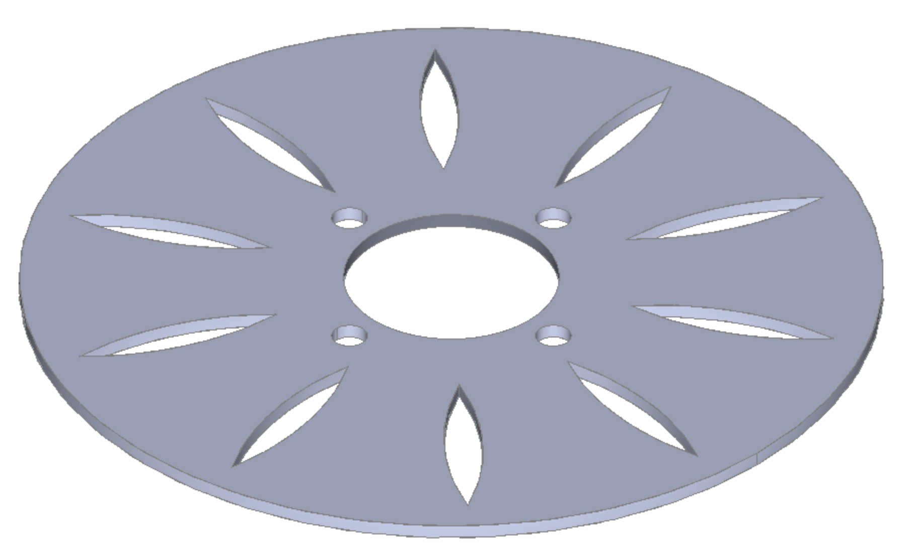
Figure 20: Disc or Rotor

The disc above contains the open spaces like a leaf, and these open spaces have been created in the disc to pass on the air in order to avoid any air pressure disturbance that will cause any fatal accident. This disc fits over the rod, and the wheels connect through the nuts as four nuts’ places are showing on the disc and the caliper will fit over this disc and when the caliper will press through the leather pads, this disc will face a lot of friction and that friction will cause the disc to stop from rotating and in the same time wheel also get a stop from moving and hence the brake applies. The disc is one most important part of the brake system, and without the disc, the brake system cannot develop and use.

Front Suspension
Following are the parts of front suspension:
- Bottom Wishbone
- Top Wishbone
- Shock absorber and Spring
Bottom Wishbone:
This is a part of double-wishbone geometry, and it is a lower part with two legs, and both are interconnected from one end and the other end is open. The bottom wishbone has shown below in figure 10.
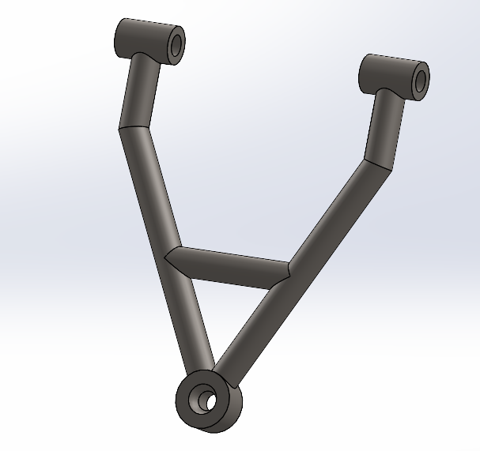
Figure 21: lower Wishbone
This bottom wishbone will provide the support for suspension from the downside of the suspension, and it will install with the top wishbone. A middle rod is present on it, which is used for the spring purpose to adjust the compression and expansion of the wishbone. This wishbone is playing a major role in the design, and it is not possible to build the suspension system without this wishbone.

Top Wishbone:
Top wishbone has a design similar to the bottom wishbone, with the difference that there is no middle rod present for the spring in the top wishbone, and the working operation of the top wishbone is the same as the bottom wishbone. Both of them collectively move in the upward and downward direction to give the bumpy effect of inhaling in their movement, the top wishbone as shown below in figure 11.

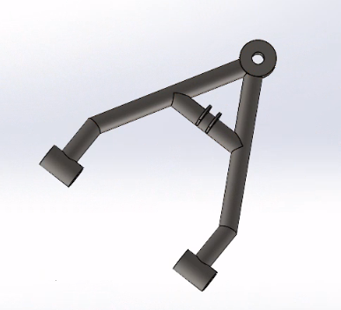
Figure 22: upper Wishbone
This wishbone will move up and down from the top-notch where both ends are joining together while the other end is open face. Wishbone is an important part of the suspension, and without the wishbone, it is not possible to make the suspension system as for this project design.

Dashboard System:
This system has different components which includes
- AT89C51 microcomputer
- LCD
- Motor
- Circuit element: capacitor, resistor
The dashboard is a device used to display the condition of the vehicle. In this project, the instrument panel includes detection of vehicle speed, rotation speed and liquid level.
Schematic:
The schematic circuit diagram shows how the single-chip microcomputer and each component are connected. The most important components in the figure are the LCD, the motor and the switch that controls the oil level. The interface information of the MCU comes from the AT89C51 datasheet. The AT89C51 is an age old 8-bit microcontroller from the Atmel family. It works with the popular 8051 architecture and hence is used by most beginners till date. It is a 40 pin IC package with 4Kb flash memory. It has four ports and all together provide 32 Programmable GPIO pins. The LCD screen displays the speed and rotation speed of the motor. The speed is calculated from the rotational speed. The speed of the motor can be changed by changing the frequency of the pulse. It also displays the level of liquid level according to the status of the switch
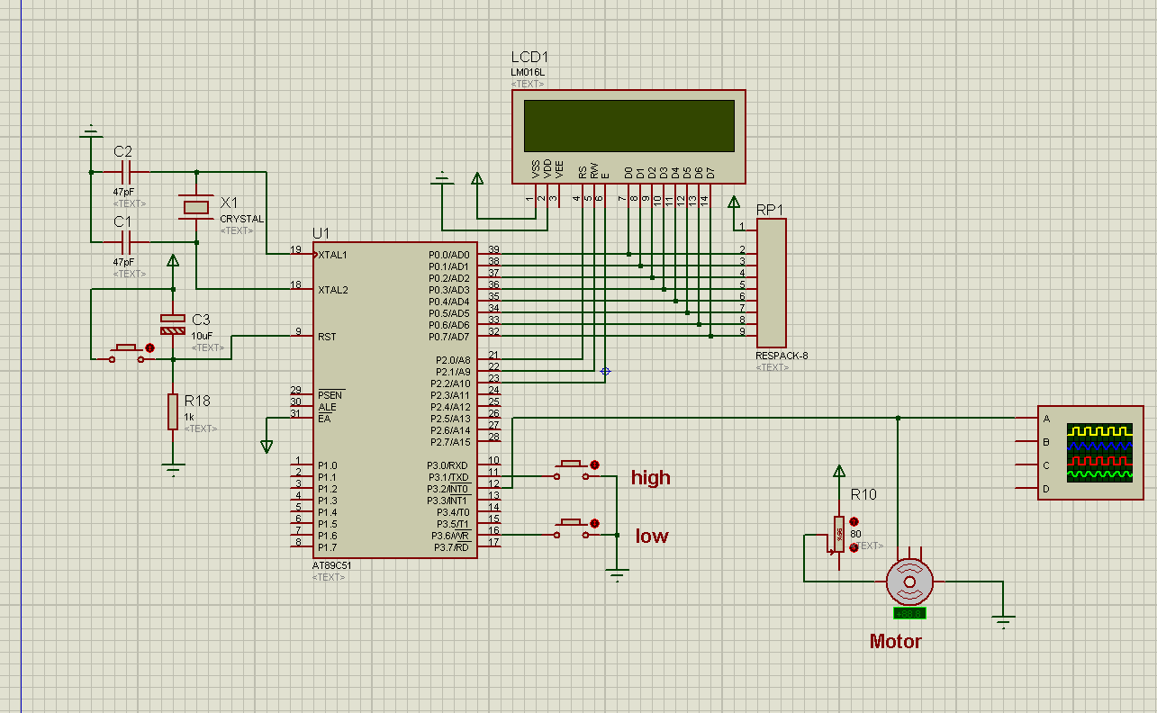
Figure 23: Schematic of dashboard circuit design
Simulation:
This picture is the result of the simulation. Through observation, it can be found that the rotation speed of the motor and the calculated vehicle speed are displayed on the LCD. And shows the liquid level condition. By changing the motor speed, the pulse frequency changes, and the speed and rotation speed change accordingly. In practice, the pulse frequency can be changed by the analog signal received by the sensor. By changing the switch that controls the liquid level, the level of the liquid level can be displayed. In actual situations, the liquid level can be detected, and the LCD prompts that the liquid level is low when it is below a certain level. The interface part includes the power supply of the single chip microcomputer, the conversion of analog signals to visual signals on the LCD, the reception, reading, writing and enable of the analog signals of the motor and the liquid level control switch.
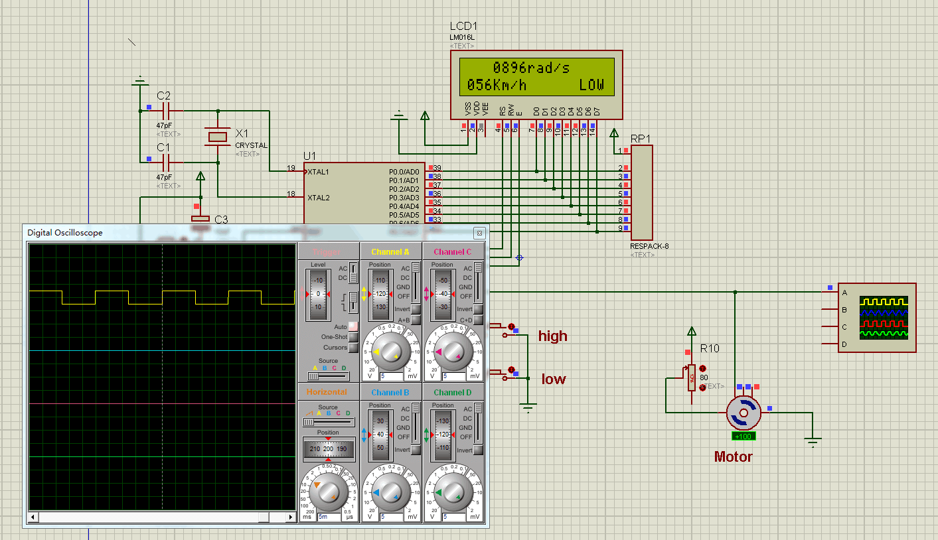
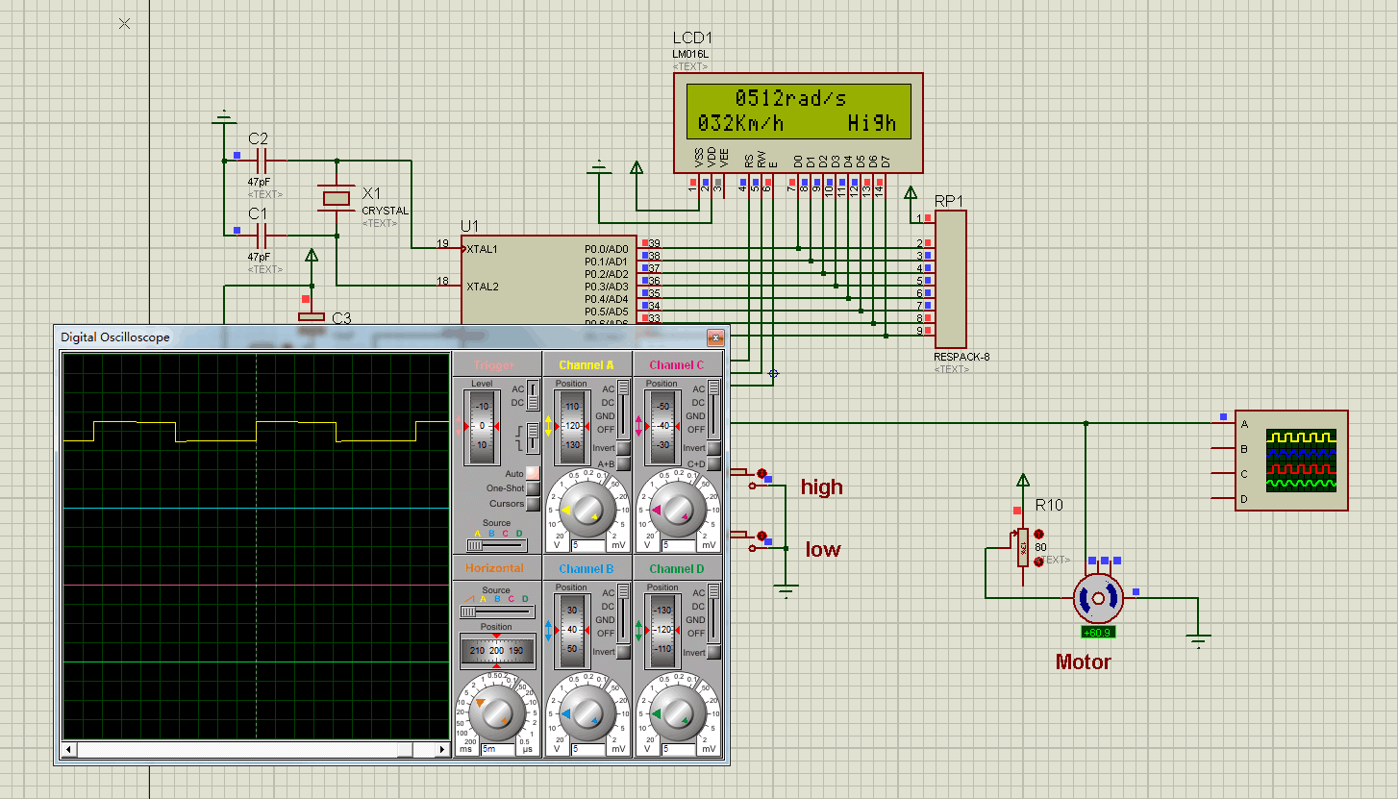
Figure 24: Simulation of the dashboard

IMPLEMENTATION – Second Semester
Our project has been assigned to be an analytical project. The Baja SAE vehicle is designed to withstand the harshest elements of rough terrain. There are many systems in this car that work simultaneously to make it possible for the car to run perfectly. The systems assigned to our team are the steering, brake, front suspension, and dashboard. This is done by designing the systems in SolidWorks, and then the design is evaluated using the calculations and FEA. The dashboard design is based on the Arduino board. The design is evaluated based on engineering requirements and modified accordingly to meet all of them.
In this section, this project assigned last Spring to be an analytical, and the team will explain in detail what we have done in last several weeks this semester and including calculations and FEA to mention the success of the project and the changes will be found in Appendix B

Design Changes in Second Semester
The vehicle design has remained mostly unchanged since SAE Baja vehicles were created. With a few minor modifications, maintenance has been simplified. After completing the final design, the team met to evaluate the benefits and compared them with the last ideas by using the decision matrix and having that discussed with the team, they reached the best solution. As a result of a few modifications to the suspension and brake were performed, as described below.

Design Iteration 1: Change in Brake Disk discussion
The original brake disk had a thickness of 0.1 inches. The disks of that minimum thickness could not meet the engineering requirements. Therefore, the thickness is increased to 0.2 inches, and FEA analysis is performed by the team. The accepted factor of safety is achieved, and hence the minimum thickness is finalized.

Design Iteration 2: Change in Front suspension
The original concept generation of the front suspension was the shock absorber connected and mounted to the lower arm throughout the linkage. However, to improve the ease of maintenance of the front suspension, the team made a decision to mount and attach the shock absorber to the upper arm. Therefore, the benefit of that is easy maintenance that can increase the performance of a car without affecting it.

Design Iteration 3: Change in dashboard
In the first semester of dashboard design, it focused on motor control, because the programmable motor has its own Hall sensor, which is very convenient for motor speed measurement. But this is not in line with the purpose of dashboard design. Therefore, in the second semester, the team chose to abandon the programmable motor and its attached Hall sensor and choose an independent sensor to measure the motor. This design not only displays the speed of the measurement target on the LCD, but also uses the pointer of the analog speedometer to point to the position and angle corresponding to the measured speed. This design can be applied to any vehicle, it needs to have a concise appearance, clear and accurate display.

RISK ANALYSIS AND MITIGATION
Potential failures have many different kinds of failures for any design while it works and operates, and engineers have to expect those failures and expect the risk in the design. This portion includes many different potential failures discussed and calculated in the failure mode and effect analysis (FMEA) and describe each subsystem. while will discuss the top 10 of the potential failures in this portion with its analysis from the table. For instance, this portion will talk about how the failures happen and the mitigation strategies to avoid any failures in the subsystems. To summarize this, this part will discuss any failures in the subsystems and what the risk is possible, and how to change the risk or failures to become better in the design.

Potential Failures Identified First Semester

Potential Critical Failure 1: Leather Pads
This failure may be a result of substandard material usage, sharp edges contacting, and most probable unnoticed manufacturing defects from its conception. Such failure will cause the depressurization of the braking system, thereby causing intense deceleration of the SAE Baja model, thereby losing its thorough effectiveness. In the competition, the success of the goal to directly stop the vehicle within the allowable prescribed time is readily dependent also on the pressure input of the driver on the brake pedals.

Potential Critical Failure 3: Wishbone
The wishbone is used in the fronts suspension, and this kind of suspension can be broken, which is called the potential failure. This failure can happen and be caused by accident during the competition caused by death. This failure can occur when the pressure keeps increasing and applying to the wishbone, which causes off-roading and high speeding, and the vehicle makes a high effort on the suspension. Because of that, the suspension can cause failure and can be broken. To treat this issue and avoid this failure , it is so important to use materials for the wishbone that have a high quality of standard, and the materials have to tolerate the high level of pressure with considering the thickness of the wishbone to prevent the failure. The mitigation of the wishbone is to keep tracking the maintenance of the standard basis to prevent any failure.

Potential Critical Failure 4: Rotor
The rotor allows the machine to drive the power from the differentials going to the wheels for movement. This continuous connection and functioning is necessary for the continuous and efficient movement of the vehicle. A terrible effect could happen when the spline connection fails at the sight of rotor breakdown. The splines fasten the axle to the wheels so that a proper torque distribution can be observed. Such failure will cause the waggling of the vehicle caused by torque disruption, and motion is horribly impeded. The splines being critical to such function should have higher than average Young’s modulus to resist abrupt changes in the pressure interruption of the moving vehicle. As such, the primary preventive maintenance step is to ensure that the torsion experienced by the rotor is well within the limits of the CV axle attached to it.

Potential Critical Failure 5: Connections
Several connections exist in the vehicle design of BAJA SAE 2021, and its functions are dependent on the effectiveness of each connector to transmit details of movement and command. The steering wheel is an important part to transmit the physical input of the driver in the movement. The improper installation and connection of the wheel into the column when not checked could be fatal. The connection for this assembly, including the connection of the gears within the system, must be calibrated with the prescribed speed expected by the driver during the operation. This can be carried out by using effectively fitted when connections and stronger material for connection sealing. Welded portions, as well as weak points of the connection system, must be regularly assessed to prevent failure.

Potential Critical Failure 5: Spring
coil spring is compressed and elongated when the vehicle moves on off-road terrain. As the car moves, it increases the chances of coil spring failure because the vehicle’s jerk may be transferred to the driver if the coil spring cannot absorb it. Therefore, during the vehicle design process, the project team should select the coil spring with a high spring constant to minimize the chances of its failure when the vehicle moves on off-road terrain.

Potential Critical Failure 5: Spring
The human energy applied on the steering wheel and interference emanating from mechanical problems may cause gears to limit the driver’s ability to steer the vehicle. The steering interference might happen due to a slight variation in the mating gear module. Because of the mating gear module malfunction, the gear tooth might break due to the driver’s sudden engagement and disengagement of the vehicle. Therefore, the project team can minimize or eliminate these possible failures by choosing and verifying the rack and pinion assembly mating gear module.

Potential Failures Identified This Semester

Potential Critical Failure 1: Disc Brake
The potential failure identified in this semester is the brake disk. This is the critical part for the braking system. Whenever the brakes are applied, whether in emergency or just to adjust the speed of the car, reliable brakes are always worth it. The brake disk failure can happen when the brake pads rub against the disk to use the friction to stop the car. The clamping force varies depending on the design. The value of this force should be kept such that the car could be stopped at the designed speed and under the required time. If the clamping force which in turns convert into braking force is too large to stop the vehicle, it would cause the disk material to yield. Therefore, this failure is to be considered in the design. Another important design decision is material for the disk. If the material wears down due to friction by pads, the brakes will fail after a several stops. Also, the thermal properties of the material should be defined such that the dusk temperature never gets too hot for the brake fluid to evaporate, causing the failure of brakes. All of these failures for the brake disk are to be considered important while designing the system.

Potential Critical Failure 5: Tie Rod
Vehicles use the tie rods to transfer the kinetic energy of the rack gear to the steering wheel to enable turning. The yielding may happen inadequate usage of quality of the material. The project team should understand they could remove any yielding change by choosing suitable materials. Notably, the selected materials for the tie rods should be impurity-free and homogeneous.

Potential Critical Failure 6: The RPM measurement
The IR sensor generates pulses by measuring the obstructions in front, and the speed of the vehicle can be obtained by calculating the frequency of the pulses. When the vehicle speed is too fast, due to hardware constraints, it may not be able to detect the change of the front obstruction. In this situation, the data may be lost. The IR sensor is also easily affected by environmental factors, such as dust, rain and sunlight.

Risk Mitigation

Suspension System
The risk of the new potential failure is mitigated by using the right diameter and thickness of the disk. The thickness and diameter is selected such that when FEA is performed to determine the factor of safety. It came out to be 7. Therefore the brakes are somehow a little over designed in a sense of risk mitigation. For the thermal failure of brake disk, the material selected is Cast Iron. FEA is again deployed to find the maximum temperature while braking and they were way below the boiling point of brake fluid. Also the Cast Iron has good wear properties and provides long life against the rubber pads.

Suspension System
The suspension system contains critical parts, such as the upper control arms, which are subjected to bending forces because of the compression on the spring when the vehicle passes a bump. The upper control arm is crucial for safety. Its rating should reach 3.64. Therefore, the project team needs to change the tube thickness to increase the FOS. However, the team has not increased the arms thickness in the suspension system because it will also increase the systems’ weight. Besides, the project team also has limitations on the car’s weight at 375 lb. Therefore, given all these factors, the project team increased the arm’s strength by choosing high-grade steel that cannot bend easily. Given the safety aspect, the suspension system will be reliable and durable, thus increasing its safety.

Steering System
Based on FMEA analysis, the project team concluded that the gear assembly is a critical component of the steering design. Therefore, when designing and developing the gear assembly, the project team was attentive to eliminating fault. Additionally, the project team understands that the potential failure mode for the steering mechanism arises from the locking of gears and digging of tooth profiles. These failures happen due to the difference in the module of both the gear and the wrong selection of the gear

Dashboard
The measurement range can be increased by reducing the number of gaps in the middle of the wheel, because this can prevent the sensor from detecting changes in front obstacles. It can also reduce the measurement distance of the sensor and increase the measurement intensity. Environmental factors can be solved with a protective cover. After the circuit design is determined, the circuit board packaging can also be used to solve environmental impacts such as jitter

ER Proofs
It is critical to ensure that all the Engineering Requirements (ERs) are met. The team should use and improve the methodology of testing to proven demonstrate that all the engineering requirements were met in the vehicle's designed subsystems. However, because the project focused on designing solutions rather than fabricating and manufacturing, few of the customer requirement could not be evaluated. The team emphasized the procedure for all of these engineering requirements. In the following subsections, the testing technique for each ER will be illustrated and proved

ER Proof #1 – [Track Width 62 inc] - Tolerance [ +2]
The track width refers to the distance between both front wheels. By using the SolidWork, team can make and prove the measuring the distance between the front wheels easy. The team has determined that the track width criteria have been met if the distance is within the permissible track width.

ER Proof #1 – [Able to carry driver weight 130 lb] – Tolerance [ +5]
The team used the design Solid Work, to undertake a finite element technique analysis to prove this requirement. The static analysis of the vehicle is carried out for the FEM analysis to determine the forces on each part of the front suspension and steering gear. For the static analysis of the suspension system, the following equations were employed:

$\sum{Fy}=0$ (1)

$\sum{M_{point}=0}$ (2)

$F= μN$ (3)
Where, F represents the force, M represents the moment, μ represents the coefficient of friction and N represents the normal reaction from the ground.
By sub into the equation (1) can find the force that impact on the upper arm
$$\sum{M_{rb}=0}= -Wca-Wp\left(a+b\right)+2 Rf\left( a+b+c\right)$$
$$R_{f= }\frac{375*25+130*(25+53)}{2(25+53+30)}=90.5Ib Front arm$$
The impact forces exerted by the suspension system can be calculated by following the equations for the moment at the pin in the chaises point.
$$\sum{M pin=0}$$
90.34 * a= $Fimp*sin\left(70\right)*\frac{4}{5}*a$
Impact Force= 90.34*17= $Fimp*sin\left(70\right)*\frac{4}{5}*17$
$Fimp$= 120.2 Ib
For the Friction Force depicted in equation (3), the following formula can be used:
F =0.5*90.5 = 45.25 Ib.
Farm = F/2 = 22.625 Ib.
During the FEM analysis of the various pieces, these forces were applied. The part will not fail if the factor of safety for each part is greater than one. As a result, the team can state that the vehicle is capable of carrying the driver's weight. If each individual's factor of safety is less than one, the part will almost certainly fail, and the inspection will be a failure.
For the subsystems, the minimum factor of safety (FOS) served as the overall factor of safety. During the investigation, the team revealed that the FOS for the suspension system; upper arm and lower arm were 3.64, 4.87 respectively while the FOS for the steering system was 2.99. The system of Baja ATV has a very low chance of failure because the minimum factor of safety is 2.99, which is also larger than 1. The analysis shows that the vehicle could carry the driver's weight. Therefore, this equipment is met and proven.

ER Proof #1 – [Weight of vehicle 375 lb] – Tolerance [ +5]
The customer's primary criteria are weight restrictions. The team's goal in this course was to design the vehicle's subsystems, not the entire whole. As a result, the team will be unable to meet this semester's engineering requirement. It can, however, be proved and confirmed after the production and assembly of the vehicle. Following the manufacture of the vehicle, the weight of the entire vehicle will be recorded.

ER Proof #1 – [[Spring Compression 4.5 in] – Tolerance [ + 0.5]
The need for spring compression can be demonstrated analytically. The team should perform a motion analysis to examine the compression between 4 and 5 inches to prove the compression of the spring analytically. As a result, utilizing a motion analysis and a 120.2-Ib impact force, they were able to prove compression at 4.5. The compression was also determined using the linear displacement from the motion analysis, as indicated in the figure1.
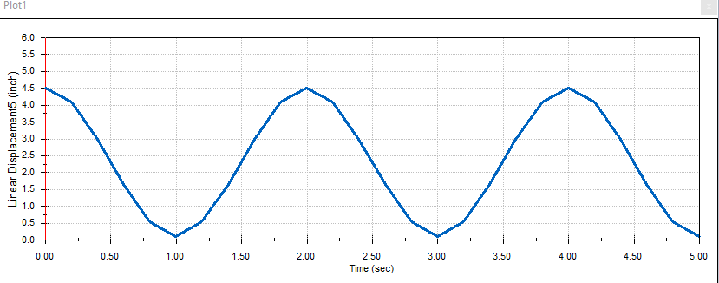
Figure 25: Liner Displacement of spring compression

ER Proof #1 – [Steering Degree 30 degree] – Tolerance [ +5]
Motion analysis is another technique to demonstrate this the engineering requirement for a 30-degree rotation. Teams can turn the wheel at 30 degrees with this software. As demonstrated in the angular displacement diagram, angular displacement may display and measure the angular distance of the wheel based on the motion analysis. Therefore, the team can say that they have met the Engineering requirement for the steering degree.

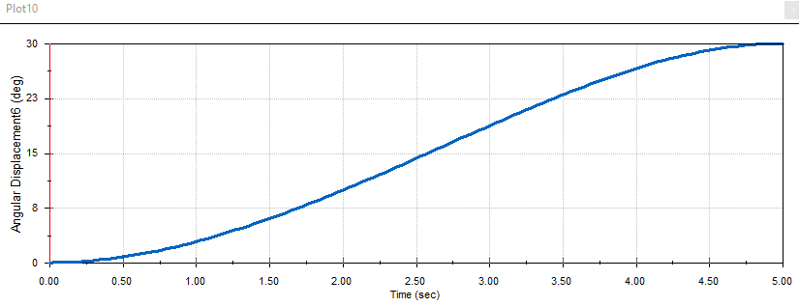
Figure 26: Angular Displacement of wheel degree

ER Proof #1 – [Steering effort 8 lb] – Tolerance [ +0.5]
Essentially, the engineering required for steering is examined to determine statically
$$F=0.5*90.5=45.25 Ib$$
The frictional force on one side of the front wheel is denoted by F. The rack's force pushes the two tires to rotate, thereby doubling the frictional force of one tire.
$$F_{R}=2×45.25=90.5 Ib$$
As a tangential force with regard to the diameter of the pinion's pitch circle, this force is applied to the teeth of the rack and turned into the teeth of the pinion.
$T=F_{R}×\frac{D_{P}}{2}=90.5×\frac{2.5}{2}$ = 113.125 Lbs.in
With the help of the driver, the torque is adjusted by rotating the steering wheel. The force required to turn the wheel is calculated by dividing the torque by the radius of the steering wheel.
$F_{D}=\frac{T}{D/2}= \frac{113.125}{{15}/2}$= 15 lb
To calculate the exact amount of steering effort, both hands must be used to spin the steering wheel. In essence, the driver turns the wheel with both hands, splitting his power and providing enough power for each hand on the drive. With one hand, the steering force is 7.55 pounds. Furthermore, each hand's force is within the technical criteria of 8 pounds, indicating that the steering force requirements are met.

ER Proof #1 – [Braking Distance 7 Meter] – Tolerance [ + 0.5]
Due to the project's situation, which was assigned to be analytical, the SAE Baja team discussed the braking distance with the client, and we agreed to search in many reports, so we approximated to be less than 7 meters. This value is used as input in the calculations, and therefore the exact value is met in the design.

ER Proof #1 – [ Braking Time <5 sec] – Tolerance [0]
Braking time is calculated in the calculations for the brake system. The calculated breaking time is 1.15 seconds. In testing, the braking time is calculated using the motion analysis in SolidWorks. The brake disk is rotated at the maximum rpm allowed by Baja SAE rules, i.e., 3800 rpm. Then the brakes are applied to stop the disk. The graph between the angular speed and time is shown in the figure below.
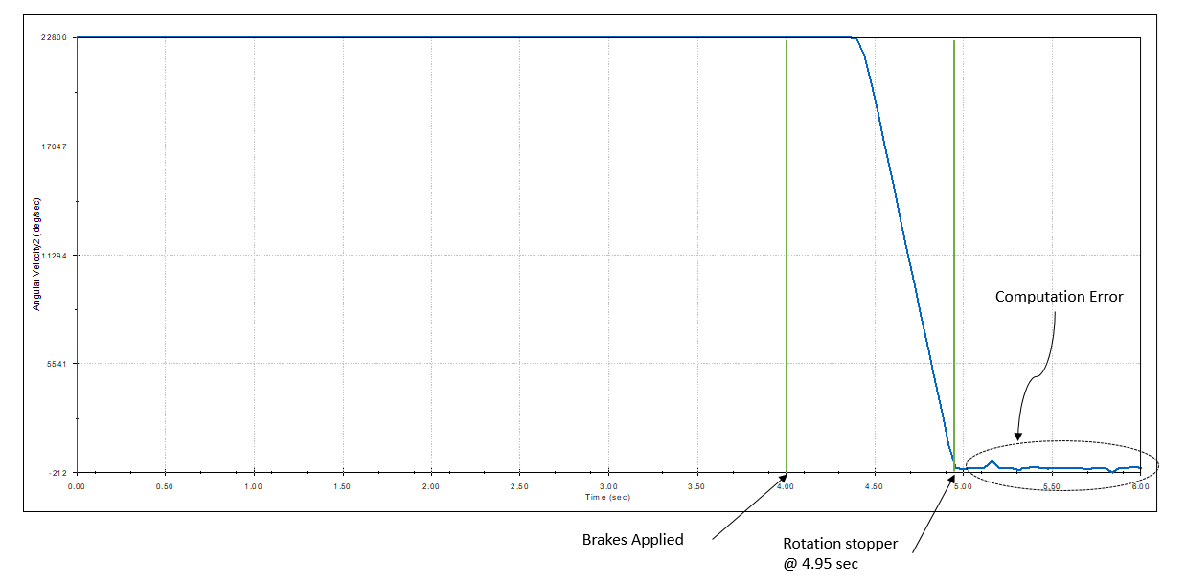
Figure 27: Motion Analysis of Braking Time

The brakes are applied at the time of 4 seconds. We can see that the disk eventually stops at a time of 4.95 seconds. The small variations in speed after that are due to computational errors. Therefore, the time to stop the disk is 0.95 seconds. We can see that the braking time in testing is less than the calculated one and our engineering requirement. Therefore, the test is passed for the braking time.

ER Proof #1 – [Braking Temperature <100 ] – Tolerance [ 0]
Brake temperature is evaluated using the FEA by performing a transient thermal analysis for the total braking time of 1.15 seconds. The maximum power generated at the result of braking is used as the load for this analysis. The temperature plot over the disk at the final time step at time 1.15 seconds is generated during braking.
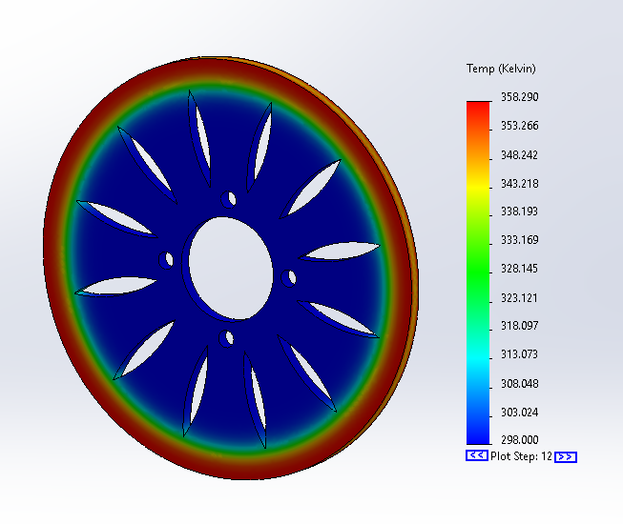
Figure 28: Braking Temperature
We can see that the maximum temperature at the end of braking is estimated to be 358.3 K which is 85.15°C. The engineering requirement is less than 100°C which is met in this result.

ER Proof #1 – [scope of speed detection] – Tolerance [+ 5]
The speed detection range of the dashboard is set from 0 to 80Km/h. The frequency of infrared reception is generally 38KHz. However, limited by the performance of the sensor itself, the detection error is relatively large when the speed reaches 80 Km/h. When the speed is fast, the change of the detection object is not obvious, which makes it difficult for the sensor to detect the change of the obstacle in front of the rotation, resulting in data loss. Therefore, it is more appropriate to set the maximum detection speed to 80 Km/h.

ER Proof #1 – [Speed detection accuracy] – Tolerance [ 5%]
$Velocity = 2 * pi * rpm*R (m/s)$ (4)
$V_display = rpm * R * 0.3768 (Km/h)$ (5)
For the Velocity calculation in equation (7), the velocity could be calculated from rpm. Here is how the dashboard detects the rpm of the vehicle.
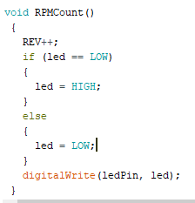
Figure 29: RPMCount function in Arduino
Whenever there is an obstruction in front of the infrared sensor, RPMCount function will run once, and REV will increase by one. The obstructions on the wheels represent the part between the wheel gaps. How many obstructions there are, how many REVs will be generated when the wheel rotates once. Divide REV by the number of the wheel gaps to get the actual number of revolutions. The calculated error comes from the accuracy of the sensor detecting rpm. Existing speed is too fast, or environmental factors cause RPMcount function to run abnormally. Assume that the rpm of a vehicle is 1500 r/m. The radius of the wheel is 5 inches, which is 0.127 meters. According to equation (8), V_display is 71.7 Km/h. When the Tolerance of rpm is 5%, the speed is 71.7+3.6 Km/h, meeting the requirements of the speed range.

ER Proof #1 – [Display delay < 1s] – Tolerance [+ 0.5s]

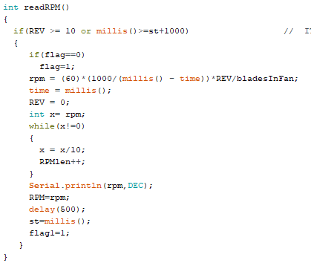
Figure 30: readRPM function in Arduino
This function is set to run when the RPMcount runs every 10 times or every second. Therefore, the display delay will be about 1s at low speed, and the display delay will be about 0.5s at high speed due to the 500ms delay setting. The delay of LCD is about 25ms, which is almost negligible in this situation.

LOOKING FORWARD
This portion is talking about how the team can improve their project in the future and how the other students can develop the project as analytically. Following are the observation/recommendations to improve/finish the project. Seemly, this project id analyzed all the subsystems deeply that the team has assigned by using the FEA and all the parts are successfully and using the motion analysis for testing the engineering requirement.

Future Work
The project is completed at testing phase where the product is tested using the motion analysis. Starting with the first step of the product design which is calculations performed for each system under static loading. The calculations performed under dynamic conditions would definitely improve the design. The FEA is performed based on these calculations using static structural analysis except for the thermal analysis which is transient in nature. In future work, the transient FEA could be performed to determine the stresses against the dynamic loading conditions. At the end, the motion analysis performed for testing can be performed for the complete system simultaneously using the actual motion of the complete car.
For the dashboard, the design could be built with Arduino board, LCD, IR sensor, stepper motor and motor driver. Basic electrical components are also needed, such as wires and resistors. Connected the components according to the schematic and runs the code in the Arduino, the whole design could operate. The next step is to find the test target, such as a fan, a bicycle or a Baja and apply the dashboard system on it. I believe it would take within 5 hours to take the test. There are some variables in Arduino code needed to be changes according to the test target, such as the radius of the wheel and the number of blades of the fan. The result of the test should be that the LCD will display the speed of the test target, and the analog speedometer will turn to display the position corresponding to the speed.

CONCLUSIONS
After two semesters of hard work, our team finally has the final design. This is not only a personal effort, but also requires teamwork. As an analytical subject, our team members are located in different countries in the world, with different time differences and different languages. During the year, we have overcome many technical problems, and even the problems of remote cooperation.
Through our display and analysis, it is shown that the design of our team basically meets CR and ER. The testing documentation demonstrated the performance of brake system, the front suspension, steering system, and the dashboard on a theoretical and practical level. We use analytical tools and methods such as Finite Element Analysis (FEA), Motion Analysis by SolidWorks, analytical analysis, and Arduino. It turns out that our design meets the design requirements.

Reflection
For a vehicle design, the most important concern is economic issues. Our team includes brake system, the front suspension, steering system, and the dashboard. The team mentioned the goal of reducing vehicle weight in CR, which can reduce vehicle emissions to a certain extent and also reduce material costs. When designing the frame, it not only considered the stability of the frame, but also considered the cost and environmental factors from the material direction. When designing the dashboard, Consider the design in terms of power and cost. In the case of completing the basic functions, reducing the cost can reduce the production cost, which has a certain economic effect. Although our subject is an analytical subject, we are always planning to manufacture them as physical products and apply them in reality.
The project of SAE Baja is helpful to the community because it makes the future engineers to understand each system specifically and that will lead them to focus on subsystems that are assigned for during the competition and the searches the team have done, such as Arduino board, SloidWorks design, teaches us the critical parts of each system, which means the members have an excellent feedback about the working of four systems. Therefore, the project is helpful to the community to have durable and reliable in normal vehicles due to the learning of this project. No less important, in middle east countries, people like to make adventure in deserts by driving these types of SAE Baja vehicles and it will be great idea if they think about using the small off road cars instead of using huge vehicles because it will cost less than the huge vehicle in maintenance or gas. On the other hand, the CO1 that emit from the exhaust will be less than by using SAE Baja vehicles because of the difference of engine sizes.

Postmortem Analysis of Capstone
In this section, the postmortem will answer the seven fundamental questions of the postmortem and we will appear the positive and negative parts of the project in the two sections are below.

Contributors to Project Success
The SAE Baja team was able to achieve the goals and prevent failures because of the help from the client, which means we were directed in a good manner. And we aimed the needed parts in the team charter in the last semester, and they have been achieved by the team.

The team was assigned to have an analytical project that led us to not manufacture the systems that the team assigned for, but it was a great opportunity to make sure about all the systems by using FEA, motion analysis and calculations for mechanical systems while the electrical system was achieved by the using of Arduino board.
The aspect performance of this project has improved the time management because we live in three different zone. Since the project was unable to be manufactured that led us to not have to have a cost and we focus on making each system works in excellent condition.
The team at the beginning of last spring preferred to manufacture since we will be engineers at the end of this semester, but the situation of the project prevent us and the COVID 19 as well. Also, the meetings weren't easy to make because everyone lives in different country.
We faced issues to use SolidWorks since the application needs an excellent processor while every one of the team doesn't have an excellent PC or laptop that can work smoothly and that led us to take a long time to handle the parts.
There are many lessons that the team learned this semester especially because we used many equations that are related to dynamic course for the mechanical students and we also used equations are related to electrical engineering.
The use of motion analysis and FEA have directed the team to make sure the project will be improved its performance, also the team has explained that well during the presentations and hardware reviews.

Opportunities/areas for improvement
The negativities of this project the team unable to test the project physically in the field and work on it as a team while and every one of SAE Baja team was looking for that in last spring. Also, the operating environment is dynamic and characterized by numerous challenges that undermine the attainment of stated aims. In capstone project one, potential barriers were registered that demanded creativity to address. Perhaps, one of the limiting issues in the program was time zone differences since team members are dispersed. Faced with such a limitation, innovative approaches must be developed, including digital communication solutions. As an illustration, a chat group was established that allowed stakeholders to contribute based on their availability. The approach was practical since all ground rules were observed, and the set goals were attained as planned. Interested parties must participate in developing a solution to an issue likely to impede the attainment of mutually shared aims.

REFERENCES

[1] Sourav Pattnaik (2020). Design and Analysis of Braking System for Baja All-Terrain vehicle. International Research Journal of Engineering and Technology (IRJET) .Volume: 07 Issue: 02.
[2] "Disc vs. Drum Brakes: Pros and Cons", NAPA Know How Blog, 2020. [Online]. Available: https://knowhow.napaonline.com/disc-vs-drum-brakes-pros-and-cons/. [Accessed: 05- Mar- 2021].
[3] Limpert, R. (2011). Brake design and safety (3rd ed.). Warrendale, Pa.: Society of Automotive Engineers.
[4] R. Limpert, Brake design and safety, 3rd ed., Warrendale, Penn.: SAE International, 2011.
[5] S. John, "Hydraulic Disc Brakes | Order Custom Hydraulic Disk Brakes from Knott Brake - Knott Brake Company", Knottbrake.com, 2021. [Online]. Available: https://knottbrake.com/categories/disc-brakes/hydraulic-disc-brakes/. [Accessed: 05- Mar- 2021].
[6] F. Flin, "Drum brakes", Your Mechanic, 2019. [Online]. Available: https://www.yourmechanic.com/article/how-drum-brakes-work. [Accessed: 05- Mar- 2021].
[7] B. Parama, "Disc vs. Drum Brakes: Pros and Cons", NAPA Know How Blog, 2020. [Online]. Available: https://knowhow.napaonline.com/disc-vs-drum-brakes-pros-and-cons/. [Accessed: 05- Mar- 2021].
[8] J. D. Stimson, "2015-2016 SAE Baja Major Qualifying Project Final Report," wpi.edu, vol. 1, no. 1, pp. 1-70, 2016.
[9] F. Liver, "BODEN AUTOHAUS", BODEN AUTOHAUS, 2021. [Online]. Available: http://www.bodenautohaus.com. [Accessed: 04- Mar- 2021].
[10] G. Michel, "Shock absorbers explained", Outback Travel Australia, 2021. [Online]. Available: https://outbacktravelaustralia.com.au/4wd-mods-tech-torque/shock-absorbers-explained/. [Accessed: 05- Mar- 2021].
[11] P. Falase, "What is a monotube shock?", Help.summitracing.com, 2021. [Online]. Available: https://help.summitracing.com/app/answers/detail/a_id/5251/~/what-is-a-monotube-shock%3F. [Accessed: 05- Mar- 2021].
[12] S. of Automotive Engineers, “Suspension - CCNY SAE,” Google Sites, 01-Nov-2014.
[Online]. Available: https://sites.google.com/site/ccnysae/past-competitions/2012-
baja/component-redesigns/suspension. [Accessed: 30-Jan-2021].
[13] L. Wright, K. Hopkins, M. Clark, and D. Tomczak, “SAE Baja - Front Suspension,”Mountain Scholar, 01-Jan-2020. [Online]. Available: https://mountainscholar.org/bitstream/handle/20.500.11919/2469/Front_Suspension_and_steering.pptx?sequence=1&isAllowed=y. [Accessed: 30-Jan-2021].

[14] Colorado.edu, 2021. [Online]. Available: https://www.colorado.edu/saebaja/sites/default/files/attached-files/team_65_design_report.pdf. [Accessed: 06- Mar- 2021].
[15] Stevens, M., 2021. MacPherson Strut vs Double Wishbone Suspension (Pros and Cons). [online] CarTreatments.com. Available at: <https://cartreatments.com/pros-and-cons-of-macpherson-vs-double-wishbone-suspension/> [Accessed 28 January 2021].

[16] "Shock absorbers explained", Outback Travel Australia, 2021. [Online]. Available: https://outbacktravelaustralia.com.au/4wd-mods-tech-torque/shock-absorbers-explained/. [Accessed: 05- Mar- 2021].
[17] W. shock?, "What is a monotube shock?", Help.summitracing.com, 2021. [Online]. Available: https://help.summitracing.com/app/answers/detail/a_id/5251/~/what-is-a-monotube-shock%3F. [Accessed: 05- Mar- 2021].
[18] "Monotube vs. twin tube shocks - Which should you trust with your vehicle?", Strutmasters, 2021. [Online]. Available: https://www.strutmasters.com/monotube-vs-twin-tube-shocks/. [Accessed: 05- Mar- 2021].
[19] "How Car Suspensions Work | Repair, Car fix, Car mechanic", Pinterest, 2021. [Online]. Available: https://www.pinterest.com/pin/468092954999018913/. [Accessed: 05- Mar- 2021].
[20] Automotivearticles.com, 2021. [Online]. Available: http://www.automotivearticles.com/uploads/a-arm_img.jpg. [Accessed: 05- Mar- 2021].
[21] ADMINISTRATOR, How to Interface LM393 Speed Sensor with Arduino? ELECTRONICS HUB, SEPTEMBER 7, 2018 [Accessed: 04- February- 2021].
[22] VadimS, Building a Capacitive Liquid Sensor, instructables circuits, 2014
[23] Shashank Wekhande and Ranjit Farakate, Hall Sensors for Fuel Level Sensing, ALLEGRO, 2017
[24]"Brake system - UR Baja SAE", Sa.rochester.edu, 2021. [Online]. Available: http://sa.rochester.edu/baja-wiki/index.php?title=Brake_system. [Accessed: 06- Feb- 2019].
[25] Ideaexchange.uakron.edu, 2021. [Online]. Available: https://ideaexchange.uakron.edu/cgi/viewcontent.cgi?article=1145&context=honors_research_projects. [Accessed: 01- Dec- 2021].
[26] B. Now, "//www.pagadesign.net/alphamap.jpg", iStock, 2021. [Online]. Available: https://www.istockphoto.com/photo/brake-pads-gm503317759-41714530. [Accessed: 01- Dec- 2021].
[27] W. shock?, "What is a monotube shock?", Help.summitracing.com, 2021. [Online]. Available: https://help.summitracing.com/app/answers/detail/a_id/5251/~/what-is-a-monotube-shock%3F. [Accessed: 05- Mar- 2021].
[28] 2021. [Online]. Available: http://www.carbibles.com/suspension_bible.html. [Accessed: 05- Mar- 2021].
[ 29] KYB, 2021. “Monotube and twin-tube” KYB Technical Resources. [Online]. Available: https://www.kyb.com/resources/technical-information/monotube-and-twin-tube/. [Accessed: 01-Mar-2021].
[30] ‘’ Twin tube picture- Google Search,’’ [Online] https://www.google.com/search?q=Twin+tube+picture&source=lnms&tbm=isch&sa=X&ved=2ahUKEwix_c2V-Mj0AhVeRPEDHQa9BV4Q_AUoAXoECAEQAw&biw=1244&bih=773&dpr=2#imgrc=6aS97oUI3-MPoM [ Accessed Mar- 01- 2021]
[31] Shrivastava, DK, Vignesh, BS, Sufiyan, A, & Chandan, V., 2019. Double Wishbone Suspension System: A Research, International Journal of Recent Technology and Engineering, vol. 8, no. 2, p. 5033. Available: https://www.researchgate.net/publication/334881551_Double_Wishbone_Suspension_System_A_Research. [Accessed: Feb- 25- -2021].
[32] "What Actually Is Double Wishbone Suspension?", Car Throttle, 2021. [Online]. Available: https://www.carthrottle.com/post/what-actually-is-double-wishbone-suspension/. [Accessed: 05- Mar- 2021].
[33] "How Car Suspensions Work | Repair, Car fix, Car mechanic", Pinterest, 2021. [Online]. Available: https://www.pinterest.com/pin/468092954999018913/. [Accessed: 05- Mar- 2021].
[34] “Car Suspension Basics, How-To & Design” Buildyourownracecar, 2020. [Online]. Available: https://www.buildyourownracecar.com/race-car-suspension-basics-and-design/4/. [Accessed: 20-Feb-2021].
[35] The Motor Ombudsman. 2021. Getting to know rack and pinion steering - The Motor Ombudsman. [online] Available at: https://www.themotorombudsman.org/useful-information/motoring-advice/getting-to-know-rack-and-pinion-steering [Accessed 19 Feb 2021].
[36] HowStuffWorks, Auto, Hood and Suspension, 2021. How Car Steering Works. [online] HowStuffWorks. Available at: https://auto.howstuffworks.com/steering2.htm [Accessed 19 Feb 2021].
[37] Steemit, 2021. AUTOMOBILE STEERING (RECIRCULATING-BALL) & ITS ASSIST MECHANISM. — Steemit. [online] Steemit.com. Available at: https://steemit.com/steemstem/@omonosa/automobile-steering-recirculating-ball-and-its-assist-mechanism [Accessed 21- Feb 2021].

[38] Corporation, L., 2021. Recirculating Ball & Nut Steering - Lares Corporation. [online] Larescorp.com. Available at: https://www.larescorp.com/toolbox/skinned-knuckles-articles/recirculating-ball-nut-steering/ [Accessed 21- Feb- 2021].

[39] MotorTrend. 2021. Steering Systems 101: Rack-and-Pinion vs. Recirculating-Ball. [online] Available at: https://www.google.com/amp/s/www.motortrend.com/how-to/1505-steering-systems-101-rack-and-pinion-vs-recirculating-ball/amp [Accessed 21-Feb 2021].

[40] Wes C, Eddie S, Dashboard and Wireless Transfer Module, Available at: https://eddiesamuels.com/projects/baja/attachments/report.pdf,
[41] Interfacing LM393 Infrared Speed Sensor with Arduino, Mohammad Damirchi, eletropeak, August 20, 2018.
[42] Arduino with IR Sensor, Alfa, Arduino project hub, September 23, 2019.

APPENDICES

Appendix A: House of Quality (HOQ)
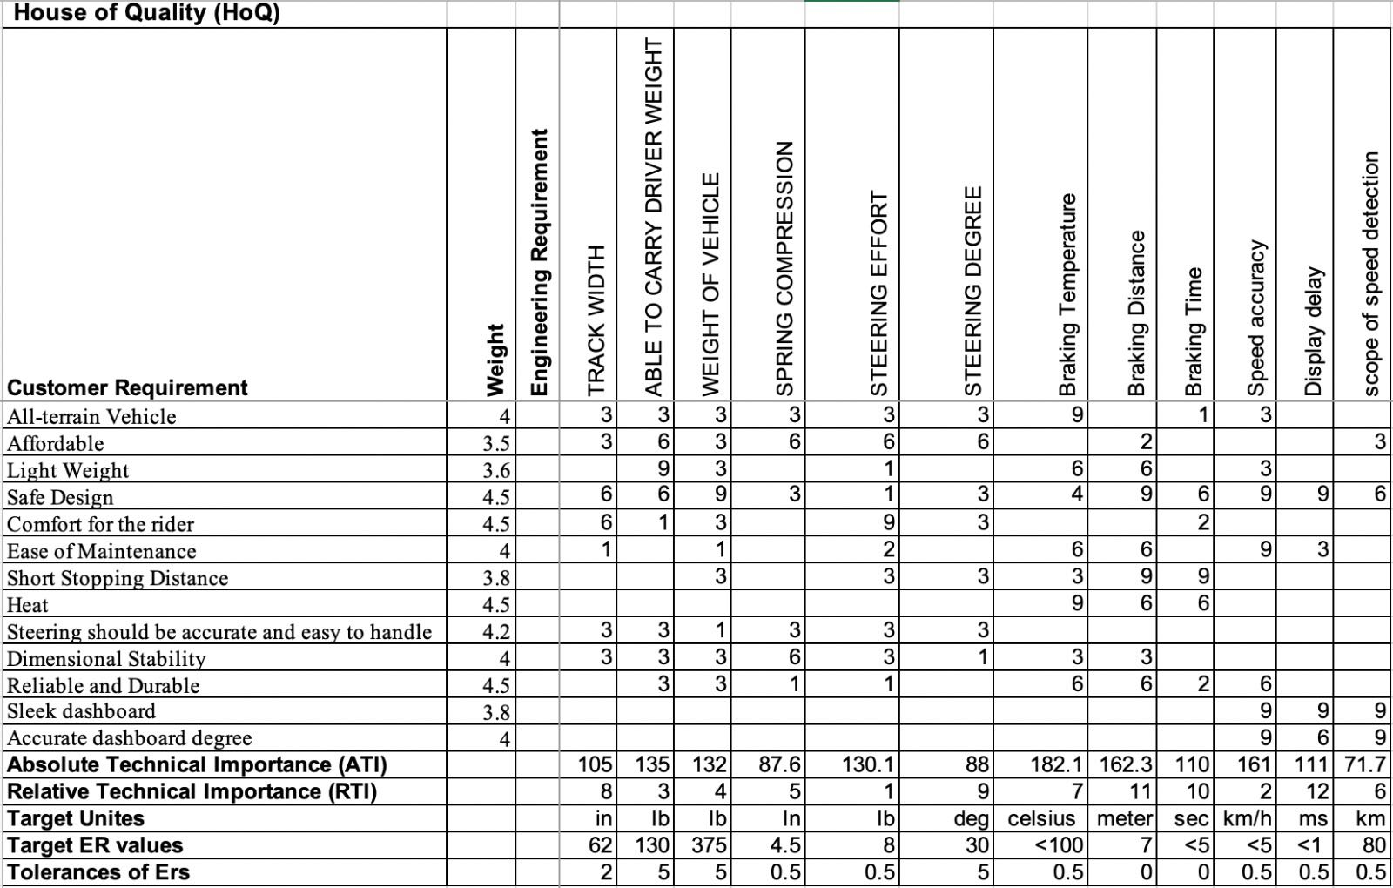

Appendix B: Failure Modeling FMEA

potential Critical Failure 6: Controller Board
The main controlling section of the SAE Baja 2021 design is in the controller board, where tiny microelectronic chips are placed for multifunctional circuit systems. This is the most sensitive part of the assembly, and as such, proper use of current and voltage flow must be ensured to avoid power tripping and bogging down of the circuitry that commands the entire vehicle movement processing. This can be done by ensuring installations of the electrical attachments such as light bulbs, sirens, warning devices to be of recommended specifications such as wattage and power requirement and is well within the capacity of the board to supply.

Potential Critical Failure 7: Wishbone Central Rod
The road's function is to support the vehicle, and its location is located between the wishbone for the softness benefits and the vehicle. The consequence of this rod, in case it is failure that means the suspension will stop working then it leads to vehicle bumps and no more supporting for the vehicle. So, the effect of failure is incredible and will prevent the vehicle from moving on. Another reason for this failure is the road will be broken due to the overweight. To avoid this, it should utilize the high quality materials while keeping track of the regular maintenance. This can be done by ensuring installations of the electrical attachments such as light bulbs, sirens, warning devices to be of recommended specifications such as wattage and power requirement and is well within the capacity of the board to supply.

Potential Critical Failure 8: Caliper
Prominent caliper problems in the vehicular assembly are the caliper mounting bracket. The primary reason for such failure is due to high impact and, more so, is the relatively substandard material type choices for the support. The failure of the caliper bracket will cause its misalignment and detachment from the intended mounting point of the braking system. This weakens, therefore, the braking capability of the vehicle due to its inability to produce a clamping force into the brake rotor.

Potential Critical Failure 9: Spindle
The function of the spindle is to work with caliper and leather pads that are connected to the wheel, and it happens and acts in the brakes, and the functionality is that if the spindle does not work, then the wheels will stop working what is caused the vehicle will stop entirely and make an accident. However, the spindle can be no longer for use, or it can break, and for preventing this failure is to buy or replace it with a new one, and thus the mitigation is. That will provide safety for the critical operator in this design.

Potential Critical Failure 10: Brake Rod
The brake rod consists of attaching the brake with the suspension and the vehicle. The functionality of this road is when the vehicle gets the order to stop from the brake system, and this brake road causes the vehicle to stop. Therefore, if this brake's brake is broken, then the brake will not happen and work this will cause the accident, so this is the failure and the risk of the brake rod by designed more pressure over it. To avoid this failure, it can utilize the solid materials and keep track of their maintenance.

Appendix C: FEA Testing and Final Product

12.3.1 Brake system
Temperature

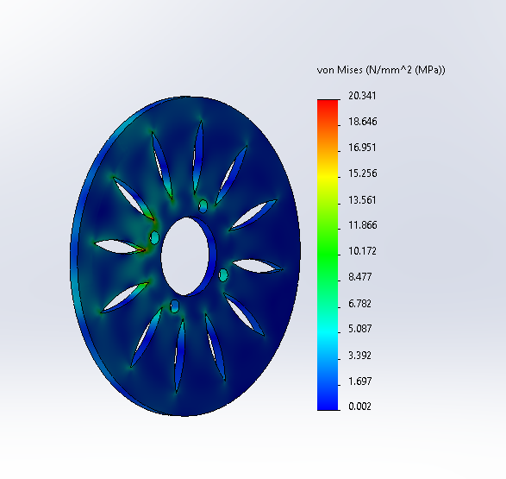
. The Von Misses stress
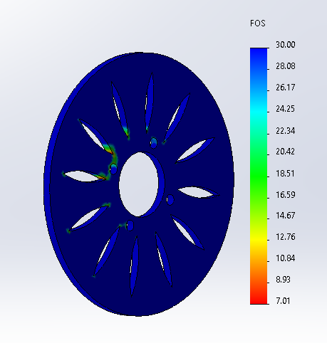
The Factor of safety plot is plotted
The Following are the results for Brake Disk Based on Motion Analysis.

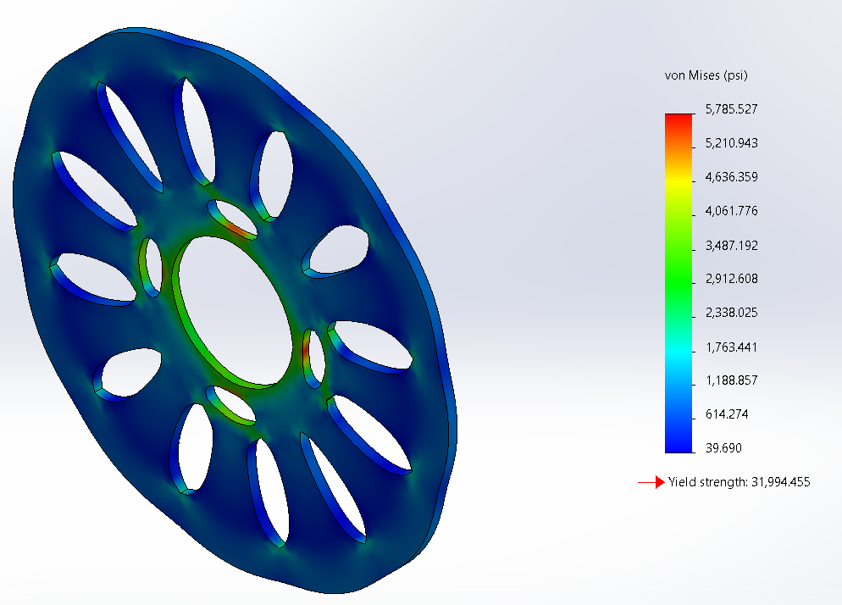
The above figure is the Von-Mises based on the motion analysis of the brake disk
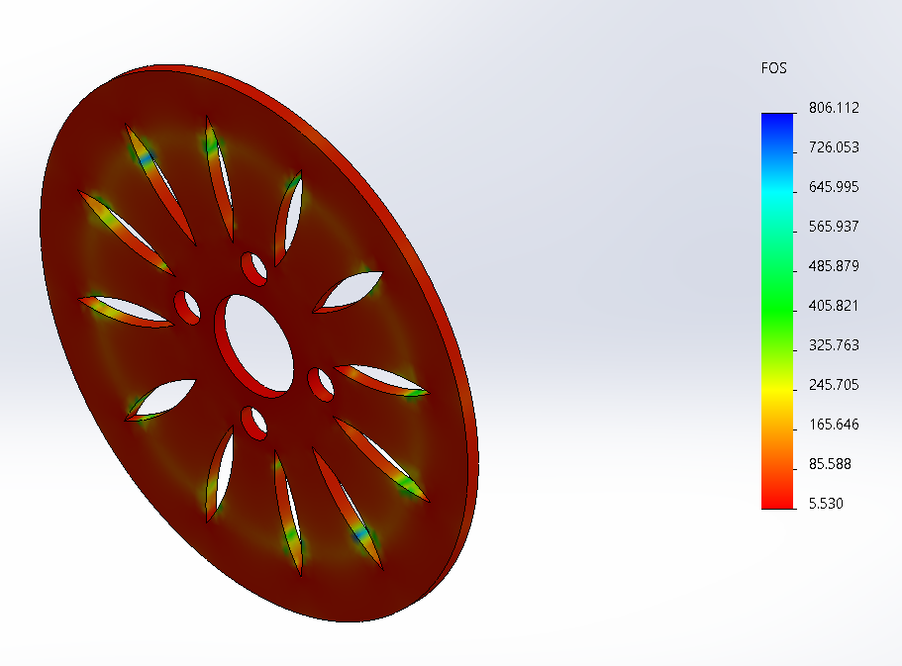
The above figure is the Factor of Safety based on the motion analysis and the minimum FOS is 5.5.

12.3.2 Front Suspension
The upper arm and the lower arm suspension analyzed by using the FEA to perform the analyzing of the load and the results are deconstrued below.
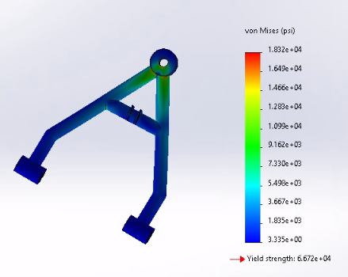
Von Misses for upper arm
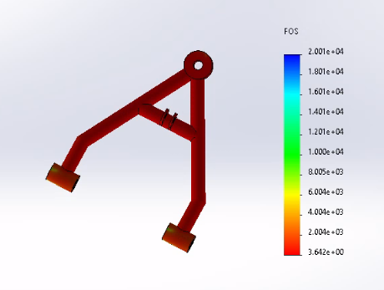
The Factor of Safety

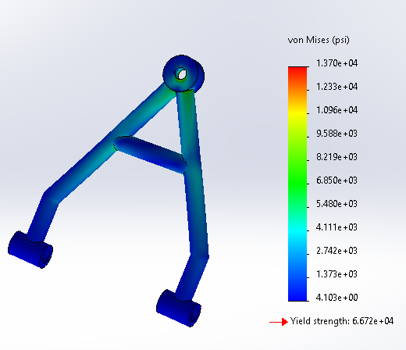
Von Misses of lower arm

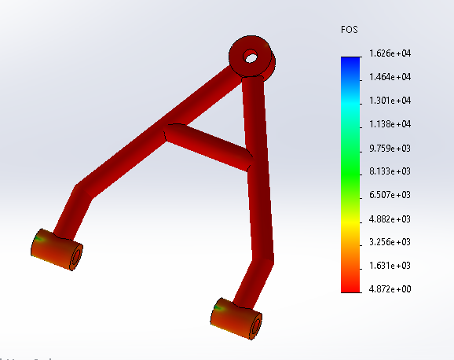

FOS of lower arm

12.3.3 Steering System
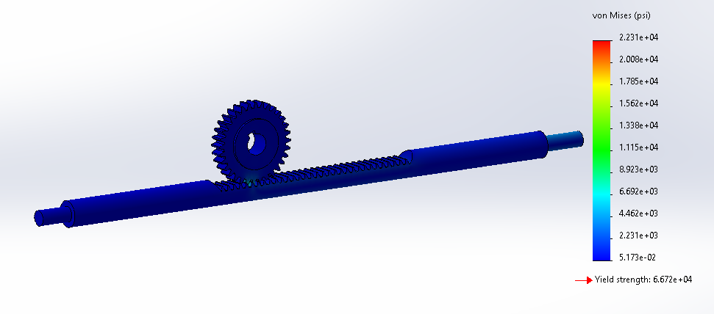
The Von Misses stress of steering
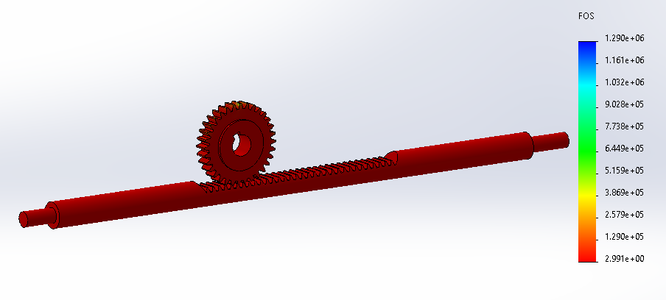
The Factor of Safety of steering

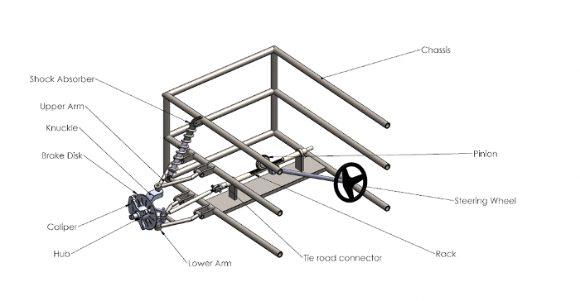

CAD Final Product

12.3.4 Dashboard
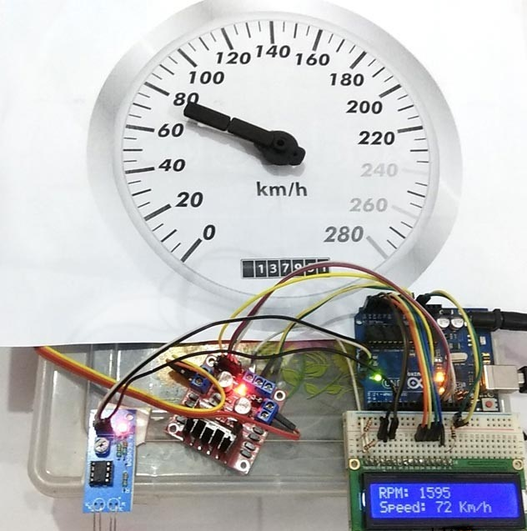
According to the testing result, the detected RPM is 1595 and displayed speed is 72 Km/h. The radius is set to 5 inches. The displayed result is in line with expectations. According to the analog dashboard printed in the Figure 6, the pointer meets the expected position. Overall, the dashboard basically conforms to CR, such as simple appearance and accurate readings. It also conforms to ER, such as measuring range and measuring accuracy.

