HR 2 BREAKDOWN

TEAM: [21Spr05-SAEBaja]

Figure 1: Steering System

Figure 2: Suspension System

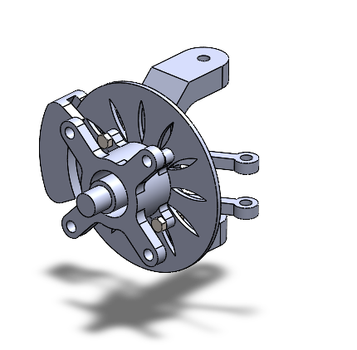
Figure 3: Isometric View of Braking System: In this figure, you can see all the parts needed to have a complete assembly for the brake system. It has fasteners, brake pad, disk, and etc.

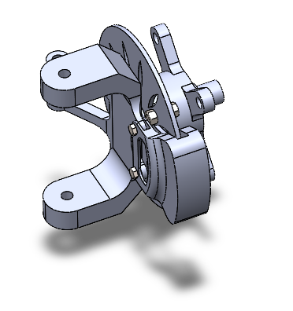
Figure 4: Another view of Braking System: In this figure we would clarify all the parts that we have done for the brake system.

Figure 5: Complete Assembly View

Figure 6: Another View of Complete Assembly

The following are the Action Items each person completed between Hardware Review 1 and Hardware Review 2:

Team Member: Omer Alamoudi
Action Item | Date Completed | Result/Proof of Completion
Brake Disk Thermal Calculations | 09/30/2021 | $Braking Time: t=1.15 s$  $Power Generated:P=3702W$  The braking time remains constant and the power generated is calculated again which comes out to be 483 W greater than the one calculated in Hardware Review I. 483 W is the difference between Hardware review I and II.
Brake Disk Thermal FEA | 10/4/2021 | 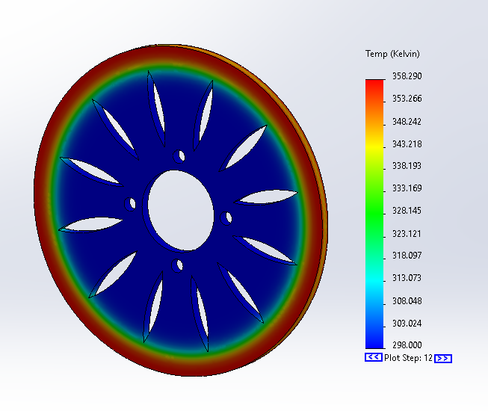
Brake Disk Caliper Design | 10/08/2021 | 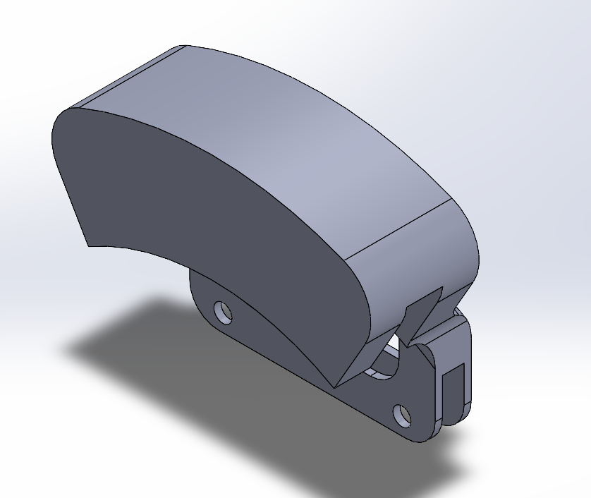
Fasteners Design | 10/08/2021 | 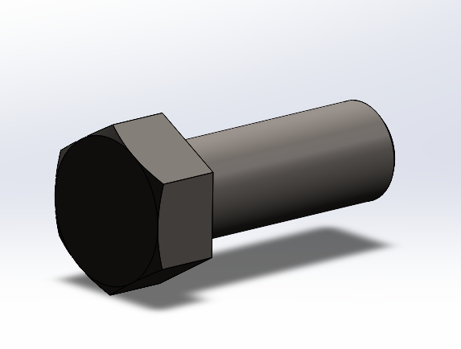
Final Brake Assembly CAD that has all the parts needed. | 10/10/2021

Team Member: Musaed Fraidoun
Action Item | Date Completed | Result/Proof of Completion
Brake Force Calculations |  | $Braking Force: F_{b}=608 N$  $Clamping Force:F_{c}=760 N$  The braking force calculated is 79 N greater than the one on Hardware Review I. The clamping force is also 105.75 N greater therefore than the Hardware Review I
Brake Disk Structural FEA |  | 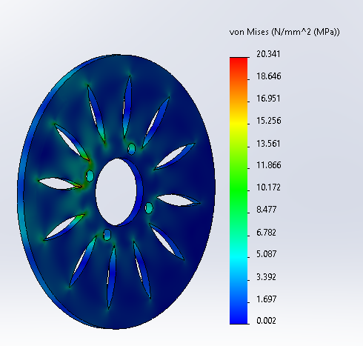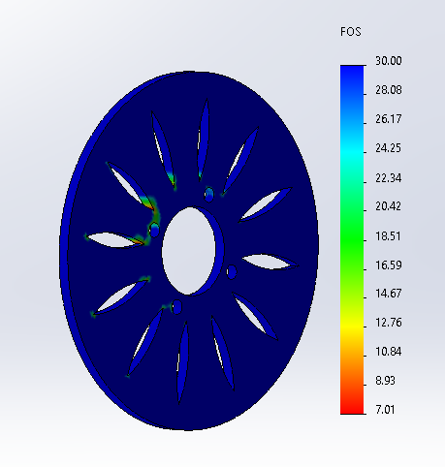
Knuckle Redesign |  | 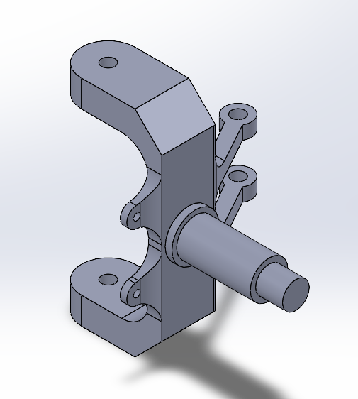
Hub Redesign |  | 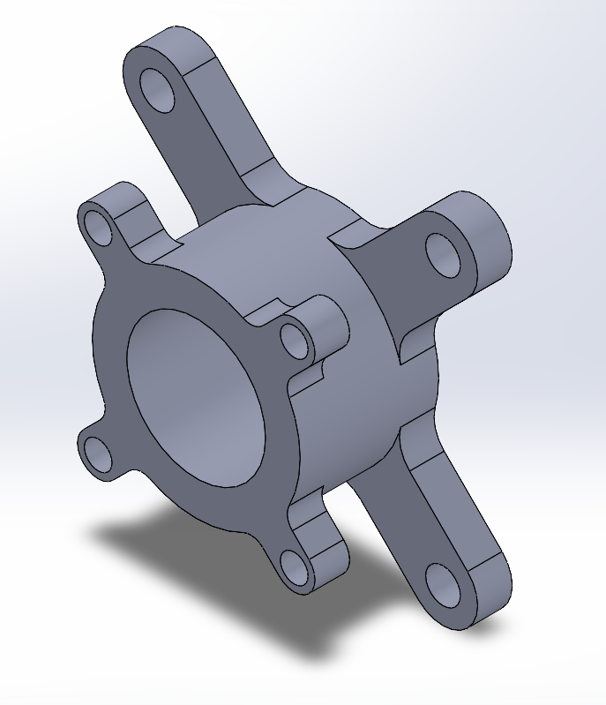

Final Assembly

Team Member: Salem
Action Item | Date Completed | Result/Proof of Completion
Complete Steering System Design
Steering System Calculations |  | The steering system is added in the project scope after the Hardware Review I, therefore the calculations performed are performed only in Hardware Review II. Following are the results of the calculations.  $Pinion Torque: T=113.125 lb.in$  $Driver Force: F_{D}=15 lb$
Rack and Pinion FEA |  | 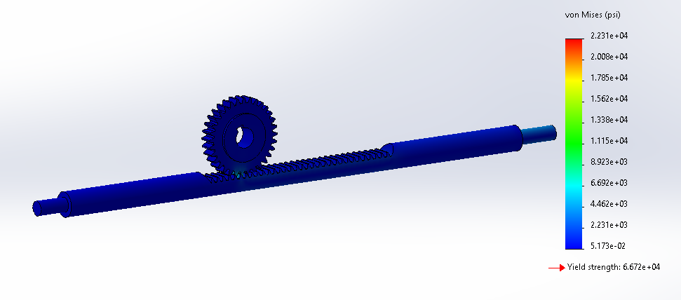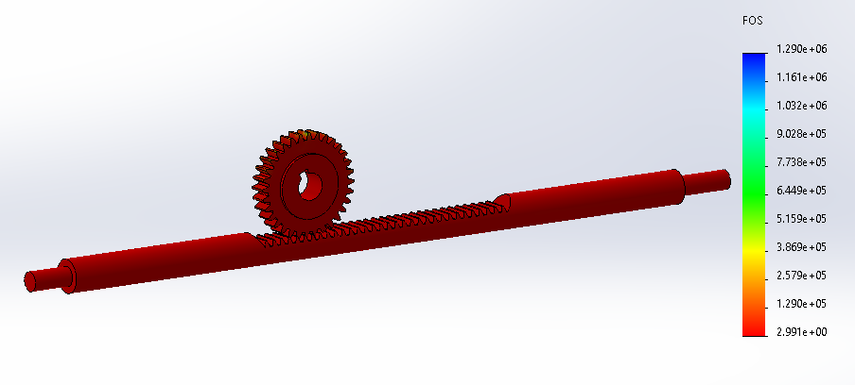

Team Member:
Action Item | Date Completed | Result/Proof of Completion
Upper Arm Calculations |  | The upper arm calculations are performed in Hardware Review II again as the vehicle mass is changed from the Hardware Review I. Following are the results of the calculations.  $Impact Force: F_{imp}=120.2 lb$  $Arm Load Force:F_{arm}=22.625 lb$
Spring Calculations |  | spring force variation with changing compression deflection of the shock absorber  Spring Rate Curve
Upper Arm FEA |  | 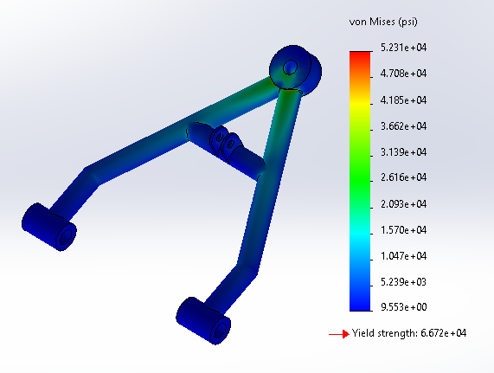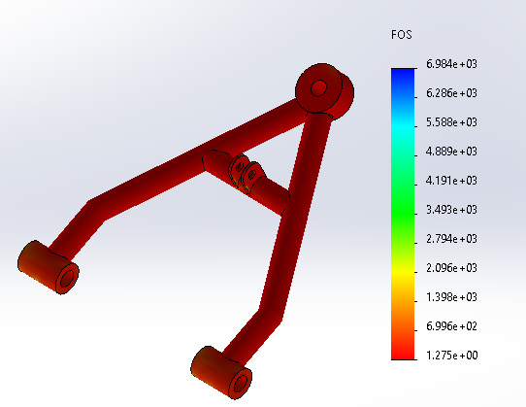

Ball Joints Included

Team Member: Salem
Action Item | Date Completed | Result/Proof of Completion
Complete Steering System Design
Steering System Calculations |  | The steering system is added in the project scope after the Hardware Review I, therefore the calculations performed are performed only in Hardware Review II. Following are the results of the calculations.  $Pinion Torque: T=113.125 lb.in$  $Driver Force: F_{D}=15 lb$

Rack and Pinion FEA

Team Member: Chujian Wang
Action Item | Date Completed | Result/Proof of Completion
Schematic of Dashboard | 10/4/2021 | - 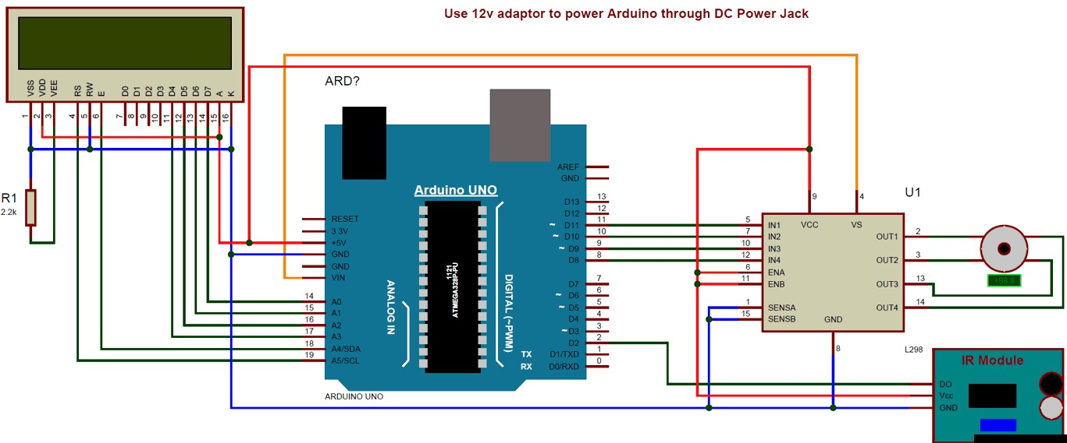
Formula of display speed | 10/4/2021 | The final formula: V_display = rpm * R * 0.3768 (Km/h)
Layout of first hardware review | 09/17/2021 | 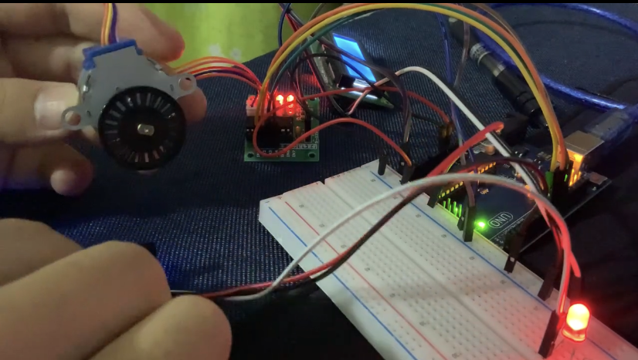
Layout of second hardware review | 11/4/2021 | 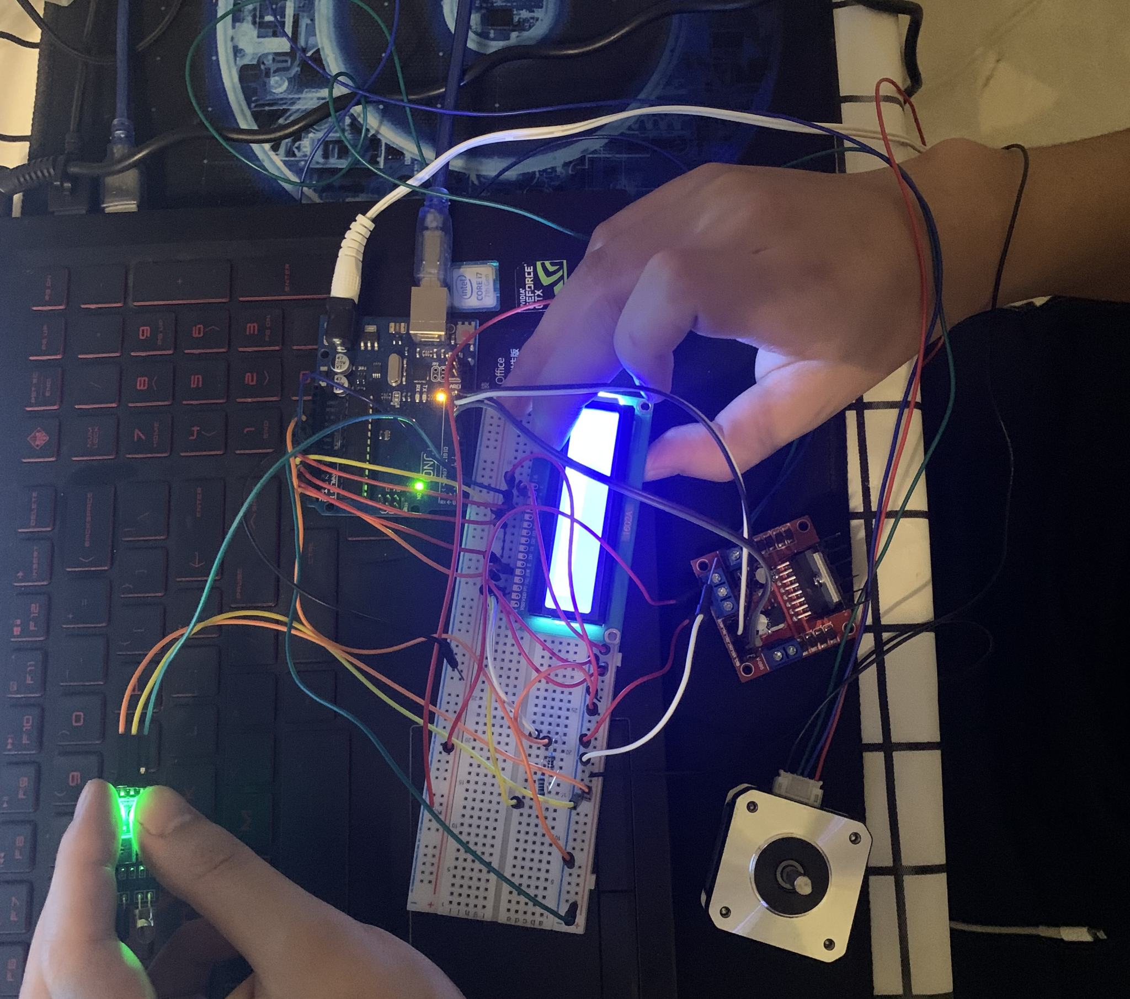

The following are the Action Items for each team member between HR 2 and the Final Product presentation:

Team Member | Action Items | Date Due
Omar Alamoudi | - Drawings for Brake Disk, Caliper and Fasteners  - Brake Motion Analysis | - 11/11/2021  - 11/18/2021
Musaed Fraidoun | - Drawings for Knuckle and Hub  - Brake Motion Analysis | - Due date 1  - Due date 2
Salem Almarri | - Drawings for Steering System Parts  - Steering Motion Analysis | - Due date 1  - Due date 2
Chujian Wang | - Fix the LCD and motor power problem  - Add I2C module to the LCD  - Test the product | - 11/12/2021  - 11/15/2021  - 11/18/2021

