Gore Stent Crimper Project

Preliminary Proposal

Ashley Blood
Nick Green
Jennifer Lawson
Cameron Lissarrague

2020

Project Sponsor: W. L. Gore and Associates
Sponsor Mentor: Tanner Moll and William Reilly
Instructor: David Trevas

1 DISCLAIMER
This report was prepared by students as part of a university course requirement. While considerable effort has been put into the project, it is not the work of licensed engineers and has not undergone the extensive verification that is common in the profession. The information, data, conclusions, and content of this report should not be relied on or utilized without thorough, independent testing and verification. University faculty members may have been associated with this project as advisors, sponsors, or course instructors, but as such they are not responsible for the accuracy of results or conclusions.

TABLE OF CONTENTS

DISCLAIMER 1
TABLE OF CONTENTS 1
BACKGROUND 1
Introduction 1
Project Description 1
REQUIREMENTS-Ashley Blood 1
Customer Requirements (CRs) 1
Engineering Requirements (ERs) 2
House of Quality (HoQ) 2
Functional Decomposition- Ashley Blood 3
Black Box Model 4
Functional Model/Work-Process Diagram/Hierarchical Task Analysis 4
DESIGN SPACE RESEARCH 5
Literature Review 6
Student 1 (Ashley Blood) 6
Student 2 (Nick Green) 7
Student 3 (Jennifer Lawson) 8
Student 4 (Cameron Lissarrague) 9
State of the Art - Benchmarking 10
System Level State of the Art - Benchmarking 10
Existing Design #1: Hand Actuated Stent Crimper with Hard Stop 10
Existing Design #2: Pneumatic Stent Crimper 11
Existing Design #3: Small Pneumatic Crimping Device 12
Subsystem Level State of the Art Benchmarking 13
Subsystem #1: Iris 13
Existing Design #1: Drug Coated Stent Crimping 14
Existing Design #2: Iris with gaps between leaflets 14
Existing Design #3: Plastic Leaflets 14
Subsystem #2: Motor Attachments 14
Existing Design #1: Worm Gear 14
Existing Design #2: Simple Lever 14
Existing Design #3: Motor Bracket 15
Subsystem #3: Motor 15
Existing Design #1: Stepper motor 15
Existing Design #2: Linear Actuator 15
Existing Design #3: Servo 15
CONCEPT GENERATION 16
Full System Concepts 16
Full System Design #1: Slotted Plate Design 16
Full System Design #2: Double Slotted Plate Design 17
Full System Design #3: Single Slot Plate Gear 17
Subsystem Concepts 18
Subsystem #1: Leaflets 18
Design #1: Single Knobbed Triangular Leaflets 18
Design #2: Two Knobbed Triangular Leaflets 19
Design #3: Single Knobbed Triangular Leaflets With Curved Tips 20
Subsystem #2: Plates 20
Design #1: Single Slotted Plates 20
Design #2: Double Slotted Plate 22
Design #3: Single Slot Gear Plate 22
Subsystem #3: Motor Attachment 23
Design #1: Servo Motor Attachment 23
Design #2: Worm Gear Plate 25
Design #3: Gear Rack System 26
Subsystem #4: Motor 27
Design #1: Servo Motor 27
Design #2: Stepper Motor 28
Design #3: DC Motor 28
Subsystem #5: Display 28
Design #1: 29
Design #2: 29
DESIGNS SELECTED – First Semester 29
Technical Selection Criteria 30
Rationale for Design Selection 30
REFERENCES 31
APPENDICES 33
Appendix A: Descriptive Title 33
Appendix B: Descriptive Title 33

BACKGROUND

Introduction
The goal of this project is to employ an iris design to create a stent crimper that outputs radial force and diameter. A stretch goal for this team is to automate the device so that it will not be hand actuated. A graphical user interface (GUI) for the output of radial force and diameter is also a desired feature but not required. The sponsor for this project is W.L. Gore and Associates, a medical device company, that works to improve the quality of life for individuals worldwide. One product distributed by Gore to accomplish this is an implantable stent used to restore blood flow to arteries. Before stents are inserted into the body they must be crimped to a specific diameter over a balloon. The current device used to crimp stents before deployment is hand actuated and does not provide radial force and diameter output. These issues will be addressed by the novel design created in this project.

Project Description
Following is the original project description provided by the sponsor.
“The scope of this project is to design, build, and test a low force stent crimping machine utilizing a crush iris with a radial force readout. Depending on team size and background, an option to create a novel test method to verify stent diameter.”

REQUIREMENTS-Ashley Blood
The specifications of a stent crimper details the customer requirements and engineering requirements. The design’s ability to meet the desired goal will be measured through these specifications.

Customer Requirements (CRs)
Customer requirements are characteristics or specifications of a design that a customer identifies for a desirable product. The customer requirements for this project include an iris design, safety and manufacturing standards, range of diameters and lengths, radial force, accuracy, cost, safety, and visual data outputs. The highest ranked customer requirements include an iris design and safety standards due to medical concerns and functional purposes of the design. The least important customer requirement was data outputs because this requirement was considered optional for the designers.

Engineering Requirements (ERs)
Engineering requirements are quantifiable parameters or conditions used to measure the design’s ability to meet customer requirements. The engineering requirements for this project include an iris design with at least 10 leaflets, a diameter range of 1 to 30 mm, a length range of 0 to 20 cm, radial force outputs of 0 to 425 N, cost under $3000, and a visual display that has a LCD or LED screen. The tolerances for the diameter and length have to be +/- 0.025 mm and +/- 3 mm [1, 2]. The tolerance for the radial force has to be +/- 10N.

House of Quality (HoQ)
A house of quality (HOQ) was constructed to translate customer needs into engineering requirements based on customer’s specifications of importance. The customer needs are related to engineering requirements based on the determined strength of their relationship. From this relationship, the technical importance of each engineering requirement was determined to assess the significance of each design aspect. The engineering requirement with the highest technical importance was the radial force due to safety concerns and functionality of the design [Figure 1]. The least important engineering requirement, based on technical importance, was the visual display. Based on the HOQ, the team considered the radial force of the design a critical element to consider within the designing produce.
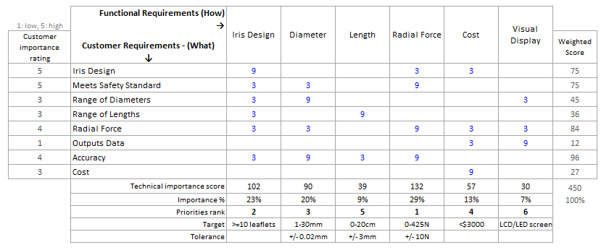
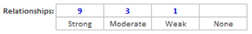
Figure 1: House of Quality

Functional Decomposition- Ashley Blood
A functional decomposition investigates the functional flows of material, energy, and signal of a device. The functional decomposition provides the team with a comprehensive guide that correlates functions with customer needs.

Black Box Model
A black box model was constructed to express the overall function of the design and identify input and output flows [Figure 2]. Flows are defined as material, energy or signal that affects or utilized by the device. The overall flow of the device is to crimp a stent which means the reduction of the diameter of a stent to conform to a catheter. The material flows consists of the input of a stent and human hands and returns the stent and hands. The energy flow consists of the input of electrical energy and human energy and returns mechanical strain energy . The signal flow consists of the on/off signal and returns the on/off signal, radial force output, and diameter reduction. The flows discussed in the black box model impact each other which will be addressed in the functional model.
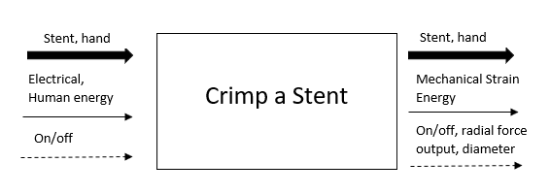
Figure 2: Black Box Model
The black box model provides the precursor for a complete functional model which is used to analyze the functional process of the device.

Functional Model/Work-Process Diagram/Hierarchical Task Analysis
A functional model provides operational guidelines to the broad overview of flows addressed in the black box. The operational guidelines or function chains is the process of transformation from the input flows to output flows [Figure 3]. Each customer need is addressed in the functional model.
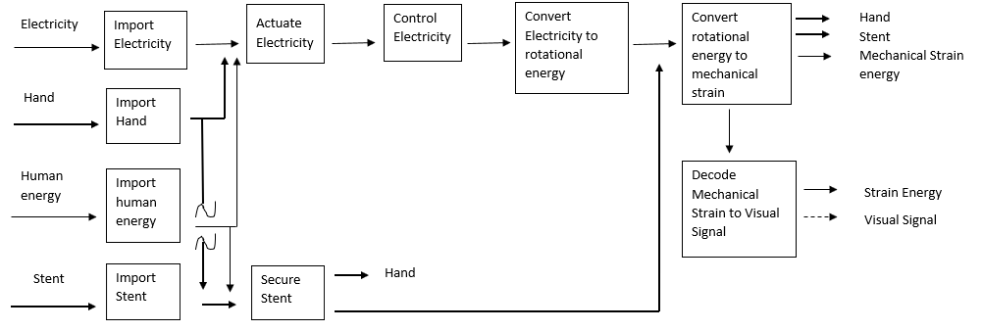
Figure 3: Functional Model
The functional flow of electricity addresses the customer needs of the diameter, length, radial force, accuracy, iris design, and safety. The function of converting rotational energy to mechanical strain energy represents the customer needs of diameter, length, radial force, iris design, and accuracy. Accuracy is also represented by the securement of the stent. The functional chain of electricity from importing electricity to converting rotational energy to mechanical strain represents the customer need of safety. The function of decoding mechanical strain to visual signals represents the customer need of data output.
The functional model generated simple sub-functions to assist with the discovery of information. This model identified critical functions and functional chains of the design that the team should concentrate on for an effective and safe device.

DESIGN SPACE RESEARCH

The design space research incorporates design research and benchmarking of existing devices. The design research involves understanding stent sizes and materials, motors, radial forces, and components of a stent crimper. This research was applied in the benchmarking section for assessment of the existing designs.

Literature Review
The literature review entails the process of individual research as well as specified information that was utilized to assess existing designs and refine engineering requirements. The literature review encompassed stent design and tolerances, motor and motor control, radial force calculations, and a brief overview of various stent crimper subsystems.

Student 1 (Ashley Blood)
This student focused on stents including materials, diameter sizes, and lengths as well as tolerances for both stents and stent crimps.
Diameters and Lengths of Stents
The student conducted research on the diameter and length sizes of aortic stents and intracranial stents sizes. The selection for these stents were made to impose a large range of diameters and lengths for the design. The GORE Excluder Endoprosthesis aortic stents have nominal diameters of 23 mm to 35 mm with lengths from 12 to 18 cm [3]. The desired crimped diameter sizes of the aortic stents were determined to be 4.4 mm to 8.6 mm [4]. For intracranial stents, the nominal diameter and lengths are 2.0 mm to 4 mm and 8 mm to 28 mm, respectively [5]. The desired crimped diameters of intracranial stents are 1.67 mm to 2.67 mm [6]. From this research, the engineering requirements for diameter and length were refined for a more effective design.
Stent Materials
Stent Materials consists of metal and polymer stents [7]. The metallic stents include nitinol, stainless steel, and other alloys such as Magnesium or Zinc alloys. The polymer material includes nylon and polyurethane. The stent material affects the radial force required by the design [8].
Tolerances
Tolerances of the diameter and length for both stents and stent crimpers was conducted to understand the desired operational deviations for the device. The diametral tolerance of both a stent and stent crimper should be +/- 0.025 mm or smaller [1,2]. The length tolerance was determined to be approximately +/-3 mm [2]. From the tolerances, the engineering requirements were refined and utilized to assess existing designs if the information for tolerances is readily available.

Student 2 (Nick Green)
This student focused on the research of motors and motor controllers.
Source 1
This source is a forum discussing the coding behind how to detect physical resistance using a stepper motor. The various authors of the post talk about different ways to measure torque. The way that seems to be the most viable and practical is using an encoder on the stepper motor [9].
Source 2
This source talks about using an arduino to control an induction motor. It talks about how a motor works, using equations and other pieces that can be used to translate into our code for other components that were asked of the team in the project description [10].
Source 3
This is a description on how to code an LCD display into showing what is needed in order to meet the needs of the clients. This will be very useful for the project because one of the requirements is a way to display the force and diameter [11].
Source 4
One method of setting the requirements would be the capacitive touch screen. This works by two layers of conductive glass separated by an insulator, essentially creating a capacitor. When a finger or other charged surface comes into contact with the screen, electricity flows and registers [12].
Source 5
Resistive touch technology is when there is a film that flexes and creates an air gap and is pressed into a glass with a resistive layer that is used to calculate the location of the touch [13].

Student 3 (Jennifer Lawson)
This student focused mainly on researching methods for calculating radial force while also exploring actuation mechanisms for the iris and maximum radial forces of the device.
Source 1
The force required to move a hand actuated mechanism is obtained and is related to the radial force by conservation of energy. This method measures force and displacement and uses those values to calculate diameter and radial force. The slope of the measured diameter and displacement are used with the measured linear force to obtain radial force [14].
Source 2
This article focuses on the dimensions and forces of stents during deployment into tissue and provided information on radial forces of the stent crimper used in the study, which is the same stent crimper currently used by our client. The max radial force was found to be approximately 60N and was determined by using equations that relate radial force to hoop force [15].
Source 3
A current radial tester manufactured by Blockwise uses a linear actuator controlled by a stepper motor and implements a force transducer to read in the force. The stepper motor is coded to determine the diameter of the device and relates that to radial force in a similar manner as source 1. This source also provides specifications on the maximum radial force of multiple stent crimpers with the highest of 980N [16].
Source 4
A method for crimping stents by Machine Solutions utilizes equipment that measures force and angular rotation with an optical encoder and calculates diameter. The hoop force is found and then related to radial force, where it is displayed in a software. The software does the majority of the work for calculating and outputting the data. Guidance on where to find specifications on standards was also provided within this source [17].
Source 5
Another source by Blockwise covers the differences in force versus diameter control of crimping devices. The benefits of a diameter controlled device include less mistakes as the settings are consistent for products (stents) of varying lengths. One disadvantage of using diameter control is the variability of surface pressure on a product with varying cross sectional area [18].

Student 4 (Cameron Lissarrague)
This student focused on researching similar products as a complete system and subsystems. The purpose of researching existing designs is so that the team does not replicate a design that already is in production.
Source 1
Blockwise is a resource the team used for more than just benchmarking but they have many products that team was able to use for benchmarking. The Model RJ Machine Base is a radial compression machine that uses compressed air to attach stents to balloon catheters. These devices do not use electronic measuring devices or motors. The diameter and lengths have different ranges. [19].

Source 2
The MSI models use both hand and pneumatic activation to close the iris. The iris leaflets can be made in either stainless steel or thermoplastic material. The manufacturer also has an option for a heated crimp head. These stent crimpers use a micrometer to stop the crimping process for precise diameter control [20].

Source 3
Iris leaflets are made of different materials and there are several factors that go into choosing the material of the leaflets. The main factor that is considered when looking into materials to use for the leaflets is friction. Friction causes binding of the iris if there is two much of it and the motor would need to have enough torque to overcome the friction. Friction will also cause the iris to wear and will reduce the lifespan of the product. This is why a material with a low coefficient of friction should be chosen for the leaflets [21].

Source 4
The motor that will activate the iris to close will need to be able to supply enough torque to overcome friction and crimp the stent effectively. The two motors that the team is leaning towards are a stepper motor and a servo motor. Both of these motors utilize a DC electrical input. Stepper motors operate in an open loop constant current mode. This motor requires no encoder but creates heat. Stepper motors are stable at rest and hold their position without fluctuation. Servo motors require an encoder to control and supply current to the motor. Servo motors require current to hold the position. Typically a stepper motor is ideal for applications that require low-to-medium acceleration rates and for high holding torque. Servo motors are ideal for high speed applications with high torque [22]

Source 5
Linear actuators could be another way the team closes the iris. There are 4 main types of linear actuators, electric, hydraulic, pneumatic, and piezoelectric. Electro mechanical linear actuators convert rotational motion to linear motion and are typically the slowest linear actuator but still create high numbers of thrust. Hydraulic linear actuators use a pressurized hydraulic fluid to create thrust. These actuators are typically used in rugged applications where high power per unit weight and volume are desired. The pneumatic linear actuators used compressed air to create thrust and are very versatile in their applications. These are common in stent crimping devices. The Piezoelectric actuator uses voltage to expand a material. These actuators are the fastest accelerating actuators and typically exceed accelerations of 10000 Gs. This is too fast for the stent crimping device the team is designing [23].

State of the Art - Benchmarking
The team was not able to complete on-site visits to handle a stent crimping device. Benchmarking was conducted with thorough online research. The whole system was researched along with three subsystems. The subsystems selected are the iris, the motors, and the motor attachment to plates. Three complete systems were selected for benchmarking three designs were selected for each subsystem.

System Level State of the Art - Benchmarking

The team began with researching the complete system to gain knowledge about hardware that was already on the market. The systems either use hand actuation, pneumatic actuation or electrical actuation. The most common actuation is pneumatic. The research completed on the complete systems allowed the team to have a better understanding of what the design consisted of.

Existing Design #1: Hand Actuated Stent Crimper with Hard Stop
The MSI SC100/200 model is a hand actuated benchtop stent crimper as seen in figure 4. This product features a uniform segmental compression head for uniform compression [20]. Other features of this product are an optional heated stainless steel or thermoplastic crimp head and a micrometer that stops the hand actuator for precise diameter control [20].
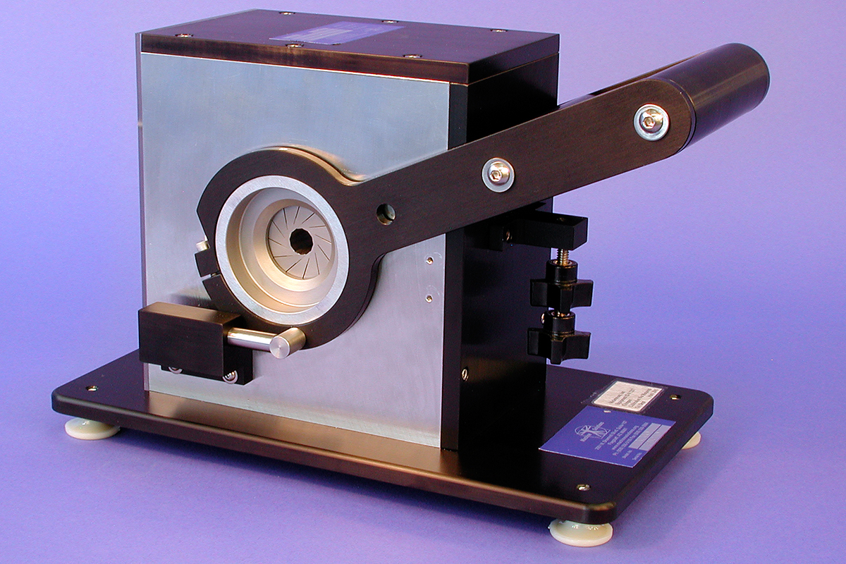
Figure 4: MSI SC100/200 Benchtop Hand Stent Crimper [20]

This crimper uses a stainless steel die material and is hand actuated. The micrometer is a basic concept to stop the crimper for precise diameter measurements. The design the team must make also must have an accurate diameter measurement system. The team would like to pursue an automatic system which could be able to utilize similar methods to obtain precise diameter measurements.

Existing Design #2: Pneumatic Stent Crimper
The Model RJ with J-Crimp Compression Station, seen in figure 5, is used for medium sized general-purpose crimping [19]. The stent crimping machine uses a pneumatic activator to close the iris. A pneumatic device is just a device that uses compressed air to initiate movement. This model can support a diameter from 0mm to 16mm and a length of 62 or 124mm [19]. This model has a max radial force of 955N and uses hardened stainless steel for the die material used in the iris.
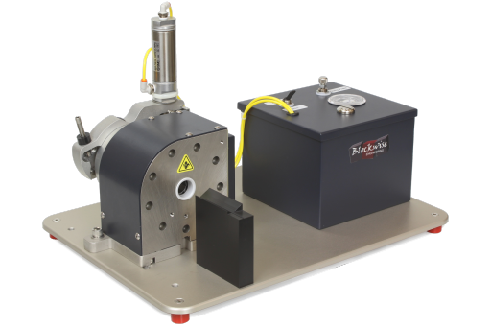
Figure 5: Model RJ with J-Crimp Compression Station [19]

Figure 5 above shows the stent crimping device with a compression station to the right of it. The pneumatic actuator is located on top of the crimping device. A pneumatic actuator would be one way the team could actuate the iris to close effectively crimping a stent, but this would require an air compressor seen on this workstation and causing the price to rise for the unit. This unit does not appear to have a digital readout for the forces and diameter when crimping a stent. This unit has a gauge to read the pressure the compression station is producing. This could be used to create a digital readout of forces and diameters, but it is a complex design. This product utilizes small gaps between the dies within the iris to reduce wear. While this does reduce wear this also reduces the range of diameters this crimping device can crimp. With the small gaps between die the larger of the diameter the larger these gaps become causing issues while attempting to crimp larger stents this is why different models with zero gap between die have a larger range for diameters seen with the model RJ with Zero-G compression station.

Existing Design #3: Small Pneumatic Crimping Device
[Describe this system-level existing design and explain how it relates to your requirements. Cite all textual information and figures.]
The Model CX with Alpha-Crimp Compression Station allows for the crimping of stents of smaller size. This crimping device uses a compression station to allow for accurate control of the iris and utilizes stainless steel leaflets [24]. This device can be seen in figure 6.
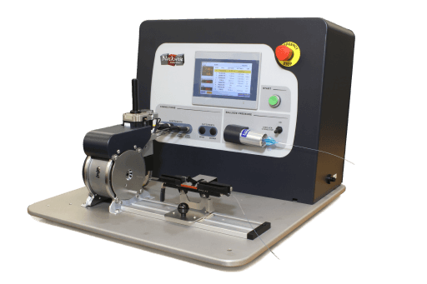
Figure 6: Model CX with Alpha-Crimp Compression Station
Figure 6 shows the device layout with the crimping device and the compression station. This device uses a pneumatic actuator to control the iris and a compression station to supply the compressed air. The device is small and has zero gap between the leaflets which allows for the device to crimp small stents with a range of diameters of 0-8mm [24]. The zero gap between the leaflets is the goal the team is interested in. This allows the stent crimper to get a smaller range of stents.

Subsystem Level State of the Art Benchmarking
The complete system can be broken down into subsystems. Each of the subsystems have a purpose and a different function that come together and produce a functioning system. There are several different existing designs.

Subsystem #1: Iris
The iris subsystem is the part of the design that will be in contact with the stent. This part has the potential of having a lot of friction when closing. Designing an iris with minimal friction will allow for the most force to be translated from the motor to the stent when crimping. There are several different types of existing designs. For the iris design to function correctly in a stent crimper it must be able to be extruded to create a length of crimping. It needs to create a circle or a shape similar to a circle and must be capable of diameter reduction to specified diameter ranges.

Existing Design #1: Drug Coated Stent Crimping
This iris design is from the company MSI and uses triangular leaflets with two layers of PTFE film as a protective layer between the stainless steel leaflets and the drug coated stent. The stent is inserted between these layers of PTFE and the iris closes around the stent crimping it [25]. This method makes the process of crimping drug coated stents easier and less time consuming. Drug coated stents need to be protected from being damaged by the stainless steel leaflets in the iris. These layers of PTFE also help shape the stent because it will form a circle around the stent as the iris closes which does not make a perfect circle.

Existing Design #2: Iris with gaps between leaflets
This iris design has gaps between the leaflets within the iris. The gap between the leaflets reduce the friction when operating the device which puts less strain on the motor and overall system. This will increase the lifespan of the device and make it more reliable. The disadvantage to this is it reduces the diameter range of stents it can crimp. The gaps close and form a small diameter range. The team wants to design a product that has a large range of diameters so this method of iris design is not ideal.

Existing Design #3: Plastic Leaflets
This design uses plastic leaflets instead of stainless steel. The plastic used is not specified but has a lower coefficient of friction than stainless steel. This increases the lifespan of the product but does not increase the durability. The plastic leaflets are not as durable as the stainless steel leaflets. The tips of the plastic leaflets can wear due to high pressure contact with stents.

Subsystem #2: Motor Attachments
The motor attachment is the part that connects the motor to the iris plates. This transfers the motion from the motor to the iris. This subsystem can affect the systems reliability, the torque transmitted from the motor and the manufacturability of the product.

Existing Design #1: Worm Gear
A worm gear motor attachment system consists of a worm, a screw like gear, and a helix gear. Worm gears amplify torque from the motor but reduce speed. The worm will have an angular velocity similar to that of the motor and the gear, depending on the size, will have a greatly reduced angular velocity. This can be both an advantage and a disadvantage. The advantage is that it will be easier to control becasue the iris will be closing slowly. The disadvantage is that it could cause the iris to close too slowly and reduce productivity while using the device. One major advantage to a worm gear is that it is self locking. It is self locking because the worm will drive the gear but the gear will not drive the worm. This will allow the crimping device to hold its position when it needs to.

Existing Design #2: Simple Lever
The simple lever is just a lever that is attached to the iris plate. When a force acts on the lever the iris will close or open. The lever is typically used in hand actuated crimping devices, but could be used with a linear actuator, or a servo motor. To be used with a servo motor there would need to be additional linkage to properly attach the motor to the lever. The advantages of the lever is that it is easily manufacturable, reliable and simple to work with. The disadvantages are that there are no self locking features and it is not as controllable as the other options listed here.

Existing Design #3: Motor Bracket
A motor bracket would use a bracket to directly attach the motor to the iris plates. This method would have less parts than any gear set up but one more than the simple lever method. This method would directly transfer the torque from the motor with no amplification of torque input from the motor. This would require a motor which has more torque. The motor would have to be designed to handle the extra workload or this could reduce the lifespan of the product.

Subsystem #3: Motor
The motor is an essential part of the system because the iris must be closed and opened. The iris can be actuated using a motor or by hand. The team is going to design the stent crimper as an automatic sent crimper so a hand actuated device is not an option. The motor will have to supply a sufficient amount of torque to overcome friction within the device and apply enough force to crimp the device.

Existing Design #1: Stepper motor
Stepper motors create high torque at lower speeds. This is due to the design of the motor. The motor requires more current exchanges per revolution when compared to a DC motor or a servo motor. For this reason the stepper motor does generate more heat than other motors. A stepper motor also typically has a high holding torque which is perfect for crimping a stent where a stent is crimped down to the desired diameter and held at that position for a specific amount of time. These motors are an inexpensive option that the team is considering. To implement this motor in the design a system of gears will have to be designed for the system or it can be attached using a direct bracket to an iris plate..

Existing Design #2: Linear Actuator
Linear actuators exist in stent crimping devices and are typically pneumatically driven. These types of linear actuators use compressed air to close the iris. These devices create a lot of thrust and are relatively easy to control. Linear actuators provide a smooth movement into position. They are more expensive than the other two designs in this subsystem costing anywhere from 30 to 500 dollars. Another disadvantage to this type of motor is it must be supplied with compressed air and this compressor must be supplied with electricity. This causes the design to have more parts and more parts means less reliability of the system overall.

Existing Design #3: Servo
A servo motor is controlled by electric signals typically received as a pulse and not a constant current. A servo motor can supply a high amount of torque and high dynamic load changes. A servo motor typically operates and is suitable for high speed and high torque applications. This may not be ideal for the stent crimping design but it can work and will supply an effective amount of torque. Another drawback of the servo motor is that it can only rotate 90 degrees in each direction with a total range of 180 degrees of rotation. This motor will require a linkage to be designed to connect the motor to the iris assembly.

CONCEPT GENERATION

Full System Concepts
Three alternative stent crimping devices were considered for the purpose of generating a final design of the project. Each design was examined based on the individual sub-systems.

Full System Design #1: Slotted Plate Design
The slotted plate design is named after the slotted back plate that guides the leaflets into position. The design consists of a stationary front plate, a movable back plate with a motor attachment, a servo motor, and housing. The front plate has slots that enable the leaflets to slide into position and a back plate that actively advances the leaflets. A motor attachment is secured to the back plate and actively rotates due to a servo motor placed at its center. The leaflets are positioned due to an extruded slot that fits into the front plate and an incised hole for a knob that glides into the slots of the back plate. Each component is placed inside a housing which is shown in the exploded view [Figure 7].
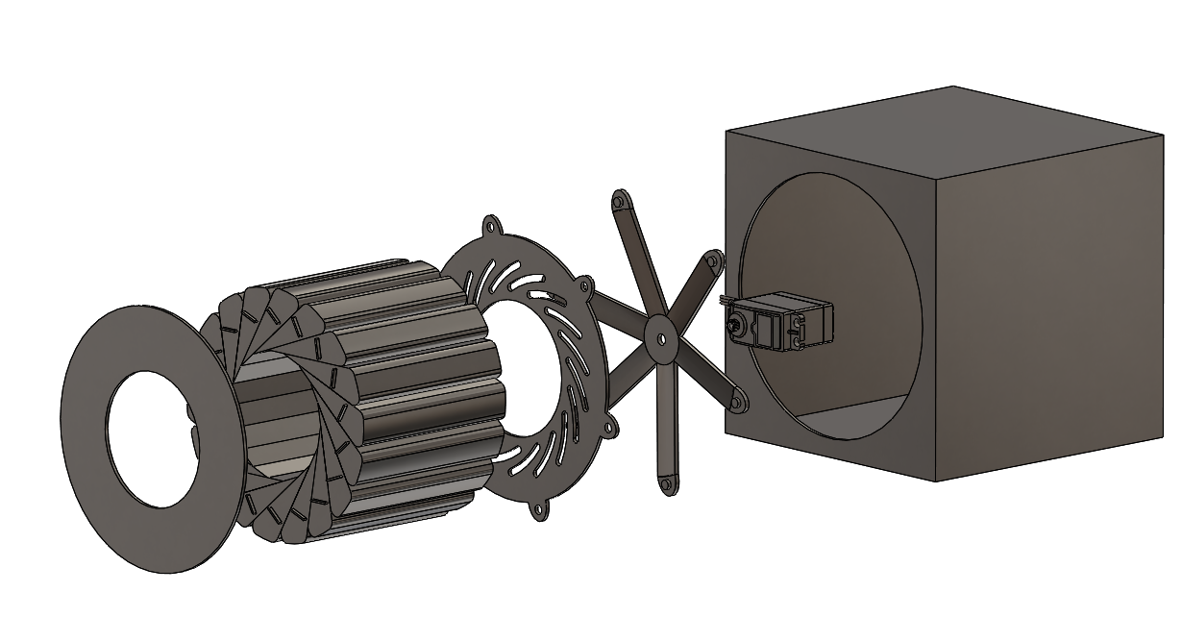
Figure 7: Slotted Plate Design
The advantage of this design is the number of leaflets. The 18 leaflets produce an octadecagon shape that provides a relatively accurate crimping structure. The disadvantage of this design is the high machining costs due to complex geometries and the required tolerances.

Full System Design #2: Double Slotted Plate Design
The double slotted plate design is named after the plate that uses two concentric slot patterns to guide the leaflets into position [Figure 8]. The design consists of an outer plate mentioned before with two different sets of slots. A worm gear that has slots on the face of the gear to move the leaflets. A worm that is driven by a motor. The leaflets which have two knobs on the leaflets. The knobs on the leaflets will be inserted in the slots on the gear and on the outer plate to guide them into a closed and open position. Then there is housing which all of these parts are placed in. An exploded view of this system can be seen in the figure below.

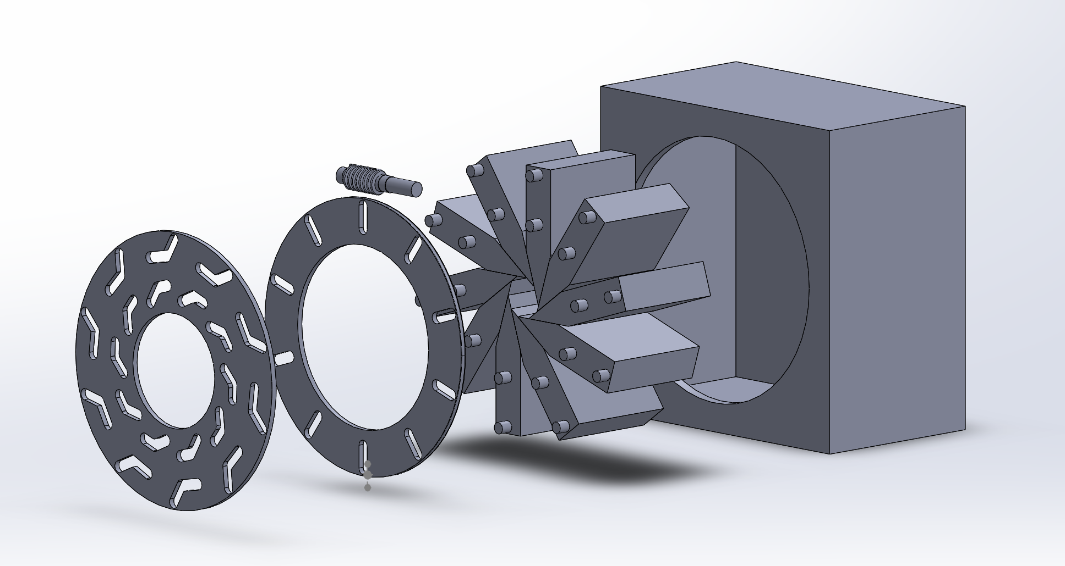
Figure 8: Double Slotted Plate Design
The advantage of this design comes from the worm gear. The worm gear allows for the iris to be closed slowly and precisely. The disadvantages are that this design only utilizes a ten leaflet design which causes the iris to close into a decagon and not a circle. This design will also cost a lot to machine because of the complex geometry.

Full System Design #3: Single Slot Plate Gear
The single slot plate gear design is named after the slotted gear plate that connects with a rack gear. The design consists of a stationary slotted back plate, leaflets, a slotted gear plate, a rack and gear, worm gear motor, and housing [Figure 9]. The slotted gear plate has the same slotted design shown in Design 1 in Figure x that enables the leaflets to slide into position. This gear plate has added teeth to connect with a rack and gear to enable motion from a worm gear motor. The stationary back plate enables leaflets to guide into position through narrow slots.The leaflets are positioned due to an extruded slot that fits into the front plate and an incised hole for a knob that glides into the slots of the slotted gear plate. Each component is placed inside a housing which is shown in the exploded view.
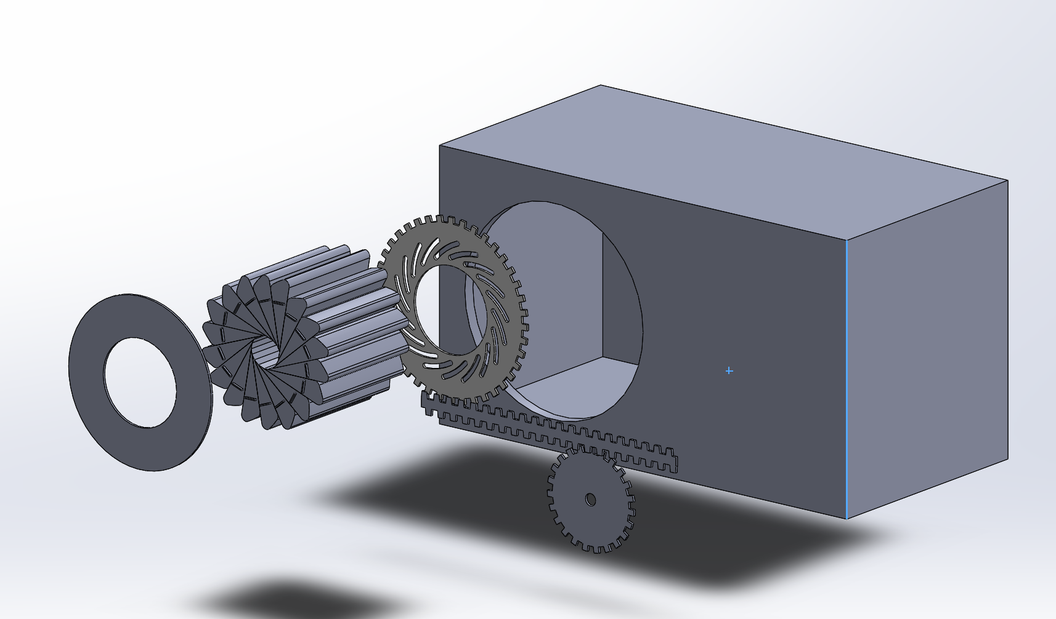
Figure 9: Single Slot Plate Gear

Subsystem Concepts
Five subsystem concepts for three distinctive stent crimping designs will be evaluated based on the functional decomposition. The five subsystems that will be examined are the leaflets, plates, motor attachment, motor, and display. The subsystems of the leaflets, plates, and motor attachment address the function of converting electricity to rotational energy. The subsystem of leaflets will, also, address converting rotational energy to mechanical strain energy. The subsystem of motor addresses the functional chain of electricity from actuating electricity to controlling electricity. The subsystem of the display will address the function of decoding mechanical strain to output signals.

Subsystem #1: Leaflets
The subsystem of the leaflets address the functions of converting electricity to rotational energy and converting rotational energy to mechanical strain energy. This subsystem is vital for addressing the engineering requirements of leaflet numbers and diameter.

Design #1: Single Knobbed Triangular Leaflets
The single knobbed leaflets consist of a knob attachment area and an extruded slot [Figure 10]. The knob attachment initiates movement between the moveable back plate and the leaflets. The extruded slot enables the leaflet to slide across the stationary front plate during motion. The angle of the leaflets allow up to 18 leaflets within an iris and can be adjusted for various leaflet numbers. The leaflet has a thickness of 20 cm, which is not shown in Figure 10, to allow a large range of stent lengths.
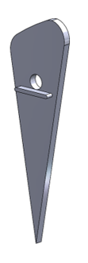
Figure 10: Single Knobbed Triangular leaflets
The leaflets must rest at a specific angle for a circular configuration of the leaflets. This requires an unique front plate to facilitate motion.

Design #2: Two Knobbed Triangular Leaflets
These leaflets are different between other leaflets because there are two knobs on this design [Figure 11]. The two knobs allow for this leaflet to follow a different slot pattern on the plates and it allows for the leaflets to change the angle at which they close. This helps widen the range of diameters the iris can crimp. This design can be seen in the figure below.
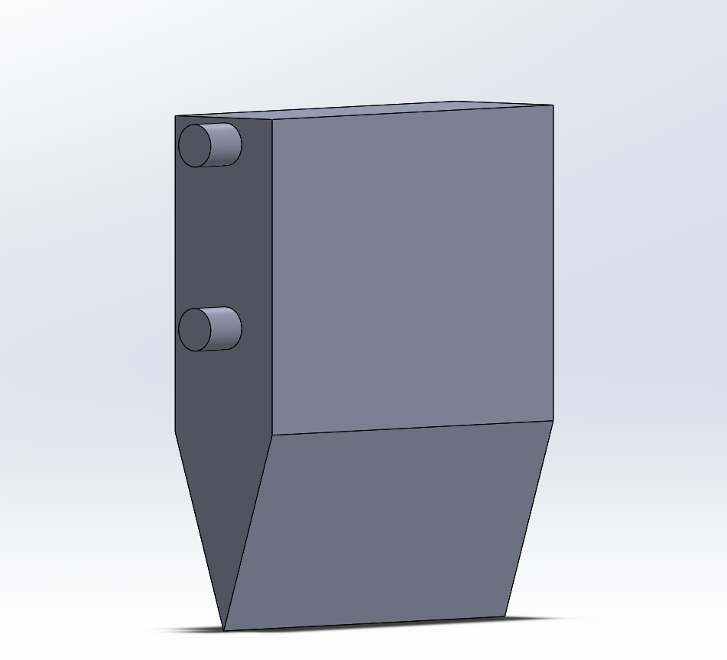
Figure 11: Two Knobbed Triangular Leaflets
Figure 11 is a solidworks model of the leaflet with two knobs. The shape of this leaflet will only work if it is moving at an angle. This will require an unique front plate. This specific design in figure 11 is designed for ten leaflets to form the iris but this will cause the iris to close forming a decagon. The more leaflets that are added to the iris allow the shape formed when the iris closes to be closer to a circle.

Design #3: Single Knobbed Triangular Leaflets With Curved Tips
The triangular leaflets with curved tips are designed so that the tips have a subtle curve to create a circle to crimp the stent. This creates a smooth curved surface to insure no damage comes to the stent when crimping. This design can be seen in the figure below.

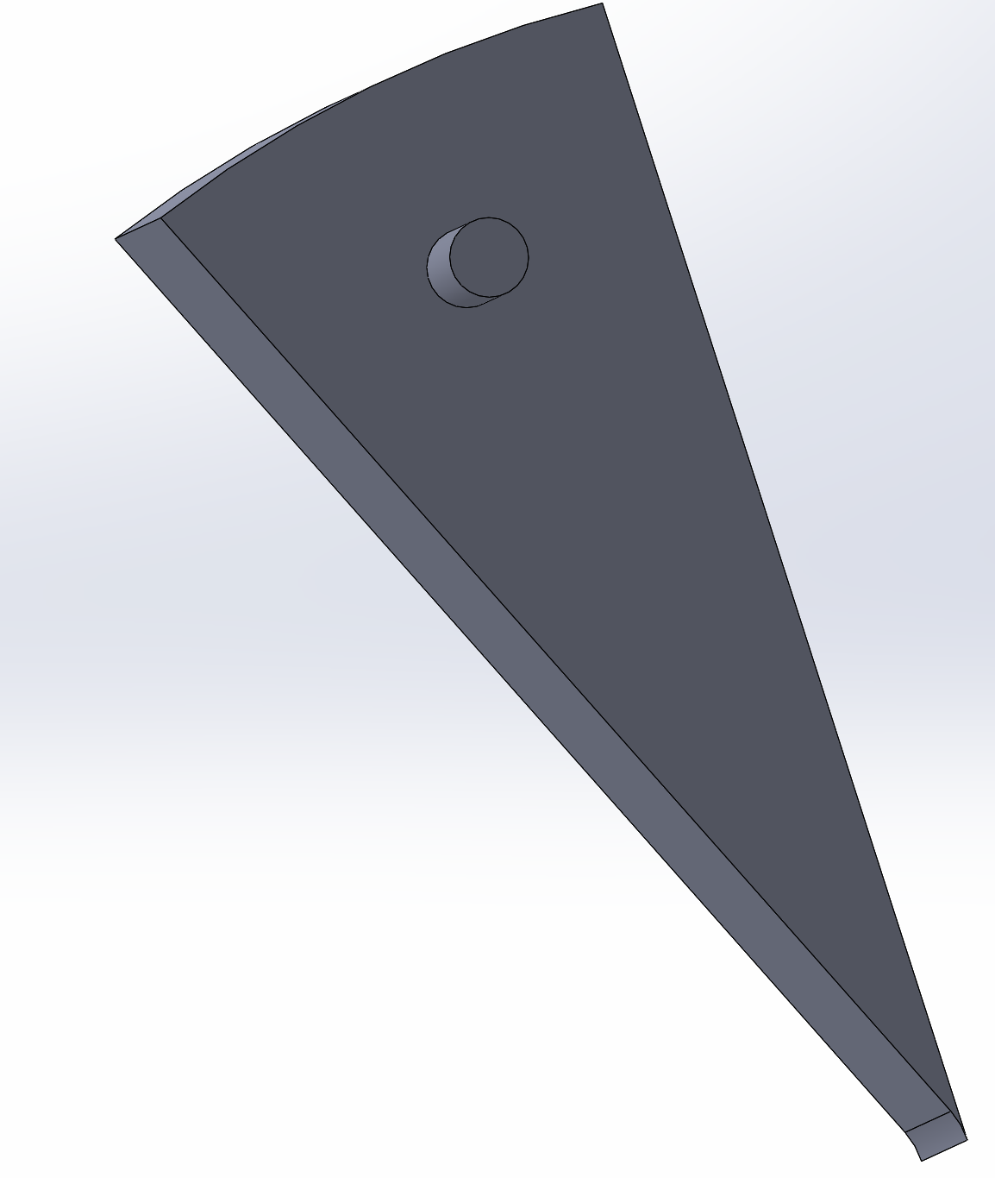
Figure 12: Triangular Leaflet with Curved Tips
Figure 12 displays a 3D CAD model of a leaflet that has a curved tip to create a perfect circle when iris is completely closed. There is a knob that is located on the front face of the leaflet to be inserted into the plates to guid the leaflets into position. The disadvantages of this design are that the diameter of stents it can crimp are limited because of the curve. it can only go down to a 5 mm diameter stent.

Subsystem #2: Plates
The subsystem of the plates address the function of converting electricity to rotational energy. This subsystem addresses the engineering requirements pertaining to diameter, cost, and iris design. The plates direct the leaflets to the correct position to crimp the stent.

Design #1: Single Slotted Plates
The single slotted plates utilizes slots to facilitate the motion of the leaflets. The slotted back plate is a movable plate that utilizes curved slots that connect to the knob attached to the leaflets to facilitate motion [Figure 13]. The slotted back plate requires specific manufacturing potentially increasing the overall cost of the stent crimping design. This design, however, provides precise movements of the leaflets.
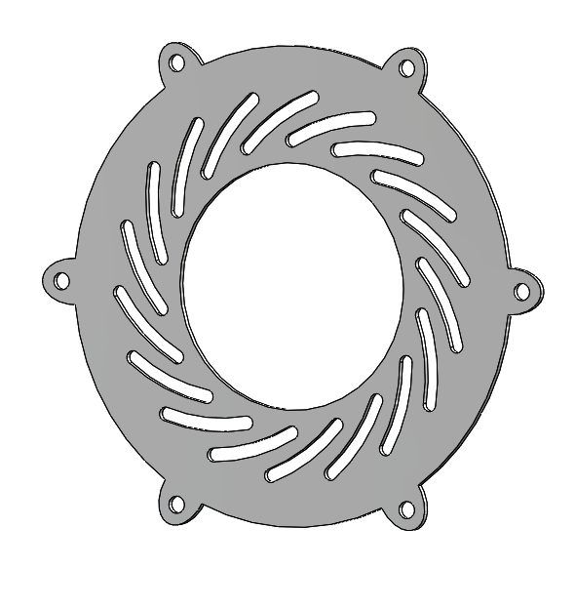
Figure 13: Slotted Back Plate
The slotted front plate is a stationary plate that leaflets will glide along during motion. The slotted front plate has linear slots with a width of 1 mm and a length of 44 mm [Figure 14]. The slots on this plate prevents the stent crimping design from completely closing due to the limitation of the length of the slots. The number of slots can be adjusted for fewer leaflet numbers which will potentially allow the iris to completely close during crimping. The leaflets, however, are capable of reaching a diameter of approximately 0.3 mm with this plate.
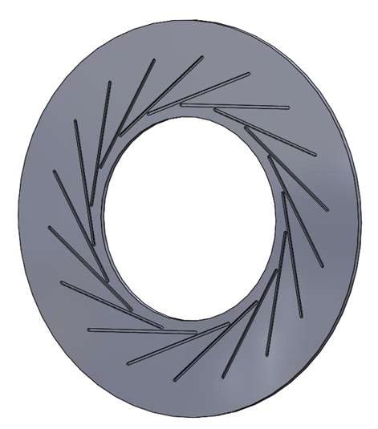
Figure 14: Slotted Front Plate

Design #2: Double Slotted Plate
The double slotted plate design uses two slots on the front plate to maneuver the leaflets into position to crimp the stent. This design changes the angle of the leaflets as they close. This allows the leaflets to create different diameters and do not damage the stent when closing. This design can be seen in the figure below.
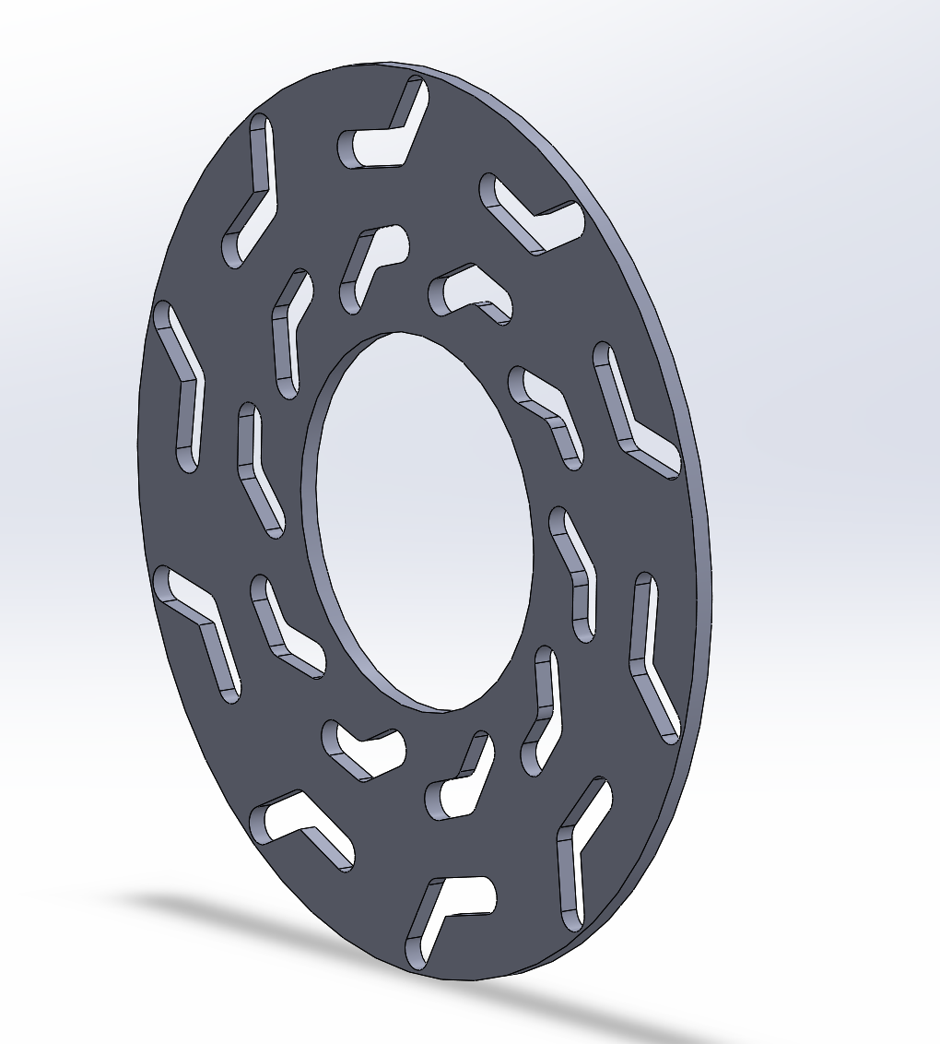
Figure 15: Double Slotted Plate
This figure shows a plate with two concentric slot patterns on it. The leaflets would have two different knobs on the surface to go into the slots. These slots would guide the leaflets as a plate behind it moves. This design does have drawbacks. The pattern would require machining and because of the complex geometry. This complet pattern also restricts the amount of leaflets permitted to be in the design. The design in figure # is designed for ten different leaflets. To increase the number of leaflets the total size of the face plate would need to be increased causing the stent diameter range to increase as well.

Design #3: Single Slot Gear Plate
The single slot gear plate design utilizes curved slots and gear teeth to enable the motion of the leaflets [Figure 16]. The curved slots connect to a knob that enables the motion of the leaflets and the gear teeth translates the motion of a motor and gear system to the leaflets. This plate requires specific manufacturing especially of the gear teeth. The gear teeth will increase the costs of the design compared to the slotted back plate of design 1 [Figure 13]. This design may, however, provide significantly better torque than the slotted back plate of design 1.
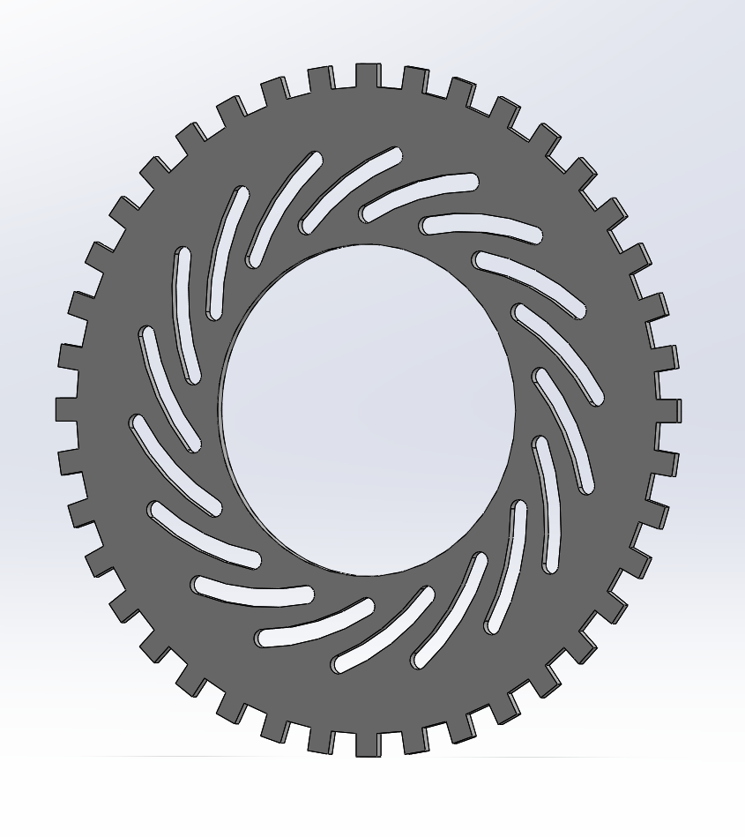
Figure 16: Single Slot Gear Plate
The stationary front plate is the same design shown in design 1 Figure 14.

Subsystem #3: Motor Attachment
The motor attachment addresses the function of converting electricity to rotational energy. This subsystem involves the engineering requirement of radial force and cost.

Design #1: Servo Motor Attachment
A six arm plate is used as the servo motor attachment to the movable back plate. The motor attachment plate has a hole in the center for motor placement and knobs along the end of each arm that attach to the back plate [Figure 17, Figure 18]. Friction within the iris design could potentially reduce the life expectancy of the motor attachment and motor due to the strain experienced within the arms.
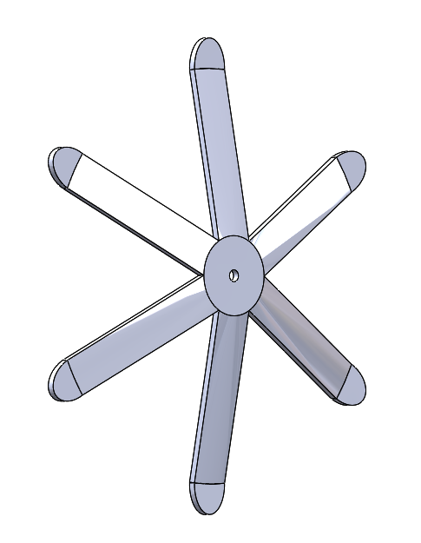
Figure 17: Servo Motor Attachment
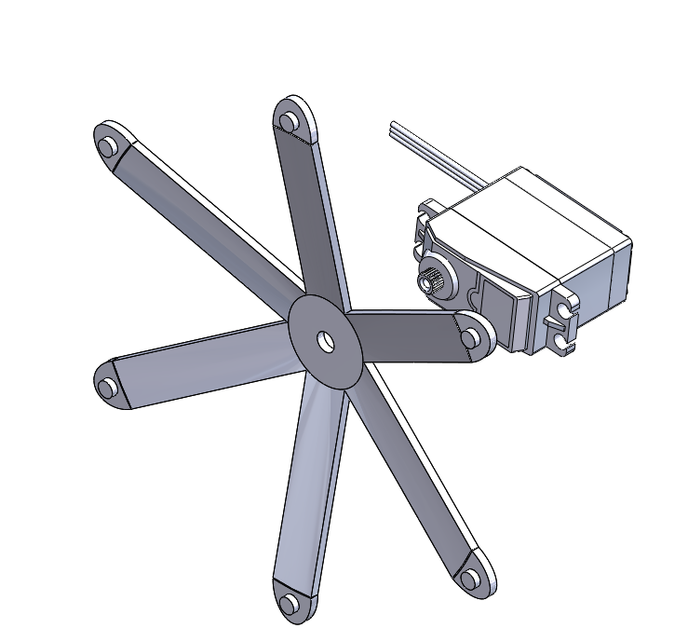
Figure 18: Mount Attachment with Servo Motor
The motor attachment will be expensive due to the distinctive nature of the design. The motor attachment should be able to translate the supplied torque of the motor with minimum losses as long as the friction of the components are reduced.

Design #2: Worm Gear Plate
The worm gear plate is the combination of a worm and a worm gear. the worm gear would have slots on the face of the gear allowing for the knobs on the leaflets to be inserted. The gear would rotate and cause the leaflets to move. The worm would be linked to the gear on one of the sides or on top as seen in the figure below.
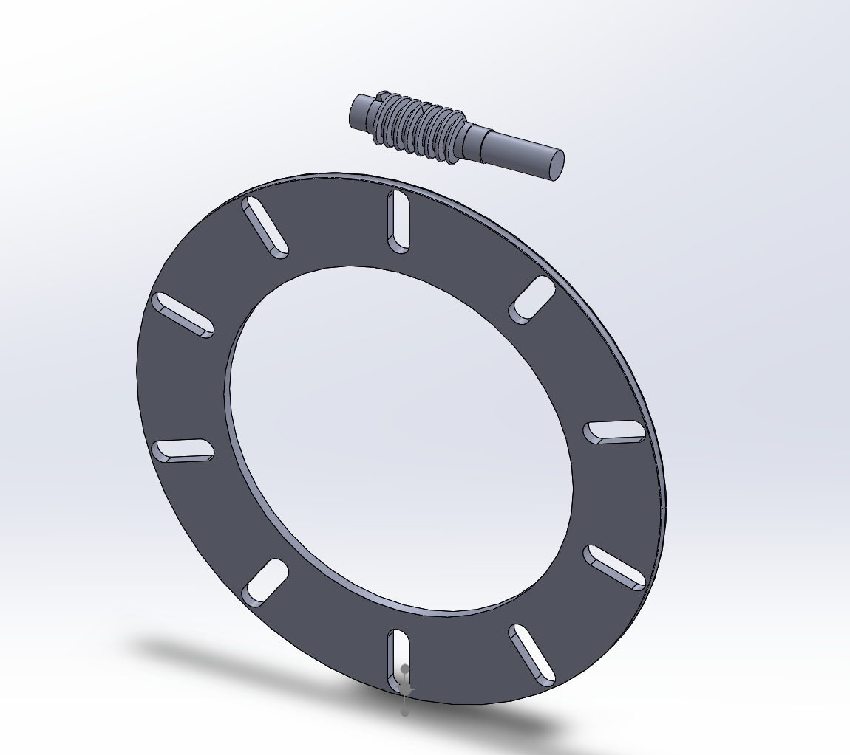
Figure 20: Worm Gear Plate
Figure 20 shows the worm and worm gear with slots on the gear face for the knobs on the leaflet to be inserted. This method of motor attachment allows for a dc or stepper motor to be utilized and will supply sufficient torque when required. The pitch of the gear teeth would determine the torque this set up would produce. Using a worm gear would make the system self locking. A crimper that is self locking is beneficial because once the iris is closed it will not move due to the force the stent is exerting on the iris. The iris would only move when the motor is activated. This method would also allow for precise measurement and control of the device. This is because one revolution of the gear would be several revolutions of the worm. This could also be considered a bad thing because the motor would have to rotate several times just to close the iris. This would reduce the longevity of the device and the time required to operate the device.

Design #3: Gear Rack System
A gear rack system utilizes a gear system with a gear rack to actuate the leaflets. This system would be connected to a dc motor or a stepper motor. The main advantage to this system is that the gearing ratio would increase the amount of torque that the iris receives. The motor would not need to supply a large amount of torque for the required radial force needed to properly crimp the stent. Another advantage is that the rack gear could be separated into two halves and a pressure gauge could be placed between the two halves which would give the user a force output signal. The main disadvantage to this system is that the gear rack takes up alot more space then the other concepts in this report. This concept can be seen in the figure below.
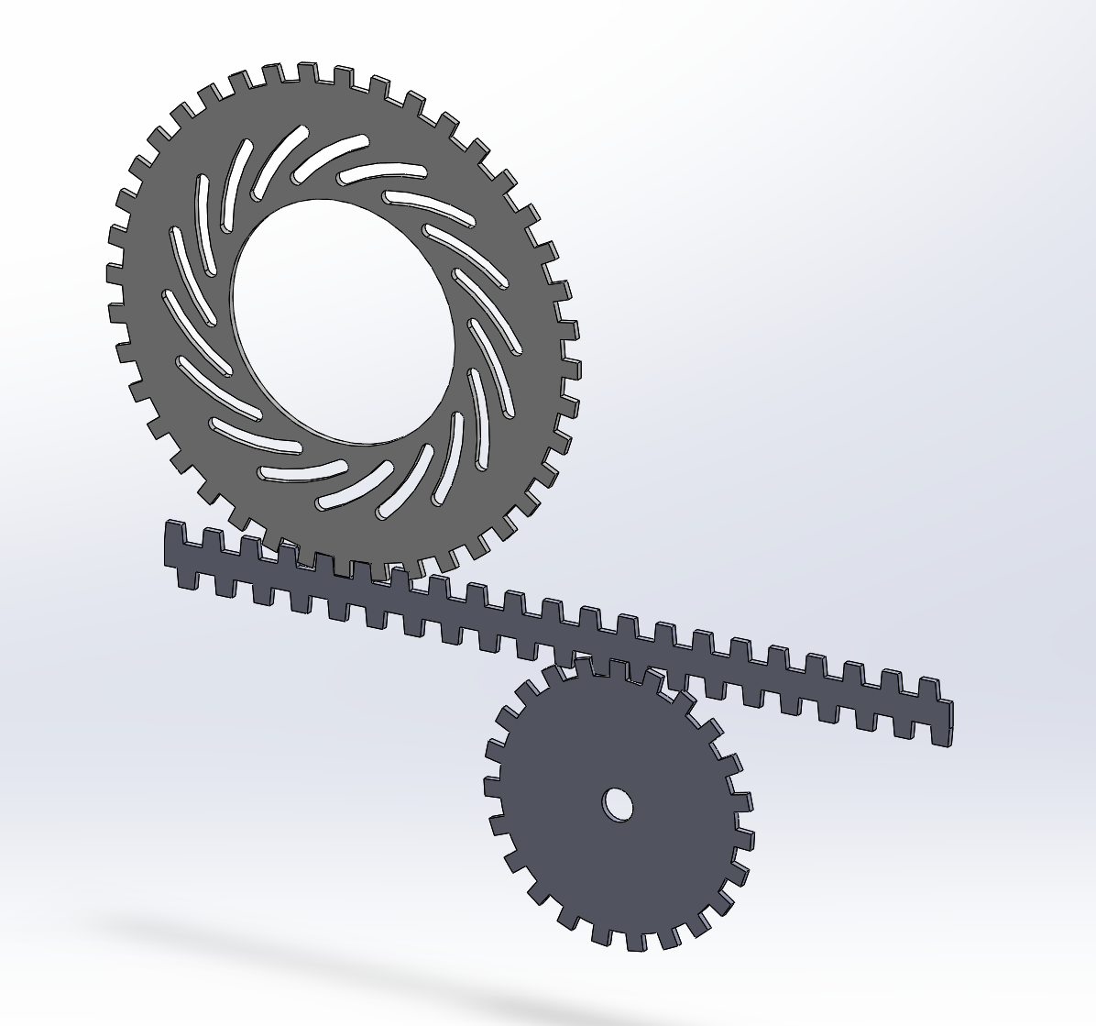
Figure 21: Gear Rack
Figure 21 displays the motor attachment system using a gear rack. the gear in the lower right hand side is the gear that is attached to the motor. This gear drives the gear shaft, the straight gear placed between the two round gears. The large gear is an iris plate which the knobs on the leaflets would glide inside the slots effectively closing and opening the iris.

Subsystem #4: Motor
The motor addresses the functions of actuating electricity and converting electricity to rotational energy. This subsystem involves the engineering requirements of radial force and cost. This subsystem directly impacts the type of motor attachment that each design can support.

Design #1: Servo Motor
A servo motor is a self-contained electronic device with a rotating shaft that supplies torque to the design [26, Figure 22]. The servo motor delivers high accuracy positioning and consistent torque due to a feedback mechanism [27]. The servo motor, however, is generally more expensive than a stepper motor due to its complex design such as the feedback mechanism. The size of a motor may vary due to the required torque of the design.
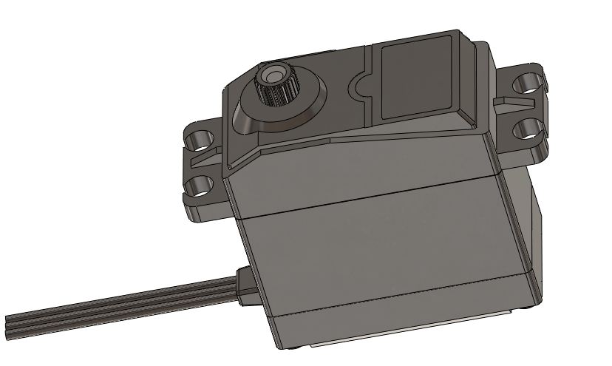
Figure 22: Servo Motor

Design #2: DC Motor
The DC motor can be easily implemented in any of the motor attachments subsystem designs. The DC motor has an output shaft that rotates and supplies torque. The output shaft would be mated with the attachment system directly. If the motor was being mated with the worm gear system it would attach directly to the worm, the screw like gear. If it were to be mated with the gear rack system it would be directly mated with the driving gear and not the plate gear. It could also be attached to the servo motor attachment system it would just need to be placed directly in the center with the output shaft attached to the motor attachment. A DC motor would likely need to be attached to a gearing system because of the angular velocity and the torque output of the motor. This is the main disadvantage of the DC motor is that it does not produce a large amount of torque, and it spins relatively fast.

Design #3: Stepper Motor
A stepper motor can be attached in the same method the DC motor is. There are more advantages when using the stepper motor than there are for a DC motor. The first advantage is that it produces more torque then the DC motor. The stepper motor produces high torque at low angular velocities. The stepper motor also has high holding torque which means it would be able to supply high torque when the iris need to hold a position which is beneficial when crimping a stent. The low velocity of the stepper motor means it would be ideal for a gear set up or a direct mounting system. The disadvantage for the stepper motor is that it requires more current exchange per revolution then the DC motor. The stepper motor also requires more coding and circuitry then a DC motor.

DESIGNS SELECTED – First Semester
The design selection was not performed at this time due to engineering requirements that are awaiting approval.

REFERENCES
[1] Wrought Seamless Nickel-Titanium Shape Memory Alloy Tube for Medical Devices and Surgical Implants, TBT Standard F2633, 2019. [Online]. Available: https://compass-astm-org.libproxy.nau.edu/download/F2633.36443.pdf
[2] “Stent Crimping Machine: Datasheet C-150,” Medical Production Technologies. [Online]. Available: https://www.mpteurope.com/wp-content/uploads/2018/03/Datasheet-CR-150-2.pdf (Accessed: March 12, 2020)
[3] “Catalogue numbers for GORE® EXCLUDER® AAA Endoprosthesis,” Gore Medical. [Online]. Available: https://www.goremedical.com/products/excluder/specifications. [Accessed: 06-Mar-2020].
[4] W. A. Lee, M. P. Brown, P. R. Nelson, and T. S. Huber, “Total percutaneous access for endovascular aortic aneurysm repair (‘Preclose’ technique),” Journal of Vascular Surgery, vol. 45, no. 6, pp. 1095–1101, 2007.
[5] M. Trossbach, M. Hartmann, C. Braun, K. Sartor, and S. HäHnel, “Small vessel stents for intracranial angioplasty: in vitro evaluation of in-stent stenoses using CT angiography,” Neuroradiology, vol. 46, no. 6, Jan. 2004. [Online]. Available doi: 10.1007/s00234-004-1205-3
[6] “Neuron MAX 088.” Penumbra. https://www.penumbrainc.com/wp-content/uploads/2016/12/4900C_NeuronMAX_Flex_Comparison_Ordersheet_USA.pdf (Accesses: March 12, 2020).
[7] K. Yamauchi and K. Yamauchi, “Medical applications of superelastic nickel-titanium (Ni–Ti) alloys,” in Shape memory and superelastic alloys: technologies and applications, Cambridge, UK: Woodhead Publishing, 2011. [Online]. Available: https://www.sciencedirect.com/science/article/pii/B9781845697075500158
[8] C. Shanahan, S. A. Tofail, and P. Tiernan, “Viscoelastic braided stent: Finite element modelling and validation of crimping behaviour,” Materials & Design, vol. 121, pp. 143–153, 2017.[Online]. Available: https://www.sciencedirect.com/science/article/abs/pii/S026412751730179X
[9] Arduino, "Detecting "Physical" Resistance from Stepper Motor," Arduino, 08 December 2012. [Online]. Available: https://forum.arduino.cc/index.php?topic=136261.0. [Accessed 13 March 2020].
[10] Baanto, "Shadow Sense Vs. Other Tocuh Technologies," baanto, [Online]. Available: https://baanto.com/competitive-analysis/#resistive-touch-technology. [Accessed 13 March 2020].
[11] T.-J. Ho and C.-H. Chang, "Robust Speed Tracking of Induction Motors: An Arduino-Implemented Intelligent Control Approach," Applied Sciences, vol. 8, no. 2, p. 159, 2018.
[12] Circuit Basics, "ARDUINO LCD SET UP AND PROGRAMMING GUIDE," Circuit Basics, [Online]. Available: https://www.circuitbasics.com/how-to-set-up-an-lcd-display-on-an-arduino/. [Accessed 13 March 2020].
[13] ExplainThatStuff, "Touchscreens," 6 December 2019. [Online]. Available: https://www.explainthatstuff.com/touchscreens.html. [Accessed 13 March 2020].
[14] Measuring Radial Force, “Blockwise Engineering LLC” p://www.blockwise.com/assets/knowledge/K050-Measuring%20Radial%20Force.pdf
[15] M. S. Cabrera, C. W. Oomens, and F. P. Baaijens, “Understanding the requirements of self-expandable stents for heart valve replacement: Radial force, hoop force and equilibrium,” Journal of the Mechanical Behavior of Biomedical Materials, vol. 68, pp. 252–264, 201
[16]Tensile testing machine for radial force, “Blockwise Engineering LLC” http://www.e-tronics.hu/v4/e69bc5c4-143b-4e1a-8b00-6e75fc4558c9/uploads/TTR2-DataSheet.pdf
[17]https://devicetesting.com/pdfFiles/Radial%20Force%20Testing%20White%20Paper.pdf
[18]Crimpers: Diameter or force control, “Blockwise Engineering LLC” http://www.blockwise.com/assets/knowledge/MS009-CrimpersDiaOrForceControl.pdf
[19] “RJ - Stent Crimping Machines,” RJ - Stent Crimper. [Online]. Available: http://www.blockwise.com/stent-crimpers/rj/#largetwin. [Accessed: 14-Mar-2020].
[20] “R & D/Pilot Production Stent Crimping,” MSI. [Online]. Available: https://msi.equipment/product/sc500700/. [Accessed: 14-Mar-2020].
[21] “What's the best material to use for iris blades?,” Iris Calculator, 23-Sep-2019. [Online]. Available: https://iris-calculator.com/whats-the-best-material-to-use-for-iris-blades/. [Accessed: 14-Mar-2020].
[22] “Stepper vs Servo,” AMCI. [Online]. Available: https://www.amci.com/industrial-automation-resources/plc-automation-tutorials/stepper-vs-servo/. [Accessed: 14-Mar-2020].
[23] D.-T. Precision, “Linear Actuators: 4 Types,” Del, 27-Jul-2018. [Online]. Available: https://www.deltron.com/Linear-Actuators.html. [Accessed: 14-Mar-2020].
[24] “CX - Stent Crimping Machines,” CX - Stent Crimper. [Online]. Available: http://www.blockwise.com/stent-crimpers/cx/#cx-alpha. [Accessed: 14-Mar-2020].
[25] “Automated Drug Coated Stent Crimping equipment,” MSI. [Online]. Available: https://msi.equipment/product/sc1775s1875s/. [Accessed: 14-Mar-2020].
[26] Science Buddies, “Introduction to Servo Motors,” Science Buddies, 10-Jan-2020. [Online]. Available: https://www.sciencebuddies.org/science-fair-projects/references/introduction-to-servo-motors. [Accessed: 11-Mar-2020].
[27] StackPath. [Online]. Available: https://www.machinedesign.com/mechanical-motion-systems/article/21836868/whats-the-difference-between-servo-and-stepper-motors. [Accessed: 11-Mar-2020]
[28] Science Buddies, “Introduction to Servo Motors,” Science Buddies, 10-Jan-2020. [Online]. Available: https://www.sciencebuddies.org/science-fair-projects/references/introduction-to-servo-motors. [Accessed: 11-Mar-2020].
[29] StackPath. [Online]. Available: https://www.machinedesign.com/mechanical-motion-systems/article/21836868/whats-the-difference-between-servo-and-stepper-motors. [Accessed: 11-Mar-2020]

