HR 2 BREAKDOWN

TEAM: NAU Gore Stent Crimper Team

Due Date:
Friday, October 16, 2020 at 11:59pm

Provide several pics of the current state of your completed system thus far here:

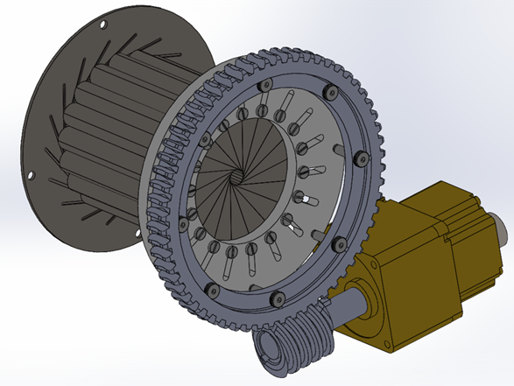
Figure 1: Assembly without Housing

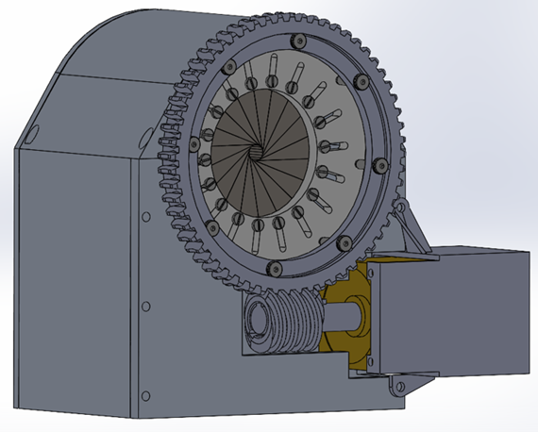
Figure 2: Full Assembly

The following are the Action Items each person completed between Hardware Review 1 and Hardware Review 2:

Team Member: Ashley Blood
Action Item | Date Completed | Result/Proof of Completion
Update main body of CAD model | 9/26/2020 | 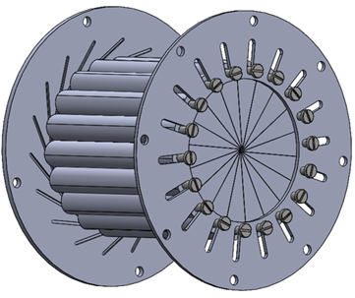  The updated main body of the CAD model includes new slots on the rotating plate and symmetric leaflets from front and back views. The new design provides more precision in diameter measurements and provides ease of tolerancing for manufacturing.
Order Parts:  - screws  - inserts  - gear and worm  - load cell  - motor and driver | 10/9/2020 | The screws and inserts were ordered on September 25th. The gear and worm were ordered on September 28th after verification of the required worm gear system. The load cell was ordered on September 30th after verification of force of the design. The new motor and driver were ordered on October 9th
Tolerance Slots | 10/4/2020 | 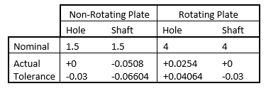  The diametral tolerances for the slots were based on the ANSI B4.1 RC8 fit. The slots that correspond to the rotating plate and standardized screws were toleranced based on tolerances provided by the screw components. The slots on the non-rotating plate were toleranced based on the RC8 fit and geometric considerations to the design.
Tolerance Leaflets and Plates | 10/11/2020 | The full tolerances for the leaflets and plates were finished on 10/11/2020 based on ISO 2768 recommendations and geometric considerations (see Appendix A)

Team Member: Nick Green
Action Item | Date Completed | Result/Proof of Completion
Housing Completion | 10/7/2020 | Housing as shown above. The top was created, the sides were adjusted and the back plate was completely redone. The purpose of the redesign was to limit the number of unique parts and make assembly easier.
Calibration starting equation | 10/12/2020 | Through my individual analysis I was able to create an equation for the stepper motor to diameter calculations. My initial finding was incorrect as I missed the inclusion of the gearing down of the shaft.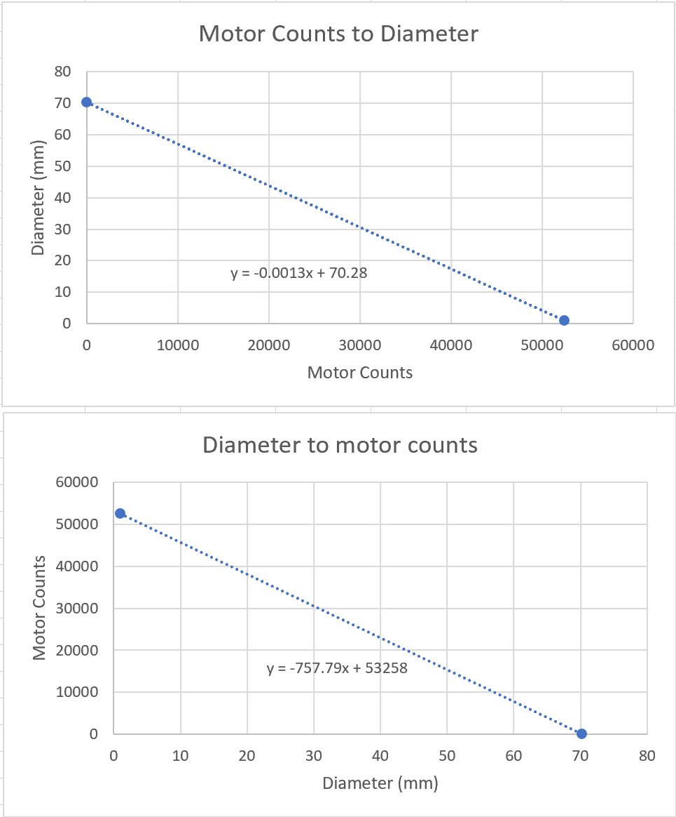
Code rework | 10/12/2020 | Worked with Jenny to redo the Arduino code to work with the new stepper motor and driver and load cell. Without the components in hand, we were able to write the code and set up the device with what we had on hand. 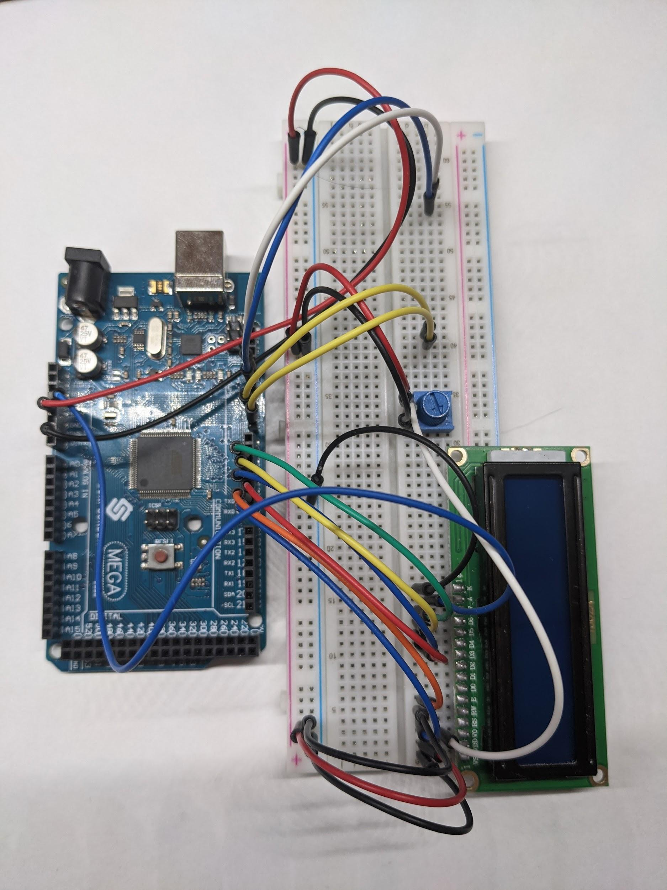

Team Member: Jennifer Lawson
Action Item | Date Completed | Result/Proof of Completion
Determine dD/dx (change in diameter/change in distance) relationship for radial force | 9/30/2020 | Measured multiple diameters and corresponding displacements within solidworks. The values were plotted and the slope of the line formed from those values equals k (dD/dx). The value was determined to be -1.99. We will take the positive of this value because our data points were flipped, creating a negative slope rather than a positive one.  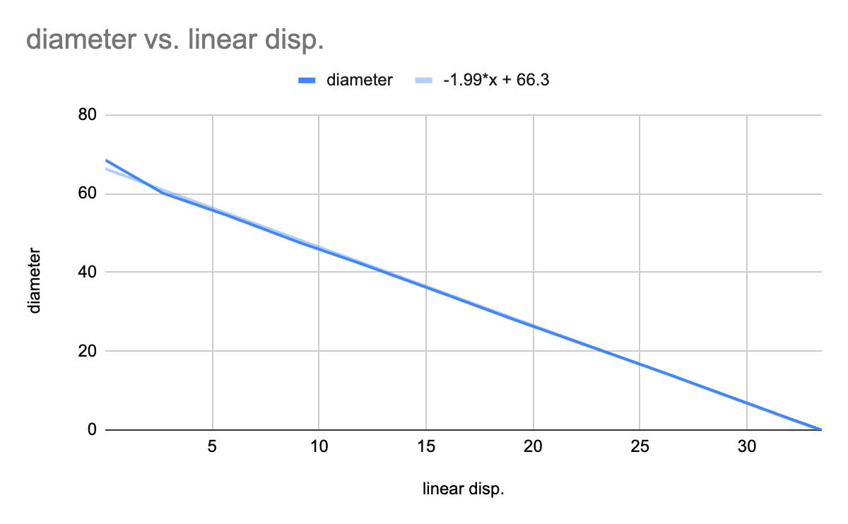
Posted Website | 10/3/2020 | Website has been posted but still needs some pictures and links. Pictures will also be added when the device is assembled as well as throughout testing.  https://www.ceias.nau.edu/capstone/projects/ME/2020/20Spr1_GoreStent/
Code update | 10/12/2020 | Worked with Nick to rewrite code that will include the new stepper motor and driver.

Team Member: Cameron Lissarrague
Action Item | Date Completed | Result/Proof of Completion
Solidworks worm gear | 10/08/2020 | 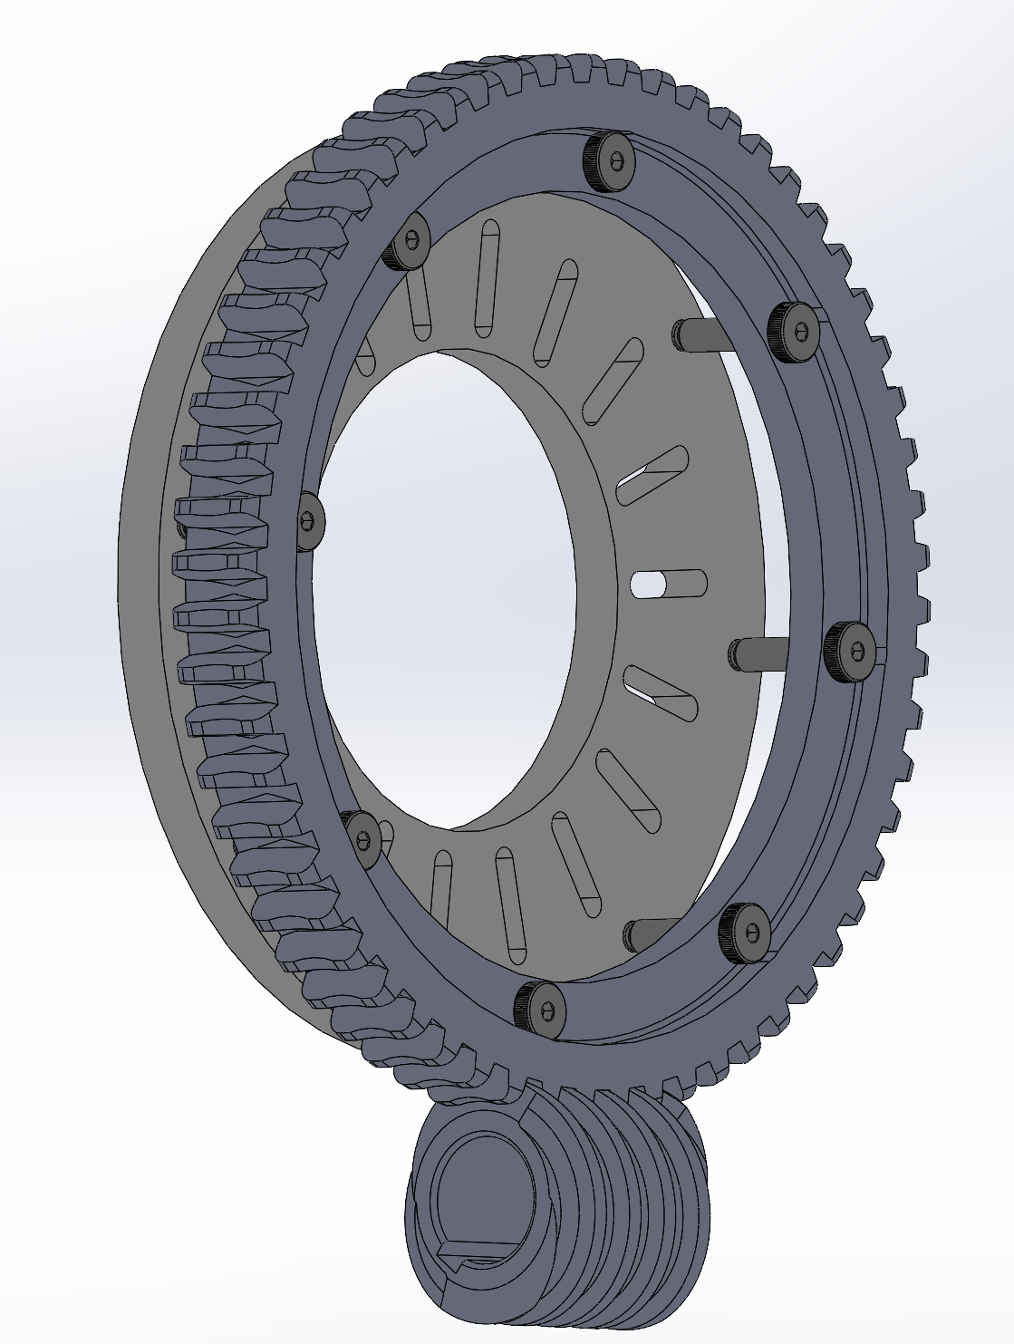  The worm and gear that the team purchased had CAD files available, those solidworks parts had to be added to the model and an attachment system was designed. The attachment system consists of 8 shoulder screws. The shoulder screws will require spacers between the rotating plate and gear. The rotating plate had threads added, unfortunately the team will not be able to get this part machined and will 3d print it therefor threaded inserts will be used.
Material Order and Pick Up | 10/09/2020 | 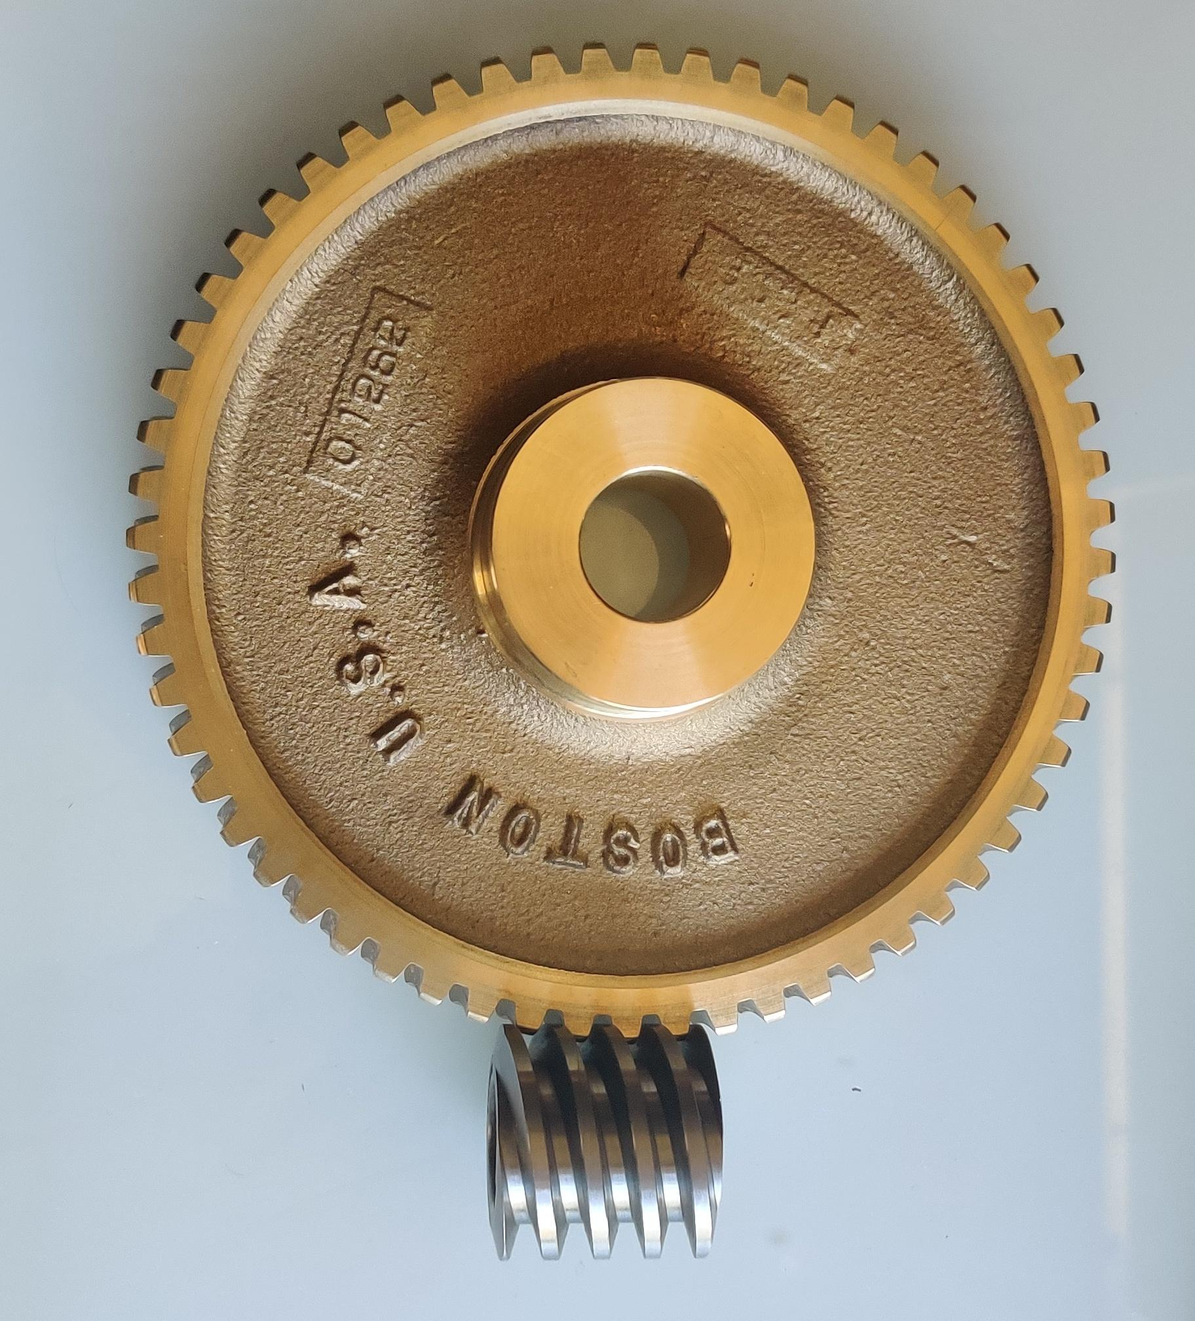  The worm and worm gear were ordered from boston gear and delivered to the engineering building. The gear will be machined to fit our design. The leaflets will also be machined and that material was ordered and picked up from Industrial Metal Supply in Phoenix, AZ. The aluminum and the gear have been taken to the machine shop for the machining process.
Worm Gear Analysis | 10/06/2020 | The worm gear analysis was conducted to ensure that the worm and worm gear will work for our design. The required radial force was used to calculate how much torque the stepper motor will need to supply. This analysis was done using excel and calculating the different forces acting within the worm and gear.

The following are the Action Items for each team member between HR 2 and the Final Product presentation:

Team Member | Action Items | Date Due
Ashley Blood | - Order Final Parts  - Assemble Device with team  - Test design and implement updates as needed | - 10/16/2020  - 11/1/2020  - 11/5/2020
Nick Green | - Print housing  - Assemble housing, make adjustments as needed.  - Finish electronics assembly, test, change as needed. | - 10/21/2020  - 10/24/2020  - 11/1/2020
Jennifer Lawson | - Assemble device with team  - Test radial force of stent crimper (and rest of electronics with nick) after assembly  - Finishing touches to website | - 11/1/2020  - 11/1/2020  - 11/5/2020
Cameron Lissarrague | - Work order form for machine shop.  - Design spacers to be 3D printed for the Gear-to-Rotating Plate attachment system.  - Pick up parts for assembly | - 10/16/2020  - 10/18/2020  - TBA

Appendix A: Tolerances
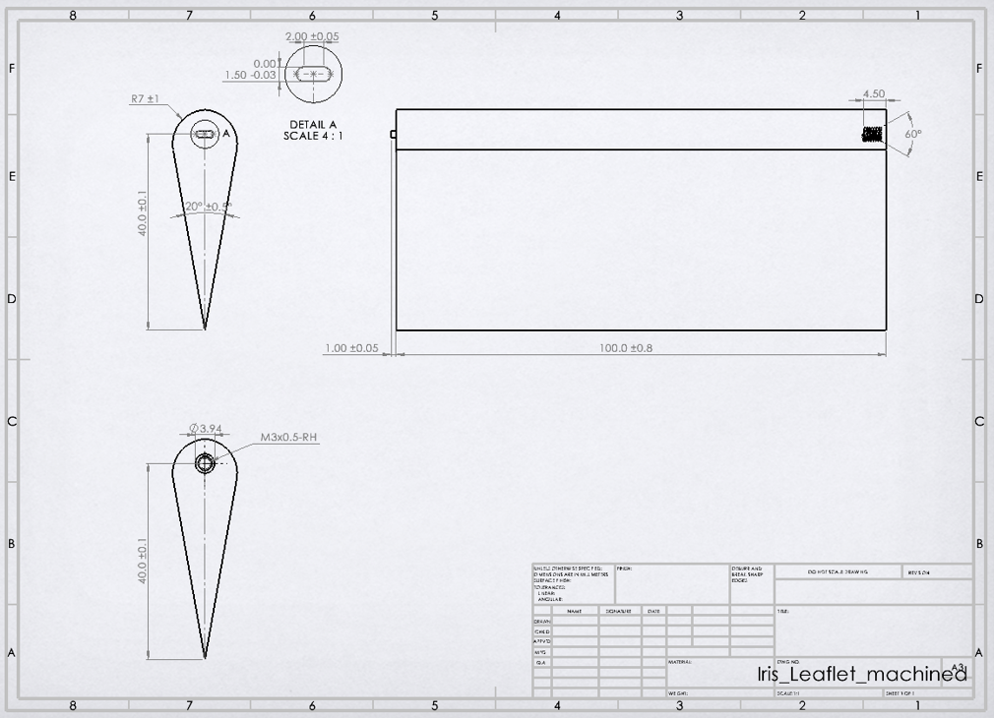
Figure A.1: Leaflet Tolerances
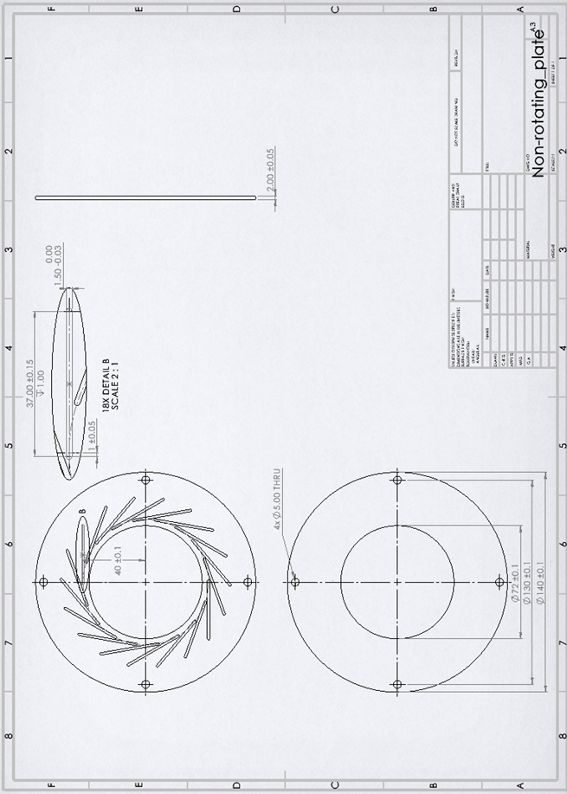
Figure A.2: Non-rotating Plate Tolerances
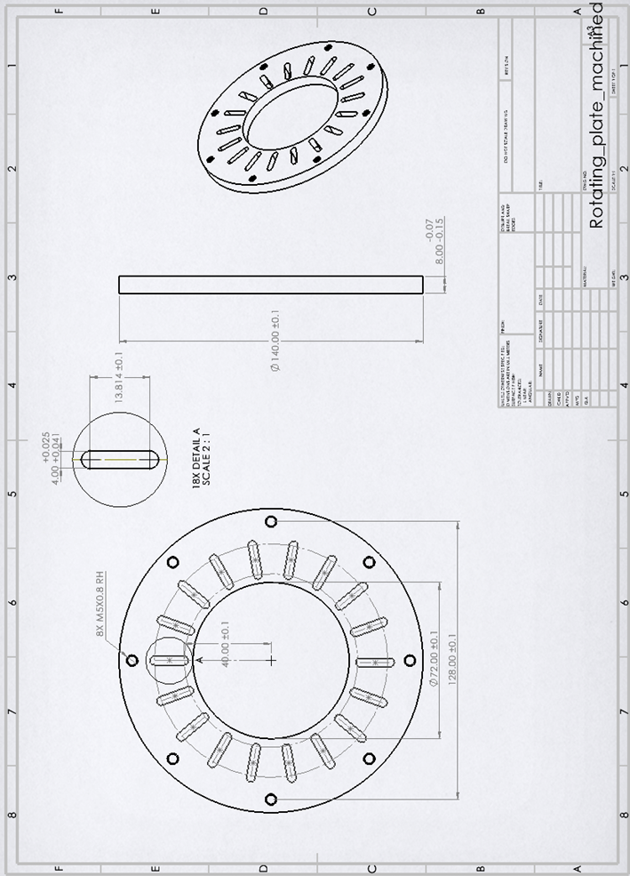
Figure A.3: Rotating Plate Tolerances

