NAU Gore Capstone Team

Final Proposal

Ashley Blood
Nick Green
Jennifer Lawson
Cameron Lissarrague

2020

Project Sponsor: W.L Gore
Faculty Advisor: David Trevas

DISCLAIMER
This report was prepared by students as part of a university course requirement. While considerable effort has been put into the project, it is not the work of licensed engineers and has not undergone the extensive verification that is common in the profession. The information, data, conclusions, and content of this report should not be relied on or utilized without thorough, independent testing and verification. University faculty members may have been associated with this project as advisors, sponsors, or course instructors, but as such they are not responsible for the accuracy of results or conclusions.

EXECUTIVE SUMMARY
[Provide a one-page summary of your project, including description, design, and results.]

TABLE OF CONTENTS
[Use Word to delete the following Table of Contents and insert a new TOC. Include front matter (except for the cover page), body of the report, and all appendices. The Table should include three levels of headings, e.g., down to 2.3.1, as illustrated below. Front matter should be in Roman numerials.]
Contents
DISCLAIMER 1
EXECUTIVE SUMMARY 2
TABLE OF CONTENTS 3
1 BACKGROUND 1
1.1 Introduction 1
1.2 Project Description 1
2 REQUIREMENTS 2
2.1 Customer Requirements (CRs) 2
2.2 Engineering Requirements (ERs) 2
2.3 Functional Decomposition 2
2.3.1 Black Box Model 2
2.3.2 Functional Model/Work-Process Diagram/Hierarchical Task Analysis 2
2.4 House of Quality (HoQ) 3
2.5 Standards, Codes, and Regulations 3
3 Testing Procedures (TPs) 2
3.1 Testing Procedure 1: Descriptive Title 2
3.1.1 Testing Procedure 1: Objective 2
3.1.2 Testing Procedure 1: Resources Required 2
3.1.3 Testing Procedure 1: Schedule 2
3.2 Testing Procedure 2: Descriptive Title 2
3.2.1 Testing Procedure 2: Objective 2
3.2.2 Testing Procedure 2: Resources Required 2
3.2.3 Testing Procedure 2: Schedule
2
4 Risk Analysis and Mitigation 3
4.1 Critical Failures 3
4.1.1 Potential Critical Failure 1: Descriptive title 3
4.1.2 Potential Critical Failure 2: Descriptive title 3
4.1.3 Potential Critical Failure 3: Descriptive title 3
4.1.4 Potential Critical Failure 4: Descriptive title 3
4.1.5 Potential Critical Failure 5: Descriptive title 3
4.1.6 Potential Critical Failure 6: Descriptive title 3
4.1.7 Potential Critical Failure 7: Descriptive title 3
4.1.8 Potential Critical Failure 8: Descriptive title 3
4.1.9 Potential Critical Failure 9: Descriptive title 3
4.1.10 Potential Critical Failure 10: Descriptive title 3
4.2 Risks and Trade-offs Analysis 3
5 DESIGN SELECTED – First Semester 4
5.1 Design Description
5.1.1 Leaflet Description
5.1.2 Knob
5.1.3 Front Plate Description
5.1.4 Back Plate Description
5.1.5 Linkage Plate Description
5.1.6 Linear Actuator
5.1.7 Control Components
5.2 Implementation Plan 4
6 CONCLUSIONS 5
7 REFERENCES 6
8 APPENDICES 7
8.1 Appendix A: Descriptive Title 7
8.2 Appendix B: Descriptive Title 7

BACKGROUND

Introduction
The goal of this project is to utilize an iris design to create a stent crimper that outputs radial force and diameter. A stretch goal for this team is to automate the device so that it will not be hand actuated. A graphical user interface (GUI) for the output of radial force and diameter is also a desired feature but not required. The sponsor for this project is W.L. Gore and Associates, a medical device company, that works to improve the quality of life for individuals worldwide. One product distributed by Gore to accomplish this is an implantable stent used to restore blood flow to arteries. Before stents are inserted into the body they must be crimped to a specific diameter over a balloon. The current device used to crimp stents before deployment is hand actuated and does not provide radial force and diameter output. These issues will be addressed by the novel design created in this project.

Project Description
Following is the original project description provided by the sponsor.
“The scope of this project is to design, build, and test a low force stent crimping machine utilizing a crush iris with a radial force readout. Depending on team size and background, an option to create a novel test method to verify stent diameter.”

REQUIREMENTS
One main goal for this project was to treat it like a start-up company, and therefore required the team to define the requirements rather than having the requirements pre-defined. The specifications of a stent crimper details the customer requirements and engineering requirements. The design’s ability to meet the desired goal will be measured through these specifications. The customer requirements were obtained from the project proposal and the engineering requirements were defined based on literature research. The functional decomposition for this project includes a black box model, functional model, and house of quality.

Customer Requirements (CRs)
Customer requirements are characteristics or specifications of a design that a customer identifies for a desirable product. The customer requirements for this project include an iris design, safety and manufacturing standards, range of diameters and lengths, radial force, accuracy, cost, safety, and visual data outputs. The highest ranked customer requirements include an iris design and safety standards due to medical concerns and functional purposes of the design. The least important customer requirement was data outputs because this requirement was considered optional.

Engineering Requirements (ERs)
Engineering requirements are quantifiable parameters or conditions used to measure the design’s ability to meet customer requirements. The engineering requirements for this project include an iris design with at least 10 leaflets, a diameter range of 4 to 12 mm, a length range of 10 to 59 mm, radial force outputs of at least 105N, cost under $3000, and a visual display through use of GUI [1,2]. The tolerances for the diameter and length have to be +/- 0.025 mm and +/- 3 mm, respectively [3]. The tolerance for the radial force has to be +/- 10N. The diameter and length range is a minimum range set by the team to ensure a successful design.

Functional Decomposition
A functional decomposition investigates the functional flows of material, energy, and signal of a device. The functional decomposition provides the team with a comprehensive guide that correlates functions with customer needs. A black box model and functional model were created to visualize the flow of the device. A house of quality diagram was also created to transform customer requirements to engineering requirements.

Black Box Model
A black box model was constructed to express the overall function of the design and identify input and output flows [Figure 1]. Flows are defined as material, energy or signal inputs that are utilized by the device. Material flow is represented by the bold line, energy flow is represented by the regular line, and signal flow is represented by the dotted line. The overall flow of the device is to crimp a stent which means the reduction of the diameter of a stent to conform to a catheter. The material flows consists of the input of a stent and human hands and returns the stent and hands. The energy flow consists of the input of electrical energy and human energy and returns mechanical strain energy . The signal flow consists of the on/off signal and returns the on/off signal, radial force output, and diameter reduction. The flows discussed in the black box model impact each other which will be addressed in the functional model.
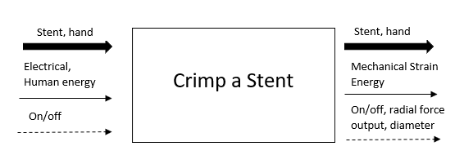
Figure 1: Black Box Model

Functional Model/Work-Process Diagram/Hierarchical Task Analysis
A functional model provides operational guidelines to the broad overview of flows addressed in the black box. The operational guidelines or function chains is the process of transformation from the input flows to output flows [Figure 2]. Each customer need is addressed in the functional model.
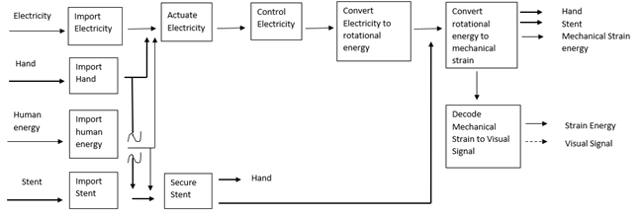
Figure 2: Functional Model
The functional flow of electricity addresses the customer needs of the diameter, length, radial force, accuracy, iris design, and safety. The function of converting rotational energy to mechanical strain energy represents the customer needs of diameter, length, radial force, iris design, and accuracy. Accuracy is also represented by the securement of the stent. The functional chain of electricity from importing electricity to converting rotational energy to mechanical strain represents the customer's need for safety. The function of decoding mechanical strain to visual signals represents the customer's need for data output.
The functional model generated simple sub-functions to assist with the discovery of information. This model identified critical functions and functional chains of the design that the team should concentrate on for an effective and safe device.

House of Quality (HoQ)
A house of quality (HOQ) was constructed to translate customer needs into engineering requirements based on customer’s specifications of importance. The customer needs are related to engineering requirements based on the determined strength of their relationship. From this relationship, the technical importance of each engineering requirement was determined to assess the significance of each design aspect. The engineering requirement with the highest technical importance was the radial force due to safety concerns and functionality of the design [Figure 1]. The least important engineering requirement, based on technical importance, was the visual display. Based on the HOQ, the team considered the radial force of the design a critical element to consider within the designing process.
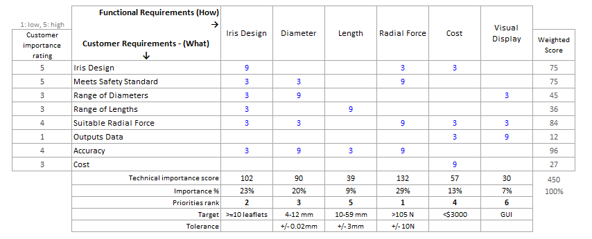
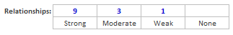
Figure 3: House of Quality

Standards, Codes, and Regulations
Standards must be acknowledged and followed for this project as the device is used in medical device manufacturing. The standards and regulations this team has explored include the following organizations:

- American Society of Testing and Materials (ASTM)
- American National Standards Institute (ANSI)
- Food and Drug Administration (FDA)
- Occupational Safety and Health Administration (OSHA)

The standards that were found for this project are shown in table 1. These regulations are of great importance because the proposed device will be used with medical instruments and factors such as biocompatibility, compression force, and tolerances must be considered. Biocompatibility ensures that the material used for the stent crimper will not flake onto the stent and negatively affect human tissue when deployed. Understanding the correct compression force protects the stent from being over compressed and damaged. Tolerances for the diameter and length establish safety for the device by determining how well it performs.
Table 1: Standards of Practice as Applied to this Project
Standard Number or Code | Title of Standard | How it applies to Project
ANSI/AAMI HE 74:2001 [4] | Human Factors Design Process for Medical Devices | Helps in the design of how the device will interface with the user in a safe manner.
ASTM F2257 [3] | Standard Specification for Wrought Seamless or Welded and Drawn 18 Chromium-14Nickel-2.5Molybdenum Stainless Steel Small Diameter Tubing for Surgical Implants | Helps in the determination of tolerances for diameter and length measurements in accordance to stents.
FDA 876.5011 [5] | Title 21- Food and Drugs  Chapter 1, subchapter --Medical Devices | Helps in identifying what factors must be considered for design construction such as material and compression force.
ASTM F639 - 09 [6] | Standard Specification for Polyethylene Plastics for Medical Applications | Helps in identifying specific polyethylene (PET) plastics requirements for medical use

Testing Procedures (TPs)
The following testing procedures will be used to validate the diameter, length and radial force of the device. The diameter and length will be tested using simple but accurate methods. These include diametral rods and a ruler. The radial force test implements a force-feedback linear actuator and an arduino. These tests will determine whether or not the device meets or exceeds the engineering requirements.

Testing Procedure 1: Diametral Rods
The diametral rods is a testing procedure that ensures the device is capable of meeting diameter requirements. This procedure will require multiple rods at various diameters to ensure the device is capable of reaching specified diameters. This will be an effective test as the percent difference is expected to be around one percent. This test requires less than a day to perform and will be performed multiple times over the course of several days.

Testing Procedure 1: Objective
The objective of the diametral rods is to measure the diameter of the stent crimper at specific points to ensure the design meets diameter requirements. The diametral rods will be placed at the center of the design as the diameter of the design is steadily decreased to relatively match the diameter of a specific rod. This testing procedure will ensure the design will meet the diameter requirements of various stents based on the percent difference of the area between the diametral rod and the octadecagon shape created by the leaflets. The percent difference of the area should be within approximately 1.02 percent.

Testing Procedure 1: Resources Required
The necessary items to conduct the diametral rods testing will include several diametral rods of specified diameters as well as a ruler. The diametral rods will have the diameters of 70 mm, 30 mm, 12 mm, and 4 mm. Tasks will be divided among the team to efficiently carry out the testing procedure. These tasks include controlling the device, reading the diameter, and recording the diameter. The location of these tests have not been determined but one possibility includes the engineering thermal fluids lab. This is a low maintenance task and therefore can be performed anywhere the team has access to power the device.

Testing Procedure 1: Schedule
The diametral rods testing should be performed after the completion of the first prototype that is capable of motion and before any other testing is completed. The testing procedure will only require one day to be completed however the testing will be performed over several days to ensure the readings are accurate.

Testing Procedure 2: Radial Force

Testing Procedure 2: Objective
The purpose of measuring the radial force is to guarantee that the device will perform as expected and apply the correct amount of force to the stent. Too much force will damage the stent and too little force will not provide enough pressure to decrease the diameter.

Testing Procedure 2: Resources Required
To execute this test, a force-feedback linear actuator and an arduino will be implemented. The force feedback will be read into the arduino and code written by the team will convert the force to the corresponding radial force. The procedure for running this test requires one person to control the arduino system.

Testing Procedure 2: Schedule
This test will take only a couple minutes to complete but requires the device to be fully functional. Testing for the radial force will occur after successful diametral rod testing. Multiple testing trials will be performed to justify the capability of the device.

Testing Procedure 2: Length

Testing Procedure 2: Objective
The purpose of measuring the length is to prove that the device will accommodate a range of stents and meets the stated engineering requirements.

Testing Procedure 2: Resources Required
This test will be carried out using a ruler to measure the length of the stent crimper after it has been assembled. It requires only one person to measure the length.

Testing Procedure 2: Schedule
This test takes less than a minute to perform and will occur once the crimper has been fully constructed.

Risk Analysis and Mitigation
The risk analysis and mitigation of the design was performed through the use of a failure modes and effects analysis (FMEA) chart. The risk priority number (RPN) of each failure mode was evaluated with the use of the equation (1) where S, O, and D represent severity, occurrence, and detection respectively.
$RPN=S*O*D (1)$
A high risk priority number indicates a high risk associated with the failure. The failures with the highest risk priority number or recurrent failure modes among multiple components are listed below and a full FMEA can be found in Appendix A.

Critical Failures

Potential Critical Failure 1: Fatigue Failure
Each component of the design is susceptible to fatigue failures that cause microcracks and potentially macrocracks. The design will be exposed to cyclic stresses below the yield stress of the proposed materials. An area of particular concern is areas of high stress concentrations such as the slots on the front plate. Due to the small spacing between the slots on the front plate, the slots are more prone to fatigue cracking and potential failure of the design to initiate movement. A way to prevent fatigue failure is material selection based on a S-N curve and the redesign of areas with high stress concentrations.

Potential Critical Failure 2: Linear Actuator Connection
The linear actuator is connected to the linkage plate using a pin. This pin will experience shear stresses along with frictional forces. This can cause the pin to shear and cause a failure between the linkage and the actuator. If the pin were to fail it would cause the linear actuator to not rotate the linkage plate causing the iris not to close. If the iris does not close it will not crush a stent. This pin would be cheap to replace and the pin is designed to fail before the linkage plate for this reason. One way this can be mitigated is to add ball bearing to help reduce friction when the pin slides across the linkage plate.

Potential Critical Failure 3: Leaflet Sliding Wear
Sliding wear is caused by the frictional contact between two surfaces as the surfaces slide against each other. The sliding wear results in damage to the leaflets surface which may prevent fluid movement of the design. The failure of this extent would lead to replacement of multiple leaflets to accomplish fluid movement. To prevent sliding wear of leaflets, material selection should consider frictional coefficients, composition, surface finish, and machining methods.

Potential Critical Failure 4: Fastener Shear Failure
The linkage plate is connected to the back plate through two fasteners. The fasteners will experience shear stress corresponding to loading from the linear actuator and the resistance of the back plate to motion. Failure of the fasteners would cause displacement or complete disconnection between the linkage plate and the back plate which would disrupt or completely prevent actuation of the design. The fasteners are cheap components that are easy to replace however failure of fasteners may cause damage to the attachment points. To avoid shear failure, fasteners should be chosen based on their shear strength and design.

Potential Critical Failure 5: Ductile-Brittle Failures
Ductile and brittle failures occur due to the applied stresses and stress concentrations. Ductile failures include plastic deformation and ductile rupture of the components which will result in the inability to properly actuate the device. Brittle fractures will result in the device failing to actuate due to sudden crack propagation. The material of the individual components, the stress concentrations, the processing methods, and the operating temperature of design will determine ductile vs brittle failures. For proposed material of the final design, the ductile-brittle transition temperatures are an important consideration as it will determine the likely type of failure that can occur. For POM plastics, the transition temperatures are below -70 °C meaning the material is likely to fail in a ductile manner under normal operating temperatures of 15 to 25 °C [7]. The design will be operated below the yield stress of the material to prevent ductile rupture and plastic deformation. The design especially around stress concentrations may still fail in a brittle manner. To prevent brittle fracture, the design’s component should be thoroughly tested with focus on reducing high stress concentrations.

Potential Critical Failure 6: Improper Securement of Leaflets
The leaflets attach to the front plate through a series linear slots however improper fitting of the slots may lead to critical failures. Possible critical failures include sliding wear of the leaflet slot attachment, deformation wear of slots, and ductile-brittle failures of slot attachments. These failures may result in improper movement of the leaflets or detachment of the leaflets from the front plate. To avoid design failures, the slots on the front plate should be redesigned to either a new slot type or a slot with increased depth. Potential for lubrication of the front plate slots should be considered in designing and verified for medical use.

Potential Critical Failure 7: Bearing Shear Failure
The linkage plate is attached to the back plate through two fasteners. The front plate and the linkage plate will experience bearing shear stresses at these points of connection. A bearing shear failure will result in deformation or complete fracture at these connection points and will prevent actuation of the design. The bearing shear failure may be prevented through redesign of the attachment points and increasing thickness of the plates. Potential redesign of attachment points includes adjusting attachment points positions, modifying the attachment methods, or amalgamating the front plate and the linkage plate into one component.

Risks and Trade-offs Analysis
The risks and trade-offs analysis was performed to assess and compare the recommended actions to mitigate failure modes. A highly recommended action for all parts includes material selection for several different types of failures however, medical standards, as well as manufacturing standards, keep the number of usable materials to a minimum. Another factor the team must look at for material selection is cost, including manufacturing costs. Material selection will affect certain failure modes and may increase the likelihood of certain failures while minimizing other failures. For example, PET plastic has a lower coefficient of friction than POM plastic however PET is more prone to brittle failures than POM at operating temperatures. For further information on POM vs PET plastic refer to Table 2.
Table 2: Material Properties of POM vs PET Plastic
Material Properties | Units | PET plastic | POM plastic
Shear Strength | MPa | 55 [8] | 55 [9]
Compressive Strength | MPa | 103 [8] | 103 [9]
Friction Coefficient | - | 0.2 [8] | 0.25 [9]
Glass Transition Temperature | °C | 67 [10] | -70 [7]

A highly recommended action for several types of failures is a partial or full redesign of the front plate slots. A redesign of the slots may increase performance and migitage several failures such as fatigue and brittle-ductile failures due to stress concentrations however a complete redesign may lead to unforeseen failures.

DESIGN SELECTED – First Semester

The design selected is shown as a CAD model. The CAD model was designed and constructed in solidworks. The design has five main subsystems that will be explained in the following sections. Every piece in this design is necessary for the operation of the device. The design will be further improved with prototyping.

Design Description
The design the team selected can be seen below in figure 4 as a CAD model. This design consists of five different subsystems. These subsystems all have an essential role in the operation of the stent crimper.

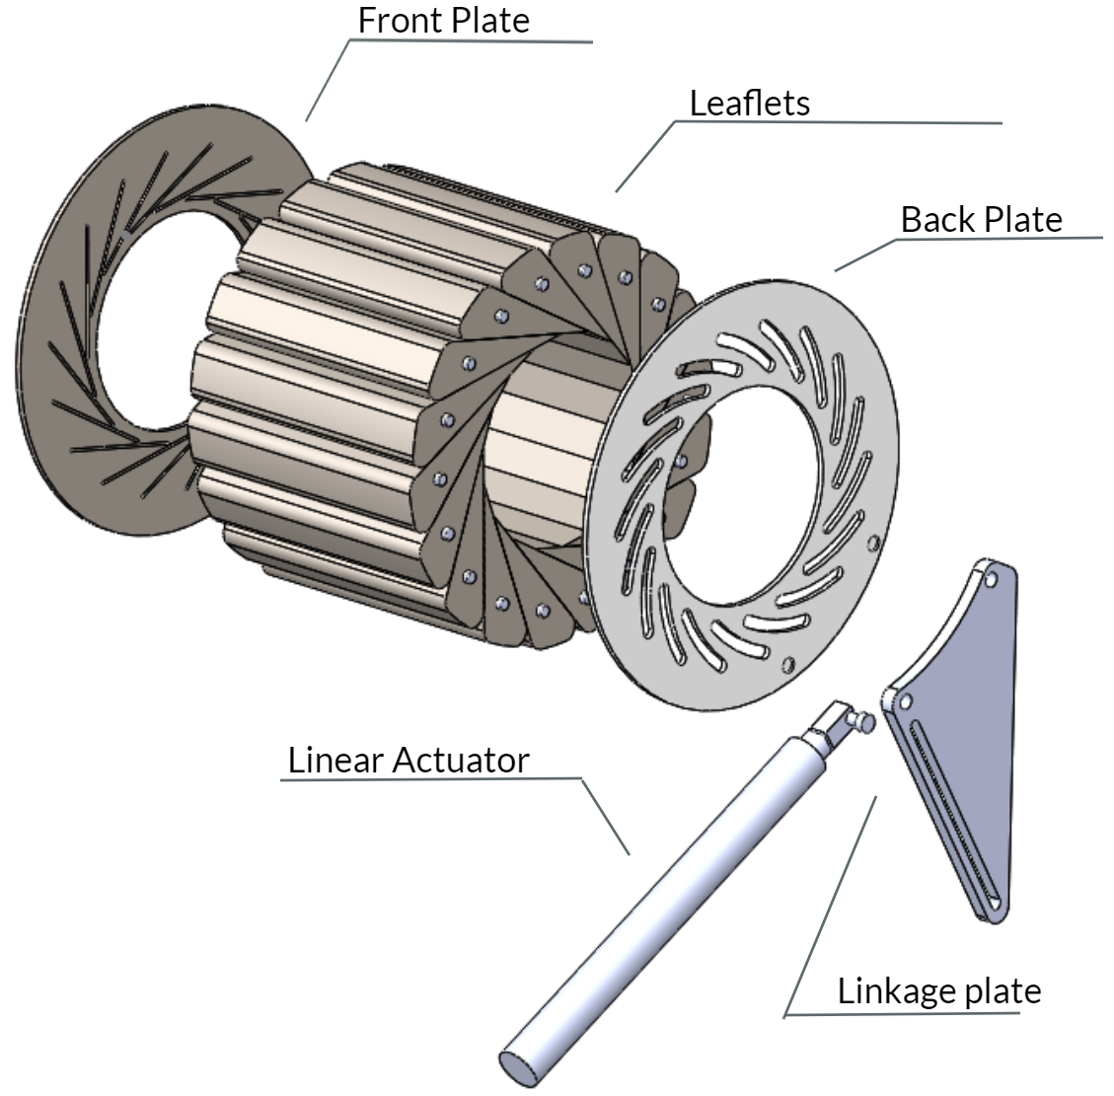
Figure 4: CAD Model
The first subsystem are the leaflets. This design consists of 18 leaflets that make up the crushing surface and the main part of the iris design. These leaflets are placed at an angle that creates a circular pattern. The leaflets are held in place by a front and a back plate. The front plate is stationary and has straight slots to guide the leaflets as they rotate and close. The back plate rotates which forces the leaflets to rotate and close. The back plate will attach to the linkage plate. The linkage plate is connected to the linear actuator which will force the linkage plate to rotate the back plate.

Leaflet Description
The leaflets consist of a knob attachment area with a diameter of 4 mm and depth of 2 mm and an extruded slot with the length of 10 mm and thickness of 1 mm [Figure 5]. The leaflets were designed by setting a wedge of 20 degrees inside of a circle with a diameter of 120 mm and extruding the part out to a length of 100 mm [Figure B1]. A displaced circle of 130 mm was utilized as the basis for the fillet placement [Figure B1]. The fillets of the leaflets have a radius of 5 mm and are designed to minimize potential friction between leaflets. In total, there are 18 leaflets that facilitate the crimping diameter.
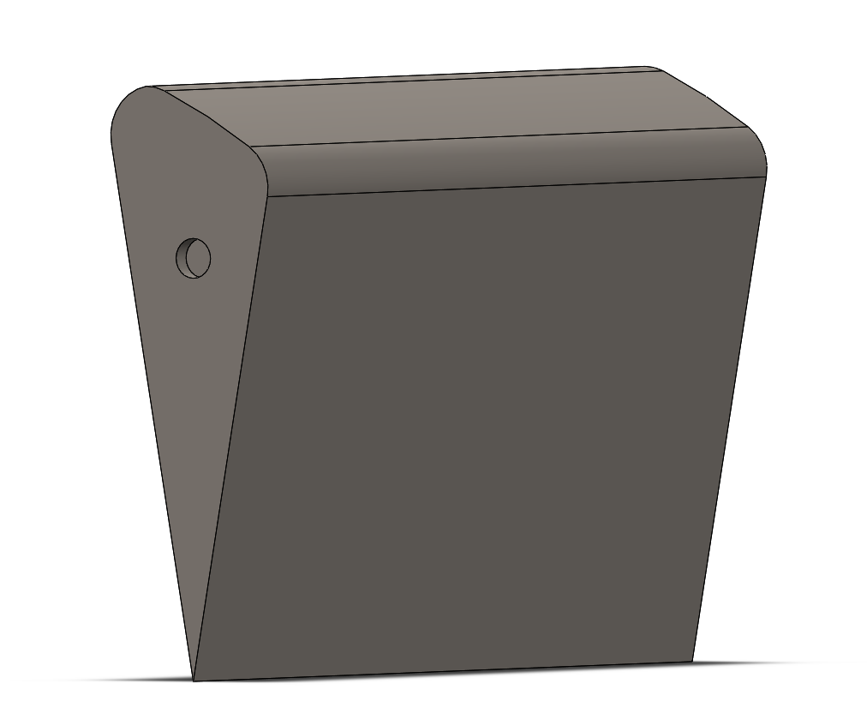
Figure 5: Leaflet

    - Knob
The knob has a diameter of 4 mm and a length of 4 mm. The ends of the knobs are chamfered with a diameter 0f 0.25 mm and an angle of 45 degrees [Figure 6].
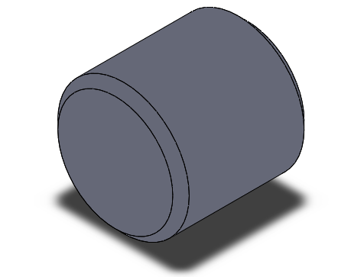
Figure 6: Knob

Front Plate Description
The slotted front plate is a stationary plate that leaflets will glide along during motion. The slotted front plate has linear slots with a width of 1 mm and a length of 44 mm [Figure 7]. The slots are separated by a minimum distance of 0.443 mm. The total number of slots corresponds to the total number of leaflets.
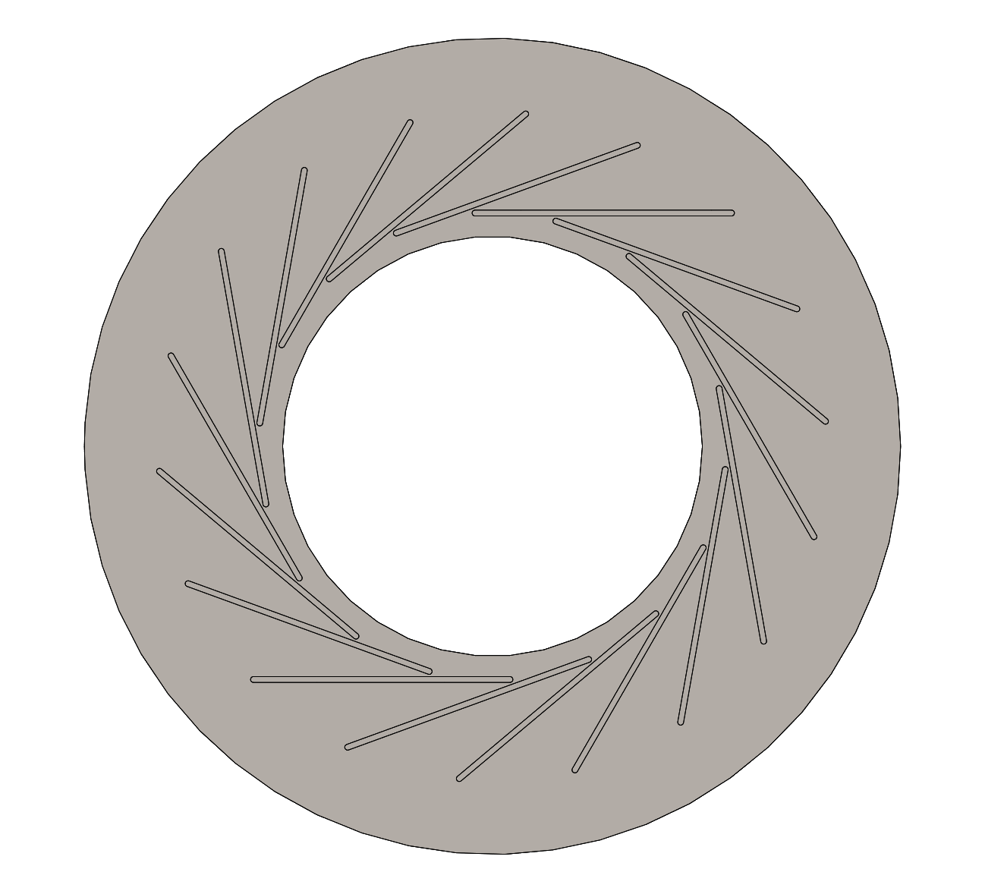
Figure 7: Front Plate

Back Plate Description
The slotted back plate is a movable plate that utilizes curved slots that connect to the knob attached to the leaflets to facilitate motion [Figure 8]. The curved slots were designed by placing a three point slot in between two circles with the diameters of 85 mm and 111 mm. The radius of the curvature is 50 mm and the slot width is 2.05 mm. The total number of slots corresponds to the total number of leaflets. For a detailed drawing of the back plate see Figure B2.

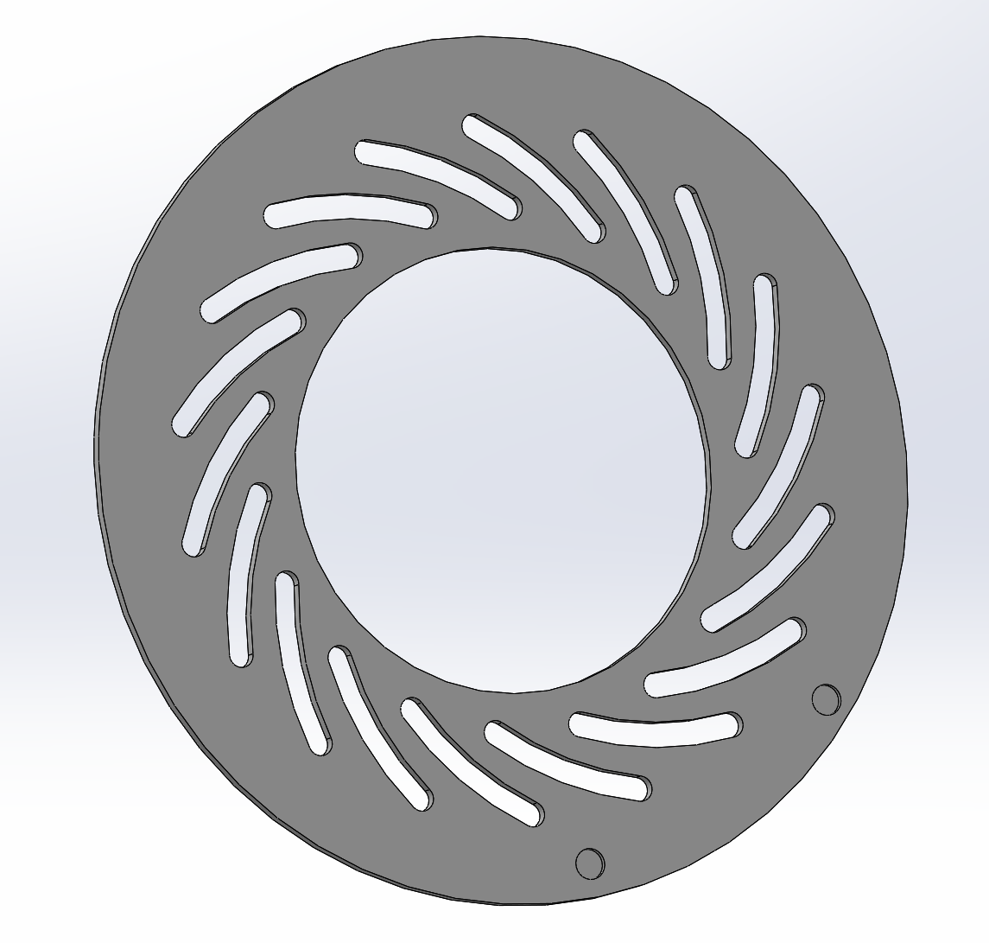
Figure 8: Back Plate

Linkage Plate Description
The linkage plate connects the linear actuator to the back plate. The linkage plate will help convert the linear stroke of the linear actuator to the rotational motion of the back plate. This linkage plate can be seen in figure 9.

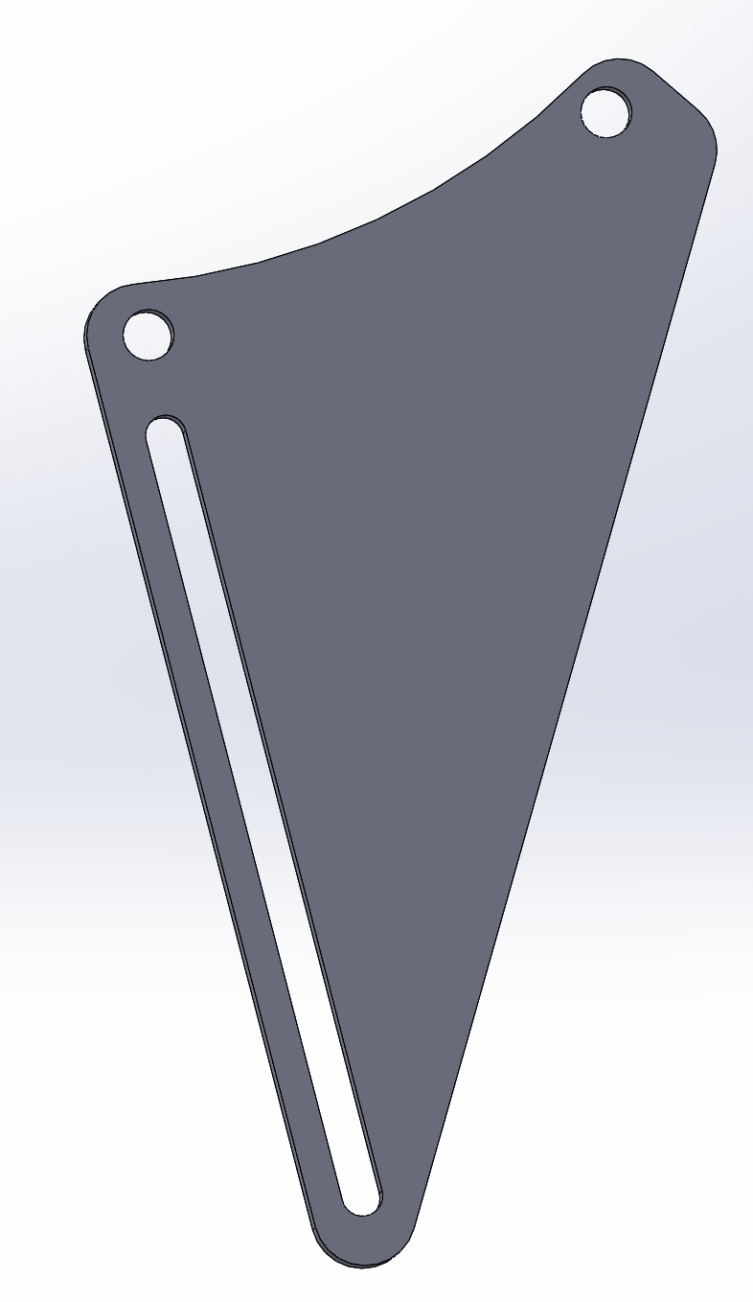
Figure 9: Linkage Plate

The linkage plate has a slot in it that the linear actuator will attach to by a pin. The will allow the linear actuator to push the linkage plate out. The linkage plate is fixed to the back plate so this linkage plate will rotate. As the linear actuators lengthens the pin connection will be able to slide down the slot. This action will force the linkage plate to rotate the back plate.

Linear Actuator
The team is going to purchase a linear actuator to reduce manufacturing time and cost. The team had to calculate the force the actuator must be able to produce and the stroke length. The stroke length was found by evaluating and measuring the CAD model in solidworks. The team found that the stroke length required for the linear actuator was 130 mm. The stroke length is the distance at which the linear actuator can extend out to. The force that the actuator must supply must be able to produce at least 105 N of radial force. The radial force can be estimated using the following equation:
$RF = \frac{2}{dD/dx}*F (2)$ [11]
The radial force is represented by RF and the force supplied by the linear actuator is represented by F. The dD/dx represents a constant that will be specific to the design. This constant is obtained by dividing the change in diameter over the change in actuator stroke. The team was able to calculate the force the linear actuator must supply is 36.7 N of force. \\
    - Control Components
The control components consist of an Arduino Mega, an LCD display and user input interface. The interface at this point is a joystick with standard movements. In the future, the display could change to a touch screen to eliminate the need for a separate user interaction piece. Initially, the user will be able to input the desired diameter of the crushed stent and press the joystick to make the device crush to that diameter.
The arduino will be able to keep track of the motor counts of the linear actuator and, after some testing and calibration, the diameter will be able to be tracked as a relation to the linear motion of the actuator.

Implementation Plan
The team plans to implement the design by creating a prototype. Because of the circumstances and changes to the semester, prototyping is only being done by one person this semester. The primary method of prototyping is via 3D printer to ensure the complex geometry and tight tolerances of the design are maintained. The team has focused on the iris portion of the design this semester and will create a housing for the iris next semester. The team will also work next semester to implement the electronics of the design.
The electronics of the design will include an Arduino Mega, a linear actuator, an LCD display screen, and a user input device. The linear actuator will move the plate that contracts the leafs to the diameter set by the user using the user input device. The LCD display will assist the user with the input and display the diameter of the device during the crimping process as well as the force being output. The Arduino is the main computer and brain for the device and will be located within the device.

CONCLUSIONS

The scope of this project was to design a functioning stent crimper that utilizes an iris mechanism and incorporate an electrical component that will have an input and output. The requirements of the design were based on radial force, diameter, length, and standards. The engineering requirements were properly supported by the research that the team carried out. The proposed design includes 18 dies, a front plate, back plate, a force-feedback linear actuator, and an arduino and stepper motor for controlling the system. Prototyping will begin shortly after the semester ends and will aid in the selection of die material and understanding the amount of friction present. An arduino will be used to control the device while also displaying the correct radial force and diameter on an LCD screen. The process for designing the stent crimper has been iterative but has improved our engineering skills and has made us confident in our design.
REFERENCES
[1] J. Madjarov, “Stents,” CTSNet. [Online]. Available: https://www.ctsnet.org/article/stents. [Accessed: 24-Apr-2020].
[2] S. H. Duda, J. Wiskirchen, G. Tepe, M. Bitzer, T. W. Kaulich, D. Stoeckel, and C. D. Claussen, “Physical Properties of Endovascular Stents: An Experimental Comparison,” Journal of Vascular and Interventional Radiology, 15-Apr-2007. [Online]. Available: https://www.sciencedirect.com/science/article/pii/S1051044307616200. [Accessed: 24-Apr-2020].
[3] “Standard Specification for Wrought Seamless or Welded and Drawn 18 Chromium14Nickel-2.5Molybdenum Stainless Steel Small Diameter Tubing for Surgical Implants,” TBT Standard F2257, 2014. [Online]. Available: https://compass-astm-org.libproxy.nau.edu/EDIT/html_annot.cgi?F2257+14
[4] Human Factors Design Process for Medical Devices, ANSI/AAMI HE 74:2001. [Online]. Available: https://my.aami.org/aamiresources/previewfiles/he75_1311_preview.pdf

[5] Metallic biliary stent system for benign strictures, TITLE 21, PART 876.5011, 2019. [Online]. Available: https://www.accessdata.fda.gov/scripts/cdrh/cfdocs/cfcfr/cfrsearch.cfm?fr=876.5011

[6] Standard Specification for Polyethylene Plastics for Medical Applications, ASTM F639 - 09, 2015. [Online]. Available: https://compass-astm-org.libproxy.nau.edu/EDIT/html_annot.cgi?F639+09(2015)

[7] J. Li, Y. Wang, X. Wang, and D. Wu, “Development of Polyoxymethylene/Polylactide Blends for a Potentially Biodegradable Material: Crystallization Kinetics, Lifespan Prediction, and Enzymatic Degradation Behavior,” Polymers (Basel)., vol. 11, no. 9, p. 1516, Sep. 2019. [Online], Available: https://www.ncbi.nlm.nih.gov/pmc/articles/PMC6780351/ [Accessed: April 29, 2020].

[8] “Ertalyte PET-P,” E. Jordan Brookes Plastics. [Online]. Available: https://www.ejbplastics.com/product/33/Ertalyte_PET-P. [Accessed: 30-April-2020].

[9] “Acetal Copolymer (Delrin®) (Celcon®) (Acetron®),” Acetal Copolymer, 2011. [Online]. Available: https://www.polytechindustrial.com/products/plastic-stock-shapes/acetal-copolymer. [Accessed: 30-April-2020].

[10] B. Demirel, A. Yaraș, and H. Elçiçek, “Crystallization Behavior of PET Materials,” BAÜ Fen Bil. Enst. Derg. Cilt, vol. 13, no. 1, pp. 26–35, 2011.

[11] “Measuring Radial Force,” Blockwise Engineering LLC. [Online]. Available: http://www.blockwise.com/assets/knowledge/K050-Measuring%20Radial%20Force.pdf [Accessed: 30-April-2020].

APPENDICES

Appendix A: FMEA Analysis
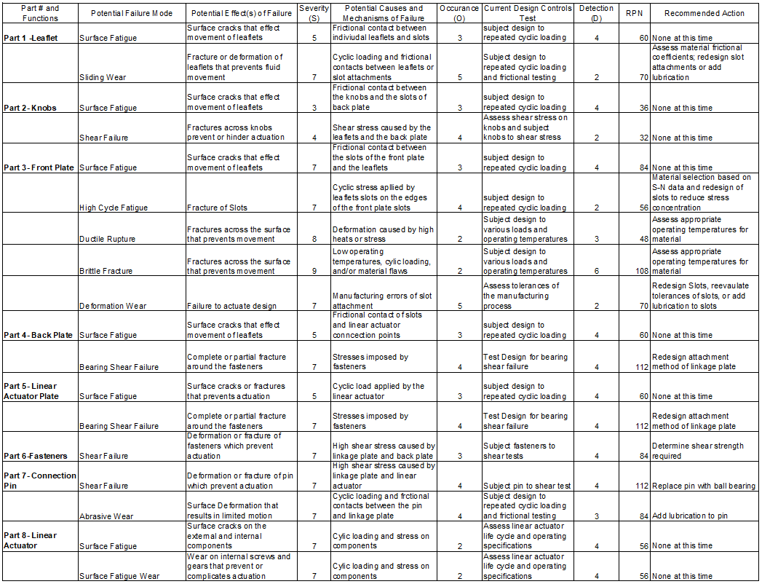

Appendix B: CAD Drawings
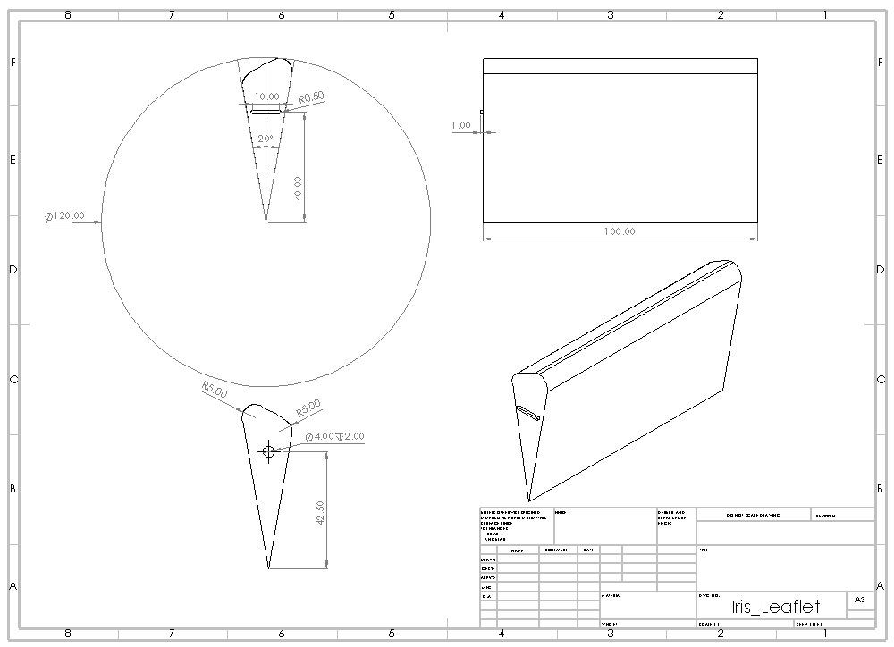
Figure B1: Leaflet CAD Drawing
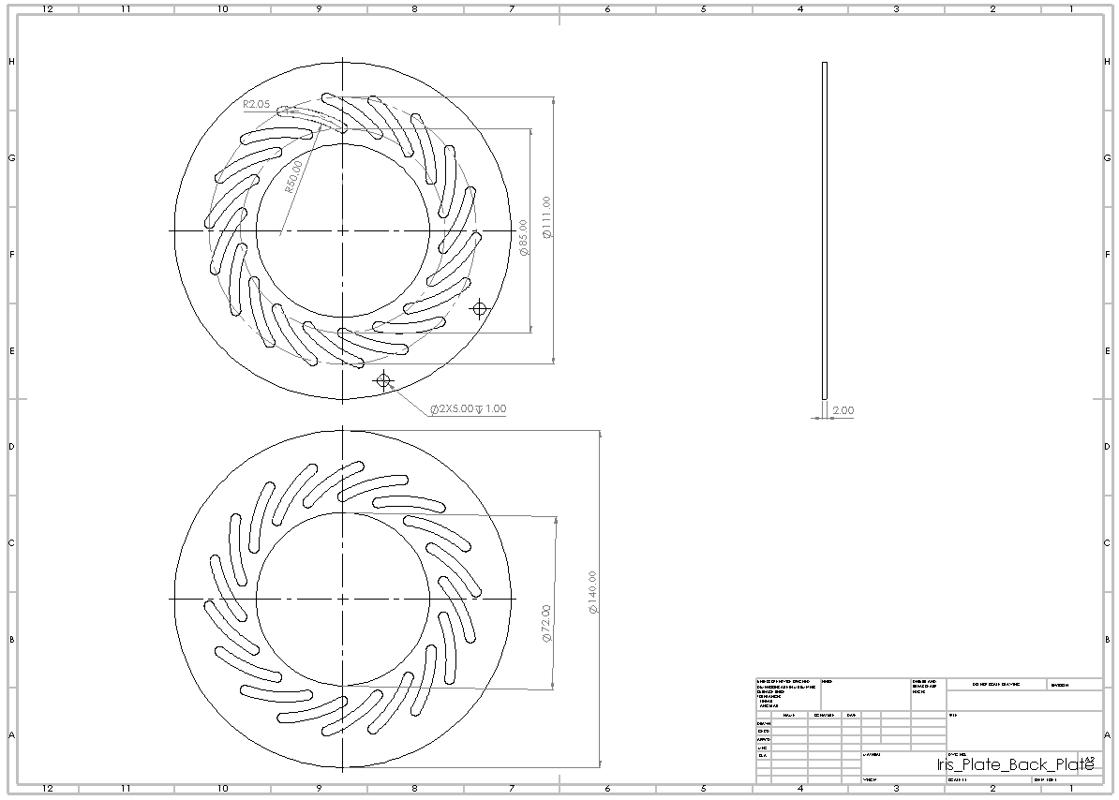
Figure B2: Back Plate CAD drawing

