Components:

Screws
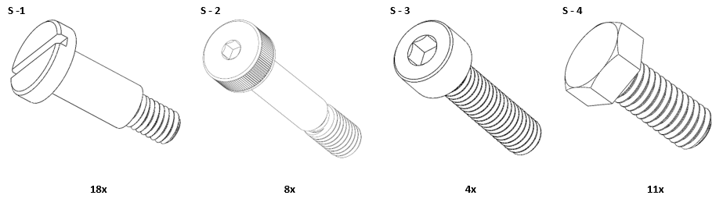

Housing
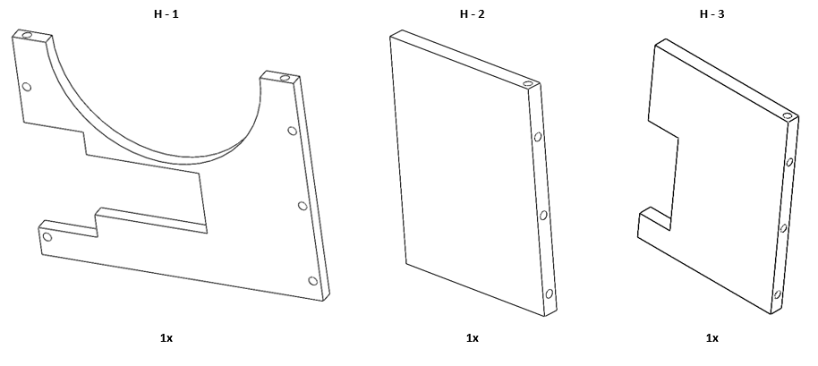
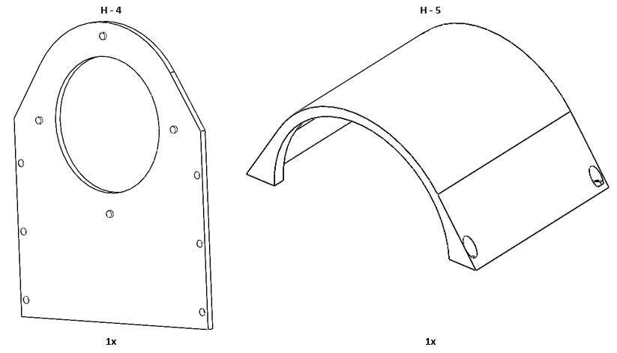

Gear
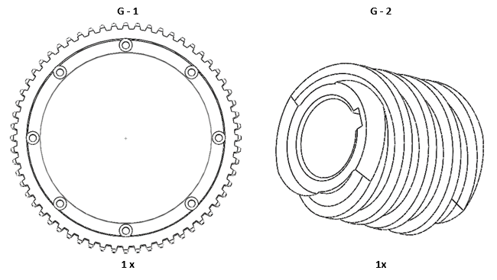

Motor Cage
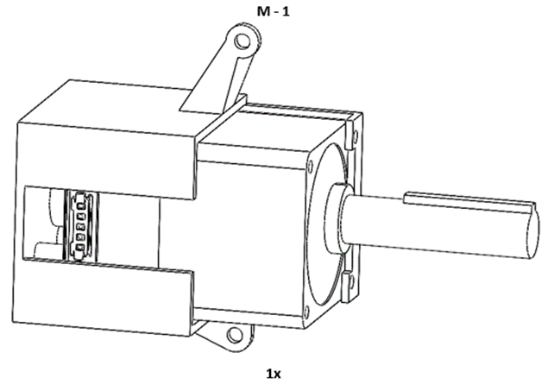

Spacer
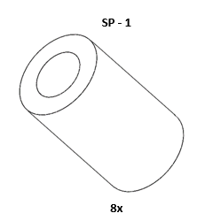

Main Body
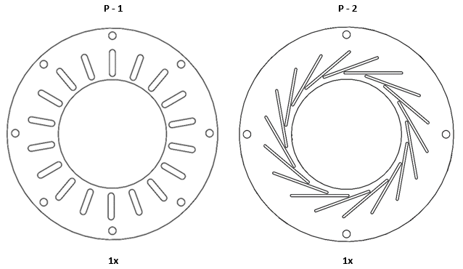
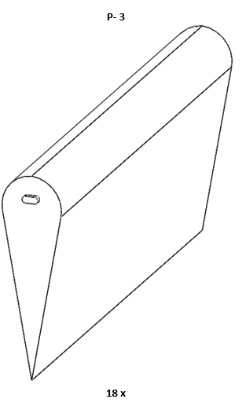

Assembly
- Assembly Main Body
  - Place Part SP-1 through Part S-2
Insert thread of Part S-2 through holes on G-1
Thread S-2 onto holes the Part P-1
  - Individually place Part S-1 through slots on P-1 and fasten to Part P-3
- Motor
  - Place Part G-2 onto shaft of Part M-1
- Assembly Housing
  - Use Part S-4 to secure the Part H-1 to Part H-2
  - Place Part M-1 on Part H-1 and attach to Part H-2
  - Place P-2 on knobs on the Part H-4
  - Place extruded knobs of Part P-3 into slots of non-P-2
  - Attach Part H-4 to the side plates (Part H-2 and H-3)
  - Place Part H-5 onto rest of housing and use Part S-3 for attachment
  - Verify that G-1 and G-2 are properly aligned
    - If the parts are not aligned detach then reattach M-1 to part H-1
See Diagrams for more details

Main Body

Step A
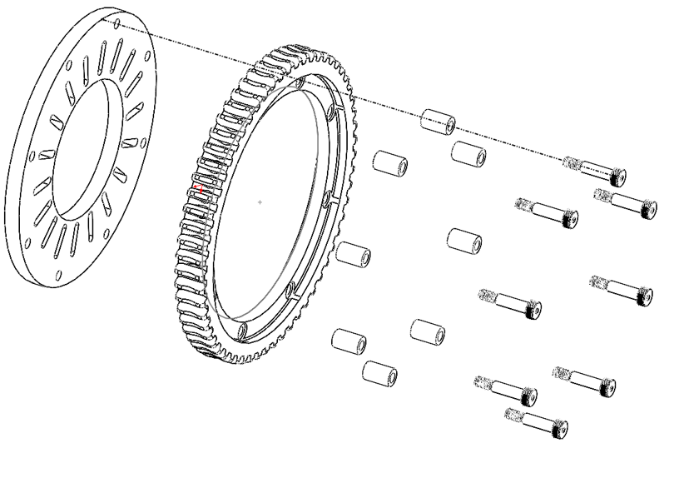

Step B
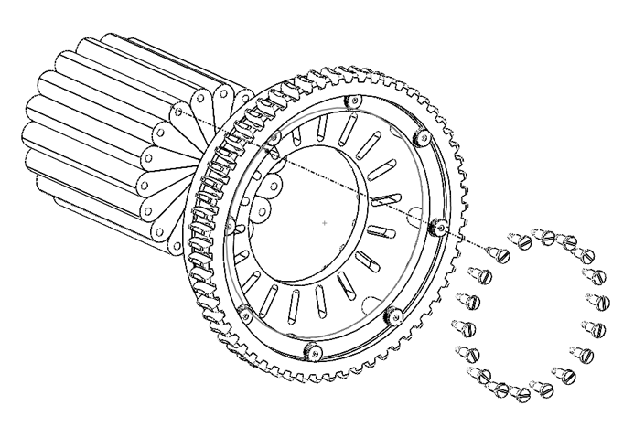

Motor Cage

Step A
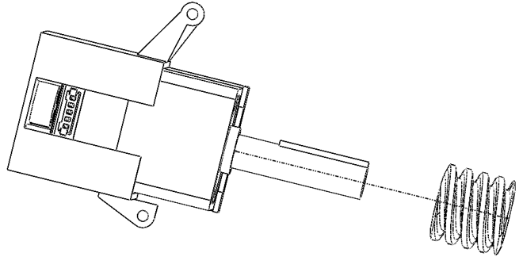

Housing

Step A
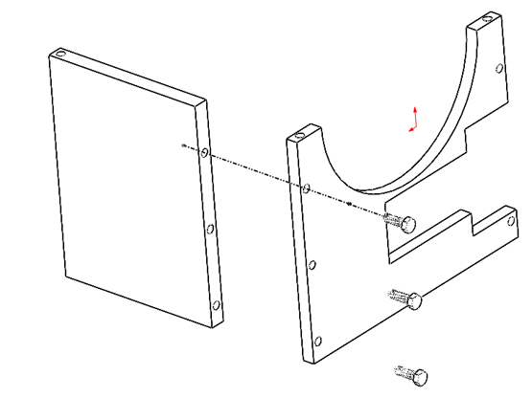

Step B
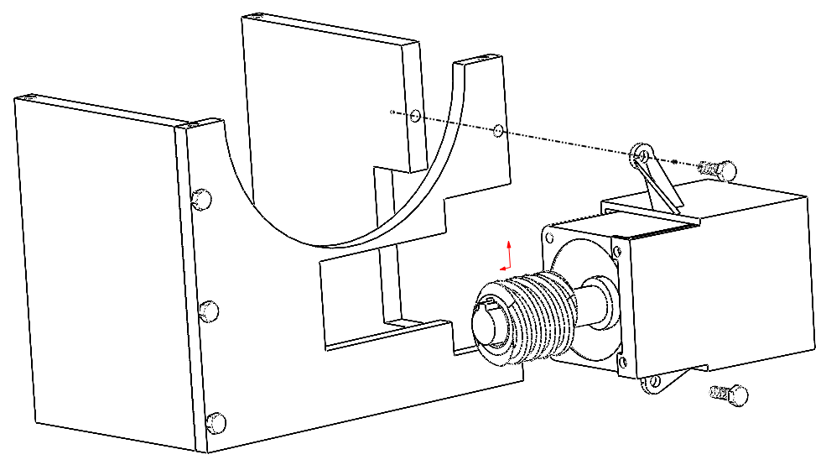

Step C
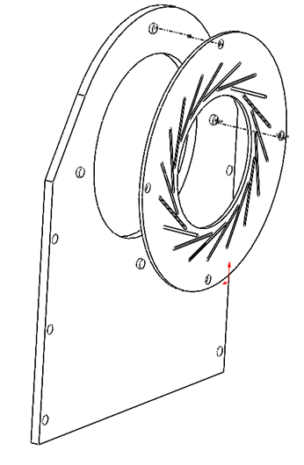

Step D
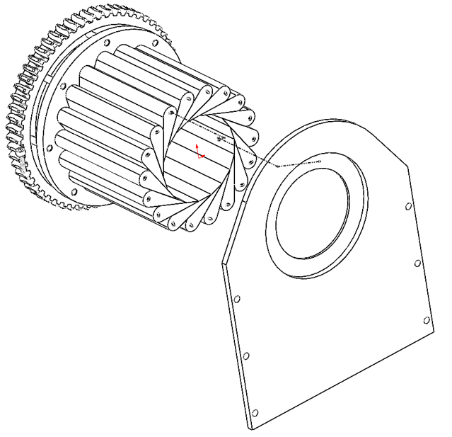

Step E
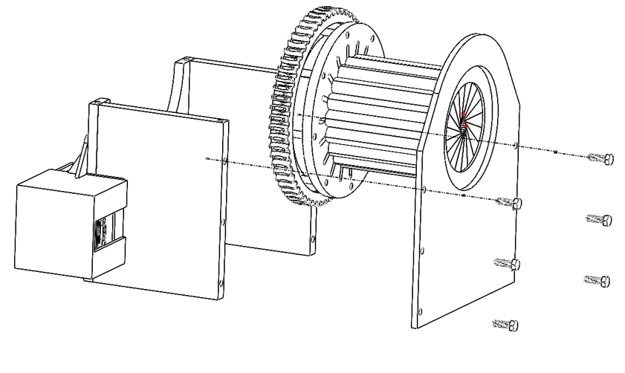

Step F
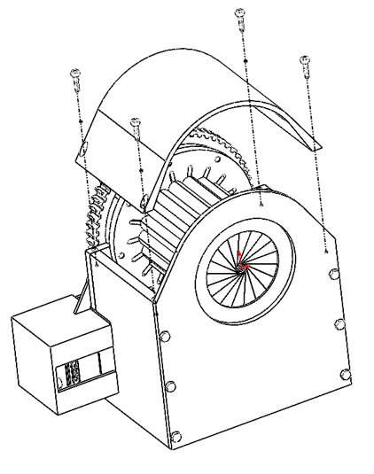

Arduino Schematic
