Bill of Materials
Product Name
Team
Part # | Part Name | Qty | Description | Functions | Material | Manufacturing Process | Dimensions | Photo
1 | Leaflet | 18 | Iris leaflet | Directly crimp the stent | Steel | Machining, Cut | Radius 60 mm  Angle 20 degrees  Fillet radius 5 mm | 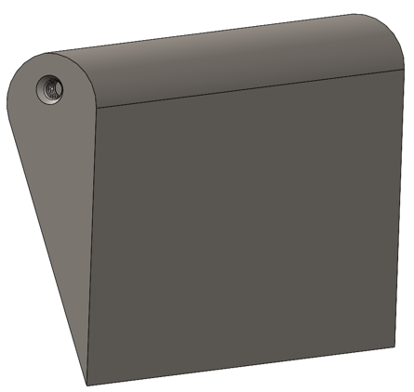
2 | Shoulder  Screw | 18 | Metal Securer | Attaches leaflets to front plate | Steel | Purchased | Shoulder-  Diameter: 4 mm  Threads-  M3x0.5  Depth 4.5 mm | 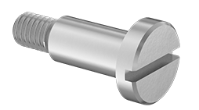
3 | Nonrotating plate | 1 | Stationary Plate with narrow linear slots | Allows leaflet movements | Metal | Machining, Cut | Outer Diameter 140 mm  Inner Diameter 72 mm  Slot length 44 mm by 1 mm | 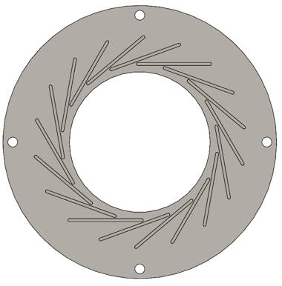
4 | Rotating Plate | 1 | Rotating Plate with linear slots | Facilitates movement of leaflets from motor | Metal | Machining, Cut | Outer Diameter 140 mm  Inner Diameter 72 mm  Slot thickness 4 mm | 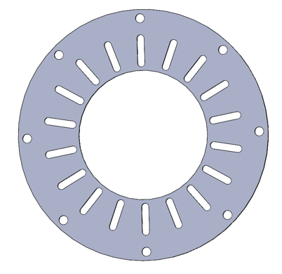
5 | Worm Gear | 1 | DB1414A  Worm Gear | Actuate Rotating Plate | Bronze | Purchased | Outer Diameter: 158.75 mm  Pitch 10  Ratio 30:1  Double-threaded  Right-handed | 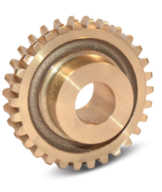
6 | Worm | 1 | D1418KRH Worm | Translate Motion of motor to Gear | Unhardened Steel | Purchased | Outer Diameter:  31.75 mm  Pitch 10  Double-threaded  Right-handed | 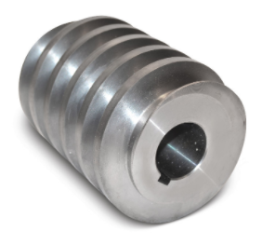
7 | Stepper Motor | 1 | Stepper Motor | Moves the front plate and leaflets | Metal, plastic | Purchased | Frame: 60 mm  Motor Length: 83 mm  Shaft Diameter: 10 mm | 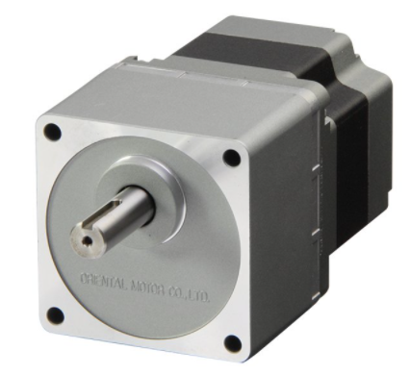
8 | Driver | 1 | CVD528BR-K CVD 5-Phase Driver | Controls motor | Metal | Purchased | Power Supply: 24 VDC  Current: 2.8 A | 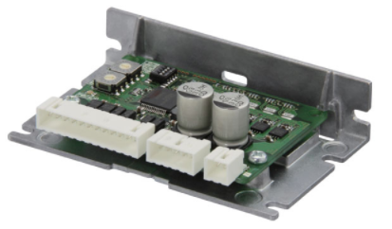
9 | Load Cell | 1 | 3 Kg Compression Force Sensor | Measures Force output by worm gear | Stainless Steel | Purchased | 3kg  Sensitivity: 1.0-2.0 mV/V  Voltage: 5-12 V | 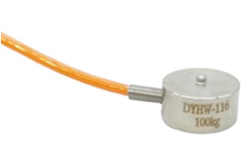
10 | Display screen | 1 | LCD1602 display | Displays Radial Force and Diameter |  | Purchased | LCD1602 | 