NAU Technical Design Report
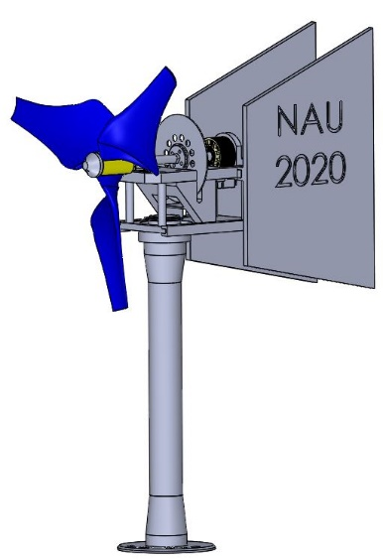
Figure 1: Full Assembly

2019-2020
Student Authors: ME Team Lead: Lucas Duncan ldd55@nau.edu, EE Auxiliary Team Lead: Calum Eikenberry cje223@nau.edu, EE DC-DC Convertor Team Lead: Nigel Grey ng474@nau.edu, Ethan Malteverne epm49@nau.edu, Daniel Massaglia dm976@nau.edu, ME Aerodynamics Lead: Marina McCue marina_mccue@nau.edu, Matt Mennell mlm636@nau.edu, ME Brake Design: Sean Veden jfv32@nau.edu
Project Sponsor: U.S. Department of Energy, National Renewable Energy Laboratory, Gore
Principle Investigator/Faculty Advisor: David Willy
Co-Principle Investigator/Faculty Advisor: Dr. Venkata Yaramasu
Capstone Instructor: Dr. David Trevas, Dr. Kyle Winfree
Table of Contents
List of Tables 3
List of Figures 3
Executive Summary (Sean) 4
1. Design Requirements (Ethan) 5
2. Static Performance Analysis (Marina) 6
3. Mechanical Loads Analysis 8
3.1. Blade Analysis (Marina) 8
3.2. Shaft Analysis (Matt) 8
3.3. Brake Analysis (Sean) 9
3.4. Nacelle Analysis (Daniel) 10
3.5. Tower Analysis (Daniel) 10
4. Yaw System (Lucas & Marina) 10
5. Electrical Analysis (Calum & Nigel) 11
6. Software Description, System Control (Calum, Nigel) 12
7. Testing Results 13
7.1. Electrical Testing Procedure (Calum & Nigel) 13
7.2. Mechanical Testing Procedure 14
7.2.1. Blades & Hub (Lucas & Matt) 14
7.2.2. Tower/Baseplate/Nacelle (Daniel) 14
7.2.3. Brake (Sean) 15
7.2.4. Yaw (Lucas, Marina & Matt) 15
7.2.5. Shaft (Lucas, Marina & Matt) 15
Appendix 16

List of Tables
Table 1: Wind Turbine Blade Geometry 8
Table 2: Mechanical Component Factor of Safety (FOS) 10
Table 3: Runaway Wind Speeds and Braking System Factor of Safety 12

List of Figures
Figure 1: Full Assembly 1
Figure 2: Turbine Electrical System 2
Figure 3: Full Assembly 6
Figure 4: Coefficient of Power versus Tip Speed Ratio 7
Figure 5: Aerodynamic Power Curve 8
Figure 6: Annual Energy Production 8
Figure 7: Wind Turbine Blade Finite Element Analysis 9
Figure 8: Shaft 10
Figure 9: Brake Assembly 10
Figure 10 : Yaw 11
Figure 11: Greater-than-one-line Diagram 12
Figure 12: Printed Circuit Board 12
Figure 13: PI-Controlled Synchronous Boost Converter Schematic 13
Figure 14: PI-Controller Arduino Program 13
Figure 15: Control Module Flowcharts 14
Figure 16: Rotor Strength Test Enclosure 15
Figure 17: Blades in Enclosure 15
Figure 18: Actuator Slider Testing 16
Figure 19: Shaft Stress Analysis 17
Figure 20: Shaft 17
Figure 21: Shaft Von Mises Stress 17

Executive Summary (Sean)
The Northern Arizona University (NAU) Collegiate Wind Competition (CWC) 2020 turbine team completed a design for a small-scale wind turbine. The turbine is a three-blade design with a passive yaw, dynamic and mechanical braking, and a closed-loop controlled synchronous boost converter electrical subsystem. The parts used in this turbine were either commercially available or manufactured by the team. The design team was split into three: one mechanical engineering team and two electrical engineering teams. The mechanical engineering team was tasked with designing the aerodynamic, structural, and mechanical parts of the turbine. The electrical DC-DC converter team was tasked with the design and simulation of the converter topology. The electrical auxiliary team was tasked with converting the DC-DC team’s design into a printed circuit board (PCB) and complimenting it with low forward-voltage component selections. To aid in the design process, the team used computer programs such as MATLAB, QBlade, Arduino IDE, and SolidWorks. Once the parts were designed, testing was completed to ensure the design worked as expected. The testing procedures are described within this document.

Design Requirements (Ethan)
Design Requirements:
- High efficiency
- High electrical generation
- Low cog
- Simple assembly
- Low cut-in speed
- Compact
- Lightweight
- Aesthetically pleasing
Sub-teams were broken into categories corresponding to subsystems with two or more people on each sub-team. The tower and nacelle components were developed by Daniel and Matt, while aerodynamics such as yaw and blades were handled by Marina and Lucas, finally Sean and Ethan were on the braking sub-team with cross-team collaboration on all systems in the developing of the following.
two primary objectives from which most design priorities branched from: performance, and aesthetics. A two-shelf nacelle design was utilized, while prioritizing weight distribution. All nonessential components were moved down tower with the goal of weight reduction and promoting an increase in yaw influence. Within our drivetrain we wanted our startup wind speed to be significantly lower, this meant we needed a more aggressive blade, paired with the least amount of resistive torque from both the motor, and any axial supports. Designing components optimized for minimal cogging torque, maximum startup torque, power generation specs, and a minimized plateau effect from higher wind speeds was the priority.
our brake system would need to be exponentially more effective than previous models due to the runaway test. The team produced a reverse mounted drop-down brake system that allowed the brake disk to intrude into the lower nacelle cabin area, ultimately solving this performance issue.
Throughout this project appropriate mounting and dimensioning was found to be one of the most crucial aspects of development. With our extremely compact design most components found themselves within 3mm of each other. This constraint pushed us to develop the multipurpose rail system implemented into the upper nacelle plate. This system utilizes the limited space of the nacelle and maintains assembly simplicity and reducing required hardware.
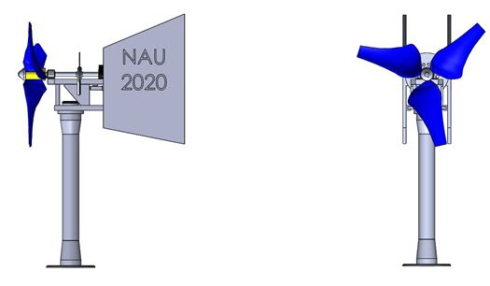

Figure 3: Full Assembly

Static Performance Analysis (Marina)
The wind turbine blades were first designed using MATLAB, analyzed and modified using QBlade, and then created using SolidWorks. The MATLAB code assumed an ideal rotor with wake rotation and accepts design tip speed ratio, angle of attack, rotor radius, number of blades, and number of blade elements as inputs to calculate angle of relative wind, chord length, and twist angle. This information, along with a selected airfoil, were inputted into QBlade and the power performance was analyzed. Chord length and twist angle were exaggerated, and different airfoils were analyzed until desirable characteristics were achieved. The final blade geometry is located below in Table 1, with a design tip speed ratio of 1.5 with an associated coefficient of power of around 0.3. Figure 3 displays the coefficient of power versus tip speed ratio for angular velocities ranging from 0 to 3500 RPM and Figure 5 displays the wind turbine aerodynamic power curve.
Table 1: Wind Turbine Blade Geometry
Local Rotor Radius (cm) | Chord Length (cm) | Twist Angle (Degrees)
1.7 | 10 | 45
3.4 | 10.8 | 27
5.2 | 11.2 | 18
6.9 | 9.1 | 13
8.6 | 7.6 | 9
10.3 | 6.5 | 6.5
12 | 5.6 | 4.7
13.7 | 4.9 | 3.3
15.5 | 4.5 | 2.2
17.2 | 4 | 1.3
18.9 | 3.7 | 0.6
20.6 | 3.4 | 0

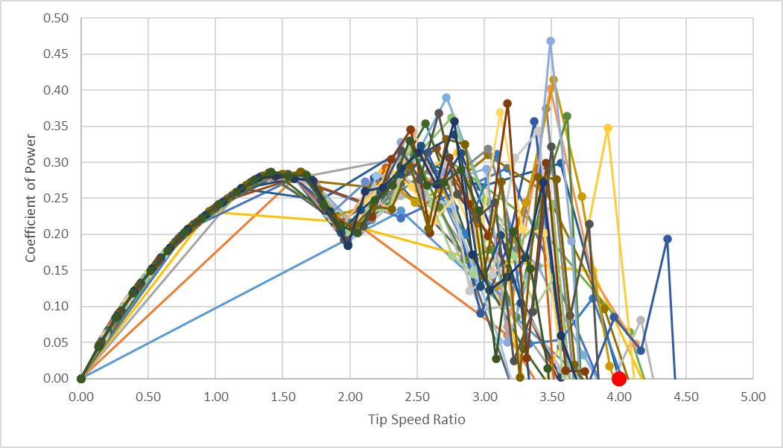
Figure 4: Coefficient of Power versus Tip Speed Ratio
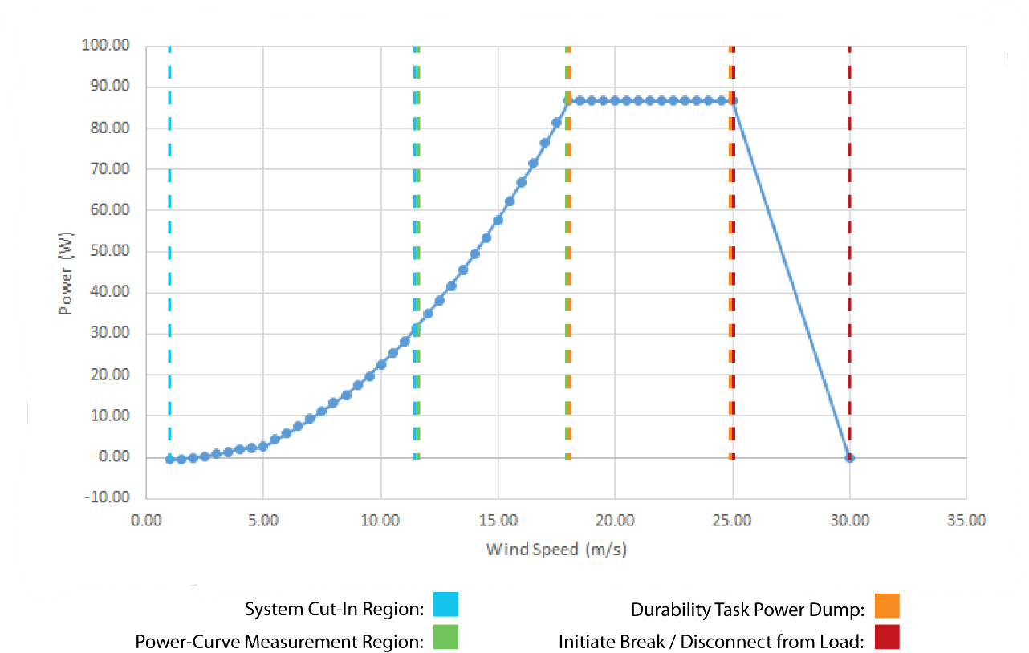
Figure 5: Aerodynamic Power Curve
As seen from Figure 4, the wind turbine cuts-in at 2.0 meters per second and produces a rated power of 30 Watts at 11 meters per second. Using this estimated power production and a Rayleigh probability distribution, the annual energy production was calculated and is shown in Figure 5, assuming the wind turbine operates 50% of the time.
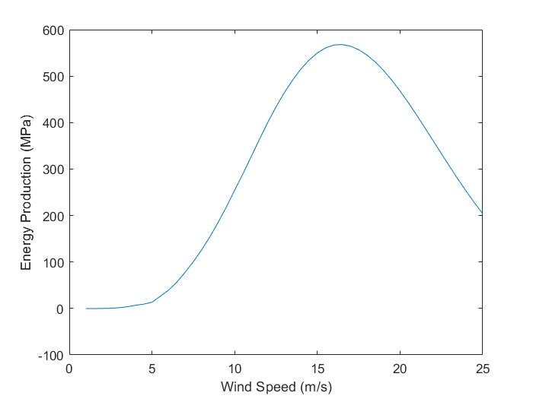
Figure 6: Annual Energy Production

Mechanical Loads Analysis
Table 2: Mechanical Component Factor of Safety (FOS)
System | Material(s) | Load Description | Loads Applied | Minimum FOS
Blades | Polycarbonate | Thrust, Centrifugal | $$T=17.0 N$$  $$Ω=4341 RPM$$ | 2.74

Blade Analysis (Marina)
The final wind turbine blade finite element analysis was conducted using SolidWorks, shown below in Figure 6. The centrifugal load was determined from the runaway rotor speed, which was calculated using the tip speed ratio where the coefficient of power is zero (see the red dot from Figure 3), rotor radius, and maximum wind speed. The thrust force was calculated using air density for standard atmospheric conditions, area of the rotor plane, maximum wind speed, and axial induction factor, assuming an ideal rotor without wake rotation.
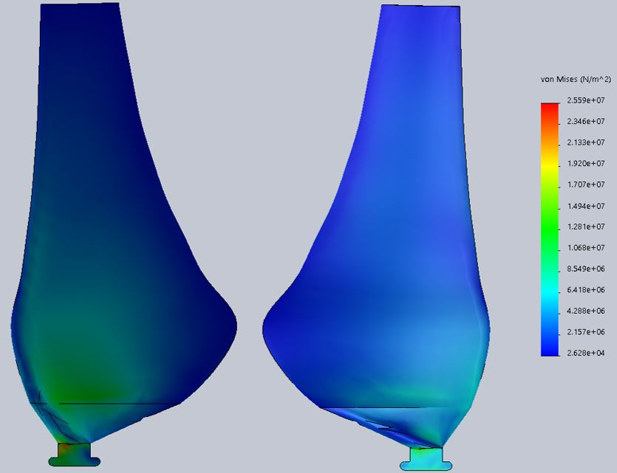
Figure 7: Wind Turbine Blade Finite Element Analysis

Shaft Analysis (Matt)
Shaft design relies on dimensions such as length and cross-sectional areas as well as the maximum centripetal forces experienced. These forces can be determined by the startup torque and during braking. The chosen design includes a short section of the shaft which is has a larger diameter and milled to have a key shape in order to lock the disc in rotation. One end of the shaft is attached to a coupler to the motor shaft. The other end of the shaft is turned down over two inches with an inch of threads cut out. This allows the hub to slide onto the shaft and lock rotation when the hub nose screws on to clamp the hub in place. The shaft is locked in place through the motor mount while support for the weight of the hub and blades on one end and reduced friction is helped with the use of a pillow block bearing mounted to the top nacelle. Due to incompletion of manufacturing of final shaft no physical testing was taken.
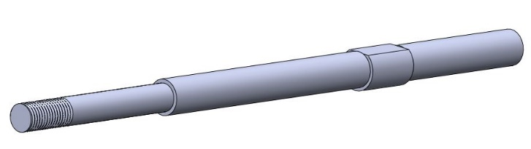
Figure 8: Shaft

Brake Analysis (Sean)

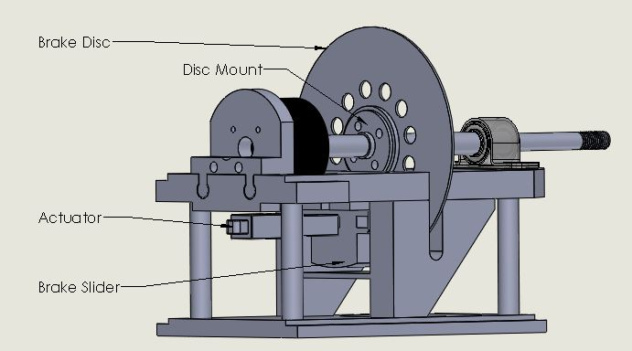
Figure 9: Brake Assembly
Figure 9 above shows the brake assembly with-in the upper level nacelle plate and provides a label of parts shown. The slider and the rail system used is made of polycarbonate and is 3D printed. The braking slider and stopper behind the disk have a slot where a brake pad is pressed into each. The braking slider is fastened to the linear actuator to clamp the brake disk when the actuator is extended. The linear actuator shown is controlled using an Arduino microcontroller and a linear actuator control board. The control board allowed for less coding and allows for fine tuning of the actuator speed and stroke length.
Based on analysis of the blades, the torque that must be overcome to stop the rotation of the blades is shown in Table 3 below. This table outlines the torque produced by the blades at runaway wind speeds and the factor of safety the braking system.
Table 3: Runaway Wind Speeds and Braking System Factor of Safety
Wind Speed [m/s] | Torque of Blades [N-m] | Factor of Safety
18 | 2.5 | 2
22 | 4 | 1.35
25 | 5 | 1.08

The brake disk is 67.5 mm in radius and the linear actuator produces 80 Newtons which means the torque of the braking system is 5.4 N-m. This design can stop the turbine with the use of a push button and with speed sensors that actuate the braking system when runaway wind speeds are sensed.

Nacelle Analysis (Daniel)
The nacelle is comprised of two sections including a lower and upper plate. The lower plate, made of polycarbonate printed at the NAU Rapid Lab, lets wiring from the generator and brake assembly run down the tower while not binding when the turbine experiences wind change. The upper nacelle plate is also produced from the Rapid Lab using polycarbonate. It is made up of two sections that bolt to the bottom plate which are both designed to fasten the nacelle cover and yaw in place.
The top nacelle plate serves multiple purposes. Starting with the bottom of the top plate, an actuator for the brake is mounted to linearly push a brake pad against the brake rotor housed on the top of the plate. Moving to the upper face, a single pillow block with a pressed bearing give support to the drive shaft. In addition to this block the other support for the main shaft is the generator itself where the shaft ends. The generator mounts to the upper nacelle plate as well. The most important part of this portion of the turbine is making sure that the clearance for the brake and shaft do not hit anything.

Tower Analysis (Daniel)
Using steel tube stock, the tower of the turbine was designed on SolidWorks and used in a stress and displacement analysis. Because the team wanted to be able to trim the tube stock to a desired shape, a 2-inch outer diameter with a half inch wall thickness. It is important to make sure that the trimmed tower could withstand the forces it would experience in the wind tunnel. Shown in Figure 18 in the Appendix, the von Mises stress distribution across the tower is shown. The importance of these stresses shows where a part can failure due to fatigue or yielding. Using mild steel, the amount of stress that the tower is miniscule in respect to what it would take to yield the steel. Computing a factor of safety of over 30, the towers wall thickness could be decreased from 1/8th of an inch to 1/16th of an inch and still have a large factor of safety.

Yaw System (Lucas & Marina)
The Yaw of the turbine helps keep the nacelle perpendicular to air flow as it sits on a ball bearing. This design utilizes two tails to increase the surface area which decreases the amount of force needed to hold the nacelle in an ideal position. Attached rails with set screws secure the yaw to the nacelle.
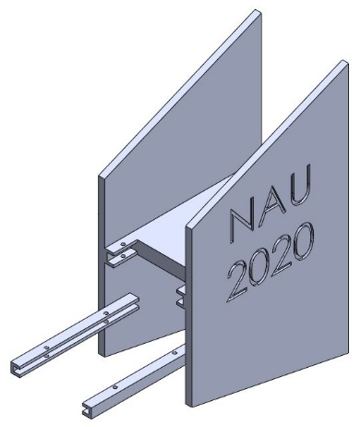
Figure 10 : Yaw

Electrical Analysis (Calum & Nigel)
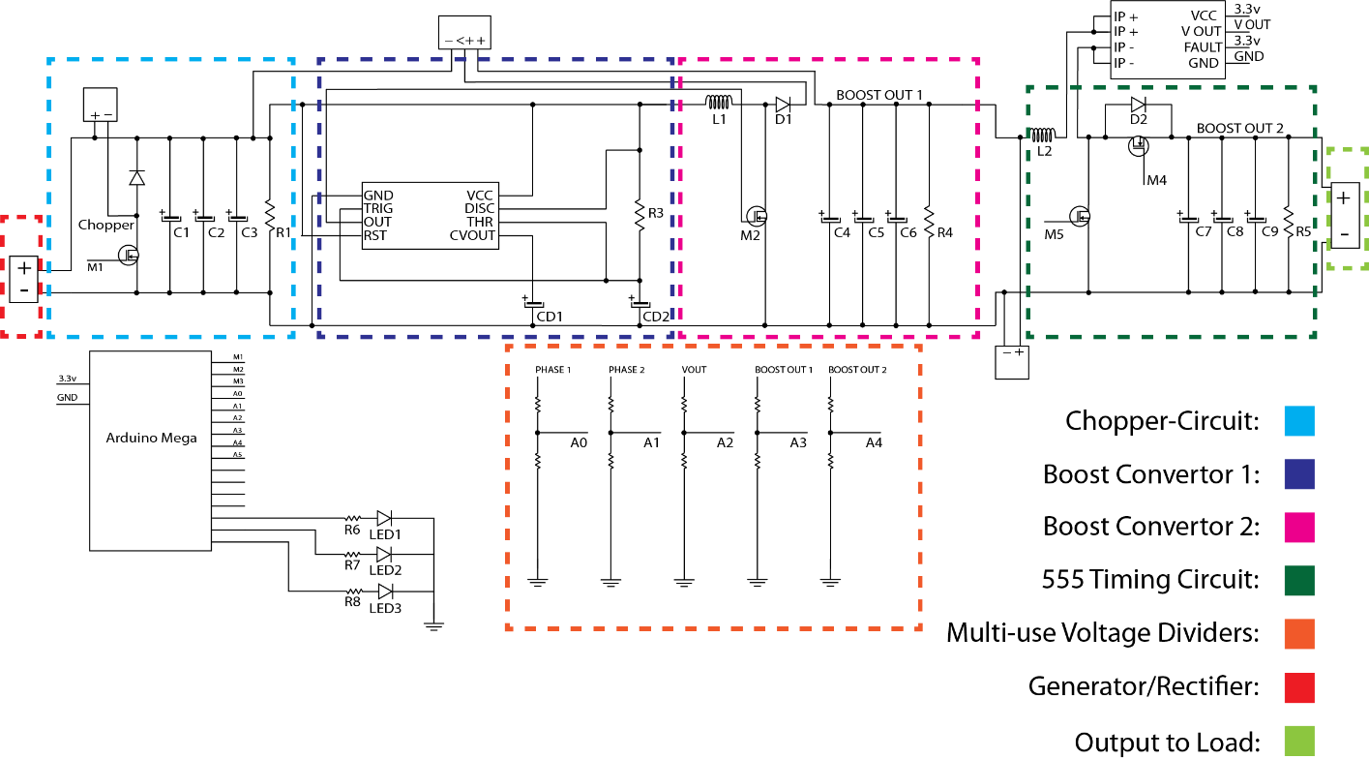
Figure 11: Greater-than-one-line Diagram
The electrical analysis and sub-system design processes were delegated to two sub-teams: the DC-DC team and the Auxiliary team.
The DC-DC team primarily worked to design, simulate, and build a three-stage boost convertor system that utilized a synchronous boost converter topology (two complementary MOSEFTs) in place of a standard MOSFET and diode combination (see Figure 13). The goal of the design was to maximize power generation at low wind speeds, while minimizing the total voltage drop of the system (see Figure 11).
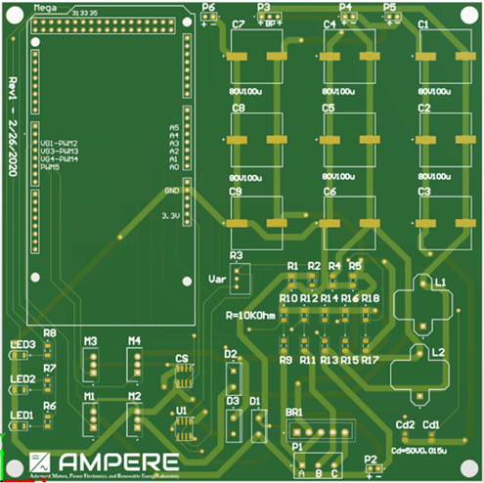
The Auxiliary team worked in parallel with the DC-DC team to optimize all electrical components (i.e. rectifier, auxiliary component wiring, generator) to best complement the low cut-in design and synchronous topology. In addition, the Auxiliary team spearheaded the printed circuit board (PCB) design and construction (see Figure 12), which integrated the entire power/control system from Figure 11 into one circuit.
Altium Designer was utilized by the Auxiliary team to create a 6” by 6”, single-sided PCB (see Figure 12) with all discrete components mounted to it (excluding braking chopper chassis mount resistor and packaged boost convertor for initial microcontroller power source). The design of this PCB included LEDs to allow visual verification that each stage (rectifier, first boost converter, second boost converter) was on, flush-mounted spacing for the Arduino Mega, additional footprints for parallel capacitors for quick changes in signal rectification after each convertor, and the maximum separation of control components/routing from power components/routing as to minimize signal interference. The control components lay along the bottom-left of the board and the power components across the top-right to center-right.
Figure 12: Printed Circuit Board
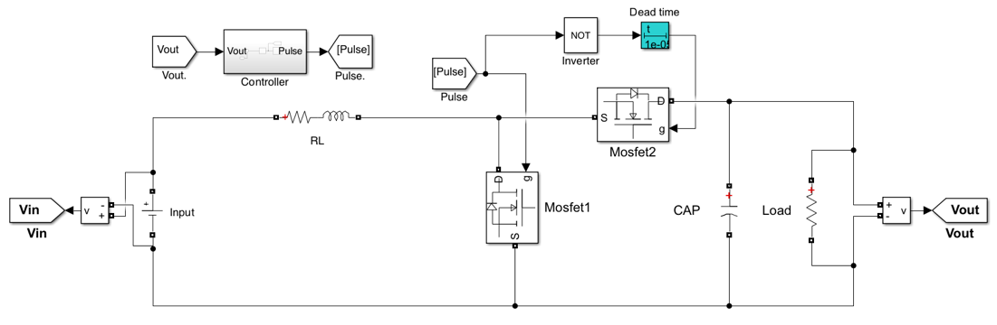
Figure 13: PI-Controlled Synchronous Boost Converter Schematic
The intended load attached at the end of the schematic diagram (see Figure 11) was to be a fixed resistance load with a 300W power rating and 10 Ohm resistance. Upon further testing the team would home in on the optimal resistance/power rating.

Software Description, System Control (Calum, Nigel)
MATLAB Simulink was used for circuit and closed-loop control simulations (see Figure 13). Simulink also allowed for a block-programming style that easily modularized the numerous electrical and mechanical turbine control algorithms and allowed a direct export to the Arduino Mega microcontroller (see Figure 14).
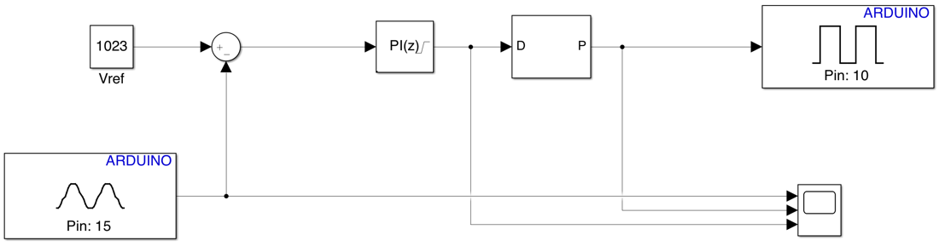
Figure 14: PI-Controller Arduino Program
All control modules (see Figure 15), were to be modeled within the Simulink environment and then exported directly to the microcontroller (same style of programming implemented in Figure 14) to reduce timing complications and optimize the controller’s multithreading capability.
Control Module Descriptions:
- Dump-Load Circuit: when an overspeed event occurs, route the rectified signal through an external resistor to ground via the “Chopper Circuit” in Figure 11. This control module is active only during the “Durability Task Power Dump” region (see Figure 5).
- Phase 1-2 Voltage Measurement: calculate the turbine rpm via phase 1 and 2 x-axis crossing point difference. This module occurs as soon as the microcontroller is powered on as to detect the point in time to trigger the system brake for the “Initiate Break” region (see Figure 5).
- PI Controller: utilizes proportional integral calculation to control second stage boost converter duty-cycle.
- Current Sensor Measurement: used to detect and signal if load is disconnected. This module is active as soon as the “System Cut-In Region” is reached and detects the “Disconnect from Load” region (see Figure 5).
- Stage 2, 3, & 4 Voltage Measurements: voltage divider circuits used to detect electrical potential at each key stage; trigger LEDs to provide visual feedback. This is also utilized to detect the “Disconnect from Load” region (see Figure 5).
- Actuator Signal: provides PWM signal for mechanical breaking control and is utilized during the “Initiate Break” region (see Figure 5).

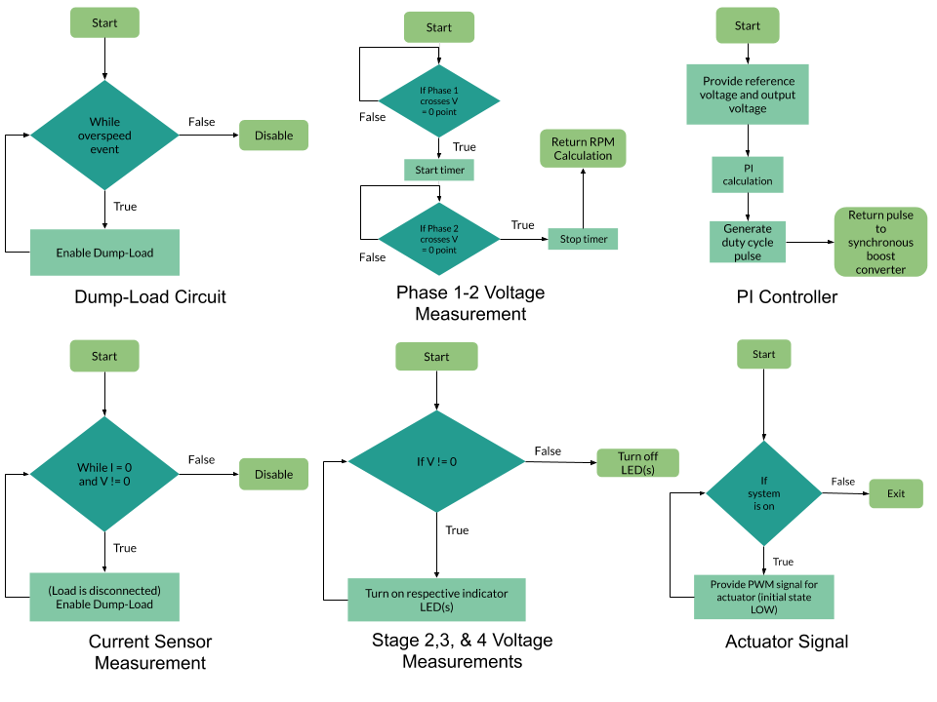
Figure 15: Control Module Flowcharts

Testing Results

Electrical Testing Procedure (Calum & Nigel)
Testing and power quality measurements of the PCB with all soldered components was to take place immediately after receiving of the PCB from the manufacturer if the project were able to continue. LEDs were integrated after each stage of conversion within the circuit to provide visual feedback to the tester, and an oscilloscope would be used to provide exact measurements per the CWC2020 rules and requirements. The design (see Figure 11) featured the ability to change the capacitance values to decrease noise and increase signal integrity. Due to the modular capacitance and closed-loop control, additional filtering techniques would not likely be needed. The generator output would be tracked with the use of a dynamometer throughout this testing.

Mechanical Testing Procedure
The testing procedures for the turbine have come to a stop, but in the following sections each major sub-system testing procedures that have been done will be discussed. The findings during these tests will be gone over and how it aided in the team’s design decisions. Also discussed below is the testing procedures that would have taken place if the times would allow.

Blades & Hub (Lucas & Matt)
The blades and hub subsystem were tested early during the semester. Members of the team assembled a safety container out of wood and Plexiglass. With the expectancy of the blades sheering the box was built with a high factor of safety. Attached to the back of the box was a rail system which fastened a motor in place to turn a shaft up to 3300 rpm. The box is equipped with two self-aligning flange bearings which helped smooth un-concentric rotation. The rotor testing taken concluded with two sets of broken blades which had different density values. We found that the area where the blades formed into a key for the hub was the weakest point. This led to redesign of the hub and blades to fix the failure point.
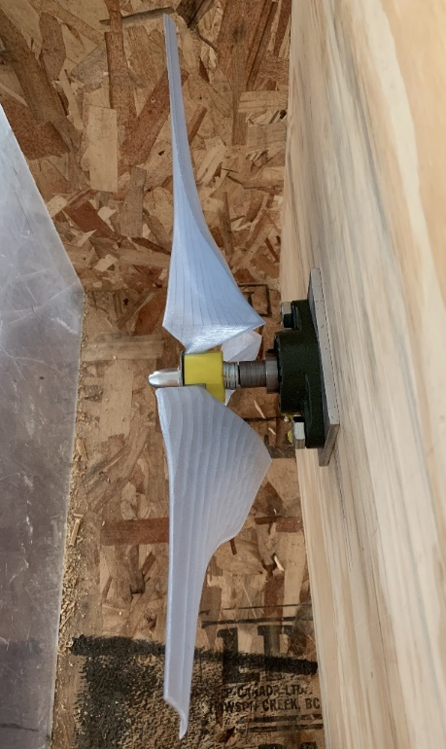
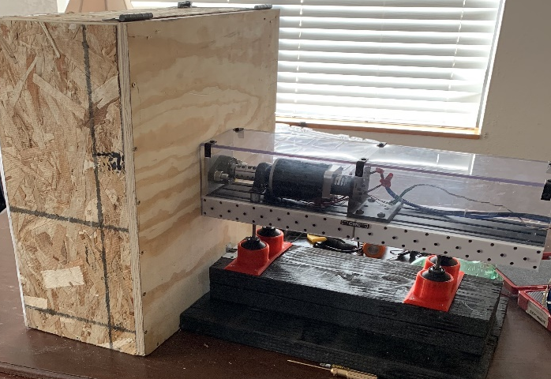
Figure 16: Rotor Strength Test Enclosure

Figure 17: Blades in Enclosure

Tower/Baseplate/Nacelle (Daniel)
Failure these sections of the turbine can cause catastrophic failure while the turbine is in operation. Failures could include the tower disconnecting from the baseplate or the nacelle. Since this system is an expensive portion of the project to obtain the final materials, online simulations play a big role in the research of this system. Shown above in section 3.6, the tower analysis gave reassurance that a final welded tower and baseplate system could withstand possible forces up to ten times the amount of yield stress that it would take. Once the tower and baseplate are manufactured, doing mounted car testing for the turbine would test if the math behind the design was correct. It would be hard to know what forces it experienced due to not having a strain gauge or anything to measure the forces experienced.

Brake (Sean)
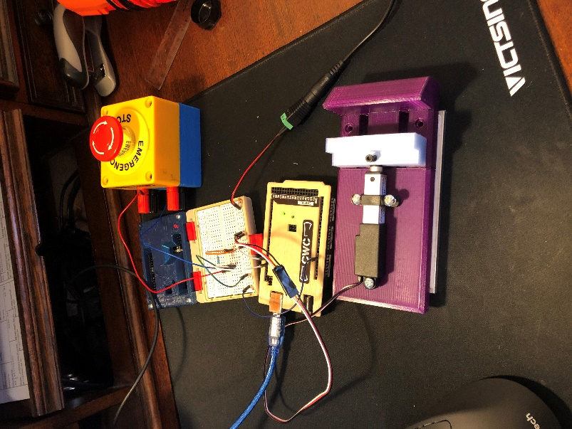
The braking system for the turbine was one aspect of the assembly that was behind schedule. Due to this, the testing of the sub-system was not completed before the project was halted. The Arduino code and circuit were built, and the actuator was able to be controlled with the use of a push button (See Figure 18). The plan was to analyze the braking sub-system through physical testing, using an apparatus made to simulate the loads produced by the blades of the turbine. Through this testing, the material of the brake pads and the proper stroke and speed of the linear actuator would have been chosen. Since the factor of safety for the braking system is below the industry standard of 2 at max runaway speed of 25m/s, the braking system would need to be actuated during the ramp up phase at 18 m/s. This would require further testing to ensure that the sensing system used in the design could detect wind speeds of 18 m/s and actuate the actuator promptly.
Figure 18: Actuator Slider Testing

Yaw (Lucas, Marina & Matt)
The yaw system was another subsystem that was put on the back burner while other subsystem was being completed. The plan was to 3D print the Yaw for the final assembly after spring break. Yaw would be tested via car testing with the final assembly. The team made a mount to attach to roof rack that would secure the turbine to car. The team would force the turbine to rotate through turns and high wind speeds. The teams most concern was making sure yaw’s rail system did not shear. The team would experiment with different 3D print fills and try to test for shear points and fatigue life.

Shaft (Lucas, Marina & Matt)
The shaft subsystem testing was on hold until the brake system was completed. The teams main concerned was shearing while braking the turbine. The shaft would be tested via caring testing. The team would stop the turbine at various wind speeds and applied brake forces. It was determined through blade tests our shaft and the startup torque of the motor in use.

Appendix
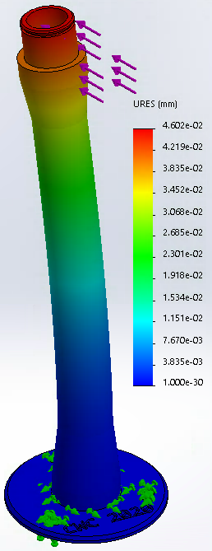
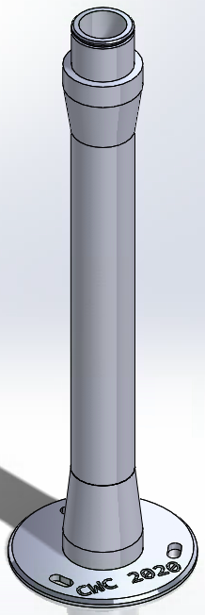
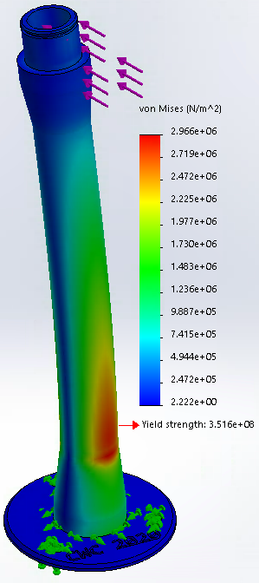
Figure 19: Shaft Stress Analysis
Figure 20: Shaft
Figure 21: Shaft Von Mises Stress

