NASA Psyche Mission: Robotic Explorer

Final Report

Badir Alrefai
Mackenzie Chasse
Jeremiah Curnalia
Jacob Morrissey
Dylan Randall
Trey Roberts

2020



Project Sponsor: Dr. Cassie Bowman with NASA and ASU
Faculty Advisor:
Instructor: Dr. Sarah Oman

DISCLAIMER
This report was prepared by students as part of a university course requirement. While considerable effort has been put into the project, it is not the work of licensed engineers and has not undergone the extensive verification that is common in the profession. The information, data, conclusions, and content of this report should not be relied on or utilized without thorough, independent testing and verification. University faculty members may have been associated with this project as advisors, sponsors, or course instructors, but as such they are not responsible for the accuracy of results or conclusions.

EXECUTIVE SUMMARY
Our solar system is comprised of many asteroids orbiting the sun, around 92% of these are mainly rock. This leaves only 8% with a metallic makeup, finding these metallic (m-type) asteroids like Psyche 16 is equivalent to finding a needle in the haystack. Psyche is a unique opportunity due to its hypothesized metallic composition. With the Psyche NASA mission this dream is becoming reality with an orbital spacecraft sent to better understand Psyche’s makeup and history. While an orbital spacecraft is an excellent step to examine the environment and make new insights, humankind is always pushing the boundaries of what is possible in our ever-expanding curiosity. With humanities desire to discover and Psyche’s unique structure, one could extrapolate the likelihood of a proposal landing and exploration of Psyche to be high. We have recognized this eminent and logical progression and are here to set in motion this next phase of Psyche exploration.

We, a small team of five engineering students, have been assigned a capstone project to design, analyze, and manufacture a rover capable of traversing Psyche’s harsh surfaces. Our prototype will need to be able to traverse a mimic design of Psyche hypothesized surfaces and conditions which will be made by our client Dr. Bowman. Our sponsor has also given us a set of conditions and requirements, as well as a budget.

This rover is designed with several interconnected subsystems which enable it to efficiently traverse the hypothesized surfaces. The first design concept generated was based on a rocker bogie style rover. This utilizes a six-legged design to allow the rover to maneuver over various types of obstacles. One flaw of this design when applied to the microgravity on the asteroid Psyche is the wheels of the Rocker Bogie. This led to the design evolving with the addition of an Archimedes’ screw wheel design. Additionally, a tethering system was integrated into the hull of the rover adding a secondary measure for the microgravity and movement along the asteroid. Due to size and operational requirements, changes to the rover design were made.

After weighing and analyzing the different concepts for each subsystem the team generated a final design. The six-legged design would change to a four-legged design. The hydraulic legs have been replaced with a rack and pinion utilizing every motor to create the desired movement, radial, x-axis, and z-axis. The screw wheel design was kept from the concept generations, although the tethering mechanism has been canceled due to time constraints. The rover will use an Arduino system, to control the movement of the rover motors and actuators.

ACKNOWLEDGEMENTS
People to be acknowledged throughout the project are Professor Dr. Sarah Oman and client Dr. Cassie Bowman. Other organizations to be acknowledged include the Northern Arizona Department of Mechanical engineering and the Psyche Cobalt Class.

TABLE OF CONTENTS
Contents
DISCLAIMER 1
EXECUTIVE SUMMARY 2
ACKNOWLEDGEMENTS 3
TABLE OF CONTENTS 4
1 BACKGROUND 7
1.1 Introduction 7
1.1 Project Description 7
2 REQUIREMENTS 9
2.1 Customer Requirements (CRs) 9
2.2 Engineering Requirements (ERs) 10
2.3 Functional Decomposition 12
2.3.1 Black Box Model 12
2.3.2 Functional Model/Work-Process Diagram/Hierarchical Task Analysis 13
2.3.3 House of Quality (HoQ) 14
2.4 Standards, Codes, and Regulations 15
3 Testing Procedures (TPs) 18
4 DESIGN SPACE RESEARCH 21
4.1 Literature Review 21
4.1.1 Badir Alrefai 21
4.1.2 Jeremiah Curnalia 22
4.1.3 Mack Chasse 23
4.1.4 Jacob Morrissey 24
4.1.5 Dylan Randall 25
4.2 Benchmarking 26
4.2.1 System Level Benchmarking 26
4.2.1.1 Existing Design #1: JPL ‘Hedgehog’ Robot 26
4.2.1.2 Existing Design #2: JPL ‘LEMUR’ Robot 27
4.2.1.3 Existing Design #3: JPL ‘RoboSimian (Track A)’ Robot 27
4.2.2 Subsystem Level Benchmarking 27
4.2.2.1 Subsystem #1: Drive System 27
4.2.2.1.1 Existing Design #1: ZIL-29061: Russian Archimedes Screw Vehicle 28
4.2.2.1.2 Existing Design #2: NASA SnakeBot 28
4.2.2.1.3 Existing Design #3: RoboSimian Arm Drive 29
4.2.2.2 Subsystem #2: Tether System 29
4.2.2.2.1 Existing Design #1: ‘Stickybot’ 29
4.2.2.2.2 Existing Design #2: Electromagnetic Hoverboard 30
4.2.2.2.3 Existing Design #3: Gripping Foot Mechanism 30
4.2.2.3 Subsystem #3: Arm Mechanism 30
4.2.2.3.1 Existing Design #1: Rocker Bogie System (Mars Curiosity Rover) 31
4.2.2.3.2 Existing Design #2: Lunar Rover (360 degree motion) 31
4.2.2.3.3 Existing Design #3: Lunar Outpost Resource Prospector (Differential System) 32
5 CONCEPT GENERATION 33
5.1 Full System Concepts 33
5.1.1 Full System Design #1: Tethered Cable Rover 33
5.1.2 Full System Design #2: Superconducting Magnets 34
5.1.3 Full System Design #3: Archimedes’ Screw Rocker Bogie Combination 35
5.2 Subsystem Concepts 36
5.2.1 Subsystem #1: Screw/Wheels 36
5.2.1.1 Design #1: Archimedes Screw 36
5.2.1.2 37
5.2.1.3 Design #3: Snake 37
5.2.2 Subsystem #2: Rocker Bogie 38
5.2.2.1 Design #1: Zero Degree of Movement Legs 39
5.2.2.2 Design #2: X-Axis Leg Movement w/ Hydraulics 39
5.2.2.3 Design #3: Radial and X-Axis Leg Movement w/ Hydraulics 41
5.2.3 Subsystem #3: Tether 42
5.2.3.1 Design #1: Magnet 42
5.2.3.2 Design #2: Claw 43
5.2.3.3 Design #3: Bio-Inspired 44
5.2.4 Subsystem #4: Control System 44
5.2.4.1 Design #1: Single Arduino 45
5.2.4.2 Design #2: Dual Arduino 46
5.2.4.3 Design#3: Arduino Trio 46
6 DESIGN SELECTED – First Semester 48
6.1 Design Description 48
6.2 Implementation Plan – First Semester 52
7 RISK ANALYSIS AND MITIGATION 54
7.1 Potential Failures Identified Fall Semester 54
7.2 Risk Mitigation 55
7.3 Arduino Mitigation 55
8 IMPLEMENTATION – Second Semester 56
8.1 Manufacturing 56
8.1.1 Design Changes 59
8.1.1.1 Design Iteration 1: Change Rack and Pinion legs to Linear Actuators 59
8.1.1.2 Design Iteration 2: Change to body design 60
8.1.1.3 Design Iteration 3: Manufactured Screws to 3-D Printed Screws 60
8.1.1.4 Design Iteration 4: Removal of launching Tethers 61
8.1.1.5 Design Iteration 5: Secondary Subassembly Design 61
8.2 Design Changes Cont. 61
8.2.1 Design Iteration 6: Change in Arduino circuit 61
8.2.2 Design Iteration 7: Spray on coat for Screws 62
8.2.3 Design Iteration 8: Removal of the Electromagnets 62
8.2.4 Design Iteration 9: No Secondary Design 62
8.3 Updated Bill of Materials and Budget 62
9 Frame Updates and Final Physical Model 63
9.1 Final Deliverables 66
10 TESTING 68
11 FUTURE WORK AND CONCLUSION 69
12 PROJECT SUCCESS AND AREAS OF IMPROVEMENT 71
12.1 Contributors to Project Success 71
12.2 Opportunities/areas for improvement 71
13 REFERENCES 73
14 APPENDICES 77
14.1 Appendix A: 77
14.1.1 Project Schedule 77
14.1.2 Work Breakdown Structure Dictionary 79
79
80
14.2 Appendix B: CAD Electromagnet Dimensions 82

BACKGROUND

Introduction
The NASA Robotic Explorer project is a hypothetical project that is linked with the NASA psyche mission to send an orbiter to the Psyche asteroid that is in the asteroid belt between the planets Mars and Jupiter. The Psyche asteroid is approximately the size of Massachusetts and is hypothesized to be made of largely nickel-iron metal but, has some areas that are rocky as well. The hypothesis of the asteroid being mostly metal is due to the density of the asteroid ranging from 4000-7000 $kg/m^{3}$[2], and the dimensions of the asteroid is (173 x 144 x 117 miles) [2]. This asteroid is hypothesized to be the core of a protoplanet that has been exposed due to bombardment during the creation of the early solar system. Our capstone group is tasked with creating an explorer that will be sent to the surface of the asteroid and must be able to maneuver across 5 different hypothesized surface conditions. We also must overcome the problem of microgravity. The Gravity on the surface of Psyche is 0.144 m/s^2 which limits the designs we can choose from because certain types of locomotion are not feasible in microgravity. The design for this explorer will give NASA another strategy on how to approach this problem in the future. The robotic explorer will give us the ability to analyze and inspect the surface and properties of the asteroid and this may give us some insight into our own core.

  - Project Description
The following information is the original project description provided by NASA and Dr. Bowman of ASU,
“Psyche is a large, mostly metal asteroid in the Asteroid Belt between Mars and Jupiter. Psyche is likely made largely of nickel-iron metal, though its surface appears to have small areas that are rocky. The asteroid’s composition has been determined by radar observations and by the measurement of thermal inertia (how quickly an object gains or reradiates heat). While scientists have combined radar and optical observations to generate a 3D model of Psyche (which shows evidence for two crater-like depressions and suggests that there is significant variation in the metal content and color of the asteroid over its surface), no one has seen the Psyche asteroid yet--what its surface is truly like remains unknown.
NASA’s Psyche Mission, led by ASU, is set to launch in 2022 and arrive at the asteroid in 2026. It is an orbiter mission and will not land on the surface. Instead, it will spend 21 months performing science operations from four staging orbits, which become successively closer. This will be NASA’s first space mission to a world likely made mostly of metal, rather than rock or ice. The Psyche mission will take a giant step forward in our understanding of this mysterious metal world. It is possible to imagine, however, that after learning about Psyche from orbit, there may be scientists and engineers interested in proposing a subsequent mission to land on the asteroid to explore and sample its surface. In this capstone project, you are that team!
Designing to the range of hypothesized surfaces that might be found at Psyche (and keeping in mind other constraints such as its gravity), you will design (and, if your capstone supports/allows, create a prototype of) a robotic explorer capable of efficiently traversing each of the hypothesized surfaces and, ideally, able to adapt to each of them mid-traverse. Hypothesized surfaces may include mostly flat metallic surface, flat metallic with metal and/or rocky debris, rough/high-relief metallic and/or rocky terrain, high-relief metallic crater walls. Specifications will be provided for the team design [2].”

REQUIREMENTS
The goal of the NASA Psyche Mission is to observe the asteroid Psyche (16) at close range and maybe in the future, land a rover on its surface to collect samples. Psyche’s surface is believed to be comprised of primarily metal. The mission of the Robotic Explorer team is to design and create a rover capable of traversing this unknown terrain. From this mission the team created several engineering requirements (ERs) and prioritized them based on importance to the mission. The most important ERs are associated with maneuverability of the rover and its ability to adapt to the hypothetical obstacles that it may encounter. The next most important ERs are associated with the durability of the rover. Some of the ERs, such as sensors, are not going to be applied to the design created for the small-scale terrain being created by the ASU team. However, these ERs will be essential to creating a rover that is space worthy and able to successfully traverse these terrains. There are no major changes in our ERs or CRs from last semester, but the target values and tolerances have changed slightly.

Customer Requirements (CRs)
The following section includes information on the customer requirements. These criteria were listed in the project statement and are to be followed throughout the design process in order to achieve optimal design. Each item on the list is weighted accordingly to its impact on the project.
- Cost within budget (8) 5%
- Durable and Robust design (6) 10%
- Reliable design (4) 10%
- Safe to operate (7) 5%
- Maneuver Hypothesized and Unknown Terrain (1) 20%
- Adaptable to Microgravity (2) 20%
- Traverse Rocky/Unlevel Terrain (3) 10%
- Traverse Slippery Terrain (5) 10%
- Long Lasting Battery Life (10) 5%
- Prototype Able to be Scaled to Larger Size (9) 5%

The customer requirements listed above have been weighted based on its impact to the design. The highest ranked requirement is that of adapting to microgravity and maneuverability. Based on the project statement, creating a rover that can traverse Psyche’s environment, these two parameters drive the design process. The next highest ranked customer requirements are traversing variable terrain, reliability, and durability. Having a reliable rover allows for a smoother traversing process, as well as the overall quality of the design. In theory, this design would operate in space for a long period of time, durability and reliability must be taken into consideration. The other parameters listed in the customer requirements included staying within cost, battery life, and adaptability to a full-scale model. Staying within cost is important to the project, with an allocated $1000 budget, keeping the model within cost is a priority. The ability to change the scale of the rover is also a customer requirement based on the hypothetical design that the team will also be implementing alongside the scale model. Ensuring scaling will allow the team to design a rover that can operate in space on a full-scale asteroid.

The first four requirements are mandatory. The main goal of our project is to traverse the hypothesized terrain of Psyche. Due to this any requirements involving maneuvering are weighted the highest. The different terrains were split up into different requirements. This is because different modes of transportation excel in different types of terrains. The microgravity of Psyche creates a unique problem to be solved, miscalculation could result in the rover being flung into space. Since this would be catastrophic to the success of the mission, being able to traverse in microgravity is highly weighted.

First Semester Report-
The changes made to this section based on the Preliminary Report include adding an intro and talking about how the customer requirements were ranked. The customer requirements did not really change from the time of documenting them in the Preliminary Report to this semester. Client, Cassie Bowman did not add any new CR’s to the project and is still basing project requirements on the itemized list shown above. The only real change in the project is a new sub-model design “The Crawler” that will operate on different mobility than the main rover. The client did not specifically ask for a new design, but the team wanted to make sure that the maneuverability of the design would satisfy the customer and engineering requirements. A separate budget of $200 has been allocated for this design, provided by Dr. Oman at NAU. This will ensure that the targeted weight on cost will remain the same. Although due to time constraints the team opted out of creating a sub-model, and to also make sure a quality product is delivered to client.

Second Semester Report-
Changes in customer requirements due to COVID19 resulted in three CAD models of a 6-wheel, 4-wheel and physical model design. The crawler sub-model was not complete, and all manufacturing was halted.

Engineering Requirements (ERs)
This section introduces the engineering requirements created, based on the customer requirements listed in the previous section. These values are tolerances that the team’s rover should meet. Each engineering requirement has a targeted value, shown in Table 1.

Table 1. Engineering requirements with listed tolerances
Engineering requirement | Target value | Tolerances (±)
Terrain Maneuvering Contact Area | 24 (in²) | 2(in²)
Frame Material (E=Mpa/Psi) | 10000 ksi | 20 ksi
Motor Torque (lb·ft/lb·in) | 510 (oz•in) | 10 (oz•in)
Hydraulics Capabilities/Degrees of Freedom | 30 (θ/φ=Degrees/Rad) | 10 (θ/φ=Degrees/Rad)
Battery Life (Min) | 60 minutes | 5 minutes
Number of Wheels (#) | 6 | 0
Infrared Sensor | 20 (Resolution/ft) | 5 (Resolution/ft)
Number of Motors (#) | 18 | 0
Weight of Rover | 30 (lb.) | 3 (lb.)
Size of Rover | 3 (ft²) | .5(ft²)

2.2.1 ER #1: Terrain Maneuvering Contact Area
- ER #1: Terrain Maneuvering Contact Area Target = 24 (in²)
The contact area of the wheels affects the traction of the rover. Which is crucial for the screw drive design.
- ER #1: Terrain Maneuvering Contact Area Tolerance = ± 2(in²)
If all six wheels are touching the floor the diameter of the screw drive will ensure the necessary, contact area to move the rover.

2.2.2 ER #2: Frame Material
2.2.2.1 ER #2: Frame Material - Target = 10,000 ksi
The frame material will affect the weight of the rover, as well as, the strength of the structure. Aluminum has an elastic modulus around 10,000 ksi. Aluminum will keep the rover light and strong, while keeping the cost low.
2.2.2.2 ER #2: Frame Material - Tolerance = ±20 ksi
The 20 ksi tolerance keeps the material within the strength range of aluminum. This should keep the material strong enough to support the rover.

2.2.3 ER #3 Motor Torque
2.2.3.1 ER #3: Motor Torque - Target = 510 (oz•in)
This target value is to ensure torque isn't too high to rip the 3-D printed screw drive on the surface. while not to slow so that it does not take a long time to traverse the terrain.
2.2.3.2 ER #3: Motor Torque - Tolerance = ± 10 (oz•in)
A range of 500-520 (oz•in) will be ample enough to traverse the rovfer forward. While not shredding the screw drives.

2.2.4 ER #4: Hydraulics Capabilities/Degrees of Freedom
2.2.4.1 ER #4: Hydraulics Capabilities/Degrees of Freedom Target = 30 (θ/ φ=Degrees/Rad)
The 30-degree target is based on the stress calculations for the legs of the rover. 30 degrees will allow the rover to widen its stance to maneuver around obstacles without overstressing the legs.
2.4.2.2 ER #4: Hydraulics Capabilities/Degrees of Freedom Tolerance = ± 10 (θ/φ=Degrees/Rad)
The 10-degree tolerance allows for the rover to still function properly without effecting the functionality. The tolerance amount was also created through the stress calculations.

2.2.5 ER #5: Battery Life
2.2.5.1 ER #5: Battery Life Target = 60 minutes
60 minutes is enough time to traverse a 4x8 surface with ample battery life for multiple trials.
2.2.5.2 ER #5: Battery Life Tolerance = ± 5 minutes
The battery only needs to last long enough to traverse the test surface. Because of this the tolerance is 5 minutes. The battery lasting 55 minutes should still work long enough to traverse the test surface.

2.2.6 ER #6: Number of Wheels
2.2.6.1 ER #6: Number of Wheels Target = 6
The number of wheels will affect the traction of the rover. Six-wheel design is imperative for the success of the rocker design of the screws.
2.2.6.2 ER #6: Number of Wheels Tolerance = ± 0
6 wheels are needed for the rover to be able to traverse obstacles and uneven terrain.

2.2.7 ER #7: Infrared sensor
2.2.7.1 ER #7: Infrared sensor Target = 20 (Resolution/ft)
If the cameras on the rover are not high quality, it will be unable to detect obstacles and uneven terrain. For the prototype, an infrared sensor is being used for the remote-control aspect of the rover.
2.2.7.2 ER #7: Infrared sensor Tolerance = ± 5 (Resolution/ft)
The tolerance for the infrared sensor was determined by the infrared sensor currently being used on the Arduino, and the size of the testing surface. Since the longest distance on the testing surface is 8 ft, the sensor had to operate at greater than 8 ft. The target and tolerance values are so high because of the varying nature of the remote’s successful operation at a distance. To ensure the rover’s operation at any point on the test surface from any point on its perimeter, we will need an infrared sensor that meets these minimum values.

2.2.8 ER #8: Number of Motors
2.2.8.1 ER #8: Number of Motors Target = 18
18 motors are required to operate the different mechanisms the rover performs. From powering the screw drive to raising the legs upwards to traverse obstacles.
2.2.8.2 ER #8: Number of Motors Tolerance = ± 0
There is no tolerance on the motors as each motor plays an essential role in the success of the rovers' mechanisms.

2.2.9 ER #9: Weight of Rover
2.2.9.1 ER #9: Weight of Rover Target = 30 (lb)
The weight of the rover ensures the legs are capable of efficiently handling the weight of the rover.
2.2.9.2 ER #9: Weight of Rover Tolerance = ± 3 (lb)
The rover will be able to efficiently handle this weight, but an increase of weight might introduce problems to the legs as well as speed of the rover.

2.2.10 ER #10: Size of Rover
2.2.10.1 ER #10: Size of Rover Target = 3 (ft²)
The size of the rover is based on the test surface the rover will be tested on. A 4x8 surface.
2.2.10.3 ER #10: Size of Rover Tolerance = ± .5 (ft²)
The size of the rover may change slightly but can't be too big, to ensure the rover traverses the hypothesized surfaces efficiently.

Functional Decomposition
The following section contains the Black Box Model as well as the Functional Decomposition chart that describes the subsystems involved with the overall rover design

Black Box Model
This section of the report focuses on the Black Box Model for the NAU Psyche rover system. The primary function of the rover system is to essentially move the rover. The primary inputs into the system are material, signal and energy flow. Human energy is translated into the system by the hand, electric signal is inputted into the system through the power source, and the controller signal is inputted into the system through the Arduino. The outputs of the system include digital output as well as mechanical energy dissipation in the form of motion. The model shown in Figure 1 provides a generalized outline of the components involved to provide motion in the rover system.
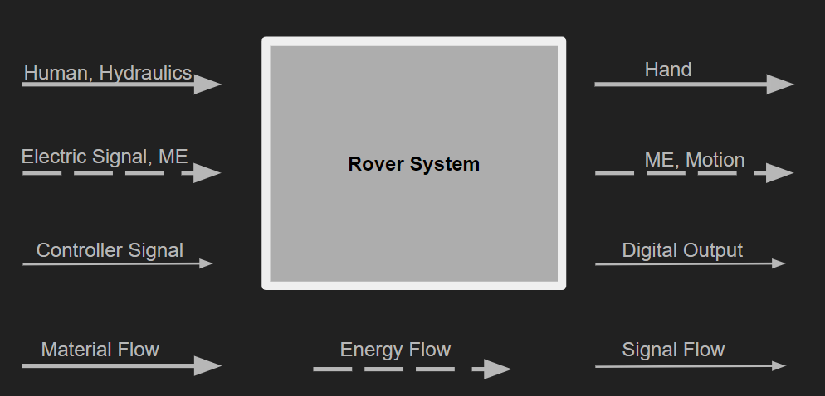
Figure 1. Black Box Model

Functional Model/Work-Process Diagram/Hierarchical Task Analysis
The following section portrays the functional decomposition of the rover system. Figure 2 represents the breakdown of the system based on the three sub functions defined prior: tether system, arm mechanism and screw drive. This is a more specific version of the Black Box model and represents everything that is happening within the box. A general outline of how the system works is as follows: human hand is inputted into the controller where a signal is sent the other parts of the system, powered by an electric input and dissipated throughout the system. The signal from the controller is used to actuate the sub functions of the rover, where eventually heat energy, excess particulate and a digital output are displayed. Creating the functional decomposition chart provides the team with a better understanding of the sub functions involved with system and how they correlate with each other to function the rover. Using this breakdown, the team has a good understanding of the main subcomponents that need to be focused on in the design. When deciding the final design, correlation to the main functions of the rover must be followed. Using the Functional Model, identification of these functions can be easily made.

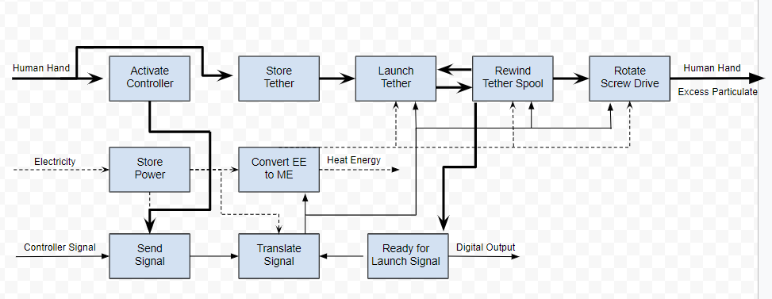
Figure 2. Functional Decomposition Chart

House of Quality (HoQ)
Using the customer and engineering requirements from section 2.1 and 2.2, a house of quality was created. The target values were then decided upon using our preferences. Based on a scale of 1-10, each customer requirement was ranked against an engineering requirement to determine the relative technical importance of that parameter. The House of Quality, shown in Figure 3 expresses the relationship between the two parameters. As stated in the section 2.1, the highest ranked customer requirement was that of maneuverability. Based on the HoQ, maneuverability is relative to motor torque, degrees of freedom, and terrain adaptation. The technical importance of these values come out to be a 7.3, 6.65 and 7.55 respectfully. This information allows the team to determine the aspects of the rover that should have the most focus on. Based on the information found from the HoQ, the team will have an emphasis on the drive system, arm mechanism, and electrical components of the rover. The updated HoQ includes the implementation process and correlates what engineering requirements influence the test procedures. A number 1,2, or 3 was recorded in that spot, correlating the test to the numbers listed in section 3 of the report.
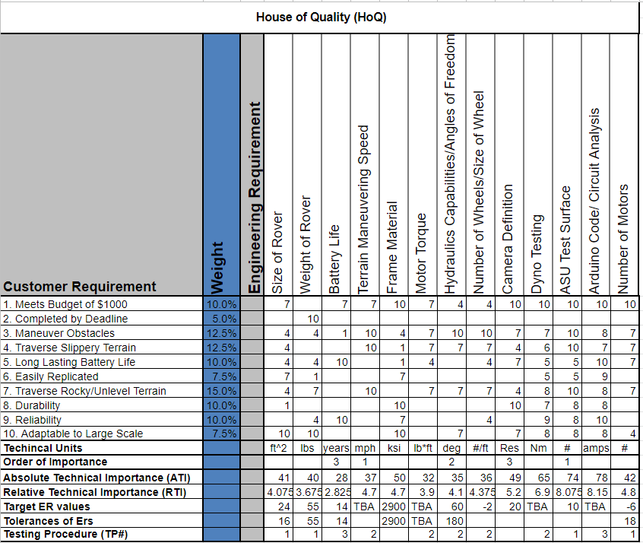
Figure 3. House of Quality

  - Standards, Codes, and Regulations
The standards, codes, and regulations below provide useful information to the design and development of the NAU NASA Psyche Rover. Information includes parameters that must be met for successful operation of each subsystem, safety requirements, modeling and simulation recommendations, testing procedures, and general design guidelines. These will be used to assist in material and component selection and analysis for the design as well as safety and risk analysis for the prototype. The specific uses of the standards, codes, and regulations are detailed below in the table.

Table 2. Standards of Practice as Applied to this Project
Standard Number or Code | Title of Standard | How it applies to Project
NASA-STD-1006 | Space System Protection Standard | Design of device must be in line with NASA’s agency level protection requirements ensuring that a mission is resilient to any outside threats.
NASA-HDBK-4002 | Mitigating In-Space Charging Effects-A Guideline | Detailed conditions where in-space charging becomes an issue. Provides design solutions and a process for creating design specifics.
NASA-STD-5017 | Design and Development Requirements for Mechanisms | Provides NASA design, development, and test requirements for mechanisms whose operation is required for safety or mission success.
NASA-STD-5009 | Nondestructive Evaluation Requirements for Fracture Critical Metallic Components | Establishes nondestructive evaluation requirements for components where fracture control is a requirement.
NASA-STD-5006 | General Welding Requirements for Aerospace Materials | Provides processing and quality assurance requirements for all forms of welding for equipment.
NASA-STD-6016 | Standard Materials and Processes Requirements for Spacecraft | Provides standard requirements for selection, application, and design criteria of materials.
NASA-STD-6012 | Corrosion Protection for Space Flight Hardware | General corrosion protection requirements of surface treatment and finishing of space flight hardware.
NASA-STD-6008 | NASA Fastener Procurement, Receiving Inspection, and Storage Practices for Spaceflight Hardware. | Standards and practices relative to fasteners used on NASA hardware.
NASA-STD-6001 | Flammability, Offgassing, and Compatibility Requirements and Test Procedures. | Provides requirements for evaluation, testing, and selection of materials for use in space vehicles. Specifically for flammability, offgassing, and compatibility.
NASA-STD-7009 | Standard for Models and Simulations | Provides requirements in design, development, and use of models and simulations for the NASA Technical Standard.
NASA-STD-7001 | Payload Vibroacoustic Test Criteria | Addresses acoustic and random vibration environments of space and offers test levels for analysis of object.
NASA-STD-8739.12 | Metrology and Calibration | Ensures accuracy of measurements affecting safety and mission through proper selection, calibration, and use of Measuring and Test Equipment.
NASA-STD-8739.10 | Electrical, Electronic, and Electromechanical (EEE) Parts Assurance Standard | Requirements to control risk and enhance reliability of EEE parts. Aids in selection, acquisition, traceability, testing, handling, packaging, storage, and application of these parts.
NASA-STD-8739.9 | Software Formal Inspections Standard | Inspection process designed to provide a framework for detecting and eliminating defects as early in the software life cycle as possible.
NASA-STD-8739.5  NASA-STD-8739.4  NASA-STD-8739.1 | WORKMANSHIP STANDARD for Fiber Optic Terminations, Cable Assemblies, and Installation.  WORKMANSHIP STANDARD FOR CRIMPING, INTERCONNECTING CABLES, HARNESSES, AND WIRING.  WORKMANSHIP STANDARD FOR POLYMERICAPPLICATION ON ELECTRONIC ASSEMBLIES | Technical and quality assurance requirements for general components, assemblies, etc.
NASA-STD-8719.13 | NASA Software Safety Standard | Activities necessary to ensure safety is designed into software that is acquired or developed by NASA.
NASA-STD-8719.11 | Safety Standard for Fire Protection | Fire protection requirements and guidelines.
C37.95-2012 | IEEE Guide for AC Motor Protection | Offers methods of protection for AC motors including protection systems, applications, and setting philosophy for motor installation.
SAE J3073 | Battery Thermal Management | Surveys system used for thermal management of batteries in vehicles. Also includes design considerations for thermal management.
DS/EN 16603-20-07 | Space Engineering – Electromagnetic Compatibility | Details system requirements, general test conditions, verification requirements, and test methods for use of electromagnetism in a variety of systems.
SAE J1292 | Automobile and Motor Coach Wiring | Covers wiring distribution systems to automotive vehicles. Helps with performance, operating integrity, efficiency, economy, uniformity, and facility of manufacturing and services. This information could assist with the rover as well.
SAE ARP6216 | EWIS Wiring Insulation Breakdown Testing | Details minimum requirements for testing of insulated electrical wiring for aerospace applications. Assists in finding wire faults safely.
ISO TR 10828 | Worm gears – Worm profiles and gear mesh geometry | Provides formulae to calculate path of contact, conjugate profile, lines of contact, radius of curvature, velocities at points of contact, and application of formulae to calculate parameters used in load capacity calculations.
UL 1004-1  UL 1004-6 | Standard for Rotating Electrical machines – General Requirements  UL Standard for Safety Servo and Stepper Motors | Evaluates the suitability of a motor for normal use when fed from an appropriate controller through its normal operating region. Will be useful in evaluating servos in the robotic explorer.
SAE J490 | Ball Joints | Provides general data for ball joints, load carrying and wear capabilities, and recommendations for application of varying types of joints.
DS/EN 16603-10-04 | Space Engineering – Space Environment | General standard for all product types existing or operating in space. Helps understand the environment being worked in or provides rules for determining the environment being worked in.
ISO TS 15066 | Robots and Robotic Devices – Collaborative Robots | Provides safety requirements for industrial robot systems and the work environment. The safety principles are useful for general robotics.

Testing Procedures (TPs)
3.1 Testing Procedure 1: ASU Test Surface
This test procedure is the focus of our design. ASU and Dr. Bowman will be providing a test surface that is 8 ft by 4 ft. There will be 5 sections on this surface each being 1.6 ft long. This will give our team an idea of how the surface of Psyche could look and how well our design will be at traversing them. This will satisfy our engineering requirement of terrain maneuvering contact area.

3.1.1 Testing Procedure 1: Objective
The objective of this test is to determine how well our design performs on each of the proposed surfaces. The team will set our robotic explorer on one side and traverse each area on the test surface and determine what changes need to be made to achieve completion of the area. These tests will tell us how well our screw drive design performs on the proposed surfaces.

3.1.2 Testing Procedure 1: Resources Required
For this test we will need our completed design to test, as well as the surface from ASU and Dr. Bowman.

3.1.3 Testing Procedure 1: Schedule
The test will take place in the spring semester at the ASU campus or here at NAU. The test will only take a few minutes based on the size of the surface we are provided. An estimated arrival of the surface is the week of February 24th but has not been solidified by client.

3.1.4 Testing Procedure 1: Engineering Requirement Satisfied
This test satisfies ER’s #1,4.

3.2 Testing Procedure 2: Arduino Code and Circuit Analysis
We will write our code and test to see how well it controls the motors and communicates with our controller. We will create a rough design that will be a body as well as the screws to test speeds and torque settings or limits. This satisfies our motor torque, number of motors as well as the battery size/ life engineering requirements.

3.2.1 Testing Procedure 2: Objective
We will use circuit analysis to figure out how much power we will need to power the number of motors we plan on using.

3.2.2 Testing Procedure 2: Resources Required
For this test we will need wires, Arduino, a multimeter and an oscilloscope. We will use these to test the voltage that will be

3.3.3 Testing Procedure 2: Schedule
We will be doing this testing before our prototype is due. We will continue to do more complex testing during the spring semester on testing speed settings.
3.1.4 Testing Procedure 2: Engineering Requirement Satisfied
This test solidifies ER’s #5,3,8,7

3.3 Testing Procedure 3: Frame Weight Test
3.3.1 Testing Procedure 3: Objective
This test will be to see that the weight of the frame does not exceed 20 lbs. This is to ensure that the motors will be able to move the rover freely. This is important because we need to make sure the motors, we buy are powerful enough to drive the rover. This test will be to take the finished frame and put it on a scale and read the value to make sure it is less than approx. 20 lbs.

3.3.2 Testing Procedure 3: Resources Required
We will use a scale to measure the weight and the body of the rover. The scale that will be used is a personal scale provided by a team member.

3.3.3 Testing Procedure 3: Schedule
This test will take place in the next week once the frame is finished being constructed. Between the dates of February 19th and 21st.

3.1.4 Testing Procedure 3: Engineering Requirement Satisfied
This test satisfies ER # 9.

3.4 Testing Procedure 4: Screw Drive Weight Test
3.4.1 Testing Procedure 4: Objective
This test will determine whether the 3D printed Screw Drive Wheels will be strong enough to support the rover. This is to make sure that the wheels can withstand the overall weight of all the components and not break during operation. After completing the test, changes to the wheel design, material and infill percentage will be made.

3.4.2 Testing Procedure 4: Resources Required
The resources needed to test the screw drives would be the frame with the linear actuators and motors mounted on. As much of the total weight of the rover as possible will be used for this test. The test itself is a visual test to see if there is any cracking in the filament.

3.4.3 Testing Procedure 4: Schedule
The test will take place during the weekend of February 29th. Most of the rover should be assembled by that point in time and have an accurate weight to test the screws on.

3.1.4 Testing Procedure 4: Engineering Requirement Satisfied
This test satisfies ER’s # 10,9,2,6

3.5 Testing Procedure 5: Electromagnet Test
3.5.1 Testing Procedure 5: Objective
This test will determine the strength of the Electromagnets for the tethering system. The primary tether being used in the design are electromagnets and a weight test to see if they meet the desired force is required. The main goal is to obtain a force that will compensate for the normal and microgravity forces acting in Psyche. Upon completion of this test, verification of the Electromagnet and transformer design will be made.

3.5.2 Testing Procedure 5: Resources Required
The resources needed to run this test would be a completed Electromagnet, transformer to reach the voltage requirement, and a metal weight of approx. 25 lbs. The electromagnets will be manufactured in house and the team will use a 25 lb. metallic dumbbell that a team member possesses to test the force.

3.5.3 Testing Procedure 5: Schedule
This test will take place during the week of February 24th. The electromagnets and transformers will be constructed by Feb. 24th upon which, testing can be done.

3.1.4 Testing Procedure 5: Engineering Requirement Satisfied
This test satisfies ER #1

3.6 Testing Procedure 6: Arm Extension Test
3.6.1 Testing Procedure 6: Objective
This will test the extension of the arms to see if they can extend the 14 in. we designed for. We will also see if the actuators can hold the body under weight of the rover and the jostling from the test surface.

3.6.2 Testing Procedure 6: Resources Required
The resources we will use in this test are the linear actuators on the arms and a meter stick to measure the difference in height achieved.

3.6.3 Testing Procedure 6: Schedule
This will be completed during the week of February 29th. Before this test can be completed the rover should be 90% complete.

3.1.4 Testing Procedure 6: Engineering Requirement Satisfied
This test satisfies ER #4.

DESIGN SPACE RESEARCH

Literature Review
In this section each team member researched a subsystem and wrote a literature review of them. each member researched 5 sources to read and wrote a summary of it and why it is relevant to the project.

Badir Alrefai
Badir Alrefai focused on choosing a control system for the rover, as well as how to apply it to the rover.

Arduino VS Raspberry pi
To have full control of a project it is best to use an open source hardware and software, which can be programmed and changed as desired. There are two top options to choose from when talking about open source controlling and programming: Arduino and raspberry pi. This article talks about the differences of Arduino and raspberry pi and how to choose between them, so this article can benefit us by showing us which one should be chosen for the project. There is a budget for the project so Arduino, being a cheaper price, has an advantage over the raspberry pi. Raspberry pi is faster and has more RAM than Arduino and is more like a small independent computer. However, it is more applicable when it comes to software like operating systems. But it is not superior to the Arduino when it comes to controlling hardware. Since, the project is dynamic and much may be changed along the way, Arduino’s simplicity would be best, because even though it is simple it can operate almost anything and can be easily changed and manipulated to achieve the wanted task. Both of them have available parts and kits, that might be needed for the project, mostly offered by a company named Adafruit which sells parts and kits for Arduino and raspberry Pi projects. So, for the best interest of the project, the decision is made that Arduino would be used.[1]

Arduino Complete guide
This source is a guide that shows a more direct implementation of setting up an Arduino. It shows how to set up the hardware for many things from LED lights to different kinds of sensors and motors. It also shows the component needed for setting them up like wires, resistors, breadboard, and adapters. This will help us in the project in a practical way to know the right way to set up the hardware. Some of the useful things are the sensors and motors. Different motors like DC motors and stepper motor are shown in this guide, which will give us a better understanding on how to set up motors with Arduino. The guide also shows things for the user to control them with like joysticks and remotes. Another thing that is directly applicable in this project is the kinds of sensors that are shown like, ultrasonic sensor, water level detection sensor, sound sensor, and others. This would be good practice and a good place to start setting up our Arduino.[2]

OpenCV WebCam Applications in an Arduino-based Rover
This article talks about how to create an Arduino control system based rover with many different aspects to consider such as having an algorithm which enables the rover to identify it’s objective as well as how these algorithms can be manipulated to meet other programmed necessary to meet the objectives of the rover. This is very meaningful for the project, as it could give me an idea to create a sensor in which the rover can detect the different surfaces and adjust its mobility mechanism as needed.[3]

Design and Analysis of Arduino, Raspberry Pi, and Xbee based Wireless Sensor Networks
This Article goes in depth about how platforms like Xbee series 2 to create and wireless bridge between sensors and Arduino, also talking about the wireless technology and networks being used and how it functions. This could be applied to the rover as creating a controller of some kind to control steering and power will be required. Moreover, a connection between the rover and any required sensors whether it be for mobility or a surface identifier.[4]

Real-time surface material identification using infrared sensor
This literature covers how a team was able to use infrared sensors to identify obstacles. They were able to detect different surface material so that cars would stay on pavement rather than go off road. This technology could be used on the rover to identify the different surfaces, while at the same avoiding any large obstacles, if it is to be autonomous.[5]

Jeremiah Curnalia
Jeremiah was tasked with researching a tethering system for the rover to attach to the asteroid.

A Tethering Device for Mobile Robot Guidance

Tethering is going to be a crucial component for the final design of the rover. This journal explains a method of robot transportation called ‘Navi-Guider’ which uses a tether to plan out its movement. A tether is pulled out of the robot, and the robot detects the length and direction of that tether. It then uses that information for robot guidance and control [6]. If we apply this method to the rover itself, it improves the information gathered for traversing Psyche, and can be easily combined with the tether system in place.

Tether Based Locomotion for Astronaut Support Robot Introduction of Robot Experiment on JEM

Tether based motion for robots had been proposed before. This paper gives a detailed analysis of tether-based motion and largely focuses on solving the issue of control difficulty due to tethers instantly becoming slack in microgravity environments. The proposed solution is a ‘model-based control method using statics analysis as slack less control in a microgravity environment’ [7]. Mechanistic characteristics, kinematics and dynamics models, a static analysis, and model-based control using that static analysis are all supplied. This article provides validation that there are ways of using a tether system in a microgravity environment and is useful for team analysis of the tether length and material.

Bio-Inspired Landing and Attachment System for Miniaturised Surface Modules

Tethers need to firmly attach to the side of an asteroid while minimizing the mass of the attachment system. This paper offers a bio-inspired method of attaching to the surface by using a system inspired by dry-adhesion of geckos and spiders. Geckos utilize van-der-Waals forces caused by setae (micro-structured arrays of hair like keratinous bristles) to adhere to any substance. These setae can be imitated using polymer materials [8]. The paper suggests the use of this design in the landing of numerous miniaturized satellites or probes, which means their use in a much lower force environment is much more applicable. This attachment system offers a strong alternative to magnetic or claw tethers since it is applicable any solid surface.

A Rough Concrete Wall-Climbing Robot Based on Grasping Claws: Mechanical Design, Analysis and Laboratory Experiments

The surface of the asteroid Psyche can be assumed to be partially rocky and not smooth all the way around. As a result, tethering systems must be able to attach to a rough surface. This article covers a current design for a claw system that can grapple the side of a rough concrete wall and hoist a robot. By observing the minute spine structure of cockroach legs, the design team came up with design criteria for hooks to grab rough bulges in walls [9]. The claw design will be useful for creating tethers that can successfully grapple onto the rough surfaces on Psyche. It will allow improved stability on areas of rock where a magnet won’t work.

Ground-based Experiments of Tether Deployment Subject to an Analytical Control Law

Deployment of a tether in microgravity conditions undergoes a ‘taut-slack’ process which makes it difficult to control deployment. This journal proposes ground-based experiments using a control law to simulate the deployment of tethers in microgravity conditions. Results concluded that following their method allows for a controlled tether deployment in an assigned direction [10]. This article is valuable to the rover design chosen for prototyping. The NAU Psyche team wants to utilize tethers as a method of pulling the rover across the asteroid, and successful and accurate deployment of that tether is important in traversal.

Mack Chasse
Mack was tasked with researching rover maneuvering systems for rovers
Kinematics modeling and analyses of articulated rovers
For the rover to maneuver through the hypothesized terrain the rover design must utilize multiple axis of motion. This article explains the importance of arms’ angles and the contact area of the wheels and comet’s surface. Without a sufficient amount of contact the rover wheels will be unable to have enough traction to propel itself along the surface. The Rocker Bogie design allows for the rover arms to position themselves at more angles than if there were only four wheels, instead of six.[25]
Terrain Response Estimation Using an Instrumented Rocker-Bogie Mobility System
Traversing the terrain of Psyche will take a strong understanding of the effects that the terrain has on the rover’s mobility system. This article explains the importance of traction control and overall control of the torques from the wheels of the rover. Due to our screw design, we will need to do extensive testing on the response of the terrain on the wheels and the effect of the wheels on the terrain itself. Since most of the rovers used in space exploration use primarily cylindrical metal wheels there is little information on the use of screw wheels. [32]
Conceptual design of tetrad-screw propelled omnidirectional all-terrain mobile robot
The use of screw-propelled vehicles started with the screw steamboat in the 19th century. Although the technology has been around for hundreds of years very few vehicles use the screw design for propulsion. This article focuses on the use of the screw propulsion to create omnidirectional motion for a mobile robot. The proposed design uses 4 screw wheels-oriented must like a car. The screws can operate independently allowing it to rotate its’ chassis. The screw propelled vehicles excel in traversing through thick non-rigid terrains. This is due to the screw being propelled by the displacement of the terrain. [33]

Jacob Morrissey
This team member was tasked with working on the screw drive system of the robot.

Screw Propelled Vehicles

The drive was developed as a type of amphibious vehicle that would be able to maneuver through rugged terrain. These vehicles perform very well in min areas such as snow and mud but not on flat surfaces such as roads. the helical surface of the screw digs into the surface that drives the vehicle forward. This Article provides many examples of the screw propelled vehicles that have been developed through the years. it begins with the first patent created in 1899. These vehicles took advantage of the Archimedes screw that was developed between 287-212 BC by Archimedes.

Small Remotely Operated Screw Propelled Vehicle

This article is about how the screw drive work and that there are many configurations of the screws that allow the vehicle to have increased maneuverability. there are a few screw drive vehicles referenced in this article that are from the size of a small truck to the size of a toy. these vehicles were considered a failure due to the inability to move along rigid terrain. A Russian company is working on improving the propulsion design by combining the screw with a rubber tire. while the vehicle is used in softer areas the tires are deflated but when it is on a rigid surface the tires are inflated. the screw drive works by having the forces on the ground being applied to the screw helix and rotating the left and right screws in opposite directions. This produces smaller tangential forces. this also allows the vehicle to move in a variety of directions while the body stays in the same position.

Design and Analysis of a Novel Multifunctional Screw-Propelled Vehicle

This article goes into depth on each of the subsystems that the screw propelled vehicles have to work. these subsystems include the body, transmission, suspension and wheels. Each of these systems work together to propel the vehicle forward. the wheels of the vehicle are useful because they it replaces the thicker heavier wheels with a thin blade that pushes material out of the way and reduces resistance []. comprehensive analysis was explained in this which improves the reliability and plausibility of the design.

Screw-Powered Propulsion in Granular Media: An Experimental and Computational Study

This paper introduces the basics about the screw propelled vehicle such as its ability to traverse through rugged terrain and that it has the ability to be an amphibious vehicle. it also explained that this design was proposed to be installed on the moon rover. in the article they tested two different pitches of the screw that were 8 cm and 4 cm. they did experiments in a bed of glass beads and tested 6 rpm speeds to see which was the best pair. from the results it was determined that that 8 cm pitch screw produced more thrust force of 4.5 N at 150 rpm. the 4 cm pitch screw produced 3.5 N at 75 rpm and at 150 rpm. these values are useful in our future calculations and decisions for choosing motors.

Conceptual Design of Tetrad-screw Propelled Omnidirectional All-terrain Mobile Robot

In this article different types of movement are introduced and compared based on their ability to move omnidirectionally. the article goes into depth into the design and testing of the screw drive. the orientation of the wheels is perpendicular to most screw-drive vehicles. using this rotated configuration allows the vehicle to move on a more rigid medium such as road because it is able to drive with a regular wheel configuration.

Dylan Randall
This team member was tasked with working on the tethering system as well as working in other areas that need attention.

Prototype for an asteroid exploratory robot using multi-phalanx micro spine grippers

Dealing with the microgravity environment encompassed by Psyche, attaching the rover onto the surface is an important aspect of design. This article focuses on the adaptations made to the JPL’s LEMUR robotic gripper design in order to utilize the omni-directional micro spine claws in a microgravity environment. The results concluded with a design that allowed for more diverse conformation to surface conditions [11]. The NAU Psyche team is tasked with a similar problem and utilizing multi-phalanx grippers may prove successful on tethering onto the surface.

Deep sea mining with an Archimedes screw driven vehicle

This journal covers topics involving an Archimedes screw driven vehicle that operates underwater. Situational problems such as friction, traction, maneuverability is all taken into account in the design of the vehicle. This journal provides Archimedes screw theory and design parameters. The results of the journal expressed that friction forces and traction forces are directed sideways and provide information regarding the motion behavior and slippage that occurs with this design [12]. The Psyche team are considering using the Archimedes screw within the design to compensate for tangential forces involved with the microgravity environment.

Possible Surface Characteristics of (16) Psyche

This article talks about the various surface conditions that are hypothesized to be on Psyche. The following are suspected surface conditions: metal and rock, mixture of metal and porous material, fractures and sand [13]. Based on the possible materials, geologic topography can be determined, and Psyche now has a generalized shape. The results of the article express a generalized idea of the type of terrain that the rover may encounter. Overall, the topography of Psyche is still vague but having knowledge of the types of surface conditions will allow the NAU Psyche team to develop a rover capable of traversing the metallic terrain.

Design and Analysis of a Four Wheeled Planetary Rover

This article covers topics on the difference between a rocker bogie six-wheeled rover system, compared to that of a four-wheeled. A breakdown of how the rocker bogie system works as well as how it aids in traversing over different obstacles in its path is portrayed within the article. Results of the discussion showed that the rocker bogie system allowed for more versatile travel over obstacles and that for current space rover designs, this is the benchmarked product. One thing to take into consideration is that Psyche involves a microgravity environment that a normal wheel design would not work in. Using the knowledge found in this article, the NAU Psyche team can incorporate the rocker bogie system into the arm design aspect of the rover but a different drive system will have to be implemented to stay on the surface.

An innovative space rover with extended climbing abilities

This journal summarizes the various locomotion concepts for rovers and micro-rovers. The journal goes into detail regarding the difference between wheel or caterpillar systems, noting that there is a clear power efficiency regarding the improved design. The main focus of the design is based on the rocker bogie system and the results show that the rover is passively able to overcome obstacles up to two times the diameter of the wheel [15]. Correlation to maximum stability in low friction climbing areas are represented by the rocker bogie system as well. The NAU Psyche team can utilize the information from this journal to compare the pros and cons of using this type of suspension system in design.

Benchmarking
This section focuses on the benchmarking processes used by the team to develop the rover design. The benchmarking process involves researching other companies’ products and designs and incorporating parameters of these designs into the developed product, in this case the Psyche Robotic Explorer. The current issues involved with designing the explorer involve Psyche’s microgravity environment and varying surface conditions. Based on the surface conditions of Psyche, the team decided to break down benchmarking into three separate subsystems of the rover: the drive system, tethering system and arm mechanism. Focusing benchmarking on these subsections of the rover will allow for better understanding of solutions that are currently available as well as adapt these solutions to fit the current design parameters.

System Level Benchmarking
The following system level benchmarks were selected because they expressed a solution to traversing the microgravity environment encompassed by Psyche. Although all parameters of the design may not be used in the overall design of the explorer, certain aspects of these robots can be used to build a rover that suits engineering requirements.

Existing Design #1: JPL ‘Hedgehog’ Robot
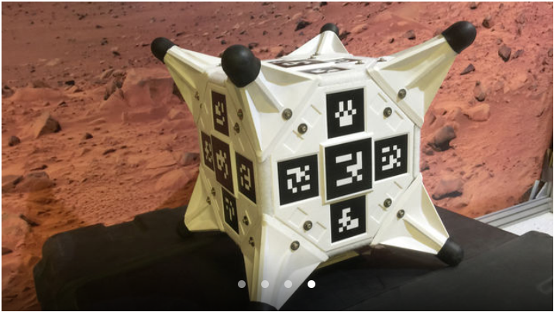
Figure 4. Image of JPL Hedgehog jumping robot [16]

This robot was designed to work in a microgravity environment, similar to that of Psyche. This robot uses a momentum-based flywheel system, actuated by timed braking. Hedgehog essentially hops from one position to another without exceeding a force great enough to lift out of orbit. Incorporation of microgravity into rover design will be essential, and the Hedgehog’s design may be helpful in the developmental phase of Psyche’s rover.

Existing Design #2: JPL ‘LEMUR’ Robot
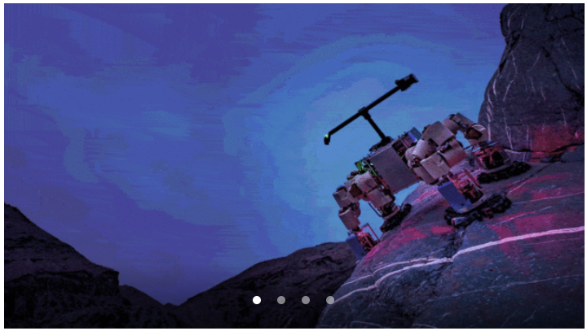
Figure 5. Image of JPL LEMUR climbing robot [17]
The LEMUR is a robot designed by JPL that can scale smooth rock faces. The technology used in the design involves hundreds of micro-hooks that are capable of latching on to any surface. Using this concept in the rover design would help solve the problem with microgravity, as well as provide the rover with a safety feature.

Existing Design #3: JPL ‘RoboSimian (Track A)’ Robot
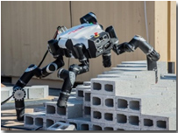
Figure 6. Image of JPL RoboSimian Track A Robot [18]
RoboSimian was designed by JPL to maneuver over obstacles and changing terrain. The arms of the robot are capable of multi-transitional rotation and allow the robot to move in almost any direction. Incorporating the rotational design of RoboSimian’s arms into Psyche's rover arm mechatronics will be beneficial to overcoming the variety of terrain on 16 Psyche.

Subsystem Level Benchmarking
This section breaks down the overall design into three separate subsystems. The drive, tether and arm mechanisms are all aspects of the rover that would benefit from benchmarking. Each subsystem must be incorporated in order to meet all engineering requirements and overcome variables associated with Psyche.

Subsystem #1: Drive System
The drive system is the portion of the rover that enables forward motion. This system is important because it is essentially what drives the explorer across the terrain. Incorporation of the microgravity environment must be taken into account when developing this system.

Existing Design #1: ZIL-29061: Russian Archimedes Screw Vehicle
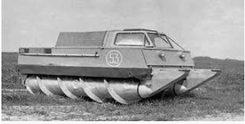
Figure 7. Image of ZIL-29061 Russian Screw Vehicle [19]
The ZIL uses an Archimedes-type screw to propel the vehicle forward. This type of drive allows for a lower tangential force than that of the wheel. Forces in the drive are important to consider in the Psyche rover design due to the microgravity environment.

Existing Design #2: NASA SnakeBot
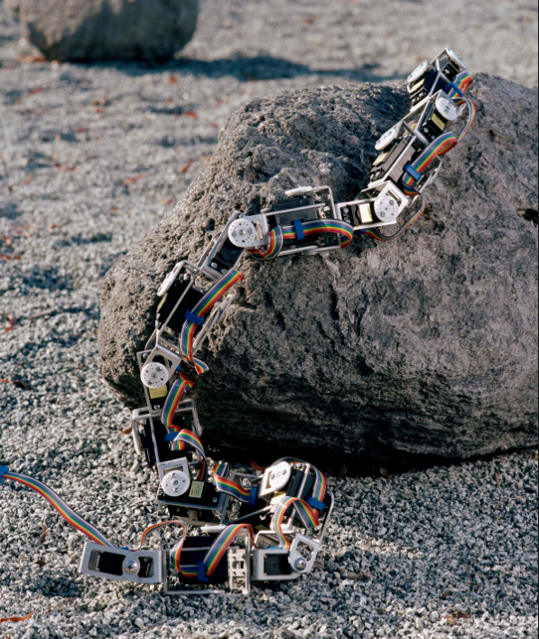
Figure 8. Image of NASA SnakeBot [23]
This design uses a link of mechanical motors capable of 360-degree rotation to propel itself forward. This bio-inspired design moves like a snake, in a sense never leaving the ground. As stated, prior, the microgravity environment of Psyche expresses a problem for motion on the asteroid. This design serves as an alternative to the wheel drive, which would not be feasible on Psyche.

Existing Design #3: RoboSimian Arm Drive
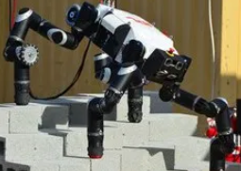
Figure 9. Image of RoboSimain Arm Mechanism [18]
Robosimian incorporates a multi-component motor arm design. The arms are designed in a way that allows for multi-directional movement and is primarily based on the contact between a single arm and the surface. Incorporating an arm powered design into the rover would allow for forward motion without causing large rotational movement as a wheel would in microgravity. Instead, this design allows for full rotation and motion of the robot and doesn’t primarily focus on frictional motion.

Subsystem #2: Tether System
The tethering system acts as a way to attach the rover to the surface. The system acts as a safety feature in the sense that it must be capable of preventing the rover from exiting the orbit. The surface conditions of Psyche varies, and having a subsystem that can attach to any of the hypothesized terrains would be beneficial to the design.

Existing Design #1: ‘Stickybot’
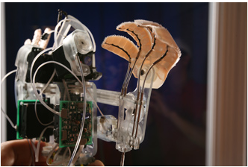
Figure 10. Image of Stickybot [24]
This robot is capable of climbing smooth surface walls using gecko-like adhesives. The ability to tether onto smooth surfaces will help solve the microgravity problem on Psyche, as well as traverse over glass-like terrain the rover might come into contact with.

Existing Design #2: Electromagnetic Hoverboard
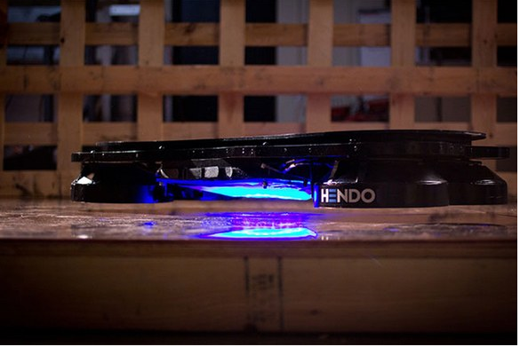
Figure 11. Image of Henod electromagnetic hoverboard [20]
The Henod Hoverboard uses an electromagnetic field to hover above the metallic surface beneath it. Incorporating electromagnets into the tethering design would be beneficial for attaching to all the metallic terrain apart from sand on Psyche. Tethering into hard rock may not be possible with hooks or a penetration mechanism, instead this offers an indirect way of attaching to the surface.

Existing Design #3: Gripping Foot Mechanism
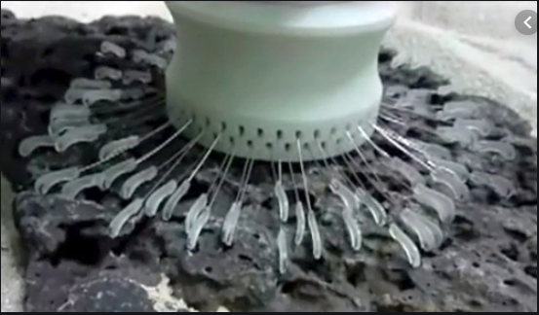
Figure 12. JPL Gripping Foot Mechanism for Microgravity Environments [21]
This system uses micro spine-based anchors attach itself to rock-like surfaces. The system uses a multitude of small bristle-like hooks, arranged in a circular pattern to grab onto the surface. The hooks are actuated using a tensioning system that are linked to multiple motors. This system can be incorporated into the stationary tethering of the Psyche rover design.

Subsystem #3: Arm Mechanism
The Arm mechanism consists of the portion of the rover that connects the body to the drive system. The arm mechanism will allow forward motion, suspension, and rotation of the robot. This system will allow the rover to maneuver over obstacles that may come into contact with the drive system.

Existing Design #1: Rocker Bogie System (Mars Curiosity Rover)
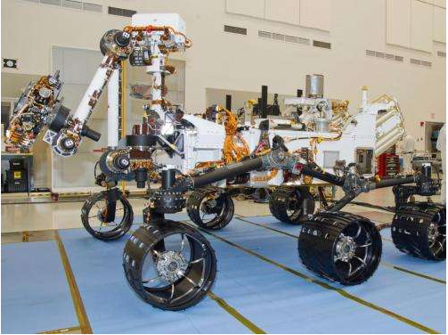
Figure 13. Mars Curiosity Rover with Rocker Bogie System [22]
The Rocker Bogie mechanism incorporates a six-wheel design that allows for movement over obstacles. The Bogie refers to the two sets of arms connected together, while the rocker is a separate arm mechanism. This design is used on the current Mars 2020 rover, and Mars Curiosity rover. Incorporating this design into the Psyche rover allows for maneuverability over elevation changes.

Existing Design #2: Lunar Rover (360 degree motion)
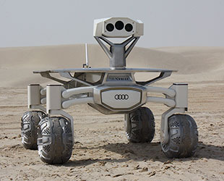
Figure 14. Image of Lunar Rover [25]
This rover uses a simple arm design that allows for 360 degrees of motion from the wheels. This arm design also allows for simple upward rotation of the wheels as well as travers ability over smaller objects. Incorporation of the arm attachments to the body, dual arm design, may be incorporated in the overall design of the rover traversing system.

Existing Design #3: Lunar Outpost Resource Prospector (Differential System)
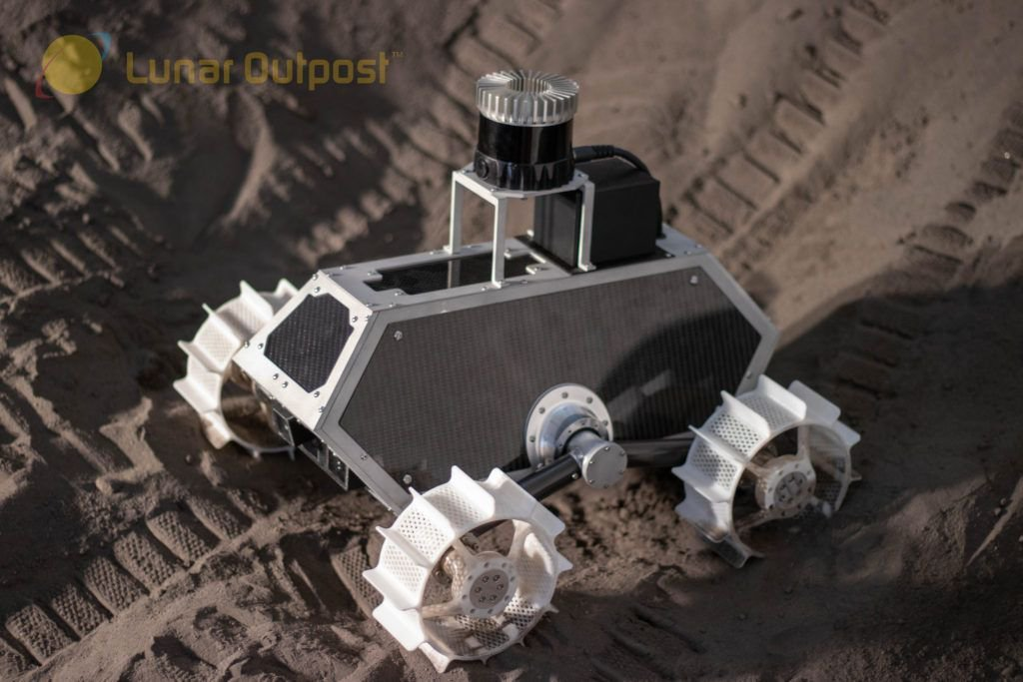
Figure 15. Image of Lunar Outpost Resource Prospector [26]
This design focuses on a simple differential system that allows for articulation over simple rocks and other materials. This design is based primarily in reference to moon traversing, so it would be beneficial to overcoming sand related environments on Psyche. The overall design might not be incorporated in the NAU Psyche Rover final design, but aspects of the simple differential system may be referenced when designing the arm mechanism.

CONCEPT GENERATION

Full System Concepts

Full System Design #1: Tethered Cable Rover
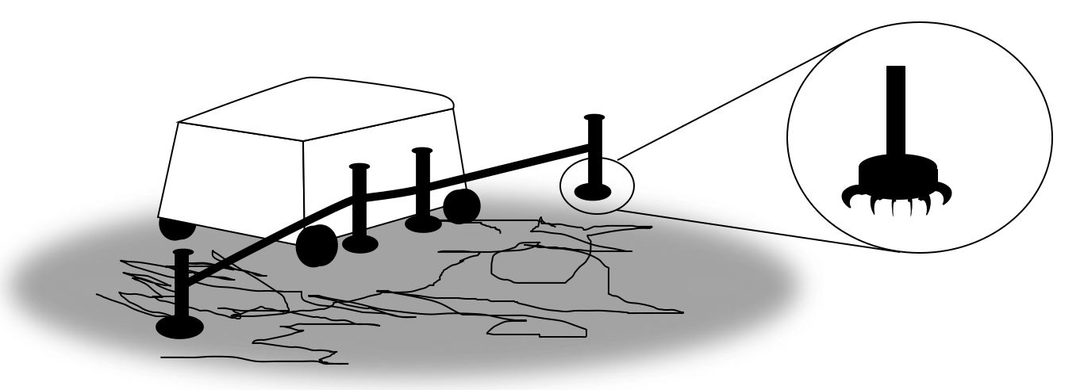
Figure 16. Rendition of Rover Tether
System Design 1 counteracts the risk of leaving the asteroid due to the low gravity of Psyche by utilizing a tethering system. Deployable tether connectors are mounted to the rover and are threaded by a cable attached to a spool in the rover. The connectors can either be placed right next to the rover or launched to reach across pits, cracks, etc. Connectors can attach to the asteroid through electromagnets or a series of small claws that clamp onto the surface. Once tethered, the rover can use a motorized wheel to move itself along the cable similar to a ski-lift.
Table 3. Pro-Con Design 1
Pros | Cons
- Prevents the rover from leaving the asteroid.  - Allows traversal across pits, holes, cracks, etc. more easily.  - Cables can provide stable movement. | - Limits mobility without tethers.  - Tethers require lots of external space on rover.  - Requires numerous parts and high risk of cable failure.

Full System Design #2: Superconducting Magnets
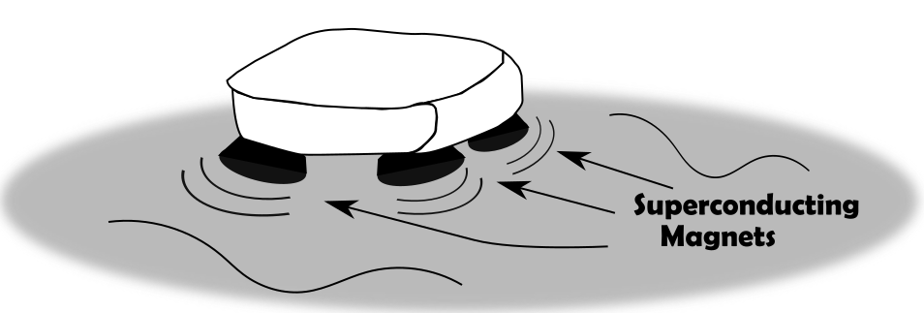
Figure 17. Rendition 2 of Rover Tether

System Design 2 focuses on a means of traversing the large areas of iron and nickel hypothesized to be on Psyche. When magnet windings are cooled below their critical temperature, they create much greater magnetic fields and can levitate above a metal surface. By shifting weight around the rover, the force from the magnets can push the rover in any direction. Magnets would be strategically placed around the bottom of the rover to ensure a strong enough magnetic field and to allow for movement in any direction.
Table 4. Pro-Con Design 2
Pros | Cons
- Least moving parts of any design.  - Varying metal surfaces have less effect on traversal. | - Requires the Magnet to be Supercooled.  - Magnets push away from surface rather than attach the rover to the surface.  - Rover can only traverse metal areas.

Full System Design #3: Archimedes’ Screw Rocker Bogie Combination

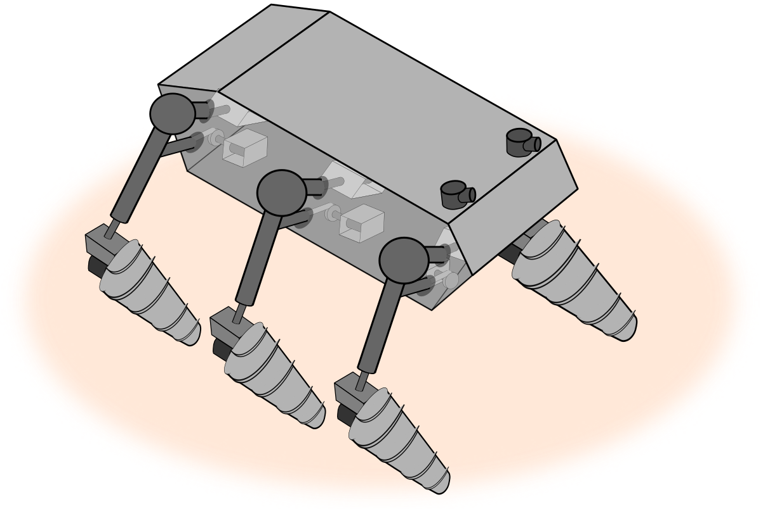
Figure 18. Rendition of Rocker Bogie Screw Drive Design

System Design 3 prevents the possibility of leaving the asteroid by attaching screws to the legs of the rover. Each leg can dig partially into the ground below it to prevent motion. This design is primarily useful for areas of silicate rock and regolith (a type of particulate).

Table 5. Pro-Con Design System 3
Pros | Cons
- Reliable traversal through silicate rock and regolith.  - Motion while partially attached to the asteroid. | - Ineffective on metal areas.  - Much slower traversal due to time it takes to dig into and out of rock/regolith.

Subsystem Concepts

Subsystem #1: Screw/Wheels

Design #1: Archimedes Screw

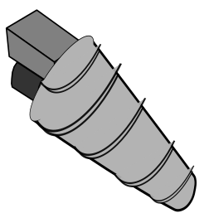
Figure 19. Concept Drawing Screw Drive

The Archimedes screw will allow traversal through rocks and particulate as well as over other solid surfaces. It uses a cone with a helical flange on it to propel itself across a surface. One side of screws runs clockwise while the other side runs counterclockwise. This ensures movement along the axis of rotation.

Table 6. Pro-Con Screw Drive
Pros | Cons
- Makes traversal through smaller rocks and particles easier.  - Partially digs into rocks and particles allowing it to stay more firmly on the asteroid. | - Makes turning more difficult.  - Worse efficiency on solid areas.

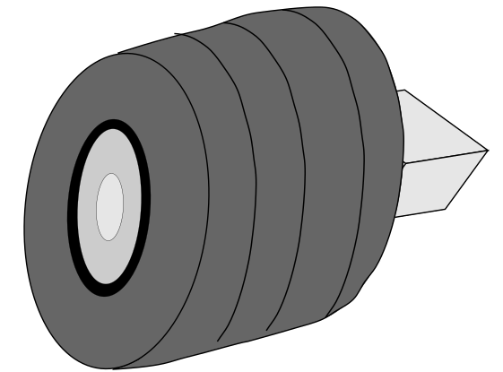
Figure 20. Concept Drawing Wheel Design
This is a basic wheel design for movement along the asteroid. Motors are used to rotate the wheel and propel the vehicle forward or backwards. Wheels would be used alongside a method of staying on the surface of the asteroid. This could mean the wheels could be used to pull the rover along a tether, or for very small wheel motions that won’t launch the rover off the asteroid.
Table 7. Pro-Con Wheel Design
Pros | Cons
- Easy design with lots of variation and options for purchase.  - Can be resilient to rough surface conditions. | - Provide a lot of Torque that can launch the rover off the asteroid.  - Hard to use with microgravity.

Design #3: Snake

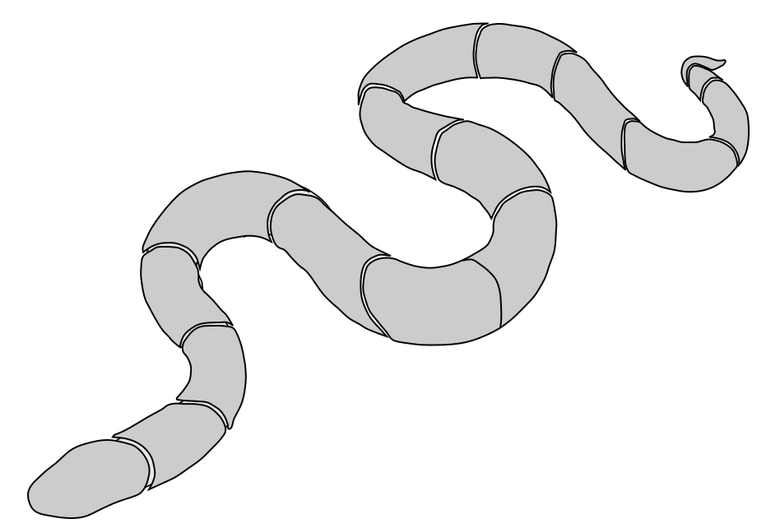
Figure 21. Concept Drawing of Snake Robot
The snake design allows for individual motorized movements of each section. It can imitate the movement of a snake and push itself along the ground in the desired direction. Since each part has its own motor, the force of the entire design can be minimized by moving specific parts at a time. It allows vertical and horizontal movements so that the design can travers uneven terrain.
Table 8. Pro-Con Snake Design
Pros | Cons
- Small Motors = Low Forces.  - Vertical and Horizontal movement. | - Numerous motors  - Hard to implement systems on this type of body.

Subsystem #2: Rocker Bogie

Design #1: Zero Degree of Movement Legs
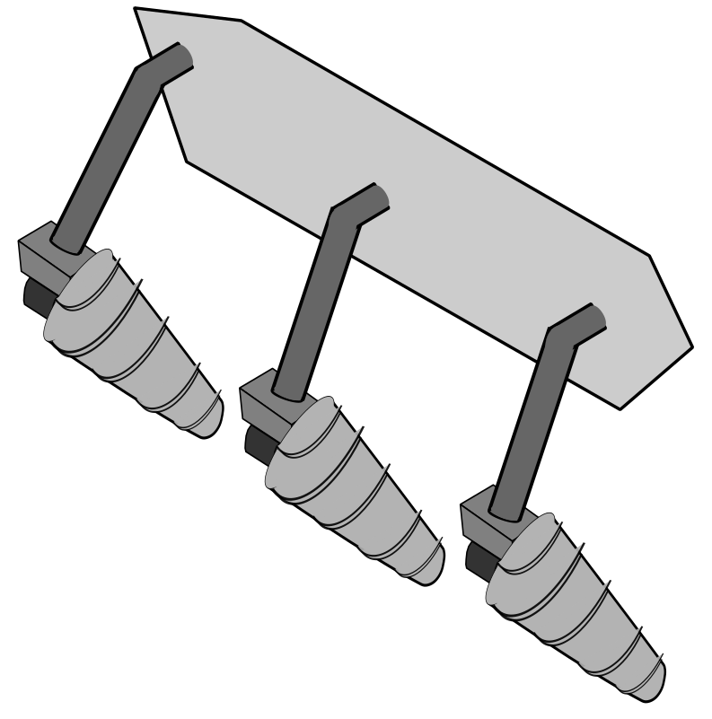
Figure 22. Concept Drawing Leg Design

This design is the simplest of the three Rocker Bogie based designs. The design only needs six motors to operate. The arms are locked in place attached directly to the rover’s chassis. The six-leg design allows for more motors propelling the rover.
Table 9. Pro-Con Leg Design 1
Pros | Cons
- Cost Effective (Minimum Number of Motors)  - Rigid, Durable Structure  - Minimal Joints  - Easy to Complete by Deadline | - Ineffective Against Rocks and Large Obstacles  - Incapable of Adapting to Slopes  - Minimizes Maneuvering Capabilities  - Minimal Independent Motor Functions

Design #2: X-Axis Leg Movement w/ Hydraulics

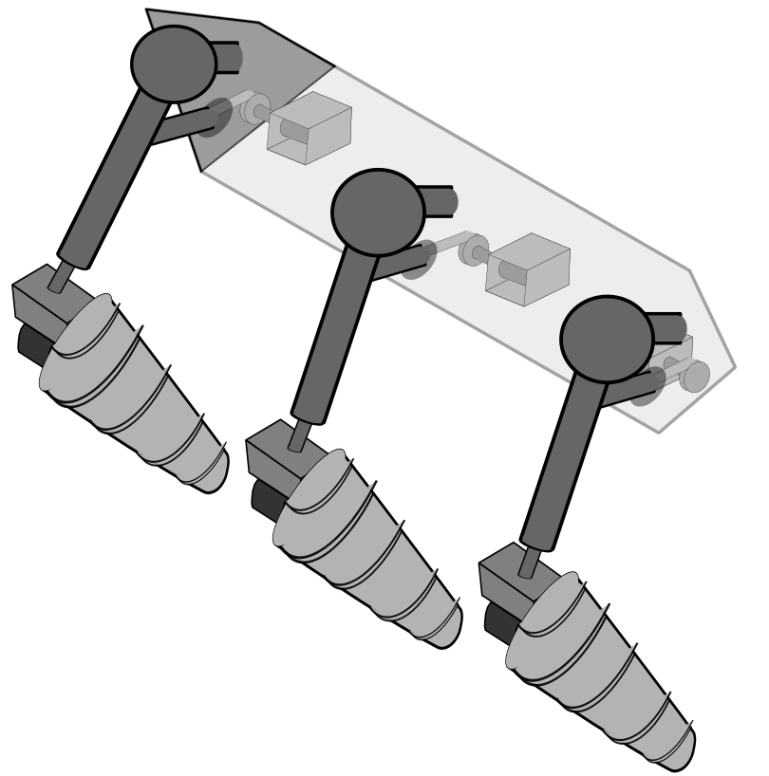
Figure 23. Concept Drawing Hydraulic Leg Design
This design allows the rover to widen its’ stance and raise its’ chassis to get over wide obstacles. There are motors inside the chassis attached to a gear that moves powers a rod attached to each arm. Within each arm is a hydraulic piston that allows the user to change the height of the chassis.
Table 10. Pro-Con Hydraulic Leg Design
Pros | Cons
- Cost Effective (⅔ Max Number of Motors)  - Ability to Change Chassis High  - Ability to Change Wheel Width  - Basic Arduino Setup | - Ineffective Against Rocks and Large Obstacles  - Incapable of Adapting to Slopes  - Basic Maneuvering Capabilities  - Minimal Independent Motor Functions

[Describe in detail a design solution you have considered. Include a list of Pros and Cons.]

Design #3: Radial and X-Axis Leg Movement w/ Hydraulics

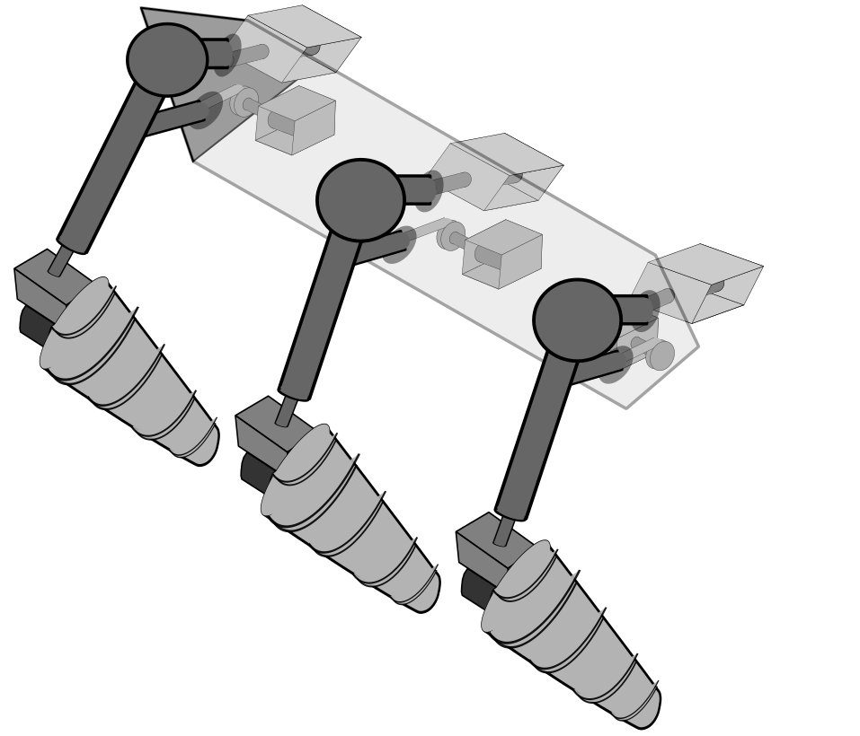
Figure 24. Concept Drawing Leg Movement Design
This design is similar to design #2 but has three more motors in the chassis. These motors control the radial movement of the arms. The extra radial movement of the arms allows the wheels to position themselves in any area within 180 degrees of the sides.
Table 11. Pro-Con Radial and x-axis movement
Pros | Cons
- Ability to Change Wheel Position in Radial Axis  - Ability to Change Chassis High  - Ability to Change Wheel Width  - 180° Radial & 90° X-Axis of Freedom for Legs | - Maximum Budget Cost  - Maximum Number of Motors  - Least Durable Leg Design  - Most Complicated Arduino Setup

Subsystem #3: Tether

Design #1: Magnet
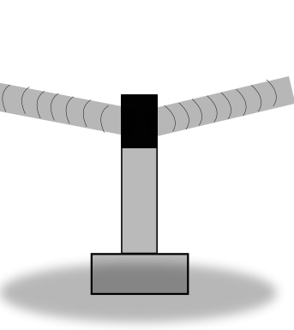
Figure 25. Concept Drawing Magnet Tether

This design will utilize electromagnetism to be able to activate or deactivate its connection to the surface at any time. A small magnet connects to the ground with a pole sticking out of it that contains the tether. By winding the spool inside the rover containing the tether, the rover will pull itself in the direction of the magnet.
Table 12. Pro-Con Magnetic Tether
Pros | Cons
- Strong connection that is easy to attach and detach.  - Relatively simple design. | - Only effective on metal areas.  - Magnetism may cause problems with metal rover.

Design #2: Claw
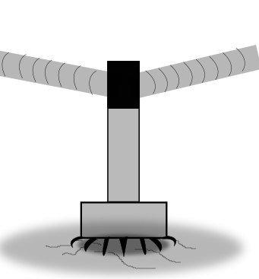
Figure 26. Claw Tether
Numerous small claws are placed around the edge of the bottom of the pole. Each claw can clamp down on the surface beneath it. The claws can move individually in order to fit different types of surfaces, and will grab onto cracks, holes, etc.
Table 13. Pro-Con Claw Tether
Pros | Cons
- Works on rough surfaces of both metal and rock. | - Not effective on smooth surfaces.  - Lots of little claws with small motors increase the risk of certain components malfunctioning.

Design #3: Bio-Inspired
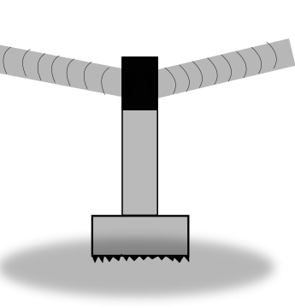
Figure27. Bio-Inspired Tether
This design imitates the setae (micro-structured arrays of hair like keratinous bristles) found on geckos’ feet. These bristles can be made using a multitude of different polymers and would allow the pole to sit on any solid surface. These bristles in mass amounts will enter numerous crevices and solidify a connection to the asteroid.

Table 14. Pro-Con Bio Inspired Tether
Pros | Cons
- Works on the most surfaces of any design.  - No moving parts to maintain. | - Harder to produce than other designs.  - Won’t work on entirely smooth surfaces.

Subsystem #4: Control System

Design #1: Single Arduino
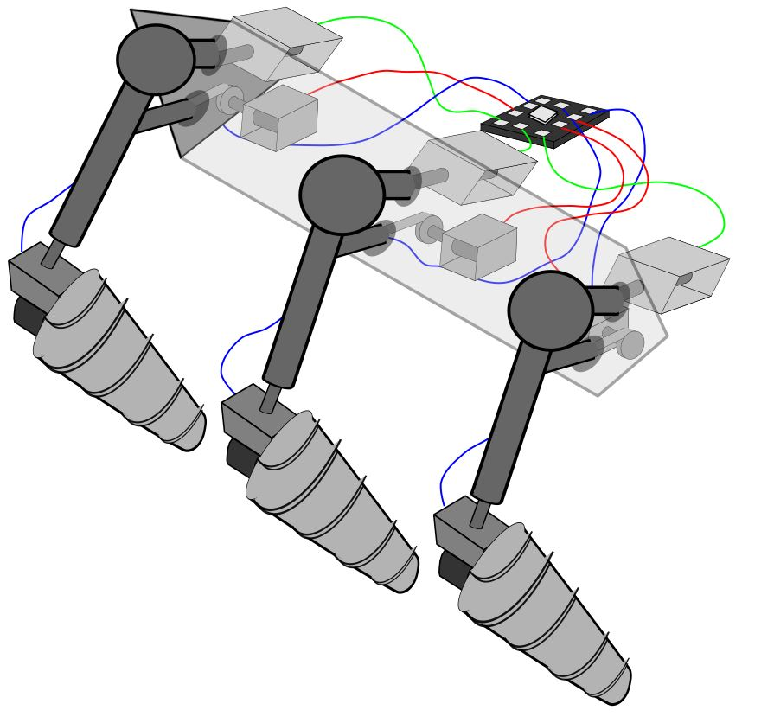
Figure 28. Concept Drawing Single Arduino
This Design has an Arduino Configuration with all the motors connected to one Arduino. (Red wire: X-Axis motors; Green wire: Radial Motor; Blue: Screw Motor)

Table 15. Pro-Con Single Arduino
Pros | Cons
Cheapest configuration | To many motors for one Arduino

Design #2: Dual Arduino
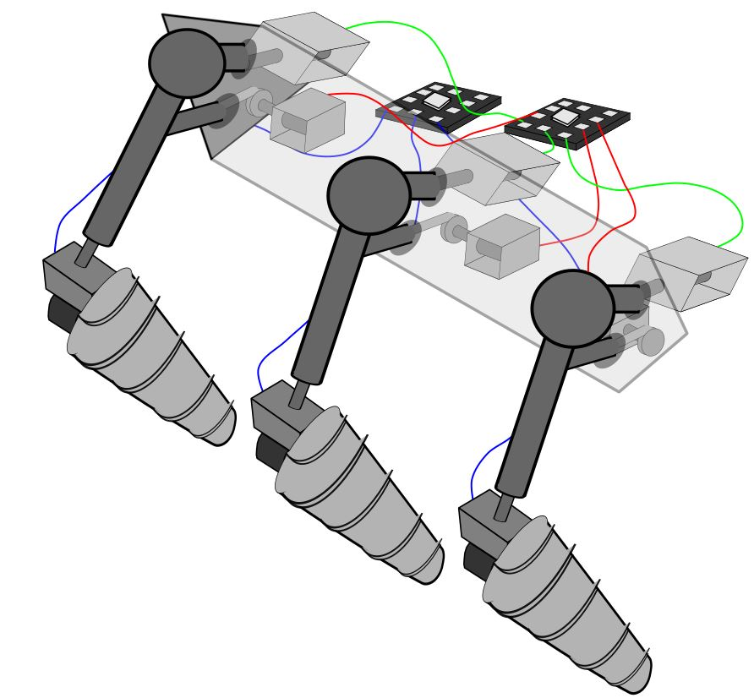
Figure 29. Concept Drawing Dual Arduino
This Design has an Arduino Configuration with the Screw Motors connected to an Arduino, with the X-Axis and Radial Motors to one Arduino. (Red wire: X-Axis motors; Green wire: Radial Motor; Blue: Screw Motor)
Table 16. Pro-Con Dual Arduino
Pros | Cons
Configuration has enough capacity to run motors | Requires more coding  More expensive

Design#3: Arduino Trio

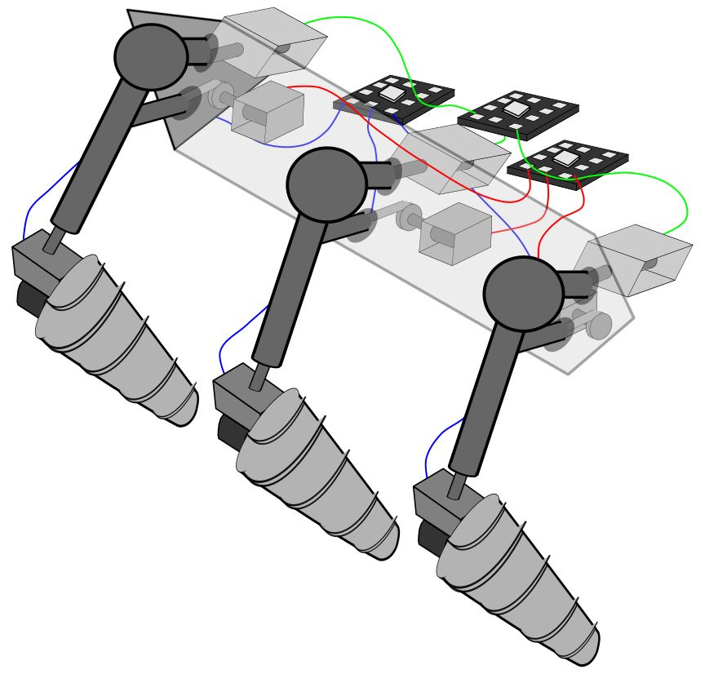
Figure 30. Concept Drawing Arduino Trio

This Design has an Arduino Configuration with each type of motor connected to an Arduino.

Table 17. Pro-Con Arduino Trio
Pros | Cons
Configuration has enough capacity to run motors | Requires a lot of coding  Most expensive option

DESIGN SELECTED – First Semester
The following sections includes information on the updated final design of the rover. An implementation plan for prototyping the rover is also included in this section. A breakdown of resources can be found in section 4.2. A comparison of cost of implementation and budget is also included in the section along with an updated schedule reflecting the implementation process.

Design Description
After completing design analysis in the preliminary report, some changes to the rover design were made. Figure 4 reflects the old model of the rover, implementing a rocker bogie hydraulic system and an Archimedes screw drive. A tethering system was also part of this design, but the specifics on how it would work was not yet determined. Upon completing additional analyses, an updated version of the rover was designed.

Figure 31. Rover design from Preliminary Report
The new rover implements a hydraulic system that will allow for adaptation to the surface conditions by allowing freedom of motion in the x and y directions. A drawing of this part is shown in Figure 16 of Appendix B. The Archimedes screw was adapted to fit the dimensions of the new rover. Analysis on optimal pitch angle, threads and length are being calculated in the next few weeks during the analytical analysis. The body of the rover was changed from a single frame to two separate components, split by inner shaft that allows the rover to rotate about the axis. The premise of this design change is to allow more motion of the rover in case the rover needs additional maneuverability over the terrain. A primary electromagnet tethering system was also implemented into the design. This component raises and lowers from the rover using a rack and pinion design and will allow the rover to compensate for the low gravity on psyche. Upon completion of the analytical analysis in the next few weeks, a relative magnetic force will be determined. A CAD drawing of this component is shown in Figure 15 of Appendix B. A secondary tether system will also be implemented into the design to deal with sandy surface conditions that the electromagnet may not work on. This design is not yet finalized but it will implement a micro-spline tethering system paired with an electromagnet core.
An initial prototype of the rover was designed, shown in Figure 5. The dimensions of the final rover will be constrained to 2.5’x2’x2’. The prototype shown in the figure below is roughly that size. Although similar in size, the prototype doesn’t accurately show all the components of the updated rover design. This model doesn’t have the pivotal center connection, or the tethering system shown on the design.

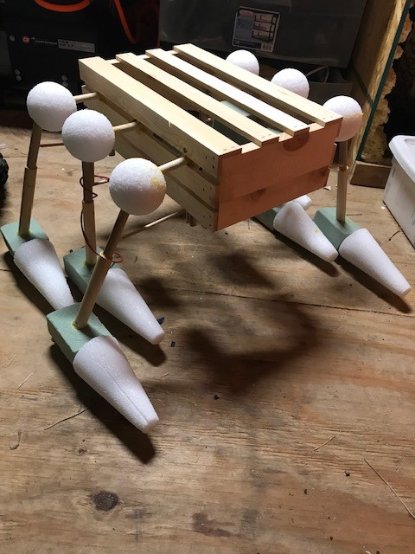
Figure 32. Initial Prototype of Updated Rover Design
Upon completion of the initial prototype, the team decided to go with a different suspension system from the hydraulic design. There was nothing entirely wrong with this design apart from the costs associated with building it. After reflecting on ability to construct parts in the machine shop, the team decided to go with a rack and pinion design. This new concept will still allow motion in the x and y directions, but it will be much more cost efficient to produce. The rack and pinion arm design are shown in Figure 6. Consideration for limiting the drive system to 4 wheels instead of 6 is also being considered for the final prototype. This decision will be made during prototyping and is mainly based on the prototype testing surface, provided by ASU. The hypothetical design for the Psyche rover will still reflect a 6-wheel rocker bogie design.
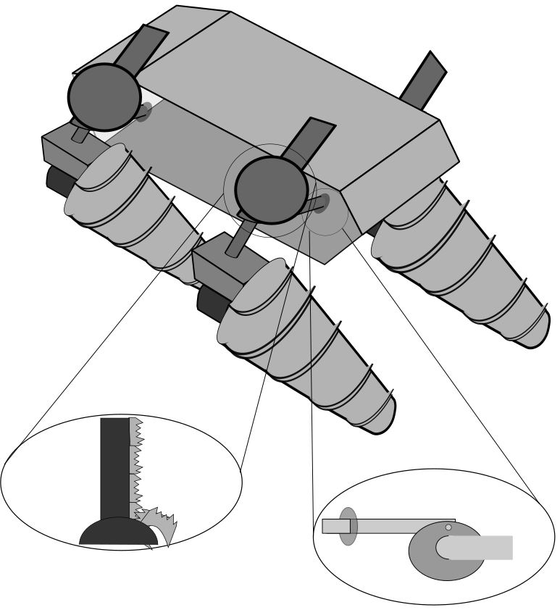
Figure 33. Rack and Pinion arm design
The figure shown below represents the updated CAD model of the design apart from the newly introduced Rack and Pinion arm assembly. An updated CAD model reflecting these changes will be included in the submitted CAD package during the week of November 18th.

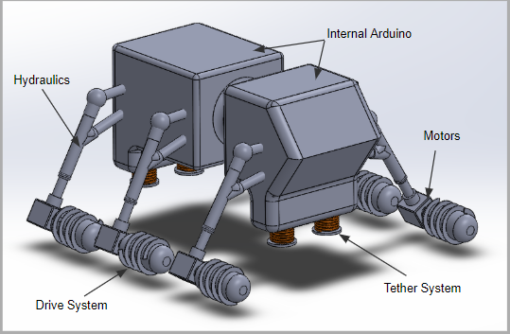
Figure 34. Updated CAD Assembly of Rover
Calculations made up to this date were mainly based on the normal forces caused by the rover’s weight and size in the microgravity environment. For the hypothetical design, assumptions were made based off the size of NASA’s Mars Curiosity rover. Sizing the rover in correlation to that design puts its mass at 899 kg for the full-scale model. On Psyche, this causes the normal force to be roughly 130 Newtons. Calculations on the electromagnet and secondary tethering system will be found based on this number, to compensate for the microgravity and keep the rover on the surface. For the prototype that will be tested on earth, the team assumed a mass of around 50 lbs. or 22.6 kg. With earth gravity, this would cause the normal force to be roughly 222 Newtons. For the prototype, calculations of the tethering system will also be made to work within this environment. Figure 8 shows the calculations made to obtain these numbers.

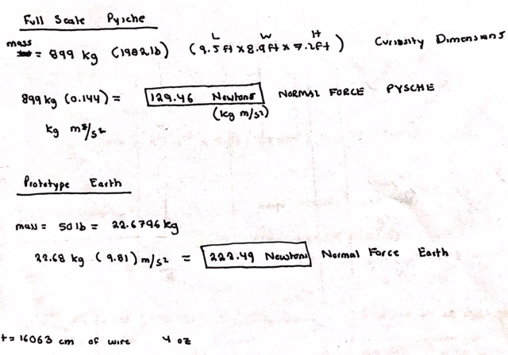
Figure 35. Hand Calculations for Normal Forces on Psyche and Earth
Other calculations that will be determined in the next few weeks upon completion of the analytical reports include electromagnet force, tether tension, stress strain calculations on legs, screw drive forces, and Arduino code and orientation. An FEA analysis in SolidWorks will be used to calculate most of the listed calculations. The electromagnet forces will be calculated using Equation 1.
F = $\frac{{(N*I)}^{2}*k*A}{(2*g^{2})}$ (1)
The variable F represent the magnetic force from the electromagnetic field in Newtons. N represents the number of turns in the wire, I, the current in Amps, K is the coefficient for copper, A is the area of the solenoid and g is the gap distance between the magnet and the object [1].

Implementation Plan – First Semester
Implementation of the design will be done by constructing two different prototype models. Prior to the start of either prototype, initial subcomponent analyses will be completed. Testing of the electromagnet tethers will be completed by doing a circuit and power analysis. The resources needed to complete this test include items 19-21 on the updated Bill of Materials, located in Appendix A. This analysis will be completed by team member Dylan Randall at home. A dyno analysis on the motors and electrical system will also be conducted. The only item needed to conduct this test is a small-scale dyno machine. The team does not currently have access to this device, but soon are hoping to obtain one from the EE department at NAU to test the motor torques. This item is listed on the Bill of Materials as 22 and is currently TBD for purchasing price. This test will be coordinated by team member, Mack Chasse, and help from other members of the team will be available. A voltage test will be conducted on the Arduino system to ensure that there is no wasted power, and the circuit is properly set up. The resources needed to conduct this test is item 23 on the Bill of Material, multimeter. Upon completion of the subsystem analyses, the final prototype will be constructed.
The initial prototype that the team will complete by December 4th will display an accurate layout of the Arduino system and body of the rover. This will allow the team to have a general idea of the orientation of the parts in the rover and will make secondary system designs go a lot faster in the next semester. Figure 11 represents a general schedule for the team’s second semester activities. Beginning in January, the team will have completed all analyses needed to construct the rover design. Most of the parts for the rover will be manufactured by the team to stay within budget. Manufacturing of the final components will begin in January and go until mid-February. The drive screw will be manufactured by team member, Jacob Morrissey in the machine shop. The rack and pinion arm design will be made by Mack Chasse in the machine shop. Arduino construction will be coordinated by Badir Alrefai, but all team members will help. As stated, prior, the Arduino will be completed by December 4th and a general construction of the rover body will be made. The electromagnet and secondary tethering systems will be constructed by Dylan Randall and Jeremiah Curnalia respectfully. The items needed for the secondary tethering system are still TBD and will not be accurately represented until the final BoM due the week of November 18th. The test surface, provided by ASU will be completed by the end of December, so in January, the team will begin testing their rough design on the scaled model. The final prototype will be constructed mid-February, giving the team a little over a month to implement the final design prior to testing. Additional schedules involving website checks, posters and final UGRADS presentation are included in Figure 11 of Appendix A.
The overall budget allocated for this project is $1000. After revising the budget and Bill of Materials, the team has a new total cost of $642. Changing the arm design from hydraulics to a Rack and Pinion design allocated a an extra $350 for further prototyping. Most of the components used for the implementation process will be donated and consideration of the manufactured parts have been estimated in the BoM under the wheels and joints. Having an extra $350 will be helpful if other components need more revision and will allow our design to be more flexible based on cost.
An assembly view of the updated CAD drawing is shown in Figure 7 of section 4.1. The exploded view of the CAD model is shown in Figure 9 below. An additional exploded view including the explode lines is included in Appendix B.
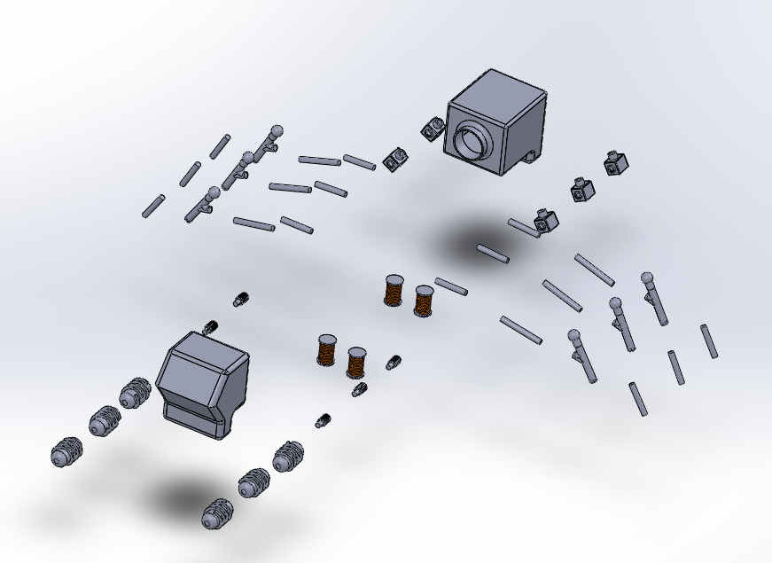
Figure 36. Exploded View of CAD model First Semester

RISK ANALYSIS AND MITIGATION
This section of the memo covers the potential failures the team encountered this semester, represented by the FMEA in Figure 8. Descriptions of how these risks were mitigated are also included in this section, primarily for Arduino.

Potential Failures Identified Fall Semester
The building of the rover brought up new challenges from technologies outside of team members’ general areas of expertise, such as wiring and coding. From new potential failures came new risks. These challenges lead to new potential failures like wires unable to withstand the amps flowing through them. Although none of these failures greatly differ from the failures identified last semester labeled under the control system section of the shortened FMEA. However, these failures presented themselves in ways that the group did not hypothesize.
The Arduino proved to be more unreliable and temperamental than originally planned for. Even when the code was written properly the motors and actuators wouldn’t function properly from time to time. The relays used to connect the Arduino to the motors and actuators, as well as the power sources, were sometimes faulty or eventually failed. Even problems as simple as the gauge of wiring used to connect the devices together became problematic due to the high amps for the motors.

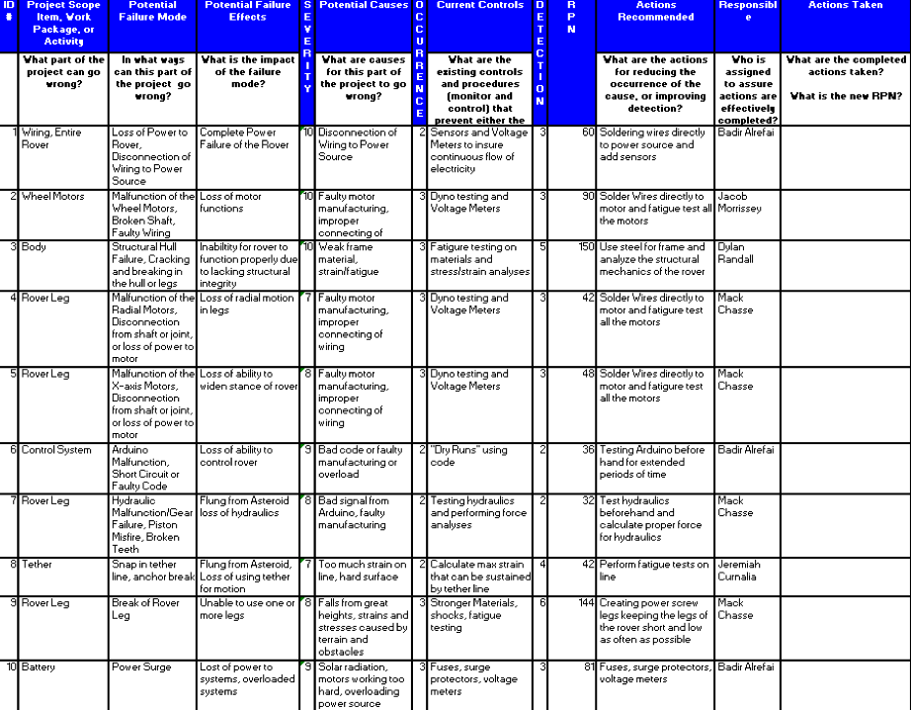
Figure 37. FMEA

Risk Mitigation
Throughout the course of the design and build process there have been numerous compromises and changes to the design. The budget for the project had a greater impact in the design of the rover than initially thought. It effected how the group purchased materials, and which parts of the project were necessary to complete the task at hand. Some of materials had to come from China to lower the cost. One risk that has had an even greater effect is the outbreak of a disease that has limited people meeting in large groups.

Arduino Mitigation
To prevent critical failure in the entire circuit, fuses are being soldered into the wiring of each motor. Fuses will end a connection to a motor that is producing a current higher than the maximum allowed current for the motor shields, relay modules, or Arduino board. This prevents burnout of these components and allows continual operation of the remaining subsystems. Also, wire connections will be soldered to each component and reinforced/protected in the frame to ensure they remain intact.

IMPLEMENTATION – Second Semester
The following section depicts the NASA Psyche: Robotic Explorer Capstone teams’ major implementation milestones that occurred during weeks 7-11. The team was tasked with building a robotic explorer cable of traversing multiple features in a microgravity environment, on a metallic asteroid. The project requirements involved creating a scale model capable of traversing 4 out of 6 terrains on a test surface provided by ASU. Due to COVID-19, manufacturing was cut short and the team was not able to finish the construction of the rover. Revisions to the project requirements were made and the team has dropped the physical model and is reverting to a CAD only package. The following sections cover the manufacturing processes design changes, standards, and risk analysis the team followed up to this point in time. As of March 20th, manufacturing of the rover (frame, front-end arm assembly, screw drives, circuitry, and motor housing) was complete.

Manufacturing
The original manufacturing processes the team had to complete this semester are as follows: Construction of frame, wheel drive, Arduino, power supply and component layout.
The frame was constructed using 1/8-inch aluminum and cut into various lengths using a grinder to create a general layout of the frame. The aluminum bars were then welded together using a 175-amp MIG welder with an Aluminum spool gun. This was done in house by two of the team-members and up to this point in time is a general box waiting for mounts. The dimensions of the frame are approx. 1ft x 2ft x 10 inches and is well within the original dimensions of the approved frame design. The team estimated the rover frame to be approx. 15 lbs. and so far, the frame only weighs 2.4 lbs. This number is well within the engineering requirements the team was aiming for. Figure 38 represents the rover frame up to this point in time without the mounts for actuators and other various components. The team decided to wait to finish until all the components arrived for layout.
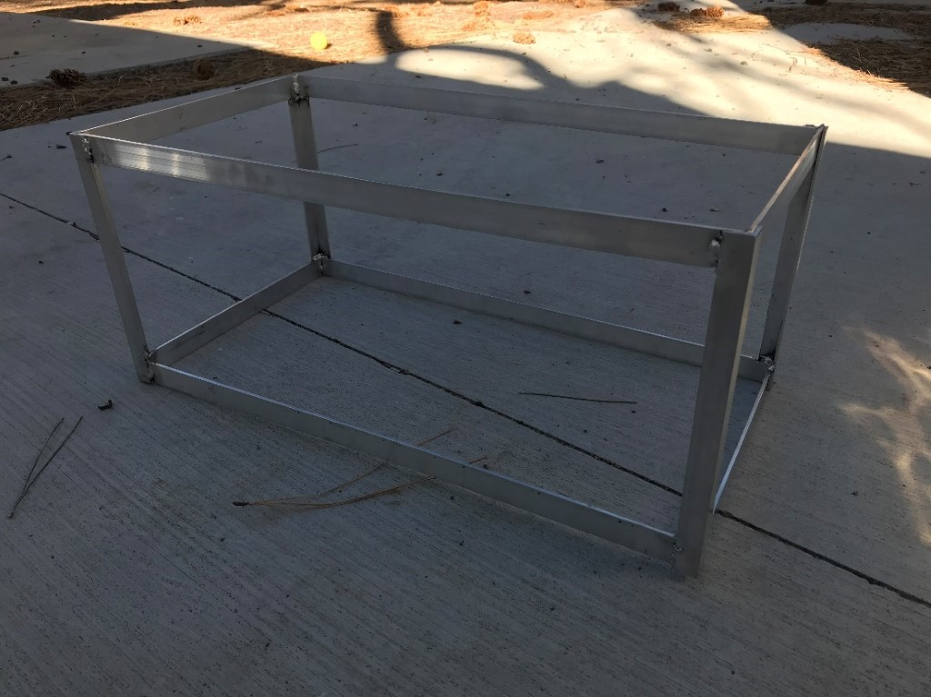
Figure 38. Welded Rover Frame (Prior to Mounts)
The wheel drives were made using a Prusa 3D printer and PLA filament. The team initially wanted to CNC the screw drives but after researching into the cost and skills required to manufacture the drive that way, the team decided that 3D printing the parts would suffice for the design. Initially, the screws were made in SolidWorks, and after a few revisions to the pitch and length of the screw, manufacturing began with the Prusa 3D Printer. Overall, only 600 grams of PLA filament was used to construct 6 screw drives. Once the frame is further along, the team will mount the screws and begin testing the operation of the current design. Figure 39 shows the 3D printed screw drives for the rover as well as a screw that has been coated with a protective spray on layer for testing procedures.
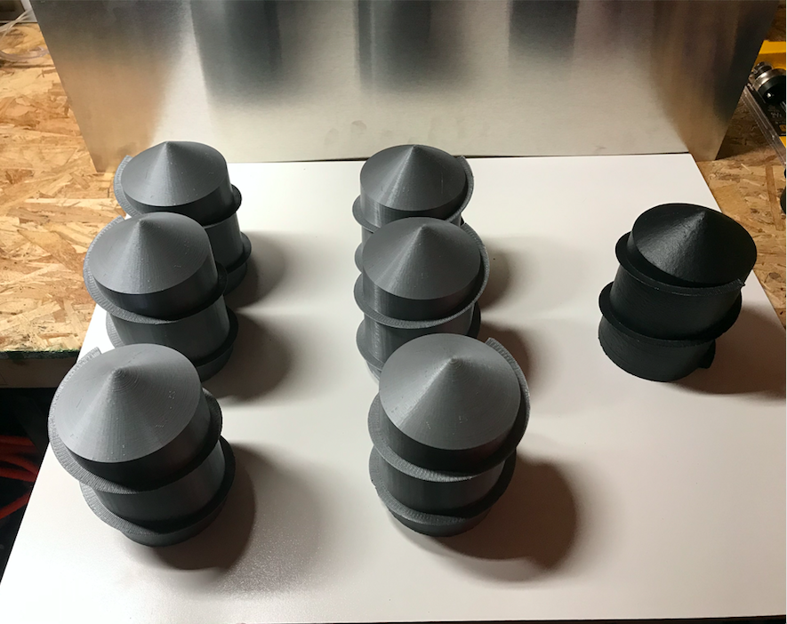
Figure 39. Printed Screw Drives (Black is Coated with Protective Seal)
The manufacturing of the Arduino system has been operational throughout the course of the semester. Two of the team’s members have been working with the Arduino software to build a code capable of operating 6 screw drives,12 linear actuators and other various electrical components. The Arduino up to this point in time can operate two 3V motors a servo motor and infrared sensor based on a 9v battery. Further programming was halted due to COVID 19.
The original manufacturing processes the team had to complete this semester are as follows: Construction of frame, wheel drive, Arduino, power supply and component layout.
The frame was constructed using 1/8-inch aluminum and cut into various lengths using a grinder to create a general layout of the frame. The aluminum bars were then welded together using a 175-amp MIG welder with an Aluminum spool gun. This was done in house by two of the team-members and up to this point in time is a general box waiting for mounts. The dimensions of the frame are approx. 1ft x 2ft x 10 inches and is well within the original dimensions of the approved frame design. The team estimated the rover frame to be approx. 15 lbs. and so far, the frame only weighs 2.4 lbs. This number is well within the engineering requirements the team was aiming for. Figure 40 represents the rover frame without the mounts for actuators and other various components. The team decided to wait to finish until all the components arrived for layout.
Figure 40. Welded Rover Frame (Prior to Mounts)
The wheel drives were made using a Prusa 3D printer and PLA filament. The team initially wanted to CNC the screw drives but after researching into the cost and skills required to manufacture the drive that way, the team decided that 3D printing the parts would suffice for the design. Initially, the screws were made in SolidWorks, and after a few revisions to the pitch and length of the screw, manufacturing began with the Prusa 3D Printer. Overall, only 600 grams of PLA filament was used to construct 6 screw drives. Once the frame is further along, the team will mount the screws and begin testing the operation of the current design. If needed, changes to the wheel design (pitch, height of thread, length) will be made for the rover to operate as expected. Figure 41 shows the 3D printed screw drives for the rover as well as a screw that has been coated with a protective spray on layer for testing procedures.
Figure 41. Printed Screw Drives (Black is Coated with Protective Seal)
The manufacturing of the Arduino system has been operational throughout the course of the semester. Two of the team’s members have been working with the Arduino software to build a code capable of operating 6 screw drives,12 linear actuators and other various electrical components. The Arduino up to this point in time, can operate two 3V motors a servo motor and infrared sensor based on a 9v battery. Further programming halted due to COVID 19.

Design Changes
These design changes happened at our first team meeting in the beginning of the semester. We went over our design and wanted to change it to make sure that we could produce a product that was within our budget. These are the designs that we though needed to be changed to make sure we reach our deadline as well as provide a functional rover to our client.

Design Iteration 1: Change Rack and Pinion legs to Linear Actuators
The original leg design consisted of a rack and pinion controlled by a servo that allowed the legs to move up and down. The leg width was controlled by a servo as well. We changed the design from the rack and pinion to six 8-inch linear actuators. The servo that controlled the width was swapped to a set of 4-inch linear actuators. The original design was decided against because we found linear actuators to control leg motion was more reliable and within our budget range. The old design is seen in figure 3 and the linear actuators can be seen in figures 12 and 13.
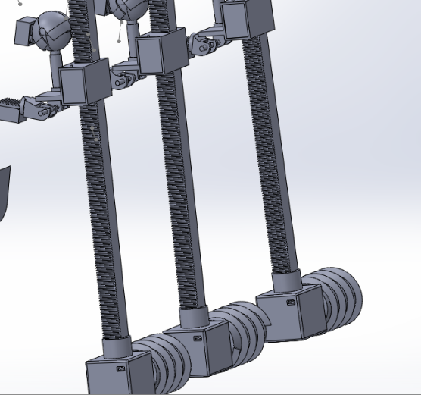
Figure 42. Rack and Pinion design

Design Iteration 2: Change to body design
The original body design was two sections that connected in the middle by a ball joint to allow the body to rotate between the front screws and the back set. This was changed to a single body to simplify the design. This was changed because we could figure out how to attach the two sections without manufacturing parts and going out of our budget. The body was also changed from having metal sheet around the outside to having a 3-D printed shell coving it. This was changed because it will be easier to access the interior of the rover and would look nicer. The previous design can be seen in figure 4 and the new design can be seen in figure 1.
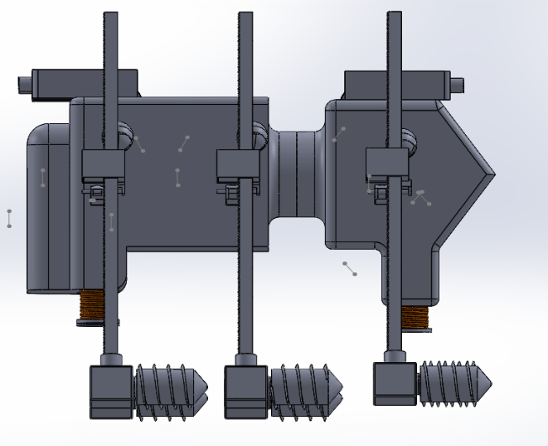
Figure 43. Previous Rover Body

Design Iteration 3: Manufactured Screws to 3-D Printed Screws
The original design for the screws was to manufacture them out of steel on the lathe in the machine shop or have it made by another company. This was out of the range of our budget so we designed to 3-D print the screws to use on the test surface and state that if we had the budget to manufacture them, we would make them out of steel. The 3-D printed screws are shown in figure 2.

Design Iteration 4: Removal of launching Tethers
The design from the first semester had tethers that would launch out of the rover and allow it to attach to the surface to ensure that the rover would not loose contact with psyche. We decided to remove this subsystem because the primary electromagnet tether would be enough to keep the rover in contact. These can be seen in figure 4 as well as figure 5.
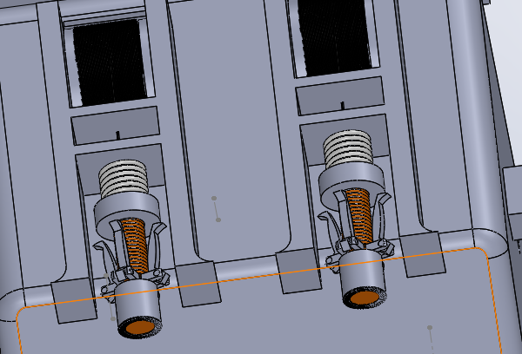
Figure 44. Electromagnet tethers

Design Iteration 5: Secondary Subassembly Design
This design was created to explore a secondary option to the locomotion of the rover. We designed a crawling rover to have to show another option to replace the screw drive if it does not work out. Figure 6 shows the CAD of the body that will hold the subassembly.
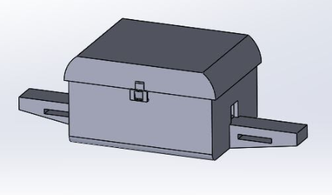
Figure 45. Body to house subassembly

Design Changes Cont.
The team has kept the design fairly like the original design. We have removed some of the ideas due to a lack of funds and time to implement them into the final design. The team changed the Arduino circuit so it would be more reliable. Another change that occurred was the use of a spray on coat to help improve the surface durability of the screws. Due to a lack of time we decided to remove the electromagnets. The secondary design was dropped because the team wanted to remain focused on providing the original design on time.

Design Iteration 6: Change in Arduino circuit
Upon receiving the motor shields, some stranded copper wire connections were changed to solid wire to help prevent wire from falling out of component screw connections. Fuses were introduced to the screw drive motor wires to prevent burning out of motor shields or the Arduino board. These were the only major changes to the Arduino subsystem.

Design Iteration 7: Spray on coat for Screws
Upon receiving the 3D printed screws, the team was concerned with the structural integrity of the screws. A spray coat was found to be compatible with the filament. This increased the surface hardness of the screws to help them withstand the weight of the rover. This would also help with the rover as it was tested on the test surface.

Design Iteration 8: Removal of the Electromagnets
Due to a lack of time to implement the electromagnets onto the final design we decided against adding them. This was also decided upon because the test surface would not have magnetic materials on it so it would have not been practical to spend time adding it.

Design Iteration 9: No Secondary Design
The Secondary crawling design was no longer pursued. We wanted to make sure that we provided the final design to our client. It was too much work to try to split our focus and still be productive.

Updated Bill of Materials and Budget
The overall budget for the project was $1200 in total after second semester revisions. The final Bill of Materials listed in Table 18 includes all updates to the rover up to the end of the semester. All materials listed in the BoM were either purchased or donated to the group. The majority of costs associated with the project revolved around the Arduino and electrical components (linear actuators, motors, etc).
Table 18. Final Bill of Materials
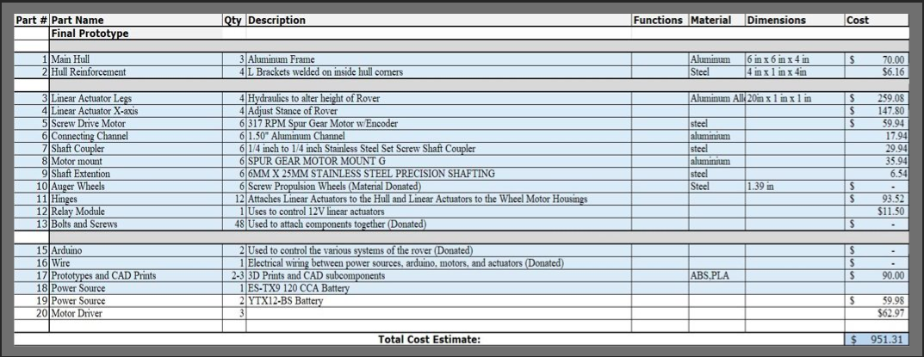
Out of the $1200 budget, the team ended up only spending $ 817.1 leaving a remaining budget of $382.9. The cost breakdown for actual components was Parts- $604.16, Electrical Components- $122.95 and Prototyping - $90. The costs associated with the manufacturing of the Rover didn’t change much over the semester and moving forward with design, for future terms, the initial budget of $1000 or $1200 was an adequate amount to fund the project.

Frame Updates and Final Physical Model
During the week of March 16th, the remaining parts (mounting hardware) arrived and the team was able to finish the construction of the frame. Upon arrival of the mounting hardware, additional supports were added to the top of the frame using a MIG welder. A base and sidewalls were created to fit the frame to support the rover components. The sidewalls were made using 1/16th inch aluminum, cut using aluminum scissors, and then mounted to the frame using sheet metal screws. Next, ¾ inch holes were cut into the side panels so the linear actuators could be properly mounted to the base. The image shown in Figure 46 represents this stage of the rover manufacturing.
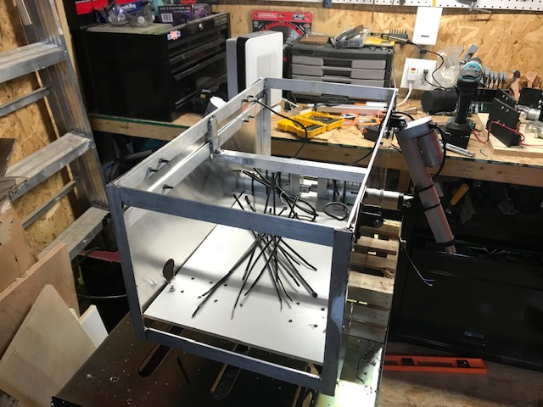
Figure 46. Updated Frame with additional supports and side panels
Prior to this time a design for the motor mounts was not established. During the same week, four motor mounts were created using the 1/4-inch wood and painted black. Measurements were taken from the motors and actuator mount and a simple schematic was created. Holes to mount the motor and actuator bracket were cut using a drill and the mounts themselves were fastened using small bolts. The assembly progression of the four motor mounts is shown in Figures 47-49.
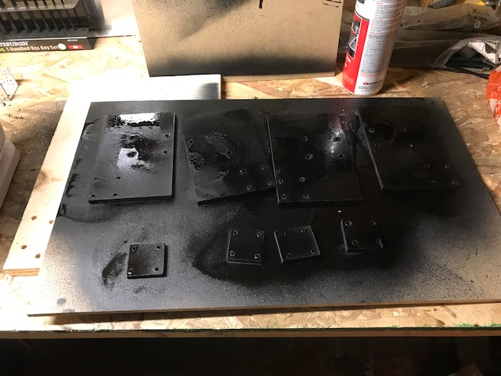
Figure 47. First completed motor mount

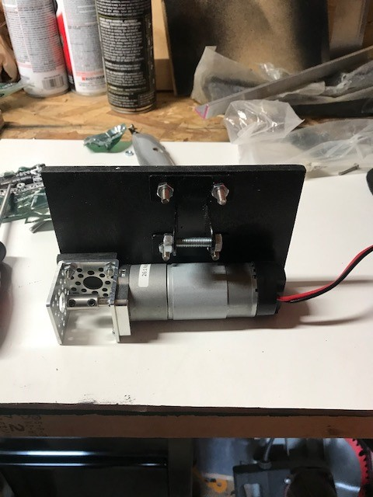
Figure 48. First completed motor mount
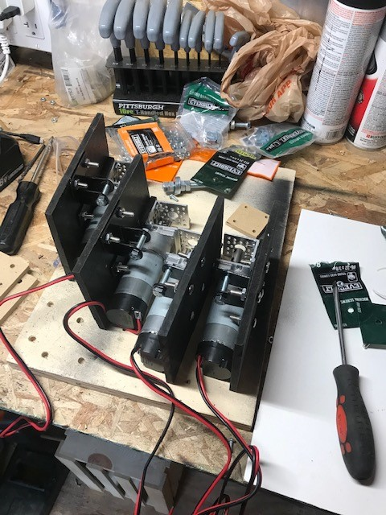
Figure 49. All motor mounts assembled

Upon completion of the motor mounts, the front end of the rover was assembled. The remaining motors and actuators were being used to test the Arduino and were not assembled to the frame during this period. Due to the changes made in the Capstone deliverables, the physical model stopped at this stage of manufacturing. The current state of the physical model is shown in Figure 50.
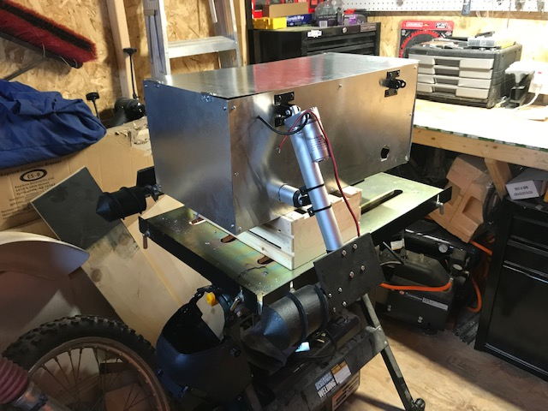
Figure 50. Current state of Rover

For the Arduino, the wiring for a linear actuator and motor using the relay module and motor shield were solidified. Individual versions of the circuit without the battery attached are shown below in Figure 51 and 52.

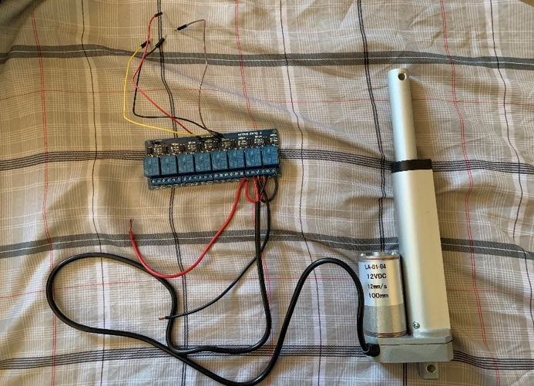
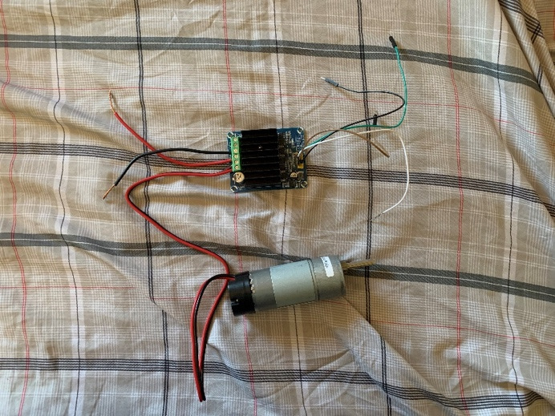

Figure 51. Linear Actuator and Relay Module Setup Figure 52. Motor Shield and Motor Setup

The relay module and motor shield have both been tested using Arduino code to ensure their functionality with the actuator and motor. This was the last stage of Arduino manufacturing prior to deliverable changes. The rest of the motors and actuators are connected to the frame and must still be connected to the circuit, as well as fuse holders for each motor to prevent burning out the Arduino board when subjected to high current. Soldered connections haven not yet been made as we still need to connect all components to the circuit.

Final Deliverables
As stated, prior, due to changes in the project plan, manufacturing was cut short and a physical model was no longer required of the team. The new deliverables required CAD renditions of the rover design. The team developed three models. A 6-wheel, 4- wheel and model of the physical design are shown in figures
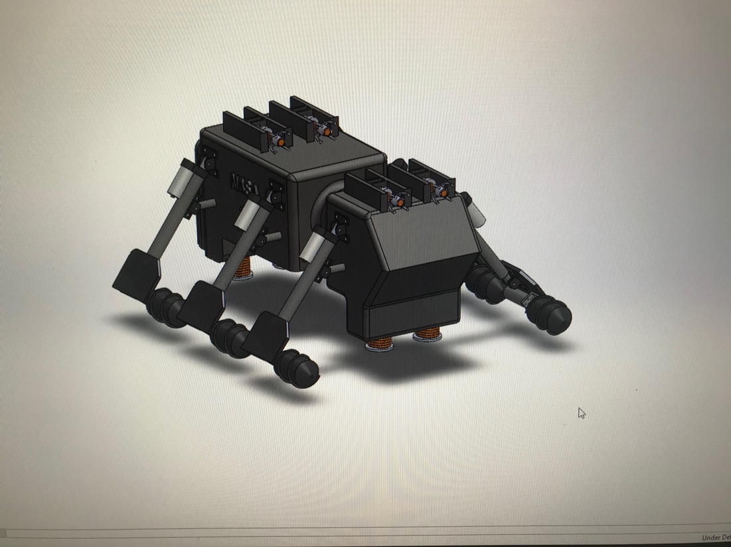
Figure 53. Final CAD 6-Wheel Psyche Design
The final design, shown in figures 53 and 54 represents the hypothetical Psyche Rover Models. This design features the electromagnet tethering system, screw drive, and uses linear actuators for arm rotation. The concept of this design did not change too much from the first semester, apart from renditions to the arm mechanisms and dimensioned parts.
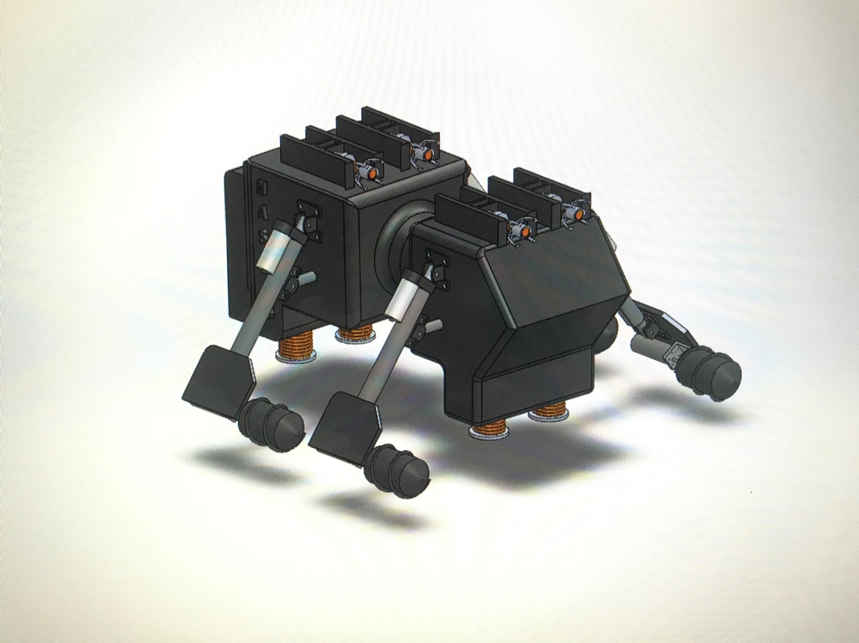
Figure 54. Final CAD 4-Wheel Psyche Design
The rover shown in Figure 55 represents the physical model of the prototyped design. This rover is a simplified version of the 4-Wheel Psyche design and is a single frame design without any tethering mechanism for the purpose of testing on the Psyche Model Surface.
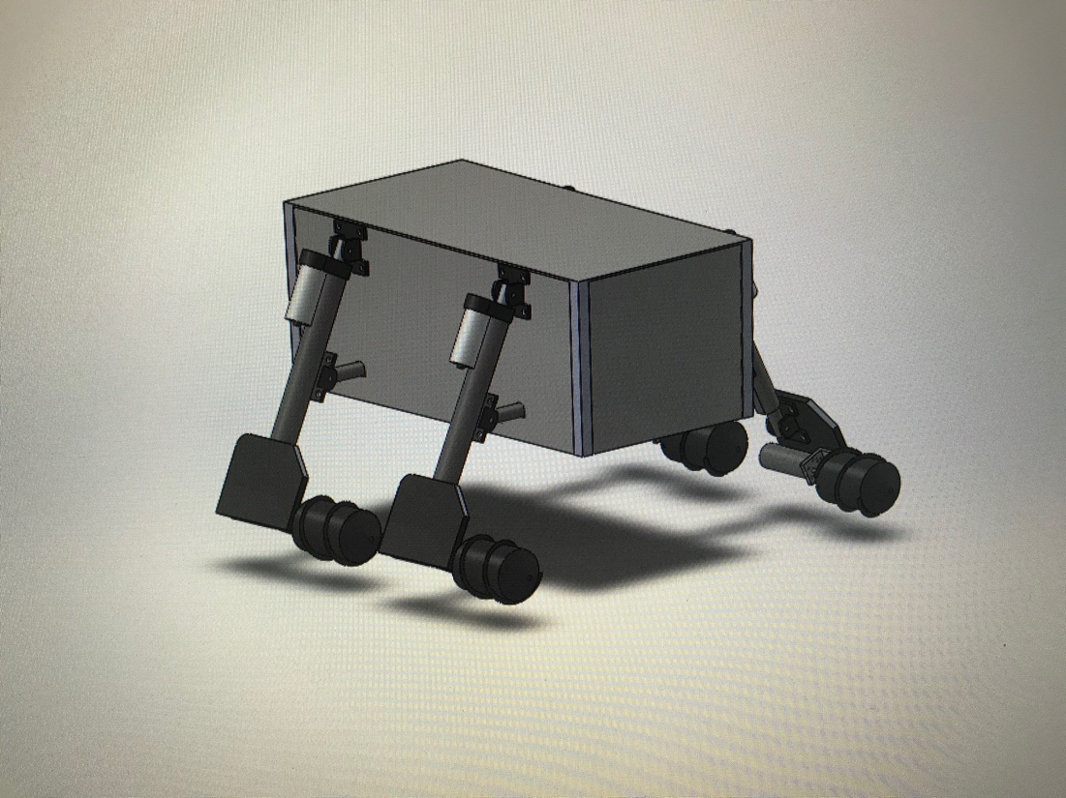
Figure 55. Final CAD Physical Design

TESTING
Due to COVID 19, testing procedures did not occur. All procedures that would have taken place are listed in Section 3 of the report.

FUTURE WORK AND CONCLUSION
The extreme environment of a place like Psyche presents some major problems during the course of a robotic explorer project. This section will focus on our innovative solutions to these problems and how our sponsor can implement these advancements in the future. First, the identification and resolution of these challenges was only possible because our sponsor empowered us to ‘learn while doing’ and trusted us to provide an innovative result. We were given access to the ASU/NASA/PSYCHE network to educate ourselves on Psyche, as well as the responsibility to execute the plans we believed best answered this call to action. With the inspiration of, one day, traversing the surface of Psyche we constructed a prototype rover that builds on traditional extraterrestrial rover technology and provides two key insights into the future of space exploration.

The most differentiating design aspect of our rover are the Archimedes screws, utilized to move along the surface of Psyche. This design was chosen to reduce tangential forces, forces pushing up on the rover, while allowing stability and maneuverability to increase. These forces are critically important on Psyche because the gravity is so minuscule, one wrong move could mean dismemberment from the surface. A drive system made up of Archimedes screws mitigates the risk of leaving the surface while permitting all the creature comforts of a traditional drive system. Additionally, our design has 4 separate drive systems, so, future iterations of this concept could mimic the traditional wheel-based system, or even crawl along surfaces while leaving the availability to almost glide onward with the screw drives. Designing this subsystem required great mechanical engineering, CAD modeling, and material science expertise as well as some trial and error in the programming department. These advantages come with one main drawback, that is, the reliability of these types of metal screws is unknown. Current generation rovers on Mars use metal wheels and they are known to disintegrate over time. With Psyche’s environment being much more extreme than Mars’s, the test of reliability will be another key factor in rover design.

As a recommendation for implementing the Archimedes screw design, we would suggest further testing with the current prototype to finetune the physical specifications of the screw designs. These models can be rapidly prototyped and tested via 3D printing, making design changes effortless as we get more information on Psyche. As mentioned above, our designs were made of strengthened 3D printed plastics but, future designs will need to be made of much stronger materials. Metal 3D printing or machining parts from aluminum are both valid solutions but we were unable to investigate this under the scope of this project. Overall, the flexibility and maneuverability allotted by this design is undeniable and successful implementation on Psyche is just a 3D print away.

Another innovative solution to keep the explorer firmly attached to Psyche’s surface was the use of a tether system. We investigated both magnetic and wire-based systems to take any advantages possible in light of Psyche’s unique characteristics. While the magnet-based system was heavily researched and partially developed, we decided to halt progress on this subsystem after new research was published stating “Although earlier observations suggested that the asteroid consists almost entirely of iron and nickel, in now appears that those metals make up only 30%-60%” of its volume, with the rest consisting of silicate rock and pore space.” [25]. Originally, the rover was expected to have electromagnets mounted to the bottom of the chassis, which could be powered on before a lift off event could even occur. Unfortunately, with a surface that is less metallic than originally planned the power usage of this system could not be justified. If a tether system is required, our recommendations are to utilize a wire-based tether to reduce power usage and usability of the subsystem.

The final outcome of the rover system consisted of three different CAD models. The hypothetical Psyche Models use a linear actuator arm mechanism mixed with the screw drive system and electromagnet tethers. The 6-WHeel and 4-Wheel design shown in Figures 53 and 54 represent the Psyche models. The physical model, described in Section 10 is shown in Figure 55, and emphasized a similar design to the hypothetical models without a tethering system and rotational center.

PROJECT SUCCESS AND AREAS OF IMPROVEMENT

Contributors to Project Success
This section of the memo includes the contributions used to achieve project success. The positive contributions included organizational tools such as the Gannt Chart, credible documentation, and the accountability of team members.
The overall purpose and goals of the project were mostly achieved as stated in the team charter. designing a robotic explorer capable of efficiently traversing the different hypothesized surfaces on the psyche asteroid. The rover was also designed, to be capable of adapting to these different terrains mid-traverse. Although we were not able to achieve any of the failsafe. Bi-weekly meetings with our client were effective in showing our progress in the project. The Gantt chart was relatively followed, while weekly action items was mostly used to organize the team. The Ground Rules and Coping Strategies stated in the Team Charter were followed. We have yet to implement any punishments, as it never had to be used. Communication was the most important thing to develop make sure all team members were helping each other. Resulting in a cohesive and efficient team, with no team members causing any offenses and punishments. The aspects of the projects that went smooth was that we documented our work well as well as having categories in our team drive where we could find this research and work. We were thorough in making sure to write down all our ideas and making sure they were clear what we were thinking.

Opportunities/areas for improvement
This section of the memo includes information on what the team could have done better to improve the scope of the project. Issues regarding communication, prototyping, and budget. A follow up analysis on improvements that can be made are listed in the end of this section.
Some things that did not run too smooth was the way we did our prototyping. We could have allotted more time to this task in order to get a higher fidelity prototype as well as having all our subsystems incorporated onto a body. As a team we did not have the best time management due to all of us taking a heavy load last semester. This meant we were doing assignments in one week instead of having it done prior allowing us to improve upon our work and thoughts. Working with a limited budget was also a problem and resulted in removing the rack and pinion design and moving to a linear actuator arm mechanism.
Prior to each assignment, the team outlined and discussed each of the required sections to validate the information being documented and ensure that all required information was there. This had a positive outcome on the overall quality and grades of the reports, memos, and presentations since we did not lose points on missing information and team members were still on the same page when working on their sections alone. For the more difficult reports, the team often stayed in the same room and/or utilized the Microsoft Teams app with its group editing features. The ability to discuss ideas with each other, ask for writing or editing tips, and format the document at the same time significantly reduced errors made and time spent editing, and allowed for a higher quality product. Having a relatively detailed budget early on helped guide the team through the design process and has allowed us to take on some challenging engineering problems that would have proved disastrous later in the semester. It also gave us a good idea of the number of parts we would need to machine or create ourselves coming into the second semester of capstone.
The largest problem the NASA Capstone team has encountered has been the budget provided by our client. This small budget paired with a lack of communication on the desired scope of the project has made it hard to design a valuable product for the client and has prevented much true innovation on the engineering problem we were tasked with solving. The first couple months of the project were hindered significantly by the lack of communication, and in hindsight it would have been best to really sit down with the client and capstone professor, flesh out a definite scope for the project agreed upon by all parties, and then begin the design process. Another major problem that has caused some inconsistencies within the team has been the organization of important project information. There were a multitude of causes for this disorganization that all compounded on top of each other to make it a challenge for the team. These causes include numerous different chat and communication apps, and a lack of valuable tools in some of these apps that allow for organization such as folders or pinned messages, etc. We did not settle on a specific app at the beginning of the year and did not start organizing files and messages early enough in the semester. Lastly, the lack of an engineering mentor with experience in spacecraft application who could give feedback during the design process has left us with multiple concepts that may not be effective in space. Without that reliable feedback throughout the design process, the ability for our team to procure an effective design was much more intensive than it needed to be and has forced us to create some late stage design changes.
Overall, the team’s greatest struggles were with communication. The app we chose to communicate with each other didn’t have the capabilities to organize conversations. This led to searching through hundreds of messages to find important information. This caused large amounts of wasted time just locating information needed to complete tasks and analyses. One way to mitigate this problem is by consolidating the important information into a single file that all team members have access to. This solution not only makes accessing important information easier but also allows team members check if they are on the same page. Another purposed solution is to switch the app used to communicate. This will allow the team to organize the conversations into channels based on the subsystem/category. This will limit the time spent tracking down conversations and information. The final purposed improvement for this semester is for the team to meet at least once per week this will give every team member a chance to voice any concerns or ideas to improve the design/manufacturing process.
Team members learned or refined skills to improve the chance of success this semester. Machining skills that multiple team members focused on were lathe, mill, welding and CNC. These skills were learned through taking the Manufacturing Processes Lab or taking the advanced machine shop trainings. These machines will be instrumental in the manufacturing of the final prototype, most of the machine will be done by team members to meet the budget required. Throughout both semesters, there were many deliverables, memos, proposals, prototypes, and a website. These deliverables are an important part of the design process and help to identify flaws and potential failures. When problems arise having concise and organized information help to mitigate the time required to fix the problem. These deliverables also act as a progress report to the client. Along with the document-oriented deliverables there was also a website. The website used html and css style coding.

REFERENCES

[1] Orisini, l. (2014). Arduino Vs. Raspberry Pi. [online] ReadWrite. Available at:
https://readwrite.com/2014/05/07/arduino-vs-raspberry-pi-projects-diy-platform/

[2] https://images-na.ssl-images-amazon.com/images/I/D1oC-c3G5TS.pdf

[3] Valeria Loscri, Nathalie Mitton, Emilio Compagnone. OpenCV WebCam Applications
in an Arduinobased Rover. International Workshop on Wireless Sensor, Actuator
and Robot Networks (WiSARN),

[4] Cassero, Sean. &quot;Design and Analysis of Arduino, Raspberry Pi, and Xbee Based
Wireless Sensor Networks.&quot; (2016): 82. Web.

[5] Nanda, Susmit K., Sourav Manna, Arup Kumar Sadhu, Amit Konar, and Diptendu
Bhattacharya. Proceedings of the 2015 3rd International Conference on Computer,
Communication, Control and Information Technology, C3IT 2015 (2015): 1-6. Web.
37

[6] S. Na, H. Ahn, Y. Lee and W. Yu, &quot;A Tethering Device for Mobile Robot Guidance&quot;,
International Journal of Advanced Robotic Systems, vol. 6, no. 2, p. 17, 2009. Available:
10.5772/6796.

[7] M. Yamazumi and M. Oda, &quot;Tether Based Locomotion for Astronaut Support Robot
Introduction of

[8] C. Bombardelli, M. Broschart and C. Menon, &quot;Bio-Inspired Landing and Attachment
System for Miniaturised Surface Modules&quot;, Proceedings of the 58th International
Astronautical Congress, 2007. [Accessed 18 October 2019].Robot Experiment on JEM&quot;,
Journal of Robotics and Mechatronics, vol. 25, no. 2, pp. 306-315, 2013. Available:
10.20965/jrm.2013.p0306.

[9] F. Xu, J. Shen, J. Hu and G. Jiang, &quot;A rough concrete wall-climbing robot based on
grasping claws&quot;, International Journal of Advanced Robotic Systems, vol. 13, no. 5, p.
172988141666677, 2016. Available: 10.1177/1729881416666777.

[10] B. Yu, L. Geng, H. Wen, T. Chen and D. Jin, &quot;Ground-based experiments of tether
deployment subject to an analytical control law&quot;, Acta Astronautica, vol. 151, pp. 253-
259, 2018. Available: 10.1016/j.actaastro.2018.06.013.

[11] Boohene, A., Newill-Smith, D., Trieu, T. and Stengel, R. (2019). Prototype for an
asteroid exploratory robot using multi-phalanx microspine grippers. [online] New Jersey
Research Community. Available at:
https://www.researchwithnj.com/en/publications/prototype-for-an-asteroid-exploratory-
robot-using-multi-phalanx-m [Accessed 19 Oct. 2019].

[12] Lotman, R. and Grima, M. (2019). Login - CAS – Central Authentication Service.
[online] Www-engineeringvillage-com.libproxy.nau.edu. Available at: https://www-
engineeringvillage-
com.libproxy.nau.edu/search/doc/abstract.url?&amp;pageType=quickSearch&amp;usageZone=re
sultslist&amp;usageOrigin=searchresults&amp;searchtype=Quick&amp;SEARCHID=e483efa7a8bf42c
49a3e5b5b17114efb&amp;DOCINDEX=1&amp;ignore_docid=cpx_535b581350b75242eM4fc520
61377553&amp;database=1&amp;format=quickSearchAbstractFormat&amp;tagscope=&amp;displayPagination=yes [Accessed 19 Oct. 2019].

[13] L. Elkins-Tanto and Psyche Science Team, “Possible Surface Characteristics of
(16) Psyche”, IEEE Standar, August 2019

[14] Matthew J. Roman, Norman, Oklahoma “Design and Analysis of a Four Wheeled
Planetary Rover,” M.S. thess, College of Eng. and Sc., University of Oklahoma, 2005

[15] Estier, T., Crausaz, Y., Lauria, M., Piguet, R. and Siegwart, R. (2019). Login - CAS –
Central Authentication Service. [online] Www-engineeringvillage-com.libproxy.nau.edu.
Available at: https://www-engineeringvillage-com.libproxy.nau.edu/search/doc/abstract.url?&amp;pageType=quickSearch&amp;usageZone=resultslist&amp;usageOrigin=searchresults&amp;searchtype=Quick&amp;SEARCHID=36b6b087cf46487facb8bf8fb94308ee&amp;DOCINDEX=1&amp;ignore_docid=cpx_b753f811bfb3c2041493b2061377553&amp;database=1&amp;format=quickSearchAbstractFormat&amp;tagscope=&amp;displayPagination=yes [Accessed 19 Oct. 2019].

[16] NASA/JPL. (2019). &#39;Hedgehog&#39; Robots Hop, Tumble in Microgravity. [online]38
Available at: https://www.jpl.nasa.gov/news/news.php?feature=4712 [Accessed 19 Oct.
2019].

[17] NASA/JPL. (2019). For Climbing Robots, the Sky&#39;s the Limit. [online] Available at:
https://www.jpl.nasa.gov/news/news.php?feature=7449 [Accessed 19 Oct. 2019].

[18] Www-robotics.jpl.nasa.gov. (2019). JPL Robotics: Research Tasks. [online]
Available at: https://www-robotics.jpl.nasa.gov/tasks/showTask.cfm?TaskID=236&amp;tdaID=700043 [Accessed 19 Oct. 2019].

[19] Sorrel, C., Sorrel, C., Rubin, P., Staff, W., Staff, W., Amit Katwala, W., Null, C. and
Gilbertson, S. (2019). ZIL-29061: Russian Screw Powered Vehicle. [online] WIRED.
Available at: https://www.wired.com/2007/07/zil-29061-russi/ [Accessed 19 Oct. 2019].

[20] Allain, R., Allain, R., Baker-Whitcomb, A., Allain, R., Molteni, M., Niiler, E., Harrison,
S., Hirad, A. and Mahon, B. (2019). The Physics of the Hendo Hoverboard. [online] WIRED. Available at: https://www.wired.com/2014/10/physics-hendo-hoverboard/ [Accessed 19 Oct. 2019].

[21] Www-robotics.jpl.nasa.gov. (2019). JPL Robotics. [online] Available at:
https://www- robotics.jpl.nasa.gov/tasks/taskVideo.cfmTaskID=206&amp;tdaID=700015&amp;Video=147 [Accessed 19 Oct. 2019].

[22] Phys.org. (2019). NASA&#39;s curiosity continues mobility checkouts. [online] Available
at: https://phys.org/news/2011-06-nasa-curiosity-mobility-checkouts.html [Accessed 19
Oct. 2019].

[23] Nasa.gov. (2019). NASA - NASA Ames Research Center Public Affairs Office.
[online] Available at:
https://www.nasa.gov/centers/ames/news/releases/2000/00images/snakebot/snakebot.
html [Accessed 19 Oct. 2019].

[24] Nsf.gov. (2019). Multimedia Gallery - Climbing Robot Stickybot (Image 5) | NSF -
National Science Foundation. [online] Available at:
https://www.nsf.gov/news/mmg/mmg_disp.jsp?med_id=72882&amp;from=search_list
[Accessed 19 Oct. 2019].

[25] collectSPACE.com. (2019). Part Time Scientists reserves rocket to land Audi moon
rovers at Apollo 17 site | collectSPACE. [online] Available at:
http://www.collectspace.com/news/news-112916a-ptscientists-moon-rover-apollo17.html
[Accessed 19 Oct. 2019].

[26] Phys.org. (2019). Lunar Outpost shows off new moon rover. [online] Available at:
https://phys.org/news/2018-11-lunar-outpost-moon-rover.html [Accessed 19 Oct. 2019].

[27 ]&quot;SCREW PROPELLED VEHICLES&quot;, Unusuallocomotion.com, 2019. [Online].
Available: http://www.unusuallocomotion.com/pages/locomotion/screw-propelled-
vehicles.html. [Accessed: 19- Oct- 2019].

[28 ]&quot;Small Remotely Operated Screw-Propelled Vehicle&quot;, Link-springer-
com.libproxy.nau.edu, 2019. [Online]. Available: https://link-springer-39 com.libproxy.nau.edu/chapter/10.1007%2F978-3-319-15847-1_19. [Accessed: 19- Oct-
2019].

[29] &quot;Design and analysis of a novel multifunctional screw-propelled vehicle&quot;, Ieeexplore-
ieee-org.libproxy.nau.edu, 2019. [Online]. Available: https://ieeexplore-ieee-
org.libproxy.nau.edu/document/8278363. [Accessed: 19- Oct- 2019].

[30] &quot;Screw-Powered Propulsion in Granular Media: An Experimental and Computational
Study&quot;, Ieeexplore-ieee-org.libproxy.nau.edu, 2019. [Online]. Available: https://ieeexplore-
ieee-org.libproxy.nau.edu/document/8460916. [Accessed: 19- Oct- 2019].

[31] &quot;Conceptual design of tetrad-screw propelled omnidirectional all-terrain mobile robot&quot;,
Ieeexplore-ieee-org.libproxy.nau.edu, 2019. [Online]. Available: https://ieeexplore-ieee-
org.libproxy.nau.edu/document/7935033. [Accessed: 19- Oct- 2019].

[32] T. P. Setterfield and A. Ellery, “Terrain Response Estimation Using an Instrumented
Rocker-Bogie Mobility System,” IEEE Transactions on Robotics, vol. 29, no. 1, pp. 172-
188, 2013 [Abstract]. Available: IEEE Xplore, https://ieeexplore-ieee-
org.libproxy.nau.edu/document/6355701. [Accessed: 16-Oct- 2019]

[33] J. H. Lugo, V. Ramadoss, M. Zoppi, et al, “Conceptual design of tetrad-screw
propelled omnidirectional all-terrain mobile robot,” 2017 2nd International Conference
on Control and Robotics Engineering, 2017 [Abstract]. Available: IEEE Xplore,
https://ieeexplore-ieee-org.libproxy.nau.edu/document/7935033 [Accessed: October 16,
2019]

[34] Banas, T. (2017). How to Calculate the Force of an Electromagnet. [online] Sciencing. Available at:
https://sciencing.com/calculate-force-electromagnet-5969962.html [Accessed 15 Nov. 2019].

[35] https://psyche.asu.edu/mission/faq/

[36]"NASA Technical Standards | NASA Technical Standards System (NTSS)", Standards.nasa.gov, 2019. [Online]. Available: https://standards.nasa.gov/nasa-technical-standards. [Accessed: 16- Nov- 2019].

[37] IEEE Guide for AC Motor Protection. C37.96. 2012

[38] Space Engineering – Electromagnetic Compatibility. DS/EN 16603-20-07

[39] Automobile and Motor Coach Wiring. SAE J1292. 2016.
[40 EWIS Wiring Insulation Breakdown Testing. SAE ARP6216. 2017

[42] Worm Gears - Worm Profiles and Gear Mesh Geometry. ISO TR 10828. 2015.

[43] UL Standard for Safety Servo and Stepper Motors. UL 1004-6. 2017.

[44] Standard for Rotating Electrical Machines - General Requirements. UL 1004-1. 2018.

[45] Ball Joints. SAE J490. 2012.

[46] Space Engineering – Space Environment. DS/EN 16603-10-04. 2015.

[47] Robots and Robotic Devices – Collaborative Robots. ISO TS 15066. 2016.

APPENDICES

Appendix A:

Project Schedule

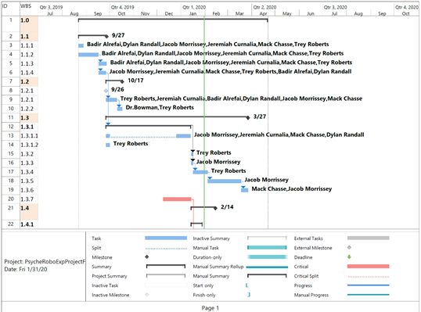
Figure 56. Schedule for Fall Semester 2019 & Start of 2020

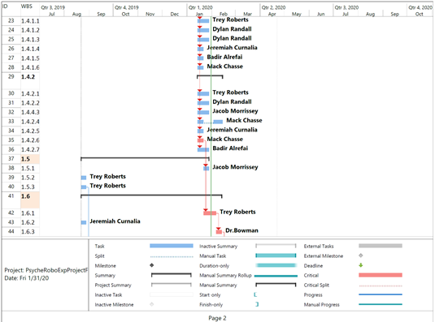
Figure 57. Continuation of Schedule for Spring Semester 2020

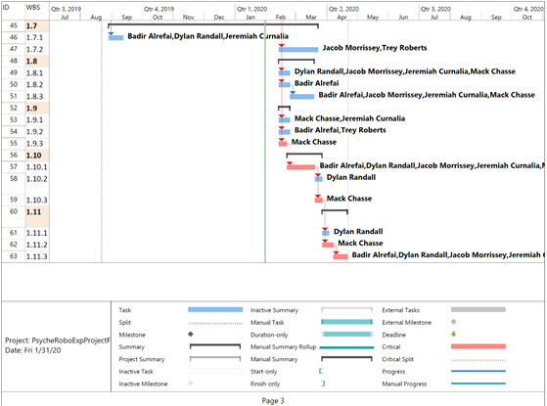
Figure 58. Continuation of Schedule for Spring Semester 2020

Work Breakdown Structure Dictionary
Table 19. Structure Dictionary

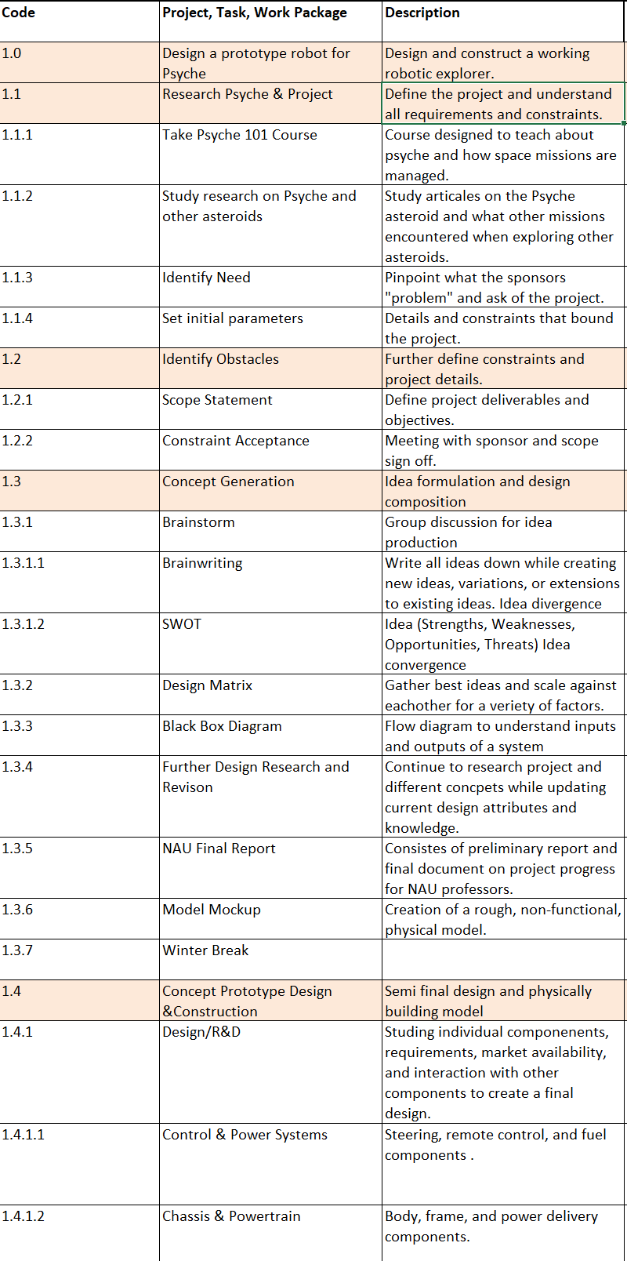

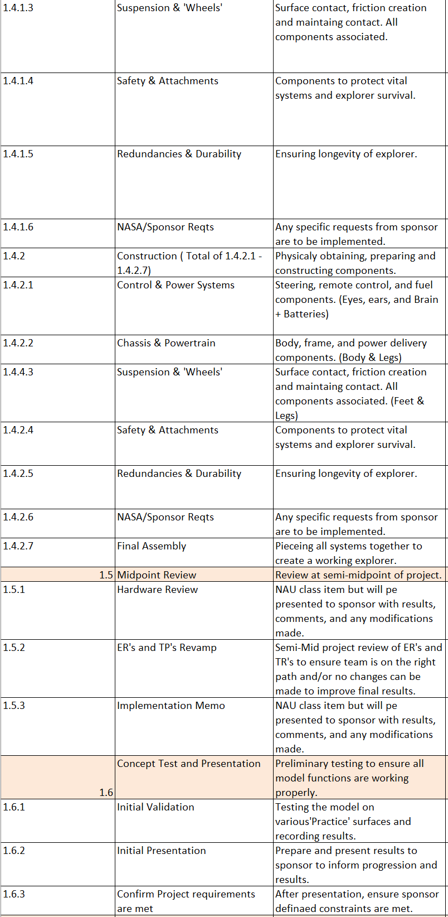
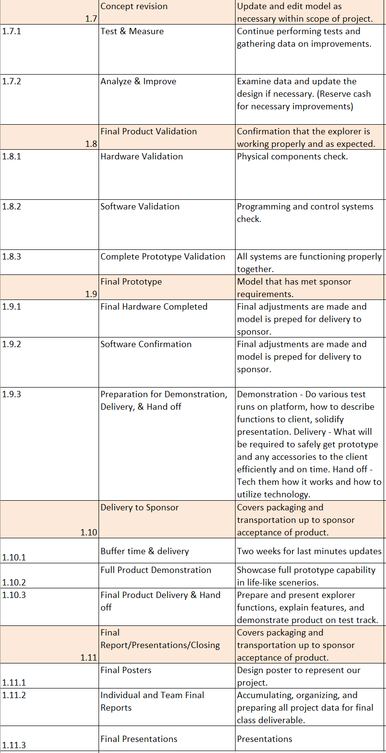

Appendix B: CAD Electromagnet Dimensions
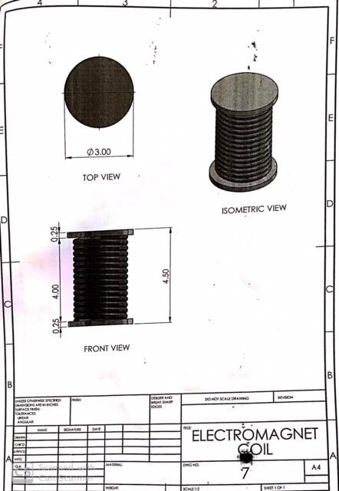
Figure 58. CAD Drawing of Electromagnet Coil

