Hydraulic Demonstrator

Preliminary Report

Team member names:
Mosaed Aljebly
Fawaz Alenezi
Sultan Alenezi
Cal Skilsky

2017-2018

Project Sponsor: Northern Arizona University.
Client: David Trevas
Instructor: David Trevas

TABLE OF CONTENTS

TABLE OF CONTENTS 2
BACKGROUND 4
Introduction 4
Project Description 4
REQUIREMENTS 4
Customer Requirements (CRs) 5
Engineering Requirements (ERs) 5
EXISTING DESIGNS 6
Design Research 6
System Level 6
Existing Design #1: Hydraulics Training System (FESTO) 6
Existing Design #2: Hydraulic Training Systems (Parker) 7
Existing Design #3: Electro-Hydraulic Trainer (Qoura) 8
Functional Decomposition 9
Black Box Model 10
Functional Model/Work-Process Diagram/Hierarchical Task Analysis 10
Subsystem Level 11
Subsystem #1: Hydraulic Pump and Oil Tank 11
Existing Design #1: Hydraulic vs. Electric Motor 11
Existing Design #2: Gear Pump Test rig 12
Existing Design #3: Labvolt Hydraulics system 13
Subsystem #2: Trainer Kit with Valves 13
Existing Design #1: Hydraulic Accumulator 14
Existing Design #2: Pressure control valves 14
Existing Design #3: Flow control valves 15
Subsystem #3: PID controller 15
Existing Design #1: Manual Control 16
Feedback Control 16
Control Loop 16
Existing Design #2: Automatic Control 16
DESIGNS CONSIDERED 18
Design #1: The pump and motor design 18
Design #2: Driving Motor Schematic Diagram 19
Design #3: Connections and valves 20
DESIGN SELECTED – First Semester 21
Rationale for Design Selection 21
REFERENCES 22

- BACKGROUND

  - Introduction
The problem of lifting heavy objects has gained great importance in industrial applications. Engineers have found several ways to lift heavy objects by having a higher force at the output than what is required at the input. The most effective method in mechanical applications is the hydraulic actuator, where hydraulic cylinders are used to gain a lot of force. This method enhances the way of moving objects in large and medium sized industrial applications, whereas in smaller size applications the use of electrical motors is still preferred. [1]

  - Project Description
This project entails the design of hydraulic demonstration units to be used in laboratories. This unit consists of a fluid reservoir, pump, pressure safety valve (PSV) and various diameter cylinders. The pressure in the cylinders and the forces of the pistons are to be measured and recorded electronically.

The design of this bench sized unit and its components will be discussed in detail. A manual will be written to describe the assembly and operation of the unit. The manual should contain lab procedures for the students to learn about hydraulic components and apply Pascal’s Principle.

Many other additions can be made to the project if time and budget permit. This includes adding an accumulator to store energy and smooth out the motion, installing a hydraulic motor to get rotary motion and torque from the system, adding an electronically-controlled on-off valve to control basic motion, and installing a proportional valve to do closed loop motion control using PID (proportional-integral-differential) control schemes.

- REQUIREMENTS

This project involves the design of an educational training system. The proposed system should be easy to use and contain sufficient training experiments. The design requirements should meet both customer requirements (CRs) and Engineering requirements (ERs).

  - Customer Requirements (CRs)
The hydraulic trainer is to be designed and developed according to the teaching outline of the thermal-fluids laboratory, in combination with requirements of vocational training and professional study in the hydraulics industry.
Specifically, the designed module should be bench sized and be stable in order to be used easily in a laboratory. It should not be very heavy so it can be moved easily. While under operation, its vibrations should not exceed acceptable limits and the sound level should be low. Above all, this unit must be safe for all users.

  - Engineering Requirements (ERs)
This project includes many engineering requirements that must be satisfied. Based on the customer requirements, the key engineering requirements involve the unit’s safety. Every part of the unit must be designed to withstand the maximum pressure. In addition, each component should be securely fastened to the frame. The next important customer requirement is portability. The weight must be under 300 pounds, the height must be less than 6 feet, and the width must be less than 4 feet. In addition, the unit must be able to roll while remaining stable.

- EXISTING DESIGNS

The hydraulic trainer system is found in hydraulic laboratories and hydraulic industries. Its functions may vary according to the required application and the desired goals of the system. This chapter reveals the design research of existing hydraulic trainers, which includes the system levels that address the requirements of this project.

  - Benchmarking
The research for hydraulic system designs leads to several areas in which hydraulic trainers are used, which include laboratory use and industrial use. The resources of the designs are mainly internet websites, literature review, and an examination of a similar system in a university's engineering laboratory. From what our team has researched, we have concluded that there are certain benchmarks that make a hydraulics unit effective. First, the unit must have many functions to allow for different design circuits. It is optimal that there are single acting cylinders and double acting cylinders so The user can experience one direction and two direction hydraulic action. The more options the user has, the better. Also, the unit has to be user friendly. This means it should be easy to connect new hydraulic circuits and record data. In addition, the hydraulic fluid used must have a high bulk modulus so energy isn't lost into compressing the liquid. The following systems have been researched and are the current state of the art.

  - System Level

In this section, three hydraulic systems are mentioned in detail. The similarities between this project and these three systems are mentioned.

    - Existing Design #1: Hydraulics Training System (FESTO)

The Hydraulics Training System by FESTO is part of a modular program in hydraulics and its applications. The Hydraulics Training System answers the needs of students in technical institutes, vocational colleges, university engineering departments, as well as in industry. [10]

The training system encourages hands-on learning and is a great addition to any hydraulics lab. The training program is divided into the following subsystems: Hydraulics Fundamentals, Electrical Control of Hydraulic Systems, Hydraulics Applications – PLC (programmable logic controller), Troubleshooting Hydraulic Circuits, Servo Control of Hydraulic Systems, and Sensors. In Hydraulics Fundamentals, students are introduced to the basic principles and components of hydraulics. Electrical Control of Hydraulic Systems covers electrical control of hydraulic systems with ladder diagrams. Hydraulics Applications – PLC expands upon the others with hydraulics applications controlled by PLCs. In Servo Control of Hydraulic Systems, students are introduced to servo-controlled hydraulic systems and their associated circuitry.

In Troubleshooting Hydraulic Circuits, students develop their skills in troubleshooting. In Sensors, students are introduced to the operating characteristics of six types of photoelectric and proximity sensors. Most electrical components of the subsystem Electrical Control of Hydraulic Systems can also be used with the Pneumatics Training System, Model 6081, allowing interconnection of the systems to perform more complete functions.
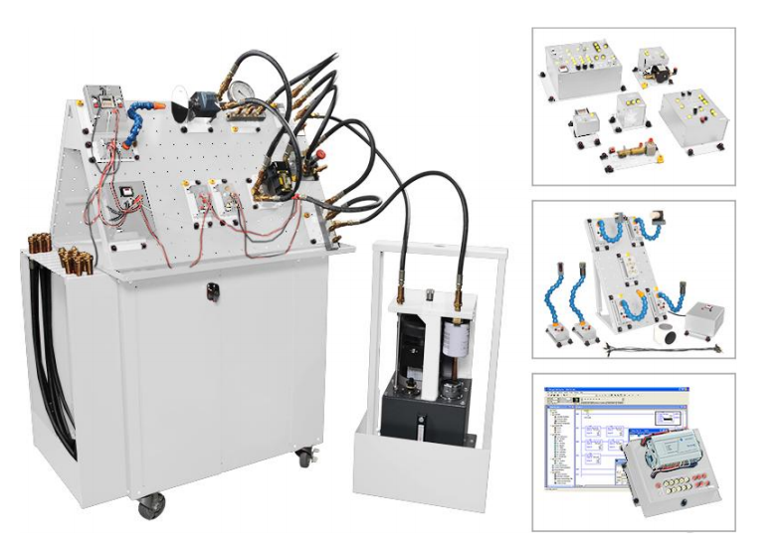
Figure 1: Hydraulic Training System – FESTO [10]

Although this design is very complex and gives many functions that exceed the aim of our design, it is helpful to use it as a reference and benefit from it in our design.

    - Existing Design #2: Hydraulic Training Systems (Parker)
The Modular Hydraulic Training System is a flexible training platform to accommodate the user’s needs and budget. Learning Modules are available for all motion & control training technologies. Two Vertical Panels (PSKBB) can be purchased and mounted back-to-back for multiple working stations. The Vertical Panel can also be purchased individually and placed onto a secure horizontal surface. The Storage Cart (PSK9T66) rolls beneath the Modular Frame (PSKMF) for easy storage or can be rolled into the classroom to support a visual learning experience. All 13 Hydraulic Hoses (PSK20607) are equipped with flush face leak-free couplers. The horizontal surface of the Modular Frame incorporates a Manifold (PSK20600) that connects to the Power Unit (PSKFPU). The Manifold provides multiple pressure, tank and drain ports for convenient connection to the learning modules. The Modular Frame and Power Unit are mounted on casters that enable the units to be easily relocated to another training location or stored for shared facility usage. [6]

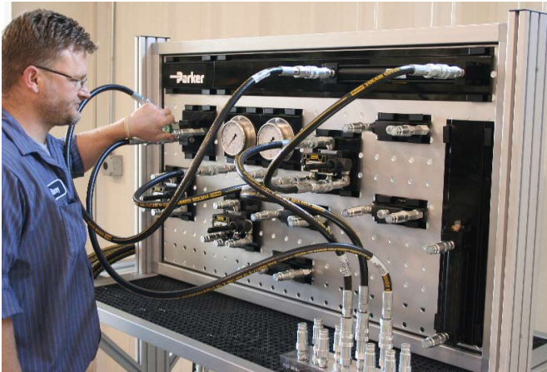
Figure 2: Hydraulic Training System – Parker [6]

The system shown is an industrial system with many applications. It will be useful to incorporate some of these functions in our design, including its user-friendly layout and its simplicity.

    - Existing Design #3: Electro-Hydraulic Trainer (Qoura)
This training device uses an operating board with an open structure. Any hydraulic component can be installed in the operation board and can be connected with the hydraulic pressure tube between components. The quick-change connector of the hydraulic hose makes training experiments efficient and safe. [3]

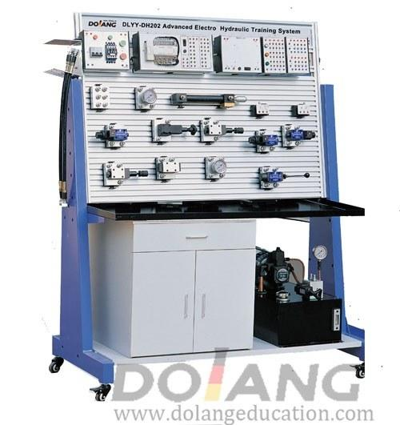
Figure 3: Electro-Hydraulic Training System – Qoura [3]

The system shown is an extended educational system with many applications, including hydraulic and electro-hydraulic circuits. Our device will include the essential components of this device and will have a similar layout.

  - Functional Decomposition

In engineering design, all products have some intended reason behind their existence: the product function. Functional modeling provides a useful method for understanding and representing an overall product or artifact function. In this project the main function of the trainer is to provide the trainee with the most effective and reliable training, depending on suitable experiments that can be exercised using the trainer. [8]

    - Black Box Model
The black box model of this project shows both the inputs and outputs for the project. The inputs are mainly the manual or automatic motion of driving wheel whereas the output is the required position. Using feedback signal, the input is then can be changed to meet the desired output.

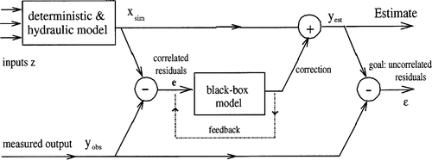
Figure 4: Black Box model

    - Functional Model/Work-Process Diagram/Hierarchical Task Analysis

The following diagram shows a functional model diagram for the proposed project. This model is essential in our teamwork since it enhances the understanding of the designed equipment and it shows how each component in the system interacts with other components.
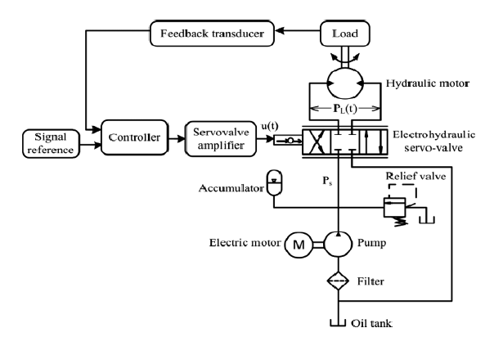
Figure 5: Functional Model Diagram [8]

  - Subsystem Level
The hydraulic system contains many subsystems that, when integrated all together, drive the overall system. These subsystems include the hydraulic pump and the oil tank, the trainer kit with all the required valves and sequences, and the control unit including the data acquisition and the PID controller.

    - Subsystem #1: Hydraulic Pump and Oil Tank
This subsystem is crucial to the overall system since it drives the working fluid inside the hydraulic system. In order to circulate the oil we need a circulating pump which must produce sufficient pressure to handle the high pressure of the system. The pump needs to be driven using an electric motor. The following types of pumps and oil tank are already found in real hydraulic systems.

      - Existing Design #1: Hydraulic vs. Electric Motor

Some hydraulic systems use hydraulic motors while other use electric motors, this depend on the nature of the system and the type of application.
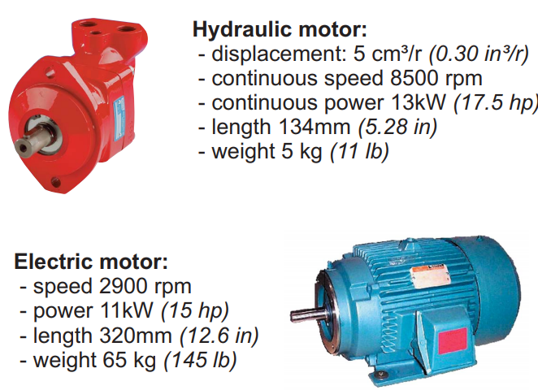

Figure 6: Hydraulic vs. Electric Motor [3]

      - Existing Design #2: Gear Pump Test rig
The gear pump test rig is designed for performance analysis of a hydraulic gear pump at different delivery pressures. The test rig consists of a gear pump driven by an electric motor. The pump draws oil from an oil reservoir and the delivery pressure is controlled by a valve.
Measuring instruments are provided to measure Suction & delivery pressure, oil flow rate & power consumption of the motor.
Experimental Capabilities:
- Study Gear pump performance at different delivery heads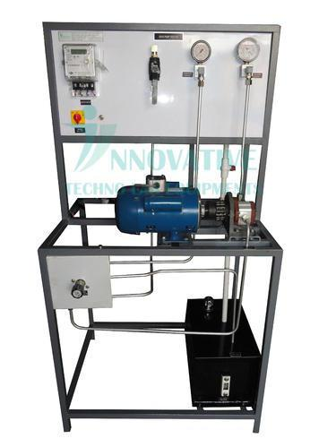
- Determination of gear pump efficiency & its performance characteristics
Specifications:
- Gear Pump: Input Power - 1 hp, Flow – 7 to 9 LPM (Max.)
- Electric Motor: 1 hp, 230 V AC
- Sump Tank: 20 Ltrs
- Oil Flow Measurement
- Pressure Relief Valve
- Digital Wattmeter
- Glycerin Filled Pressure Gauge
- Vacuum Gauge
- Hydraulic Seamless Piping with Oil Filter
- Base Frame: Made in M.S. Square Tubes, Powder coated.
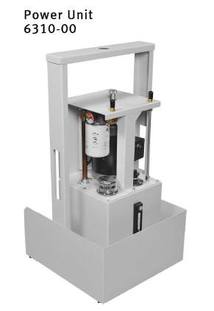
      - Existing Design #3: Labvolt Hydraulics system

The Power Unit consists of an electric drive motor coupled to a fixed displacement gear-type hydraulic pump, an oil reservoir, and an oil filter with pressure drop indicator. A built-in pressure relief valve limits the maximum pump outlet pressure to 6200 kPa (900 psi). The Power Unit is provided with a lifting frame that allows the Power Unit to be raised and lowered hydraulically, using either of the Cylinders.

The specifications of the previous system are as follows:
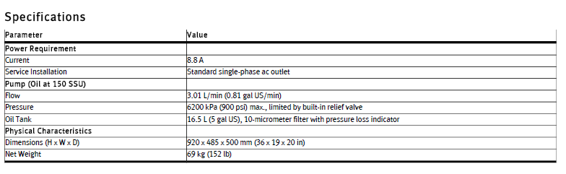

    - Subsystem #2: Trainer Kit with Valves
This is the frame where all valves and connections are fixed, the frame can have many shapes but the basic hydraulic components are similar. In this section the main hydraulic components are listed.

      - Existing Design #1: Hydraulic Accumulator

A hydraulic accumulator is a pressure storage reservoir in which a non-compressible hydraulic fluid is held under pressure that is applied by an external source. The external source can be a spring, a raised weight, or a compressed gas. An accumulator enables a hydraulic system to cope with extremes of demand using a less powerful pump, to respond more quickly to a temporary demand, and to smooth out pulsations. It is a type of energy storage device.
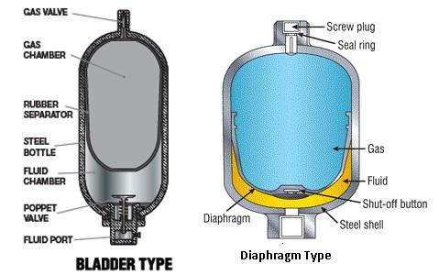

Figure 7: Hydraulic Accumulator [2]
      - Existing Design #2: Pressure control valves

Pressure-control valves are found in virtually every hydraulic system, and they assist in a variety of functions, from keeping system pressures safely below a desired upper limit to maintaining a set pressure in part of a circuit. Types include relief, reducing, sequence, counterbalance, and unloading. All of these are normally closed valves, except for reducing valves, which are normally open. For most of these valves, a restriction is necessary to produce the required pressure control. One exception is the externally piloted unloading valve, which depends on an external signal for its actuation.
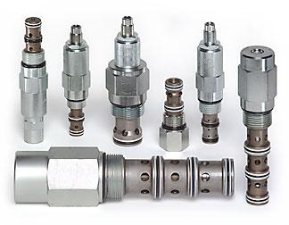
Figure 8: Pressure Valves [5]

      - Existing Design #3: Flow control valves
Flow-control valves include simple orifices to sophisticated closed-loop electro-hydraulic valves that automatically adjust to variations in pressure and temperature.
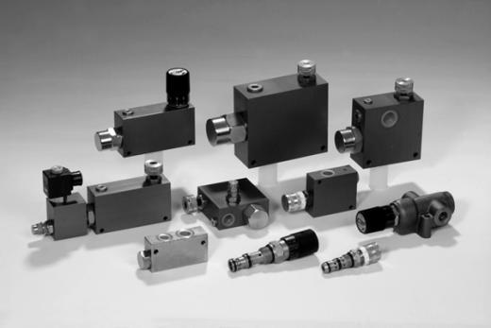
Figure 9: Flow control Valves [5]

    - Subsystem #3: PID controller

PID controllers are named after the Proportional, Integral and Derivative control modes they have. They are used in most automatic process control applications in industry. PID controllers can be used to regulate flow, temperature, pressure, level, and many other industrial process variables.

      - Existing Design #1: Manual Control
Without automatic controllers, all regulation tasks will have to be done manually. For example: To keep constant the temperature of water discharged from an industrial gas-fired heater, an operator will have to watch a temperature gauge and adjust a fuel gas valve accordingly (Figure 1). If the water temperature becomes too high for some reason, the operator has to close the gas valve a bit – just enough to bring the temperature back to the desired value. If the water becomes too cold, he has to open the gas valve.

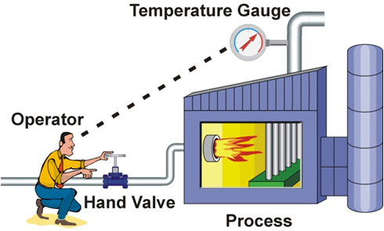
Figure 10: PID Manual Control [6]

Feedback Control
The control task done by the operator is called feedback control, because the operator changes the firing rate based on feedback that he gets from the process via the temperature gauge. Feedback control can be done manually as described here, but it is commonly done automatically, as will be explained in the next section.

Control Loop
The operator, valve, process, and temperature gauge forms a control loop. Any change the operator makes to the gas valve affects the temperature which is fed back to the operator, thereby closing the loop.

      - Existing Design #2: Automatic Control

To relieve our operator from the tedious task of manual control, we should automate the control loop. This is done as follows:
- Install an electronic temperature measurement device.
- Automate the gas valve by adding an actuator (and perhaps a positioner) to it so that it can be driven electronically.
- Install a controller (in this case a PID controller), and connect it to the electronic temperature measurement and the automated control valve.
A PID controller has a Set Point (SP) that the operator can set to the desired temperature. The Controller’s Output (CO) sets the position of the control valve. And the temperature measurement, called the Process Variable (PV) gives the controller its much-needed feedback. The process variable and controller output are commonly transmitted via 4 – 20mA signals, or via digital commands on a Field bus.
When everything is up and running, the PID controller compares the process variable to its set point and calculates the difference between the two signals, also called the Error (E).
Then, based on the Error and the PID controller’s tuning constants, the controller calculates an appropriate controller output that opens the control valve to the right position for keeping the temperature at the set point. If the temperature should rise above its set point, the controller will reduce the valve position and vice versa.

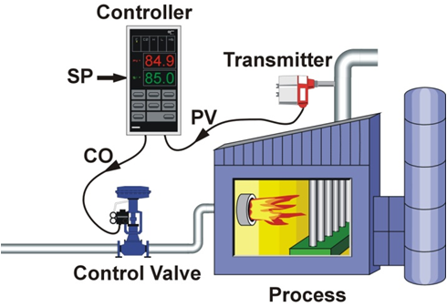
Figure 11: PID Automatic Control [6]

- DESIGNS CONSIDERED

The design consideration for this project is actually simple because the main kit is simple while all other valves and components are attached to the frame. The motor and the pump are coupled together with a suitable coupling to minimize friction losses and fixed on a movable trolley that enables the movement of them.

  - Design #1: The pump and motor design

In this section the design of both the pump and motor is shown, note that this design is typical for this kind of design.
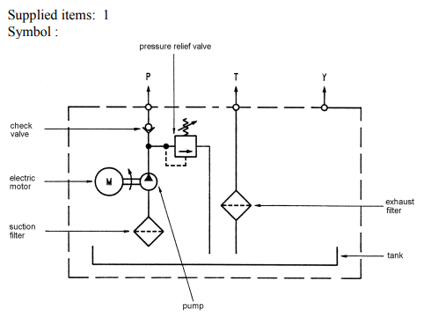
Figure 12: Pump and Motor

  - Design #2: Driving Motor Schematic Diagram

The design of the driving motor along with the pump is drawn schematically in the following figure, the figure represents the main features of the motor with its drawings.

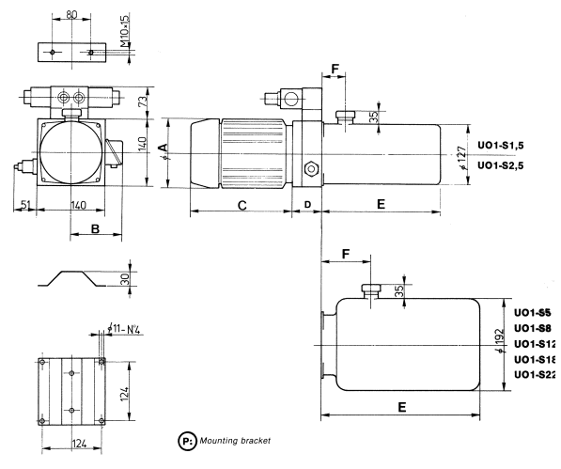
Figure 13: Schematic diagram for driving motor

  - Design #3: Connections and valves

The design of the component circuit is shown in the following figure; the figure shows the basic design for each pressure and flow valve with the operating cylinders.
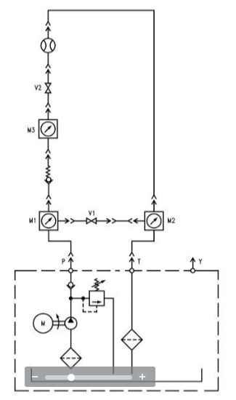
Figure 14: Connections and Valves

- DESIGN SELECTED – First Semester

The design selected for our work is the essential design of hydraulic trainers; it consists of a moving pump and motor.

  - Rationale for Design Selection
According to the previous designs shown in Chapter 4, we have chosen a set of design combinations in order to obtain the optimal design according to the available budget and facilities, the proposed design should meet the design requirements discussed earlier in this report.

- REFERENCES

[1] Principles of Hydraulic Systems Design, 2nd Edition, 2014.

[2] Oil Hydraulic Systems : Principles and Maintenance, 1st Edition, 2002.

[3] http://www.cesindustries.com/hydraulics

[4] http://www.tctrainers.com/basic_hydraulic_trainer.html

[5] http://www.boshhrexroth.com/hydraulic-training-systems

[6] http://www.parker.com/

[7] http://www.womack-machine.com/

[8]https://engineering.purdue.edu/EPICS/k12/resources/1.20%20Teacher%20Toolbox-%20Functional%20Decomposition.pdf

[9] Electronica Venitta Training Manual/ Hydraulics

[10] FESTO Training Systems, FESTO Company, Hydraulics.

[11] GUNT training manual- Hydraulic System.

