Flight Components Test Fixture
Assembly and Operation Manual

By:
Israel Sotelo
Alexandra Spotts
Shanna Lechelt
Abdulaziz Alzaid

ME-486C
Group: 4B

Instructor: Dr. Sarah Oman
TA: Amy Swartz

Submitted towards partial fulfillment of the requirements for
Senior Capstone Mechanical Design
November 30, 2018

Department of Mechanical Engineering
Northern Arizona University
Flagstaff, AZ 86011

Table of Contents
1. Introduction 4
2. Background 4
3. Assembly 4
3.1. Required Tools 4
3.2. Physical Requirements 4
3.2.1. Universal Flooring (Shanna) 4
3.2.2. Power 4
3.2.3. Water 4
3.2.4. Compressed Air 4
3.3. Test Fixture Components and Assembly 5
3.3.1. Fixture Structure 5
3.3.2. Fixture Bill of Materials 5
3.3.3. Schematics and Assembly 5
3.3.4. Hydraulic Ram 6
3.3.5. Heat Lamp Schematics 6
3.3.6. Fixture Hardware 7
3.4. Flight Component Assembly 7
3.4.1. Flight Component Interfacing 7
3.4.2. Subject Hardware 8
3.5. User Interfacing 8
3.5.1. Sensors 8
3.5.2. Actuators 8
3.5.3. Data Acquisition and Control 8
4. Operation 9
4.1. Application of Mechanical Loading 9
4.1.1. Optimal Mechanical Loading 9
4.2. Application of Thermal Loading 9
4.2.1. Optimal Thermal Loading 9
5. Preventative Maintanence 9
5.1. Maintanence Schedule 9
5.2. Inspections 9
5.3. Hardware Replairs 9
6. Safety 9
7. Troubleshooting 10
7.1. Common Issues 10
7.2. FAQ 10
References 11

Introduction
The purpose of this manual is to aide in the construction, operation, and maintenance of the team’s aerospace test fixture. The test fixture is designed to test missile radomes and leading edges for flight by applying mechanical and thermal loading. The information contained within this document is intended to ensure safe and effective operation and assembly of the fixture. It includes all necessary physical requirements of the system, such as floor bolt pattern, power, water, and air requirements. Schematics of the system and assembly instructions have been discussed as well. Lastly, this manual will include maintenance and troubleshooting for any problems that may occur.

Background
This test fixture was intended to be used to test various aerospace components for mechanical and thermal loads simultaneously. These will be applied using quartz heat lamps and a hydraulic ram. The test fixture was designed to test a wide variety of parts of varying geometry. Part adaptors not included, as they will differ with each component that is tested.

Assembly
The following section describes the steps necessary to assemble the test fixture, as well as physical requirements and required tools.

3.1 Required Tools
Table 1 describes the tools that are required for assembly.

Table 1: Necessary Tools
Tool | Size
Impact Wrench | 5/8” socket
Box Wrench | 5/8”
Box Wrench | ½"
Phillips Head Screwdriver | Medium
Forklift | N/A

The fixture does not include any specialized tools required to attach specific missile test parts.

3.2. Physical Requirements

Universal Flooring
The gridded flooring on which the fixture will be assembled and fixed to consists of 5/8” tapped holes with 6” spacing between each hole. The hydraulic ram and each leg of the fixture frame must be securely fastened to the floor grid.

2 Power
19-pin connector on the heater cover will be connected to junction box and the same kind of cable will be connected to power controllers for each heater

3.2.3 Water
Connect ½" water lines with two tubes one for inlet and one for outlet for each heater used, all inlet tubes will be connected to the water pump to a tank of 40-gallon capacity and all the outlet tubes will be connected to other tank with the same capacity. The water can be used again but the water temperature should be at room temperature.

Compressed Air
½" air lines connect to regenerative blower after the test is done to start the cooling process

Test Fixture Components and Assembly

Fixture Structure
Figure 1 shows the fully assembled system.

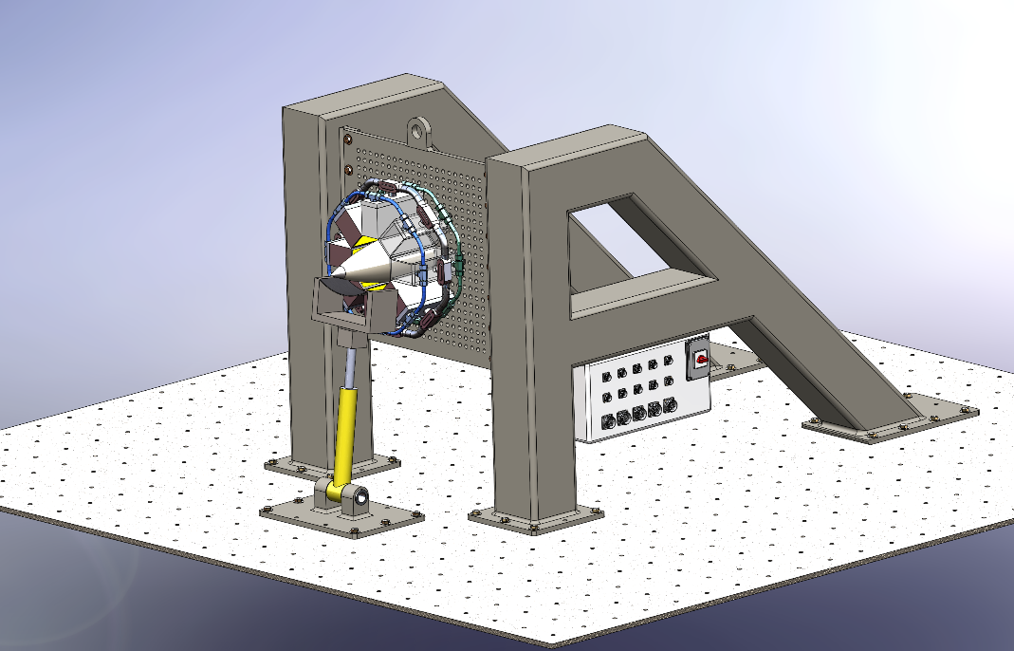
Figure 1: Full System

Fixture Bill of Materials
Table 2 shows the parts included in the fixture.
Table 2: Bill of Materials for Assembly
Part | Quantity
Left A-Frame | 1
Right A-Frame | 1
Universal Plate | 1
5/8” Bolts | 56
5/8” Washers | 56

Schematics and Assembly
Step 1. First, set the right A-Frame in place. Next, center bolt holes in desired position. Next, bolt in place. Refer to Figure 2.
Figure 2: Step 1
Step 2. Similar to Step 1, set the left A-Frame in place. Ensure the distance between the frames is the same as the width of the universal plate. Next, center the bolts and bolt them in place. Figure 3 shows what the system should look like after Step 2.

Figure 3: Step 2
Step 3. Center the universal plate between the two A-Frames and ensure the bolt holes line up with the holes on each A-Frame. Bolt in place. Refer to Figure 4.

Figure 4: Step 3

Hydraulic Ram
The hydraulic ram should be positioned in front of the test fixture. Center the holes and attach the 5/8” bolts. Ensure that the hydraulics touch the radome at the desired position.

Heat Lamp Schematics
Figure 5 shows one of the quartz lamps individually. The number of lamps that will be attached will vary depending on the size of the part being tested. Each lamp has power, water, and compressed air lines that must be attached. Refer to the operation manual of the lamps for assembly instructions.
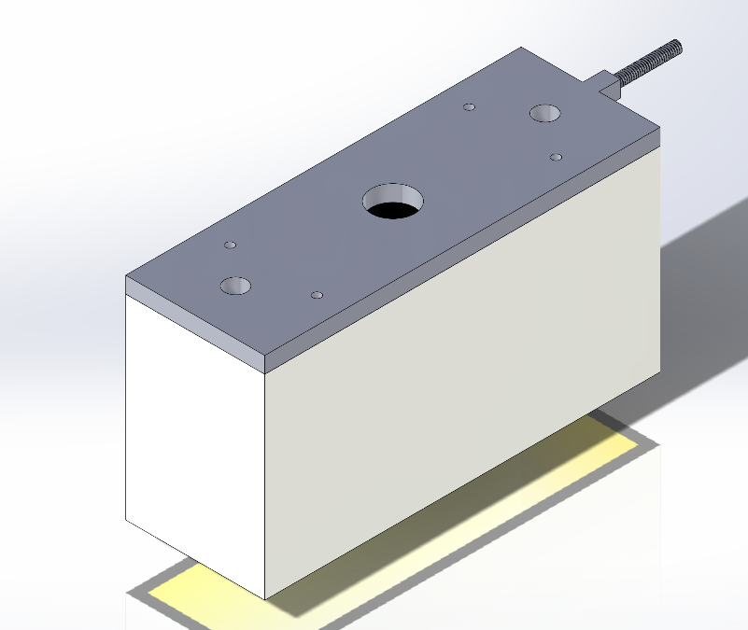
Figure 5: Quartz Lamp with Attachment
Figure 6 shows one possible orientation for the radome and lamps. The number of lamps will depend on the size of the missile part. Ensure that the quartz lamps are nearly touching and are only 1-2 inches from the surface of the radomes.
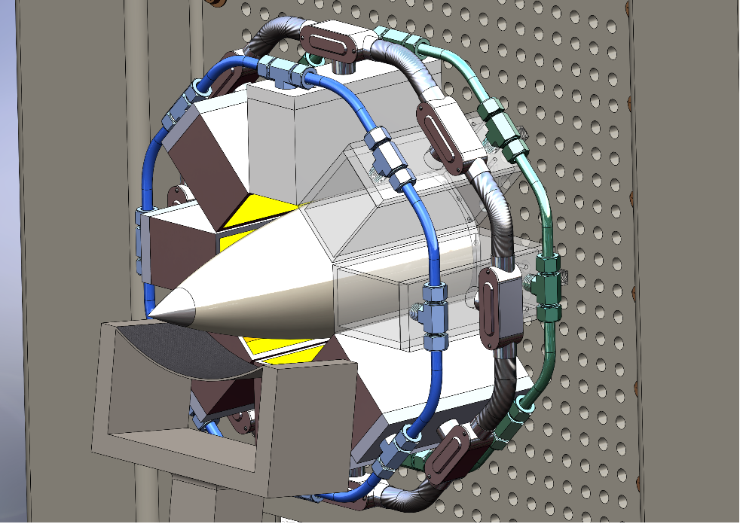
Figure 6: Radome Close-Up

Fixture Hardware
The only hardware required to attach the lamps to the universal plate is the 5/8” bolts and washers. All other hardware will be component specific.

3.4 Flight Component Assembly

Flight Component Interfacing
The radome attachment also uses 5/8” bolt. Each missile part will require a unique interfacing adaptor in order to be attached. These parts will not be provided with test fixture as they are different for each part. Figure 6 shows one example of what an AMRAAM radome would look like attached to the universal plate.

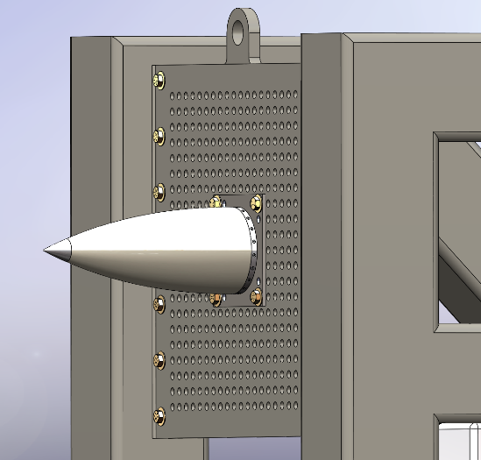
Figure 7: A Sample Radome Connection

Subject Hardware
The hardware between the radome attachment and the missile itself will also vary from part to part. This will also have to supplied by the client. Figure 8 shows the subassembly of the radome, mounting ring, and adaptor plate.
Figure 8: Radome Attachment Subassembly

User Interfacing
The test fixture is supplied with a control panel to aide in sensor and actuator usage. The back of the control panel has the ability to interface hundreds of sensors. The front of the control panel has pin out adaptors to connect to a computer. An emergency shut off switch is supplied. Control panel usage is optional, and wiring can be modified for individual needs.

Sensors
Sensors can be connected to terminal blocks on back of control panel, as seen in Figure 9. There are places to attach force transducers, strain gauges, thermocouples, and linear variable displacement transducers. A Phillips head screw driver is required to secure wiring.
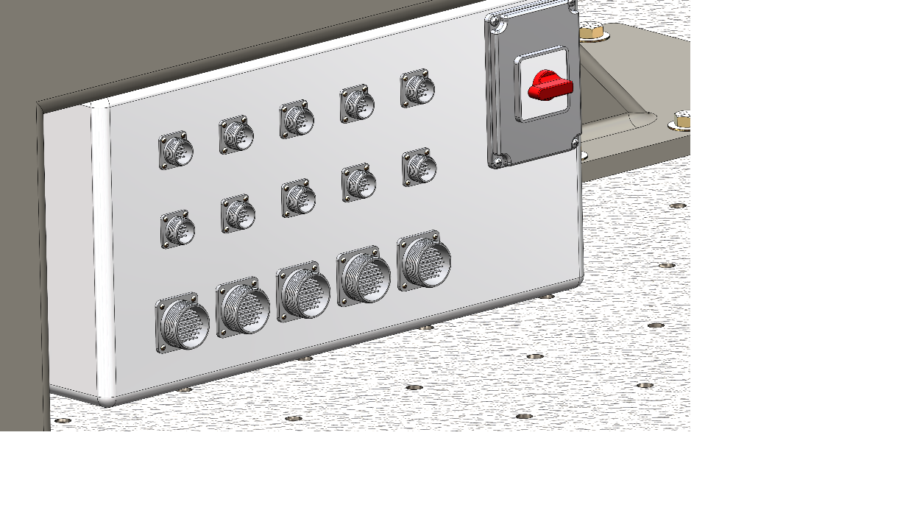
Figure 9: Connection Panel

Actuators
The hydraulic ram and lamps will require actuation. The control panel can be used if desired. Connect to terminal blocks on back of control panel to interface, then use the pin out.

Data Acquisition and Control
The front of the control panel contains 37 pin connectors and 9 pin connectors to interface the test fixture with computers. The wiring can be changed as the user sees fit. This is intended to be universal. Pin out and control panel use is optional.

4. Operation

4.1 Application of Mechanical Loading
A hydraulic ram delivers mechanical loading. The ram can be positioned in various locations on the floor. the ram can also be angled. The end of the ram has a strap which allows the loading to be more evenly distributed over various surface geometries. other load delivery interfaces can be used but are not supplied

4.1.1 Optimal Mechanical Loading
Avoid applying loads that are concentrated. try to apply loads over larger areas to distribute the pressure and to avoid damaging parts.

4.2 Application of Thermal Loading
Heat lamps can be arranged as the user sees fit on the universal plate. The number of lamps can be varied. the only restrictions are physical space and heat/water/electrical restrictions. Plumbing must be considered for each test configuration

4.2.1 Optimal Thermal Loading
An even distribution of thermal loading is optimal. try to arrange lamps so the test part is evenly heated.

5.0 Preventative Maintanence

5.1 Maintenance Schedule
If the test fixture is disassembled after each use, no maintenance schedule is required. Alternatively, various components need to be inspected during each assembly of the test fixture. Maintenance on the fixture frame itself should be minimal, but should any concern arise,

5.2 Inspection
At each assembly, the hardware needs to be inspected and verified that its fit for use. the threads need to be in working condition and no visible damage to the bolt. water and air lines need to be visually inspected at each assembly. The hydraulic system needs to be checked for leaks. the lamps need to be inspected for damage. check the test fixture assembly for signs of fatigue

5.3 Hardware Replairs
The heat lamps need to be maintained and repaired per the instruction manual. The hydraulic system needs to be maintained and repaired per the instruction manual. Reusing bolt fasteners for multiple experimental trials is an acceptable practice but may lead to gradual deformation or potential fracture with each use due to lifecycle fatigue. The test fixture should not require repairs unless there is yielding within one of its members or there is catastrophic failure.

Safety
Do not stand near the text fixture during operation. Do not activate heat lamps and hydraulics when people are standing near the fixture. Try to operate the test from a different room or behind a shield using long pin out cables connected to the control panel. Be careful with large amounts of electricity and make sure it all covered. don’t let water leak on electrical. Do not touch the heater while testing and let heater to cool by using water and compressed air for three minutes until it safe to touch, disconnect the power before changing lamp to make sure that the lamp will break, also do not use heater without using the heater cover [1].

Troubleshooting

7.1 Common Issues

7.1.1 Bolt and Fastener Fatigue and Deformation
With each use, fixture bolts will gradually begin to fatigue and deform. Because all bolts used in the fixture are of the same standards and because bolt deformation post-testing is so minimal that it may not be visible to the naked eye, it is recommended to replace these bolts frequently to avoid unexpected fastener failure and shear. A suggested method to reduce deformation and fatigue would be to log the number of times the fasteners have been used, and cycle in new fasteners every few testing trials.

7.2.1 Plumbing Challenges
Plumbing is challenging and is unique to each component being tested. Plumbing connectors also tend to leak with time.

57.2 FAQ
Adapters for specific aerospace component are not included with the assembly and will have to be designed and manufactured by the consumer. The rest of the fixture are universal and can be used for any types of missile. Consumers are also required to provide the mounting ring screws to be connected to adapter plate. Forklifts and operating straps are required to position the test fixture components for assembly and disassembly.

8. References
[1] Precision Control Systems, Inc. and Research Inc, “Leaders in Industrial Infrared Heaters, Systems and Control Solutions,” Precision Control Systems, Inc. Research Inc., Nov-2008. [Online]. Available: http://www.pcscontrols.com/. [Accessed: 30-Nov-2018]

Appendix

CAD models
Figure#:

