4B – Test Fixture for Flight Components (Willy)

Midpoint Report

Abdulaziz Alzaid
Shanna Lechelt
Israel Sotelo
Alexandra Spotts

October 19, 2018


Department of Mechanical Engineering
Northern Arizona University
Flagstaff, AZ 86001

Project Mentor: Chuck Vallance
Instructors: Sarah Oman and David Willy

DISCLAIMER
This report was prepared by students as part of a university course requirement. While considerable effort has been put into the project, it is not the work of licensed engineers and has not undergone the extensive verification that is common in the profession. The information, data, conclusions, and content of this report should not be relied on or utilized without thorough, independent testing and verification. University faculty members may have been associated with this project as advisors, sponsors, or course instructors, but as such they are not responsible for the accuracy of results or conclusions.

TABLE OF CONTENTS

Contents
DISCLAIMER 1
TABLE OF CONTENTS 2
1 BACKGROUND 1
1.1 Introduction 1
1.2 Project Description 1
1.3 Original System 1
1.3.1 Original System Structure 1
1.3.2 Original System Operation 2
1.3.3 Original System Performance 2
1.3.4 Original System Deficiencies 2
2 REQUIREMENTS 3
2.1 Customer Requirements (CRs) 3
2.2 Engineering Requirements (ERs) 3
2.3 Testing Procedures (TPs) 4
2.3.1 Quick Transportation Test 4
2.3.2 Quick Assembly Test 4
2.3.3 Standard Bolt Test 5
2.3.4 Extreme Loading Test 5
2.3.5 Extreme Temperature Test 5
2.3.6 Part Size Test 5
2.3.7 Safety Factor Test 5
2.3.8 Sensor Test 6
2.3.9 Power Test 6
2.3.10 Storage Test 6
2.4 House of Quality (HoQ) 6
3 EXISTING DESIGNS 7
3.1 Design Research 7
3.2 System Level 7
3.2.1 Existing Design #1: Gulfstream Aerospace Test Fixture 7
3.2.2 Existing Design #2: Pyroceram Radome Thermal Testing 8
3.2.3 Existing Design #3: NASA Aerostructures Test Wing (ATW) 8
3.3 Functional Decomposition 9
3.3.1 Black Box Model 9
3.3.2 Functional Model 10
3.4 Subsystem Level 10
3.4.1 Subsystem #1: Thermal load 11
3.4.1.1 Existing Design #1: Pyroceram Radome Thermal Testing 11
3.4.1.2 Existing Design #2: Combined Loads Test Fixture 11
3.4.1.2 Existing Design #3: A Test Fixture for Measuring High-Temperature Hypersonic-Engine Seal Performance 11
3.4.2 Subsystem #2: Mechanical Load 11
3.4.2.1 Existing Design #1: Gulfstream Aerospace Test Fixture 11
3.4.2.2 Existing Design #2: Combined Loads Test Fixture 11
3.4.2.3 Existing Design #3: NASA’s Armstrong Flight Research Center 11
3.4.3 Subsystem #3: Beams 12
3.4.3.1 Existing Design #1: Gulfstream Aerospace Test Fixture 12
3.4.3.2 Existing Design #2: HDT Global 12
3.4.3.3 Existing Design #3: Hybrid Composite Beams 12
4 DESIGNS CONSIDERED 13
4.1 Thermal Loading 13
4.1.1 Design #1: Oven 13
4.1.2 Design #2: Heat Coils 13
4.1.3 Design #3: Fixture 13
4.1.4 Design #4: Fluid 14
4.2 Mechanical Loading 14
4.2.1 Design #5: Rings 14
4.2.2 Design #6 – Cradle 14
4.3 Test Fixture 15
4.3.1 Rail 15
4.3.2 Turntable 15
4.3.3 Upright 15
5 DESIGN SELECTED – First Semester 17
5.1 Rationale for Design Selection 17
5.2 Design Description 19
5.2.1 Design Description 19
5.2.2 Heat Lamp Calculations 21
5.2.3 Mechanical Loading Calculations 21
5.2.4 Bolt Calculations 22
5.2.5 Beam Calculations 22
5.2.6 Proof of Concept Prototype 23
6 PROPOSED DESIGN – First Semester 24
6.1 Description of Implementation Plan 24
6.2 Resources Needed 24
6.3 Implementation Scheduling and Budget 24
6.4 Design Model 25
7 IMPLEMENTATION – Second Semester 27
7.1 Analyses 27
7.1.1 Quartz Lamps Analyses 27
7.1.2 Second Iteration Compressible Flow 29
7.1.3 Second Iteration Beams 29
7.1.4 Second Iteration Bolts 29
7.2 Design Changes 29
7.2.1 Quartz Lamps 29
7.2.2 Beams 30
7.2.3 Bolts 30
8 CONCLUSIONS 31
9 REFERENCES 32
10 APPENDICES 33
10.1 Appendix A: House of Quality 33
10.2 Appendix B: Bill of Materials 33
10.3 Appendix C: CAD Models 34

BACKGROUND

Introduction
The team has been presented with the task to create a universal test fixture for missile flight components such as radomes and leading edges in high temperature and high-pressure flight conditions. The final design must have a quick set up and take down time, with minimal time delay between each step in the process. The team’s client and sponsor, Chuck Vallance, is a former Raytheon employee who has asked us to make changes to the current testing environment either by improving upon the currently existing design or by a redesign using an original concept to increase the efficiency of the testing process. This project is important because as missile and flight technology continue to improve and advance, the equipment used to test these designs must also do so. Large amounts of money are invested into missiles and aircrafts. Testing these vehicles is one of the most essential steps in assuring that failure during an actual flight does not occur, which typically leads to huge financial loss. By designing a functional and technologically competent test fixture that can improve upon and more accurately apply and measure the modes of loading, our design could potentially have applications in the flight industry.

Project Description
The following is the project description verbatim from the client.
“Outer mold line flight components, such as missile and aircraft radomes and wing leading edges often operate in extremely harsh environments. Small practical radomes can be 6 inches in diameter and 18 inches in length. A large radomes can be 4 feet in diameter and 8 feet long. Wing leading edges can vary as dramatically. Successful design efforts for these hardware components include testing to validate the design. Common environments to which the hardware is subjected to include internal and external pressure, high heat fluxes, and pressure induced flight loads. Specialized test rigs to perform the testing are standard. The output of this project will be a set of design specifications for a test fixture which can be deployed in standard laboratories (may be outside) and capable of testing a wide variety of radomes and leading-edge shapes and sizes as well as producing a wide variety of testing environments (pressures, loads, fluxes). Some fabrication and testing of scaled models of the test fixture will benefit this project to prove it is viable but is not required.”

Original System
The original system is a missile radome and leading-edge test fixture. The fixture simulates supersonic flight conditions and applies mechanical and thermal loading in different orientations. The following sections will describe the original fixture in further detail.

Original System Structure
The team’s mentor, Chuck Vallance, had given us a representation of what one of these test fixtures might look like; this will also be the basis of our benchmarking process. Testing occurs in a large room where all equipment can fit in a 24’x 24’ space. The loading area is typically built on a steel platform with holes drilled every six inches as to form a grid where things can be screwed down into the floor. The loading structure is a three-foot-tall mechanism made of steel I-beams with a strap attachment. To reproduce a thermal load that a missile component would experience during flight, several quartz heat lamps are placed in multiple, specific locations around the component. Sensors such as thermocouples and calorimeters are placed along the surface of the radome as well as inside to measure temperature. Force transducers and load cells are used to measure mechanical loads. Linear variable differential transformers (LVDTs) collect deflection data. Figure 1 shows the schematic of the original test fixture.

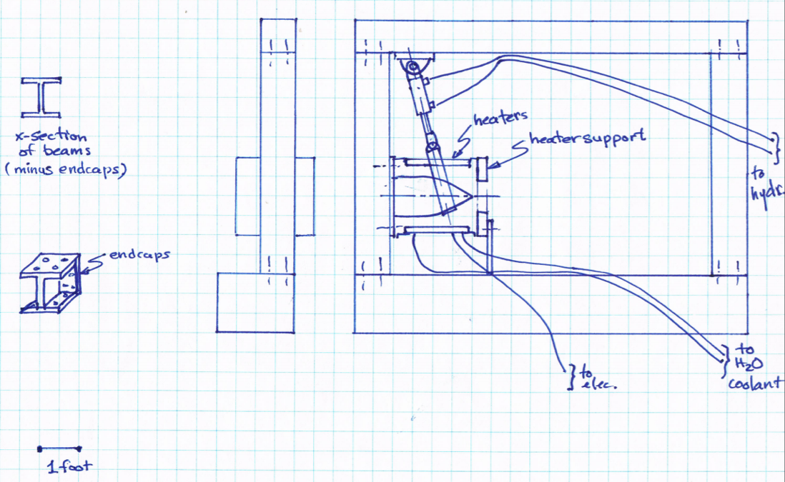
Figure 1: Original System Schematic

Original System Operation
When the fixture is powered, it begins to simulate flight conditions. The strap is designed to cradle the flight component that is subject to testing and replicate a pulling mechanical load. The quartz lamps are used to achieve a heat flux that is as equally distributed as possible. The quartz lamps include a water-cooling system. Separate from the test fixture is a control room that receives signals from the sensors and displays data from the testing room as well as prescribes loading and temperature profiles to the mechanical and thermal equipment.

Original System Performance
The team is unable to visit the test fixture. The client has also refrained from giving specific performance parameters for the current fixture because he wants the team to figure them out. At this time, the team is only able to observe fixtures and data collected from a select few designs that are available to the public, many of which concern a different aspect of flight testing than that the team is striving to address.

Original System Deficiencies
Although the original system is functional, there are three main areas of concern for the fixture. As it stands, it takes hours or even days to set up and take down, meaning there is a large time and labor investment. With this, it also requires a lot of man power to assemble and tear down. Lastly, it is unable to support testing for a variety of different radome sizes and orientations, making its capabilities and diversity limited.

REQUIREMENTS
The following section details the customer and engineering requirements for the test fixture. It also includes testing procedures to ensure that the fixture fulfills the requirements and a house of quality to evaluate how each requirement relates to another.

Customer Requirements (CRs)
After meeting with the client, customer requirements were established. The purpose of the customer requirements is to narrow the scope of the project and translate what the client wants into qualitative design requirements. The customer requirements are related to the functionality of the test fixture, as well as safety, durability, and ease of use. Table 1 shows the customer needs that must be fulfilled for the test fixture, as well as their corresponding weights. The requirements that are weighted the highest are those that the client emphasized were of greater importance, such as simulating flight conditions, minimal labor, and ability to test a variety of missile parts. Safety is also rated highly as it is essential to any functional design.
Table 1: Customer Requirements
Qualitative Customer Requirements | Weight (1-10)
Simulate supersonic and hypersonic flight conditions | 9
Ability to test a variety of missile parts | 7
Applies varying mechanical loads | 7
Applies varying heat loads | 7
Applies loads in different orientations | 5
Minimal labor required for set up and changing out parts | 9
Measures loads, strain, temperature, and heat flux | 7
Transmits measurements to the command center | 5
Portable | 9
Compact Storage | 3
Safe | 9

Engineering Requirements (ERs)
Engineering requirements were decided based on customer requirements. The team identified how each customer need could be translated into an engineering requirement that can be quantitatively measured. Table 2 shows the engineering requirements as well as their target values. The target values are rough estimates based on information from the client. At the moment, the team does not have target values for the resistance and voltage requirements, however the team fully intends to complete power estimations in the upcoming semester.

Table 2: Engineering Requirements and Target Values
Engineering Requirement | Target Value
Transports quickly from storage | 1 hr
Assembles quickly | 2 hrs
Mounts to a standard bolt pattern | 6 inches
Applies and withstands extreme loads | 10⁶ in-lb
Applies and withstands heat flux | 75 W/m²
Ability to test parts up to 3 feet long | 3 ft
Safety Factor | 4
Sensors read out to a different location | ohm
Load driven from an alternate location | Volt
Small storage space | 100 ft³

Testing Procedures (TPs)
Testing is essential to the success of the team's design because it confirms what has been found in theory to what would occur in real life. Although this project is mostly analytical, it is essential to come up with tests that can ensure the functionality of the test fixture. It is also important to be able to fulfill all of the necessary engineering requirements. However, it should be noted that nearly all testing for this project will be using simulations and calculations, and there will always be some uncertainty with theoretical modeling. The following sections will detail future and hypothetical test scenarios.

Quick Transportation Test
A quick transportation test should be completed to confirm that the fixture can be moved quickly from storage to the testing environment. For the hypothetical full-scale fixture, the transportation time could be tested by estimating the distance the fixture will have to travel, and timing how long it takes using any timer. This test would require a forklift as well as manpower to transport the full-size fixture. In this project’s case, a simulation could be used in SolidWorks or hand calculations could be done to estimate the time it takes to pack and unpack pallets and distance travelled to approximate the time. To ensure that our SolidWorks transportation test meets the 1-hour target value, we will have to allot a time that is slightly more than what we would expect for both loading and unloading the fixture. Because we are unable to build a full-scale test fixture, there is no way for the team to ensure that a physical test fixture will meet the target time, other than using estimated values.

Quick Assembly Test
To ensure that the design can be quickly assembled, a simulation will be completed in SolidWorks of the full assembly. Every part of the fixture can be modeled, and the rate of assembly can be slowed in the simulation to more closely match the speed at which workers could realistically assemble a fixture, which will allow our simulation to be measured in real time. Completing several runs of this simulation at varying rates of assembly and averaging the times may give us a rough estimate of the manpower required to complete the assembly within the 2-hour target value. An alternative way the assembly time can be tested is to construct a scale model and time how long it takes to put together by hand. Then, scale model analysis would be completed to see how much time it would take for our full-scale design. With this assembly test, the team will need to contact the client to discuss how long each specific part takes to assemble, as there are some very particular ways some specific parts need to be installed. This would perhaps be a less accurate estimation of time, as we cannot consider the magnitude of the full-scale weight or adjust the rate of assembly to account for varying degrees manpower. The prototype would be 3D printed using on campus resources. Other than that, the only materials required are glue to hold the pieces together, a timer, and a person to put the fixture together.

Standard Bolt Test
To test that the bolt fits the standard 6-inch bolt pattern of the floor, one hole can be drilled into a similar steel that would be utilized in the theoretical full-scale assembly. Then, the bolts in question could be fitted to see if they matched the hole size and dimensions. For the purpose of this project, the bolt part file will be downloaded from its vendor and matched to holes that will be modeled in SolidWorks. From both of these tests, it will be clear whether the bolts will match with the bolt pattern correctly in the simulation as well as an actual model.

Extreme Loading Test
The mechanical loading test can be completed hypothetically by attaching a force gauge to the mechanism applying the load. This device can be found online at many retailers. The force meter will accurately ensure that the target force of 7500 lbs is being applied to a specific sized flight component to induce the desired moment of 10⁵ in-lb. A simulation can be modelled in ANSYS to see what kind of stress is applied to the radome. The simulation is useful for this project, but only testing the mechanism in real life will ensure that the necessary force is applied. The most accurate way for us to test if the hypothetical fixture itself and the components can withstand the loads applied without failing, is to assure that our factor of safety calculations are correct and the factors of safety we use are liberal.

Extreme Temperature Test
In order to test how much heat flux would be applied to the radome, ANSYS will again be utilized. The approximate target heat flux of 75 W/cm² will be applied using the software. Then, a temperature profile will be plotted as a result of the applied heat flux. The software will also supply a heat flux contour plot. This test will help ensure that the heat flux is being applied in the correct place and at the correct value. The software will also be able to give values for heat flux for many kinds of missile parts. If extreme heat fluxes were to be tested in real life, the temperatures at different points around the radome could be taken using thermocouples and given the heat transfer coefficient conductive heat flux could be calculated. This would be a way to ensure the design was applying the correct amount of loading.

Part Size Test
The ability of the fixture to handle different sizes of radomes can be quickly tested. The maximum diameter radome that will be tested is 3 feet, therefore the mounting plate can be tested by modeling a radome of that size in SolidWorks and the mounting plate. This is a simple way to test the interface. One way to ensure the plate is large enough is to measure it using a tape measure. The mounting plate should also have a few extra inches on each side to ensure that it is large enough. Another analysis that should be considered after the test is completed, is to ensure that the bolt holes on the plate are in the correct orientation to accept all types and orientations of parts.

Safety Factor Test
Safety factors will be tested and calculated based on the results of the other tests, to assure that the fixture will not fail at any point in the test. Every part of the fixture must have a minimum safety factor of 4, and that will be ensured by hand calculations as well as computer software. ANSYS can be used to determine stresses and strains as a result of the mechanical loading, and factor of safety will be calculated from there. ANSYS can also be used similarly for heat transfer applications, as mentioned in Section 2.3.5.

Sensor Test
One way to test that the sensors are working correctly is to perform calibrations for each sensor. Once calibrations are complete, the fixture can be run to see if the values received are within reason. If this test is completed multiple times, it should ensure that all the sensors are connected correctly and are reading out reasonable values. It also ensures that the data is being transmitted to the intended place.

Power Test
The power output of the fixture can be tested using a voltage and current reading. A voltmeter and ammeter will be used to collect data for the power calculation. Power estimations can also be used by contacting the vendor of the parts to obtain their power estimations.

2.3.10 Storage Test
A storage test can be completed by measuring the dimensions of the fixture when it is collapsed to confirm it is under a volume of 30 ft³. A similar process can be completed using SolidWorks and the modelled parts.

House of Quality (HoQ)
Once customer and engineering requirements were determined, the team created a House of Quality to relate them to each other, as well as rank currently existing designs. The House of Quality helps the team prioritize design requirements by calculating the relative and absolute technical importance. The team gave each customer need a value (on a 1-9 scale) based on how important it was to the client. Next the team determined how much each engineering requirement might influence each customer need. These values were then used to determine absolute and relative technical importance. Each engineering requirement was evaluated for how it related to other engineering requirements as well. As a result of the House of Quality (Appendix A), applying both mechanical and thermal loads will be prioritized because they are ranked first in relative technical importance. Quick assembly, transportation, and testing parts up to 3 feet are ranked second, third, and fourth respectively. These requirements will be important, although slightly less so than those ranked above. One item to note is that the team does not currently have voltage or resistance target values for outputting the signals. However, next semester those calculations will be completed. Not only did the House of Quality help the team prioritize technical requirements, it also provided benchmark information for existing test fixtures. Four existing fixtures were benchmarked also, so that the team could identify the strengths and weaknesses of the designs. Benchmarking helped the team figure out which elements of other fixtures should be incorporated into the current design and which should be discarded.

EXISTING DESIGNS
This section of the report contains a compilation of all the aspects of research that have been completed thus far for the capstone design project. Starting with a description of how the team chose to conduct research and select designs for the benchmarking analysis, each subsequent section will explore existing designs that are similar as a full system to the original system. Following the broad overview of each system, the team will provide an elaborate break down of the systems in the form of a functional decomposition and black box model. Sequentially, each existing design will be broken down into a variety of sub-system components and elaborate on their relevance to the engineering requirements and in our design project.

Design Research
In order for the team to gain a more comprehensive understanding of the current state of flight component test fixtures, it was necessary to conduct research on presently existing designs. Due to facility restrictions, on-site observations are not a viable research option. Instead, information on existing systems was attained through web-based research, as it proved to be the most extensive and efficient method of research. Through recommendations and guidance from the client in addition to academic resources, the team was able to gather a small, but sufficient assortment of scholarly articles and studies.
After selecting three designs from the team’s research with similar processes as the current design, each design was benchmarked, as seen in the QFD, located in Appendix A. Selected benchmarking designs were scored in the right-most column of the QFD based upon how well each benchmark met each customer need. As a result of detailed research, the team was able to acquire a thorough enough understanding of the functionality and capabilities of each design to give each the most reasonable score in comparison to the existing design. The benchmarking process compared three existing designs that serve a different purpose than the team’s test fixture, but each of them included some type of approach that either applied a mechanical or thermal load, or a testing environment that could be considered when synthesizing design concepts.

System Level
Due to the nature of this project as well as company confidentiality, existing test fixture designs are not readily available for public access. Because of this dilemma, the system level designs detailed in the following three sections will not serve the same purpose as the system the team is expected to replace. The design research for currently existing designs that exemplify components, testing procedures, or features that are similar or can be related to the project objective. With limited system level options, the three existing designs in this section were reviewed by the team and selected as the systems that most accurately aim to include and execute the same tests and requirements as the original design.

Existing Design #1: Gulfstream Aerospace Test Fixture
The first design that the team benchmarked was the Gulfstream test fixture. The team used videos of the testing environment to gather the information needed to benchmark this design [2]. The Gulfstream Aerospace test fixture is suitable for only testing wings and leading edges. The inner side of the wing, which would be attached to the body of the aircraft, is held in place by a fastening mechanism while the opposing side, the point of the wing farthest away from the body, is subjected to a load in order to test how the moment impacts the point closest to the body. The load is applied by a strong pully mechanism, lifting the wing up, causing the wing to bend into an upwards, curved shape until fracture or the conclusion of the test. Many wires and sensors are attached to the wing and the equipment to convey information and data to the control room. Due to the restrictions on the content that Gulfstream Aerospace is allowed to release about their testing environment, an educated assumption is being made that thermal load testing must occur in a separate environment that achieves all requirements needed for a successful and accurate thermal load test. Referring to the QFD (Appendix A), the Gulfstream test fixture scored excellent for the following customer needs:
- Applies varying loads
- Measures load, strain, temperature, and heat flux
- Measurements and data collection outside the bay
- Safe for operators
These ratings are justified because this design meets all the basic requirements needed for the types of loading that will be analyzed and can safely execute the desired test while keeping the operators and analysts in the control room safe. Although it meets these basic requirements needed for any loading test, it is still missing quite a few major elements requested by the client, and scores poorly in all other categories. This benchmark is not precisely the type of design that is being considered, but it provides some valuable information that will help the team identify areas in the designs that miss the target set by the client.

Existing Design #2: Pyroceram Radome Thermal Testing
The second system level design that the team analyzed and benchmarked was an experiment that sought to determine the thermal environment that would induce failure due to compressive stress for the Pyroceram missile radome [3]. This experiment involved two major relevant testing analyses to determine if the radome design was suitable for harsh thermal stresses under Mach 4 flight conditions. The first component of this study consisted of conducting a thermal analysis computer simulation, using an IBM 7094 computer program. The radome trajectory and geometry selected for the simulation were chosen such that the results would yield the highest rate of heat input as well as its corresponding tensile stress induced by the thermal load. The data collected from this theoretical test was then used to influence the conclusion and verify the speculated results by means of a full-scale wind-tunnel test. In order to induce tensile stress due to thermal loading, the wind-tunnel was set to the desired Mach number, and then radome was placed into the airstream for a pre-determined amount of time. The same test was conducted multiple times to assure measurements for pressure, temperature, and tensile stress were consistent with each trial. The only variable that was adjusted for each test was the radome's initial temperature, to observe the varying effects of temperature on tensile stress. The experimental data was recorded to compare its accuracy to the theoretical predictions.
As seen in the benchmarking columns of the QFD (Appendix A), the Pyroceram thermal loading test scored well in the subsequent areas:
- Simulate supersonic and hypersonic flight conditions
- Applies varying heat loads and fluxes
- Measures load, strain, temperature, and heat flux
- Safe for operators
Although this experiment was dissimilar to this project, as it was primarily focused on the radomes and evaluating their structural adequacy, this analysis conducted a thermal test in a manner that the team would ideally wish to utilize in this project. By using a different means to achieve the same goal, despite the contrasting focus, this study can be related to this project by comparing the similar flight conditions and the anticipated results of this project. This test gave us insight into what an efficient and successful thermal testing process would consist of, had we been given the opportunity to continue further with our project.

Existing Design #3: NASA Aerostructures Test Wing (ATW)
The final existing design the team researched was the piezoelectric actuator structural excitation test, used to induce instability identical to flutter during flight turbulence, in the NASA ATW [4]. Light-weight aircraft wings lack structural stiffness, which can cause complications during flight. Piezoelectric devices are used to both measure and generate motion to more accurately predict the onset of flutter in real flight scenarios. This experiment used the piezoelectric actuators to test their ability to invoke the first-bending and first-torsion modes on the ATW for both the ground and in-flight tests.
The impact vibration ground test was performed by first striking the ATW with a large mass, stimulating the piezoelectric sensors to convert the movement into electrical signal response data. Accelerometers placed at the outer edge of the ATW were also used to collect time response data at specific locations along the wing. Conversely, an electrical signal is sent to the piezoelectric actuators via various frequencies and voltages to prompt vibrations, which are applied to the ATW. The wingtip accelerometers were used once again to record the actuator data at each of the voltages. The other phase of the actuator testing consists of measuring the turbulence excitation and wing response at multiple, stabilized test points over a 30 second interval. After the stabilization period, the piezoelectric actuators were signaled to generate motion over the wing for 60 seconds while the accelerometers gather the response data, as before.
This testing method strives to achieve a completely different set of objectives than this project, and therefore, there are a limited number of engineering requirements this analysis can meet. Although this existing design serves a different purpose than ours, there are still a few concepts and design considerations used in this testing environment that could have potential applications in this design and testing procedure. For this test to improve upon current flutter measurements and predictions, wing excitation is essential for gathering the proper data needed to validate the structural dynamics of an aircraft. In a way, this test is analogous to our own test fixture in that the team's design must apply the correct thermal and mechanical loads to the flight components during the testing phase to assure that those components do not fail during an actual flight. The piezoelectric actuator is a small and simple, yet versatile device that was able to quickly drive and sense various loads with precision, when used in conjunction with the accelerometers. These components of the excitation test conform to the requirements of applying loads (although to a significantly lesser degree), sensing input, and transmitting data.

Functional Decomposition
The project has some complex processes, and it is necessary to break it down into pieces. This section will contain a black box model to show the inputs and outputs of the fixture: the types of material that go into and out of the system, the types of energies that the fixture will be using, and the type of signals that go into and out of the system. The next step is functional model, which will explain the functional roles of each input and output.

Black Box Model
The purpose of the black box model (Figure 2) is to show the input and the output of the design. There are three types of inputs: materials, energy, and signals. The material inputs for the design are the fixture and the missile parts that will be connected to the fixture. In terms of energies there is hydraulic energy, heat energy, electricity, and human energy. In terms of signals, there is a load signals input. The outputs of this design are the fixture and the missile part. The only output energy is the human energy in order to break down the fixture. The signal output will be the sensor signals that will be connected to the control center. This model helps the team know what kind of input flows to transform them into desired output flow.
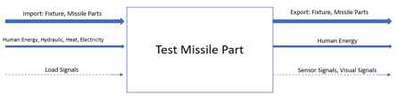
Figure 2: Black Box Model

Functional Model
The functional model (Figure 3) is made based on the black box. The purpose of a functional model is to break down the design into smaller systems and functions that are associated with each input and output. The inputs and outputs are materials, energy, and signals. The functional model shows the process each input goes through. The reason why a functional model is helpful is because each piece is a function that needs to be solved and put to help the next function, one by one to reach the purpose of the design.
There will be four imports: the control center, fixture, missile part, and sensors. Each import will be assembled by human energy. The control center will send signals to apply both mechanical and thermal loading. The sensors that will be used are strain gages for the mechanical loading and thermocouples for the thermal loading. Both types of sensors are connected to the missile part. The output will be signal of voltage transfer back to the control center where all the data will be measured and calculated. Then using human energy, the fixture will be taken down.
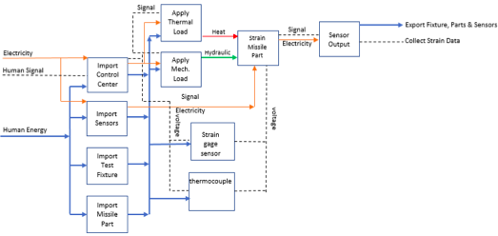
Figure 3: Functional Model

Subsystem Level
This section contains three subsystem levels that will be helpful for the design in order to ensure the design produces accurate results for supersonic conditions and can be assembled quickly. The three subsystem levels are thermal loading, mechanical loading, and the best beam to use. For each subsystem, the team did research of existing designs that would help creating the best design possible for the fixture.

Subsystem #1: Thermal load
One of the requirements of the fixture is to test a missile part at a high temperature and to create an environment as similar as possible to the flight conditions of hypersonic missiles. Hypersonic missiles endure very high temperatures which can cause damage to the fixture. As a result of this, it is necessary to research existing designs that apply these kinds of temperatures and find out the pros and cons of each.

Existing Design #1: Pyroceram Radome Thermal Testing
This design is designed to apply the temperatures that occur at Mach number four. To get the thermal loading analysis, they used IBM 7094 computer program [3]. This program can handle three dimensional geometric configurations of heat transfer for radiation, convection, and conduction. This is helpful for our design because the output analysis is similar to what is required of this project.

3.4.1.2 Existing Design #2: Combined Loads Test Fixture
Their design is to test aerospace vehicle panels under simultaneous structural and thermal loading. The density of quartz lamps is high. The goal is to reach the necessary higher heat flux, for the flight conditions. A fence is important to shield the less massive material from the high heat. This design utilizes heat lamps in the same way the new design will [5]. One advantage this design has is that it minimizes the heat loss. The heat shield also makes it safer.

Existing Design #3: A Test Fixture for Measuring High-Temperature Hypersonic-Engine Seal Performance
In this design, NASA is measuring a hypersonic engine seal at a high temperature. High density watt heaters are strapped on the sides, top, and bottom of the test rig. The heaters that they have been using are 35 kW. The fixture's temperature reached 1500 F in five hours [6]. This is helpful because in our design we have the same purpose: to apply a high thermal loading and test it. Also, it gave the team some idea of how long it will take to complete the testing. The test will most likely only be a few minutes long.

Subsystem #2: Mechanical Load
One of the major requirements that the fixture needs is the ability to apply a mechanical load that meets with hypersonic flight conditions. For this design, mechanical loading will be applied to the missile part using hydraulic energy. Because of the high temperatures, the material is important as well as the performance.

Existing Design #1: Gulfstream Aerospace Test Fixture
The first existing design applies the mechanical load by a hydraulic ram that is connected to a beam above the wing that is being tested. Two straps are connected on the end of the wing in order to pull it up and six hydraulic rams push up in six different locations. These loads create a huge amount of moment on the wing and that is the purpose of the test [2]. This is helpful because their goal is to create a high moment to see if the wing can withstand it. In this project, the team will apply a moment to the missile part, which will be a similar process.

Existing Design #2: Combined Loads Test Fixture
In this design NASA is applying mechanical loading to a vehicle panel. The panel is 48-by-48-in. The load applied is from 30000 lbf to 50000 lbf. Hydraulics are used in order to add pressure from two sides on ten different areas [5]. The is important for the design because it introduces the idea of using more than one ram. Also applying the pressure from more than one side could make the results more accurate.

3.4.2.3 Existing Design #3: NASA’s Armstrong Flight Research Center
For this design, they use weight as pressure force, which means they are using gravity to apply pressure. Using this type of pressure is less expensive than using hydraulics [7]. On the other hand, using weight requires more room for the weight. This way is also not as safe as the hydraulics, considering the fact that hypersonic missiles accumulate huge amounts of pressure. This design introduces another way of applying the moment to the missile part.

Subsystem #3: Beams
The beams are essential for the structure of the fixture. The hydraulic ram will create a high stress area where it attaches to the beam. A large moment will be applied to the plate that holds the radome. According to OSHA standards, the factor of safety needs to be four or more, which means the beams need to have high moment of inertia. When the moments of inertia of the beams are high, the stresses on the beam will be lower. As a result, the mechanical load will be more directly applied to the missile part, instead of the beam deflecting.

Existing Design #1: Gulfstream Aerospace Test Fixture
The beams that Gulfstream use are rectangular beams. While I-beams have a higher moment of inertia, rectangular beams are better at withstanding high stresses at bolt connections. Also, in regard to the shear stress that the bolts are holding [2], this information could be helpful if the shear calculations are higher than expected. The team could use rectangular beams in that case.

Existing Design #2: HDT Global
This company has designed a beam that has unique properties by creating a highly oriented fiber layer. The structure is flexible, and the angles of its fiber will increase the beam's strength under pressure loads [8]. This design is helpful because one of the goals of this project is to make it fast to assemble, using fiber rather than steel will make the beam lighter and quicker to assemble.

Existing Design #3: Hybrid Composite Beams
This beam is designed to endure high mechanical loading. At the same time, it is light. They use this kind of beam for bridges. They use a concrete arch, a low-density foam core, and a fiber plastic shell [9]. The purpose of their design is different than the purpose of this project, but it is still applicable. Using a fiberglass beam, which is a lightweight, strong material, will help the design.

DESIGNS CONSIDERED
For this design project, there are three parameters that must be evaluated. The first two are the means by which mechanical loading and thermal loading must be determined. Each has a unique set of engineering requirements and there are many options for how these loads could be applied. The third parameter that must be analyzed is the overall orientation and geometry of the test fixture. The test fixture will affix the components and allow the loads to be applied. This section will review the designs considered and the impact of each of the designs.

Thermal Loading
The thermal loading which simulates the extreme temperatures of supersonic flight must be replicated at the same time as the mechanical loading. A successful design is one that will have an even distribution of heat flux and still allow for the mechanical loading mechanism to operate. The next four designs are attempts at solving these problems.

Design #1: Oven
The first thermal loading concept is simply an oven. In this concept, the entire test fixture is loaded into an oven and the mechanical load is applied. The primary benefit to this system is that it is very simple, and it avoids using complex and expensive heating mechanisms. Unfortunately, the drawbacks are extensive. First, every single component in the test fixture would have to withstand temperatures nearing the melting point of steel. This will drive up the cost of virtually every component on the structure, negating any savings. Another drawback is the oven would now have to heat a large volume and would result in a long heat up time.

Design #2: Heat Coils
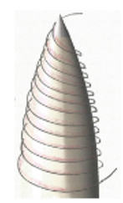
Figure 4: Heat Coils Design
In this design, a coil system containing electrical current is wrapped around our flight component. As high currents travel through the coils, heat is expelled, and the flight component is heated. One nice feature of this design is that the amount of heat delivered can be accurately controlled. The coils can also be wrapped around a variety of parts making it fairly universal. Another benefit to this design is that the heat is evenly distributed on the test component. The drawback of this design is that it blocks the part from being able to receive the mechanical load.

Design #3: Fixture
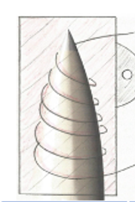
Figure 5: Fixture Design
The thermal loading mechanism we are calling the fixture utilizes the same concept as the heat coils with one addition. The entire heat coil mechanism is encased in metal allowing the mechanical load to be applied. The inner surface of the fixture is perfectly matched to interface with the aerospace component to be tested. This is the major drawback of this design. Every single part that would be tested requires a unique fixture, eliminating the customers universal requirement.

Design #4: Fluid
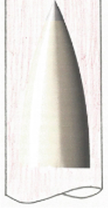
Figure 6: Fluid Design
The application of thermal loading through a dense fluid is another way mechanical and thermal loading can be applied simultaneously. The component to be tested would be inserted into the fluid stream at some non-orthogonal angle, creating a moment on the part. The hot fluid would then heat the part. There are several issues with this design, the first being that the extreme temperatures would cause many oils to combust. Secondly, the part may become damaged from being in contact with the fluid. Finally, there could be a health or safety risk if the oil were to spill.

Mechanical Loading
As flight vehicles turn while traveling at high velocities, there are lateral pressure loads applied to various components. In addition to pressure loads, the vehicles experience lateral acceleration while turning. This acceleration causes forces which must also be replicated in testing. The following two designs apply the mechanical loading to flight components.

Design #5: Rings
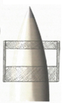
Figure 7: Ring Design
The application of mechanical loading using concentric rings will allow for a more even distribution of loading. The rings would have to be custom-made for each component leading to the same issues as the fixture. One advantage to the ring design is that they could potentially be used on a variety of radome sizes, the only differences being that they would just be situated at different distances from the base.

Design #6 – Cradle
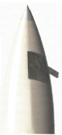
Figure 8: Cradle Design
The cradle is designed to evenly distribute the mechanical load on test parts and is also more universal than the rings. The major disadvantage is that the curvature is generalized so it will not distribute loads as evenly as the rings however, the overall cost will be lower as multiple fixtures will not have to be manufactured.

Test Fixture
The test fixture is the overall assembly which holds and stabilizes the flight component and delivers the mechanical and thermal loading to it. The design of the fixture will have a significant impact on assembly times, storage volume, and ease of use. The fixture will also dictate the size and shape of components that can be tested. Most importantly, the fixture will determine the overall safety and success of the tests to be performed.

Rail
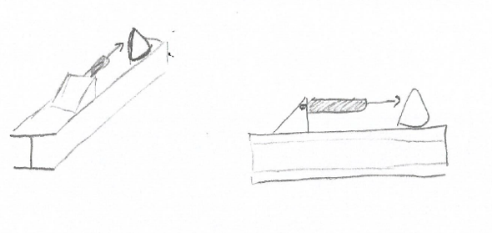
Figure 9: Rail Design
The rail test fixture is a one-piece test fixture designed for simple setup and operation. The fixture is composed of a single I-beam with the hydraulic ram and part interface permanently affixed. This test fixture would transport easily and could be stored in pieces. There are a few disadvantages to this design, which is that there is a small range of parts that can be tested; large components will simply not fit on the I-beam.

Turntable
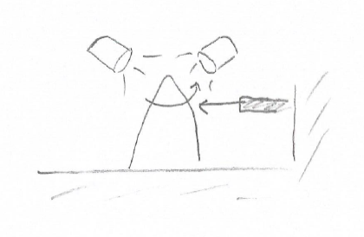
Figure 10: Turntable Design
The turn table fixture is unique in that it rotates as mechanical and thermal loading is being applied. Under normal test conditions, a part must be fully tested and then rotated 90 degrees and re-tested. This fixture would save time as the parts would not have to be disconnected in between tests. In theory, the part could be rotated during the test to create a sinusoidal load, effectively testing fatigue. This fixture also offers the benefit of even heat distribution.

Upright
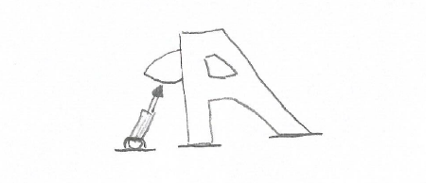
Figure 11: Upright Design
The upright is a multi-sectional test fixture which is designed to handle a wide variety of components. The mechanical load is applied from the floor minimizing deflection of the fixture. The fixture is versatile and perhaps could be adapted for other tests.

DESIGN SELECTED – First Semester
The following section describes the process that the team used to select a design. First, a Pugh chart and decision matrix helped the team decide on which designs to pursue. Next, the team completed engineering calculations to validate that the designs could fulfill the necessary requirements.

Rationale for Design Selection
In the first iteration of the design process, the team focused on two subsystems: mechanical and thermal loading, as they were the most important parts of the design. As a result of the Pugh charts in Figures 12 and 13, the team decided to continue with the designs that most easily incorporate simultaneous mechanical and thermal loading. This design was the fixture design, which fulfills all the customer needs except universality. The fixture design was safe, nondestructive, and could be quickly assembled because it was one single piece however, after meeting with the client and continuing with the iterative calculation process, this fixture is not being considered anymore. The problem with the fixture is that inductance coils were going to be used, which detracts from the universality of the fixture. Inductance coils can only be used for metal radomes and do not work with all materials. This is an issue because radomes are made of many different materials, even quartz.

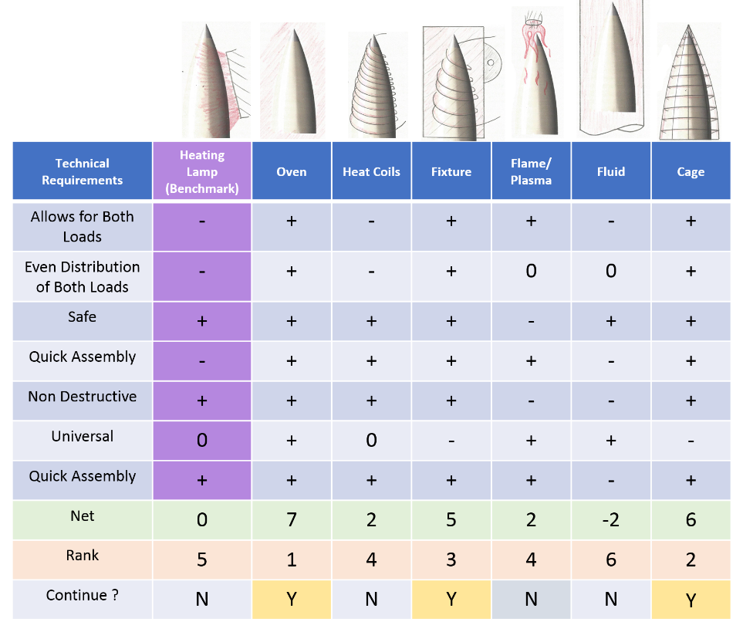
Figure 12: Thermal Loading Pugh Chart
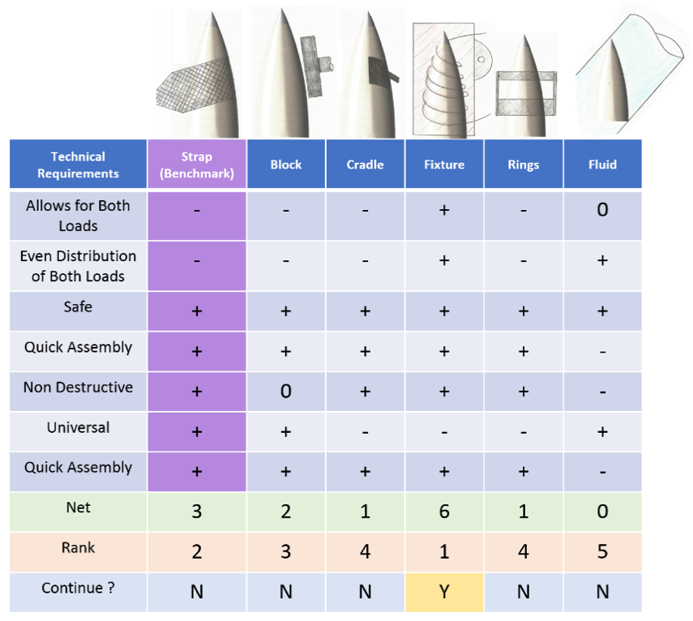
Figure 13: Mechanical Loading Pugh Chart
Instead of using the fixture design, the team is going to move forward with the cradle design and heating lamps for the time being. The heating element may be changed, but lamps are being used for now because that is a standard practice for the client’s company. Next, a decision matrix for the designs of the entire fixture was created (Figure 14). The team decided it was necessary to get a picture of the entire fixture. Each design encompasses all three subsystems mentioned in Section 3. The cradle design has been modified so that there will be multiple sizes of cradle for the different radomes. There will not be a cradle for every single radome, but enough that it can accommodate any part.
Figure 14: Full Fixture Decision Matrix
As a result of the decision matrix, the upright fixture is being pursued. It fulfills nearly every design requirement as is the most robust of the four. It was also selected because of its high scores in simulating flight conditions, minimal labor for setup, and universality. The client has emphasized the importance of these requirements, so they were considered most. The rail design also scored relatively high due to its simple and effective design. However, the rail design cannot be used for large radomes as they will not fit on the I-beam. Both the rotisserie and turntable design could not apply loading in different orientations, so they were not selected. The rotisserie design also scored lower in universality. Therefore, the upright fixture is the best design to fulfill all requirements and apply the mechanical and thermal loading simultaneously.

Design Description
Based on the outcomes of the decision matrix and Pugh chart, and after having a discussion with our client, we decided to move forward with the upright test fixture. In this section we will discuss in further detail the fixture itself and the analyses used to determine the features of the fixture.

Design Description
The test fixture is composed of just 4 major components. There are two uprights which compose the major structure, a universal plate and the hydraulic ram. The entire structure is assembled using various threaded fasteners. The uprights can be lifted with forklift straps and the plate has a lift hook for easy transport. The uprights as well as the universal plate can be stacked in small space reducing the overall storage required. The hydraulic ram is a commercially available part however, the base plate and cradle will need to be manufactured. The following figure illustrates the critical components of the assembly and shows an AMRAAM radome. Figure 15 shows the orientation of the full design.

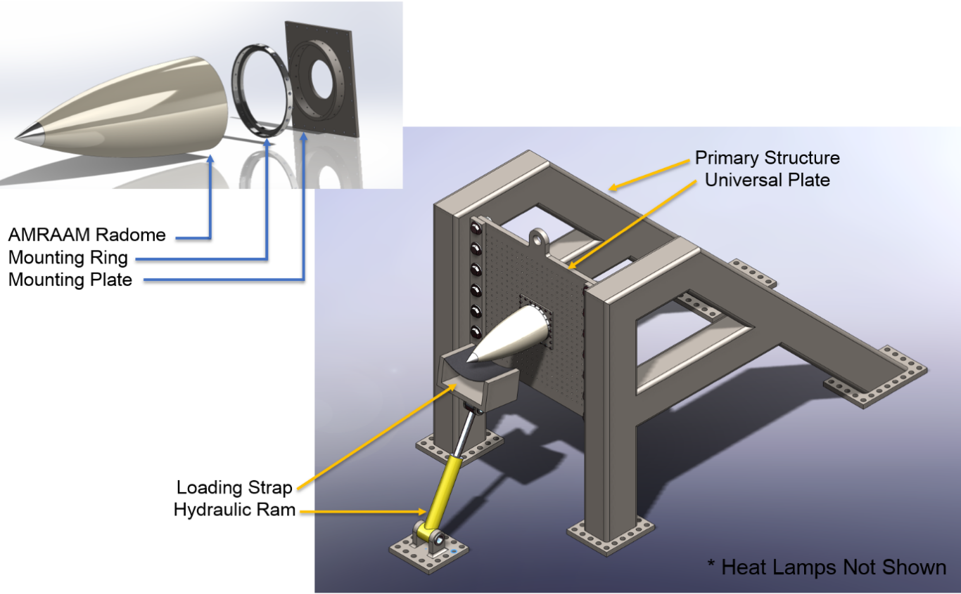
Figure 15: Proposed Test Fixture
The primary component in the fixture is the uprights. The uprights are constructed from 6-inch by 8-inch box beams with a 3/8-inch wall. The tubes are to be cut and welded into the configuration shown. Base plates made from 1-inch plate steel will be used to bolt the fixture to the floor of the testing bay. The upright also has a lip with mounting holes for the plate to be bolted to. The two uprights are virtually identical, the only difference being the side that the mounting lip is welded to. Figure 16 illustrates the left-hand side upright in closer detail.
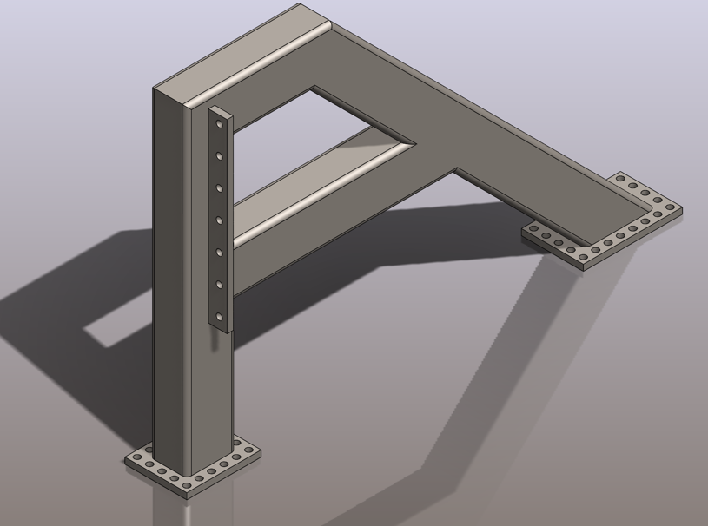
Figure 16: Left Upright
The main plate or universal plate is designed to allow a wide variety of aerospace components to be bolted to the fixture. This interface is what allows a wide range of parts to be tested. This plate is 30 inches by 30 inches which is just large enough to test a Tomahawk radome. The plate has 1-inch diameter holes to connect to the uprights, and a 3-inch diameter center hole to allow sensor cables to be passed through. Figure 17 highlights the universal plate design.
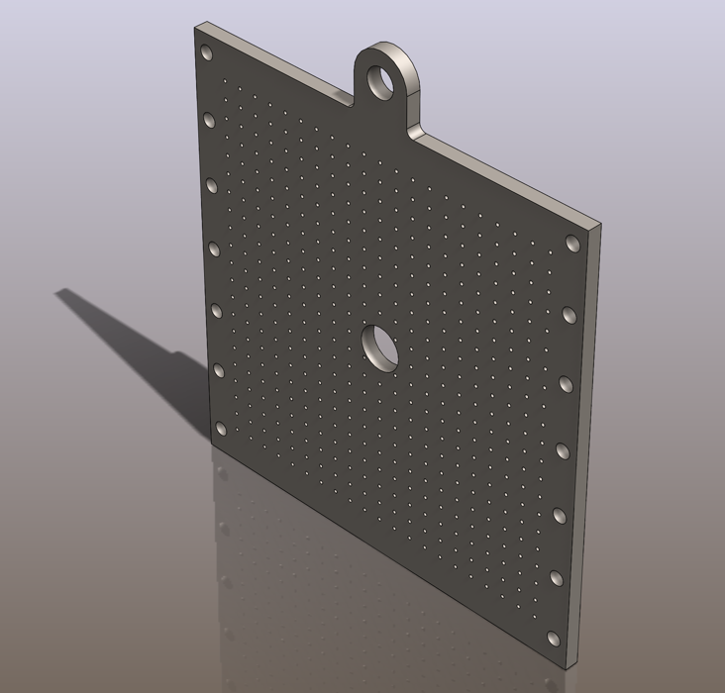
Figure 17: Universal Plate
Each of the components in this assembly will have to be analyzed to ensure they can withstand the mechanical and thermal loading which will be applied. The following sections provide a brief overview of these analyses. Several of the analyses in the following sections were calculated before deciding upon this fixture, and because of that, the beam calculations were performed on an I-beam instead of a box beam. It is important to note that these the heat flux calculations and mechanical loading calculations were performed for an AMRAAM missile and analyzing different missiles would result in unique loads.

Heat Lamp Calculations
The amount of heat flux applied to the missile components is a critical part of this project’s analysis. Calculations were completed to determine how much heat flux should be applied to the specific radome used in this example. Two calculations were completed: heat flux at the tip of the nose cone and heat flux along the running length of the radome. MATLAB was utilized to compute determine these heat fluxes. Figure 18 shows the flow chart for the script used.
Figure 18: Code Flow Chart
First, density and air properties were calculated using the altitude and velocity information. These properties include: reference temperature, dynamic viscosity, specific heat capacity, adiabatic wall temperature, Prandtl number, Reynolds number, and thermal conductivity. Next heat flux was calculated using those properties, as well as Nusselt number and heat transfer coefficient. When the original analysis was completed, the team planning on applying 200 W/cm² using heating coils. However, after discussing these results with the client and searching for materials, the team determined that this heat flux is too large, and we decided to move forward with a heat flux of approximately 75 W/cm² [1]. This number will be more accurate because it is the heat flux located about 3 to 6 inches along the radome. The initial estimate was calculated at the tip of the nose cone, which receives a much larger flux than the body of the radome and is of less interest. Heating lamps were chosen for this project because heating coils may not be able to apply the same flux. Therefore, the team will be utilizing about 6 to 8 lower wattage quartz lamps.

Mechanical Loading Calculations
The calculations for the flight conditions on the AMRAAM radome were broken down into two sections. The loading due to supersonic flight and the loading due to hard banking. The first load is caused by the vehicle traveling at Mach 4. At these speeds, immense pressure is applied to the nose of the vehicle. The second load comes from the vehicle banking at 40 G’s. In order to determine these loads, several properties needed to be determined including mass, distance to the center of gravity and other geometric properties of the missile radome. SolidWorks was utilized to determine these geometric and mass properties for our analysis.

In order to determine the loading due to stagnation pressure at Mach 4, we utilized the isentropic flow equation:
$P_{s}=\left(\frac{P_{0,2}}{P_{1}}\right)P1$
The ratio of $\frac{P_{0,1}}{P_{1}}$ can be found in Appendix B of Fundamentals of Aerodynamics [10]. For our example, at Mach 4, $\frac{P_{0,2}}{P_{1}}$ is equal to 21.07. By using atmospheric pressures, we were able to determine the forces for various altitudes and for various angles of attack. The results are summarized in the following table.
Table 3 - Force due to Mach 4 Flight
AOA | X-sectional  Area [in²] | Altitude [ft] | Atmospheric  Pressure [$\frac{lb}{{ft}^{2}}$] | Stagnation  Pressure [$\frac{lb}{{ft}^{2}}$] | Force [lbf]
0° | 38.48 | 52,000 | 232.8 | 4,905 | 1,311
5° | 38.59 | 52,000 | 232.8 | 4,905 | 1,314
10° | 38.93 | 52,000 | 232.8 | 4,905 | 1,326
0° | 38.48 | 20,000 | 973.3 | 20,507 | 5,480
5° | 38.59 | 20,000 | 973.3 | 20,507 | 5,496
10° | 38.93 | 20,000 | 973.3 | 20,507 | 5,544
10° | 38.93 | 0 | 2116.2 | 44,584 | 12,053

For determining the loading due to 40G turns, we simply used:
$F=ma$ (1)
$F=5.91\left[lb\right]*40*$32.2 [$\frac{ft}{s^{2}}$]
F=7,612 [lbf]

The final calculation in Table 3 shows the vehicle traveling at Mach 4 at sea level. While this speed is most likely unattainable at this altitude, the longitudinal force is 12,000 pounds. The lateral force due to a 40G turn was calculated to be 7,600 pounds. Fortunately for the vehicle, the maximum longitudinal and lateral forces will not happen simultaneously. These calculations can now be used to determine the loading on the individual components of the test fixture. These loading conditions can be multiplied by an appropriate factor of safety and each flight component can be tested. The size and dimensions of the test fixture will also be determined from these calculations.

Bolt Calculations
The bolt loading analytical calculations investigated the structural integrity of the threaded fasteners that connect the mounting plate to the universal plate of the test fixture. The ¼"-20 X 1 ¾" UNC SAE grade 8, steel hex head screw was the selected fastener for the first iteration of these bolt calculations. A total of 24 bolts with a preload of 5.5 kips was used to estimate the tensile load, the yielding and joint factors of safety. As requested by the client, all aspects of our design must meet a factor of safety of 4 or greater. Using the plate thickness, nut length, and washer thickness, the tensile load per bolt, yielding factor of safety, and joint factor of safety came out to a value of .417 kip, .683, and 16.83, respectively. Although the joint factor of safety significantly exceeds requirements, the yielding factor of safety noticeably misses the mark. Upon further inspection, when the preload is reduced to approximately 3 kip, the factor of safety requirements are met. This is important because it informs us that the current state of the test fixture will be unable to support the required maximum load without failure. To account for this and assure the fixture will be able to achieve a factor of safety of 4 while enduring expected maximum loading, specific variables of the fasteners and universal mounting plate will need to be modified in the 2nd iteration of our calculations.

Beam Calculations
The purpose of this beam calculation is to determine the correct specification for the I-beam required for this test fixture The I-beam was initially chosen because they typically have large moment of inertia compared to other beams. The assumptions are that the load should be 100,000 N, and that the material is steel, considering steel has high yielding stress which is 1,000 MPa [11] The stress of the I-beam should not exceed 250 MPa and the length of the I-beam that is connected to the hydraulic ram is 0.9 m. After finding the stress calculation, the best result was 233.233 MPa, which will make the factor of safety 4.3. The cross-sectional area should be 917 mm². If the cross-sectional area of the I-beam were to increase, the factor of safety will also increase. The mass of the 0.9 m beam will be 9 kg if the steel is exposed to an environment of 20 degrees C [12].

Proof of Concept Prototype
Figure 19 shows the proof of concept prototype. It was created to serve as a visual aid of the design. Prototyping will be continued with the purpose of quick assembly testing.
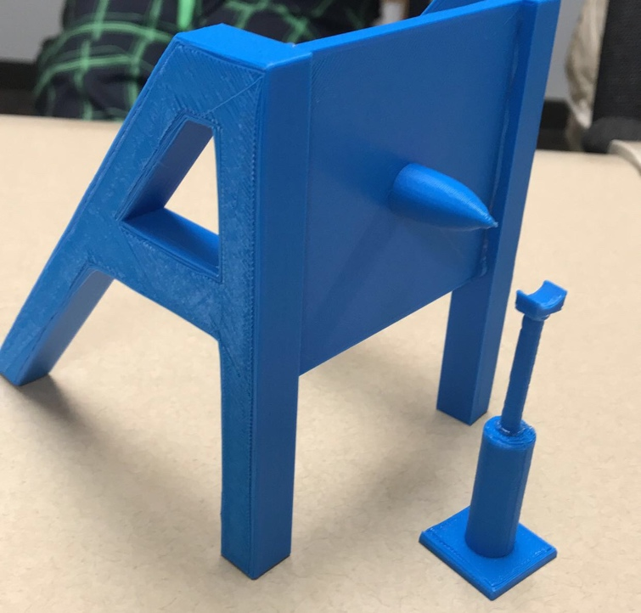
Figure 19: Initial Prototype

PROPOSED DESIGN – First Semester
The following section details the plan for implementing and furthering the design. It also includes the resources that will be required for implementation and the bill of materials for the design. The schedule and budget for the upcoming semester will be detailed in this section. The SolidWorks models of the assembled design and parts will also be shown.

Description of Implementation Plan
The first step in implementing the design is to produce more detailed specifications using the current drawings. Parts of the design have not been validated mathematically, so that will be a future requirement. Bolt calculations for the radome mounting plate need to be readdressed in order to produce finite specifications. These calculations may also reveal design flaws or weaknesses that will need to be addressed. After all the parts have been validated and design changes have been made, a second iteration of 3D printed prototyping will be completed. This prototype will be used to test the assembly time of the entire test fixture. Next, load and power estimations will be completed for the whole fixture. The team will also decide what will be used to power the fixture. After the power calculations are completed, a third iteration of calculations will be completed if necessary. Because this project is iterative in nature, the design will likely change before the end of the semester. Several rounds of calculations and prototyping may be the end result of this project.

Resources Needed
The bill of materials for the proposed design can be found in Appendix B. This details all the necessary components to construct a full-scale fixture. It includes the part description, unit cost, total cost, and a link to where the item cam be purchased. It is important to note the bill of materials does not include any labor costs that may be required to build the full-size test fixture. Other resources that will be required for implementation will be computer software. ANSYS and SolidWorks will be utilized to simulate and model the test fixture. Another resource that will be needed for prototyping is a 3D printer. In addition, the team will need various textbooks and online resources to continue to refine the test fixture design.

Implementation Scheduling and Budget
Table 4 shows the scheduling for the implementation procedure as described in 6.1. The dates are tentative and will be revised as the semester progresses. The scheduling may also have to be accelerated based on capstone requirements.
Table 4: Schedule
Task | Estimated Completion Date
Produce Specifications | September 10th, 2018
2nd Iteration Bolt Calculations | September 24th, 2018
2nd Iteration of Prototyping | October 15th, 2018
Quick Assembly Testing | October 22nd, 2018
FEA Temperature Profile Modeling | October 22nd, 2018
Load and Power Estimates | November 5th, 2018
3rd Iteration of Calculations | November 26th, 2018
3rd Iteration of Prototyping | December 5th, 2018

As this is an analytical project, all of the team’s expenses will come from 3D printing. The overall budget of this project is approximately $800 which was supplied by the university. However, the team intends to use less than $200 on 3D printing for prototyping purposes. At this point in time 3D printing is the only expense, however another potential area of cost is analytical software. Currently only $12.50 has been spent on 3D printing for the proof of concept prototype. The MakerLab on campus will be used to print the prototype.

Design Model
The following image (Figure 20) shows an isometric view of the entire test fixture assembly. The figure shows the side legs of the test fixture and the universal mounting plate. A radome can also be seen connected to the square adaptor plate. The universal plate has many bolt holes so that a wide variety of parts can be easily attached to the fixture. Figure 12 also shows the hydraulic ram and cradle, which will be used to apply the bending moment about the adapting plate. The heat lamps are not shown but will be set up in a ring around the missile radome.

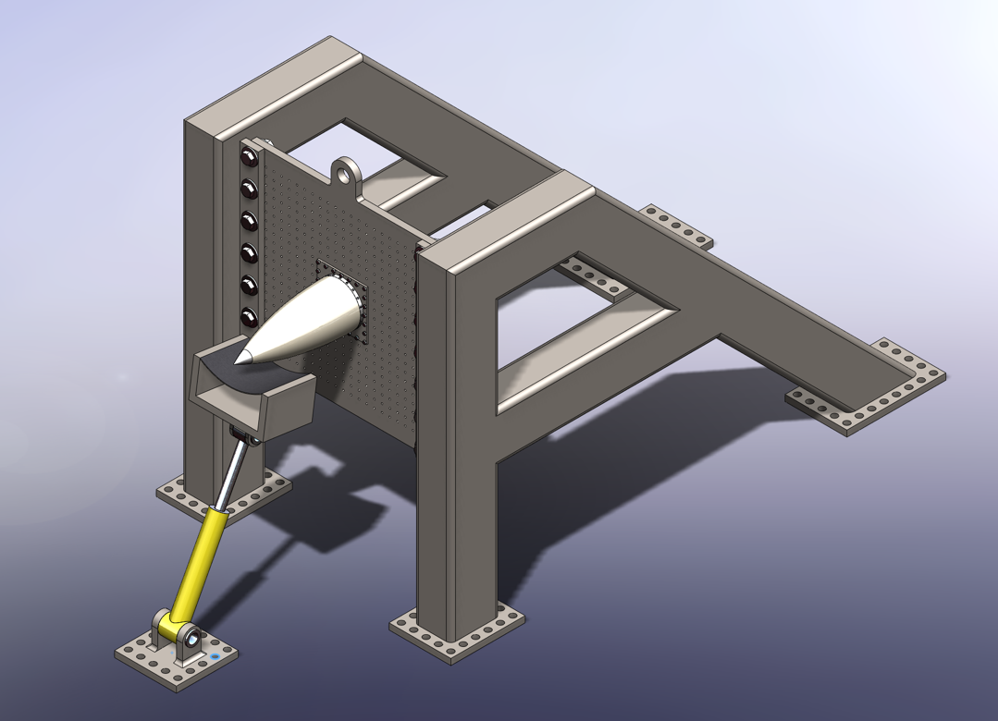
Figure 20: Assembly View of Test Fixture
Figure 21 shows an up-close view of the radome and adaptor plate in an exploded view. There is a ring that attaches the missile to the adaptor plate. The bolts that will hold the assembly together are not shown.
Figure 21: Exploded View of the Radome Connection Assembly
Further modeling details and drawings part of the test fixture can be found in Appendix C.

IMPLEMENTATION – Second Semester
Designing the test fixture is entirely analytical, therefore no physical implementation or manufacturing will be completed. In place of manufacturing, the team is using analyses to validate that the design is viable. The following section details the analyses that have been completed this semester. These analyses are used to justify each design choice. Design changes as a result of each analysis will be discussed as well.

Analyses

Quartz Lamps Analyses
One analysis that was performed was the temperature distribution analysis. This analysis was completed in order to influence how the quartz lamps will be placed around the radome and to ensure there is temperature data for future calculations. It is important that there is not a high temperature differential surrounding the radome. The heat flux analysis that was discussed earlier was necessary for the temperature distribution. For this reason, MATLAB was used, and new code was added to the previous program. Finite-differencing was utilized and the radome was vertically cut into 20 slices. First, heat flux due to aeroheating was found for each slice. Then the height, radius, surface area, contact area, and volume were found for each slice. After that the heat flux into and out of each slice was computed. This included fluxes due to convection, conduction, radiation, and aeroheating. Once the fluxes were found, temperatures were computed using the mass, surface area, time of flight, heat transfer coefficient, and specific heat capacity of each section of the radome. Figure 22 shows the flow chart of the code.


Figure 22: Temperature Distribution Flow Chart
Figure 23 shows the resulting temperatures of each section of nose cone. This model is of AIM-120D AMRAAM, because the team is using this radome as a baseline. The temperatures only vary from about 125 to 160C at the base of the radome.
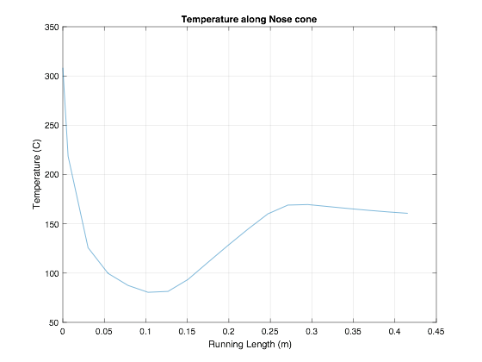
Figure 23: Temperature Results
After the temperature distribution calculations were completed, the heat flux distribution was modelled using the ray tracing method. Figure 24 shows the six heating elements in each lamp and the rays that extend from each. The surface of the radome was split into 20 sections, and the number of rays in each was added up. This data was plotted and curve-fitted as seen in Figure 25.
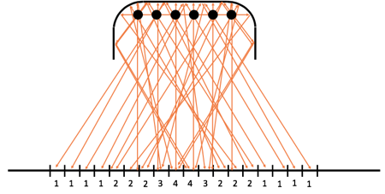
Figure 24: Ray Tracing for Heat Flux Distribution
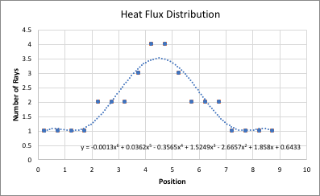
Figure 25: Heat Flux Distribution Plot
Both analyses show that in order to have an even heat flux and temperature distribution, the lamps must be nearly touching each other, and should be 1 to 2 inches away from the radome. This is because the rays do not extend out very much past the position of the lamp, which is extends from Position 2 to 7. The team wants to heat each section to with 50 W/cm² ± 10%. This spacing will ensure that the radome is evenly heated and is in the same temperature range.

Second Iteration Compressible Flow
The second analysis performed was the mechanical loading analysis. The loading is generated from two different modes. High speed flight and extreme G banking. The first load is caused by the vehicle traveling at Mach 4. At these speeds, immense forces are applied to the nose of the vehicle. The second load comes from the vehicle banking at 40 G’s. Determining these loads is crucial in the design and testing of AMRAAM radomes. The lateral loading of the radome was completed last semester so this section will focus on compressible flow due to traveling at Mach 4.

The longitudinal loading the vehicle experiences is primarily composed of drag due to traveling at Mach 4. This drag force will be calculated utilizing isentropic compressible flow models. More specifically, oblique shock waves and the resultant drag forces will create a moment if the vehicle changes its angle of attack.

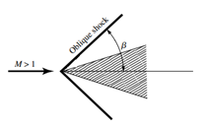
Figure 26: Oblique Shock Wave on Conical Section
The first step in the analysis is to determine the angle of the oblique shock wave which is designated β (see Figure 26). The shock wave angle can be determined utilizing figures within the Fundamentals of Aerodynamics text book. Figure 9.9 on page 613 illustrates the shock wave angle as a function of the conical section half angle and the speed of flight (see Figure 27. For our example, the half angle of our cone is 26° and the Mach number is 4. The output of this chart is the angle of the oblique shock wave β. For this example, β is 40°.

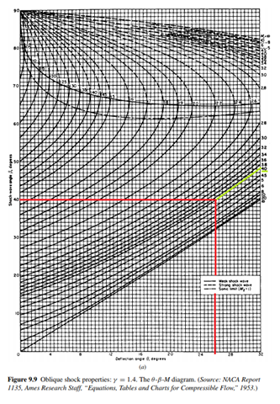
Figure 27: Figure 9.9 from Fundamentals of Aerodynamics [10]
The next step in the analysis is to determine the pressure difference after the shock wave, Appendix B of Fundamentals of Aerodynamics text book will be utilized for this result. Having determined that the air speed after the shock wave is Mach 2.6, Appendix B then tells us that the ratio of pressure before and after the shock wave will be 7.72.

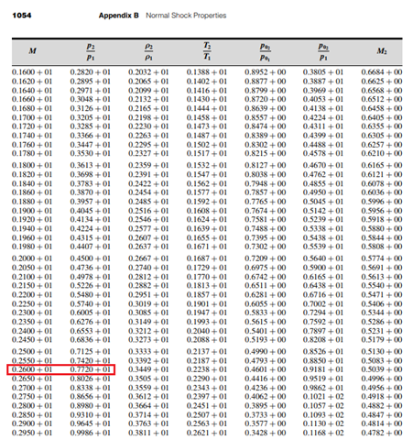
Figure 28: Appendix B from Fundamentals of Aerodynamics [10]

Now that the pressure post shock wave is known, all of the information required to calculate the coefficient of drag is available. The equation for the coefficient of drag is:
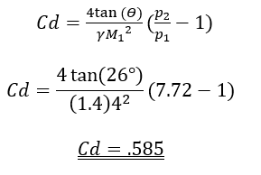
Where γ is the ratio of specific heat for air. This coefficient of drag can now be used to determine the force of drag that the AMRAAM radome experiences along with the moment being applied to the base. The force of drag is found using:
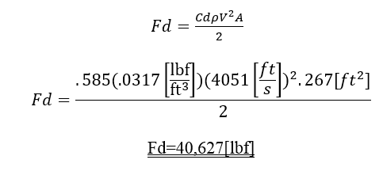
After calculating the lateral and longitudinal forces on the radome, it becomes clear that there are enormous forces being applied to the quartz. The final calculation from equation 6 shows the vehicle traveling at Mach 4 and with a 10° angle of attack will produce a moment of 45,503[in-lb]. The lateral force due to a 40G turn was calculated to be 7,612 pounds creating a moment of 49,098[in-lb]. Fortunately for the vehicle, the maximum longitudinal and lateral forces will not happen simultaneously. These calculations can now be used to determine the requirements of the test fixture. Ultimately, it was shown that the moments from 40G turns and full speed maneuvers produce similar moments. The value of 49,000[in-lb] will be used in further calculation of our test fixture to determine the size and dimensions of the structure.

SUMMARY OF RESULTS
Maximum Force Due to 40G Turn ……………………………….…..……7,612 [lbf]
Maximum Drag Force Due to Mach 4 Velocity ……………….…………40,627 [lbf]
Maximum Moment Due to Turn …………….…………..………..….…49,098 [in-lb]
Maximum Moment Due to Velocity …………………...…………….…19,404 [in-lb]

Second Iteration Beams
This analysis is about getting the right size of the beams, using the maximum force applied on an AMRAAM radome. Based on the shape of the fixture, the force should be split in half and the calculation would be for one of the uprights. Figure 29 shows one side of the A-frame and its applied loading. The reaction forces have also been calculated all over the upright beams in order to get the maximum moment and maximum stress. The material is YST 310 steel, which has a high tensile strength and the fulfills the factor of safety of four. Next, considering the moment of inertia for a square hollow section will get us the dimensions of the cross section needed. After that, using the density of steel and the dimensions of the beam gave us the weight of a single upright which is 85 kg. Figure 30 shows the table that was used to choose the beam.

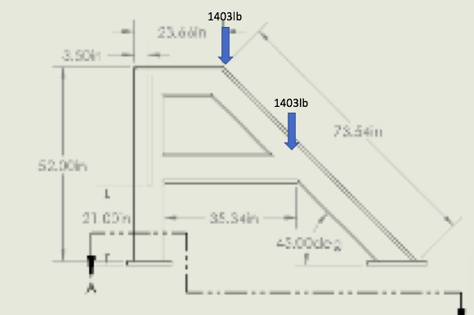
Figure 29: Upright with Applied Forces
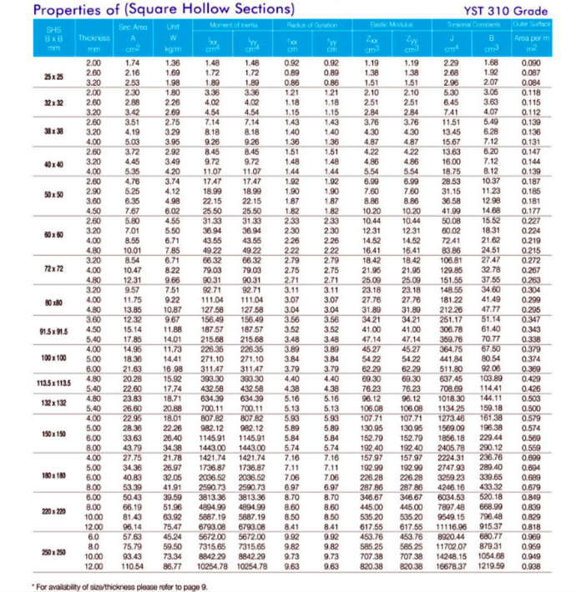
Figure 30: Properties of square hollow section [14]

Second Iteration Floor Bolts
The second iteration of the bolt analysis focuses primarily on the fasteners that hold each of the four legs into the ground, keeping the entire fixture in place under any loading condition applied. Although the only directly applied force from the hydraulic is applied onto the radome, each of the legs of the test fixture receives a reaction force. These reaction forces, based upon the applied force on the radome, will determine whether the entire fixture will be able to withstand the load on the radome. Firstly, there are a few variables that the team has either calculated or were specifically given by the client; these specifications will remain unchanged as all other variables are determined. The client has stated that the bolts used in securing the fixture to the floor must be 5/8” diameter bolts with 18 threads per inch. The fixture must be able to handle and apply conditions to a variety of radome lengths and diameter sizes. For the sake of consistency across all fixture analysis the team has decided to use a radome 17 inches in length and 7 inches in diameter. The final parameter was the moment about half the radome’s diameter, located at the connection point between the radome and the AMRAAM mounting ring, M_{c}. The moment created was 49,098 in-lbf, which was established from the aforementioned compressible flow calculations. For the purpose of this analysis and in the manner the calculation program operates, the value of the force applied on the radome, F_{a}, and its distance from the connection point, L_{AC}, are arbitrary values and can be adjusted at any time; the only constraint is that L_{AC} must be greater than 6 inches due to the extension length of the heat lamps from the mounting plate. Given M_{c}, L_{AC} was selected to be 8 inches, meaning F_{a} is 3,608.62 lbf applied on the radome.
Approaching the design from a side profile as seen in the figure called Upright, to solve for the reaction forces at the front leg, named point B, and the back leg, named point D, the moment about point D must be calculated to find F_{D.} To find these moments, it's important to also know the various distances between each of the points where either a moment occurs, or a force is applied. Finally, finding the reaction forces requires the sum of the forces at equilibrium in the Y direction to solve for the reaction forces F_{a}, F_{B}, F_{C}. It is to be noted that the force at point B puts the bolts in tension, while the force at point D puts the bolts in compression. This however, should not affect the test results of the bolt integrity. The results are as follows, summarized in Table 5.
Table 5: Summarized Floor Bolt Force Results and Distances
Point Type / Name | Point Location | Force at Point Location [lbf]
Point A | Applied force on radome | 3068.62
Point B | Center of base of front leg | 4196.11
Point C | Given moment at mounting ring | ---
Point D | Center of base of back leg | 1127.49
Relevant Distances | Distance Value [in]
Length AB | 8.25
Length AC | 8
Length AD | 74.25
Length BD | 66
Length BC | 0.25
Length CD | 66.25

Design Changes

Quartz Lamps
One way that the test fixture design has changed is the way the quartz lamps will be arranged and what model will be used. Previously, the team did not have a design for an apparatus to hold the lamps. Now, the lamps will each be attached to a bracket that inserts into a hole in the universal plate. This design was chosen because it fits easily with the current design and can cater to the size of the radome; lamps can be added or removed. Model 5209 with 5 inches of lighted length are the chosen lamps because they can provide the right heat flux and fit best with the design [13]. The team is using shorter lamps because the base of the radome is the most important section, and the rest of the radome does not need to be heated. Having shorter lamps also allows more room to apply the mechanical loading using the ram. Due to the above heat flux and temperature analyses, the lamps will be nearly touching and will be 1 to 2 inches from the radome. The spacing of the lamps is influenced by the analyses detailed in Section 7.1.1 abovc.
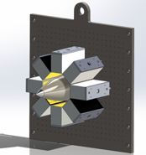
Figure 31: Heat Lamps Attached to Plate

Beams
The recent calculation of beams has changed the dimensions of the cross section of the beam, before we just assumed the dimensions without knowing the amount of stress on the system. But at this moment considering the stresses on the beam, it should be 113.5 mm x 113.5 mm, with thinness of 5.4 mm. Also, the material is YST 310 steel which has the highest tensile strength among the other types of steel. These conclusions are a result of the second iteration of the beam calculations.

Floor and AMRAAM Mounting Plate
From the second iteration analysis and the team’s most recent meeting with the client, we have found that one of the best ways that we can improve our design to lower assembly and disassembly time is to use the same exact specifications for every bolt utilized in our design. In our case, this means we much change and adjust the bolt selection, number of bolts, and bolt distribution that currently exists for the AMRAAM mounting plate and have them match those of the floor bolts. This would involve recalculating the factors of safety given the new bolt specifications and determining if the fasteners between the AMRAAM mounting plate and universal mounting plate would still hold. The results of this analysis have led to the decision that all fixture bolts will be steel, 5/8”-18 UNF, SAE grade 5 (Q&T), and have a fastener length of approximately 1.96 inches or greater. The fixture is significantly over built, and with the given load, the AMRAAM mounting plate is still well within the required load and joint factors of safety, and the number of bolts can be reduced from 24 to 8. Regarding the floor bolts, again, the load, joint, and fatigue factors of safety are well over what is expected of the design, and therefore the number of bolts in the front leg can be reduced from 18 to 6 and the number of bolts in the back leg can be reduced from 22 to 8 bolts and still be well over the required factors of safety.

CONCLUSIONS
The design of this test fixture at both the system and subsystem level is a complicated task which will require many iterations. The storage, transport, and construction of the test fixture will define the performance at the system level. The means in which the thermal and mechanical loading is applied, as well as the measurement data defines the performance of the sub functions. The team completed beam, bolt, thermal loading, and mechanical loading calculations, which helped influence the design decision. The team has chosen the upright fixture and will continue to refine the calculations as the semester progresses. Testing and prototyping will also continue as our analyses continue.

REFERENCES
[1] R. Cunnington, "Recommended Aeroheating Methods", Teleconference, 2018.
[2] Gulfstream Aerospace, "Ultimate Load Test I,” 2016. [Online]. Available: https://www.youtube.com/watch?v=UGFZ7OWlNpo. [Accessed Feb. 5, 2018].
[3] Suess, R., Weckesser, L. "Radome Thermal Design for a Mach 4 Missile", 2018. [online]. Available at: http://www.jhuapl.edu/techdigest/views/pdfs/V03_N6_1964/V3_N6_1964_Suess.pdf [Accessed 5 May 2018].
[4] Voracek, D., Reaves, M., Horta, L., Potter, S. "Ground and Flight Test Structural Excitation Using Piezoelectric Actuators", 2018 [online]. Available at: https://ntrs.nasa.gov/archive/nasa/casi.ntrs.nasa.gov/20020065233.pdf [Accessed 5 May 2018].
[5] Richards, W., Fields, R., & DeAngelis, M. (2004). Combined Loads Test Fixture for Thermal-Structural Testing Aerospace Vehicle Panel Concepts - NASA/TM-2004-212039
[6] Steinetz, B. (1990). A test fixture for measuring high-temperature hypersonic-engine seal performance - NASA-TM-103658.
[7] NASA Armstrong Flight Research Center "Composite Material Loads Testing,” 2016. [Online]. Available: https://www.youtube.com/watch?v=OeS1_h1doQg. [Accessed Aug. 19, 2016].
[8] HDT Global Inc. 2012. [Online]. Available: http://www.braider.com/Case-Studies/High-Pressure-Airbeam.aspx. [Accessed FEB. 31, 2018]
[9] What is Hybrid Composite Beam, 2012. [Online] Available; http://innovativeglobal.net/products/hc-bridge/. [Accessed Apr. 21, 2018].
[10] J.D. Anderson, Jr., Fundamentals of Aerodynamics. New York, NY: Mc Graw Hill, 2011
pp. 555-776, 1053-1057
[11] K. J. Anusavice and R. W. Phillips, Phillips science of dental materials. St. Louis, MO: Saunders, 2003.
[12] W. A. Nash and M. C. Potter, Schaums outlines: strength of materials. New York: McGraw Hill Education, 2014
[13] Pcscontrols.com. (2018). [online] Available at: http://www.pcscontrols.com/sites/default/files/HiTempIR%20Model5209%20User%20Manual.pdf [Accessed 9 Oct. 2018].
[14] JSL Ispat Pvt. Ltd. (n.d.). Retrieved October 11, 2018, from http://www.jslispat.com/ [Accessed 23 Sep. 2018].

APPENDICES

Appendix A: House of Quality

Appendix B: Bill of Materials
# | Item | Unit Cost | Units | Total | Sourcing
1 | 4-40 X ¼” FH | $3.75 | 20 | $75.00 | https://www.mcmaster.com/#93401a100/=1cgj2mz
2 | ¼-20 X 1 ¾” HH | $1.06 | 24 | $25.44 | https://www.mcmaster.com/#92245a548/=1cgkjhp
3 | ¼” Washer | $0.07 | 48 | $47.52 | https://www.mcmaster.com/#98032a477/=1cobnmo
4 | ¼” Nut | $0.30 | 24 | $7.29 | https://www.mcmaster.com/#94191a100/=1cgl7bj
5 | 1-8 X 3 ½” HH | $5.50 | 75 | $412.50 | https://www.mcmaster.com/#92198a918/=1cgmm7w
6 | 1” Washer | $6.34 | 75 | $475.50 | https://www.mcmaster.com/#98019a530/=1cgmpf5
7 | 1” Nut | 1.29 | 14 | $18.06 | https://www.mcmaster.com/#90499a847/=1cgmqis
8 | 8x6x3/16” A550 Box Tube | $42.30 | 25 | $1057.50 | https://www.metalsdepot.com/steel-products/steel-rectangle-tube
9 | Quartz Heat Lamps | $679.00 | 10 | $6790.00 | http://www.infratechheatersusa.com/lighting/
10 | Hydraulic Ram | $655.12 | 1 | $655.12 | http://www.tooldiscounter.com/
11 | 1”-12”-12” Steel Plate | $81 | 3 | $243 | http://www.speedymetals.com/pc-4197-8221-1-a-36-hot-rolled-steel-plate.aspx
 | Total |  |  | $9762.96

Appendix C: CAD Models
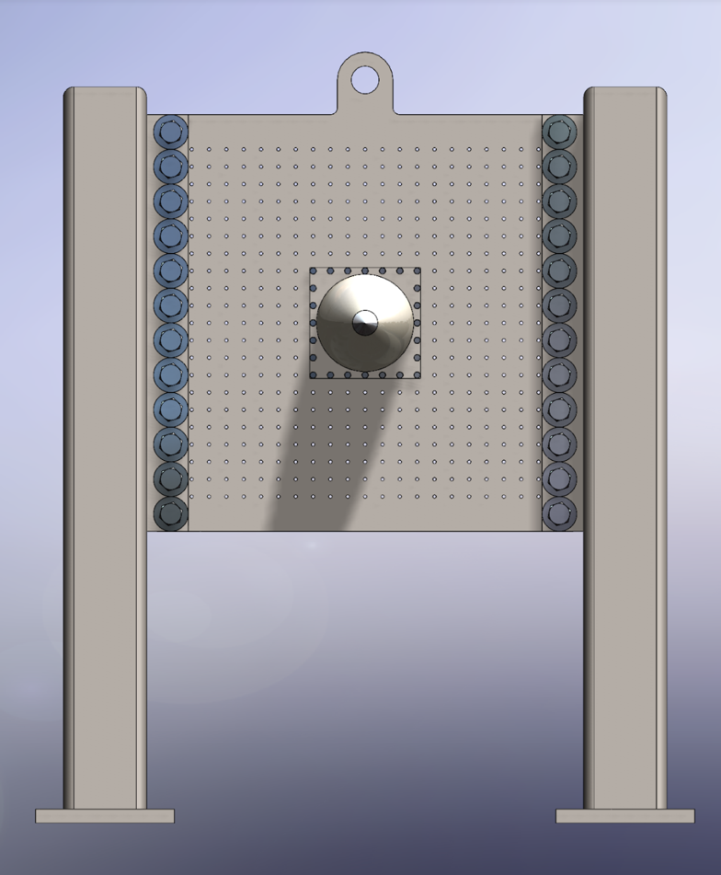
Figure 32: Front View
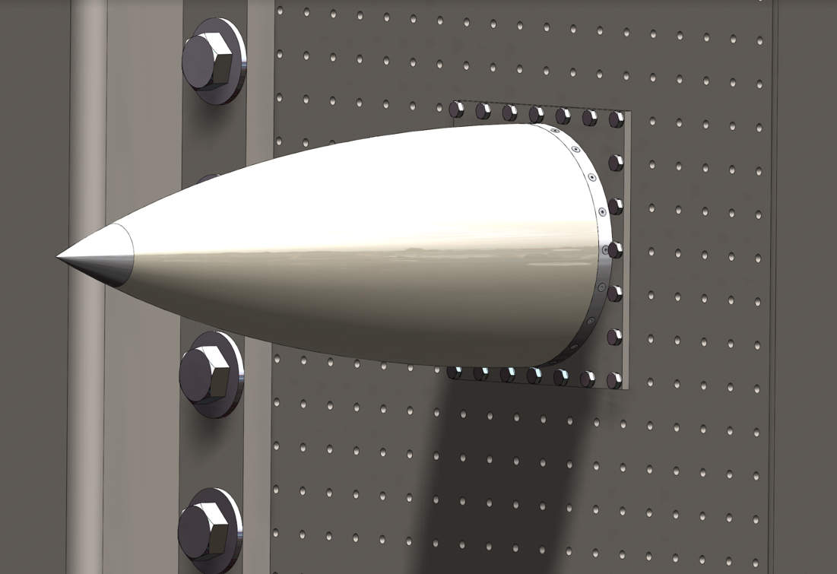
Figure 33: Close-Up of Radome Attachment
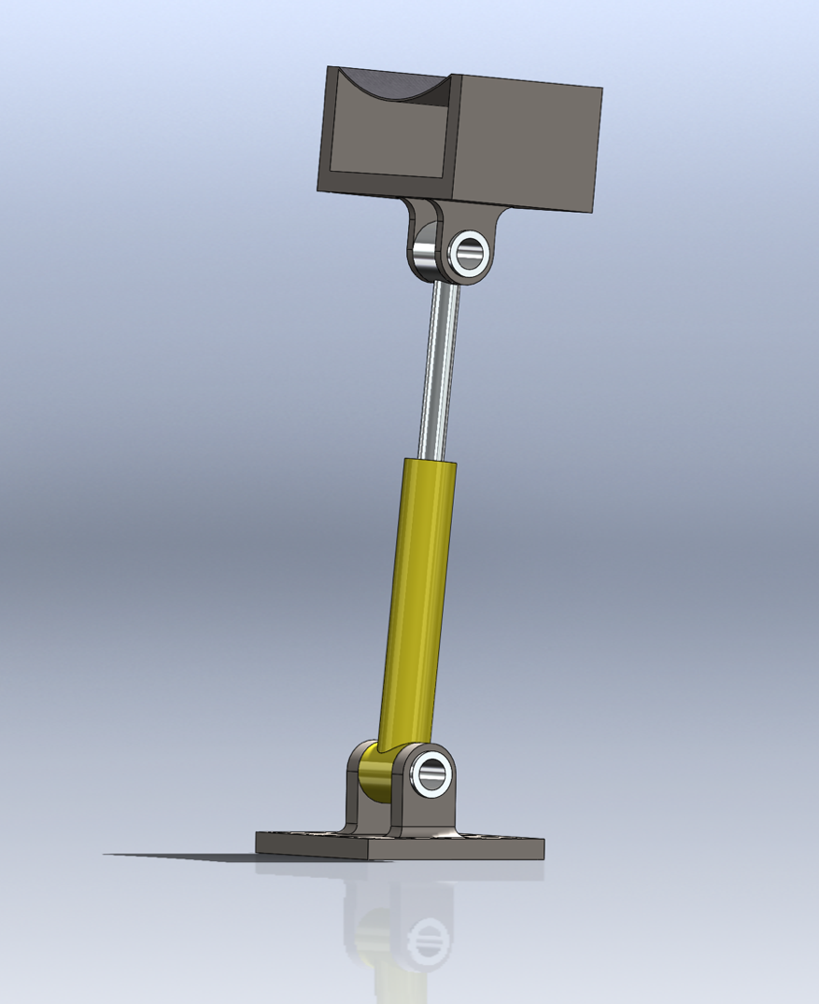
Figure 34: Hydraulic Ram
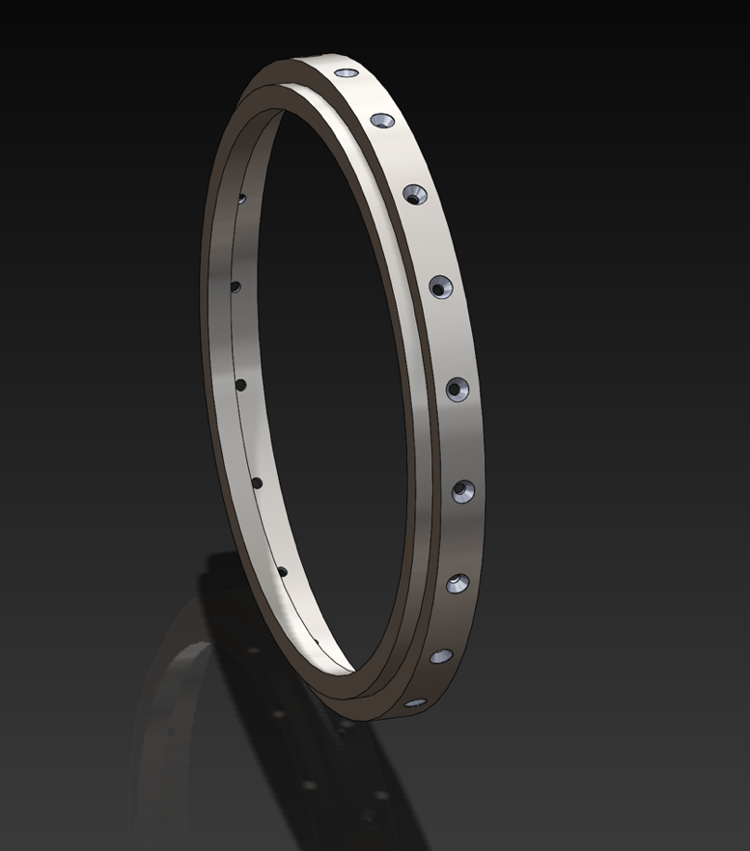
Figure 35: Mounting Rim
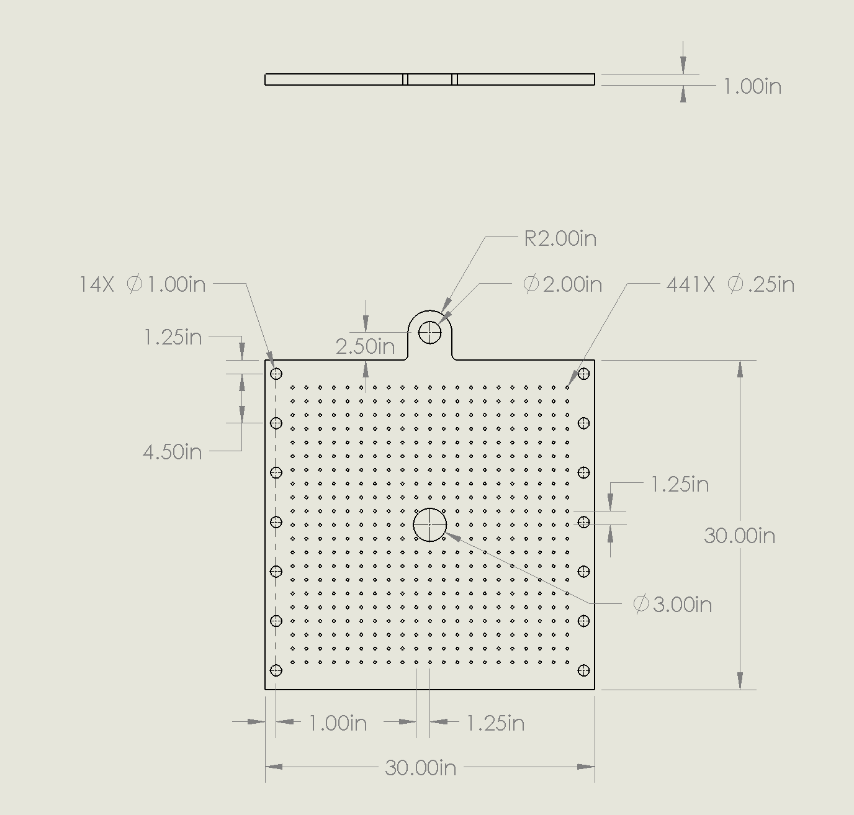
Figure 36: Universal Plate Dimensions
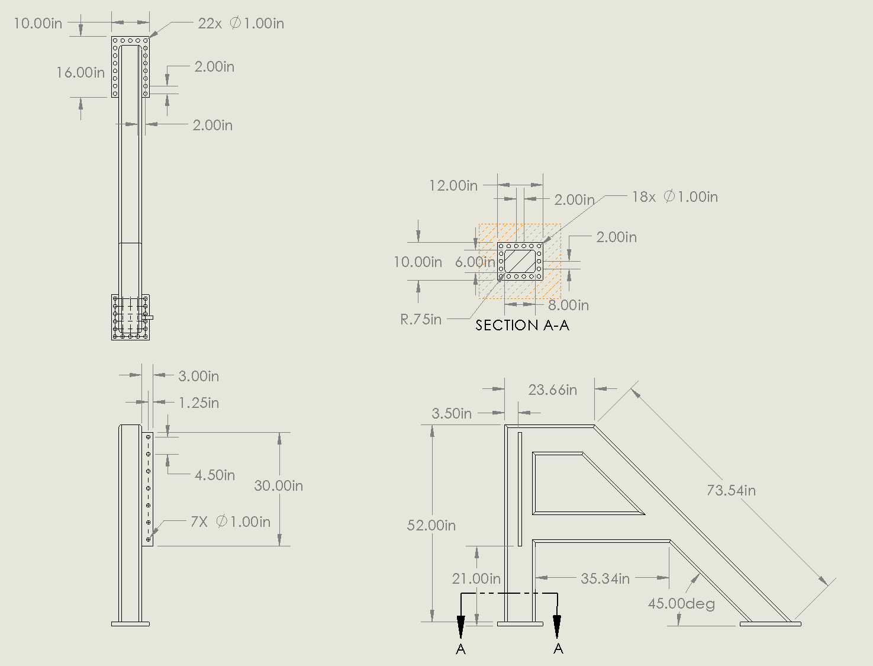
Figure 37: Left Upright Dimensions
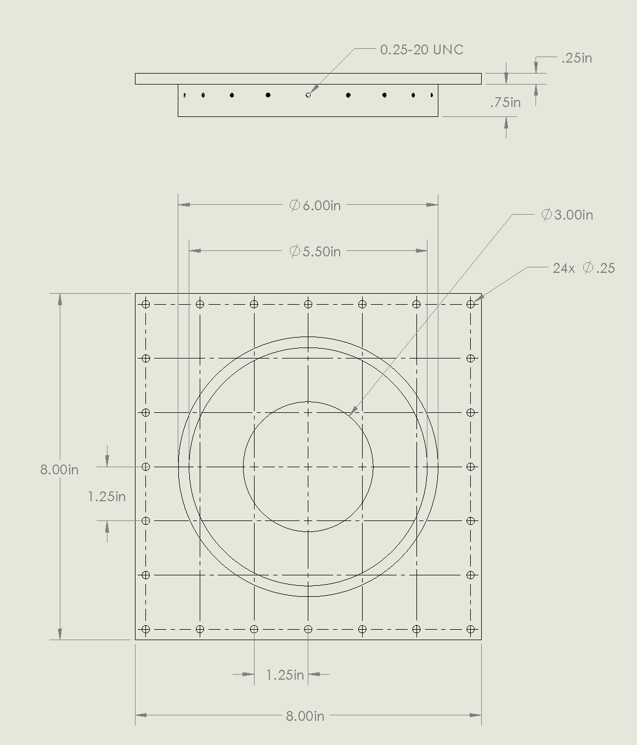
Figure 38: Mounting Plate Dimensions

