Preliminary Report

By:
Ahmad Alharbi
Ahmad Altheyaib
Mishary Alhooli
Abdulaziz Hussain
Mahmoud Shaban

ME 476C KinSculp 18F25
Section: 001

Submitted towards partial fulfillment of the requirements for
MECHANICAL EGR DESIGN I (FALL 2018 M16)006
– 10/26/18


Department of Mechanical Engineering
Northern Arizona University
Flagstaff, AZ 86011

DISCLAIMER
This report was prepared by students as part of a university course requirement. While considerable effort has been put into the project, it is not the work of licensed engineers and has not undergone the extensive verification that is common in the profession. The information, data, conclusions, and content of this report should not be relied on or utilized without thorough, independent testing and verification. University faculty members may have been associated with this project as advisors, sponsors, or course instructors, but as such they are not responsible for the accuracy of results or conclusions.

EXECUTIVE SUMMARY
This project is about the kinetic sculpture, which is an art transform into mechanical engineering aspects. Kinetic sculpture is showing engineering principles in a structural form which has some motion as well. This motion can be fully moving or partially moving or virtual movement can be observed in the kinetic sculpture.
In this project a kinetic sculpture will be developed and represented in a mechanical engineering (ME) process and it will positively express the Mechanical Engineering Department. For this purpose, customer requirements have been developed and then engineering requirements as well. These requirements have interlinked with each other using House of Quality matrix. This matrix determined the ranking of engineering requirements as well and the most important engineering requirement is light weight of the product because it will have to carry from one place to another place which shown its Robustness.
To understand this project, research has been done in which kinetic art has been studied and kinetic sculptures have been viewed. The research was done using the IEEE website and some other libraries which provided the articles regarding the kinetic sculpture and mostly the article were appeared about the kinetic art.
Existing Designs have presented for the project including the system level design and sub-system level designs. From the research functional model has developed which shown all the inputs and outputs and all the process that will perform in the project.
From the functional model and existing designs and following the requirements of client, new design ideas have generated for the project along with the description of design, sketches, pros and cons. And then decision matrix has used which check each requirement in each design and give a rated score according to the level of requirement present in the design. In this way top design has selected which is Bird Sculpture, it consists of a box over which the bird will place and two wings which will show movement using the spring and this bird sculpture will develop in this project.

Table of Contents
DISCLAIMER 2
EXECUTIVE SUMMARY 3
1 BACKGROUND 5
1.1 Introduction 5
1.2 Project Description 5
1.3 Original System 5
2 REQUIREMENTS 6
2.1 Customer Requirements (CRs) 6
2.2 Engineering Requirements (ERs) 6
2.3 House of Quality 7
3 EXISTING DESIGNS 9
3.1 Design Research 9
3.2 System Level 10
3.2.1 Existing Design # 1: Gear Bird 10
3.2.2 Existing Design # 2: Make Faire 10
3.2.3 Existing Design # 3: Mimic Rings 11
3.3 Functional Decomposition 11
3.3.1 Black Box Model 12
3.3.2 Functional Model 12
3.4 Subsystem Level 13
3.4.1 Subsystem # 1: Box 13
3.4.2 Subsystem # 2: Wings 14
3.4.3 Subsystem # 3: Springs 15
4 DESIGNS CONSIDERD 17
4.1 Design # 1: Bird Sculpture 17
4.2 Design # 2: International Symbol 17
4.3 Design # 3: Rotating Gears System 18
4.4 Design # 4: Clock Rolling 18
4.5 Design # 5: Train Message 19
5 DESIGN SELECTED 20
5.1 Rationale for Design Selection 20
5.1.1 Pugh Chart 20
5.1.2 Decision Matrix 21
Conclusion 21
References 23

1 BACKGROUND

1.1 Introduction
Kinetic sculpture is basically an art to display things in a different and attractive way. It is a form to make a structure which has some sort of motion or presumably produces the motion effects as well. This is a type of artistic work which uses the different technological ideas to implement any structure. Kinetic sculpture is making such kind of three dimensional structures which can show some kinetic motion. In such sculptures, there are different parts which shows movement and because of its movement some sort phenomena happen which may create for making it attractive. These sculptures use motors, generators or any other powered sources and different mechanical and electrical devices which cause such sculpture to move and show some sort of motions which is attractive to see. Some sculptures move and some sculptures parts moves like virtual movement, or movement at certain angles. This project is also about making such a kinetic sculpture which shows related to the Engineering building at Northern Arizona University (NAU).
Objective of this project is to make a sculpture in order to show the physical example of Mechanical Engineering principles. It must be sign to the engineering department. This project will be a lot of help and support towards the department of mechanical engineering. As it describes the principles of engineering in a creative form inspiring many students. This project is essential as this impact would cause such benefits towards the department and help people think outside the box.

1.2 Project Description

1.2 Project Description

The project description has been provided by the client and according to that “This project would involve creating a Kinetic Sculpture for the Engineering building at NAU. The motivation of this sculpture would be to deliver a physical sample of ME principles in an entertaining and attractive fashion. The system should be strong for transportation from on location to another if necessary, and clearly demonstrate a minimum of three engineering principles. The design should imply a message that describes represents the principles of the ME department.

1.3 Original System
This is an original system and there is no such system developed.
“This project involved the design of a completely new Kinetic Sculpture system. There was no original system when the project began.”

2 REQUIREMENTS
In this section, what is require to do in the project will provide which includes, customer requirements, engineering requirements, testing procedures to test the engineering requirements, and House of Quality.

2.1 Customer Requirements (CRs)
Customer requirements are needs and tasks given from the client. The description has provided in the form of paragraphs so the important points have listed in a tabular form and given the name customer requirements. From the description given by the client, it has mentioned that it must be robust so robust has placed in the customer requirements, it has stated that it can fit into the doors to pass easily so fits into the door has put in the customer requirements. Two persons can carry has mentioned in the description so it has chosen as a customer requirement. Portable factor has mentioned in the description so it has chosen as customer requirement. These are the requirement that will be completed in this project.
Table 1.1: Customer Requirements
Customer Requirements
Fits into the Door
Two persons can carry
Durable
Entertaining
Robust
Interactive
Portable
Above customer requirements are the one which will be the main focus in making the kinetic sculpture.

2.2 Engineering Requirements (ERs)
Engineering requirements are fetched from the customer requirements (CRs) and it contains the technical numbers about the project. Engineering requirements tells how the project will develop and what will be the technical aspects of this project at the end. As it has mentioned that it can easily carry by two persons which means it should be light weight therefore light weight has put as engineering requirement with the technical value of 50 lb. It has mentioned that size should be not big so it can fit into the doors therefore it has put in the engineering requirement with the technical value as well. In this way engineering requirements have generated.
Table 1.2: Engineering Requirements
Engineering Requirements | Targets
Light Weight | 50 lb.
Volume | 1.5 x 4 x 5 ft.^3
Wings Length | 4 in
Spring Length | 4 in
Gear System | 5 gears
Torque | 10 Nm
Wings Width | 3 in

2.3 House of Quality
It is a chart which shows the relation between the customer and engineering requirement. Each of the customer requirement check with each engineering requirement and then assign a weightage according to that. Using that weightage, it calculates the absolute technical value and then it calculates the relative technical value to find the ranking of engineering requirement. This ranking provides the importance of each engineering requirement from top to bottom.
QFD help in making the design as ranking of engineering requirements determines from QFD so each design will make on the basis of most important engineering requirement to follow, in this way QFD helped. Weightage given to the customer requirements have given on the basis of how the client has focused on these things and it has determined during the meeting with the client and by understand on which thing client is focusing more, we found fits into the door is an important aspect focusing by client again and again so it has given 9 and then two persons can carry is also focusing repeatedly so it has given 3 and durability has given 1 because it is on focusing much by the client in the meeting. Entertaining is also not focusing much so given 1, robust has focused quite a lot so it has given 3, interactive is also the one on which client focused so it has given 3 and portable is the one on which client also focused so it has given 3.
As light weight has checked with the fits into the door and it can see that if the size is small it will have less weight as well so relating to each other directly that’s in their common box a 9 grade has given. For the volume and fits into the door also relates directly to each other because volume is less than it can fits into the door easily. Two persons can carry also relates with the light weight that’s why the weightage assign is 3 and for the volume case it has given 9 weightages because higher volume cannot carry by two persons so it will not work if volume is too big which make them most important to each other.
Table 1.3: House of Quality
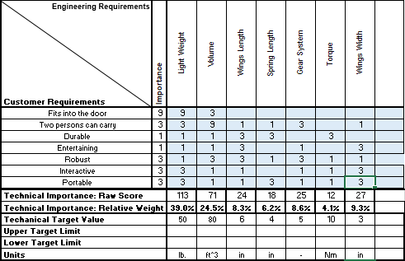
From the above results it is clear that the highest ranking engineering requirement is light weight and lowest ranking engineering requirement is torque.

3 EXISTING DESIGNS
According to chapter 3, design project cannot start without doing the research because research gives the idea of how to do that project and by finding similar implemented ideas can explain their experience and identifies the difficult you may face. Therefore, design ideas can implement by doing the research and then find its functions which will play major role in its working. Some existing designs need to consider as well for doing the project, and these existing design need to search for the complete project and also for its subparts.

3.1 Design Research
Design research has done on the internet, using different websites, which included IEEE website where some articles were found related to the Kinetic sculpture. To understand kinetic sculpture properly some definitions have studied as well. And more research has done using the Google to learn about kinetic sculpture and found some kinetic sculptress as well.
There is additionally a segment of kinetic craftsmanship that incorporates virtual development, or rather development saw from just certain points or areas of the work [1]. This term additionally conflicts oftentimes with the expression "evident development", which numerous individuals utilize when alluding to a craftsmanship whose development is made by engines, machines, or electrically controlled frameworks [1]. Both clear and virtual development are styles of kinetic craftsmanship that as of late have been contended as styles of operation workmanship. The measure of cover among kinetic and operation workmanship isn't sufficiently critical for specialists and craftsmanship students of history to think about consolidating the two styles under one umbrella term, however there are refinements that presently can't seem to be made [1].
"Kinetic workmanship" as a moniker created from various sources. Kinetic craftsmanship has its starting points in the late nineteenth century impressionist specialists, for example, Claude Monet, Edgar Degas, and Edouard Mamet who initially tried different things with complementing the development of human figures on canvas [1]. This triumvirate of impressionist painters all tried to make workmanship that was more similar than their counterparts. Degas' artist and racehorse pictures are models of what he accepted to be "photographic realism" specialists, for example, Degas in the late nineteenth century wanted to challenge the development toward photography with clear, cadenced scenes and representations [1].
By the mid-1900s, certain specialists developed consistently nearer to crediting their specialty to dynamic movement. Naomi Gabo, one of the two craftsmen ascribed to naming this style, composed much of the time about his work as models of "kinetic rhythm" [2]. He felt that his moving sculpture Kinetic Construction was the first of its kind in the twentieth century. From the 1920s until the 1960s, the style of kinetic craftsmanship was reshaped by various different specialists who explored different avenues regarding mobiles and new types of sculpture [2].
The various assortments of the class incorporate sculptures whose segments are moved via air flows, as in the outstanding mobiles of Calder; by water; by attraction, the claim to fame of Nicholas Takes; by electromechanical gadgets; or by the investment of the onlooker himself. The neo-Dada satiric nature of the kinetic sculpture made amid the 1960s is exemplified by crafted by Jean Tingly. His self-destructing "Tribute to New York" idealized the idea of a sculpture being both a question and an occasion, or "occurring." The point of most kinetic stone carvers is to make development itself a necessary piece of the outline of the sculpture and not only to grant development to an effectively total static protest. Calder's mobiles, for instance, depend for their stylish impact on continually changing examples of relationship occurring through space and time [3]. Whenever fluids and gases are utilized as segments, the shapes and measurements of the sculpture may experience consistent changes. The development of smoke; the dissemination and stream of shaded water, mercury, oil, et cetera; pneumatic swelling and collapse; and the development of masses of air pockets have all filled in as media for kinetic sculpture. In the complex, electronically controlled "spatial-dynamic" and "luminous-dynamic" developments of Nicolas Schaffer, the projection of changing examples of light into space is a noteworthy element [3].
A one-week course in kinetic sculpture was intended to acquaint center school understudies with the marriage of art and engineering. Since art can speak to unexpected sensibilities in comparison to engineering alone, it can fill in as a way to widen points of view of understudies with various inspirations [3]. In light of expanding accentuation on the improvement of projects in STEM (Science, Technology, Engineering, and Math) in U.S. training, this undertaking fills a requirement for more open doors in STEAM (Science, Technology, Engineering, Arts, and Math). Despite the fact that the accessibility and prominence of STEAM programs for kids is developing, these open doors for youthful youngsters are as yet constrained. Along these lines, there is a business opportunity for a course that joins art and the engineering configuration process like this one. Every day exercises in a starting week-long kinetic sculpture course are characterized. Every day's exercises are given along assets for further examination. The structure of the course depends on sound academic practice [3]. The quality of the course is its capacity to consolidate science and art funky that will bid understudies. Future work would comprise of the development of the exercises with more detail for instructors and the expansion of more exchange exercises [3].

3.2 System Level
In this section research has done to find existing designs, and the research has done over the Google mostly. These existing designs are important to the project because it will help in designing the project. These existing designs have researched in the same way as other research has done. These designs have researched on Google and determine through different articles and different websites. These ideas have determined in order to take help for making the kinetic sculpture for this project.

3.2.1 Existing Design # 1: Gear Bird
This kinetic sculpture is about the bird, in which two gears have attached with the wings to show the motion of wings. Wings are using in this project as well and working of motion of wings has described in the existing design article. This design can be useful for our project because it has used similar concept.
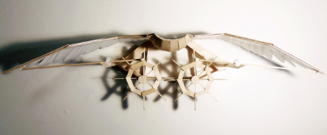
Figure 1: Gear Bird [4]

3.2.2 Existing Design # 2: Make Faire
This is also a design of faire which shows the motion of wings and this design can helpful for us in the designing phase because we will use any similar project idea. This idea is also useful for the project in a way that we are building the same concept of showing the motion of wings so such design idea can help us in making similar design idea therefore this existing design can provide some support to our design.
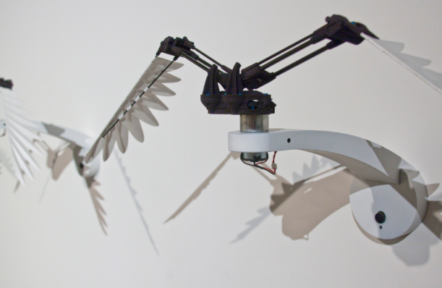
Figure 2: Make Faire [5]

3.2.3 Existing Design # 3: Mimic Rings
This existing design has shown the movement of wings and our project will be similar so this design can also help us in making the project specially in designing and implementing phase. This is moving the wings with the help of string and we will also move the wings using the string so this existing is quite close to our project so we can understand the motion of wings using the string from this concept and will apply it to our project.
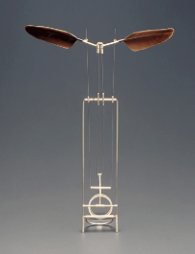
Figure 3: Mimic Rings [6]

3.3 Functional Decomposition
As the project is a design project so it need to show the functional parts of the system before going to design the project. Reason for doing the functional decomposition is to understand the project clearly and see the process of project from input till the output how the input converts to output. For this purpose, firstly, the black box model will present and then functional model will present.

3.3.1 Black Box Model
The black box model described the inputs and output of the system and it doesn’t depend of what’s going inside the model that’s why it names The Black Box mode. It has three inputs, of material, energy and signal and three outputs of material, energy and signal. In the inputs, first input is hand, as the hand will use to move the rod and then the string will move and wings will come into motion. Second input is kinetic energy and human energy, as moving the hand is equal to providing the energy and kinetic energy is present in the motion of wings. Third input is on/off to stop or start moving the sculpture. First output is the movement of wings which will appear, second output is heat which will generate when the rod will rotate and push the string, and also sound will produce and some energy will release in kinetic form. And the last output is to turn off the system. The black box model has helped in understanding the project by seeing the inputs and outputs we have understood what will be going to implement in this project and what inputs we have to take and what outputs we need to produce from the product and this concept has used in generating the design ideas as well.
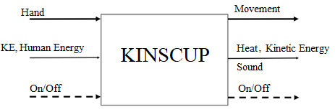
Figure 4: Black Box Model

3.3.2 Functional Model
In the functional model all the sub functions show and show the process of taking the input to the output. This functional model has developed after going through the existing designs have seen what will be the sub parts of our projects. In the functional model, tension in string will cause the motion because tension in the string will expand the spring and that spring expansion will cause the wing to move up and then in the reverse side, spring will compress and cause the wing to move down. Motion of wings are depending on the speed of rod’s rotation and functional model has helped in developing the design as all the designs have generated by putting the sub-parts in it and then consider each design if it has all the sub parts as mentioned in functional model so it helped a lot in making the new concepts. So from these existing designs functional model of our project has developed and presented in the following figure.
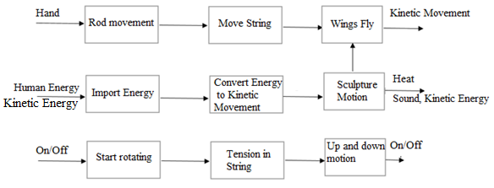
Figure 5: Functional Model

3.4 Subsystem Level
As the project has different sub parts and these sub parts are going to present in this section. Existing designs will show in the section regarding the subpart. Sub parts to consider in this parts are: box, wings and spring.

3.4.1 Subsystem # 1: Box
This is a subsystem that will place under the sculpture for giving the height and provide the space to put mechanism inside. Box will be most important in our project.

3.4.1.1 Existing Design # 1: Wooden Box
Wooden box is already available and it is a good choice to use as well in the project therefore this existing design is quite useful for us and we can use similar box to our project or we can take the idea form this existing design for the box.
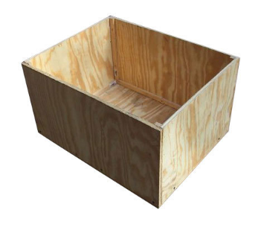
Figure 6: Wooden Box [7]

3.4.1.2 Existing Design # 2: Steel box
This is another existing design for the box which is steel box, this box is also strong and can use for our project as well. This box has shown in the following figure.
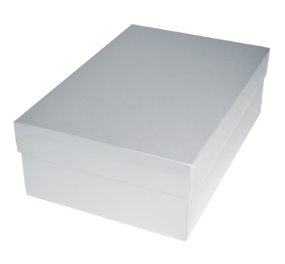
Figure 7: Steel box [8]

3.4.1.3 Existing Design # 3: Plastic Box
Another existing design for the box has found. This is a plastic box which is hard enough to carry to load of sculpture place over it. As this design is helpful for the project because we will use the box in our project as this design can use the project.
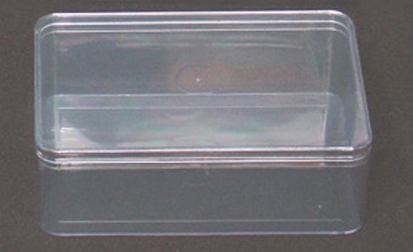
Figure 8: Plastic Box [9]

3.4.2 Subsystem # 2: Wings
We are going to use wings in our project and there are some existing design ideas available for the wings so in this section existing design will present for the wings.

3.4.2.1 Existing Design # 1: Roblox Wings
This an existing design about the wings and this design is consisting of shape roblox. These wings are light weight and it take less force to lift up and down so we can take the idea of wings from this existing design. Shape of wings are chronical from both ends.
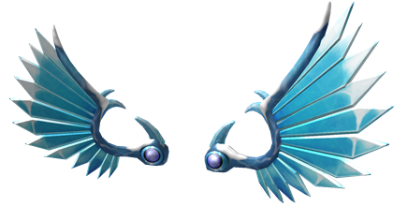
Figure 9: Wooden Wings [10]

3.4.2.2 Existing Design # 2: Angle shape wings
This is another type of wings which can use for the project. This shape of wings is diverting straightly backward to make it long and moveable. Wings idea can utilize for the project as well because it can move up and down.
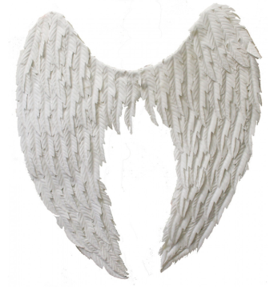
Figure 10: Angle Wings [11]

3.4.2.3 Existing Design # 3: Mechanical Wings
Another existing design for the wings is mechanical wings. This is the formation of wings in mechanical form and it would be a nicely formed mechanical type of wings and it can use for our project as well because it is strong and has capability to move accordingly as required and strong to hold the wings openly.
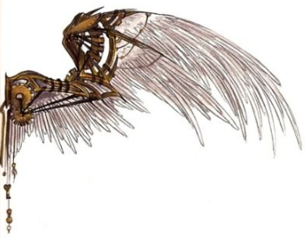
Figure 11: Mechanical Wings [12]

3.4.3 Subsystem # 3: Springs
In the project springs will use to move the wings, in to and fro motion to make the movement like birds therefore spring is an important subsystem of the project.

3.4.3.1 Existing Design # 1: Helical Back Springs
This is a type of spring which have the hooks from both sides and these type of springs uses where need to attach from both sides and that’s why this existing design is quite useful for our project because in the project we need to attach springs from both sides, wings and with the box therefore helical springs are useful.
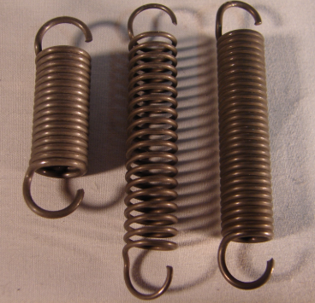
Figure 12: Helical Shape Spring [13]

3.4.3.2 Existing Design # 2: Garage door springs
This is another type of springs mostly uses for the rotational process. This type of springs has highly rotation value. This existing design can also use for the project or this idea can take and some similar type of design can use for the project.
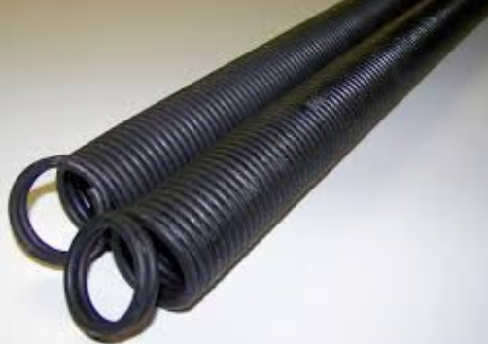
Figure 13: Garage Door Springs [14]

3.4.3.3 Existing Design # 3: Trampoline Springs
Trampoline springs is another existing design. This design has hooks on both sides but it has wider body from the center. This design can also use for the project and we can attach the wings with the box using this type of springs as well.
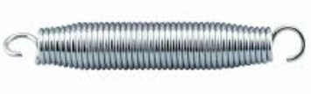
Figure 14: Trampoline Springs [15]

4 DESIGNS CONSIDERD
This section will present different design ideas related to the project. And these design ideas will generate on the basis of customer requirements, functional model and using the help of existing designs founds in the previous section.

4.1 Design # 1: Bird Sculpture
In this design the idea is to generate a sculpture that can show the movement of flying of bird. So a box has used and over the box a bird has placed which has wings on both sides. The idea is that wings attached with the spring and the spring attached with the mechanical function which may include gear system. The wings will move when the user will move the rod and it will show flying wings.
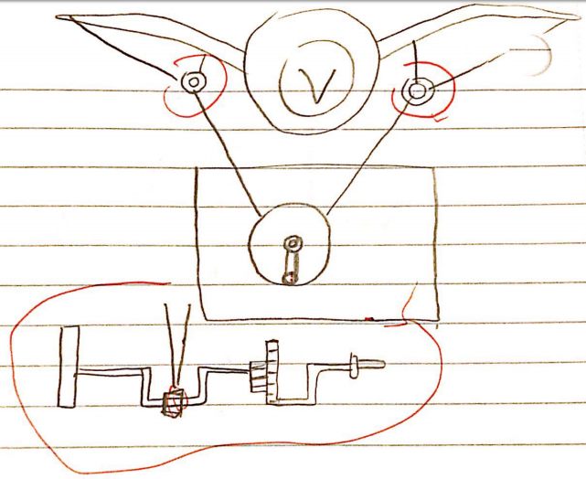
Figure 15: Bird Sculpture
Pros:
- Entertainment
- Attractive
- Mechanical process displays
- Easy to operate
- Easy to move from one location to another
Cons:
- Difficult to make the connection of wings with the rod
- Restrict movement of wings

4.2 Design # 2: International Symbol
In this design the idea is to make an international symbol as a sculpture with the outer lines shows the movement. International symbol has placed over the box and make the horizontal line longs and make it moveable like to and fro motion.
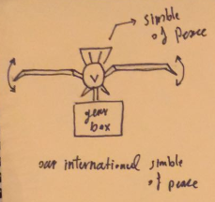
Figure 16: International Symbol
Pros:
- Movement of Wings
Cons:
- Difficult to Balance
- Large Extended body

4.3 Design # 3: Rotating Gears System
In this design we have selected the idea of using interlocked gears system. This interlocked gear system has gears linked with each other and it rotates to show an interactive display. Rotation of the gears depends on the input rod which moves the gear.
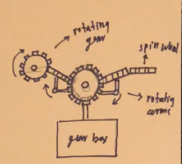
Figure 17: Rotating Gears System
Pros:
- Interactive Display
Cons:
- Interlocking cause trouble
- Extended body

4.4 Design # 4: Clock Rolling
The idea behind this design is that a clock with the rolling which shows movement from top to down around the clock and because of their movement, the clock pendulum moves.
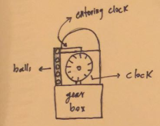
Figure 18: Clock Rolling
Pros:
- Rolling balls
Cons:
- Not an interactive display item

4.5 Design # 5: Train Message
This is the design idea in which a train will move and spread the message. The train will move over the trail and a message board will display over the train so it will move all around on the trail and display that message.
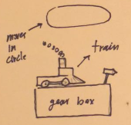
Figure 19: Train Message
Pros:
- Display a good advice
Cons:
- Not interactive display item
- Not Robust

5 DESIGN SELECTED
According to Chapter 5, for any design project we need to generate different concepts related to the requirements. And these concepts cannot select directly and just generating one concept and directly selecting that as a final design is not a fruitful thing to do in the design project. Therefore, it is important to generate the concepts and then select the best concept idea. To select the best concept by comparing their pros and cons can’t give the best idea which fulfill all the client requirements. To do so we need to use some method for selection of design. There are two methods that uses which are Pugh Chart and Decision Matrix. These two methods use together to determine the final design and in this section these two methods are going to use.

5.1 Rationale for Design Selection
As this section is about the using of Pugh chart and decision matrix to select the final design so first move to the Pugh chart.

5.1.1 Pugh Chart
This is a method to select the design, and in this method all the designs check against all the customer requirements. If a customer requirement has been listed in the Pugh chart we place a + sign if not we place a - sign. In this way a chart develops and the design with larger number of + signs becomes the top ranking design. In this Pugh chart top three designs will take into consideration. In the Pugh chart Kinematic Sculpture has taken as Datum design because it has all the features and it can use to compare other designs as well. Looking at the bird sculpture, it can easily fit into the door so + sign has placed in the box, two people can carry so + sign has placed in the box, durable as well + sign has placed entertaining as well so + sign has placed. So all requirements check in the same way and put + or – sign and if both have no connection then kept the box empty. Pugh chart has presented in table 4.
Table 4: Pugh Chart
KINETIC SCULPTURE | Weight | Bird Sculpture | KINETIC SCULPTURE DATUM | Rotating Gears | Clock Rolling | Train Message | International Symbol
Fits into the Door | 7 | + | D | + | - | - | +
Two Person Can Carry | 6 | + | D | + | + |  | +
Durable | 5 | + | D | + | - | - | +
Entertaining | 4 | + | D | + | - |  | -
Robust | 3 | + | D | + | - | + | +
Interactive | 2 | + | D |  | + | - | -
Portable | 1 | + | D | - | - | - | +
Pluses |  | 7 | - | 5 | 2 | 1 | 5
Minus |  | 0 | - | 1 | 5 | 4 | 2
Total |  | 7 | - | 4 | -3 | -3 | 3

Results of Pugh chart have shown that the top three designs are bird sculpture, rotating gears, and third one is international symbol.

5.1.2 Decision Matrix
Three designs have been settled from the Pugh chart then placed into the decision matrix in order to finalize the selection. Decision matrix is a way to check each requirement against each design and give a raw score according to the level of requirement fulfilling by the design idea. So the raw score will multiply with the weightage and total score of each requirement for each design determines and after that sum up all the total score to make the single score for each design. So at the end, check for the highest score in the matrix and top scorer is the final selected design.
Table 5: Decision Matrix
Decision Matrix | Fits into the door | Two person can carry | Durable | Entertaining | Robust | Interactive | Portable | Total
Weight | 7 | 6 | 5 | 4 | 3 | 2 | 1
Bird Sculpture | 6x7=42 | 6x6=36 | 4x5=20 | 6x4=24 | 6x3=18 | 4x2=12 | 5x1=5 | 157
Rotating Gears | 4x7=28 | 3x6=18 | 2x5=10 | 4x4=16 | 3x3=9 | 2x2=4 | 2x1=2 | 87
International Symbol | 2x7=14 | 3x6=18 | 3x5=15 | 3x4=12 | 2x3=6 | 2x2=4 | 3x1=3 | 72

From the design it is clear that the most effective design for the project is Bird Sculpture. So the final design selected is Bird Sculpture and it will be the one we will develop in this project.

Conclusion
Purpose of this report was to represent the project and describe the progress about the project. The progress has presented, and new concepts have generated as well. To finalize the selection of the device two methods have been used (Pugh chart and decisions matrix) . Final design has selected in the last section of this report and now this design will continue to do till the end of the project and it will develop a kinetic sculpture based on the birdy fly and wings motion.

References
[1] S. Gooch, “Design and mathematical modelling of the kinetic sculpture”, available [online], https://core.ac.uk/download/pdf/35469297.pdf
[2] G. Smith, “Swing Low Sweet Chariot, Kinetic Sculpture and the Crisis”, available [online], http://www.mdpi.com/2076-0752/4/3/75/pdf
[3] G. Chen, “The History and the Evolution of Kinetic Art”, available [online], http://www.ijssh.org/papers/581-F00005.pdf
[4] E. Lynch, “Study in Bird Motion, A Hand Cranked Kinetic Sculpture”, available [online], https://laughingsquid.com/study-in-bird-motion-a-hand-cranked-kinetic-sculpture-that-flaps-like-a-bird/
[5] M. Maker, “Make Fairer”, available [online], https://makerfaire.com/mfarchives/intertropes-and-ornithopters-by-ryan-buyssens/
[6] C. John, “Kinetic Rings Mimic the Flight of Birds”, available [online], https://www.thisiscolossal.com/2012/02/wearable-kinetic-rings-mimic-the-flight-of-birds/
[7] I. Mart, “Wooden box”, available [online], https://www.indiamart.com/proddetail/trolley-wooden-box-15066178591.html
[8] P. Queen, “Gloss White Steel Box”, available [online], https://www.packqueen.com.au/p/shoe-gift-box-gloss-white/700-FB9-10GWHTC
[9] W. Don, “Plastic Box”, available [online], https://www.watdon.co.uk/acatalog/E6052-174x115x60mm-clear-plastic-box.html
[10] N. Den, “Wooden Angle Wings”, available [online], https://www.nova68.com/large-wooden-wings.html
[11] R. Box, “Roblox Majestic Wings”, available [online], https://www.roblox.com/catalog/188702967/Majestic-Ice-Wings
[12] A. Gel, “Angle Wings”, available [online], http://www.thepartypeople.com.au/angel-wings-white-11
[13] R. Con, “Helical Rack Springs”, available [online], https://www.roncofurniture.net/products/helical-back-springs-3
[14] A. Grade, “Springs”, available [online], http://www.accentgaragedoorsutah.com/blog/signs-you-need-you-garage-door-springs-repaired/
[15] T. Dep, “The Home Depot”, available [online], https://www.homedepot.com/p/Everbilt-Trampoline-Mat-Spring-SP-9655/100556816

