Prototype Detail Summary

ME 476C

Fall 2018

Team Fanflyer

Corey Marcum

Travis Byakeddy

Steve Sorden

Nathaniel Schaul

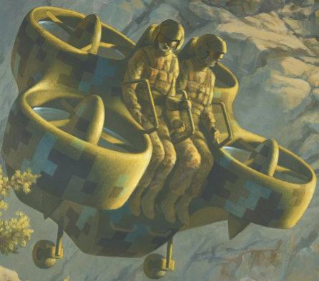

The Fall semester of 2018 for ME 476C-006 resulted in the ground breaking and preliminary work for the FanFlyer design for Novokinects’ internal frame. The semester entailed various meetings with Novakinects in order to receive validation and input for the project’s progress.
To recap, the purpose of Team FanFlyer’s design analysis is to provide analytical justification for the design of the internal frame of Novakinetics’ flyer. This frame will support and allow Novakinects flyer to function appropriately in order to be entered into the ‘GoFly’ Boeing sponsored competition, which Novakinects has entered.

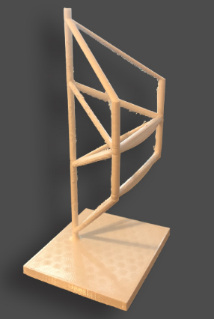
Figure 1: 3D printed prototype Frame
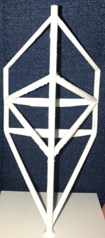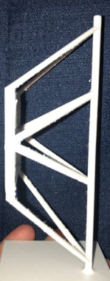
Figure 2: Back view Figure 3: Side view
How It Was Made
Before a prototype was designed for this project, a lot of work went into research and preparation. The first thing on the team’s agenda was to retrieve the background information on the design from the CEO of NovaKinetics Aerosystems, Jim Corning. When the team met Mr. Corning, the team was informed of the project’s progress that had already been performed and was given the prototype pamphlet. The pamphlet contained vital information about the project’s technical specifications and what was expected of the team. Inside the pamphlet, Mr. Corning had already possessed an idea of what what was desired for the frame’s appearance based on projected loads of the chosen subsystems, see figure 4 below.
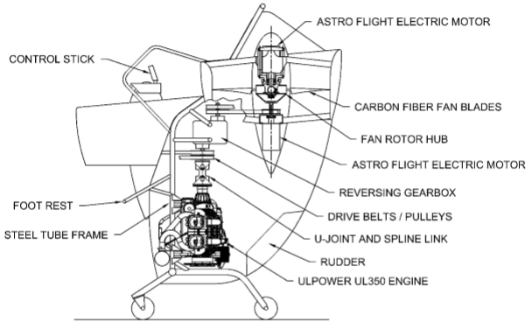
Figure 4: Novakinetics chosen subsystems supported by the frame

In addition to the competition requirements, these subsystems provide additional design criteria and constraints that must be accounted for in the design of the frame. Using these subsystems, the team started to design potential sketches for the new frame. After comparing all of the potential design concepts in a decision matrix, the team decided to start with the frame shown in figure 5, see below. The team used this concept as a basis for their final design adding a few changes before finding a liable proposal, resulting in the final frame proposal design that can be seen in figures 1 to 3 above. The sketch was then converted into a Solidworks CAD model and 3D printed. The final results of which can be seen in figures 1 to 3.
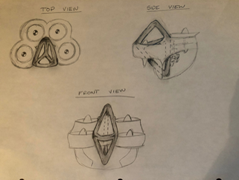
Figure 5: Original Team Design Sketch

What It Represents
The model represents the future design that the team plans to move forward with as the baseline on which analysis will be made for improvements. This design can be thought of as a blank slate were the team can identify potential failures and solutions in order to progress toward the ultimate design concept, in other words ‘the first iterations of many to come’.
Moving forward the team will continue to receive information on aspects from both the client and from the design analysis, and will modify the design accordingly based on the given information. Various redeigns will occur based on the information received from the client and from the analysis that shows where improvements are required. Upon view of the preliminary design sketch and the 3D printed model, Figures 1 to 3 & 5, it can be identified that there are already slight changes between the two designs which have arised from design restrictions and analysis modeling this semester.

Current State
Performing an ANSYS analysis of the proposed frame, based upon the dimensions and geometry provided by Novakinetics, along with the proposed frame design of team Fanflyer, resulted in a more robust outcome for team Fanflyer’s frame. Both designs failed under the same provided bending moment conditions, however team FanFlyer’s design failure was not as catastrophic as Novakinetics’ frame failure. See Figures 6 & 7.

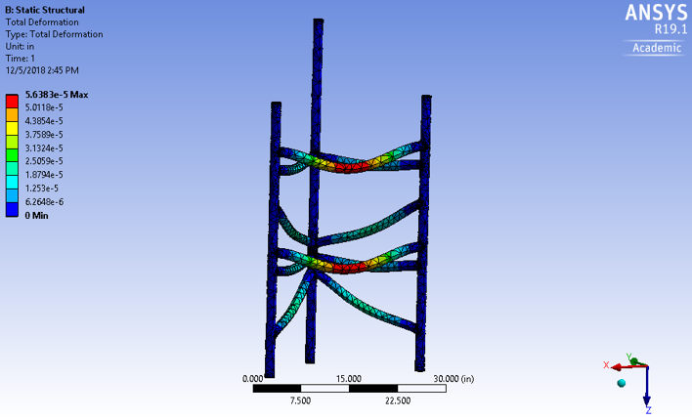
Figure 6: Novakinetics Frame Total deformation

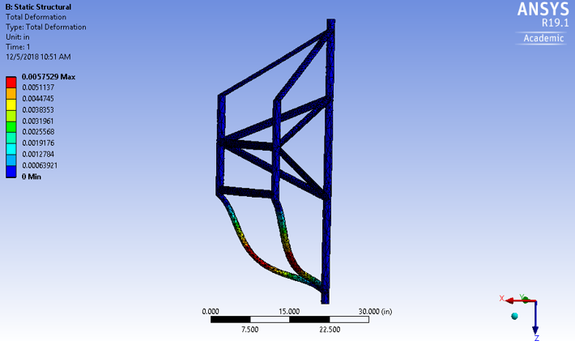
Figure 7: Team Fanflyer’s Frame Total Deformation

Figure 7 represents the scaled up model of the prototype represented in Figure 1 to 3. It can be seen that more support is required at the bottom-front end of the frame.

Moving Forward
The client has given the team freedom to analyze the different combinations of tube diameters and wall thickness. Therefore, the team will be creating charts of the different combinations of the tube diameters and thicknesses and performing stress and strength analysis on them. This will help the team identify the size parameters that give the best strength to weight ratio for the material used in the design of the frame. From there the team can perform secondary analysis by repeating the initial experiment with various types of materials. This will help to ensure that the team has the most optimal size and material for the frame. From there the team will implement the material into the frame design and analyze the total frame to identify where stresses and failures localize. This well help the team to design the most sound frame possible for the client.

