Team FanFlyer

Semester One CAD package and BOM
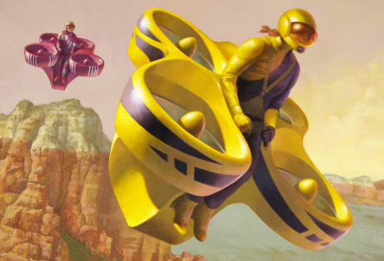
Parts
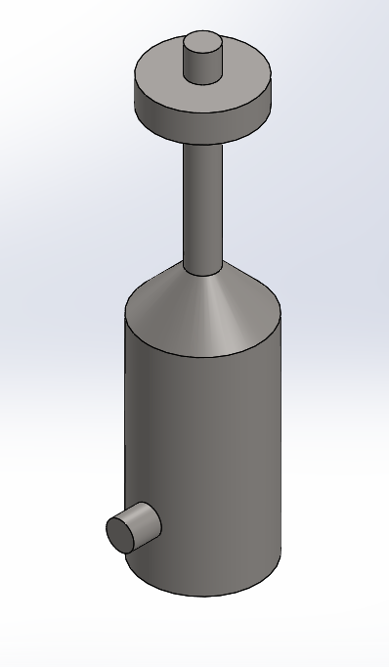
Figure 1: Engine & Crank Shaft (1)
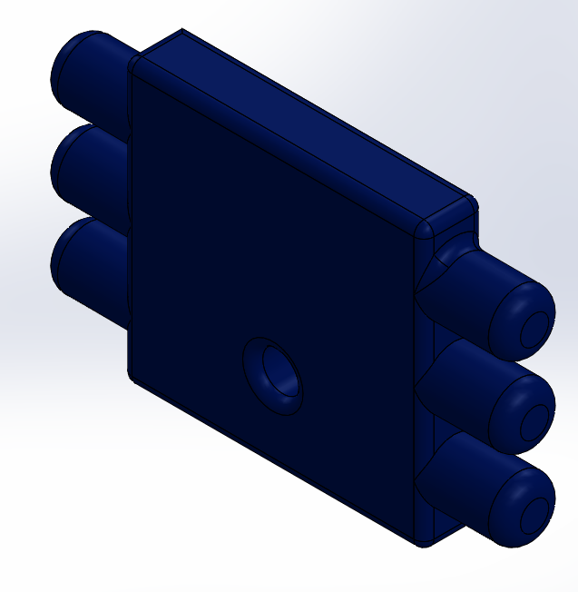
Figure 2: Engine Front (1)

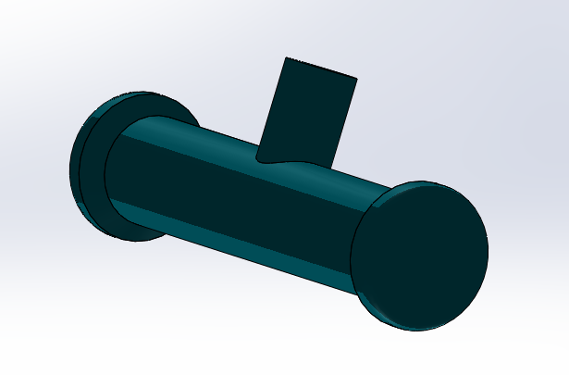
Figure 3: Engine Bottom (1)

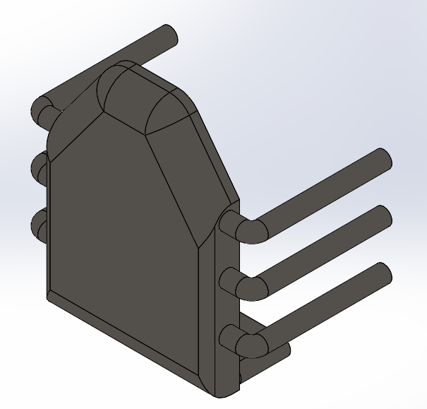
Figure 4: Engine Exhaust System (1)
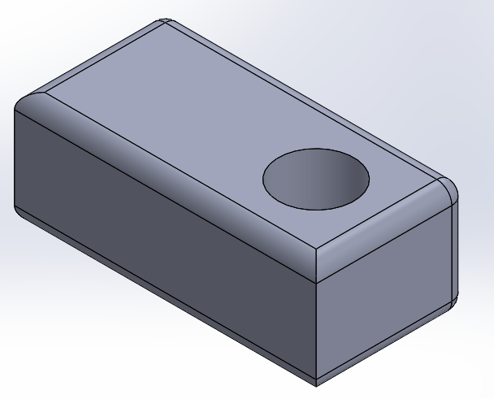
Figure 5: Reversing Gearbox (1)

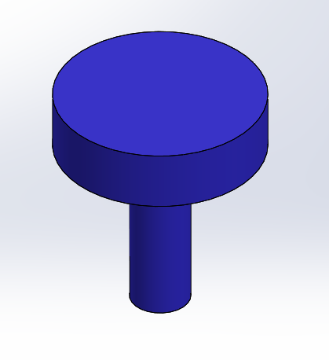
Figure 6: Top Belt Drive (1)

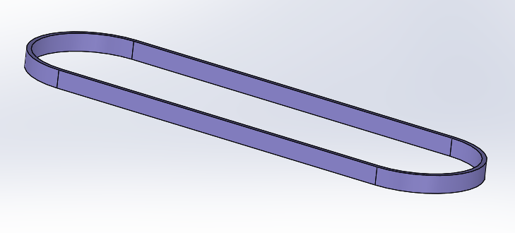
Figure 7: Lower & Upper Belts (2 sets of 2)

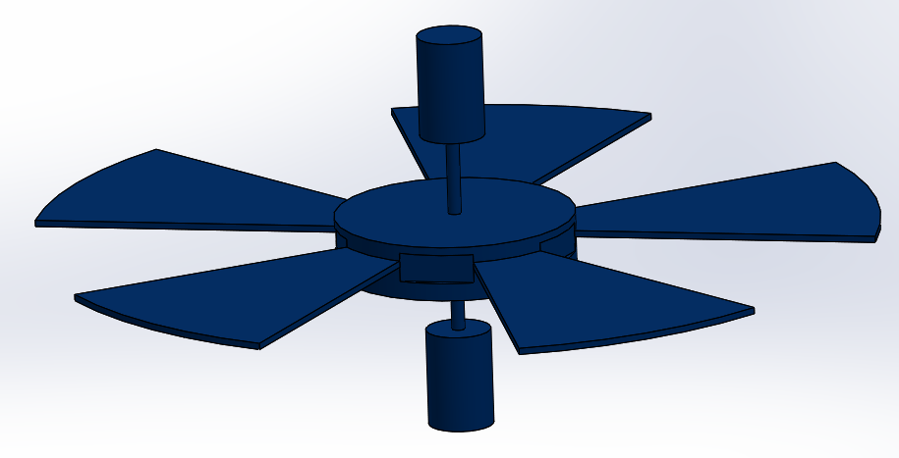
Figure 8: Rotors (4)

Assemblies
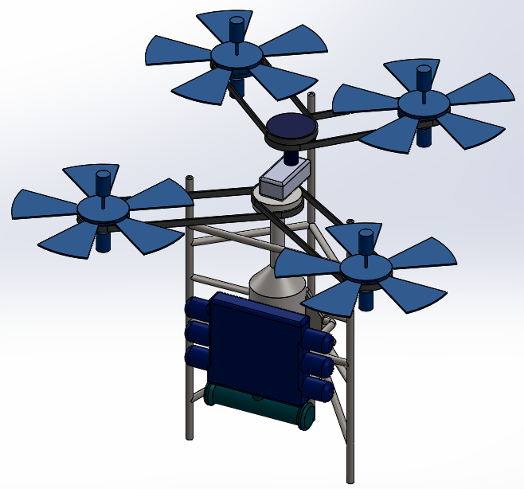
Figure 9: Jim’s Assembly

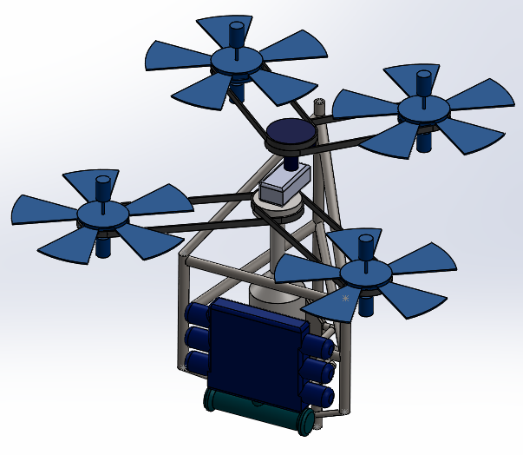
Figure 10: FanFlyer’s Assembly

Drawings
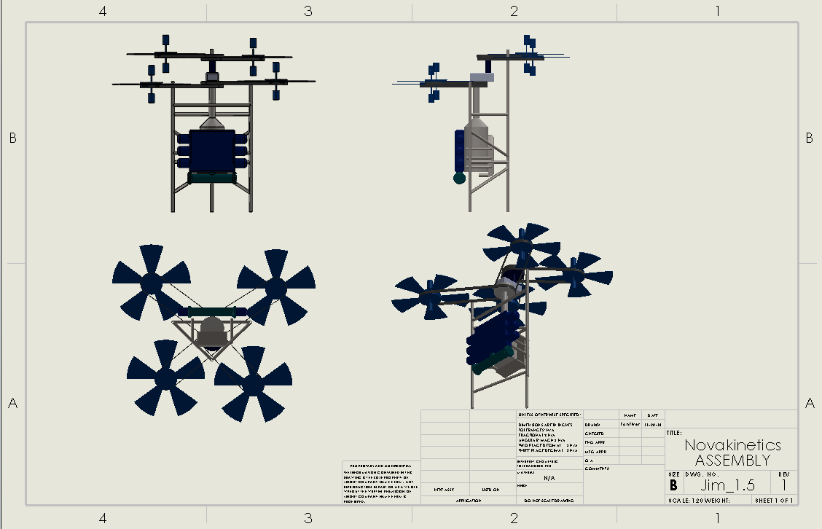
Figure 11: Nova-Kinetics

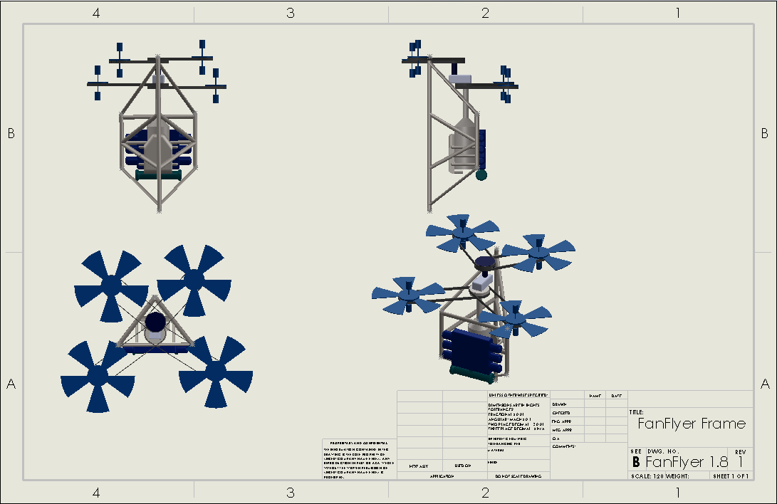
Figure 12: FanFlyer

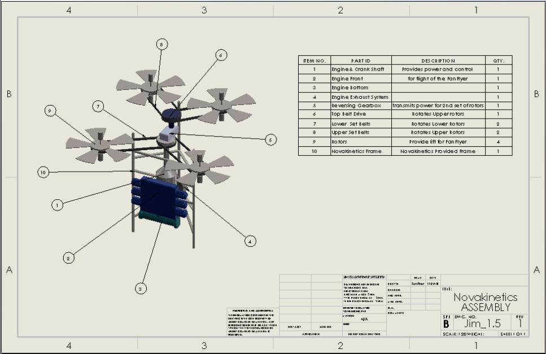
Figure 13: Nova-kinetics BOM with Nova’s frame

Table 1: BOM zoom in for Figure 13
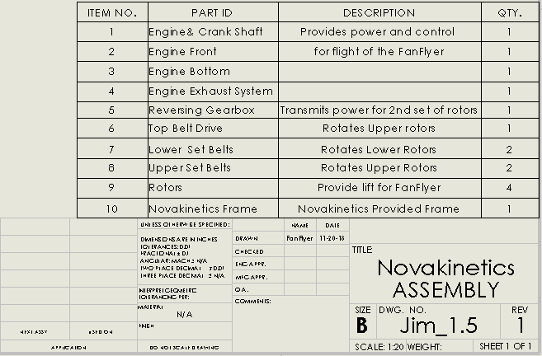

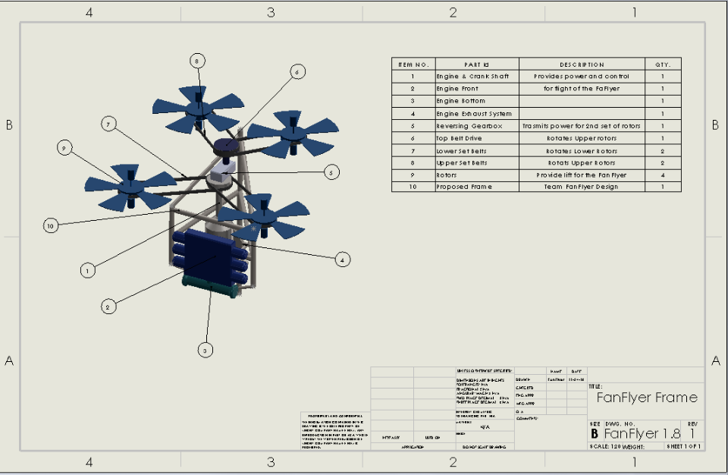
Figure 14: Team FanFlyer’s BOM with Fan Flyer’s frame

Table 2: BOM zoom in for Figure 14
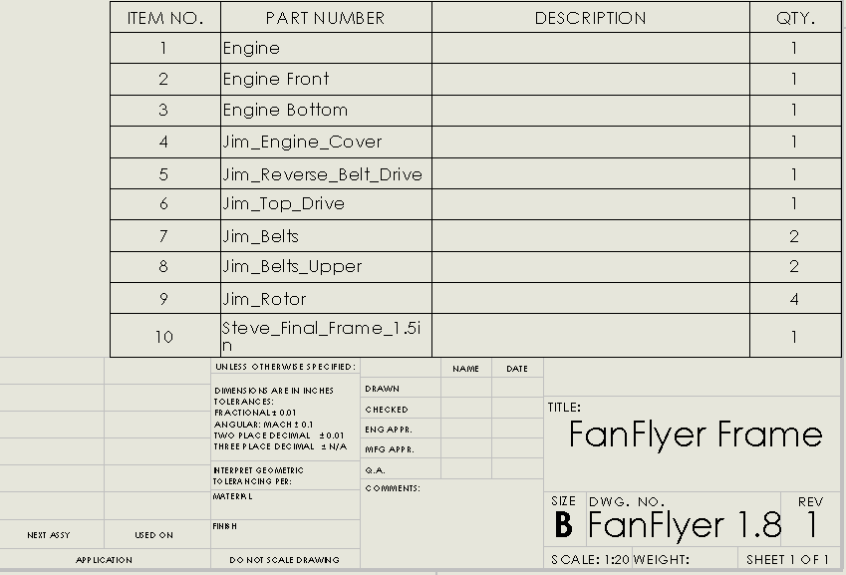
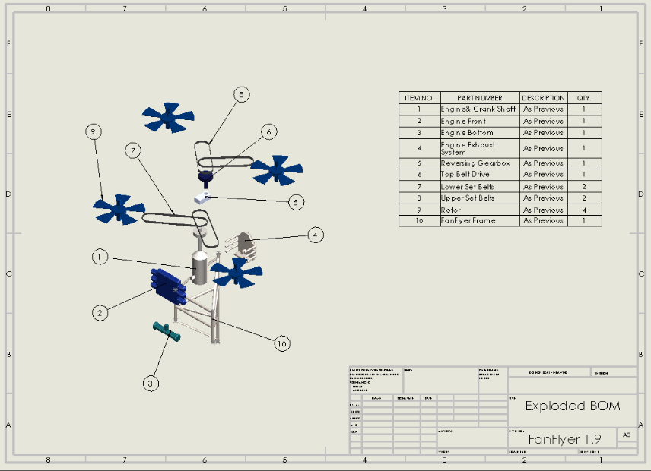
Figure 15: Exploded view of Team FanFlyer Sub System BOM

Table 3: BOM zoom in for Figure 15
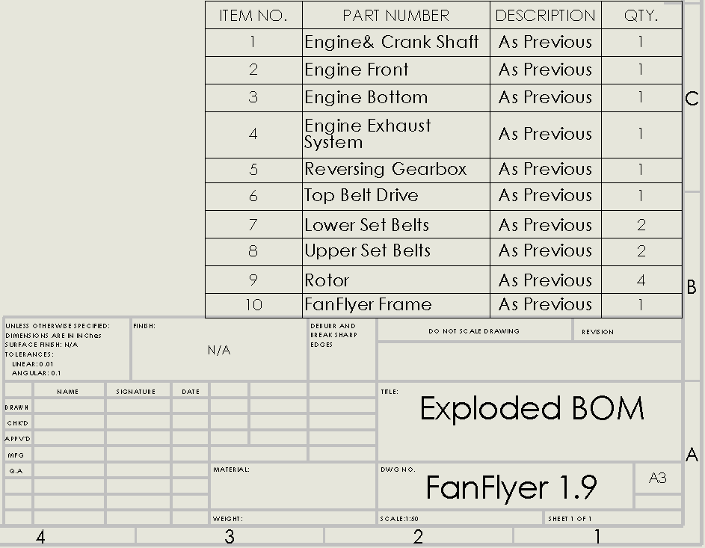

Table 4 – Realistic BOM for 4130 Steel
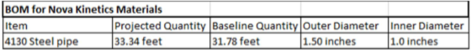

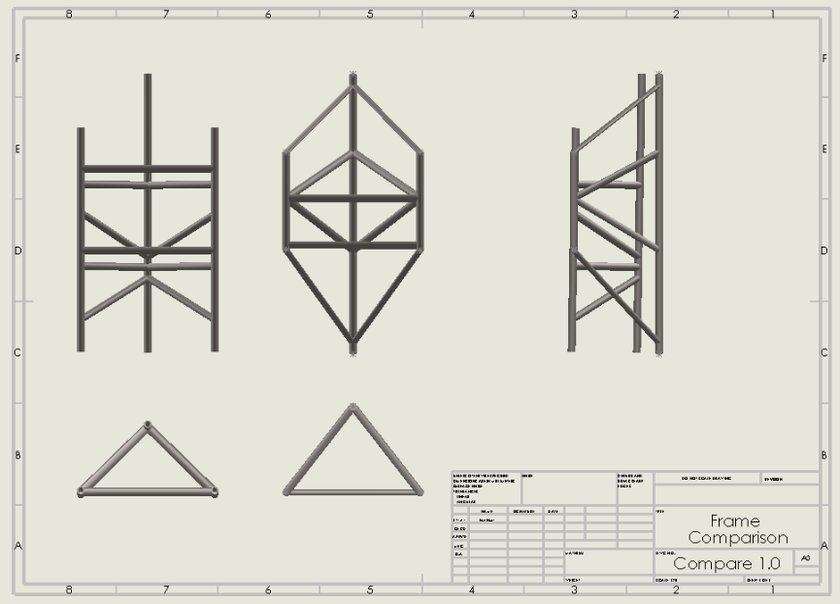
Figure 16: Novakinetics & Team FanFlyer frame comparison

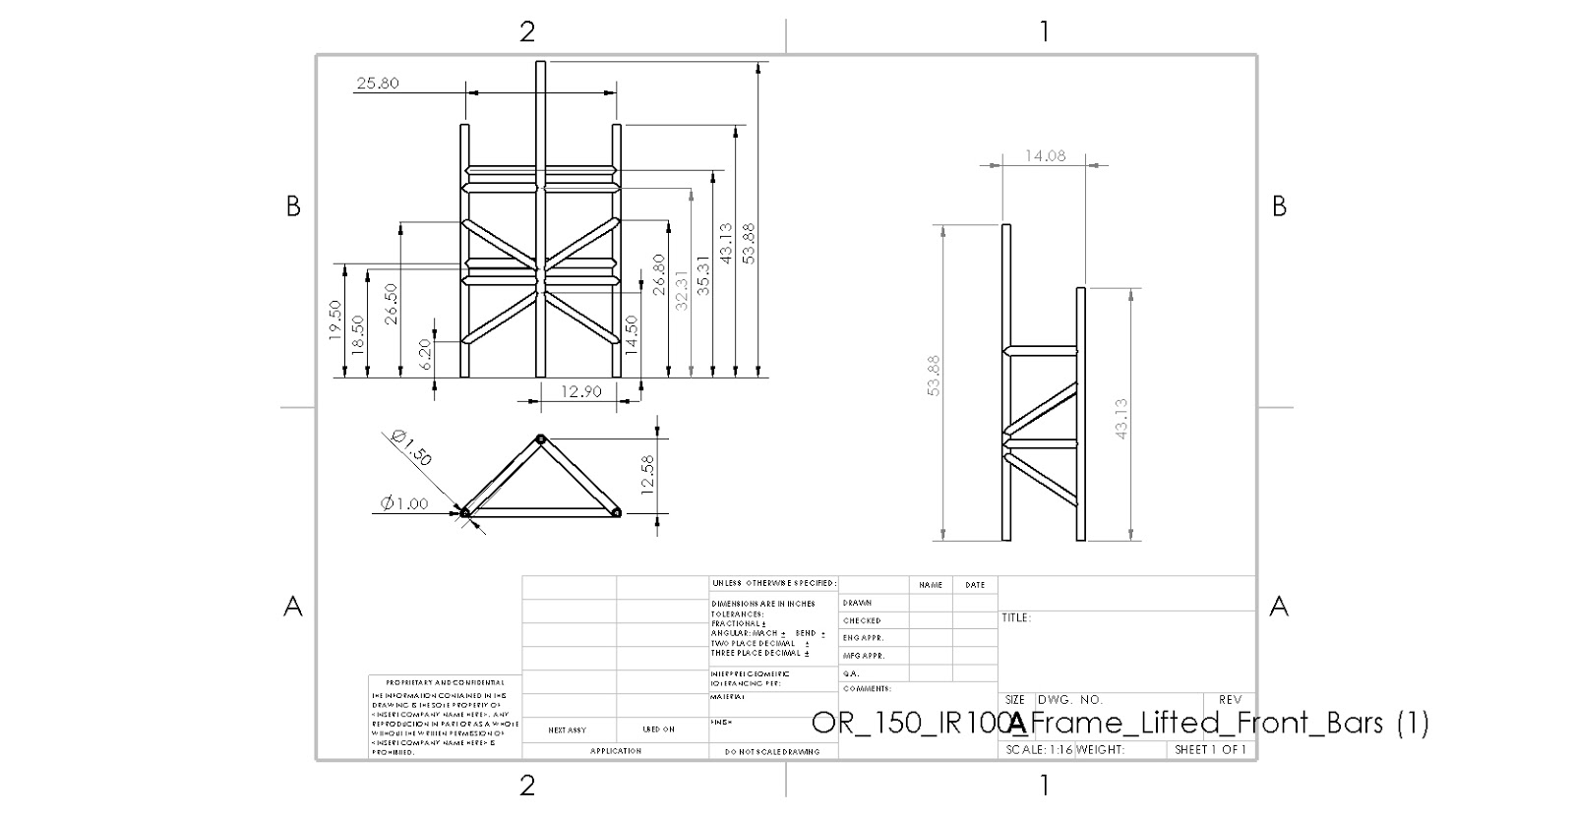
Figure 17: Novakinetics Frame dimensions
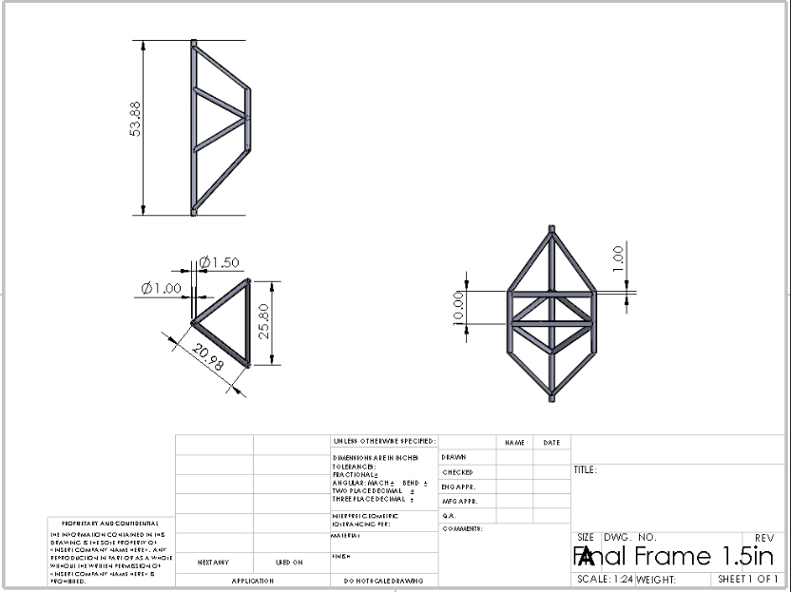
Figure 18: Team FanFlyer’s frame dimensions
Nova-Kinetics Provided
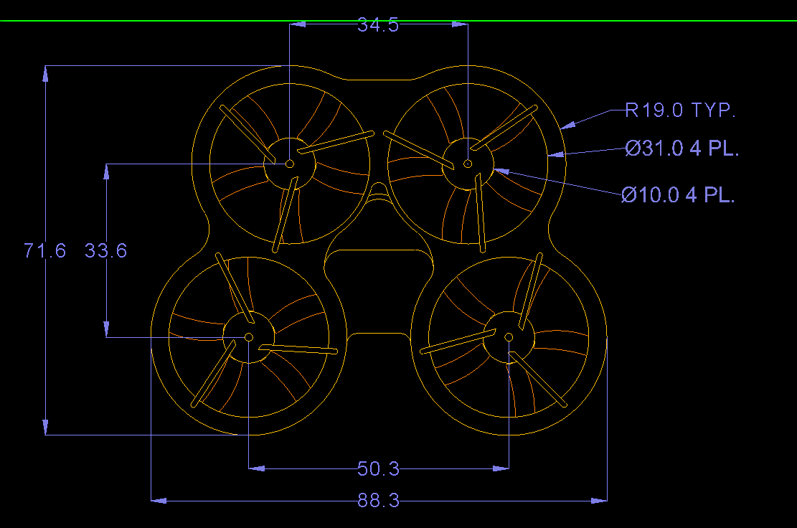
Figure 19: Top view of Nova-Kinetics CAD dimensions

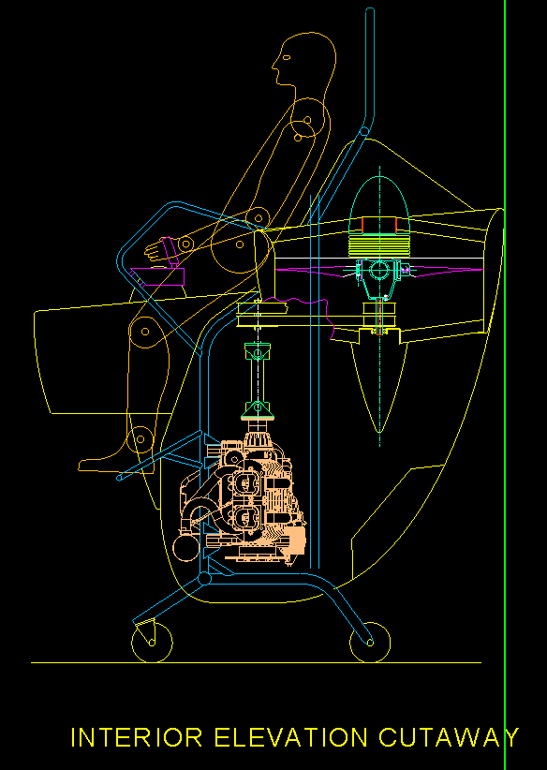
Figure 20: Side view interior of Nova-Kinects FanFlyer with pilot
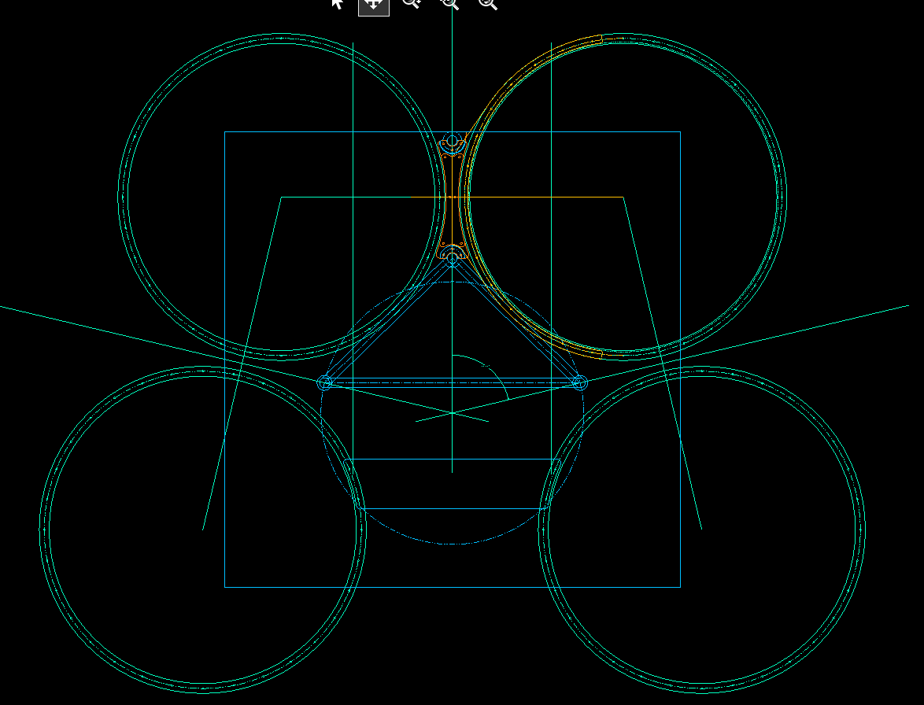
Figure 21: Top view radial position of Nova-Kinects FanFlyer

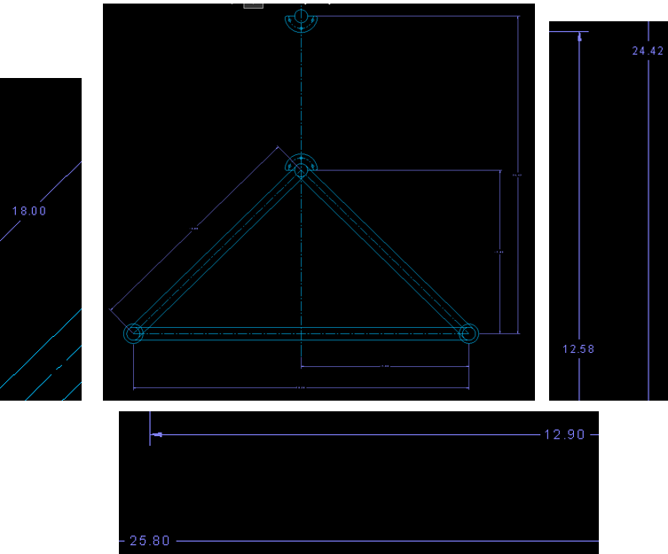
Figure 22: Top view of Nova-Kinetics Frame dimensions
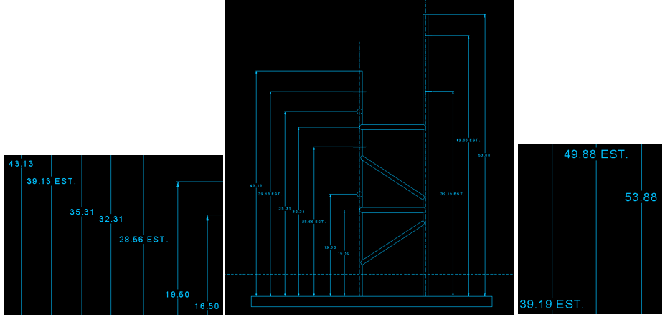
Figure 23: Side view of Nova-Kinects Frame dimensions

