FanFlyer - Internal Frame

Final Proposal Report

Steve Sorden
Corey Marcum
Nathaniel Schaul
Travis Byakeddy

2018-2019

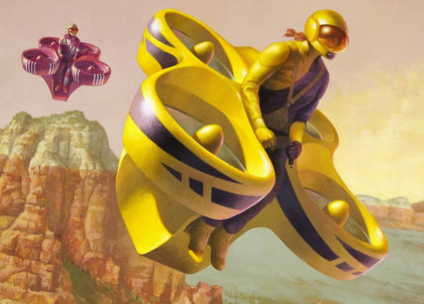

Project Sponsor: Jim Corning of Novakinetics AeroSystems
Faculty Advisor: Brandon Begay
Instructor: Dr. Trevas

DISCLAIMER
This report was prepared by students as part of a university course requirement. While considerable effort has been put into the project, it is not the work of licensed engineers and has not undergone the extensive verification that is common in the profession. The information, data, conclusions, and content of this report should not be relied on or utilized without thorough, independent testing and verification. University faculty members may have been associated with this project as advisors, sponsors, or course instructors, but as such they are not responsible for the accuracy of results or conclusions.

EXECUTIVE SUMMARY

NovaKinetics Aerosystems has invited the NAU FanFlyer team to assist them in their design for their personal Manned-Air-Vehicle (MAV). Jim Corning, the CEO of NovaKinetics Aerosystems is taking part of the Boeing sponsored competition GoFly. By designing their MAV, Jim and his company are hoping to bring home the $2 million dollar grand prize for the competition as well as create a market for their design after it is completed. Jim gave the team a pamphlet at the start of the year containing vital information about the project. In in it, the base design for the MAV was already laid out for the team to analyze. The rotors, engines, belts, and outer shell for the design had already been designed and Jim sought out the NAU FanFlyer team for assistance with designing the MAV’s inner frame.
From Jim’s requirements, the team learned about the parameters their design for the frame would need to withstand. The frame will need to be able to sustain all of the forces and weights from the rotors, engine, and the rest of the parts from the design. The estimated weight of the frame is about 900 lbs and various other forces will require the frame to hold together all of the parts of the MAV. The target weight for the frame the team decided to achieve was 50 lbs which is half of the weight of Jim’s pre-existing design at 107 lbs. The team decided to cap their maximum weight requirement to be 99 lbs in order to achieve a lighter weight than Jim’s pre-existing design. For the team this is the most important requirement as shown in the Customer Requirements section.
In order to design and test a proper frame to propose to Jim, the team had to endure many steps. Getting the information about the design was first on the list. After the team had acquired this information they were able to estimate the forces that were going to be acting on their frame. Calculating these forces were critical for their design in order to design a durable and sturdy frame while still being lightweight. The main focus of team this semester was to learn how to use the program Ansys. Ansys is a Finite Element Analysis program that shows the user the critical points of stress and deflection on a design. For the team, this program is used to analyze their frame’s stresses to locate the weak points. This way, the team knew where the critical points were so they could add supports to their frame’s design where the Yield Stresses were too high. The calculations from Ansys were then to be back checked using closed-form-solutions. These solutions included a lot of statics such as free body diagrams, method of joints, and truss analysis. These closed-form-solutions were used to check the hand calculation work on the Ansys evaluations.
After extensive designing and calculations, the team designed a frame to propose to Jim. Using Ansys and closed-form-solutions, the team checked the stresses and deflections in both the existing design and their new frame. The team managed to decrease the weight of the frame from 107 lbs down to 70.97 lbs while still making sure the frame wouldn’t fail. The main concern for the team was making sure the yield stresses had a high enough factor of safety so the frame wouldn’t fail when subjected to the loads from the MAV.

TABLE OF CONTENTS

Contents

DISCLAIMER………………………………………………………………………………………………………....2

Executive Summary………………………………………………………………………………………………….3
TABLE OF CONTENTS………………………………..……………..……………………………………………....4
1 BACKGROUND……………………………………………………...…………………………….6
1.1 Introduction………………..………………………….…………………………............................................6
1.2 Project Description…………………….………….….………………………………………………………6
1.3 Original System…………………..….……………….…………….………………………………………...6
2 REQUIREMENTS………………….……………………….…….………………………………..7
2.1 Customer Requirements (CRs) …………..………...………….……………………………………………..8
2.2 Engineering Requirements (ERs)…………….….……………….…………………………………………..8
2.3 Testing Procedures (TPs) …………………….…….…..…………………………………………………….8
2.3.1 Lower cost of material………………………………………………………………………………………..9
2.3.2 Total empty weight…………………………………………………………………………………………...9
2.3.3 Precision of structural analysis…………………………………………………………………………….....9
2.3.4 Precision of structural analysis…………………………………………………………………………….…9
2.3.5 Factor of Safety within Aircraft Tolerance…………………………………………………………………..9
2.3.6 Structure within standard for FAA 23 & 27……………………………………………………………….…9
2.3.7 Deflection and stress within tolerance…………………………………………………………………..….10
2.3.8 Pilot drag coefficient………………………………………………………………………………………..10
2.4 House of Quality (HoQ)…….……………………………………………………………………………....10
3 EXISTING DESIGNS………………………….……….………………………………………....10
3.1 Design Research………………..…….………..…………………………………………………………....10
3.2 System Level ……………………..………….….…………………………………………………………..11
3.2.1 Existing Design #1: HoverBike…..…………………………………………………………………………..12
3.2.2 Existing Design #2: EHang 184…..……….………………………………………………………………....12
3.2.3 Existing Design #3: Quadcopter Frames.……….……..……………………………………………………..12
3.3 Functional Decomposition……………….….….…………..……………………………………………….13
3.3.1 Black Box Model …………………….….……….…………..……………………………………………....13
3.3.2 Work Progress ……………………………………………..………………………………………………....15
3.4 Subsystem Level ……………………………………………….…………………………………………...16
3.4.1 Subsystem #1: Finite Element Analysis (FEA)……………….….…………………………………………..16
3.4.1.1 Existing Design #1: ANSYS………………………………………………………………………………....16
3.4.1.2 Existing Design #2: MATLAB………………………………………………………………………………..16
3.4.1.3 Existing Design #3: SolidWorks……………………………………………………………………………...16
3.4.2 Subsystem #2: Design Frames from CR………………………..…………………………………………….17
3.4.2.1 Existing Design #1: Single Rotor…………………………………………………………………………….17
3.4.2.2 Existing Design #2: Multi-Rotor……………………………………………………………………………..18
3.4.2.3 Existing Design #3: Fixed Wing Hybrid Drone……………………………………………………………...18
3.4.3 Subsystem #3: Materials……………………………………..…..………………………..………………….18
3.4.3.1 Existing Design #1: 4130 Steel…………………………………………………………………………….....18
3.4.3.2 Existing Design #2: Aluminum…………………………………………………………………………….....18
3.4.3.3 Existing Design #3: Cold rolled steel………………………………………………………………………....19

4 DESIGNS CONSIDERED…………………………………..….….……………………………...19
4.1 Design #1: Smaller Main Design…………………………….…….………………………………………..19
4.2 Design #2: Three Pole Frame……………………………...……….… ……………………………………19
4.3 Design #3: Hover Pad Frame……………………………….……………………………………………….20
4.4 Design #4: Triangular Box Frame ………………………..………….. …………………………………....20
4.5 Design #5: Race Car Hover Pad……………….…………………………………………………………....21
4.6 Design #6: Five Point Pole……………………….……..………………………………………………… .21
4.7 Design #7: Box Frame……………………….……..……………………………………………………….22
4.8 Design #8: Simple 3-Point Design……………………….……..…………………………………………. 22
4.9 Design #9: Multi-Support Design……………………….……..……………. ……………………………..23
5 DESIGN SELECTED – First Semester………………..……………………………………….... 24
5.1 Rationale for Design Selection…………………….…..……………………………………………………24
5.2 Design Description ………………………………….….…………………………………………………..25
6 PROPOSED DESIGN – First Semester…………………………………….………………….. ….....25
7 REFERENCES……………………………………………………………………………………………...27
8 APPENDICES……………………………………………………….. …………………………...28
8.1 Appendix A: Black Box model …………………………………………………………………...28
8.2 Appendix B: Functional Decomposition ………………………………………………………….29
8.3 Appendix C: Decision Matrix……………………………………………………………………..30
8.4 Appendix D: System level……………………………………………………………....30
8.5 Appendix E: Black Box Model…………………………………………………………..31
8.6 Appendix F: Functional Decomposition………………………………………………....32
8.7 Appendix G: Decision Matrix & Pugh Chart…………………………………………....32
8.8 Appendix H: Design Models……………………………………….................................33
8.9 Appendix I: Hand Calculations & Software Analysis…………………………………...41

.

1 BACKGROUND

1.1 Introduction

The NAU Fan Flyer team has been given the opportunity to assist NovaKinetics AeroSystems with their design to compete in the Boeing sponsored, GoFly competition. Jim Corning, the CEO of Novakinetics has tasked the team with designing and analyzing an interior steel frame for their manned air vehicle. The steel frame will have to support loads that add to about 900lbs. Novakinetics is looking for a strong and durable frame to act as the backbone for their manned air vehicle. Jim Corning is striving to win the GoFly competition as well as create a market to sell their design with the help of the Fan Flyer team’s frame. The GoFly competition is a two year long feat requiring teams from all over the world to generate a personal flying vehicle. After passing the first-year trials, Novakinetics is looking to bring home the million dollar prize in the second year with the help of the NAU Fan Flyer team.

1.2 Project Description

Following is the original project description provided by Novakinetics AeroSystems; “The FanFlyer will have a ladder structure of welded 4130 steel tubing that connects the engine,
landing gear, reversing gearbox, pilot restraint harness mounting points, and ballistic parachute
harness anchor point. This steel tube structure will also interface with the carbon fiber shell
structure that forms the ducted fan housings. Each ducted fan will have a structural outer shell
that connects with the steel tube frame, and an inner duct that is removable, along with the fan
hub and supports, for maintenance and for easy updating of ducted fan components.” [1].

To take on this task, the team will be learning to use Finite Element Analysis (FEA) and the program Ansys, as none of the members have a background in either. Using Ansys, the team will be able to analyze their proposed designs by locating the weak points and areas of high stress on the steel frames. These calculations will then be checked by the team by performing closed-form solutions by hand.

1.3 Original System
The original system structure for the design shown in Figure 2, below, has already been designed by Novakinetics. The original system houses four rotors, a combustion engine, generic pilot seat with controls, and generic landing wheels. Figure 3 shows an isometric view of the rotor, crank shaft, and combustion engine. The system includes everything for the manned air vehicle besides the steel frame required from the FanFlyer team. Because there was no original system for the frame at the beginning of this project, it is considered a new design. The FanFlyer team can be creative and generate a frame not based on previous designs. Thus, there is no data showing how the original system operated, performed, and failed.

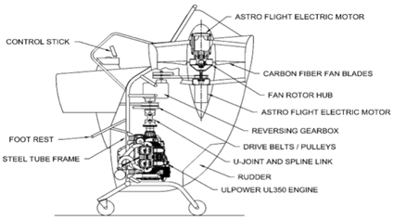
Figure 1 -Original System Layout [1].

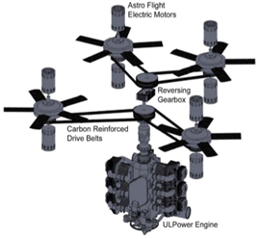
Figure 2 - Powertrain layout [1]

2 REQUIREMENTS
In section 2, the team evaluates the requirements put forth by the client and engineering industry. The FanFlyer team will use the requirements discussed to prioritize the aspects of the project into an order of operations in which to complete the project to the best manner possible. This is done in order to exceed the expectations of the client by meeting and or exceeding
industry standards associated with the project.

2.1 Customer Requirements (CRs)

From the first meeting with Jim, the team learned that the customer requirements from Jim Corning were extremely vague. He stated that the main things he wanted was a lightweight frame that stable enough to carry the loads given by the MAV. For this reason, the design being lightweight was ranked number one for the team to focus on. This criteria was also important because in the GoFly competition there is a weight limit. A higher factor of safety was the next most important requirement because it would guarantee the frame not to yield under the forces imposed on it. Next, stability was classified as the third most important requirement. This is important for the frame because the design has to be aerodynamic and accountable for the center of gravity to keep balance. Next, the joint failure and impact parameters were ranked fourth most important. Minimizing joint failure is important because the stresses and strains are usually localized at the joints, so the team must make sure the joints are strong. In the instance of a collision, the team also is taking precautions for impacts. Making sure the design is strong and durable were also requirements because of their importance to keep the MAV from failing and failing over long distances of time. A list of the Customer Requirements can be seen in appendix A

2.2 Engineering Requirements (ERs)

Nine engineering requirements were derived from the customer requirements by the team for this project. Lower cost of materials was the first and is important because the client needs a realistic price to market their design after it is tested. Next, the total empty weight will have to fall under 625 lbs in order to meet the competition requirements. The total volume must not exceed 275 ft^3 because of the requirements for the GoFly competition. Another engineering requirement the team added was to precise in their structural analysis. They will complete this by using the Ansys program as well as checking those calculations using closed-form-solutions. Having the analysis of the proposed frame to jim complete by February 19th is also a requirement in order to give Jim and the team a month to prepare for their first testing. Also, meeting the factor of safety within aircraft tolerances was required in order to meet the industry standards for private aircrafts. Meeting the FAR 23 and 27 standards were also requirements because it is crucial for the specifications of the structural loads. Another requirement was to meet the deflection and stress tolerances to make sure the design will not wear down over time. Finally the pilot drag coefficient has to be less than 0.5 in order to create optimal flight control for the MAV. A list of the Engineering Requirements can be seen in appendix B

2.3 Testing Procedures (TPs)
Initially, there were no specific ways that the group could evaluate each engineering requirement because of the project’s ambiguity and vagueness. However once the team received the Flyer dimensions, and the individual team analysis were completed it gave a better idea of how some testing procedures could unfold. Doing hand calculations of the forces, stresses and moments that Nova-Kinetics’ frame will endure based upon the power output of the rotors narrowed down the testing scope. Because it showed the range of forces that the frame is expected to endure based upon the force output of the rotors combined with the weight of the Flyer and pilot. Receiving the dimensions also provided a Solidworks blueprint of the baseline design that could be compared to the team’s design.

2.3.1 Lower cost of materials:
To ensure that the cost of material was low the team researched the cost per mass of aluminum, steel, and a few other metals and estimated the cost to determine which material was cheep. This was performed once the Solidworks frame was generated, based on the weight, dimensions, and geometry of the CAD frame, by changing the material in solidworks to get the proper changes properties.

2.3.2 Total empty weight:
For the weight the team brainstormed ways that would reduce the weight of the frame and then calculated the weight based off the material research. Among the brainstormed ideas the team made the pipes hollow and reduced the number of pipes need to construct the final design.

2.3.3 Total volume:
The volume was kept at the same size of the original frame which kept it in the required volume, The difference is in the shape.

2.3.4 Precision of structural analysis:
The determined precision of the structural analysis was by using ANSYS. First the team built SolidWorks models based on the dimensions of their final design and then the team transferred the model into ANSYS and used the FEA programs in ANSYS to ensure the measurements were precise.

2.3.5 Factor of Safety within Aircraft Tolerance:
Researching for a baseline for a FOS in a prototype is challenging when it is the first of its type. Researching similar products and attempting to uncover their technical data is a difficult task because a number of it is either confidential at the moment because they are either in their phases of R&D, or they are in current production, so their technical information is not easily accessible. However, for the design applications of Fan Flyer additional FOS were accounted for in some of the individual analysis. For the bending moments found in the the Frame the weight of the Flyer was presented in for both a 900 lb Flyer and for a 1200 lb Flyer. The 900 lb Flyer is the deadweight minimum weight required. Where as the 1200 lbs were added to account for additional potential forces that the the rotors may have to impose on the Frame. Moving forward, other FOS will have to be discussed as they arise based on their appropriate analysis.

2.3.6 Structure within standard for FAA 23 & 27:
To determine if it met the standards the team read the Federal Aviation Administration part 23 and 27. The team believes the design is within the parameters set by these standards.

2.3.7 Deflection and stress within tolerance:
For deflection and stress tolerance the team used ANSYS and Solidworks again. The Solidworks models were then transferred into ANSYS and then used the FEA to calculate the stress and deflection that would occur depending on the amount of force applied to the design at specific locations.

2.3.8 Pilot drag coefficient:
The team was given that the human drag coefficient was 0.5 and knowing this value they could determine whether the drag coefficient of the design would allow to be within this tolerance.

2.4 House of Quality (HoQ)
The House of Quality was generated in accordance to the list of customer and engineering requirements. The customer requirements were weighted appropriately and connected to corresponding engineering requirements. The customer requirements and engineering requirements correlation is indicated by an x in cross section of both categories. Engineering requirements were established by considering the FanFlyer proposal and whenever applicable the requirements were associated with targets or tolerances. This can be seen in the House of Quality located in Appendix C. The House of Quality allows the FanFlyer Capstone team to keep design requirement organized and find correlation through the design process.

3 EXISTING DESIGNS

Throughout the next section, the FanFlyer Capstone team includes all of the research designs and techniques that have been considered through the project thus far. Within this research the team has used these designs to narrow the scope of the project to find a result that will most appropriately fit the expectation of the client. The designs were analyzed and juxtaposed in order to completely understand every aspect of the project.

3.1 Design Research

Although the below references for the Hoverbikes & various drone style cars [2-8] could be cited as potential benchmarks there are differences in their lift force generation. Novakiniects has selected the ‘2017 Can Am Maverick X3’ engine to provide power to their circuitry and rotor systems. Whereas the references [2-7] do not seem to utilize a combustion engine of any type. However each of the references do make better use of their rotor placements, and if they do not utilize a combustion engine they are far superior in design to what Novakinetics is attempting to produce.

That being said, the flyer design itself is beyond the scope of team FanFlyer. Novakinetics has already begun production of their flyer’s exterior and have already laid out where they would like the rotors and engine to be placed. Team FanFlyer is tasked with designing an optimal internal support frame that will hold the pilot, pilot seat, four rotors, combustion engine, and battery pack system. That being said there is not a lot of freedom to research basic internal frame designs for this project. The team is limited by the already decided external flyer frame. Stated differently, team FanFlyer has no say in where the engine, pilot seat, and four rotors will be placed, they are simply tasked with designing of a frame that will effectively support all of these systems, that must be justified by FEA simulations.

Current quadcopter frames were sought and considered to generate basic geometrical conceptions for sketch designs, beyond that there is little creative freedom in how the frame will be researched because given the exterior of the flyer being produced, the internal frame has to fit that model from the inside out.

3.2 System Level

What follows are three current, but different benchmark designs that team Fan Flyer can revert to for both inspiration and guidance in satisfying some of the requirements of Nova-Kinetics in Flyer size, weight, and pilot operations. They are Hoverbikes, Quadcopter-cars, and Quadcopter drone frames. Each of the three satisfy a need of the client in some way, or they pave the way for the mental framework of how to approach the Fan Flyer design.

3.2.1 Existing Design #1: Hoverbikes

Hoverbikes in development from Malloy Aeronautics and Hoversurf [2-4], are currently in the testing and funding stages, or in are ready for public sales of their personal hovercraft bikes. They are designed to combine the flight dynamics of a helicopter with the simplicity & compactness of a personalized bicycle. See Appendix D for Hoversurf.

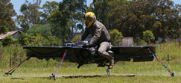

Figure 3 - Mallory Aeronautics [2]

These designs and application meet the client’s CR, of size and weight. Mallory Aeronautics is essentially a large overlapped quadrotor that houses one person and given the size of the tester, it would fit within a parking space of 9’x 9’. It also appears to be lightweight and compact however, no technical specifications were found, but given the size of the rotors it is not an unreasonable weight. The same can be said for Hoversurf, however their rotor blades are oriented in a the fashion as current drone-copters.

3.2.2 Existing Design #2: Quadcopter Car
The Chinese based company EHang [5,6], and Italian centered company Italdesign [7,8], have essentially made what Novakinetics is hoping to achieve, only lighter, comfortable, user friendly, and more effective. These drone can be programed to transport one passenger to their desired location with the touch of programed button. Eliminating the need for a pilot to control and fly the air-vehicle. In the case of EHang an entire system mapping out the location of a city can be uploaded via GPS and the passenger contacts a touch screen, selecting a preloaded landing pad to fly to and the drone flies there itself. There is no need for additional flight input from the passenger. They only point and click where they wish to go and the drone does the rest. This is a large scaled coaxial-double-quad-rotor drone with an enclosed seat on top for a person to sit in.

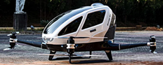
Figure 4 - Full scale working prototype [9]
A tag line of the article claims that it is ‘car sized’, and given the picture and accompanying video this design is about the size of a small car which certainly fits within a parking space to satisfy the CR of a 9’x9’ area. The video also shows one person entering the MAV and seemingly flying off, which accounts for the overall weight of the aircraft and passenger. Judging by the image of the MAV the largest areas of mass is the cockpit which houses the passenger. It would be a safe assumption that the MAV does not require an automotive engine to power the rotors, thereby reducing the weight in both engine and fuel loads. The rotor attachments seem to only be connected to the body via the arms housing electronics and serving as a bridge to the MAV. This seems to imply negligible heat transfer and vibrations experienced by the arms.
This satisfies FanFlyers customer’s needs by adhering to approximately fitting into parking space, while also being incredibly lightweight for its personal applications. It is also based on the Client’s quadrotor design.
Italdesign has a similar concept called ‘Airbus’. The difference is that the cockpit can also be attached to a set of wheels to become a type of smart car. This is beyond the scope of team FanFlyer, however, see Appendix D and ref [8] for more details.

3.2.3 Existing Design #3: Quadcopter Drone Frames
These are frames for current remote-control quadcopters that can be purchased & assembled for hobbyists. Although, the sizes are incredibly small relative to what team FanFlyer is expected to design, they can serve as a benchmark of what to bare-in-mind when designing the internal frame.
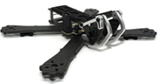
Figure 5 - Quadcopter Frame [9]
These frames give an approximate idea of what team FanFlyer should aim to consider in the project design. The geometries vary and some layouts are impractical for what is being asked, however, Novakinetics is in essence designing a glorified quadcopter. So, it would be in the best interest of team FanFlyer to keep an open mind about quadcopter frames, at the very least for inspirational ideas, if not small scaled geometric analysis.
This applies to FanFlyer’s project by understanding the layout of sub-system placements, and how various geometries can be manipulated to accomodate all subsystems. This can be done by locating and understanding the design considerations of the analogous systems to FanFlyer that were accounted for on these Quadcopter frames.

3.3 Functional Decomposition
In order to grasp the design concept and product generation breakdown, the Functional Decomposition for the FanFlyer project was broken up into two aspects, ‘The Black Box model’ and a ‘Detailed Decomposition model’.

3.3.1 Black Box Model
The ‘Black Box model’ for the FanFlyer design encompasses the compositional breakdown of Matter & Energy for the internal frame team FanFlyer is designing, see Appendix E. ‘Signal’ is omitted because a visual cue of the frame integrity is beyond the scope of team FanFlyer. Novakinetics will install their own method of validating the performance quality of in-flight frame integrity to their pilot operations system if they choose. This is in large part because team FanFlyer is not being asked to build the frame itself, but rather provide supporting data for Novakinetics to use in making the frame themselves. However, they will not need anything from team FanFlyer aside from the frame construction data to achieve that system on their own. So, this Black Box model will only house ‘materials & energies’. See Appendix E.
Materials
For the Matter component of the Black Box model, the following ingredients will go into the physical construction of the support frame:
● 4130 Steel
● Welding materials
● Fasteners (bolts, nuts, rivets, etc.)
● Finite Element Analysis (FEA) data

Energy
For the Energy portion of the Black Box model the following sources of influence will be experienced by the internal metal frame, or will be entering the system (input) upon its use in the manned aerial vehicle (MAV):
● Forces (stress, strain, gravity)
● Heat
● Vibrations
The functional response, or ‘output’, will be the following:
● countered acted forces to balance the input forces experienced by the frame
● Heat dissipation &/or resistance
● Vibrational damping & redirection

3.3.2 Work Progress
The Decomposition Functional Model is based on four tiers of consideration to generate team FanFlyer’s project design, they are: FEA, Customer Requirements, Imposed Caveats, & Materials. See Appendix A. The project break down of what will generate the team’s FanFlyer design will be based on these four tiers of influence. They will serve as the parts to help guide and direct the teams justified design.

FEA
The cornerstone of this project, from the initial project description, is Finite Element Analysis. Novakinetics has asked NAU engineering for an analysis for an interior metal frame for their FanFlyer MAV, which will encourage their construction designs of the frame. Novakinetics has already determined the exterior design & geometry of said flyer, and have selected a ‘2017 Can Am Maverick X3’ engine for their initial trials. However, they are still in search of the proper rotors to use. The FEA simulations will have to account for the forces imposed on the frame by the main engine and the four rotors, in conjunction with the weights of the pilot, the pilot seat, pilot controls, battery system, and circuitry systems. Heat and Vibrational analysis will be conducted once the basic enacted forces of stress, strain, gravity, and thrust are designed and accounted for.
The FEA component of the project is broken into two areas, of ‘ANSYS’ & ‘Theory’. The ANSYS branch is comprised of learning how to use the FEA program ANSYS, where the team will have to double check the results of ANSYS using a closed form hand calculation of the Frame. The theory aspect is learning the basics of FEA theory to better understand the boundary conditions and element constraints of the FEA simulations. Dr. Penado is an unofficial resource for basic questions of FEA because he teaches the FEA class in the spring of each year. Further initiative was performed to find free online courses, lectures, and textbooks to learn FEA on the teams’ own time.

Customer Requirements
Mr. Corning’s requirements, that apply to team FanFlyer, are based on the GoFly competition’s constraints of total empty weight of 625 lbs. and total volume of 275 ft^3. As such Novakinetics has already designed & constructed the exterior framework of the MAV. The geometries they have decided upon, based on the competition requirements, are team FanFlyer’s baseline requirements to adhere to. The internal Frame itself has a target weight requirement of 50 lbs. with a max of 99 lbs., and the proposed geometry must accommodate the total volume limit, which will include the application of all the mechanical systems.

Imposed Caveats
These are forces & phenomena that must be considered due to the presence of the required matter in the MAV, like engine & rotor weights, heat transfer, and vibrations. These forces & phenomena will be experienced by the designed frame and will be
accounted for.

Materials
The material (matter) makeup of the frame has a baseline material recommendation of 4130 steel, however Novakinetics is open to suggestions regarding alternative materials. Welding various beams & bars in combination based on the design composition will greatly aid in the overall frame strength, but will provide additional matter to the system. Welding joints and fasteners to each other will also be installed in some fashion to the frame for its integration into the MAV.

The layout of these four tiers help to map out all the external and internal influences to team FanFlyer’s design. They each encompass a different branch of required influences that the team must adhere to.

3.4 Subsystem Level
What follows are three subsystems that Nova-Kinetics and Fan Flyer are based on, Finite Element Analysis (FEA), Rotor Platforms, & Materials. These subsystems have proven useful in other applications and products around the world for various situations. Here they will not only serve as a type of bench march, but also to serve as considerable options for analysis references, like comparing different types of FEA software as a check or for comparing different types of metallic properties to one another. These subsystems have variable applications, constituents, variations, Pros and Cons. Within each subsystem three variations of each will be addressed.

3.4.1 Subsystem #1: Finite Element Analysis
As mentioned earlier, FEA is what the entire FanFlyer project is based upon. A proper analysis using FEA techniques will help support the desired geometrical designs of the proposed internal metal frame. This analysis will show various stress/strain concentrations of the frame based upon applied loads and forces in relation to the geometrical layout of the designed frame.
For subsystem #1, three programs that can perform Finite Element Analysis of solid mechanics are presented: ANSYS, MATLAB, & Solidworks. They each have their strengths and weaknesses when applied to various systems and conditions. For the purposes of FanFlyer, because of simplicity and availability, ANSYS will be utilized.

3.4.1.1 Existing Design #1: ANSYS
ANSYS is a powerful tool for numerical analysis relating forces and physical phenomena to physical geometrically defined systems. The software has branches in fluid mechanics, solid mechanics, & electricity, among other subjects [10]. For purposes of FanFlyer the structural analysis component of ANSYS will be utilized for the interior support frame of the MAV. It relates to team FanFlyer’s project because ANSYS is readily available for the team’s use, and can perform reliable FEA simulations, which is what is required per request of Novakinetics.

3.4.1.2 Existing Design #2: MATLAB
Matrix Laboratory (MATLAB), has numerous built in mathematical functions that can perform numerical calculations and can produce simple vectorized simulations based upon boundary conditions and mathematical descriptions. These conditions and descriptions require the user to properly input syntax code to generate the proper simulations. This FEA approach is beyond the capability of the members of team FanFlyer. However, its relevance to the project could, when coded correctly, be able to see how the forces & phenomena relate to the frame mathematically. This would help design the frame from a different physical perspective.

3.4.1.3 Existing Design #3: SolidWorks
Solidworks, which is used mainly as a drafting tool for team FanFlyer, also has FEA capabilities for simple geometries. Solidworks will apply to team FanFlyer because the sponsoring professor, Dr. Trevas, recommends that the team attempt basic FEA simulations using Solidworks to gain any results and understanding. Aside from the simple FEA simulations, Solidworks will be utilized for drafting the proposed frame concepts because ANSYS requires a CAD packaged model to perform analysis on.

3.4.2 Subsystem #2: Rotor types
There are four types of aerial drone platforms, Single-Rotor, Multi-Rotor, Fixed-wing, & Fixed-Wing-Hybrid. ‘Single’ is basically a helicopter design, ‘Multi’ is anything more than one, ‘Fixed-wing’ is essentially an airplane usually with horizontal rotors, & The ‘Hybrid’ is a fixed wing drone with one or more helicopter style rotors attached to it [11]. Nova-Kinetics is designing their Flyer with 4 rotors which classifies as a Multi-Rotor aerial vehicle. Only three of the four will be discussed here, Single, Multiple, and Hybrid. ‘Fixed-wing’ will be omitted because Nova-Kinetics’ Flyer does not fit within this category.

3.4.2.1 Existing Design #1: Single Rotor
Single Rotors are the most commercialized currently with the applications of helicopters [12]. The tail rotor does not contribute to the rotor count so most helicopters are still considered Single-Rotor vehicles. This design has been in use for decades and as such has proven its reliability. Nova-Kinetics’ Flyer will operate similar to a helicopter considering its hovering and pitch capabilities. However, rather than one large rotor it will be comprised of four smaller rotors.

3.4.2.2 Existing Design #2: Multi-Rotor
Multi-Rotors, or multi-engine aircrafts rotors fall into this classification [12,13]. Drones of this nature are aerodynamically unstable and require onboard electronics to assist in its flight controls. It was brought to the attention to Nova-Kinetics that such an on board capability may be required for their type of multi-rotor application as well. Nova-Kinetics’ FanFlyer is an upscaled Quadcopter (Multi- Rotor) and this directly applies to team Fan Flyer’s design and consideration.

3.4.2.3 Existing Design #3: Fixed Wing Hybrid Drone
Fixed-Wing-Hybrids are an amalgamation of a fixed wing design with any number of helicopter style rotors [14]. This offers the best of both worlds in providing the vertical takeoff and landing capabilities of a quadrotor with the speed, and range of a fixed wing aircraft. This is adding one extra powerful dimension to the design of current quadcopters, and is beyond the scope of team Fan Flyer’s design and requirements, however it does provide a baseline of control in the various potentials that Nova-Kinetics could branch into.

3.4.3 Subsystem #3: Materials
What the frame is composed from is highly important. It will react differently if it were made from metal or plastic, which will determine the life and function of the frame under its intended use. ‘Materials’ is a design tier from the decomposition model, and also houses welding and fastener materials. However, for the bulk of expected materials, team FanFlyer does not have much experience working with metals or plastics under extreme conditions that the MAV will endure. However, at the recommendation of Novakinetics, welded 4130 steel is offered as a base material for the frame’s material construction.

3.4.3.1 Existing Design #1: 4130 Steel
The Client of Novakinets has recommended 4130 steel as the base material, but is open to alternative justified suggestions. The advantages of this option are that not only was it recommended by a mechanical engineer who is also the president of the Novakinetics, it is incredibly strong, and will yield before it breaks.
This applies to the project in satisfying the integrity of the internal frame of the MAV by yielding before breaking. As such it is incredibly strong and under the correct ratio of cross diameter geometries to thickness (wider diameter & thicker walls, or visa-versa) it can withstand the imposing forces that it is expected to experience.

3.4.3.2 Existing Design #2: Aluminum
Aluminum, although light and strong, can be brittle in comparison to 4130 steel. Under certain conditions and geometries, more Aluminum may be required to equate to the strength of the 4130 steel. Alloy 3003 is an aluminum alloy that can compete with steel. It is 20% stronger than most aluminums because it is inject with magnesium to increase its strength. Alloy 3003 is also extremely easy to weld which is an important factor for this project because Mr. Corning desires to weld the parts of the the MAV to the frame. Not only this, but Alloy 3003 has great properties for preventing corrosion which will expand the life of the frame.
This relates to the project because it was mentioned in meetings with Mr. Corning that certain alloys of aluminums may work, however, further analysis would be required to verify that suggestion.

3.4.3.3 Existing Design #3: Cold rolled steel
Cold roll steel was used before the use of 4130 steel. It is incredibly durable; however, it is heavier and not as hard as 4130 steel is. 4130 steel is a standard for current aircraft materials because of its simplicity in its workability, of forming, welding, cutting and fastening. Whereas cold rolled steel is not as ‘flexible’ because it is lacking a similar hardness.
This relates to the project because although 4130 steel is far superior, cold roll steel does offer a potential alternative if used accordingly.

4 DESIGNS CONSIDERED
Included within this section are the designs that have been proposed and evaluated thus far. As the project continues there will undoubtedly become more concepts that need to be considered. Each concept has a description and picture associated with it in order to fully explain what the team was aiming for in the design concept. Included in this section is only a portion of the designs considered but were considered to be the best, most creative, or most inspiring to the group.

4.1 Design #1: Smaller Main Design
This design has come from the advise of the client of this this project, but on a smaller scale and with some additional features. This design is lighter than the clients but does not protect the pilot and is unstable in comparison to the original.

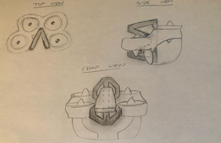
Figure 6 - Design #1 - Smaller Main Design

4.2 Design #2: Three Poll Frame
This design was brainstormed off of Jim Coring’s idea of using a 3-point system for the device. Three long poles connect the seat to the outer shell of the design. This design is lightweight, and easy to test and manufacture. However, it is not aesthetically pleasing, not very stable, and has a good chance of joint failure.

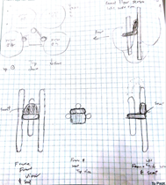
Figure 7 - Design #2 - Three Poll Frame

4.3 Design #3: Hover Pad Frame
This design is another design based off the advice received from the client. This design is light, has near to no possibility of joint failure, is safe and is easy to manufacture. Some disadvantages include that it is not easy to test and it is not very stable.
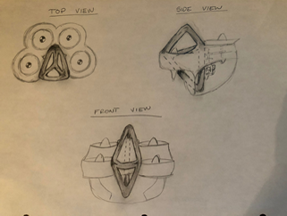
Figure 8 - Design #3 - Hover Pad Frame

4.4 Design #4: Triangular Box Frame
This design is once again conceived from the client’s three-point system. It is much like the three-poll frame but with smaller poles and with supports on the right, left, and bottom of the sides of the seat. This design is heavy, provides no ease of load testing and is not very safe. However, it has great stability and a low chance of joint failure.
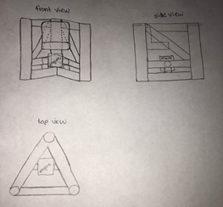
Figure 9 - Design #4 - Triangular Box Frame

4.5 Design #5: Race Car Hover Pad
This design is once again based off the advise the client relayed to us requiring a 3 point-of-contact system. This design is light and should not have joint failure. However, it is not very safe or stable.
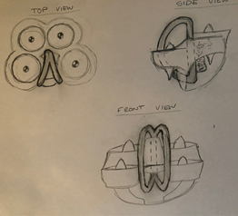
Figure 10 - design #5 - Race Car Hover Pad

4.6 Design #6: Five Point Pole
This design was based off of a five point-of-contact frame instead of three points. It is light, easy to analyze, and pleasing to the eye. However, it is not very balanced and could have joint failure because of the five cantilever beams extruding from the base pole in the back, this fram would be subjected to high bending moments which would in turn cause high stresses at the joints of each of the five poles.
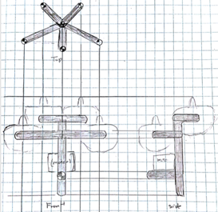
Figure 11 - Design #6- Five Point Pole

4.7 Design #7: Box Frame
This design does not meet Jim’s requirement of having a 3-point of contact system. However, the design is extremely lightweight and safe for the pilot. It also could be very unstable and weak at the joints. This is why this design was not included in the decision matrix.

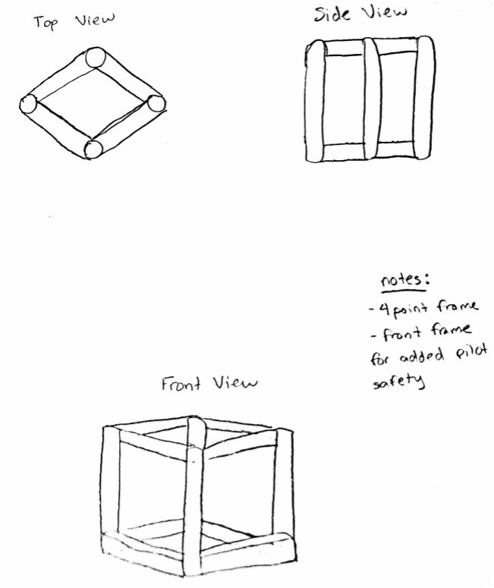
Figure 12 - Design #7 Box Frame

4.8 Design #8: Simple 3-Point Design
This frame was designed to be very simple and lightweight. However, because of this the design is very weak at the joints and is subject to failure from the loads. This is why design 8 was not included in the decision matrix.
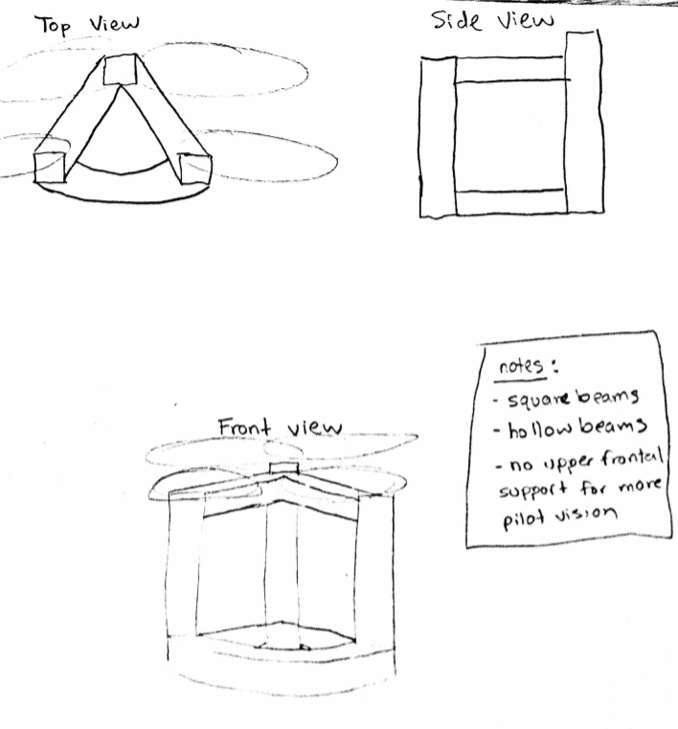

Figure 13 - Design#8 Simple 3-Point Design

4.9 Design #9: Multi-Support Frame
This frame was designed to be extremely structurally sound and stable. It utilizes numerous support beams to make sure the forces acting on the frame will not let it yield. However, this design is extremely heavy which objects with the most important customer requirement; lightweight. Therefore, this design was not included in the decision matrix.
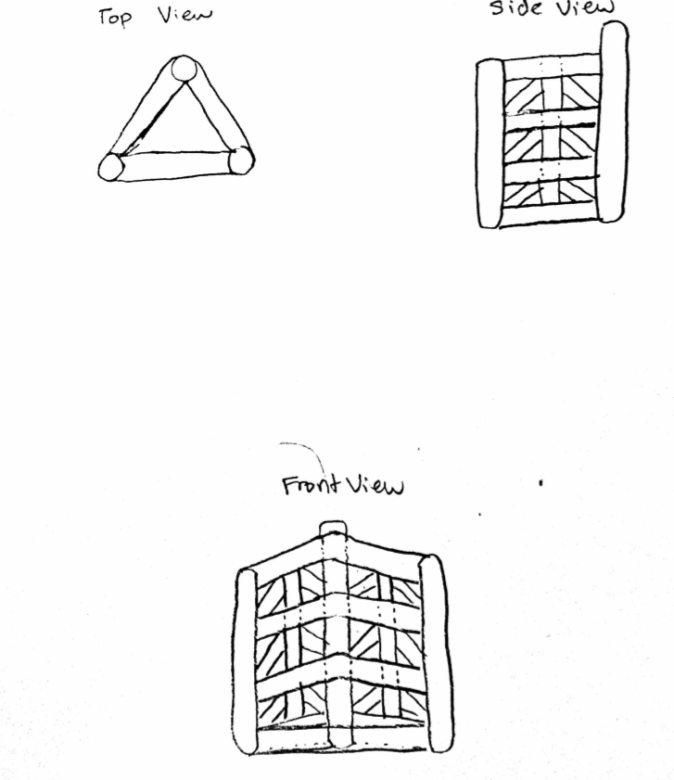

Figure 14- Design #9 Multi-Support Frame

5 DESIGN SELECTED – First Semester
The client wants the FanFly team to aid in his company’s participation in the GoFly competition. The team is to design an internal frame for the aircraft he has proposed. The Criteria is that it needs to be lightweight, stable, and safe. The design must be within 900 lb. operating weight, can remain stable on the ground or in the air for 20 minutes, and has safety measures in case of emergency. The client also wants the team to keep the device within 9x9 ft ground area to be able to fit within a parking space. After examining the considered designs the team reached a final decision, through the pugh chart and the decision matrix in Appendix G and chose to use design #3.

5.1 Rationale for Design Selection

Through the team’s help of the decision matrix and pugh chart the team was able to narrow down its choices into a singular selection that meets the necessary requirements and proves to be a more sound choice than the datum design offered by the client. As can be seen in the pugh chart and decision matrix located in Appendix G. Design #3 came out as the best choice for the team to pursue. In the decision matrix where the designs were evaluated on the given criteria alone where decision #3 outperformed the next best design which was #4. The pugh chart allowed the team to analyze the designs against the datum offered by the client. In the pugh chart and decision matrix narrowly beat the 5th design on how it compared to the datum. The team evaluated the design and decided it best meets the required standards by being more lightweight, stable, aesthetically pleasing and safer than the client design proposal.
The design was chosen to be more lightweight based off the fact that overall it involved less of the material needed to be constructed. Based off the simple notion that whichever material the analysis determines to be the best for the project a less quantity means less weight. The design was determined to be more stable because it offers a suggested lower center of gravity which creates an increase in balance and stability. The design is “suggested” to lower center of gravity based on a basic visual evaluation and until the team can use FEA simulations and closed form hand calculations to determine if the design is actually more stable they will move forward with the evaluation and at the time of evaluation will be able to adjust the the design to fit the required stability. The aesthetics is a subjective category and was decided based off the teams preferences. Lastly the design was determined to have a higher operator and safety score simply because the design implemented a directly integrated roll cage into the design. The team has been unable to contact the client to propose the chosen design but is moving forward with the evaluation of the frame.

5.2 Design Description
The datum design constructed by the client was offered in a CAD package that provided the detail specifications of the frame. The CAD package that was used can be viewed in Appendix H Figures 26-28. The team then used the CAD package to create a 3D model using solidworks to fully visualize the design in its full measurements and determine the areas that could be improved upon. The team then moved onto turning the selected design sketch into a 3D CAD model that was created using the specifications required by the client. The 3D models of both the datum client design and final proposal design can be seen in Appendix H Figures 24 & 25. The CAD models were compared using the Solidworks software to determine the differences between the two frames. The finalized frame was determined to be approximately 17 lbs lighter when the were analyzed using 4130 steel suggested by the client. This analysis confirms the teams initial assumption that they could cut weight from the datum design. The frame weight also came in under the maximum weight requirement of the client. The team will continue to evaluate other materials to determine which would be best based off the other analysis that will be performed in the future using the ansys software.
The team has been working through the semester on teaching themselves the ANSYS program to analyze the frame through FEA. The team is currently far from proficient using the software but has made headway in ANSYS as well as analyzing the frame using closed form hand calculations. These hand calculations can be seen in Appendix I Figure 29 & 30. The hand calculations are used to determine the static stresses and deflection of the frame using the forces acting on the frame. These hand calculations are performed in order to create a baseline of what the finite element analysis should return using the ansys software and will help determine how accurate the analysis is. The team has also gotten some basic results from ansys though they are far from finalizing results on the frame. The preliminary ANSYS results can be seen in Appendix H and shows a brief glimpse into what the stress results should ultimately look like and what the team is working towards.

6 PROPOSED DESIGN – First Semester
The way the team is planning to implement the design is by providing a full analysis of all stresses, strains, delflections, and possible failure propagations, of the team’s proposed frame compared to the datum frame provided by the client through the ANSYS data and by hand calculations.
This data will be prevented to the client and will show how both the frames will perform in relation to one other under the same conditions. To do this, a printout and write up of the calculations found in ANSYS, along with hand drawn static analysis on the design, will be used in order to demonstrate the capability of the team’s final design. It will also be shown that calculations on the volume and weight of the design will be much lighter and smaller than the datum frame from Nova-Kinetics.
Additionally, because the team’s project is based solely on data analysis, and will not be constructed by the team, there is no costs, budget, purchasing, or assembling of the frame on team FanFlyer’s part. The only budget that has been considered so far has been the purchasing of an ANSYS software book.
The frame is to be welded and as such there are no components that will make up a bill of materials aside from the frame material, and it’s projected quantity. Nova-Kinetics has established a baseline of 4130 Stainless Steel as the material. However, research and analysis is ongoing to find more robust material to outperform this . Regardless of the material selection the material in conjunction with the frame must be below 99 lb. and if team FanFlyer chooses to remain with 4130 steel, the client will remain happy so long long as their requirements are met.
The table below is the team’s realist Build of Materials (BOM.) As stated only the material of the frame will make up the frame itself because it will be welded together. Along with the material are both the baseline and projected quantities of the material, along with the geometry type with the inner and outer diameters. The projected quantity is based on Fan Flyer’s frame and the baseline quantity is based on Nova Kinetics frame. These are based on Solidworks dimensioning of 28.34 feet for FanFlyer’s design, and 26.78 feet for Nova-Kinects frame design, where an additional 5 feet were added to accomodate for waste, because these numbers represent the combined length of each pipe that makes up the finished frame model.
Table - 1 Frame Materials BOM
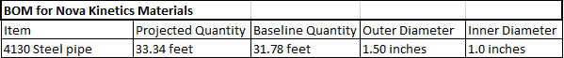
The team has ultimately created a CAD view model of the components that will be provided by the client, that the frame will support, but that are also outside the scope of the team’s project. This model was created in order to get a better understanding of how the outside components fit within the frame and where they will be located in relation to the frame. These components are the motor, the rotors, belts, and the fan ducts. This CAD model can be seen in Appendix H Figure 23.

In conclusion, team FanFlyer has hit a few roadblocks and setbacks in relation to ANSYS and FEA software, dude to the lack of experience of both aspects for all members, however despite the slow progress, progress is still being made, and the team knows how to perform the required hand calculations in order to supplement and validate the ANSYS simulations.

7 REFERENCES

[1] FanFlyer Potential Technical & Design Discussion. Novakinetics. 2018. Journal copyright 2018.

[2] V. Turk., "This Hoverbike Is Basically A Giant Quadcopter Drone". [online] Motherboard. Kickstarter. Available at: https://motherboard.vice.com/en_us/article/pgakab/this-hoverbike-is-basically-a-giant-quadcopter-drone, [23 Jul. 2014.]
[3] A. J. Hawkins. The Verge. World’s first rideable hoverbike looks cool as hell but will probably kill you. [online] Available at: https://www.theverge.com/2017/2/20/14671758/hoverbike-hoversurf-russia-drone-quadcopter-hellno [20 Feb. 2017].
[4] Home | HOVERSURF. (2018). Home | HOVERSURF. [online] Available at: https://www.hoversurf.com/ [Accessed 1 Dec. 2018].
[5] A. Fitzpatrick., "This Insane Car-Sized Drone Carries People Like A Helicopter". [online] Time.com. Innovations. Available at: http://time.com/4171329/drone-helicopter-ehang-184-ces/ [7 Jan. 2016].
[6] M. Fitzsimmons., “Flying cars? Watch as this drone flies around with passengers inside”. [online] TechRadar. Available at: https://www.techradar.com/news/flying-car-watch-as-this-drone-flies-around-with-passengers-inside, [5 Feb. 2018]
[7] Italdesign. Italdesign-Airbus-PopUp. [online] Available at: https://www.italdesign.it/project/popup/. 2016.
[8] Website. The Verge. (2018). Airbus’ new concept is a car, a drone, and a train all in one. [online] Available at: https://www.theverge.com/2017/3/7/14841324/airbus-concept-car-drone-train-geneva-motor-show [7 Mar. 2017].
[9] THE BEST QUADCOPTER FRAMES
FPV Know-It-All - Joshua Bardscell. (2018). THE BEST QUADCOPTER FRAMES. [online] Available at: https://www.fpvknowitall.com/ultimate-fpv-shopping-list-frame/ [Accessed 26 Oct. 2018].

[10] Ansys.com. (2018). Engineering Simulation & 3D Design Software | ANSYS. [online] Available at: https://www.ansys.com/ [Accessed 27 Oct. 2018].
[11] Chapman, A. (2018). Types of Drones: Multi-Rotor vs Fixed-Wing vs Single Rotor vs Hybrid VTOL - AUAV. [online] AUAV. Available at: https://www.auav.com.au/articles/drone-types/ [Accessed 1 Dec. 2018].
[12] Global UAV Technologies Ltd. (2018). Single Rotor and Multi Rotor Drones Face Off. [online] Available at: https://www.globaluavtech.com/news-media/blog/single-rotor-or-multi-rotor-uavs-your-choice/ [Accessed 1 Dec. 2018].
[13] Ardupilot.org. (2018). What is a MultiCopter and How Does it Work? — Copter documentation. [online] Available at: http://ardupilot.org/copter/docs/what-is-a-multicopter-and-how-does-it-work.html [Copyright 2016].
[14] L3 Latitude. (2018). Hybrid Quadrotor - Hybrid Quadcopter - VTOL UAV - Autonomous Takeoff - Autonomous Landing. [online] Available at: https://www.latitudeengineering.com/products/hq/ [Accessed 1 Dec. 2018].
8 APPENDICES
8.1 Appendix A: Customer Requirements

Table - 2 Customer Requirements
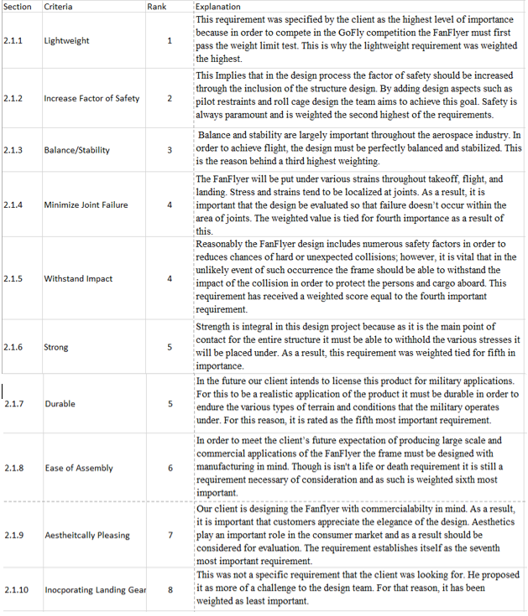

8.2 Appendix B. Engineering Requirements

Table - 3 Engineering Requirements
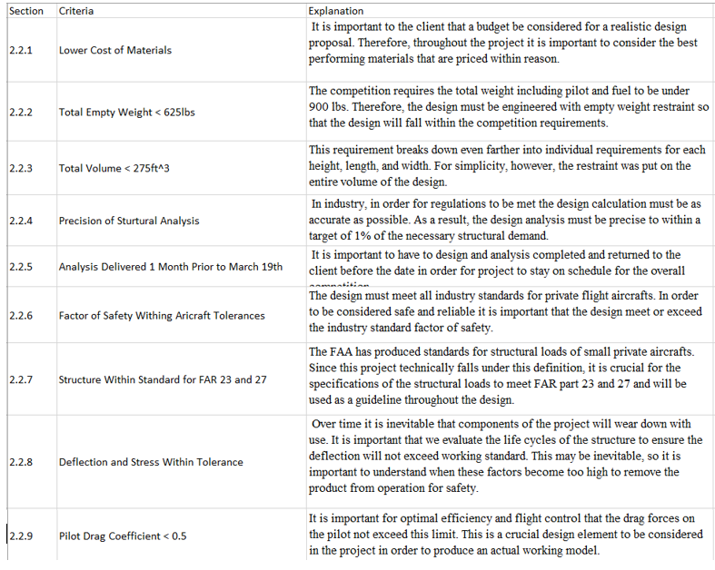

8.3 Appendix C: House of Quality

Table 4 - House of Quality
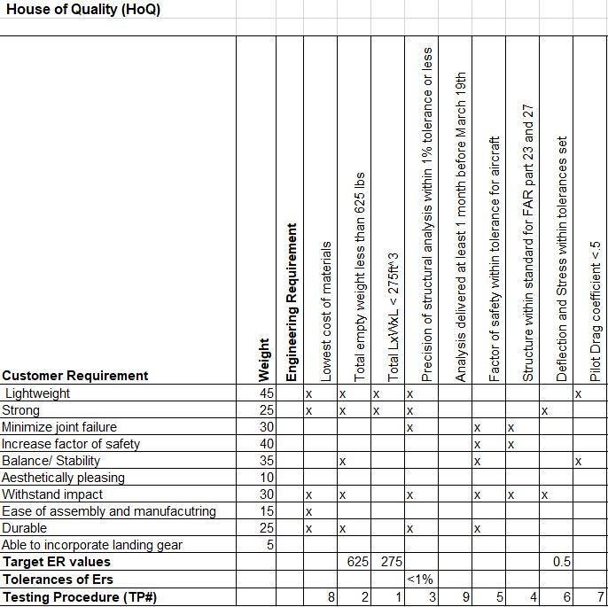

8.4 Appendix D: System Level

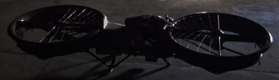

Figure 15 - Full scale working prototype. Mallory Aeronautics [2]

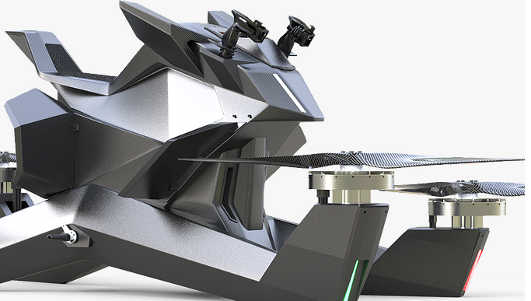
Figure 16 - Production Model, Hoverbike eVTOL [2]

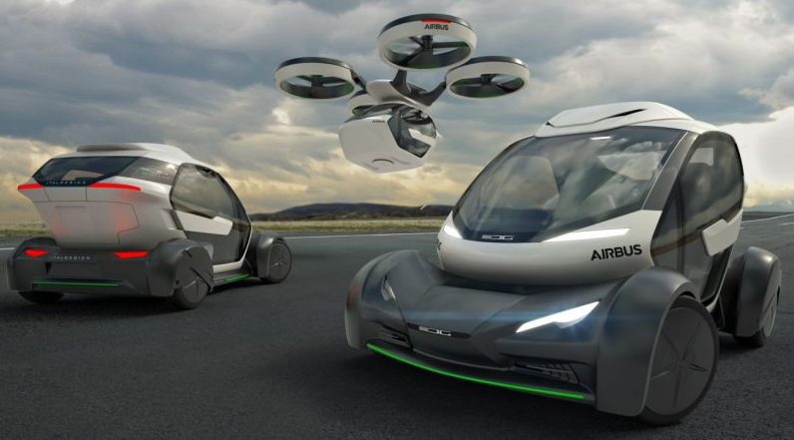
Figure 17- Italdesign Airbus flyer and driver [8]

8.5 Appendix E: Black Box model
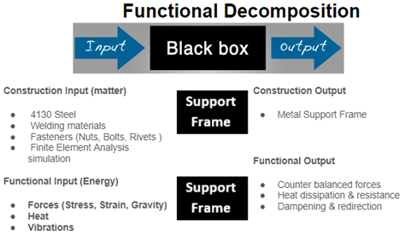
Figure 18 - Black Box Model

8.6 Appendix F: Functional Decomposition
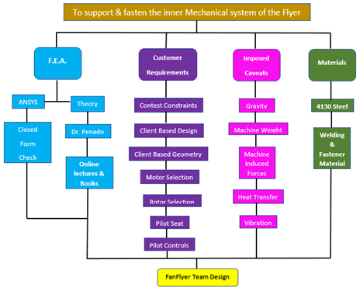
Figure 19 - Functional Decomposition

8.7 Appendix G: Decision Matrix & Pugh Chart
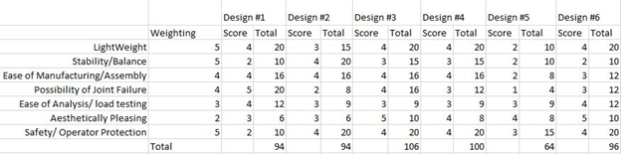
Figure 6 - Decision Matrix

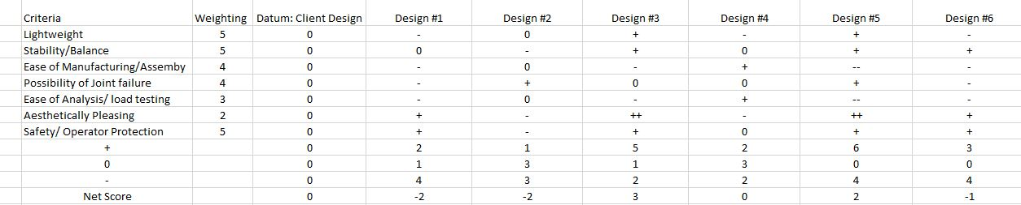
Figure 20 - Pugh Chart
8.8 Appendix H: Design Models

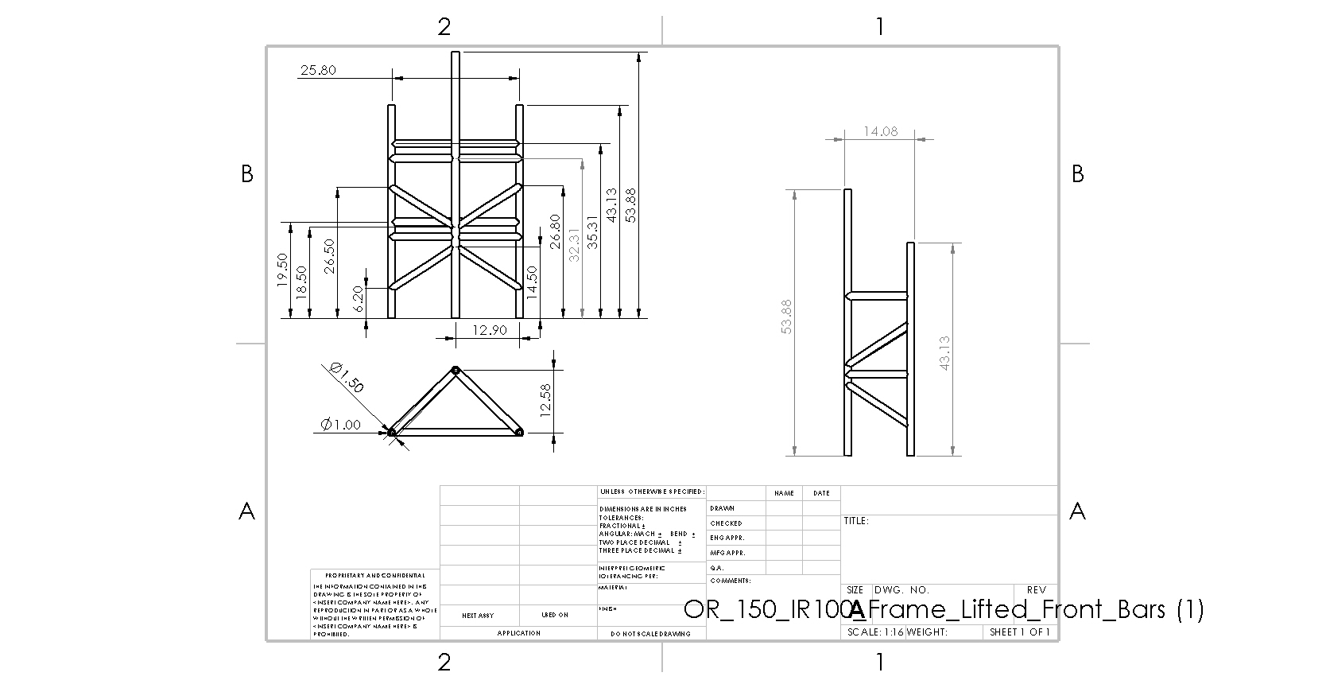
Figure 21 - Client Design CAD Model

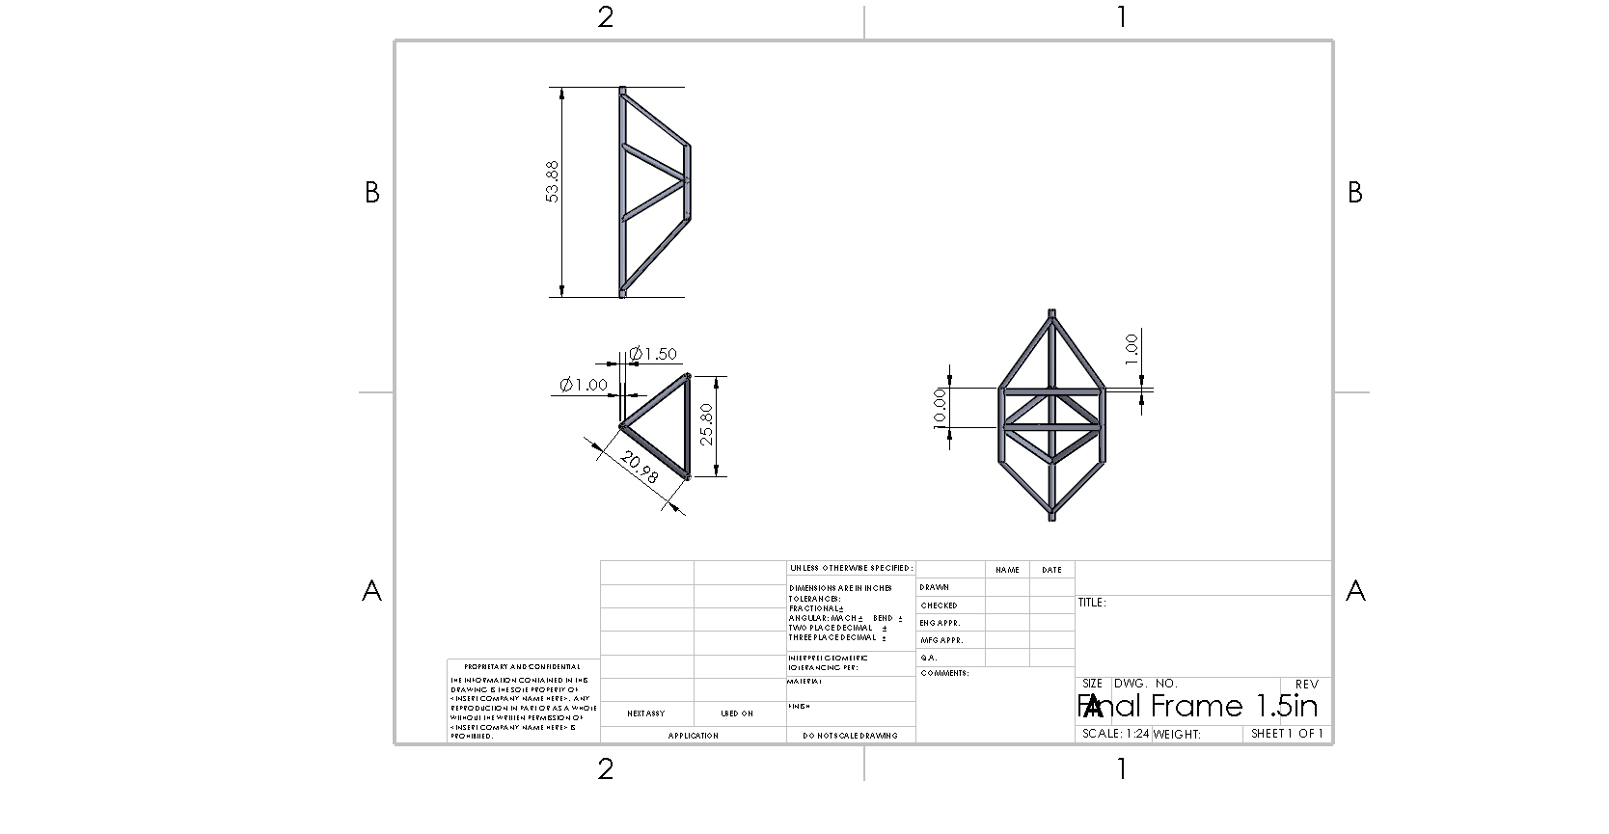
Figure 22- Team Frame Design CAD Model

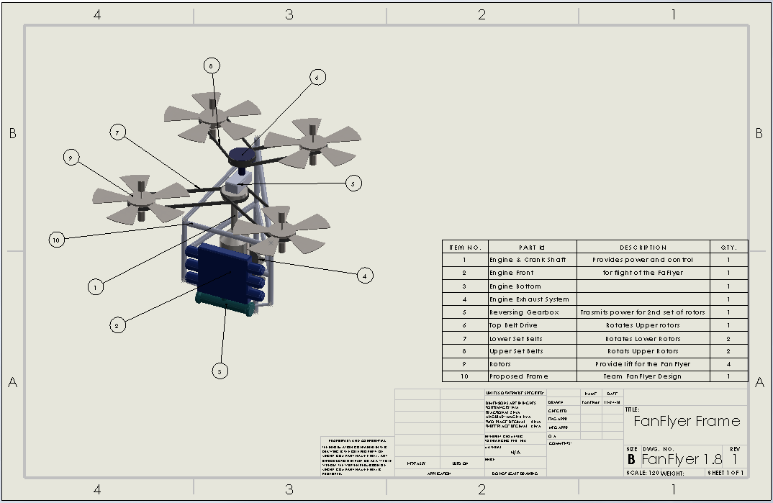
Figure 23 - Integrated Final Design CAD Model

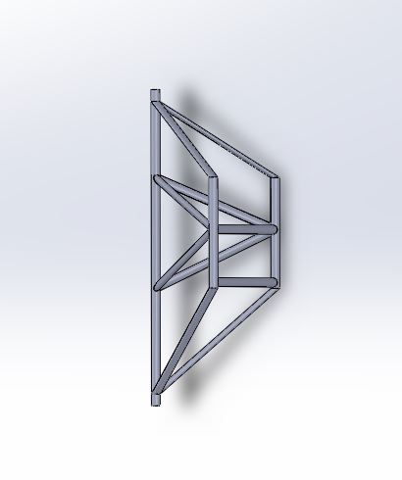
Figure 24 - 3D CAD Model of Final Frame

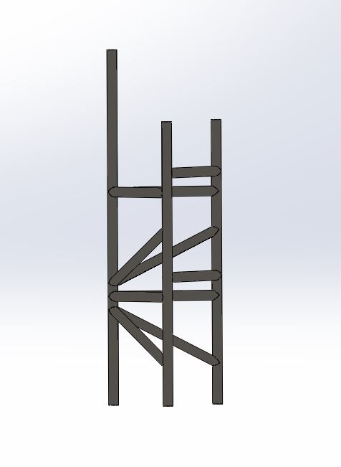
Figure 25 - 3D CAD Model Datum Frame

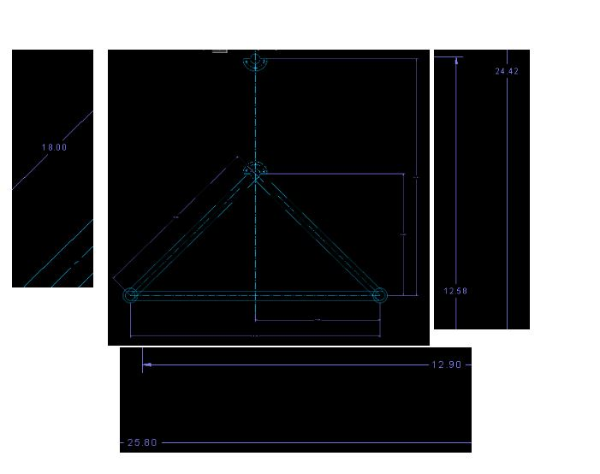
Figure 26 - Client Design Specifications 1

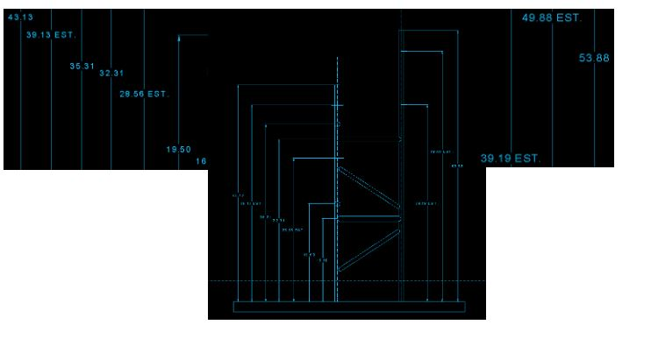
Figure 27 - Client Design Specifications 2

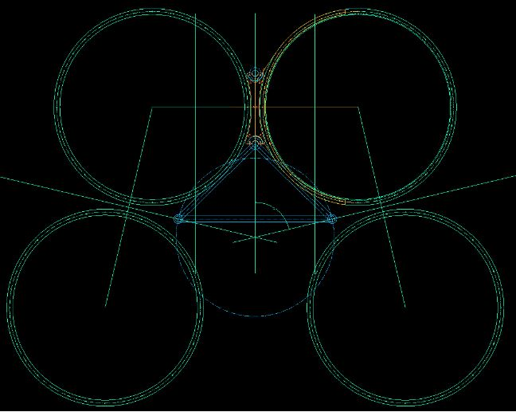
Figure 28- Client Design Specifications 3

8.9 Appendix I: Hand Calculations and Software Analysis

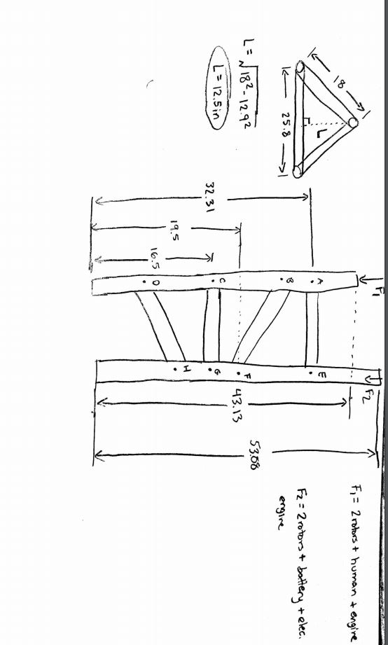
Figure 29 - Hand Calculations 1

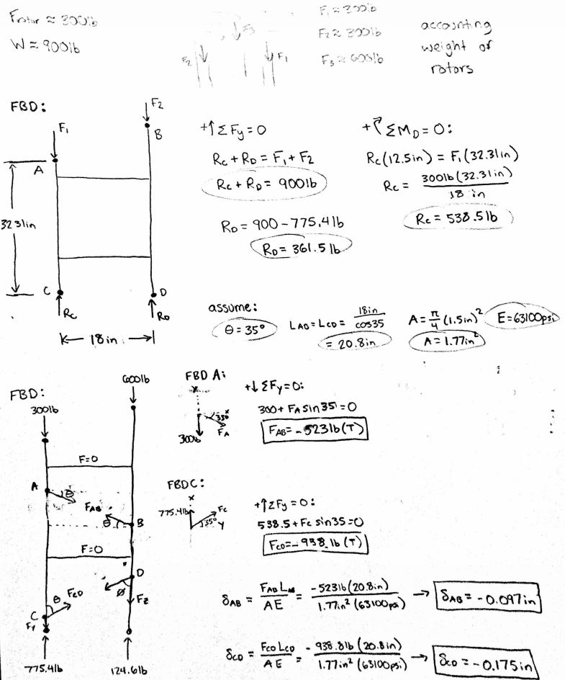
Figure 30 - Hand Calculations 2

