Memorandum
To: Jim Clark III
CC: Joel Dugdale
From: DSK Engineering
Date: 3/8/2011
Re: Conceptual Development Analysis & Results

Introduction:
In preparation for our in-depth senior capstone project, DSK Engineering was given the task of proving that our team was capable of testing our beam compressor with 3-axis accelerometers. For this task, our team was presented with a simple vibrating system in the form of a large steel rod that would allow us to become familiar with calculating frequency and comparing our calculations with results from actual accelerometer testing. This conceptual development project consisted of the use of a large stainless steel rod, a multi-axis accelerometer, data acquisition systems & signal conditioning units, LabVIEW 6, Cosmos/M, and Microsoft Excel.

Theoretical/FEA Analysis:
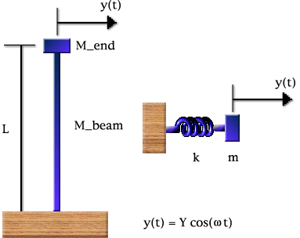
In starting this task, the vibrating system was modeled as a simple cantilever beam with a mass on the end (Figure 1).
Figure 1
Using vibration equations from Singiresu S. Rao’s textbook Mechanical Vibrations, we calculated the natural frequency of this cantilever beam with the know values: volume, density of stainless steel, modulus of elasticity and rod dimensions. These equations are shown below in the order they were used:
$V=\frac{1}{4}πd^{2}h$ (volume)
Figure 2
$ρ=7805.73 kg/m^{3}$ (density)
Figure 3
$d=0.0381 meters (diameter)$, $h=1.07315 meteres (height)$, E = 193 GPa
Figure 4
$m= ρV$ (mass)
Figure 5
$$I=\frac{π}{64}d^{4}$$
Figure 6
$$k=\frac{3EI}{l^{3}}$$
Figure 7
$$w_{n}= \sqrt{\frac{k}{m}}$$
Figure 8
$$f=\frac{w_{n}}{2π}$$
Figure 9
Upon completing the calculations, it was found that theoretically the stainless steel rod’s first fundamental frequency is 11.3 Hz.

However, the particular calculations above were only calculated to compare against our experimental results. The in-depth project that DSK Engineering will be completing requires the comparison of a finite element analysis model with the experimental results. To complete this part of the conceptual development task, Cosmos/M was used to model the system. Using 2 nodes and 1 element to create an FEA model to mimic the movement of the cantilever rod, a vibration simulation was run. Below shows the nodal mesh and the results of the Cosmos/M analysis.

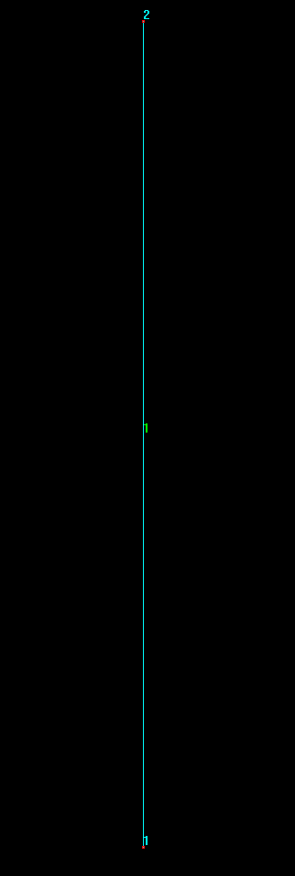
Figure 10
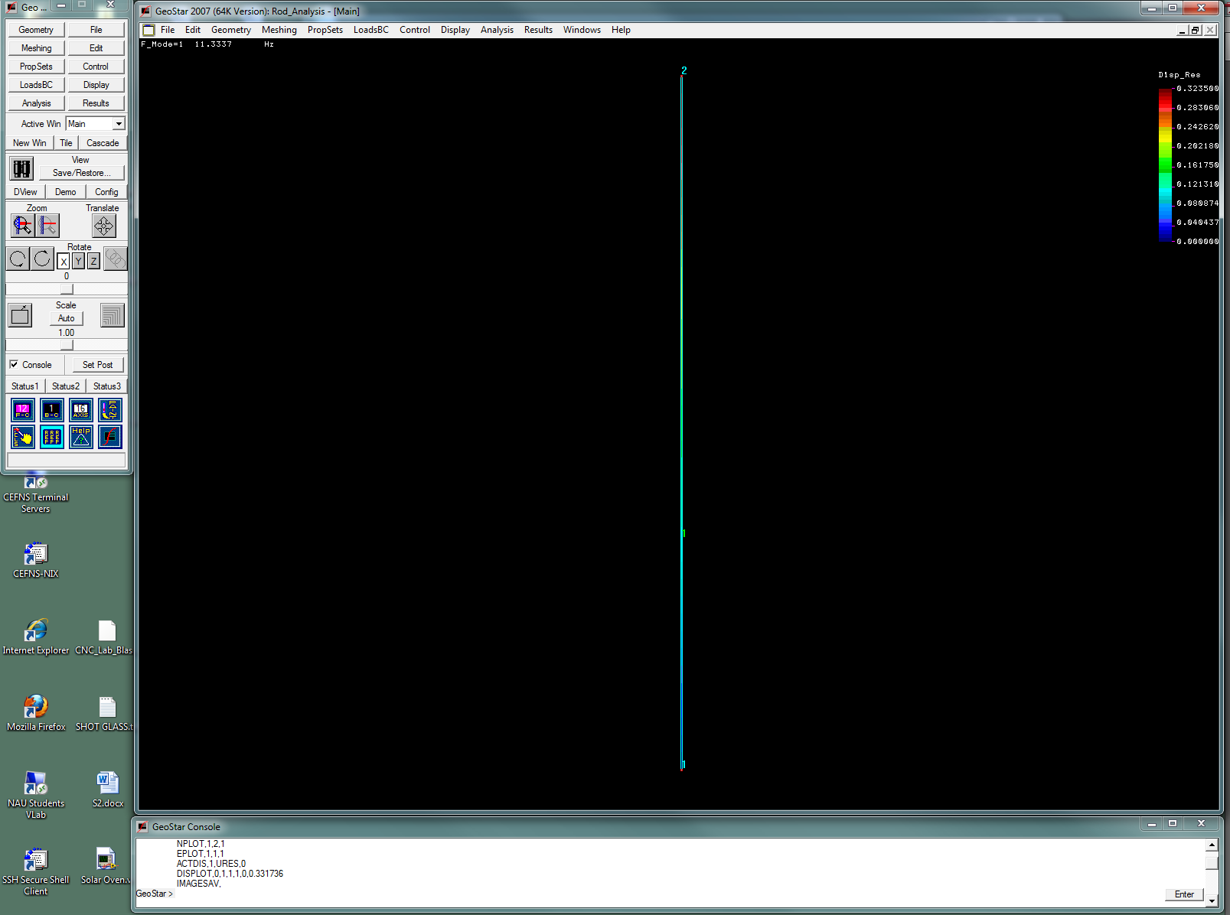
Figure 11(above)

Figure 12

As shown above, the Cosmos/M analysis matches the theoretical analysis to within 3% percent. This percent is under the 10% maximum difference requested by our NPOI clients. This shows that the FEA model does a very good job of representing the theoretical model. In the following section, the experimental analysis will be shown and compared to this solution in the FEA model and the theoretical model.

Experimental Analysis:
To complete this section of the conceptual development, a LabVIEW VI, a signal conditioner, and a data acquisition system were used to collect the accelerometer data and output the acceleration and time associated with this incoming data into a spreadsheet. The data was then plotted and the result is shown below in Figure 13.

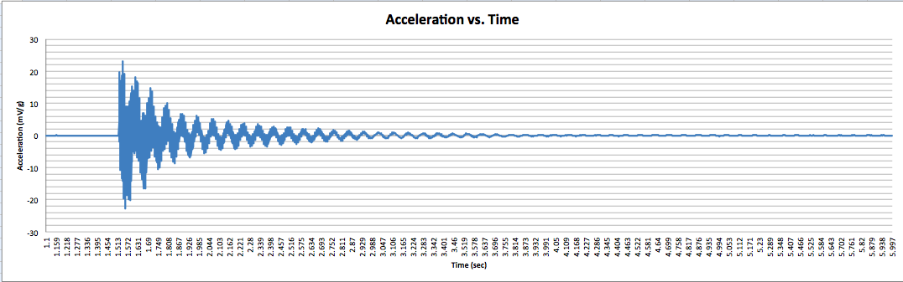
Figure 13

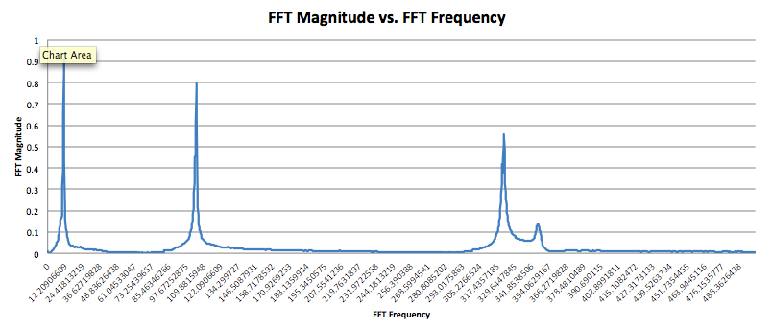
Upon noting the high quality of the data and the lack of noise presented in the signal, the data was then placed into another spreadsheet in which a Fast Fourier Transform (FFT) function was run on the data. The figure shown below shows the results of this FFT.

Figure 14

With the use of the FFT, the first fundamental frequency was found to be equal to 11.96 Hz. The table below shows the fundamental frequency for the theoretical and experimental solutions and the relative error between them.

 | Theoretical FF (Hz) | FEA FF (Hz) | Experimental FF (Hz) | Relative Error btwn T & FEA | Relative Error btwn T & E | Relative Error btwn FEA & E
Simple Vibrating System | 11.3 | 11.3337 | 11.96 | 2.501% | 5.84% | 5.526%

Figure 15

The format of the table above will be similar to the one used in the final project. The final section will discuss our results and conclusions for this conceptual development assignment.

Results & Conclusion:
After completing our analysis, it was found that the theoretical, the FEA, and the experimental solution varied no more than 6 % from each other. Since this is less than the 10% maximum deviation requested by our clients, it could be said that DSK Engineering’s testing methods are accurate enough for our client’s needs. Upon arriving at this conclusion, DSK Engineering believes that we are capable of testing the Big Beam Compressor (BBC) and comparing our data to the current FEA data associated with the BBC.
Confidential

