To: Robert Severinghaus, Mahsa Keshaverz, General Dynamics Mission Systems
From: Team 9 - Oscillation 300: Anthony Galdi, Luke McGowan, Brendan Smith, Bryce Vegh
Date: March 26, 2021
Subject: Testing Results Document

This report details the testing results of our team's capstone project. Our project is a Site Weather and Power Recorder (SWAPR) device for General Dynamics Mission Systems to use at their remote fixed facilities (RFF). The device is made up of two main components, a weather station and a radio signal power recorder. The weather station will sense and record temperature, humidity, wind speed and direction, and if rain is present on site. The signal power recorder will detect if a signal is being transmitted at a certain frequency by detecting power.

Our team executed six different tests for this device to ensure that it met all of the requirements specified by our customer. We performed three unit matrix tests, one on each of the individual weather station sensors (wind, temperature and humidity, and rain). We performed one unit step-by-step test on the Hamshield power recorder.

The final two tests were integration tests. One integration test was on the completed weather station, and the other was on the weather station integrated with the signal power recorder. We estimate that our team spent a combination of approximately 22 hours on testing for this project. Each unit matrix test was completed successfully prior to performing the weather station integration test, which was also successful. The unit step-by-step test for the power recorder was successful at all tested frequencies within the 140 to 172 Mhz rangesThe final integration test of the completed project has been executed and is successful throughout.

Introduction to the system:
Our Client General Dynamics Mission Systems is a technology integrator and original equipment manufacturer who provides various mission critical solutions to civil government, defense, intelligence and cybersecurity customers. These services help those who serve, from soldiers to sailors, to complete their missions safely and efficiently. This project specifically aids the General Dynamics Rescue 21 system, which assists the U.S Coast Guard advanced command with search and rescue operations (SAR).

Our project is to develop a device to measure power transmission as well as verify site weather conditions at an unmanned facility owned by our client. The goal of this is to prevent our client from having to send technicians out to the site in person as the device would handle it without their presence. More specifically, this device will be measuring the VHF radio output in order to determine if the radio is transmitting properly as well as be measuring the immediate local weather conditions. The benefits of such a device will provide our customer with the ability to securely view the current weather conditions of a remote location, as well as determine important information about local VHF signals regarding power and channel frequency. Secure access to such information allows for the customer to make important decisions without having to be on site themselves.

Our design incorporates two Arduinos, a laptop, a hamshield mini, attenuators, and weather sensors that are used to gather data from our weather and power station. The weather portion of our device will use wind, temperature/humidity, and rain sensors to gather the weather data. The power portion of our device will use a hamshield mini and attenuators to gather the power of the radio signal that is being transmitted from the radio. Once the weather and power data is gathered it will be sent through two COM ports, one COM port for the weather data and one COM port for the power data. Finally, a python program on the laptop will be used to access the two COM ports to be able to take in the data and record the data with a timestamp in a text file that can be accessed on the laptop at a later time.

System Architecture:

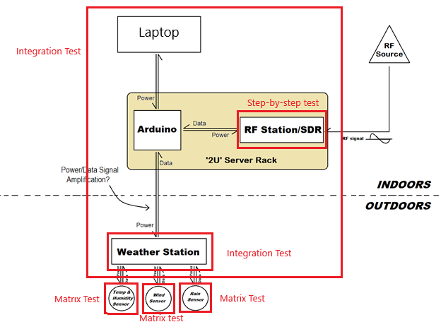
Figure 1: System Architecture with Testing Completed

Requirements, status, type of test:
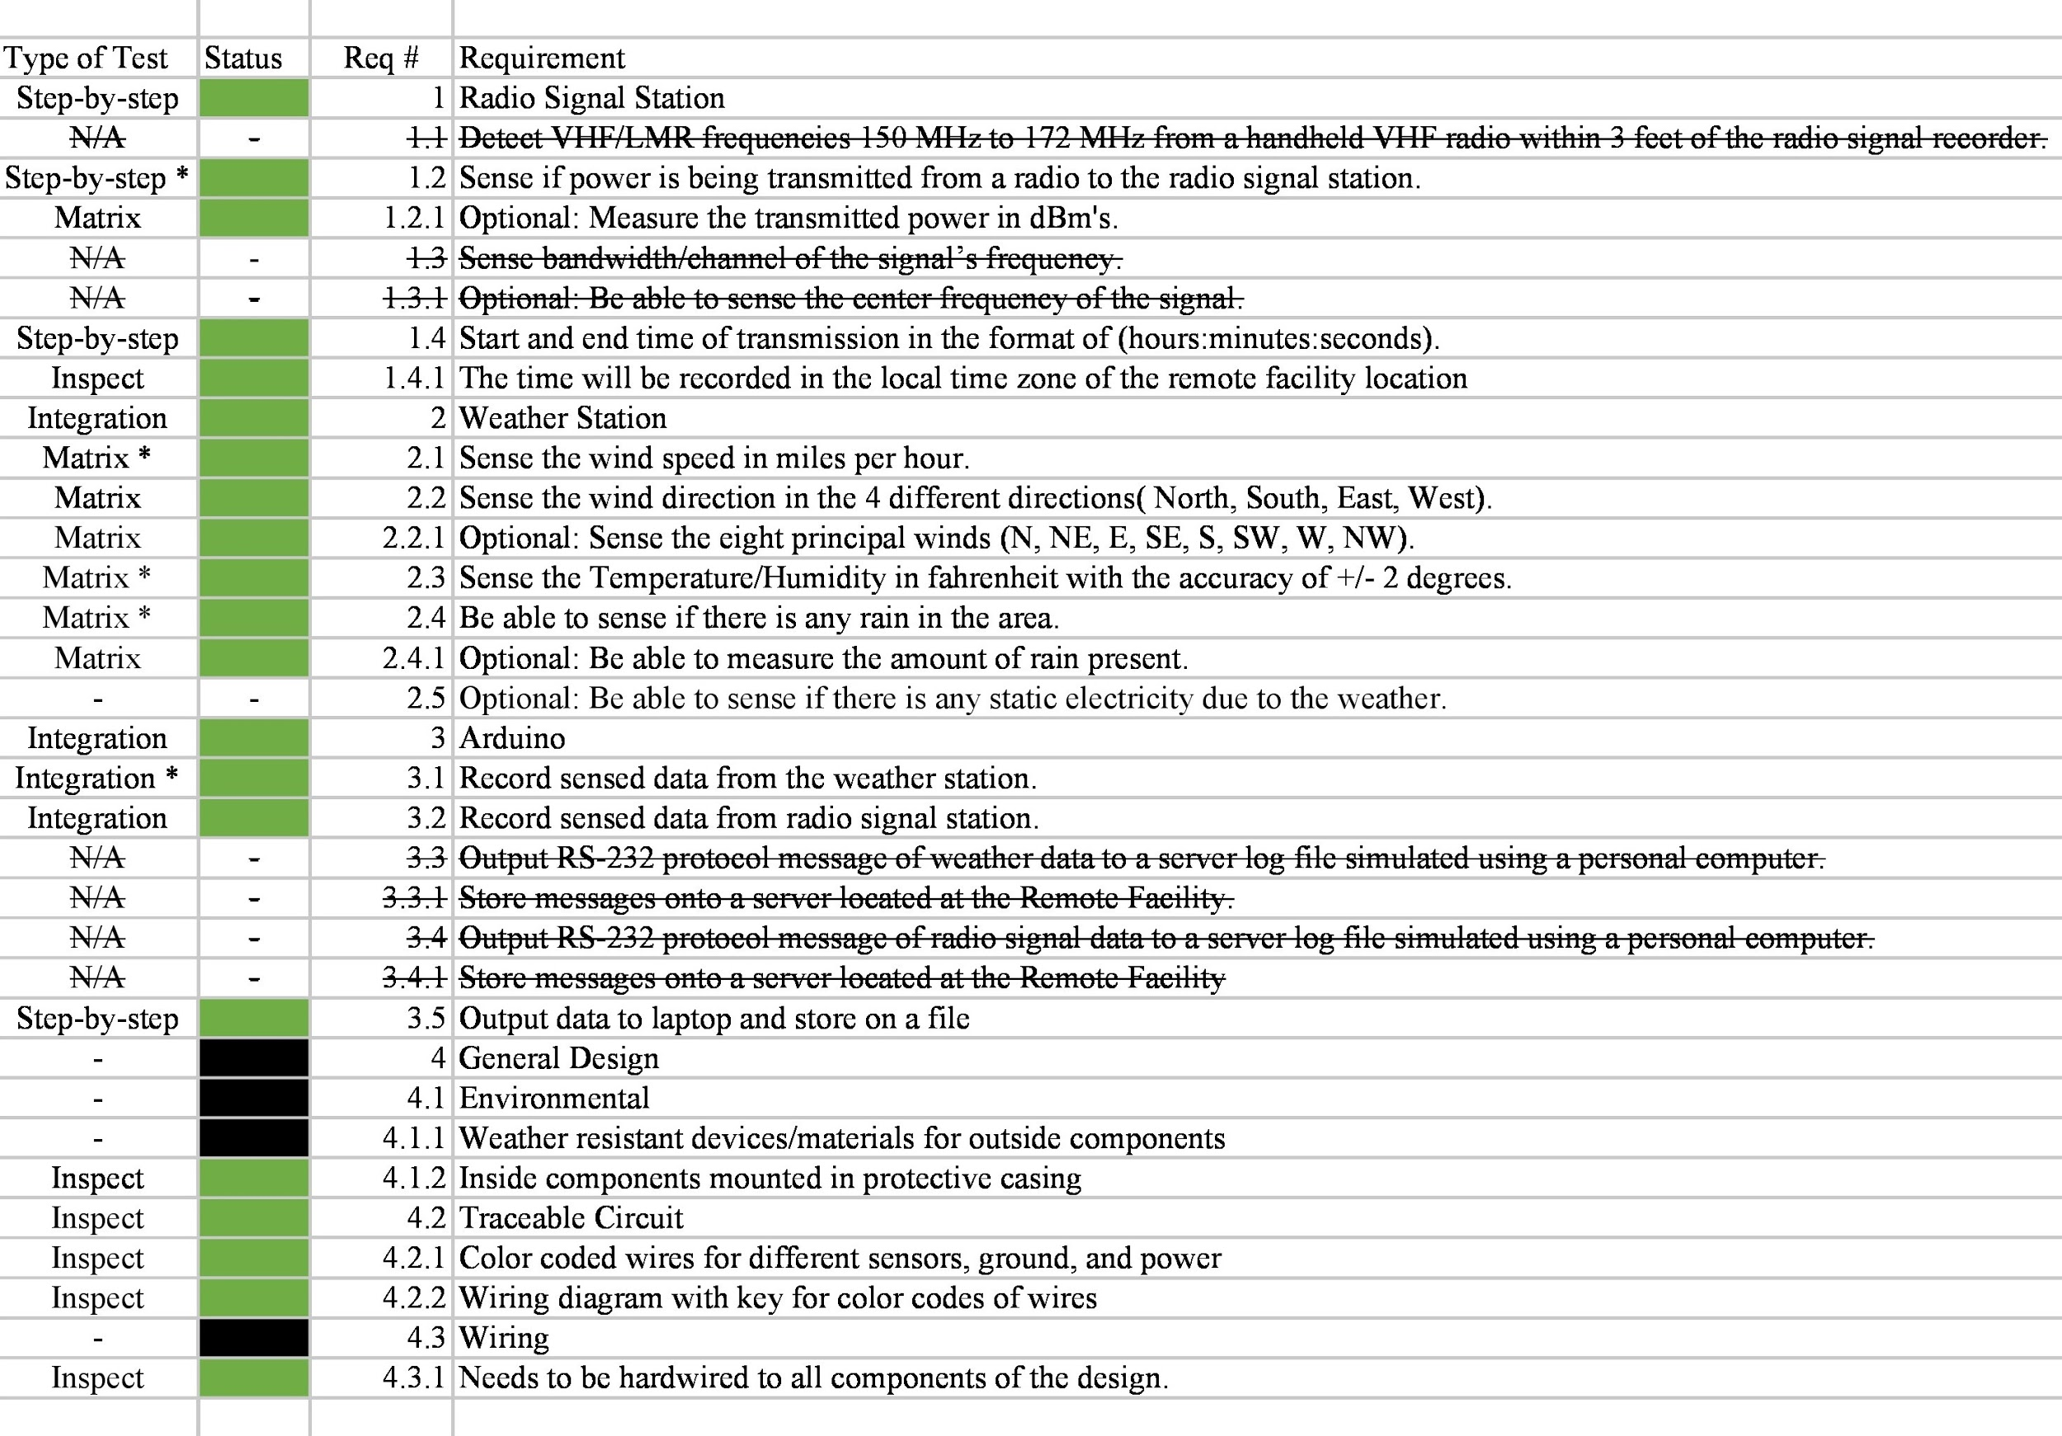
Figure 2: Requirements Page from Completed Test Workbook
Most important requirements:

- Req. #3.1 Record sensed data from the weather station.
- Req. #3.2 Record sensed data from power station.
- Req. #3.5 Output data to the laptop and store on a file
- Req. #4.1.1 Weather resistant devices/materials for outside components
- Req. #4.3.1 Needs to be hardwired to all components of the design.

Requirement #3.1 Record sensed data from the weather station is extremely important to the client as it is 1 of the 3 major functions of the system, which is to detect the weather of the immediate area. The next requirement, #3.2 Record sensed data from the power station, is equally important as it is the previous function, which is to determine if a signal is being transmitted and at what power level. The third major requirement, #3.5 Output data to the laptop and store it on a file is the final important function of the project, which is to log all the data recorded by the other two stations so it can be viewed and made useful by our client. If any of these 3 major functions did not work then the client would most likely view the project as unacceptable for their use as those requirements are interdependent on each other in order to complete the objective.

Requirements #4.1.1 Weather resistant devices/materials for outside components and #4.3.1 Needs to be hardwired to all components of the design are secondary, but important aspects for the project as they indirectly affect the major 3 functions mentioned above. The weather resistance will protect our equipment from being damaged which would prevent any components from ceasing to work or giving faulty data. The hardwiring is important to our client since it ensures the data is sent in a secure manner. Both of these secondary requirements are very important to the client but if there were any issues here it would also be detrimental to the project’s success, since the client would not be willing to implement our design if it was unsecure or likely to stop functioning.

Types of tests:

The four types of testing that we used to test our final project were; matrix testing, step-by-step testing, integration testing, and inspection testing. The first two types of unit testing are the unit matrix test and the step-by-step test. A matrix test is designed for when only the inputs are the same structurally and differ only in their values. Matrix tests are best used for when the input is a variable like voltage or temperature. It is called a matrix test because changing the value of the input will generate a matrix of results.
The other type of unit testing step-by-step test. This type of test is a set of instructions used to generate and check the results of the test. Step-by-step tests are used for flowcharts or any unit that has a series of steps that are necessary to test it. Integration testing is used to check the overall functionality of a system. Due to this, integration testing can be a combination of matrix and step-by-step testing.
The final type of testing that we used was inspection testing, which is a basic test. It involves simply verifying whether a requirement has been satisfied or not. For example, a visual inspection to confirm that the wire coloring follows convention. These are the four testing types that were used for the testing portion of the project.

Major tests:

Full Weather Station Integration Test
The full weather station integration testing started by gathering a multimeter, the rain sensor, the temperature/humidity sensor, the wind sensor, the Arduino Nano, and the Arduino code. Once these items were gathered, the test started by hooking up the Arduino Nano to the laptop and compiling the full integration code to make sure there were no errors which this step was successful. Next, the rain sensor was wired into the Arduino. After that, the multimeter was used to measure the voltage at the device which the voltage was 4.62V. Next, the Arduino code was run and the COM port was checked to verify that the rain JSON key was being printed to the COM port and this was the case. Then, the temperature/humidity sensor was wired into the arduino in addition to the rain sensor and the Arduino code was compiled to make sure that there were no errors which there were no errors and this step was successful.
Once this was finished, the multimeter was used to verify the voltage, the rain sensor voltage was 4.66V and the temperature/humidity sensor was 4.67V meaning that these sensors were successfully integrated. Once these voltages were checked the Arduino code was run to double check that the rain, temperature, and humidity JSON keys were being printed out to the COM port and all of these JSON keys were being seen on the COM port. The last integration was to wire in the wind sensor and then run the full weather station Arduino code to see if any errors were present, there were no errors present. Then the final voltage check was done using the multimeter, the rain sensor was 4.67V, the temperature/humidity sensor was 4.65V, and the wind sensor was 4.66V meaning all of these sensors were successful in the final voltage check step of the test.
Next, the Arduino code was run to be able to verify that all of the JSON keys were being correctly printed out to the COM port. When we first looked at the COM port, the first set of data was being printed correctly out to the COM port but the next set of data showed that the temperature and humidity values were outputting null values. Which confused our team because at first we were not sure what was going on, so the first troubleshooting step we took was to switch the Arduino to an Arduino uno. This did not fix the problem, so our team went to adding each wind function code one by one to see which function was causing the issue with the temperature and humidity sensor data. When we added the wind direction function code, there was no error happening with the temperature and humidity data. Which meant that the problem was with the wind speed function code, and after looking at the code for around 10 minutes our team realized that there was an attachinterrupt function that was not being detached after it was done being used.
Our team added a detach function after the attachinterrupt was done being used and this was able to correct the issue and we were able to see all of the JSON keys present in the COM port correctly. The final step of this testing was to allow the device to run constantly for two minutes with all sensors attached, and this part of the test was successful by how all of the JSON keys were being correctly printed out to the COM port with no errors for the full 2 minutes. Each of these testing steps can be seen in the flowchart in appendix A and the output of the full weather station can be seen in appendix B.

HamShield Test

Required Components:
1x Personal Computer (PC), 1x USB-to-microUSB cable, 1x Arduino Microcontroller, 7x jump wires, 1x HamShieldmini (SDR), 2x 50-Ohm SMA connection wires with adapters, -82 dbm worth of attenuators, 1x BAOFENG Handheld Radio.

Testing Setup:
First step is to set up the hardware by replacing the Radio’s provided antenna with a SMA connection cable, which connects to the attenuators followed by another SMA connection directly into the SDR’s SMA input. From here, the SDR is then connected to the Arduino with 7 jump wires. Finally, the Arduino will connect to the PC via the USB cable.
The second step is to set up the software on the PC by downloading the latest Arduino IDE and then downloading the HamShield’s library for use within said IDE. Code was drawn up based on the example projects from https://github.com/EnhancedRadioDevices/HamShieldMini as well as from referencing the flowchart (see Appendix C) created. Lastly, the Radio itself needs to be programmed to only output 1 Watt of power while transmitting, and the radio needs to be set to the intended delivery Frequencies being used for the tests(140MHz at first).

Actual Testing:
The testing is done by setting the radio to an output frequency, running the code, then seeing if the microcontroller can detect any major dbm changes if and when the Radio transmission button is pressed as well as documenting results. The expected dbm readings were -137 when radio is off, -133 when radio is on but not transmitting, and around -55 when transmitting near the same frequency that the SDR is expecting. Any dbm readings within from -45 to -65 would be considered a detected signal and would be logged for later use. Once able to see successful responses from the system on single tested frequencies, the full implementation of the flowchart was incorporated into the code to test multiple frequencies in a single sweep. All test resulted in successful detection of expected frequencies.

Temperature or Rain Sensor Test
Required materials: Ice water, hot plate, thermometer, arduino microcontroller, dht11 sensor, waterproof protection for sensor.

Setup: First prepare the dht11 sensor by placing it in a sealable plastic bag. Then submerge the sensor in the ice-cold water. Let the sensor sit for at least 5 minutes to ensure that it has been adequately chilled. Once the sensor has been chilled, remove it from the water and the bag and use the thermometer to check its temperature, once the temperature has been logged, connect the sensor to the Arduino using Appendix D as a reference and check the reading. At this point the temperature of the sensor will be 0 °C. Then, using a heat source, slowly raise the temperature of the sensor and for every 5°C, record the temperature of the sensor from the thermometer and the reading from the Arduino. This will generate the matrix of results for the temperature sensor at 5°C increments.

Test and results:

The blue represents the measured temperature from the sensor and the orange is the expected value.
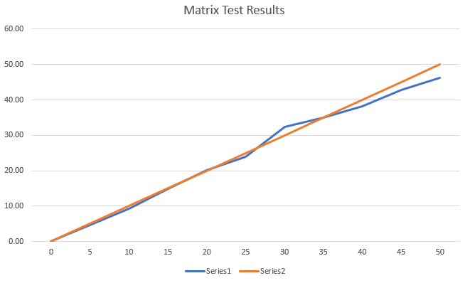
Figure 3: Temperature Matrix Test Results

Analysis of results:
Our project performed very well under the test conditions that we subjected the device to. Each individual unit matrix test on the weather station sensors was entirely successful. Each sensor’s code was debugged and any hardware issues were resolved during prototyping and early white box testing, so that when it was time for the actual testing, everything went smoothly and as expected. The weather station integration test initially failed because the temperature/humidity sensor was outputting invalid values. Through debugging, we found that the attached interrupts from the wind sensor code were causing this issue. We resolved the problem by attaching the interrupt inside of the findSpeed function for the wind sensor and then detaching it at the end of the function. After this fix, the integrated weather station performed successfully and as expected. The unit step-by-step test for the Hamshield did behave as expected and was able to detect power transmission as desired. The final integration test of the entire system was successful and performed as expected. All weather station sensors were being sensed and recorded correctly and the Hamshield recorded power in dBm’s for the tested frequencies. A few of our client’s requirements have changed over the course of this project and these changes are shown using strikethrough in Figure 2. Our project meets or exceeds all of the current requirements from our client and also meets a few of the optional requirements.

Lessons Learned:
Overall, our project went well but of course it was not perfect. The one major challenge we ran into during this project was with our selection of a software defined radio (SDR) for the power recording portion of the project. We had chosen and purchased parts for a SDR and then built and prototyped that SDR, but later discovered that our SDR selection could not be used because it required a laptop or computer for processing, which was not allowed for this project. So, our team had to quickly find a new solution to record power for this project. Due to this late change, we had to adapt our work schedule and stray from the Gantt chart some to ensure the project would be completed on time. So, a lesson learned is to develop a thorough understanding of all requirements and to ensure that our selected parts meet those requirements and constraints. In the future, our team will be sure to spend more time on the selection of parts and will verify with our client and supervisor if we are unsure about any component. Other than that, our team only experienced minor issues during testing that were quickly resolved through debugging. For example, when the weather station was integrated, the temperature/humidity sensor began to malfunction. We used the test-fix-test procedure to find and resolve this issue. The test-fix-test was also used during white box testing of the rain sensor to calibrate the sensor and its output. Our team also used regression testing often, usually before integrating a new module or when returning to work after an extended break. The regression test allowed us to verify that certain components were working so that if something goes wrong, debugging would be quicker and easier. A few requirements were changed throughout the project because as we researched and worked on the project, we developed a better understanding of what was actually required. For example, the struck-through requirements in Figure 2 like requirement 3.3.1, Store messages onto a server located at the Remote Facility, was changed because we learned that we would be storing the data to a text file on our personal laptop rather than a server. Our team did not come across any requirements that were too difficult to test, we believe that our requirements met AVUT (abstract, verifiable, unambiguous, testable) which made our requirements easy to test. Our team learned that testing is more about the preparation and previous work than it is the actual test. We learned that a majority of the work must be completed prior to completing the test such as writing strong and AVUT requirements, prototyping the device, building the device, and designing a quality test that will actually tell if the device meets requirements. If all of this work is completed correctly before the test, then the test itself is very simple and easy. Our project’s performance could have been improved by meeting the remaining optional requirements listed. These requirements included sensing how much static electricity is in the air and a higher degree of accuracy for the amount of rain present in the area.

Appendixes:

Appendix A:

The figure below is the flow chart that was used for the integration of the full weather station. It shows the step by step process our team used to methodically test the integration of the system to determine that there are no errors in the integration.

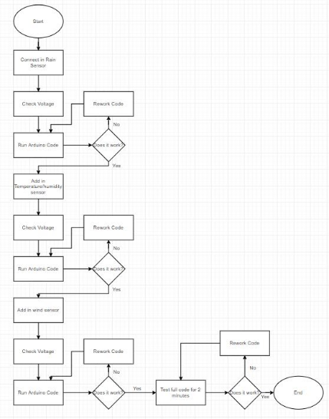
Figure 4: Flow Chart for Integration Testing of the Weather Station

Appendix B:

The figure below is the data that was outputted by the weather station during the last step of the full weather station integration testing. This shows that all of the data is correctly being printed out to the COM port.

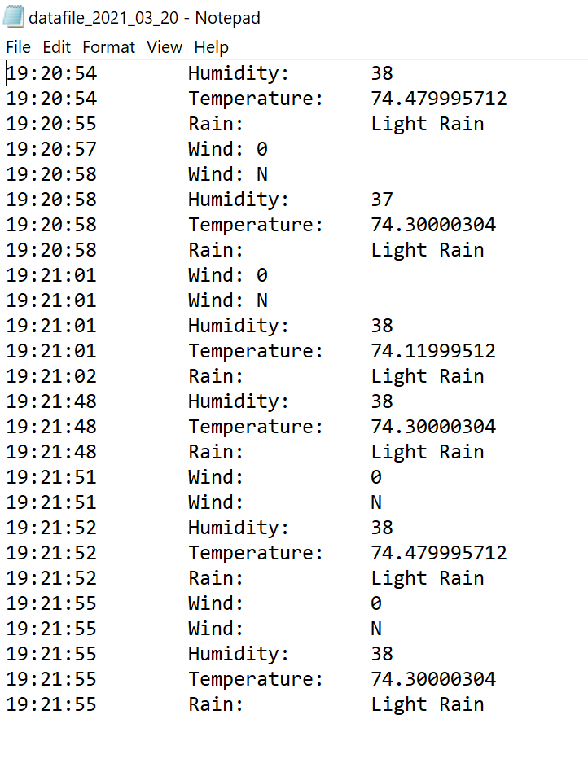
Figure 5: Output Data from Full Integration Testing

Appendix C:

Flowchart for Power Station’s SDR (HamShield) Code
Figure Y (below) represents the exact process the Arduino microcontroller will be executing in order to scan the expected Radio Frequencies within the 140-172MHz range.

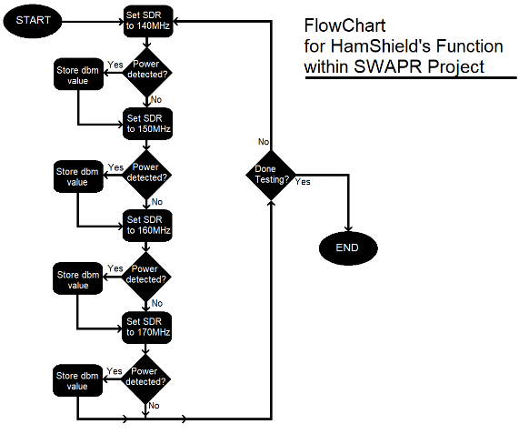
Figure 6: Flowchart for Power Station’s SDR (HamShield) Code

Appendix D:

The figure below is a circuit diagram for DHT11 setup. It shows the proper wire connections we used for setting up the dht11 to work properly.

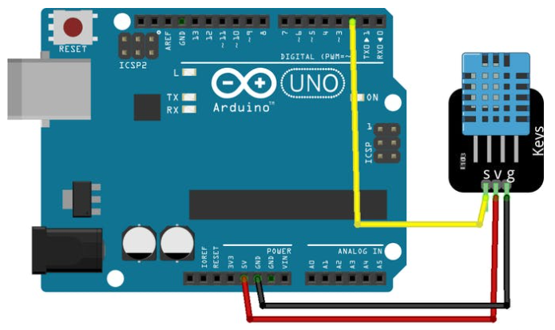
Figure 7: Schematic for Temperature/Humidity Sensor

