To: Dr. Kyle Winfree
From: Abdulaziz Alharbi, Christopher Schafer and Abdulrahman Alnajar
Date: April 3, 2020
Subject: Design Review 3

Dear Dr, Winfree
This memo highlights the status of this project. It covers who our client is, what we are tasked with, what is going right and what is going wrong, the challenges that we are facing, the risks and even the solution to those risks and challenges.

Thank you in advance,
Smart Mosquito Trap-Power team

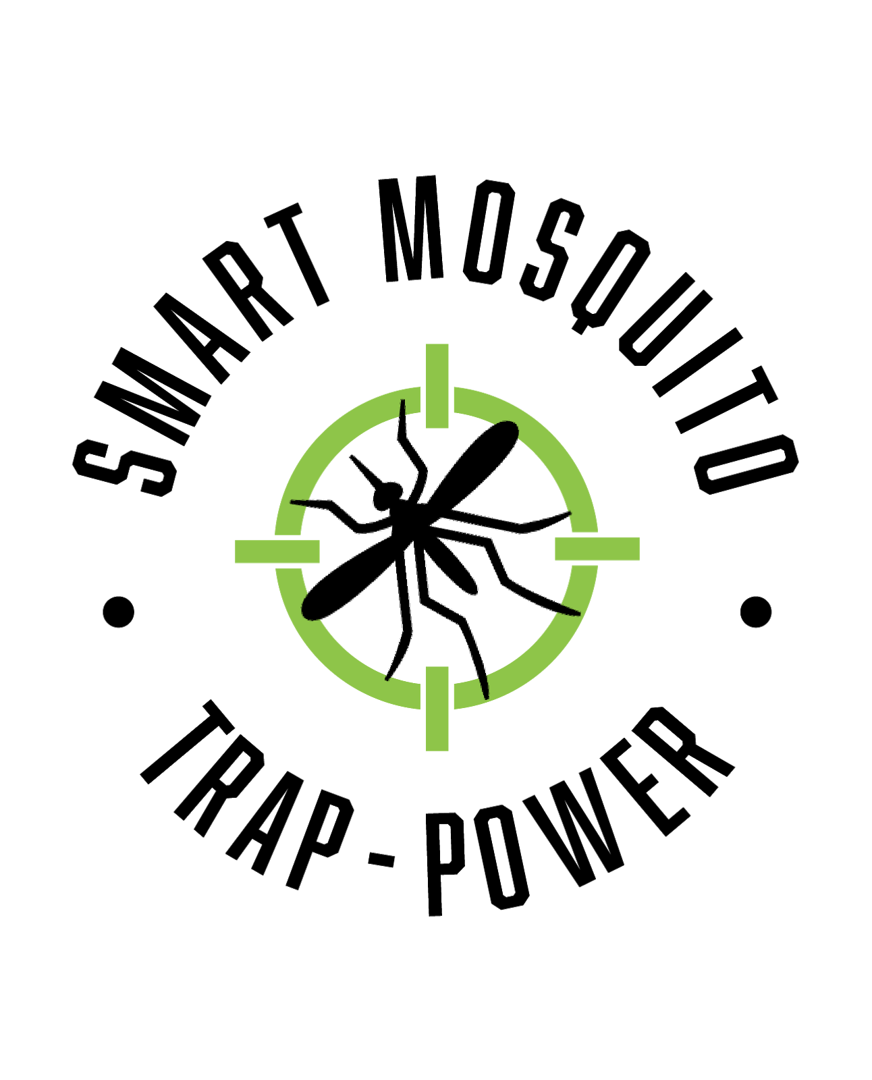

Smart Mosquito Trap-Power

Client: Dr. Crystal Hepp

GTA: Mahsa Keshavaraz

1st Abdulaziz Alharbi
2nd Christopher Schafer
3rd Abdulrahman Alnajar

Table of Contents
Introduction 3
Who we are and Our Client 4
Project Subsystems 4
Figure 1: WBS 5
Figure 2: Gantt Chart 6
The Project Progress 6
Risks 6
Challenges 6
Solution 7
Conclusion 7

Introduction
Various types of mosquitos are responsible for the spread of various disease-causing organisms. The intensity of the spread of a disease by mosquitoes can be based on the abundance of mosquitoes in a certain location. Trapping these mosquitos is something that can help to reduce the number of mosquitos so that the chances of these mosquitoes spreading disease-causing microorganisms are minimized. Concerning that, many researches and developments in the design and implementation of mosquito trappers have been in place for quite some time now. These trappers, which are in place, have some drawbacks in that they do not categorize the specific type of mosquito trapped. Thus, our design will incorporate the capability of mosquito traps to detect the type of mosquito being trapped. Furthermore, our project will allow the BG-sentinel 2 trap used by Dr. Hepp to run for extended periods.

Who we are and Our Client
Our client in this project is Dr. Crystal Hepp. As individuals who are supposed to present a perfect, working and completely amazing project, we are tasked with finding a way to power the smart mosquito trap for Dr. Hepp for as long as a week. In the course of our work, we are expected to include a solar panel, and the design must be small, travelable and waterproof. For the prototypes of our project, a small 12V solar panel, a 12V lead-acid battery and a DC/AC converter are used. These prototypes were chosen because all three are mission-critical to our project to function at the very minimum. These fit into the bigger picture because the solar panel will charge the battery throughout the day so the trap can be powered throughout the night. The converter is necessary because, without it, the trap will not operate at all.

Project Subsystems
Normally, a project is considered to be a system that has several subsystems that are supposed to be connected to work harmoniously. For this project, we considered it as a system and therefore we had its subsystems, which we are supposed to bring together to ensure that these subsystems work harmoniously for the success of the entire system. For our subsystems, we have a solar panel, batteries, and a converter to convert DC to AC. The solar panel is important because it will charge the battery throughout the day and allow the battery to last overnight, which should include the traps busiest operation times. The dc/ac converter is necessary, as the trap runs on AC power, and the solar panel generates DC power. The converter is related to both the Solar Panel and battery bank because this is connected directly to the battery bank, which again, gets its power from the solar panel throughout the day. Related to these first three subsystems is a charge controller. These subsystems can be summarized in the WBS presented below.

Figure 1: WBS
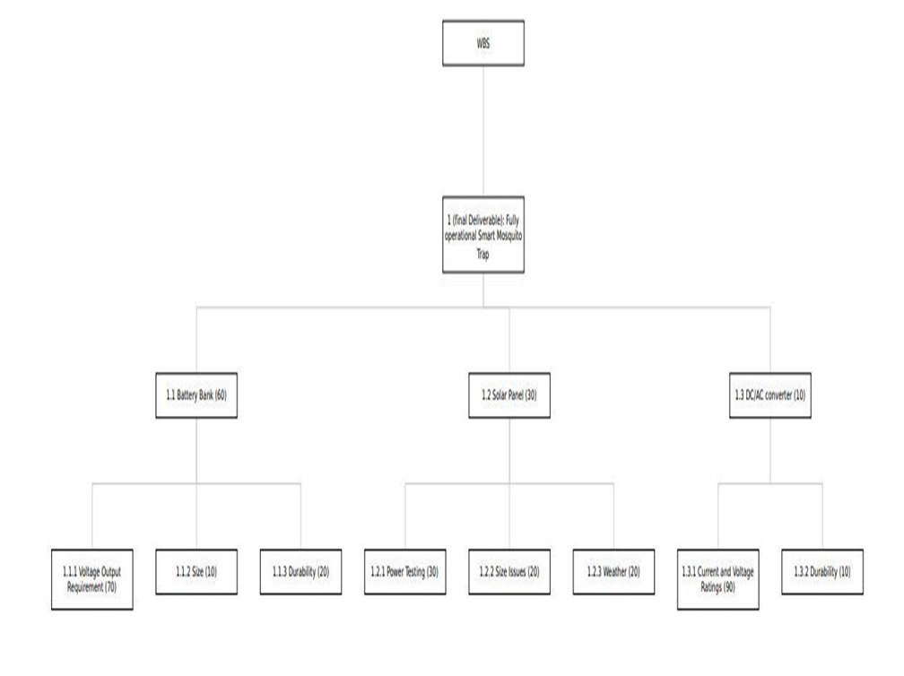
From the WBS above, the source of electricity for the mosquito trap is solar energy. However, for optimal performance, our device has to take ac voltage. This is the reason why we have the DC/AC converter because it is essentially the main driver of the project. Other controls that will be incorporated in the device such as those for sensing direction will consume DC power and provision is already there. Normally mosquitoes are dormant during the day, and the battery will be charged during the day. The integration of the component first involves circuit design where we have well-defined schematics and then simulates to ensure that they are working as per the team’s goal, which was outlined at the start of the project.
This project is supposed to be handled within a stipulated period. With that in mind, we developed a Gantt chart to help us work on the project effectively and ensure that we complete the milestones as required and within the scheduled time. This will ensure that the entire project is done within the required time. The Gantt chart is shown below.

Figure 2: Gantt Chart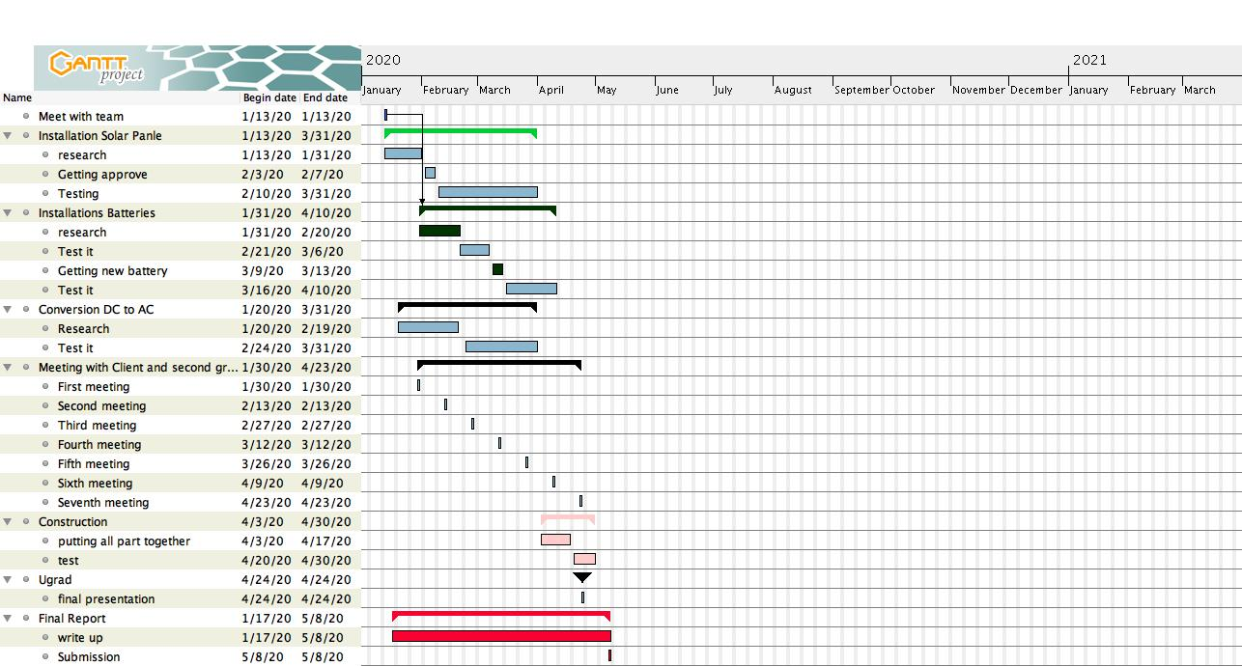

The Project Progress
This project is quite long, due to this, we divided it into portions to ensure that we handle it bit by bit. The handling of this project was therefore based on the Gantt chart that we developed to ensure that we adhere to it. Up to now, we have been working on DC/AC converter configuration and building. The material for the project has already been selected and those that are not available, we have decided to order them. After this, we will be able to test the device and determine how effective it proves. After testing, the project will be finalized, soldering will be done, and a package and instruction booklet will be created to ensure that Dr. Hepp knows exactly what needs to be set up. This will ensure that the trap will run for as long as possible

Risks

While working on this project, several risks were evident just from the beginning. One of the risks was we already have solar cells 500MW 8.2v which will be part of the solar tracker. However, the solar tracker is not required to have a solar tracker, and we worked in that much time then it was expected.

Challenges
Based on the project requirements, a consideration of the availability of the power source when needed, reliability and efficiency were the core issues that were ought to be addressed in the provision of the power to the mosquito trap. Although much effort was put to ensure that the power supplied to the system meets the minimum expected threshold, many challenges were experienced. Some of these challenges included but not limited to the cost of the power source, and limited knowledge to determine the best approximation of the sizing of the power source. Although that was not a challenge at the beginning, the challenges emerged during the time of implementation of the prototype. This made the team to change some parameters for each of the three prototypes considered checking the suitability of the prototypes. Previously, conversion of DC to AC was considered as the main source that could be selected for the design but after changing the parameters, solar emerged the winner of this project.

Solution
Working as a team, we were able to share ideas on how each of the prototypes could be implemented to meet the set requirements. As a team, we participated in framing the details to be used in the decision and pair matrices developed. It's from sharing ideas that we decided how the project should be done, for it to be successful.

Conclusion
Mosquito traps are designed and developed based on the mosquito characteristics. By using these characteristics, the development of mosquito traps takes place depending on the specific technology available and the intended purpose of the trap. For example, it has been observed that insect wing beats can determine the species of an insect. Such behavior can be inherently adopted in the design and implementation of the mosquito trap. Through understanding the characteristics of mosquitoes, it is possible that mosquito detection and trapping can be done. This can be achieved through interfacing and integrating many features such as power systems, mosquito detection sensors, and software integration. This will enable the categorizing of the species of mosquito captured. Thus, these journals and research papers reviewed show the prior art of our project development but ours will be just an improvement of the already existing ones.

