Memo
To: Dr. Crystal Hepp
From: Abdulaziz Alharbi, Christopher Schafer and Abdulrahman Alnajar
Date: 12/12/19
Subject: RD2 Draft
_____________________________________________________________________________
Dear Dr. Winfree,
Attached below is the RD2 Final from Smart Mosquito Trap-Power. In this assignment, we discuss all of our findings of and progress of our project over the semester, and give a look into how we will progress through next semester until our design is complete.

Thank you in advance,
Smart Mosquito Trap-Power team
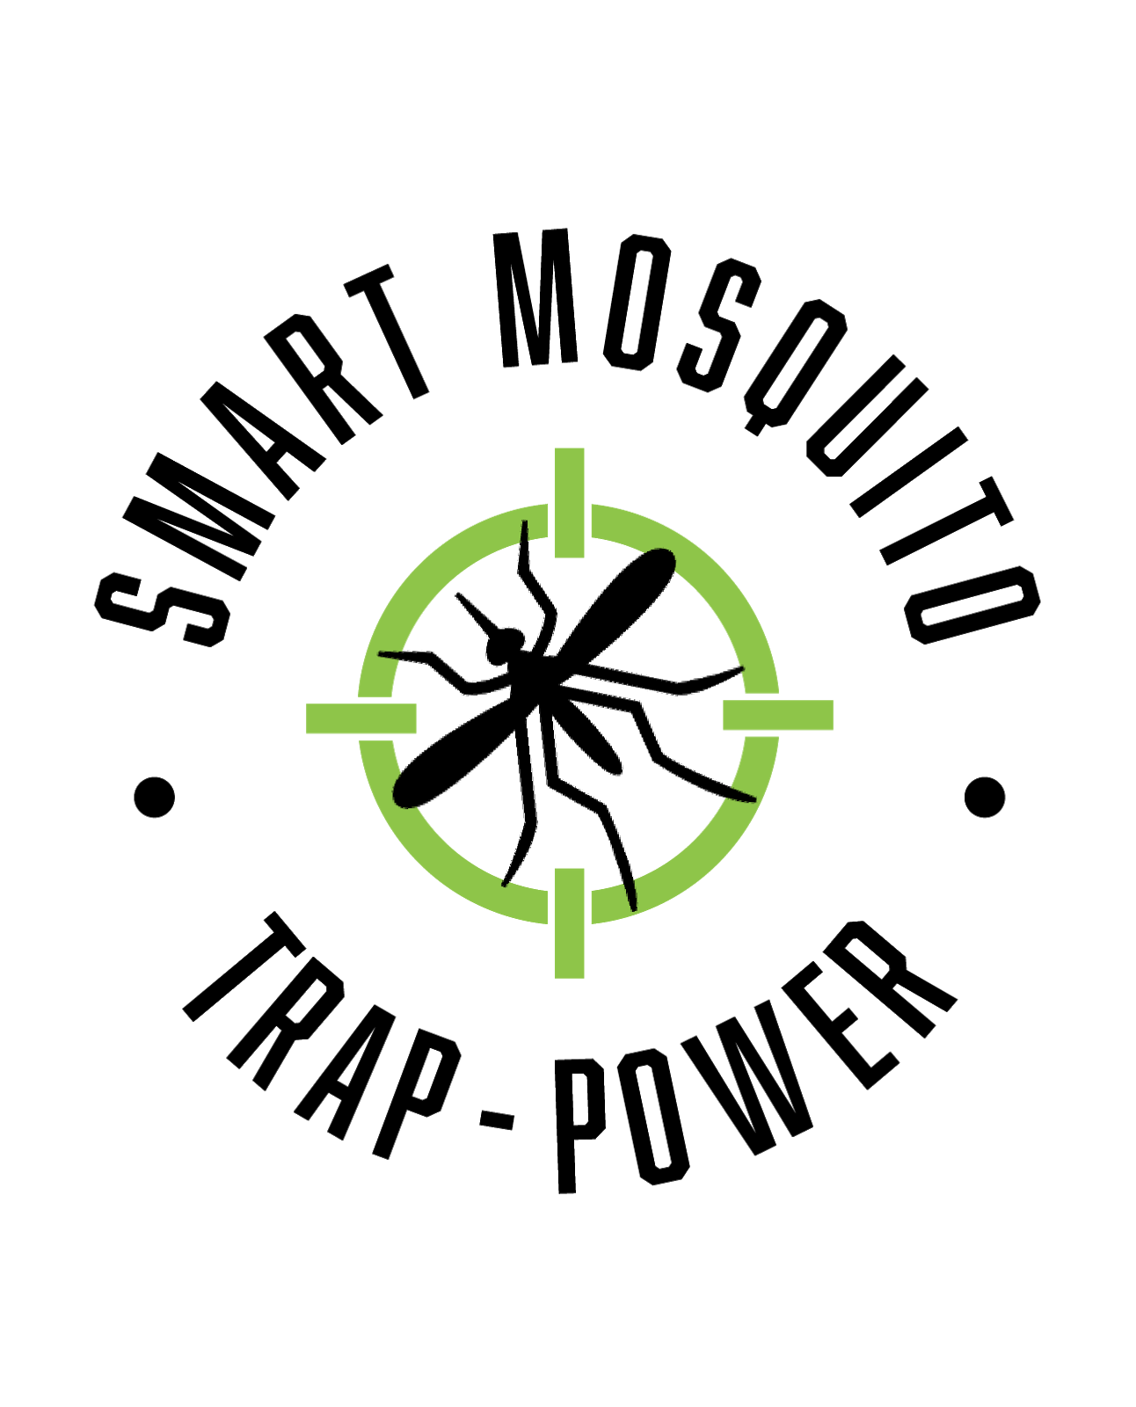

Smart Mosquito Trap-Power

Client: Dr. Crystal Hepp

GTA: Mahsa Keshavaraz: mk959@nau.edu

1st Abdulaziz Alharbi: aaa682@nau.edu , 928-637-3582
2nd Christopher Schafer cms688@nau.edu , 480-235-3589
3rd Abdulrahman Alnajar aa3792@nau.edu , 928-788-5890

Contents
3. Overview
4. Literature Reviews
7. Subsystems
9. Prototyping
14. Future Planning
17. Conclusion
19. Appendix

Overview
Mosquitos are the number one killer worldwide, as they carry several diseases (Viruses and other microorganisms). It is very important to be able to trap and also analyze the number of
mosquitoes in order to determine the step that should be taken to prevent the transmission of
diseases. Dr. Hepp, an Evolutionary Biologist at Northern Arizona University, has been studying mosquitoes and the diseases they carry. The main disease being researched is West Nile virus, and her and her team are studying this in places like Africa and Mexico. Dr. Hepp and her research team want to catch mosquitoes, grind them up, and look for virus as a mean of surveillance. For doing this her team distributes traps over a large geographic area such as the southern US and Mexico border. These traps must be able to attract mosquito bait towards them. The current ongoing method to do this is to load a trap with dry ice as a ${CO}_{2}$ emitter which is powered by D-cell batteries that run a fan and catches and retains the mosquitoes. This method though is feasible but has certain limitations too. One of the main limitations of our project is it has to fully operate the mosquito trap for as long as seven days. The Mosquito trap cannot go off at any point, so the power going to the trap must be consistent. The trap may operate in a low power mode when there are no mosquitoes around the trap, but for the majority of the time, the trap must be operating at full power. Furthermore, the power system designed should be small enough and light enough to carry and travel with. Also, a solar panel must be implemented in the project, to display our capabilities of designing more complex power systems. The problem at hand is specific to the goals of our client, as we are given direct instructions on what should be included and how the design should look.

Literature Review
Chantira et al. [1], in their research paper, have worked on proposing and showing that a Low optical power laser, when arranged in a zigzag fashion in free space, can create strong air thermal stress and form a chemical-free optical net that is capable of repelling adult mosquitoes away. In the research paper, they talk about the experimental procedure in which their design is similar to a window or a doorframe with a dimension of WxL, consisting of a pointer-like a laser on one corner of the frame (i.e., top left corner) and two reflective surfaces. The laser is adjusted in such a way that the laser beam is incident with an angle () on the reflective surface, and it continues to reflecting back and forth between these two reflective surfaces until it reaches another corner of the frame, forming an optical net in free space. In the paper under the section of Experimental proof, the concept of using a pointer-like diode-pump solid-state laser (447 nm wavelength and 500 mW maximum) and reflective sheets has been talked about, and it has been shown that all 80 adult Aedes albopictus mosquitoes are completely trapped inside the open glass chambers. The final result they got was concluded by saying that the design can make the adult mosquito feel more than 27°C is capable of repelling it away and if the spacing between the laser beam spot is increased, it reduces the thermal air stress and the mosquitoes can fly past the net.
Audah et al. [2], in their research paper, talks about developing a smart mosquito trap using a Favorito monitoring system. In the paper, a prototype design has been developed, and the Prototype trap was designed with the capability of sensing the nearby mosquitoes and also
Transmitted the collected real-time data of the average number of trapped mosquitoes to the Favoriot IoT cloud platform for remote monitoring. In the paper favorite mechanism has been used to support the integration of data to the internet. Through the design that was proposed, all the data collected will be sent to IoT devices and will be processed automatically, and based on this platform, the users were able to extract data in various forms, for example, graph y and x-axis. The results obtained showed that the prototype design was working perfectly fine, and with strong Wi-Fi coverage, the user could access the data provided via Favorito Platform. The system was also attached with UV light and carbon dioxide attractant to attract mosquitoes to enter the traps.
Renann et al. [3], in their research paper, has talked about the development of a fan-based smart, selective mosquito trap. The design is made up of a microcontroller that operates two DC fans arranged at the ends of an aerodynamic structure. The lower power consumption actuator system was proposed in there, and the prototyping platform chosen in the project was the Arduino Uno. The paper discusses how the actuator system input signal readings are read by the microcontroller and the microcontroller process each of these values and relate them to a Frequency content through a quantized level that identifies what flying insect species, and genus crossed the sensor's field of view. The results from the experiment done in the research paper showed that the band from 550 Hz to 600 Hz is common to both species. Their paper proposed the creation of a low energy consumption selective trap to capture the female Aedes aegypti automatically through an exhaustion and suction system.
The journal, "Design of a Fiber-Optic Sensing Mosquito Trap," is a journal that addresses the issue of mosquito capturing through the use of fiber-optic sensing [4]. In this case, life mosquitos are captured, and they are counted based on the ON and OFF triggering of the sensor at the entrance of the mosquito trap. In order for the mosquito trap to perform the intended work, it needs to be powered by any source of power. With this kind of technology, the team was able to have an accuracy rate of above 93% [4]. But, since the majority of the places where mosquitoes are mostly available do not have power, it has become challenging for the development of mosquito traps, which can be powered for long hours without being monitored. Based on this literature review, our team was tasked with the responsibility of providing power to the mosquito detecting team so that it can meet the client's needs. Thus, this journal paper is relevant to our team project in that it can help us in selecting the best size of the power source to the smart mosquito trap to be implemented.
The journal of Vector Ecology on "Mosquito traps for urban surveillance: collection efficacy and potential for use by citizen scientists," is a journal that addresses the issue of the use of mosquito traps by citizen scientists [5]. Here, a comparison between the use of the BG sentinels and BG Gravid Aedes traps were compared in collecting mosquitos at different location with similar conditions. These two traps are considerably differently priced, and thus, BG Sentinels were found to be more expensive as compared to the BG Gravid Aedes. Despite the variation in pricing, BG Sentinels are installed at power outlets while the BG Gravid Aedes can be deployed anywhere. In terms of the capturing capacity and capability, the BG Sentinels has an advantage. On the other hand, the overall cost incurred by using the BG Gravid Aedes is much far low. In addition, the power consumption for the latter is much low, which enables it to be deployed anywhere.
Tseng et al., in their conference paper, "Applying physical optics to design solar-powered outdoor UV LED mosquito trapping system," talks about the application of ultraviolet LED solar powered Outdoor mosquito trapping system [6]. This is a response to the current state of the most common types of mosquito trapping systems consists of nets, swatters, lamps, and other tools. Thus, considering designing the mosquito trapping system, which has the component of the electrical part is done by using the various technologies in simulating human survival. This also increases the mosquito trapping based on the application of the use of solar.

Subsystem Organization Overview
Figure 1 (on the next page) illustrates the mind map and idea processing of our project. It goes over our initial thoughts on how we thought our project would be divided. Although the subsystems may seem overly simple, these systems will have to go under rigorous testing in order to be realized. The first subsystem to be realized is the solar panel. We started out with a cheap one just to get an idea of how they work/function, but further testing will be required to see if we need an expensive one to realize our final goal of the project. The battery bank is connected to the solar panel, so they are related because throughout the day, the solar panel will charge the battery throughout the day and allow the battery to last overnight, which should include the traps busiest operation times. The dc/ac converter will also be necessary, as the trap runs on AC power, and the solar panel generates DC Power. The converter is related to both the Solar Panel and battery bank because this will be connected directly to the battery bank, which again, gets its power from the solar panel throughout the day. Related to these first three subsystems is a charge controller. The charge controller is important to the final design of the power system because it greatly reduces damage to the Mosquito Trap’s internal hardware. It does this by controlling voltage and current going into the system, because sometimes there are over currents and under voltages in the system. Furthermore, the charge controller has an LED interface that can let the user know how much relative charge the battery is holding, if the solar panel is actually charging the battery, and if the load is operating at full power. Our final subsystem involved in the project will be a weatherproof, sleek-lookng container for all the parts of the design. This will be important because of
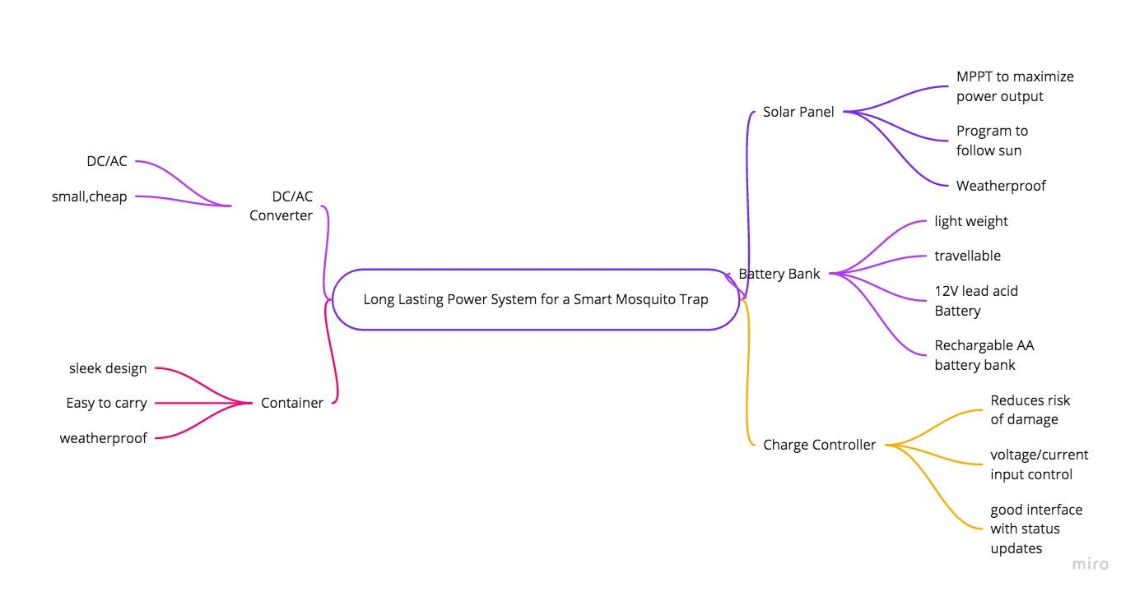
thetough conditions the power system of the mosquito trap will be going through. Furthermore, it will make the power system much easier to carry around via plane, car, or on foot. Together, this will make the project fully functional with minimal risk of being damaged over the course of the week it is supposed to last for.
Figure 1: mind map of our project

Prototyping
The problem being presented to our group is to find a way to power the smart mosquito trap for Dr. Hepp for as long as a week. The project must include a solar panel, and the design must be small, travelable and waterproof. For the prototypes of our project, A small, 12V solar panel, a 12V lead-acid battery and a DC/AC converter are used. These prototypes were chosen because all three are mission-critical to our project and are functional and complete. These fit into the bigger picture because the solar panel will charge the battery throughout the day so the trap can be powered throughout the night. The converter is necessary because, without it, the trap will not operate at all. We expected to learn about how much energy the panel will retrieve throughout the day, how long the battery would charge and if we would need a converter or not to operate the trap. This was not expected to be a challenge from the group, but there were some more challenges involved than expected. The unknowns of these prototypes included how long the battery would last and how much charge the solar panel would give to the battery in a certain amount of time. These are discussed in greater detail below
Battery Bank
We chose to prototype the battery bank of the Smart Mosquito Trap because it is mission critical to our project. Without a power source, the mosquito trap will not be able to trap mosquitoes. It should also be able to power the trap for an extended period of time without human intervention. These 3 main points are discussed about the battery bank: Power output, size, and Durability/Organization. These three concerns are discussed below.

Voltage output:
The battery bank should store enough energy so it can power the mosquito trap for at least a week at a time. This will include rigorous testing of the mosquito trap during all different types of weather to see what will be required of the battery. In prototyping, we decided to go with a 12 volt 7 Ah/ 20 hr lead acid battery. This was because of it being inexpensive, easy to implement, and is long lasting. Without the mosquito trap, it was difficult to spend a lot of money on a prototype without knowing how long it will last. So we got something with a similar amperage use and tested it, we only got a rough estimate of how long the battery would truly last. When tested, we allowed the battery to be charged throughout the day without any human intervention. At night, it was able to charge a load from full charge for 8 hours. This is was good, but it did not last nearly as long as we thought it would. It will continue to work longer throughout the day when the solar panel is connected, but we do not believe it will power it for a full week. We will upgrade our battery supply amperage and continue testing the device until we are certain it can last for a week. This is the most important part of the project, so it is critical that we know exactly how long it can last under specific conditions. The plus side to this testing is we did only spent roughly $15 dollars on the battery supply, so it was good we went cheap for our prototyping. From testing this device, we learned how to apply subjects we have been tested on throughout our coursework. It is easy to realize how not everything works how it would work in a “simulated environment”.
Size
Size is also critical in the completion of the project in general, but is also very critical to the battery. This power source will be traveling in all different corners of the Earth, and it is critical that the power source not be so big and bulky that it is not suitable for conventional travel. Furthermore, it should not be too heavy either, as someone will be carrying it to and from the field. A convenient container is necessary as well, so wires are not all over the place and disorganized. This small, 12-volt battery completely filled our expectations in regards to size and ease of transportation. The battery is small enough to carry around in a small container or bad and only weighs roughly 5 pounds. This should be perfect for the transportation needs of Dr. Hepp, and should not be an issue at any point of travel.

Durability/Organization
The mosquito trap will often be in unforgiving parts of the globe, so durable and weather proof power source is critical to the end goals of the project. This relates to size, but again the battery bank must be in a concealed environment so water does not get into the source and ruin critical components. The problem with this is that our battery states on the warning label that it should not be charged in sealed container. This is to prevent overheating I assume, so we must figure out another way to ensure the battery is not damaged or compromised while in the field. This is achievable throughout next semester through trial and error. A few ideas I have for the container of the battery bank is possibly 3d printing something, building something out of metal with small holes drilled in the sides for wiring, then sealed shut with rubber. One of these two methods should do the trick, but around 1 month of testing the durability will be required.
Solar Panel
The solar panel is mission critical to our project for two reasons. It is included in our requirements for the project, and will help our power system accumulate power throughout the day.
Power testing
In the beginning, we did not know what type of solar panel we would need, so we just bought a basic one to test out and gage what we would need in the future. We went with a 12V solar panel, after researching what panel we would need. When tested, the panel was able to accumulate enough power to keep the battery at a decent level of charge. We let the panel charge the 12V lead acid battery throughout the day, and it was able to keep the battery on and not completely discharge overnight. There were a couple issues we ran into while testing the solar panel. First, we were unable to maximize power output because we weren’t orientating the solar panel correctly throughout the day. As the sun changes position throughout the day, it is important to change the solar panel angle so it faces directly at the sun. Luckily, we learned these angles can optimized based on your location on earth. Furthermore, solar panels often do not maximize power output on their own because they cannot control their voltage or current. We learned this can be achieved by implementing a Maximum Power Point Tracking method. These are fairly expensive, but would greatly help the power output of our solar panel. We have not decided which method we would like to use yet, but things that we will consider when choosing a method are cost, amount of sensors, and ease of implementation. Cost meaning how much money the device will cost. The budget for our project is around $500, and some of these devices can go anywhere from $40-$200 dollars. The amount of sensors involved will also be critical to the project. We want to minimize the amount of sensors so the design is more simple and the difficulty of programming is kept to a low. Ease of implementation meaning, how easy would it be to implement? We’re likely to keep the method a simple one, as the problem at hand does not require high power.
DC/AC converter
For the DC/AC converter, we did not first realize we needed this. After attempting to charge a phone without the Converter, we did not first realize that we would need a converter to implement. Then, after some research, we bought a cheap, universal inverter that would allow us to test our device. While testing, the device was able to easily convert the energy and allow the power to be converted to AC for device use.

Discussion/Review of Prototypes
Everything did not go exactly as planned while prototyping our subsystems. For example, we did not realize at first that we would need a converter for the trap to operate, but this is surely a necessity. Also, we did not realize that a charge controller would be necessary to ensure that the powersystem does not damage the mosquito trap. Fortunately, we did not have to change prototypes to ensure delivery. We had to "dumb them down" in a way because some of the parts we need will end up being expensive, but other than that nothing in the prototypes was changed to ensure our grade. The whole team worked together on this prototyping. We all met up and set up the circuit together, then Aziz and Abdul worked to ensure the solar panel was working. One major challenge we had to address as a group was making sure the battery was charged enough before it could provide power to a load, but once that was handled, our prototype was a success. If we were to prototype again, we would make sure my client had the actual trap provided to us so we could do more testing on how much power the trap would require though a 7-day cycle. The prototyping took a little longer than expected, just because of all of the testing that was involved. Our perception of the project is a little different, and we realized it is going to take much more work than originally thought. The prototyping will have a positive experience on our project because it brings us multiple steps further to completion. We feel like the hardest part of the project is starting to get wrapped up, and now the fun part will be fine-tuning and making sure the final design functions perfectly.
Future Planning
In the next semester the team has a lot of work to do. The precision and consistency of the design needs plenty of test runs before the final product can be achieved. We will start with working on testing the solar panel, as many different factors come into play when discussing the power output of a solar panel. The solar panel will have to be able to point at the sun at different times of the day, so programming that into the Arduino provided by the detection group will have to be implemented and tested. In testing, we might conclude that the solar panel initially bought does not generate enough power for the mosquito trap. In this instance, a Maximum Power Point Tracking Device should be implemented. In short, this device tracks the Maximum Power output potential of a Photovoltaic system, and makes the correct adjustments in order to achieve maximum power. This must be decided within the next month, as there is due dates involved and the deliverable should be on time.
Also, in the coming months we plan to begin DC/AC converter configuration and work on building the configuration. We are also planning to work on Solidworks to check the feasibility of the design. The team has planned to get ready the circuit designing for the project. Selection of materials is also an important thing and requires a good approach while selecting them and the team has almost finalized the materials but in the next semester, we will be adding final touches to it and finalizing the materials that we need. Once all these parts are completed the team has planned to do the circuit simulation and do the full integration of the circuit and also assembly of the circuit. Demo test run will be done on the design and if there comes out to be any flaw, the team will try to rectify it. Once the design is ready to go the team will work upon making the final report of the project and submitting it to the instructor as well as the client with the design.
Furthermore, our team will have to finish the testing of the battery life to ensure that the battery can go as long as a week, as described in the deliverables. We believe we have the correct battery (a 12 volt, Lead acid Battery) to ensure that the trap lasts long enough, but without the trap we have been unable to determine how long the battery will last. This is critical to mission completion, as without the correct battery the mosquito trap will either shut off while collecting important data, or break the trap. Also, the team plans on designing a nice container for everything involved in the power system. This is to ensure that the components and circuitry do not get damage while traveling either on plane, car or foot. Furthermore, it will ensure that nothing gets lost or stolen. Figure 2 on the next page shows the Gantt chart for the remainder of our project.

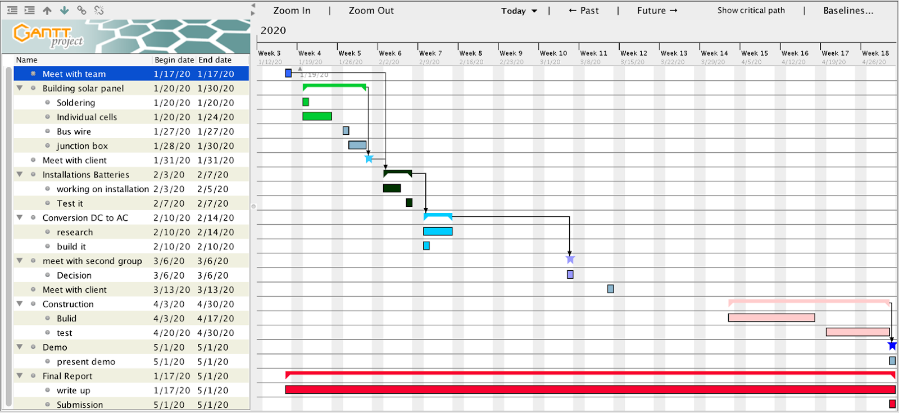
Figure 2: Gantt Chart for remainder of project

Conclusion
Mosquitoes have become a very big problem in today’s world as a large number of diseases are being spread through mosquitoes. Proper mechanisms and designs should be made for
capturing these mosquitoes. The project that the team is working on intends to catch these
mosquitoes and to study the virus present in those mosquitoes. The teams will be working in
groups where one group will handle power supply and radio communication and the other group will supply the power to the team and also will relay binary state variables representing the detection of mosquitoes. The standards talked about can be used in improving the design and making the design more feasible. Mosquito traps are designed and developed based on the mosquito characteristics. By using these characteristics, development of mosquito traps takes place depending on the specific technology available and the intended purpose of the trap. For example, it has been observed that insect wing beats can determine the species of an insect. Such behavior can be inherently adopted in the design and implementation of mosquito trap. Through understanding the characteristics of mosquitoes, it is possible that mosquito detection and trapping can be done. This can be achieved through interfacing and integrating a number of features such power system, mosquito detection sensors, and software integration. This will enable the categorizing the species of mosquito captured. Thus, these journals and research paper reviewed shows the prior art of our project development but ours will be just an improvement of the already existing ones. The design is an interesting challenge and requires a lot of effort to get it done correctly. The best part of the design is the use of renewable source of energy for generation of power. The teams expect to deliver a full functioning mosquito trap power system that is travelable, inexpensive and allows the trap to operate for a week to the client.

Appendix
[1] C. Boonsri, S. Sumriddetchkajorn and P. Buranasiri, "Laser-based mosquito-repelling
module," 2012 Photonics Global Conference (PGC), Singapore, 2012, pp. 1-4.doi:
10.1109/PGC.2012.6458039
[2] N. Zulkiply, L. Audah and M. H. Abdul Wahab, "Smart Mosquitoes Trap Using Favoriot
Monitoring System," 2018 IEEE Conference on Wireless Sensors (ICWiSe), Langkawi,
Malaysia, 2018, pp. 83-88.
[3] D. A. A. Santos, R. F. Brandao, G. A. C. Duarte, D. R. Totti, V. Furtado and J. J. P. C.
Rodrigues, "A Fan-Based Smart Selective Trap for Flying Insects," 2018 IEEE 10th
LatinAmerican Conference on Communications (LATINCOM), Guadalajara, 2018, pp. 1-5.
[4] A. K. Biswas, N. A. Siddique, B. B. Tian, E. Wong, K. A. Caillouët and Y. Motai, "Design of a Fiber-Optic Sensing Mosquito Trap," in IEEE Sensors Journal, vol. 13, no.11, pp. 4423-4431, Nov. 2013. doi: 10.1109/JSEN.2013.2274271
[5] M. Bazin & C. R. Williams, " Mosquito traps for urban surveillance: collection efficacy and potential for use by citizen scientists," 2018 Journal of Vector Ecology. https://doi.org/10.1111/jvec.12288
[6] W. Tseng et al., "Applying physical optics to design solar-powered outdoor UV LED mosquito trapping system," 2018 IEEE International Conference on Applied System Invention (ICASI), Chiba, 2018, pp. 1052-1055. doi: 10.1109/ICASI.2018.8394456
[7] M. Minakshi, P. Bharti and S. Chellappan, "Identifying mosquito species using smart-phone cameras," 2017 European Conference on Networks and Communications (EuCNC), Oulu, 2017, pp 1-6
[8] A. K. Biswas, N. A. Siddique, B. B. Tian, E. Wong, K. A. Caillouët and Y. Motai, "Design of a Fiber-Optic Sensing Mosquito Trap," in IEEE Sensors Journal, vol. 13, no. 11, pp. 4423-4431, Nov. 2013. [6] E. Fanioudakis, M. Geismar and I. Potamitis, "Mosquito wingbeat analysis and classification using deep learning," 2018 26th European Signal Processing Conference (EUSIPCO), Rome, 2018, pp. 2410-2414.
[9] W. Tseng et al., "Applying physical optics to design solar-powered outdoor UV LED mosquito trapping system," 2018 IEEE International Conference on Applied System Invention (ICASI), Chiba, 2018, pp. 1052-1055.
[10] X. Porcasi et al., "Spatial analysis of Aedes aegypti activity for public health surveillance," 2019 XVIII Workshop on Information Processing and Control (RPIC), Bahía Blanca, Argentina, 2019, pp. 214-217. doi: 10.1109/RPIC.2019.8882135
[11] G. E. A. P. A. Batista, Y. Hao, E. Keogh and A. Mafra-Neto, "Towards Automatic Classification on Flying Insects Using Inexpensive Sensors," 2011 10th International Conference on Machine Learning and Applications and Workshops, Honolulu, HI, 2011, pp. 364-369. doi: 10.1109/ICMLA.2011.145
[12] B. J. Johnson, B. B. Rohde, N. Zeak, K. M. Staunton, T. Prachar, S. A. Ritchie" A low-cost, battery-powered acoustic trap for surveilling male Aedes aegypti during rear-and-release operations," 2018 PLOS one Research Article, Doi:https://doi.org/10.1371/journal.pone.0201709
[13] Y.N. Liu, Y. L. Y.-C. C., Hsin-Yi Ma & Hsiao-Yi Lee" Enhancement of mosquito trapping efficiency by using pulse width modulated light emitting diodes," Scientific Reports volume 7, Article number: 40074 (2017). doi: 10.1109/OCEANSKOBE.2008.4531029
[14] B. Poulin, , G..Lefebvre, C.M-Kovacs, and S. Hilaire, " Mosquito Traps: An Innovative, Environmentally Friendly Technique to Control Mosquitoes," Journals IJERPH Volume 14 Issue 3 10.3390/ijerph14030313

