
Sponsors: Northern Arizona University
USDA
US Forest Service
Clients: Dr. Jamie S. Sanderlin, Dr. Ana Miller-ter Kuile, and Dr. Kiona Ogle
Mentor: Scott Larocca
Team Members: Alyssa Ortiz, Andrew Ortega, Payton Watts, and Tyler Chapp

October 3, 2024

This document will focus on the skills and interests of the group members that are working on the FireFlight Project.
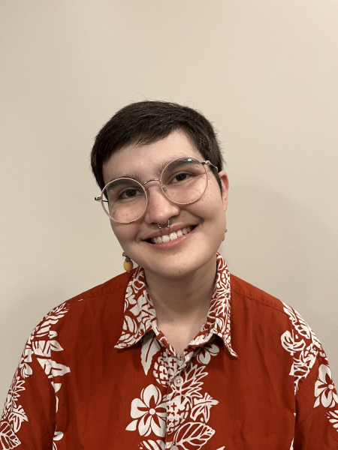
Alyssa Ortiz

Biography: I am currently pursuing a Bachelor's degree Applied Computer Science, and have my Associate’s degree in Web Development/Design. I am from Phoenix, Arizona, but have lived here in Flagstaff for almost 2 years now.
Education: I am currently enrolled at Northern Arizona University, pursuing a Bachelor's degree in Applied Computer Science, with an expected graduation date in Spring 2025. I have a 4.0 GPA, and I have taken both CS 386 Software Engineering and CS 312 Web Development II, which will aid me greatly with this project. I graduated from Scottsdale Community College (with Highest Distinction and a GPA of 4.0) with my Associate’s in Web Development/Design in Fall 2022. I graduated from Horizon High School in Scottsdale in Spring of 2018.
Work Experience: Currently, I am the Teaching Assistant (TA) for CS 386 Software Engineering. I have advised students and led class on software engineering and architecture concepts, many of which we will be implementing in this project. In the past, I was the Open Educational Resources (OER) Student Specialist at Scottsdale Community College, where I researched and was editor of “Geographic Information Technologies” Textbook.
Skills:
- Web Development: I have my Associates Degree in Web Development/Design, and have expanded my knowledge even further with upper level classes at NAU.
- Software Engineering: I took a Software Engineering course at NAU, where my group and I excelled. I am currently the Teaching Assistant for this course, and cement my knowledge and guide other students in software engineering.
Other Interests: In my spare time, I enjoy bird watching, and have gained an amateur knowledge of the local birds in both Phoenix and Flagstaff. I enjoy collecting antiques, specifically uranium glass and other depression glass, and country goose themed decor. I enjoy learning, and reading books and articles that expand my knowledge in all categories. I also enjoy reading horror and science fiction books.

Andrew Ortega
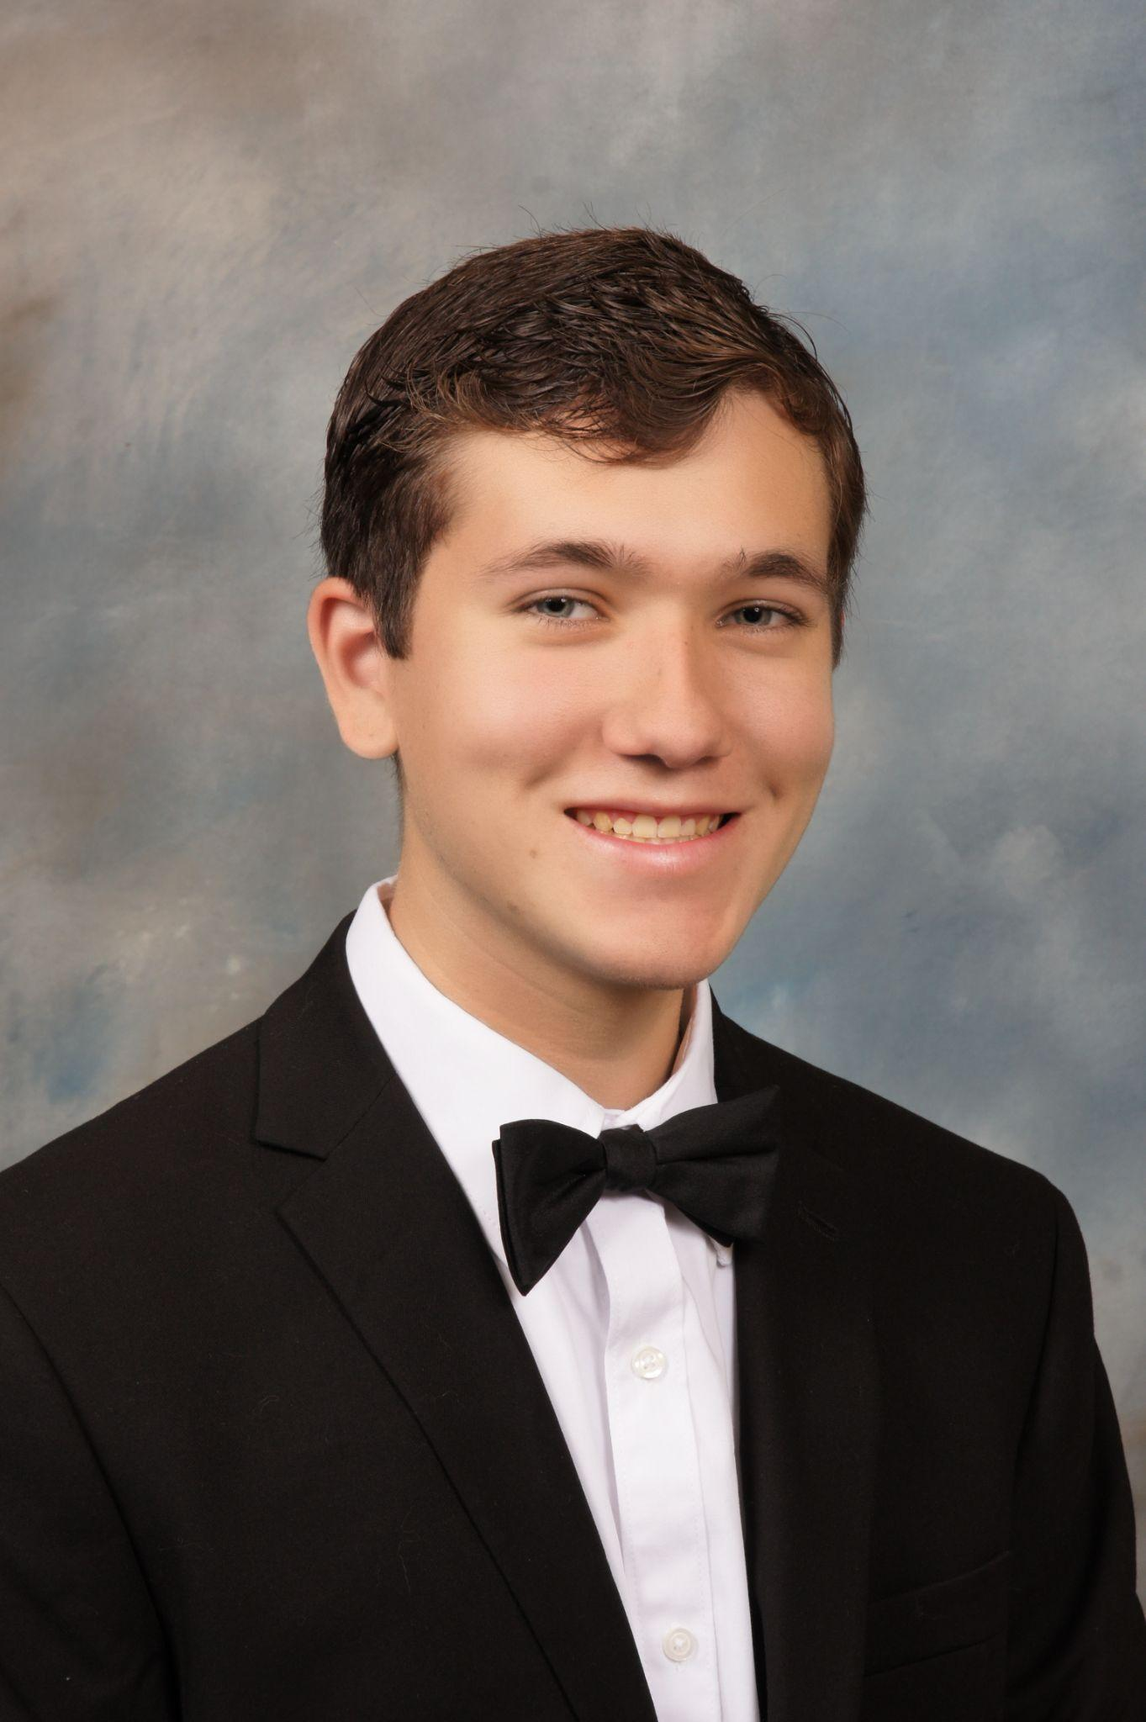
Biography: I am currently pursuing two Bachelor's degrees, Mathematics and Computer Science. I was raised in West Covina, California. I have lived in Flagstaff for almost 4 years now.
Education: I attended South Hills High School. I graduated with a 3.9 GPA, where I also ran varsity cross country and track. During my senior year, I took two classes with the local community college, Mount San Antonio College. While there, I took basic prerequisite classes, which were an intro to stats and an intro to political science.
Work Experience: My work experience has mainly been in the customer service industry. However, I did recently obtain an internship with Northern Arizona University through the NASA Space Grant. In this internship, I am writing code in Python to map out graphs of the spread of West Nile Virus and how birds, mosquitoes, and humans are all affected by each other and the virus. I am just starting out, however I am learning how to use Rume and Jupyter notebooks rather quickly.
Skills:
- Communication: Being in the customer service sector for years, I have learned how to phrase questions and concerns in multiple variations so that my point is understood. I have learned to listen to those around me and adhere to their advice and their concerns.
- Research: I learned how to research questions that I have and ask any if I cannot find the answer that I am looking for.
- Python Coding: My main experiences have been with the Computer Science 1 class offered at NAU and my internship listed above.
Other Interests: I am an avid gamer and try to game any chance I get. I love reading, walking around NAU and going for runs. I also love all things Disney and Marvel Comics.

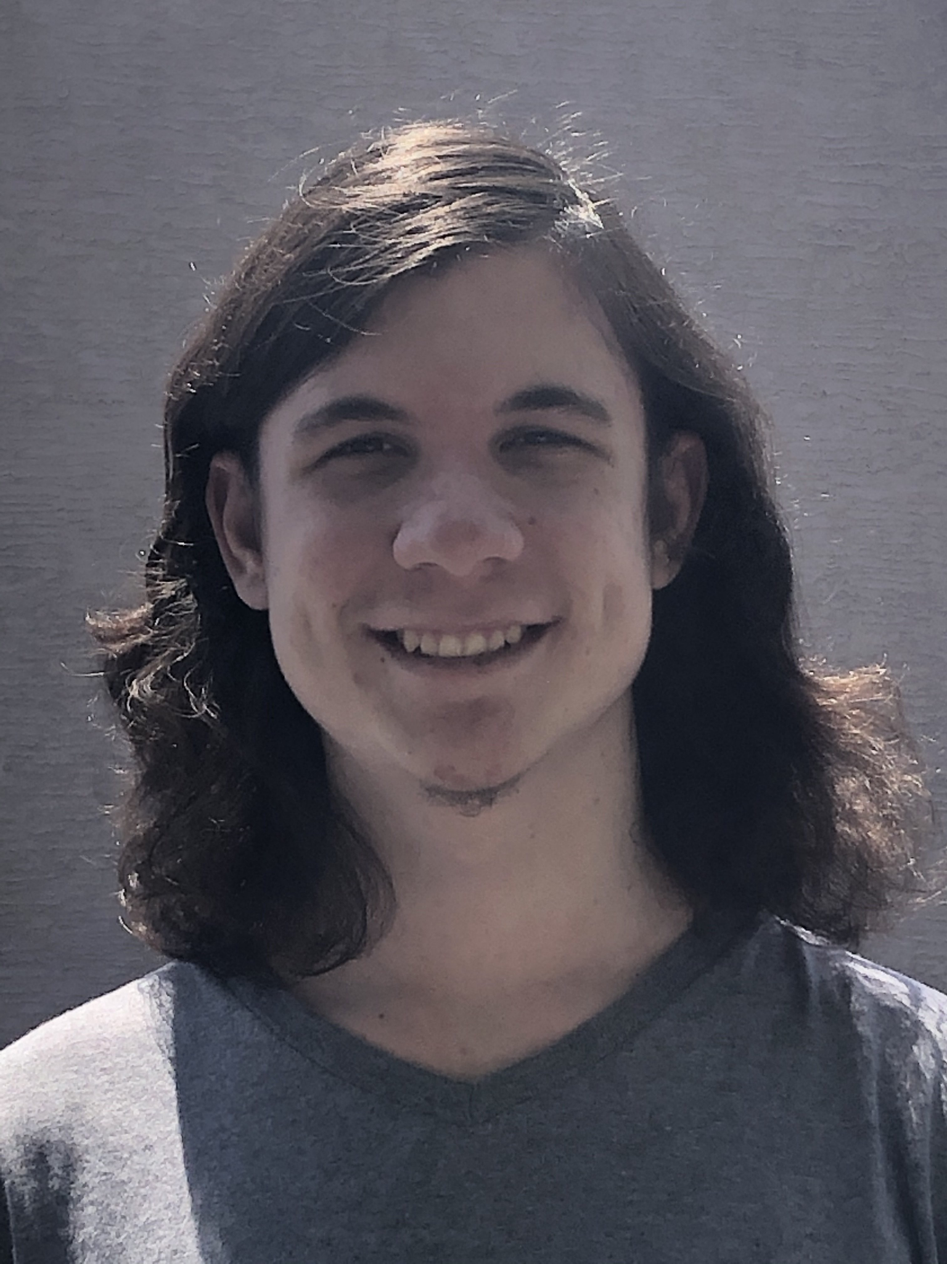
Payton Watts

Biography: I’m currently pursuing my Bachelor in Computer Science here at NAU, with a minor in Japanese. I was born in northern California but moved to Arizona at 8 years old in 2010, so I consider myself an Arizonan, and Phoenix is my hometown. But having lived in Flagstaff most of the year the past four years, I consider it a second hometown in a sense. Part of why I love Flagstaff so much is because of how surrounded it is by nature.
Education: I went to Deer Valley High School in Glendale, Arizona. In high school, I took two computer science electives and multiple art electives. I received a certification/award for my Java-focused computer science class, and as for my artistic endeavors, I won multiple awards at the district art show my senior year, including first place in digital photography. My grades were a bit all over the place in my first two years, but I straightened things up in my last two years and did well enough to be able to qualify for the Lumberjack scholarship. I’m still immensely grateful to the teachers who helped motivate me and my guidance counselor in those later years.
Work Experience: My only official work experience has been working in grocery.
Skills:
- Coding: I can work efficiently in C, C++, and Python. I had prior experience in Python from my classes in high school, which I expanded upon in my first year at NAU. After that, I learned C at NAU as well, along with C++ in Principles of Languages specifically. I’m also currently in a class for R, and have worked somewhat in Javascript for my software engineering class project, and I studied some Java in high school.
- Efficient Student: I’ve experienced a lot of ups and downs throughout my college career, and these have led me to become a much better student. I’m persistent, a skilled critical thinker/problem solver, creative, a team player, decent researcher and note-taker, and great at working closely with my professors to figure out issues I’m having with a class.
Other Interests: I have a love for technology, but also art. I’m a huge fan of movies and music in particular, and I love to find new films and music to explore. I’m also very fascinated by history, especially American political science/history and geopolitical history. I also enjoy video games when I get the chance, I enjoy FPS and grand strategy games in particular.

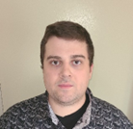
Tyler Chapp

Biography: An aspiring Software Engineering B.S. student with a focus on full-stack development, automated software testing, and big data. Born and raised in Chandler, Arizona, I have spent most of my life in the beautiful state of Arizona. I fell in love with Flagstaff after moving just under four years ago and plan to pursue a master’s in informatics here at NAU.
Education: I graduated with honors from Hamilton High School located in Chandler, Arizona. I spent some time trying out different majors at Chandler-Gilbert Community College before finding my passion in computer science and transferring to Northern Arizona University. I have completed several classes that apply to my capstone project including GSP 420 Principles of Remote Sensing, CS386, and SE460 which were project-based classes.
Work Experience: Although I do not have professional software development experience, I have worked in various technology-related positions that required data collection, following detailed procedures, quality assurance, and leadership. I worked at Intel for three years and am currently employed by W.L. Gore as a manufacturing technician, which all offer transferable skills to software development.
Skills:
- Geographical Information Systems: Experienced working with GIS software, sourcing, processing, and rendering spatial data.
- Software Testing: Responsible for running automated testing for each project-based class and am currently enrolled in SE450 software testing.
- Full-Stack Development: Took computer networks and wrote the code for many servers. Experienced working with various API’s and other back-end frameworks like Node and Flask.
Other Interests: I play the guitar, piano, and do a bit of singing for a cover band. Passion for spending time in nature doing things like camping, hiking, and playing disc golf. Spent ten years working as a professional chef and love being able to express my creativity through food.

