Weekly Team Task Report

Team: Team Lora |  |  |  |  |  | Date: 4/6/20
Project Title: Mobil Crowdsensing Framework Over Low-Power Wide Area Networks

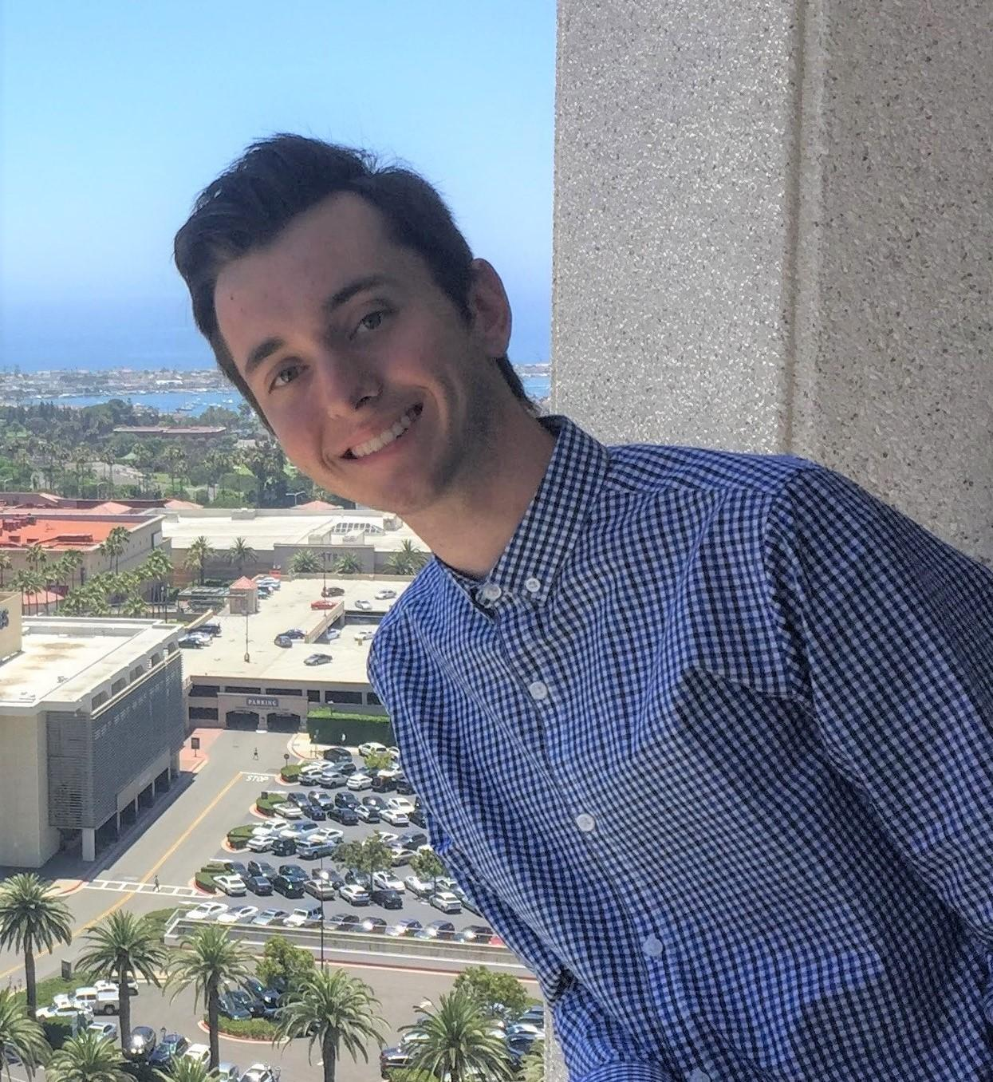 | Ryan  Present  On-time | 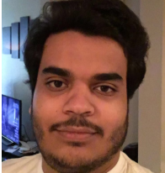 | Mohammed  Present  On-time | 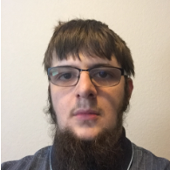 | Benjamin  Present  On-time |  | 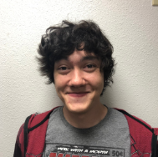 | Brandon  Present  On-time

Recent Meetings:

- Team Meeting (2/22/20) Team meeting via Discord after meeting with Scooter. Discussed tasks for the upcoming week, worked on revising the software design document.
- Team Meeting (2/26/20) Met on Zoom to troubleshoot problems with the formatting of the demo app and assign roles for the software testing plan and design review 3.

TASKS COMPLETED since the last meeting:

Task Title: Software Testing Plan Draft | Task Initiation:  3/23/20 | Orig. Due Date:  4/1/20 | Status: In-Progress  20% Completed
Who (%): Ryan (25%) Mohammed (25%) Benjamin (25%) Brandon (25%)
Description: Write a draft of the software testing plan document and turn it in to the editor for a final editing pass.
Expected Outcome: A completed rough draft of the software testing plan is produced.

Task Title: Software Testing Plan Final | Task Initiation:  3/23/20 | Orig. Due Date:  4/3/20 | Status: In-Progress  0% Completed
Who (%): Benjamin (100%)
Description: The editor(s) go over the rough draft of the software testing plan and polish it before it is due for submission.
Expected Outcome: A finalized software testing plan is submitted.

This week’s Tasks: Work plan for the coming week

Task Title: Create Wiki For Documentation | Task Initiation:  2/10/20 | Orig. Due Date:  2/17/20 | Status: In-Progress  10% Completed
Who (%): Ryan (25%) Mohammed (25%) Benjamin (25%) Brandon (25%)
Description: Create the start of the Wiki for our project.
Expected Outcome: A github wiki for our github project that explains how to use our code.

Task Title: Secure Proxy Server’s Connections | Task Initiation:  2/8/20 | Orig. Due Date:  4/3/20 | Status: In-Progress  0% Completed
Who (%): Ben (100%)
Description: Ensure that the packets being transmitted to and from the proxy server are properly encrypted, and that the server validates all connections made to it.
Expected Outcome: Demonstrate that the packets transmitted to and from the proxy server are encoded, show a connection without proper certification be refused

Task Title: Implement Fragmentation | Task Initiation:  3/7/20 | Orig. Due Date:  4/24/20 | Status: In-Progress  50% Completed
Who (%): Ryan (25%) Mohammed (25%) Benjamin (25%) Brandon (25%)
Description: Currently, boths sides of our framework can only handle a single packet at a time. This puts a great deal of constraint on the amount of data that we can send. Implement best-effort fragmentation so that a single large message can be split into multiple packets to fit through the LoRaWAN pipe.
Expected Outcome: Demonstrate that the framework can send a large message over LoRaWAN using fragmentation.

Task Title: Implement OpenCellID Demo App | Task Initiation:  3/7/20 | Orig. Due Date:  4/24/20 | Status: In-Progress  0% Completed
Who (%): Ryan (25%) Mohammed (25%) Benjamin (25%) Brandon (25%)
Description: Create a demo app which extends the OpenCellID SendSingleMeasurement API to show our framework in action.
Expected Outcome: Demonstrate the working app being able to send a valid SendSinglemeasurement call over LoRaWAN..

Task Title: testing and finalizing LoRaMessenger Library | Task Initiation:  3/8/20 | Orig. Due Date:  5/1/20 | Status: In-Progress  0% Completed
Who (%): Ryan (25%) Mohammed (25%) Benjamin (25%) Brandon (25%)
Description: This is the part where we perfect our code and make our project run smoothly and remove any issues we find. This might also include adding more functionality to our project.
Expected Outcome: Polished and finalized android library.

Task Title: Design Review 3 Footage | Task Initiation:  3/23/20 | Orig. Due Date:  4/1/20 | Status: In-Progress  0% Completed
Who (%): Ryan (25%) Mohammed (25%) Benjamin (25%) Brandon (25%)
Description: Record footage for the design review 3 presentation based on the finalized script.
Expected Outcome: Submit the necessary footage to the editor for the final compilation of the design review.

Task Title: Design Review 3 Editing | Task Initiation:  3/23/20 | Orig. Due Date:  4/3/20 | Status: In-Progress  0% Completed
Who (%): Ryan (100%)
Description: The editor(s) glues together the various footage and clips submitted to create the full video.
Expected Outcome: A finalized, polished design review video is submitted.

Task Title: Interface improvement | Task Initiation:  3/26/20 | Orig. Due Date:  4/5/20 | Status: In-Progress  30% Completed
Who (%): Ryan (50%) Mohammed (50%)
Description: Improve and polish the LoRaWAN application’s interface.
Expected Outcome: A professional and finalized interface.

Task Title: Create Ugrads | Task Initiation:  4/5/20 | Orig. Due Date:  4/10/20 | Status: In-Progress  0% Completed
Who (%): Ryan (25%) Mohammed (25%) Benjamin (25%) Brandon (25%)
Description: Create an eye-catching and effective poster as per the assignment on the capstone website
Expected Outcome: Submit the finished poster in a printable file format to Eck Doerry.

Upcoming Tasks: Planning

Task Title: Have Library Read JSON File | Task Initiation:  3/7/20 | Orig. Due Date:  4/24/20 | Status: In-Progress  0% Completed
Who (%): Ryan (25%) Mohammed (25%) Benjamin (25%) Brandon (25%)
Description: Currently, the decoding table JSON file is read by the main thread of the demo app and the resulting JSON string is passed to the library. Ideally, the library should be able to read the decoding table without the main thread’s assistance.
Expected Outcome: Demonstrate that the library can read in the decoding_table.json file when it is placed in a specific place in the app’s package.

Other Problems / Other Issues:

