Software Design Document
LabRats
Project Sponsors: Dr. Terry E. Baxter & Michael Kelly
Team Mentor: Ana Steinmacher
Julian Bell
Remy Brandriff
Blake Lawton
19 February 2019



Version: 1.3

Table of Contents

Introduction 3
Implementation Overview 5
Architectural Overview 7
Module and Interface Descriptions 10
Website Interface 10
About 11
Contact Us 12
Lab Requests 13
Inventory 15
Implementation Plan 17
Conclusion 19

Introduction

Research in the field of environmental engineering is an area of study that helps scientists gain a better understanding of the world around them, allowing for more informed decisions about protection of the Earth’s environment through waste management, pollution control, and other such topics. The Environmental Engineering Lab (ENE Lab), an NAU-based lab that facilitates and hosts research in environmental engineering, handles topics in climate change, water safety, and sustainability, among many others, which contribute to global efforts in preserving the environment. This includes coursework, independent student research, and research performed by faculty and industry professionals using university resources. When there are failures or issues with said research or data, however, which can occur in a number of ways, that calls into question the validity of the results, and by extension, this could endanger the field of environmental engineering. Consequently, this may affect life on Earth as a whole.

With such an important set of guidelines and restrictions that the lab must meet and follow to meet safety standards and certain regulations, it stands to reason that the entire NAU ENE lab system requires a robust, effective web-based framework where administrators, faculty, and students alike can access important information, receive updates on training and chemical properties, and ensure that the lab and its subcomponents are operating properly on all fronts and at all times. As it stands, there is no such online or computer-based system to ensure that these needs are being met, which can pose logistical and safety issues that are best left avoided at all costs for the risks that could be associated with it.

Thus, our capstone project is the ‘Environmental Laboratory Informatics and Management System,’ a proposed system that will aim to centralize management of the Environmental Engineering (ENE) Laboratory. Several members of the Civil and Environmental Engineering department, including our clients, Dr. Terry Baxter and Michael Kelly, are responsible for supervising lab usage and experiments, managing the space, and reviewing lab usage requests for either approval or denial. Right now, the system is functional, but ad-hoc and leaves a lot to be desired in the way of efficiency, sustainability of lab use processes, and scalability as NAU inevitably grows rapidly in population. Right now, lab requests and data storage are handled, at the most advanced level of technicality, through email forms and CSV sheets, which are currently enough to keep decent and coherent records of what is going on within the lab, but could definitely stand to pose problems as NAU’s aforementioned growth continues.

Our task, essentially, lies in creating this system and making sure it can be supported in years to come so that it can serve as a valuable resource to the ENE community at NAU, as well as at large. It is critical to ensure that the ENE Lab operates efficiently and safely to avoid or mitigate issues such as failed experiments, faulty data, dangerous chemical interactions, and potential health risks, and the current processes in place for these tasks have been determined to be difficult and ill-suited for supporting current and future lab growth, which is why our project holds increasingly dire importance and viability for NAU’s department.

In the interest of fixing these issues, our capstone project has been proposed in the form of the Environmental Laboratory Informatics and Management System (ELIMS). ELIMS has been designed as a robust, user-friendly web application which will streamline the process of lab usage requests, and allow for a more centralized, dynamic management system for the department by displaying each of these critical metrics and tools in a singular location. There are several key requirements that are prioritized in the design and implementation of the system: ease of use, simplification of the lab usage request process, simplification of managing lab space, and centralization of lab resources. Our goal is to make sure that we can incorporate each of the aforementioned elements into a centralized web framework that will serve the needs of authorized students, faculty, and administration that can be supported and expanded in the future by NAU’s ITS services in the years to come.

Implementation Overview

The Environmental Laboratory Informatics and Management System has been designed as a web application with two main aspects: The web interface frontend and the database backend.

Through the web interface, different types of users will be able to interact with the ENE Lab. Standard users will be able to submit requests to use the lab, manage their requests, and contact lab management, and once approved for lab usage, users will be able to search the lab’s chemical inventory and report issues. Admin users will be able to manage requests and contact form responses, search the inventory, and update the inventory. The implementation of different user permissions, and admin users’ ability to assign permissions, is a central part of the implementation of the entire app. User authentication and authorization will be implemented both natively in the ELIMS system, for new users, and through the use of NAU’s CAS (Central Authentication Service) server, for NAU students and faculty.

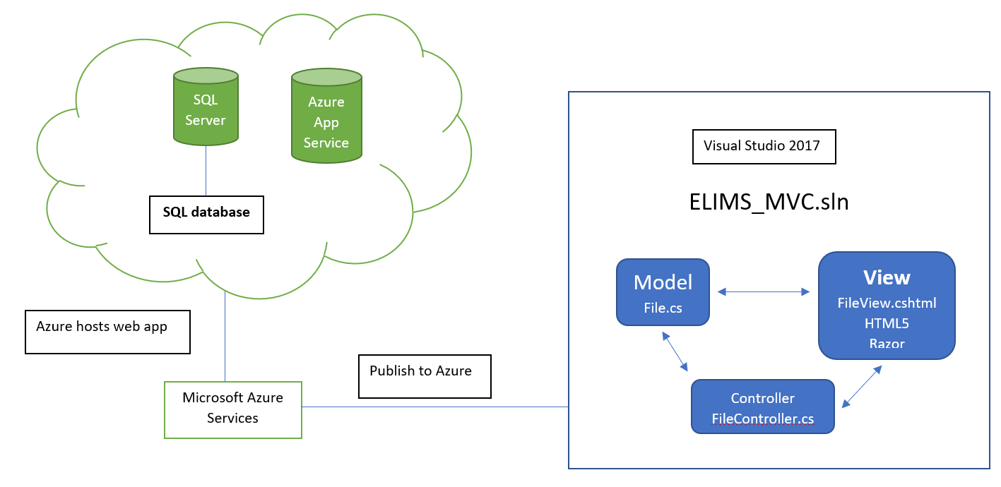
Figure 1. Basic diagram of the ELIMS site structure and supporting modules/features.

The backend of the system will include an SQL server-based database to manage information such as user permissions, lab usage requests, and contact form responses, as well as the ENE Lab’s chemical inventory. The chemical inventory database will be seeded by an existing inventory performed recently, which although not entirely up-to-date, will allow us to plug in the data to be updated when another takes place.

We are using the Visual Studio 2017 IDE to implement the system as an ASP.NET Core web app, using the Model-View-Controller architecture, as defined in the System.Web.Mvc assembly in the .NET Core framework. Using Visual Studio’s NuGet package manager, we are also using AspNetCore.Security.CAS user authentication and authorization (version 2.0.4), an open source module that is used by NAU, among other universities, for user login to software, and MailKit (2.1.2) for an internal email service. The backend of the system is written in C# and LINQ, the SQL variant that allows us to manipulate the database and tables. The frontend is written in HTML5 as .cshtml Razor pages, with Bootstrap 4 and CSS to control and implement formatting.

During development and testing, the app will be deployed to a Microsoft Azure web server, with an SQL Server hosting the database and tables, which is how it will be deployed by ITS when they take over the project once we finish it. By deploying to the same servers ITS uses, we can troubleshoot the app in the same context it will operate in post-development, and be able to find and solve most of the problems before ITS takes over. The way in which each of these elements interact with each other are outlined in figure 1 above.

Architectural Overview

We are developing the ELIMS project using the Model-View-Controller architectural pattern on the ASP.NET Core framework. The MVC architectural model has three main components, as seen in figure 2:
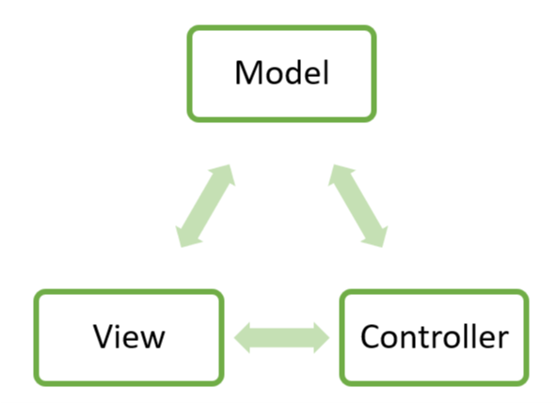
Figure 2. The MVC software architectural model

- The model is the application’s data structure, representing a particular aspect’s state
- The view takes in information from the model and controller and renders a user interface
- The controller handles interactions and updates the model accordingly

This divides the app into the three interconnected components, which is designed to separate the internal representations of the data, i.e. the database, from how the data is presented to the user. By decoupling the Model, View, and Controller components, we’re able to more efficiently reuse code and develop the different elements of the app in parallel, because they don’t affect each other. As an ASP.NET web app, the model exists only on the server, while the view exists client-side and the controller is on both.
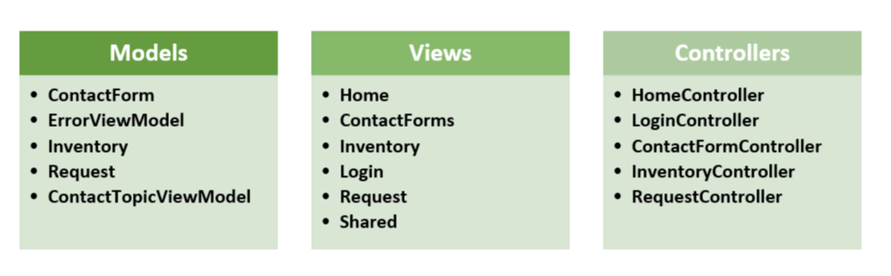
Figure 3. The broad MVC architecture of the ELIMS system

Many of the views in figure 3 -- specifically ContactForms, Inventory, and Request -- are actually folders, with similar Razor page views, which will be detailed further in the Module and Interface Descriptions section of this document; each folder contains a page for Create, Details, Delete, and Edit, as well as the view’s Index. These views are auto-generated by Visual Studio and create the associated dashboards that will change based on which type of user; for example, admin users will be able see every contact form submission in the contact form Index view, while standard users without permission will only be able to see theirs. Similarly, each aspect of the web app, except for the basic one-page views such as the About page, have at least one model, controller, and view associated with it based on user permissions to allow for the different user types and different permission levels. The contact form, for example, has two models associated with the controller; one model, ContactForm.cs, is for the contact form in general, and the second, ContactTopicViewModel, is specifically associated with allowing the admin users to filter contact form responses by topic.
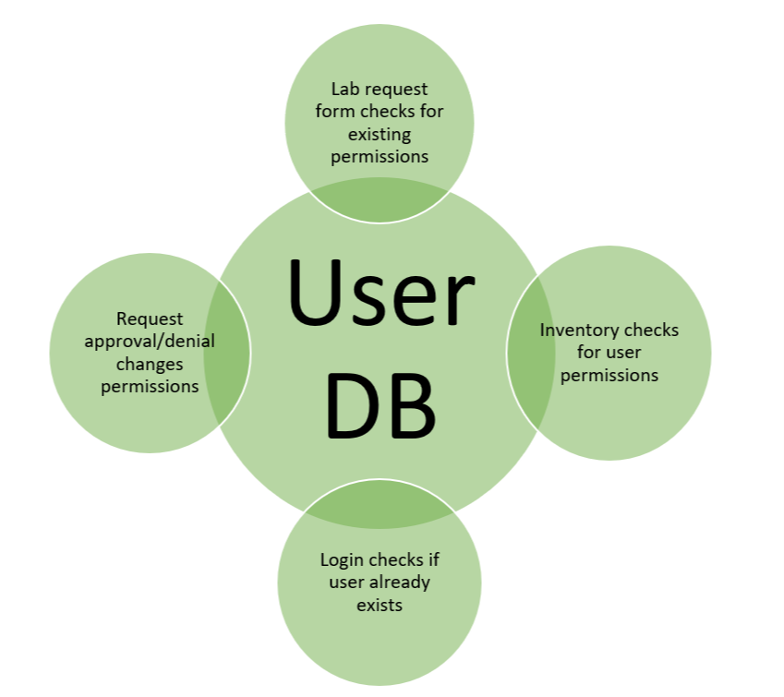
Figure 4. The structure and functionality of the user database

The user database behind ELIMS is detailed in figure 4 above. User permissions are determined by a user database that the other controllers will interact with, as opposed to interacting directly with each other; when a lab usage request is approved, those users may get permissions associated with accessing the inventory, and the inventory controller must check for a user’s permissions before allowing them to search or view the data in the inventory table. The user permissions are responsible for enforcing the separation of the different user capabilities within the app; for example, only users with specific privileges can view the lab’s chemical inventory to ensure that only those with direct access to the lab can view the locations of specific chemicals. These permissions will be created and implemented as authorization via the CAS module, as shown below in figure 5.
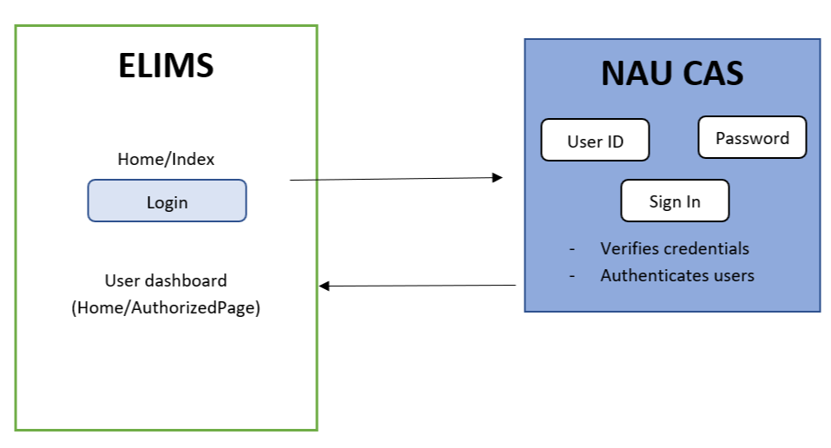
Figure 5. The ELIMS-CAS relationship

Module and Interface Descriptions

Website Interface
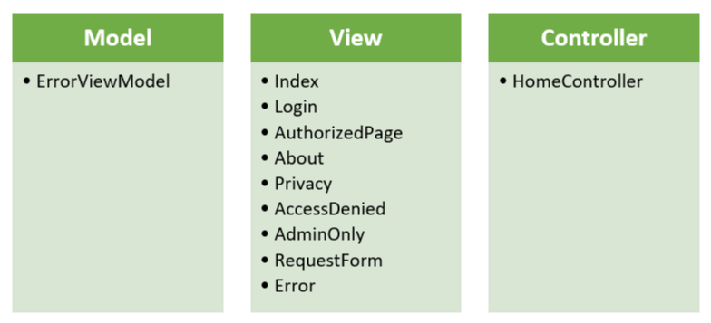
Figure 6. The MVC architecture for the HomeController and its components

The basic structure of the website starts with our homepage ELIMS, an acronym for our Environmental Laboratory Informatics and Management System. Several of the single-page and simple components, including the home page, login, user dashboards, about and privacy pages, and error page, are controlled by the HomeController (see figure 6). When developing an MVC web app in Visual Studio, the IDE automates a lot of the initial development, providing a template for the front end that is modified by the project, both dynamically in the controllers and statically with CSS and Bootstrap.

The site’s home page contains information about the system with a small list of functionality that ELIMS provides for users, as shown in figure 7, all linked to their respective pages.
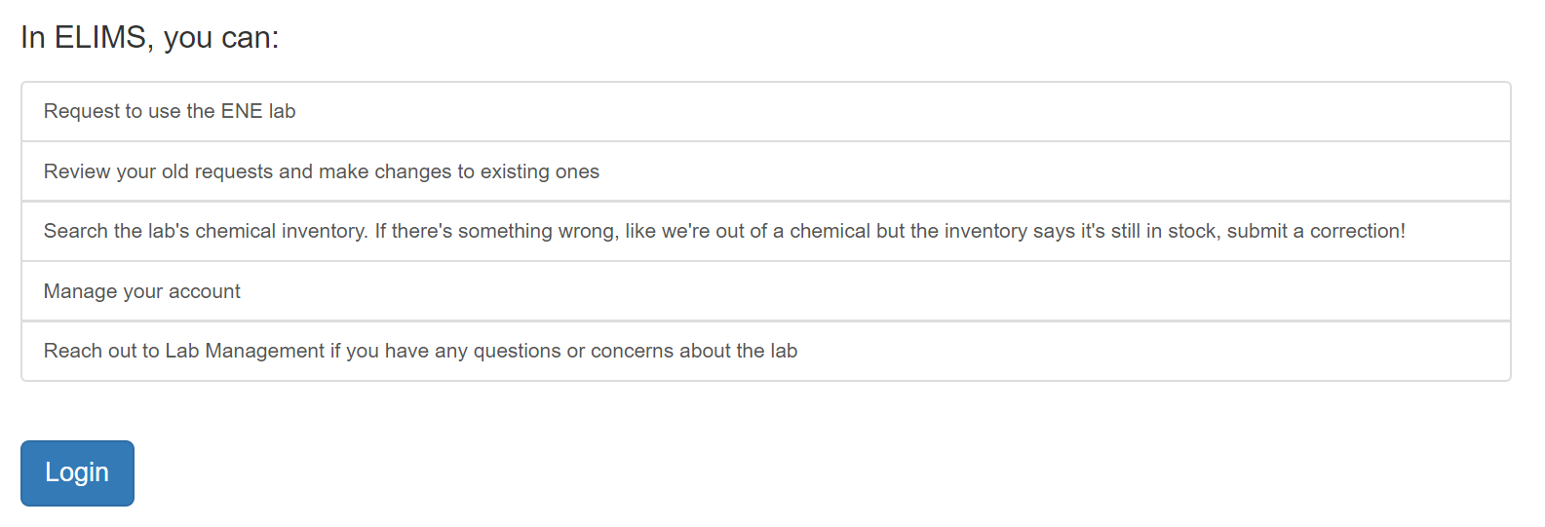
Figure 7. A portion of the ELIMS homepage, with a list of the system’s main features linked to their pages

Each page also contains a very easy navigation bar at the top of the page that allows you to go to any part of the website. This navigation bar, shown in figure 8, provides links to the ELIMS home page, the about page, contact, lab requests, and inventory, as well as the admin and user dashboards (‘Admin Only’ and ‘My Dashboard’ respectively).
Figure 8. The header for the web app, established in the shared _Layout.cshtml view.

About
The about page, shown below in figure 9, has a short description of what the ENE lab has to offer. It also explains some of the technical uses that the lab is used for along with the people allowed to use it. The labs usage must be requested, recorded, and approved by the lab management. The website provides a way to allow students and faculty to request the usage of the lab.

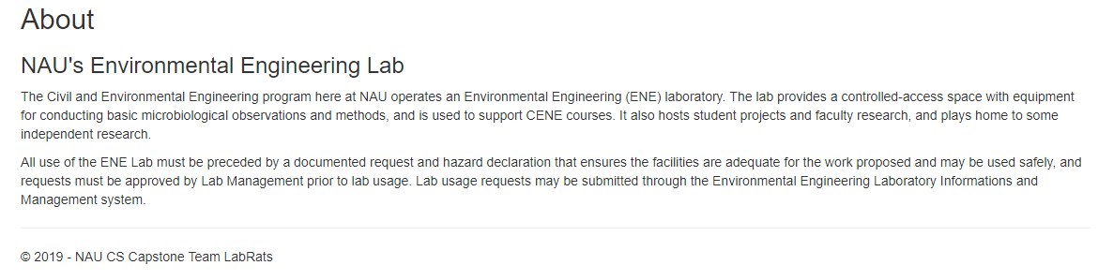
Figure 9. The About page contains a quick summary of what the ENE Lab does

Contact Us
The contact us page has the purpose to allow any faculty or students to contact ELIMS with any sort of technical issue or incorrect information that the system is holding. We encourage users to take advantage of this page as it will help us fine tune the site and create a more refined website. The page, shown in figure 10, requires you to have an account and to write a message that will then be emailed directly to an administrative personnel who can respond through the email provided.
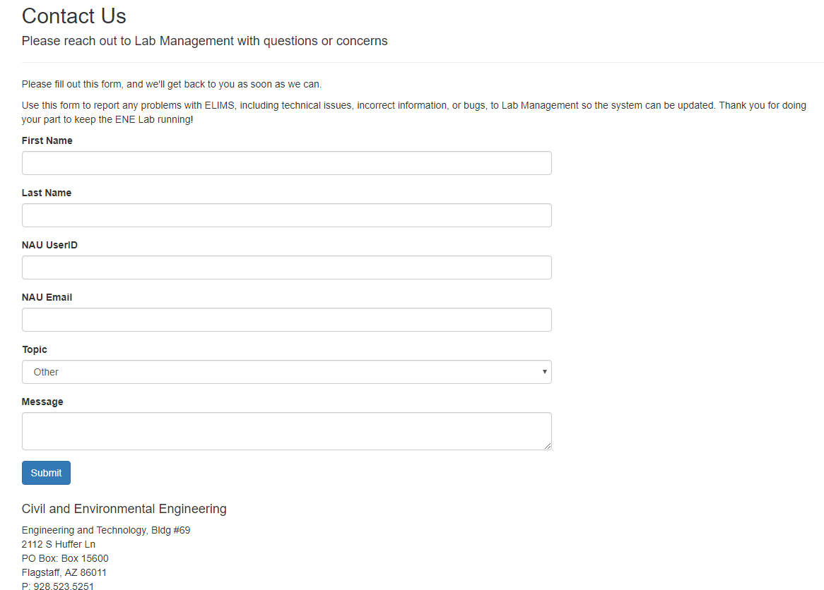
Figure 10. Users may fill out and submit the Contact Us form to contact lab management
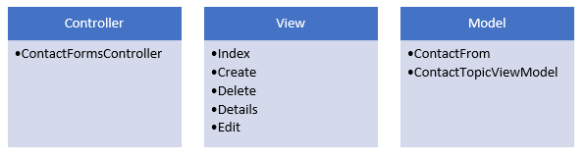
Figure 11: The MVC for the ContactFormController and its components
At the bottom of the page is a link to go to a provided list of tickets. This implementation will allow users to only see their own tickets unless they have the correct admin permissions, in which case they will see all the tickets that have been filed into the database. This will allow an easy way to check for issues in the system and keep it organized for admin users. There is also a search filter for last name in this section so that it is easier for an admin to go through tickets that may be of more urgency.(See Figure 12)

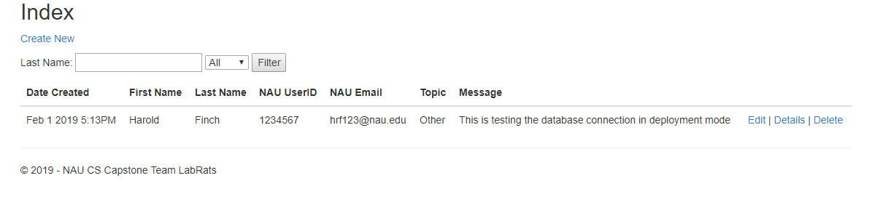
Figure 12: Webpage of Contact management page
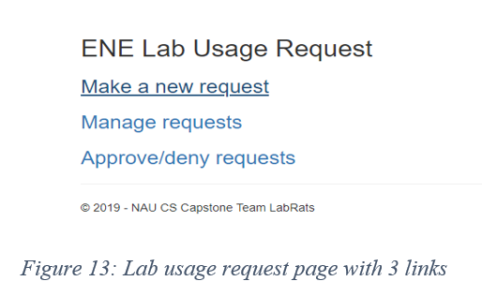

Lab Requests
The lab requests page allows users to make a request for a lab time slot and manage these requests, and if the user has correct administrative permissions, they will be able to approve or deny any requests.

The make a new request page, shown in figure 14, allows users to input the following information in order to correctly apply for a lab slot; first mame, last name, User ID, NAU Email, project name, project objective, start date, end date, primary contact, source of project funding or name of course, faculty sponsor or course instructor name, sponsor phone number, sponsor email, chemicals used, potential meeting times, and group members. This will most likely be the way that chemicals are requested and checked against the database system. We are looking into implementing an input box that students can search their chemicals in and create a list that instantly checks against the database system for the admin and alerts him if there is insufficient amount for it, and will provide regular updates on progress with this aspect as development continues.

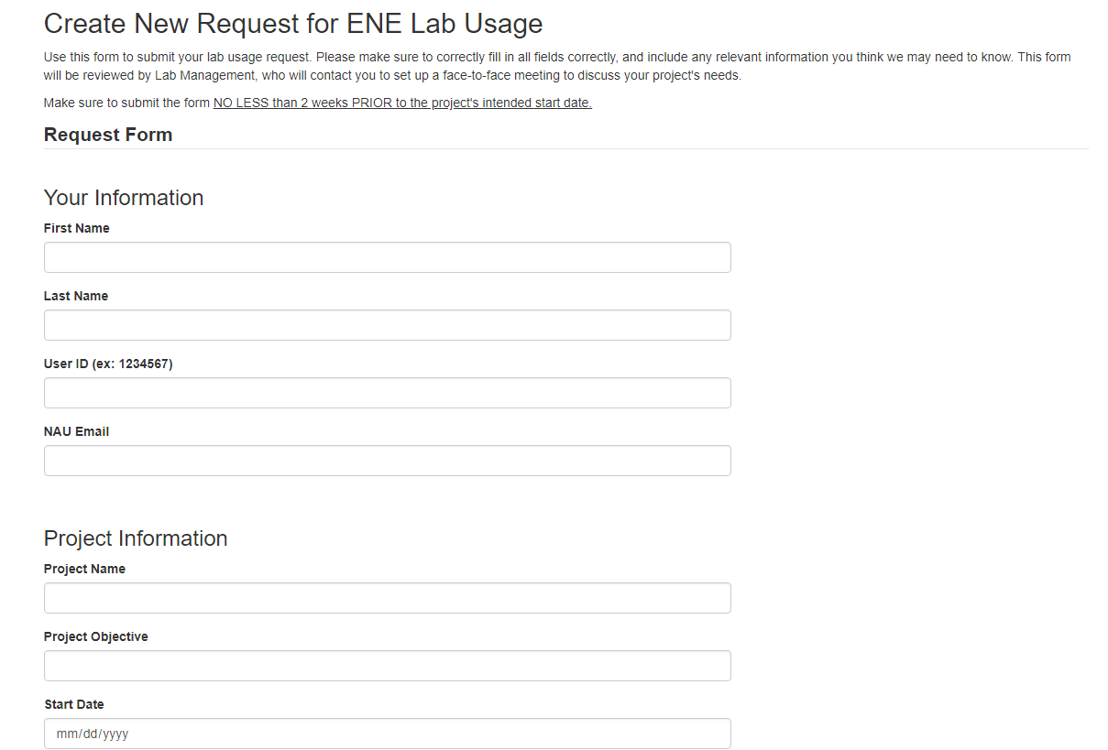
Figure 14: Webpage for new lab request. Not all information is shown in the screenshot
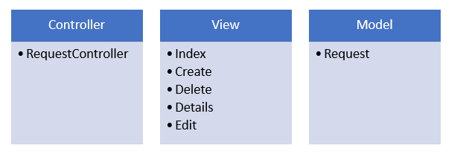
Figure 15: The MVC for the RequestController and its components
In figure 15, we show the controller only interacts with one model being request. The view is also interconnected with standard five view functions. These views help create and delete the requests and link them into the controller.
The manage request page is simple; it will display any information needed to the user about their request and the approve/deny page will look roughly the same, but with an approve and deny option. (as seen in figure 16 and figure 17)
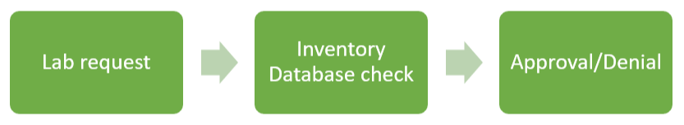
Figure 16: The process of lab requesting
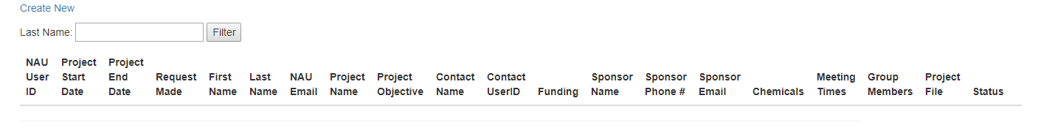
Figure 17: All fields of the lab request

Inventory
The inventory page will store all the chemicals information as when it was used, how much was used, how much is left, and if there is need to request any new chemicals. This page is only for admin users as this is a strictly need to know bases inventory. It will allow lab instructors to easily update/request chemicals in the database. This is going to be the main focus of our backend part of the project. The administrators, and users with specific permissions assigned by admin users, will be able to search the database backend and submit corrections as necessary to update the inventory, and download the records as a file.

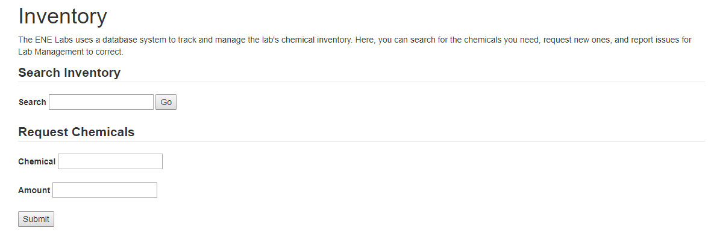
Figure 18: Webpage view of the inventory search page
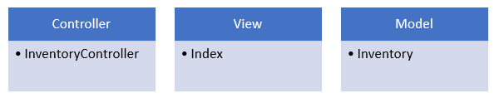

Figure 19: The MVC for the InventoryController and its components
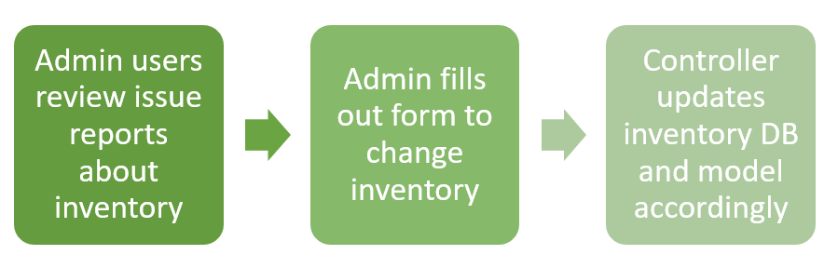
Figure 20: Break down of admin usage on inventory page

Implementation Plan

Our team’s Gantt Chart, which details a rough blocked-out plan of each task we plan to do in chronological order throughout the next three months, is detailed below:

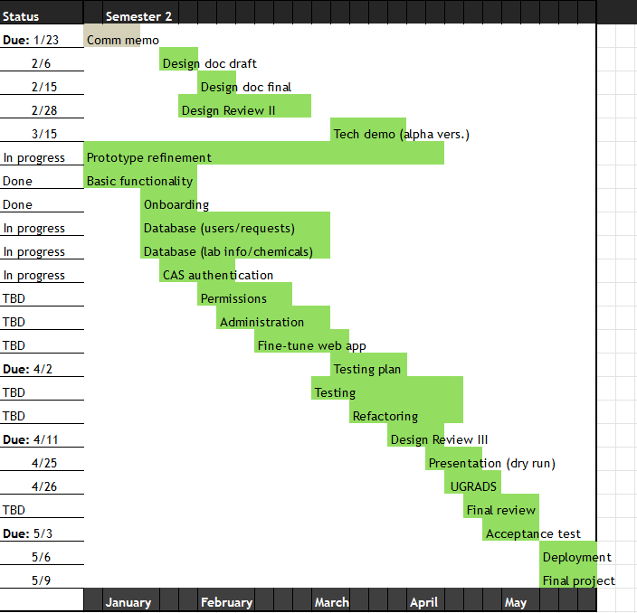
Figure 21. The Gantt chart detailing the capstone team’s progress
As we are currently in the first few weeks of February, we are mostly on-track with project progress as it is defined above, and ahead in some areas. We have made major strides in providing a lot of basic front-end functionality, as well as meeting with ITS and our sponsor to obtain methods for CAS authentication and to start populating our database back-end, respectively. Right now, with new third member Blake onboarded to the team and basic front-end functionality of our prototype completed, our next major steps are going to be ensuring CAS authentication works and is secure, creating permissions for each type of user once that is fully functioning, and beginning work on our back-end, which is going to house our databases for users and permissions, requests, and chemical, equipment, and safety sheet inventories.

Once all of this is functional, we will be doing heavy testing with the front-end to make sure permissions are working properly (a vital component to ensure safety and legal standards are met with respect to lab use and dissemination of valuable information), and fine-tuning the web application itself so that all of these components are working properly in tandem. As the semester progresses, we aim to have most of our prototype functioning and ready for heavy testing by the time Spring Break rolls around (in the second half of March). That way, we will have a lot of time to check and work on critical aspects of the system through the remainder of the semester, with plenty of time to spare in case unintended issues arise during those final weeks.

In addition, we have also roughly split each part of the system for each member to work on; with Remy having the most experience in front-end and web-based development, they will be tasked with working on the majority of the front-end, which will cover the web framework, the request system, and permissions for each class of users. Blake and Julian will be predominantly responsible for handling the back-end of the system, which will include the databases, and tying authentication, requests, and so forth back to the controller aspect. If any issues arise in either of the two “areas” of the system, or progress is slowing, all three members will work on whatever is necessary to ensure workflow is going as smoothly as possible.

Conclusion

Our project will address the current difficulties and inefficiencies of the Environmental
Engineering (ENE) lab management and usage processes, as explained to us by our client, Dr.
Terry Baxter. The ENE lab supports research into, among other topics, climate change, water
safety, and sustainability, which contribute to global efforts of preserving the environment.
When there are failures or issues with research or data, which can occur in any number of ways,
that endangers the validity of the results, and as a whole, endangers the field of environmental
engineering. Consequently, this may affect life on Earth as a whole. The ENE lab critically needs
a system that centralizes the management and lab usage processes in order to operate efficiently.

We propose a robust web-based application that will combine lab usage requests and lab management into one system, allowing users to make requests for lab usage and check the lab’s inventory, as well as facilitating lab management’s maintenance of the space, all in one
convenient place. This app will be portable, platform independent, and easy to maintain, and will
ensure the safe and efficient operation of the ENE lab. Based on current progress and our projected development plan, we are confident we will be able to deliver a product that suits our client’s needs, serves the ENE Lab effectively, and will continue to support the ENE Lab in the future.

