
CS 486C
Capstone Experience
Spring 2013
Instructor: Dr. Doerry

FINAL REPORT
  - Version Date: 5.13.13
Greg Andolshek
Alex Koch
Michael McCormick

Table of Contents
1 - Problem Statement 2
2 - Process Overview 4
3 - Requirements 8
3.1 - Goals 8
3.2 - Requirements Overview 9
3.3 - Constraints 10
4 - Solution Statement 12
4.1 - Functional Specifications 13
4.2 - Architectural Overview 14
4.3 - Other Technologies 20
5 - System Implementation 21
5.1 - Site Overview 21
5.2 - Attributes 26
5.3 - User 28
5.4 - User Notifications 35
5.5 - Group 37
5.6 - Forum 45
5.7 - Analysis 48
5.8 - Site Settings 51
6 - Usability Testing 52
7 - Future Work 53
8 - Conclusion 54

1 - Problem Statement

Groups are a fundamental concept in any large organization or social circle. Managing groups is a complex challenge that encompasses managing the group/subgroup hierarchy, analyzing group characteristics, and supporting intra-group and inter-group communication. While there are a number of software systems available for group management, many of these systems are designed for workflow management or casual social groups. Existing systems are unable to handle efficient creation, reorganization, and communication within complex, hierarchical group structures. There is a need for a hybrid system that combines social aspects and administrative group management. Any hybrid system should be able to:

- Manage members by providing support to add and track members
- Define groups manually and automatically using custom attributes to determine membership
- Analyze members and groups with graphical and statistical breakdowns
- Facilitate group communication via blogs, forums, and email

The lack of a suitable group management system is the primary motivation for the establishment of Group Wrangler.

GSEP and the Need for a Proper Group Management Tool

Group Wrangler was initially developed to support the Global Science and Engineering Program (GSEP) at Northern Arizona University (NAU). GSEP is a dual-degree curricular track that combines studies in any science or engineering discipline with studies in language and culture. The goal of GSEP is to internationalize the Science, Technology, and Math (STEM) degree programs at NAU. There are currently 13 science and engineering majors and 5 language choices for the program. The program is set up so that students can earn their dual-degree in 5 years. Students spend the fourth year of the program abroad studying and participating in an internship.

As Assistant Director of GSEP, our sponsor, Melissa Armstrong, manages a rapidly growing group of GSEP students that fall into multiple overlapping groups and subgroups, defined by academic status, language, major, and other characteristics. Currently, GSEP is using a variety of tools to manage students in the program, including Excel and word processing documents. This makes it very difficult to keep track of members within the organization. It is also inefficient because one person is responsible for entering all of the data for GSEP. GSEP was looking for one tool that would allow them to manage students in the program and facilitate communication among members. Specifically, GSEP needs one tool that will allow them to:

- Manage 300-500 students
- Define groups manually and automatically using attributes specific to GSEP
- Analyze students and groups through charts and statistical breakdowns
- Facilitate group communication for students to allow them to share their experiences

These criteria match up very well with the needs of a hybrid group management and communication system identified earlier. Addressing these key requirements will help to reduce the time spent on managing GSEP students. It will also allow students to be active participants in GSEP and help other students in the program.

More About GSEP

Analysis of Existing Products

We looked at a variety of existing products to determine if any of them would meet the needs of a hybrid group management system (Figure 1). We analyzed the products based on the criteria identified earlier for a proper hybrid system. The rating scale ranges from poor to excellent. A breakdown of some of the products is shown below.

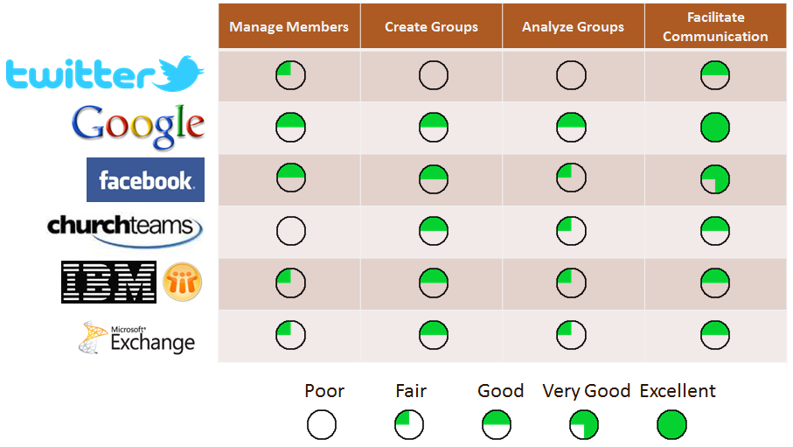
Figure 1 - Existing Product Comparison

None of the products fully meet all of the criteria that we have identified. Google comes the closest in terms of meeting the criteria. Tools such as Google+ and Google Groups provide some very useful functionality in terms of facilitating functionality through forums blogs and emails. However, the Google products are lacking in some of the other areas because they do not provide great support for tracking members, defining groups automatically, or analyzing group statistics. Many of the other products suffer from similar shortcomings.

As described earlier, the main issue is that these systems are either focused on administrative control or social communication. Social tools such as Twitter, Facebook, and Google largely focus on self-organized groups that have users enter their own information. Tools for administrative control such as Church Teams, IBM Lotus Notes, and Microsoft Exchange are often centrally controlled and have a strong management focus. These tools are all very good at accomplishing specific tasks, but there is no tool that combines the full set of administrative needs with complete freedom of communication among members. After going through this process of analyzing other products, we decided that we would need to build a new hybrid system without relying on other existing products.
2 - Process Overview
Our capstone group, Team Lasso, is made up of three members. We initially had four members, but the fourth member was unable to continue into the development phase of the project. The main project roles for each member of the team are indicated below

- Greg Andolshek - Design architect, back-end developer, documentation lead
- Alex Koch - Graphics designer, frond-end developer
- Michael McCormick - Team leader, back-end developer, client coordinator

Note that these roles were not exclusive, and we shared responsibilities while working on the project. All of us were involved in programming the code for the system and producing the documentation for the deliverables.

Our sponsor and mentor provided us with support throughout the development process. Our sponsor was very helpful in providing helpful feedback for any questions that we had about the organization or any specific requirements that the system should have. Our mentor has particular experience with user interface design, so his feedback was very helpful in terms of building a useful and intuitive layout for the site. Information about our sponsor and mentor and their titles are given below.

- Melissa J. Armstrong – Assistant Director for the Global Science and Engineering Program
- Dr. Eck Doerry – Associate Professor in the Computer Science Program at NAU

More About Team Lasso

Project Management Framework

Most of the project decisions were made in group meetings. We usually had meetings 2-3 times a week, and each meeting usually lasted between 1 and 2 hours. During these meetings, we reviewed the current status of work on the project and assigned people to work on future tasks. We made design and functionality decisions as a group. We used a voting scheme in case where we could not come to a unanimous decision. Some of the meetings were meant for meeting with our client and mentor to get their feedback on the work we had done. We also used email, text-messages, and phone conversations to communicate between team meetings.

We used a variety of tools to help us manage the tasks for this project. We used tools for both task management and configuration management. For task management we used the YouTrack system by JetBrains. This allowed us to prioritize issues and bugs and clearly communicate our progress to each other and to our mentor. For configuration management, we used Git and Bitbucket. Git allowed us to easily keep track of the different versions of the application. Bitbucket allowed us to store the code in a central location and easily get the latest code onto any machine.

Design Methodology

We used an agile development approach for this project because it was well-suited to the type of application we were developing. We did not have a solid idea of all of the requirements for the system before we began development. Specifically, we knew that we would need to make many revisions to the user interface. The agile approach allowed us to develop many prototypes for the system and rapidly incorporate user feedback. We were able to revise our requirements based on the feedback and incorporate the requirements into the next version of the system.

Deliverables

We developed several main documents while we were working on Group Wrangler. These documents helped us define the scope of our project and give us a clear idea of the product we were developing. Some of the main deliverables are listed below.

- Team Inventory – a description of each team member in terms of experience and role on the project
- Team Standards – a document that that describes the expectations of each team member in terms of the procedures for developing the applications and the steps for conflict resolution
- Technology Feasibility – an exploration of the various technologies that could be used to build the application and a description of what technologies were ultimately chosen and why they were chosen
- Requirements – a complete listing of the functional and non-functional requirements for the application, including environmental constraints
- Final Report – the final document that includes a summary of the project overall and covers the details of the application as it has been built

In addition, we had presentations that we developed for design reviews that took place over the course of the year. We also had a poster and presentation for the Undergraduate Research Symposium at NAU.

List of Documents for Viewing

Timeline

The actual timeline (Figure 3) we ended up with for this project differs slightly from our initial plan (Figure 2) for the schedule we made when we first began working on the project. The original and actual timelines are shown below.

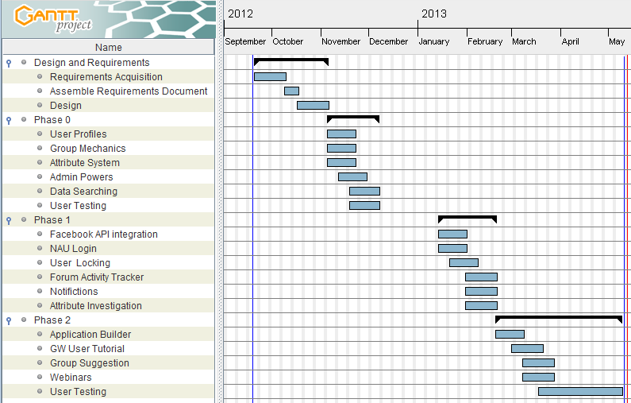
Figure 2 - Original Schedule Plan

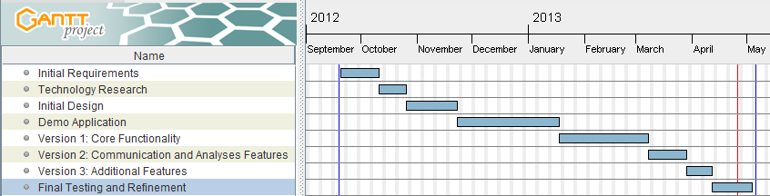
Figure 3 - Actual Schedule

The timelines show the main project phases that we worked on over the course of the two semesters. The phases are broken up into time to work on the requirements, research technology, design the application, build a demo, work on the various versions of the project, and apply final testing and refinement.

Notice the differences between the original version of the project schedule and the final version. Our original project schedule was quite ambitious. We had even planned to include support for webinars in our original schedule. Also notice that we planned to build certain features in the system much earlier than we actually began working on them. This meant that we had less time to build the system, and less time for user testing as a result. We found three main reasons for the difference between the planned and actual schedule:

Expanding requirements scope

The nature of our project meant that it was difficult to narrow down all of the functional requirements for the system ahead of time. We had a solid concept of the main functional requirements based on the project description and meetings with our client and sponsor, but many of the details regarding the user interface were hard to establish before beginning development. We wanted to build a user interface that was intuitive and allowed users to quickly analyze the group hierarchy to find only the users and groups that they were interested in. We used an agile approach to address the changing requirements, but this made it difficult to stick to a solid schedule for the requirements.

Time for technology exploration

We had a few main criteria in mind when we were choosing which technologies we wanted to use to develop the application. We were looking for technologies that would allow us to quickly develop prototype versions of the application so that we could rapidly incorporate feedback from testing. Additionally, we wanted to use technologies that had solid documentation and support for software engineering principles. We wanted future developers to be able to pick up our code and be able to easily adjust it to fit the needs of their organization.

We spent a substantial amount of time researching the various frameworks we could have used to develop the application. We looked at frameworks in a variety of languages, including PHP, Ruby, Java, JavaScript, and Python. Our team built several demos in these various languages in order to see which technology would work best for our application. We built our first substantial demo application using Google Web Toolkit. We chose not to use Google Web Toolkit because we found it quite difficult to build basic features, and we were unsatisfied with the level of community support and documentation. We ultimately decided to use Ruby on Rails as our framework at the beginning of the second semester. We did lose some time choosing which technology to use for the application, but it paid off in the end. The initial investment of time spent choosing the proper technologies helped us to build a better application.

Fewer team members during development

When we first made our initial project schedule, we had planned on developing the application with the original four team members. However, we found out near the end of the first semester that the fourth team member would be unable to continue on into the second semester. This meant that we had to adjust the schedule based on the amount of work we believed we could accomplish with the remaining three team members. Each remaining team member also had to pick up the team roles of the fourth team member. It took us some time to figure out the new team dynamic.

Given the difficulties we encountered during working on the project, we are quite happy with the final version of the application. We were able to adjust to the challenges and adjust the schedule so that we could still build a proper product. Through the development process, we learned valuable lessons about how to handle changing requirements and team dynamics.
3 - Requirements

In the initial requirements acquisition phase, we met with our sponsor, Melissa Armstrong, to establish some of the key features of the Group Wrangler system. We then met with our mentor to refine our initial list of requirements. Our goal was to establish the needed core functionality of the system. We then constructed our initial requirements document, which we submitted to our sponsor and mentor for comments. Our peers and the faculty also provided us with helpful feedback when we presented our work in the form of design reviews. We had further meetings with our mentor and sponsor to further refine the scope of our requirements.

3.1 - Goals

The main goal of the application is to provide a system that combines administrative grouping control with intra-group freedom in terms of communication. The application is meant to provide one tool that meets a variety of grouping needs. While the application was initially designed with GSEP in mind, the application can actually be used for a variety of organizations. The system addresses the four main grouping challenges listed below.

Manage members

The system should allow for adding, tracking, and deleting members. In particular, GSEP is interested in allowing users to enter and track their own profile information. The burden of maintaining data is then taken off of the administrator. Additionally, GSEP wanted to support individual member profiles.

Define groups manually and automatically

The system should allow administrators to set up custom attributes that can be used to determine group membership automatically. GSEP is specifically interested in attributes such as major, language, year abroad, etc. The system should also allow administrators to manually invite users to groups. Regular users should also be allowed to join certain public groups.

Analyze members and groups

The system should allow administrators to analyze members and groups through graphical and statistical breakdowns. This will allow administrators to get quick feedback on the people that are in certain groups and decide when it might be a good idea to create a new group.

Facilitate group communication

The system should include several tools for communication such as blogs, forums, and email support. GSEP wants to use these communication tools to support students abroad and allow them to share their experiences.

Additionally, the system should be easy to use, maintain, and extend. The idea is that any organization should be able to install Group Wrangler and tailor it to fit certain needs.

3.2 - Requirements Overview

We broke our main functional requirements down based on the capabilities of certain users. Our main classes of users include generic users and administrators. People without a user account are also able to view certain parts of the site, but they do not have any other abilities. Below is a short breakdown of what the main user types can do in the system.

Generic User

Once a generic user logs into the system with his or her password, he or she can perform any of the following actions:

Communicate

A user can communicate with other members of the organization via a variety of tools. The user can post to the forums to ask questions of other members. Each user has a blog where he or she can share experiences.

View groups

Each user can view information about groups he or she is in as well as other groups in the organization. A user can view particular information about any group he or she has permission to see. This information includes group announcements, a list of the group members, and rules for membership in the group. A user can subscribe to a particular group to get information about that group in the form of notifications. A user also has the ability to manually join any public groups.

Manage account

A user can manage his or her account information. Each user can fill out his or her own values for the custom attributes set up by the administrator. These attribute values can then be used to automatically place users into groups based on the rules for the groups. A user also has access to general settings such as email address, password, and profile image. Additionally, a user has privacy settings that can be used to determine who should be able to view the user’s information.

Administrator

An administrator can do everything that a generic user can do, plus more. Once an administrative user logs into the system with his or her password, he or she can perform any of the following actions:

Manage users

An administrator can manage any user in the system. This includes the ability to create, update, or destroy any user in the application. Additionally, an administrator can make notes about any user in the. These notes are only visible to administrators. The notes allow the administrators to easily track each member. The administrator also has the ability to promote other users to administrators.

Manage groups

An administrator can manage any group in the system. He or she can create, update, or delete any group in the system. The administrator can post to the group announcements, set the rules that define automatic group membership, and attach analyses to the group. Additionally, the administrator can manually invite particular users to a private group. Each group has general settings and privacy settings that the administrator can adjust. General settings include the group name, description, contact information, and image. Privacy settings determine who can view information about the group.

Manage applications

An administrator can manage applications for admittance to the organization. Potential users can post their completed applications for administrators to review. An administrator can decide whether or not to the user should be allowed to retain full user privileges in the system.

In addition to the functional requirements, the application needed to meet several environmental requirements. These requirements include support for running the server on a variety of common platforms, viewing the application from any modern browser, and protecting private user information.

There were also several non-functional requirements that the system needed to meet. The most important of these non-functional requirements were related to usability, maintainability, and extensibility. Any user should be able to use the application without very little prior instruction. The interface should be intuitive and easy to follow. This prevents the user from having to read a thick manual before getting started with the application. The application should also be organized such that any future programmers can take the code and adjust it to fit the needs of a particular organization. The code should be structured so that it is easy to read and add to.

3.3 - Constraints

There were a few constraints that the client placed on the requirements for the application. First, the client was looking to meet the following restrictions:

Web-based application

The client wanted the system to be a web-based application. This would allow any user to access the application securely from any machine with an Internet connection.

Secure

The client wanted the system to be secure. Since private user information would be held on the server, the application must provide strong authentication to ensure that users only see information relevant to themselves.

Power and ease of use

The client wanted the system to effectively balance functionality with simplicity and maintainability. The idea is that the system is powerful enough to meet all of the functional requirements while being easy to interpret and build upon.

4 - Solution Statement

The solution we developed is a web-based application that supports an intuitive experience for creating and managing groups in a social community. The application addresses the four main grouping challenges mentioned earlier. It combines the functionality of tools that focus on social organizations with the functionality of tools that focus on centrally managed organizations. The application is both free and open-source. It uses a variety of modern web technologies to provide a simple and easy to learn interface. The application can easily be modified to meet the needs of any particular organization. Below is a screenshot of a user’s page (Figure 4), which gives a general idea of how the site works.

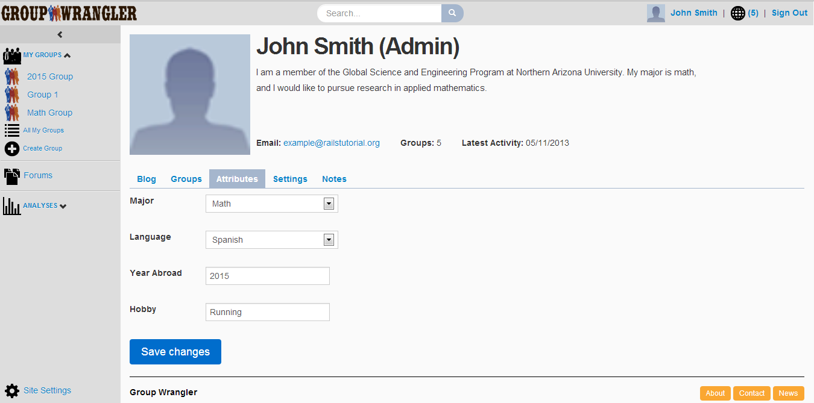
Figure 4 - User Page (Attributes tab)

The three main areas of each page include the header, sidebar, and content area. Below is a description of these main areas.

Header

The header provides quick access to a few of the site pages, including a links to the home page, the user’s profile page, the user’s notifications, and the sign in/sign out feature. There is also a search bar in the middle of the header that allows users to quickly search the site based on entered characters.

Sidebar

The sidebar contains quick access to site pages and some relevant user information. Every user will be able to see all of the groups that he or she is in and see a link to the forums. Administrative users will also be able to see all of the organization’s analyses and a link to the site settings. The sidebar can be contracted to show just icons.

Content area

The content area takes up most of the page. In the case of the home page, there is information about general site announcements, which an administrator can post to. There are also quick link that are relevant to the particular user. The content area changes based on the page you visit on the site, while the header and sidebar are always the same. In the case of the user profile page, there is information about the user’s name, biographical information, email, group count, and latest activity date. The user can quickly access information relevant to him or her from the tabs in the content area. There are tabs for the user blog, groups, attributes, settings, and notes. Only administrators can make notes about users.

4.1 - Functional Specifications

The application meets all of the functional requirements mentioned earlier. This section shows various site pages and how they address the functional requirements. The functional specifications are again broken down by generic user and administrator.

Generic user

A generic user can see most of the site pages, except for the analyses pages and the site settings pages. Each user has a profile page, which contains information about the user. A user can also view any other user page, group page, or forum page that he or she has permission to see.

Communicate

Each user has a variety of communication tools on the site. On each user’s profile page, there is a blog tab where the user can post about his or her experiences. Additionally, each user can view and or post to any forum that he or she has permission to see. Each forum supports any number of topics where the users can post. Each forum is attached to a group. The forums can be quickly accessed from the sidebar or any group’s page.

View groups

Any user can view information about the groups on the site. Any user can see the groups he or she is in from the groups tab on the user’s profile page or from the sidebar. Additionally, a user can view information about any other group on the site. The group profile page includes general information about the group, including the group announcements, members of the group, and the rules that define membership for the group.

Manage account

Each user is responsible for managing his or her account information. A user can fill out his or her values for the site’s custom attributes on the attributes tab of the user’s profile page. Filling out values for these attributes will result in the user automatically being placed into groups based on the group rules.

A user can also fill out general and privacy settings under the settings tab on the user’s settings tab. The privacy settings determine who can see the user’s blog, attributes, and groups.

Administrator

An administrator can view any of the pages on the site. He or she has access to all of the pages that a generic user can view as well as the site settings page and analyses pages.

Manage users

An administrator can create, update, and destroy users in the system. An administrator can invite users to the system from the invite tab on the site settings page. The all users tab lets the administrator see all users and delete any particular users. Additionally, the administrator can keep track of any user from the notes tab on the user’s profile page.

Manage groups

An administrator can also create, update, and destroy groups in the system. The group creation page can be quickly accessed from the sidebar. Administrators fill out rules for the group that determine group membership.

Manage applications

Each user can post an application to his or her profile information. Administrators can also post applications for the users. Administrators can review these applications to review to decide whether or not the users should be allowed to continue using the site.

4.2 - Architecture Overview

We had a wide range of choices for how to implement Group Wrangler. There are a variety of web application frameworks written in a variety of languages that we could have used to develop the application. We came up with the following criteria to help us choose a framework:

- Solid code structure to help us organize the code into logical areas
- Strong community support in terms of APIs, forums, and other helpful documentation
- Fast development cycle to fit a rapid prototyping and agile approach
- Easy maintenance so that future developers can easily change and update the code
- Support for software engineering patterns and principles in order to make the development process simple and understandable

We looked at many frameworks in languages such as PHP, Ruby, Java, JavaScript, and Python. Ultimately, we decided to use Ruby on Rails for our framework because it met all of the above criteria and would allow us to quickly build a working application. Ruby on Rails is very well suited to an agile approach because it allows developers to rapidly develop applications without very much setup. Ruby on Rails is a full-stack framework that comes packaged with all of the technologies necessary to develop a full web application. There are default tools that allow you to start working with the framework out of the box. Many of the default technologies can easily be swapped out to handle different web servers, databases, etc.

Ruby on Rails simplifies the development process because it focuses on particular software engineering practices and principles, including active record pattern, convention over configuration, don’t repeat yourself, and model-view-controller. Active record pattern is used to place object information in a relational database. Convention over configuration means that only things that are uncommon should need to be specified in the code. Don’t repeat yourself is the idea that code should be in a clear location and not repeated. The model-view-architecture provides a clear way to organize code by separating concerns with handling the database interaction from concerns related to rendering the page.

The model-view-controller setup is a crucial aspect of Ruby on Rails and other web application frameworks. It is an essential organizational tool for structuring code so that different logical aspects of the code are separated and not repeated. The model holds application data and permits manipulation of that data through functions. The application data is grabbed from the database and stored in the model. In Ruby on Rails, the model is an object representing something like a user, shopping cart item, or topic post. A user model might store information about the user’s name, date of birth, height, etc. The view is a template that is responsible for actually rendering the HTML for the page based on data that is passed to it. There can be any number of views for a given set of data. The controller handles the interaction between the model and the view. The controller interprets a certain action from the user and then interacts with the model to get or manipulate certain data. The controller then passes the necessary information onto the view so that the view can render the final web page.

The example below (Figure 5) shows a request to the server to see all users by visiting the user’s index page at /users. The image is from the Ruby on Rails tutorial.
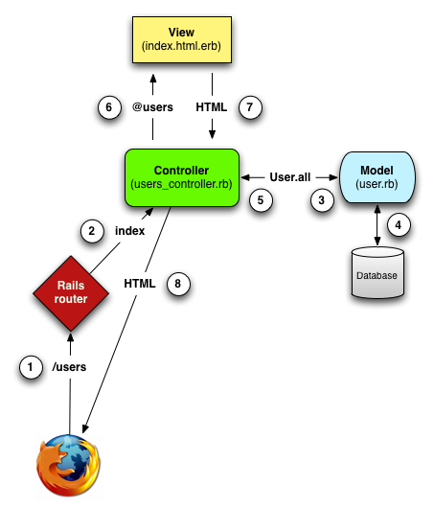
Figure 5 –Ruby on Rails Model-View-Controller Architecture
Image from http://ruby.railstutorial.org/chapters/a-demo-app#sec-mvc_in_action

Here we describe the main steps involved in requesting a page from the server. The numberings match up with the numbers in the figure.

- The browser passes the /users URI request onto the server.
- The Rails router maps the /users request to the index action in the Users controller.
- The index action in the Users controller gets all user information from the User model.
- The User model retrieves all user information from the database.
- The User model sends the all user information back to the controller.
- The stores all user information in the @users variable and passes the variable onto the index view.
- The index view uses embedded Ruby to render the HTML for the page based on the information in the @users variable.
- The controller sends the HTML from the view back to the browser.

The actions in a Ruby on Rails controller are usually based on the REST (representational state transfer) architecture. That is, the actions are based around the concept that resources in the application can be created, read, updated, and destroyed. Each action corresponds to a specific HTTP request and URI. The index, show, new, and edit actions in the controller all correspond to actual view pages in the application. In the case of the user resource, the index action links to the index view, which displays all users. The show page shows an existing user, the new page is used to set up a new user, and the edit page is for editing an existing user. There are other controller actions that do not correspond to any particular view. These other actions include create, update, and delete and they are used to update information about a resource in the database. Additional actions can be added to a controller, but these are the main ones used in the RESTful style of development.

Model-View-Controller Setup

We took advantage of the model-view-controller and REST architectures provided by Ruby on Rails in order to develop Group Wrangler. Here we walk through some of the basics of how groups are handled within the architecture.

Group Model
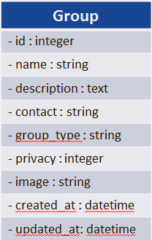
Figure 6 - Group Data Model
The group model defines the attributes of a group that can be accessed by the application, the relationship of the group model with other models, and how attributes should be validated. Before setting up the group model, it is necessary to create the group table to define which attributes belong to the group (Figure 6).

The group table defines the attributes that belong to a group. Each group holds information about its id, name, description, contact email, privacy, etc.

Group Controller

The group controller closely follows the RESTful actions described above. These actions set up the variables necessary to render pages for showing or editing a group. In addition there are actions for creating, updating, and destroying a group without actually displaying a page. The group controller interacts with the group model and the group views. For example, the show action in the group controller retrieves the needed information from the group model and then passes that information onto the group show view.

def show
@group = Group.find(params[:id])
…
end

The @group variable here holds information for the group with id equal to the id passed as a parameter. The call to render the show view is implicit here.

Note that the routes file determines how URIs are mapped to controller actions. For example the Rails router sets up the information to match the /groups/1 URI to call the show action for the group with id equal to 1.

Group View

There are many views that are used to represent group information. For the most part, the group views correspond to the actions for rendering pages in the group controller. For example, there is a show view that is rendered by the show action in the group controller (Figure 7).

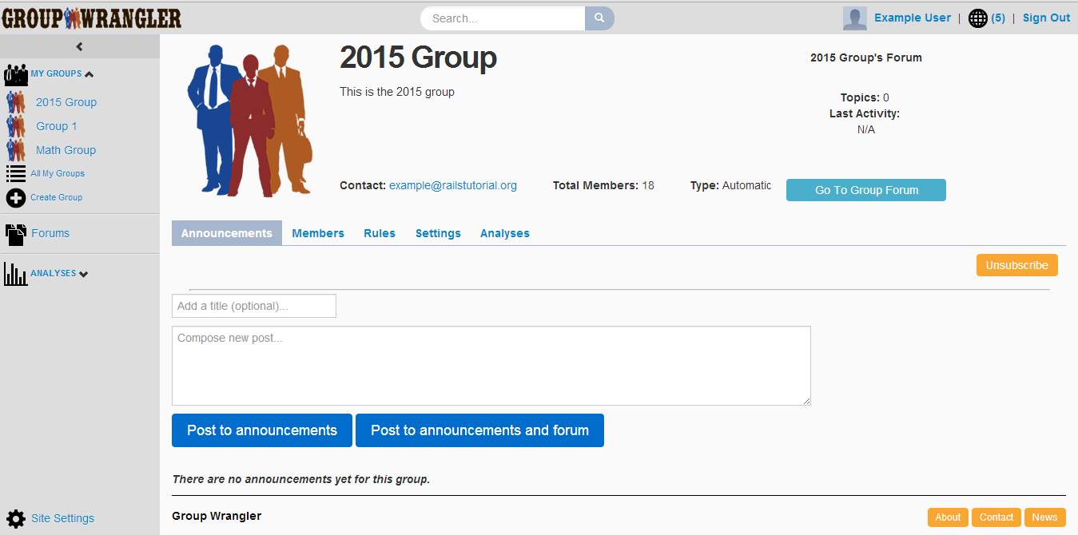
Figure 7 - Group Show View

Here we can see the information regarding the group’s name, description, contact email, etc. The information displayed on this page changes dynamically based on the data passed to it from the controller.

Each view uses embedded Ruby to interpret the variables passed to it from the controller and handle conditionals and loops. Each of the views can become quite complicated, so we use partial views to help break up the views into more manageable pieces and reduce the amount of repeated code. For the group show page, we use a partial view for each of the tabs on the page.

Functional Modules

The complex nature of our application led us to break up the structure into main functional modules. The entity-relationship diagram for this application is quite large. This application includes over 20 types of entities, and we needed a way to manage them and the interaction between them. We decided to break up the application into three main functional modules that group common entities together and help to define the relationship between these entities. These main functional areas are based off the main grouping needs we identified previously (Figure 8).
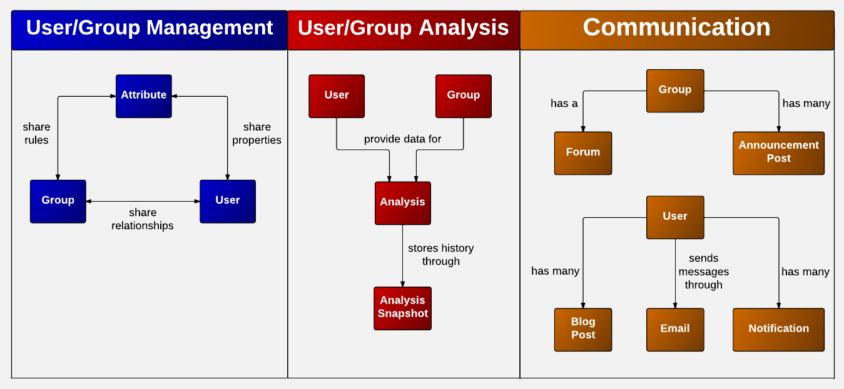
Figure 8 - Main Functional Modules

Each of the main entities discussed here has a view or partial view associated with it. Other than email, each entity also has a model associated with it. Most of the entities have their own controllers, but some controllers handle more than one entity. Note that this is a simplified view of the entities and their relationships. The actual E-R diagram for this application is much larger. The figure simply provides a high-level overall view of the main entities based on the major functional modules.

User/Group Management

Here we can see the relationship between attributes, users, and groups. This triangular relationship is used to set up automated grouping. An administrator will begin by setting up the possible attributes for the site. In the case of the GSEP, this may be attributes such as major, language, year, abroad, etc. The administrator can also put restrictions on the possible attributes such as the allowed values, types, and range.

A user can fill out values for the attributes that the administrator has set up. This sets up properties for the user that are associated with the attributes. The user can also manage other information in his or profile and upload files for an application, resume, and profile picture. The administrator can use the information in the application to decide whether or not the user should be allowed into the Group Wrangler system. An administrator can enter notes about an individual user in order to keep track of the user.

An administrator can fill out rules for the group based on the possible attributes that have been set up for the application. Each rule is embedded in a rule block that defines what conditions must be met. Each rule block can contain sub rule blocks. Once the group rules have been set up, users will be added to the group automatically if they meet the rules for the group. An administrator can also setup other group information and upload an image for the group. There is also support for public and private groups that don’t rely on group rules.

Note that there is also support for manual grouping here. In this case, an administrator can form a relationship between users and groups regardless of whether or not the user meets the group rules based on his or her attributes. A user can also join any public group.

User/Group Analysis

The analysis tool is used by administrators to quickly find out information about users and groups. Information about users and groups feeds into the analysis tool. The administrator can apply a filter in a manner similar to setting up group rules in order to narrow down which users and groups he or she is interested and looking at. The information about the filtered users and groups is then represented in the form of tables, charts, and graphs. The analysis entity itself holds information about the description, filter details, and display options. Note that analysis can optionally be associated with a group.

The analysis snapshot entity stores historical information about an analysis. It stores information about the relevant users and groups at the time the snapshot was created. The view for the snapshots displays the essential information for the analysis at the time of the snapshot. The snapshots are viewable to all users, not just administrators. An analysis can have more than one snapshot associated with it.

Communication

There are many entities related to communication in the application. We split the entities into functional areas in terms of how communication is handled for users, groups, and for the overall site. Users can share their experiences by writing on their blog. They can also view relevant information through notifications. Relevant information includes an update about being added or removed from a group, an alert about a recent announcement, etc. An administrator can post announcements for a group to alert people about important group updates. Anyone can also post to a group forum if they have the proper permissions.

An administrator can also communicate with users via email. An email is first sent to a user when he or she is first invited to the site. This initial email contains a unique token that the user must enter in order to sign up for the site. The administrator can also email specific users by linking from various site pages. The email entity holds information about the email address, port, username, and password used to send out email messages.

Miscellaneous

In addition to the main functional modules, there are parts of the code that do not necessarily correspond to entities, but are still essential to the application. The most important part of the code is related to navigation. There are views for rendering the navigation code for the site that don’t have any models or controllers associated with them. Some of the main navigation views include the header, footer, sidebar, and home page. Each of these views is described in more detail in the system implementation section.

4.3 - Other Technologies

We used a variety of other technologies to help build the Group Wrangler application. For the front-end we used JavaScript and JQuery to manipulate the DOM and change the display. We also used Google Charts to help render the tables, charts, and graphs for the analysis tool. For the styling, we used Bootstrap as a framework for the CSS. Ruby on Rails provides directories for assets where you can place JavaScript files, style sheets, and images. This allowed us to clearly separate the asset files from the view files.

On the server side, we were able to get the application to work with a variety of databases. Ruby on Rails is designed to work with a number of different databases without having to change any of the code responsible for querying the database. This is because Rails translates all queries into the attached database language. Rails comes packaged with a database called WEBrick that we were able to use during development. We were also able to get the application to work with MySQL and PostgreSQL. Changing databases is simply a matter of changing some configuration files.

Rails are many technologies that can be used to deploy a Ruby on Rails application. We were able to deploy Group Wrangler for GSEP by using the Apache server running the Phusion Passenger module. Rails also works with a variety of web hosting services. We were able to get our application working with Heroku. See the installation guide for more information about installing and setting up an instance of the Group Wrangler application.

5 – System Implementation
In this section, we explore the actual implementation that we developed for the system by looking at the implementation overview, services provided, and contribution to the system as a whole for each module that makes up Group Wrangler. This section intends to give any programmer that reads it a solid understanding of the implementation of Group Wrangler so that they can modify and build off of the system to fit the needs of their organization. Each module is listed with the functional module that it is associated with. As mentioned previously, the functional modules include: user/group management, user/group analysis, and communication. There is also an indication of the modules that relate to site navigation.
5.1 - Site Overview
Group Wrangler was designed with ease of use in mind. To that end, Group Wrangler has a variety of tools, like the header, sidebar, and home page (Figure 9), that are available to allow users to quickly navigate to all important parts of the site.
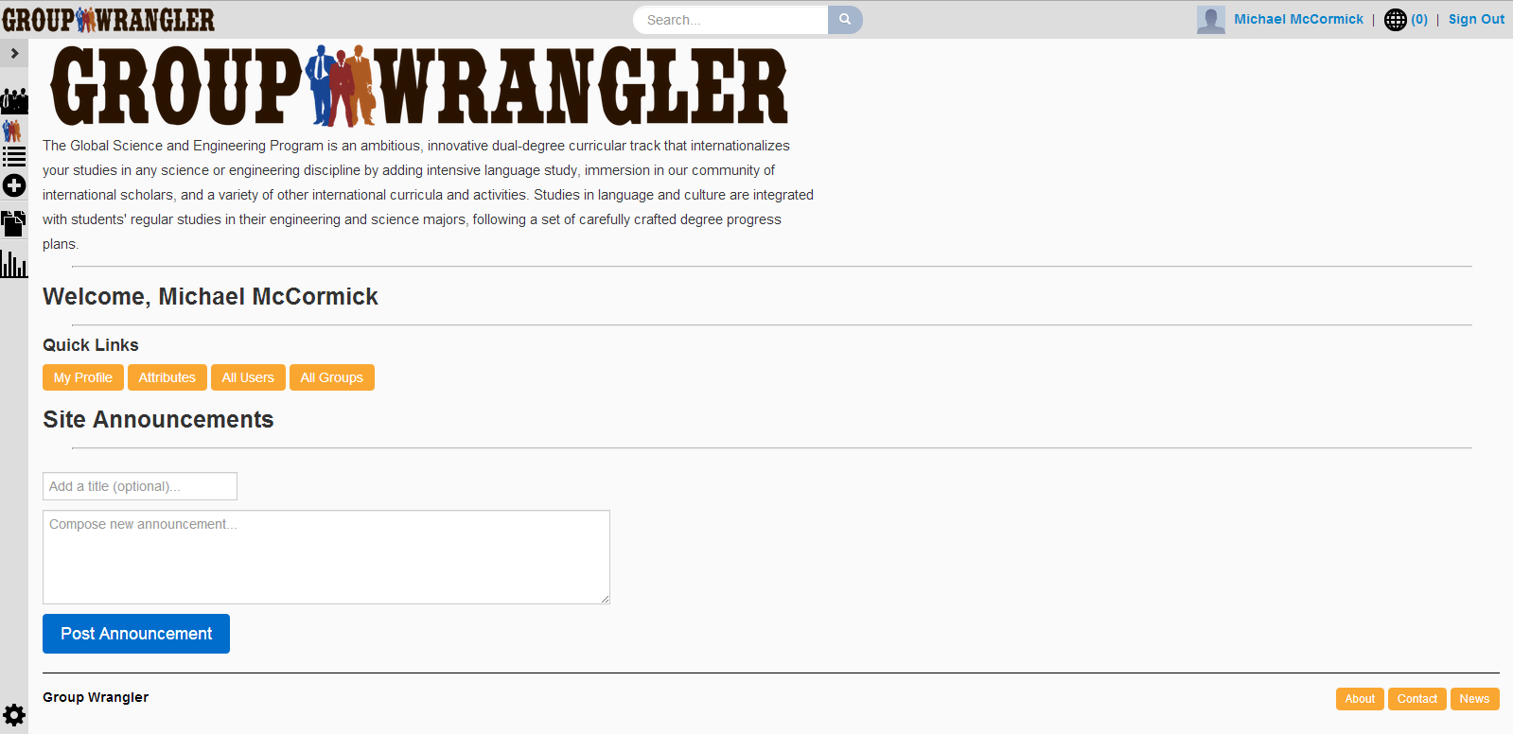
Figure 9 - Site Overview
The header is available on every page, regardless of whether or not a user has signed in. The sidebar is available to all users once they have signed in. Finally, administrators have access to a set of quick links to important site management tools on the site’s home page.

Header (navigation)
The header bar (Figure 10) is located at the top of every single page in Group Wrangler.
Figure 10 - Header Bar

Implementation Overview
The header bar was built to include links to some of the most frequently accessed tools and to include tools that an average user would expect to see. The logo, search bar, and sign in/out features are always there, and if the system detects a signed in user, that user’s picture and name are displayed, as well as the user’s notifications.
Services Provided:
- Quick access to both the home page and the user’s profile page
- Notifications overview, including total notifications count, quick access to the most recent five notifications, and access to all notifications
- Search tool that provides users with a means to search users and groups by name, contact info, and attributes.
- Sign in and sign out links for users
Contribution
The including of the header bar simply makes for a much nicer user experience by giving one click access to frequently access pages that might take three or more clicks to access otherwise.

Sidebar (navigation)
Shortly into development, our team realized that our header bar was getting very crowded. To that end, we implemented a sidebar that like the header provides quick access to a lot of the frequently accessed tools of the site.
Implementation Overview
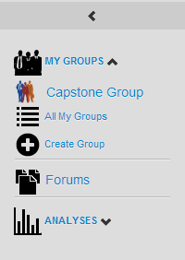
As most of the information on the sidebar is only relevant to signed in users and administrators, the sidebar is only visible when logged in to the site. Once logged in to the site, the system displays various information and tools depending on whether or not the signed in user is an admin. We included the option to change the sidebar to have either a maximized view (Figure 11) or a minimalistic view, showing only icons.
Services Provided:
- Quick access to all of the user’s groups as well as a link to the user’s groups tab
- Link to the group creation page (administrator only)
- Link to the list of all groups’ forums
- Quick access to all saved analyses as well as a link to the list of all analyses page (administrator only)
- Link to the analysis creation page (administrator only)
- Quick access to global site settings (administrator only)
Figure 11 - Sidebar (Expanded)
Contribution
Including the sidebar allowed us to really clean up the header bar by moving a lot of the header bar content to the sidebar. It also allowed for showing of lists of groups and analyses at all times, which would have been hidden away in drop down menus, had those features stayed in the header bar.
Footer (navigation)
The Group Wrangler footer display information about the project itself, as well as links to some helpful materials (Figure 12).
Figure 12 - Footer Bar

Implementation Overview
The footer was added as a place to display some miscellaneous information that the average user might not be too interested in. Knowing that this information would be rarely accessed, we decided placement on the bottom of each page would be sufficient. The footer is completely static, and only contains links and information about the development of Group Wrangler.
Services Provided:
- Displays ‘Group Wrangler’ even if logo/site name are changed.
- Link to page talking about project and us
- Link to contact information
- Link to news information for ruby on rails (useful for developers)
Contribution
Adding the footer gave us a place to give ourselves credit, talk about how the project was developed, and give aspiring developers somewhere to start if they want to build something similar/expand on our project.

Home Page (navigation)
Early into the project, signing into Group Wrangler directed the user to the profile page. While this was nice, it made it harder for administrators to get information to the general users of the site. The home page was added as a place for administrators’ to post announcements and well as a launching point to the user’s profile page and a selection of site management tools for administrators (Figure 13).

Figure 13 - Home Page
Implementation Overview
The home page is where users are directed after signing in or signing up to the site. This page can only be accessed by signed in users. The page checks for administrator status to determine whether or not to include administrator only tools.
Services Provided:
- Displays custom site description if one has been added
- Quick link to user’s profile
- Quick link to site attributes, all users list, and all groups list (administrator only)
- Form to post announcements (administrator only)
- Paged list of site announcements
Contribution
The including of the home page gives users an easy way to keep up on major announcements, keeping administrators from being forced to email users. It is also useful for administrators, making some of the harder to find administrator tools (attributes and all users/groups list) easy to navigate to through use of the quick links feature.
5.2 – Attributes
Attributes are a core feature of Group Wrangler. They are used by both users and groups to keep track of user information as well as the automated grouping algorithm, which is used to determine members for groups.
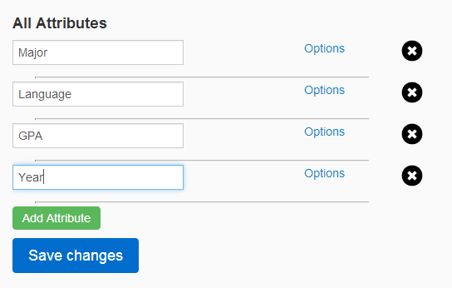
Figure 14 - Attributes Tab
Attributes Tab (user/group management)
Implementation Overview
Easily the most complicated part of Group Wrangler, the attribute system allows for completely customizable attributes. While some information for users and groups such as name and contact info is static and always available, all other attributes in the system are completely dynamic.
The attributes tab (Figure 14) is where administrators can set up system attributes, which can then be immediately used by both users and groups. Administrators have access to a wide variety of options for specifying and limiting the information that can be entered for each attribute (Figure 15).
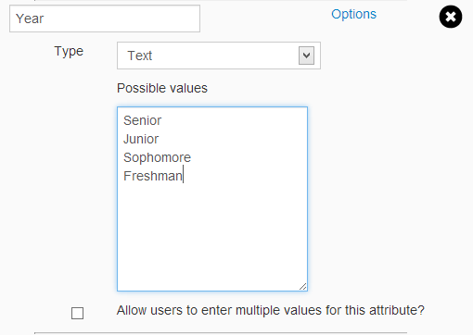
Services Provided:
Figure 15 - Attribute Options
- Allows for attributes to be tailor fit to any organization that is using Group Wrangler.
- Allows for various types of attributes (text, whole number, date, etc.).
- Attributes can be limited by possible values (ex. Year attribute could be limited to Senior, Junior, Sophomore, or Freshman).
- Attributes can be limited to ranges of values (useful for numbers and dates).
Contribution
Allowing for customizable attributes is a big part of what makes Group Wrangler unique. It makes it so any organization can use the system and build it to keep track of any kind of information they want.
Automatic Grouping (user/group management)
Implementation Overview
Once the attribute system was in place, we implemented our automated grouping algorithm. The algorithm works such that whenever a user updates their attributes, the system checks all groups using automatic grouping. The user is added to any groups that they now meet the requirements to join and is removed from any groups that they no longer meet the requirements for. Similarly, if a group using automated grouping is updated, the system checks all users of the system, adding users that now meet the group’s requirements and removing any members of the group that no longer meet the requirements of the group. One last thing of note here is the automated grouping algorithm can be overridden, with administrators having the ability to invite users to groups even if they don’t match the criteria for that group.
Services Provided:
- Manages placement of users intro appropriate groups
- Membership is checked for whenever a user or group updates their information.
Contribution
Automated grouping is the single most useful tool in Group Wrangler. It removes the need for users to manually search for groups to find users with similar attributes as them. By automatically managing users’ groups, Group Wrangler also eliminates the hassle of users having to manually leave groups they will likely no longer interact with.
5.3 – User
The user page (Figure 16) is the hub for all user activity. It is from here that users can access all of the tools available to them as well as maintain their profile information.
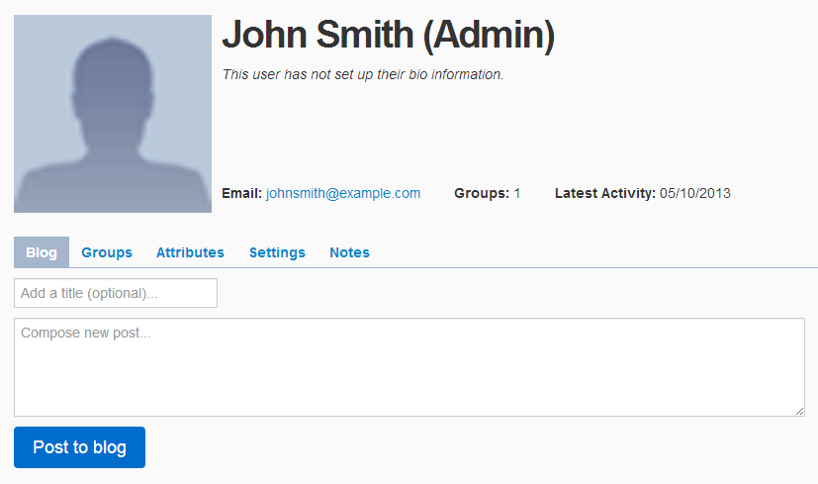
Figure 16 - User Page
The tools available on each user’s page are their profile, a personal blog, a list of their groups, a place to set their attributes, and a place to configure general and privacy settings. Additionally, administrators have access to a place where they can keep notes on the individual user.

User Profile (user/group management)
The user profile (Figure 17) was added to feature the user’s basic information, especially any information that other people visiting a user’s page might be interested in.
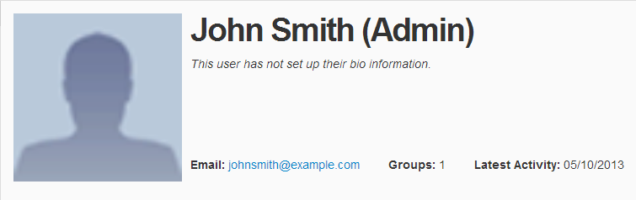
Figure 17 - User Profile
Implementation Overview
The system checks for administrator status and displays it after the user’s name if the user is an administrator in order to make administrators easily recognizable. The profile will also display links to a personal website for the user as well as the user’s resume.
Services Provided:
- User profile picture and administrator status
- User bio information
- User’s email address
- Other important information (number of groups and date of last activity)
- A button to promote the user to administrator status, or demote them back to general user status (administrator only)
- Links to professional website and resume (if the user has uploaded them)
Contribution
The user profile is a great “snapshot” of each user, offering anyone who comes to the page a solid idea of just whose page they are visiting.

Blog Tab (communication)
The blog is a tool that is provided to all users. Users can post blog posts, which can then be viewed by anyone who has permission to view it (based on the user’s privacy settings).
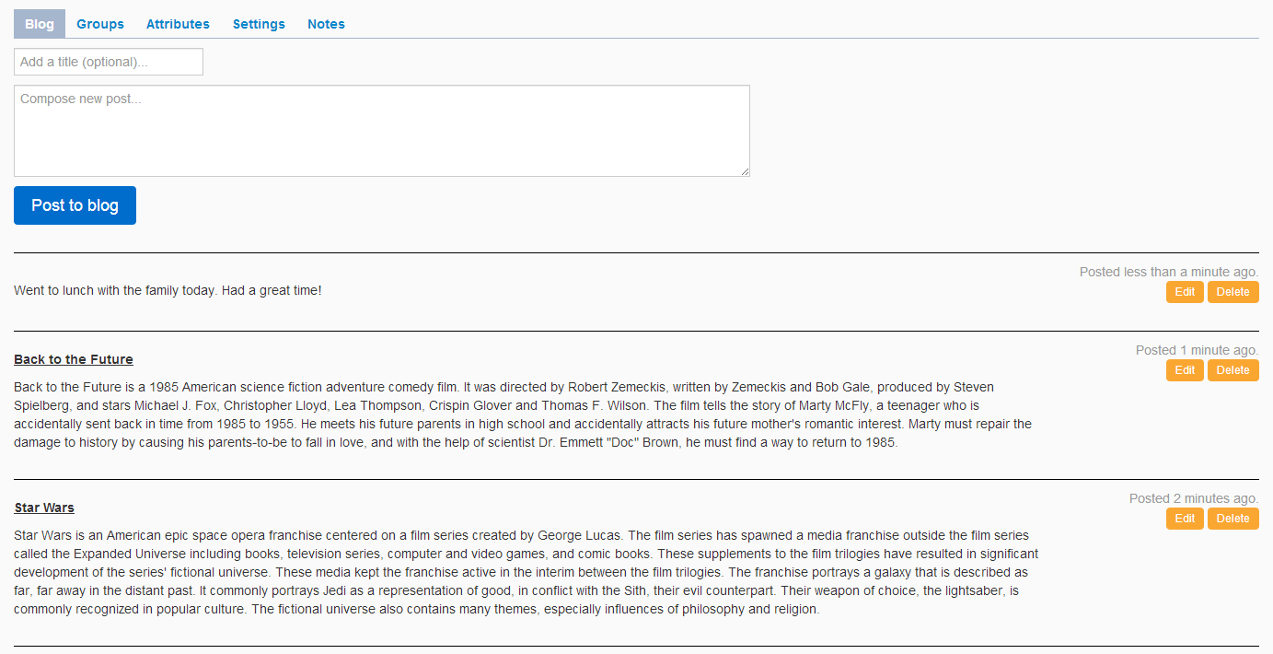
Figure 18 – User’s Blog Tab
Implementation Overview
The user blog (Figure 18) was implemented in a similar manner to both the home page announcement posts and group announcement posts. It displays a paged list of the user’s blog posts, starting with the most recent. If the system detects the signed in user is on their own page, a form to submit new blog posts will appear, as well as the option to edit or remove old blog posts. As it is likely the tool that a user will use most on their page, it is always the default tab that gets loaded when a user visits their own page.
Services Provided:
- Users can share information
- Optional titles for each blog post
- Blog posts can be edited or removed by the user who posted them or any administrator
Contribution
The blog tool is a great way for users to share experiences, post progress, or post whatever they want. It is a great way for visitors of the page to see what a user has been up to.

Groups Tab (user/group management)
The groups tab (Figure 19) is where the user can go to view a list of their groups. Users can also navigate to their group’s pages from here.
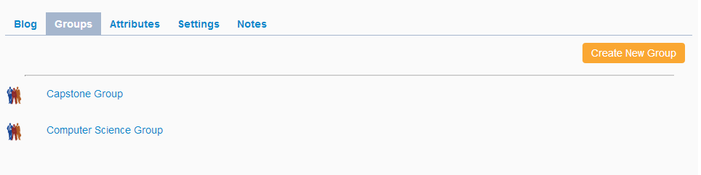
Figure 19 – User’s Groups Tab
Implementation Overview
While the user can view all of their groups from the sidebar, only so many groups can be seen at once. The user must scroll to see further groups. The groups tab (Figure 11) was added so the user a can see a larger list of the groups that they are in.
Services Provided:
- Paged list of all groups the user is a member of
- Link to create a new group (administrator only)
- Any groups the user has been invited to will show up at the beginning of the list, with the option to accept or decline the invitation listed after the group’s name.
Contribution
While the groups tab doesn’t provide functionality much different from the “My Groups” portion of the sidebar, having more screen real estate makes it easier to look through, and also is a great place for users to immediately see groups they have been invited to.

Attributes Tab (user/group management)
The attributes tab (Figure 20) displays a list of all attributes that have been set up by administrators. It is from here that users can enter their own information for any available attributes that they wish. The information stored here is responsible for placing the user into the groups that they meet the criteria for.
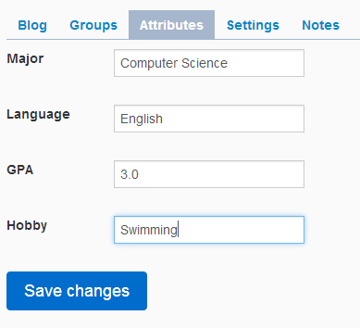
Figure 20 – User’s Attributes Tab
Implementation Overview
The attributes tab grabs the list of currently set up attributes, and displays each one in a form that the user can fill out. Each attribute can show various options, like a drop down list of options or fields for multiple entries, all based on the administrator settings set up for that attribute.
Services Provided:
- Provides the list of attributes the user currently has available to enter information for.
- If an attribute has been set up to only accept a set of possible values, the user will be provided that list of values to choose from.
- Users can enter multiple values for an attribute if the administrator has set up the attribute to allow for multiple entries.
- Allows for users to be automatically placed into relevant groups.

Contribution
While the groups tab doesn’t provide functionality much different from the “My Groups” portion of the sidebar, having more screen real estate makes it easier to look through, and also is a great place for users to immediately see groups they have been invited to.
Settings Tab (user/group management)
The settings tab (Figure 21) is where the user can configure general profile and privacy settings.
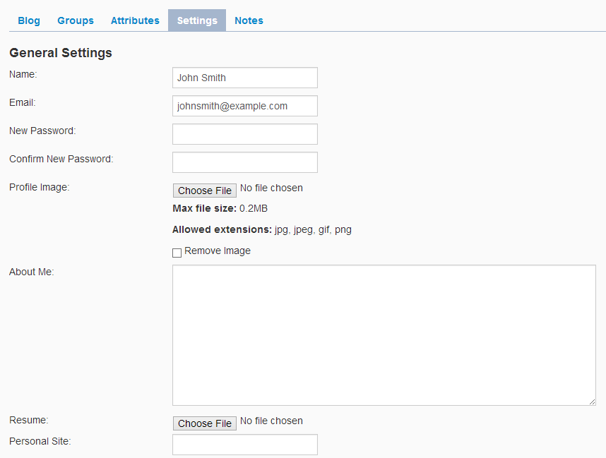
Figure 21 – User’s Settings Tab (General Settings)
Implementation Overview
The settings tab only shows up if the page detects the signed in user is the owner of the page or if the signed in user is an administrator. If the system is using the token feature to invite users to the system, then only administrators will be shown the fields to update the user’s name and email address.

Services Provided:
- Users can manage general settings from here (password, profile photo, biography, personal site, and resume)
- If the site settings allow it, the user can manage their name and email address. Otherwise, only administrators can update user’s name and email address information.
- Users can manage privacy settings including who can access their page as well as who can see their blog, groups or attributes.
- If access to the user’s page is restricted, people who cannot access the page will also not see the user in searches or member lists.
Contribution
The settings tab provides a lot of basic, expected functionality to the user. Privacy is very important in this day and age, and this tool gives the user the ability to control who can see their page or specific parts of their page.
Notes Tab (user/group management)
The notes tab (Figure 22) is a tool exclusively available for administrators. While it is located on the user’s page, only administrators will be able to see it at all. Many uses of Group Wrangler may find uses for this tool. For example, educational uses of Group Wrangler might keep track of advising notes on each user.
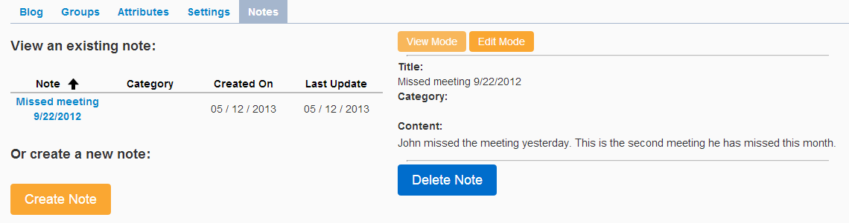
Figure 22 – User’s Notes Tab
Implementation Overview
The notes tab only shows up if the currently signed in user is an administrator; whether or not a general user is visiting their own page does not matter. If no notes are currently attached to the user, the form to add a new note is displayed. Otherwise, if one or more notes are attached to the user, the list of notes will be displayed along with a button to open up the form for creating new notes.

Services Provided:
- Administrators can view a list of created notes that can be sorted by a variety of criteria (title, category, creation time, or time of last update).
- Administrators can create notes that include a title, a category (optional), and the content of the actual note.
- Administrators can delete and edit previously created notes.
Contribution
The notes tab provides administrators a simple, but powerful tool that lets them keep notes on each user containing information that the user might not need to see.
5.4 - User Notifications

On the average Group Wrangler site, a user may be a part of many groups, and may be active in many forum topics. With all of that going on, it may be difficult for the user to keep track of what has been updated they may be interested in. To that end, Group Wrangler supports a notification tool (Figure 23) and subscription system that allows the user to receive notifications of any updates that they may be interested in.
Figure 23 - Notifications Tool (Globe symbol with number)
Notifications (communication)
The notifications feature can be separated into two tools. The header bar contains a quick look tool, displaying the total count of unviewed notifications, the most recent five notifications. The notifications page (Figure 24) contains a full list of all of the user’s notifications. Users can click on notifications in either tool to be taken directly to the appropriate page.
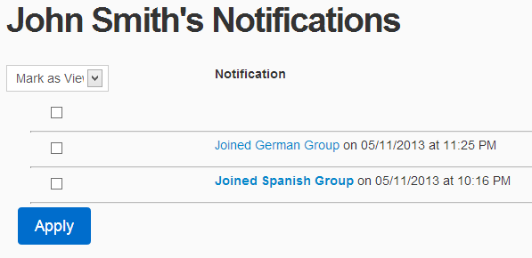
Figure 24 – Notifications Page
Implementation Overview
The notifications tool was implemented to allow the user to quickly get an idea of any updates to the site since their last visit. To that end, notifications are sorted with the most recent one first. The quick view tool in the header bar was implemented allow users to get this information even faster.
Services Provided:
- Notifications for invites to groups that direct the user to their groups tab, where they can accept or decline the invite. Performing either action will delete the notification.
- Notifications for automated grouping causing the user to join or leave a group.
- Notifications for new posts on a group’s announcement tab (if the user has subscribed to the group).
- Notifications for new posts in a forum topic that the user has previously posted in (if the user has subscribed to the topic).
- Notifications get marked as viewed when the user clicks on them to keep track of which notifications have not been looked at.
- Notifications can be marked as viewed or deleted in bulk from the notifications page.
Contribution
Users do not want to have to check every group and every forum they are a part of in order to see what has been updated. The notifications tool makes Group Wrangler much less frustrating for the user and over all makes visiting the site a potentially must faster experience.
Subscriptions (communication)
While notifications are a great tool for keeping users aware of what is going on with a site, there are a few inherent dangers in using them. The largest of which is preventing a user’s notifications from getting too cluttered. For instance, there may be forum topics that a user posted in once and no longer is interested in receiving updates on. Getting these updates could bump important notifications further down the list, which could make them harder to find. While it was mentioned earlier how the user can delete any notifications they no longer want, it would be even better if the user could prevent specific notifications from being sent at all. Group Wrangler includes an option for users to subscribe and unsubscribe to both groups and forum topics (Figure 25) to help control the notifications that the user will receive.
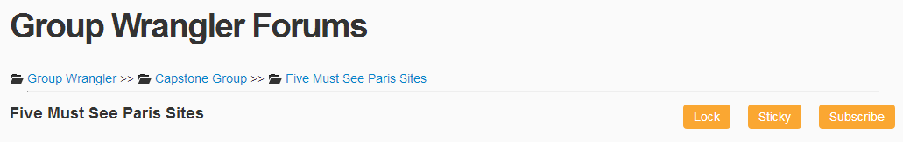
Figure 25 - Subscribe Button (lower right corner)

Implementation Overview
The subscription feature is a button that is located on every group’s announcement tab and in every forum topic. Whenever a group announcement is added or topic post is made, only users who are currently subscribed to the group/forum topic will receive notifications. When joining a group the user is initially subscribed, however, when creating a topic the user will not be initially subscribed.
Services Provided:
- Allows the user to apply some control over what notifications they receive.
- Users can subscribe or unsubscribe to a group or forum topic at any time.
Contribution
While simple, the subscription feature makes the notifications tool much more customizable. Users could be challenged by having to search through large amounts of notifications they may or may not be interested in. The inclusion of the subscription feature mitigates this challenge.
5.5 – Group
The group page (Figure 26) is the hub for all group activity. It is from here that all group tools can be accessed by any users that are permitted to use them.
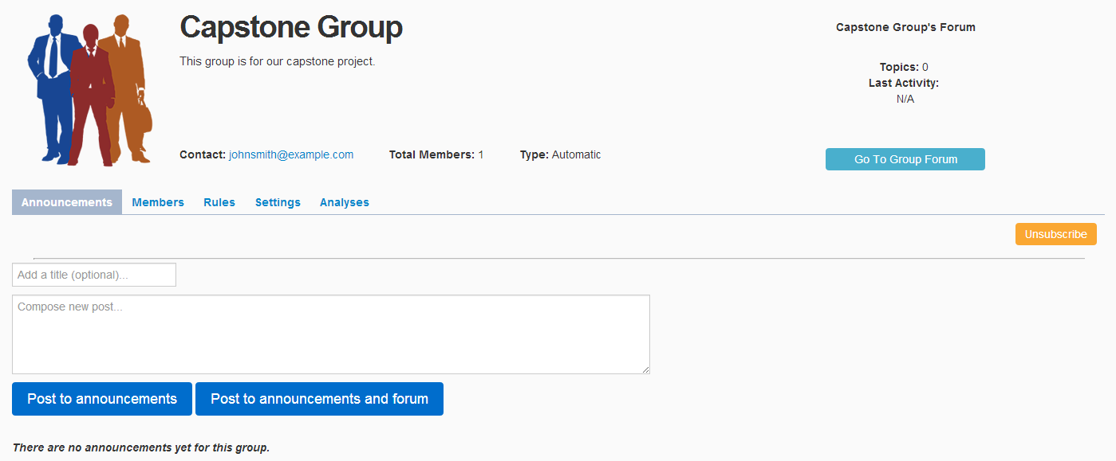
Figure 26 - Group Page
The tools available on each group’s page are a profile, an announcements board, and a list of the members of the group. Additionally, administrators have access to a tool to define the requirements for joining the group, and a tool to configure general and privacy settings. Additionally, administrators can create analysis for the group from the group page.

Group Profile (user/group management)
The group profile (Figure 27) was added to feature the group’s basic information, as well as to provide a quick look and access to the group’s forums.
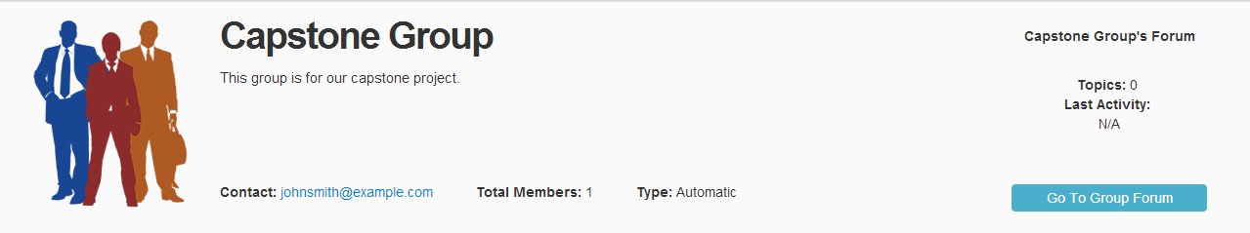
Figure 27 – Group Profile
Implementation Overview
The group profile was designed to look very similar to the user profile. The information displayed for general users and administrators is nearly identical, with the only difference being that administrators can always see the join button, while general users only are given the option for public groups.
Services Provided:
- Displays group name.
- Displays group photo.
- Provides a description for the group, if one has been added.
- Displays contact information for the group.
- Shows a count of the total number of members in the group.
- Shows the type of the group (public, private, automatic) .
- Provides an option to join/leave the group based on the type of group.
- Provides a quick look area for the group’s forum, as well as a link to take a user directly to that group’s forum.
Contribution
The group profile, like the user profile, is designed to allow anyone visiting the page to be given a solid idea of what each group was made for and view important details of the group.

Announcements Tab (communication)
The group announcements tab (Figure 28) was added to give a place for members of a group to view recent news and updates related to that group.
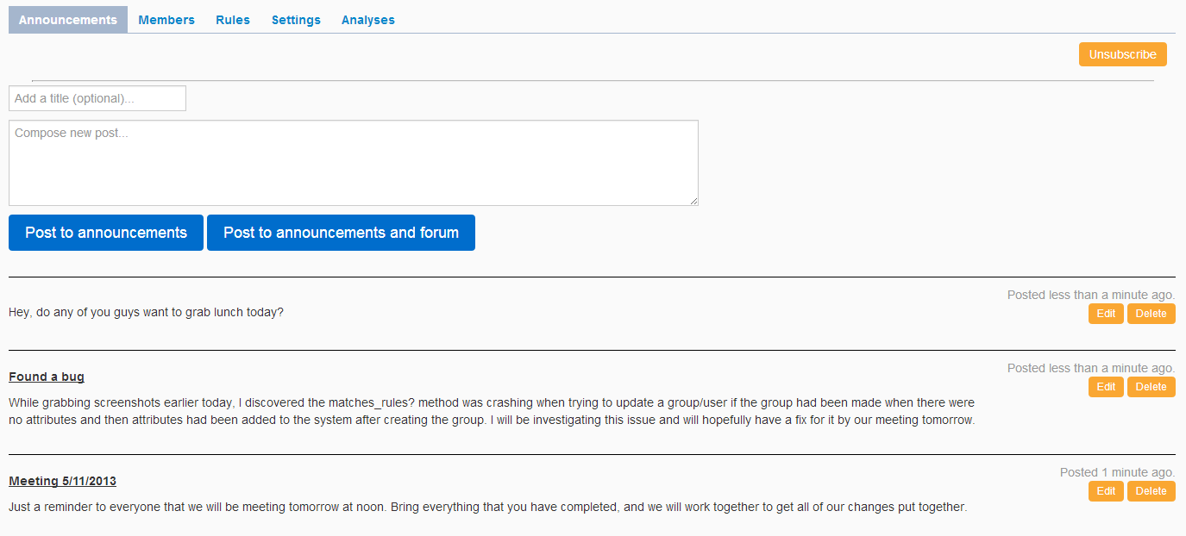
Figure 28 – Group Announcements Tab
Implementation Overview
The group announcements tab was designed to look very similar to the user’s blog. Announcement posts are sorted to display the newest announcement first. If the page detects that the current user is an administrator, then the page will display a form to submit new announcements as well as the option to edit and delete previously existing announcements. Additionally, whenever a new announcement is created, any user who has subscribed to the group will be given a notification for the new post.
Services Provided:
- Allows any users who can have permission to view the tool to see any news and updates that have been posted about the group.
- Provides a form for posting new announcements (administrator only).
- Includes a secondary option that allows for an announcement post to be posted to both the group’s announcements tab and as a new topic in the group’s forum.
- Provides buttons to open an existing announcement post up for editing, as well as to delete existing announcements posts (administrator only).
- A subscribe/unsubscribe button in the upper right corner of the tab gives users the ability to decide whether or not they would like to receive notifications whenever this group receives a new announcement post.

Contribution
The announcements tab provides administrators a clean way to post news and updates for members of the group. By providing an option to post the announcement to the forums as well, users are given a place where they can discuss and comment on the announcement.
Members Tab (user/group management)
The group members tab (Figure 29) is where users can go to view the current members of a group.
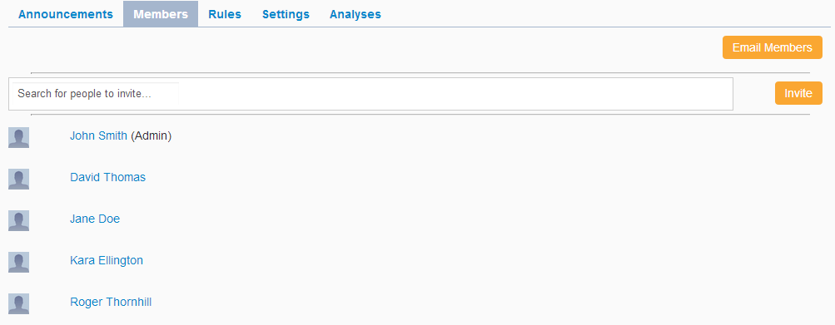
Figure 29 – Group Members Tab
Implementation Overview
The group members tab provides a paged list of users in a group. Since each member has little information display, members are displayed in up to three columns per page. The page sorts the member s to display administrators that are a part of the group first, as well as signifies that they are administrators. Finally, administrators have access to both an option to open up a form to email any and all members of a group, as well as the option to invite multiple members to a group at once.
Services Provided:
- Displays a paged list of members that is sorted by administrator status. Member names function as links that lead to the member’s page.
- Provides an option for administrators to email any and all members of the group (administrator only).
- Provides an auto completing invite tool for users that allows for multiple selection (administrator only).

Contribution
A crucial part to managing groups is being able to see the members that make up the group. The members tab makes it easy for administrators to view all the members of the group as well as makes it easy for members to locate an administrator or any other members in the group. The invite tool makes adding members to any type of group easy and quick no matter how many users the administrator is looking to invite.
Rules Tab (user/group management)
The group rules tab (Figure 30) is where the requirements for being automatically added to the group are defined.
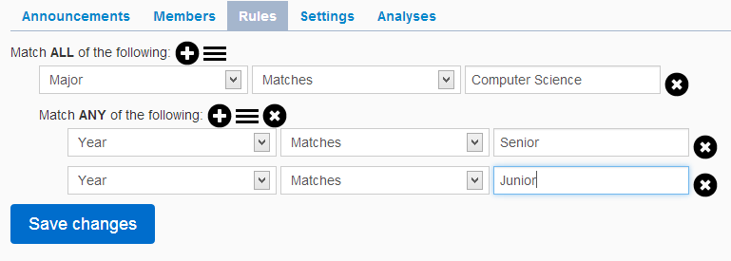
Figure 30 – Group Rules Tab
Implementation Overview
The group rules tab has the most complicated form in all of Group Wrangler. It is a nested form that allows administrators to build a complex set of rules where users must meet all, any, or a combination of all and any, in order to become a member of the group. Administrators have buttons available to add new rules, add new inner blocks containing more rules, and remove existing rules and blocks of rules. Once a rule has been added, the administrator can then pick from the list of current attributes, and define an operator and enter a value to make up a requirement for the group. If the user visiting the page is not an administrator, the rules are shown in text format, with no options to edit or save appearing.
Services Provided:
- Provides a button to add a new rule to the current block of rules (administrator only).
- Provides a button to add a new block of rules inside the current block of rules (administrator only).
- Provides a button to remove individual rules or entire blocks of rules (administrator only).
- Allows for an administrator to specify each rule’s attribute, operator, and value (administrator only).
- Displays text read out of rules for any non administrator visitor.
Contribution
Defining requirements for groups is a necessary feature in order to support automatic grouping. Group Wrangler provides a tool here that allows for administrators to tailor fit a group’s requirements to match any conditions they need.
Settings Tab (user/group management)
The group settings tab is where administrators can go to update any of the group’s profile information (Figure 31) as well as update privacy settings.
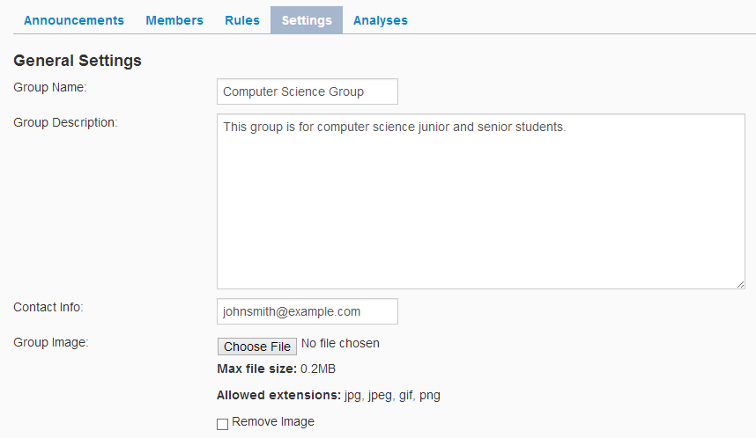
Figure 31 – Group Settings Tab (General Settings)
Implementation Overview
The privacy settings tab only shows up for administrators, regardless of any privacy levels. Its layout is designed to be very similar to the user’s settings tab. Groups were given an additional privacy level (only administrators) that can be used to make an group only show up to administrators.
Services Provided:
- Administrators can manage general settings from here (name, description, contact information, and profile photo).
- Administrators can manage privacy settings including who can access the group’s page as well as who can see their announcements, members, or rules.
- Administrators can also manage the privacy of the group’s forum. If a forum is hidden from a particular user, they will not see the quick view on the group profile, nor can they find that group’s forum on the list of all forums index.
- Provides with an additional level of privacy (only administrator).
- If access to the group’s page is restricted, people who cannot access the page will also not see the group in searches or on a user profile’s groups tab.
Contribution
The settings tab provides a lot of basic, expected functionality for the group. Privacy is very important in this day and age, and this tool gives the administrators the ability to control who can see the group’s page or any individual tools on the page.
Analyses Tab (user/group analysis)
The group analyses tab (Figure 32) contains an assortment of analyses information and tools that are tied to the group.
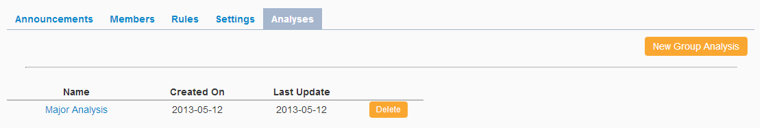
Figure 32 – Group Analyses Tab
Implementation Overview
The analysis tab is visible to administrators only. The page looks through all analyses and finds the ones that are tied to the current group, and then displays a list of those analyses.
Services Provided:
- Provides a list of links to analyses that are tied to the group that can be sorted by name, creation date, or date of last update.
- Provides a button to link to a new analysis that is tied to this group and starts with that group’s rules loaded as default filters.
Contribution
The group analyses tab provides a simple way for administrators to view only the analyses that are associated with a particular group. The create analysis button preloading the group’s rules in the new analysis the button creates saves a lot of time for administrators.
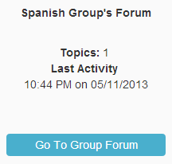
Forum Quick Look (communication)
Figure 33 - Forum Quick Look
Every group created in Group Wrangler is given its very own forum space. In addition to providing access to that forum through the group page, the group page also displays a few statistics generated from the forum. All of this is contained in the forum quick look section (Figure 33) of the group page, which is located along the right edge of the group’s profile area.
Implementation Overview
The forum quick look section shows up provided members have permission to view the current group’s forum to begin with. It counts the total number of topics associated with the current group, and finds the topic that has the most recent post.
Services Provided:
- Provides a link to the forum itself.
- Displays the total number of topics currently in the forum.
- Displays the time and date of the most recent post created in the forum.
Contribution
The forum quick look provides access to a group’s forum quickly, but more importantly it shows members the information they need to see whether or not the forum was updated at all since they last checked.

5.6 - Forum
Every group is Group Wrangler is given its own forum space. The Group Wrangler forums can be accessed in two different ways, either through the sidebar which leads to the list of all forums currently available to the user (Figure 34), or through a group’s profile, which will take the user directly to that group’s individual forum.
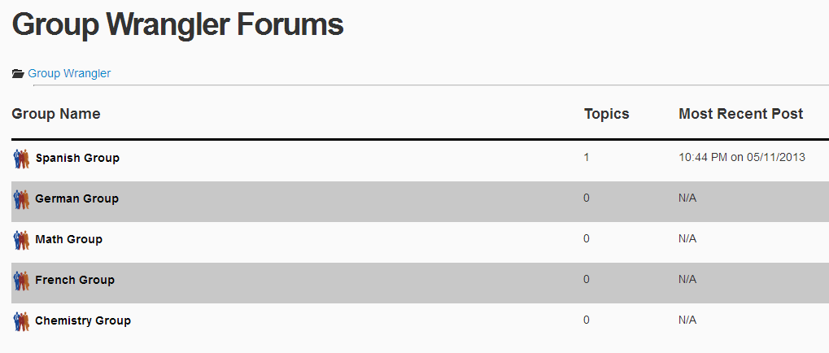
Figure 34 – Forums Index
The forums index page will only show the forums that the user has permission to see based on the settings for each group.

Group Forum Page (communication)
The group forum page (Figure 35) displays all topics that belong to a particular group. It can be accessed by clicking a particular forum from the forum index page or by clicking the go to forum button found in each group’s profile.
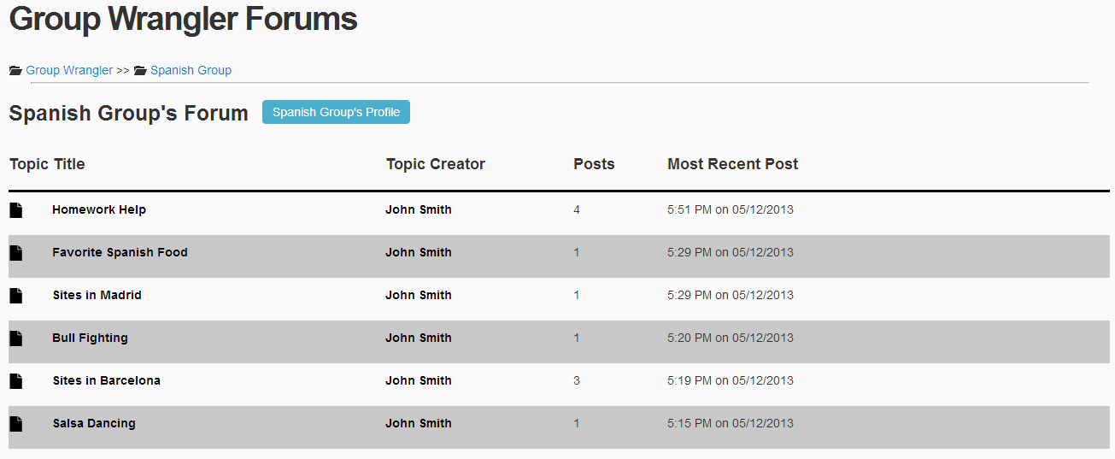
Figure 35 – Group Forum
Implementation Overview
The group forum page checks the database for all topics associated with the group that forum belongs to. The page then displays the topics in a paged list format. The page also checks for user status, and displays an edit title button for administrators and topic creators, as well as a delete button for administrators. If the user has signed in at all, the page will display a form to add a new topic at the bottom of the page.
Services Provided:
- Breadcrumb trail up top allows for refreshing of the current page or to navigate back to the list of all forums.
- Provides a button that will take the user back to the corresponding group’s page.
- Topics sorted so that the topic with the most recent post is displayed first.
- Provides a form for creating new topics by entering a title and the content for the first post of the topic.
- Option to edit the title of a previously created topic for both administrators and the user who created the topic.
- Option to delete topics (administrator only).
Contribution
Including the group forum page allows for topics to be organized by the group for which they were created. It makes navigating the forums significantly easier for a user.
Forum Topic Page (communication)
Opening a topic from the group forum page brings the user to the forum topic page (Figure 36), where all the posts that belong to that topic are displayed. This page can be accessed as well through a notification about new posts pertaining to the topic.
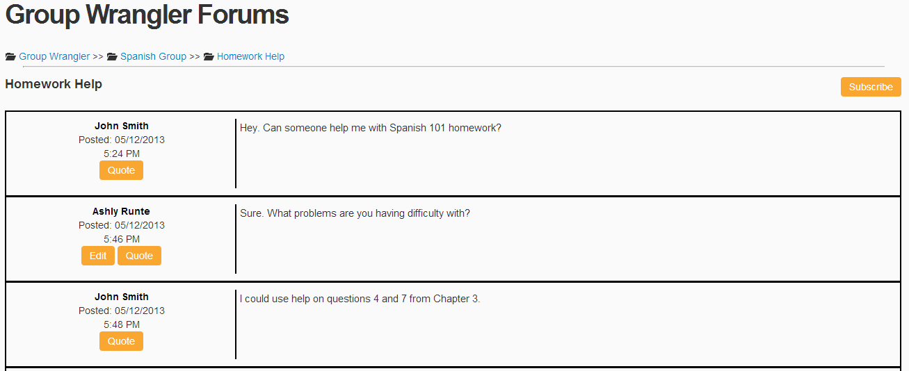
Figure 36 – Forum Topic
Implementation Overview
The page checks the database for all posts that correspond to the current topic, and displays them in a sorted format with the oldest post first. If the page detects that the current user is an administrator, it will display the lock/unlock button and stick/unstick button. If the user has signed in at all, the page will display a form to add a new post at the bottom of the page.
Services Provided:
- Breadcrumb trail up top allows for refreshing of the current page or to navigate back to the list of all forums or all topics for that forum.
- Provides a button to subscribe/unsubscribe the user to/from the current topic.
- Posts sorted so the oldest post is displayed first.
- Option to lock/unlock the topic, controlling whether or not users can add new posts to the topic, or edit old posts (administrator only).
- Option to stick/unstick the topic. Stickied topics are placed at the top of the first page in each group’s forum regardless of the time of most recent most (administrator only).
- Form to add a new post by entering the content for that post.
- Button to edit the content of a post that only shows up if the current user is the one who created the post or an administrator.
- Option to create new post that by quoting an older post.

Contribution
The posts feature now provides users with a simple, but powerful format for enabling discussions between users. By allowing for subscriptions of topics, users can keep up with conversations easily.
5.7 – Analysis
The analysis module is used to quickly analyze users and groups with statistical and graphical breakdowns that can be saved as templates or snapshots of past data.
Analysis Tool (user/group analysis)
The analysis tool (Figure 37) can be accessed through an administrator sidebar as well as through a group’s analyses tab. The analysis tool shows statistical and graphical breakdowns made up of live data constructed from filtered users and groups.
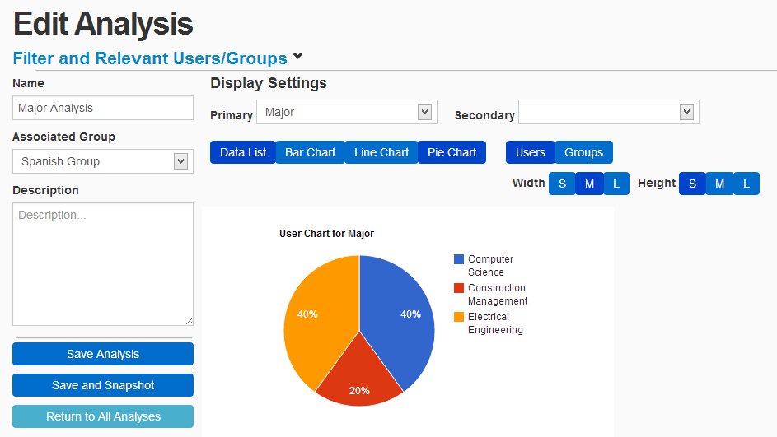
Figure 37 - Analysis Tool

Implementation Overview
The analysis page can only be accessed by administrative users. It has a filter that is built in the same manner as the group’s rules tab. The page uses the rules from this filter to grab relevant users and groups which are then applied to the various chart and graph options. Various options for charts will be displayed depending on the type of chart chosen.

Services Provided:
- Option to edit the name of the analysis.
- Option to edit the description of the analysis.
- Option to update the associated group for the analysis.
- If a group is associated, the new analysis filters are preloaded with that group’s rules.
- Can update filters to narrow or broaden user/group results.
- Displays lists of both relevant users and groups that can be hidden.
- Can create a group based on the filters currently applied to the analysis.
- Can email the users displayed in the relevant list of users.
- Provides ability to choose a primary and secondary attribute for analysis.
- Provides five choices for analysis type (pie, bar, line, area, and data chart).
- Option to customize whether analysis is performed on user, groups or both.
- Provides a variety of options depending on the type of chart selected.
- Provides ability to customize height and width of charts.
- Can save analysis as a template.
- Can save analysis as a snapshot.
Contribution
The analysis gives a lot of power to the administrator. It is extremely useful for seeing what a potential group will look like in terms of what users will be a part of the group, before the group is even created. Similarly, it is useful for seeing how the member base for a group will be affected by modifying a group’s rules.

Analysis Snapshot Tool (user/group analysis)
The analysis snapshot feature is a way for administrators to save historical information about analyses, so that the data from the time of snapshot creation is preserved. Analyses snapshots can be view by anyone, provided that they have the URL that it is stored at.
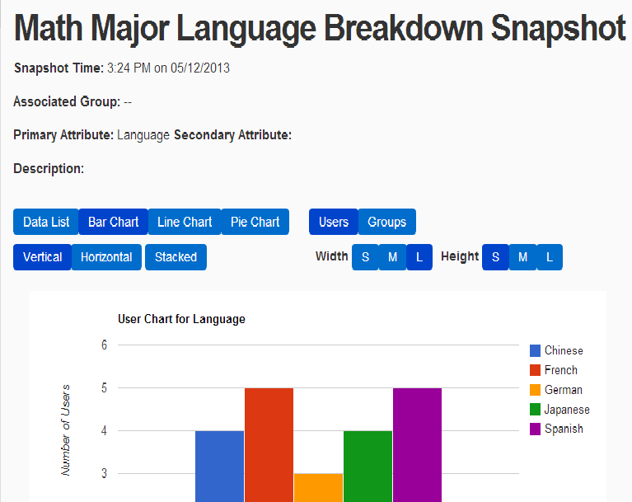
Implementation Overview
When an analysis snapshot is created, the relevant user and group information, as well as all of the selected chart options, are saved to the snapshot as text. This way, if the users and groups are updated, the snapshot will remain unaltered.
Services Provided:
- Displays a list of snapshots
- Provides a button to delete a snapshot (administrator only).
- Stores a historical view of an analysis that can be viewed by anyone.
Contribution
The snapshots feature allows administrators to share read access of an analysis with anyone, while protecting user information. It also allows for administrators to store save live data from an analyses for later viewing.
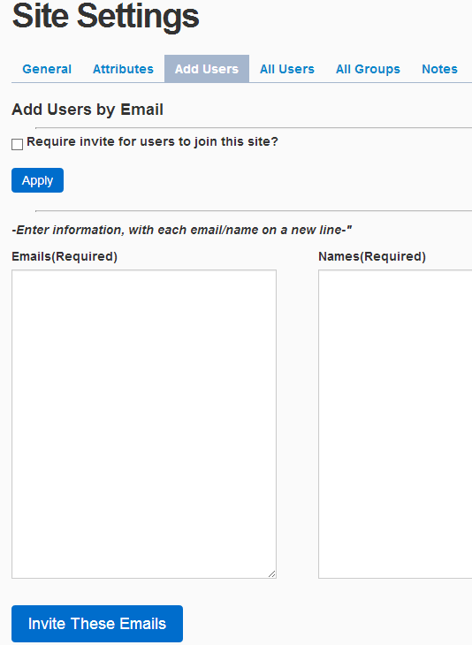
5.8 - Site Settings
The site settings page (Figure 39) is where administrators can access a variety of tools that pertain to site wide management. It can be accessed through the lower portion of the sidebar.
Implementation Overview
The site settings page can only be accessed by administrators. It provides forms for updating site wide options, as well as complete lists of users and groups.
Services Provided:
- Provides option to update site logo.
- Forms for updating site name as well as an optional site description.
- As mentioned earlier, attributes are managed and created by administrators.
Figure 39 - Site Settings (Add Users Tool)
- Option to require users to be invited to the site.
- Provides ability to invite users to the site by entering user email and name.
- Paged list of all users with options to remove each user from the system.
- Paged list of all groups with options to remove each group from the system.
- Provides a tool that allows administrators to define the categories that will be used by the notes tool.
Contribution
The site settings page provides a place to consolidate all site management functionality that is available to administrators. Having all of these tools in one place reduces the page navigation amount for the administrator, and also makes it all simply easier to find.

6 - Usability Testing

Our initial usability testing approach consisted of giving users a list of tasks to complete to determine how intuitive our design actually was. The list included basic tasks such as creating a group, adding posts to a user blog, and creating an analysis. We did not give the testers very much direction because we wanted to see how difficult it was to work with the application. The idea was that the user should be able to pick up and learn to use the application without any real guidance. We changes to the application based on the feedback from testing.

Our main testing subject for this application was our sponsor, Melissa Armstrong. We learned quite a bit from her experience with testing the application. In fact, when we first gave our sponsor the list of tasks to complete, she was unable to complete the very first task because she could not find the group creation page. To address this issue we decided to move the link to the group creation page to a much more accessible area in the sidebar.

The testing process led to a number of significant improvements to the application. Most of these improvements were related to page layout. We were able to move elements around on the pages so that the site became easier to navigate. We moved buttons around and rearranged some aspects of the header and sidebar. This process also led to several improvements in screen real estate. The initial version of our application had a large amount of white space, and most of the content was presented vertically so that the user had to scroll to see all of the page content. We were able to improve the page utilization so that information was compactly represented on the page while retaining full functionality.

In addition to testing the application with people unfamiliar with the development process, we also had regular meetings with our mentor, Dr. Eck Doerry. During these weekly meetings, he was able to help us identify what aspects of the application were working well and what aspects needed improvement. Our mentor has particular experience with user interfaces, so his feedback was very helpful in terms of developing an intuitive layout.

We are happy to report that we were able to incorporate most of the feedback from usability testing. The work we did to improve usability really helped to improve the application. We were able to show a live demo at the undergraduate research symposium at NAU, and people seemed impressed with how easy the application was to use. People were genuinely excited about being able to use the application for their own organizations.

7 - Future Work

While we are quite happy with the final version of Group Wrangler, there is still plenty of work that could be done to improve the application. Some of the items that we would like to see in future versions of the application are listed below.

Support for larger user bases

During the final part of this semester, we were only able to test the application with a limited amount of users and data. This should work great for an organization the size of GSEP, but we would like to see how the application scales with a much larger user base. We are thinking about user bases of 100,000 users or more. We envision Group Wrangler becoming the premiere group management system in the very near future, so we want to see how it handles the increased demand from more users. Much of the application’s ability to scale will depend on the servers that are used to run the application. However, there may still be areas where the algorithms in the application could be improved to reduce response time.

Additional analysis tool features

We believe the analysis tool is one of the most useful features of the application, but we can think of several features that could be added to improve it. First, it would be nice to incorporate additional graph types for the display options of the analysis tool. We were able to incorporate support for basic tables and graphs, but Google Charts supports a variety of other graph types as well. For some organizations, it may be very interesting to see a location graph of all of the people that are in a particular city or country. Second, it would be nice if there were a feature to automatically suggest when an administrator might want to make a group based on the results of an analysis. The analysis tool already provides helpful statistical breakdowns, but it would be great if the system tips on when a certain threshold of users has been reached or when you may have already created similar groups.

Additional integration with social sites

Group Wrangler works quite well as a social site by itself, but it would be great to integrate the application with other major social sites such as Facebook, Twitter, LinkedIn, and Google+. We really want to get users excited about using Group Wrangler and one way to accomplish this is to spread the word by letting people share content from Group Wrangler on other sites. This would be a great way for Group Wrangler users to share their experiences within a larger community.

8 - Conclusion

We are very pleased with the application developed. We were able to meet the main requirements of the product, and incorporate most of the changes requested from user feedback. We were even able to incorporate additional features such as notifications and saved snapshots for analyses. Our sponsor, Melissa Armstrong, was quite happy with the final version of the product. She found the application easy to use and recognizes how helpful it will be in terms of managing students in the GSEP program. The program will be used by GSEP beginning this fall. We are glad that we were able to produce a hybrid system that combines proper tools for group management with full support for communication among group members. We envision that Group Wrangler will become the premiere group management system in the very near future, and we look forward to seeing it applied to help manage a variety of organizations.

