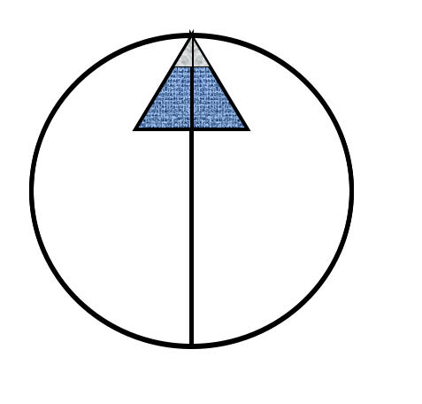

Northern Arizona Consulting

Preliminary Assessment and Site Inspection:
Copper Age Mine

Prepared for: Bureau of Land Management, Eric Zielske

Prepared by: Northern Arizona Consulting
Laura Garcia, Spencer Harvey, Carl Haskie, and Sarah Reddinger

Date: 05/10/2018

Acknowledgements

We would like to thank the Bureau of Land Management representative and client, Eric Zielske, for providing our Capstone team with this opportunity and for all the of his guidance along the way. We would also like to express our gratitude to Dr. Bero, our technical advisor, for her continuous support, immense knowledge, and assistance. We would like to thank our grading instructor, Alarick Reiboldt, for the advisement and motivation that he provided for two semesters. In addition, we would like to give a special thanks to everyone who helped with advisement and the lab procedures. This includes, Josue Juarez, Adam Bringhurst, Jeffrey Propster, Marty Mihay, and Josh Froyum, we would not have been able to complete this work without them.

Table of Contents
List of Figures iv
List of Tables v
List of Abbreviations vi
1 Project Understanding 1
1.1 Introduction 1
1.2 Project Background 2
1.2.1 General Background 2
1.2.2 Geology 3
1.2.3 Hydrology 3
2 Technical Procedures 4
2.1 Field Work 4
2.1.1 Site Reconnaissance 4
2.1.2 Soil Sampling 8
2.2 Laboratory Analysis 10
2.2.1 Sample Preparation 10
2.2.2 XRF Analysis 12
2.2.3 FAAS Analysis 13
3 Data Analysis 13
3.1 Correlations 13
3.2 Statistical Analysis 15
3.2.1 Quality Assurance and Quality Control 17
3.2.2 Mapping 20
4 Risk Assessment 23
4.1 Human Health Risk 23
4.1.1 Exposure Scenarios 23
4.1.2 Non-Carcinogenic and Carcinogenic Risks 25
4.1.3 Lead Risks 27
4.2 Ecological Risk 32
5 Conclusions 33
6 Summary of Engineering Work 33
7 Summary of Engineering Costs 35
References 36
Appendix A: Work Plan 38
Appendix B: Raw XRF Data 39
Appendix C: Analyzed XRF Data 40
Appendix D: Field Notes 41
Appendix E: Photographs 42
Appendix F: GPS Data. 43
Appendix G: General Risk Assessment Calculations 44
Appendix H: Data Transformations 45
Appendix I: Human Health Risk Assessment 46
Appendix J: Ecological Risk Assessment 47

List of Figures
Figure 1.1: CAM statewide location with respect to Kingman, AZ. 9
Figure 1.2: Aerial view of the CAM site. The arrows near the southwestern area of the site depict possible migration pathways due to slope, small washes, and roadways. 10
Figure 1.3: Topographic map of the region surrounding the CAM site 11
Figure 1.4: Sacramento Valley Basin watershed that includes Chloride and the CAM site 12
Figure 2.1: View of the mill foundations, looking southwest. 13
Figure 2.2: View of the unpaved road travelling through the property; mine tailings are visible on the left. Photo taken from a central location looking east. 13
Figure 2.3: View of small wash observed running along the north side of the incoming road. It appeared to drain southwesterly. 14
Figure 2.4: Tire tracks and footprints observed west of the mill foundations. 14
Figure 2.5: Close-up view of cow tracks observed at the site. 15
Figure 2.6: Typical vegetative species and density observed at the site and its surrounding area. 15
Figure 2.7: Proposed sampling grid with 84 individual sections, each approximately 95 feet by 95 feet. 16
Figure 2.8: Proximity of the grid sampling area in relation to the background and hotspot samples. 17
Figure 2.9: Laura Garcia and Josue Juarez performing decontamination on sampling trowel. 18
Figure 2.10: Dried samples ready for sieving. 19
Figure 2.11: Shaker with half sieve, 20, 30, 40, 50, and 60 mesh sieves and pan. 20
Figure 2.12: Typical volume of sample obtained for XRF analysis. 21
Figure 2.13: Typical XRF analysis of samples. 22
Figure 3.1: Arsenic XRF and FAAS correlation graph with outliers removed. 23
Figure 3.2: Lead XRF and FAAS correlation graph. 24
Figure 3.3: Log distribution of arsenic soil samples. 25
Figure 3.4: Log distribution of antimony soil samples. 25
Figure 3.5: Log distribution of lead soil samples 26
Figure 3.6: Arsenic contamination map of the CAM site. 30
Figure 3.7: Lead concentration map of the CAM site, with XRF data. 30
Figure 3.8: Lead concentration map of the CAM site. 31
Figure 3.9: Antimony concentration map of the CAM site. 32
Figure 4.1: Blood lead level for a 0 to 24-month-old child at 50% lead concentration. 37
Figure 4.2: Blood lead level for a 0 to 24-month-old child at 95% lead concentration. 37
Figure 4.3: Blood lead level for a 36 to 48-month-old child at 50% lead concentration. 38
Figure 4.4: Blood lead level for a 36 to 48-month-old child at 95% lead concentration. 38
Figure 4.5: Blood lead level for a 60 to 84-month-old child at 50% lead concentration. 39
Figure 4.6: Blood lead level for a 60 to 84-month- old child at 95% lead concentration. 39

List of Tables
Table 3.1: 50% and 95% concentration values for arsenic, lead, and antimony 26
Table 3.2: Arsenic duplicate samples’ summary. 27
Table 3.3: Lead duplicate samples’ summary. 27
Table 3.4: Antimony duplicate samples’ summary. 28
Table 3.5: CAM background sample data. 29
Table 4.1: Parameters of risk assessment exposure scenarios: non-carcinogenic risk. 33
Table 4.2: Chronic daily intake summary for arsenic and lead exposure scenarios: non-carcinogenic risk. 34
Table 4.3: Chronic daily intake summary for arsenic and lead exposure scenarios: carcinogenic risk. 34
Table 4.4: Exposure scenarios’ risk summary: 50% concentrations. 35
Table 4.5: Exposure scenarios’ risk summary: 50% concentrations. 35
Table 4.6: IEUBK exposure components including ingestion rate per age range. 36
Table 4.7: ALM exposure scenarios’ results. 40
Table 4.8: Ecological soil screening levels (mg/kg dry weight in soil). Highlighted cells indicate that the contaminant concentration exceeded the ecological soil screening levels. 41
Table 6.1: Detailed work hours associated for each personnel. 42
Table 7.1: Summary of the costs for each personnel based on Table 6.1. 43
Table 7.2: Summary of project costs. 43

List of Abbreviations
ADMMR: Arizona Department of Mines and Mineral Resources
ALM: Adult Lead Model
ASTM: American Society for Testing and Materials
BLM: Bureau of Land Management
CAM: Copper Age Mine
CDI: Chronic Daily Intake
CERCLA: Comprehensive Environmental Response, Compensation, and Liability Act
CPAL: Colorado Plateau Analytical Lab
COC: Contaminants of Concern
COPC: Contaminants of Potential Concern
Eco-SSLs: Ecological Soil Screening Levels
EIT: Engineer-in-Training
EPA: Environmental Protection Agency
FAAS: Flame Atomic Absorption Spectrometry
HAZWOPER: Hazardous Waste Operations and Emergency Response
HQ: Hazard Quotient
IEUBK: Integrated Exposure Uptake Biokinetic Model
IRIS: Integrated Risk Information System
LOD: Limit of Detection
NAU: Northern Arizona University
NIOSH: National Institute for Occupational Health and Safety
OSHA: Occupational Safety and Health Administration
PA/SI: Preliminary Assessment and Site Inspection
PbB: Lead Blood Level
PE: Professional Engineer
QA/QC: Quality Assurance/Quality Control
SRLs: Soil Remediation Levels
USGS: United States Geological Survey
XRF: X-Ray Fluorescence

Project Understanding

Introduction
The objective of the project is to perform a combined Preliminary Assessment and Site Inspection (PA/SI) of the Copper Age Mine (CAM) site. CAM is located in northwestern Arizona approximately 15 miles north of Kingman on Bureau of Land Management (BLM) land. The location is depicted below in Figure 1.1.
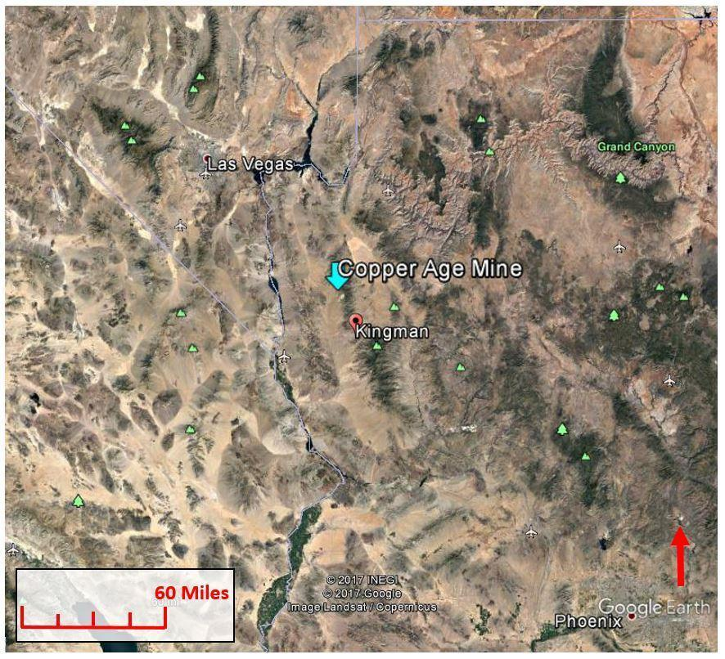
Figure 1.1: CAM statewide location with respect to Kingman, AZ [1].
The site was assessed for contaminants of concern (COC), including heavy metals associated with the mining process. The results of this PA/SI will provide the BLM information to perform future remediation or removal strategies.
Human and ecological risk were assessed for the potential contaminants on the CAM site. Lead and zinc are the primary commodities reportedly produced by the site [3]. The CAM site likely processed ore from the surrounding region and, as a result, the mine tailings may be contaminated with other heavy metals. A site inspection was performed to determine the extent of the contamination and the chemical composition of the mine tailings, as the BLM currently has no data on the site [5]. The contaminants found were arsenic, lead, and antimony, which have adverse health effects on both humans and the environment [4].

Project Background
This section includes a brief description of CAM site's relevant history.

General Background
The CAM site, also known as El Oro Mine, is located in Mohave County, approximately two miles southeast of Chloride, Arizona. Its cadastral description is Township 23 North, Range 18 West, Section 11, Northwest Quarter [2]. The CAM site is not a populated area; however, the closest town, Chloride, reported a population of 271 people as of 2010 [6].
The current status of CAM site is "past producer;" it was operational in the early- to mid-1900s, during which its operational status was "shipping” [2]. The former means that the mine is no longer operational; the latter indicates during its operation the site was primarily used to ship mined materials from surrounding mines [5]. Figure 1.2 below shows recent conditions of the site.
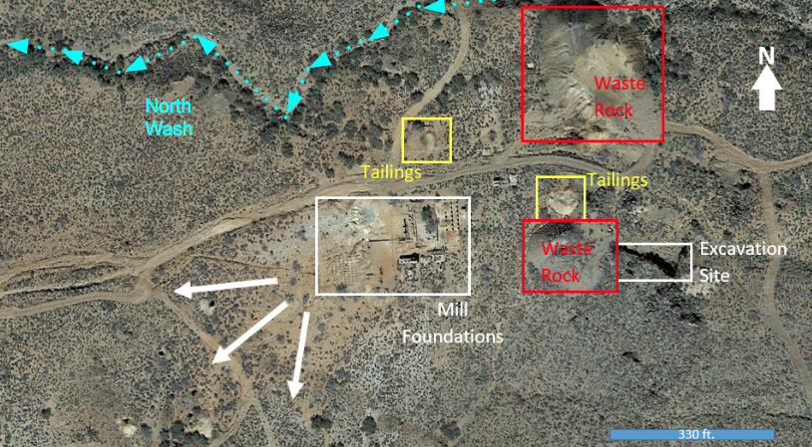
Figure 1.2: Aerial view of the CAM site. The arrows near the southwestern area of the site depict possible migration pathways due to slope, small washes, and roadways [2].
During operation, its commodities were lead and zinc, its co-product was silver, and its by-products were gold, antimony, and copper. The CAM site processed 5,000 tons of ores from on-site operations, as well as ores from nearby mills and mines [2, 5]. The records indicated operation, which began in the early 1900s, ended around 1946 [2]. The owner during operation was Arizona Ore Reduction Company and from 1976 forward Samuel Williams was the listed owner [7, 8].
The CAM sites' underground development consists of shafts, depths ranging from 20-350 feet deep, and a 1,700-foot tunnel [2]. The tunnel follows a mineral vein of "low grade" copper, silver, and gold [2]. According to the site’s Arizona Department of Mines and Mineral Resources (ADMMR) records, the tunnel is not currently operational as all equipment has been removed, but it was not explicitly stated if it had been backfilled [2].

Geology
CAM site is located on the western slope of the Cerbat Mountains, seen in the figure below. Its approximate elevation ranges from 4,055 to 4,140 feet above mean sea level and generally slopes from the southwest to northeast [6]. Figure 1.3 below depicts the topography.
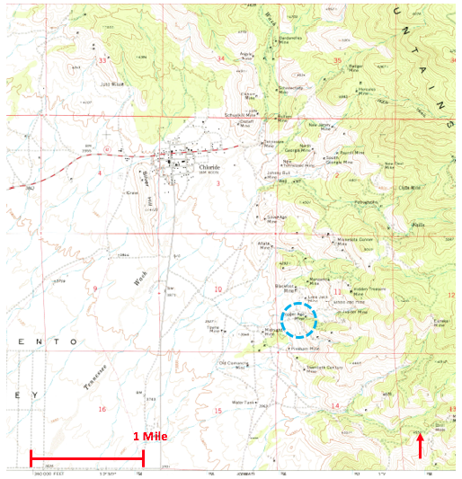
Figure 1.3: Topographic map of the region surrounding the CAM site [9].
Regional geologic formation predominantly consists of pre-Cambrian granite, gneiss, and schists [3]. Nine significant mineral veins run through the area, generally from northwest to the southeast [2]. One of the veins is 2-3 feet wide and runs the approximate length of the CAM site.

Hydrology
The CAM site is in the northern portion of the Sacramento Valley Basin, as depicted in the figure below [10]. The local region receives an annual precipitation of 10 inches.
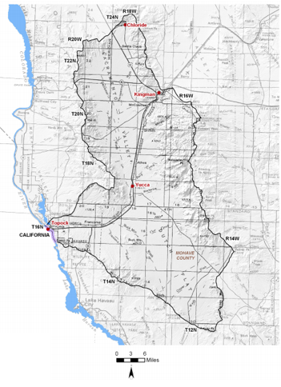
Copper Age Mine
Figure 1.4: Sacramento Valley Basin watershed that includes Chloride and the CAM site [10]
The basin drains into the Colorado River, which is located approximately 25 miles west of the site [6]. The general groundwater flow direction near the CAM site is south-southwest [10]. The major aquifer is basin fill consisting of mixed gravel, sand, silt, and clay; approximately 15 miles southeast of the CAM site, the reported depth to the aquifer is 1,000 feet below ground surface [10]. However, regional mine shafts 275-366 feet deep have produced water in the past [2].

Technical Procedures

Field Work
For efficiency, all field work, including site reconnaissance and soil sampling, was consolidated into one on-site visit, which occurred on January 19-20, 2018.

Site Reconnaissance
Site reconnaissance evaluated off- and on-site conditions. The CAM site interior and perimeter were walked and observed. The reconnaissance included observations of environmental conditions, such as types and amounts of flora and fauna, and potential migration pathways. Figures 2.1 and 2.2 below depict conditions during the site visit.
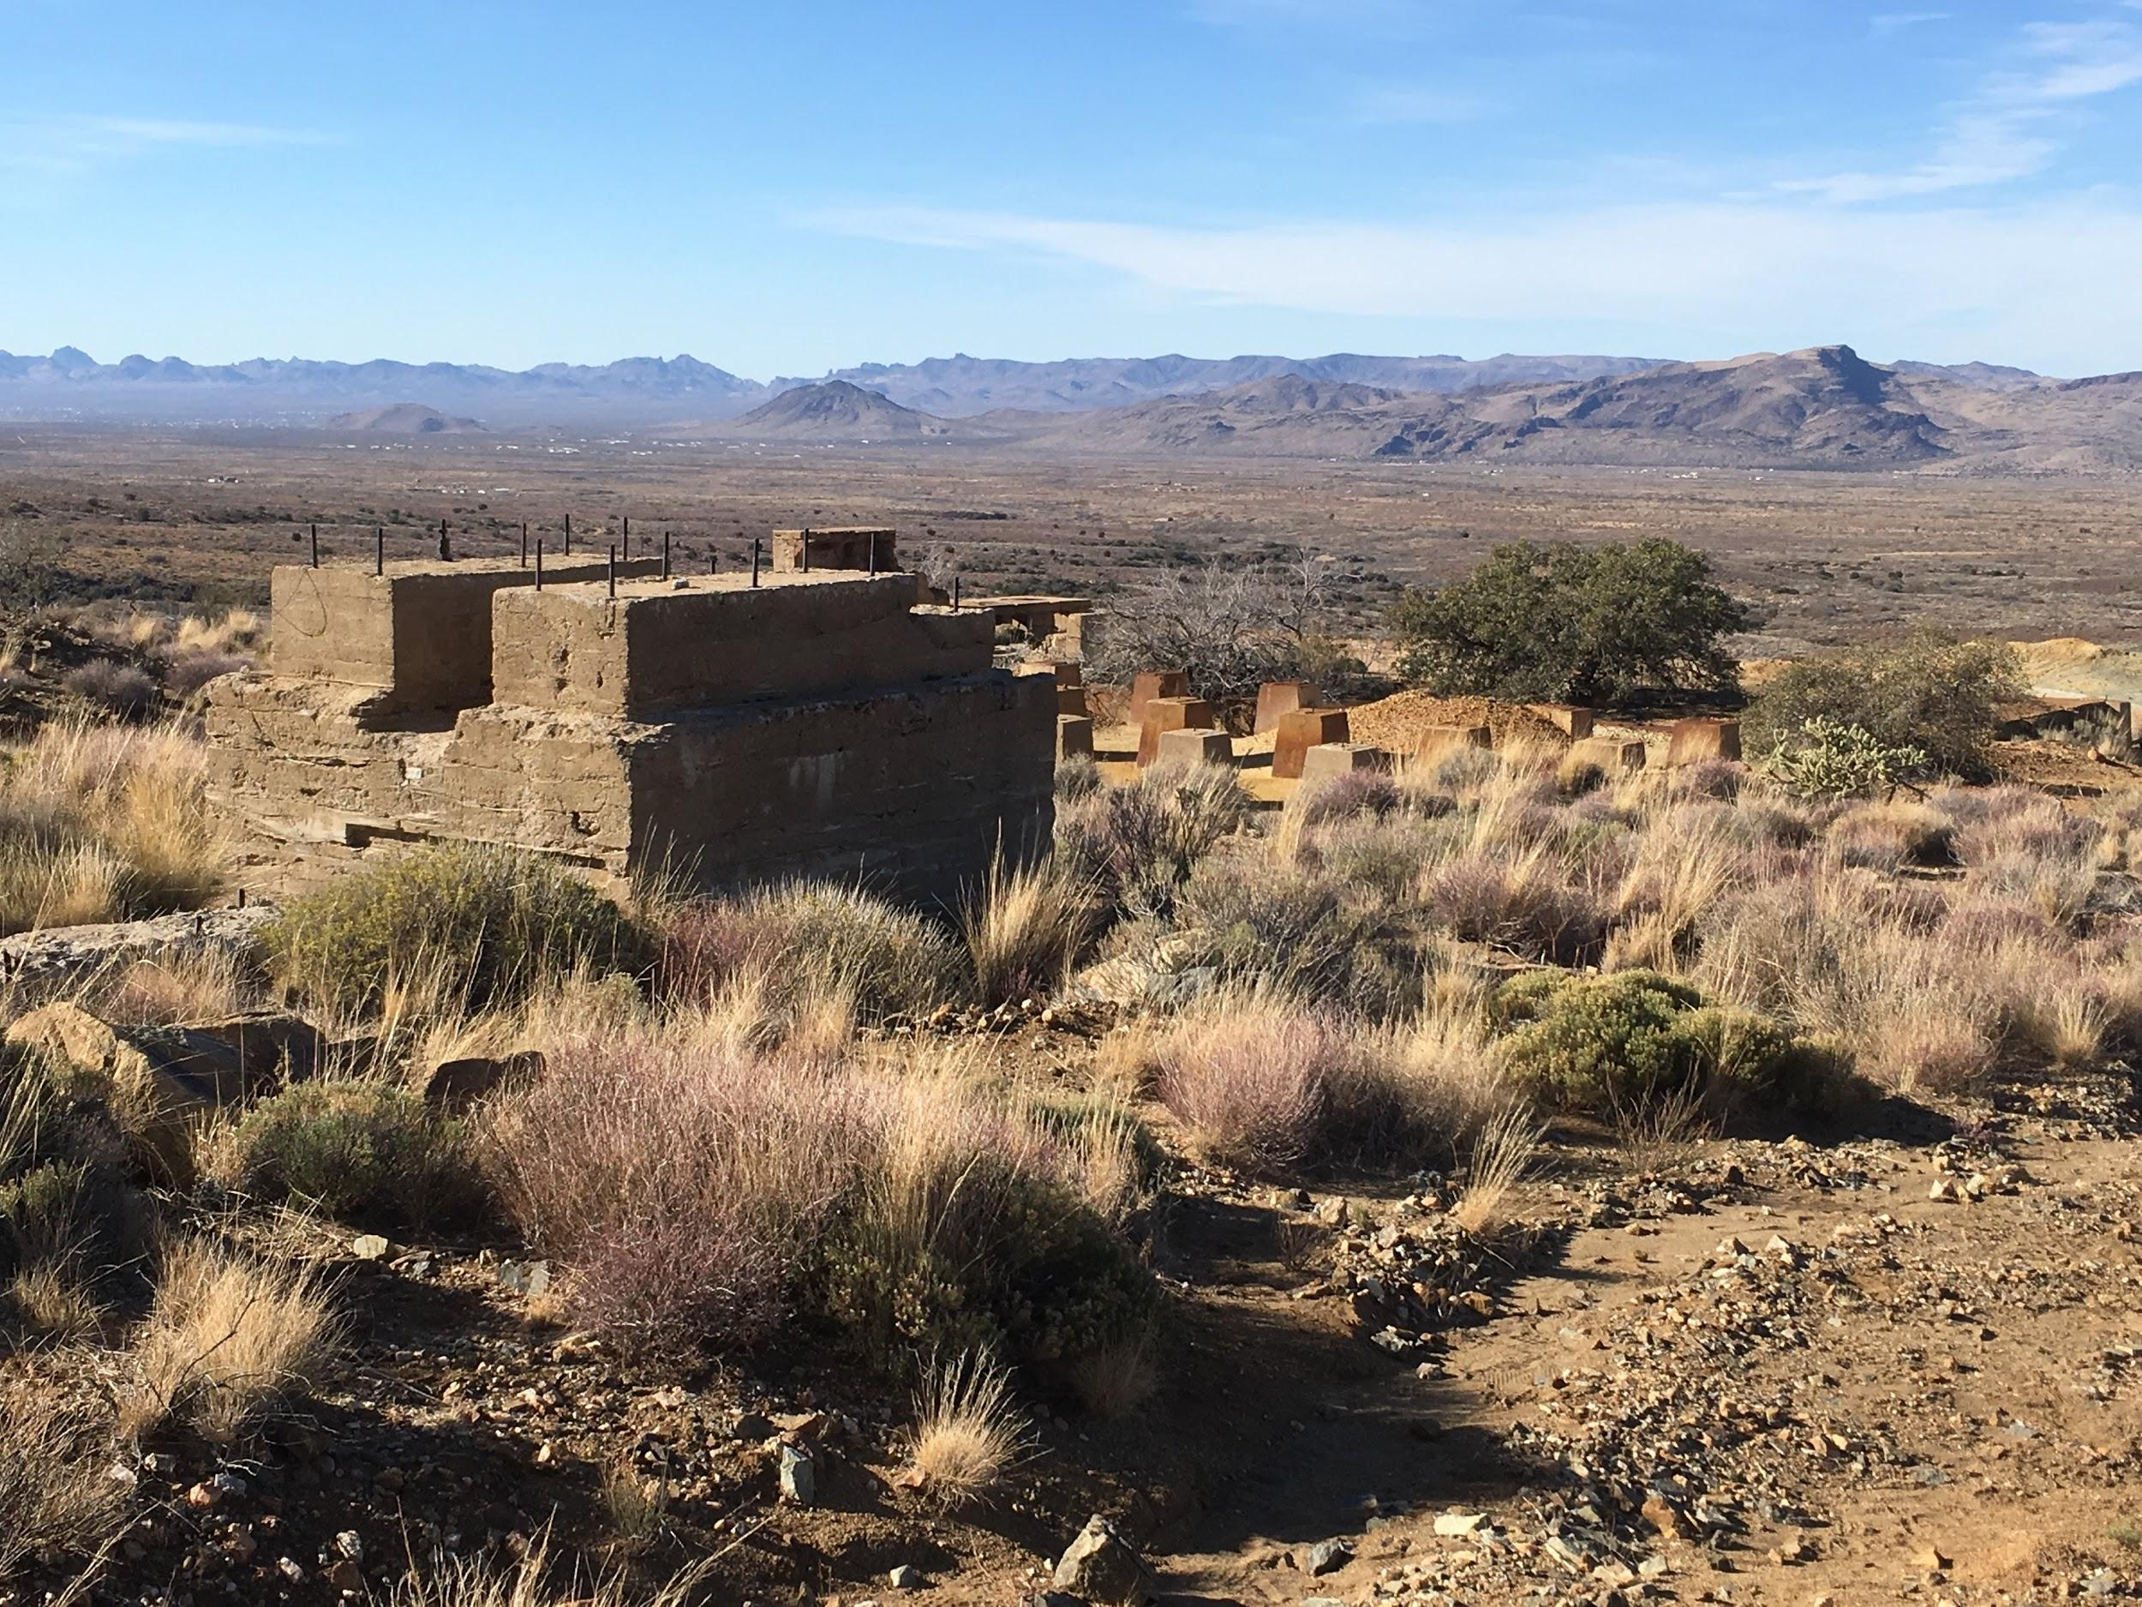
Figure 2.1: View of the mill foundations, looking southwest.

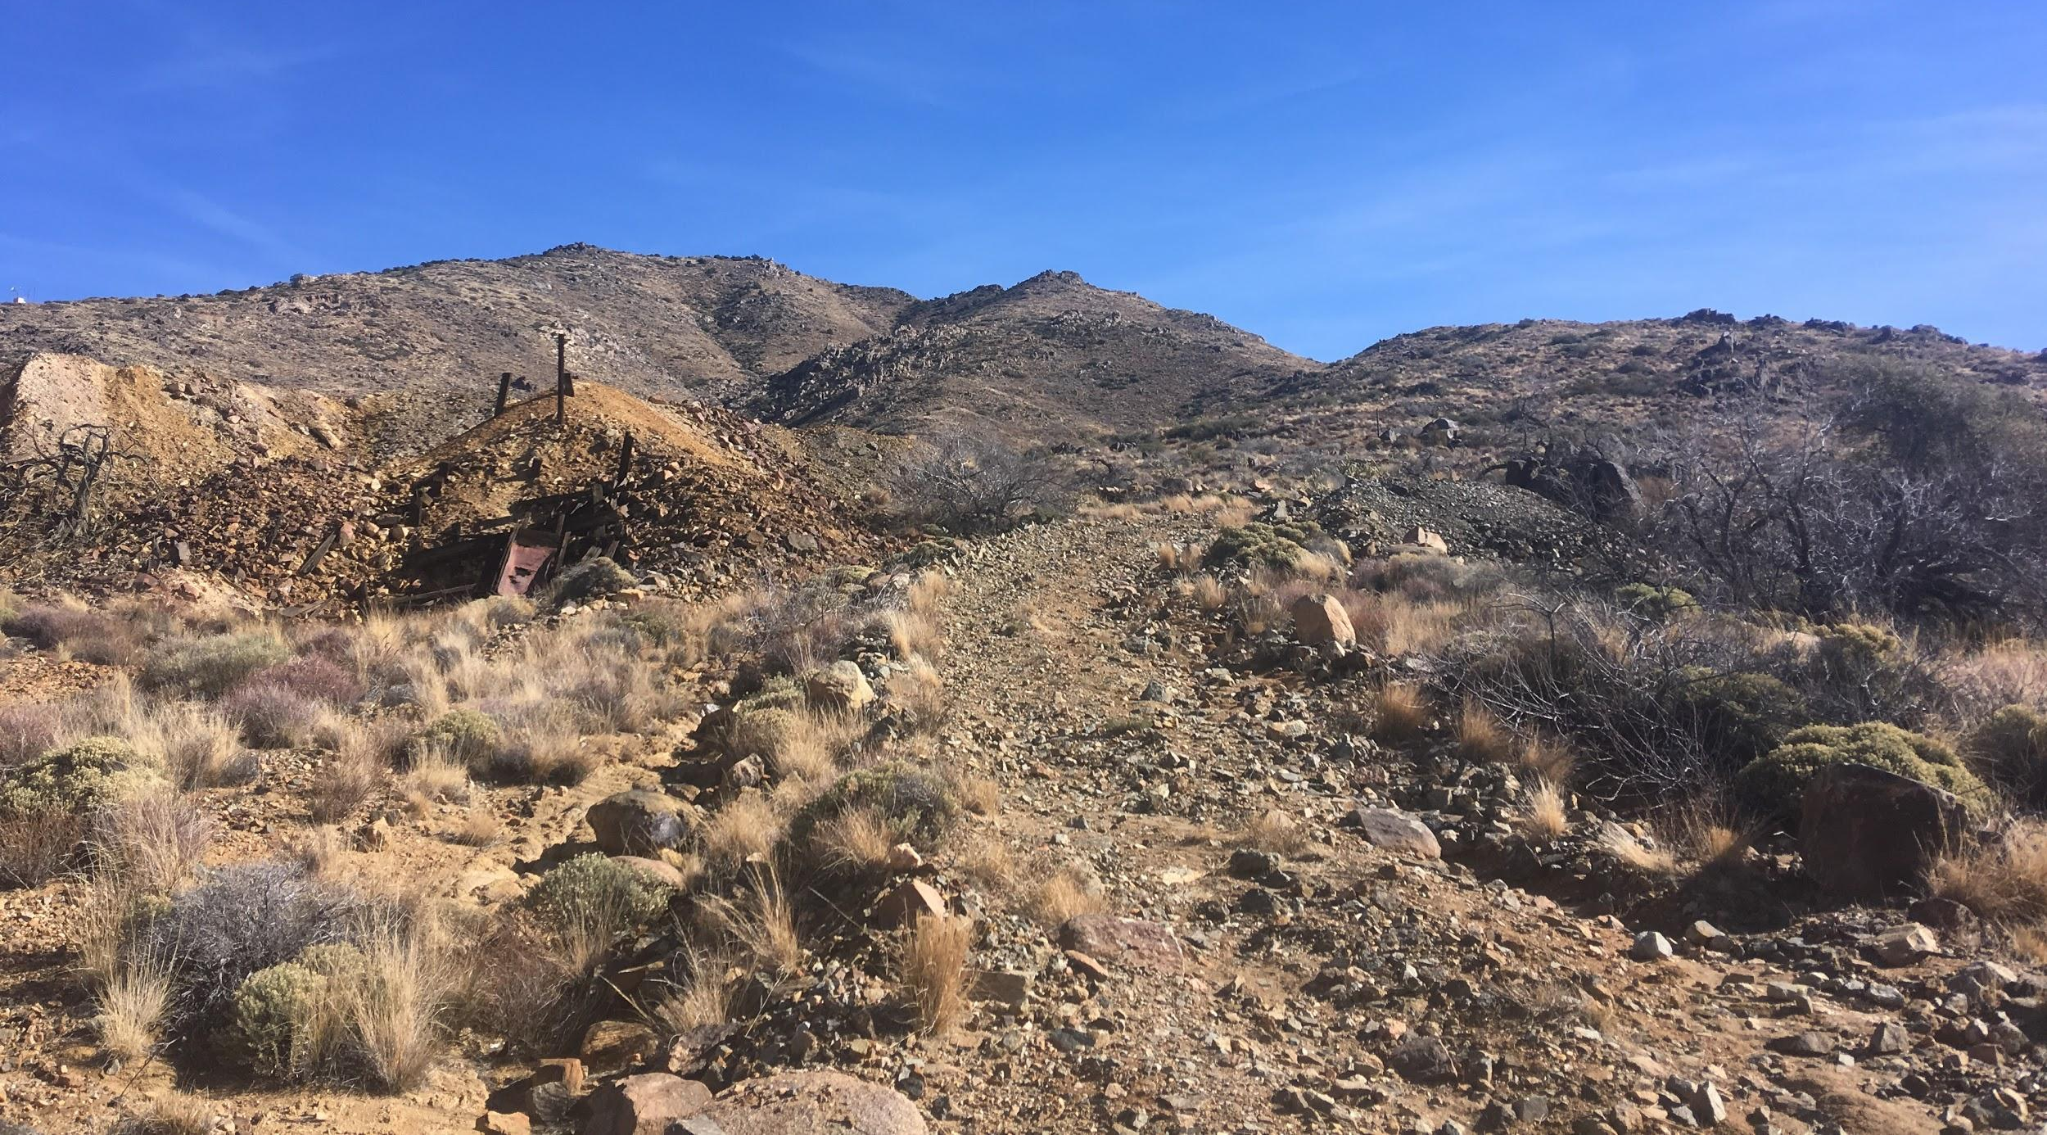
Figure 2.2: View of the unpaved road travelling through the property; mine tailings are visible on the left. Photo taken from a central location looking east.
Several possible migration pathways were confirmed during the site reconnaissance, including small washes and unpaved roads. As shown in Figure 1.2, small washes were observed along the incoming road, southeast of the mill foundations, north of the large tailings pile, and in the southwestern area of the site. Figure 2.3 below shows the typical small wash conditions observed.
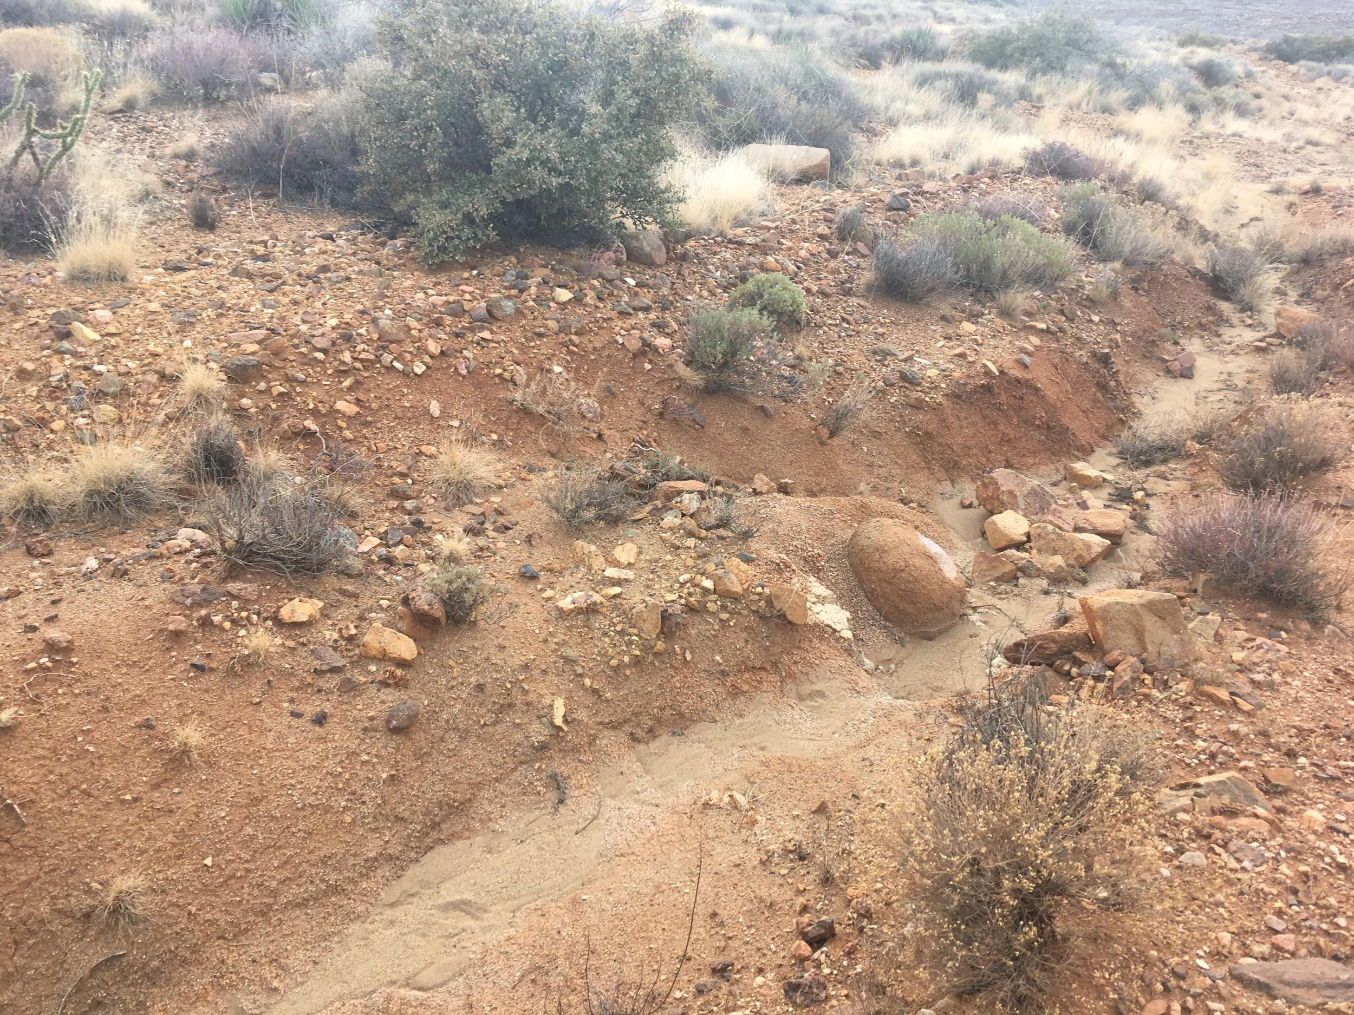
Figure 2.3: View of small wash observed running along the north side of the incoming road. It appeared to drain southwesterly.
An additional large wash was observed on the aerial view, located north of the site, and running east to west. This north wash was not included in the initial gridding of the site because it was believed that the wash was up-gradient from the flow of runoff and groundwater. Upon inspection during the site reconnaissance it was found that the wash was in close proximity to what appeared to be a large mine tailings and waste rock pile with one sloped side leading into the wash. While walking along the wash, potential hotspots were noted and field notes taken describing the characteristics of the wash. Areas of the site were flagged for consideration as a hotspot and for future sampling.
Evidence of recreational activity was observed; however, it appeared minimal. Beer cans, tire tracks, footprints, and a shooting target were all observed at the site, as seen in Figure 2.4.
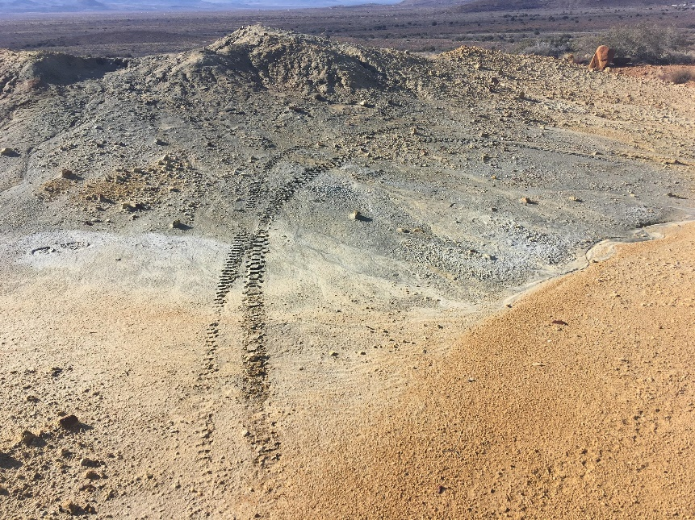
Figure 2.4: Tire tracks and footprints observed west of the mill foundations.

Evidence of animal activity was also observed, including tracks and droppings throughout the site and surrounding area (Figure 2.5). A herd of cows was seen on the site during the visit. A herd of deer was also observed in close proximity of the site.
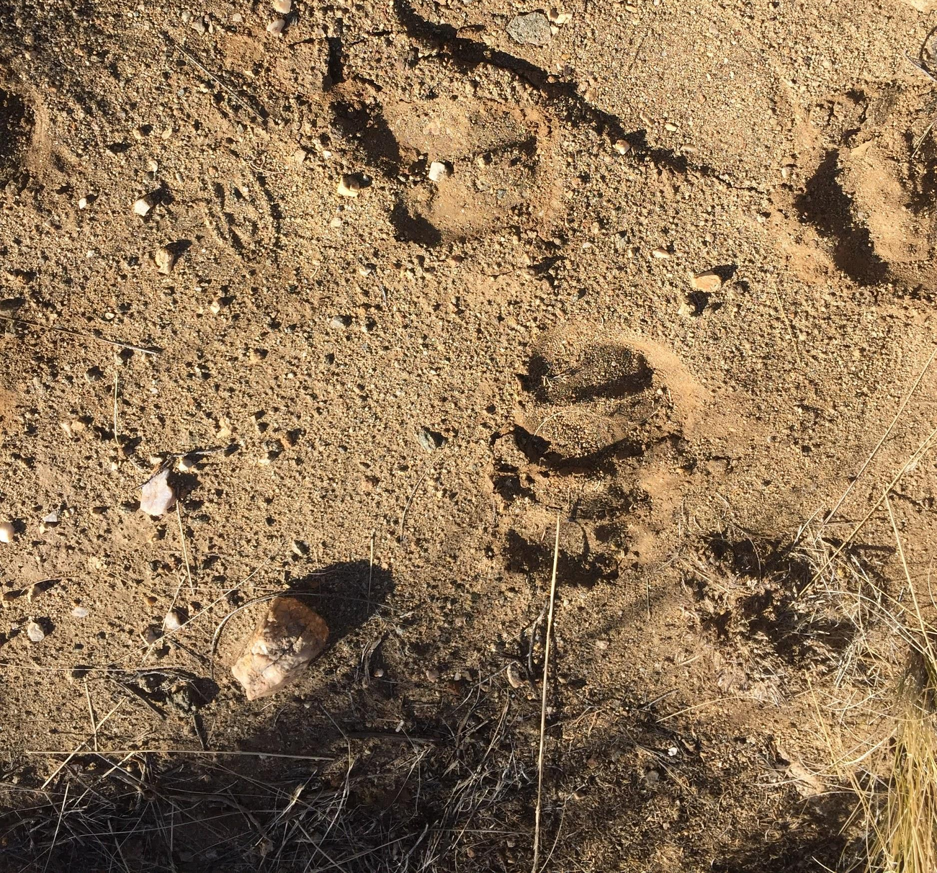
Figure 2.5: Close-up view of cow tracks observed at the site.
The vegetation appeared to consist of regional species, such as cacti, soapweed, scrub juniper and piñon, and various desert grasses; it was of density consistent with the surrounding undisturbed area. Figure 2.6 below depicts the typical vegetation observed at the site. Flora appeared to be denser on the site when compared to the aerial photo.
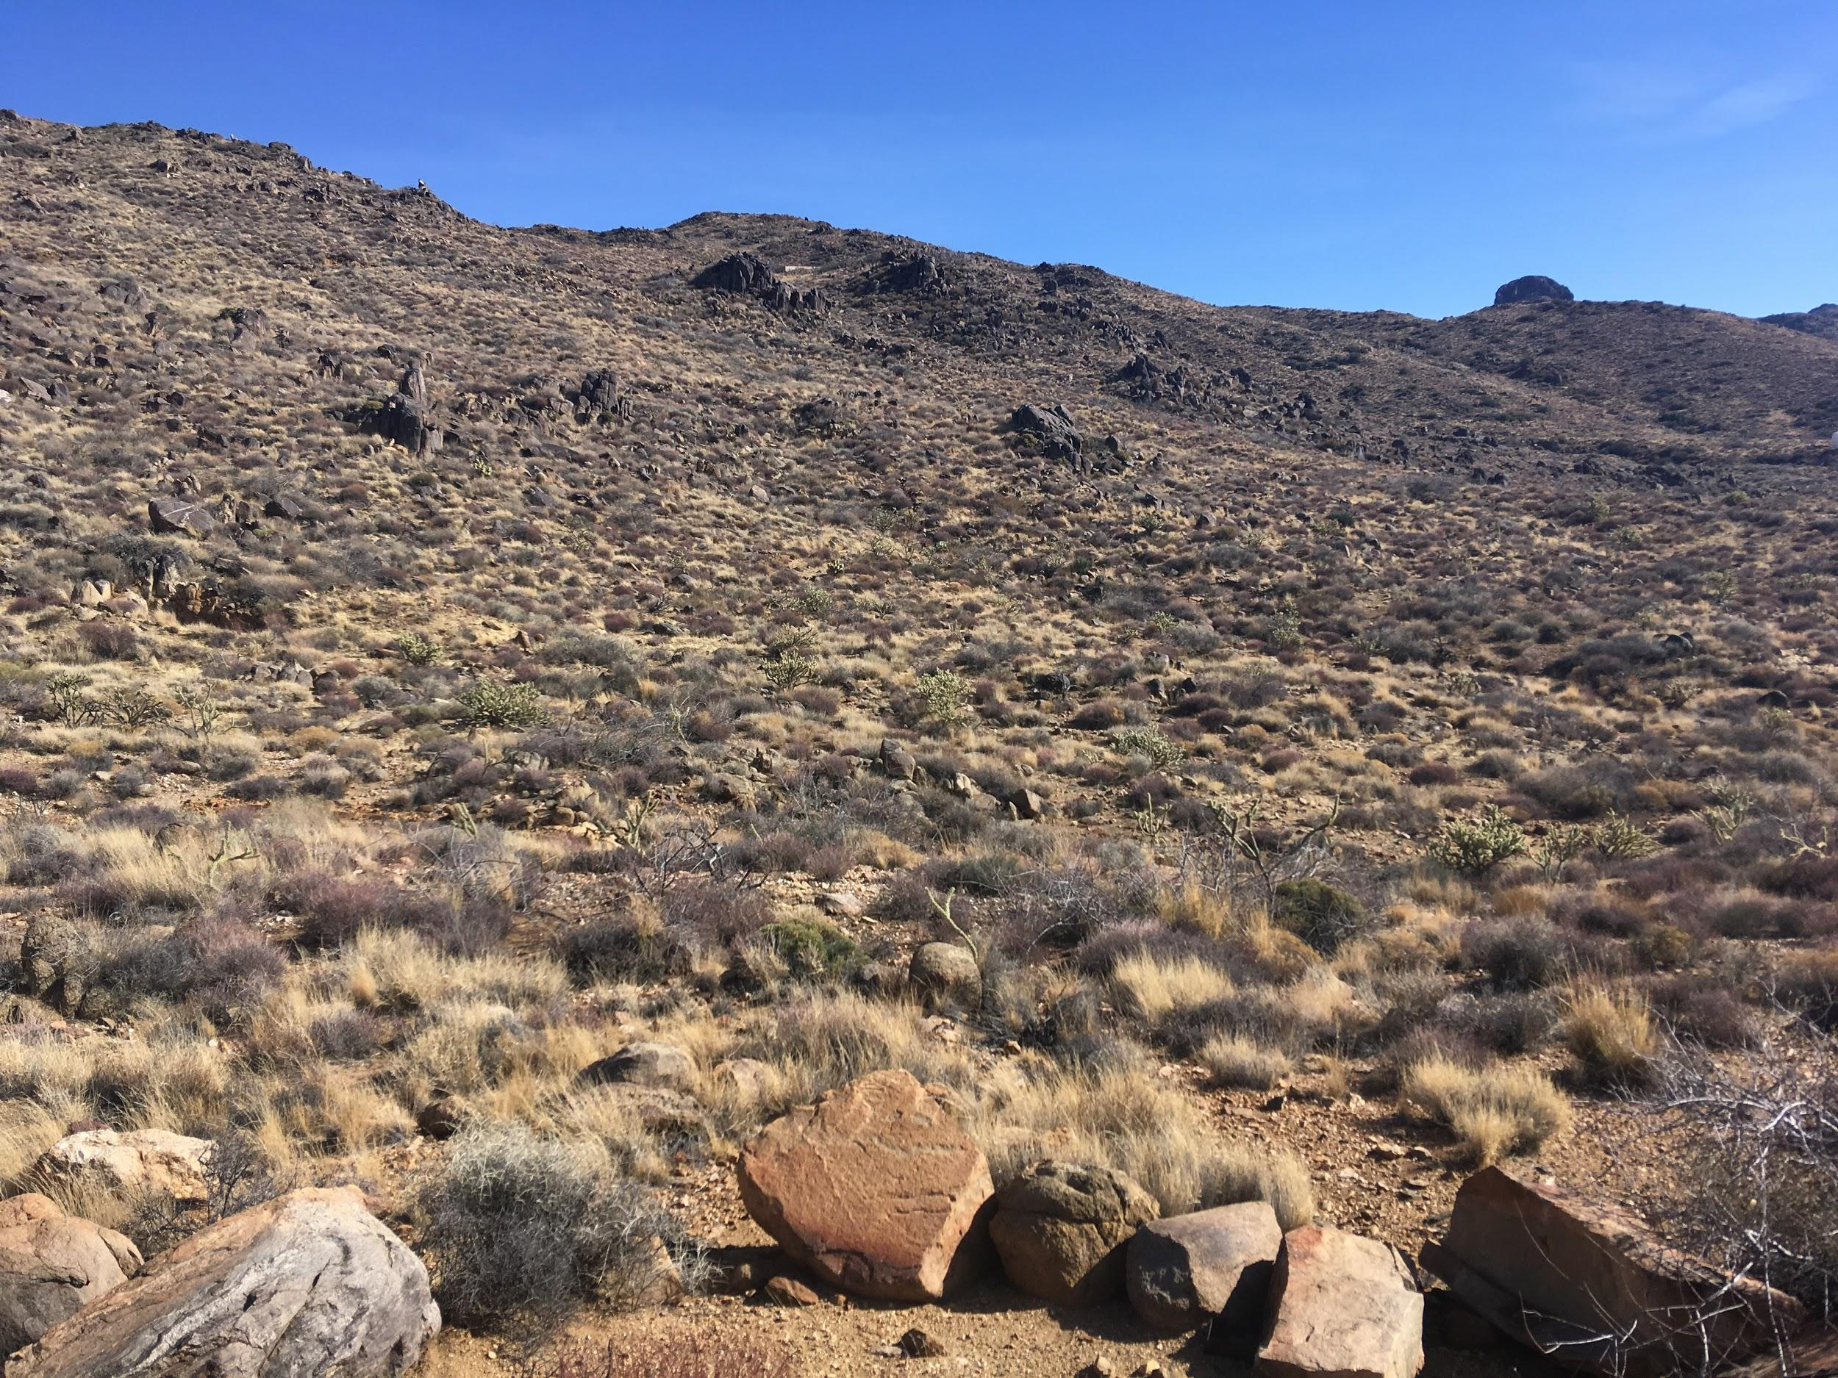
Figure 2.6: Typical vegetative species and density observed at the site and its surrounding area.

The site reconnaissance helped confirm suspected site conditions, including migration pathways, physical locations of mining features, and present flora and fauna. Additionally, the visit provided opportunity to identify new migration pathways, such as the small and northwestern washes.

Soil Sampling
The completion of project objectives required on-site sampling, which was primarily carried out according to the Work Plan (Appendix A). Any deviations from the Work Plan are discussed in the following sections.
Following arrival to the site and prior to soil sampling, the client performed separate preliminary X-Ray Fluorescence (XRF) Spectrometer readings and conducted a field work hazard and safety briefing. The samples were taken using a systematic, grid approach, which provided an unbiased, representative characterization. The sampling grid is presented below in Figure 2.7.
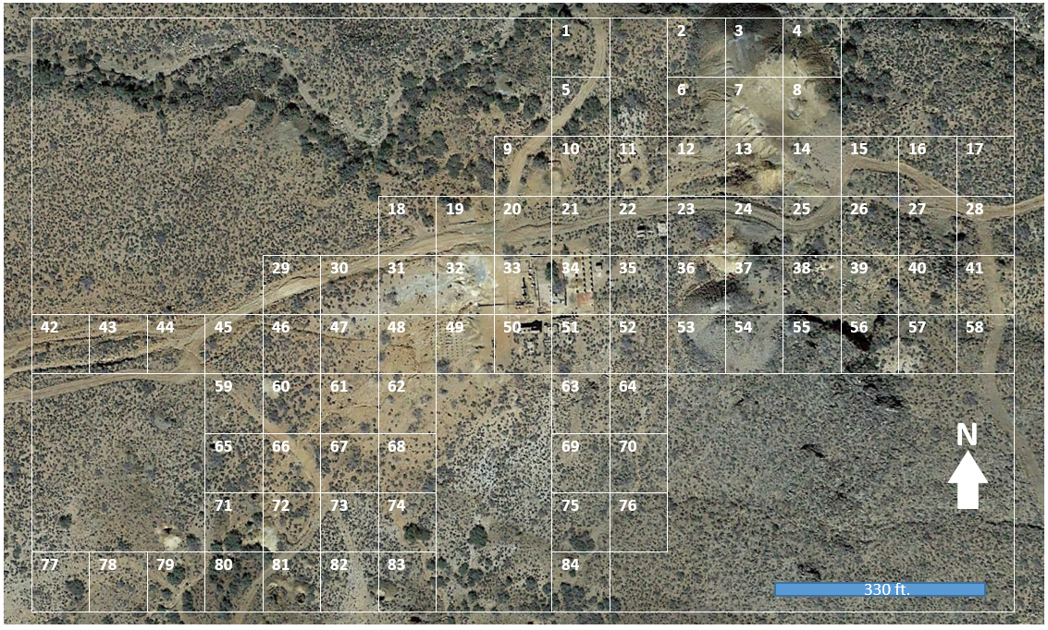
Figure 2.7: Proposed sampling grid with 84 individual sections, each approximately 95 feet by 95 feet.
A total of 94 samples were collected from the site: 84 grid, three background, and seven hotspots. The Work Plan stated four background samples would be collected; however, per the TA’s recommendation, only three were necessary to characterize the surrounding area and the baseline soil profile. The background samples were taken from undisturbed locations outside of the site boundaries and at higher elevations, to minimize contamination from runoff, as shown in Figure 2.8.

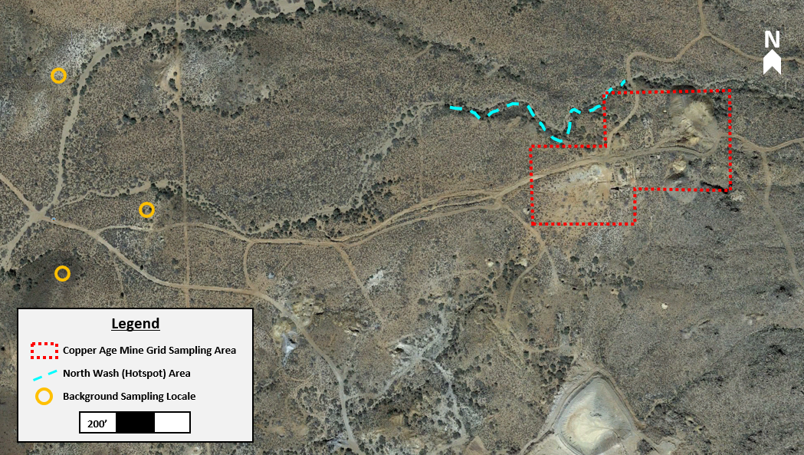
Figure 2.8: Proximity of the grid sampling area in relation to the background and hotspot samples.
Hotspot sampling was performed by walking the outlying areas with the TA. The primary objective of the hotspot exploration was to look for indicators of heavy mine tailing deposition or migration. Potential hotspots were noted in the field notebook and flagged for XRF readings and/or soil sampling. Hotspot observations began in the wash running north of CAM site, which was not initially included in the gridding.
The wash was walked from east to west approximately the same length as CAM site and no clear indications of mine tailings were observed. Per the TA’s discretion and the potential for mine tailing migration, seven soil samples were taken from the wash. Due to the lack of clear mine tailing indicators, six of the samples were taken as transects of the wash and one was taken in the thalweg of the wash. After the north wash investigation, continued reconnaissance occurred in the southwestern area of the site.
In the southwestern portion of the site, one open mine shaft was found while a potential second, collapsed mine shaft was also noted. Piles of potential waste rock and mine tailings were also found, some of which were not indicated in the client's initial site reconnaissance and thus not included in the gridding of the site. Due to size, time constraints, and TA recommendation, this area was not a candidate for hotspot samples, yet the area could be considered for future soil sampling. Multiple small washes were observed running directly south of the CAM site. One small wash at the base of a tailings pile was observed to contain a fine, black, consolidated soil which resembled mine tailings. The area was flagged and returned to later be read with XRF, yet the returned results were not indicative of mine tailings.

During collection, the samples were placed in gallon-sized Ziploc bags labeled with the appropriate sample identification. Prior to sampling and between each collection, the sampling materials were decontaminated. Figure 2.9 below shows the typical process, which was performed according to the Work Plan specifications.
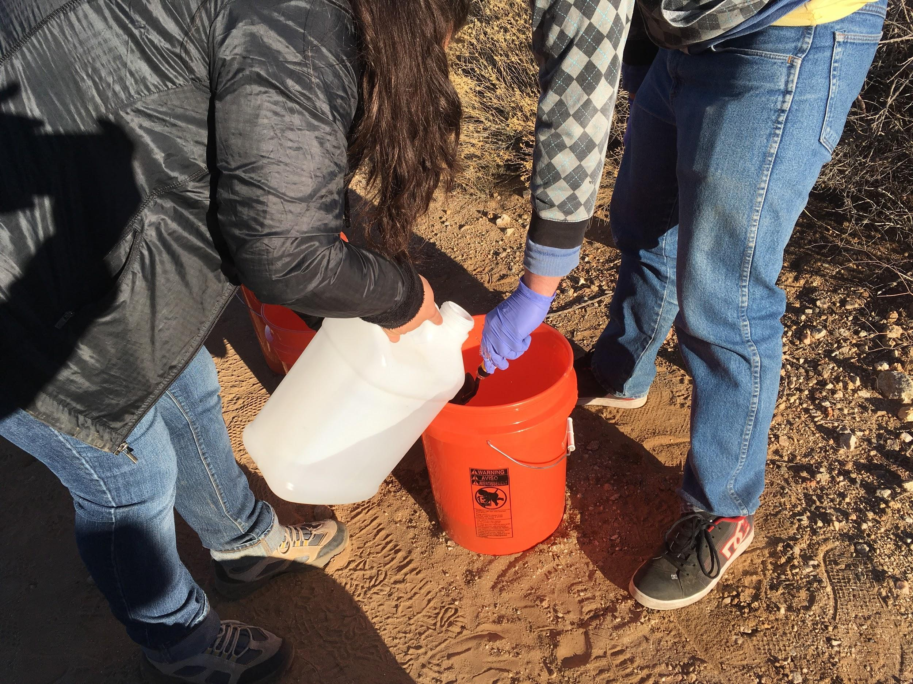
Figure 2.9: Laura Garcia and Josue Juarez performing decontamination on sampling trowel.
Additionally, gloves were disposed of between each sample to prevent cross-contamination. Disposable sampling materials were collected, bagged, and appropriately disposed of off-site. Wastewater was disposed of on-site.
After collection, the samples were placed in storage bins and chain-of-custody forms were filled out accordingly. The samples were then transported to the NAU engineering labs for sample prep and laboratory analysis.
General information of the sampling plan is included in this report. However, specific detail of each sample can be found in Appendix D. Specific information includes the color, moisture, location, and type of soil.

Laboratory Analysis
The 94 samples obtained from the CAM site were prepped and tested in the NAU engineering labs prior to the third-party lab analysis.

Sample Preparation
The samples taken from the CAM site were dried and sieved in the NAU engineering labs. Each sample was dried for 24 hours in the asphalt lab at 145 ºC. It took a duration of eight days to complete drying the 94 samples, shown in Figure 2.10.
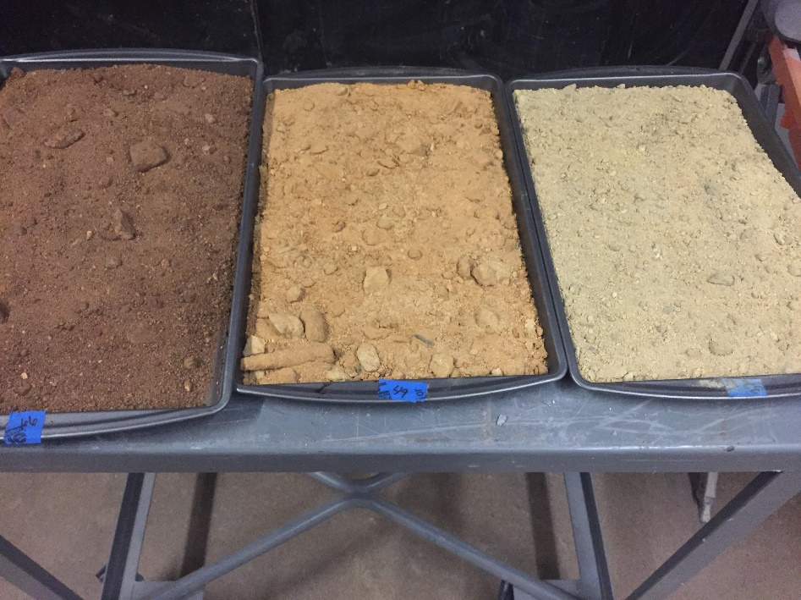
Figure 2.10: Dried samples ready for sieving.
After samples were dried and cooled, sieving occurred. Each sample was sieved in the following order, starting from top to bottom: 4, 12, 20, 30, 40, 50, and 60 mesh. However, while using the mechanical shakers, only the 20 through 60 mesh sieves were used. Sieves 4 and 12 were only used to shake the samples by hand, which removed larger particles so as not to clog the other sieves. Two mechanical shakers were used, one required a size 200 mesh sieve, which was half the height of the other sieves; this was a height adjustment in order to for the machine to shake properly. This sieve was placed at the top of the 20-60 mesh placement and no soil sample was passed through it. The placement of these sieves is demonstrated in Figure 2.11.
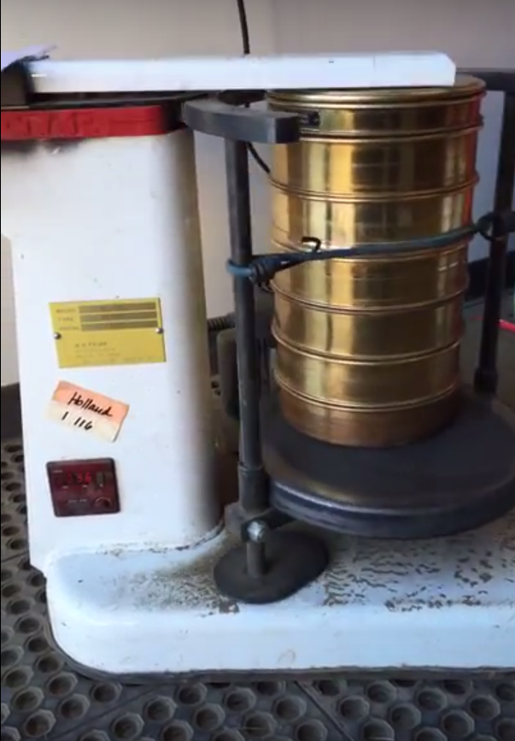
Figure 2.11: Shaker with half sieve, 20, 30, 40, 50, and 60 mesh sieves and pan.

Originally, the Work Plan required each sample to be sieved for 10 minutes, yet actual shaker times deviated from this. Sample shaking times varied between 5 and 15 minutes per volume of sample passing through the 60 mesh, which was dependent upon the amount of fines in each sample.
Samples were prepared using EPA 6200 Method: Field Portable X-Ray Fluorescence Spectrometry for the Determination of Elemental Concentrations in Soil and Sediment. This deviated from the Work Plan that specified ASTM D421: Standard Practice for Dry Preparation of Soil Samples for Particle-Size Analysis and Determination of Soil Constants, because soil preparation was included in the EPA 6200 Method and it was requested by the client. This method states 90% of the collected sample should pass through the 60 mesh sieve. However, the soil samples were often sandy and had few fines, therefore, the desired sample volume was reduced to what was able to be collected within 15 minutes per sample.
Steps were taken during sample collection to ensure that enough material would be available to pass through the 60 mesh and compensate for this deviation from the sample method. The approximate average sample volume retrieved for analysis is shown below in Figure 2.12.
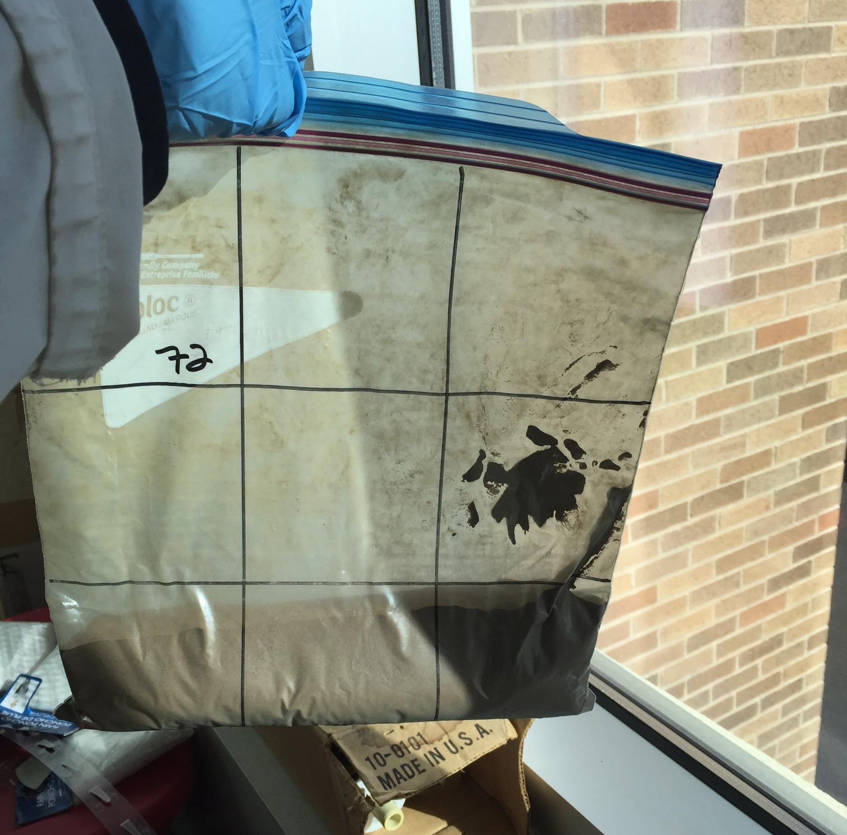
Figure 2.12: Typical volume of sample obtained for XRF analysis.
Following the drying process, samples were checked with the chain-of-custody to verify the complete sample set and correct any mistakes made. Two of the largest samples, CA-G-48 and CA-G-67, were also split into duplicates for quality assurance/quality control (QA/QC) measures. Thus a total of 96 samples were analyzed via the XRF. See Section 3.3 for further details on QA/QC.

XRF Analysis
After the 96 samples had been dried and sieved, they were placed in new freezer gallon sized Ziploc bags with nine gridded labels. All samples, including duplicates, were placed in the storage bins to maintain chain-of-custody. Prior to XRF analysis, performed using EPA Method 6200, the sample was laid flat and distributed evenly throughout the gallon bag. Each grid square was then analyzed using a Niton XL3t Goldd+ XRF for 90 seconds under the soil setting. Once all 96 samples were analyzed, the data were exported for analysis, which is discussed in Section 3.0.
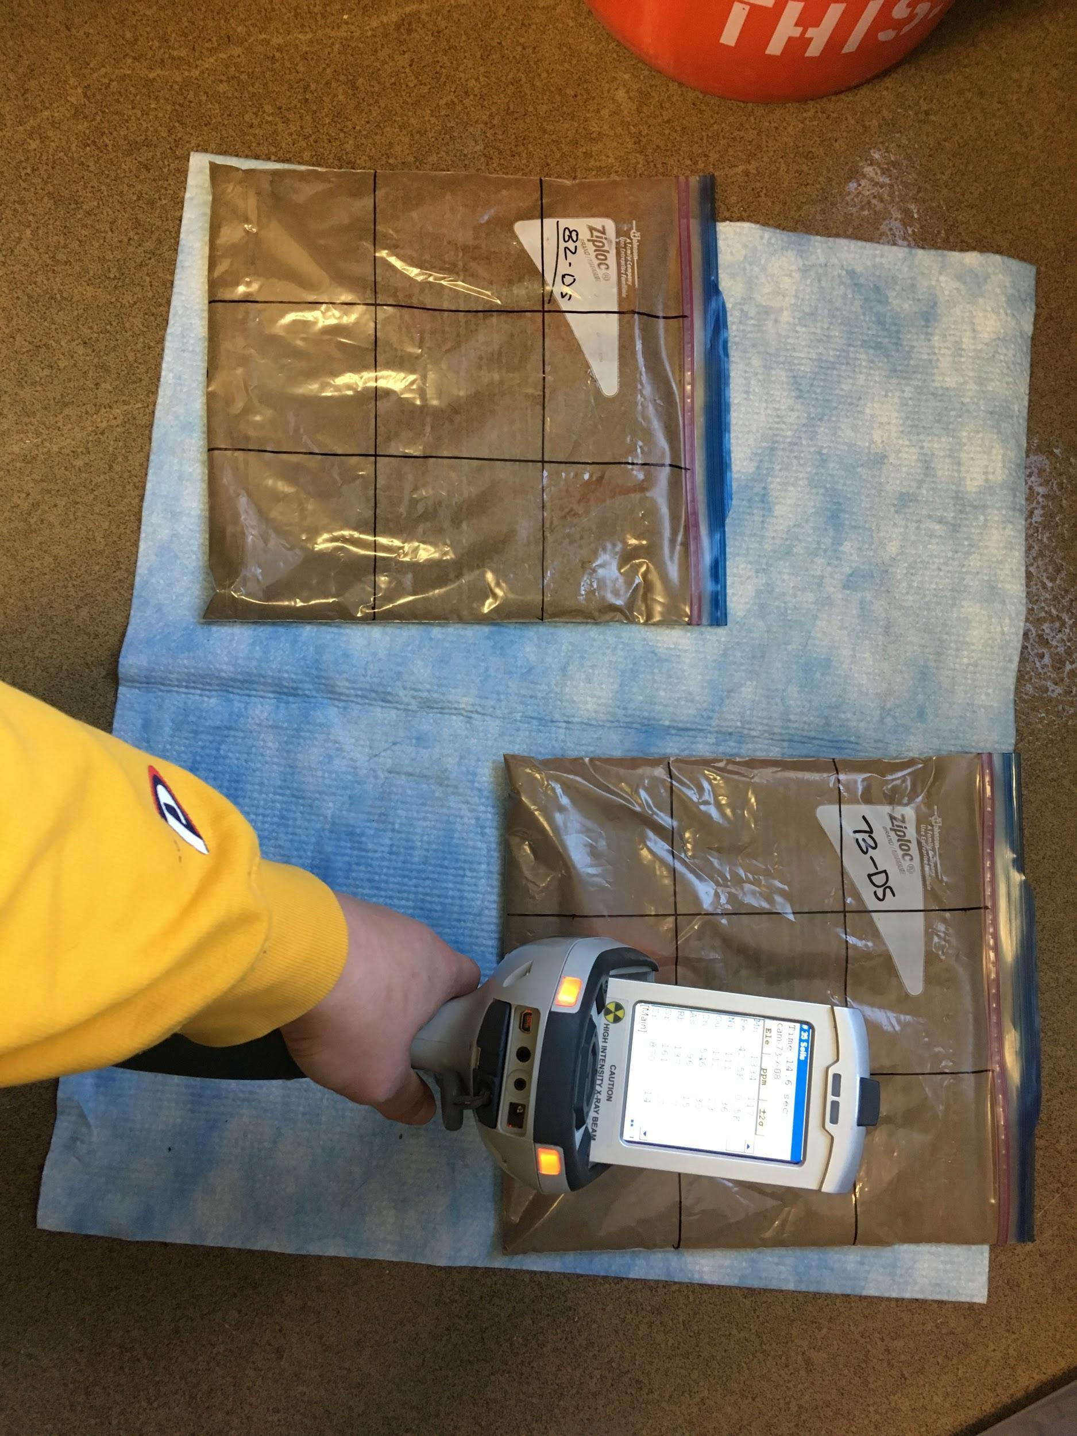
Figure 2.13: Typical XRF analysis of samples.
Following analysis, the COCs were identified using the Arizona Non-Residential Soil Remediation Levels (SRLs). The COCs identified were arsenic, lead, and antimony.

FAAS Analysis
The 22 samples representing the concentration ranges observed for the COCs (included two duplicates) underwent acid digestion at the Colorado Plateau Lab in the Wettaw Biology Building on the NAU campus. Acid digestion was performed by the CAM team in accordance with ASTM D5258-02: Standard Practice for Acid-Extraction of Elements from Sediments Using Closed Vessel Microwave Heating, ASTM D3974-09: Standard Practices for Extraction of Trace Elements from Sediments, and ASTM E2941-14: Standard Practices for Extraction of Elements from Ores and Related Metallurgical Materials by Acid Digestion. The Flame Atomic Absorption Spectroscopy (FAAS) analysis was performed by Jeffrey Propster, the research specialist of the Colorado Plateau Analytical Lab (CPAL), for third-party validation of the samples. The three COCs were analyzed and a correlation was found for the XRF data, as described in Section 3.1.

Data Analysis

Correlations
To validate XRF results, the FAAS data was intended to be used as a correction factor. Due to different confounding factors, this was not always an applicable method. Ultimately, the antimony and lead XRF data were not corrected while the arsenic data was.

Arsenic data were plotted to show the relationship between XRF and FAAS. Linear regression was then performed to obtain the correlation coefficient, which represented the relationship between XRF and FAAS data. Figure 3.1 below shows the arsenic correlation graph.
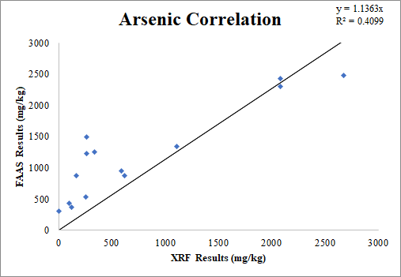
Figure 3.1: Arsenic XRF and FAAS correlation graph with outliers removed.
According to EPA Method 6200, arsenic values are increasingly inaccurate when the lead to arsenic ratio is greater than 10:1. From the acid digested samples, those that had lead to arsenic ratios greater than 10:1 were removed from the correlation calculations, as they were determined to be outliers. This increased the correlation coefficient to an R=0.64, which was acceptable for XRF data transformation.
The correlation coefficient for lead, R=0.57, was not high enough to justify using the FAAS data for correction (see Figure 3.2). The lead XRF data had high concentrations that appeared extremely unlikely, therefore the data are considered suspect. The poor lead correlation is likely due to two common interferences experienced during the XRF analysis. First, lead can potentially be biased high due to “direct emission line overlap,” which is known to happen with arsenic. This possible error is further discussed in Section 3.2.1 [11].
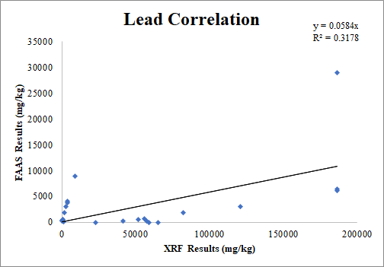
Figure 3.2: Lead XRF and FAAS correlation graph.
The antimony FAAS results did not return any detections for antimony, unlike the XRF data, which identified concentrations above Arizona non-residential SRLs. This is believed to be caused by the method used for acid digestion (microwave with nitric acid) which has been shown to have low efficiency and precision related to antimony [11]. Due to this complication, only the XRF data for antimony was used for further analysis.

Statistical Analysis
To determine the 50% and 95% exposure point concentrations for the risk assessment, the data were statistically analyzed. The distribution of the grid sampled data were computed; the data were found to be lognormally distributed for all three COCs. Therefore, the data were lognormally transformed, thus providing a normal distribution. Lognormal transformation is often used for contaminant concentrations at Superfund sites, due to the positive skew of the data [12]. With arsenic and antimony, some values were reported as non-detect, so instead the 5 mg/kg limit of detection (LOD). The data was then plotted using the lognormal transformation, as shown in Figures 3.3 and 3.4 below.
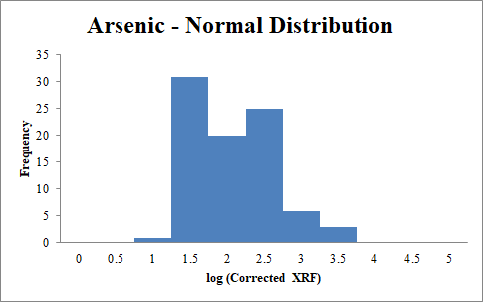
Figure 3.3: Log distribution of arsenic soil samples.

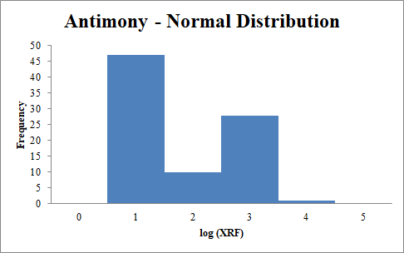
Figure 3.4: Log distribution of antimony soil samples.
For the lead distribution, the values also did not distribute normally with any of the normal, lognormal, or square root transformations. Therefore, the FAAS data were used to obtain a more normal distribution via log transformation, as seen Figure 3.4.
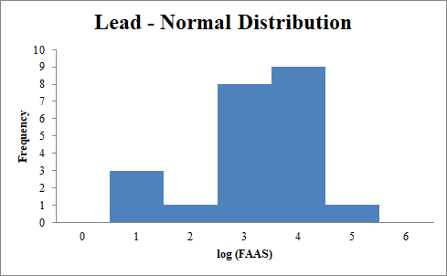
Figure 3.5: Log distribution of lead soil samples
Using the lognormal distributed data, the 50% and 95% concentrations were identified. The 50% concentrations were the averages of the transformed data and the 95% concentrations were the 50% value plus two standard deviations. The identified concentrations are summarized below in Table 3.1. The Arizona non-residential SRLs are included in Table 3.1 for comparison. These data represent the exposure point concentrations used in the risk assessment.
Table 3.1: 50% and 95% concentration values for arsenic, lead, and antimony
 | Soil Remediation Levels (mg/kg) | 50% Concentration (mg/kg) | 95% Concentration (mg/kg)
Arsenic | 10 | 186 | 1,070
Lead | 800 | 3,245 | 15,800
Antimony | 400 | 176 | 732

Quality Assurance and Quality Control
Results of testing of background samples are shown in Table 3.2, where N/A indicates not applicable, as the sample was not run using FAAS, and N/D indicates non-detect. These values were used to provide a baseline for what is occurring further down gradient from the CAM site.

Table 3.2: CAM background sample data
 | Sample ID | Arsenic (mg/kg) | Lead (mg/kg) | Antimony (mg/kg)
XRF | CAM-B-01 | 183 | 65,438 | 184
XRF | CAM-B-02 | 84 | 68,264 | 314
XRF | CAM-B-03 | 58 | 22,797 | 226
FAAS | CAM-B-01 | N/D | N/D | N/D
FAAS | CAM-B-02 | N/A | N/A | N/A
FAAS | CAM-B-03 | 322 | N/D | N/D

United States Geological Survey (USGS) sampling of surface soils returned typical background arsenic concentrations of up to 97 mg/kg for Arizona; the average background arsenic concentrations presented in Table 3.2 is 162 mg/kg [15]. Surface soil samples taken by the USGS showed background lead concentrations of 21 mg/kg for Arizona; the average concentrations presented in Table 3.2 is 52,166 mg/kg [16].
However, as discussed above, the XRF lead readings are likely biased high. In Arizona, antimony background soil concentrations are equal to 2.6 mg/kg; the average concentrations presented in Table 3.2 is 241 mg/kg [17]. This indicates CAM’s surrounding area may have higher background concentrations for all three contaminants than typical Arizona levels.
Duplicate samples were used throughout the laboratory process, including XRF, acid digestion, and FAAS. These results provided data for comparison, helping to monitor the analytical process, thereby validating results or identifying areas of concern. The duplicate results were compared, and their ranges were monitored closely for indication of possible errors or procedural mistakes. Results for arsenic and lead are shown in Tables 3.3 and 3.4 below.

Table 3.3: Arsenic duplicate samples’ summary.
 | Sample ID | Reading 1 (mg/kg) | Reading 2 (mg/kg) | Relative Percent Difference
XRF | CAM-G-48 | 30.2 | 32.5 | 7.34%
XRF | CAM-G-67 | 617 | 615 | 0.32%
FAAS | CAM-G-50 | 2,311 | 2,427 | 4.90%
FAAS | CAM-G-32* | 1,491 | 1,225 | 19.69%

Table 3.4: Lead duplicate samples’ summary.
 | Sample ID | Reading 1 (mg/kg) | Reading 2 (mg/kg) | Relative Percent Difference
XRF | CAM-G-48 | 31.2 | 33.5 | 7.11%
XRF | CAM-G-67 | 1,375 | 1,395 | 1.44%
FAAS | CAM-G-50 | 38.2 | 41.0 | 7.07%
FAAS | CAM-G-32* | 6,403 | 6,100 | 4.85%

The sample CAM-G-32 was run a third time during the CAM-G-50 duplicate FAAS testing set and returned arsenic and lead concentrations of 2,766 mg/kg and 29,042 mg/kg, respectively. Due to the high discrepancy, this third CAM-G-32 datum was considered an outlier and discarded. This indicates potential inaccuracies and unreliability with the FAAS testing procedure and further analysis should be considered. Table 3.5 shows results for antimony.
Table 3.5: Antimony duplicate samples’ summary.
 | Sample ID | Reading 1 (mg/kg) | Reading 2 (mg/kg) | Relative Percent Difference
XRF | CAM-G-48 | N/D | N/D | --
XRF | CAM-G-67 | 18.6 | 15.1 | 20.77%
FAAS | CAM-G-50 | N/D | N/D | --
FAAS | CAM-G-32 | N/D | N/D | --

The relative percent difference of the duplicate samples was compared to the standard of 20% [13]. All arsenic and lead duplicate results fell within this range, indicating they met QA standards. The detected antimony results, CAM-G-67, were just outside of the standard 20% relative percent difference range; however, due to its close proximity and the complete lack of FAAS antimony data, the XRF antimony data was still used in risk assessment and concentration calculations.
Additional QA/QC measures included data verification at third-party lab, CPAL. Twenty-two samples, including two duplicates (Tables 3.2-3.4), were sent to CPAL lab for FAAS analysis. These results were then compared to previously obtained XRF results and, in the case of arsenic, were used to correct the XRF data set.
The poor lead correlation is likely due to two common interferences experienced during the XRF analysis. First, lead can potentially be biased high due to “direct emission line overlap,” which is known to happen with arsenic [11]. Since the samples are known to have high concentrations of arsenic, this seems like a probable interference; thus, demonstrating why the XRF lead concentrations were skewed much higher than those of the FAAS lead concentrations.
Furthermore, a “sum peak overlap” may cause issues with the detection and measurement of lead [11]. Lead and iron are known to overlap emission lines; iron was present in a majority of the samples, as identified by the XRF data. This may have resulted in further inaccuracies of the XRF lead readings and is a likely factor in the large discrepancy observed between the XRF and FAAS lead data; therefore, it may have contributed to the low correlation coefficient.
While the antimony XRF data identified concentrations above Arizona non-residential SRLs, the antimony FAAS results did not return any detections for antimony. This is believed to be caused by the method used for acid digestion (microwave with nitric acid) which has been shown to have low efficiency and precision related to antimony [14]. Due to this complication, only the XRF data for antimony was used for further analysis.

Mapping
The collected GPS data points were exported from the GPS units and imported into Google Earth, providing the base map for concentration ranges. The arsenic contamination maps were developed using the transformed XRF data while the antimony contamination maps utilized the raw XRF data. Two maps were created for lead, one which displayed the raw XRF data and one that only showed the FAAS data. Each map is based on the Arizona residential and non-residential SRLs.
Both the Arizona residential and non-residential SRL for arsenic is 10 mg/kg. The arsenic contamination concentration map (Figure 3.5) is based on levels of exceedance of these SRL levels. The pink squares denote exceedances between 10 mg/kg and 100 mg/kg. Red squares are representative of values between 100 mg/kg and 1000 mg/kg while the black squares show samples in which arsenic exceeded 1000 mg/kg.
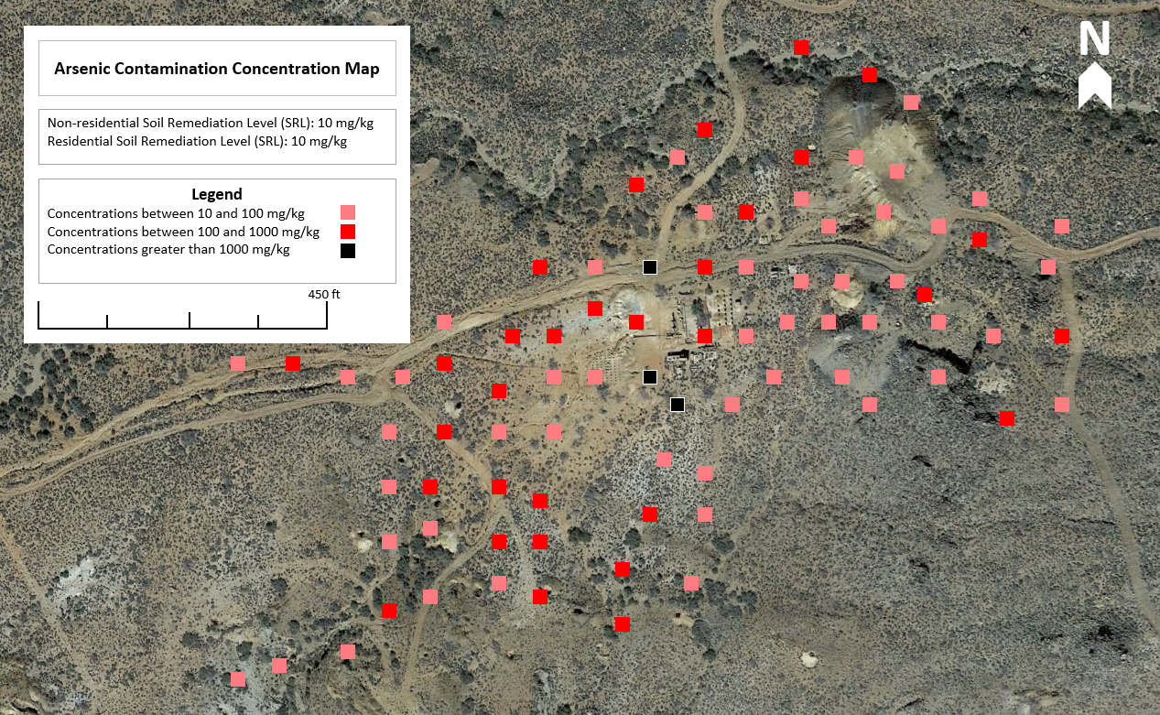
Figure 3.6: Arsenic contamination map of the CAM site.
As shown in Figure 3.7, the lead concentration map displays the distribution of contamination based upon the raw XRF data. The color scheme is based upon comparisons to the Arizona residential and non-residential SRLs for lead, which are 400 mg/kg and 800 mg/kg respectively. The blue squares denote concentrations between 0 and 400 mg/kg, the purple squares denote concentrations between 400 mg/kg and 800 mg/kg, the red squares denote concentrations between 800 mg/kg and 15,000 mg/kg and orange squares denote concentrations greater than 15,000 mg/kg.
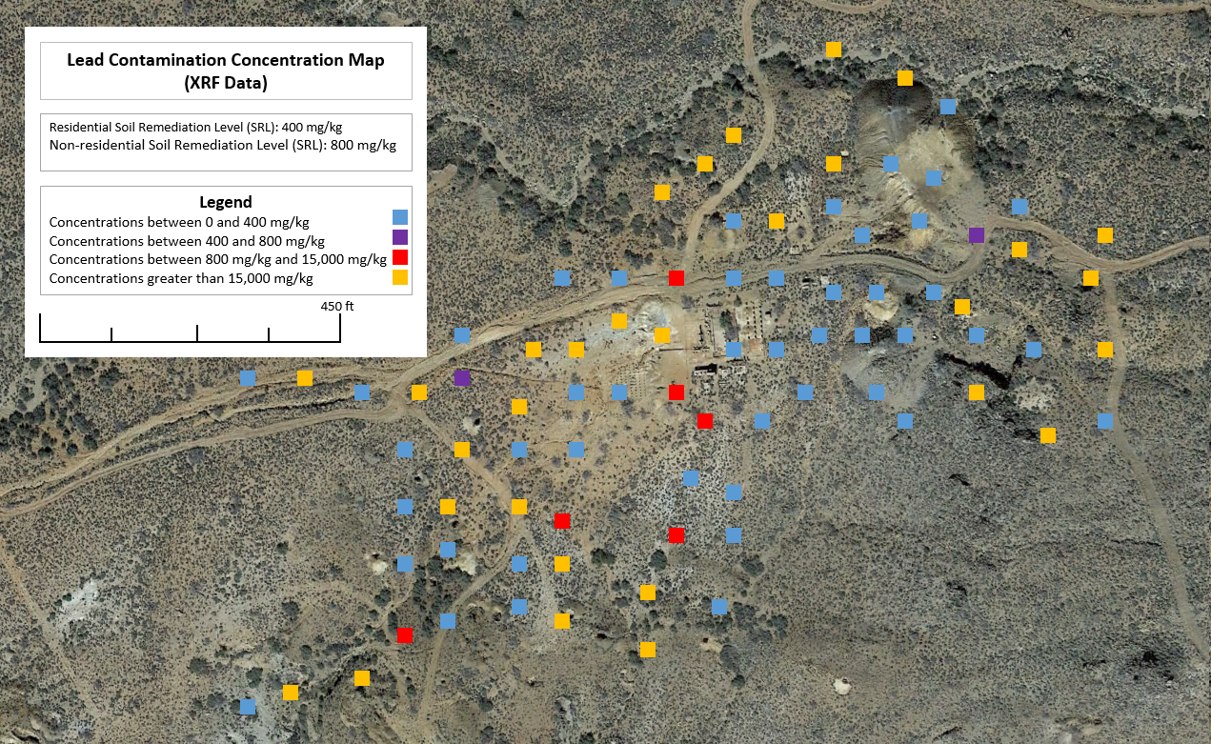
Figure 3.7: Lead concentration map of the CAM site, with XRF data.
Figure 3.8 displays the lead concentration map based on FAAS data. Both figures 3.8 and 3.9 are based on the following color scheme: green is between the non-detect level and the residential SRL, yellow represents values between the residential and non-residential SRL, while red is any value exceeding the non-residential SRL. As stated previously, due to inaccuracies believed present in the raw XRF lead data, it is recommended that the FAAS lead data map (Figure 3.7) be used and relied upon for future decisions.
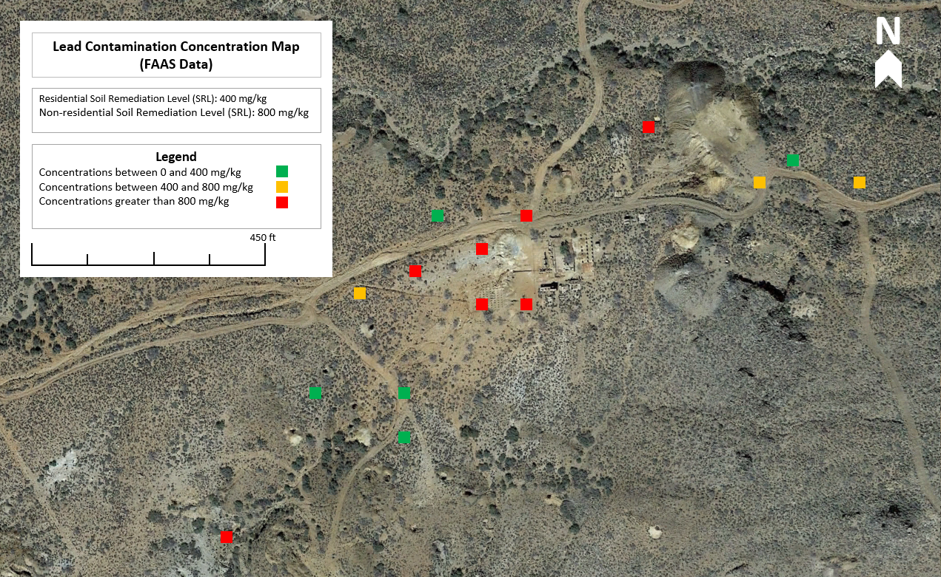
Figure 3.8: Lead concentration map of the CAM site.
The antimony concentration map (Figure 3.9) follows a similar color scheme to the lead concentration maps: green is between the non-detect level and the residential SRL, yellow represents values between the residential and non-residential SRL, while red is any value exceeding the non-residential SRL. While the highest arsenic and lead values are centrally located (Figure 3.6 and 3.8), the highest antimony values appear to be on the edge of the sampling site.
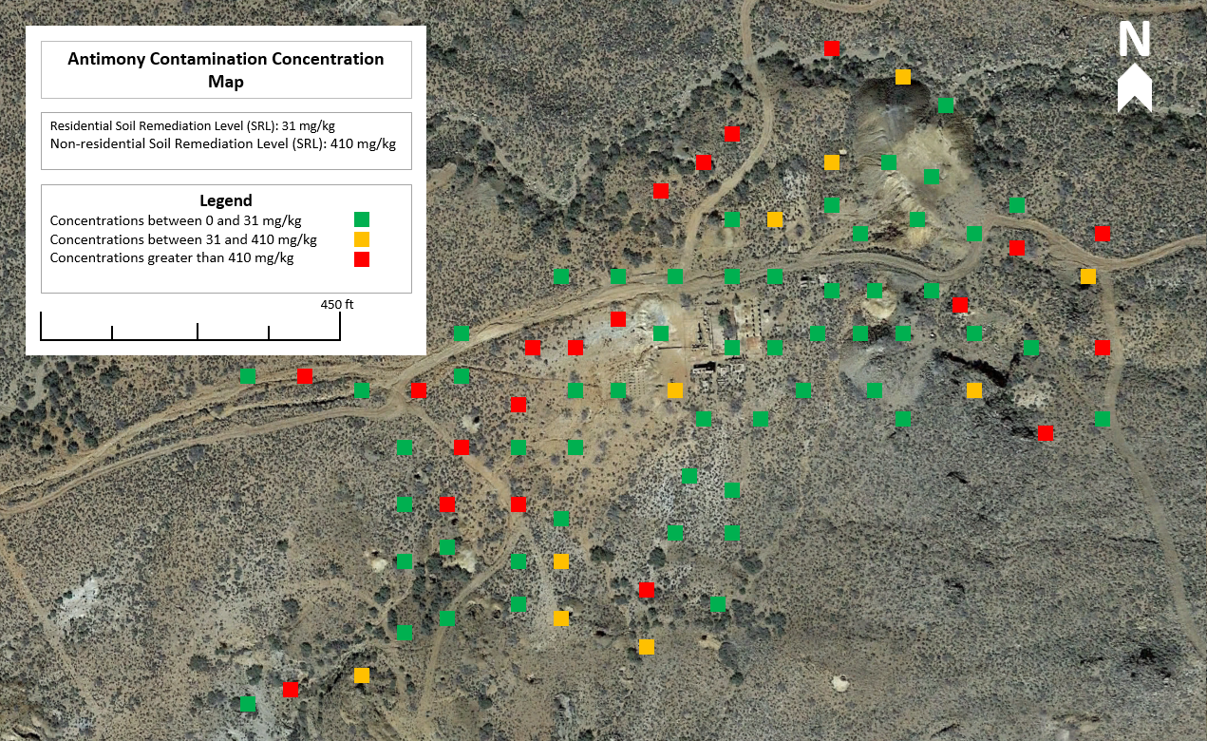
Figure 3.9: Antimony concentration map of the CAM site.

Risk Assessment
Risk assessment for the Copper Age Mine was divided into two categories: human health and ecological.

Human Health Risk

Exposure Scenarios
Human health risk assessment focused on three site-specific scenarios: recreational adult, recreational child, and a 1-year worker. The recreational exposure frequencies were set at 14 days, which is the maximum legal camping limit for BLM land; thus, representing the maximum expected exposure. The worker scenario represents worker exposure for a 1-year remediation scenario, with exposure frequency equal to 50 weeks minus weekends.
The expected site-specific conditions and scenario parameters used to determine the likely risks to human health are summarized below in Table 4.1.

Table 4.1: Parameters of risk assessment exposure scenarios: non-carcinogenic risk.
 | Recreational Adult | Recreational Child | 1-Year Worker
Body Weight (kg): | 70 | 33 | 78
Exposure Frequency (days/year): | 14 | 14 | 250
Exposure Time (hours/day): | 24 | 24 | 8
Averaging Time (days): | 7300 | 2190 | 365
Fraction Ingested: | 1.0 | 1.0 | 1.0
Soil Ingestion Rate (mg/day): | 100 | 200 | 100
Exposure Duration (years): | 20 | 6 | 1

Table 4.1 summarizes the variables used in non-carcinogenic risk calculations; the carcinogenic risks utilized the same conditions and parameters, except the averaging time was weighted over a 70-year lifetime rather than the exposure duration. The three exposure scenarios were then used to calculate the non-carcinogenic and carcinogenic chronic daily intakes (CDI) for arsenic and antimony, using both the 50% and 95% concentrations of each.
See Equations 4.1 and 4.3 for the non-carcinogenic and carcinogenic CDI equations, respectively. Sample calculation are also included of the non-carcinogenic and carcinogenic CDI for ingestion of 95% arsenic concentration (Table 3.1) of a recreational adult (Table 4.2).
Equation 4.1: Non-Carcinogenic Chronic Daily Intake
$$CDI \frac{mg}{kg-day}=\frac{Cs (\frac{mg}{kg})*IR (mg\frac{soil}{day})*EF (\frac{days}{year})*ED (years)}{BW (kg)*AT (days)}$$

Equation 4.2: Exposure Scenario 1: Recreational Adult for Arsenic Non-Carcinogenic CDI at 95% concentration
$$CDI \frac{mg}{kg-day}=\frac{1070 \left(\frac{mg}{kg}\right)*100 \left(mg\frac{soil}{day}\right)*14 \left(\frac{days}{year}\right)*20 \left(years\right)*\frac{kg}{1,000,000 mg}}{70 (kg)*7300 (days)}=5.8630E-05\frac{mg}{kg*day}$$
Equation 4.3: Carcinogenic Chronic Daily Intake
$$CDI \frac{mg}{kg-day}=Cs (\frac{mg}{kg})*IR (mg\frac{soil}{day})*(10^{-6}\frac{kg}{mg})*EF (\frac{days}{year})*(\frac{ED (years)}{BW (kg)*AT (days)})$$

Equation 4.4: Exposure Scenario 1: Recreational Adult for Arsenic Carcinogenic CDI at 95% concentration
$CDI \frac{mg}{kg-day}=1070 \left(\frac{mg}{kg}\right)*100\left(mg\frac{soil}{day}\right)*\left(10^{-6}\frac{kg}{mg}\right)*14 \left(\frac{days}{year}\right)*\left(\frac{20 \left(years\right)}{70 \left(kg\right)*7300 \left(days\right)}\right)=1.6751E-05\frac{mg}{kg*day}$

Non-Carcinogenic and Carcinogenic Risks
With the three-exposure scenarios established, human health risk assessment was then carried out in two parts: arsenic and antimony, and lead. According to EPA’s Integrated Risk Information System (IRIS), lead requires unique analysis to fully determine its risk potential; therefore, it was analyzed by different means, while arsenic and antimony used the standard approach for risk assessment. The risks associated with lead are discussed in Section 4.1.3, this section addresses the non-carcinogenic and carcinogenic risks of arsenic and antimony.
Antimony was treated as non-carcinogenic, and arsenic was treated as both non-carcinogenic and carcinogenic risks. Tables 4.2 and 4.3 presents the non-carcinogenic and carcinogenic CDI results.

Table 4.2: Chronic daily intake (CDI) summary for arsenic and antimony exposure scenarios: non-carcinogenic risk.
 | Recreational Adult | Recreational Child | 1-Year Worker
Arsenic 50% CDI (mg/kg-day) | 1.0192E-06 | 4.3237E-05 | 1.6333E-04
Arsenic 95% CDI (mg/kg-day) | 5.8630E-05 | 2.487E-04 | 9.3958E-04
Antimony 50% CDI (mg/kg-day) | 9.6434E-06 | 4.0913E-05 | 1.5455E-04
Antimony 95% CDI (mg/kg-day) | 4.0110E-05 | 1.7016E-05 | 6.4278E-04

Table 4.3: Chronic daily intake (CDI) summary for arsenic exposure scenarios: carcinogenic risk.
 | Recreational Adult | Recreational Child | 1-Year Worker
Arsenic 50% CDI (mg/kg-day) | 2.9119E-06 | 3.7061E-06 | 2.3333E-06
Arsenic 95% CDI (mg/kg-day) | 1.6752E-05 | 2.1320E-05 | 1.3423E-05

Once the CDI values were determined, they were used to obtain the non-carcinogenic and carcinogenic risk values for each applicable scenario. For non-carcinogenic risk, the CDI was divided by the oral reference dose (0.0003 and 0.0004 mg/kg-day for antimony and arsenic, respectively), resulting in the hazard quotient (HQ) value [18, 19]. For the arsenic carcinogenic risk, the CDI was multiplied by the oral ingestion cancer slope factor (1.5 (mg/kg-day)⁻¹) to obtain the potential cancer risk [18]. The results are presented in Tables 4.4 and 4.5 below and the equations with their respective example calculations are demonstrated below.
Equation 4.5: Non-Carcinogenic Hazard Quotient
$$HQ=\frac{CDI}{0.0004\frac{mg}{kg*day}}$$
Equation 4.6: Exposure Scenario 1: Recreational Adult for Arsenic Non-Carcinogenic HQ at 95% concentration
$$HQ=\frac{5.8630E-05\frac{mg}{kg*day}}{0.0004\frac{mg}{kg*day}}=0.20$$

Equation 4.7: Carcinogenic Hazard Quotient
$$HQ=CDI*1.5 {\left(\frac{mg}{kg*day}\right)}^{-1}$$
Equation 4.8: Exposure Scenario 1: Recreational Adult for Arsenic Carcinogenic HQ at 95% concentration
$$HQ=5.8630E-05\frac{mg}{kg*day}*1.5 {\left(\frac{mg}{kg*day}\right)}^{-1}=2.5127E-05$$

Table 4.4: Exposure scenarios’ risk summary: 50% concentrations.
 | Recreational Adult | Recreational Child | 1-Year Worker
Arsenic Non-Carcinogenic Risk (HQ) | 0.034 | 0.14 | 0.544
Antimony Non-Carcinogenic Risk (HQ) | 0.024 | 0.10 | 0.386
Arsenic Carcinogenic Risk | 4.3679E-06 | 5.5591E-06 | 3.4999E-06

As shown in Table 4.4, the 50% concentrations result in HQs below 1.0 for all three scenarios; therefore, they do not represent a significant non-carcinogenic risk. All three carcinogenic risks are above $1 X {10}^{-6};$therefore, they represent an increased potential for cancer [20].

Table 4.5: Exposure scenarios’ risk summary: 95% concentrations.
 | Recreational Adult | Recreational Child | 1-Year Worker
Arsenic Non-Carcinogenic Risk (HQ) | 0.20 | 0.83 | 3.13
Antimony Non-Carcinogenic Risk (HQ) | 0.10 | 0.43 | 1.61
Arsenic Carcinogenic Risk | 2.5127E-05 | 3.1980E-05 | 2.0134E-05

As shown in Table 4.5, the HQs for both recreational scenarios are below 1.0; therefore, they do not represent a significant non-carcinogenic risk. Both worker HQs are above 1.0; therefore, they indicate unsafe exposure scenarios. All three carcinogenic risks are above$1 X {10}^{-6}$; therefore, they represent an increased potential for cancer.

Lead Risks
To fully determine the risks of lead exposure, the Integrated Exposure Uptake Biokinetic (IEUBK) Model and Adult Lead Model (ALM) were used [21].
The IEUBK model is used to assess the blood level concentration in children under 7 years old or 84 months in micrograms of lead per deciliter of blood (μg/dL). This model predicts the relative effects of lead that may result from environmental exposure through a child’s lifetime. Per the client’s request, recreational activity is assessed for 14-day exposure, this is not applicable to the IEUBK as it is limited in assessing short-term, periodic or acute exposures. Therefore, for educational purposes only, the 14-day data were distributed over 365 days to estimate a daily exposure, which is acceptable for model use. The corrected 50% and 95% concentrations calculated were 125 and 608 mg/kg, respectively.
Model inputs consisted of 50% and 95% site-specific soil sample data and EPA default recommended values; these can be seen in Table 4.6. The standard soil/dust age-specific intake rates in mg/day are used with it being apportioned 55% dust and 45% soil. In addition, the indoor dust lead concentration, in μg/g, was derived using a multiple source analysis built into the modeling software and the geometric standard deviation was defaulted to 1.6 [21].
The results of the model are demonstrated in Figures 4.1 through 4.6, where the highest point represents a spike in blood level in the time the child was exposed. The vertical line at 10 μg/dL is the established federal lead level of concern and anything to the right represents the fraction of the population above the cutoff. The goal is for no child to have greater than 5% probability of having a blood level greater than 10 μg/dL [21]. For the exposure period at this site, looking at the most vulnerable age group of 0 to 24 months and using the 50% concentration, there is a 0.58% probability of exceedance. Using the same age group at 95% concentration, there is a 10.5% probability of exposure, which exceeds the EPA’s standards. However, because the model does not accurately calculate short-term exposure of less than 90-days and only assess children younger than 7 years of age, a final conclusion cannot be made using solely this model.

Table 4.6: IEUBK exposure components including ingestion rate per age range.
Age-Specific Intake Rates
Age Range (years) | 0-1 | 1-2 | 2-3 | 3-4 | 4-5 | 5-6 | 5-7
Soil/dust (mg/day) | 85 | 135 | 135 | 135 | 100 | 90 | 85

Figures 4.1 and 4.2 below present the IEUBK models for the age group of 0 to 24 months.

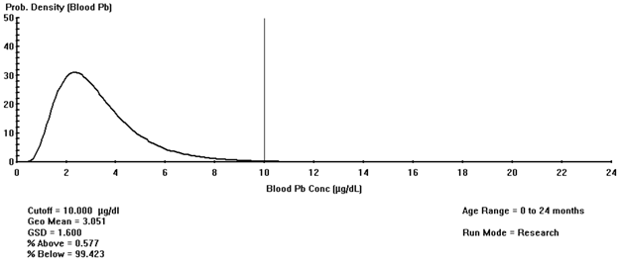

Figure 4.1: Blood lead level for a 0 to 24-month-old child at 50% lead concentration.

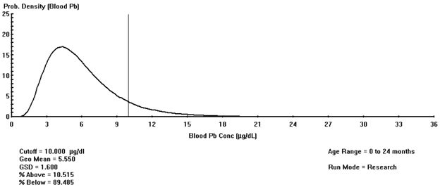
Figure 4.2: Blood lead level for a 0 to 24-month-old child at 95% lead concentration.

Figures 4.3 and 4.4 present the IEUBK models for the age group of 3-4 years.

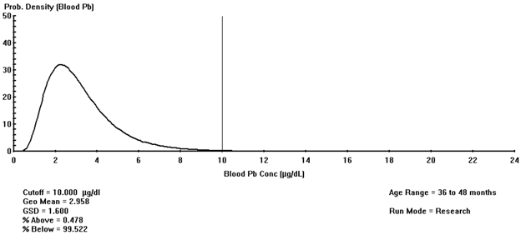
Figure 4.3: Blood lead level for a 36 to 48-month-old child at 50% lead concentration.

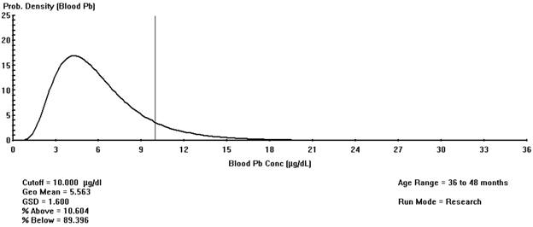
Figure 4.4: Blood lead level for a 36 to 48-month-old child at 95% lead concentration.

Figures 4.5 and 4.6 present the IEUBK models for the age group of 5-7 years.

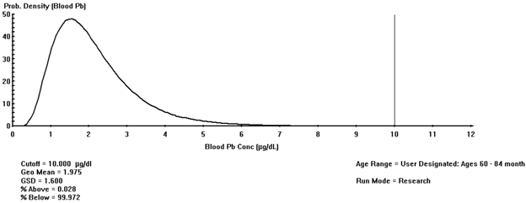
Figure 4.5: Blood lead level for a 60 to 84-month-old child at 50% lead concentration.

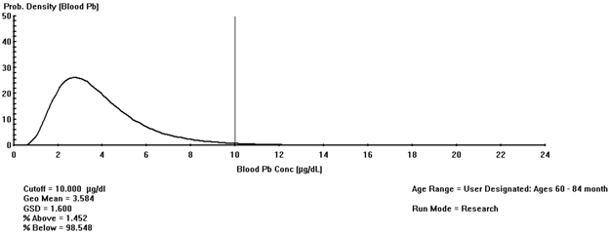
Figure 4.6: Blood lead level for a 60 to 84-month- old child at 95% lead concentration.

While the IEUBK analyzed exposure scenarios for children, the ALM analyzed adult lead blood levels (PbB) for the two applicable site-specific scenarios: recreational adult and 1-year worker. The results are summarized below in Table 4.7.

Table 4.7: ALM exposure scenarios’ results.
 | Recreational Adult | 1-Year Worker
Soil Ingestion Rate (g/day) | 0.1 | 0.1
Exposure Frequency (days/year) | 14 | 250
50% Adult PbB (ug/dL) | 1.5 | 11.6
95% Adult PbB (ug/dL) | 3.9 | 52.9

The 50% adult PbB used the 50% lead concentration of 3,245 mg/kg; the 95% adult PbB model used the 95% lead concentration of 15,800 mg/kg.
According to the National Institute for Occupational Health and Safety (NIOSH), the reference PbB for adults is 5 ug/dL, which was used as the target PbB of concern in the ALM. Table 4.5 shows the recreational adult PbB for both scenarios is below this level; however, the 1-year worker PbB is above this level in both scenarios. This indicates the 1-year worker scenario is unsafe and will likely result in unsafe PbB levels unless proper personal protective measures are taken.

Ecological Risk
The overall average XRF concentrations were compared to the Ecological Soil Screening Levels (Eco-SSLs) of 15 elements, as determined by the EPA [22]. The Eco-SSLs are similar to the non-residential SRLs for humans. The Eco-SSLs are the maximum concentration of contaminants in soil before harm is done on biota that live in or on soil and are used to find the contaminants of potential concern (COPC); however, they are not designed to be used for cleanup levels [19]. The 15 Eco-SSLs assessed only look at four categories of biota: plants, soil invertebrates, avian wildlife and mammals, which are presented in Table 4.8.

Table 4.8: Ecological soil screening levels (mg/kg dry weight in soil). Highlighted cells indicate that the contaminant concentration exceeded the ecological soil screening levels.
Contaminant | Average XRF Concentration (mg/kg) | Ecological Soil Screening Levels  (mg/kg dry weight in soil)
Contaminant | Average XRF Concentration (mg/kg) | Plants | Soil Invertebrate | Avian Wildlife | Mammals
Lead | 3,245 | 120 | 1,700 | 11 | 56
Selenium | 205 | 0.52 | 4.1 | 1.2 | 0.63
Arsenic | 2,798 | 18 | NA | 43 | 46
Zinc | 1,556 | 160 | 120 | 46 | 79
Copper | 516 | 70 | 80 | 28 | 49
Nickel | 24,982 | 38 | 280 | 210 | 130
Cobalt | 365 | 13 | NA | 120 | 230
Manganese | 26,552 | 220 | 450 | 4,300 | 4,000
Chromium (III) | 102,049 | NA | NA | 26 | 34
Vanadium | 1,198 | NA | NA | 7.8 | 280
Antimony | 1,435 | NA | 78 | NA | 0.27
Cadmium | 21 | 32 | 140 | 0.77 | 0.36
Silver | 312 | 560 | NA | 4.2 | 14
Barium | 688 | NA | 330 | NA | 2,000

It should be noted that the lead concentration presented in Table 4.8 is the 50% concentration from FAAS data, as the XRF lead data was inconsistent and likely unreliable due to interferences previously discussed. The highlighted cells represent the instances of exceeded Eco-SSLs. Due to the high occurrence of exceedances, there appears to be a significant ecological risk at the site.

Conclusions
The findings of this PA/SI have identified arsenic, lead, and antimony as contaminants of concern for CAM. Problems occurred when analyzing the correlation of the XRF and FAAS data for lead and antimony. The lead interferences possibly occurred during XRF analysis, when emissions overlapped with arsenic and iron concentrations [11]. The antimony FAAS data was non-detect due to the digestion methodology being insufficient for isolating antimony [14]. Ultimately, the antimony and lead XRF data were not corrected, while the arsenic data was. This led to the determination of 50% and 95% concentrations for each contaminant, which formed the basis of the risk assessment analysis.
Through laboratory and data analysis, and the application of three site-specific scenarios, it was determined that arsenic presents non-carcinogenic risk to unprotected workers at the 95% EPC level, and a potential increase for cancer risk for all three exposure scenario groups at the 50% EPC level. Antimony presents a non-carcinogenic risk to unprotected workers at the 95% level. Lead, which was analyzed through different modeling techniques, was found to present a risk to children 0-4 years old at the 95% EPC level and to adult workers at the 50% EPC level. Additionally, fifteen elements were used to analyze ecological risk, with the overall concentrations exceeding the screening levels for both flora and fauna.

Summary of Engineering Work
The engineering work required to complete this project is outlined in Table 6.1 below. The work hours were estimated prior to the start of the project, and later compared to the actual hours put towards the project. The projected task total was estimated during the development of the work plan and is comparable to the actual hours required to complete all engineering work associated with this project. It should be noted that there were also 30 hours projected for the subcontractor laboratory analysis, which were met in totality by CPAL.
Table 6.1: Detailed work hours associated for each personnel.
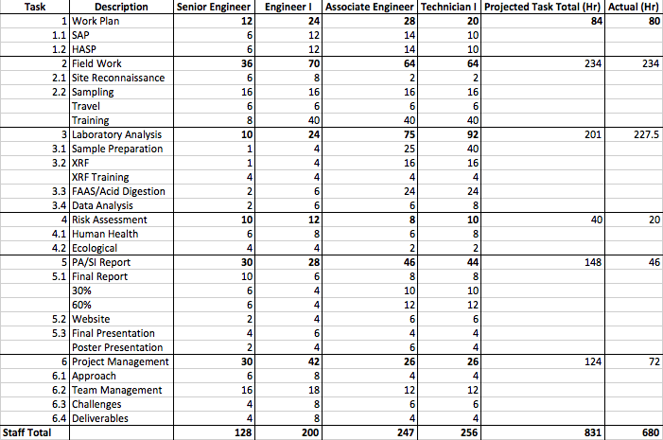

Summary of Engineering Costs
The actual costs were lower than the initial projection. The total staffing hour cost was $50,840 compared to the predicted $61,730. Table 7.1 shows the costs for each personnel and the total costs.
Table 7.1: Summary of the costs for each personnel based on Table 6.1.

The hourly rate per employee depends on their experience and responsibilities. The cost per staff position is displayed in Table 7.1 and is in accordance with the Abandoned Mine Land and BLM figures and current industry standards.
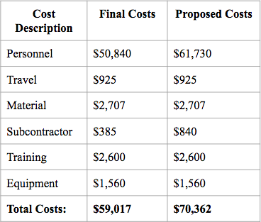
The following table summarizes the overall project costs and includes both the proposed and final costs.
The personnel cost is the total staffing amount, as shown in Table 7.1. The travel costs included van rental, gas, hotel accommodations, and per diems. The material costs included sampling supplies, such as gloves, Ziploc bags, and shovels. The subcontractor costs include acid digestion materials and FAAS analysis. Training costs included 40-hour Occupational Safety Health Administration (OSHA) HAZWOPER certifications for all team members. Equipment costs included safety, field sampling, field monitoring, and laboratory equipment.
Overall, the travel, material, training, and equipment costs were as expected; the personnel and subcontractor costs were lower than anticipated. Due to the decreased costs of personnel and subcontractors, the overall project cost was approximately 16% lower than projected.
Table 7.2: Summary of project costs

References
[1] Google Earth Pro. Google, 2017.
[2] E. Zielske, Copper Age Files.
[3] "El Oro", Arizona Department of Mines and Mineral Resources File Data.
[4] M. O. Fashola, V. M. Ngole-Jeme and O. O. Babalola, "Heavy Metal Pollution from Gold
Mines: Environmental Effects and Bacterial Strategies for Resistance," Environmental
Research and Public Health, vol. 13, no. 11, pp. 1-20, 2016.
[5] E. Zielske, "BLM Client Meeting", NAU, 2017.
[6] "American FactFinder - Community Facts", Factfinder.census.gov, 2017. [Online].
Available: https://factfinder.census.gov/faces/nav/jsf/pages/community_facts.xhtml?src=bkmk#. [Accessed: 19- Sep- 2017].
[7] World Mines Register: Volume 15. Miller Freeman Publications, 1922, pp. 254-256.
[8] "El Oro Mine (MRDS #10186259) AU", Mrdata.usgs.gov. [Online]. Available:
https://mrdata.usgs.gov/mrds/show-mrds.php?dep_id=10186259. [Accessed: 22- Oct- 2017].
[9] "Chloride Community Park Topo Map, Mohave County AZ (Chloride Area)", TopoZone.
[Online]. Available: https://www.topozone.com/arizona/mohave-az/park/chloride-
community-park/. [Accessed: 22- Oct- 2017].
[10] "Section 4.9 Sacramento Valley Basin", Arizona Water Atlas.
[11] "Common Causes of Lead Interference Using XRF", XOS, 2013.
[12] "The Lognormal Distribution in Environmental Applications", EPA: Technology Support
Center for Monitoring and Site Characterization, Las Vegas, 2004.
[13] "MODULE 1. GUIDANCE ON PREPARING A QA PROJECT PLAN", US EPA.
[14] M. Tighe, P. Lockwood, S. Wilson and L. Lisle, "Comparison of Digestion Methods for
ICP-OES Analysis of a Wide Range of Analytes in Heavy Metal Contaminated Soil
Samples with Specific Reference to Arsenic and Antimony", Communications in Soil
Science and Plant Analysis, vol. 35, no. 9-10, pp. 1369-1385, 2004.
[15] "Study of State Soil Arsenic Regulations", Association for the Environmental Health of
Soils, 1999.
[16] "USGS Background Soil-Lead Survey: State Data | US EPA", US EPA, 2017. [Online].
Available:
https://www.epa.gov/superfund/usgs-background-soil-lead-survey-state-data#AZ.
[17] “Final Prelimanry Assessment/Site Inspection,” Weston Solutions Inc., July 2015.
[18] "Arsenic, inorganic CASRN 7440-38-2 | IRIS | US EPA, ORD", Cfpub.epa.gov. [Online].
Available: https://cfpub.epa.gov/ncea/iris2/chemicalLanding.cfm?substance_nmbr=278.
[19] "Antimony CASRN 7440-36-0 | IRIS | US EPA, ORD", Cfpub.epa.gov. [Online]. Available:
https://cfpub.epa.gov/ncea/iris2/chemicalLanding.cfm?substance_nmbr=6.
[20] "Regional Screening Levels Frequent Questions (November 2017) | US EPA", US EPA,
2018. [Online]. Available:
https://www.epa.gov/risk/regional-screening-levels-frequent-questions-november-2017
#FQ28.
[21] EPA. “Training on the IEUBK Model, Adult Methodology, and Recent Lead Risk
Assessment Updates”. [Online]. Available: https://semspub.epa.gov/work/11/176285.pdf.
[22] EPA. “Interim Ecological Soil Screening Level Documents”. Safer Chemicals Research.
2005. [Online]. Available:
https://www.epa.gov/chemical-research/interim-ecological-soil-screening-level-documents.

Appendix A: Work Plan

** See attached file **

Appendix B: Raw XRF Data

** See attached file **

Appendix C: Analyzed XRF Data

** See attached file **

Appendix D: Field Notes

** See attached file **

Appendix E: Photographs

** See attached file **

Appendix F: GPS Data.

** See attached file **

Appendix G: General Risk Assessment Calculations

** See attached file **

Appendix H: Data Transformations

** See attached file **

Appendix I: Human Health Risk Assessment

** See attached file **

Appendix J: Ecological Risk Assessment

** See attached file **

