PCI BIG BEAM COMPETITION 2016
NORTHERN ARIZONA UNIVERSITY

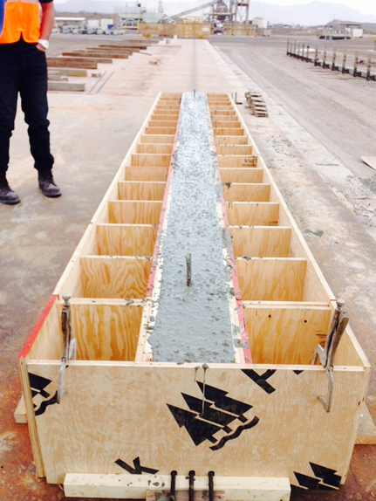
Team Members:
Eman Albdiwyi
Deena Albustan
Nicholas Jokerst
Michael O’Reilly
Faculty Advisor: Sponsoring PCI Member:
Dr. Robin Tuchscherer, P.E., Ph.D. TPAC Kiewit Western Company, Phoenix, AZ
Special thanks to:
Abdullah Kassab, P.E.
Vincent Rossi, P.E.

1.0 Summary and Judging Form

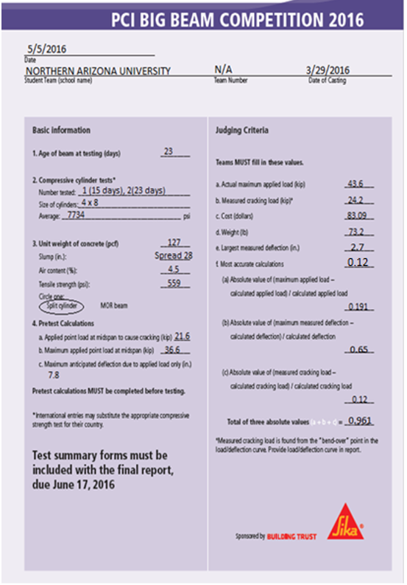

1.1 Load vs Deflection

Figure 1.1.1 shows the load versus deflection plot that was generated during the testing of the NAU Big Beam.

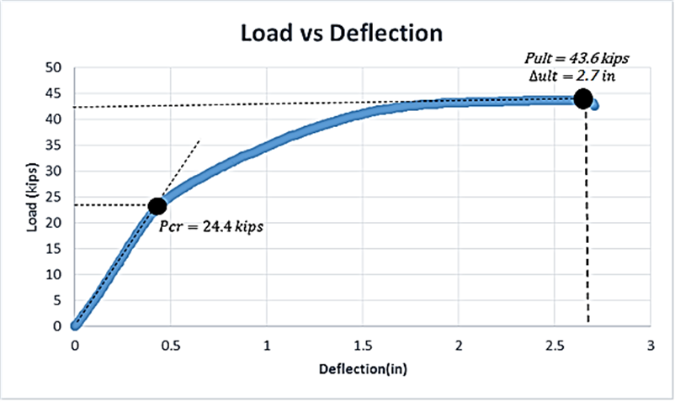
Figure 1.1.1: Load versus deflection of NAU Big Beam

2.0 Calculation Certification

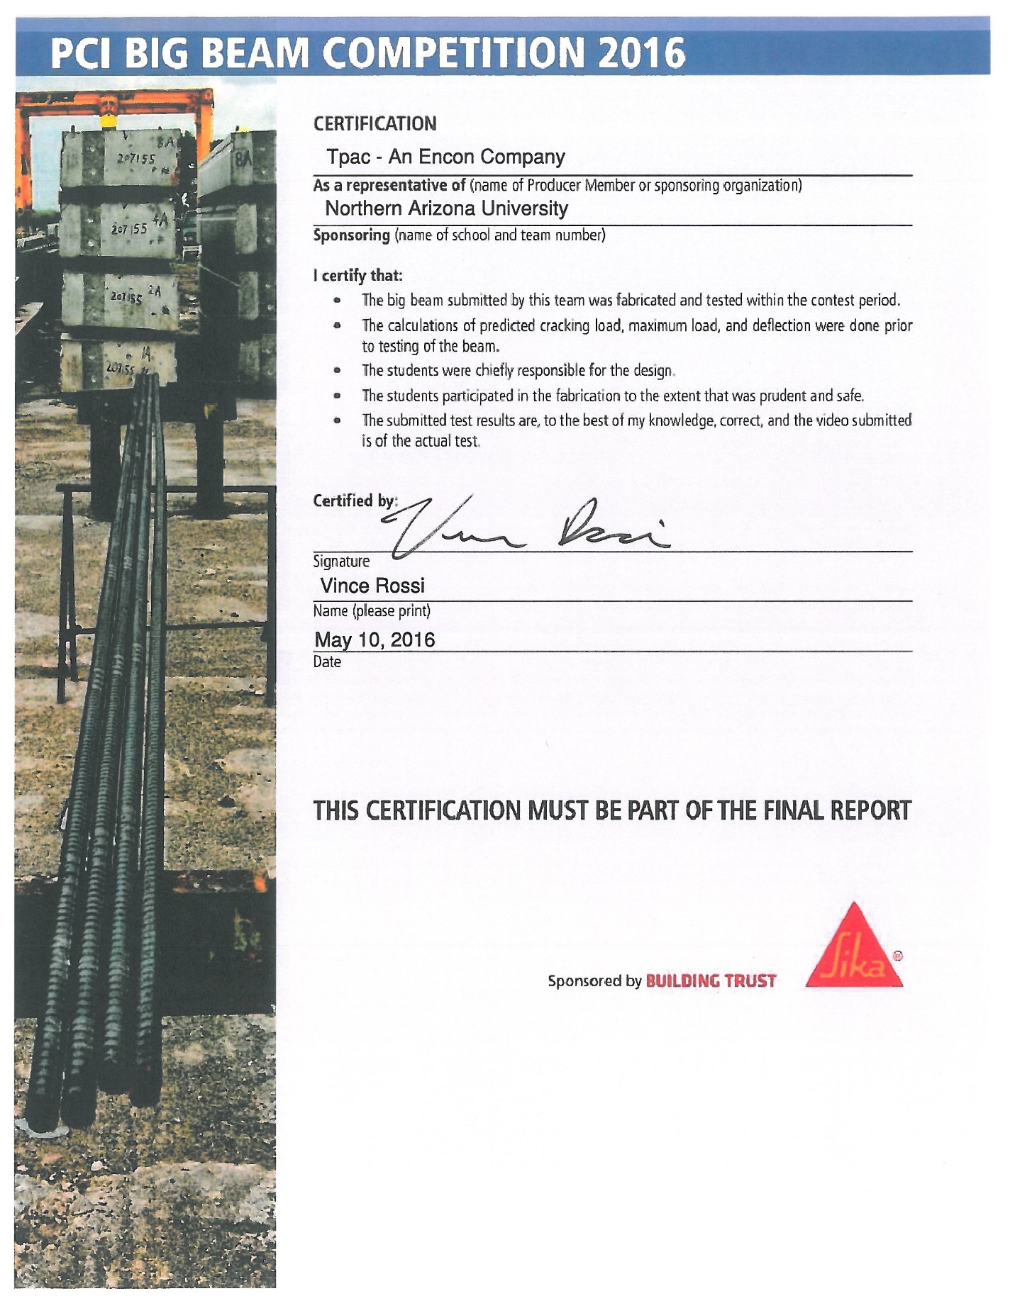

3.0 NAU Big Beam Cross Section and Elevation
Figure 3.0.1 and 3.0.2 provide the cross section and elevation view of the NAU Big Beam, respectively.

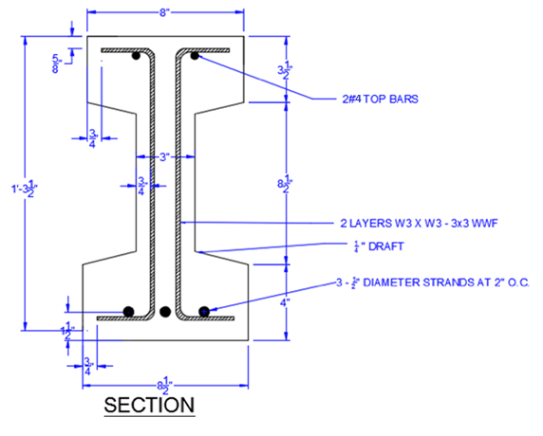

Figure 3.0.1: Big Beam cross sectional view

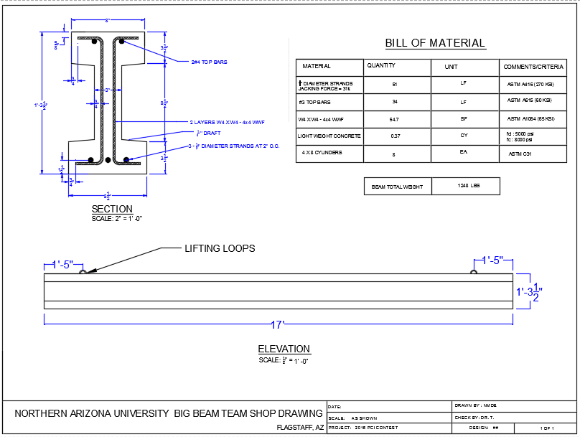
Figure 3.0.2: Big Beam elevation view

4.0 Concrete Mix Design
4.1 Existing Concrete Mixture:
TPAC provided the team with two pre-made concrete mix options: the lightweight mix and the normal weight concrete mix. The table below shows the difference between the two mixtures.
Table 4.1.1: Lightweight to Normalweight Mix Comparison.
 | Cost ($/${yd}^{3}$) | Compressive Strength (psi) | Unit weight (lb/${ft}^{3}$) | Relative Deflection
Normal Weight | 100 | 8500 | 145.0 | 1
Light Weight | 110 | 8000 | 124.1 | 1.15-1.30
Percent Different | +10 | -5.9 | +14.4 | + 0.15-0.30

The lightweight concrete mixture appears to be more beneficial for several reasons. As can be seen in the table, it provides 15%-30% more deflection when compared to the normal weight mix [1]. The light weight concrete mix will also conserve 14.4% in terms of unit weight. However, it costs 10$/CY more than the normal weight concrete mix, according to the PCI Big Beam rules. In conclusion, the lightweight mix appears to be better suited for our application, but both types of mixes will be evaluated during beam design.

4.2 New Mixture Design:
The team had two options for choosing a concrete mix. The first option is designing a concrete mixture from scratch. This option has several constraints. It must utilize TPAC available admixtures at the plant and must act as a self-consolidating concrete mixture to comply with TPAC’s traditional operation. Additionally, many cylinders would have to be tested to analyze a mixes performance if a new design was created. According to ACI 318-14 there must be a minimum of 30 cylinders tested for each test (tensile and compression) on each required day of cure (7 and 24) for the concrete to not receive a reduction in strength. At 30 cylinder tests, the scatter in the test data will likely contribute to a skewed strength average. TPAC recommends testing hundreds of cylinders in order to compensate for the scatter in the test data to achieve a realistic representation of the mix’s strength. TPAC’s available mixes have concrete properties whose values are statistically reliable. The team decided that the risk associated with designing a new mix outweighed the possible benefits of the new mix.
The other possibility is modifying TPAC premade concrete mix to suit our specific application. Potential benefits of modifying TPAC mixture include increasing the compressive strength which will lend itself to a higher cracking load and thinner flange/web. Also, the mixture could be modified to achieve a higher peak strain, consequently a higher deflection. This option was not pursued for the same reasons as designing a unique mix.

Table 4.2.1: TPAC Lightweight Mixture Constituent.
Material | Ingredients | Quantity | Units
Cement | (AZ Type II Portland Cement) | 730 | lb/cy
Cement | (Pozzolan, Class F(fly ash)) | 185 | lb/cy
Aggregate | (WCS Marricopa) | 1306 | lb/cy
Aggregate | (Expanded Shale (Utelite)) | 812 | lb/cy
Water | 317 |  | lb/cy
Air Content | 3% |  | lb/cy
Spread Test | 28 |  | in
W/C Ratio | 0.346 |  | -
Admixtures | * |  | -
3 Days Compression Strength | 5000 |  | psi
28 Days Compression Strength  * Admixtures: Advacast 577, VmarF-100, AE 90 Air and Vmar 3. | 8000 |  | psi

4.3 Mixture Performance:
During the process of casting the beam, eight concrete cylinders were taken from the same concrete batch. These were tested to get the most accurate performance of the mix. The testing was following ASTM standards. According to the standards, the compressive strength testing is under (ASTM C39), and the tensile strength testing is under (ASTM C496). The concrete performance, based on the team’s testing, is projected in the stress strain curve below.

Max Stress = 7.14 Ksi
Peak Strain =0.00249

Maximum Stress

Max Stress = 7.44 Ksi
Peak Strain = 0.00323

Peak Strain

Modulus, E

Figure 4.3.1: Stress/Strain Curve

The strain value at the peak stress was determined as the highest point on the curve before the values start decreasing. The peak strain was defined as the highest strain before the cylinder was crushed and the curve showed material failure. Because two cylinders were tested for the compressive strength these results were averaged to get the final concrete properties. The results for compressive strength, tensile strength and peak strain are shown in Table 4.3.1.

Table 4.3.1: Cylinder Test Results
Concrete Mix Results – 23rd Curing Day
 | Compression Strength (ksi) | Tensile Strength (ksi) | Peak Strain (in/in)
23 days | 7.27 | 0.55 | 0.00286

It is important to note that the team tested two cylinders for both compression and tension on the 15th day. This was done due to internal team time constraints as the team was attempting to test their beam as soon as possible. However, the team determined that it would be better to wait another week of curing because the concrete compressive strength tested at 6.8 ksi. Therefore, the team only tested two cylinders in compression and two in tension before breaking the beam on the 23rd day of cure.

5.0 Structural Design
The first step of design was designing beam options for flexural strength. Next the top several beams that had sufficient flexural strength were scored to choose a final design option. Once a final selection had been made the shear reinforcement for it was designed and it final deflections was predicted.

5.1 Preliminary Design
The preliminary beam design calculations were done in MathCAD. The reason for this was twofold: firstly, it was used as a learning tool for the team members; secondly it was used to quickly compare multiple design options. In this way, inputs for the dimensions of the cross section, reinforcement, and concrete properties were altered. With these inputs, weight of the beam, the moment due to self-weight, the stresses at release, the cracking load, and the load at ultimate flexural capacity were calculated. Release stresses and the cracking load were calculated based on conventional elastic assumptions. Ultimate capacity was determined using conventional Whitney Stress Block assumptions and strain compatibility. Stress in the pre-stressed strands were assumed to be 174ksi and 190ksi at release and at cracking respectively. Stress in the strand was determined based on strain compatibility and the modified Ramberg-Osgood stress strain relationship.
In order to optimize the final design, each team member used the MathCAD sheet to optimize one aspect of the beam such as deflection, weight, or cost. Each team member sought to determine which beam performed best in their respective category while meeting the cracking and ultimate load criteria. This was done through modifying a single input such as the height of the beam or the number of pre-stressed strand in the beam. Changing one value often caused undesired results in a different area of the beams performance (such as decreasing the height increased the deflection but reduced the ultimate flexural capacity). Therefore, the process of optimizing an aspect of the beam was very iterative. Once these beam options were generated, the team scored them against the other beam options per the competition scoring procedures (Equation 1).

$Score=\frac{(your value-worst value)}{(best value-worst value)}$ Equation 1

However, the results from comparing only three beam options were unhelpful because, with only three beams, the scoring criteria gave quality designs options a score of zero in many categories where they were slightly out performed by another beam. This caused the team to score the top several (i.e. 5-6) beam design option from each team member against each other per the competition scoring procedures. The team then selected the beam which had the highest cumulative score out of the group of beams (see Appendix B for scoring table). The winning beam scored highest because it scored well in cost and weight. Also it performed slightly above average in deflection. Because it was well balanced and scored medium to high in every category it ended up being the best design option.

5.2 Shear Design
After a final beam cross-section was selected, the team determined the shear capacity and shear reinforcement requirements using the ACI 318-14 code. The shear carried by the concrete was taken as the lesser of the web-shear and the flexural-shear values calculated at mid-span. After this calculation, the amount of reinforcement needed to carry the remainder of the factored load was determined. This resulted in two layers of 4 gauge wire mesh of at four inches spacing.

5.3 Analysis and Final Predictions
After the team selected a final cross-section and flexural reinforcement, these values were input into Response 2000. Response 2000 is a software that allowed the team to get more accurate analysis values and it verified that the MathCAD sheet had produced reliable results. Response 2000 produced more accurate results because it analyses the beam using a fully sectional response and strain compatibility which is a more accurate way than the Whitney Stress Block assumption is. This is especially true after the beam has been loaded passed the cracking load. For instance, the Response 2000 results yielded an ultimate moment capacity nearly twenty percent greater than calculated with MathCAD. Additionally, the longitudinal wires of the wire mesh were modeled as longitudinal reinforcement in Response which added to the accuracy of the analysis. All the Response inputs are found in Appendix C.
The deflection of the beam was calculated using numerical integration to perform a virtual work method of analysis (Equation 2).

$∆=\int{\frac{mM}{EI}dx}$ Equation 2
Where: m is the virtual moment
$\frac{M}{EI}$ is the real curvature
$∆$is the midspan deflection

This was done in Microsoft Excel using the moment curvature relationship output in Response. Finally, the camber of the beam was added to the calculated deflection from the horizontal to get a total deflection value (see Appendix D for these deflection calculations). The actual load versus deflection graph of the beam can be seen in Section 1.1

Table 5.3.1: Final Predicted Performance
Final Design Predictions
Cracking Load (kips) | 21.6
Ultimate Load (kips) | 36.6
Ultimate Deflection (in) | 7.8

6.0 Beam Fabrication and Testing

6.1 Overview of Facilities
For the fabrication of our prestressed beam, we collaborated with TPAC Architectural and Structural Prestressed Concrete. The 50-acre TPAC fabrication facility is located in Phoenix, Arizona. TPAC’s close proximity to Northern Arizona University and sixty years of industry experience made them an ideal partner for this project. The plant includes a state of the art on-site batch plant, carpentry shop, 33 200’ casting beds equipped with pre-stressing and post-tensioning systems, and available steam curing beds.

6.2 Formwork and Reinforcement Verification
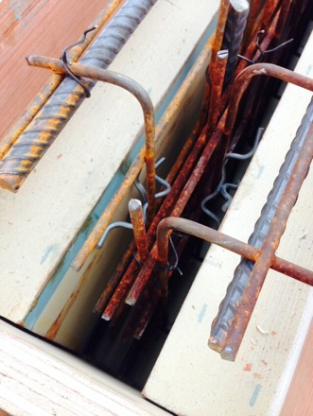
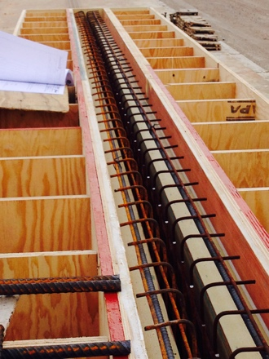
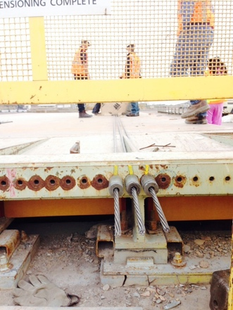
To ensure dimensional accuracy and quality assurance, all members of the NAU team were present for the casting day of our beam. Upon arrival, the team verified that the formwork and reinforcement complied with construction documents provided in Section 3.0. The bull bed length, depth, flange width, web width and clear covers were verified using a standard tape measure. The pre-stressed strands were already anchored, Figure 6.2.1, and the team retrieved the tensioning report from SWPC to verify the pre-stress magnitude, see Appendix E. Figure 6.2.2 is an image, taken prior to casting, of the rebar cage and ply-wood formwork. To prevent displacement of the reinforcement during concrete placement, a foreman tied the wire mesh reinforcement to the compression steel once the design was verified followed by the insertion of spacers between the formwork and mesh cage, Figure 6.2.3.
Figure 6.2.2: Formwork and reinforcement array
Figure 6.2.1: Anchored pre-stressed strands

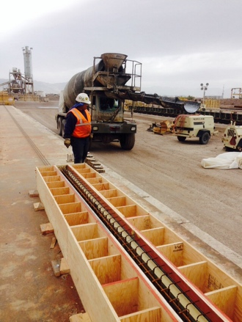
6.3 Concrete Mixing and Casting
The team’s Big Beam was constructed of a self-consolidating lightweight concrete, batched on site. TPAC prepared our concrete mix and delivered it via a ready-mix truck. Concrete was placed into the formwork as seen in Figure 6.2.4. As the concrete filled the formwork, the truck proceeded backwards to allow it to flow to the rest of the form. Once concrete reached the compression steel in the upper flange, the concrete was placed by hand to ensure constant cover. The concrete didn’t require any vibration because it was a self-consolidating mix. After, the team filled eight cylinders from the same mixture for compression and tension strength tests.
Figure 6.2.4: Big Beam casting
Figure 6.2.3: Reinforcement spacers

6.4 Mill Report and Tensioning Report
The Mill Certificate of Inspection, Appendix F, verifies the steel strand properties. The team used three uncoated seven-wire steel strands within the pre-stressed beam. The material properties of the seven wire strands are included in Table 6.4.1.

Table 6.4.1: Seven-wire strand material properties
Strand Type | Cross Sectional Area (in²) | Yield Point (ksi) | Elongation (%) | Elastic Modulus (Mpsi)
S1288776-2 | 0.1525 | 266.74 | 5.1 | 28.8

6.5 Cylinder Compression and Tensile Testing
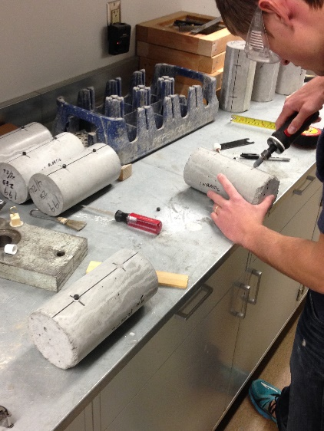
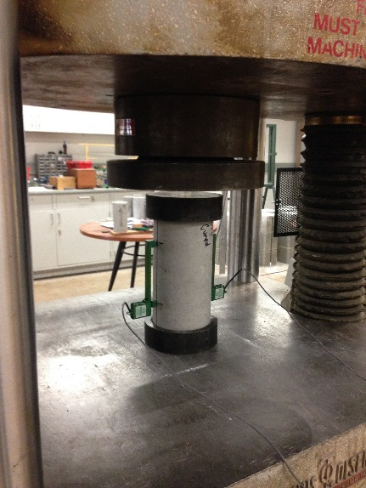
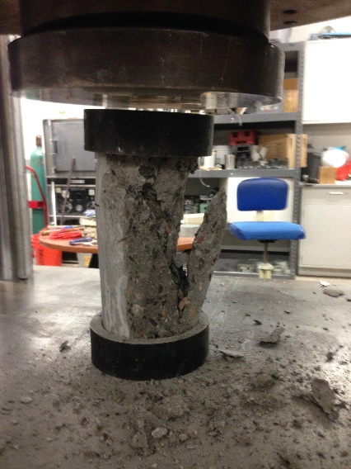
Four cylinders were tested for compressive strength and four were tested for tensile strength. Figure 6.5.1 shows NMDE preparing the cylinders for testing. The magnets were used to attach extensometers for collection of displacement data. Four cylinders were tested for compressive strength and four were tested for tensile strength. The compression testing of a cylinder before and after failure is shown in Figure 6.5.2 and 6.5.3, respectively. The tensile strength was determined by testing according to ASTM C496. The tension test set up can be seen in Figure 6.5.4 and the resulting failure can be seen in Figure 6.5.5.
Figure 6.5.2: Compression Testing per ASTM C39

Figure 6.5.1: Cylinder preparation for testing
Figure 6.5.3: Compression Failure

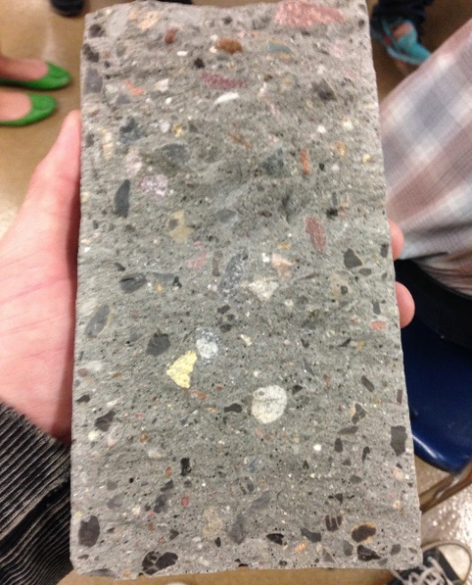
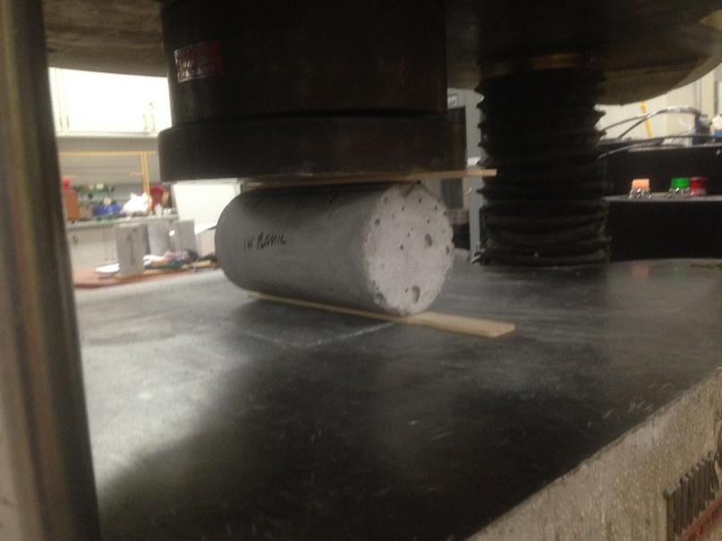
Figure 6.5.5: Tension Test Split
Figure 6.5.4: Tension Test Set-Up

6.6 Cylinder Testing Results
The results of the compressive and tensile cylinder tests are reported in Section 4.3. The averages of the four tests were used for final predictions.

6.7 PCI Big Beam Test Setup
After forwarding predictions to TPAC, the PCI Big Beam was tested at NAU on April 22, 2016. As seen in Figure 6.7.1, a 400-kip capacity steel reaction frame (A.K.A “The Hulk) and hydraulic ram were used to test the beam.
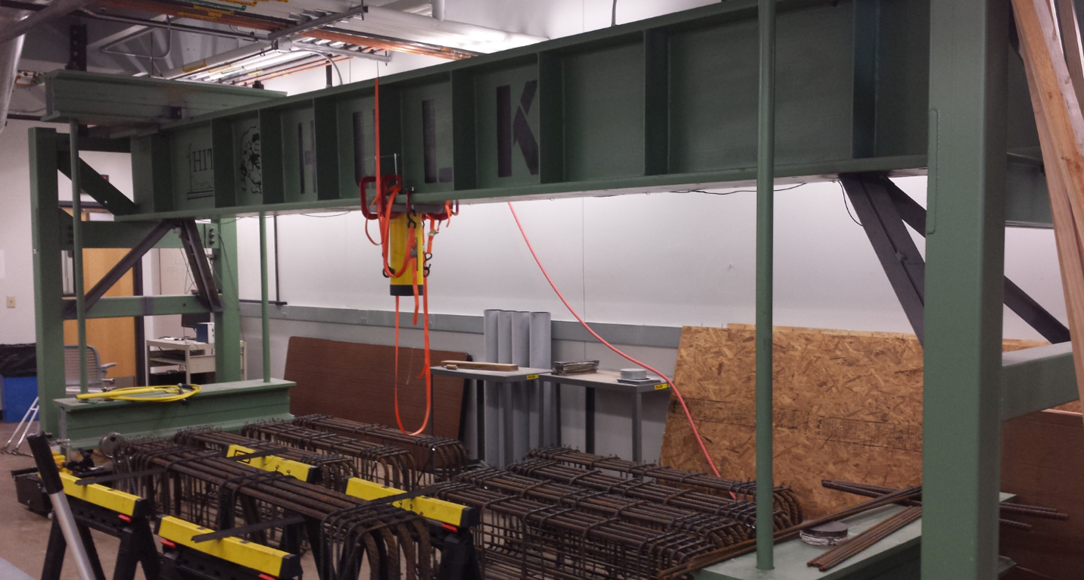
Figure 6.7.1: “The Hulk” – NAU Big Beam Testing Device

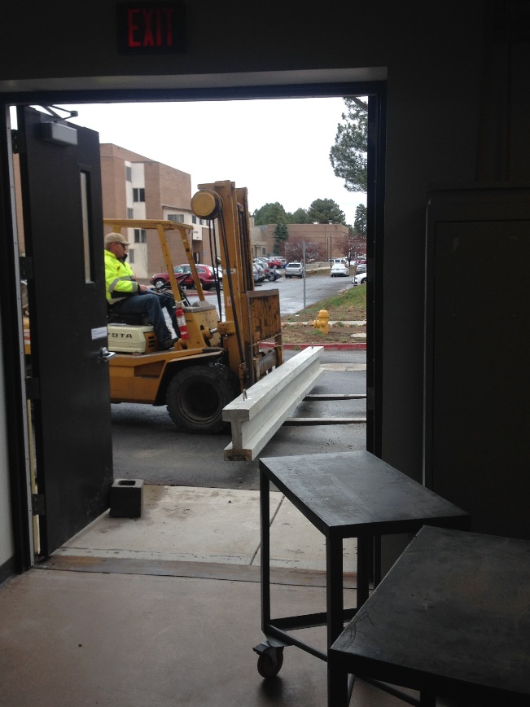
Prior to the beam delivery, the beam supports had to be moved to the span of fifteen feet according to the 2016 PCI Big Beam rules. The supports were then locked into place to prevent any slippage during testing. The team received the beam at the testing facility on April 7, 2016. Figure 6.7.2 shows the loading of the testing beam into the testing lab at NAU.

Once the beam was moved inside the testing facility, the team measured and marked the horizontal and vertical center lines on the top, bottom and each side of the beam. Once the centerlines and supports were marked, the beam was set on a bed of self-leveling gypsum and two 3 x 9-inch steel plates, Figure 6.7.3.
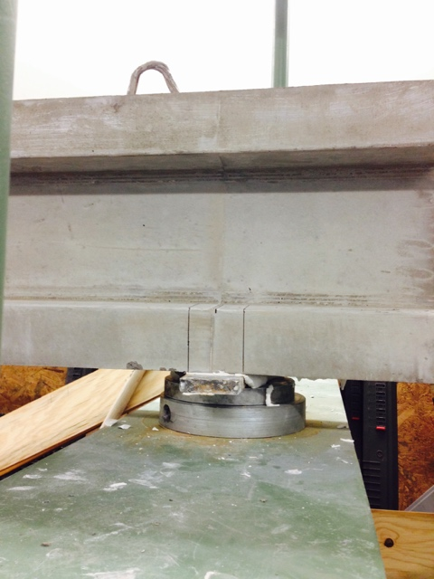
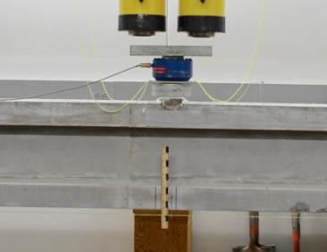
The self-leveling gypsum ensures even bearing surface between the beam and supports. At this point, instrumentation was attached to the beam for collection of load and displacement data. This instrumentation included a 50-kip capacity load cell and three string potentiometers. Two string potentiometers were used to measure displacement of the supports, and the other to measure centerline deflection of the beam, Figure 6.7.1. A ruler was attached in front of the beam as a visual indicator of deflection as well, Figure 6.7.4.
Figure 6.6.4: Visual indication of deflection

Figure 6.6.3: Beam and supports
Figure 6.6.2: Beam loading into the lab

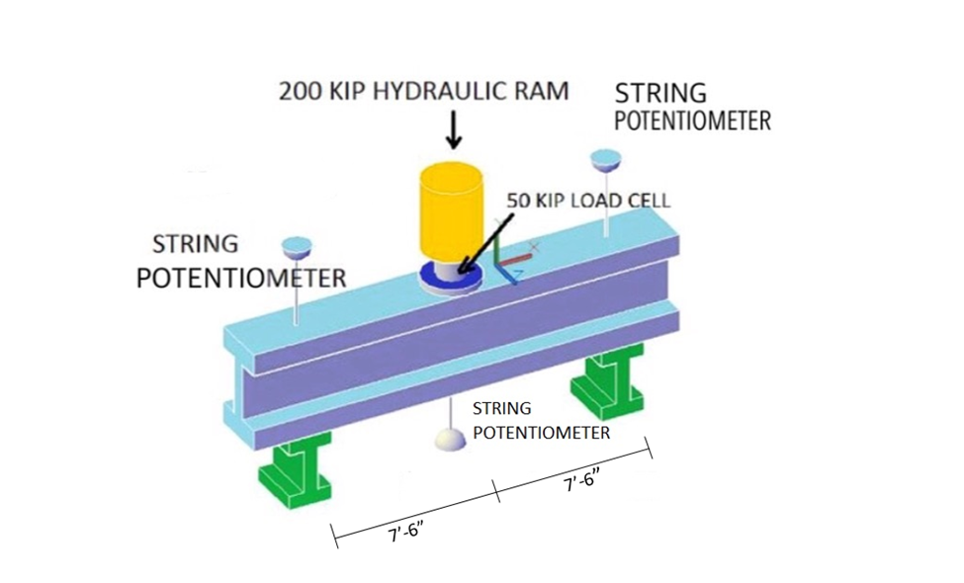
Figure 6.6.5: NAU Big Beam Conceptual Test Set Up

6.8 PCI Big Beam Test Results
The beam was loaded to failure on the Hulk, Figure 6.7.1. As the beam was loaded, the load cell and potentiometers transmitted data to the data acquisition system which produced a real-time load versus midspan deflection graph. The final results for the cracking load, ultimate load and ultimate deflection are found in Section 6.9.

6.9 PCI Big Beam Results
Table 6.9.1 provides a comparison of our final predictions to the actual performance of the beam.

Table 6.9.1: Comparison of theoretical predictions to beam performance.
PCI Big Beam Test Results vs. Predictions
 | Cracking Load (kip) | Ultimate Load (kip) | Ultimate Deflection (in)
Predictions | 21.6 | 36.6 | 7.8
Results | 24.2 | 43.6 | 2.5
Percent Difference | +12.0 | +16.0 | -68.0

6.10 Failure Mode and Impact on Performance
During testing, the team observed crushing of concrete in the compression zone prior to hearing the fracture of a strand wire. After inspecting this failure mode, the NAU Big Beam team surmised that a lack of a hook at the end of the resulted in a premature failure.

The team proceeded to investigate the cause of failure and impact on the accuracy of predictions. Upon closer inspection, the team observed that the compression steel had buckled laterally out of the concrete. Refer to Figure 6.10.1 and 6.11.1 for images of the buckled compression steel and subsequent concrete failure. This was a second-order failure that the team did not account for. Additionally, cracking load predictions were conservative and relatively close as seen in Table 6.9.1. Differences between theoretical and actual could be attributed to a higher f_{c}’ than what was measured during cylinder testing and the actual span during testing was from the inside to inside of each plate, whereas predictions used the edge to edge span. Ultimate load predictions were also conservative and reasonably close, Table 6.9.1, and the differences could be attributed to a higher f_{c}’ of concrete than predicted, a higher f_{y} of the wire mesh than what was used in predictions, and the fact that the span used in predictions was three inches longer than the actual testing span. The deflection predictions, however, were significantly higher. This difference can be attributed to the fact that buckling in the compression zone caused failure before the beam could reach its full curvature.
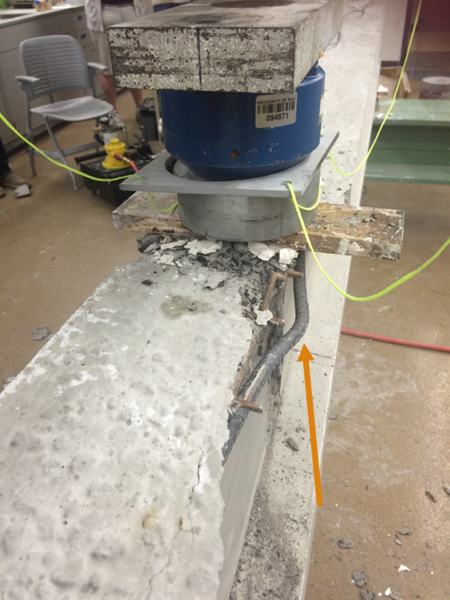
Figure 6.11.1: Elevation view of compression steel failure
Figure 6.10.1: Top view of compression steel failure
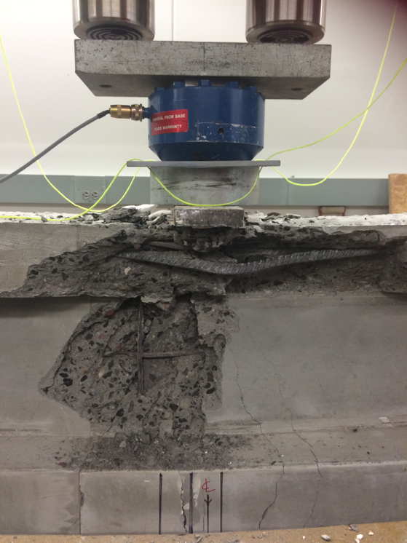

7.0 Personal Statements

7.1 Eman Albdiwyi
The contest helped me to realize how challenging designing every single element used in construction is. There are a lot of considerations and calculations that should be done prior to starting the actual design. Many errors might occur while in the process of designing, and teamwork is the key to catch the errors, fix the errors, and produce a reasonable design. Every single component in the design matters, and the absence of one makes a lot of difference. These components are not just existing to fill a blank space; they are added to fulfil a requirement that will help the design achieve the desired results. Every design has basic phases to go through, and in designing the PCI Big Beam, the team learned to accomplish the planning phase. Then move to the calculating phase. Then the comparison phase to choose and produce the design. Finally, the team must make future predictions.

7.2 Deena Albustan
Over the two semesters of the 2016 PCI Big Beam Competition I learned that team communication is the most crucial aspect for a successful project. When each team member understands their duties and proceeds within the criteria assigned, it delivers the project to a successful end. Engineering concepts and analysis that I was exposed to throughout my academic career were the backbone of the project. Having a clear understanding of pre-stressed concrete greatly helped in the design process, where comprehending how pre-stressed concrete is an ideal choice because of its economic value and its long life expectancy. This competition has taught me to think outside the box and look past analytical calculations and equations, and that making the appropriate decision in regards to any situation faced. The team designed the PCI Big Beam using the MathCAD sheet to insure that the criteria was met and agreed upon a specific design, I completed the cross section of the PCI Big Beam, which was then finalized using the AutoCAD. The PCI Big Beam was delivered and it was a first to see a design we created from scratch on a piece of paper come to life. The most important lesson learned is having the need to establish great team communication and not spending time on misunderstandings due to the inability of having healthy discussions to further better the project and aids in following the schedule assigned to complete the project, which were skills learned in previous engineering design classes.

7.3 Nicholas Jokerst
The PCI Big Beam contest taught me valuable lessons in project management and the immense breadth of knowledge that must be put into a design. When the team began the project, we were highly disorganized and it inhibited efficient progress on the beam. Once an effective meeting schedule, role assignment and basis of communication were established, the team proceeded forward with much greater efficiency. Secondly under project management, I learned how to work with individuals that come from a completely different background than I, as two members of the team were foreign exchange students. As far as the knowledge required to design, I severely underestimated this at the beginning. I quickly learned that we would have to research an immense amount to gather adequate knowledge regarding designing prestressed concrete because the team only had experience in traditional reinforced concrete through NAU’s curriculum. Through the help of our technical advisor, Dr. Tuchscherer and the NAU research database, I learned to utilize all resources at your disposal to give yourself the tools required to design a proficient beam.

7.4 Michael O’Reilly
The 2016 PCI Big Beam Competition taught me many things. Foremost among what I learned is the importance of fully collaborating with team members to work on every aspect of the project. I learned that if every member knows what is happening in each aspect of the project then the project runs very smoothly. However, if each team member is working on one aspect of the project and they do not know how the other aspects of the project are progressing then many issues arise with staying on schedule with the project and with integrating each aspect of design. I also learned how important it is to truly seek to have a full comprehension of a project. A lot of time was wasted in the beginning of the project because the team started working on designing a beam without having a full understanding of what was required in the competition. Finally, the importance of paying attention to the small details of a project, especially one as technical as pre-stressed concrete, was reinforced in me through this process. This became very apparent to me when I was creating the MathCAD sheet to analyze the beams behavior. If just one variable had the wrong units or if one calculation had a misplaced parenthesis, then the whole sheet became dysfunctional. I learned a lot about how to conduct a successful long-term project through being a part of this competition. The three previous factors are just the three largest lessons I learned throughout this process.

NAU Big Beam Team Addresses:

Michael O’Reilly
2500 South Huffer Lane, Apt 30-234 Flagstaff, AZ 86001

Eman Albdiwyi
700 W University Ave
Flagstaff, AZ 86001

Nicholas Jokerst
3400 Lake Mary Road, Apt. 18307
Flagstaff, AZ 86001

Deena Albustan
4343 East Soliere Avenue, Apt 23-1063
Flagstaff, AZ 86001

8.0 Summary of Project Costs

8.1 Project Schedule
Table 8.1.1 shows the anticipated schedule compared the actual dates of completion for the project. Dates of completion that are highlighted in red represent tasks that weren’t completed on time according to the anticipated schedule. Dates of completion highlighted in green are tasks that were completed on time or ahead of schedule.

Table 8.1.1: Projected Project Hours
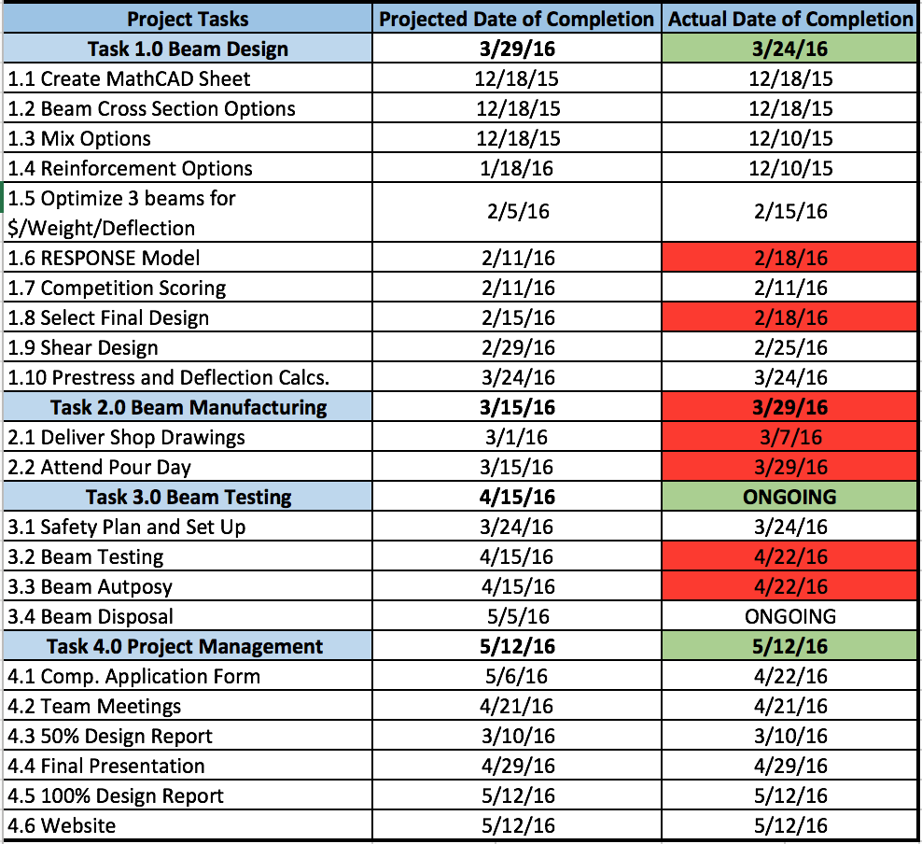

8.2 Project Hours
The team developed the projected hours by estimating the length that each task would take based on prior experience in classes and internships. Table 8.2.1 provides a comparison of the projected hours compared to the actual hours spent on each task.
Table 8.2.1: NAU Big Beam Projected vs. Actual Project hours 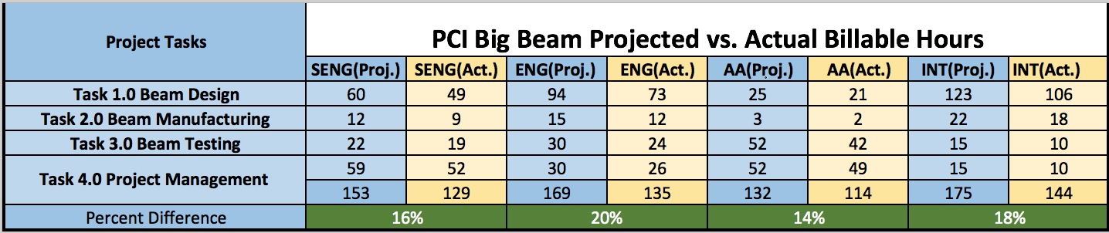

The difference in projected to actual hours spent can be attributed to the relative lack of experience the team shared. Though some members of the team have experience through internships projecting hours, none of the team had ever worked a project from start to completion. For this reason, the team overestimated the hours that would be required to complete the project. This ensured that more than enough time would be set aside within our individual schedules to complete the project on time. In the end, this approach worked in our favor because the project was completed on time and we had adequate float when some tasks fell behind.

8.3 Project Cost
The cost of the projected cost of the project was developed by multiplying the projected hours by the cost of each team member role. The projected cost and actual cost are reported in Table 8.3.1 and Table 8.3.2, respectively.

Table 8.3.1: Projected Project Cost
Total Projected Cost
1.0 Personnel | Classification | Hours | Rate, $/hr | Cost, $
1.0 Personnel | SENG | 153 | 175 | 26,775.00
1.0 Personnel | ENG | 169 | 75 | 12,675.00
1.0 Personnel | AA | 95 | 60 | 5,700.00
1.0 Personnel | INT | 197 | 50 | + 9,850.00
1.0 Personnel | Total |  |  | = $55,000
2.0 Travel | 2 trips to Phoenix at 286 mi/trip | $0.445 per mile |  | + $254.00
3.0 Project Total |  |  |  | = $55,254.00

Table 8.3.2: Actual Project Cost
Actual Project Cost
1.0 Personnel | Classification | Hours | Rate, $/hr | Cost, $
1.0 Personnel | SENG | 129 | 175 | 22,575.00
1.0 Personnel | ENG | 135 | 75 | 10,125.00
1.0 Personnel | AA | 114 | 60 | 6,840.00
1.0 Personnel | INT | 144 | 50 | + 7,200.00
1.0 Personnel | Total |  |  | = $46,740
2.0 Travel | 2 trips to Phoenix at 286 mi/trip | $0.445 per mile |  | + $254.00
3.0 Project Total |  |  |  | = $46,994

9.0 Impacts
Prestressed concrete is becoming a viable alternative to traditional reinforced concrete and steel construction. It impacts the economic portion of the construction industry because it allows for shorter build times and shorter beams to be used. The shorter build times saves the contractors because they do not have to pay workers for as much time as previously, and they can move on to other projects faster which also allows them to turn a greater profit [2]. The fact that prestressed beams are shorter than other beam options means that buildings made with prestressed beams are not as tall as other buildings. This means that money is saved through conserving materials and through reducing labor.
The environmental impacts of prestressed concrete are fairly negative. Concrete releases more greenhouse gases than steel does [3]. This negatively impacts the environment. It also requires a more energy intensive transportation process because prestressed concrete beams are much heavier than steel beams. This causes more fuel to be burned which also releases more CO₂ heat into the atmosphere.
Prestressed concrete is more ductile than traditional concrete and can provide more warning before failure. This could cause the public to see prestressed concrete as a preferred building material. However, the public could also decide that the environmental effects associated with concrete outweigh the benefits of it in construction.

References

[1] | AboutCivil, "ACI Method Concrete Mix Design," [Online].  Available: http://www.aboutcivil.org/concrete-mix-design.html. [Accessed 15 April 2016].

[2] | aboutcivel.org, "Advantages of Prestressed Concrete," 2014. [Online]. Available: http://www.aboutcivil.org/advantages-of-prestressing.html. [Accessed 7 5 2016].
[3] | A. Guggemos, "Comparison of Environmental Effects of Steel- and Concrete-Framed Buildings," Journal of Infrastrure Systems, vol. 11, no. 2, 2005.

Appendices

Appendix A: TPAC Batch Report for NAU Big Beam

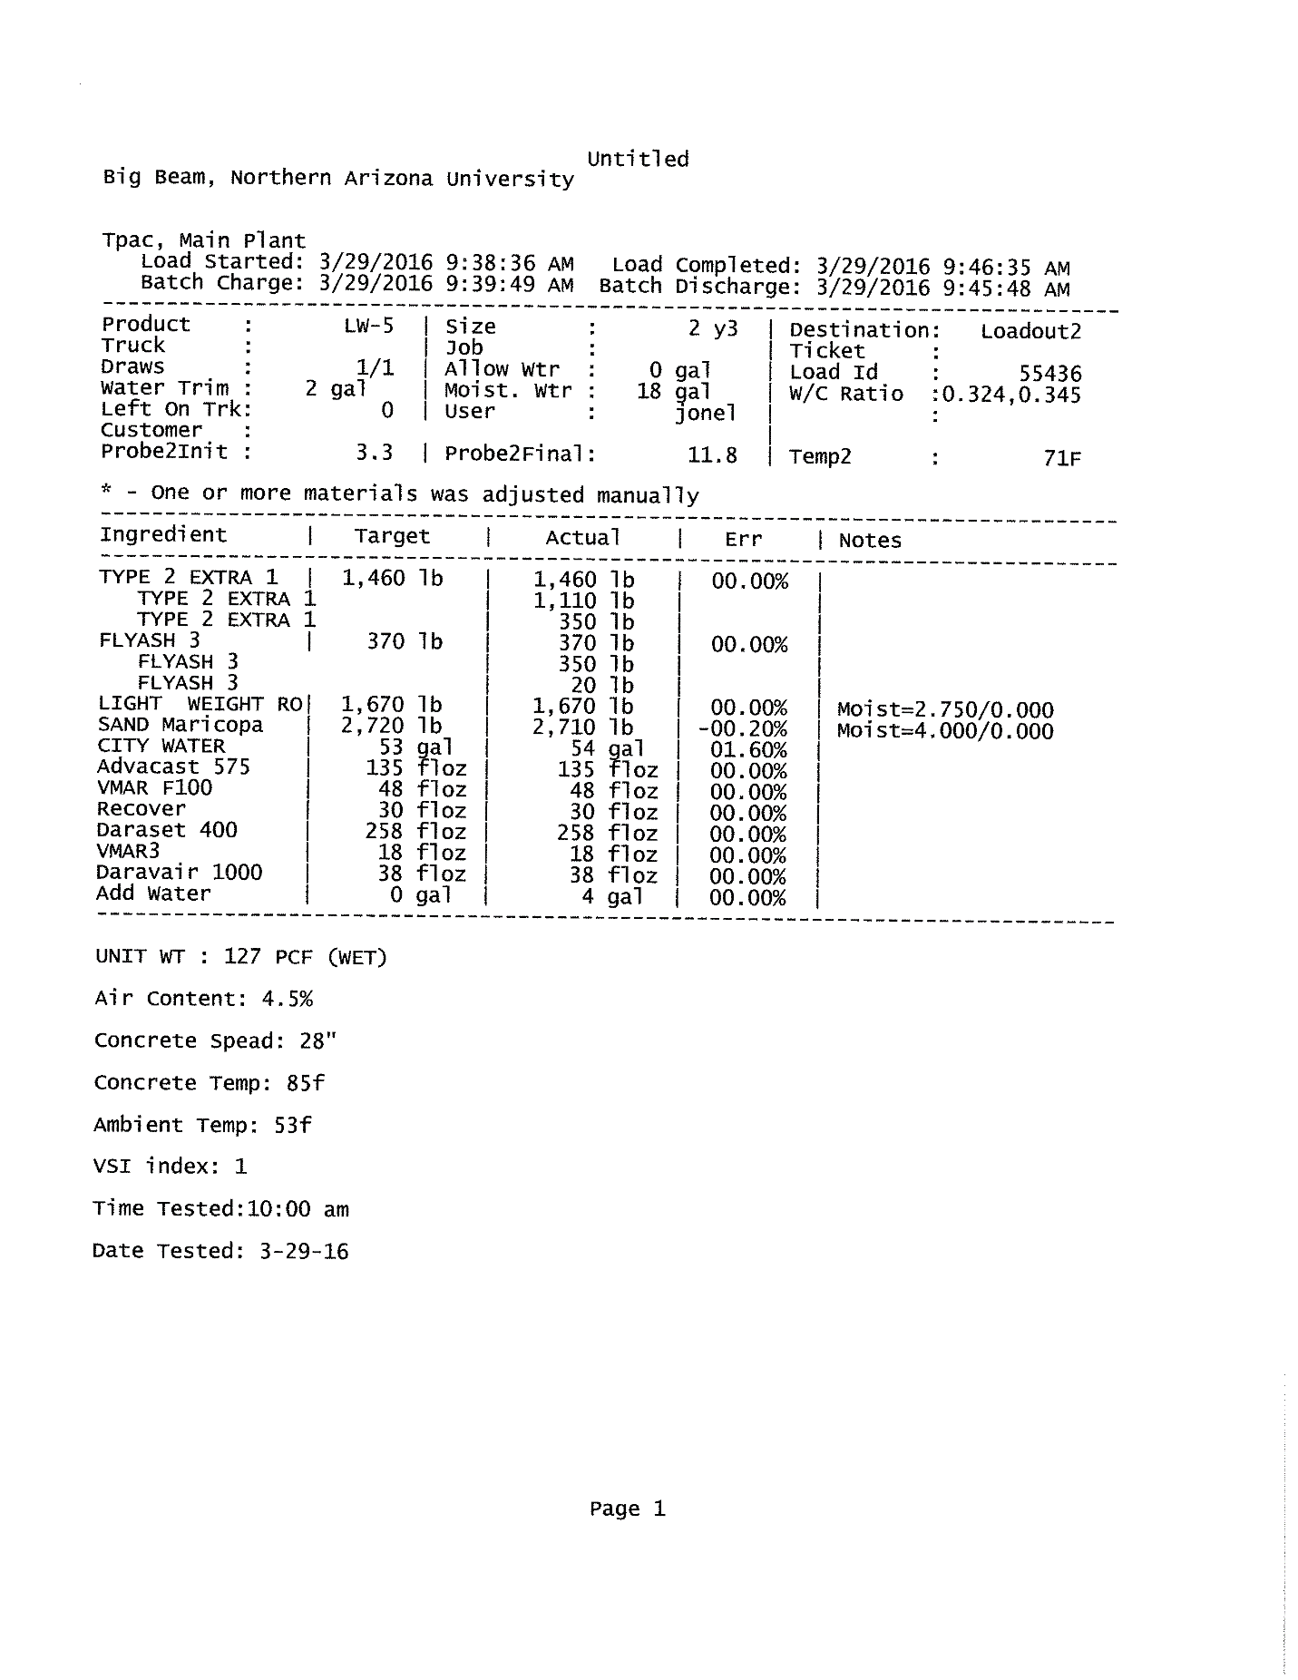

Appendix B: NAU Big Beam Modeling Assumption Values
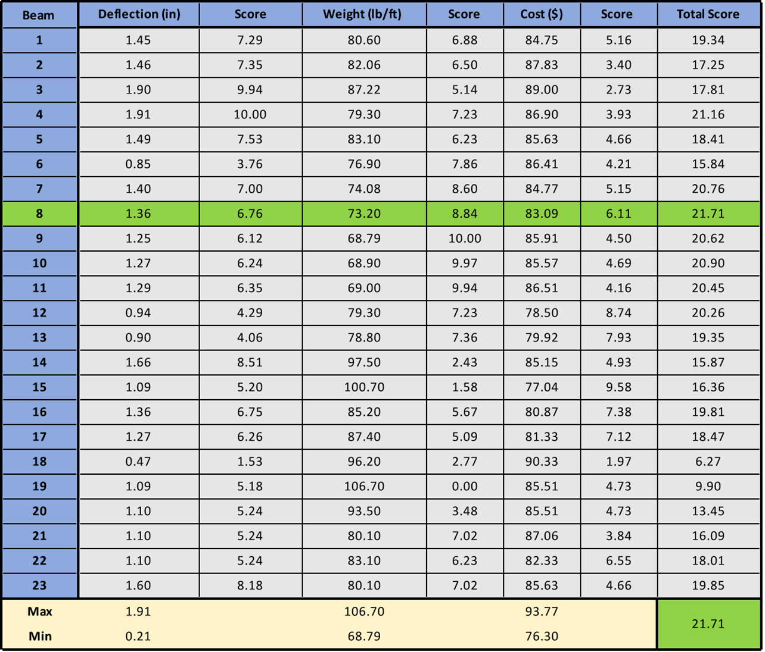

Appendix C: NAU Big Beam Scoring Matrix

Appendix D: TPAC Tensioning Report

Appendix E: TPAC Tensioning Report

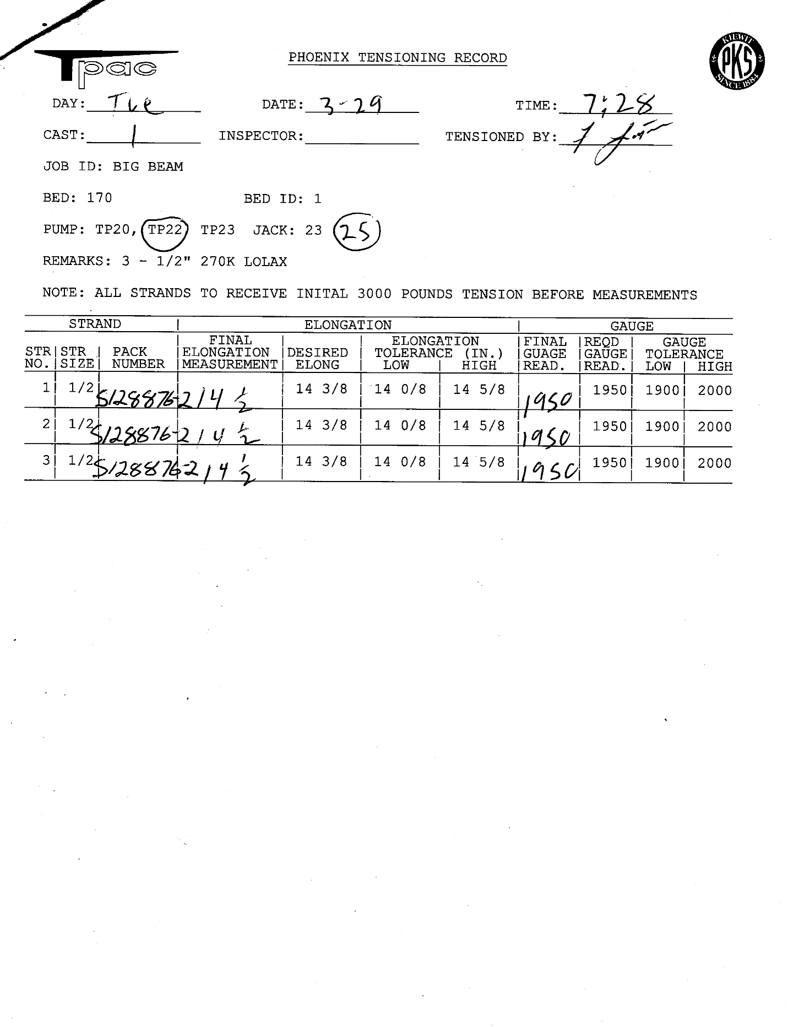

Appendix F: SWPC Mill Certificate
