2012
Ian Braun
Proposal to Provide Consulting Services for Hualapai Museum Site Design

APEX Engineering
Andrew Halley █ Ian Braun █ Jorge Hernandez █ Mohamad Haikal Bin Maamor
Date: 12/5/2012

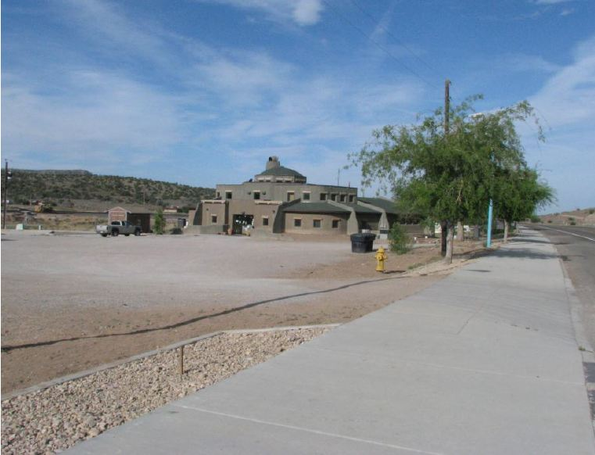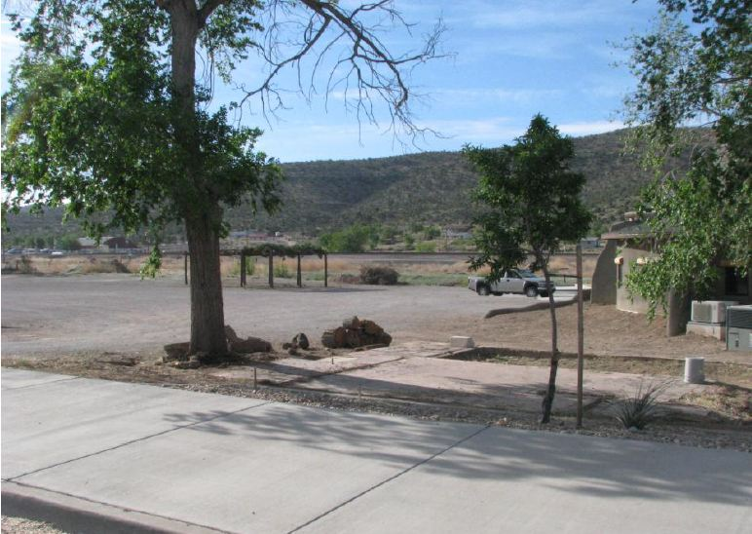

APEX Engineering
Civil Site Design █ Land Surveying █ Construction Planning
2112 S. Huffer Ln
P.O. Box: 5621
Flagstaff, AZ 86001
Engineering and Technology – (Bldg #69)

Dawn Hubbs, Program Manager, Anthropologist/Archaeologist
P.O. Box 310
Peach Springs, AZ 86434
Re: Hualapai Museum Site Design, Request for Proposals

Dear Ms. Hubbs,
Apex Engineering proudly presents our proposal to design the Hualapai Tribe’s museum site layout. To follow is a detailing of Apex Engineering’s approach to the site design. Included in this proposal are:
- Qualifications of the Design Team
- Background Information Provided Through Project Understanding
- Work Proposal and Scope of Services
- Work Timeline
- Budget and Personnel Breakdown

Please review this proposal and feel free to contact us with comments and questions that arise.
Respectfully,

APEX Engineering

Andrew Halley | Ian Braun
Mohamad Haikal Bin Maamor | Jorge Hernandez
Contents
1.0 Design Team Qualification 4
2.0 Project Understanding 5
2.1 Proposed Hualapai Tribe Museum 5
2.2 Background Information 5
2.3 Stakeholders 5
2.4 Existing Site Conditions 5
2.5 Key Aspects of Civil Site Design 6
2.6 Design Challenges 7
2.7 Factors of Design Success 7
3.0 Scope of Services 7
3.1 Field Survey/Topographic Map 7
3.1.1 Establishing Survey Control Points 8
3.1.2 Fill/Grading Plan Design 8
3.2 Storm Water Drainage Design 8
3.2.1 Runoff analysis 8
3.2.2 Design Specifications of Storm Water Inlet/Outlet Structures 9
3.2.3 Design of Storm Water Detention/Retention Facility 9
3.3 Sanitary Sewer Systems 9
3.3.1 Arizona Administrative Code 9
3.3.2 ASCE Report No. 69 9
3.4 Municipal Water Supply 9
3.4.1 Water Demand 9
3.4.2 Design of Municipal Water Supply 10
3.5 Parking Facility Design 10
3.5.1 Analysis of Surrounding Intersection 10
3.5.2 Modeling 10
3.5.3 Model Analysis 10
3.5.4 Parking-Lot Design 10
3.6 Project Management/Public Outreach 11
3.6.1 Project Stakeholder List 11
3.6.2 Field Visits 11
3.6.3 Workshops with Client 11
4.0 Project Timeline 12
5.0 Proposed Budget 14

1.0 Design Team Qualification

APEX Engineering’s qualified design team is comprised of:
Ian Braun
Design Tasks- Field Surveying and Drainage Design
Experience- 6 years land surveying experience under a registered Professional Land Surveyor, with 1 year as a survey crew leader
Received an A in a graduate level course in analysis of open channel flow, and design of open channel drainage structures
Skilled with drainage and flow analysis applications including HEC-RAS, HEC-HMS, Hydraflow Express, FlowMaster, CulvertMaster, and WaterGEMS
Drew Halley
Design Tasks- Traffic Analysis and Parking Facility Design
Experience- Completed all offered graduate level courses in traffic analysis applications, and traffic flow design
Skilled with traffic analysis applications including Synchro, and PETRAPro
Mohamad Haikal Bin Maamor
Design Tasks- Fill/Grading Plan Design
Experience- Skilled with drafting software such as Auto CAD
Jorge Hernandez
Design Tasks- Sidewalk/Paving Design
Experience- 7 years experience in the concrete industry with advanced experience reviewing plan sets and concrete mix designs
Received training in reinforced concrete design

2.0 Project Understanding

After extensive research APEX Engineering has compiled a detailed understanding of the proposed civil site design.

2.1 Proposed Hualapai Tribe Museum

This project will design a museum site for the Hualapai tribe in Peach Springs, AZ. The museum would be an expansion on the existing Hualapai Cultural Center site. The hope is to have a modern museum which meets the United States Federal Museum standards; these standards allow Hualapai tribe possession of antiques that were created within their tribe. This museum will educate the current and future generations of the Hualapai tribe of their culture and heritage. The museum would also serve as an archive for the Hualapai tribe, where information on previous generations of Hualapai tribe can be restored, and reside permanently.

2.2 Background Information

This project is to be funded with both government grants and private funding. The parcel has had a prior land survey performed and currently has a portion of the parking lot that is compliant with the Americans with Disabilities Act (ADA). This could affect the drainage of the parcel and how a new drainage plan is developed. In addition, there is a stream along the side of the parcel that overtops during heavy rainstorms.

2.3 Stakeholders

The key stakeholders for the museum site design project will be the planning and public works department and the tribal administration of the Hualapai Nation. Therefore, any design considerations or proposals will have to be approved by these administrations. More research must be conducted in order to comply with any approval processes concerning design proposals for this project. In order to maintain communication with the tribal administration, Dawn Hubbs, the program manager at the cultural center, will be the one of the main contacts for the group.

2.4 Existing Site Conditions

The proposed museum will be located on a 7.5-acre parcel located in downtown Peach Springs, AZ. This parcel has two existing structures located on the east and northwest areas of the property. An aerial photo graph of the parcel has been provided in figure 1.
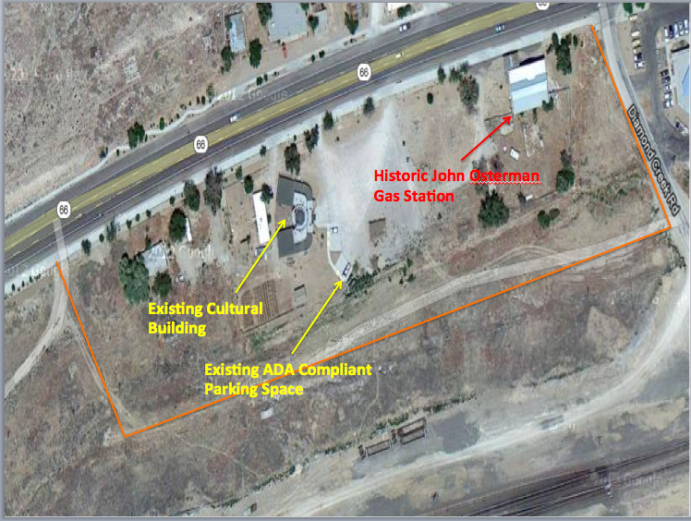
Figure 1- Figure 1 depicts a labeled aerial photograph of the existing conditions of the proposed building sit in Peach Springs, Arizona.
The western building is the existing cultural center building that holds programs and displays artifacts of the Hualapai Nation. The Historic John Osterman Gas Station is located on the northeast corner of the parcel. The gas station was registered as a historic building on March 15, 2012. The building is of great value to the community due to the history it has with the town. Vehicle parking for the existing cultural center is an unpaved parking lot with an ADA parking structure. Once the size of the museum is determined, steps will be taken to size a paved parking lot. In addition to the buildings located on the parcel there is a retention basin that is located due east of the John Osterman Gas Station and between Diamond Creek Road.

2.5 Key Aspects of Civil Site Design

When addressing site design for a large multi-use facility such as the proposed Hualapai Museum, numerous aspects of civil engineering site design must be addressed. For the site design of the facility in question, technical considerations are as follows: grading, storm-water drainage design, detention/retention facilities, sanitary sewer systems, municipal water supply, and parking facility design/site access. All designs must meet required specifications including those of the ADA, and NPS guidelines for buildings housing cultural/historical artifacts.

2.6 Design Challenges

Due to the proposed site’s historical and spiritual nature, there are numerous considerations that must be addressed. Several large trees that are currently present on the proposed site are important for both aesthetic and cultural reasons. At the request of the client, these trees should only be removed if absolutely necessary. A registered historic building lies directly adjacent to the proposed site, and also lies between the proposed site and an area in which parking facilities may be implemented. Due to the building’s historic nature, it cannot be demolished or moved. Another problem is the presence of a railroad easement along an entire edge of the site. As engineers, this easement must be taken into consideration. In the Hualapai culture a building’s entrance must face east; this must be taken under advisement for site design. Numerous other cultural considerations, such as the use of local building materials important to the tribe, will also need to be considered. It is our job as the engineering firm to work around this issue and find a suitable design.

2.7 Factors of Design Success

One of the key factors for the success of the project will be obtaining the required funding. As with any development project, funding and capital are critical, due to many specific design criterions that must be provided for and accommodated. Private donors would be one way to help alleviate the cost and provide for the success of this project.
Also, full support of the Hualapai community and their input would greatly aid in the success of the design implementation of the project. The tribal administration should be vocal on behalf of the community and help with aesthetic elements of the design.

3.0 Scope of Services

Due to the size and magnitude of this site design, APEX engineering has created a six step approach to the design of the museum. These steps include all preliminary and final design work to produce a finished site layout. This includes a field survey, storm water drainage plan, sanitary sewer system, municipal water plan, parking facility design, and public outreach.

3.1 Field Survey/Topographic Map

Based upon an on-site inspection of the building location for the proposed Hualapai Museum, AE has deemed it necessary to perform a detailed topographic survey of the area. A detailed topographic survey shows the topography, or elevation and contours, of the existing ground. The topographic survey will also show all relevant buildings and roadways in the area. A survey is necessary in order to coordinate grading and fill quantities for the site and create a level building foundation, as well as an even drainage grade for paved areas to prevent pooling. Data collection for creating a topographic map will be accomplished through a field survey. A field survey will serve as a more accurate method of creating a three-dimensional topographic map than an aerial-photogrammetric survey. An aerial photogrammetric survey would be more expensive, and would not provide adequate accuracy for computing cut and fill quantities. Due to the relatively small survey area, a topographic survey performed from ground controls with a total station will be a more cost effective process. Once this process is finished a detailed topographic map will be provided to the client.

3.1.1 Establishing Survey Control Points

Establishing survey control points is a necessary step to orient a topographic survey to its surroundings, in terms of northing and easting, and elevation. Survey controls will be established from existing Arizona Department of Transportation highway control monuments. For added accuracy, existing survey control points from previous surveys of the area will be used to verify. Control point lists from existing surveys will be acquired from either the Mohave County Recorder’s Office, or the land surveyor who initially performed the survey.
A list of survey control points is necessary so that future land surveyors can continue work in the area, and not be hindered by our work. A survey control point list is simply a table formulated from AutoCad, which lists all survey control points used on the project with the north and east state plane coordinates, and their elevations. A control point data table would be provided for the client’s records.

3.1.2 Fill/Grading Plan Design

Based upon topographic information collected during the field survey, a final building platform and paving surface can be designed. The proposed building surface and paving surfaces have to be level, or at a calculated grade, and at a proper elevation to allow for drainage. A proposed level surface will be combined with the existing contour map to extrapolate cut/fill depths at numerous locations. Cut/fill depths can be located by a land surveyor, and utilized by the contractor.
These cut/fill depths compose a grading plan which will allow for the creation of a level surface for the proposed museum’s foundation as well as parking facilities. This grading plan will consist of a contour map that shows the site’s existing contours as well as the proposed final contours after cut or fill. This map will contain a data table that corresponds to spot elevations on the contour map with an inverse distance to the existing elevation. A grading plan is a necessary tool for design as well as for all construction. A grading plan will be provided for the client.

3.2 Storm Water Drainage Design

Creating an impermeable surface, such as with a paved parking facility, will create issues with storm water runoff during precipitation events. This runoff must be collected from the impermeable surface, and discharged to an alternate location. Cultural and environmental considerations may also require the use of an oil-water separator or other treatment approach.

3.2.1 Runoff analysis

A rainfall analysis of precipitation events in the area must be performed so that the peak design runoff can be determined. This runoff analysis will be used to size storm water drainage structures. A copy of the hydrological runoff model will be given to the client.

3.2.2 Design Specifications of Storm Water Inlet/Outlet Structures

A specific plan set of Inlet/Outlet structures and piping systems for storm water runoff will be prepared. This design will include type, location, and dimensions of inlet/outlet structures as well as a complete piping system design. A plan set consisting of multiple drawings will be delivered to the client.

3.2.3 Design of Storm Water Detention/Retention Facility

A design plan of Water Detention Facility would be developed based on the storm runoff data. The facility design requirements will include type of facility, dimensions, location, safety consideration, and maintenance tasks. A detailed plan set would be given to the client.

3.3 Sanitary Sewer Systems

A design plan of Sanitary Sewer System for the Hualapai Museum would be developed based on existing area sewer hookups. The design requirements will include proper wastewater flow, overflow prevention, water quality protection, maintenance tasks, and adherence to any applicable codes and regulations. A design schematic of the sanitary sewer system will be provided for the client.

3.3.1 Arizona Administrative Code

The proposed sanitary sewer should be designed and constructed in compliance with the Arizona Administrative Code. Any modification from the requirements of the Arizona Administrative Code shall be noted. This code regulates what allowable flows and sanitation levels should be achieved.

3.3.2 ASCE Report No. 69

ASCE Report No. 69 governs over the byproducts and how efficient sewage systems should be. Sanitary sewage systems within the Proposed Hualapai Museum location must adhere to ASCE’s Report no. 69; Sulfide in Wastewater Collection and Treatment Systems.

3.4 Municipal Water Supply

Municipal water supply must be designed and coordinated with the city planner and architect to provide desired pressure and volumes necessary for fire-protection. In any town setting, it is necessary to analyze the needs of the population and their water consumption.

3.4.1 Water Demand

A water demand analysis would be performed to determine the average demand in Peach Springs. The average water demand will be used to determine amount needed to be supplied to Hualapai Museum. A report of water demand analysis will be provided for the client.

3.4.2 Design of Municipal Water Supply

Design for Municipal Water Supply for Hualapai Museum will be based on average water demand. The design will be based on building layout, pumping facilities, water storage, and distribution systems. The distribution system will provide the Hualapai museum with information regarding supplied water pressure and volumes. A design schematic of the proposed supply will be provided for the client.

3.5 Parking Facility Design

The parking facility is to serve visitors to the Hualapai museum, and upon request of the tribe and regulations, must be designed under specifications compliant with the American Disabilities Act (ADA). A parking study must be performed in order to appropriately size parking facilities. AE will model the proposed parking lot to allow for increased use of the Hualapai cultural center and proposed museum. The added uses of the lot will cause an increase in traffic to the area, which may have a negative effect on the adjacent intersection.

3.5.1 Analysis of Surrounding Intersection

A traffic count of the intersection directly adjacent to the lot will need to be completed. This count will be the first step for all parking studies and aid in the design of the lot. Printouts from the traffic count software, PetraPRO, will be provided for proof of completion.

3.5.2 Modeling

The intersection will be modeled using accepted software for traffic modeling. Once the model has been created, the current demand stemming from the cultural center will be added into the model. A table from the Synchro software will show all turning movements and how they affect the lot and the access to the lot.

3.5.3 Model Analysis

With a completed model of the current demands, the increased usage for the center can be modeled and enhanced to best allow for use of the area. This added demand can be obtained from trip generator manuals. Once the extra demand has been added to the model, a second printout from Synchro will be provided.

3.5.4 Parking-Lot Design

A design needs to be created that incorporates the current ADA compliant parking spots. Without hindering the ADA spots, and according to the demands determined from modeling, ample parking spots should be provided. The demand that was determined from the Synchro model will be accounted for in the lot layout. The layout of the lot should contain sufficient parking spots as deemed necessary. An AutoCAD print will be created showing the proposed parking lot design that will comply with the drainage and grating plan.

3.6 Project Management/Public Outreach

3.6.1 Project Stakeholder List

AE will work in collaboration with the city to develop an inclusive and diverse database of affected stakeholders. Depending upon public reaction and involvement to the project, the database may include stakeholders from the following groups:
- Landowners/occupants
- Community/neighborhood associations
- County and State agencies
- Community and regional planning organizations

3.6.2 Field Visits

AE will conduct field visits to the site to examine the project and any possible alternatives to identify sensitive resources. These resources may include, but are not limited to, archaeological, architectural and historical sites. A survey for hazardous waste in accordance with the Hualapai Nation and Mojave County may be conducted.
The purpose in both instances will be to identify the potential for sensitive species habitat, the presence of historic buildings, or obvious prehistoric and historical features or sites along the existing right of way.

3.6.3 Workshops with Client

AE will hold at least two workshops during the planning phase of the project. The first would be a general meeting with Dawn Hubbs intended to obtain public input prior to detailed work. The second meeting would be to allow the team to see how Ms. Hubbs’ input from the first workshop was included in the design of the project. These forums will be designed to create and allow for a two-way communication between stakeholders and the project team. This will allow AE the opportunity to receive necessary feedback on all aspects of the museum site design. Meeting minutes will be provided to the client on a monthly basis detailing public outreach and all AE and client interactions.

4.0 Project Timeline

Figure-2 depicts APEX Engineering’s proposed timeline to complete the detailed scope of services for this project. Design tasks will begin by December 14, 2012, and conclude by April 16, 2012 at the latest.

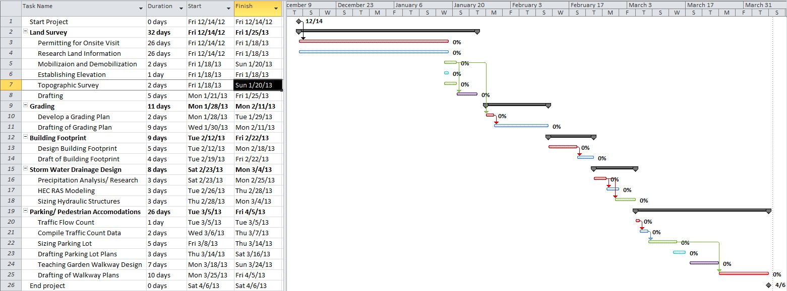
Figure 2 – Proposed timeline for the Hualapai Museum Site Design

5.0 Proposed Budget
Task Name | Position | Amount | Cost per Hour | Duration (hrs) | Total
Land Survey
Permitting for Onsite Visit | N/A | 0 | $0.00 | 500 | $0.00
Research Land Information | Sr. Engineer | 1 | $150.00 | 16 | $2,400.00
Mobilization and Demobilization | Engineer | 4 | $75.00 | 6 | $1,800.00
Establishing Elevation | Crew man | 2 | $45.00 | 2 | $180.00
Topographic Survey | Crew man | 2 | $45.00 | 10 | $900.00
Drafting | Sr. Engineer | 1 | $150.00 | 12 | $1,800.00
Grading
Develop a Grading Plan | Engineer | 2 | $75.00 | 8 | $1,200.00
Drafting of Grading Plan | Engineer | 2 | $75.00 | 8 | $1,200.00
Building Footprint
Design Building Footprint | Sr. Engineer | 2 | $150.00 | 16 | $4,800.00
Draft of Building Footprint | Sr. Engineer | 1 | $150.00 | 8 | $1,200.00
Storm Water Drainage Design
Precipitation Analysis/ Research | Sr. Engineer | 2 | $150.00 | 5 | $1,500.00
HEC RAS Modeling | Sr. Engineer | 1 | $150.00 | 5 | $750.00
Sizing Hydraulic Structures | Sr. Engineer | 2 | $150.00 | 8 | $2,400.00
Parking/ Pedestrian Accommodations
Traffic Flow Count | Engineer | 2 | $75.00 | 8 | $1,200.00
Compile Traffic Count Data | Engineer | 1 | $75.00 | 4 | $300.00
Sizing Parking Lot | Engineer | 2 | $75.00 | 8 | $1,200.00
Drafting Parking Lot Plans | Engineer | 1 | $75.00 | 6 | $450.00
Teaching Garden Walkway Design | Sr. Engineer | 2 | $150.00 | 8 | $2,400.00
Drafting of Walkway Plans | Sr. Engineer | 1 | $150.00 | 6 | $900.00
 |  |  |  | Total | $26,580.00
The proposed budget details the cost of each main design task and sub-design task to be completed during the course of this project by APEX Engineering. Rates charged are listed as hourly rates multiplied by total man-hours worked. A total charge can be found at the bottom of the table, and is $26,580.00.

